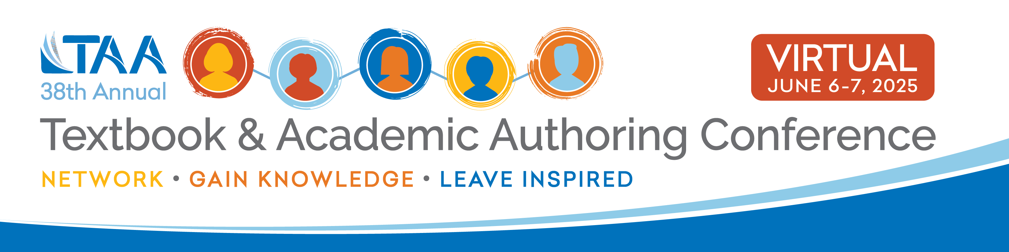
[Date]

Dear [Insert Employer's Name],

I am requesting approval for reimbursement for registration fees to attend the Textbook & Academic Authors Association’s 2025 Textbook & Academic Authoring Conference, which will be held online on Friday, June 6 and Saturday, June 7, 2025.

This year's theme is "The Future is Now" and will focus on developments in digital educational content and how AI is impacting the textbook and academic authoring publishing industry, as well as other hands-on and interactive educational and networking opportunities to help me improve my writing.

The cost to attend this two-day virtual conference is $___. [Registration fees - $125 members, $150 non-members, $75 presenter, $62.50 member graduate student, $75 non-member graduate student.] Registration opens on January 6, 2025, and I would submit my reimbursement after registering.

Attending TAA’s 2025 Virtual Conference will enhance my professional knowledge and skills and I’ll return to work ready to put them into practice. You can learn more about this event at https://www.taaconference.org/2025.

Thank you for your consideration of this request.

Sincerely,

[Signature]
[Your Name]

