**The title of your abstract (capitals for first word and proper nouns only)**

Blank line 12 pt

Blank line 12 pt

First Author a, Second Author b, Third Author c (14pt)

Blank Line 9 pt

aInstitutional Affiliation, City, State/region, Country, Email address (12pt)

bInstitutional Affiliation, City, State/region, Country, Email address (12pt)

cInstitutional Affiliation, City, State/region, Country, Email address (12pt)

Blank line 12 pt

Blank line 12 pt

SUMMARY: (10 pt)

Type your summary of not more than 150 words. The summary title has to be 9 cm from the top. For the summary title use Times New Roman 10 point bold, while for summary text use Times New Roman 10 pt regular and justified, both single line spacing.

Blank line 10 pt

Keywords: keyword 1, keyword 2 (one line of text but not more than 6 keywords, Times New Roman 10 pt italic, leave one blank before, keywords must be separated by commas)

Blank line 12 pt

Blank line 12 pt

1. GENERAL INSTRUCTIONS

The text should fit exactly into the type area. For letter-size paper the margin settings are: Top: 2.54 cm (1 inch); Bottom: 2.54 cm (1 inch); Left: 2.54 cm (1 inch); Right: 2.54 cm (1 inch). Use Times New Roman 12 point size and single line spacing. Never use bold, except for the headings, as described below and never underline any text. Use a smaller font (10 points) for tables, figure captions and the acknowledgement and references. Do not use/insert page numbers.

Blank line 12 pt

The abstract must be no longer than **4 pages**, including summary, text, figures, tables and references.

Blank line 12 pt

The basic structure of the paper should be: Introduction, Methods (background and/or materials), Results, Discussion, Conclusions, Acknowledgments, References. Preparation of figures and tables must follow the indications provided on the next pages. All pertinent references should be included.

Blank line 12 pt

1.1. Title, author and affiliation

Use bold Times New Roman 18 point size, centre alignment and single line spacing for the title. Title must not be longer than 120 characters and should be fitted in the first three rows of text.

Blank line 12 pt

Use bold Times New Roman 12 point size and single line spacing for the name of the first author (first the initials and then the last name). Leave two blank lines before first line of authors, only, as shown above. Type the correct affiliations in the lines below the authors’ names using italic Times New Roman 12 point size and single line spacing. Leave two blank line 12 pt after these affiliation lines. If there are authors linked to other institutes, type the name(s) of the author(s) and after a return the affiliation. Repeat this procedure until all affiliations have been typed.

Blank line 12 pt

Blank line 12 pt

2. SECTION HEADING (12pt BOLD AND ALL CAPS)

Section headings are to be in 12pt bold and full caps (except for the first line after the title). Number the headings consecutively. Leave two blank lines before Section Heading and one blank line between the sub-heading and the first line of text.

Blank line 12 pt

Between paragraphs of text leave one blank line gap. Paragraphs are not to have any indents. Text should be single spaced, alignment-justified, providing 25mm (1 inch) all margins

Blank line 12 pt

2.1. Secondary Heading or Sub-headings (12 pt bold, only first letter capital)

Sub-headings are printed in 12pt bold as shown. Use upper and lower case letters. Leave one blank line above a sub-heading and one blank line between sub-heading and the first line of the text.

Blank line 12 pt

2.1.1. Tertiary headings

Tertiary headings are printed in 12pt italics, and numbered. Leave one blank line above and no blank line below tertiary headings.

Blank line 12 pt

Blank line 12 pt

3. TABLES

Authors may choose how they wish to format the table layout. Use Times New Roman 10 pt for table heading and for table text. Table heading should be left alignment (e.g. the beginning of the table). Number the table headings and please be consistent throughout your manuscript. Leave one blank line before table heading and one blank line after the table, as in Table 1 shown below.

Blank line 12 pt

**Table 1.** (10pt bold) Margin settings for A4 size paper (10 pt regular)

|  |  |  |  |  |
| --- | --- | --- | --- | --- |
| Row 1 | A | B | C | D |
| Row 2 | 1 | 2 | 3 | 4 |
| Row 3 | Text | text | Text | Text |
| Row 4 | 123 | 123 | 123 | 123 |

Blank line 12 pt

Text after the table.

Blank line 12 pt

Blank line 12 pt

4. ILLUSTRATIONS AND DIAGRAMS

Illustrations are to be centred, with the reference and caption below the figure having one blank line 10 pt. Type as follows: ‘**Figure 1.** Caption’, Times New Roman 10 pt.

Blank line 12 pt

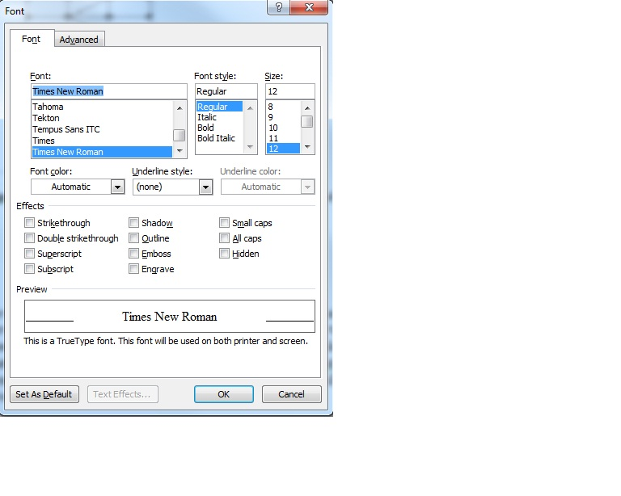

Blank line 10 pt

**Figure 1.** Screen capture of font

Blank line 12 pt

The lettering used in the illustrations should not be too small. Illustrations are to be referred to as figures, and must be quoted in the text, e.g. see Fig. 1, or in Fig. 1 it is shown… One blank line should be left between the text and figure, as well as the figure caption and the next paragraph. Keep figures as simple as possible. Resolution must be at least 250 dpi.

Blank line 12 pt

Blank line 12 pt

5. EQUATIONS

Use the equation editor of the selected word processing programme. Equations are aligned with the left margin. Number equations consecutively and place the number with the tab key at the end of the line, between parentheses. Refer to equations by these numbers. Leave one blank line above and also below any equation. Equation references are in the form of “equation number” and should be referred to in the text in the form Eq. (1). Equations should be typed and all symbols should be explained within the text of your manuscript.

Blank line 12 pt

 ${\left(x+a\right)}^{n}=\sum_{k=0}^{n}{\left({n \atop k}\right)x^{k}a^{n-k}}$ (1)

Blank line 12 pt

Blank line 12 pt

6. REFERENCES

Citations to references in the text must follow the format shown here (Doudak et al., 2005; Jain, 1996; Simiu and Scanlan, 1996). The references are listed in alphabetical order by first author (Caracoglia, 2014) and formatted as shown by the examples at the end of this template. For more than two authors the citation should replace all authors except the first one with “et al”. The reference style is provided in a separate file, using *EndNote* software. The list of references must be placed at the end of the text in a separate section, after “ACKNOWLEDGEMENTS” and should be typed in 10 pt Times New Roman. For each reference, an indentation (0.2”) of all lines except for the first one must be used.

Blank line 12 pt

Blank line 12 pt

7. CONCLUSIONS: FINAL CHECKS AND SUBMISSION TO AEROVEHICLES6

Once the text is complete, we recommend that you run a spell check through the text. The complete file, converted to PDF file, should be uploaded online through the paper submission process. Please go to <https://uobevents.eventsair.com/aerovehicles-6/abstract-submissio> and follow the instructions. If you have any questions please contact the organising committee at:

[academic.conferences@contacts.bham.ac.uk](mailto:academic.conferences@contacts.bham.ac.uk).

Blank line 12 pt

For submission, the name of the file that you choose is not important. Files will automatically be renamed by our on-line system after submission. Please submit your abstract by 29th January 2025. If the submitted manuscript is not prepared according to above guidelines it may be returned back to the author for correction. The corrected version must be re-submitted as soon as possible.

Blank line 12 pt

ACKNOWLEDGEMENTS

Acknowledgement heading is to be typed using Times New Roman 10 pt bold and with all caps, but not numbered. Text of the acknowledgement should be typed using Times New Roman 10 pt regular and justified. No blank line should be left between the heading and the text. Leave two blank lines after the text 10 pt size.

Blank line 10 pt

Blank line 10 pt

REFERENCES (heading 10pt all caps not numbered, right justified)

Caracoglia, L., 2014. Comparison of various reduced-order models to analyze the wind-induced response of a tall building subjected to parametric loading uncertainty. Proceedings of Mini-symposium 16 on “Stochastic dynamics and reliability analysis of structural and mechanical systems under environmental excitation,” IX International Conference on Structural Dynamics (EuroDyn2014), European Association of Structural Dynamics (EASD), ISSN: 2311-9020, ISBN: 978-972-752-165-4, Porto, Portugal, 2869-2876.

Doudak, G., McClure, G., Smith, I., Hu, L. and Stathopoulos, T., 2005. Monitoring structural response of a wooden light-frame industrial shed building to environmental loads. Journal of Structural Engineering, ASCE 131, 794-805.

Jain, A., 1996. Multi-mode aeroelastic and aerodynamic analysis of long-span bridges. PhD Dissertation, Johns Hopkins University, Baltimore, Maryland, USA.

Matsumoto, M., Yagi, T., Hatsuda, H., Shima, T., Tanaka, M. and Naito, H., 2010. Dry galloping characteristics and its mechanism of inclined/yawed cables. Journal of Wind Engineering and Industrial Aerodynamics 98, 317-327.

Simiu, E. and Scanlan, R.H., 1996. Wind effects on structures. John Wiley and Sons, New York, NY, USA.