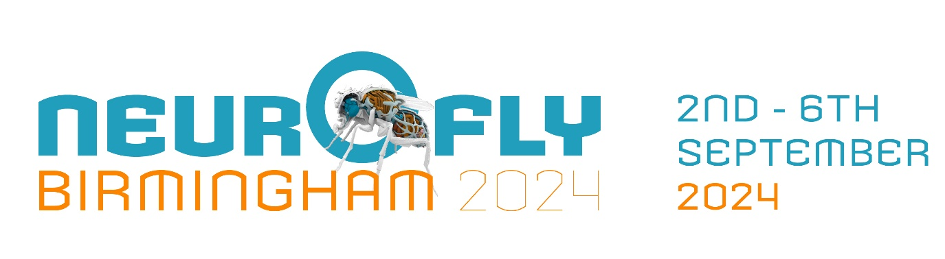

**Neurofly 2024 Manual Registration Form**

If you would like to register for the conference, please complete the table below and consent to the terms and conditions.

Once completed, please email as an attachment to [academic.conferences@contacts.bham.ac.uk](mailto:academic.conferences@contacts.bham.ac.uk). For any queries on the form, please also contact us at the address above.

|  |  |
| --- | --- |
| Title: |  |
| First Name: |  |
| Last Name: |  |
| Organisation: |  |
| Job Title: |  |
| Email Address: |  |
| Address Country: |  |
| Dietary Requirements: |  |
| Specific Requirements: |  |
| Would you like to attend the complimentary drinks reception on 2nd September? | Yes/No |
| Would you like to attend the conference dinner on the evening of 5th September (£30/£45) | Yes/No |
| Do you require accommodation at the Vale? (£50 per night) [More information](https://uobevents.eventsair.com/neurofly24/accommodation) | Yes/No (if yes please confirm check in/ check out date) |

**Which registration type do you require?**

* Early Bird - Student - £400
* **Early Bird - Postdoc Registration Fee** - £450
* **Early Bird - Academic Registration Fee - £500**
* **Early Bird - Industrial Registration Fee** - £500

**Would you like to book an additional space for an accompanying person?** - £150

Please be aware that an accompanying person does not have access to the conference, but this fee includes the welcome drinks, refreshments, lunches and conference dinner.

Yes  No

**Trip to Stratford Upon Avon and visit to one of Shakespeare's Family Homes - £25/£32**

Please be aware visiting a Shakespeare family home is mandatory if you are attending the trip.

Coaches will be included in the price if you opt-in to attend the trip.

Would you like to book onto the trip to Stratford Upon Avon on Wednesday 4th September?

Yes  No

**If you select to visit one of Shakespeare's family homes, you will have the option to see a theatre show in Stratford at an additional cost.**

Would you like to add on a theatre ticket to see ‘The Merry Wives of Windsor’- **£18**

Yes  No

**Internal payments**

There are two options for internal payments, you will only be required to fill out one of the tables below.

|  |  |
| --- | --- |
| Grant/Project Code |  |
| Task Number (e.g 1.1) |  |

**If this is part of a project, please provide the following information in the table below:**

**Alternatively, please provide the following information, which you may need to ask your finance team for:**

|  |  |
| --- | --- |
| Analysis Code |  |
| Cost Centre |  |
| Activity Code |  |
| Source of Funds |  |

**Terms and Conditions**

Registrations cancelled before Wednesday 7 August 2024, will receive a full refund minus 15% administrative fee.

No refunds can be processed after this date.

Registration names can be substituted at any point by emailing academic.conferences@contact.bham.ac.uk please copy in both parties to confirm consent for the substitution.

It may be necessary for reasons beyond the control of the organisers to alter the content and timing of the programme or the occasional identity of the speakers. The Neurofly 2024 committee and the University of Birmingham’s Event Management Team take no responsibility for non-refundable travel/accommodation in the case of a changed programme or cancelled event.

**I Agree to the terms and conditions \***