How To Prepare an Abstract

A. Researcher,* A.N. Other & T.H.E. Rest

Ilovewaltz University, Department of Spanish Riding School, 1010 Vienna, Austria

[*a.researcher@ilovewaltz.ac.at](mailto:*a.researcher@ilovewaltz.ac.at)

To streamline the reviewing process and the preparation of the final abstract book, please adhere to this template when preparing your submission to MIP2026 (Fig. 1).

Abstracts need to be in English, maximum one page including Figures/Tables and references. Use the provided template here. If you are unsure: each element of the abstract (title, authors, references etc.) has been assigned a format template starting with “MIP2026”. Use Calibri as the font and the following sizes:

* Title: centered, 18pt, bold
* Authors: Centered, 11pt, underline the presenting author and mark the corresponding one with an asterisk
* Main text: 12 pt, justification
* Figure caption: 12 pt, italics
* References: 10pt, left justified.

Please write without using subsection headings. Figures should be numbered and referred to in the text. Figure captions should give a brief description of the content (as concise as possible).

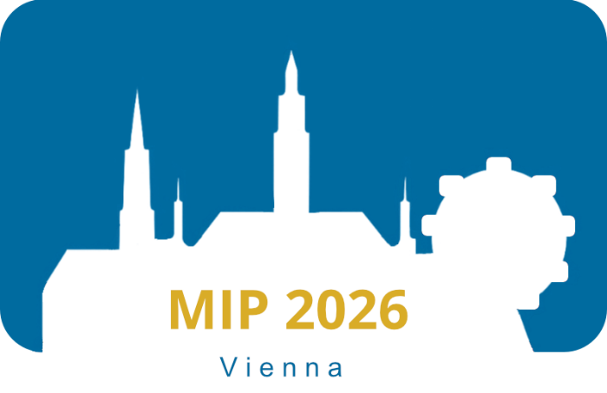

Figure 1. Looking forward to seeing you in Vienna!.

Upload your abstract as an MSWord document (*.docx) through the web mask. Only use unaccented Latin characters (ABCabc..), numerals (123...) and the underscore character (_) in filenames. If you intend to upload more than one abstract, please ensure that each has a different filename to avoid overwriting a previously uploaded document.

[1] Sainsburys, High Street, Nowhere Special.