Applying Multi-Agent Reinforcement Learning for Escape Path Planning in a Fire Evacuation Environment

ISABELLE FITKAU¹, TIMO HARTMANN¹

¹Technische Universität Berlin, Berlin, Germany

ABSTRACT:

Emergency evacuation planning is critical for building safety, yet current approaches often require costly re-modeling after design completion. This research addresses the gap between static evacuation simulations and dynamic environment optimization by implementing a multi-agent reinforcement learning framework where agents simultaneously learn escape paths and modify building components. Our system features a navigator agent seeking fast and efficient path trajectories and a door controller agent dynamically adjusting door positions across rooms. Using Proximal Policy Optimization, we tested three terminal configurations in a minimal MARL environment model. Results demonstrate successful agent cooperation without explicit communication, reducing episode lengths by 42-73% and developing door positioning strategies tailored to spatial constraints. These findings establish a foundation for future research on more complex evacuation scenarios, potentially contributing to improved building design and emergency response planning.

KEYWORDS:

Floor Plan Design, Multi-Agent Reinforcement Learning, Dynamic Environment Modeling, Escape Path Scenarios

1. INTRODUCTION
When designing a building, providing necessary escape paths is essential. This requirement results from the fire safety aspect in the general building code (hereby referencing German codes), which states that "[...] in the event of a fire, the rescue of people and animals as well as effective extinguishing work is possible" (§14 Brandschutz, MBO, (Bauministerkonferenz, 2002)) The number and arrangement of escape paths for multi-story buildings have several rule-based requirements, including "[...] on each floor with residential rooms there shall be at least two independent escape paths to the outside; however, both escape paths within the floor may lead through the same necessary hallway.” (§ 33 (1) Erster und Zweiter Rettungsweg, MBO, (Bauministerkonferenz, 2002)). Currently, fire safety planning occurs late in the design process, often requiring costly remodeling and presenting challenges for authorities approving permits if rule-based requirements aren't met (vfdb TB 04-01, 2020).
Since an evacuation plan affects many domains during planning (e.g., (re)modeling of staircases and hallways), this work focuses on developing a suitable dynamic environment (in which a minimal floor plan is implemented as an adaptive model) capable of mapping an evacuation scenario to a reinforcement learning-task. Multiple agents (MA) will use reinforcement learning (RL) to learn optimal escape strategies through the principle of ‘trial and error’ (Sutton and Barto, 2018). Unlike conventional evacuation simulations, our approach aims to both develop escape strategies and enable agents to suggest floor plan modifications. In this way, the approach presented in this paper differs from conventional performance-based simulations, which often focus on human behavior in evacuation scenarios in fixed floor plans.
While previous research has explored RL in evacuation scenarios with static environments and has focused almost exclusively on optimizing the algorithm used (Sharma et al., 2021; Sinpan et al., 2022; Zhang et al., 2023), it has also been demonstrated that a single agent can strategically learn to escape in dynamic environments if the emphasis is placed on fine-tuning the environment modeling (Fitkau, 2024; Fitkau and Hartmann, 2024).
The research questions that arise are as follows: 1) Can a multi-agent RL environment derive meaningful escape routes under simultaneous and constant environmental changes by another agent? and 2) Can trained agents make design decisions on building components that result in optimized escape path trajectories?
In summary, the aim is to have multiple agents identify escape paths simultaneously in a dynamic RL environment and to modify components based on the learned escape paths.

2. POINT OF DEPARTURE
The concept that learning occurs through interaction with the environment is fundamental to understanding the nature of learning. Reinforcement Learning (RL) as a computational approach focuses on goal-directed learning from interaction and maximizing reward. This approach involves discovering which actions yield the most reward through trial and error without direct instructions, where the consequences of actions play out over extended time periods (Sutton and Barto, 2018).
In terms of escape scenarios, existing research has used RL to model behavior and interactions during emergencies. Prior work in this area includes simulations of realistic fire scenarios with pretrained agents on complex building models represented in graph form (Sharma et al., 2021). Several investigations support the use of explicit visualization methods, such as grid-based approaches to pathfinding for escape routes (Wongsai and Pawgasame, 2018) and analysis of evacuation routes in single-room settings with multiple exits and obstacles (Zhang et al., 2021). Other research has explored deep reinforcement learning within 3D environments to simulate evacuation processes (Zhang et al., 2023), and leader-driven approaches to streamline evacuation management (Sinpan et al., 2022).
While existing research provides valuable insights, a significant limitation is the reliance on stationary environment modeling and lack of dynamic elements that better reflect real-world scenarios (Sharma et al., 2021; Zhang et al., 2023, 2021).
Previous research has not adequately modelled the dynamic nature of designing a floor plan based on results from traditional escape path simulations and building regulations, where doorways, paths, and objectives can change. Although dynamic environment modeling has been introduced in a single-agent escape scenario (Fitkau and Hartmann, 2024), it did not extend to the fact that modeling floor plans is a multi-person domain. Making informed floor plan alteration decisions based on path simulation outcomes is a natural way of creating floor plans in the first place.

2.1 Objective
This work addresses this gap by implementing a multi-agent reinforcement learning framework in a dynamic environment. A navigator agent is introduced that must learn to reach an exit, the terminal state, efficiently. The assumption made is that greater speed in finding the exit leads to straighter path trajectories, which are considered optimal. A door controller agent is established that can dynamically adjust door positions between rooms and the hallway, and learns to act according to the navigator agents’ learned escape path trajectories. This creates a dynamic environment where optimal paths constantly evolve based on the door agent's decisions and the navigators’ learning ability to escape in a frequently dynamic environment.
The results demonstrate that these agents can successfully develop cooperative behaviors, where the door controller learns door positioning strategies that facilitate efficient navigation for the navigator agent.

3. RESEARCH METHOD
Given the complexity of coordinating multiple agents seeking escape paths in dynamic floor plans, a multi-agent reinforcement learning (MARL) framework that balances cooperative behavior is proposed. To manage the increased state-action space complexity, the prototype incorporates attention mechanisms enabling agents to focus on relevant environmental features and other agents' states during training (Huang et al., 2023; Liu et al., 2024). The processes are applied in a prototypical development process (model – test – redefine – test).
The environment was modeled using Farama’s Miniworld, a minimalistic 3D interior environment simulator for RL and robotics research (v2.1, Chevalier-Boisvert et al., 2023). It was then wrapped in an Agent Environment Cycle (AEC) environment using PettingZoo (v1.24.3, Terry et al., 2021), which allowed each agent to take turns, followed by setting up training with Ray's RLlib library (ray v2.44, Liang et al., 2018).
During the training, the number of episodes and the door positions of each room were tracked, and a trained model was saved every 10 iterations (e.g., checkpoint at 10 iterations, 20 iterations, etc.). One iteration represents a complete training cycle where experiences are collected and then used to update the agent’s policies. Metrics were also tracked using tensorboard (v2.19.0 Martín Abadi et al., 2015) during training, so results such as the mean episode length, mean total return, and mean agent return could give an indication of performance during training.
After training, trained models were then loaded using a test script, and the learned behavior of both agents and the navigator agent’s trajectories could be visualized.

4. PROTOTYPE ENVIRONMENT
The prototype environment comprises three rooms with an I-shaped hallway (Figure 1). A navigating agent is placed at random in each room in turn using an increment (e.g., i = 2 means in each room twice, before continuation with the next room within a loop) to learn optimal escape paths in terms of speed during training. He is allowed to take one of three actions (turn left, turn right, or move forward).
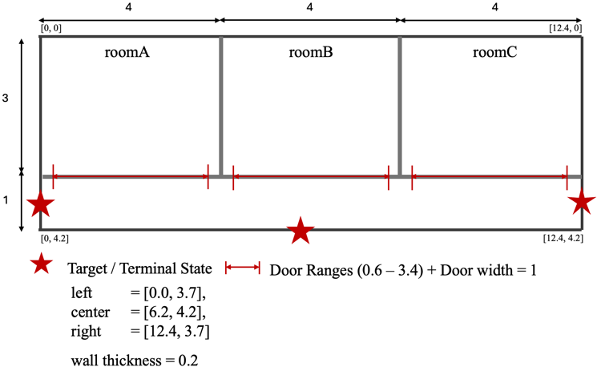
After a set number of episodes (door move frequency), the door agent takes an action to modify the environment (alteration of door locations) to optimize the learned escape paths by the navigating agent.
Figure 1: Example of prototypical environment.

4.1 Configuration
Using RL, the agents’ performance depends on the environment's observation, action space parameters, and reward function (Sutton and Barto, 2018). Table 1 describes the action spaces used by both agents. Table 2 displays the environmental configuration, which is further explained in more detail.

Table 1: Action Spaces of both agents.
“Num” = Number of Actions, “Space” = Type, “Option” = Meaning of Actions
Agent | Num | Space | Option
Navigator | 3 | Discrete | 0 = left  1 = right  2 = forward
Door Controller | 11 | Multi-Discrete | 0 = keep the position  num_positions= number of discrete door positions from the configuration file  within door ranges[0.6, 3.4]

4.1.1 Action Spaces
The navigating agent has a discrete action space consisting of three actions: turn left, turn right, and move forward. The door agent has a multi-discrete action space consisting of x number of actions based on the number of discrete door positions selected in the configuration.
The door agent selects door locations for each room with access to the hallway according to the following pattern: each time the door agent is allowed to act (due to the door move frequency parameter) and dynamically modifies the environment by placing doors at different locations, the door position is the result from a discrete number
of actions. The actions consist of either “0” = "keep location" for a room or a number of discrete door positions available, which is placing doors with a width of 1m evenly distributed over the door ranges. The number of discrete door positions is taken from the respective parameter in the configuration (see Table 2). If the number of discrete door positions is, e.g., 10, then “1” means placing the door at position x = 0.6, while “10” means placing the door at x = 3.4.
In the AEC environment used, both agents took 500 steps each (= 1000 total steps for the environment per episode), which results in a maximum episode length of 500 steps, as the navigating agent is the only one who can end the episode prematurely by reaching the terminal. Due to the frequency of the door movement, the door agent was only allowed to change the door locations through his action space during the first action of every x’th episode. The door agents’ actions were masked for the rest of the episode, and only the observations and rewards were collected.

4.1.2 Policy Updates
Both agents have their own separate policies defined in the multi-agent configuration, each mapping their respective observations to actions.

Table 2: Configuration used for training.
“Name” = name of config parameter, “Value” = parameter value
Environment
Name | Value
door_width | 1.0
door_position_min | 0.6
door_position_max | 3.4
terminal_location | one of:  [0.0, 3.7] for terminal “left”  [6.2, 4.2] for terminal “center”  [12.4, 3.7] for terminal “right”
max_episode_steps | 500
random_agent_placement | True
door_move_frequency | 2
num_positions | 10
sigmoid_min | 500
sigmoid_max | 4000
sigmoid_midpoint | 200
sigmoid_steepness | 0.025
navigators_reward_scales
reward_distance | 1.0
penalty_distance | 1.0
penalty_time | 1.0
reward_hallway | 1.0
reward_terminal | 1.0
penalty_terminal | 0.0
penalty_room | 1.0
door_controller_reward_
scales
cooperation | 1.0
path_efficiency | 1.0
path_quality | 1.0
PPO
train batch size | 12000
learning rate | 0.0003
number of epochs | 20
minibatch size | 256
gamma | 0.99
number of workers | 1
number of parallel environments per worker | 1

The navigator's policy processes spatial information, including distance to the terminal, agent position, door positions, and lidar measurements to select its actions. Meanwhile, the door controller's policy analyzes the navigator's position, spatial
information, and path history to select optimal door placements across multiple rooms, demonstrating how specialized policies can evolve to address different aspects of a cooperative task.
The environment was trained using the Proximal Policy Optimization (PPO) (Schulman et al., 2017) implementation of RLlib. Each agent's policy is trained independently but simultaneously on its respective experiences. PPO's clipped objective function ensures stable learning by limiting policy changes and preventing catastrophic performance collapses, which are particularly problematic in multi-agent settings where the environment becomes non-stationary from each agent's perspective as other agents learn. The separate policy optimization processes allow each agent to specialize in its role while still developing cooperative behavior through the shared reward structure.
One policy update is based on what happens during one iteration. Each iteration is shaped by some key parameters: train batch size, which determines how many transitions must be collected before a policy update occurs. Using a train batch size of 12000 and a total of 1000 steps for the environment per episode, approximately 12 complete episodes would need to be completed to reach the required 12000 transitions for a single iteration (though the actual number may vary depending on the progress of learning and reduction of episode length).
During each iteration, both agents interact with the environment, generating experiences or both across multiple episodes until the batch size requirement is met. Once sufficient data is collected, the PPO algorithm processes this batch, creating minibatches of size, and runs a number of epochs of optimization on the collected data to update both agents' policies. The configurations used for the prototype in this work can be found in Table 2.

4.1.3 Reward Structure
The reward design addresses the challenge of aligning individual actions with the shared goal of efficient navigation through complementary incentive structures. For the navigator agent, progress rewards provide immediate feedback when moving toward the terminal, helping the agent learn directional navigation. The hallway rewards encourage the agent to find and use doors strategically. The sigmoid terminal reward creates a smooth gradient that rewards faster completion, avoiding the "cliff" effect of binary rewards. Stagnation penalties prevent the agent from getting stuck in local minima or circular patterns. For the door controller agent, cooperation rewards are given when the navigator makes progress, creating a clear feedback signal despite the temporal gap between door placement and navigator success. Efficiency rewards based on ideal path length encourage optimal door positioning without requiring the controller to understand navigation details. Shared terminal rewards align both agents' interests toward fast episode completion. This reward structure successfully bridges the credit assignment gap in cooperative multi-agent systems, allowing the door controller to learn effective strategies despite acting at a lower frequency than the navigator.

The reward function for the navigating agent can be formalized as:

$R_{nav}= α_{1}\left(\frac{2}{d_{t}+2}+\frac{2}{∣θ∣+1}\right)- α_{2}\left(\frac{3}{d_{t}+2}∙\frac{∣θ∣}{π}\right)-α_{3}∙0.1+ α_{4}R_{hall}-α_{5}∙R_{tpen}+α_{6}R_{term}-α_{7}R_{stag}$ (1)

where:
$d_{t}$ is the distance to the terminal
$Θ$is the direction difference (angle to terminal)
${ R}_{hall}$ is the hallway reward (0.1 plus 500 one-time bonus) $R_{tpen}$ is the penalty given at truncation
${ R}_{term}$ is the terminal reward: $R_{min}+\left(R_{max}-R_{min}\right)∙(\frac{1}{1+e^{\left(s-m\right)+k}})$
$R_{stag}$ is the stagnation penalty (500 if stagnant for 100 steps)
$α_{i}$ are the scaling factors

The reward function for the door agent can be formalized as:
$R_{door}= β_{1}R_{coop}-β_{2}\left(100∙{\left(\frac{5.0}{L_{ideal}+1.0}\right)}^{1.5}\right)+β_{3}R_{path}+β_{4}R_{succ}$ (2)
where:
$R_{coop}$is the cooperation reward (0.1 for progress, 1.0 in hallway)
$L_{ideal}$ is the ideal path length through the door
$R_{path}$ is the path quality reward
$R_{succ}$ is the success reward: $R_{min}+\left(R_{max}-R_{min}\right)∙(\frac{1}{1+e^{\left(s-m\right)+k}})$
$β_{i}$ are the scaling factors

5. RESEARCH FINDINGS
Three different runs have been trained using the configurations described in 4. One run, “Run L,” uses the terminal state on the left at position [0.0, 3.7], one run, “Run C,” uses the terminal state near the center at the bottom of the environment at position [6.2, 4.2], and one run, “Run R,” uses the terminal state on the right at position [12.4, 4.2] (see also Figure 1 for placement of terminal states).
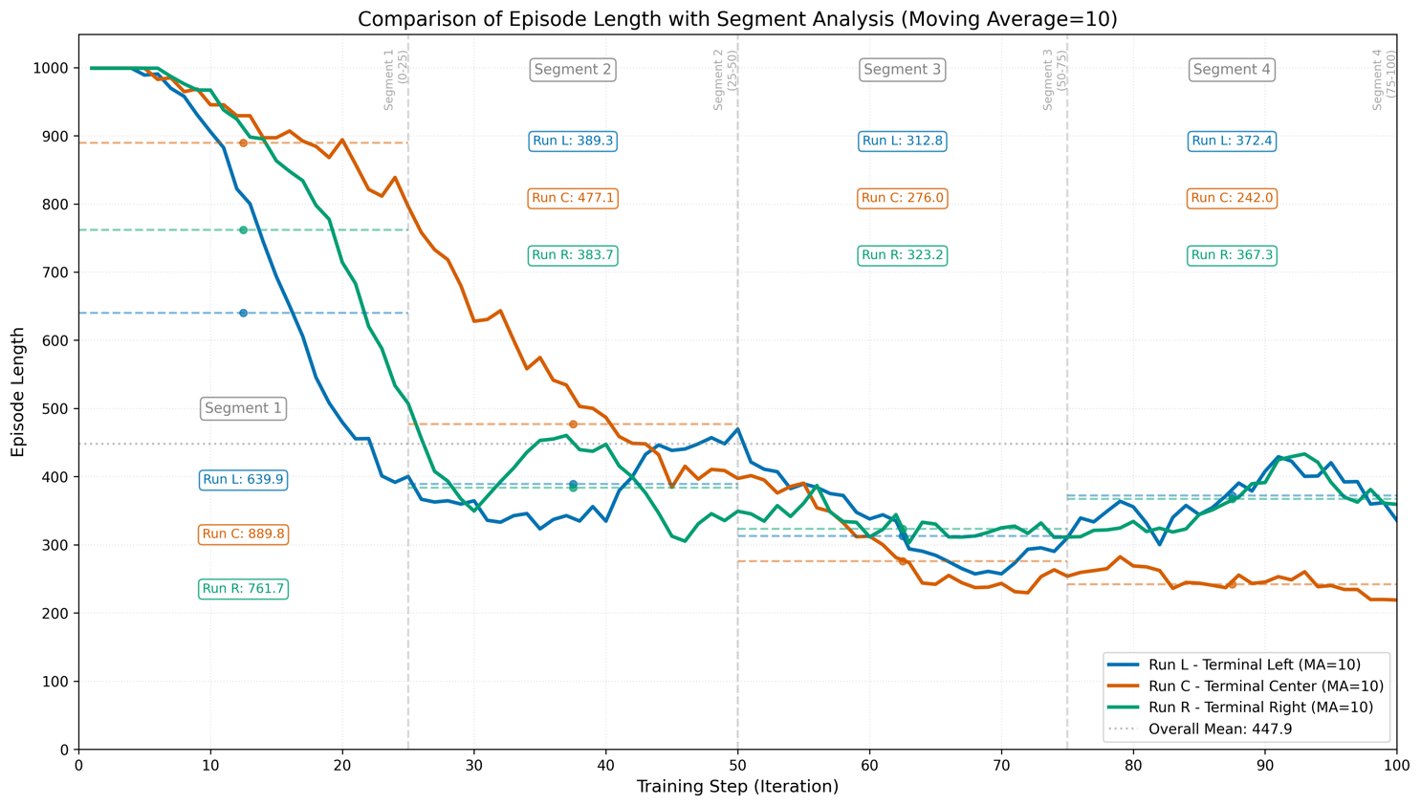
Then, with the same environment configurations (Table 2), each run was trained using the described setup. Figure 2 shows the resulting graphs regarding mean episode length and in-depth segment metrics of all three runs combined.
Figure 2: Resulting comparison of episode length of three runs using tensorboard, each trained for 100 iterations total using the configurations mentioned in 3.1.
The following discusses the results of “Run C” to further analyze the learned progress and visualize in-depth metrics. To visualize what has been learned during training, the trajectories of the navigating agent could be traced using the test script (number of test episodes 200, checkpoint at iteration 100) and thus better assessed (Figure 3).
The subsequent visualization of the tracked door positions throughout the training yielded insights into the extent to which the door agent was able to converge toward optimal door positions in the later episodes (Figure 4).
Figure 5 shows the navigator agent's mean return and the door agent's mean return.

5.1 Results
The results of all three runs demonstrate successful cooperation between the navigating agent and the door controller agent in the escape room environment with three rooms connected by doors to a hallway. The agents learned coordinated behaviors, and the door controller optimized door positions to facilitate efficient navigation based on speed to the terminal state.
Figure 2 shows the reductions in episode length observed across all three terminal locations (left, center, and right). “Run C” showed the most significant improvement, reducing from initial mean episode lengths of ~890 steps to ~242 steps (73% reduction). “Run L” improved from ~640 steps to ~372 steps (42% reduction), while “Run R” decreased from ~762 steps to ~367 steps (52% reduction).
The training results demonstrate clear segmented learning phases, beginning with a steep reduction during initial exploration, followed by gradual stabilization, achievement of consistent performance, and finally, sustained optimal behavior. Overall, the center terminal placement (“Run C”) achieved the lowest final episode length.
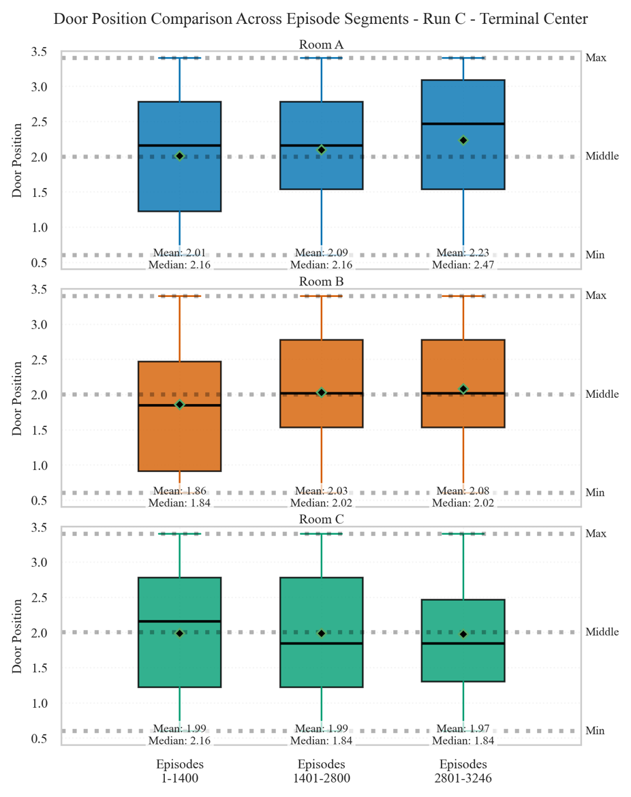
Figure 3 reveals systematic door positioning patterns that the door controller agent developed across the three distinct rooms throughout the training of “Run C.” It facilitates direct comparison: rows correspond to Rooms A, B, and C, while columns represent sequential training segments (Episodes 1-1400, 1401-2800, 2801-3246). The y-axis (0.5-3.5) captures the full range of possible door positions, with reference lines at possible minimum (0.6), middle (2.0), and maximum (3.4) values. This standardized scale enables direct room-to-room comparison of positioning strategies. Each box plot consists of a) interquartile range (IQR) boxes showing the middle 50% of positions, b) median lines indicating the central tendency (50th percentile), c) mean markers (green diamonds) showing the average position, and d) whiskers extending to minimum and maximum non-outlier values.
Room A exhibits consistently higher positioning (overall median: 2.16, mean: 2.08), with distributions favoring the upper-middle range. The IQR (approximately 1.5-2.8) demonstrates moderate variability, with mean values showing subtle progression (2.01→2.09→2.23) before stabilizing.
Room B shows lower overall positioning (median: 1.84, mean: 1.96) with temporary elevation during middle segments (mean: 2.03→2.08). The wider IQR in initial episodes (0.9-2.5) contracts in later segments, suggesting a refined positioning strategy.
Room C demonstrates consistency in mean values (1.99→1.99→1.97→1.99) despite shifting median values (2.16→1.84→1.84→1.84), indicating a balanced distribution that became increasingly skewed toward lower positions.
Figure 3: Comparison of door positions across different episode segments for "Run C", which trained with the terminal state in the spatial center of the environment at [6.2, 4.2] (see also Figure 1).
Room A, therefore, shows slightly higher positioning compared to Rooms B and C. Notably, with the terminal state being in the spatial center of the environment, the door positions of Rooms A and C moved towards that spatial center, with increasing door positions for Room A and decreasing door positions for Room C (in relation to the door ranges).
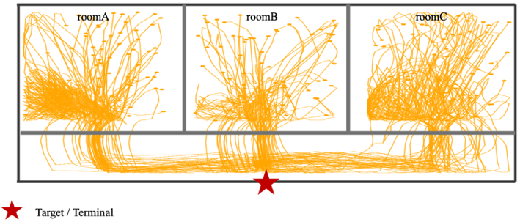
Figure 4 displays the episodes’ mean return of both agents. Both agents showed continuous improvement in returns throughout training. The door controller agent ultimately achieved higher returns (mean: 2919.6) than the navigator agent (mean: 2543.0). This difference is expected given the door controller's mostly rewarding components with no penalties applied. The similar shape of both graphs suggests that the sigmoid-shaped terminal reward has the most influence, possibly overshadowing other reward components. Both agents experienced rapid improvement during early training, with returns stabilizing after iteration 60. In summary, the pattern suggests that successful cooperative behavior emerged where the door controller effectively supported the navigator.
Figure 4: Resulting trajectories from the navigating agent of the trained “Run C” model using the center terminal (200 test episodes, checkpoint at iteration 100).

Figure 5 visualizes the navigating agents’ paths using the trained model of the run where the terminal state was placed in the center, spatially. The final trained model saved has been evaluated using the test script. The evaluation run took 200 episodes in which both agents acted as trained using the final trained model (after 100 training iterations). The results shown demonstrate that agents learned to navigate efficiently from all three rooms. Path density is appropriately concentrated near those door positions, as found in Figure 3, which confirms the progress made by the trained model. The successful convergence to the center terminal state from random starting positions, in the absence of random wandering behavior, indicates strong policy learning.

5.2 Discussion
Our goals of learning the fastest possible escape paths (reducing the mean episode length) in dynamic environments controlled by the door agent and its actions, and learning the door agent's cooperative placement of doors to support the escape paths of the navigating agent can be considered achieved.
Figure 2 shows that the length of the episodes was reduced, allowing the navigating agent to adapt quickly to the dynamic environments, as the door locations were always changing.
In Figure 3, we can see from the rightmost plot (results using door positions from episodes 2801 - 3246) that the door agent prefers a centered door position in room B. For both outer rooms A and C, doors are positioned closer to room B, and thus, the terminal used, which is located at [6.2, 4.2] for the “Run C” used for this figure. Nevertheless, it can be said that the differences between all the rooms and the training appear marginal. This may be due to the chosen room dimensions of the environment. The selected number of door options (according to Table 2) was 10, and the width of the doors chosen was 1m in each case. This evenly distributed over an interval between [0.6, 3.4] allowed the door operator to place a door at 10 different positions within a length of 2.8m. It can be assumed that these very subtle nuances are not noticeably considered by the door agent in the decisions, or that the navigating agent prefers to converge quickly using the same door positions and is therefore somewhat quickly biased when training the door agent's observations based on the successful episodes that the navigator has undertaken.
The influence of the reward structure for the door agent can also be attributed to the small dimensions ([0,0] to [12.4, 4.2]) of the environment. The door agent is rewarded at the beginning of each episode based on the agent's starting position for the placed door. The more direct the path created for the navigator by placing the door toward the spatial exit, the greater the reward the door agent receives. However, because the dimensions are so small, these door agent-specific rewards may not vary enough for the agent to have an apparent effect. The biggest differences, even for the door agent, only arise from the sigmoid function used for both agents, which identifies successful episodes as very rewarding for both the navigator and the door agent. Further research is needed to determine whether more complex or larger environmental dimensions can noticeably increase the influence of path quality rewards for the door agent or whether the reward structure itself requires further scaling.

6. OVERALL DISCUSSION
This paper examines the results of a prototypical modeling of a multi-agent reinforcement learning (MARL) system in a dynamic environment,
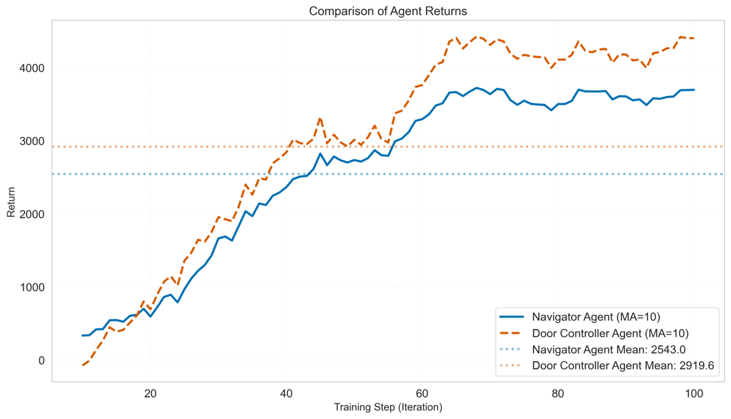
Figure 5: Resulting mean episode return for the navigating and door agent. Raw data extracted using tensorboard.
demonstrating successful cooperation between the navigator and door controller agents. The system was evaluated using a 3-room layout with a hallway connecting all rooms and with different exit locations (left, center, and right). Through 100 training iterations, the door controller and navigator agents developed complementary policies, with the door controller learning to position doors to facilitate the navigator's escape. This form of coordination emerged without explicit communication between agents, highlighting the effectiveness of our reward structures in promoting cooperation.
The training methodology employed in this study, using PPO, proved effective for learning in this prototypical MARL setting. The episode length curves (in Figure 2) show rapid initial improvement followed by stable optimization, indicating effective exploration-exploitation balance. The consistent convergence across different exit location configurations demonstrates signs of robustness of our approach. However, given the environment's limited size, a more uniform approximation of the training results should be expected. In future research, a more detailed investigation of the interplay between the number of door positions, large-sized rooms, or entire floor plans, the spatial observation, and the reward structure of the agents must be conducted and discussed to provide new insights and prove the robustness further.
Instead of consistently placing doors at extreme positions or defaulting to the middle, the agent learned positioning strategies that differed slightly across rooms. This suggests the door controller developed an understanding of spatial relationships within the environment and how door placement affects navigation efficiency. The slight difference in the range of door positions in Rooms A and C at the

end of training compared to Room B indicates that the agent recognized room-specific optimal positions rather than applying a universal approach.
Despite the results, several limitations in our current approach should be acknowledged: a) the current implementation uses a predetermined room layout with fixed dimensions, limiting the generalizability of our findings to more complex architectural spaces; b) the current environment model does not incorporate dynamic obstacles, multiple agents navigating simultaneously, or time-varying elements like spreading fire, which would be present in realistic emergency evacuation scenarios; c) each training run used a fixed exit location, whereas real-world scenarios might involve multiple possible exits with varying accessibility depending on emergency conditions; d) the AEC training architecture, required computational resources, particularly for longer training runs, that could be shortened by using a parallel environment implementation. More efficient sampling and update mechanisms could further improve training speed.
Extending the shown approach to use graph-based representations of spaces and especially layers of components would enable the application to handle more complex and realistic building layouts, supporting scalability to larger environments and making it an interesting future research area. Also, incorporating realistic human movement patterns, visibility constraints, and crowd dynamics would enhance the practical applicability of the learned policies. Adding fire spread models or their dynamics would create time-sensitive escape requirements and potentially blocked pathways, creating more complex decision-making scenarios for both agents.
Exploring transfer learning across different environments and how policies learned using one or the other floor plan layout might transfer to new, unseen designs, enhancing the approach's utility for applications. This, in turn, and mentioned, might require an improved reward mechanism, developing reward structures that could better address the challenges of sparse rewards and local optima.

7. CONCLUSION
This research investigated two key questions: whether multi-agent reinforcement learning can derive more sensible escape paths compared to single-agent settings and whether trained agents can make design decisions on building components that optimize escape path trajectories.
The implemented multi-agent reinforcement learning environment features two agents: a navigating agent tasked with finding efficient escape paths and a door controller agent that dynamically adjusts door positions between rooms. This created a dynamic environment where optimal paths continuously evolved based on the door controller's decisions and the navigator's learning processes.
The experimental findings demonstrate that these agents developed cooperative behaviors without explicit communication mechanisms. The prototypical MARL environment system was evaluated using a three-room floor plan layout and a hallway connecting all rooms and containing terminal states at different locations. The door controller learned to optimize door positions across three different rooms, with each room developing slightly different optimal configurations. This cooperation led to improvements in escape efficiency, with episode lengths decreasing from initial averages of 639-889 steps to final averages of 242-372 steps across different terminal configurations.
The reward profiles show that both agents learned complementary policies. The door controller achieved higher mean rewards (2919.6) compared to the navigator (2543.0), reflecting that the sigmoid-shaped terminal reward influence, possibly overshadowing other reward components. However, the MARL structure developed emergent door placement strategies, revealing the environment's ability to foster spatial optimization learning that differs across rooms.
This work demonstrates a promising approach to optimizing building layouts to facilitate efficient path trajectories by addressing the gap in dynamic environment manipulation within a reinforcement learning framework. The findings establish a basis for subsequent research on more complex and realistic evacuation scenarios, potentially enhancing building design and emergency response planning.

REFERENCES
Bauministerkonferenz, I.-A., 2002. Musterbauordnung - MBO (Fassung November 2002), zuletzt geändert durch Beschluss der BMK vom 23./24.11.2023.
Chevalier-Boisvert, M., Dai, B., Towers, M., de Lazcano, R., Willems, L., Lahlou, S., Pal, S., Castro, P.S., Terry, J., 2023. Minigrid & Miniworld: Modular & Customizable Reinforcement Learning Environments for Goal-Oriented Tasks.
Fitkau, I., 2024. Integrating Dynamic Environment Modelling With Reinforcement Learning for Fire Safety Design, in: Tagungsband des 35. Forum Bauinformatik 2024. Presented at the 35. Forum Bauinformatik 2024, Hamburg, Germany, pp. 82–89. https://doi.org/10.15480/882.13486
Fitkau, I., Hartmann, T., 2024. Applying Reinforcement Learning for Design Decisions on Fire Safety Requirements in a Fire Evacuation Environment, in: Proceedings of the 31st International Workshop on Intelligent Computing in Engineering. Presented at the 31st International Workshop on Intelligent Computing in Engineering, Vigo, Spain, pp. 433–442.
Huang, Z., Liang, R., Xiao, Y., Fang, Z., Li, X., Ye, R., 2023. Simulation of pedestrian evacuation with reinforcement learning based on a dynamic scanning algorithm. Physica A: Statistical Mechanics and its Applications 625, 129011. https://doi.org/10.1016/j.physa.2023.129011
Leitfaden Ingenieurmethoden des Brandschutzes (Technischer Bericht vfdb TB 04-01 No. 4., überarbeitete und ergänzte Auflage März 2020), 2020.
Liang, E., Liaw, R., Nishihara, R., Moritz, P., Fox, R., Goldberg, K., Gonzalez, J.E., Jordan, M.I., Ion Stoica, 2018. RLlib: Abstractions for Distributed Reinforcement Learning, in: International Conference on Machine Learning (ICML).
Liu, R., Wu, W., Becerik-Gerber, B., Lucas, G.M., 2024. Enhancing Building Safety Design for Active Shooter Incidents: Exploration of Building Exit Parameters using Reinforcement Learning-Based Simulations, in: Proceedings of the 31st EG-ICE International Workshop. Presented at the International Workshop on Intelling Computing in Engineering, Vigo, Spain.
Martín Abadi, Ashish Agarwal, Paul Barham, Eugene Brevdo, Zhifeng Chen, Craig Citro, Greg S. Corrado, Andy Davis, Jeffrey Dean, Matthieu Devin, Sanjay Ghemawat, Ian Goodfellow, Andrew Harp, Geoffrey Irving, Michael Isard, Jia, Y., Rafal Jozefowicz, Lukasz Kaiser, Manjunath Kudlur, Josh Levenberg, Dandelion Mané, Rajat Monga, Sherry Moore, Derek Murray, Chris Olah, Mike Schuster, Jonathon Shlens, Benoit Steiner, Ilya Sutskever, Kunal Talwar, Paul Tucker, Vincent Vanhoucke, Vijay Vasudevan, Fernanda Viégas, Oriol Vinyals, Pete Warden, Martin Wattenberg, Martin Wicke, Yuan Yu, Xiaoqiang Zheng, 2015. TensorFlow: Large-Scale Machine Learning on Heterogeneous Systems.
Schulman, J., Wolski, F., Dhariwal, P., Radford, A., Klimov, O., 2017. Proximal Policy Optimization Algorithms. https://doi.org/10.48550/ARXIV.1707.06347
Sharma, J., Andersen, P.-A., Granmo, O.-C., Goodwin, M., 2021. Deep Q-Learning With Q-Matrix Transfer Learning for Novel Fire Evacuation Environment. IEEE Trans. Syst. Man Cybern, Syst. 51, 7363–7381. https://doi.org/10.1109/TSMC.2020.2967936
Sinpan, N., Sasithong, P., Chaudhary, S., Poomrittigul, S., Leelawat, N., Wuttisittikulkij, L., 2022. Simulative Investigations of Crowd Evacuation by Incorporating Reinforcement Learning Scheme, in: Proceedings of the 6th International Conference on Algorithms, Computing and Systems. Presented at the ICACS 2022: 2022 The 6th International Conference on Algorithms, Computing and Systems, ACM, Larissa Greece, pp. 1–5. https://doi.org/10.1145/3564982.3564983
Sutton, R.S., Barto, A.G., 2018. Reinforcement learning: an introduction, Second edition. ed, Adaptive computation and machine learning series. The MIT Press, Cambridge, Massachusetts.
Terry, J., Black, B., Grammel, N., Jayakumar, M., Hari, A., Sullivan, R., Santos, L.S., Dieffendahl, C., Horsch, C., Perez-Vicente, R., others, 2021. Pettingzoo: Gym for multi-agent reinforcement learning. Advances in Neural Information Processing Systems 34, 15032–15043.
Wongsai, P., Pawgasame, W., 2018. A Reinforcement Learning for Criminal’s Escape Path Prediction, in: 2018 5th Asian Conference on Defense Technology (ACDT). Presented at the 2018 5th Asian Conference on Defense Technology (ACDT), IEEE, Hanoi, pp. 26–30. https://doi.org/10.1109/ACDT.2018.8593191
Zhang, D., Li, W., Gong, J., Zhang, G., Liu, J., Huang, L., Liu, H., Ma, H., 2023. Deep reinforcement learning and 3D physical environments applied to crowd evacuation in congested scenarios. International Journal of Digital Earth 16, 691–714. https://doi.org/10.1080/17538947.2023.2182376
Zhang, Y., Chai, Z., Lykotrafitis, G., 2021. Deep reinforcement learning with a particle dynamics environment applied to emergency evacuation of a room with obstacles. Physica A: Statistical Mechanics and its Applications 571, 125845. https://doi.org/10.1016/j.physa.2021.125845

