Shared Biophilic Spaces as Social Conduits: A Conceptual Pathway to Urban Livability and Well-Being
Ar. Sushmita Singh Parmar¹, ² Dr Kshetrimayum Bangkim Singh²

1, Department of Architecture, School of Planning and Architecture, New Delhi, India
2 Department of Architecture, Faculty of Architecture, School of Planning and Architecture, New Delhi, India
1 E-mail: sushmita.arch.phd@spa.ac.in , 2 E-mail: bangkim.singh@spa.ac.in
ABSTRACT
Urbanization has accentuated the human-nature disconnection in high density urban areas, particularly in the context of hot dry areas, where easily accessible shared green space is lacking. Biophilic design, which is connected to the restoration process, has been associated with positive outcomes but the means through which shared biophilic designs might facilitate social connectivity and improve urban life have not yet been adequately described. This paper will develop an operationalizable conceptual framework that explains the way shared biophilic designs operate as social facilitators within high density residential areas. The integration of conceptual synthesis framework that uses biophilic design, environmental psychology, social cohesion, and urban green space literature is used to develop the concept. Existing biophilic patterns are matched against social functions and matched with spatial, behavioral, social, psychological, and environmental measures. The framework is tuned towards a hot dry high density environment, using Delhi as the contextual framework. Evidence is strongest for individual restorative effects and for associations between greener common spaces, shared-space use, and social contact. Evidence for the complete pathway from biophilic intervention through social cohesion to urban livability remains more limited, particularly in hot-dry residential contexts. The paper contributes an evidence-strength map, a social conduit model, and an operationalisation matrix for future empirical testing. It also proposes a practical workflow that integrates BIM-based design specification, VR pre-occupancy assessment, post-occupancy evaluation, and Digital Twin-supported adaptive management. The framework provides a basis for evidence-led, human-centred residential design and future comparative case-study research in rapidly urbanising cities.
Keywords: Biophilic design; shared spaces; social cohesion; urban livability; well-being; high-density housing; digital twins; post-occupancy evaluation
- INTRODUCTION
Rapid urbanisation has reduced routine contact with vegetation, water, daylight, and natural processes in residential environments. Contact with nature may influence health through interacting pathways that include stress reduction, physical activity, air quality, and social cohesion (Kuo, 2015). In dense urban settings, limited access to shared nature-rich spaces can therefore affect both individual restoration and the social conditions underpinning neighbourhood well-being. This challenge is especially relevant to hot-dry metropolitan contexts such as Delhi, where heat exposure, compact residential development, uneven green-infrastructure provision, and limited communal open space constrain access to restorative outdoor environments. Green roofs and green walls have been proposed as nature-based strategies to mitigate heat stress in New Delhi (Chaudhary, 2024). Their value, however, should not be assessed only through temperature reduction, energy performance, or visual amenity.
Shared biophilic spaces, including community gardens, green atria, shaded courtyards, planted walkways, rooftop gardens, and biophilic streets, can provide settings for casual encounter, collective activity, mutual support, and environmental stewardship. Research on greener common areas in residential settings has associated vegetation with more frequent shared-space use, greater social activity, stronger neighbourly ties, and a greater sense of belonging (Kuo et al., 1998).
Existing biophilic-design research has primarily examined individual restoration, comfort, productivity, and health. The social mechanism connecting shared biophilic environments to trust, belonging, social capital, and urban livability requires clearer conceptualisation and empirical testing. This paper addresses that gap by developing an operationalisable framework for shared biophilic spaces as social conduits in high-density residential environments. The paper has four objectives: first, to identify biophilic design patterns with potential social functions; second, to explain the proposed pathway from design intervention to social contact, collective identity, well-being, and livability; third, to clarify variation in evidence strength across this pathway; and fourth, to specify measurable indicators and digital workflows for future empirical validation.
Table 1: Summary of Biophilic Design Patterns and Their Social Function
Design Pattern | Category | Shared Space Application | Proposed Social Function
Visual Connection with Nature | Nature in the Space | Shared gardens, green courtyards | Provides a common focal point for casual interaction
Presence of Water | Nature in the Space | Fountain atria, rain gardens | Creates gathering nodes and sensory common ground
Thermal and Airflow Variability | Nature in the Space | Ventilated green corridors | Extends the duration of outdoor social activity
Prospect and Refuge | Nature of the Space | Semi-enclosed biophilic seating | Balances privacy and social visibility
Complexity and Order | Natural Analogues | Patterned planting, fractal geometry | Stimulates shared aesthetic appreciation
Non-Rhythmic Sensory Stimuli | Nature in the Space | Seasonal vegetation, bird habitats | Provides shared temporal markers for the community
Connection with Natural Systems | Nature in the Space | Edible gardens, composting zones | Facilitates cooperative activity and shared purpose
Note. Author’s synthesis based on Browning et al. (2014), Kuo et al. (1998), and Jennings and Bamkole (2019).
Source: Adapted from Browning, Ryan, and Clancy (2014).
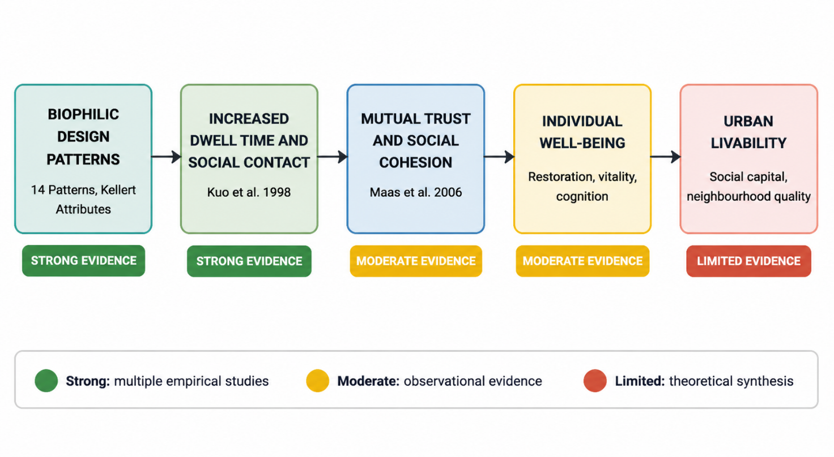
Figure 1: Evidence Strength Map Across the Proposed Conceptual Pathway
The diagram traces the five stages of the proposed pathway, from biophilic design patterns through social contact, social cohesion, individual well-being, and urban livability, indicating the strength of empirical support at each stage. Green denotes strong evidence supported by multiple independent empirical studies (e.g., Kuo et al., 1998, for the link between vegetation and social contact). Amber denotes moderate evidence supported by observational studies or theoretical synthesis (e.g., Maas et al., 2006, for social cohesion as a mediator of green space and mental health). Red denotes limited evidence supported primarily by theoretical reasoning or single-context findings, indicating where further empirical testing is required. Source: Author's synthesis based on the evidence grading criteria detailed in Table 2.
2. Literature Review
2.1 Biophilic Design and Human Well-Being
Biophilia is defined as an inherent tendency in humans to relate and connect with natural systems and living things (Wilson, 1984). Biophilia for the built environment was defined by Kellert et al. (2008), and Browning et al. (2014) categorized biophilic experience into three groups, namely Nature in the Space, Natural Analogues, and Nature of the Space.The presence of nature in the environment is associated with experiences of relaxation, restoration of cognitive resources, mood improvement, and a decrease in stress indicators such as increased heart rate and higher skin conductance (Kuo, 2015). The mentioned effects may be realized within an urban environment through the implementation of parks, gardens, green courtyards, and shared landscape residential areas.
According to Xing et al. (2024), the efficacy of biophilic design ought to be evaluated not just through passive biophilia but also through the biophilic behavior which it encourages. The identified framework identifies opportunity, motivation, and capacity as factors that contribute to consistent nature interaction. Shared residential spaces may provide the necessary opportunities through gardening, walking, sitting, playing, maintaining and socializing.
2.2 Green Space, Social Cohesion, and Health
Social cohesion entails trust among people, belongingness, support, identity, and collective efficacy. Urban green spaces are able to foster social cohesion by providing venues for leisure, gatherings, exercise, cultural activities, and caring for the environment (Jennings & Bamkole, 2019).
Residents living close to greener public spaces have more social activities, visit them frequently, are familiar with their neighbors, receive better neighborhood support, and have a feeling of belonging, Kuo et al. (1998) noted. Nature–health mechanisms literature shows that the use of public spaces could help mediate the relation between vegetation and informal social interaction.The health effects of greenery could be partially transferred socially. De Vries et al. (2013) revealed that stress and social cohesion could act as mediators of the effect of streetscape greenery on mental and general health in the Netherlands. These results do not confirm the causal relation but show that social and environmental mechanisms need to be studied simultaneously in biophilic residential designs.The effectiveness of green spaces depends on their quality, accessibility, safety, comfort conditions, presence of amenities, and organized or informal activities in them. Open designs, walkways, shading, and community programs could facilitate the social function of green spaces (Jennings & Bamkole, 2019).
2.3 Evidence Strength and Research Gap
Empirical support for the social conduit theory is varied. There are many pieces of literature that provide information on the impact of nature on rest and healing, as well as on the relationship between greener public spaces, shared space use, and social interactions. Social cohesiveness studies are mostly observational and contextual instead of being experimental.In a virtual reality study, researchers found that biophilic designs provided higher recovery from physiological stress and psychological relief from anxiety in comparison to non-biophilic designs (Yin et al., 2020). However, the full causality process from shared biophilic design to dwell time, trust, collective identity, individual well-being, and urban livability has not been examined.
That is particularly the case for high-density hot-dry urban environments where variables like heat stress, maintenance issues, gender barriers for public space use, cultural norms, security, and population density may significantly affect shared biophilic space usage and its role in promoting social cohesion.
Table 2: Mapping Biophilic Design Patterns to Social Mechanisms and Outcomes
Evidence-Grading Criteria:
Rating | Criteria
Strong | Multiple independent empirical studies, including at least one controlled or quasi-experimental design, with consistent findings
Moderate | At least one empirical study (observational or cross-sectional), corroborated by theoretical synthesis or single-context case studies
Limited | Primarily theoretical reasoning or single-study findings; no direct empirical test of the specific pattern-social function link

Design Pattern | Social Mechanism | Evidence Rating | Basis for Rating | Outcome
Visual Connection with Nature | Common focal point; reduced visual barriers | Strong | Kuo et al. (1998): vegetation predicted social ties; Coley et al. (1997): nature attracted larger groups | Increased casual social contact
Presence of Water | Gathering nodes; sensory common ground | Moderate | Browning et al. (2014): theoretical synthesis; limited direct empirical tests in shared residential settings | Enhanced social bonding
Prospect and Refuge | Balances privacy and visibility; extends stay | Moderate | Ulrich (1984): restorative environment theory; Browning et al. (2014): theoretical synthesis | Greater sense of safety and belonging
Non-Rhythmic Sensory Stimuli | Shared temporal markers; conversation starters | Limited | Browning et al. (2014): theoretical framework; no direct empirical tests of social function | Shared aesthetic appreciation
Connection with Natural Systems | Cooperative activities (e.g., gardening) | Strong | Longitudinal studies on community gardens (Jennings & Bamkole, 2019); Kuo et al. (1998) | Collective identity formation
Complexity and Order | Shared aesthetic appreciation | Limited | Browning et al. (2014): theoretical framework; limited empirical validation | Enhanced place attachment
Thermal and Airflow Variability | Extended outdoor social activity | Moderate | Environmental comfort studies; Chaudhary (2024): heat mitigation in Delhi | Increased social engagement
Note. Author’s synthesis based on Browning et al. (2014), Kuo et al. (1998), de Vries et al. (2013), Jennings and Bamkole (2019), and Chaudhary (2024).
Source: Synthesised from Browning et al. (2014), Jennings and Bamkole (2019), Kuo et al. (1998), and Sugiyama et al. (2008).
- Methodology
  - Research Design
In this study, the method of conceptual synthesis has been used in developing the theoretical as well as operational framework. Conceptual synthesis is employed when the research problem spans several disciplines and requires the development of a framework through theories and constructs integration rather than combining similar results using systematic review (Torraco, 2005). This synthesis integrates four dimensions: biophilic design theory, environmental psychology, social cohesion and social capital, and digital methods for designing and evaluating buildings.
3.2 Framework Development Process
The framework was developed in three stages.
- Step 1: Discovery. A literature review concerning biophilic design, restoration, pathways between nature and health, social processes, and shared urban green space is undertaken to define constructs and evidence related to the concept.
- Step 2: Integration. Biophilic designs are linked to possible social uses of spaces, such as common focus, feeling of safety, time spent, sharing activities, and management of these spaces. These uses, in turn, are connected to underlying social processes, such as opportunities, interaction, trust, membership, and collective identity.
- Step 3: Calibration. The framework was tailored for high-density hot-dry areas. This step defines moderating variables that might strengthen or limit the suggested relationship, namely thermal comfort, maintenance, accessibility, population density, safety, culture, and equitable access.

Table 3: Synthesis Layers and Theoretical Components
Synthesis Layer | Theoretical Foundation | Key Variables | Source Examples
Architectural | Biophilic Design Frameworks | 14 Patterns, Kellert's Attributes | Browning et al. (2014); Kellert (2008)
Social | Cohesion and Capital Models | Trust, Belonging, Interaction Frequency | Jennings & Bamkole (2019); Putnam (2000)
Psychological | Behavioural Change and Restoration Theory | COM-B Model, Attention Restoration Theory | Xing et al. (2024); Kaplan (1995)
Contextual | Urban Ecology and Climate Mitigation | Heat stress, Density, Maintenance | Chaudhary (2024); Maas et al. (2006)

Operationalisation and Validation Strategy

The model is built in such a way that it will be empirically tested in the future. Abstract concepts are operationalized in concrete spatial, behavioral, social, psychological, and environmental variables.Common biophilic design interventions can be measured through factors like vegetation coverage, visibility of nature, provision of shade, presence of seats, provision of water elements, thermal comfort, accessibility, and maintenance quality. The social conduit process may be measured through variables like number of visitors, length of stay, co-presence, frequency of interactions, engagement in communal activities, feelings of safety, trust, belonging, collective efficacy, and place attachment. Well-being outcomes can include perceptions of restoration, perceptions of stress, vitality, life satisfaction, and physiological variables such as heart-rate variability and skin conductance, where ethical considerations permit.
Table 4-Operationalisation and Validation Matrix
Framework Component | Measurable Indicators | Suggested Method | Digital Support
Biophilic design inputs | Vegetation, natural views, shade, water, seating, thermal comfort, access | Design audit, BIM review, site observation, microclimate assessment | BIM, GIS, environmental simulation
Stimulated encounter | Visitor frequency, dwell time, co-presence, route choice | Behaviour mapping, structured observation, occupancy monitoring | Privacy-preserving occupancy sensors
Social interaction | Interaction frequency, shared activity, gardening participation | Observation, activity mapping, interviews | Mobile survey or digital diary
Social cohesion | Trust, belonging, collective efficacy, perceived safety, social support | Resident survey, focus group, interview | Survey dashboard
Individual well-being | Restoration, stress, vitality, life satisfaction | Pre- and post-occupancy survey and interview | Optional wearables under ethical approval
Contextual moderators | Density, maintenance, heat, safety, cultural norms | Site audit, management records, resident interviews | Digital Twin data integration
Urban livability | Neighbourhood satisfaction, place attachment, equitable access | Comparative case study and resident survey | GIS and dashboard monitoring
Note. Author’s framework.
- The Biophilic Social Conduit Framework
In the proposed framework, biophilic spaces are viewed as socially active infrastructures. The framework is not premised on the assumption that all forms of vegetation or green facilities contribute to social cohesion but rather that biophilic spaces that are easily accessible, secure, and comfortable facilitate good social interaction.
  - Architectural Inputs
Interventions that are relevant include shaded courtyards, terraces, green atriums, roof gardens, plant-filled corridors, water elements, vertical gardens, and community gardens. The green roofs and walls may aid in the creation of a microclimate through heat reduction and thermal improvement of the surrounding environment (Chaudhary, 2024). At a neighborhood level, green streets, gardens, urban trees, urban agriculture, water channels, and permeable surfaces provide shade and cooling as well as communal spaces (Lee & Kim, 2021).
  - Social Activation Process
Social Conduit Theory involves three sequential steps.
Step 1: Stimulated Encounter. Features that characterize biophilia are likely to make environments more attractive and comfortable thermally and may result in extended stay as well as more chances of meeting each other and interacting in a relaxed way, for instance, greeting, chatting.
Step 2: Social Interactions and Activities. Regular co-presence may result in the development of more durable interactions through recreational and other activities, such as gardening, maintenance, play, physical exercises and other activities which will reduce social distance and increase reciprocity.
Step 3: Collective Identity and Place Attachment. Positive interaction and shared care of an environment are likely to lead to developing sense of belonging, collective identity, trust and place attachment. In this way, shared spaces will turn into communal places rather than residual ones.
This process will be influenced by such things as accessibility, quality of maintenance, thermal comfort, safety, cultural appropriateness and equal access. Otherwise, the space will not provide social outcomes described above.
  - Well-Being and Livability Outcomes
The model illustrates two interrelated outcomes paths. The first path is the environmental restoration path, where environmental attributes rich in nature may lead to reduced stress, cognitive restoration, positive affect, and perceived restoration (Kaplan, 1995; Ulrich, 1984). The other path is the social path, where trust, social support, sense of community, and collective efficacy can reduce feelings of isolation and enhance resilience. Livability in urban spaces emerges from the interactions of these paths, and it is measured using factors such as social capital, perceived quality of the neighborhood, thermal comfort, place attachment, and subjective well-being.
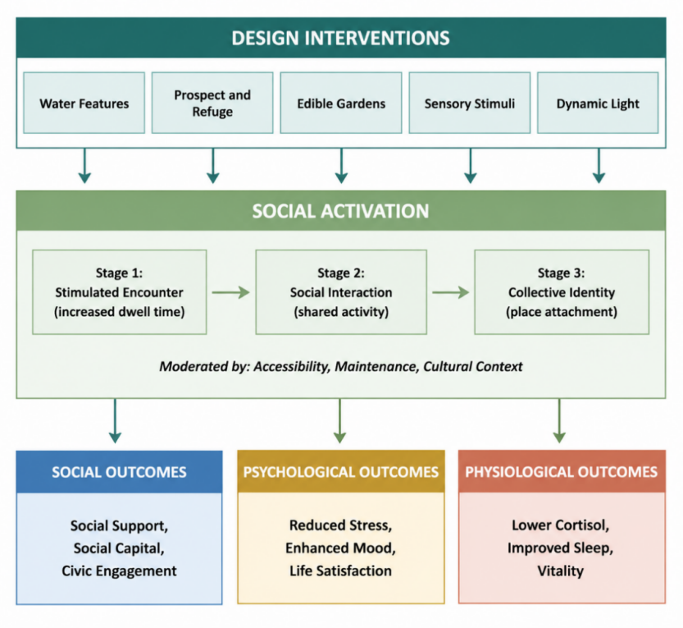
Figure 4: The Biophilic Social Conduit Model
The Biophilic Social Conduit Model The figure illustrates how shared biophilic design interventions activate a three-stage social process, from stimulated encounter to social interaction and collective identity, leading to social, psychological, and physiological outcomes. Accessibility, maintenance, and cultural context moderate the pathway.
- Digital Implementation and Evidence-Led Design
Digital technologies are proposed as tools for implementing and evaluating the framework, not as substitutes for real-world social evidence. Their role is to support design specification, pre-occupancy testing, post-occupancy evaluation, and adaptive management.
5.1 Design Phase: BIM-Based Specification
The initial design process will allow documenting within BIM the positioning, classification, and performance goals for the biophilic components that will be shared among the buildings. Relevant information could include information such as the plant species used, shade provided, seat capacity, natural viewing, accessibility, irrigation requirements, maintenance, and intended use for social purposes. Embedding this information in BIM makes the social and well-being intentions clear together with the structural, environmental, material, and performance intentions. Thus, the system treats the shared biophilic areas as performance features instead of optional landscaping elements.
5.2 Simulation Phase: VR and Agent-Based Modelling
VR may be used for pre-occupancy evaluation whereby the occupant, designer, and stakeholder can explore different spatial arrangements before construction. This involves the manipulation of layout, plant density, sunlight, view, seating, and enclosures while holding constant other variables in the environment (Di Giuseppe et al., 2024). Studies conducted using immersive virtual environments have shown that biophilic design elements have the potential to facilitate physiological recovery from stress. For instance, Al Sayyed and Al-Azhari (2025) found out that the skin conductance change was greater in biophilic residential environments compared to non-biophilic environments. In the present context, VR can be used to evaluate perceived safety, thermal acceptability, willingness to stay, and willingness to interact in different shared space scenarios. Agent-based modeling is recommended as another tool that can be used to investigate movement, visibility, co-presence, flow paths, and possible meeting points. However, this should be done to compare scenarios not to predict social capital before occupancy.
5.3 Operational Phase: Post-Occupancy Evaluation and Digital Twins
Post-occupancy evaluation is necessary for ascertaining whether the design intentions have been achieved through usage. Assessment methods for biophilic designs increasingly pay attention to the integration of environmental quality measures, user satisfaction, and post-occupancy evaluations.Post-occupancy evaluation methods include resident questionnaires, interviews, environmental measurements, systematic observation, and occupant-related data. The use of wearable technology can provide physiological data related to evaluation of biophilic designs, provided that the participation is voluntary and that data handling follows proper ethics and privacy practices.A digital twin will be able to integrate data related to environment, occupancy, maintenance, and resident feedback into a management system. This would facilitate adaptive management decisions concerning irrigation, plant health, shading, seating, accessibility, and community programming. The overall goal is adaptive management of common spaces, not resident monitoring.
Table 5-Digital Workflow for Framework Implementation
Project Stage | Objective | Suggested Tools | Expected Output
Design | Specify biophilic and social-performance requirements | BIM, GIS, climate simulation | Design specification and performance targets
Pre-occupancy evaluation | Compare alternative spatial and sensory configurations | VR, environmental simulation, proposed agent-based modelling | Preferred design scenario
Occupancy | Assess actual use, comfort, interaction, and well-being | Post-occupancy evaluation, surveys, observation, sensors | Evidence on framework performance
Adaptive management | Maintain long-term usability and environmental quality | Digital Twin dashboard, maintenance records, resident feedback | Responsive maintenance and management actions
Note. Author’s framework.
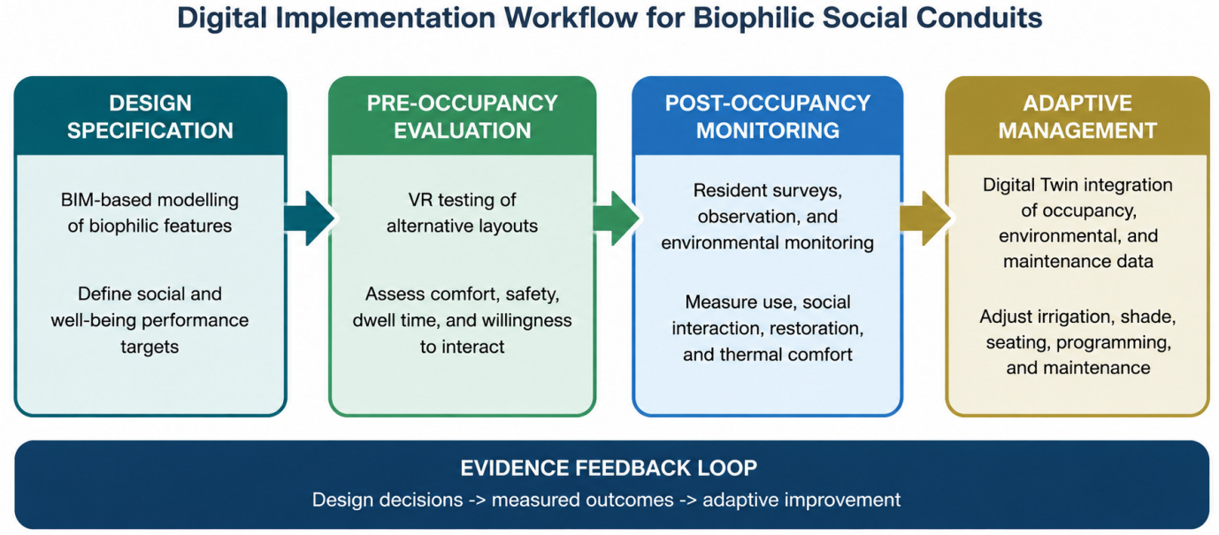
Figure 4: Digital Implementation Workflow for Biophilic Social Conduits
The figure presents a proposed workflow linking BIM-based design specification, VR-supported pre-occupancy evaluation, post-occupancy monitoring, and adaptive management through Digital Twin integration.
- Conclusion and Future Research
This paper presents shared biophilic spaces as social conduits within high-density residential environments. The proposed framework explains how accessible, comfortable, safe, and well-maintained biophilic interventions can support a progression from social encounter to shared activity, trust, belonging, collective identity, and well-being.
The paper contributes a pattern-to-function mapping, a three-stage social activation model, an evidence-strength map, and an operationalisation matrix for future empirical testing. These elements translate a broad conceptual proposition into an evaluable framework for design, simulation, post-occupancy assessment, and adaptive management.
As an integrative conceptual synthesis, the framework should be treated as a structured basis for evaluation rather than a universal causal model. Its operation is likely to vary according to heat exposure, density, maintenance quality, safety, cultural practices, gendered patterns of public-space use, and pre-existing social networks. These factors should be treated as moderators in future research and design practice.
Future work should test the framework through longitudinal post-occupancy studies and comparative residential case studies. Delhi-based pilot projects can examine how shared gardens, shaded courtyards, rooftop landscapes, and green circulation spaces influence social interaction, restoration, thermal comfort, and perceived livability. Mixed-method research should combine environmental monitoring, behavioural observation, resident surveys, interviews, and management data. VR, BIM, sensors, and Digital Twins can support this work when they are used as complementary tools within an ethical, resident-centred evaluation process.
Urban livability is not produced by physical infrastructure alone. It is co-created through everyday social relations that occur within accessible, comfortable, and meaningful shared environments. Shared biophilic design offers a practical route toward more climate-responsive, human-centred, and socially supportive residential development.
References
- Al Sayyed, H., & Al-Azhari, W. (2025). Investigating the role of biophilic design to enhance comfort in residential spaces: Human physiological response in immersive virtual environment. Frontiers in Virtual Reality, 6, 1411425. https://doi.org/10.3389/frvir.2025.1411425
- Browning, W. D., Ryan, C. O., & Clancy, J. O. (2014). 14 patterns of biophilic design: Improving health and well-being in the built environment. Terrapin Bright Green. Chaudhary, S. (2024).
- Green roofs and green walls as heat stress mitigation strategies for New Delhi, India [Master’s thesis, HafenCity University Hamburg].
- de Vries, S., van Dillen, S. M. E., Groenewegen, P. P., & Spreeuwenberg, P. (2013). Streetscape greenery and health: Stress, social cohesion and physical activity as mediators. Social Science & Medicine, 94, 26–33. https://doi.org/10.1016/j.socscimed.2013.06.030
- Di Giuseppe, E., Marcelli, L., Latini, A., & D’Orazio, M. (2024). Evaluating biophilic design strategies in immersive virtual indoor environments: A systematic review on the implications for building occupants. Journal of Building Engineering, 98, 111127. https://doi.org/10.1016/j.jobe.2024.111127
- Jennings, V., & Bamkole, O. (2019). The relationship between social cohesion and urban green space: An avenue for health promotion. International Journal of Environmental Research and Public Health, 16(3), 452. https://doi.org/10.3390/ijerph16030452
- Kaplan, S. (1995). The restorative benefits of nature: Toward an integrative framework. Journal of Environmental Psychology, 15(3), 169–182. https://doi.org/10.1016/0272-4944(95)90001-2
- Kellert, S. R., Heerwagen, J. H., & Mador, M. L. (Eds.). (2008). Biophilic design: The theory, science, and practice of bringing buildings to life. Wiley.
- Kuo, F. E. (2015). How might contact with nature promote human health? Promising mechanisms and a possible central pathway. Frontiers in Psychology, 6, Article 1093. https://doi.org/10.3389/fpsyg.2015.01093
- Kuo, F. E., Sullivan, W. C., Coley, R. L., & Brunson, L. (1998). Fertile ground for community: Inner-city neighborhood common spaces. American Journal of Community Psychology, 26(6), 823–851. https://doi.org/10.1023/A:1022294028903
- Lee, S., & Kim, Y. (2021). A framework of biophilic urbanism for improving climate change adaptability in urban environments. Urban Forestry & Urban Greening, 61, 127104. https://doi.org/10.1016/j.ufug.2021.127104
- Putnam, R. D. (2000). Bowling alone: The collapse and revival of American community. Simon & Schuster.
- Torraco, R. J. (2005). Writing integrative literature reviews: Using the past and present to explore the future. Human Resource Development Review, 4(3), 356–367. https://doi.org/10.1177/1534484305278285
- Ulrich, R. S. (1984). View through a window may influence recovery from surgery. Science, 224(4647), 420–421. https://doi.org/10.1126/science.6143402
- Wilson, E. O. (1984). Biophilia. Harvard University Press.
- Xing, Y., Williams, A., & Knight, A. (2024). Developing a biophilic behavioural change design framework: A scoping study. Urban Forestry & Urban Greening, 96, 128278. https://doi.org/10.1016/j.ufug.2024.128278

