Vision-based Scene Understanding: Preliminary Study on Concrete Placement Progress Monitoring

SEUNGMO LIM¹, JUNGHOON KIM¹, INSOO JEONG¹, YELIN RYU¹, and SEOKHO CHI¹

¹Department of Civil and Environmental Engineering, Seoul National University, South Korea

ABSTRACT:

Conventional construction progress monitoring relies on manual processes like on-site inspections and paper-based reporting, making it labor-intensive, time-consuming, and prone to human error. Recent advancements in vision technologies have enabled the automation of progress monitoring. This study proposes a 2D vision-based construction progress monitoring framework for monitoring concrete placement. The framework integrates instance inpainting to address occlusions caused by dynamic construction objects, and performs single image-based 3D reconstruction using monocular depth estimation for precise progress evaluation. Experimental results demonstrated strong alignment with ground truth, while also indicating the framework’s potential to distinguish between different work states over time. The proposed framework contributes to the widespread implementation of automated progress monitoring across diverse construction sites.

KEYWORDS:

Construction progress monitoring, Computer vision, Concrete placement, Surveillance video

1. INTRODUCTION
Construction progress monitoring plays a transformative role in minimizing schedule delays, cost overruns, and safety incidents. Despite its importance, conventional progress monitoring practices still depend on manual processes carried out by site managers or stakeholders, including on-site inspections and paper-based reporting. These methods are labor-intensive and time-consuming, often plagued by critical shortcomings such as low monitoring accuracy due to human error and significant challenges in collecting real-time data (Bosché et al., 2015; Golparvar-Fard et al., 2015; Pal et al., 2023). In particular, monitoring the concrete placement process is crucial due to its irreversible and time-sensitive nature (Moon & Yang, 2010; Pfitzner et al., 2025; Yang et al., 2023). Once poured, concrete rapidly undergoes setting and hardening, leaving little room for corrective action in the event of improper execution. Errors in timing, placement accuracy, or quality control during this process can lead to structural deficiencies, costly rework, or long-term durability issues. Therefore, there is a pressing need for automating progress monitoring, particularly in concrete placement processes.
In the academic realm, computer vision-based approaches have gained attention as cost-effective and efficient solutions for automated progress monitoring technologies. These approaches are broadly categorized into two-dimensional (2D) and three-dimensional (3D) methods. 2D vision-based methods rely on standard RGB cameras to capture and analyze visual data, using techniques such as object detection, image segmentation, and feature tracking to monitor progress over time. The researches in this field primarily focused on analysing the types and activities of dynamic objects, such as workers and dump trucks, to indirectly evaluate construction progress (Chen et al., 2023; J. Kim et al., 2018). 2D vision-based methods usually leverage surveillance videos, such as those captured by CCTV systems on construction sites, offering advantages in practicality and affordability. However, a significant challenge arises from occlusions between objects, which restrict the analysis of unseen scenes, thereby limiting their applicability in complex and dynamic construction sites. For more precise and intuitive progress monitoring, 3D vision-based methods have been developed, incorporating Building Information Modeling (BIM) and drones to generate 3D models of construction sites. These methods enable automated tracking of the placement and installation of structural elements such as columns and precast walls, offering enhanced spatial accuracy and comprehensive scene understanding (Braun et al., 2020; Wang et al., 2021; Wei et al., 2023).
Although 3D vision-based monitoring offers clear theoretical benefits, their practical adoption in the field remains limited. A major barrier is the reluctance of stakeholders to modify existing systems and workflows, especially given the complexity and variability of site-specific conditions (Ahn et al., 2023). Furthermore, generating accurate 3D models of construction sites typically requires specialized hardware such as LiDAR, laser scanners, and drones for data collection. Processing this data also demands significantly greater computational resources, making real-time analysis difficult, a notable drawback when dealing with time-sensitive operations like concrete placement, and often resulting in low cost-efficiency for on-site applications. Reflecting these challenges, only 24% of construction sites managed by South Korea’s 18 largest contractors have implemented 3D technologies (i.e., laser scanners, drones) during the construction phase (Dnews, 2022).
To bridge this gap, this study aims to propose a 2D vision-based automated construction progress monitoring framework using surveillance videos, which are commonly installed at construction sites for site monitoring purpose. By leveraging only a single-view camera, the proposed framework enables accurate and timely progress evaluation with minimal hardware requirements, offering a highly practical and scalable solution for real-world construction environments.

2. Literature Review
Vision-based approaches for automated construction progress monitoring have been broadly categorized into 2D and 3D methods, each offering distinct advantages and challenges.
Among them, 2D vision-based methods have gained attention to the affordability and accessibility of RGB cameras. Researchers have proposed various methods to leverage such data for progress tracking; however, most approaches still struggle with occlusion handling and generalizability under complex site conditions. For instance, Kim et al. (2013) proposed an image-processing method to update 4D CAD models, incorporating color-based filtering to detect component progress. Ying and Lee (2019) applied Mask R-CNN to extract as-is BIM components from site imagery, improving segmentation accuracy while eliminating the need for handcrafted features. While both methods enhanced automation, their scope was limited because they rely on predefined object characteristics or required extensive labelled data. These limitations become especially pronounced when handling occlusions or scaling across diverse construction scenes. Several researchers have attempted to address activity-level monitoring in more dynamic contexts. Wang et al. (2021) demonstrated that CCTV footage could be repurposed to monitor precast wall installations using object detection and tracking. Wei et al. (2022) applied Mask R-CNN to monitor plastering progress across interior walls, leveraging pixel-based percentage to quantify progress. Zhang et al. (2025) introduced a real-time concrete pouring tracking system using an enhanced U-Net architecture, focusing on robust segmentation under occlusion. Despite these advances, all three studies relied heavily on task-specific model training or auxiliary techniques (e.g., SLAM), limiting their scalability and field practicality. wNotably, none of these works fully resolved the challenge of automated occlusion handling in dynamic and cluttered scenes.
In parallel, 3D vision-based methods have offered precise spatial context and rich geometric information for evaluating progress. Han and Golparvar-Fard (2015) employed Structure-from-Motion (SfM) to generate point clouds aligned with BIM for material classification. While promising, their approach required manual alignment and was sensitive to occlusions. To overcome such limitations, Wei et al. (2023) proposed an enhanced instance segmentation framework
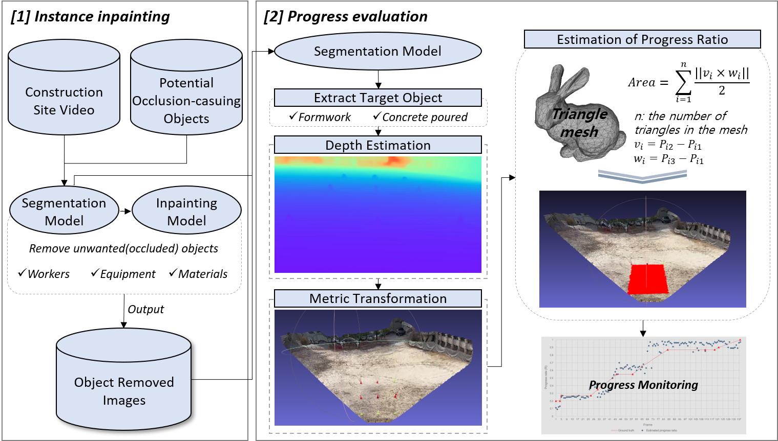
Figure 1. Research process

combining Segmenting Objects by LOcations v2(SOLOv2), Swin Transformer, and Neural Architecture Search-Feature Pyramid Network (NAS-FPN), specifically designed to address occlusion and object similarity issues. However, their method still relied on high-end computing resources and specialized sensing equipment, which hinders field deployment. Braun et al. (2020) attempted to integrate semantic BIM data with point cloud fusion and deep learning, improving detection accuracy in occluded environments. Jeon et al. (2025) introduced Neural Radiance Fields (NeRF) for highly realistic 3D scene reconstruction and progress evaluation, showcasing novel view generation. However, in both studies, data acquisition was performed at time points with minimal occlusion, avoiding rather than handling occlusions.
In summary, while both 2D and 3D approaches offer valuable insights, several critical challenges remain. Most notably, existing studies have yet to effectively automate occlusion handling in complex scenes, often relying instead on manual corrections or indirect inferences. Moreover, the dependence on costly 3D sensing equipment (e.g., LiDAR, laser scanners) continues to hinder the practical deployment of these methods in real-world construction environments.
To address these gaps, this study aims to:
- Utilize widely available surveillance videos to reduce reliance on specialized 3D sensing devices, offering a more scalable and cost-effective solution for progress monitoring;
- Integrate instance segmentation and image inpainting techniques to enable automated occlusion handling during visual data analysis.

3. Methodology
This study proposes a vision-based framework for automated progress monitoring of concrete placement using single-view surveillance videos. As illustrated in Figure 1, the proposed framework consists of two stages: (1) instance inpainting for occlusion handling and (2) progress evaluation. Each stage is described in detail below.

3.1 Instance Inpainting
In construction site environments, visual occlusion remains one of the most pervasive challenges in progress monitoring, particularly when utilizing 2D visual data. Dynamic objects such as workers, construction heavy equipment, or construction materials frequently obstruct the camera’s view of target structural elements, preventing accurate tracking of ongoing construction tasks. To address this issue, our framework incorporates an instance inpainting module that reconstructs visually occluded image regions before conducting progress evaluation. This module is composed of two main components: prompt-based object detection and segmentation, and instance inpainting.
Accurate inpainting first requires the precise identification and removal of occluding objects. However, bounding boxes from conventional object detection models are often inadequate for this task. In construction environments, occlusions are caused by objects with irregular geometries, such as slender or partially occluded objects (e.g., scaffolding poles, rebars, or hoses), which are not well represented by rectangular boxes because they may include unnecessary background or miss parts of the actual object, resulting in inaccurate masking. Therefore, a pixel-level segmentation of occluding objects is critical for effective inpainting.
To this end, our framework adopts Grounded SAM2, a vision-language foundation model capable of performing open-vocabulary object detection and segmentation simultaneously. Grounded SAM2 integrates Grounding DINO, which interprets natural language prompts to identify target objects, with the Segment Anything Model (SAM), which generates high-resolution segmentation masks. This model allows the system to detect and segment arbitrary objects specified via textual queries, such as “dump truck”, “formwork”, or “worker”, without predefined class labels or task-specific training. Its strong generalization performance in zero-shot settings, which makes it well suited for domains with limited training data, was another key reason for choosing this model. To ensure comprehensive detection of relevant objects, we reviewed Construction Standard Estimating System in South Korea (Ministry of Land, Infrastructure, and Transport, 2024) and defined a prompt list of target object classes and their synonymous terms for concrete placement process, as summarized in Table 1. A set of representative object classes was organized under two main categories: machinery and structural elements. For each object class, we compiled a list of synonymous terms, which are then used as prompts for object detection and segmentation. Although workers can be subdivided (e.g., concrete worker, surface finishing worker), the general term “worker” was used as a prompt because it led to more consistent and accurate detection results.
Following segmentation, occluding objects are defined based on their spatial relationship to the region of interest (ROI). In our framework, the ROI is defined manually by specifying the boundary of the scheduled placement area in the image, then a binary mask of ROI is generated. Any detected object whose segmentation mask partially or fully overlaps with this ROI mask is considered as an occluding object.
Once the occluding objects are identified and segmented, the corresponding object masks are used to remove those regions from the original image, producing a masked image that serves as the input for the inpainting process. For this step, we employ LaMa (Large Mask Inpainting Model), a state-of-the-art deep learning-based image inpainting model designed for high-quality completion of large and irregular missing regions. It makes LaMa especially effective in construction environments, where visually complex and structurally diverse objects frequently create challenging occlusion patterns. By combining accurate object segmentation from Grounded SAM2 with the powerful reconstruction capabilities of LaMa, our framework effectively restores occluded portions of the image. This restoration process reveals the previously hidden construction elements, such as newly poured concrete slabs or formwork arrangements, enabling a complete and unobstructed view of the worksite.

Table 1: Object classes and corresponding synonyms for concrete placement process
Categories | Class | Prompts
Machinery | Concrete truck | concrete truck,  cement mixer,  mixer truck
Machinery | Excavator | excavator,  digger,  backhoe
Machinery | Pump truck | concrete pump truck,  boom pump,  line pump
Machinery | Hand tools | wheelbarrow,  concrete vibrator,  hand tools
Structural elements | Formwork | formwork,  rebar mat,  rebar grid, reinforcement mat
Structural elements | Concrete | poured concrete, concrete pouring, fresh concrete

3.2 Progress Evaluation
The progress evaluation is performed by analyzing a sequence of surveillance video frames to quantify the extent of concrete placement over time. The key principle of the progress evaluation lies in comparing the spatial extent of scheduled placement areas (i.e., formwork) with that of concrete poured areas.
It begins by designating a reference frame that represents the initial state, a stage prior to any concrete placement. This frame serves as a baseline against which progress in subsequent
frames are evaluated. To extract the spatial footprint of scheduled placement areas within the initial frame, we utilize SAM with prompts related to formwork (as listed in Table 1), isolating areas corresponding to scheduled placement. These areas are segmented at the pixel level, resulting in a binary mask that defines the scheduled placement area. Subsequent frames, which represent progressive states of construction, are processed using the same segmentation method, but with prompts tailored to identify concrete, as detailed in Table 1. This yield a second set of masks representing the completed placement areas at each respective time step. These masks, corresponding to distinct semantic areas at different temporal stages of construction, serve as the basis for spatial comparison and progress quantification.
To enable progress evaluation using only single-view camera footage, the framework integrates monocular depth estimation via Metric3D, which has demonstrated strong performance in monocular depth estimation for producing metric-scale depth maps from a single RGB image. Metric3D generates dense depth maps with real-world scale (i.e., meter) alignment, enabling reconstruction of scene geometry without the need for stereo inputs or multi-view setups. The estimated depth maps are spatially aligned with the segmented masks for both scheduled and completed areas to generate labelled 3D point clouds for each frame. Each 3D point is assigned a class label based on its corresponding pixel label. Only points classified as scheduled or completed are retained for downstream processing in order to improve computational efficiency.
The labelled point cloud is then converted into a 3D triangular mesh using Poisson surface reconstruction, which robustly interpolates continuous surfaces from discrete point samples. The surface area is calculated by summing the areas of all constituent triangles. To estimate construction progress more robust and conservative, we adopt an Intersection over Union (IoU) metric. It penalizes both under segmentation, where portion of the poured concrete are missed, and over segmentation, where areas outside the actual formwork are incorrectly identified as concrete. Let P_{s} and P_{c} denote the sets of 3D points for the scheduled and completed areas, respectively. Their intersection and union are computed as follows:
P_{intersection} = P_{s} ∩ P_{c} (1)
P_{union} = P_{s} ∪ P_{c} (2)
These subsets are used to calculate respective surface areas A_{intersection} and A_{union}. The final progress rate R is defined as:
R = A_{intersection} / A_{union} (3)

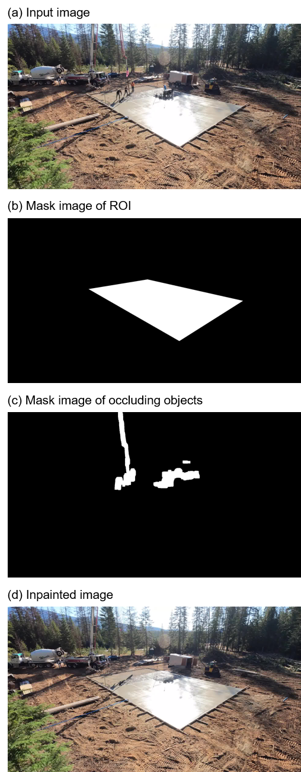
Figure 2. Examples of Instance Inpainting for Occluding Objects

4. Experimental Results and Discussion
In this study, a time-lapse video of approximately two-minutes in duration, with a resolution of 1920 × 1080, capturing the process of concrete placement was used as experimental data.
The video was obtained from an online source (Koverage Contractors, 2021). In this video, the construction process at the site involves the placement of a 40ft × 60ft concrete slab. A team of five workers is observed performing repeated cycles of concrete pouring using boom pumps, and subsequent surface finishing using a machine and hand tools. For analysis, the video was sampled at a rate of one frame per second, resulting in a total of 138 frames.
Instance inpainting was performed on all frames, and Figure 2 illustrates an example of the results. As the first step, in the input image as shown in the Figure 2(a), the ROI was defined by manually specifying the boundary of the scheduled placement area and the binary mask representing the ROI was extracted, as shown in the Figure 2(b). Among the detected objects, those whose mask pixels partially or fully overlapped with the ROI mask were identified as occluding objects and were subsequently removed via inpainting. Figure 2(c) shows the masks of the occluding objects, and the inpainting result is presented in Figure 2(d).

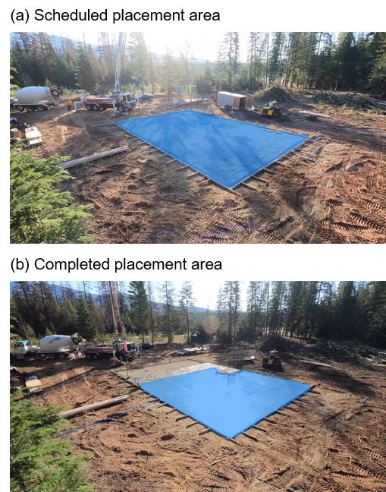
Figure 3. Examples of the segmented masks for scheduled and completed placement areas

Following instance inpainting process, we conducted progress evaluation using the inpainted images. The reference image representing the initial construction state was first selected from the earliest timestamp. In this frame, the scheduled placement area was segmented using Grounded SAM2, using prompts “formwork, rebar mat, rebar grid, and reinforcement mat” listed in Table 1. For each subsequent frame in the video sequence, the completed placement area was segmented in a similar manner, using prompts “poured concrete, concrete pouring, and fresh concrete.” Figure 3(a) and 3(b) illustrate examples of the resulting masks for the scheduled and completed placement areas, respectively. As shown, occlusions caused by workers and equipment, which are evident in the original image, were effectively removed, allowing for consistent identification of newly poured areas. Without the inpainting process, large portions of the area would have been misclassified or unobserved, highlighting the importance of the instance inpainting module.
To quantify the progress rate, we generated labelled 3D point clouds by fusing the depth maps produced by Metric3D with the semantic segmentation masks, and evaluated surface areas and progress rate by reconstructing triangular meshes, using Equation (1) to (3). The progress rate was evaluated for each frame in the video sequence, and the results are visualized in Figure 4. In Figure 4, the blue circular points represent the estimated progress rate and the red dashed line indicates the ground truth. The ground truth was manually calculated based on visual inspection of the rebar grid pre-installed in the placement area. For example, if the scheduled placement area was divided into 260 uniform grids and placement has been completed in 130 of them, the progress rate is calculated as 0.5. Since concrete placement is a continuous process, we calculated the ground truth at specific timestamps where construction activity appeared to pause (indicated by red triangular points, p1 to p14, in Figure 4), and applied linear interpolation between these points under the assumption of steady progress during uninterrupted operation. Note that, in this study, the completion of concrete placement is defined as the area where both concrete pouring and subsequent surface finishing have been completed.
In the early stage of the process, when the progress rate is below 0.5 (from p1 to p6), the evaluated progress rate demonstrated a reasonable alignment with the ground truth. For instance, at p3, where the ground truth was 0.27, the estimated progress was 0.25, and at p6, where the ground truth was 0.5, the estimated rate also approximated 0.5. However, in the subsequent
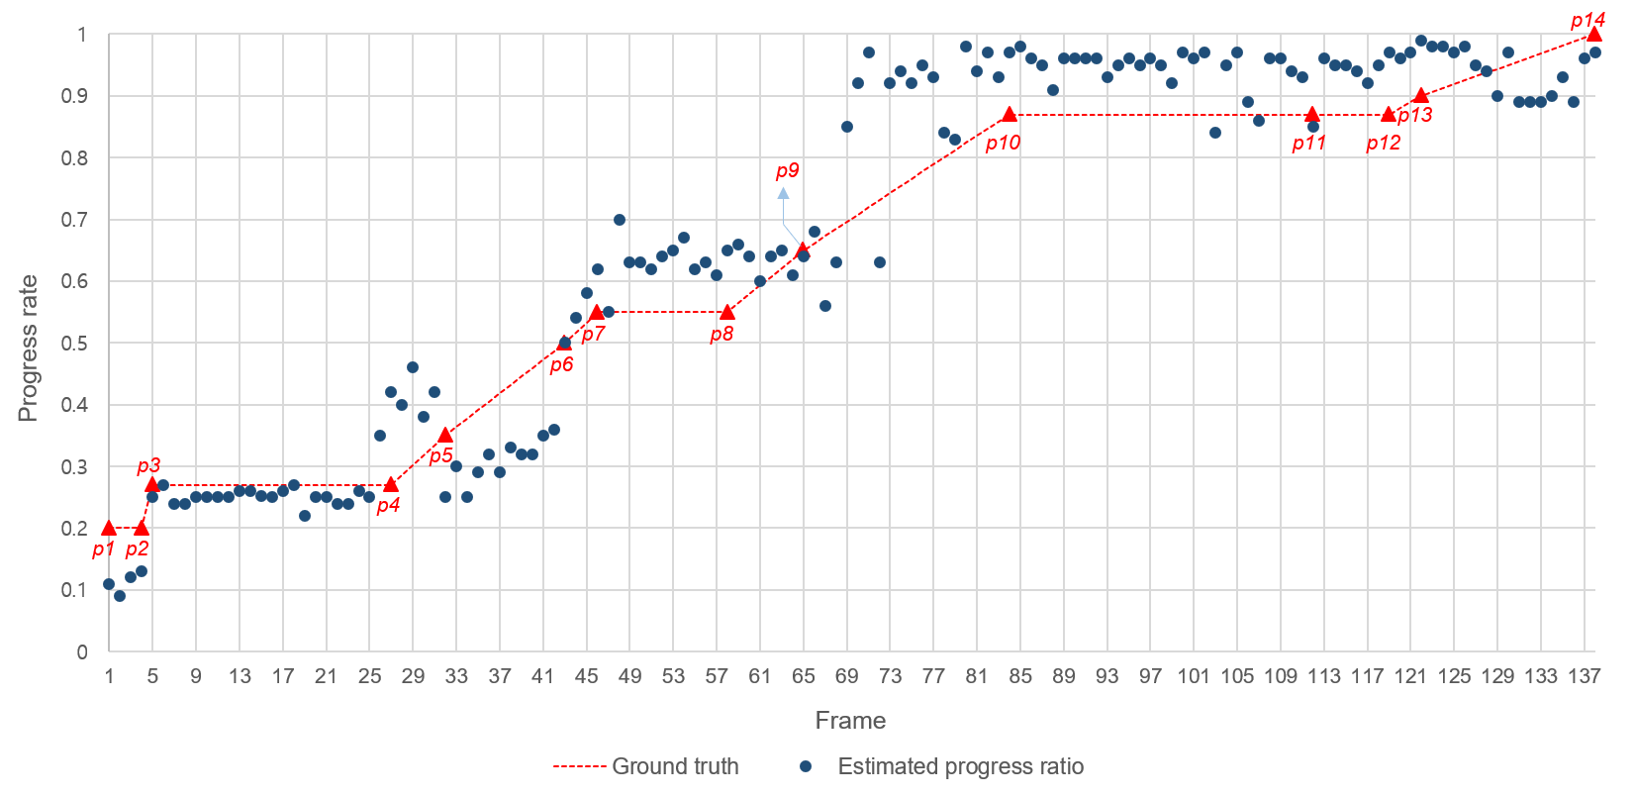
Figure 4. Results of evaluated progress rate

stage, the progress rate tended to be overestimated, with the estimated rate exceeding the ground truth at most frames. As the work progressed further from the camera, it became increasingly difficult to distinguish between areas that were merely poured (i.e., incomplete areas) and those that had undergone surface finishing (i.e., completed areas), due to their visual appearance similarity. Consequently, as shown in Figure 5(a), areas that were just poured were misclassified as completed areas (i.e., false positive), leading to the occurrence of false positive segmentations and resulting in progress overestimation. In contrast, as shown in Figure 5(b), after performing instance inpainting, if the background behind the object is not perfectly restored and visual artifacts remain, areas that have actually been completed are incorrectly segmented as incomplete (i.e., true negative), resulting in progress underestimation.
Furthermore, the trend of the estimated rate was assessed to evaluate how well it reflects the actual work states. Distinct work states between p1 to p14 were identified manually, and the linear regression coefficients of the estimated progress rate for each interval were calculated and summarized in Table 2. According to the previously defined definition of completion of concrete placement, the progress rate is expected to remain constant during the idle and pouring states, while it is expected to increase during the surface finishing state. Between p1 to p2 and p10 to p11 where idle states were identified, the estimated progress rate remains nearly constant, with linear regression coefficients of 0.009 and -0.002, respectively. Similarly, between points p3 to p4, p7 to p8, and
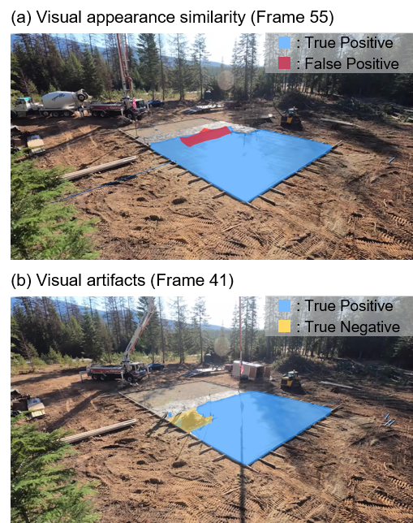
Figure 5. Causes leading to negative results

p11 to p12 where pouring states were identified, the estimated rate also remains nearly constant, with regression coefficients 0.003, 0.002, and 0.008, respectively. In the surface finishing states, the regression coefficients for the intervals between p2 to p3 and p8 to p10 were 0.120 and 0.016, respectively. These values indicate that the progress rate increased by 12% and 1.6% per frame, which is sufficiently significant to expect that the surface finishing process was actively underway. Note that the video is a time-lapse, so the rate of progress rate increase per frame is greater than that of a normal-speed video. However, in the intervals between p4 to p7 and p12 to p14, despite the expectation of a steep increase in progress, the coefficients were considerably low, at 0.008 and -0.004, respectively. This can be attributed to the overestimation and underestimation of progress during these intervals, which resulted from visual appearance similarity and artifacts, as demonstrated in Figure 4.

Table 2: Identified work states between key timestamps
Start point | End point | Regression coefficient | Work state
p1 | p2 | 0.009 | Idle
p2 | p3 | 0.120 | Surface finishing
p3 | p4 | 0.003 | Pouring
p4 | p7 | 0.008 | Surface finishing
p7 | p8 | 0.002 | Pouring
p8 | p10 | 0.016 | Surface finishing
p10 | p11 | -0.002 | Idle
p11 | p12 | 0.008 | Pouring
p12 | p14 | -0.004 | Surface finishing

5. Conclusion
This study proposed a novel 2D vision-based framework for automated construction progress monitoring, focusing on concrete placement processes using surveillance video. The proposed framework addresses critical limitations in current progress monitoring practices, including the challenges of occlusion and the impracticality of 3D sensing due to their high cost- and computing-inefficiency. By leveraging readily available surveillance videos, the framework provides a scalable, cost-effective solution to monitor construction progress. By integrating an instance inpainting module with advanced deep learning models, Grounded SAM2 and LaMa, the occluding objects such as workers and machinery were effectively inpainted, allowing accurate tracking of concrete placement progress even in cluttered scenes. In the progress evaluation, the framework utilized monocular depth estimation and single image-based 3D point cloud reconstruction in order to achieve a more representation of the physical scale of the construction site than conventional 2D pixel-based methods.
The experimental results demonstrated a high degree of consistency between the estimated progress and the ground truth, particularly during the early stages of placement. However, the framework exhibited limitations in accurately determining whether the poured concrete had undergone complete finishing (i.e., both pouring and surface finishing) in the later stages, resulting in an overestimation of progress. This issue stemmed from the visual similarity between different concrete states, especially when viewed from a distance. In addition, visual artifacts that could potentially arise during the inpainting process occasionally led to an underestimation of progress. Despite these limitations, the proposed framework demonstrated the potential to reliably identify the overall work state, showing reasonable alignment with actual construction progress.
This study contributes to automating construction progress monitoring, offering a practical alternative to 3D sensing technologies that are often costly and difficult to deploy. By leveraging surveillance video systems, the proposed framework enables practical implementation with minimal additional hardware, offering a scalable and accessible solution for a wide range of construction sites. Future research could build upon this framework by enhancing occlusion handling robustness, especially in visually complex scenarios. The framework also holds potential for extension to a broader set of construction activities beyond concrete placement.

ACKNOWLEDGEMENTS
This work was supported by the Korea Agency for Infrastructure Technology Advancement (KAIA) grant funded by the Ministry of Land, Infrastructure and Transport (RS-2024-00417877). This work was also supported by the National R&D Project for Smart Construction Technology (RS-2020-KA156875) funded by the Korea Agency for Infrastructure Technology Advancement under the Ministry of Land, Infrastructure, and Transport.

Refernces
Ahn, H., Lee, C., Kim, M., Kim, T., Lee, D., Kwon, W., & Cho, H. (2023). Applicability of smart construction technology: Prioritization and future research directions. Automation in Construction, 153, 104953. https://doi.org/10.1016/J.AUTCON.2023.104953
Bosché, F., Ahmed, M., Turkan, Y., Haas, C. T., & Haas, R. (2015). The value of integrating Scan-to-BIM and Scan-vs-BIM techniques for construction monitoring using laser scanning and BIM: The case of cylindrical
MEP components. Automation in Construction, 49, 201–213. https://doi.org/10.1016/J.AUTCON.2014.05.014
Braun, A., Tuttas, S., Borrmann, A., & Stilla, U. (2020). Improving progress monitoring by fusing point clouds, semantic data and computer vision. Automation in Construction, 116, 103210. https://doi.org/10.1016/J.AUTCON.2020.103210
Chen, C., Xiao, B., Zhang, Y., & Zhu, Z. (2023). Automatic vision-based calculation of excavator earthmoving productivity using zero-shot learning activity recognition. Automation in Construction, 146, 104702. https://doi.org/10.1016/J.AUTCON.2022.104702
Dnews. (2022). Smart Construction Corporation Index Report.
Golparvar-Fard, M., Peña-Mora, F., & Savarese, S. (2015). Automated Progress Monitoring Using Unordered Daily Construction Photographs and IFC-Based Building Information Models. Journal of Computing in Civil Engineering, 29(1), 04014025. https://doi.org/10.1061/(ASCE)CP.1943-5487.000020
Han, K. K., & Golparvar-Fard, M. (2015). Appearance-based material classification for monitoring of operation-level construction progress using 4D BIM and site photologs. Automation in Construction, 53, 44–57. https://doi.org/10.1016/j.autcon.2015.02.007
Jeon, Y., Tran, D. Q., Vo, K. T. D., Jeon, J., Park, M., & Park, S. (2025). Neural radiance fields for construction site scene representation and progress evaluation with BIM. Automation in Construction, 172. https://doi.org/10.1016/j.autcon.2025.106013
Kim, C., Kim, B., & Kim, H. (2013). 4D CAD model updating using image processing-based construction progress monitoring. Automation in Construction, 35, 44–52. https://doi.org/10.1016/j.autcon.2013.03.005
Kim, J., Chi, S., & Seo, J. (2018). Interaction analysis for vision-based activity identification of earthmoving excavators and dump trucks. Automation in Construction, 87, 297–308. https://doi.org/10.1016/J.AUTCON.2017.12.016
Koverage Contractors. (2021). “40x60 Concrete pour in 4 minutes. Full time-lapse with Somero Laser screed.”
MOLIT. (2024). 2024 Construction Standard Estimating System.
Moon, S., & Yang, B. (2010). Effective Monitoring of the Concrete Pouring Operation in an RFID-Based Environment. Journal of Computing in Civil Engineering, 24(1), 108–116. https://doi.org/10.1061/(ASCE)CP.1943-5487.0000004
Pal, A., Lin, J. J., Hsieh, S. H., & Golparvar-Fard, M. (2023). Automated vision-based construction progress monitoring in built environment through digital twin. Developments in the Built Environment, 16, 100247. https://doi.org/10.1016/J.DIBE.2023.100247
Pfitzner, F., Hu, S., Braun, A., Borrmann, A., & Fang, Y. (2025). Monitoring concrete pouring progress using knowledge graph-enhanced computer vision. Automation in Construction, 174, 106117. https://doi.org/10.1016/J.AUTCON.2025.106117
Wang, Z., Zhang, Q., Yang, B., Wu, T., Lei, K., Zhang, B., & Fang, T. (2021). Vision-Based Framework for Automatic Progress Monitoring of Precast Walls by Using Surveillance Videos during the Construction Phase. Journal of Computing in Civil Engineering, 35(1). https://doi.org/10.1061/(asce)cp.1943-5487.0000933
Wei, W., Lu, Y., Lin, Y., Bai, R., Zhang, Y., Wang, H., & Li, P. (2023). Augmenting progress monitoring in soil-foundation construction utilizing SOLOv2-based instance segmentation and visual BIM representation. Automation in Construction, 155. https://doi.org/10.1016/J.AUTCON.2023.105048
Wei, W., Lu, Y., Zhong, T., Li, P., & Liu, B. (2022). Integrated vision-based automated progress monitoring of indoor construction using mask region-based convolutional neural networks and BIM. Automation in Construction, 140. https://doi.org/10.1016/j.autcon.2022.104327
Yang, B., Gao, B., Han, Y., & Zhang, B. (2023). Semantic segmentation-based framework for concrete pouring progress monitoring by using multiple surveillance cameras. Developments in the Built Environment, 16, 100283. https://doi.org/10.1016/J.DIBE.2023.100283
Ying, H. Q., & Lee, S. (2019). A Mask R-CNN Based Approach to Automatically Construct As-is IFC BIM Objects from Digital Images. 2019 Proceedings of the 36th ISARC, 764-771.
Zhang, R., Deng, R., Zhang, Z., & Mao, Y. (2025). Vision-based real-time progress tracking and productivity analysis of the concrete pouring process. Developments in the Built Environment, 21. https://doi.org/10.1016/j.dibe.2025.100609

