Optimising Environmental Sensor Placement in Residential Settings: Evaluating the Ei1025 for Accurate Indoor Air Quality Monitoring
Assessing the Impact of Sensor Positioning on CO₂, Temperature, and Humidity Measurements in Residential Environments

MUHAMMAD ZAEEM FAROOQ¹, ALEJANDRO MORENO-RANGEL¹, SILVIU NISTOR², TIM SHARPE¹, PRAVEEN SIRIMANNE¹
1 University of Strathclyde, Glasgow, United Kingdom
2 AICO Limited, Oswestry, United Kingdom

ABSTRACT:

Ensuring accurate indoor environmental monitoring is essential to maintain healthy living conditions and to improve energy efficiency. The placement of environmental sensors plays an important role in the reliability of collected data, such as temperature, relative humidity, and carbon dioxide (CO₂) levels. While standards such as BS 40101:2022 provide recommendations for sensor placement, practical constraints often induce deviations, which may affect data accuracy. This paper assesses the impact of sensor positioning. Multiple Ei1025 sensors are placed on walls and ceilings within a residential setting. Variations in readings across different locations are analysed through statistical methods. The work identifies that an optimal placement of these sensors is important as stratification of indoor air, exhalation of occupants and circulation of air impacts the readings. As an output, the determination of correction factors based on detected deviations will be presented. These findings are expected to contribute towards enhancing the indoor environmental monitoring practices. This would eventually support the development of improved residential ventilation strategies as well as ensuring robust data collection for future building performance assessments.

KEYWORDS:

Indoor air quality, sensor placement, environmental monitoring, CO₂ measurement, residential ventilation

1. INTRODUCTION
Indoor environmental monitoring is fundamental to maintaining occupant well-being and optimising energy efficiency in a residential setting. Other than the sensor accuracy, the measurements are heavily dependent on the positioning of sensors within the room as placement would influence the exposure to air circulation patterns, heat sources, and other ventilation components. This is of particular interest in Building Performance Evaluation (BPE) for indoor parameters such as carbon dioxide (CO2) levels, temperature, and humidity (Mena et al., 2022)
Existing guidelines, such as British Standard BS 40101:2022 (BSI, 2022) have been developed to ensure consistency in the monitoring and evaluation process, which includes recommendations for sensor placement and reliability of the readings. Other standards, such as the BS EN ISO 7726:2001 Ergonomics of the thermal environment. Instruments for measuring physical quantities (ISO, 2001) describe the characteristics of the sensors but do not provide detailed guidance on sensor placement. Many of the widely recognised standards suggest that the sensor placement should be at the centre of the room at a specified level (i.e., 0.80-2.00m) as described in Table 1.

Table 1: Positioning of internal condition monitoring sensors.
Criteria | BS 40101:2022 | ISO 16000-1:2006 | ISO 7726:2001
Distance from radiator | >2m horizontally | - | -
Distance from window | >2m horizontally | - | -
Distance from floor | 0.8–2 m, >0.8 m from ceiling | 1.0–1.5 m | 0.1–1.7 m (varies by posture)
Distance from ventilation terminal | >2m horizontally/vertically | - | -
Distance from heat sources (>100 W) | >1m horizontally/vertically | - | -
Distance from external wall | >100mm horizontally | - | -
Distance from internal walls | Can be mounted on any wall (measuring air conditions) | - | -
Direct solar gain | Avoid direct exposure | - | -
Sensor accuracy | ±0.5°C (T), ±3% (RH), ±50 ppm (CO₂) | - | ±0.5°C (T), ±0.2°C
Desirable location | Centre of room, >1 m from walls | Centre of the room | Centre of the room

The BS 40101:2022 focuses on three core metrics: temperature, relative humidity and CO2 – the Ei1025 Environmental Sensor parameters. It suggests that environmental sensors could be built into or stand-alone, logging data at least 30-minute intervals. Regarding sensor placement, several conditions must be met, depending on the type and characteristics of the room (see Table 1).
While following standards ensures consistency in data collection and enhances data quality and robustness, long-term monitoring (lasting at least 12 months) may not be feasible in practical terms (Mena et al., 2022). Hence, sensors are often located in walls, ceilings, or on top of existing furniture or fixtures, which could impact data collection. The sensor manufacturing quality and data processes also have an impact on the data quality (Moreno-Rangel et al., 2018).
Several studies have looked at the optimal placement of indoor environmental sensors (temperature, relative humidity, and CO_{2,} among others) in offices (Yoganathan et al., 2018; Yun & Licina, 2023) and greenhouses (Lee et al., 2019). In the office context, it was found that the wall (height between 1.0m to 1.5m) behind the occupants and the mounted exhaust near the standing occupant were the best locations for placing the sensors for particulates, and for CO₂, those closer to the occupants were the best locations (Yun & Licina, 2023). However, CO₂ was more dependent on the location of the participants and activity in the room. Moreover, this study was limited to 7 different locations, 2 on the wall, 2 on the ceiling, 2 on the desks and one at a breathing zone, which limits the understanding of the sensors' placement in other areas of the room.
(Rackes et al., 2018) looked at the optimal sensor placement in office environments to manage indoor air quality and ventilation in the building. However, rather than collecting physical measurements, they focused on virtual simulations. They found that capturing spatial distribution is probably less important than enhancing sensor accuracy, and without higher quality sensors, trying to do so can actually reduce network accuracy. Another study looked at the combination of physical and virtual sensors for temperature and relative humidity in farms, developing an algorithm to optimise the sensor placement to collect data for digital twins (Shin & Kwak, 2024). However, this approach looked to develop virtual sensors placement for the twin model, rather than the physical measurements.
While there are several guidelines and studies on sensor placement in buildings, most of these are not feasible for residential use. Therefore, there is still the need to further understand the impact of sensor placement in residential settings. This will allow us to obtain more accurate data at a large scale needed to support retrofit decisions and policy monitoring or changes.
This project aims to understand the impact of the Ei1025 Environmental Sensor placement in different locations within a room and identify the optimal placement and/or correction factors that best represent average room conditions to ensure robust monitoring of temperature, relative humidity, and CO2.

2. MATERIALS AND METHODS
This study is being conducted in 4 selected dwellings ranging from detached, semi-detached houses and flats from different construction eras. Main bedroom, kitchen and living room from each of these understudy dwellings are installed with Ei1025 sensors. A total of 22 sensors are placed on lower and higher wall levels, ceiling and at a central position. The scatter of these sensors is aimed at informing stratification, dispersion and effectiveness of the indoor air.

2.1 Data Collection and Analysis
Data collection is being conducted with the following considerations:
- Environmental data, including CO2 concentration (ppm), temperature (°C), and relative humidity (%), are recorded at 30-minute intervals using 22 Ei1025 sensors strategically placed in the room.
- Sensors on the walls are positioned at two heights across the four walls to assess variations caused by stratification and/or proximity to ventilation sources.
- Ceiling sensors are placed at five locations i.e., the centre and four offset positions, to evaluate air mixing and thermal distribution at ceiling levels of the room.
- A central sensor was positioned in the middle of the room to determine if a single reference point could reliably represent overall indoor conditions.
The collected data is aimed to be analysed to assess expected spatial variations in monitored parameters. Descriptive statistics will be used to summarise overall trends. Paired comparisons would evaluate the difference between lower and higher level and wall-to-wall sensor readings. Furthermore, based on the data trends, additional analyses to identify optimal sensor location and correction factors are determined.

The sensors were installed in three rooms of the case study flat i.e., living room, main bedroom and kitchen. This paper deals with the analysis of living room monitored data. This monitored data constitutes a week-long monitoring of CO2, RH and indoor temperatures. A total of 22 sensors were placed at three height levels i.e., low breathing height (1.5m), higher level (2.3m) and on the ceiling (2.33m). An additional sensor was placed on the centre table in the room at a height of 0.4m.
Sensor Level | Sensor Number
Low | S1-S8
High | S9-S16
Ceiling | S17-S21
Centre Table | S22

As part of the study, an occupant’s diary was also filled in by the participant to log their presence, window and door opening, cleaning, clothes drying and smoking. The purpose of this diary was to elaborate on any anomalies or spikes in the data visualisations.
2.2 Data Processing
The raw data exhibited two significant issues. First, not all sensors began logging at the same time, which resulted in asynchronous start times. Second, the sensors did not adhere to a regular logging interval, however, at large, the data was logged at 15-minutes intervals. This compromised the uniformity of the time series and the possibility of direct time-step-wise comparison of the data from all sensors.
For data cleaning purposes, a processing strategy was devised which involved calculating time offsets between the sensors. This allowed for standardising the temporal resolution and hence eventually resolving the data alignment. For each sensor $i$, the time of this first recorded reading $t_{i}$ was determined and the sensors were placed in groups i.e., low, high, ceiling and table.
To find the most “central” sensor in terms of logging start time to account for asynchronous start, the initial step involved calculating the offset for each sensor. The total difference between the two sensors $i$ and $j$ is calculated as:
$$D_{i}=\sum_{j≠i}{\left|t_{i}-t_{j}\right|}$$
While the sensor with the smallest $D_{i}$ was chosen and here denoted as $t_{ref}$. The offset for the sensor $i$ was calculated as:
$$∆t_{i}=t_{i}-t_{ref}$$
The next step caters to the issue with irregular logging intervals. To standardise the temporal resolution of the data to 15-minutes consistency, each sensor’s time step was rounded down using the floor function to the nearest 15-minute interval. Mathematically, if a given time stamp $t$ is recorded, it is transformed to:
$$t_{rounded}=\left\lfloor \frac{t}{15 min}\right\rfloor ×15min$$
As a result of this floor function rounding process, more than one reading fell into the same 15-minute time slot. For example, when a reading at 9:57 was rounded to 10:00 and if there is already a reading present at 10:00, the readings at these time steps were aggregated by computing their arithmetic mean. Finally, the previously computed offset $∆t_{i}$ was applied to the rounded time stamps. Each sensor time series was shifted by applying the positive or negative offset and a new aligned time series is formed.
For validation purposes, mean, max and Pearson correlation r were calculated for the cleaned data and the original dataset. Mean values had <2 units of difference while max values were identical. The Pearson correlation r was calculated to be >0.99.
2.3 Regression Analysis
To evaluate biases between sensor measurements due to different placements, structured data is used to derive two time series. Group mean, which is the average of all sensors in that group (low, high, ceiling, centre table) and overall mean, which is the average of all 22 sensors at each timestep. Linear regression is conducted in three ways for each parameter.
Sensor vs group mean regression involved comparing the sensor’s readings to the mean of its group at corresponding times. This allowed to assess how each sensor deviates from its co-located other sensors. The regression equation is in the form:
$$Sesnor Reading=m×Group Mean+b$$
Where m is the slope, b is the intercept. A slope <1 indicates that the sensor has a lower response (multiplicative bias) as compared to the group. As the bias is greater than unity, there is an over response from the sensor and vice-versa. The intercept b indicates the additive bias or offset, which is, if positive, the sensor consistently reads higher than the other sensors’ mean by b units and vice versa. An ideal, unbiased and perfectly calibrated sensor with respect to the other sensors would have m=1 and b=0.
For each regression run, Pearson correlation is also determined. Please note that as it is calculated for a cleaned and aligned data, it is aimed to be close to unity. Such a high (close to 1) measure of goodness of fit means that the sensor’s readings follow a tight linear trend with the overall mean of the other sensors. On the contrary, a low number would indicate a deviation in the behaviour from the other sensors in a time varying way.
2.4 Bias Characterisation
As the slope and intercepts are obtained for all sensors, the distribution of these values is analysed with each sensor group. Group-wise averages for slopes and intercepts are used to identify systematic trends. These trends show, for example, that all ceiling sensors tend to have a slight positive intercept. This also detects outliers in cases where the slope of the intercept of a sensor deviates from that of others. The multiplicative bias in percentage is quantified as $\left(m-1\right)×100\%$ and the additive bias is an absolute intercept value in the native units i.e., ppm for CO2, % for RH and °C for temperature. This provides a quantitative indication of each sensor’s deviation in explicit terms. For example, a sensor with m=0.9 has a 10% multiplicative bias as it shows 10% lower changes in measurements and an intercept of +20 would indicate that it reads 20ppm (in case of CO2) higher across the group.
2.4 Deriving Correction Factors
To eradicate the biases, group level correction equations are derived instead of per sensor evaluation. For this purpose, the average slope and intercept of each group of sensors for each parameter are calculated. These averages represent a typical bias for the group. A linear correction formula is then applied to any sensor in that group.
$$Corrected Value=\frac{Raw sensor reading-b_{avg}}{m_{avg}}$$
Where $m_{avg}$ and $b_{avg}$ are the average slope and intercept for that sensor group and parameter. This equation solves for the overall mean-aligned value when a raw reading is available. By subtracting the average offset (additive bias) and dividing by the average slope (multiplicative bias), the corrected reading is calculated. These correction factors are derived from sensor vs overall mean regression results. This ensures that the correction factor is indicative of a zone-wide sensor readings rather than group wise data.

3. Results
This section details the data analyses for the three measured parameters i.e., CO2, RH and temperature. Discrepancy in the sensor measurements and their statistical meaning is explored to pave the way for calculating correction factor equations.
3.1 Initial Data Visualisations
Time series plots for the three parameters are presented in the figures 1-3. A further description of this data is provided in another section.

3.1.1 CO₂
CO2 individual sensor readings were found to be in good agreement with overall mean values. The figures below categorise sensors by placement and visualise correlation with the overall means. The data from these plots is further discussed in this section.
Slopes (Figure 5): The slope values were well clustered around 1.00, indicating a well-cleaned and well-aligned dataset. The slopes range from 0.98 to 1.06 amongst all sensors, which is a spread of ±6%. Looking at the grouping averages of slopes, low level sensors had an average slope of 0.996, high level 1.005 and ceiling mounted 0.996. These values indicate that there are no significant systematic biases associated with sensor height. However, it is observed that high-mounted sensors were marginally or insignificantly over responsive on average (+0.5%) while low and ceiling level sensors were under responsive by -0.4%, but these differences are minimal compared to normal sensor tolerance. In practical terms, a multiplicative bias of 6% would mean that with a 100 ppm change in CO2, the sensor could show a 106 ppm change.
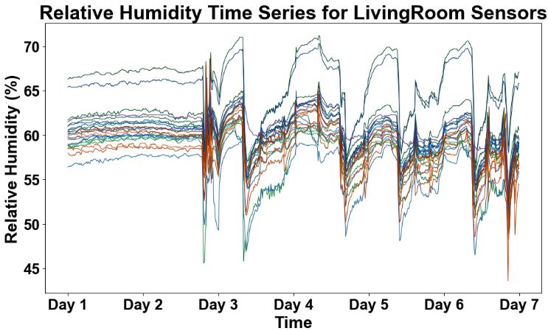
Figure 2: RH Time Series for Living Room Sensors
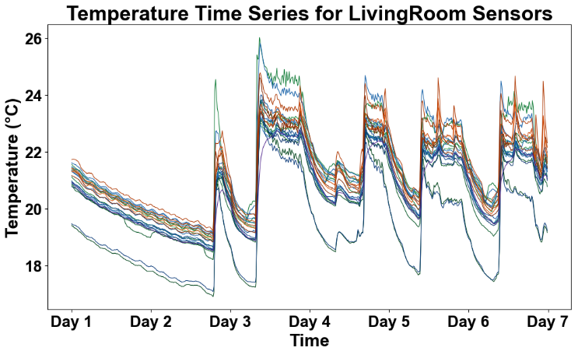
Figure 3: Temperature Time Series for Living Room Sensors

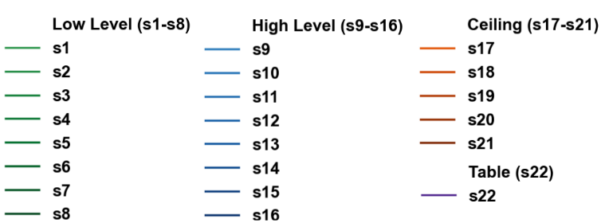
Figure 4: Legend for Figure 1 till Figure 3.

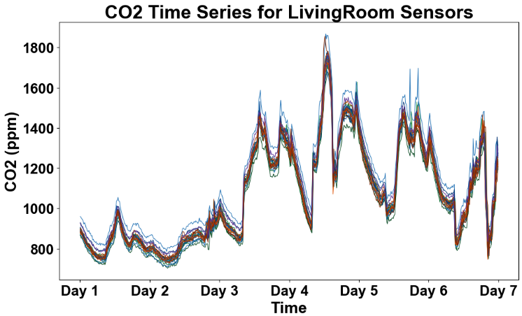
Figure 1: CO2 Time Series for Living Room Sensors

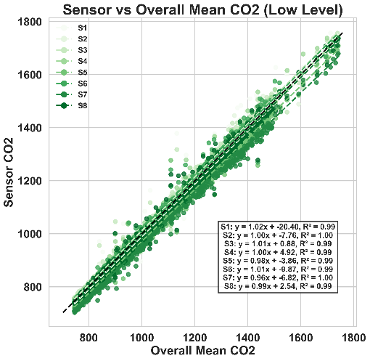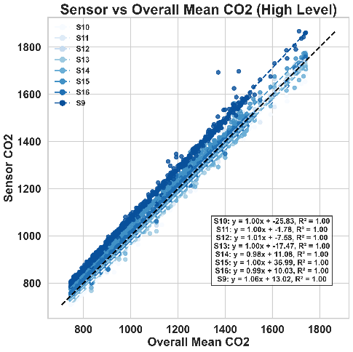

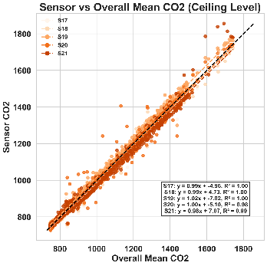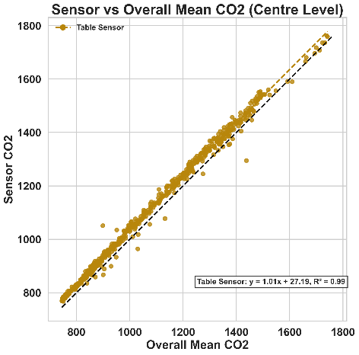
Figure 5: Block of Scatter Plots for CO2 Sensor Readings vs Overall Means.

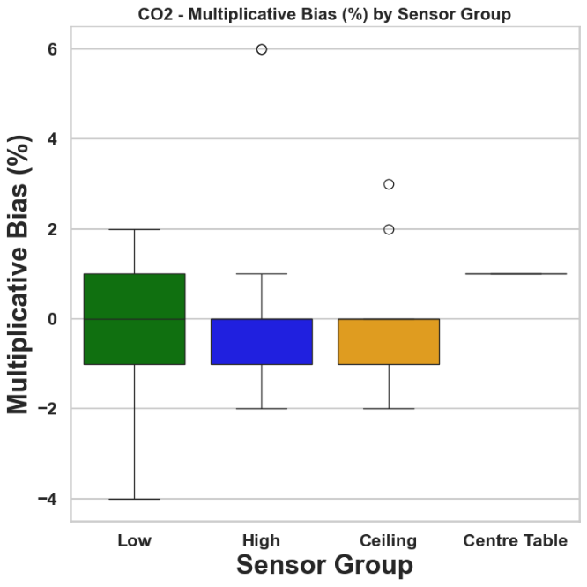
Intercepts: The intercepts for CO₂ measurements were also generally small, although they showed a wider relative spread than the slopes. Across all sensors, the offset values spanned from -27 ppm to +37 ppm. This means that the “worst-case” sensor was 37 ppm higher than the overall mean, while the other one was 26 ppm lower. Most sensors were observed to have smaller offsets.
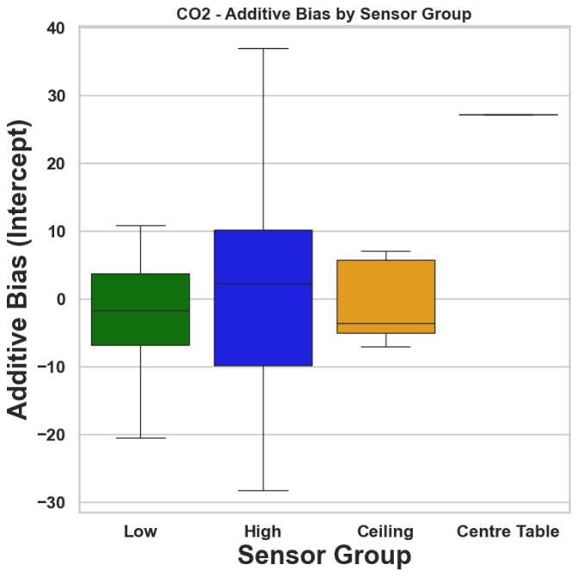

Correlation (R²): All sensors demonstrated a close to perfect linear relationship with the overall mean. These values were close to 1.00 for all sensors, indicating that temporal CO₂ fluctuations matched the overall trend. The differing is only by the constant biases as described previously.
Outliers: There were no extreme outliers in CO₂ measurements. As mentioned previously, an offset of a few tens of ppm is relatively small in the context of indoor CO₂, which ranges from 400 ppm to well over 1000 ppm in occupied spaces, while in unventilated spaces it reaches beyond 2000 ppm.
3.1.2 Relative Humidity
Relative humidity values for different sensors/sensor groups were found to vary significantly, as depicted in the figure below. This section elaborates on slopes, intercepts, linearity and outliers in the upcoming results discussion.
Slopes: A greater variability was found in the slope range for RH measurements. The slopes indicated an under responsive up to 0.70 (indicating -30% multiplicative bias). Other sensors were over responsive with slopes up to 1.50 (indicating +50% multiplicative bias). Examining group levels, low-sensing individuals had an average slope of 1.01, but high variance among individuals. High level sensors averaged 0.99, while ceiling sensors (average of 1.05) tend to respond slightly more strongly than average. However, the spread between low and high sensors was large. Individual sensor slopes ranged from 0.7 to 1.5 (-29% to 49%); centre table sensor also matched the lowest multiplicative bias. This means that within the same group, one sensor might read significantly flatter humidity variations and another much sensitive with sharper variations than the overall mean. The ceiling sensors had a narrower range but still a notable variation. This substantial spread in slopes indicates that the multiplicative bias is a flag worthy issue.

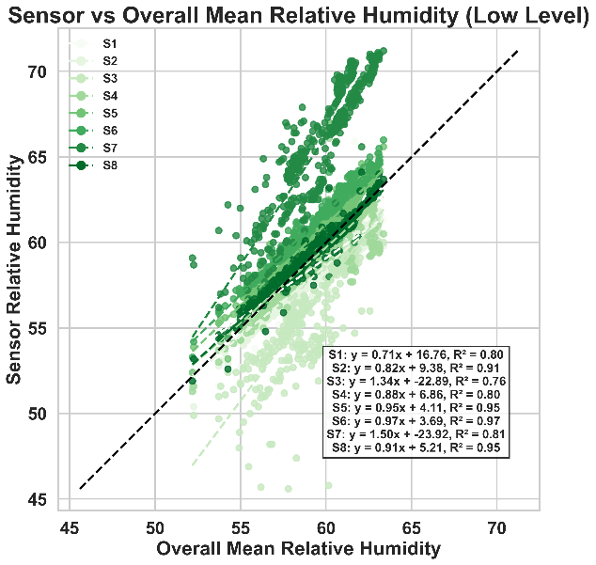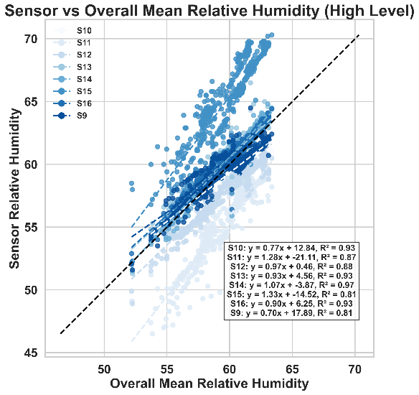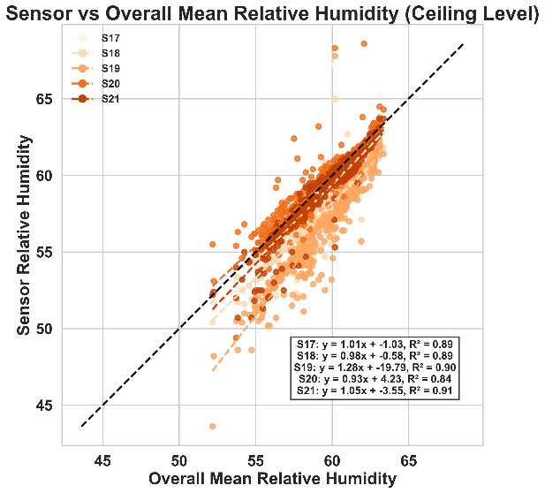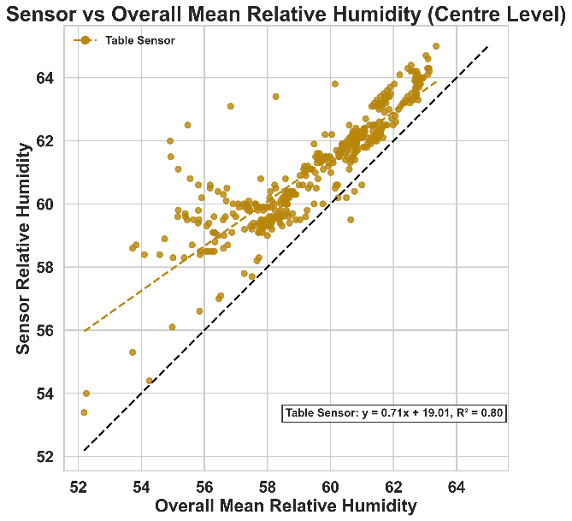
Figure 6: Block of Scatter Plots for RH Sensor Readings vs Overall Means.

Intercepts: The additive biases showed similar variations across all sensors, ranging from -24% to 18% RH. The group average intercepts are around -0.1% for low level, +0.3% for high level, -4.1% for ceiling and 19% for centre table. The close to zero averages for low and high groups imply an inconsistent bias towards reading too high or too low in the respective positions, as any offset bias tends to cancel out when averaged, suggesting they are sensor specific rather than position specific. Ceiling sensors showed a small negative intercept (-4%), which indicates a tendency to read slightly lower RH than the overall average. This could be due to stratification as warm air rises, containing more moisture for the same RH, potentially leading to a lower RH if not fully mixed. In practical terms, the offset calculated is highly significant as a 50% RH would be interpreted as 30% by one sensor and 70% by another sensor.
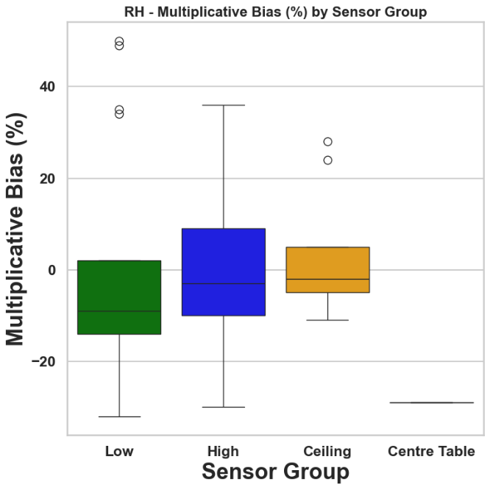
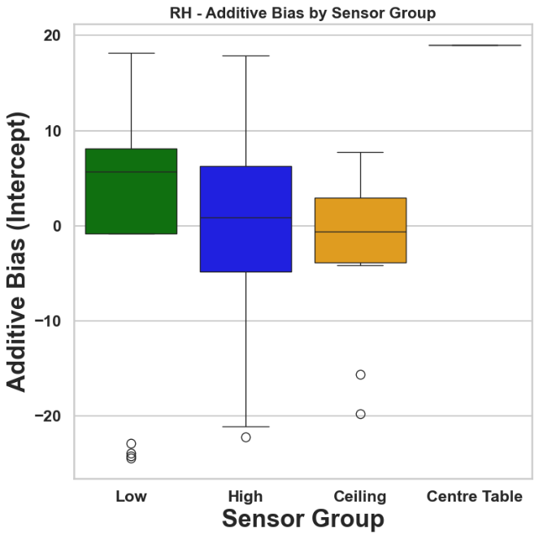
Figure 7: Multiplicative and Additive Biases for RH Sensing for Different Sensor Locations.

Correlation (R²): The Pearson correlation for RH sensors was calculated to be lower than CO₂ reading. Many sensors had values in the range 0.8-0.9 with the lowest being 0.76. An average of 0.89 was observed for wall-mounted groups (low and high) and 0.89 for ceiling indicating moderately strong correlation. Such low values emphasise that humidity can be influenced by local factors such as proximity of people, plants, airflow currents etc. Since not all variances can be explained by a linear model, a simple linear bias correction might leave some residual differences.
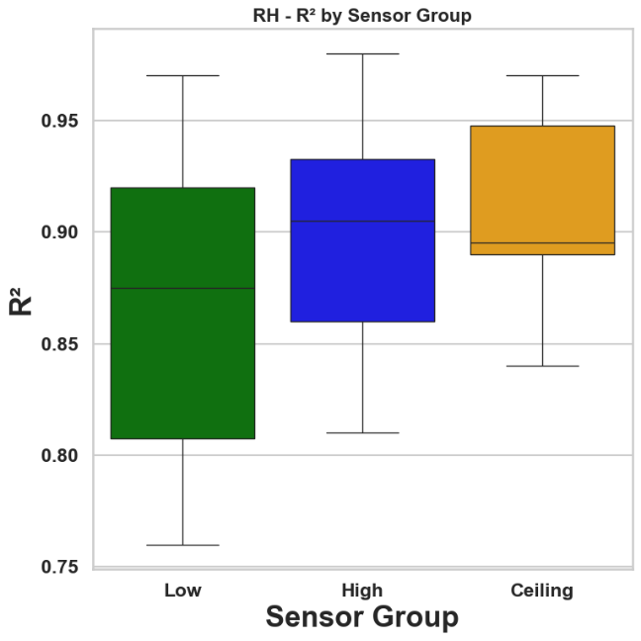
Figure 8: R² by Sensor Group in Relation to Overall Mean.

3.1.3 Temperature
This section includes linear correlation plots for temperature readings from all sensors divided into groups against the overall mean temperature. The figures below provide a preliminary overview of the data, including a fit equation that displays the slope, intercept, and Pearson correlation. Following the steps outlined in the previously described parameters, the upcoming discussion will elaborate on these factors in relation to the temperature readings.
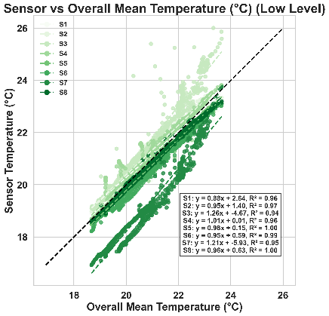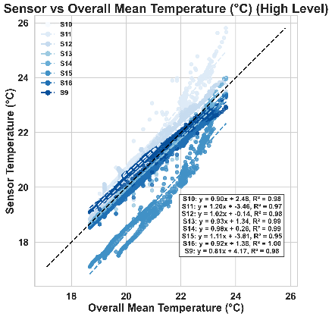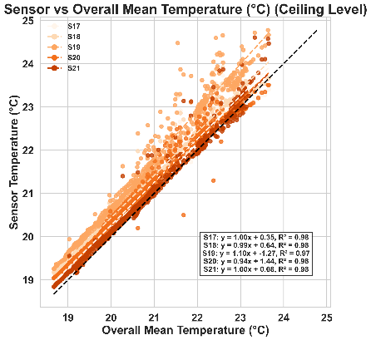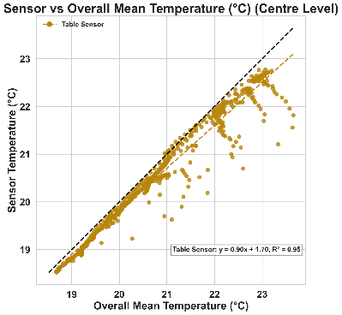
Figure 9: Block of Scatter for Temperature Sensor Readings vs Overall Means.

Slopes: Most of the sensors showed slopes reasonably close to 1.0, while the range is between 0.8 to 1.26. Group wise comparison shows that low level sensors had an average slope of 1.03 (+2.5% of bias), high level sensors had an average slope of 0.98 (-1.6% bias), ceiling sensors having average slope of 1.01 (+0.6% bias) and table sensor having slope of 0.9 (-10% bias). While wall/ceiling mounted sensors show a small bias and are almost neutral, the table sensors show a lag in responding to the temperature changes. Such an under response could be due to its positioning relative to thermal mass, a different microclimate, or a calibration issue.
Intercepts: The intercepts offsets in the temperature reading ranged from -5.9°C to +4.2°C across all sensors. It means that one sensor read ~6°C lower than the “true” temperature. While another read about 4°C higher than the baseline. These extreme cases are not representative of the bulk, as most sensors had much smaller offsets. The average intercept for low level sensors was -0.65C indicating that due to heat stratification near the floor, sensors tended to read lower temperatures than the mean. For higher level sensors, it was +0.28°C and similar value for ceiling, i.e., +0.25°C. The table, on the other hand, the centre table was +1.7°C. Most of the sensors had intercepts within ±2C which is the typical accuracy of low-cost environmental sensors. However, the notable -5.9°C outlier and others in the range of ±3°C to 4°C indicate that some sensors might have been positioned in a spot that consistently differed from the room average.
Correlation R²: The temperature sensors were well correlated with the overall mean temperature, with a range lying between 0.94-1.00. Such high R² values suggest that, despite there being offsets and scale differences, the sensors measured the variation in the temperature in a harmony and hence random noise is not an issue as it was detected for RH sensing.
4. DISCUSSION ON RESULTS
The near ideal behaviour of CO₂ data shows that there is a lack of any significant systematic bias between lower and higher sensors. The vertical stratification is negligible hence thus with a minimal correction factor and adjustments, CO₂ sensing locations could be interchanged if high absolute accuracy is required.
On the other hand, RH there was a broad spread in slopes which is indicative of significant sensor to sensor variance. The measurements from the sensors would rely highly on the location and level of installation. The data did not show a significant consistent pattern between sensor height and bias for RH as low and high wall sensors had a similar bias distribution. However, ceiling sensors had a slight tendency to read lower humidity as negative intercept is found in the fit equations. This can be explained physically as due to stratification, near the ceiling temperature is higher (also evident from temperature sensing data analysis).
Temperature measurements were quite reliable across sensors; however, the impact of sensor location can be discerned. The systematic offset between low and high sensors aligns with the thermal stratification. The regression analysis treats this temperature gradient as sensor bias relative to the overall mean. Apart from one sensor with an offset of 6°C, a general accuracy of ±2°C is detected.
4.1. Results and Occupancy Behaviour
As occupant was given a diary to fill in for their daily activities, it is found that one person used the living room for inhabitation as well as to dry cloths. Windows were operated as well as a dehumidifier was also used. This shows an inconsistent condition as well as possible microclimates causing disruption in RH readings. The sensors placed near the windowpane show relevant behaviour as well. S7 and S15 have large offsets for all three measured parameters. 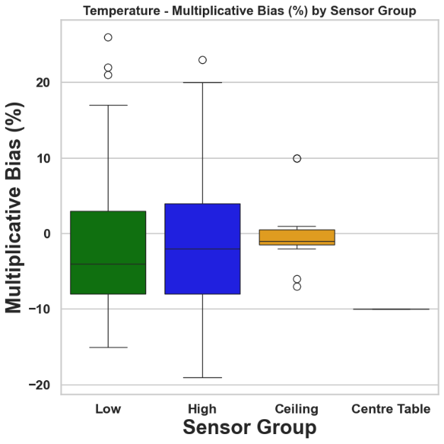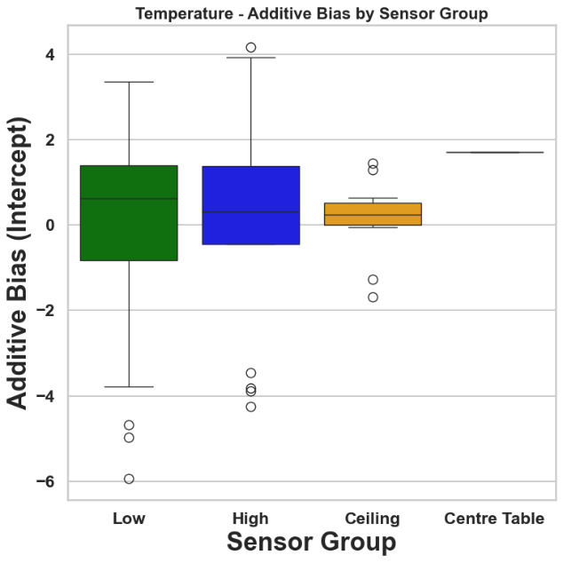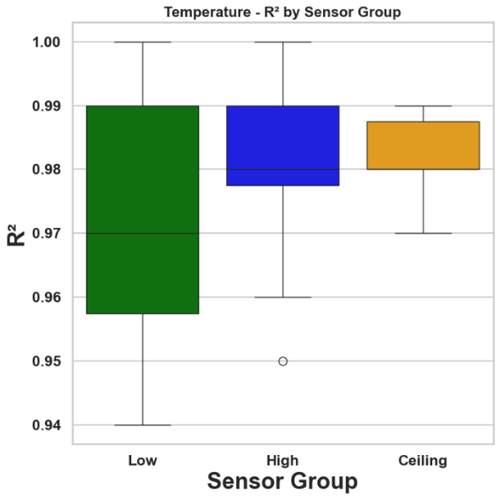
Figure 10: Multiplicative and Additive Biases, and R² for RH Sensing for Different Sensor Locations.

5. CORRECTION FACTORS
Based on the regression analysis for CO₂, RH and temperature against the overall mean values, an averaged correction factor is calculated for each sensor group. These factors are expressed as linear equations so to adjust a raw sensor reading to a corrected value. Purpose of this application would be to better represent the true environmental values aligned with the mean of the all-sensor placements. The formula is in the form:
$$Corrected=\frac{Raw-b}{m}$$
Where m is the average slope (multiplicative factor) and b is the average intercept (additive bias) for the given group and parameter. The core idea is to subtract the average offset bias and divide by the average gain to normalise the respective sensor reading.
CO2 regression equations are processed for average slope and intercept for each level giving following equation set:
$${CO2}_{Low, Corrected}=\frac{Raw+5.05}{0.996} \\ {CO2}_{High, Corrected}=\frac{Raw-2.31}{1.005} \\ {CO2}_{Ceiling, Corrected}=\frac{Raw+1.06}{0.996} \\ {CO2}_{Centre Table, Corrected}=\frac{Raw-27.19}{1.010}$$
Similarly for RH the following equations are computed:
$${RH}_{Low, Corrected}=\frac{Raw+0.10}{1.010} \\ {RH}_{High, Corrected}=\frac{Raw-0.31}{0.990} \\ {RH}_{Ceiling, Corrected}=\frac{Raw+4.14}{1.050} \\ {RH}_{Centre Table, Corrected}=\frac{Raw-19.01}{0.710}$$
In the same manner equation for temperature readings would look like:
$${Temp}_{Low, Corrected}=\frac{Raw+0.65}{1.025} \\ {Temp}_{High, Corrected}=\frac{Raw-0.28}{0.984} \\ {Temp}_{Ceiling, Corrected}=\frac{Raw-0.25}{1.006} \\ {Temp}_{Centre Table, Corrected}=\frac{Raw-1.70}{0.900}$$
The equation sets above show how to adjust a raw sensor reading. Applying these corrections will adjust sensor readings towards the overall mean baseline. For example, for a low-level CO₂ sensor, if raw reading is 1000 ppm, the corrected value would be 1005.1 ppm, scaling up the reading by 0.4% to account for low placement tendency to read slightly lower values. Another example for ceiling RH measurement of 50%, the corrected value would be 51.47% hence resulting in ~1.5% point increase. These adjustments are generally modest for CO₂ and temperature but quite significant of RH in some cases such as centre table RH correction is substantial which is corrected to 43.7% for a 50% reading.
It is important to note that these group-based corrections introduce the reductions in systematic buas but do not eliminate any error for each individual sensor. Since there is variability within each group, an individual sensor’s true optimal correction might differ. For instance, high level RH sensor varied widely. Using the average m=0.99 and b=0.31% will bring an average high sensor in line but an “outlier” sensor S9 (m=0.70, b=+17.9%) would need much larger correction factor.

6. CONCLUSION
This research analysed bias in a network of indoor sensors measuring CO₂, RH and temperature using regression-based approach against the network’s overall mean. The results showed that CO₂ sensors were consistent with negligible bias. Temperature sensors also performed well with high correlation and minor biases which a largely attributed to the predictable spatial gradients and small calibration offsets. In contrast RH sensors exhibited significant variability in both scale and offset.
The quantification of the biases is presented as multiplicative and additives which would be helpful in a reliable sensor reading depending upon the level at which sensors are placed.
Future work: The analysis in the paper is for one room of one house. The data is made available for 3 rooms (bedroom, living and kitchen) for 4 houses in total. It is anticipated to include whole dataset for a wider analysis which would bring accuracy to these calculated correction factors. It is also aimed to produce a certain set of correction factors for each type of room.

REFERENCES
Institution, B. S. (2022). BS 40101: Building performance evaluation of occupied and operational buildings (using data gathered from tests, measurements, observation and user experience)-specification. British Standards Institution.
ISO. (2001). BS EN7726: 2001--Ergonomics of the thermal environment. Instruments for Measuring Physical Quantities.
Lee, S., Lee, I., Yeo, U., Kim, R., & Kim, J. (2019). Optimal sensor placement for monitoring and controlling greenhouse internal environments. Biosystems Engineering, 188, 190–206.
Mena, A. R., Ceballos, H. G., & Alvarado-Uribe, J. (2022). Measuring indoor occupancy through environmental sensors: A systematic review on sensor deployment. Sensors, 22(10), 3770.
Moreno-Rangel, A., Sharpe, T., Musau, F., & McGill, G. (2018). Field evaluation of a low-cost indoor air quality monitor to quantify exposure to pollutants in residential environments. Journal of Sensors and Sensor Systems, 7(1), 373–388.
Rackes, A., Ben-David, T., & Waring, M. S. (2018). Sensor networks for routine indoor air quality monitoring in buildings: Impacts of placement, accuracy, and number of sensors. Science and Technology for the Built Environment, 24(2), 188–197.
Shin, H., & Kwak, Y. (2024). Enhancing digital twin efficiency in indoor environments: Virtual sensor-driven optimization of physical sensor combinations. Automation in Construction, 161, 105326.
Yoganathan, D., Kondepudi, S., Kalluri, B., & Manthapuri, S. (2018). Optimal sensor placement strategy for office buildings using clustering algorithms. Energy and Buildings, 158, 1206–1225.
Yun, S., & Licina, D. (2023). Optimal sensor placement for personal inhalation exposure detection in static and dynamic office environments. Building and Environment, 241, 110459.

