AN INTEGRATED FRAMEWORK FOR INTELLIGENT CONSTRUCTION CLAIM MANAGEMENT: A CONCEPTUAL ROADMAP
Ankita¹ and Purva Gupta²

¹ Faculty of Technology, CEPT University, Ahmedabad, India
² Assistant Professor, Birla Institute of Technology and Science Pilani, Dubai Campus, Dubai, UAE
*Corresponding email: purvagupta2010@gmail.com

ABSTRACT
Claim mismanagement continues to be a major cause of delays and cost overruns in construction projects. A large proportion of claims are rejected due to a lack of clear or verifiable evidence, indicating persistent shortcomings in documentation practices rather than intentional misrepresentation. Existing digital solutions typically address isolated stages of the claim process and do not provide an integrated, verifiable environment for managing claims throughout their lifecycle. This paper presents an integrated framework for intelligent construction claim management that combines natural language processing, blockchain, and machine learning within a unified architecture. The framework is intended to support earlier identification of potential claim issues, improve the organization and traceability of project information, and strengthen the link between project communications, contractual obligations, and project events. It envisions blockchain-based secure and transparent record-keeping, along with automated support for basic contractual checks and claim-related assessments, while preserving the role of professional judgment. Overall, the proposed framework aims to move construction claim management from a fragmented and reactive process towards a structured, transparent, and auditable digital workflow.

Keywords – Construction Claims; Blockchain; Natural Language Processing; Smart Contracts; Artificial Intelligence

- INTRODUCTION
The construction industry is undergoing rapid expansion and transformation. Global construction output is expected to reach USD 15.2 trillion by 2030, representing approximately 13% of world GDP (KPMG-GCS-2023, 2023). This growth magnifies the economic and social consequences of inefficiencies, disputes and delays in project delivery (Knight Frank, 2024).
Claims have become one of the most persistent sources of inefficiency in construction project delivery, particularly through their impact on time and cost performance. Construction claims can be defined as formal requests for additional time and/or money when a party believes it is entitled to compensation beyond the original contract scope or price (Narayan et al., 2024). A claim is not necessarily a dispute; it becomes a dispute only when the counterparty rejects it, thereby initiating a process of disagreement and dispute escalation (Iyer et al., 2008). Prior analyses of delay disputes and dispute‑prone clauses suggest that construction claims are largely triggered by the inherently complex and multi‑party nature of projects, where different parties view the same circumstances differently and operate under ambiguous risk allocations (Kalogeraki & Antoniou, 2024). Claims therefore significantly affect project completion, delivery delays, and overall budgets (Chaphalkar & Iyer, 2014).

- INTEGRATED GOVERNANCE AND TRUST – THE BLOCKCHAIN LAYER
Claims are often addressed only after the problem has escalated into a major dispute rather than being handled proactively from the early stages of a project (Alrasheed et al., 2025). Studies on dispute‑prone areas show that a high frequency of claims tends to generate adversarial relationships among stakeholders, undermining the trust and collaborative engagement that are fundamental to successful project delivery (Jha & Iyer, 2007; Iyer and Jha, 2005; Narayan et al., 2024). The cause of these persistent failures is increasingly architectural rather than merely procedural. Current claim management practices typically depend on centralised document systems in which a single organisation controls database administration, including the creation, modification, and deletion of project records (Gupta & Jha, 2024; Torkanfar et al., 2023). Opposing parties consequently have no independent mechanism to verify whether stored records accurately reflect site events. Electronic Document Management Systems and Enterprise Resource Planning platforms have digitised record storage without resolving this underlying governance and trust problem in construction claim management (Narayan et al., 2024; Torkanfar et al., 2023)
Approximately 38% of construction claims are rejected not on their merits but because verified and independently authenticated evidence does not exist at the time of adjudication (Kim et al. 2022), an absence that arises less from the events not having occurred than from the lack of any neutral system recording them as they occurred. Siloed ecosystems, blame culture and a risk aversion that discourages open information sharing persist even on projects where digital tools have been adopted (Gupta & Jha 2022), and current practice remains dependent on centralised authority, in which a single organisation controls the record and no independent verification mechanism exists for opposing parties (Saygili et al. 2022). A common data environment provides version control, access control and an audit trail, yet it does not alter this position, because the environment and its audit log are administered within a single domain and the administering organisation is ordinarily a party to the claim. Ambiguity of roles and the unavailability of records at the moment they are needed compound disputes well before formal adjudication is reached (Torkanfar et al. 2023). Digital tools have improved storage and retrieval; they have not resolved who controls the record, nor whether what has been stored can be independently verified, so the governance problem persists after the digitisation problem has been addressed. A permissioned ledger is adopted for this reason alone, since it supplies a shared, tamper resistant record whose integrity any party may verify without depending on a controlling custodian.
- RESEARCH GAP
Prior research has tackled specific stages of the digital claim management problem, but largely in isolation. Blockchain-based contract administration has demonstrated automated payment execution and decentralised project governance on live infrastructure projects (Gupta & Zala, 2026). Computable smart contracts encoding delay accountability and price variation logic have shown that machine-executable contractual clauses are technically feasible (Gupta & Jha, 2024). NLP models fine-tuned on claim-related documents have achieved promising extraction performance, and smart contract process models for claim and payment workflows in construction supply chains have reported measurable improvements in capital flow efficiency (Ranjan et al., 2025; Li et al., 2025). Each of these contributions, however, focuses on a discrete stage of the claim process.
By contrast, relatively little work has examined the construction claim lifecycle as an integrated governance problem. Existing frameworks typically treat blockchain, Natural Language Processing (NLP), smart contracts, and Artificial Intelligence (AI) as separate technologies attached to separate stages, rather than as interoperable components of a single architecture. This fragmentation leaves open a gap for end-to-end frameworks that combine event detection, evidence anchoring, automated procedural checks, and learning from resolved outcomes.
Blockchain, as a form of Distributed Ledger Technology (DLT), provides a secure, transparent, and tamper-resistant shared record across a peer-to-peer network, setting it apart from the Common Data Environments (CDEs), avoiding dependence on a single central authority for data control (Gupta & Zala, 2026). Smart contracts are executable code deployed on such ledgers that enforce predefined rules over these shared records. In parallel, AI offers capabilities in learning, knowledge representation, perception, planning, action, and communication, which are operationalised through subfields such as machine learning, computer vision, natural language processing, optimisation, and automated planning. Together, these technologies provide a technical basis for linking claim‑related event detection with verifiable evidence storage, automated contractual checking, and adaptive learning.
Research on digital claim frameworks has progressed, but mostly in siloed strands. Kim et al. (2022) developed a blockchain-based document tracking system for claims and disputes, without NLP-based event detection, smart contract logic, or predictive analytics. Torkanfar et al. (2023) proposed a conceptual blockchain claim framework without formalised smart contracts or AI integration. Gupta and Jha (2023; 2024) implemented decentralised contracting and computable smart contracts for delay accountability, demonstrating the feasibility of machine-executable clauses under standard forms. Li et al. (2025) modelled smart-contract-based claim and payment processes in supply chains, reporting improved capital flow, while Nalioğlu et al. (2023) examined smart contracts’ claim-management potential at a conceptual level.
However, the existing research do not address the claim process as a single, end-to-end pipeline.
The key research questions that the study aims to address are:
RQ1. How trust, credibility and transparency can be built into the system architecture that holds and executes the claims?
RQ2. How can security and intelligence be integrated in the claim management system with defined data structures and inter-layer interfaces?
The present work advances the line of research by introducing a blockchain-based claim management system that is secure and tamper proof with an AI supported feedback loop in which resolved claim outcomes are used to retrain and refine predictive models. The resulting integrated, learning-enabled architecture constitutes the central contribution of this research.

- INTEGRATED FRAMEWORK FOR INTELLIGENT CONSTRUCTION CLAIM MANAGEMENT

The framework structures the claim management process into four interoperable layers as shown in Figure 1, operating over a single architecture. Each layer addresses specific challenges identified based on the literature and industry interaction. The key challenges being: poor record‑keeping, centralised control, data manipulation and low trust, while collectively supporting a more objective claim process.
Layer 1 – Data Acquisition, Pre‑Processing and Claim Classification
This layer ingests heterogeneous, claim‑relevant data and converts it into structured, machine‑readable form. Contracts, tender documents, and project documents are stored in an access‑controlled cloud repository that is linked to the blockchain network and functions as the operational data mart for the framework. A Natural Language Processing (NLP) engine scans unstructured text to extract contractual clauses and obligations, and to detect potential claim‑triggering events (for example delay notices, scope changes, or payment issues). It classifies these into categories such as delay, variation, disruption, or additional work, and links detected entities (parties, dates, locations, work items) to time and cost baselines. The result is a structured claim registry for each prospective event, with metadata such as claim ID, claimant/respondent, event description, relevant notice periods, and affected activities. This directly addresses long‑standing problems of fragmented and inconsistently tracked claim documentation. Certain heterogeneous project documents such as progress images, drawings and schedules are not processed by this NLP pipeline alone and would require complementary methods such as OCR, computer vision, BIM-based extraction, or schedule analytics, depending on the source format and validation requirements of the project. A Large Language Model can also be used to support claim classification across diverse claim-related records; however, NLP is preferred here because it is more practical, lighter to deploy, and computationally less intensive for project environments where data availability and energy efficiency are important considerations.

Layer 2 – Blockchain Evidence Layer
This layer ensures integrity and shared visibility of claim records. For each registry entry created in Layer 1, a corresponding transaction is committed to a permissioned blockchain network, recording information such as claim ID, title, involved parties, key timestamps, and references to underlying documents stored off‑chain. Cryptographic structures link blocks so that any attempt to alter referenced documents is detectable at the ledger level. In this way, the blockchain acts as a tamper‑evident evidence backbone through which all authorised parties can independently verify that claim‑related information has not been modified, directly mitigating the trust and governance limitations of centralised EDMS/ERP systems. As an output a ledger transaction identifier, a block timestamp and committed claim state readable by every authorised organisation is generated. Layer 3 chaincode reads and writes claim state within the same ledger, so no data crosses a trust boundary between the two and Layer 4 reads the committed history.

Layer 3 – Smart Contract Layer
This layer operationalises contractual logic to automate routine checks and trigger procedural actions. Smart contracts encode key procedural and entitlement rules, such as notice period requirements, time‑bar conditions, mandatory supporting documentation, thresholds for automatic escalation, and linkages between schedule baselines, milestones, and delay attribution logic. When Layer 1 identifies and records a potential claim and its data are anchored on the blockchain, the smart contracts automatically verify compliance with notice provisions, assess documentation completeness, flag procedural breaches or missing evidence, and update claim status (for example “notified”, “under review”, “time‑barred”, or “ready for negotiation”). This makes early‑stage procedural evaluation more consistent, transparent, and auditable, while reducing subjectivity and ensuring that all parties operate under the same codified rules. An output of procedural status, a machine-readable reason code, and the version identifier of the rule set applied, so a determination made today remains reproducible after the rules are amended. Status and reason code enter Layer 4 as features and the decision-support view as claim state.

Layer 4 – AI-Based Analytics and Decision Support
This layer provides analysis and insight to support human decision‑makers. Machine‑learning models analyse historical claim records on the blockchain to identify patterns such as recurring causes, high‑risk work packages, or parties associated with frequent disputes. Given the features of a new claim (type, delay magnitude, documentation quality, compliance with notice provisions), the models estimate the likelihood of entitlement, plausible ranges of time and cost impact, and similarity to previously resolved claims. Claims can then be ranked by risk and materiality, supporting prioritisation and portfolio‑level monitoring. Aggregated outputs are presented through decision‑support views that highlight validated claim records, current entitlement status (accepted, rejected, escalated), process bottlenecks, and early indicators of dispute escalation. Final decisions remain with practitioners, but AI‑based analytics provide evidence‑informed recommendations that shorten analysis time, improve consistency, and embed learning from historical disputes into future claim handling.
Here, the integrated framework should be understood as a coordinated set of specialised interconnected tools rather than a single model, with each layer applied to the data type and task for which it is most suitable.
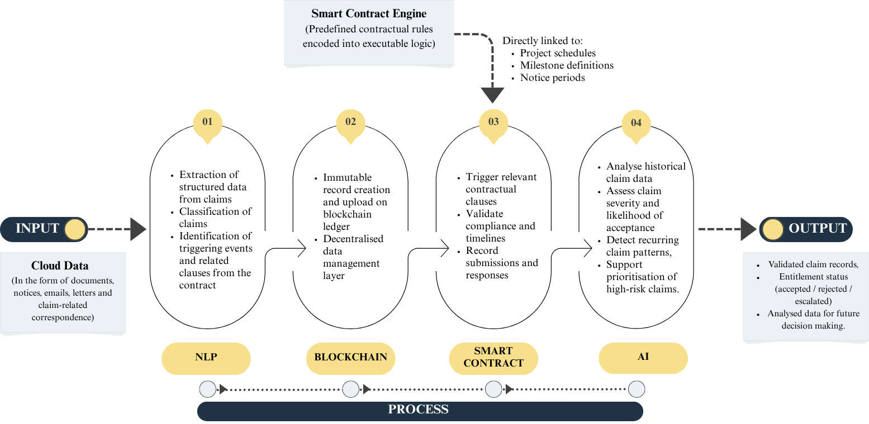

Figure 1 Conceptual model for Integrated claim Management Framework
- WORKFLOW ARCHITECTURE
Figure 2 presents the end-to-end claim management workflow across the four layers of the proposed framework. When a potentially disruptive site event occurs, relevant project records are uploaded to the cloud repository and become available for processing. In Layer 1, the NLP engine analyses the uploaded documentation, detects a potential claim event, links the event to relevant contractual clauses and schedule baselines, and generates a structured claim record. In Layer 2, the claim record together with cryptographic references to supporting documents is committed to a permissioned blockchain, thereby creating a time-stamped and tamper-evident evidence trail accessible to authorised parties. Layer 3 applies smart contract logic to assess procedural compliance, including notice periods, document completeness, and preliminary entitlement conditions, and updates the claim status accordingly. In Layer 4, AI-based analytics evaluate claim severity, estimate entitlement likelihood, and assess potential time and cost implications to support negotiation, determination, or escalation. Once a claim is resolved, the outcome is fed back into the analytical layer to improve subsequent predictions and into the governance logic to support continuous refinement of contractual and procedural settings.
This conceptual workflow responds directly to a recurring finding in the literature: claims become problematic not only because they arise, but because they are fragmented across systems, inconsistently documented, and evaluated through processes that lack transparency and shared verification. By combining verifiable evidence capture, codified procedural checks, and data-driven analytics, the framework repositions claim management as a more structured, auditable, and proactive process.
To illustrate the workflow, consider a delay claim arising on a metro rail infrastructure project delivered under a FIDIC-based contract. A late issue of revised structural drawings triggers a potential Extension of Time and associated prolongation cost claim. In Layer 1, the NLP engine analyses the data and the event, extracts relevant entities and delay attributes, and generates a structured claim record. In Layer 2, the notice and supporting documents are anchored to the blockchain through cryptographic hashes, creating a verifiable evidence trail. In Layer 3, smart contract logic evaluates compliance with notice requirements and documentation rules, and records the resulting claim status. In Layer 4, the analytics module estimates entitlement likelihood, probable time impact, and similarity to previously resolved cases, thereby supporting professional review and determination. Once the claim is concluded, the outcome is reintroduced into the learning pipeline to strengthen future assessments.

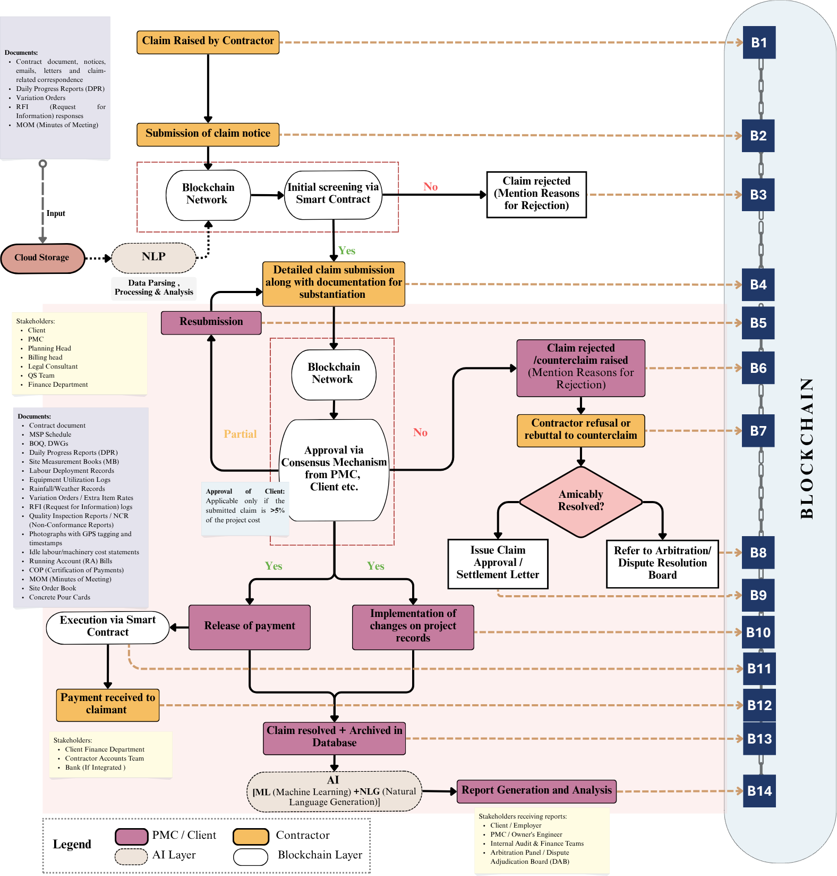

Figure 2. Claim Management Workflow

- CONCLUSION, LIMITATIONS AND FUTURE WORK
Construction claim management has long suffered from scattered records, centralized control of documents, and weak evidence trails that allow disputes to grow beyond their origins. The literature consistently highlights the late recognition of triggering events, poorly issued notices, and imbalances in information between contracting parties as the main causes of hostile outcomes. These problems arise from manual, document-driven processes that are not suited to fix them. This paper suggests a four-layer framework that combines NLP-based data collection, a permissioned blockchain for evidence, smart contracts with defined rules, and AI-driven analysis. This approach aims to change claim management into an ongoing, data-rich process, rather than just a response to past events. The intent is not to substitute professional judgment, but to narrow opportunities for manipulation, enhance transparency, and strengthen the evidentiary basis for decisions.
There are, however, important limitations in both design and applicability. The framework assumes a relatively high level of digital maturity, including reliable access to structured and unstructured project data, stable connectivity, and a willingness among contracting parties to adopt shared digital infrastructure, which may not hold in smaller projects or in resource‑constrained environments. Its current formulation is aligned with standardised contract conditions and claim procedures; adaptation to bespoke contracts or informal practices will require additional modelling effort and domain calibration. Questions also remain regarding the legal admissibility and probative value of blockchain‑anchored records across jurisdictions, organisational resistance to shared ledgers and increased transparency, and the effort required to encode heterogeneous standard forms into robust smart‑contract logic.
Future work should therefore include pilot implementations on live projects with varying sizes and delivery models, co‑developed with industry partners; engagement with legal and dispute‑resolution experts to assess enforceability and evidentiary standards; and progressive enhancement of the analytics layer using longitudinal, real‑world claim datasets. As projects scale in size, complexity, and contractual interdependence, the case for tamper‑evident, analytically supported claim processes moves from being an optional innovation to an essential component of resilient project governance.

REFERENCES
Alrasheed, K., Bahman, M., Soliman, ; Ehab, & Albader, H. (2025). Enhancing Claims Management in the Construction Industry Using Analytic Hierarchy Process. https://doi.org/10.1061/JLADAH
Chaphalkar, N., & Iyer, K. C. (2014). Factors Influencing Decisions on Delay Claims in Construction Contracts for Indian Scenario. Australasian Journal of Construction Economics and Building, 14(1), 32–44. https://doi.org/10.5130/AJCEB.v14i1.3766
Gupta, P., & Jha, K. N. (2022). A Decentralized Contracting System in Digital Construction." Journal of Legal Affairs and Dispute Resolution in Engineering and Construction, 15(1), 02522002. https://doi.org/10.1061/JLADAH.LADR-938
Gupta, P., & Jha, K. N. (2023). A Decentralized and Automated Contracting System Using a Blockchain-Enabled Network of Stakeholders in Construction Megaprojects. Journal of Management in Engineering, 39(4). https://doi.org/10.1061/jmenea.meeng-5366
Gupta, P., & Jha, K. N. (2024). Determining Delay Accountability, Compensation, and Price Variation Using Computable Smart Contracts in Construction. Journal of Management in Engineering, 40(3). https://doi.org/10.1061/jmenea.meeng-5811
Gupta, P. & Zala, H. (2026). Optimizing construction equipment management with blockchain-integrated IoT systems. International Journal of Construction Management, 2026. https://doi.org/10.1080/15623599.2026.2630240
Iyer, K. C., Chaphalkar, N. B., & Joshi, G. A. (2008). Understanding time delay disputes in construction contracts. International Journal of Project Management, 26(2), 174–184. https://doi.org/10.1016/j.ijproman.2007.05.002
Iyer, K. C., & Jha, K. N. (2005). Factors affecting cost performance: Evidence from Indian construction projects. International Journal of Project Management, 23(4), 283–295. https://doi.org/10.1016/j.ijproman.2004.10.003
Jha, K.N. & Iyer, K. C. (2007). Commitment, coordination, competence and the iron triangle, International Journal of Project Management, 25(5), 527-540. https://doi.org/10.1016/j.ijproman.2006.11.009.
Kalogeraki, M., & Antoniou, F. (2024). Claim Management and Dispute Resolution in the Construction Industry: Current Research Trends Using Novel Technologies. Buildings, 14(4). https://doi.org/10.3390/buildings14040967
Kim, E. W., Park, M. S., Kim, K., & Kim, K. J. (2022). Blockchain-Based Automatic Tracking and Extracting Construction Document for Claim and Dispute Support. KSCE Journal of Civil Engineering, 26(9), 3707–3724. https://doi.org/10.1007/s12205-022-2181-z
Knight Frank. (2024). india-real-estate-a-decade-from-now-2024-11102 - Knight Frank.
KPMG-GCS-2023. (2023). KPMG-GCS-2023-India-edition. https://assets.kpmg.com/content/dam/kpmgsites/in/pdf/2023/07/KPMG-GCS-2023-India-edition.pdf
Li, J., Mao, L., & Cao, J. (2025). Process Model for Claim and Payment Management in a Construction Supply Chain Based on Smart Contracts. https://doi.org/10.1061/JCEMD4.COENG
Nalioğlu, V., Tokdemir, H., & Artan, D. (2023). Possible Impacts of Smart Contracts on Construction Claim Management. Lecture Notes in Civil Engineering, 350 LNCE, 1631–1639. https://doi.org/10.1007/978-3-031-32511-3_167
Narayan, S., Tan, H. C., & Jack, L. B. (2024). Claims management: a review of challenges faced. International Journal of Construction Management, 24(16), 1789–1795. https://doi.org/10.1080/15623599.2023.2299527
Ranjan, R., Jagannathan, M., Chandran, P. R., & Doloi, H. (2025). Addressing Documentation Issues in Construction Claims Using Natural Language Processing. Journal of Legal Affairs and Dispute Resolution in Engineering and Construction, 17(4). https://doi.org/10.1061/jladah.ladr-1348
Saygili, M., Mert, I. E., & Tokdemir, O. B. (2022). A decentralized structure to reduce and resolve construction disputes in a hybrid blockchain network. Automation in Construction, 134. https://doi.org/10.1016/j.autcon.2021.104056
Torkanfar, N., Azar, E. R., & Mccabe, B. (2023). A blockchain-based approach for managing construction claims. In 2023 European Conference on Computing in Construction: 40th International CIB W78 Conference, Heraklion, Crete, Greece, July 10–12, 2023. DOI: 10.35490/EC3.2023.264

