BIM Command Recommendation Using Dynamic Graph Neural Network

OMAR ELSAKA^{1,2}, CHANGYU DU^{1,2}, STAVROS NOUSIAS^{1,2}, ANDRÉ BORRMANN^{1,2}

¹Chair of Computing in Civil and Building Engineering, Technical University of Munich, Germany
²TUM Georg Nemetschek Institute, Technical University of Munich, Germany

ABSTRACT:

Sequential recommendation systems predict the next item a user will likely interact with using temporal patterns and contextual information learned from historical user-item interactions. This study applies a Dynamic Graph Neural Network for Sequential Recommendation (DGSR) to predict the next BIM authoring command and extends it to the inductive setting. The proposed method models the user-command interactions in the log data as a dynamic graph and trains a DGSR model to generate embeddings that capture sequential and structural information. A similarity-based weighted average aggregation is introduced for new, unseen users to transfer embeddings from the pre-trained user nodes to the new ones based on their initial interactions. These aggregated embeddings are used to predict the new user's next preference. The model is then partially retrained to enhance the new users' representations. This hybrid approach combines the advantages of pre-trained embeddings with adaptive retraining, enabling the originally transductive DGSR to accommodate the growing number of new users in production environments. Evaluations on a real-world BIM log dataset demonstrate that the proposed model offers better prediction performance compared to the Transformer-based method, showcasing the potential of dynamic graph-based recommendation systems in BIM command recommendation scenarios. The code associated with this paper is available at: https://github.com/saqqa95/DGSR_Induction

KEYWORDS
BIM command recommendation, Dynamic graph neural network, Sequential recommendation, Building Information Modeling

1. INTRODUCTION
The increasingly complex functionalities of BIM authoring tools have made the modeling process cumbersome, imposing a steep learning curve on designers. Sequential recommendation systems that predict the next actions based on users' historical interactions demonstrate the potential for accelerating the BIM authoring process. This study models user-command interaction sequences from BIM logs as a dynamic graph. It leverages a Dynamic Graph Neural Network for Sequential Recommendation (DGSR) (Zhang, M., et al., 2023) to learn graph representations. By framing the next-command prediction task as an edge prediction problem between the user and command nodes in the graph, this study aims to enhance modeling efficiency, reduce rework, and pave the way for design automation.
However, most sequential recommendation methods based on graph neural networks (GNNs) are trained in a transductive setting (Zhou, J., et al. 2020). They cannot generalize inherently to new nodes and edges unavailable during training. This poses a challenge in adapting these methods in the production environment, where new users (nodes) keep arriving at the graph, and quick predictions are required. To address this challenge in deploying DGSR for BIM command recommendation, we devised a method to derive new user preferences from users available during the transductive model training without retraining the whole model.
Specifically, the research questions explored in this paper are as follows:
- How can BIM logs be modeled as dynamic graph representations?
- How can the originally transductive DGSR model be extended to an inductive setting suitable for production environments, enabling next-command recommendations for new users not seen during training?
- How does dynamic graph-based method compare with transformer-based method in the context of BIM command recommendation?

2. RELATED WORKS
2.1 Sequential recommendation
Recent advancements in sequential recommendation systems have demonstrated the potential of deep learning techniques, such as Recurrent Neural Networks (RNNs), Transformers (Vaswani, A., et.al., 2017), and GNNs (Scarselli, F, et.al., 2009), in predicting user behavior, mainly in commercial domains.
Transformers have become a dominant architecture for sequential recommendation due to their ability to capture long-range dependencies. TiSASRec (J. LI et al., 2020) improved upon traditional approaches by explicitly incorporating both position and time interval information between user interactions using self-attention mechanisms. The SASRec model (Kang, W et al. 2018) pioneered the use of self-attention for sequential recommendation, achieving strong performance by modeling item transitions without recurrent or convolutional structures. SSE-PT (Wu, L. et al., 2020) improved upon SASRec by incorporating user embeddings and Stochastic Shared Embeddings regularization, achieving better interpretability and the ability to handle long sequences. Building upon this, BERT4Rec (Sun, F., et al. 2019) introduced a bidirectional Transformer with a Cloze task (masked item prediction), improving recommendation accuracy by considering both past and future contexts in an autoregressive manner.
Graph-based approaches have emerged as a powerful tool for learning complex user-item interactions. GNNs have been widely adopted to capture complex relational patterns in recommendation systems. SR-GNN (Bera, A., et al. 2022) models user sequences as session graphs and employs a gated GNN to learn item transition patterns, effectively capturing both local and global dependencies. GCE-GNN (Wang, Z., et al. 2020) extends this idea by incorporating global context embeddings to improve session-based recommendations. Some works, such as LESSR (Chen, T., et al. 2020), leverages graph neural networks with edge-order preservation to better model the sequential nature of interactions.
Most graph-based sequential recommendation models operate in a transductive setting. Transductive learning and inductive learning represent two distinct paradigms for embedding generation and generalization. Transductive learning assumes that all nodes, i.e., users and items, are available during training, allowing the model to directly learn and store embeddings for each node. While this can yield strong performance when the entire graph is known and static, it lacks flexibility in dynamic settings, as it cannot handle unseen nodes at inference time. In contrast, inductive learning enables the model to generalize to new users or items by learning functions that generate node embeddings based on local neighborhood structures and features rather than memorizing embeddings. The learned features can then be passed to the model to generate predictions without being retrained. This makes inductive approaches particularly suitable for real-world recommendation scenarios where the system must continuously adapt to new entities.
For instance, SURGE (Chang, J., et al. 2023) reconstructs loose item sequences into tight item-item interest graphs using metric learning. Metric learning aims to learn a task-specific distance metric, capturing the relationships between data points. SURGE then employs cluster-aware and query-aware graph convolution and pooling to dynamically extract users' core interests from noisy behavioral sequences, effectively capturing evolving preferences. GraphSAGE (Hamilton, W. L., et al. 2018) is an inductive method that generates node embeddings by sampling and aggregating features from a node's local neighborhood, enabling it to generalize to unseen nodes or entirely new graphs. Inductive me usually require rich user and command features as input, which is not easily available in BIM authoring tools.

2.2 BIM command prediction
In the context of BIM, prior research has focused on predicting command categories using RNNs (Pan, Y., & Zhang, L., 2020a) and Long Short-Term Memory (LSTM) (Pan, Y., & Zhang, L., 2020b) networks, achieving moderate accuracy. However, these approaches are limited to predicting command classes rather than specific commands.

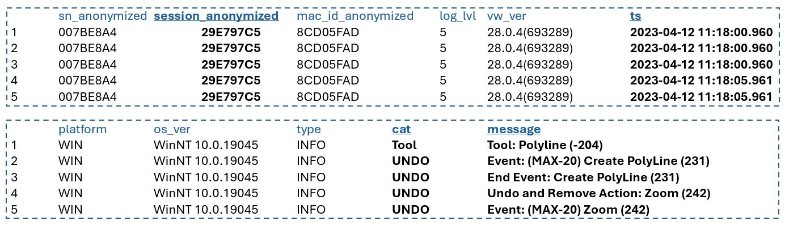
Figure 1: A sample of Vectorwork's raw event log file.

A further approach deployed a standard Transformer model (Gao. W., et.al., 2022) to predict the next command using custom Rhino logs, achieving command prediction on the instance level. The latest approach utilizes Transformer architectures from several large language models (Du, C., et.al., 2024), achieving high accuracy and real-time command suggestions.
While GNNs have shown promise in e-commerce and social media recommendation systems, their application in BIM command prediction remains unexplored. GNNs demonstrate superior performance in capturing high-order dependencies between nodes, even if they are not direct neighbors. Furthermore, they are capable of modeling user sequences of variable lengths.

3. METHODOLOGY
Our method is based on the DGSR architecture initially designed for sequential recommendation in e-commerce scenarios. As a result of our work, a trained DGSR model can be utilized to predict the next commands for new users without continuously retraining the whole graph network.
Figure 2 illustrates our methodology workflow. The method starts with preprocessing the raw event log files collected globally from the BIM authoring software Vectorworks. A preprocessing pipeline was adopted from (Du, C., et.al., 2024) to preprocess the logs to obtain the meaningful modeling sequences of the users.
The refined data is then employed in constructing a dynamic heterogeneous graph comprising user and command nodes, with edges between them representing interactions and weighted with timestamps to reflect the order of interactions. Subsequently, the DGSR is trained on the graph to obtain the final user and command embeddings. If all users were present during the training phase, the model could generate predictions as the modeling sequence expands as a link prediction between the user and command nodes.
However, when a new user is introduced, the model cannot create predictions for them without retraining. This is because the way DGSR initializes node embeddings is totally random and, without retraining, doesn't reflect actual user interests. That's why using them directly for inference would generate random predictions. This is where our method comes in use, where the graph is expanded to include the new user node and the edges between it and the commands with which it interacts are constructed. A similarity-based aggregation of the old user embeddings is then carried out to obtain a reliable embedding upon which a prediction can be made.
If more and more users arrive at the graph, the accuracy of our inference method will decay. To address this, we introduced the partial retraining method, which uses embeddings of old users to partially retrain the model only on new users, thus saving the time for a complete retraining run and improving the model's accuracy.
The following sections explain each step of the proposed method in detail.

3.1 Data filtering and preprocessing
This paper uses the same log dataset collected from the BIM authoring tool Vectorworks as in (Du, C., et.al., 2024). The raw dataset contains 25,397,138 entries collected from anonymized users from all over the world in multiple languages. Figure 2 shows the content of a sample log file.
The most important columns in the log files are "session_anonymized" which gives the ID of a modeling session; "ts" which gives the time at which a command was executed; "cat" which denotes the category of the command categorized into Tool, Menu or UNDO. Each unique session is treated as a separate user. Tool and Menu entries are high-level commands that trigger further Event entries. The UNDO commands are "Event/End Event" entries marking the start/end of low-level command execution.
We adopted the existing pipeline (Du, C., et.al., 2024) for preprocessing and filtering the dataset. The pipeline consists of several key steps. First, since BIM modelers frequently undo and redo actions as part of their workflow, an algorithm was applied to detect and remove undone commands and restore the redone ones. Next, commands such as zooming, changing views, and panning, which do not contribute to actual modeling, were excluded to prevent imbalance and irrelevant recommendations. In addition, low-level End Event commands that were automatically triggered by Tool/Menu commands were removed to avoid double-counting actions. Moreover, the dataset includes logs recorded in seven languages, which required unification for consistent processing. Commands recorded in different languages were translated into English using the Google Translate API and manually verified to ensure all translations were correct. A matchup database for Tool and Menu commands and the corresponding End Event was created for future use to facilitate the unification of the dataset. In addition, overlong modeling sessions were broken down into reasonably shorter sessions to increase the number of samples in the dataset and simulate the production environment. The processed data is then transformed into a structured CSV format, with timestamps converted to UNIX format and commands assigned unique integer IDs.

3.2 Dynamic graph construction
We represent user-item interaction sequences as a dynamic graph, where nodes correspond to users and items, and edges denote temporal interactions, as illustrated in Figure 3. This graph structure enables the model to capture direct and high-order relationships, facilitating a more comprehensive representation of user preferences.
The graph construction process begins with processing the CSV data obtained from the previous step to ensure that temporal relationships between interactions are correctly captured. This is achieved by calculating each user's relative order of interactions based on the timestamps, reflecting the sequence in which commands were executed. Similarly, each command's relative order of interactions across all users provides a global perspective on command execution over time. For instance, two-way edges are constructed between user and command nodes with edge types (' command," by," user') denoting that a user issued a specific command. In contrast (' user',' pby',' command') represents the reverse relationship. Timestamps of interactions are stored as edge features for both edge types, enabling the graph to encode temporal dynamics. User and item identifiers (user_id and command_id) are stored as node features, ensuring each node is uniquely identifiable.
Given the large-scale nature of the constructed graph, direct training on the entire graph is computationally very expensive. Instead, sub-graph sampling is employed to optimize training efficiency, as shown in Figure 3. Following a two-hop neighbor sub-sampling, a user node is selected as an anchor with their interaction sequence in the first hop, and other users interact with the same commands in the second hop. By limiting sub-graph sampling to two-hop neighborhoods, the model efficiently captures localized interaction patterns while keeping computational costs manageable. The sub-graphs then serve as the input to the DGSR model, where information flows from commands to users, encoding user preferences.

3.3 Basic transductive graph training
A DGSR (Zhang, M., et al., 2023) model is trained on the constructed graph. DGSR consists of multiple stacked layers. Each layer uses a dynamic graph attention mechanism that aggregates a user's historical interactions, assigning varying attention weights to highlight influential items that define long-term and short-term interests. Specifically, in layer $l$, a learnable relative-order embedding $p_{riu}^{K}$ is constructed for each item in an interaction sequence to encode order information. Then, attention coefficients are calculated between the user and the item as follows:
$$e_{ui}=\frac{{\left(W_{2}^{\left(l-1\right)}h_{u}^{\left(l-1\right)}\right)}^{T}\left(W_{1}^{\left(l-1\right)}h_{i}^{\left(l-1\right)}+p_{riu}^{K}\right)}{\sqrt{d}}$$
Where$W_{1}^{\left(l-1\right)}$ and $W_{2}^{\left(l-1\right)}$ are encoding matrix parameters of item and user in the $l-1th$ layer, $h_{u}$ and $h_{i}$ are the node embeddings of the user and item, respectively, $d$ is the embedding dimension and is scaled to avoid large dot products (Zhang, M., et al., 2023). The weights between user and items are then calculated by the softmax function:
$$α_{ui}=\text{softmax}\left(e_{ui}\right)$$
The long-term $h_{u}^{L}$ and short-term $h_{u}^{S}$ preferences of the user are then obtained by adaptively aggregating neighboring item nodes' information:
$$h_{u}^{L}=\sum_{i∈N_{u}}{α_{ui}\left(W_{1}^{\left(l-1\right)}h_{i}^{\left(l-1\right)}+p_{riu}^{V}\right)}$$
$$h_{u}^{S}=\sum_{i∈N_{u}}{α_{ui}h_{i}^{\left(l-1\right)}}$$
Where $p_{riu}^{V}$ is learnable relative order embedding to capture the order information in user message aggregation and $N_{u}$ indicates the number of users $u'$s neighbor nodes. Similarly, the long- and short-term characters of items are obtained by aggregating neighboring user preferences using the exact mechanism.
Once the message propagation mechanism aggregates long-term and short-term information, as well as the previous layer embedding, the node representations are updated for the next layer.
The user and item node embeddings are updated using the following equations:

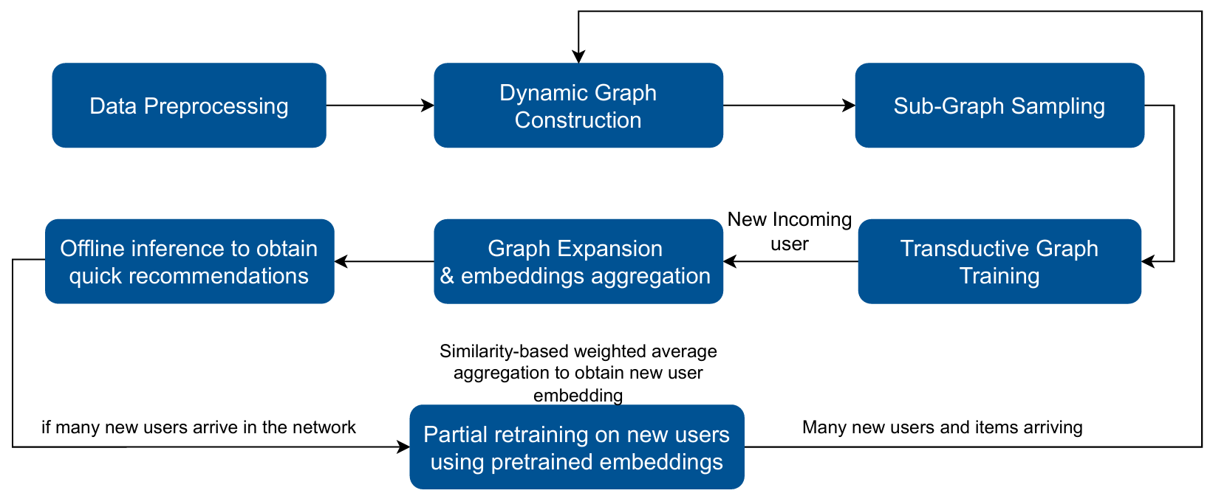
Figure 2: Overview of our methodology's workflow.

$$h_{u}^{\left(l\right)}=\tanh\left(W_{3}^{\left(l\right)}\left[h_{u}^{L}|h_{u}^{S}|h_{u}^{\left(l-1\right)}\right]\right)$$
$$h_{i}^{\left(l\right)}=\tanh\left(W_{4}^{\left(l\right)}\left[h_{i}^{L}|h_{i}^{S}|h_{i}^{\left(l-1\right)}\right]\right)$$
These components ensure adaptability to dynamic user behaviors. The model propagates and aggregates information across higher-order connections by stacking multiple layers, capturing
complex collaborative signals.
Finally, the training objective is to predict the presence of an edge between the user and command nodes at the target timestamp with the following objective function:
$$L=-\sum_{u}{\sum_{i∈I}{y_{ui}}\log{\hat{y_{ui}}}}+\left(1-y_{ui}\right)\log\left(1-\hat{y_{ui}}\right)+λ|Θ|^{2}$$
The main problem with DGSR is that it cannot inherently generalize to new users that arrive in the graph. It must be retrained from scratch to capture new user's interests and provide reliable recommendations. In order to bridge this gap, we introduced a similarity-based induction approach.

3.4 Similarity-based induction
After successfully training the original DGSR model following the transductive approach proposed by its authors, the method is further developed to accommodate real-world production environments. In a typical production scenario, a new modeler joining the team will have no prior modeling history. Since DGSR operates in a transductive manner, where all user nodes must be present during training to learn their preferences, the model cannot predict the next command for a new user who was unseen during training.
To address this limitation, we expanded the original graph to include the new user's node and timestamped edges representing their interactions with the first few commands in the interaction sequence. By incorporating these edges, the dynamic development of the new user's interaction sequence was captured. Subgraphs were then constructed for the new user, focusing on their most recent interactions, which simulate the sequential and dynamic nature of user-command interactions within a graph structure. This step ensures that the new user's node can receive collaborative signals from users with the same preferences within the graph.
To construct a reliable representation for the new user, the embeddings of existing users (who were present during training) were leveraged. First, the interaction sequences of the new user were compared with those of the pretrained users using the Jaccard similarity coefficient (Bag, S., et al. 2019). The Jaccard similarity $J$ measures the overlap between two sets of commands normalized by their union, providing an intuitive way to quantify behavioral similarity.
$$J\left(u_{\text{new}},u_{i}\right)=\frac{\left|S_{\text{new}}∩S_{i}\right|}{\left|S_{\text{new}}∪S_{i}\right|}$$
Where $S_{\text{new}}$ is the set of items (commands) interacted with by the new user, $S_{i}$ is the set of commands interacted with by an existing user $u_{i}$, nominator is the number of shared commands between $S_{\text{new}}$ and $S_{i}$, and the denominator is the total number of unique commands in their union.
Once the similarity scores were obtained, the embeddings of the similar pretrained users were aggregated to generate the embedding for the new user. This aggregation was performed as a weighted average, where the weights correspond to the Jaccard similarity scores. Users with higher similarity contributed more to the final embedding, ensuring that the generated embedding accurately reflected the new user's interaction behavior.
$$E_{\text{new}}=\frac{\sum_{i∈N}{J\left(u_{\text{new}},u_{i}\right)}⋅E_{i}}{\sum_{i∈N}{J\left(u_{\text{new}},u_{i}\right)}}$$
where $E_{new}$is the new user's embedding reflecting his interests and $E_{i}$ is the embedding of each of the older user's embeddings, as illustrated in Figure 4. In situations where no meaningful similarity could

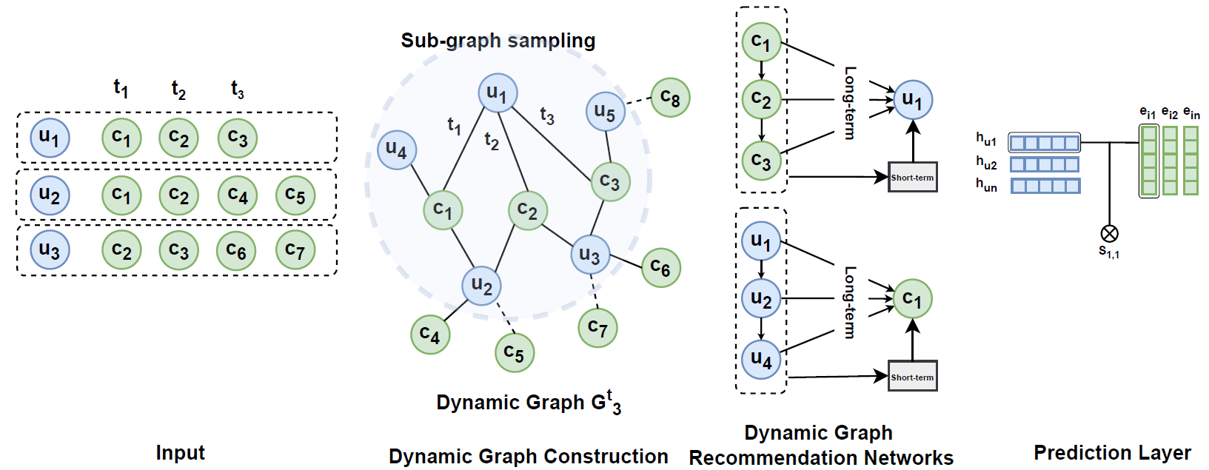
Figure 3: The DGSR framework uses input sequences to construct a dynamic graph. Sub-graphs are constructed for each user and item node to aggregate messages and update the node embedding. Each sub-graph is limited to a maximum sequence length. Long-term and short-term interests are modeled using an order-aware attention mechanism. Final user embeddings from each layer are concatenated to form the user's unified embedding. Prediction is then made by matrix multiplication between the users' unified and item embeddings (ZHANG et al., 2022)

not be established between the new user and any pretrained user (e.g., due to a lack of sufficient interaction data), a default embedding was assigned to the new user. This default embedding was computed as the mean of all pretrained user embeddings, providing a fallback representation that captures the general distribution of user preferences observed during training.
The newly generated embeddings for the new users were combined with the pretrained user
embedding vector, resulting in an updated set of user embeddings. This updated vector was saved back into the model's state dictionary, enabling the DGSR model to include both the original and new users during inference. The model was then reloaded with the updated embeddings and set to evaluation mode, and predictions were created offline, allowing for quick predictions for incoming users.
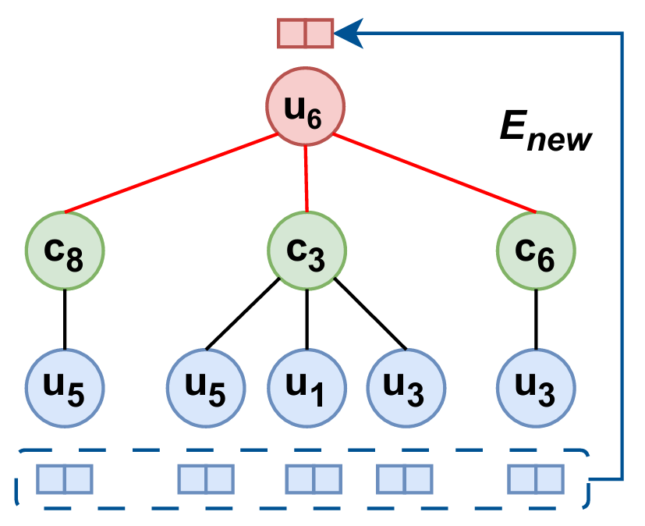
Figure 4: Second-order sub-graph of a new user 6. We aggregate old (blue) user embeddings to get new (red) user embedding E_{new}. The green nodes indicate interacted commands.

3.5 Partial retraining
If many new users arrive in the graph with interaction sequences distinct from training data, the similarity-based offline inference method will not yield reliable predictions. This is due to increased interaction sequences with distinctive modeling behavior, which will not be known to the model. Typically, in a transductive setting, a whole retraining of the entire graph will then be required.
In order to save computational cost, we extended our similarity-based inference method to partially retrain the model to learn user representations. The graph is expanded to include all the new users with their interaction sequences. Then, their sub-graphs are sampled using the same approach previously described.
Instead of passing the sub-graphs of all users, including old and new users, to the model, the subgraphs of only the new users are passed to the model. Since the sub-graphs are of second degree, old user nodes will appear in the 2-hop level, enabling message passing from the old user level to the command level and ending at the new user level.
Eventually, the node update will update the new users' representations, reflecting their true preferences as well as the collaborative signals from old users, as illustrated in Figure 5. Consequently, the whole network's accuracy is raised above this of the similarity-based inference method in a shorter time compared to retraining using the entire graph.
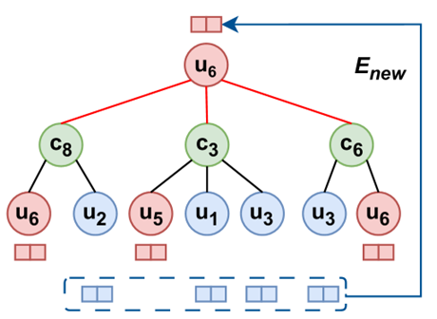
Figure 5: We aggregate old (blue) user embeddings to get new (red) user embedding E_{new}. The green nodes indicate interacted commands. Red embeddings are embeddings of old user nodes that are used as input to the partial retraining step.

4. RESULTS AND ANALYSIS

4.1 Dataset and setup
The preprocessing of the dataset, introduced in Section 3.1, aimed to remove redundancies and irrelevant commands in the raw BIM event logs to improve its suitability for training. The resulting processed dataset statics are illustrated in Table 1.

Table 1: The dataset after preprocessing and splitting
 | Preprocessed | Train | Test
Users | 1,000 | 1,000 | 1,000
Sessions | 13,613 | 10,000 | 3,613
Commands | 1,146 | 1,146 | 1,146
Interactions | 599,374 | 444,647 | 154,727
Avg. session length | 44 | - | -

The dataset was split into an 80-20 split. The training dataset was sampled by collecting the minimum number of modeling sessions that contain all unique commands to avoid encountering unseen command nodes during inference. For each session in transductive training, the last interaction was left out for testing, the second last for validation, and the rest of the sequence for training.
The evaluation of our similarity-based inference for unseen users also takes place by predicting the last interaction of sessions in test set. Suppose the last command that needs to be predicted was executed several times throughout the session. In that case, we drop it from the whole session to ensure the prediction takes place based on the collaborative signals received from other users, as shown in Figure 6. By emphasizing the uniqueness of the final interaction, the model focuses on capturing meaningful patterns that are more likely to generalize across users and scenarios.
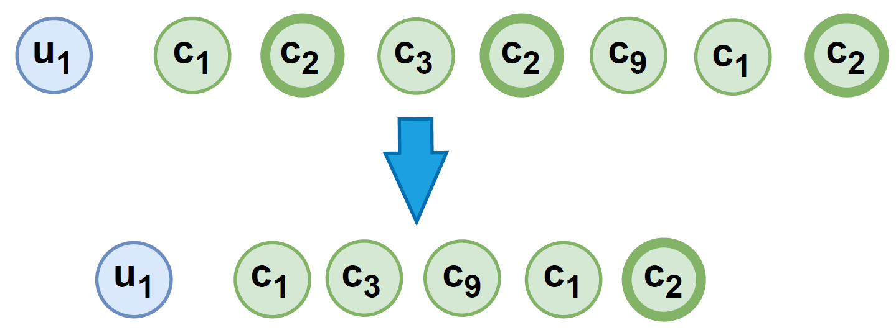
Figure 6: Repeated interactions with the same command are removed, retaining only the final unique interaction in the sequence to improve model generalization and prevent overfitting.

Also, to demonstrate the effectiveness of our method, we compared the results obtained from our method to the results of a transformer-based model (Du, C., et.al., 2024) trained on a similar dataset.

4.2 Implementation details
The DGSR model is initialized with a hidden state size of 50, dropout rates of 0.3 for both feature and attention mechanisms, and a layer count of 3 for the GNN architecture. Adam optimizer was configured with a learning rate 0.001 and weight decay (L2 regularization) of 0.0001. The loss function employed is Cross-Entropy Loss, which evaluates the discrepancy between the predicted and actual labels.
The training process includes batching with a size of 50 and uses multi-threaded DataLoader instances for efficient data handling. This means that each batch contains 50 user sub-graphs. In each sub-graph, maximum user and command lengths are limited to 50, denoting the maximum length of interactions considered in a sub-graph.
The network employed in this study was trained and tested on a laptop with a 3.20 GHz AMD Ryzen 7 5800H processor, an 8 GB GeForce RTX 3070 GPU, and 16 GB RAM. In addition, another desktop was used to train the model on relatively larger graphs with 5 GB GPU and 32 GB RAM, noting that larger graphs require higher memory resources. In addition, due to large memory requirements, mixed precision training was used to decrease memory requirements.

4.3 Evaluation metrics
This study used Recall@n and NDCG@n metrics to evaluate the utilized network's performance and the developed methodologies. Those metrics are widely used in sequential recommendation models (Kang & McAuley, 2018). Recall@N measures the fraction of relevant items successfully retrieved among the top-N recommendations. It is a widely used metric in recommendation systems to evaluate how well a model captures the relevant items in its predictions. Recall@N focuses on whether the system retrieves as many relevant items as possible within the top-N positions. A higher Recall@N indicates better performance covering relevant items for a given user.
Normalized Discounted Cumulative Gain (NDCG) (Kang & McAuley, 2018) is a metric that evaluates the ranking quality of a recommendation system by considering both the relevance of the recommended items and their positions in the ranked list. Specifically, NDCG@10 focuses on the top 10 recommended items. The calculation of NDCG involves three steps: first, the Discounted Cumulative Gain (DCG) is computed, which uses a logarithmic discount factor to reduce the contribution of relevant items appearing lower in the ranking.

4.4 Evaluation of the transductive method
The original transductive method reported by DGSR was evaluated on the training dataset summarized in Section 4.1. User sequences with less than 3 interactions were excluded from training because they might induce noise in the network. The interaction sessions were passed to the training step, with the last interaction masked for testing, the second last for validation, and the rest for training. Accuracy is measured by measuring the model's ability to predict the last interaction.
Although the original method yields high prediction accuracy in predicting existing users' preferences, it cannot inherently generalize to unseen users nor generate real-time predictions. The model's architecture is designed for a transductive setting, meaning it cannot be directly transferred to new graphs or learn embeddings for new users on the fly. Consequently, the model must be retrained on the entire graph to utilize the interaction history of all users for generating predictions for a new user. This approach is computationally expensive and impractical due to the long training times involved. For instance, second-degree subgraph sampling for a dataset with 13,613 sessions, 599,374 interactions, and a maximum user and command sequence length of 50 requires about 30 minutes. Additionally, each epoch takes around 2.5 hours to learn representations for all users and commands. With 10 epochs, the total training time is approximately 25 hours.
Despite these limitations, the results achieved with this approach demonstrate higher accuracy than those reported by the authors of the DGSR model. This improvement can be attributed to the dense interaction matrix in our dataset, which has a density of 57.39%, compared to 0.01%, 0.04%, and 0.08% in the e-commerce datasets used to evaluate the original model. Furthermore, our dataset features an average session length of approximately 44. This greater density and session length provide richer interaction data, contributing to improved performance. We didn't compare our evaluation metrics with the authors since the datasets differ totally in properties and application scenarios.

Table 2: Results of the transductive method on the training dataset
Metric | Count
Recall@5 | 0,8613
Recall@10 | 0,9187
NDCG@5 | 0,7601
NDCG@10 | 0,7833

4.5 Evaluation of similarity-based induction and partial retraining
We evaluate the proposed similarity-based induction and partial retraining methods on the test set. Our method is evaluated by measuring its ability to predict the final interaction in each session of the test set. In contrast, the remaining interactions in the sequence are used to generate the embedding for the new user (using either the similarity-based or partial retraining method). The results are demonstrated in Table 3.
Our results confirm that the proposed similarity-based inference method provides a practical alternative for generating embeddings for new users without retraining the model. The performance is further enhanced through the partial retraining on the unseen users. Although the accuracy might slightly decrease compared to completely retraining the model on the new graph, the trade-off between efficiency and accuracy is reasonable as it can effectively generate predictions for unseen users.

Table 3: Results of similarity-based and partial retraining
Metric | Similarity-based | Partial retraining
Recall@5 | 0,8134 | 0,8223
Recall@10 | 0,8571 | 0,8914
NDCG@5 | 0,6793 | 0,7002
NDCG@10 | 0,7152 | 0,7395

For instance, each epoch of the partial retraining of the model on the test set (3,613 sessions) with approximately 100k interactions requires around 7 minutes of training. Consequently, the model converges quickly since it utilizes the pre-trained embeddings of the sessions in the training set, allowing for improving the model's performance without requiring full parameter updates.

4.6 Comparison with Transformer-based method
The results of our method compared to the results of the Transformer-based model (Du, C., et.al., 2024) are reported in Table 4. We use the similarity-based method for fairness, as it has not been partially retrained on the test set, aligning with the settings used in the other study. Our similarity-based induction method performs better in Recall@5, NDCG@5, and NDCG@10 metrics.

Table 4: Results of similarity-based and Transformer-based
Metric | Similarity-based | Transformer-based
Recall@5 | 0,8134 | 0,7810
Recall@10 | 0,8571 | 0,8616
NDCG@5 | 0,6793 | 0,6501
NDCG@10 | 0,7152 | 0,6765

5. DISCUSSION AND FUTURE WORK
The proposed inference methods offer a remedy to the lack of generalization of the original DGSR model. The proposed similarity-based induction outperforms Transformer-based methods in metrics.
One potential reason could be that DGSR enables more fine-grained modeling of temporal dynamics through timestamped edges and dynamic graph evolution. This may allow it to capture temporal patterns more effectively than Transformers, which typically rely on positional encoding or timestamp embedding. In addition, the graph structure inherently connects different users interacting with the same item and different items interacted by the same user. The DGSR uses the attention mechanism combined with relative order-aware message propagation to aggregate information from neighboring nodes, thus learning the collaborative signals. In contrast, Transformers mainly focus on item dependencies within the individual sequences. This makes the modeling of cross-user and cross-sequence collaborative information less direct.
However, the Transformer-based method has advantages regarding the computation time. It is deployable without constructing a big graph and sampling huge numbers of sub-graphs. While our method offers high accuracy, Transformer methods offer a more scalable solution in dynamic environments where quick predictions are needed.
The current dataset, although collected from a BIM authoring tool, predominantly consists of commands like those found in traditional CAD environments (e.g., "Create Line", "Trim", "Drag") and lacks detailed information about modeled objects from specific disciplines. While the implemented method demonstrates high accuracy in predicting historical interaction sequences, it fails to account for the contextual relevance of recommended commands to the objects being modeled. This shortcoming is primarily due to the absence of object-related metadata in the event logs. To address this, the integration of an IFC logger, as suggested by (Kouhestani, S., et al., 2020) could enrich the dataset by recording the modeled objects along with their spatial and temporal context, such as the view or plan in which they were created, there global position, or relation to neighboring objects. Aligning this object-level information with command sequences would enable the identification of task-specific user behaviors and improve short-term preference modeling.
As proposed by (HSU & LI, 2021), an approach comprising a tripartite graph structure, incorporating users, commands, and objects as node types, can then be constructed to support inductive learning of node representations. By leveraging object attributes, command semantics, and user profiles (e.g., architect, structural engineer), such framework can enhance the prediction of future user interactions. This approach would benefit from data collected in controlled environments where the modeling tasks and associated objects are included in a timeline, knowing which commands were used to create which objects. Ultimately, combining collaborative and content-based filtering, yielding more accurate and explainable command recommendations.

6. CONCLUSION
In this paper, we apply DGSR to predict the next BIM authoring commands and extend it to inductive settings. The contributions of the study can be summarized as follows:
- Addresses a research gap where similar studies on BIM command recommendation have not yet explored the application of Dynamic Graph Neural Networks.
- The proposed similarity-based inference mechanism offers a scalable solution for graph-based recommendation systems, making the approach suitable for production environments.
- The proposed method outperforms the transformer-based model trained and tested on the same dataset.
This study contributes to the broader goal of improving BIM modeling efficiency through an intelligent predictive system while addressing possible engineering challenges when deploying such a system.

ACKNOWLEDGEMENT
This work is funded by Nemetschek Group, which is gratefully acknowledged. We sincerely appreciate the data and licensing support provided by Vectorworks, Inc.

REFERENCES
Bag, S., Kumar, S.K. and Tiwari, M.K., 2019. An efficient recommendation generation using relevant Jaccard similarity. Information Sciences, 483, pp.53-64.
Du, C.,Deng, Z., Nousias, S., & Borrmann, A., (2024). Towards commands recommender system in BIM authoring tool using transformers. https://arxiv.org/abs/2406.10237
Gao, W., Zhang, X., He, Q., Lin, B., & Huang, W., (2022), Command prediction based on early 3D modeling design logs by deep neural networks. Automation in Construction, 133. https://doi.org/10.1016/j.autcon.2021.104026
Pan, Y., & Zhang, L., (2020a). Sequential design command prediction using bim event logs.
Pan, Y., & Zhang, L., (2020b). Bim log mining: Learning and predicting design commands. Automation in Construction, 112. https://doi.org/10.1016/j.autcon.2020.103107
Scarselli, F., Gori, M., Tsoi, A., Hagenbuchner, M., & Monfardini, G., (2009). The Graph Neural Network Model. IEEE Transactions on Neural Networks. 20, no. 1, pp. 61-80.
Vaswani, A., Shazeer, N., Parmar, N., Uszkoreit, J., Jones, L., Gomez, A., Kaiser, L., & Polosukhin, I., (2017). Attention is all you need. In Proceedings of the 31st International Conference on Neural Information Processing Systems (NIPS'17). 6000–6010. https://arxiv.org/abs/1706.03762
Zhang, M., Wu, S., Yu, X., Liu, Q., & Wang, L., (2023). Dynamic Graph Neural Networks for Sequential Recommendation. IEEE Trans. on Knowl. and Data Eng. 35, p. 4741–4753. https://doi.org/10.1109/TKDE.2022.3151618
Zhou, J., Cui, G., Hu, S., Zhang, Z., Yang, C., Liu, Z., Wang, L., Li, C. and Sun, M., 2020. Graph neural networks: A review of methods and applications. AI open, 1, pp.57-81.
Li, J., Wang, Y., & McAuley, J., (2020), Time interval aware self-attention for sequential recommendation. Proceedings of the 13th International Conference on Web Search and Data Mining (WSDM '20), 322–330. https://doi.org/10.1145/3336191.3371786
Wu, L., Li, S., Hsieh, C.-J., & Sharpnack, J., (2020), SSE-PT: Sequential recommendation via personalized transformer. Proceedings of the 14th ACM Conference on Recommender Systems (RecSys '20), 328–337. https://doi.org/10.1145/3383313.3412258
Kang, W.-C., & McAuley, J., (2018), Self-attentive sequential recommendation. https://arxiv.org/abs/1808.09781
Sun, F., Liu, J., Wu, J., Pei, C., Lin, X., Ou, W., & Jiang, P., (2019), BERT4Rec: Sequential recommendation with bidirectional encoder representations from transformer. Proceedings of the 28th ACM International Conference on Information and Knowledge Management (CIKM '19), 1441–1450. https://doi.org/10.1145/3357384.3357895
Bera, A., Wharton, Z., Liu, Y., Bessis, N., & Behera, A., (2022), SR-GNN: Spatial relation-aware graph neural network for fine-grained image categorization. IEEE Transactions on Image Processing, 31, 6017–6031. https://doi.org/10.1109/TIP.2022.3205215
Wang, Z., Wei, W., Cong, G., Li, X.-L., Mao, X.-L., & Qiu, M., (2020), Global context enhanced graph neural networks for session-based recommendation. Proceedings of the 43rd International ACM SIGIR Conference on Research and Development in Information Retrieval (SIGIR '20), 169–178.
https://doi.org/10.1145/3397271.3401142
Chen, T., & Wong, R., (2020), Handling information loss of graph neural networks for session-based recommendation. Proceedings of the 43rd International ACM SIGIR Conference on Research and Development in Information Retrieval (SIGIR '20), 1172–1180. https://doi.org/10.1145/3394486.3403170
Chang, J., Gao, C., Zheng, Y., Hui, Y., Niu, Y., Song, Y., Jin, D., & Li, Y., (2023), Sequential recommendation with graph neural networks. https://arxiv.org/abs/2106.14226
Hamilton, W. L., Ying, R., & Leskovec, J., (2018), Inductive representation learning on large graphs. https://arxiv.org/abs/1706.02216
Kang, W.-C., & McAuley, J. (2018). Self-attentive sequential recommendation. In arXiv preprint arXiv:1808.09781.
https://arxiv.org/abs/1808.09781
Hsu, C., & Li, C.-T. (2021). Retagnn: Relational temporal attentive graph neural networks for holistic sequential recommendation. Proceedings of the 27th ACM SIGKDD Conference on Knowledge Discovery & Data Mining,2968–2979. https://doi.org/10.1145/3442381.3449957
Kouhestani, S., & Nik-Bakht, M. (2020). IFC-based process mining for design authoring. Automation in Construction, 112, 103069. https://doi.org/10.1016/j.autcon.2019.103069

