Voxel-Based Spatial Deviation Analysis in TBE Systems
Comparing Holistic and Component-Specific Approaches
TRISTAN KINNEN¹, JÖRG BLANKENBACH¹
¹ Geodetic Institute and Chair for Computing in Civil Engineering & GIS, RWTH Aachen University, Germany
E-Mail: [kinnen, blankenbach]@gia.rwth-aachen.de

ABSTRACT

The commissioning of technical building equipment (TBE) increasingly involves complex systems and extensive documentation requirements. Investigating methods for creating a digital twin of TBE systems at the time of commissioning therefore holds significant potential. Building Information Modeling (BIM) can provide valuable data from the planning stage for that purpose. In practice, planning often deviates from the actual built state, so that a comparison must first be made. However, this step remains a time-consuming and manual process. This study examines automatic voxel-based methods for geometric deviation analysis. The first method supports component-level evaluation using localised geometry comparisons. The second uses occupancy grids for holistic spatial assessment. The third integrates scan trajectories to filter the as-planned model based on visibility, enabling more realistic component comparison. Each method offers context-specific strengths, while the combined approach improves reliability under occlusion, though with higher computational demands.

KEYWORDS

Scan-vs-BIM, Voxelization, Technical Building Equipment

1. INTRODUCTION
As building technology continues to advance, the commissioning and operation of TBE systems present growing challenges, particularly in the implementation of energy-saving measures necessitated by climate change. Digital models of buildings and TBE systems, based BIM, can be very useful in overcoming these challenges. BIM models can be utilized across all phases in the life cycle, from planning through commissioning to operation. By consistently aligning the digital model with the actual condition, BIM models can become Digital Shadows that mirror the physical state of the building from the execution phase onwards. Especially in the context of TBE systems, the further enrichment of Digital Shadows to Digital Twins by employing real-time sensor data and energy simulations to obtain data for optimizing the real system offers great potential.
Based on this, the research project energyTWIN (Becker et al., 2022; Blut et al., 2024; energyTWIN, 2025) aimed to develop a Digital Twin of TBE systems at the time of commissioning. For the fundamental process of Reality Capturing, the Mixed Reality (MR) headset Microsoft HoloLens 2 (MHL2) was selected and evaluated. As a mobile data acquisition system, it enables a less obstructed capture of complex TBE systems compared to stationary methods (e.g. terrestrial laser scanning). In contrast to mobile laser scanners, the head-mounted MHL2 offers a hands-free acquisition process and intuitive usability, even for non-expert users. A detailed evaluation of the MHL2 as a tool for reality capturing has been presented in (Kinnen et al., 2023).
To establish a comprehensive geometric-semantic digital foundation, it is essential to identify and address deviations between the planned data (as-planned) and the actual built condition (as-built). This process is critical to ensuring the fidelity of the digital representation.
However, due to the intricate structure of TBE systems and their densely packed environments, the comparison between as-planned and as-built states is typically performed manually. Since manual effort demands substantial time and financial resources, automating the comparison process offers significant potential for improving efficiency and reducing both the time and costs associated with inspections in TBE systems.
For this reason, we divided the methodological comparison of as-planned and as-built data in three distinct stages. Firstly, a robust approach for detecting geometric deviations was established. This stage focuses on the analysis of geometric discrepancies, enabling the visual representation of identified deviations. Secondly, a component-specific validation was conducted, designed to automatically assess whether individual components are installed precisely according to the planning data, whether they are misaligned due to rotation or translation, or whether components are missing or replaced at the respective locations. Finally, based on the results of the component-specific validation, an automated as-is modelling of the TBE system was considered.
In this paper, we present the methods we have developed for the first of those stages that covers geometric deviation analysis in the context of TBE systems. The presented approaches are intended as an initial step for identifying spatial deviations. A detailed validation of individual TGA components is not yet part of this stage and will be addressed in subsequent work. To process large data sets efficiently and reduce computational demands, with a view towards potential applications on XR devices, we decided to focused on voxel-based methods, which provide a consistent framework for analysing point cloud data and eliminates common issues such as outliers and occlusions. By voxelization, the geometric structure is divided into cubic segments of the same size (voxels), creating a discrete representation of the scene. Therefore, we started with a simple and straightforward approach tailored to the limited capabilities of the MHL2 and gradually refined this method to improve the results.
Below, we first present the state of the art, followed by a detailed presentation of our voxel-based methods. Subsequently, the achieved results are presented and evaluated on a representative data set.

2. STATE OF THE ART
Ensuring the consistency of as-planned and as-built data is a critical challenge within the BIM context, often requiring substantial manual intervention. Consequently, automated approaches for this alignment have become a focal point of research. (Meyer et al., 2022) presents a method for the detection of deviations based on occupancy grids, where voxels are classified as occupied, empty, or unknown. Changes are identified through a direct comparison of voxel states between two epochs. In a similar approach, an adaptive neighbourhood analysis based on the occupy grids is presented in (Hirt et al., 2021), which takes into account variations in point density and measurement inaccuracies to improve accuracy. (Katsura et al., 2019) proposes an extended approach using Normal Distributions Transform (NDT) voxels, which classify point distributions based on geometric features such as planar and linear structures. To mitigate quantization errors, overlapping voxels are employed, while a voting mechanism across multiple measurements reduces the impact of sensor noise. A more advanced approach is presented by (Martens and Blankenbach, 2021) using a voxel-based conversion of point clouds into 2D projections. By analysing the vertical point densities, walls and other structures can be effectively segmented. In contrast, (Park et al., 2021) present a method based on modifiable nested octree indexing of surface meshes and point clouds, resulting in significantly faster execution.
(Pătrăucean et al., 2015) claims that a key concept for the deviation analysis of as-planned and as-built data is the transformation of BIM data into point clouds, enabling a direct comparison with as-built datasets through uniform data types. Following this, various methodologies have been proposed to facilitate this comparison. For instance, geometric feature extraction techniques allow for a structured analysis of point cloud data, as demonstrated by (Gumhold et al., 2001), who introduced a method for detecting edges and corners based on local point density variations. Another approach, presented by (Anil et al., 2013), calculates the minimal Euclidean distance between as-built point cloud data and corresponding objects in the as-planned BIM. Deviations exceeding a predefined threshold serve as indicators of potential inaccuracies in model generation or data capture processes. Additionally, (Chen and Yong K. Cho., 2018) describe a methodology combining Random Sample Consensus (RANSAC) with a column-detection algorithm, where BIM models are converted into point clouds to enable direct point-wise comparisons. (Kim et al., 2020) introduced an approach for monitoring project progress by combining 3D point cloud data with the 4D parameters of BIM through the application of the Scan-vs-BIM method. Another Scan-vs-BIM approach specifically designed for industrial facilities was proposed by (Lin et al., 2025), in which the precise object axes are extracted from point clouds and used to update the associated BIM model. In the same context, (Jiang et al., 2022) presents a semi-automated approach to progress monitoring in infrastructure construction, enabling real-time evaluation of 3D point clouds using Hausdorff distance and Poisson surface reconstruction.
Compared to general construction elements, TBE systems present additional challenges for Scan-vs-BIM approaches due to their complex geometries and frequent occlusions. (Bosché et al., 2014) introduced a method that involves segmenting and assigning as-built point cloud data based on distance and normal vector alignment with corresponding BIM elements. Non-matching points are filtered, and occlusion effects are accounted for by segmenting obstructing elements. A different approach, designed specifically for inspecting piping systems, was developed by (Nguyen and Choi, 2018). Their method applies geometric analysis to object-segmented point clouds derived from as-built and as-planned datasets, with metrics such as mean distance error and point-based distance deviations used for validation. Complementary to these strategies, (Kawashima et al., 2013; Kawashima et al., 2014) proposed an alternative segmentation technique employing a normal-based region-growing method, followed by cylinder fitting to identify piping components. In contrast, (Kalasapudi et al., 2014) introduced a graph-based framework for automated spatial change analysis of components that links point clouds from 3D laser scans with as-designed BIM models based on their spatial relations. These approaches demonstrate that while Scan-vs-BIM for TBE systems remains a challenging task, geometric analysis techniques provide a viable pathway for automating the comparison between as-planned and as-built data. However, the presented methods are not suitable for a high-performance implementation on the MHL2, given their computational requirements.
Beyond conventional geometric analysis methods, machine learning and deep learning techniques are gaining increasing attention in the automation of Scan-vs-BIM processes. AI-driven approaches have already demonstrated their effectiveness in reconstructing building components, particularly in indoor environments (Durrant-Whyte and Bailey, 2006). Among the most widely used neural network architectures in point cloud processing are PointNet (Qi et al., 2017), which directly analyses raw point cloud data, and VoxelNet (Zhou and Tuzel, 2017), which employs a voxel-based representation to encode spatial features. Extensions of these models, such as Voxel-FPN (Kuang et al., 2020), have been shown to improve object detection capabilities in both indoor and outdoor settings. Additionally, multi-sensor fusion models such as MVX-Net (Sindagi et al., 2019) integrate independent classification outputs, thereby enhancing detection accuracy by leveraging complementary data sources. In addition to object recognition tasks, AI methods have also been applied in the classification of building technology time series as shown in (Fütterer et al., 2017). However, despite these advancements, deep learning techniques face significant challenges, particularly concerning the availability of sufficient amount of diverse and high-quality training data. (Abreu et al., 2023) highlight that the lack of representative datasets limits the generalizability of AI-based Scan-vs-BIM methods, restricting their effectiveness in the context of TBE system analysis.
In conclusion, there are several existing approaches for the automation of Scan-vs-BIM processes, aiming to improve the comparison of as-planned and as-built data. A key challenge in this context is the reliable detection of geometric deviations, which forms the foundation for higher-level analyses such as component-specific validation and automated as-is modelling. In the context of TBE systems, most existing approaches only focus on geometric structures such as piping and cylindrical elements. While deep learning and AI-based methods have shown potential, their practical implementation remains constrained by the limited availability training datasets. In the absence of robust AI-driven object recognition, geometric analysis techniques remain fundamental for automating deviation detection. Prior knowledge from planning models, such as as-planned BIM data, provides a valuable resource in this regard.
Voxel-based deviation analysis represents a structured and scalable approach for the systematic identification of spatial discrepancies in point cloud data. By discretising 3D space into a regular grid, voxelization enables a structured comparison between as-planned and as-built representations while mitigating the effects of sensor noise, occlusions, and variations in point density. Moreover, the visual representation of voxel-based deviation analysis facilitates the efficient inspection of detected discrepancies, thereby reducing the reliance on manual verification. This can contribute to improved efficiency in large-scale TBE system validation by minimising time and costs associated with manual assessment.

3. METHODS
The following sections present the voxel-based approaches for deviation analyses. In addition to the digital BIM planning model (as-planned BIM), the respective input data also includes the 3D point cloud acquired after the installation of the TBE components (as-built point cloud). To ensure the applicability of all methods, an initial setup was defined that involves the prior registration of the input data. This registration ensures that both the as-planned BIM and the as-built point cloud are aligned within a common coordinate reference system. A schematic overview of the different voxel-based approaches is given in Figure 1.

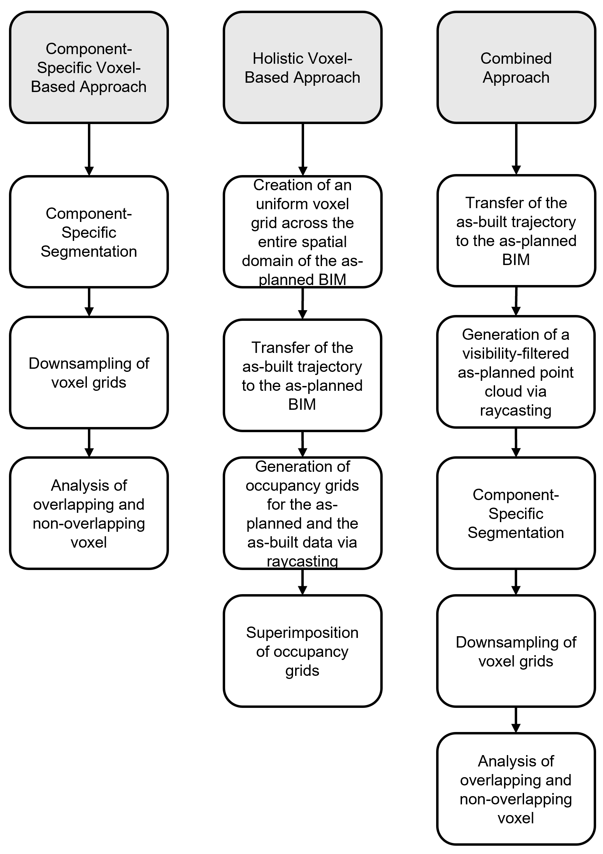
Figure 1: Schematic overview of the three voxel-based methods for geometric deviation analysis.
3.1 Component-Specific Voxel-Based Approach
The first approach is based on a component-specific analysis. In this method, a selected component is extracted from the as-built BIM model, and its bounding box is utilised to segment the corresponding region within the as-built point cloud. This segmentation ensures that only the relevant part of the point cloud at the location where the respective TBE component of the as-planned BIM is suspected is taken into account for further processing. The extracted section of the point cloud is subsequently downsampled into a three-dimensional voxel grid, which provides a structured representation of the spatial distribution of the captured data.
Simultaneously, the as-planned BIM component is converted into a mesh representation to facilitate the generation of a corresponding point cloud. This conversion is achieved by sampling the vertices of all triangular elements within the mesh. To establish a common basis for comparison, the resulting as-planned point cloud is also transformed into a voxel grid. Through the voxelization of both data sets, a structured comparison of the as-built and as-planned state is made possible, as each voxel serves as a discrete spatial unit within the defined resolution.
Following the voxelization process, an analysis is conducted to examine the spatial correspondence between the two voxel grids. Each voxel in the as-built grid is assessed for potential overlap with the as-planned grid. The level of permissible deviation is controlled through the voxel size, which is defined in accordance with the maximum acceptable tolerance for the analysis. In practice, the tolerance value is specified by the responsible authority. In addition to the execution tolerance, which should cover possible spatial deviations between the as-planned and as-built states due to the manual installation of the TBE components in reality, the measurement tolerance, which should include the unavoidable observational errors (or measurement errors) of the acquisition instrument used in each case, must also be taken into account. By equating the voxel dimensions of both grids to the given tolerance value, deviations beyond the predefined threshold can be identified.
The outcome of this process is a percentage-based distribution of overlapping and non-overlapping voxels. This distribution provides a quantitative basis for assessing whether the component has been installed in accordance with the planned specifications and offers a structured method for evaluating deviations.

3.2 Holistic Voxel-Based Approach
The second approach follows a comprehensive methodology in which the entire dataset obtained through reality capturing is systematically compared with the corresponding elements of the as-planned BIM model. The main objective of this method is to create occupancy grids for both data sets in an identical coordinate reference system, which provides a structured geometric comparison.
The process begins with the establishment of a uniform voxel grid across the entire spatial domain of the as-planned BIM. Each voxel within this grid is assigned a label to indicate whether it contains a part of the as-planned BIM model. Once the as-planned voxel grid has been established, an identical voxel grid is applied to the as-built point cloud. The voxels in this grid are similarly labelled based on the presence of points from the as-built point cloud, ensuring consistency in the spatial representation across both datasets.
Following the voxelization process, the scan positions and orientations derived from the provided trajectory data of the as-built acquisition process are registered to the as-planned data (Figure 2). This registration step ensures that the perspectives of the data collection process are systematically taken into account in the analysis.

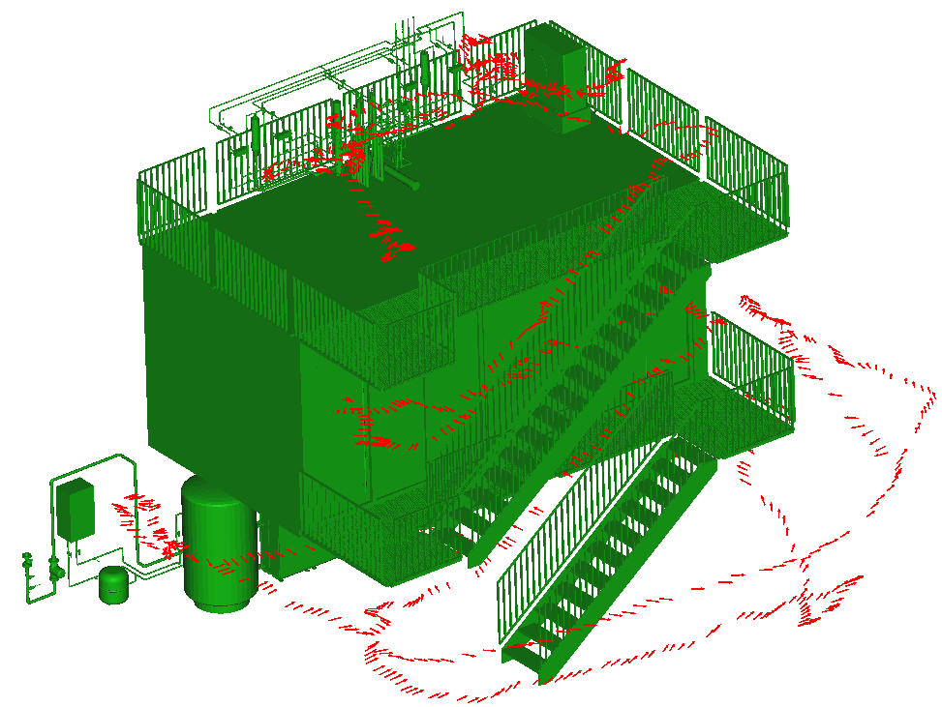
Figure 2: Transformed trajectory of the as-built acquisition process (red) into the coordinate system of the as-planned BIM (green).

Subsequently, a virtual scanning process is performed from each registered scan position using a raycasting technique (Figure 3). In this process, a virtual field of view is defined at a certain distance (focal length) from the centre of projection from each position of the trajectory of the detection process in the corresponding viewing direction. To harmonise the input data, we adapted the physical sensor parameters of the MHL2 for the focal length and the size of the field of view in this step.
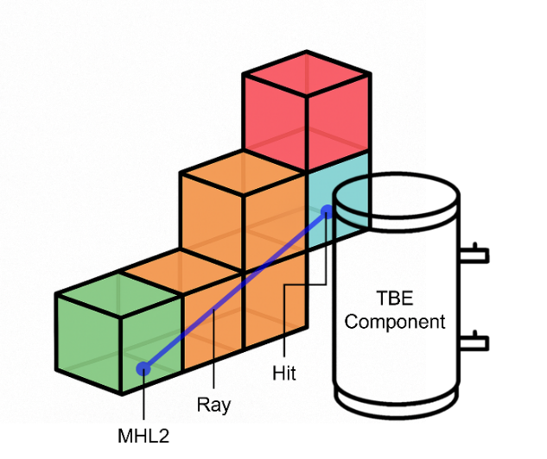
Figure 3: Raycasting technique to categorize voxels as empty (green/orange), occupied (blue) and unknown (red).
Subsequently, rays are emitted from the respective projection centre through each pixel of the field of view of an acquisition position and the first intersection with the previously determined voxels of the voxel grid, which comprise a content of the input data, are documented. Additionally, all voxels documented in the course of this procedure are declared as ‘occupied’.
This procedure is repeated for all scan positions, resulting in three-dimensional occupancy grids for both datasets. The final step involves the superimposition of these occupancy grids, allowing for a direct spatial comparison between the as-planned and as-built data. By analysing the degree of correspondence between the occupancy grids, areas of agreement and discrepancy can be identified, providing a quantitative basis for assessing the conformity of the as-built structure with the planned model.

3.3 Combined Approach
In a third approach, we aimed to combine the respective advantages of the previously described methods to provide a reliable part-specific analysis that takes into account the actual viewing conditions during the data acquisition process. This method addresses the limitation identified in the first approach, where the entire geometry of a part is compared to the corresponding segment of the as-built point cloud without taking into account that certain areas of the part may not be captured due to occlusions or installation conditions. Especially in the context of TBE systems, it is often not possible to realise a complete geometric detection of individual components. Components are often installed in confined spaces or directly on walls, which leads to incomplete data acquisition. Consequently, the comparison of the entire as-planned geometry of a component with only partially available as-built data can lead to imprecise results with regard to the actual conformity of the installed component with the as-planned model.
To overcome this challenge, we have extended the input data for the component-specific comparison by including only those sections of the as-planned geometry that were visible and therefore captured during the as-built data acquisition. This is achieved by integrating the trajectory of the reality capture process into the common coordinate reference system of the as-planned and as-built datasets. Then, as in the previous method from 3.2, a raycasting operation is performed from each recorded scan position along the trajectory. In contrast to the second approach, where the rays are cast against a predefined voxel grid, in this method the rays are directed towards the mesh of the as-planned BIM.
All initial intersections of the rays with the as-planned mesh geometry are documented for each scan position. These recorded intersections are then summarised into a point cloud that only represents the geometric sections of each component that were visible from the respective scan positions during the actual data acquisition. This visibility-filtered as-planned point cloud thus realistically reflects the scanning conditions.
In the final step, the component-specific voxel overlap analysis as described in 3.1 is applied to this newly generated, visibility-adjusted as-planned point cloud. In this way, a targeted and meaningful evaluation of the correspondence between the installed and planned state of the individual components is possible, considering the limitations of the acquisition process.
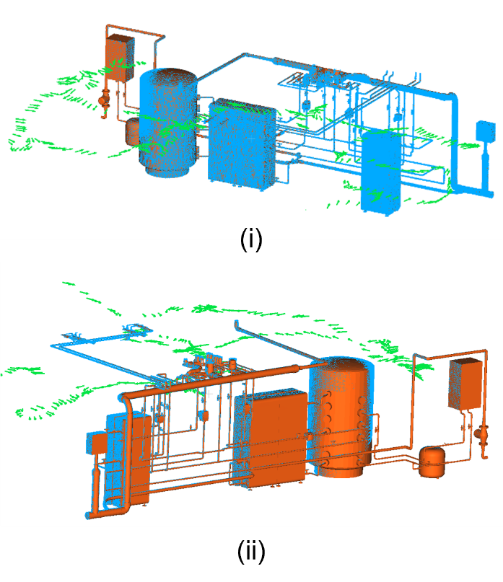
Figure 4: Superimposition of the as-planned BIM (orange), the trajectory of the as-built acquisition (green) and the resulting view-adapted as-planned point cloud (blue), shown from the front (i) and back (ii).

4. IMPLEMENTATION
For the evaluation, all three methods for geometric deviation analysis were applied to the same dataset to ensure comparability of the results under consistent conditions. The data set consists of a hot water demonstrator, which was constructed over three levels in a controlled experimental hall. The demonstrator was designed to allow access to all components of the TBE system on both the upper and lower levels. In contrast, two fully functional bathrooms were installed on the middle level. Since the components integrated into the demonstrator were supplied by a private company, the dataset is not available for publication.
To illustrate the input data, the as-planned BIM of the demonstrator is visualized in Figure 5 and the corresponding as-built point cloud, which was captured with the MHL2, in Figure 6.
In each of the three approaches, a uniform voxel size was applied for the analysis to maintain consistency in the underlying tolerance definition. As described in chapter 3, the voxel size represents the permissible tolerance for spatial deviation analysis, which, in practice, is typically defined by the client or the responsible authority. This specified tolerance reflects the maximum combined value of measurement and execution tolerances.
According to the findings presented in (Kinnen et al., 2023), the depth sensor of the MHL2 scanner operates with an standard deviation of approximately two centimetres. Accuracy measures (e.g. standard deviation) that quantify the measurement deviations, especially random ones, which are visible in our case in the scatter (or noise) of the point cloud, cannot be directly assumed as tolerances due to their probabilistic nature. Based on the theory of statistical tests, the standard deviation of the measurement method can be used to infer the achievable tolerance.

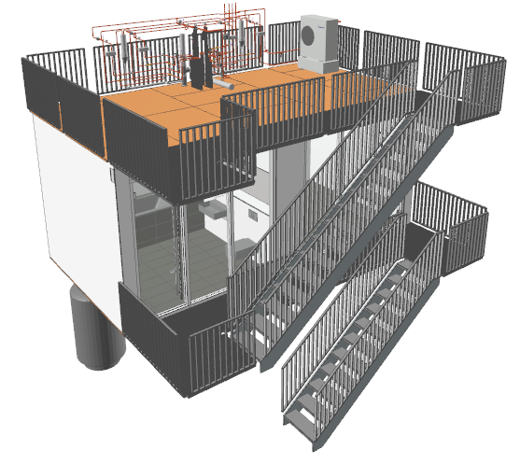
Figure 5: As-planned BIM of the demonstrator.

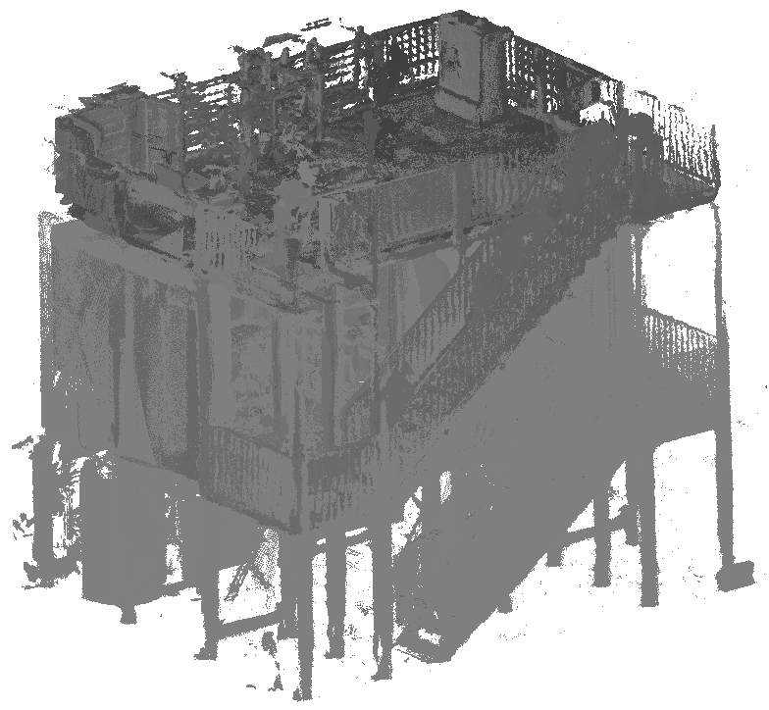
Figure 6: As-built point cloud of the demonstrator captured by the MHL2.

5. EVALUATION
The application of the first method to the dataset of the laboratory demonstrator indicates that this approach yields robust results for components of the TBE system whose geometry is largely represented in the as-built point cloud. In such cases, where those components were installed according to the planning data, the method produces high proportions of overlapping voxels, which serve as indicators of spatial conformity between the planned and the installed state.
Visual representations of the results, in which overlapping and non-overlapping voxels are shown in distinct colours, allow for a detailed interpretation of existing deviations. One example is provided in Figure 7, which illustrates a component that was installed slightly forward of its planned position. The deviation is clearly visible in the visualisation, where the corresponding shift results in a reduction of overlapping voxels in the affected area.
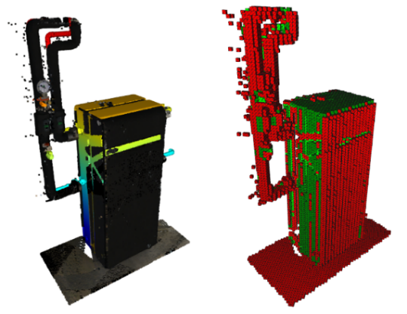
Figure 7: Overlaid representation of an as-planned component with the corresponding as-built point cloud (left) and its result visualization of the voxel analysis (right) with overlapping voxels (green) and non-overlapping voxels (red).

However, the results also reveal a fundamental limitation of this approach. Since the comparison is based on the entire geometry of the as-planned component and the segmented section of the as-built point cloud, any parts of the component that were not captured during the scanning process are interpreted as deviations. This issue is particularly relevant in the context of TBE systems, where full scanning coverage of all components is often not achievable due to installation constraints. Consequently, the resulting evaluation metric in the form of the percentage distribution of overlapping versus non-overlapping voxels is significantly influenced by incomplete data and may lead to misleading conclusions regarding the component’s compliance with the planning model.
An additional source of distortion in the evaluation can be attributed to outliers in the point cloud, which may arise from excessive measurement noise or multiple reflections during data acquisition. These confounding factors can further impair the voxel-based comparison and affect the reliability of the resulting deviation metric. For this reason, when validating components based on the percentage distribution of voxel overlap, it is necessary to define a threshold value that accounts for potential sources of interference and limits their influence on the assessment outcome.
Applying the second approach to the demonstration dataset provided a consistent and comprehensive representation of the spatial regions where the design and as-built conditions either matched or differed. By comparing the occupancy grids derived from the as-planned BIM model and the as-built point cloud, it was possible to identify areas where voxels in both datasets were classified as occupied, as well as areas where discrepancies occurred.
The method also allowed a distinction to be made between two different types of discrepancies. In some cases, voxels were classified as occupied in the as-planned model but remained unoccupied in the as-built data. In other cases, occupancy was detected in the as-built point cloud even though the corresponding geometry was not present in the as-planned model. This differentiation enabled a more precise interpretation of the spatial discrepancies between the planned and actual construction status.
The classification results were visualized using a color-coded representation, which facilitated the manual assessment of the actual condition. A representative example is shown in Figure 8, which shows one of the two bathrooms on the middle level of the demonstrator. The figure shows both the spatial overlay of the as-planned BIM model with the as-built point cloud and the resulting occupancy comparison. Voxels that were classified as occupied in both data sets are shown in green, indicating a match. Voxels that were only occupied in the as-planned model are shown in red, while those that were only occupied in the as-built data are shown in orange.
This visual format supports the manual inspection of the as-built TBE system by allowing intuitive identification of discrepancies. For example, the generated results can either be reviewed at a computer or projected directly on site through the use of mixed reality systems. In both cases, the occupancy-based comparison contributes to a better understanding of the realized building condition, especially in areas with limited accessibility or complex installations.
The third method combines key elements of the two previous approaches by performing a virtual scan of the as-planned model based on the recorded as-built trajectory and a component-specific voxel overlap analysis introduced in the first method. This combined approach addresses a critical limitation of the first method, namely the misrepresentation of discrepancies resulting from the comparison of complete as-planned geometries with incomplete as-built data due to occlusions or limited accessibility.

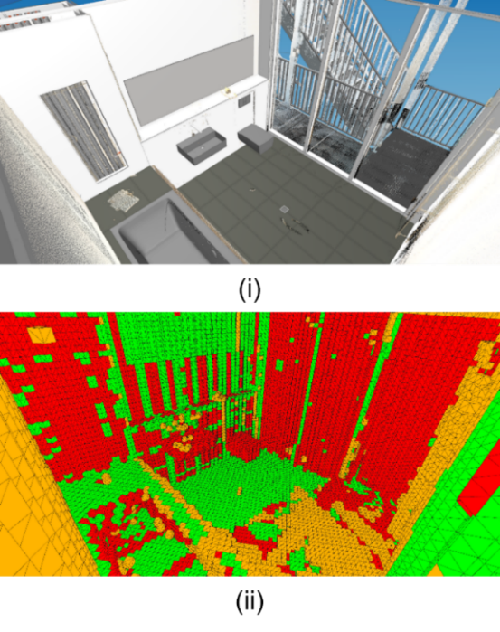
Figure 8: Superimposed display of the as-planned BIM with the as-built point cloud of a bathroom of the demonstrator (i) and result visualization of the comparison of the occupy grids (ii) with overlapping sections (green) and non-overlapping sections (red/orange).

The evaluation shows that the third method achieves significantly higher voxel overlap rates than the first method, especially for components that were not fully captured during the as-built acquisition but were installed within the defined tolerance range. To illustrate this effect, Table 1 shows the results of the voxel overlap for three selected components, each of which deviates slightly from the planning specifications in reality. The data show consistently higher overlap values when using the combined method compared to the first approach. The difference is particularly evident for larger components, where the limitations of the first method in dealing with incomplete data become clearer. The fact that the examples in Table 1 do not show a complete overlap can be attributed to measurement noise, particularly from the MHL2 depth sensor, and to minor geometric deviations between the planning model and the actual constructed state.
The difference between the first and the third method was less pronounced for components with small cross-sectional dimensions or significant geometric deviations from the planned condition. In such cases, the initially defined voxel size already accounted for minor inaccuracies, reducing the impact of visibility-based filtering. Nevertheless, the third method proved to be more effective in producing a reliable conformance metric, especially under conditions of limited visibility.

Table 1: Results of the proportions of overlapping voxels with the first approach ($p_{O,1}$) and the combined approach ($p_{O,2}$) as well as their difference ($p_{diff}$) for selected components with the volumes $V$.

Object | $V$ (m³) | $$p_{O,1}$$  (%) | $p_{O,2}$ (%) | $$p_{diff}$$  $($%)
Switch box | 0.014 | 55.61 | 75.17 | +19.56
Water heater | 0.700 | 40.42 | 65.35 | +24.93
Filter module | 0.349 | 41.20 | 62.79 | +21,59

Compared to the first method, the third approach requires significantly more computing resources due to the additional processing step of virtual raycasting based on the scan trajectory data. Further analyses were performed to evaluate the influence of different voxel sizes on the result. These investigations showed that the results remained relatively stable within a certain voxel size range, indicating a low sensitivity to moderate parameter changes. However, using voxel sizes that were too small resulted in excessive deviation values due to the presence of measurement noise, particularly with the MHL2 scanner. Conversely, larger voxel sizes increased the proportion of overlapping voxels in all components, which can mask minor but relevant deviations. Therefore, choosing a voxel size that strikes a balance between resolution and tolerance with respect to the sensor characteristics and the geometric properties of the components is important.

5. DISCUSSION AND OUTLOOK
The results of this study demonstrate that voxel-based approaches are well suited for spatial deviation analysis in the context of TBE systems. These methods exhibit a high degree of robustness with respect to occlusions and limited visibility, which are common in dense and complex installation environments. The accuracy of the analysis can be controlled through the definition of the voxel size. It is advisable to align this parameter with a predefined verification tolerance that reflects both the measurement uncertainty of the applied scanning system and the expected deviations arising from manual installation procedures.
The three methods presented in this work differ in their respective advantages and limitations, which must be considered when selecting an appropriate approach depending on the specific application scenario. The first method offers the ability to conduct a component-specific assessment and requires comparatively low computational resources. This characteristic renders it a promising candidate for potential real-time applications. However, the findings indicate that the integration of the complete geometry of the as-planned component into the analysis can lead to misinterpretation if the component was not fully captured during the as-built acquisition. In such cases, the resulting proportion of overlapping voxels does not provide a reliable measure of conformity. In contrast, the second method generates a comprehensive and structured representation of agreement and deviation by comparing the resulting occupancy grids of the as-planned and as-built data. Although it does not support component-specific evaluation, it provides a valuable visualisation framework that can support manual inspection processes. By clearly highlighting spatial discrepancies, this method has the potential to reduce the effort and cost of manual verification. Its application is, however, limited to post-processing workflows and involves higher computational demands. The third method builds on the first with the difference that it adapts the as-planned geometry to the actual visibility conditions of the as-built acquisition. Therefore, only those sections of a component that were observable from the recorded scan trajectory are included in the comparison. This modification allows for a reliable assessment even when the component was only partially captured. Compared to the first method, this approach involves a higher computational load due to the need for a virtual scan of the as-planned model based on the transformed acquisition trajectory. Future work should therefore explore the feasibility of implementing this method under real-time conditions.
Further research could investigate advanced segmentation strategies to improve the quality of component representation in the as-built point cloud. In this context, both machine learning techniques and voxel-growing algorithms may offer promising potential to enhance the reliability of deviation metrics. In addition, future studies should extend beyond deviation analysis to explore methods that enable comprehensive component-level validation. This includes the automated detection of positional changes, such as translations or rotations, as well as the identification of substitute components that differ from the originally planned elements. Such capabilities would contribute towards the development of robust as-is modelling frameworks for TBE systems.

ACKNOWLEDGEMENTS
The authors gratefully acknowledge the financial support of the German Federal Ministry for Economic Affairs and Climate Action in the project “EnOB: EnergyTWIN - Energiediagnosestecker Digitaler Zwilling. Neue sensorgestützte und KI-basierte Methoden für die digitale, BIM-basierte Inbetriebnahme von technischen Anlagen in Hochbauwerken und deren energetische Systemoptimierung” (reference number: 03EN1026).

REFERENCES

Abreu, N., Pinto, A., Matos, A. and Pires, M. (2023) 'Procedural Point Cloud Modelling in Scan-to-BIM and Scan-vs-BIM Applications: A Review', ISPRS International Journal of Geo-Information, vol. 12, no. 7, p. 260 [Online]. DOI: 10.3390/ijgi12070260.
Anil, E. B., Tang, P., Akinci, B. and Huber, D. (2013) 'Deviation analysis method for the assessment of the quality of the as-is Building Information Models generated from point cloud data', Automation in Construction, vol. 35, pp. 507–516 [Online]. DOI: 10.1016/j.autcon.2013.06.003.
Becker, R., Blut, C., Emunds, C., Frisch, J., Heidermann, D., Kinnen, T., Lenz, A., Möller, M., Pauen, Nicolas, Rettig, T., Schlütter, D., Wenthe, Matthias, Blankenbach, J., Bleimann-Gather, G., Fütterer, J., Jungedeitering, J. and van Treeck, C. (2022) 'BIM-assisted, automated processes for commissioning in building services engineering', Proceedings of the 39th International Symposium on Automation and Robotics in Construction, pp. 558–565.
Blut, C., Becker, R., Kinnen, T., Schluetter, D., Emunds, C., Frisch, J., Heidermann, D., Wenthe, M., Rettig, T., Baranski, M., van Treeck, C. and Blankenbach, J. (2024) 'Optimizing Building Energy Systems through BIM-enabled georeferenced Digital Twins', The International Archives of the Photogrammetry, Remote Sensing and Spatial Information Sciences, XLVIII-4/W11-2024, pp. 1–8.
Bosché, F., Guillemet, A., Turkan, Y., Haas, C. T. and Haas, R. (2014) 'Tracking the Built Status of MEP Works: Assessing the Value of a Scan-vs-BIM System', Journal of Computing in Civil Engineering, vol. 28, no. 4.
Chen, J. and Yong K. Cho. ([2018]) 'Point-to-point comparison method for automated scan-vs-bim deviation detection', in Proceedings of the 2018 17th International Conference on Computing in Civil and Building Engineering, Tampere, Finland, pp. 5–7.
Durrant-Whyte, H. and Bailey, T. ([2006]) 'Simultaneous localization and mapping: part I', pp. 99–110.
energyTWIN (2025) [Online]. Available at https://​energytwin.org​/​ (Accessed 15 March 2025).
Fütterer, J., Kochanski, M. and Müller, D. (2017) 'Application of selected supervised learning methods for time series classification in Building Automation and Control Systems', Energy Procedia, vol. 122, pp. 943–948 [Online]. DOI: 10.1016/j.egypro.2017.07.428.
Gumhold, S., Wang, X. and MacLeod, R. S. 'Feature Extraction from Point Clouds', IMR, pp. 293–305.
Hirt, P.-R., Xu, Y., Hoegner, L. and Stilla, U. (2021) 'Change Detection of Urban Trees in MLS Point Clouds Using Occupancy Grids', PFG – Journal of Photogrammetry, Remote Sensing and Geoinformation Science, vol. 89, no. 4, pp. 301–318 [Online]. DOI: 10.1007/s41064-021-00179-4.
Jiang, Z., Shen, X., Ibrahimkhil, M. H., Barati, K. and Linke, J. (2022) 'SCAN-VS-BIM FOR REAL-TIME PROGRESS MONITORING OF BRIDGE CONSTRUCTION PROJECT', ISPRS Annals of the Photogrammetry, Remote Sensing and Spatial Information Sciences, X-4/W3-2022, pp. 97–104.
Kalasapudi, V. S., Turkan, Y. and Tang, P. 'Toward Automated Spatial Change Analysis of MEP Components Using 3D Point Clouds and As-Designed BIM Models', in 2014 2nd International Conference on 3D Vision. IEEE, 2014., pp. 145–152.
Katsura, U., Matsumoto, K., Kawamura, A., Ishigami, T., Okada, T. and Kurazume, R. (2019) 'Spatial change detection using voxel classification by normal distributions transform', 2019 International Conference on Robotics and Automation (ICRA), IEEE, pp. 2953–2959.
Kawashima, K., Kanai, S. and Date, H. (2013) 'Automatic recognition of piping system from laser scanned point clouds using normal-based region growing', ISPRS Annals of the Photogrammetry, Remote Sensing and Spatial Information Sciences, II-5/W2, pp. 121–126.
Kawashima, K., Kanai, S. and Date, H. (2014) 'As-built modeling of piping system from terrestrial laser-scanned point clouds using normal-based region growing', Journal of Computational Design and Engineering, vol. 1, no. 1, pp. 13–26 [Online]. DOI: 10.7315/JCDE.2014.002.
Kim, S., Kim, S. and Lee, D.-E. (2020) '3D Point Cloud and BIM-Based Reconstruction for Evaluation of Project by As-Planned and As-Built', Remote Sensing, vol. 12, no. 9, p. 1457 [Online]. DOI: 10.3390/rs12091457.
Kinnen, T., Blut, C., Effkemann, C. and Blankenbach, J. (2023) 'Thermal reality capturing with the Microsoft HoloLens 2 for energy system analysis', Energy and Buildings, vol. 288, p. 113020 [Online]. DOI: 10.1016/j.enbuild.2023.113020.
Kuang, H., Wang, B., An, J., Zhang, M. and Zhang, Z. (2020) 'Voxel-FPN: Multi-Scale Voxel Feature Aggregation for 3D Object Detection from LIDAR Point Clouds', Sensors, vol. 20, no. 3, p. 704 [Online]. DOI: 10.3390/s20030704.
Lin, S., Duan, L., Jiang, B., Liu, J., Guo, H. and Zhao, J. (2025) 'Scan vs. BIM: Automated geometry detection and BIM updating of steel framing through laser scanning', Automation in Construction, vol. 170, p. 105931.
Martens, J. and Blankenbach, J. ([2021]) 'VOX2BIM - A Fast Method for Automated Point Cloud Segmentation', in EG-ICE 2021 proceedings: Workshop on Intelligent Computing in Engineering 30th June-2nd July, pp. 442–450.
Meyer, T., Brunn, A. and Stilla, U. (2022) 'Change detection for indoor construction progress monitoring based on BIM, point clouds and uncertainties', Automation in Construction, vol. 141, p. 104442 [Online]. DOI: 10.1016/j.autcon.2022.104442.
Nguyen, C. H. P. and Choi, Y. (2018) 'Comparison of point cloud data and 3D CAD data for on-site dimensional inspection of industrial plant piping systems', Automation in Construction, vol. 91, pp. 44–52 [Online]. DOI: 10.1016/j.autcon.2018.03.008.
Park, S., Ju, S., Yoon, S., Nguyen, M. H. and Heo, J. (2021) 'An efficient data structure approach for BIM-to-point-cloud change detection using modifiable nested octree', Automation in Construction, vol. 132, p. 103922.
Pătrăucean, V., Armeni, I., Nahangi, M., Yeung, J., Brilakis, I. and Haas, C. (2015) 'State of research in automatic as-built modelling', Advanced Engineering Informatics, vol. 29, no. 2, pp. 162–171 [Online]. DOI: 10.1016/j.aei.2015.01.001.
Qi, C. R., Yi, L., Su, H. and Guibas, L. J. ([2017]) 'Pointnet++: Deep hierarchical feature learning on point sets in a metric space', in Advances in neural information processing systems.
Sindagi, V. A., Zhou, Y. and Tuzel, O. (2019) 'MVX-Net: Multimodal VoxelNet for 3D Object Detection', 2019 International Conference on Robotics and Automation (ICRA), IEEE.
Zhou, Y. and Tuzel, O. (2017) 'VoxelNet: End-to-End Learning for Point Cloud Based 3D Object Detection', arXiv e-prints, arXiv:1711.06396.

