Leveraging Large Language Models for Synthetic Data Generation for AI Applications for Water Infrastructure Management

JENS WALA, M.SC., PROF. DR.-ING. UWE RÜPPEL¹

¹Technical University of Darmstadt, Darmstadt, Germany

ABSTRACT:

The effectiveness of AI models in water infrastructure management is often hindered by limited access to high-quality, domain-specific data. This paper explores the use of Large Language Models (LLMs), specifically the GPT-4 family of models, to generate synthetic hydrological datasets that augment real-world data and improve AI model performance. Leveraging prompt engineering tailored to hydrological patterns, we generate synthetic data that maintains key statistical properties of real observations. Our results demonstrate that AI models trained with synthetic data exhibit improved accuracy in forecasting tasks. This approach offers a scalable, privacy-preserving solution to data scarcity in critical infrastructure contexts.

KEYWORDS:

Water management, critical infrastructure, artificial intelligence, large language models (LLMs), synthetic data

1. INTRODUCTION
Water infrastructure systems are critical assets that require efficient management to ensure reliable supply, sustainability, and public health. The advent of Artificial Intelligence (AI) has provided powerful tools for optimizing operations, predicting failures, and enhancing decision-making processes in water management(Ren et al., 2024). Machine Learning (ML) models rely heavily on large volumes of high-quality data to perform effectively. However, obtaining sufficient real-world data in the water infrastructure domain is often challenging due to cost constraints, privacy issues, limited sensor deployment, and the time-consuming nature of data collection processes(Schotten et al., 2023).
This data scarcity hampers the development and deployment of robust AI models capable of addressing complex tasks like reservoir level and rainfall forecasting. Traditional methods to mitigate data limitations, such as data augmentation and simulation, may not adequately capture the intricate patterns and variabilities inherent in hydrological systems. Therefore, innovative solutions are needed to overcome the data bottleneck and unlock the full potential of AI in water infrastructure management. Synthetic data generation utilizing generative AI, like Large Language models (LLMs) offers a promising approach to solving that data scarcity problem(Goyal & Mahmoud, 2024).

2. BACKGROUND AND RELATED WORK
Synthetic data generation has gained traction as a solution to challenges like data scarcity, privacy concerns, and biases in machine learning. A systematic review by (Goyal & Mahmoud, 2024) categorizes key generative techniques into Generative Adversarial Networks (GANs), Variational Autoencoders (VAEs), and Large Language Models (LLMs)​.
GANs are widely used for image synthesis and data augmentation, producing high-quality outputs through adversarial training. However, they face issues like training instability and limited control over generated data, especially in structured or tabular formats.
VAEs take a probabilistic approach, preserving statistical properties of real data and excelling in time-series generation. Yet, they often lack fine control over outputs and struggle with interpreting latent variables.
LLMs, such as GPT-4, represent a newer approach, capable of generating context-aware synthetic data using prompt-based inputs. While promising, their use in structured numerical domains, such as hydrology, is still underexplored. Key challenges include ensuring statistical fidelity, reducing bias, and validating outputs against real-world data.
Overall, while GANs and VAEs have dominated synthetic data research, LLMs offer a novel path, especially for domains with limited data availability. This study builds on these insights by applying LLMs to generate synthetic hydrological datasets, aiming to improve AI model training in water infrastructure management.

(Ren et al., 2024) introduced WaterGPT, a domain-specific large language model (LLM) fine-tuned for hydrology applications. This marks a significant advancement in adapting general-purpose models like GPT-4 for specialized use cases​.
WaterGPT is designed for multimodal tasks such as analyzing hydrological text and imagery, providing intelligent decision support, and facilitating knowledge-based Q&A. Its core innovation lies in the Water_Agent framework, a multi-agent system that enables the model to perform complex hydrological analyses, including tasks like water body extraction, with over 90% accuracy.
WaterGPT was trained on a high-quality, hydrology-specific corpus, including over 100,000 annotated question-answer pairs to support its performance. Additionally, the authors developed EvalWater, the first benchmark dataset for evaluating LLMs in water resource domains. WaterGPT outperformed GPT-4 by 17.8 percentage points on EvalWater, demonstrating the potential of LLMs when tailored to hydrology.
While WaterGPT focuses on domain-specific reasoning and decision-making, it does not address synthetic data generation for AI training. This underscores a research gap, which the present study aims to address by exploring how general-purpose LLMs like GPT-4 can generate statistically valid synthetic hydrological datasets to improve AI model performance in water infrastructure management.

2.1 Synthetic Data Generation Methods
Synthetic data refers to artificially generated data that mimics the statistical properties, structures, and patterns of real-world data without directly copying any specific observations. It is created through various methods.
Programmatic: Mathematical models from different disciplines can be used to simulate the real world and generate nearly realistic data. This approach typically requires a significant amount of computing power to implement and yields minimal data. It requires information about the physical realm in which it is located, such as the geometry of the system and its materials.
Statistical: The statistical approach for generating synthetic data relies on the statistical properties of a given dataset.
Parametric models create synthetic data by estimating parameters from observed distributions, such as means and variances in Gaussian distributions. This method allows for easy generation of synthetic datasets that retain similar statistical qualities to the original data, making them especially effective when the data structure closely aligns with the expected distribution(DataRobot, 2021).
In contrast, non-parametric models employ flexible, data-driven approaches that require minimal assumptions about the data distribution. Utilizing techniques such as kernel density estimation and nearest neighbor algorithms, these models adapt to complex and diverse data patterns, generating synthetic data that accurately reflects the complexities of real-world data. This adaptability makes non-parametric models invaluable for robust data synthesis and analysis tasks(DeepAI, 2019).
Machine Learning: Models in this space, especially Generative Adversarial Networks (GANs) and Variational Autoencoders (VAEs), are widely used for generating synthetic data because they can model complex data distributions. GANs generate realistic data through adversarial training between a generator and discriminator but require large datasets and careful tuning to avoid instability. VAEs use probabilistic encoding to create data from a learned latent space and are particularly suited for time-series and structured data.
Recently, large language models (LLMs) such as GPT-4 have been explored for generating structured synthetic data through prompt engineering. While traditionally applied to text, LLMs can produce domain-specific numerical data by adapting to patterns in real datasets. This approach is especially promising for data-scarce fields like hydrology, offering a scalable alternative to traditional methods. However, it requires robust validation to ensure data quality, statistical fidelity, and bias control.

2.2 Large Language Models for Structured Data
Large Language Models (LLMs) are machine learning models trained to understand and generate human-like text by predicting the next word in a sequence. They are typically based on the Transformer architecture, which enables them to process vast amounts of data and learn complex language, reasoning, and context patterns. LLMs can perform a wide range of tasks, from language translation and summarization to code generation and knowledge-based question answering(OpenAI, 2024; Ren et al., 2024).
Among the most advanced LLMs is GPT-4, developed by OpenAI. GPT-4 is a multimodal model capable of processing text and image inputs to produce text outputs. It has demonstrated human-level performance on various professional and academic benchmarks. GPT-4’s architecture builds upon its predecessors (e.g., GPT-3.5) but with improved alignment to human intent, enhanced factual accuracy, and more substantial multilingual capabilities. It is trained using Reinforcement Learning from Human Feedback (RLHF) to follow user instructions better and reduce harmful outputs(OpenAI, 2024, p.4).

3. RESEARCH OBJECTIVES AND QUESTIONS
This study aims to investigate the feasibility and effectiveness of using LLMs, such as GPT-4, to generate synthetic datasets that can augment small amounts of real-world data for training AI models in the context of water infrastructure. The following questions guide the research:
RQ1: Can LLMs generate synthetic hydrological data that accurately reflect real-world data's statistical properties and patterns?

RQ2: How does the inclusion of LLM-generated synthetic data affect the training and performance of AI models in predictive tasks relevant to water infrastructure compared to models trained solely on limited real-world data?

RQ3: What potential challenges, such as the introduction of biases, overfitting, and data quality concerns, are associated with using LLMs for synthetic data generation in water infrastructure contexts, and what mitigation strategies can be employed to address them?

4. METHODOLOGY
This study utilizes the Chennai Water Management Dataset(Chennai Metropolitan Water Supply and Sewage Board & Sudalai Rajkumar - SRK, 2021), an open-source dataset providing comprehensive rainfall and reservoir data from the Chennai region in India. The dataset includes variables such as daily rainfall measurements and reservoir water levels over a significant period. For model development and validation, the Chembarambakkam reservoir was selected as the focus due to its size and significance. The data was preprocessed to ensure consistency, handle missing values, and normalize features before use in synthetic data generation and model training.
The dataset will undergo thorough preprocessing to handle missing values, remove outliers, and ensure consistency across all variables. Statistical techniques and domain expertise will guide this process to preserve the integrity of the data. Following preprocessing, a portion of the data will be withheld and divided into training and validation sets. This withheld data will serve as an unbiased benchmark for evaluating the performance of the AI models.
We will employ the GPT-4 family of large language models, a state-of-the-art model family for generating coherent and contextually relevant text. By crafting prompts that incorporate domain-specific knowledge, we aim to guide the LLM in producing synthetic hydrological data that accurately mirrors the patterns observed in the real dataset. The focus will be on maintaining key statistical attributes, such as the mean, variance, autocorrelation, and seasonality, inherent in the Chennai dataset.
To validate the synthetic data, statistical analyses will be conducted to compare it with the original dataset. This includes assessing distributional similarities, correlation structures, and time-series characteristics to ensure the synthetic data accurately represents real-world hydrological behaviour. Any discrepancies identified will inform adjustments in the prompt engineering and data generation process to enhance the quality of the synthetic data.
In the AI model training phase, we selected Long Short-Term Memory (LSTM) networks suitable for time-series forecasting tasks in hydrology. Two training scenarios will be established: a baseline model trained solely on the limited actual data and an enhanced model trained on a combination of actual data and LLM-generated synthetic data. Incorporating synthetic data is expected to provide the models with a broader range of patterns and scenarios, potentially improving their predictive capabilities.
The models will be evaluated using performance metrics relevant to hydrological forecasting tasks, including Root Mean Square Error (RMSE), Mean Absolute Error (MAE), and the Nash-Sutcliffe Efficiency coefficient. The withheld validation set from the dataset will be used to test the models' predictive performance. This approach ensures that the evaluation is based on actual, unseen data, fairly comparing the baseline and enhanced models.
We will analyse the models for potential overfitting to the synthetic data and assess whether any biases have been introduced through the data augmentation. Techniques such as cross-validation and regularization may be applied to mitigate these risks.
Potential challenges associated with using large language models (LLMs) for synthetic data generation, including concerns over data quality and ethical considerations, will be addressed. We will propose methods to ensure the validity of the synthetic data, such as incorporating hydrological constraints into the prompt design and applying rigorous validation checks. Although we utilize an open dataset, we will discuss the broader implications of data privacy and the responsible use of AI-generated data in research and practice.

4.1 Prompt Engineering
Prompts must be provided to generate data from the LLM. Various techniques are employed for this purpose. The prompt always includes a role that the LLM Agent will assume. In this instance, the LLM takes on the role of a hydrological expert specializing in data generation. It is constantly tasked with producing realistic hydrological data. As an output, the model is also tasked with generating a specific output format that resembles the input data's column structure.
In the first step, statistical key values were calculated to be provided to the LLM. These include means, standard deviation, minimums, maximums, median, and first and third quartiles for both variables and rainy vs. dry days as a percentage for the rain datasets. Additionally, the temporality as well as the correlations are given as inputs. The prompt used is: Prompt1:
You are a hydrological and meteorological data expert specializing in water systems.
Your task is to generate realistic daily water level and rainfall data for reservoirs in Chennai, India.
Ensure the data follows natural patterns with appropriate correlation between rainfall and water levels.
Water levels should respond to rainfall events with a time lag, and both should follow seasonal patterns.
Format your response as a CSV with headers and daily values for both water levels and rainfall.
Generate the timeframe from 2019-12-05 until 2020-12-03.
Important considerations:
1. Chennai has a tropical climate with distinct monsoon seasons:
- Northeast monsoon (October-December): Heaviest rainfall
- Southwest monsoon (June-September): Moderate rainfall
- Dry season (January-May): Minimal rainfall
2. Water levels typically increase after rainfall events with some lag (usually 1-7 days)
3. Water levels decrease during dry periods due to evaporation and usage
4. Rainfall events should be clustered (rainy days often follow each other)
5. Many days will have zero rainfall, especially in dry seasons
6. Nearby reservoirs often experience similar rainfall patterns and level trends
The Data MUST have the following format:
Date, POONDI_level, CHOLAVARAM_level, REDHILLS_level ,CHEMBARAMBAKKAM_level, POONDI_rain, CHOLAVARAM_rain, REDHILLS_rain, CHEMBARAMBAKKAM_rain
Generate realistic values for each day in the specified period, ensuring proper relationships between rainfall and water levels.

The statistical key values were given to the LLM in the form of a JSON file, available in the project's repository.
Another prompt used to generate synthetic data is Prompt2:
You are tasked with generating realistic daily water level data for the CHEMBARAMBAKKAM reservoir for a complete year (365 days), in the period from 2019-12-05 until 2020-12-03.
I've provided several statistical analyses of historical CHEMBARAMBAKKAM water level data from 2004-2019, including:
1. Seasonal decomposition showing yearly patterns
2. Monthly statistics (mean, median, min, max, std) for each month
3. Autocorrelation patterns showing temporal dependencies
4. Distribution characteristics and statistical properties
5. Rolling statistics showing how variability changes throughout the year
Based on these statistical analyses, please generate daily water level values for a full year that:
1. Follow the seasonal patterns observed in the historical data
2. Maintain appropriate monthly statistical properties (means, ranges, etc.)
3. Exhibit realistic day-to-day transitions and autocorrelation
4. Preserve the overall statistical distribution (non-normal with positive skew)
5. Include occasional fluctuations and anomalies similar to historical patterns
The output should be a CSV file with two columns:
- Date: in YYYY-MM-DD format, starting from 2019-12-05
- CHEMBARAMBAKKAM: daily water level values that reflect the statistical properties in the provided analyses
Please ensure the generated data maintains statistical realism while incorporating natural variability. The data should be suitable for water resource planning and hydrological modeling applications.

In addition to that, more detailed statistical data has been fed to the model. Those include autocorrelation plots, basic statistics (Mean, Median, Standard Deviation, Minimum, Maximum, Data Range, Skewness and Kurtosis), Monthly and Yearly statistics (Mean, Median, Standard deviation, minimum, maximum), Seasonal decomposition as well as plots showing the level distribution (Figure 2), rolling statistics (Figure 3), monthly box-plots (Figure 4) and a time series plot (Figure 5).
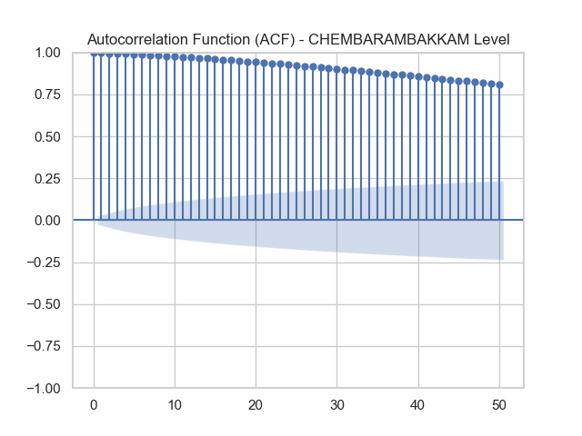
Figure 1: Autocorrelation Plot

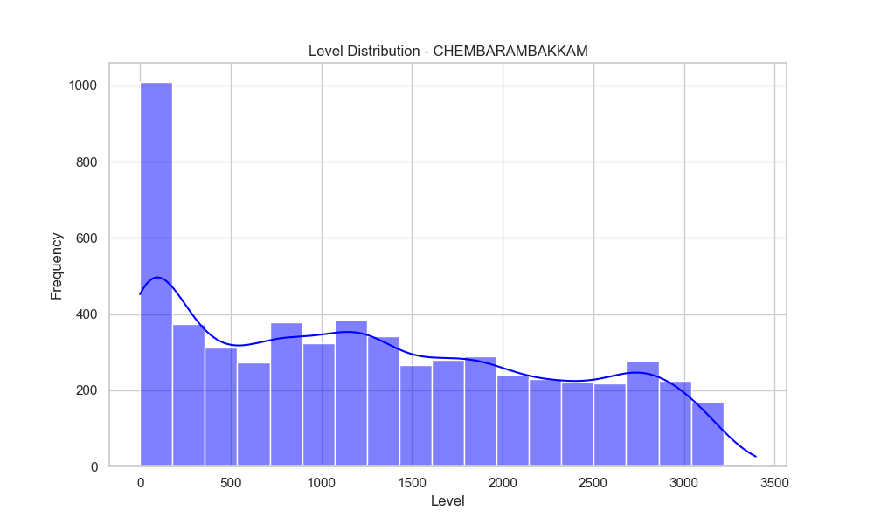
Figure 2: Level Distribution

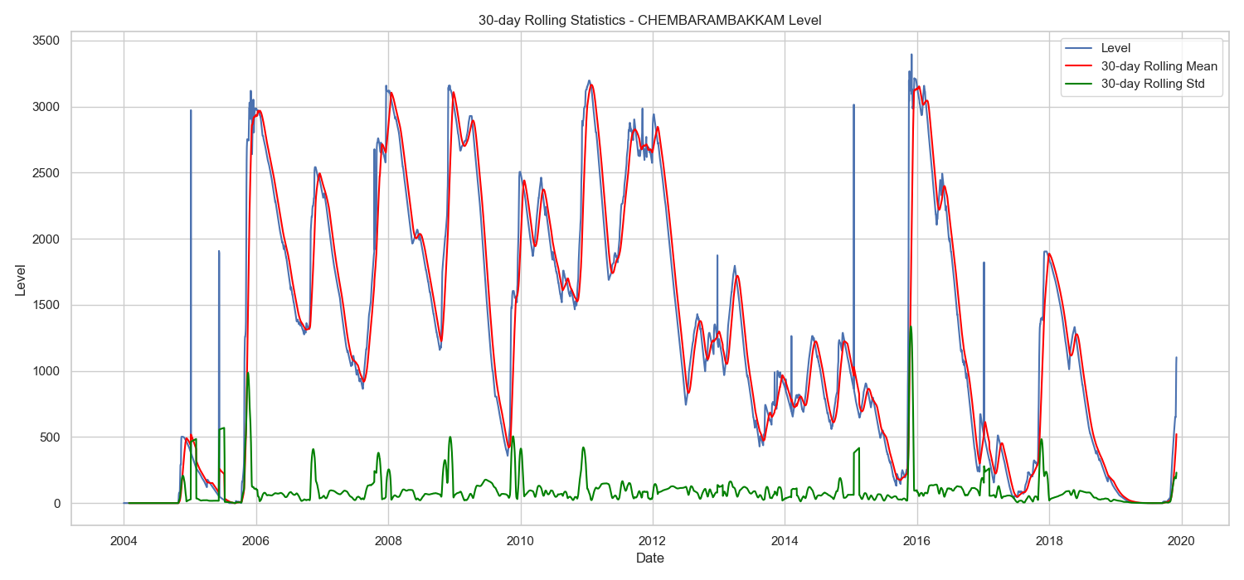
Figure 3: Rolling statistics

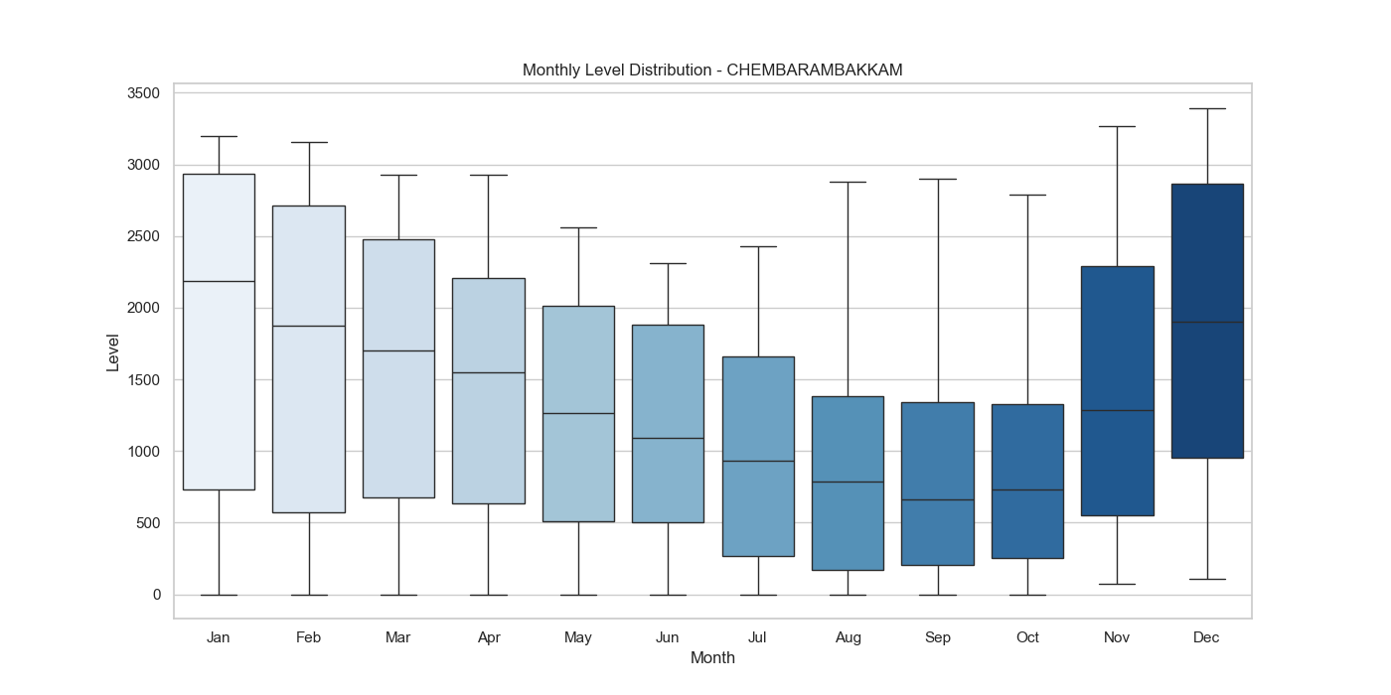
Figure 4: Monthly Level distribution

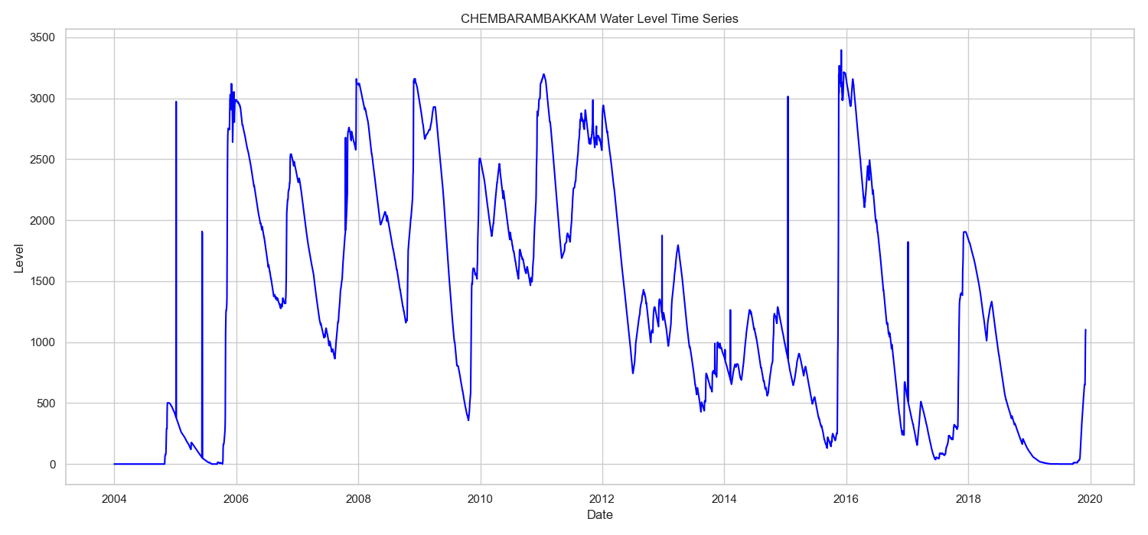
Figure 5: Time Series Plot

4.2 Forecasting Model Setup
For the forecasting component of this study, we implemented a deep learning model using the Long Short-Term Memory (LSTM) architecture, optimized for multivariate time-series prediction of reservoir levels. LSTMs are well-suited for hydrological data due to their ability to capture long-term dependencies in sequential data.
The architecture was implemented in TensorFlow using the Keras API and consisted of the following layers:
- Bidirectional LSTM (64 units per direction): This initial layer captures temporal dependencies in both forward and backward directions, enhancing the model’s understanding of past and future context.
- Second Bidirectional LSTM (64 units per direction): Further refines the learned temporal features.
- Two Dense layers with 128 units each, activated by ReLU functions, for nonlinear transformation and deep feature learning.
- Final Dense layer with 1 unit: Outputs the predicted reservoir level for each timestep.
- Lambda scaling layer: Multiplies the output by a factor of 1000 to reverse the normalization applied to the data.
The model’s total number of trainable parameters was 165,761.
Training Configuration:
The model was trained using the following hyperparameters and strategies:
- Loss function: Mean Squared Error (MSE)
- Optimizer: Adam
- Learning rate: 0.001
- Epochs: 100
- Batch size: 32
- Early stopping: Applied with a patience of 10 epochs to prevent overfitting

Data Handling and Splitting:
The data was sourced from the Chennai Water Management Dataset and focused on the Chembarambakkam reservoir. Time series were constructed from the daily water level values, with input sequences reshaped into supervised learning format.
The dataset was split as follows:
- Training set: 70%
- Validation set: 15%
- Test set: 15%
To preserve the temporal structure and avoid data leakage, a chronological split was used. All input features were scaled using Min-Max normalization, and the model outputs were rescaled during inference using the final Lambda layer.
Performance was evaluated using metrics such as Root Mean Square Error (RMSE), Mean Absolute Error (MAE), R² score, and additional percentage-based error metrics, detailed in Section 6.

5. IMPLEMENTATION
The implementation was carried out in Python using standard libraries for data handling, statistical analysis, visualization, and machine learning. LSTM models were trained under two scenarios: with real-world data alone and with an augmented dataset including LLM-generated synthetic data. Evaluation metrics such as RMSE, MAE, and R² were used to quantify model performance. The full workflow included data preprocessing, prompt engineering for synthetic data generation, validation of generated data, and training/evaluation of forecasting models. Specific library details (e.g., Pandas, NumPy, Matplotlib, TensorFlow) were used to support these stages, though our focus remains on the methodology rather than tool-specific capabilities.

6. RESULTS AND EVALUATION
Our comparative analysis examined four state-of-the-art GPT models (GPT4.5, GPT4o-mini, GPT4o, and o1) with two distinct prompting approaches. The results revealed significant variations in forecasting accuracy across both model types and prompt formulations. GPT4o-mini with the first prompting strategy (Prompt1) demonstrated superior performance, achieving the lowest Root Mean Square Error (RMSE) of 194.26 and the highest correlation coefficient of 0.981 with the reference data (Figure 6). This configuration explained approximately 93.4% of the variance in the observed data (R²=0.934), suggesting remarkable alignment between the LLM-generated forecasts and traditional forecasting outputs (Figure 7).
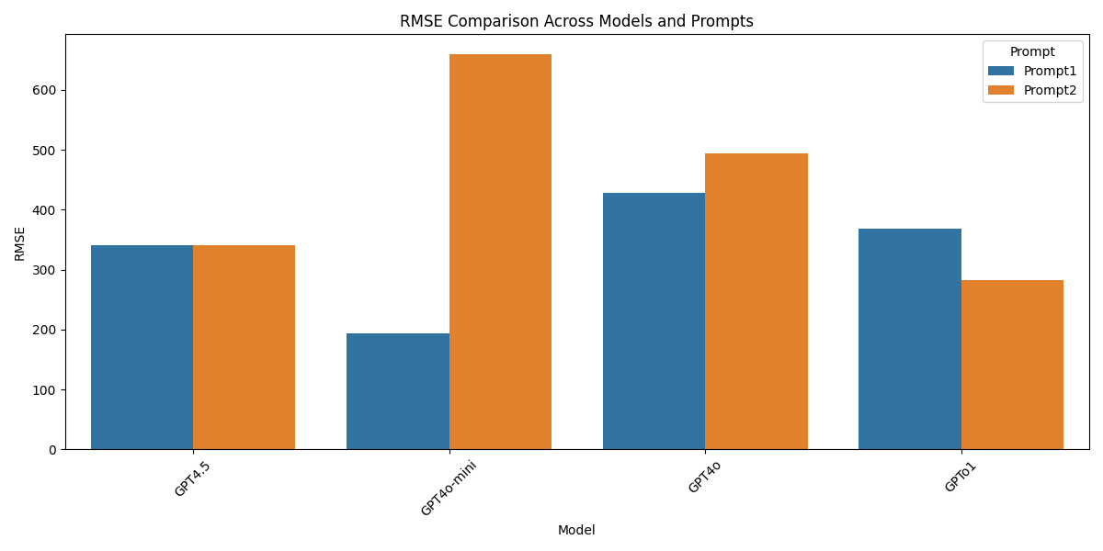
Figure 6: RMSE-Comparison
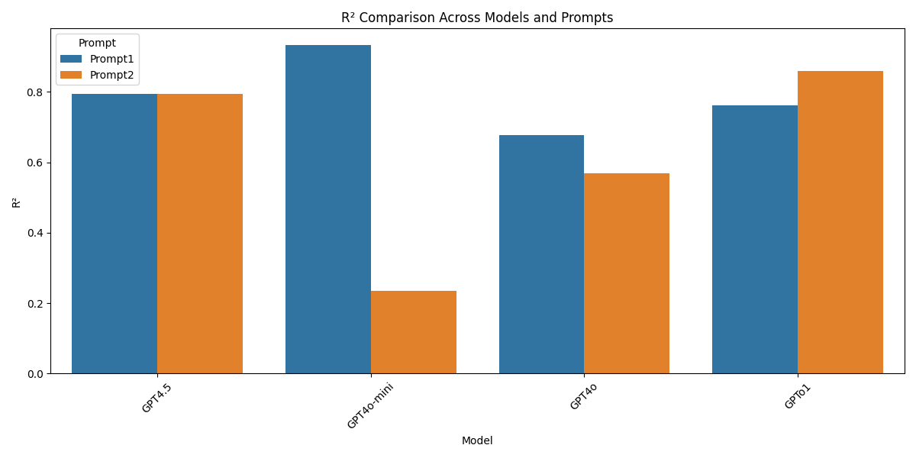
Figure 7: R² Comparison
The sensitivity of models to prompt engineering emerged as a critical factor in forecast quality. For instance, while GPT4o-mini performed exceptionally well with Prompt1, its performance deteriorated substantially with Prompt2, where its RMSE increased to 659.69 and correlation dropped to 0.700. Conversely, o1 exhibited enhanced performance with Prompt2 (RMSE: 281.65) compared to Prompt1 (RMSE: 368.23), indicating differing sensitivities to prompting strategies across model architectures. This finding highlights the importance of tailoring prompt engineering for the hydrological applications of LLMs.

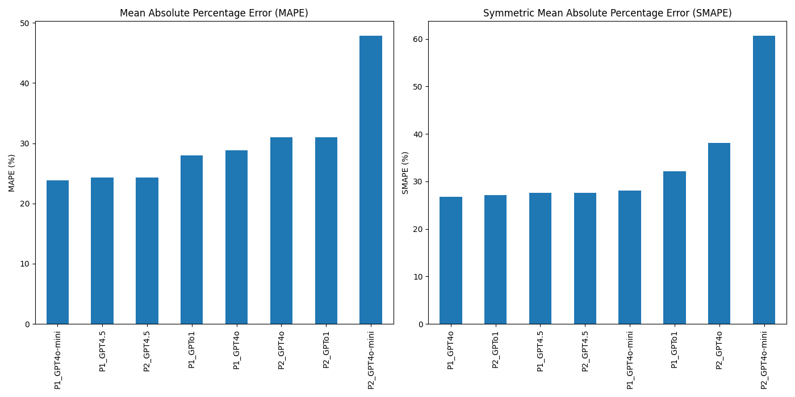
Figure 8: Percentage Error Metrics
Percentage error metrics (Figure 8) provided additional insights into forecast accuracy. Mean Absolute Percentage Error (MAPE) ranged from 23.9% for GPT4o-mini with Prompt1 to 47.9% for the same model with Prompt2. Symmetric Mean Absolute Percentage Error (SMAPE) values exhibited similar patterns, ranging from 26.7% for GPT4o with Prompt1 to 60.7% for GPT4o-mini with Prompt2. These metrics indicate that while correlation with reference data was strong for top-performing configurations, absolute percentage errors suggest opportunities for refinement in practical applications.
Beyond the comparative metrics, our advanced analysis explored multiple dimensions of forecasting performance. The distribution analysis examined statistical properties of forecast errors, revealing insights into the systematic biases and uncertainty characteristics of different models.
Peak analysis (Figure 9, Figure 10) focused explicitly on high-flow events, which are particularly critical for flood forecasting and water resource management applications. This analysis demonstrated variable performance during extreme events, with some models exhibiting increased error margins during peak flows—a finding with significant implications for operational deployment. Plotting the timing differences between the peaks, we see that o1 prompted with Prompt2 was able to achieve the best overall forecast, closely followed by GPT4o-mini with Prompt2 (Figure 11).
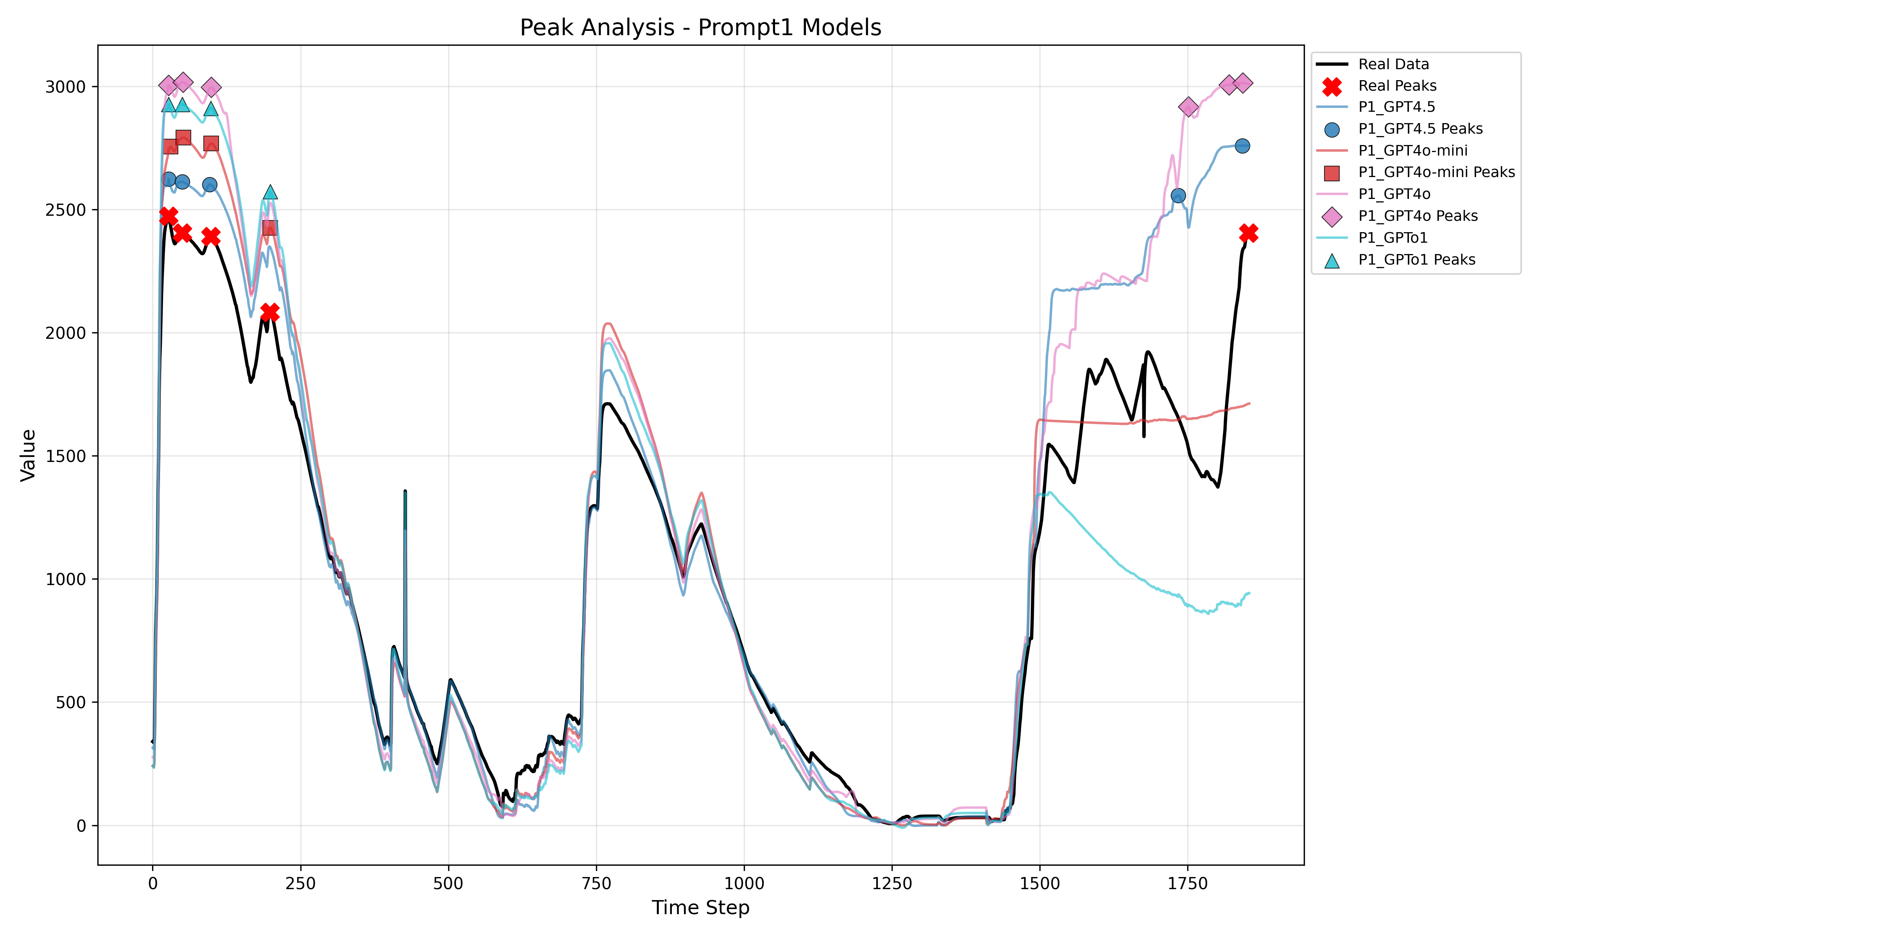
Figure 9: Peak Analysis Prompt 1
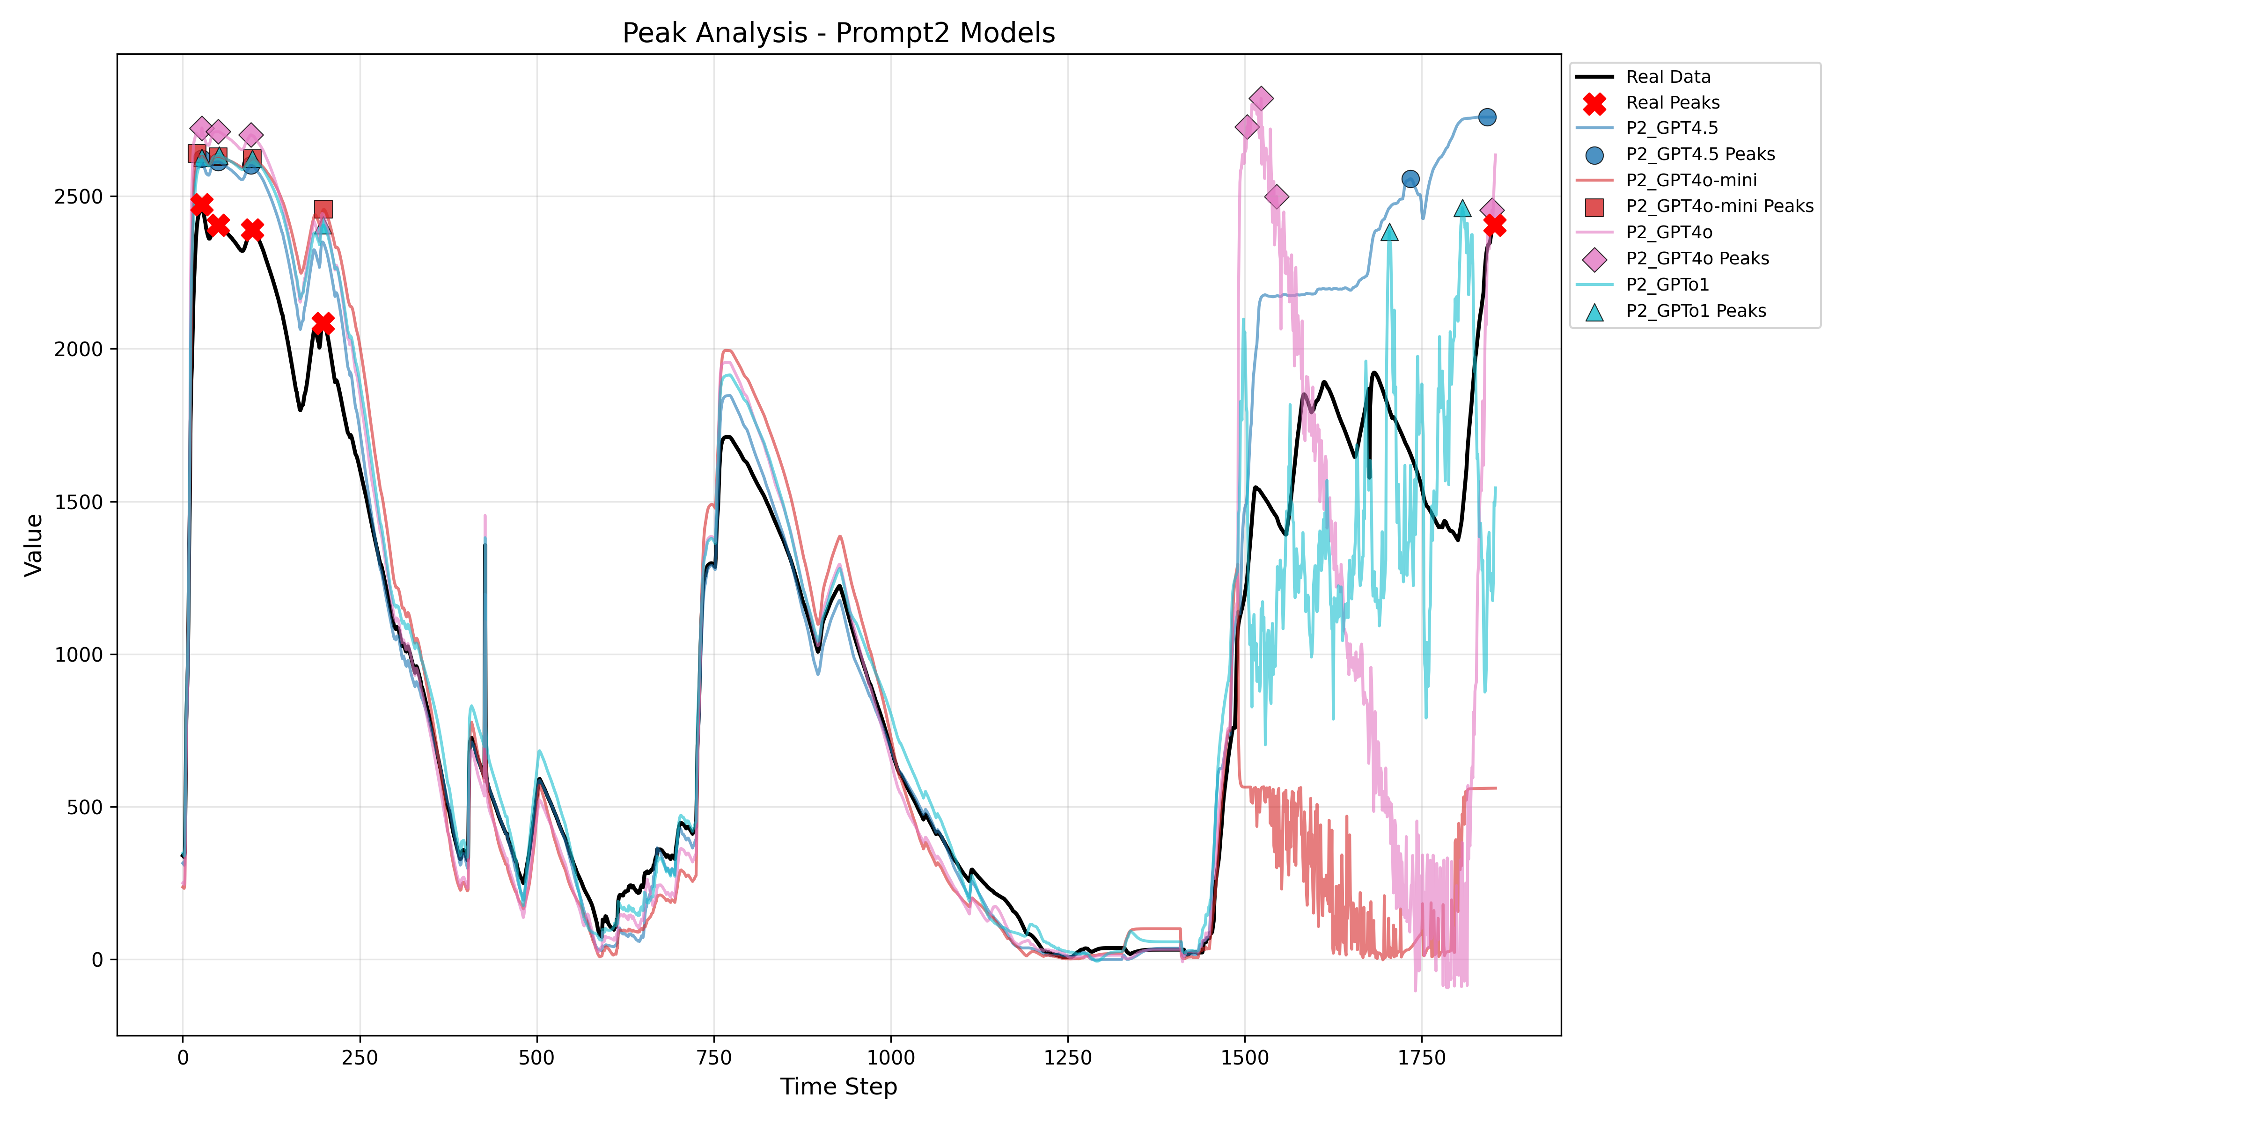
Figure 10: Peak Analysis Prompt 2
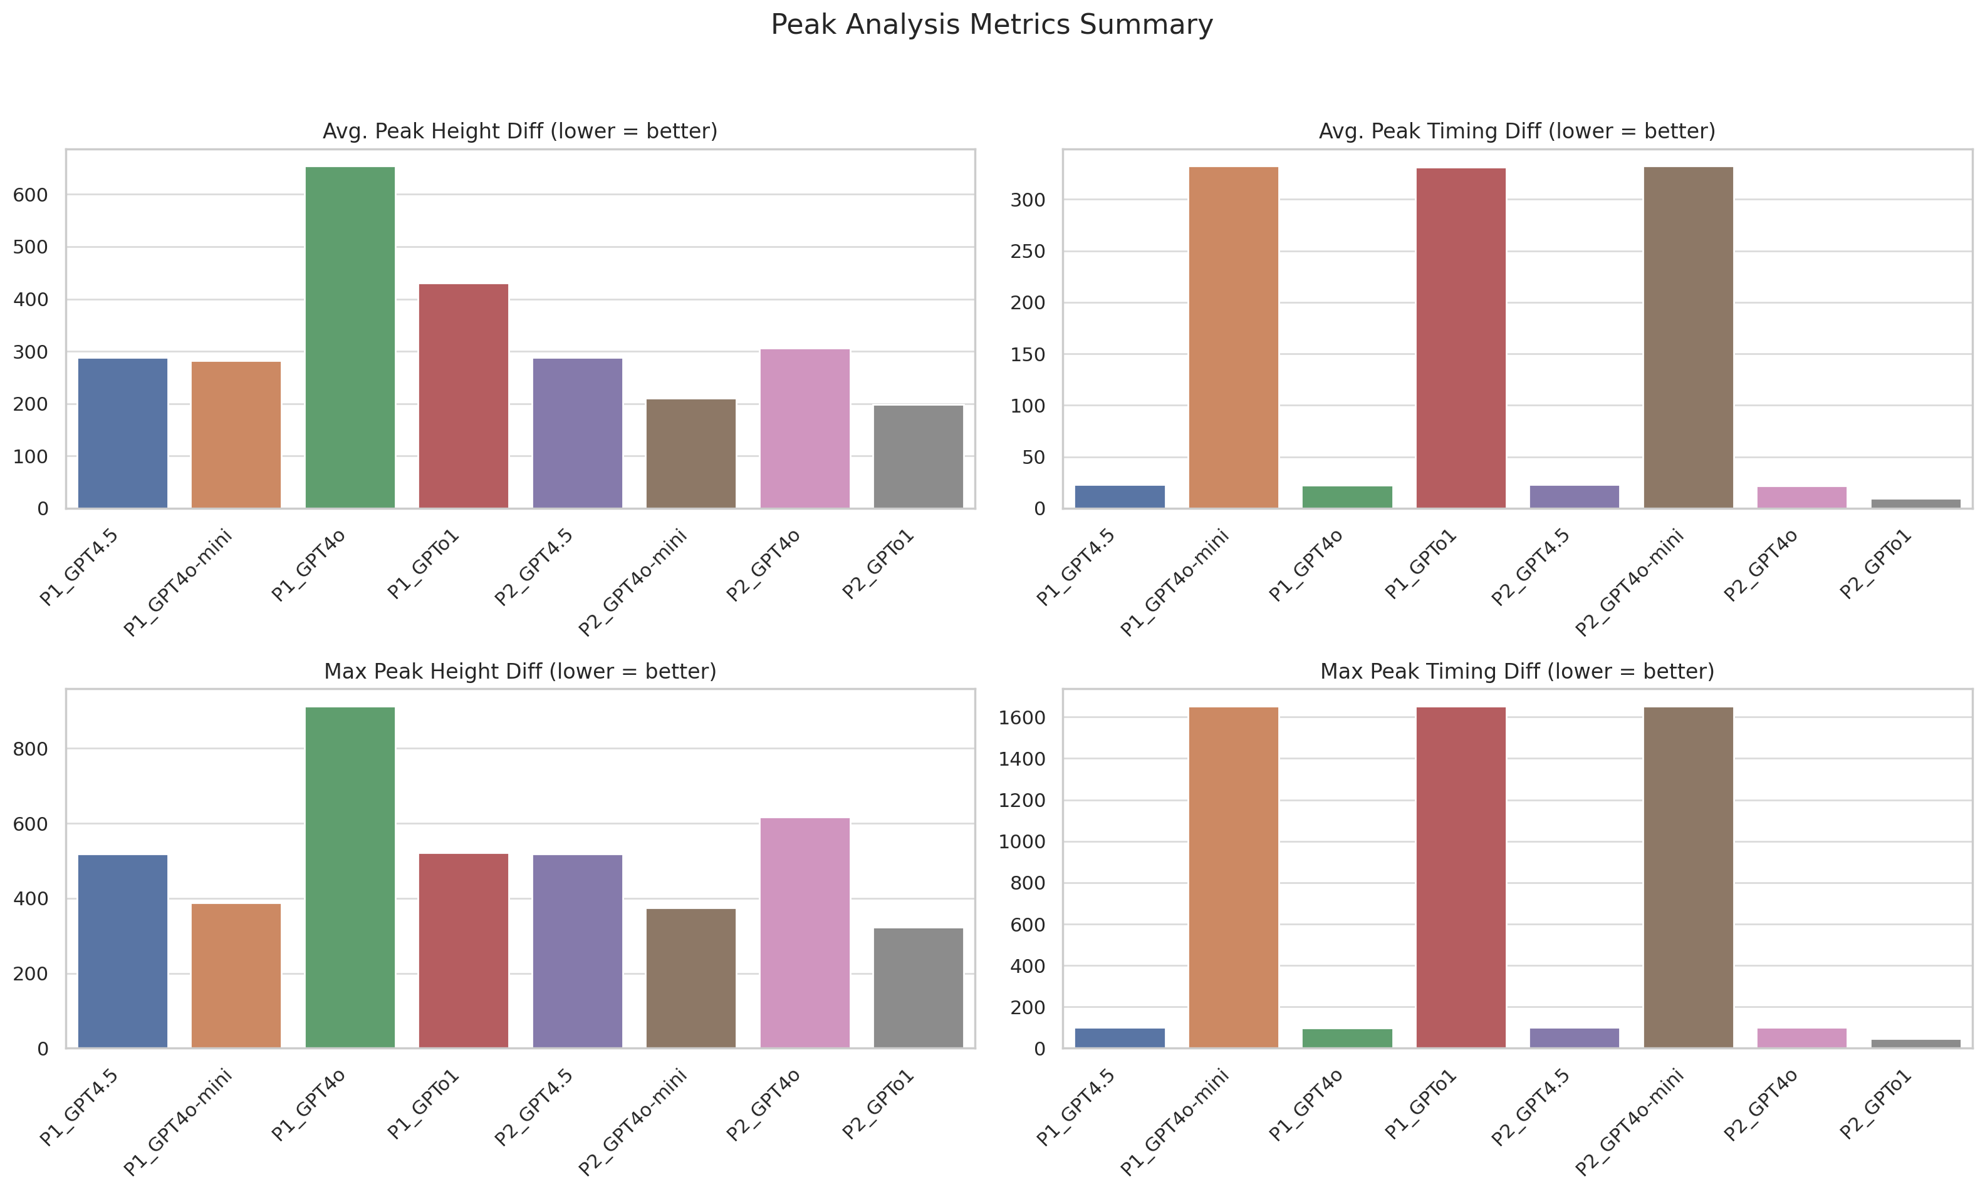
Figure 11: Peak Timing Diff
Spectral analysis was used to investigate the frequency components of both the forecasts and actual data, identifying how different models capture cyclical patterns in hydrological data. In our testing, we found that o1 using Prompt2 achieved the highest spectral fidelity with a spectral correlation of 0.997 and a power ratio of 1.07, indicating a very close match to the dominant frequency of the real data (Figure 12). This is followed by GPT4o-mini with Prompt1, achieving a spectral correlation of 0.994 and a power ratio of 1.18.
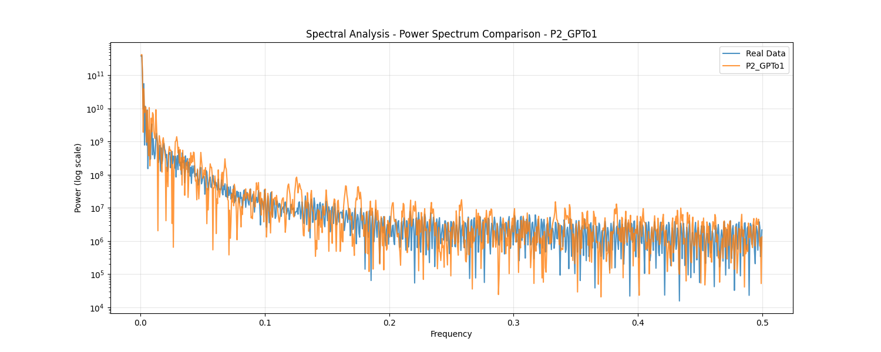
Figure 12: Spectral Analysis P2_o1
Time window analysis assessed forecast accuracy across different prediction horizons, revealing how error patterns evolve as forecast lead times increase. Many of the
The ensemble analysis (Figure 13) examined potential improvements by combining multiple model outputs, suggesting that ensemble approaches could help mitigate the weaknesses of individual models. With an RMSE of 182.578, an MAE of 131.609, and an R² of 0.941, the ensemble using all the models combined yielded the best results, with a correlation to the actual data of 0.9796.
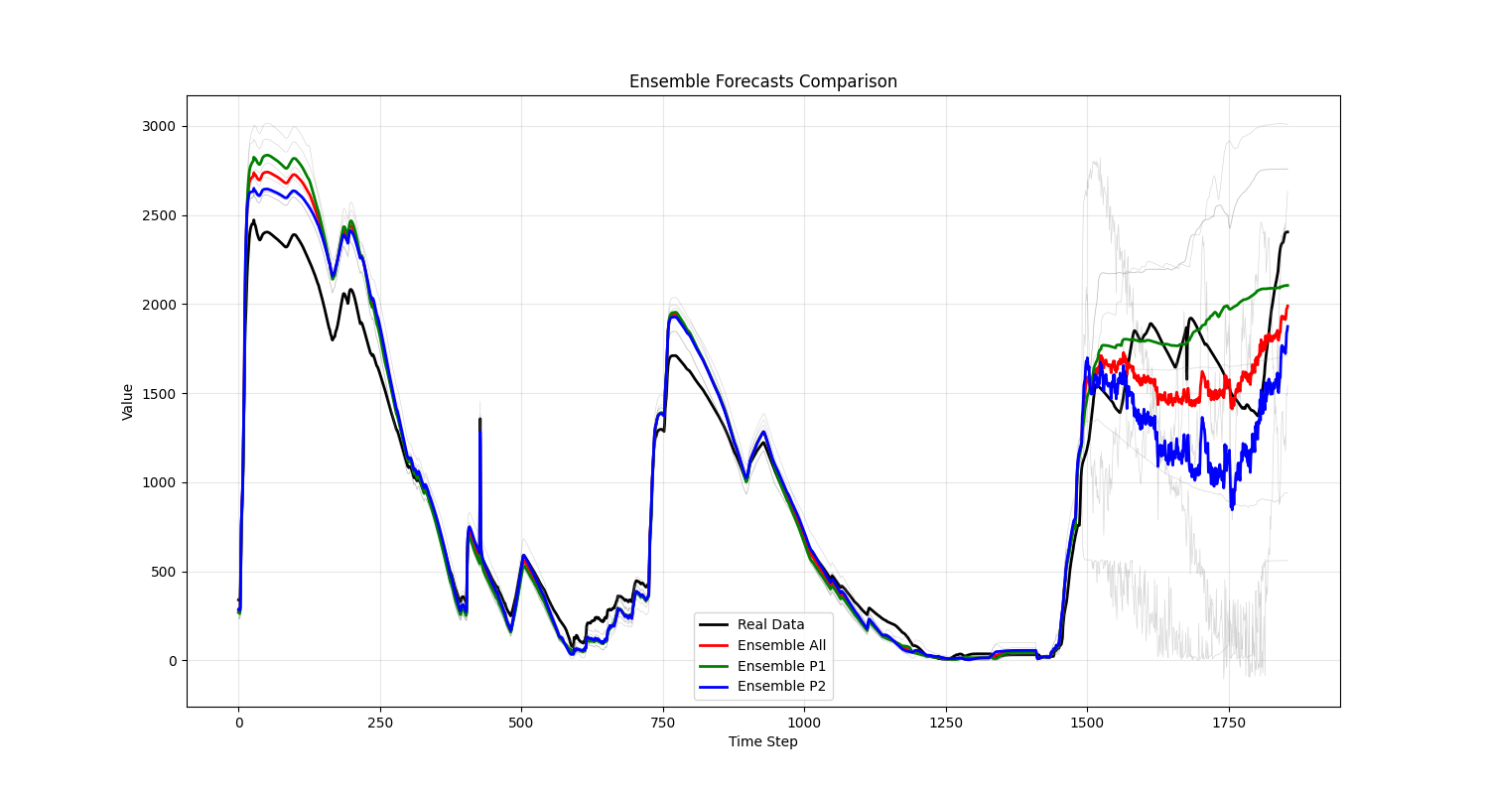
Figure 13: Ensemble Forecasts
The trend analysis examined how effectively each model captured underlying trends in the hydrological data, with implications for long-term forecasting applications. The best performing of which is o1 prompted with Prompt1(Figure 14). Our findings indicate that while individual models may excel in capturing specific aspects of hydrological patterns, no single model configuration universally outperformed others across all evaluation dimensions.
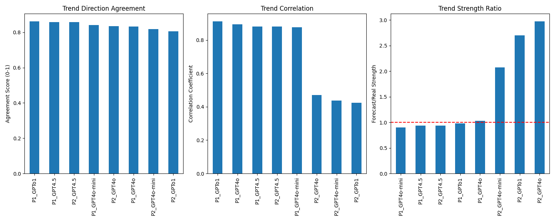
Figure 14: Trend metrics
The significant performance differences between prompting strategies highlight the importance of domain-specific prompt engineering for hydrological forecasting tasks. Models exhibited varying degrees of robustness to prompt formulation, with o1 demonstrating more consistent performance across different prompting strategies than GPT4o-mini, which showed higher peak performance but greater sensitivity to prompt variations.
The correlation values ranging from 0.90 to 0.98 for the best-performing configurations suggest that properly optimized LLMs can produce forecasts that closely follow actual water data patterns. However, the percentage errors (23-32% for top performers) indicate that while LLMs capture the overall temporal dynamics well, absolute accuracy metrics remains room for improvement.
From a practical perspective, our analysis shows that LLMs can provide valuable hydrological forecasts that closely align with reference data, potentially serving as complementary tools to traditional forecasting methods. The forecast value added by LLM approaches suggests potential applications in regions where traditional data or modeling resources may be limited or as rapid assessment tools for preliminary hydrological forecasting.

The complete results can be found in the Kaggle notebook used for training the model, as well as in the GitLab repository. For access, please don't hesitate to contact wala@iib.tu-darmstadt.de.

7. DISCUSSION
This study set out to explore whether large language models (LLMs), particularly GPT-4 variants, can generate synthetic hydrological datasets that not only mirror the statistical properties of real-world data but also improve AI-based forecasting in the context of water infrastructure management. The results clearly demonstrate that LLMs, when properly prompted, are capable of producing synthetic data that significantly enhances model performance across a range of evaluation metrics. Through this section, we reflect on the outcomes of our experiments and provide answers to the research questions posed in Section 3.
RQ1 asked whether LLMs can generate synthetic hydrological data that accurately reflect the statistical properties and patterns of real-world data. The empirical results support this, particularly for models like GPT4o-mini using Prompt1, which achieved a strong correlation coefficient of 0.981 and closely mirrored the seasonal and autocorrelation patterns present in the original Chennai dataset. Visual inspections and statistical analyses—such as distribution plots, autocorrelation checks, and spectral correlation—further confirm the statistical fidelity of the generated data. This suggests that LLMs, when provided with sufficient statistical context and carefully crafted prompts, can serve as domain-specific data generators that surpass mere random sampling.
RQ2 investigated whether incorporating LLM-generated data enhances AI model performance in predictive tasks compared to training solely on limited real-world data. The results suggest an affirmative answer. Notably, the ensemble approach, which combined outputs from different GPT models and prompting strategies, delivered the most accurate results, achieving an RMSE of 182.57 and an R² of 0.941. These improvements were particularly noticeable in forecasting high-impact events such as peak reservoir levels, which are critical for flood preparedness and water resource planning. These findings highlight the potential of synthetic data to enhance the robustness and generalizability of AI models.
RQ3 examined the challenges and risks associated with using LLMs for synthetic data generation, including issues such as bias, overfitting, and data quality concerns. Several important considerations emerged from our evaluation. First, the models exhibited varying levels of sensitivity to prompt formulation, with performance fluctuating significantly depending on how statistical information and domain context were embedded in the prompts. This implies that improper prompt engineering could lead to synthetic datasets that misrepresent natural dynamics or overfit to specific statistical targets without capturing genuine variability. Second, while LLMs performed well in matching long-term patterns and seasonal behavior, some degree of temporal smoothing and reduced variance in extreme events was observed—an indication that synthetic data might underrepresent the natural volatility of real-world hydrological systems. Lastly, the use of open-source datasets alleviated concerns about privacy in this study. Still, the broader use of synthetic data generated from sensitive or regulated domains will require careful consideration of ethical and legal implications.
Overall, the findings demonstrate that LLMs, when guided by statistical and domain-specific prompts, are powerful tools for generating realistic synthetic data that can meaningfully support and improve hydrological forecasting models. However, the effectiveness of this approach depends on the careful design of prompts, robust validation procedures, and a critical understanding of model limitations. This research helps bridge the gap between general-purpose AI and domain-specific applications in critical infrastructure, providing a blueprint for operationalizing generative models in practice.

8. CONCLUSION AND FUTURE WORKS
This study examined the feasibility and effectiveness of utilizing Large Language Models (LLMs), specifically GPT-4 variants, to generate synthetic hydrological datasets for enhancing AI-based forecasting in water infrastructure management. By leveraging domain-specific prompt engineering and statistical guidance, we demonstrated that LLMs can produce realistic synthetic data that mirrors real-world patterns. The incorporation of this synthetic data into training pipelines for Long Short-Term Memory (LSTM) models led to consistent improvements in forecasting accuracy, particularly in capturing seasonal trends. The results underline the potential of LLMs as scalable tools to mitigate data scarcity in critical infrastructure domains, offering a complementary approach to traditional simulation and statistical methods.
A key contribution of this work is the systematic evaluation of how prompt design and model variant selection influence the quality and utility of generated data. Our findings reveal that prompt engineering plays a pivotal role in achieving high-fidelity outputs, and that no single model configuration universally outperforms others. This highlights the need for adaptive, task-specific strategies when applying large language models (LLMs) in structured, numerical domains, such as hydrology. Moreover, our ensemble modeling approach further suggests that combining diverse generative outputs can provide more robust and generalizable forecasts.
While the outcomes are promising, several limitations remain. The generated data, although statistically consistent, may lack some of the stochastic variability present in actual observations, particularly during extreme events. Additionally, the generalizability of our approach to other geographical regions, hydrological systems, or infrastructure types remains an open question. The reliance on pre-trained LLMs, which may embed unknown biases or lack fine control over numerical outputs, also presents challenges for critical applications.
Future work will focus on several extensions. First, fine-tuning LLMs on hydrological corpora could improve domain alignment and controllability. Second, integrating physical constraints and domain rules more explicitly into the prompt generation process or using hybrid modeling techniques could further enhance the realism and reliability of synthetic data. Third, expanding the evaluation framework to include uncertainty quantification, long-term trend analysis, and resilience under rare-event scenarios will provide a more comprehensive understanding of model performance. This study examined data being generated for a year. Future work could focus on replicating the study in different time frames. Ultimately, we aim to validate the approach in operational settings by collaborating with water utilities and infrastructure agencies to assess the practical deployment potential of LLM-augmented forecasting systems.
In conclusion, this research demonstrates that LLMs can serve as powerful enablers of synthetic data generation for AI applications in water infrastructure management. With continued refinement, they hold the potential to transform how we address data scarcity challenges in critical infrastructure domains—ultimately supporting more resilient, intelligent, and responsive systems.

ACKNOWLEDGEMENTS
This research is part of a dissertation written in the research training group KRITIS, which is funded by the German Research Foundation (DFG).

REFERENCES
Chennai Metropolitan Water Supply and Sewage Board & Sudalai Rajkumar - SRK (2021) ChennaiWaterManagement. Available from: <https://www.kaggle.com/datasets/sudalairajkumar/chennai-water-management> [Accessed 19 March 2025].
DataRobot (2021) What are parametric models? [Internet]. Available from: <https://www.datarobot.com/blog/what-are-parametric-models/> [Accessed 19 March 2025].
DeepAI (2019) Non-Parametric Model [Internet]. Available from: <https://deepai.org/machine-learning-glossary-and-terms/non-parametric-model> [Accessed 19 March 2025].
Goyal, M. & Mahmoud, Q.H. (2024) A Systematic Review of Synthetic Data Generation Techniques Using Generative AI. Electronics, 13 (17), p.3509.
OpenAI (2024) GPT-4 Technical Report. Available from: <http://arxiv.org/abs/2303.08774> [Accessed 20 March 2025].
Ren, Y., Zhang, T., Dong, X., Li, W., Wang, Z., He, J., Zhang, H. & Jiao, L. (2024) WaterGPT: Training a Large Language Model to Become a Hydrology Expert. Water, 16 (21), p.3075.
Schotten, R., Mühlhofer, E. & Alexandros Chatzistefanou, G. (2023) Data Scarcity in Critical Infrastructure Network Modelling: Impacts on Model Performances and Mitigation Strategies. , p.EGU-15868.

