Smartphone-Based 3D Reconstruction of Buildings Using 3D Gaussian Splatting
Niels Bartels^{1,*}, Arnulph Fuhrmann¹ , Yang Zou², Richard Würstlin¹, Luca Rittmeier¹

¹ Technische Hochschule Köln, Köln, Germany
² Loughborough University, Loughborough, United Kingdom
*Corresponding email: niels.bartels@th-koeln.de

ABSTRACT
Digital reconstruction is increasingly important for BIM, digital twins, facility management, and construction progress monitoring. Conventional Scan-to-BIM methods based on terrestrial laser scanning or photogrammetry provide accurate results but often require expensive equipment and complex processing workflows.
This paper presents an integrated low-cost 3D Gaussian Splatting (3DGS)-to-IFC workflow that combines smartphone-based data acquisition, marker-assisted reconstruction, radiance field rendering, and semi-automatic IFC generation for indoor construction environments in shell condition. Two construction environments, a feature-poor concrete room and a geometrically complex staircase, were captured using different camera trajectories and ArUco marker configurations. Reconstruction quality was evaluated through geometric analyses and a user study with ten participants (N = 10). In addition, a transformation pipeline was developed to convert 3DGS reconstructions into IFC-compatible BIM models, in which element classification, spatial hierarchy and opening relationships are derived semi-automatically, yielding meshes directly usable in BIM authoring tools without further processing.
The results show that camera trajectory has a significantly greater influence on reconstruction quality than marker density. Sparse marker placement improves reconstruction robustness in feature-deficient environments, while dense marker configurations do not provide additional benefits. The proposed pipeline successfully generates semantically structured IFC models from 3DGS reconstructions while substantially reducing geometric complexity, reducing raw point clouds by a factor exceeding 12,000:1. Unlike prior work benchmarking 3DGS against laser scanning or photogrammetry, this study's novelty lies in closing the loop from smartphone capture to IFC-ready models and in isolating the acquisition factors governing reconstruction robustness. The approach targets facility managers and contractors requiring rapid, low-cost as-built documentation of building shells.

- INTRODUCTION
The digital reconstruction of buildings is becoming increasingly critical for future-oriented civil engineering and construction management. Existing buildings represent one of the world’s most valuable asset classes (Gumowski, 2025), while cultural heritage structures require accurate documentation for maintenance, conservation, and restoration (Xing et al., 2025). In addition, digital representations of construction sites can improve progress monitoring, communication, quality assurance, and decision-making across the project lifecycle. Digital twins (DT) and semantically enriched building models further enable applications such as facility management (FM), circular construction, and automated renovation planning. Despite these opportunities, the construction and civil engineering industry still lacks comprehensive and up-to-date digital representations of the built environment. Many assets remain insufficiently captured, models are often outdated, and information is frequently lost during project handovers (Attaran and Celik, 2023; Cooperman and Bartels, 2026). These limitations create challenges for FM, renovation, demolition planning, and circular reuse (Ghansah, 2025), highlighting the need for scalable and low-cost reconstruction methods.
Traditional Scan-to-BIM workflows primarily rely on terrestrial laser scanning (TLS) or photogrammetric Structure-from-Motion (SfM) approaches. While these methods can provide high geometric accuracy, they typically require expensive hardware, extensive acquisition time, expert knowledge, and computationally demanding post-processing workflows. These constraints limit their applicability for frequent site documentation and large-scale deployment in everyday construction practice. Recent advances in machine learning offer promising alternatives for reality capture in construction environments. In particular, 3D Gaussian Splatting (3DGS), introduced by Kerbl et al. (2023), addresses several limitations of previous approaches such as Neural Radiance Fields (NeRF) (Fei et al., 2024; Kerbl et al., 2023). Data acquisition requires only a standard smartphone video, model training converges within less than one hour compared to hours for NeRF-based methods, and rendering is possible in real time at frame rates exceeding 100 fps (Kerbl et al., 2023). In construction contexts, these properties enable rapid and photorealistic progress documentation without specialist scanning equipment. First applications for construction are already done, especially comparing 3DGS to laserscanning or photogrammetry (Hagedorn et al., 2026; Rüter et al., 2025). However, despite the increasing interest in 3DGS for construction applications, several challenges remain insufficiently investigated. In particular, limited research exists regarding (i) the usability of 3DGS-based workflows, (ii) the influence of artificial markers on reconstruction quality, and (iii) the transformation of 3DGS outputs into IFC-compatible BIM models.
To address these gaps, this paper proposes and evaluates a low-cost 3DGS-to-IFC workflow that combines smartphone-based data acquisition, marker-assisted reconstruction, radiance field rendering, and semi-automatic IFC generation into a unified pipeline for construction-related reality capture and BIM generation. The contributions are threefold and embedded within this integrated framework: (1) a workflow-level user study evaluating the usability and practical applicability of 3DGS-based reality capture in construction environments, (2) a systematic analysis of acquisition enhancement strategies, focusing on the role of artificial markers and their interaction with camera trajectory and reconstruction quality, and (3) a semi-automatic transformation approach enabling the conversion of 3DGS-based reconstructions into IFC-compatible building representations. Overall, the paper contributes to bridging the gap between photorealistic radiance field rendering and interoperable BIM workflows by introducing a scalable and low-cost approach for Scan-to-BIM applications in construction informatics. Accordingly, the following research questions are addressed:
- RQ1: How do artificial markers affect the reconstruction robustness and spatial accuracy of 3DGS models?
- RQ2: How can 3DGS-derived reconstructions be transformed into IFC-compatible BIM models via a combination of manual semantic labelling and automated rule-based structuring?
- State-of-the-art
2.1 Digital Reconstruction and Scan-to-BIM in Construction
Digital reconstruction technologies are increasingly important in the architecture, engineering, construction, and operation (AECO) industry, enabling applications such as progress monitoring, quality assurance, FM, renovation planning, and DT development. The growing demand for lifecycle-oriented and circular construction processes further increases the need for scalable methods to capture and document the built environment. In this context, Scan-to-BIM workflows have emerged as a key approach for generating Building Information Models from reality data. Conventional methods rely mainly on TLS and photogrammetric SfM. While TLS provides high geometric accuracy, it requires expensive equipment and expert operation. SfM reduces hardware costs but often performs poorly in environments with homogeneous surfaces, repetitive textures, or suboptimal lighting conditions typical of construction sites.
Despite these advances, major limitations remain. Current workflows typically produce unstructured geometric data (e.g., point clouds or meshes), while transformation into semantically rich BIM models remains largely manual. Consequently, scalability and interoperability continue to be key challenges for large-scale and continuous documentation in practice. Recent research has increasingly focused on automating the semantic-segmentation step of Scan-to-BIM. Deep-learning approaches based on point-based and transformer architectures have been benchmarked for indoor element classification (Mahmoud et al., 2025; Patil and Kalantari, 2025), though their performance remains constrained by the scarcity of labelled 3D training data (Yoo et al., 2025). Fully automated pipelines such as Cloud2BIM (Zbirovský and Nežerka, 2025) demonstrate that wall/slab segmentation, opening detection and IFC export can be achieved without manual intervention for TLS- or photogrammetry-derived point clouds of entire buildings. However, these approaches build on dense, high-fidelity scan data. Their applicability to sparser, lower-cost 3DGS-derived point clouds, as used in this study, remains unexplored.
2.2 IFC and Interoperability in BIM Workflows
Interoperability represents a fundamental requirement for digital construction workflows. The Industry Foundation Classes (IFC) constitute the most widely adopted open standard for exchanging semantically structured BIM data across software platforms and project stakeholders. IFC is standardized under ISO 16739 and enables vendor-neutral exchange of building information throughout the lifecycle of built assets (ISO 16739-1). The IFC schema provides structured representations of building elements, spatial relationships, attributes, and semantic information. This interoperability is particularly relevant for collaborative BIM workflows, DT, and FM applications, where long-term accessibility and consistent data exchange across heterogeneous software environments are essential (buildingSMART international, 2026; Wimmer et al., 2025). However, generating IFC-compatible models from reality capture data remains a major challenge. Most Scan-to-BIM workflows focus primarily on geometric reconstruction, whereas semantic enrichment and IFC conversion still require extensive manual modeling effort. Consequently, substantial research gaps remain between modern reality capture approaches and interoperable BIM-oriented workflows.
2.3 Radiance Field Rendering and 3D Gaussian Splatting
Radiance Field rendering has introduced new possibilities for photorealistic 3D reconstruction. Early work using Neural Radiance Fields (NeRF) demonstrated that scene representations can be learned from multi-view images (Mildenhall et al., 2020), but they are computationally expensive and slow to train Optimized NeRF frameworks like Instant-NGP. Müller et al 2022 have drastically improved training times and demonstrated interactive rendering, but only on high end GPUs which still limits practical use in construction contexts (Müller et al., 2022). 3D Gaussian Splatting (3DGS), introduced by Kerbl et al., addresses this limitation by representing scenes as explicit Gaussian primitives optimized via differentiable rasterization (Kerbl et al., 2023). This enables real-time rendering while maintaining high visual fidelity and fast training. 3DGS is particularly relevant for construction applications due to its low-cost data acquisition using smartphone videos and its ability to reconstruct complex scenes efficiently. This makes it suitable for rapid site documentation and visualization, especially in environments with homogeneous surfaces where classical photogrammetry often fails. However, 3DGS outputs remain primarily visually driven and lack semantic structure, limiting direct integration into BIM and IFC-based workflows.
2.4 3DGS Applications in the Built Environment
Since its introduction, 3DGS has gained attention in computer graphics, robotics, and spatial computing, with applications in simultaneous localization and mapping (SLAM), dynamic reconstruction, and immersive visualization. Compared to mesh-based methods, it offers improved rendering quality and efficiency (Fei et al., 2024; Kerbl, 2025; Matsuki et al., 2023). However, within the AECO domain, existing applications remain predominantly visualization-oriented (Rüter et al., 2025). Current research primarily focuses on rendering realism, reconstruction completeness, and computational efficiency, whereas interoperability and semantic integration into BIM workflows are rarely addressed. In particular, limited research exists regarding the transformation of 3DGS reconstructions into IFC-compatible building models (Hagedorn et al., 2026). Furthermore, key aspects for construction applications are still insufficiently understood, including reconstruction robustness in site conditions, the role of acquisition strategies and markers, and usability for non-expert users. Overall, the literature reveals a clear gap between emerging radiance field rendering methods and BIM-oriented, interoperable construction workflows. Although recent Scan-to-BIM frameworks (e.g., Cloud2BIM) demonstrate substantial progress towards automated point cloud–to–IFC conversion, an integrated workflow combining low-cost 3DGS-based reality capture, acquisition enhancement, and (semi-)automatic IFC generation has not yet been established (Luo et al., 2026; Zbirovský and Nežerka, 2025).
- Methodology
This section presents the proposed integrated workflow for low-cost digital reconstruction in construction environments using 3DGS. The workflow combines smartphone-based reality capture, marker-assisted reconstruction, radiance field rendering, and IFC-oriented model transformation to support BIM-oriented Scan-to-BIM processes. The workflow consists of six main stages: data acquisition, acquisition enhancement through markers, 3DGS reconstruction, geometric evaluation, IFC-oriented transformation, and user-centered evaluation.
The proposed workflow follows an integrated 3DGS-to-IFC pipeline. First, construction environments are captured using smartphone-based video recordings. The acquired data is processed using a 3DGS workflow to generate photorealistic scene reconstructions. To improve reconstruction robustness in feature-deficient environments, optional ArUco markers are integrated as additional visual reference points. Subsequently, reconstruction quality is evaluated regarding geometric consistency, visual fidelity, and artifact formation. Finally, relevant geometric structures are transferred into IFC-oriented representations to support downstream BIM workflows and interoperability. Data acquisition was conducted using an iPhone 13 Pro in 4K resolution at 60 FPS. Two interior construction environments in shell condition were selected (1) a homogeneous concrete room with limited natural features, and (2) a geometrically complex staircase with rich structural features.
Each environment was recorded using different acquisition trajectories with varying levels of parallax and baseline diversity. The experiments were designed to evaluate the influence of camera movement and scene geometry on reconstruction quality. Within the workflow, ArUco markers were investigated as an acquisition enhancement mechanism for feature-deficient environments. Three marker configurations were evaluated: (1) no markers, (2) sparse marker placement, and (3) dense marker placement. The objective was to analyze whether artificial visual reference points improve camera pose estimation and reconstruction stability in homogeneous construction scenes. The results indicate that acquisition trajectory has a substantially greater influence on reconstruction quality than marker density. Sparse marker placement occasionally improved local reconstruction stability, whereas dense marker configurations did not provide additional benefits and in some cases negatively affected reconstruction quality. The recorded video sequences were processed using the Postshot 3DGS pipeline. Compared to conventional NeRF-based methods, 3DGS enables faster training and real-time rendering while maintaining high visual fidelity. The reconstructed scenes were evaluated regarding geometric consistency, reconstruction completeness, visual realism, and artifact formation. Additionally, cloud-to-cloud (C2C) analyses were conducted to compare geometric deviations between reconstruction variants. To support BIM interoperability, the reconstructed scenes were further processed within a semi-automatic IFC-oriented transformation workflow. Since 3DGS primarily produces photorealistic but semantically unstructured representations, additional geometric abstraction and segmentation steps are required for BIM integration. The workflow therefore aims to bridge radiance field rendering outputs and interoperable BIM representations suitable for downstream construction informatics applications. A user-centered evaluation involving ten participants was conducted to assess perceived reconstruction quality. Participants evaluated in a within subjects design the models using a seven-point Likert scale with seven items regarding realism, texture quality, geometric consistency, visible artifacts, completeness of reconstruction, planarity of surfaces and depth perception.
- Results
4.1 Marker-Assisted Reconstruction Strategy
Within the proposed integrated 3DGS-to-IFC workflow, artificial markers are investigated as an acquisition enhancement strategy for feature-deficient construction environments. The objective is to assess whether marker-assisted data capture can improve reconstruction robustness and spatial stability in low-texture indoor construction scenes, and how this interacts with different acquisition trajectories. This investigation addresses a relevant gap in construction informatics and BIM-oriented reality capture workflows. While marker-based approaches are well established in photogrammetry and augmented reality applications, their role within emerging radiance field rendering-based reconstruction pipelines remains insufficiently explored. In particular, the interaction between acquisition design (camera trajectory), marker deployment, and downstream model quality has not yet been systematically analyzed in the context of integrated Scan-to-BIM workflows. The study was conducted in two representative construction environments under shell conditions: a homogeneous concrete room with limited natural visual features, and a staircase environment characterized by increased geometric complexity, depth variation, and richer structural context. To evaluate the influence of acquisition strategy, both environments were recorded using two distinct camera trajectories with varying degrees of parallax and baseline diversity. In addition, three marker configurations were investigated (1) no markers, (2) sparse marker placement, and (3) dense marker placement (see Figure 1).
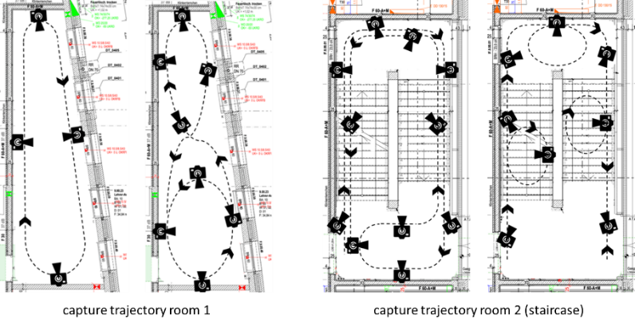
Figure 1: Overview of the capture trajectories for both rooms: a lounge (R1, left pair) and a stairwell (R2, right pair). For each room, T1 is shown on the left and T2 on the right.
All video recordings were captured using an iPhone 13 Pro in 4K resolution at 60 FPS and processed using the Postshot 3DGS pipeline. The experimental setup therefore enabled a comparative evaluation of environmental complexity, trajectory design, and marker density within a unified reconstruction workflow. The integration of ArUco markers is based on the assumption that 3DGS reconstruction pipelines, similarly to classical SfM and Multi-View Stereo (MVS) approaches, depend on reliable feature correspondences for stable camera pose estimation. In unfinished construction environments, particularly in concrete shell structures, homogeneous surfaces often provide only limited natural feature points, potentially leading to unstable reconstructions and geometric artifacts. Artificial markers were therefore introduced as additional visual anchors intended to stabilize feature matching and improve spatial consistency. ArUco markers are particularly suitable due to their robust binary encoding and reliable detectability under varying viewing conditions and partial occlusions. Within the proposed workflow, markers were evaluated as an acquisition enhancement mechanism to support low-cost reality capture in feature-deficient environments.
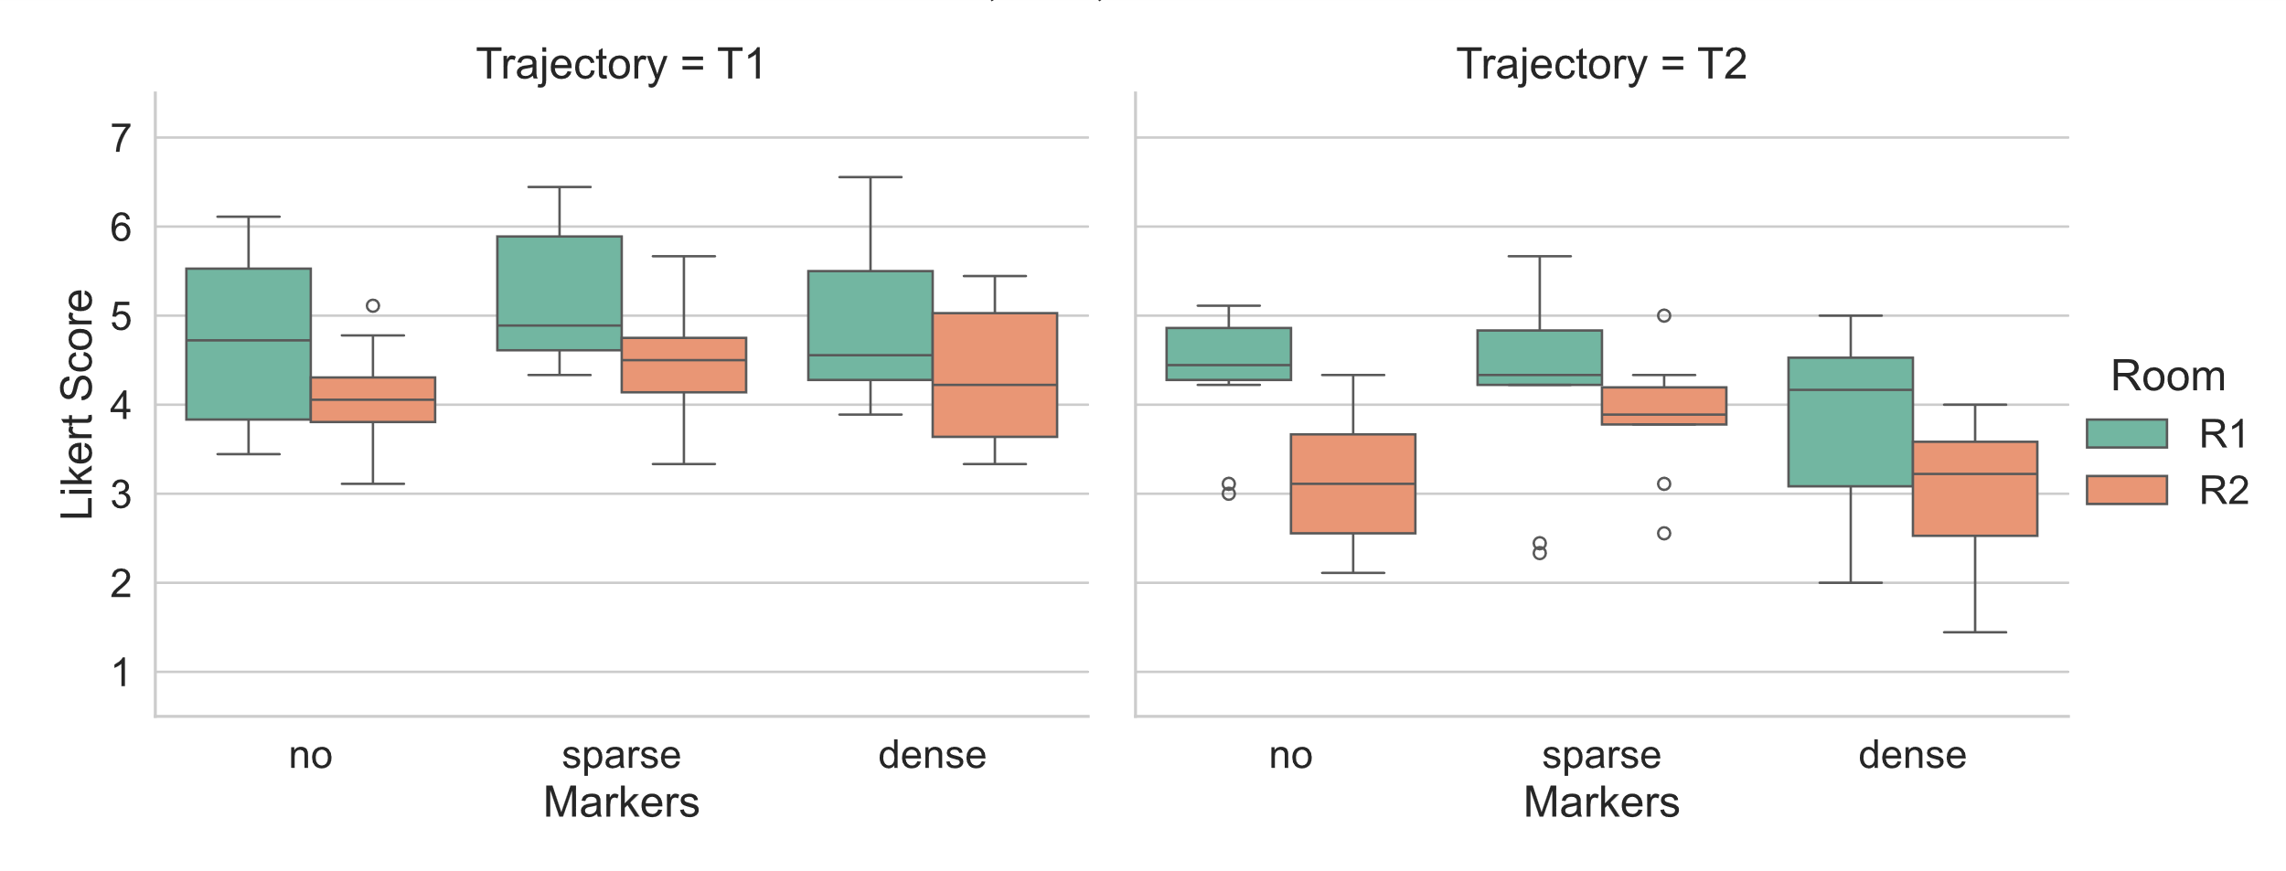
Figure 2: Boxplots detailing the distribution of reconstruction quality across marker conditions. The plot is divided into panels by Trajectory and columns by Room, highlighting that Trajectory 1 with sparse markers yields the best overall performance.
We conducted a 2 × 2 × 3 user study (N = 10) to evaluate user ratings across 12 conditions. The dependent variable was calculated as a composite score of our seven items. The results are visualized in Figure 2. To analyze the effects of our three factors (Room, Markers, and Trajectory) on perceived reconstruction quality, we performed a three-way repeated measures ANOVA. Prior to analysis, assumptions for ANOVA were verified. There were no extreme outliers, sphericity was met (Mauchly’s W = 0.69, p = .229), and a single minor violation of normality was deemed negligible given the robustness of the test.
We examined the effects of Room, Trajectory, and Markers on perceived reconstruction quality. The analysis revealed significant main effects for Room, F(1, 9) = 18.38, p = .002; Trajectory, F(1, 9) = 26.25, p < .001; and Markers, F(2, 18) = 7.20, p = .005. These main effects were qualified by a significant two-way interaction between Trajectory and Markers, F(2, 18) = 4.84, p = .021. All other interactions were non-significant. To decompose the significant Trajectory by Markers interaction, simple main effects were analyzed using pairwise t-tests with a Bonferroni adjustment. When examining the effect of markers within Trajectory 1, performance with sparse markers was significantly different from performance with no markers (t = -4.68, p = .001). No other marker comparisons within Trajectory 1 were significant. Conversely, within Trajectory 2, there were no significant differences between any of the marker conditions after alpha correction. Finally, when examining the interaction from the perspective of trajectory, Trajectory 1 consistently resulted in significantly different scores than Trajectory 2 across all three marker conditions: dense (t = 4.76, p = .001), no markers (t = 3.75, p = .005), and sparse (t = 4.82, p < .001). Post-hoc analyses of the overall marker conditions revealed that sparse markers significantly improved outcomes compared to both dense markers (t = 3.96, p < .001) and the baseline condition with no markers (t = -3.89, p < .001). However, there was no significant difference in performance between dense markers and no markers (t = 0.51,$p = .616). The user study demonstrates that Trajectory 1 consistently yields superior performance compared to Trajectory 2. Furthermore, the implementation of sparse markers proved generally beneficial, though our analysis revealed a marginally significant interaction between the room layout and marker usage ($p = .084$). This trend suggests that the advantage of adding artificial markers is highly dependent on the environment; specifically, markers provided less of an improvement in Room 2. We attribute this to Room 2 already possessing a high density of natural feature points due to the presence of natural edges, structural discontinuities, and depth variation, which inherently aids tracking and reduces the system's reliance on artificial aids. This observation aligns with the significant main effect showing that overall performance was better in Room 1. Finally, while sparse markers provided a measurable benefit, increasing the marker density actively degraded this advantage. Because dense markers performed significantly worse than sparse markers and yielded results indistinguishable from using no markers at all, the data suggests an information saturation point. An excess of artificial feature points likely introduces noise or ambiguity, negating the structural benefits of the environmental preparation. Therefore, to minimize manual preparation time while maximizing reconstruction quality, we advise using Trajectory 1 paired with sparse markers.
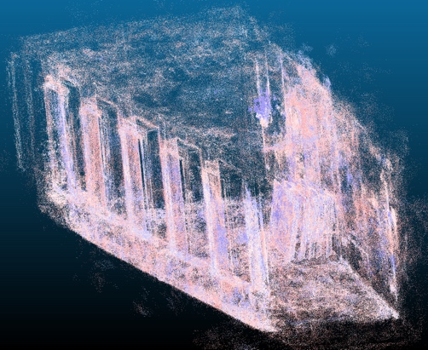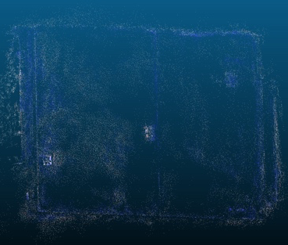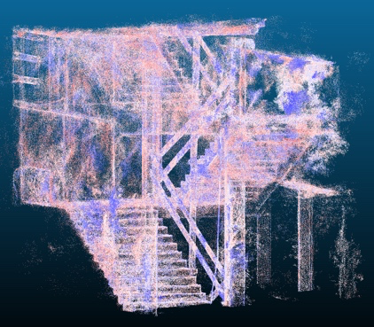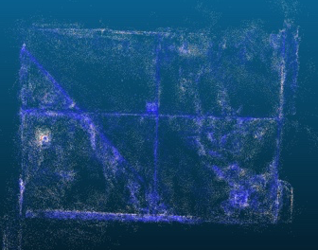
Figure 3: Point cloud visualizations of the two room types (overview and close-up of a wall)s: a feature-poor lounge (left pair) and a geometrically complex stairwell (right pair). These illustrate the differing baseline conditions for the 3D reconstruction.
The resulting point clouds of Room 1 and Room 2 are shown in Figure 3. They contrast the feature-poor environment of the lounge with the high geometric complexity of the stairwell. The close-ups of the walls demonstrate that the markers create numerous additional feature points.
4.2 3DGS-to-IFC Pipeline: Workflow Design and Validation
Based on the reality captures, a pipeline for converting 3DGS into IFC was developed. The method's explicit scene representation, collections of anisotropic Gaussian primitives parameterized by position, covariance, opacity, and spherical-harmonic color, allows direct export of positional coordinates and surface normals to standard point cloud tools, creating a practicable bridge to existing Scan-to-BIM infrastructure. The limitation this work addresses is the absence of semantic understanding: 3DGS captures geometry and appearance but cannot identify building components or produce the IFC-compliant hierarchy required for BIM integration. Potential end users include facility managers seeking low-cost as-built documentation as well as clients and general contractors requiring rapid shell construction monitoring without dedicated scanning crews. The workflow converts 3DGS-derived point clouds into IFC-compliant models through eight sequential stages across SuperSplat, CloudCompare (CC), and four open-source Python scripts. The process is shown in Figure 4.
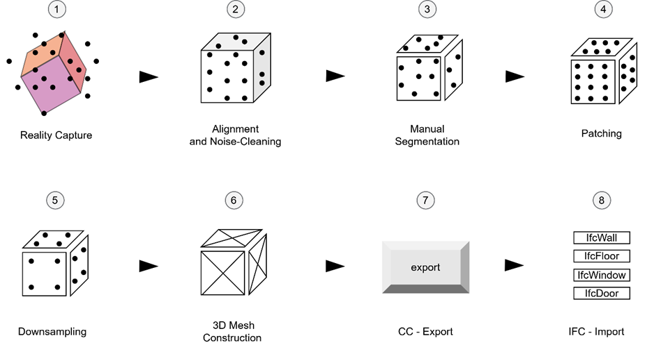
Figure 4: Pipeline Architecture and Semantic Decision-Making
The eight stages shown in Figure 5 are described more in detail afterwards. The 3DGS model is first imported into CloudCompare as a point cloud representation. All radiometric and rendering-related attributes (spherical harmonics, opacity, and Gaussian covariance parameters) are discarded, retaining only geometric information (XYZ coordinates and normals). This reduction reflects current limitations of BIM-oriented processing tools rather than a constraint of the 3DGS representation itself.
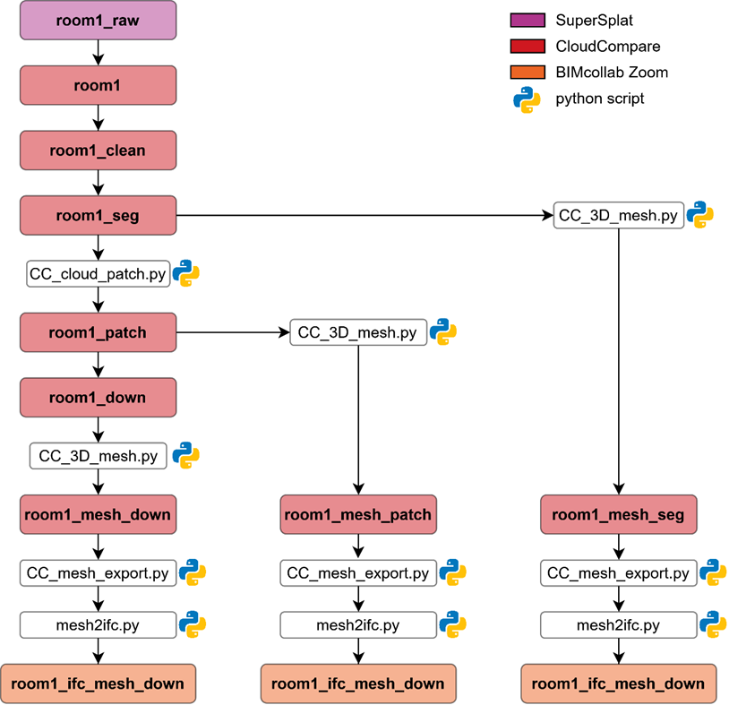
Figure 5: Stages for converting 3DGS to IFC
The resulting point cloud (2.6M points) is aligned to a BIM-consistent coordinate system, and external noise is removed, resulting in a cleaned dataset of 2.2M points. Semantic segmentation represents the central step of the pipeline and the primary point of human intervention. Due to the irregular density and reduced normal reliability of 3DGS-derived point clouds, automated methods (e.g., SOR filtering, region growing, RANSAC, and pretrained PointNet++) proved unreliable. Consequently, manual segmentation was applied in CloudCompare, where structural elements (walls, floors, doors, windows) were delineated and semantically labeled. For Room 1, this resulted in 15 segments. To address occlusions and incomplete scan regions, a custom patching procedure projects each segment onto a best-fit plane (SVD-based), computes a convex hull, and interpolates missing areas on a regular grid. The patched and original data are then merged, increasing completeness to 2.65M points. A voxel-grid filter with 50 mm spacing is applied to reduce redundancy while preserving geometric structure, resulting in a compact dataset of 69.7K points. Each segment is then converted into a prismatic mesh using plane fitting and 2D contour extrusion, producing lightweight geometry representations (e.g., 230 vertices and 400 triangles for Room 1), significantly reducing complexity compared to classical surface reconstruction methods. The resulting meshes are exported as ASCII PLY files, preserving semantic labels for downstream processing. Finally, IFC generation is performed using a custom Python pipeline based on ifcOpenShell. Element labels are mapped to IFC classes (e.g., IfcWall), and a full spatial hierarchy (IfcProject → IfcSite → IfcBuilding → IfcStorey → IfcElement) is constructed. Geometry is embedded as IfcTriangulatedFaceSet, while opening relationships (IfcRelVoidsElement / IfcRelFillElement) are inferred from naming conventions. A lightweight GUI supports manual correction of classification errors prior to export.
Semantic enrichment is thus distributed across the pipeline with manual segmentation as the primary decision point. All subsequent rule-based operations, IFC entity assignment, spatial hierarchy construction, opening relationships, are derived automatically from the names set during that single human-controlled stage. Applied to a medium-sized indoor room at shell construction stage, the pipeline achieved a reduction from 2.6M raw points to an IFC model of 230 vertices (ratio 12000:1), sufficient for LOD 200 representation of planar shell elements. All 15 elements were correctly classified without schema errors, the IFC file was validated in BIMCollab Zoom. The mesh quality is governed by boundary point distribution rather than raw density. The result of the pipeline is shown in Figure 6.
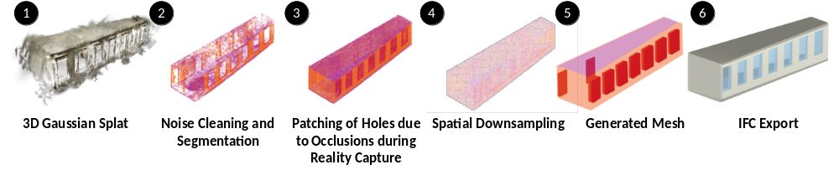
Figure 6: Exemplary room for converting 3DGS to IFC
Comparative analysis across segmentation, patching, and downsampling states shows that the patching step marginally sharpens corner definition, while the resulting triangle count (max. 400) is directly usable in BIM authoring tools without further decimation.
- Discussion
The presented workflow demonstrates that 3DGS can support low-cost Scan-to-BIM applications using only smartphone-based image acquisition. The results show that acquisition strategy has a greater impact on reconstruction quality than marker density, with sparse markers providing benefits only in feature-poor environments. This highlights that well-designed camera trajectories are more important than extensive scene preparation for achieving robust reconstructions. While the proposed pipeline successfully converts 3DGS-derived point clouds into IFC-compliant BIM models, manual semantic segmentation remains the primary limitation and restricts scalability to larger building projects. Furthermore, the conversion from Gaussian primitives to point clouds discards valuable information, such as covariance and opacity, that could support downstream semantic interpretation. Future work should therefore focus on automated segmentation using construction-specific training datasets, direct processing of Gaussian representations, and validation on larger and more complex building geometries. Overall, the proposed workflow establishes a reproducible baseline for integrating 3DGS into BIM workflows. By combining low-cost reality capture with semi-automatic IFC generation, it demonstrates a practical pathway towards scalable 3DGS-based Scan-to-BIM processes while identifying the key challenges for future automation.
- Conclusion and Outlook
This paper presented an integrated low-cost 3DGS-to-IFC workflow that combines smartphone-based reality capture, marker-assisted reconstruction, and semi-automatic IFC generation for Scan-to-BIM applications. The evaluation showed that camera trajectory has a greater influence on reconstruction quality than marker density, while sparse markers can improve robustness in feature-deficient environments. Furthermore, the proposed pipeline successfully transforms 3DGS-derived reconstructions into semantically structured IFC models, demonstrating the feasibility of integrating radiance field rendering into BIM-oriented workflows. Future work should focus on eliminating the remaining manual processing steps through automated semantic segmentation and direct processing of 3DGS Gaussian representations. In addition, the workflow should be validated on larger and more complex building environments and extended with automated IFC property generation to support scalable DT and lifecycle management applications. For facility managers and contractors, this workflow offers a low-cost alternative to TLS/SfM-based as-built documentation, particularly suited for shell-construction monitoring where speed and low equipment cost outweigh the need for LOD 300+ detail.
REFERENCES
Attaran, M. and Celik, B. G. (2023) 'Digital Twin: Benefits, use cases, challenges, and opportunities', Decision Analytics Journal, vol. 6, p. 100165.
buildingSMART international (ed) (2026) Industry Foundation Classes (IFC): An Introduction [Online]. Available at https://​technical.buildingsmart.org​/​standards/​ifc/​ (Accessed 11 May 2026).
Cooperman, A. and Bartels, N. (2026) 'Organizational Framework for Facility Management Information Definition and Delivery Process', Computing in Civil Engineering 2025. New Orleans, Louisiana, May 11–14, 2025. Reston, VA, American Society of Civil Engineers, pp. 620–630.
Fei, B., Xu, J., Zhang, R., Zhou, Q., Yang, W. and He, Y. (2024) '3D Gaussian as a New Era: A Survey'.
Ghansah, F. A. (2025) 'Digital twins for smart building at the facility management stage: a systematic review of enablers, applications and challenges', Smart and Sustainable Built Environment, vol. 14, no. 4, pp. 1194–1229.
Gumowski, S. (2025) 'Versteckte Werte im Bestand : Das UmBauLabor, ein Projekt von Baukultur Nordrhein-Westfalen'.
Hagedorn, P., Herbers, P., Waldow, K., Fuhrmann, A. and Bartels, N. (2026) 'Comparing 3D Gaussian Splatting and Laser Scanning for Assessing the Condition of Structural Concrete Elements for Circular Reuse', in Rahimian, F., Hosseini, M. R., Akanmu, A., Lafhaj, Z. and Ducoulombier, L. (eds) Proceedings of the International Conference on Smart and Sustainable Built Environment, Singapore, Springer Nature.
ISO 16739-1: Industry Foundation Classes (IFC) for data sharing in the construction and facility management industries, Berlin: Beuth Verlag.
Kerbl, B. (2025) The Impact and Outlook of 3D Gaussian Splatting.
Kerbl, B., Kopanas, G., Leimkuehler, T. and Drettakis, G. (2023) '3D Gaussian Splatting for Real-Time Radiance Field Rendering', ACM Transactions on Graphics, vol. 42, no. 4, pp. 1–14.
Luo, J., Yang, Z., Shi, P. and Ye, Q. (2026) 'Indoor scan-to-BIM automation: From mobile perception to 3D building modelling', Automation in Construction, vol. 182, p. 106731.
Mahmoud, M., Adham, M., Li, Y. and Chen, W. (2025) 'Deep Learning Semantic Segmentation-Based Scan-to-BIM for Indoor Point Clouds', 2025 15th International Conference on Electrical Engineering (ICEENG). Cairo, Egypt, 12.05.2025 - 15.05.2025, IEEE, pp. 1–6.
Matsuki, H., Murai, R., Kelly, P. H. J. and Davison, A. J. (2023) Gaussian Splatting SLAM.
Mildenhall, B., Srinivasan, P. P., Tancik, M., Barron, J. T., Ramamoorthi, R. and Ng, R. (2020) 'NeRF: Representing Scenes as Neural Radiance Fields for View Synthesis', in Vedaldi, A., Bischof, H., Brox, T. and Frahm, J.-M. (eds) Computer Vision – ECCV 2020, Cham, Springer, pp. 405–421.
Müller, T., Evans, A., Schied, C. and Keller, A. (2022) 'Instant neural graphics primitives with a multiresolution hash encoding', ACM Transactions on Graphics, vol. 41, no. 4, pp. 1–15.
Patil, J. and Kalantari, M. (2025) 'Automatic Scan-to-BIM—The Impact of Semantic Segmentation Accuracy', Buildings, vol. 15, no. 7, p. 1126.
Rüter, S., Waldow, K., Bartels, N. and Fuhrmann, A. (2025) '3D Gaussian Splatting for Construction Sites', in Noroozinejad Farsangi, E., Rasouli, A. H., Dawood, N. and Morrison, G. (eds) Construction Applications of Virtual Reality, Volume 2, Singapore, Springer Nature Singapore, pp. 37–52.
Wimmer, R., Bartels, N. and Maile, T. (2025) Next Generation BIM, Berlin, bSD Verlag.
Xing, Y., Yang, S., Fahy, C., Harwood, T. and Shell, J. (2025) 'Capturing the Past, Shaping the Future: A Scoping Review of Photogrammetry in Cultural Building Heritage', Electronics, vol. 14, no. 18.
Yoo, H., Kim, Y., Ryu, J.-H., Lee, S. and Lee, J. H. (2025) 'Semi-Automated Building Dataset Creation for 3D Semantic Segmentation of Point Clouds', Electronics, vol. 14, no. 1, p. 108.
Zbirovský, S. and Nežerka, V. (2025) 'Open-source automatic pipeline for efficient conversion of large-scale point clouds to IFC format', Automation in Construction, vol. 177, p. 106303.

