Towards Semantic Enrichment of IFC Models through
Language Modeling
STEFAN FUCHS,¹ ANDRÉ BORRMANN^{1,2}

¹Chair of Computing in Civil and Building Engineering, Technical University of Munich, Munich, Germany
²TUM Georg Nemetschek Institute, Technical University of Munich, Munich, Germany

ABSTRACT:

Semantic enrichment of Building Information Models (BIM) is critical for improving model quality and supporting downstream applications, such as compliance checking and design automation. This study explores continued pre-training of large language models on building information models in the Industry Foundation Classes (IFC) format to infer missing information required for Automated Compliance Checking (ACC). By evaluating encoder-only and decoder-only transformer architectures across different test cases, we demonstrate how much information can be inferred automatically and identify which model types and data representations are most suitable for the task. A modified ifcJSON-5a* representation was found to improve performance over traditional EXPRESS formats. The findings suggest that domain-adapted language models are a promising approach for advancing semantic enrichment in BIM and open new directions for integrating AI more deeply into the building design process.

KEYWORDS:

Semantic Enrichment, Large Language Model, Transformer, Building Information Model, Automated Compliance Checking

1. INTRODUCTION
Ensuring safety, accessibility, and energy efficiency in buildings is a critical priority within the Architecture, Engineering, and Construction (AEC) industry. To guarantee that buildings meet applicable codes and standards, obtaining a building permit is mandatory. However, the process of reviewing building permit applications is often time-intensive, resource-demanding, and criticized for inconsistencies. Automated Compliance Checking (ACC) has been proposed as a promising solution to streamline this process. Despite significant research and commercial development efforts, achieving fully automated checks remains elusive (Amor & Dimyadi, 2021).
Two primary bottlenecks hinder progress in ACC: the complexity of regulatory requirements and the availability of the necessary information within Building Information Models (BIM). More complex requirements, such as those involving inferred properties or extended data structures, present a particular challenge (Solihin & Eastman, 2015). While Information Delivery Standards (IDS) can help by specifying the properties that BIM modelers must provide, relying too heavily on this approach may become impractical. Some aspects of ACC can be efficiently covered using IDS, but attempting to enforce it for all required information could place an excessive burden on modelers.
To address these challenges, a balance must be found between information that can be inferred automatically and information that must be explicitly provided by architects and engineers. For example, many compliance checks rely on space use classifications being provided to decide their applicability. However, BIM modelers often only provide this classification implicitly through the space names. Semantic enrichment, the process of automatically inferring concepts and properties required for ACC, offers a promising pathway (Bloch & Sacks, 2020). Recent advancements include the use of Graph Neural Networks (GNNs) for semantic enrichment (Bloch et al., 2023; Wang et al., 2023), as well as the application of large language models (LLMs) and semantic similarity (Forth & Borrmann, 2024).
Building on these developments, this paper seeks to combine the strengths of both of those semantic enrichment strategies. Specifically, we propose continued pre-training of LLMs, tailoring them for BIM data. By familiarizing the language model with Industry Foundation Classes (IFC) data and employing Masked Language Modeling (MLM) and Causal Language Modeling (CLM) objectives, we hypothesize that such models can effectively predict the information required for ACC, such as space classifications, accessibility, and load-bearing status. Doing so, this study focuses on predicting missing values, instead of inferring the required types of information. Two key Research Questions (RQs) guide this study:
- RQ1: What is the most suitable representation of IFC data for language modeling tasks?
- RQ2: Which transformer architecture is best suited for the semantic enrichment of IFC models?
To address RQ1, we evaluate various data representations by strategically masking properties in previously unseen IFC models and assessing the models’ ability to accurately predict the original values. For RQ2, we investigate the accuracy of encoder-only versus decoder-only transformer architectures in performing this task.

2. BACKGROUND AND RELATED WORK

2.1 Language models
Transformer models and the underlying parallelization capability of the self-attention mechanism (Vaswani et al., 2017) have revolutionized Natural Language Processing (NLP) by enabling large-scale language modeling pre-training. Unlike sequential models such as Long Short-Term Memory (LSTM) networks (Hochreiter & Schmidhuber, 1997), where computation depends on prior time steps, creating a bottleneck for efficiency and scalability, transformers allow for parallel processing, making it possible to scale both model parameters and training data effectively.
This advancement has led to increasingly large language models whose general-purpose knowledge can be transferred across a wide range of downstream tasks. Transformer architectures can be broadly categorized into three types: encoder-only, encoder-decoder, and decoder-only models. The original transformer architecture, introduced by Vaswani et al. (2017), featured an encoder-decoder architecture designed for translation tasks, allowing the encoder and decoder to learn distinct embedding spaces for source and target languages.
Subsequently, the encoder and decoder transformer stacks have been adapted as standalone models, each with its own standard pretraining objective. Encoder-only models typically employ MLM, where a portion of tokens is masked and predicted using bidirectional context, making them well-suited for classification and sequence labeling. The most well-known example is Bidirectional Encoder Representations from Transformers (BERT) by Devlin et al. (2018).
In contrast, decoder-only models, which have gained broader adoption due to their generative capabilities, are trained using CLM. This auto-regressive approach predicts tokens sequentially to reconstruct the original input and is often followed by supervised fine-tuning or reinforcement learning to enhance task-specific performance during inference. The generalization abilities of models such as Generative Pretrained Transformers (GPT) have been demonstrated in numerous studies (Radford et al., 2019).
Despite their success, original transformer models suffer from a significant limitation: a restricted context length due to the quadratic complexity of the attention mechanism with respect to the sequence length. This becomes particularly problematic for processing IFC models, which are often large and require extensive context windows. To address this, recent research has focused on long-context transformers that reduce attention complexity through architectural innovations. Two prominent approaches are localized attention mechanisms, as employed by models like Transformer-XL (Dai et al., 2019) and Longformer (Beltagy et al., 2020), and linearized attention mechanisms, used in models such as Performer (Choromanski et al., 2020) and Linear Transformer (Katharopoulos et al., 2020).
A recent example of a long-context encoder-only model is ModernBERT (Warner et al., 2024), which extends the capabilities of BERT by combining local attention with global context tokens. It also incorporates Rotary Position Embedding (RoPE) (Su et al., 2024), allowing the model to scale its input length from BERT’s original 512 tokens to up to 8192 tokens. This makes it a strong candidate for applications involving large, structured data such as BIM.
Alternatively, decoder-only models with infilling capabilities are of particular relevance to this study. These models, frequently used in code completion tasks, can generate missing content based on both the left and right context. Two features of such models could be especially beneficial for the semantic enrichment of IFC data. The first is the pretraining on source code, which shares structural similarities with the IFC and ifcJSON representations, including the hierarchical structures, identifiers, and key-value properties. Code models may also exhibit enhanced handling of numeric and symbolic data, which is particularly advantageous for the geometry-rich nature of IFC files. Second, their ability to perform bidirectional contextual reasoning through infilling makes them suitable for tasks involving incomplete data. A broad range of recent decoder-only models optimized for code, such as WizardCoder (Luo et al., 2023), StarCoder (Li et al., 2023; Lozhkov et al., 2024), CodeGemma (CodeGemma Team et al., 2024), and Qwen2.5-Coder (Hui et al., 2024), exemplify this trend.

2.2 Semantic Enrichment
Semantic enrichment in the context of BIM refers to the process of augmenting a model with explicit information derived from implicit data. Examples include the automatic classification of spaces (Forth & Borrmann, 2024), the identification of topological relationships (Lilis et al., 2025), and the prediction of material properties (Kaltenegger et al., 2024). A more comprehensive overview of semantic enrichment tasks in the context of ACC, including the classification of information types, is provided by Bloch and Sacks (2020).
In existing research, semantic enrichment using machine learning has primarily relied on graph-based methods (Austern et al., 2024) and semantic similarity approaches (Forth & Borrmann, 2024). GNNs are commonly employed to reason over structured data and can incorporate text embeddings as features at the node level. However, their learning is typically constrained to the explicit graph structure, meaning that semantic relationships are propagated only through connected nodes. As a result, GNNs may struggle to capture the full semantic richness of textual BIM representations, especially when these semantics span across distant or unconnected parts of the graph. Moreover, pretrained GNNs are relatively scarce compared to pretrained transformer-based language models, which limits the prospect of transfer learning.
Similarly, semantic similarity approaches that rely on cosine distance between text embeddings can fail to capture nuanced meaning, particularly when contextual information or domain-specific cues are important. These limitations highlight the need for alternative approaches that can model both structure and semantics in a more integrated manner.
This motivates the approach proposed in this study: training a language model directly on IFC representations, thereby leveraging their relational structure in text form. We operate on both IFC and ifcJSON formats.
Recognizing that their interconnected entity references increasingly resemble graph-like structures, this trajectory might naturally move toward a linearized graph representation in the future. However, by using a textual representation, the model can potentially transfer semantic understanding acquired from large-scale pretraining on code and natural language to BIM-specific tasks. Such a language modeling approach could support semantic enrichment across multiple scales and stages of the building design process, offering an alternative to traditional graph-based techniques while capitalizing on the representational power of transformer models.

3. METHODOLOGY
For semantic enrichment through language modeling, two key components are required: a pre-trained language model and suitable training data. Using a pretrained model as a foundation reduces the amount of in-domain data needed and typically improves the models’ generalization capabilities.

3.1 Dataset
The dataset used for domain adaptation consists of 422 IFC models of office and residential buildings sourced from student projects, as exemplified in Figure 1. These were split into training (80%), validation (10%), and testing (10%), resulting in 338 models for training, 42 for validation, and 42 for testing. The majority of models (92.7%) were created using Autodesk Revit, followed by ArchiCAD (6.9%).
This study evaluates the following three representations of IFC data, which are detailed further throughout this section:
- IFC4 in EXPRESS format
- ifcJSON-5a, a JSON-based representation
- ifcJSON-5a*, a modified version of ifcJSON-5a in which all properties and quantities are directly attached to the respective elements
To manage processing efficiency and reduce training time, geometry data was excluded from all representations. However, recognizing its importance for semantic enrichment, future work will explore ways to incorporate geometric information more effectively without incurring significant computational overhead.

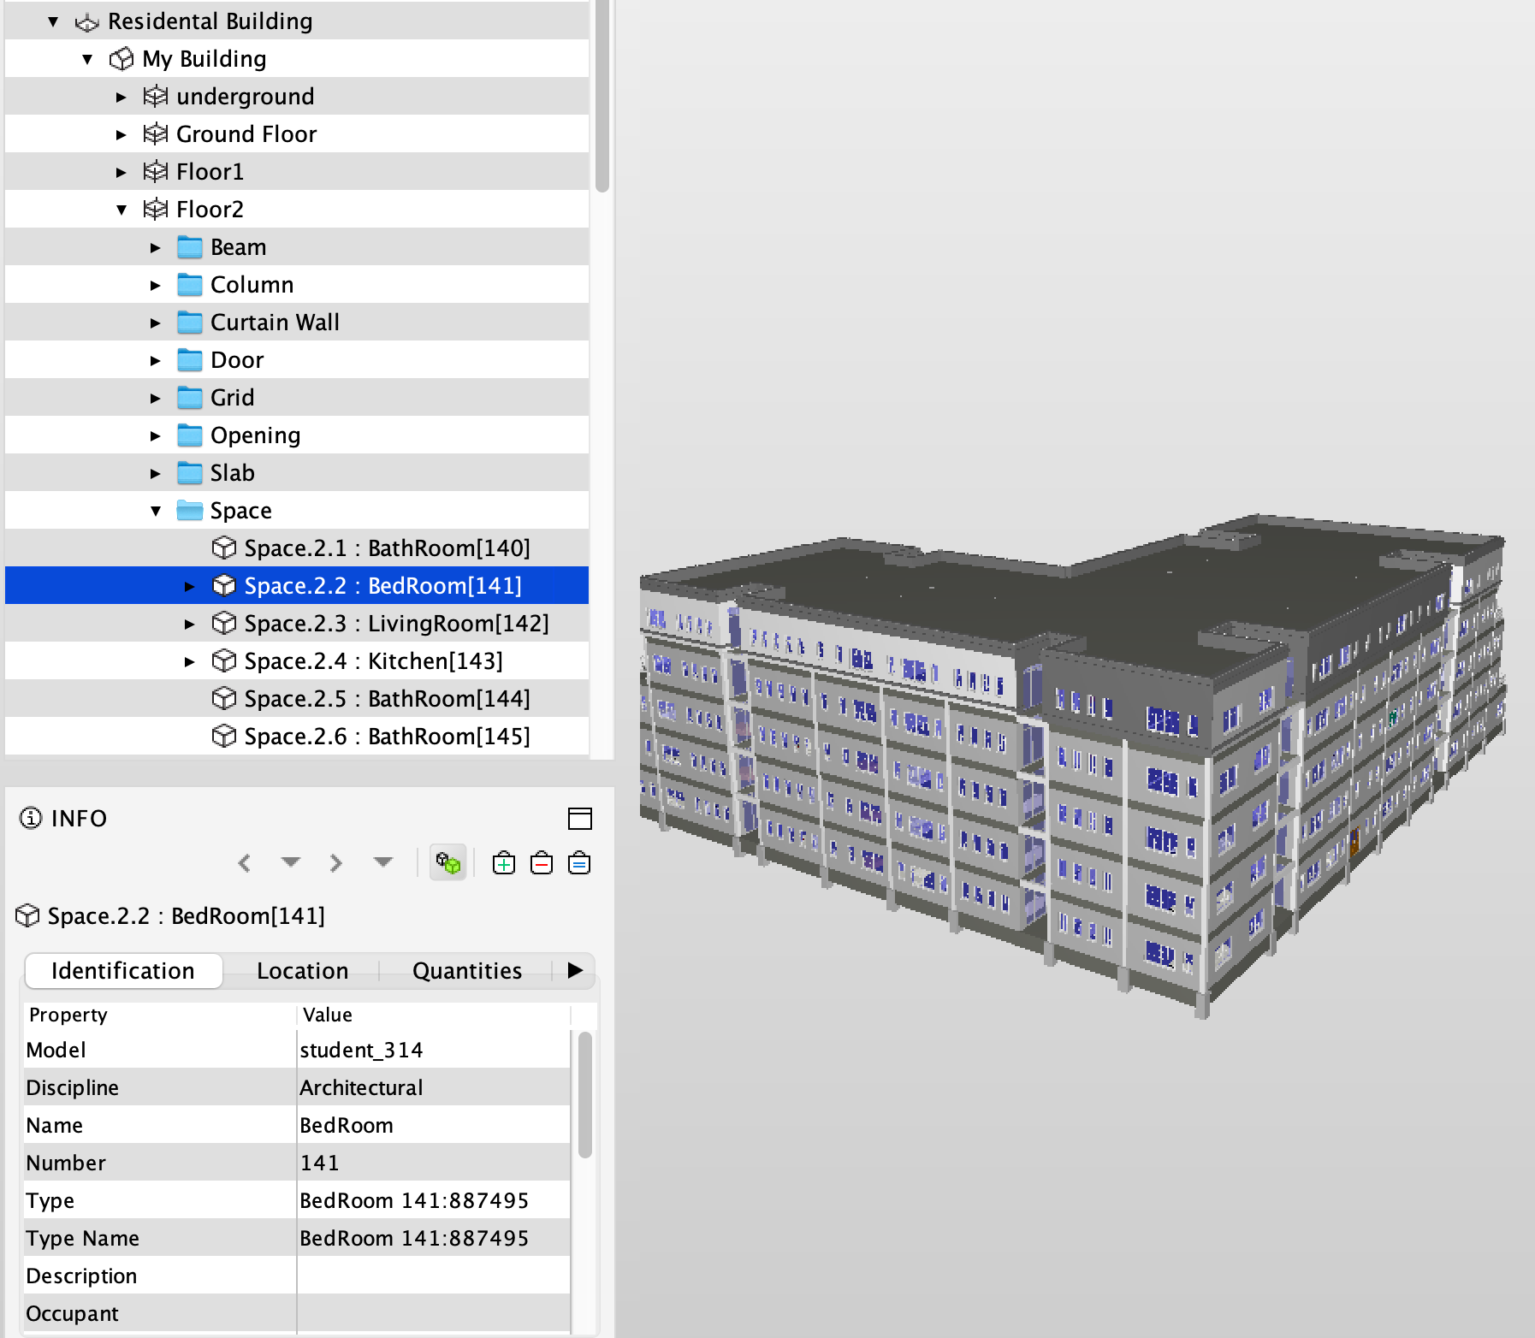
Figure 1: Example building. Screenshot taken from Solibri Anywhere.

To improve tokenization of the EXPRESS format, all IFC keywords appearing more than 10 times were added to the ModernBERT tokenizer (see Section 3.2). The model’s embedding layer was resized accordingly, and new token embeddings were initialized by averaging the embeddings of the constituent tokens.
All floating-point numbers were normalized to two decimal places, or to the last non-zero digit for small values. In the EXPRESS format, scientific notation (e-notation) was preserved, where applicable, and the same normalization was applied. Additionally, globally unique identifiers (GUIDs) were removed, as entity references are established via # notation in EXPRESS. In ifcJSON, however, GUIDs are used for referencing. We replaced these GUIDs with semantic IDs (e.g., space_1), which are more interpretable by LLMs.
Conversion from IFC4 to ifcJSON-5a was performed using a buildingSMART community project. While ifcJSON-4 closely adheres to the IFC4.3 schema, ifcJSON-5a introduces several adjustments to reduce verbosity and improve readability, making it more suitable for language modeling. However, redundancy was introduced by duplicating some properties at the object level (e.g., "isExternal": true) but keeping the property sets. In our modified version, ifcJSON-5a*, these redundant property sets were removed, and the same simplification was applied to all remaining properties and quantities, except for type elements, which were structured differently. Figure 2 illustrates these adaptations for one space.

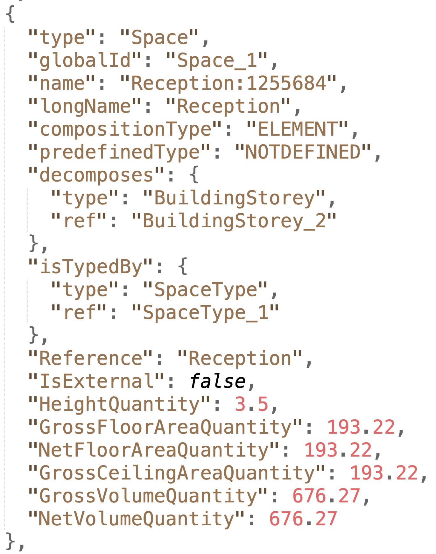
Figure 2: Excerpt of an IFC model in ifcJSONv5*

Table 1 summarizes the file size statistics for the original and modified representations. The EXPRESS format is more compact due to its schema-based structure, whereas the ifcJSON representations are more verbose, as all keys are made explicit. Despite the larger size, this verbosity is expected to benefit language modeling by providing more semantically meaningful context. Notably, geometry data accounts for more than three-quarters of the IFC file sizes in the training set, underscoring its importance for future integration.

Table 1: IFC model statistics. Minimum, maximum, and average file sizes in Megabytes (MB) for the original IFC data and the three tested representations.

Format | Set | Count | Min | Max | Avg
Original IFC | Train | 338 | 1.22 | 19.90 | 11.15
Original IFC | Valid | 42 | 2.05 | 19.08 | 10.62
Original IFC | Test | 42 | 1.21 | 18.87 | 10.53
IFC without geometry | Train | 338 | 0.13 | 17.68 | 2.72
IFC without geometry | Valid | 42 | 0.58 | 15.34 | 3.40
IFC without geometry | Test | 42 | 0.35 | 17.26 | 3.05
ifcJSONv5 | Train | 338 | 0.78 | 705.22 | 18.27
ifcJSONv5 | Valid | 42 | 2.20 | 67.98 | 16.09
ifcJSONv5 | Test | 42 | 1.44 | 42.67 | 13.84
ifcJSONv5* | Train | 338 | 0.31 | 687.21 | 9.55
ifcJSONv5* | Valid | 42 | 0.86 | 61.28 | 5.97
ifcJSONv5* | Test | 42 | 0.46 | 10.91 | 4.52

The simplifications in ifcJSON-5a* reduced the file sizes to approximately half of the original ifcJSON-5a format; however, they still remain larger than IFC EXPRESS.
To evaluate the impact of key preprocessing decisions, we trained two alternative models, for an ablation study:
- A variant retaining IFC GUIDs and geometry information.
- A variant without specialized IFC keyword tokens, to examine the effect of embedding resizing in low-resource training scenarios.
These models help isolate the effects of tokenization and the omission of identifiers and geometry on downstream semantic enrichment performance.

3.2 Language Model Training

3.2.1 Model Selection
We define two selection criteria. First, the model needs to have infilling capability to be able to perform the semantic enrichment task out of the box, and the model should include source code in its pretraining corpus. We hypothesize that pretraining on structured, formal languages (such as source code) makes models particularly well-aligned with the relational and syntax-heavy structure of IFC and ifcJSON.
To evaluate RQ1, we selected an encoder-only transformer model with an MLM objective, as this architecture supports bidirectional context. Specifically, we used ModernBERT (Warner et al., 2024) as the base model due to its extended context length, pretraining on programming code, and architectural enhancements such as disabled bias terms and RoPE.
However, the MLM setup requires the number of masked tokens to be known in advance. This constraint reveals information about the token count of the target. Additionally, each mask is predicted independently, limiting coherence when predicting multi-token properties. For this reason, we use the encoder-only model primarily to explore differences in representation formats.
Encoder-decoder models offer more flexibility in span prediction by allowing variable-length infilling with a single mask token. However, few long-context encoder-decoder models are currently available. One candidate, LongT5 (Guo et al., 2021), is optimized for text summarization and not well-suited for fine-grained infilling, so this architecture was excluded from initial experiments.
In contrast, decoder-only models with infilling capabilities are commonly used in code completion and allow for coherent and context-aware generation. Among recent models, we selected Qwen2.5-Coder for its competitive performance at the time of experimentation, support for infilling, and availability in a size comparable to ModernBERT-large (0.5 billion parameters). This size allowed for full fine-tuning on the available hardware without the need for parameter-efficient fine-tuning, which is planned for future work.

3.2.2 Model Training
ModernBERT was trained using a random masking strategy with a masking probability of 30%. In future work, more targeted strategies, such as masking complete lines or only property values, may be explored to improve downstream performance. The hyperparameters listed in Table 2 were specified based on the original ModernBERT training configuration and our exploratory testing. All other parameters were left at their default values as defined in the Huggingface Trainer. The training was conducted using two A100 GPUs with data parallelization.

Table 2: Model and training hyperparameters for ModernBERT and Qwen2.5-Coder. The effective batch size was computed as the product of the number of GPUs, gradient accumulation steps, and the per-device batch size.

 | ModernBERT | Qwen2.5-Coder
Parameters | 395M | 490M
Full Context Length | 8,192 | 32,768
Used Context Length | 8,192 | 16,384
Learning Rate | 1e-4 | 1e-6
Batch Size (BS) | 4 | 1
Gradient Accumulation Steps | 4 | 8
Effective BS | 32 | 16
Epochs | 30 | 10
Early stopping patience | 5 | 3
Adam Beta1 | 0.9
Adam Beta2 | 0.98
Adam Epsilon | 1e-6
Weight decay | 1e-5
Warmup ratio | 0.06
BF16 | true

Qwen2.5-Coder was fine-tuned using a standard autoregressive language modeling objective, extended with Fill-in-the-Middle (FIM) capability. Following the approach of Bavarian et al. (2022), we alternated between three training strategies: Prefix-Suffix-Middle (PSM), Suffix-Prefix-Middle (SPM), and samples without FIM. While PSM maintains the natural order of content, SPM offers the advantage of continuing directly from the end of the prefix, reducing the burden on the attention mechanism to locate the correct insertion point, as illustrated in Figure 3.

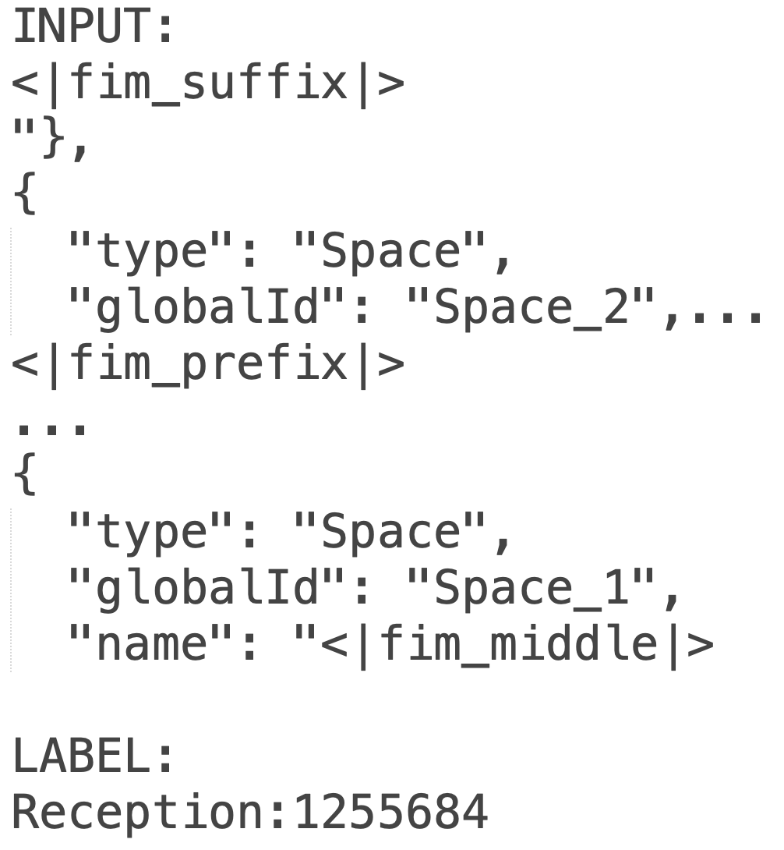
Figure 3: FIM sample with Suffix-Prefix-Middle (SPM) strategy, as used for model evaluation (Section 3.3.2)

FIM was applied with a probability of 0.66, split equally between PSM and SPM. In contrast to the original FIM setup, we used smaller in-filling ratios between 0.02 and 0.2, reflecting the shorter target spans expected during inference in semantic enrichment tasks.
Based on initial experiments, a reduced learning rate and an adjusted number of training epochs were chosen for the Qwen2.5-Coder model. Although the model supports a context length of up to 32,768 tokens, we limited it to 16,384 tokens to fit the model on a single GPU during training with a batch size of 1. Gradient accumulation steps and early stopping patience were adjusted accordingly. All other training settings were kept consistent with those used for ModernBERT. The best model was selected based on the lowest validation loss with random masking (for MLM) or causal language modeling, depending on the architecture.

3.3 Model Evaluation

3.3.1 Representations
To address RQ1, we designed a series of evaluation scenarios, with decreasing complexity but increasing practical relevance. In the best case, we would evaluate the models on well-defined and manually curated semantic enrichment tasks. However, due to the lack of public benchmark datasets and our own efforts to establish a benchmark still being in progress, we are opting for evaluation scenarios that can be automatically established. The focus was on assessing the model’s ability to infer information about spaces, a central entity in compliance checking. Specifically, we examine whether the model can predict space names given the associated properties and, conversely, whether it can infer those properties from the space name. However, tasks such as space classification were deferred to future work due to the manual effort required for labeling. For this evaluation, we limited the scope to values that were explicitly specified in the IFC models.
The following six scenarios were tested using ModernBERT across each representation format introduced in Section 3.1:
- All spaces – All properties: All property values are masked for all spaces simultaneously. This scenario evaluates whether the model can predict property values based on global distribution patterns learned during training. Contextual clues from related elements (e.g., containment or associations) may contribute to the predictions.
- All spaces – Space name properties: Only name properties (Name, LongName, and Reference) are masked for all spaces at once. This tests the model’s ability to generalize naming conventions across different models, without relying on project-specific patterns. However, the model still has access to supporting information, such as area measurements or isExternal flags, which may aid in predicting the appropriate space name.
- All spaces – Other properties: Name properties are provided, while all other space properties and quantities are masked. This scenario assesses whether space names have predictive power for inferring other attributes. However, the model cannot leverage project-specific spatial characteristics conveyed through the masked properties of other spaces.
- One space – All properties: Only the properties of a single space are masked per test sample. This setup reflects a more practical use case, such as missing data or newly added elements in an IFC model. Local context and intra-model naming conventions are expected to guide the model toward more accurate predictions.
- One space – Space name properties: Only the name-related properties of one space are masked at a time. This scenario approximates an initial step toward space classification, where the model attempts to infer a label or identifier from the surrounding context.
- One space – Other properties: All properties except naming fields are masked for a single space. With the space name and local context available, the model is expected to make more informed predictions. This scenario reflects a more realistic use case where only a few property values are missing or where new elements are added to an existing IFC model.
The total number of predicted values varies between test cases and representations. Differences arise from factors such as the reuse of property values by multiple building elements in IFC EXPRESS, direct property assignment to IfcSpace instances, redundancy in ifcJSON, conversion artifacts, and the occasional splitting of property values into different samples during tokenization and chunking. As a reference point, in the ifcJSON-5a* representation, a total of 63,868 property values were included in the test set. Of these, 13,557 were space names and references, while 50,309 were other properties and quantities.

3.3.2 Transformer Architecture
To evaluate RQ2, we tested Qwen2.5-Coder on the “One space – All properties” scenario using the ifcJSON-5a* representation. This scenario was selected for its higher practical relevance, as it reflects a typical real-world case where individual elements may be newly added. The ifcJSON-5a* format was chosen based on its high accuracy in the "One space" scenarios with ModernBERT (as reported in Table 3).
Preparing the input to match this scenario required careful handling. In contrast to the masked tokens in BERT, simply replacing specific values with dummy tokens or empty strings could inadvertently lead to the model repeating the dummy content. To maintain consistency and comparability with ModernBERT, we retained the full file structure, removing all properties but one for a single space and repeating the process for each property. However, this leads to 63,868 independent generation tasks, making the evaluation very time-consuming. In the future, generating the complete element, rather than individual properties, should be tested.
Qwen2.5-Coder was evaluated using three different context configurations: LHS, PSM, and SPM, as discussed in Section 3.2.2.
Each FIM mode was tested at two context lengths: 4,000 and 8,000 tokens. For PSM and SPM, the available tokens were evenly divided between prefix and suffix segments. These settings were chosen to explore how both prompt structure and context size affect the model’s ability to perform semantic enrichment.

4. RESEARCH FINDINGS
RQ1 investigated which representation format is best suited for training LLMs on IFC models. Table 3 presents the results of training ModernBERT across different representation formats, evaluated using the test cases described in Section 3.3.1.
Somewhat unexpectedly, models trained on the EXPRESS format outperformed others in the baseline scenarios, where all properties were masked simultaneously, with the exception of cases focused solely on space name prediction, where ifcJSON-5a* yielded the best performance. A tendency towards ifcJSON-5a* was also observed in the more realistic "One space" scenarios, where properties were masked for individual spaces while leveraging context from the surrounding spaces. In these cases, ifcJSON-5a* achieved an accuracy improvement of up to 15% compared to EXPRESS. Notably, the model trained with the standard ifcJSON-5a also slightly outperformed EXPRESS in most of these scenarios, except for the space name prediction task, where access to the surrounding context seems to have an especially large impact.
These findings suggest that ifcJSON-5a* is better suited for language modeling tasks than the other formats, likely due to its reduced verbosity and increased semantic information, which allows for more relevant information to fit within the models’ context window. Additionally, the ablation experiments showed that neither extending the tokenizer with IFC-specific keywords nor removing geometry improved prediction performance for the “All Spaces” scenarios.
In contrast, the model trained on IFC geometry had the overall best accuracy for the “All spaces – All properties” and “All spaces – Other properties” scenarios. However, the larger size due to the additional geometry prevented the model from benefiting from the information about the surrounding spaces in the “One space” scenarios.
A measurable benefit of these interventions, especially the geometry removal, was the reduced training time. These results motivate future research into more effective ways of incorporating geometry into the language modeling process without overwhelming the model’s input space.

Table 3: Accuracy of property prediction for ModernBERT across different IFC representation formats and test scenarios. Results reflect the models’ performance on space-level semantic enrichment tasks defined in Section 3.3.1.

Representation | All spaces |  |  | One Space
Representation | All Properties | Space Name | Others | All Properties | Space Name | Others
EXPRESS | 16.91 | 2.86 | 24.45 | 43.52 | 41.39 | 46.49
- Special Tokens | 18.96 | 4.97 | 25.62 | 44.3 | 43.77 | 47.33
+ Geometry | 23.44 | 1.12 | 32.46 | 29.51 | 3.57 | 36.09
ifcJSONv5 | 13.23 | 2.02 | 18.31 | 45.37 | 17.47 | 53.82
ifcJSONv5* | 13.37 | 10.85 | 18.27 | 58.96 | 66.41 | 61.37

A qualitative inspection of the predictions revealed that many correct values could be attributed to repetition and regularity within IFC models, for instance, repeated height values across storeys or repetitive naming patterns. Nevertheless, many false predictions were also semantically plausible: predicted numeric values often had the correct order of magnitude, and space names frequently resembled the intended label. However, the independent prediction of each mask token made coherent predictions inherently difficult for multi-token fields.
This naturally leads to RQ2: Are other model architectures, particularly decoder-only with infilling capability, better suited for semantic enrichment?
Table 4 presents the results of experiments conducted with Qwen2.5-Coder-0.5B on the "One Space – All Properties" scenario. With 54.05%, the best-performing Qwen2.5-Coder configuration achieved an accuracy of approximately 5% lower than the best ModernBERT model in the same scenario. However, it is important to note that in the case of ModernBERT, the number of masked tokens had to be specified in advance, leaking information about the target values and providing an advantage. The SPM configuration performed best, followed by the strategy with left-hand side context, indicating that bidirectional context can help the prediction accuracy, but only if the input stays coherent. In all cases, more context improved the accuracy slightly.
Beyond overall accuracy, a qualitative review showed that many of the predictions generated by Qwen2.5-Coder appeared more semantically plausible and coherent compared to those produced by ModernBERT. This was particularly evident for floating-point values. On average, the float prediction error for Qwen2.5-Coder was 231.55, whereas the best ModernBERT configuration in the same scenario (i.e., IFC EXPRESS without special tokens) exhibited a much higher average error of 6161.54. Even under its best-performing condition for floating-point prediction, the "All Spaces – Other Properties" scenario using the EXPRESS representation, ModernBERT achieved an average error of 631.53, still more than twice that of Qwen2.5-Coder.
These results suggest that both model types have distinct strengths: while masked language models like ModernBERT benefit from controlled masking strategies and faster inference, decoder-only models with infilling capabilities demonstrate greater consistency and realism, particularly for numeric data. For a more comprehensive comparison, future studies could evaluate encoder-decoder against decoder-only architectures or test other span-based masking strategies (Du et al., 2021) to better understand the trade-offs between generation quality, contextual reasoning, and architectural flexibility for semantic enrichment tasks.

Table 4: Accuracy of property prediction for Qwen2.5-Coder-0.5B on the "One Space – All Properties" scenario, evaluated across different context lengths (i.e., tokens) and FIM strategies. Results are shown for PSM, SPM, and LHS context configurations.

Tokens | LHS | PSM | SPM
4000 | 47.88 | 43.19 | 52.51
8000 | 48.71 | 44.51 | 54.05

5. DISCUSSION
This research explored the feasibility and effectiveness of continued pretraining of language models with IFC, for semantic enrichment tasks in the context of BIM. A simplified version of the community-driven ifcJSON-5a representation was identified as the most suitable format for language modeling in our experiments. Additional refinements, such as directly attaching properties to elements, were introduced to reduce verbosity and redundancy. However, these changes complicate lossless conversion back to the original IFC schema. This can be especially problematic when integrating geometry in the future, since some parsing errors were already encountered by the IFC to ifcJSON converter.
This raises the question of how such a language model might be integrated into practice, whether directly within the design process or primarily as a preprocessing tool for tasks such as compliance checking. In the latter case, mappings between semantic IDs and original GUIDs could serve as a bridge to the source BIM. However, an important aspect to consider is model ownership, which would result in different disciplines being responsible for performing semantic enrichment independently. To address this challenge, integrating the language model with Information Delivery Specifications (IDS) could provide a viable solution. Such an integration would enable the enrichment of models with required properties, supported by real-time suggestions within design software environments.
A threat to the validity of this study lies in the training data used for this initial experimentation. Although some filtering was applied by excluding models in IFC2x3 format and those smaller than 1 MB, the remaining IFC models vary significantly in Level of Development (LOD) and are largely limited to the architectural discipline. Additionally, the accuracy and realism of specified properties are of mixed quality, as many models may rely heavily on default values rather than design intent. Also, some of the IFC models used languages different from English, with German being the most frequent. This also causes potential issues due to the IFC-specific encoding of characters that are not specified in ISO 8859-1, which includes the German “Umlaut”.
To address these concerns, future work will incorporate real-world industry and open-source models and manually validated test cases for a broader range of well-defined semantic enrichment tasks. These tasks may include:
- Converting IfcProxy elements to appropriate IFC classes
- Enforcing consistency for shared parameters (e.g., fire resistance for similar door types)
- Standardizing naming conventions across IFC entities
- Classifying spaces based on context and properties
Such curated benchmarks, based on established classifications, would improve test quality and allow a more nuanced evaluation of the language models’ capabilities in this domain.
As discussed in Section 3, geometry plays a critical role in BIM and is central to many semantic enrichment tasks. While geometry was mostly excluded in this study to reduce computational load, it will be integrated in future work. Following suggestions by Pauwels et al. (2017), geometry could be modeled separately from IFC, potentially through dedicated geometric embedding models. Alternatively, bounding boxes or other geometric summaries may offer a lightweight yet effective way to incorporate spatial context for enrichment tasks.
Beyond enrichment, the pretraining strategy explored here opens up broader applications in building design automation. For instance, IFC-aware language models may be used to generate building components from scratch or extend existing models with semantically complete elements. To this end, future work will evaluate Qwen2.5-Coder and related models for generating entire building elements, including both their semantic and geometric components. This approach would allow evaluation through recall and precision of predicted properties, eliminating the need to design test samples for each property individually. Reinforcement learning could be employed to better align model outputs with the user intent in such use cases and reward the model for syntactic correctness.
Several promising extensions to this work can be envisioned:
- Exploration of lightweight representations: Testing more compact formats optimized for language modeling and token efficiency.
- The amount of training data could be increased through synthetic building models.
- Zero-shot semantic enrichment with larger LLMs: Comparing direct application of general-purpose LLMs against the domain-specific pretraining approach proposed in this study.
- Use of global tokens: Capturing document-wide context in long IFC files for more informed predictions.
- Improved mask prediction strategies: Addressing ModernBERT’s limitation of independent mask prediction through: A language modeling head or diffusion-based approaches, iterative span-filling, predicting one span at a time, or testing encoder-decoder models for more natural span-based masking.

6. CONCLUSION
This study explored a language modeling strategy for semantic enrichment of BIM data, identifying a modified ifcJSON-5a* representation as a particularly effective choice. In practical enrichment scenarios, ifcJSON-5a* consistently outperformed traditional EXPRESS-based formats.
The encoder-only model (ModernBERT) demonstrated stronger semantic enrichment capabilities under controlled evaluation settings and served as an effective testbed for systematically comparing different representations and testing scenarios, benefiting from faster inference times. In contrast, the decoder-only model (Qwen2.5-Coder) exhibited greater semantic consistency, particularly in the prediction of floating-point attributes, highlighting its potential and practical usability. This suggests that decoder-only models may be especially valuable in applications with fewer but clearly defined semantic enrichment tasks.
Overall, while the results are promising, several avenues for future work remain critical. These include the creation of manually curated test cases, the development of improved representation formats, the integration of geometric information, and the comparison of domain-specific models against general-purpose LLMs using zero-shot learning approaches.

ACKNOWLEDGEMENTS
Stefan Fuchs gratefully acknowledges the support received as a LOC scholarship holder from the Leonhard Obermeyer Center of the Technical University of Munich.

REFERENCES
Amor, R., & Dimyadi, J. (2021). The promise of automated compliance checking. Developments in the Built Environment, 5, 100039.
Austern, G., Bloch, T., & Abulafia, Y. (2024). Incorporating context into BIM-derived data—leveraging graph neural networks for building element classification. Buildings. https://doi.org/10.3390/buildings14020527
Bavarian, M., Jun, H., Tezak, N., Schulman, J., McLeavey, C., Tworek, J., & Chen, M. (2022). Efficient training of language models to fill in the middle. In arXiv [cs.CL]. arXiv. http://arxiv.org/abs/2207.14255
Beltagy, I., Peters, M. E., & Cohan, A. (2020). Longformer: The Long-Document Transformer. In arXiv [cs.CL]. arXiv. http://arxiv.org/abs/2004.05150
Bloch, T., Borrmann, A., & Pauwels, P. (2023). Graph-based learning for automated code checking – Exploring the application of graph neural networks for design review. Advanced Engineering Informatics, 58, 102137.
Bloch, T., & Sacks, R. (2020). Clustering information types for semantic enrichment of building information models to support automated code compliance checking. Journal of Computing in Civil Engineering, 34(6), 04020040.
Choromanski, K., Likhosherstov, V., Dohan, D., Song, X., Gane, A., Sarlós, T., Hawkins, P., Davis, J., Mohiuddin, A., Kaiser, L., Belanger, D., Colwell, L. J., & Weller, A. (2020). Rethinking attention with Performers. International Conference on Learning Representations, abs/2009.14794.
CodeGemma Team, Zhao, H., Hui, J., Howland, J., Nguyen, N., Zuo, S., Hu, A., Choquette-Choo, C. A., Shen, J., Kelley, J., Bansal, K., Vilnis, L., Wirth, M., Michel, P., Choy, P., Joshi, P., Kumar, R., Hashmi, S., Agrawal, S., … Huffman, S. (2024). CodeGemma: Open Code Models Based on Gemma. In arXiv [cs.CL]. arXiv. http://arxiv.org/abs/2406.11409
Dai, Z., Yang, Z., Yang, Y., Carbonell, J., Le, Q. V., & Salakhutdinov, R. (2019). Transformer-XL: Attentive language models beyond a fixed-length context. In arXiv [cs.LG]. arXiv. http://arxiv.org/abs/1901.02860
Devlin, J., Chang, M.-W., Lee, K., & Toutanova, K. (2018). BERT: Pre-training of deep bidirectional Transformers for language understanding. In arXiv [cs.CL]. arXiv. http://arxiv.org/abs/1810.04805
Du, Z., Qian, Y., Liu, X., Ding, M., Qiu, J., Yang, Z., & Tang, J. (2021). GLM: General Language Model pretraining with autoregressive blank infilling. In arXiv [cs.CL]. arXiv. http://arxiv.org/abs/2103.10360
Forth, K., & Borrmann, A. (2024). Semantic enrichment for BIM-based building energy performance simulations using semantic textual similarity and fine-tuning multilingual LLM. Journal of Building Engineering, 110312.
Hochreiter, S., & Schmidhuber, J. (1997). Long short-term memory. Neural Computation, 9(8), 1735–1780.
Hui, B., Yang, J., Cui, Z., Yang, J., Liu, D., Zhang, L., Liu, T., Zhang, J., Yu, B., Dang, K., Yang, A., Men, R., Huang, F., Ren, X., Ren, X., Zhou, J., & Lin, J. (2024). Qwen2.5-Coder Technical Report. In arXiv [cs.CL]. arXiv. http://arxiv.org/abs/2409.12186
Kaltenegger, J., Petrova, E., Borrmann, A., & Pauwels, P. (2024). A conceptual system architecture for enriching Digital Twins with material performance data using symbolic and sub-symbolic Artificial Intelligence. 12th Linked Data in Architecture and Construction Workshop, LDAC 2024.
Katharopoulos, A., Vyas, A., Pappas, N., & Fleuret, F. (2020). Transformers are RNNs: Fast Autoregressive Transformers with Linear Attention. In H. D. Iii & A. Singh (Eds.), Proceedings of the 37th International Conference on Machine Learning (Vol. 119, pp. 5156–5165). PMLR.
Li, R., Allal, L. B., Zi, Y., Muennighoff, N., Kocetkov, D., Mou, C., Marone, M., Akiki, C., Li, J., Chim, J., Liu, Q., Zheltonozhskii, E., Zhuo, T. Y., Wang, T., Dehaene, O., Davaadorj, M., Lamy-Poirier, J., Monteiro, J., Shliazhko, O., … de Vries, H. (2023). StarCoder: may the source be with you! In arXiv [cs.CL]. arXiv. http://arxiv.org/abs/2305.06161
Lilis, G. N., Wang, M., Katsigarakis, K., Mavrokapnidis, D., Korolija, I., & Dimitrios, R. (2025). BIM-based semantic enrichment and knowledge graph generation via geometric relation checking. Automation in Construction, 173(106081), 106081.
Lozhkov, A., Li, R., Allal, L. B., Cassano, F., Lamy-Poirier, J., Tazi, N., Tang, A., Pykhtar, D., Liu, J., Wei, Y., Liu, T., Tian, M., Kocetkov, D., Zucker, A., Belkada, Y., Wang, Z., Liu, Q., Abulkhanov, D., Paul, I., … de Vries, H. (2024). StarCoder 2 and The Stack v2: The next generation. In arXiv [cs.SE]. arXiv. http://arxiv.org/abs/2402.19173
Luo, Z., Xu, C., Zhao, P., Sun, Q., Geng, X., Hu, W., Tao, C., Ma, J., Lin, Q., & Jiang, D. (2023). WizardCoder: Empowering Code Large Language Models with Evol-Instruct.
Pauwels, P., Krijnen, T., Terkaj, W., & Beetz, J. (2017). Enhancing the ifcOWL ontology with an alternative representation for geometric data. Automation in Construction, 80, 77–94.
Radford, A., Wu, J., Child, R., Luan, D., Amodei, D., & Sutskever, I. (2019). Language Models are Unsupervised Multitask Learners.
Solihin, W., & Eastman, C. (2015). Classification of rules for automated BIM rule checking development. Automation in Construction, 53, 69–82.
Su, J., Ahmed, M., Lu, Y., Pan, S., Bo, W., & Liu, Y. (2024). RoFormer: Enhanced transformer with Rotary Position Embedding. Neurocomputing, 568(127063), 127063.
Vaswani, A., Shazeer, N., Parmar, N., & Uszkoreit, J. (2017). Attention is all you need. Advances in neural information processing systems, 30.
Wang, Z., Ying, H., Sacks, R., & Borrmann, A. (2023). CBIM: A graph-based approach to enhance interoperability using semantic enrichment. In arXiv [cs.SE]. arXiv. http://arxiv.org/abs/2304.11672

https://github.com/buildingsmart-community/ifcJSON

