Hybrid CEEMDAN-WTD Denoising Framework for Stress Sensor Signals in Bridge Erection Machines

JIAJING LIU^{1, *}; ZHEZHENG ZHANG²; WEILI FANG²
¹Key Laboratory for Damage Diagnosis of Engineering Structures of Hunan Province, College of Civil Engineering, Hunan University, Changsha 410082, China
²School of Civil Engineering and Hydraulic Engineering, Huazhong University of Science and Technology, 430074, Wuhan, Hubei, China

ABSTRACT:

Bridge erection machines play a vital role in modern bridge construction, but structural failures resulting from inaccurate stress monitoring can lead to serious accidents. Vibrating wire strain gauges (VWSGs), which are sensitive to electromagnetic interference (EMI) in construction environments, require efficient denoising methods. To address this challenge, we propose a hybrid denoising approach that combines Complete Ensemble Empirical Mode Decomposition with Adaptive Noise (CEEMDAN) and Wavelet Threshold Denoising (WTD). CEEMDAN decomposes the signal into intrinsic mode functions (IMFs), and through correlation analysis, noise-dominant IMFs are identified and denoised using WTD, while signal-dominant IMFs are left unprocessed to preserve crucial features. We validate the proposed method using field data from the Zhangjinggao Yangtze River Bridge mid-approach project. The results show effective noise suppression while retaining essential signal characteristics, providing a practical solution for monitoring systems in bridge erection machines.

KEYWORDS:

Bridge erection machines, Sensor, Signal denoising, CEEMDAN, WTD

1. INTRODUCTION
Bridge erection machines (BEMs) are critical equipment in modern bridge construction, widely used for their efficiency in handling large bridge components. However, accidents involving BEMs during construction can have severe consequences. Investigations reveal that between 1985 and 1996 in China, 22 BEM accidents occurred, including 16 major overturning incidents (Wang, X., 2000). These accidents not only cause significant property damage but may also lead to serious casualties.
For instance, the Hanzhong 7•18 BEM accident in 2019 resulted in the machine disintegrating and overturning during operation, causing 5 deaths, 4 severe injuries, and 3 minor injuries, with direct economic losses of approximately 12.953 million yuan (Baidu Baike, 2019).
To prevent such accidents, multiple sensors are deployed on BEMs to monitor their real-time operational status. Among these, stress sensors are particularly crucial for assessing structural stability. However, stress sensors are susceptible to noise interference during operation, which compromises data accuracy. Therefore, denoising the acquired signals from stress sensors is essential for ensuring the safe operation of BEMs.
Vibrating wire strain gauges (VWSG), operating at frequencies between 600 and 1500 Hz, are especially vulnerable to electromagnetic interference (EMI). This interference introduces noise into the raw measurements, making it difficult to distinguish from genuine data and undermining sensor accuracy.
With increasing emphasis on stress monitoring at construction sites, data acquisition frequencies have risen. Simultaneously, construction environments harbor numerous potential EMI sources, such as arc welding, machine ignition, power generators, and electrical cables. These disturbances not only degrade data accuracy but may also trigger excessive false alarms, leading to safety management chaos.
Current research on denoising stress sensor signals in bridge erection machines (BEMs) remains limited, particularly in addressing real-world operational challenges. To overcome the shortcomings of existing denoising methods, this study introduces a novel hybrid approach combining Complete Ensemble Empirical Mode Decomposition with Adaptive Noise (CEEMDAN) and Wavelet Threshold Denoising (WTD). CEEMDAN effectively mitigates mode mixing through adaptive white noise integration, demonstrating superior adaptability in signal decomposition (Li, Y., 2018). Subsequent application of wavelet soft-thresholding to noise-dominant intrinsic mode functions (IMFs) further eliminates redundant noise components while preserving critical structural response features. Compared to conventional techniques, this method ensures more precise noise removal without distorting essential signal characteristics.
By advancing denoising performance for BEM stress monitoring, this research contributes a robust and efficient solution to enhance construction safety through reliable sensor data analysis.

2. Literature Review
2.1 Traditional Denoising Methods for Sensors
Research on denoising VWSG signals in BEMs remains scarce. In recent years, researchers have conducted extensive studies on signal denoising across various fields (Niu, H., 2020).
Wavelet transform, with its multi-scale analysis capability, has become a vital tool for processing non-stationary signals. Liu et al. proposed a wavelet threshold denoising method based on novel noise variance estimation, validated using random signals and test data from an electromechanical transmission system. Zhang et al. applied wavelet thresholding to denoise pressure sensor output signals. However, their method overlooked useful information, leading to suboptimal decomposition.
Empirical Mode Decomposition (EMD) is an adaptive signal decomposition method that breaks down complex signals into multiple IMFs. Abdelkader et al. used EMD to denoise vibration signals from rolling bearings, significantly improving fault detection performance. However, EMD suffers from mode mixing, which affects denoising outcomes. Salman et al. introduced an EMD-based denoising method for heart sound signals. By classifying IMFs via energy density and reconstructing dominant components, they achieved effective denoising.

2.2 Advanced Denoising Methods
Traditional denoising methods exhibit various limitations, prompting researchers to explore improvements.
Ensemble Empirical Mode Decomposition (EEMD) reduces mode mixing by introducing Gaussian white noise but suffers from high computational complexity and noise amplitude dependency. Ye et al. employed EEMD to extract features from electrocardiogram (ECG) signals, overcoming EMD’s mode mixing. Through multi-theoretical analysis, they achieved 96.09% accuracy in ECG signal classification using support vector machines. Cheng et al. applied EEMD to decompose lidar signals, distinguishing IMFs via correlation coefficients. They further denoised signal-dominant IMFs using singular value decomposition and lifting wavelet transform, enhancing precision but neglecting useful information in noise-dominant components.
CEEMDAN, an improved signal decomposition method, addresses EMD’s mode mixing by adding white noise and averaging multiple iterations. Guo et al. used CEEMDAN to decompose seismic signals, selecting valid components via Pearson correlation coefficients and reconstructing them with wavelet transform. However, discarded components containing useful signals were ignored, and wavelet thresholding's inherent flaws persisted. Hu et al. decomposed dynamic imbalance signals using CEEMDAN, distinguishing signals from noise via orthogonal coefficients, wavelet soft-thresholding, and autocorrelation. While the algorithm improved IMF selection, it failed to extract useful signals from noise-dominant components.
Table 1 presents the Comparative Analysis of Signal Denoising Methods. Despite CEEMDAN’s excellence in signal decomposition, its application in VMSG, especially for BEMs, remains limited. Existing studies focus on single-method improvements, leaving multi-method fusion underexplored. For example, combining CEEMDAN with other techniques to enhance denoising warrants further research.
To bridge the gap, this study proposes a CEEMDAN-based denoising method integrated with WTD. The proposed method not only effectively resolves mode mixing issues but also mitigates noise-dominant component interference through WTD. This dual approach ensures superior noise suppression while optimally preserving critical signal characteristics. Our work aims to fill existing research gaps and provide a more efficient and precise denoising solution for BEM stress monitoring.

Table 1: Comparative Analysis of Signal Denoising Methods

Method | Limitation |  | Reference
Wavelet | Neglect useful information |  | Liu, H., 2018  Zhang, L., 2018
EMD | Suffer from mode mixing |  | Abdelkader, R., 2018  Salman, A.H., 2016
EEMD | Neglect useful information in noise-dominant components |  | Ye, L., 2023  Cheng, X., 2020
CEEMDAN | Lack of exploration into multi-method fusion |  | Guo, X.F., 2022  Hu, Y.J., 2022

3. Research Approach
3.1 CEEMDAN
EMD leverages signal fluctuations to decompose signals into IMFs of varying amplitudes. While EMD excels in decomposing nonlinear, non-stationary signals, intermittent phenomena may cause mode mixing. To address this, Wang et al. proposed EEMD, which averages IMFs obtained by decomposing signals with added Gaussian white noise. However, EEMD’s averaging process is computationally intensive, inefficient, and cannot fully eliminate noise.
In contrast, CEEMDAN calculates residual signals by subtracting modal components from the original signal after EMD decomposition with added white noise. This method achieves near-zero reconstruction error with fewer averages, resolving EMD's mode mixing and EEMD’s inefficiency and residual noise issues.
Let$u_{z}$ $E_{\left(k\right)}(·)$ denote the k-th modal component obtained via EMD, ${IMF'}_{q}$ the q-th modal component from CEEMDAN, $n_{\left(i\right)}(t)$ the zero-mean white noise added over NR iterations, and $I(t)$ the target signal. The signal-to-noise ratio (SNR) at each decomposition stage is adjusted via $β_{k}$. The CEEMDAN algorithm proceeds as follows in Eqs. (1)-(4):
1. Perform NR decompositions of the signal $I\left(t\right)+β_{0}n_{i}(t)$ using EMD, then average the results to obtain the first modal component:
$${IMF'}_{1}=\frac{1}{NR}\sum_{i=1}^{NR}{E_{1}(I\left(t\right)+β_{0}n_{i}(t))} \left(1\right)$$
2. Compute the unique residual by subtracting the first IMF from the original signal:
$$r_{1}\left(t\right)=I\left(t\right)-{IMF'}_{1} \left(2\right)$$
3. Decompose $r_{1}\left(t\right)+E_{1}(n_{i}\left(t\right))$ via EMD for NR iterations, then average to get the second component:
$${IMF'}_{2}=\frac{1}{NR}\sum_{i=1}^{NR}{E_{1}(r_{1}\left(t\right)+β_{1}E_{1}(n_{i}\left(t\right)))} \left(3\right)$$
4. Iterative Process for Remaining IMFs, For $k=2, 3, …, N$:
$$\left\{\begin{aligned}r_{k}\left(t\right)=r_{k-1}\left(t\right)-{IMF'}_{k} \\ {IMF'}_{k+1}=\frac{1}{NR}\sum_{i=1}^{NR}{E_{1}(r_{k}\left(t\right)+β_{k}E_{1}(n_{i}\left(t\right)))}\end{aligned}\right. (4)$$

3.2 WTD
WTD is a classic and effective denoising method. Its core idea involves decomposing signals into multiple scales via wavelet transform, thresholding the wavelet coefficients at each scale, and reconstructing the denoised signal.
Common threshold functions include hard thresholding (Eq. (5)) and soft thresholding (Eq. (6)):
$${\tilde{ω}}_{j,k}=\left\{\begin{aligned}{\tilde{ω}}_{j,k} , \left|ω_{j,k}\right|≥λ \\ 0, \left|ω_{j,k}\right|<λ\end{aligned}\right. (5)$$
$${\tilde{ω}}_{j,k}=\left\{\begin{aligned}sgn(ω_{j,k})(\left|ω_{j,k}\right|-λ) , \left|ω_{j,k}\right|≥λ \\ 0, \left|ω_{j,k}\right|<λ\end{aligned}\right. (6)$$
Where:
${\tilde{ω}}_{j,k}$ - wavelet coefficients after threshold modification;
$ω_{j,k}$ - decomposed wavelet coefficients;
$sgn$ - sign function.
The hard thresholding method for denoising results in a reconstructed signal with significant variance and oscillation. Therefore, the soft thresholding method is adopted, with the db8 wavelet basis selected and the wavelet decomposition level set to 4.

3.3 CEEMDAN-WTD
The CEEMDAN-WTD method proposed involves the following steps, and its pipeline is shown in Fig 1:
1. Decompose the original signal using CEEMDAN to obtain n IMFs and a residual (RES).
2. Compute the correlation coefficient between each IMF and the original signal using Eq. (7):
$$R(x\left(t_{i}\right),c_{j}\left(t_{i}\right))=\frac{cov(x\left(t_{i}\right),c_{j}\left(t_{i}\right))}{σ_{x\left(t_{i}\right)}×σ_{x\left(t_{j}\right)}} (7)$$
Where:
$cov(x\left(t_{i}\right),c_{j}\left(t_{i}\right))$- Covariance between the original signal and IMF component;
$σ_{x\left(t_{i}\right)}$,$σ_{x\left(t_{j}\right)}$ - Standard deviations of the original signal and IMF component respectively.
3. The critical order k separating high-order and low-order IMF components is determined by Eq. (8):
$$k=firstlocal[R\left(x\left(t_{i}\right),c_{j}\left(t_{i}\right)\right]+1 (8)$$
The lower-order IMF components predominantly represent noise content with minimal embedded signal features. As threshold-based processing proves insufficient for effective separation, those components before the k-th order should be categorically discarded via the modal correlation coefficient method (Lin, L., 2008).
4. The selected IMF components are classified into strong-correlation and weak-correlation groups via mean-threshold partitioning. Noise-dominant IMFs undergo wavelet threshold denoising (WTD) before being recombined with signal-dominant IMFs for final reconstruction.

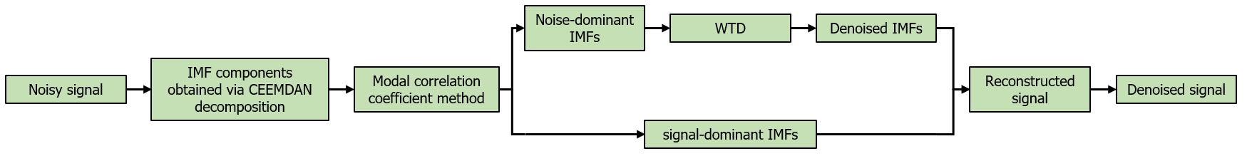
Figure 1: CEEMDAN and Wavelet Soft Threshold based signal Denoising Process

4. Case Study
We validate the proposed denoising method using field data from the Zhangjinggao Yangtze River Bridge mid-approach project.
4.1 Case Description
The Zhangjingao Yangtze River Bridge is located in the Chengtong section of the lower reaches of the Yangtze River, specifically in the Rugao Shoal area. It spans the Yangtze River within the jurisdictions of Zhangjiagang, Rugao, and Jingjiang, approximately 28 km downstream from the Jiangyin Bridge and 16 km upstream from the Husutong Bridge.
The river-crossing section consists of two navigational bridges: The South Navigational Bridge crosses the Fujiangsha Channel (the main waterway of the Yangtze River); The North Navigational Bridge crosses the Fubei Channel (the central branch of the Rugao Shoal).

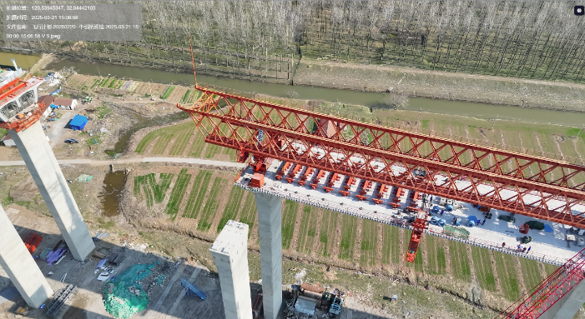
Figure 2: Field Construction Environment of the Bridge Erection Machines

The construction environment of the Bridge Erection Machines is shown in Fig. 2. This BEM is used for the segmental assembly of the middle approach bridge of the Zhangjingao Yangtze River Bridge, with Span length 71 m; Minimum horizontal curve radius 1,330 m; Heaviest segment weight 194 t. Total suspended weight 1,485 t.
The layout of sensors installed on the Bridge Erection Machines to monitor structural and operational parameters is illustrated in Fig. 3.
The bridge erection machine is equipped with 10 VWSGs distributed across its critical stages, along with 3 tilt sensors specifically positioned to monitor: horizontal levelness of the main truss, vertical alignment of the support legs and the center support legs.
To validate the denoising method while ensuring computational efficiency, we selected 4 representative sensors from the VWSGs network.

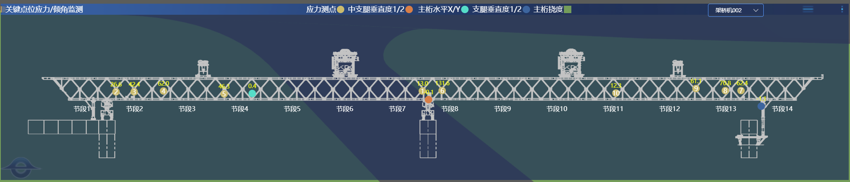
Figure 3: Deployment Diagram of Sensors on the Bridge Erection Machines

4.2 Experiment Setup
All experiments were conducted in Python 3.8 (PyCharm IDE) on a computer with an AMD Ryzen 7 6800H CPU and NVIDIA GTX 3060 GPU. The selected IMFs was processed using the soft thresholding method with a db8 wavelet basis at a decomposition level of 4.

4.3 Metrics
Common denoising metrics include SNR and Root Mean Square Error (RMSE), as shown in Eqs. (9)-(10). However, SNR and RMSE require reference signals for evaluation, which are unavailable for real-world data. Thus, this study adopts denoised SNR (dnSNR) and kurtosis, as shown in Eqs. (11)-(12). dnSNR measures the power ratio between denoised and original signals, suitable for real-world signals. For EMI-induced anomalies (e.g., abrupt signal changes), kurtosis quantifies post-denoising abruptness reduction.

$$SNR=10\lg\left[\frac{\sum_{t=1}^{n}{{y\left(t\right)}^{2}}}{\sum_{t=1}^{n}{{\left(y\left(t\right)-Y\left(t\right)\right)}^{2}}}\right] (9)$$
$$RMSE=\sqrt{\frac{1}{n}\sum_{t=1}^{n}{{(y\left(t\right)-Y\left(t\right))}^{2}}} (10)$$
$$dnSNR=10\lg\left[\frac{\sum_{t=1}^{n}{{X\left(t\right)}^{2}}}{\sum_{t=1}^{n}{{Y\left(t\right)}^{2}}}\right] (11)$$
$$kurtosis=\frac{E[{(Y-μ)}^{4}]}{σ^{4}} (12)$$
Where:
$n$ - the signal length;
$y\left(t\right)$ - the pure signal;
$Y\left(t\right)$ the denoised signal.
$X\left(t\right)$ - the noisy signal;
$E$ - Mathematical expectation of the signal;
$μ$ - Mean value of the signal;
$σ$ - Standard deviation of the signal.

5. Results
5.1 Performance of the Proposed Method
The proposed method was validated using 4 VWSGs mounted at critical locations on the bridge erection machine (Fig. 3). The Noise reduction effects of 4 selected raw signal are shown in Fig.4. Quantitative results are presented in Table 2, with detailed analysis of Sensors 1, 2, 3, 4 selected for their representative noise profiles.

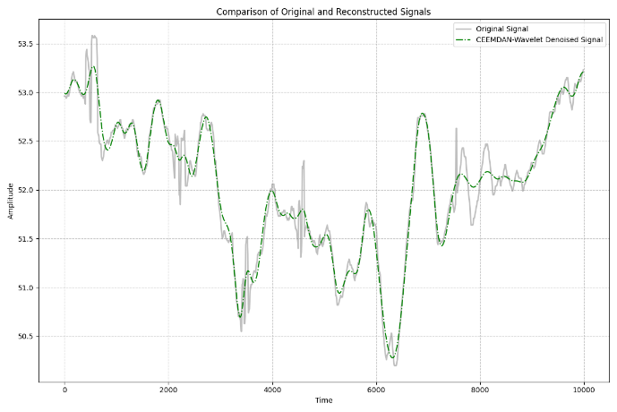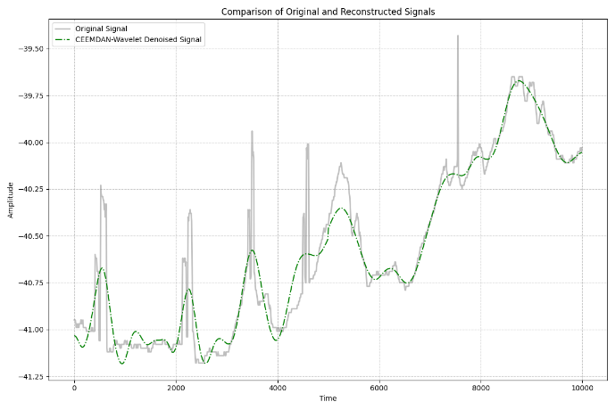
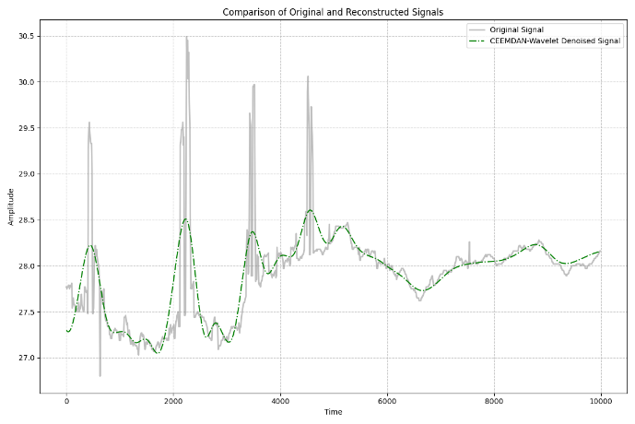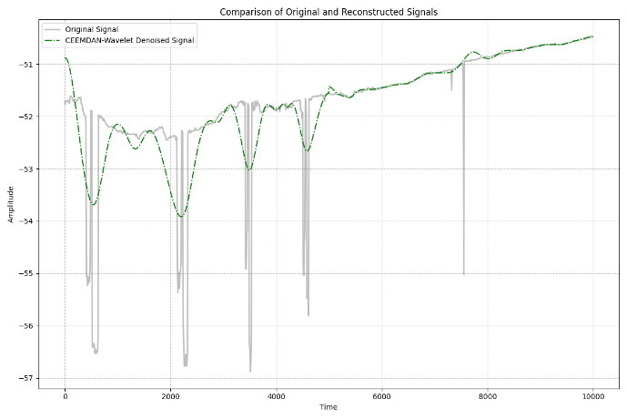
Figure 4: Noise reduction effect of noisy signal (sensor1, 2, 3, 4).

Table 2: Denoising performance summary.

Sensor | dnSNR(dB) | kurtosis | Denoised kurtosis
Sensor1 | $$0.1*{10}^{-3}$$ | 0.47 | 0.35
Sensor2 | $$0.2*{10}^{-3}$$ | 1.16 | 0.64
Sensor3 | $$1.3*{10}^{-3}$$ | 4.41 | 0.36
Sensor4 | $$0.2*{10}^{-3}$$ | 7.78 | 0.41

Using the data of Sensor 3 as an example, Fig. 5 displays IMFs and the residual (Res) obtained via CEEMDAN decomposition.
Correlation coefficients between IMFs and the original signal were computed (as shown in Fig. 6). According to the modal correlation coefficient method, IMF 4–7 were selected for reconstruction.
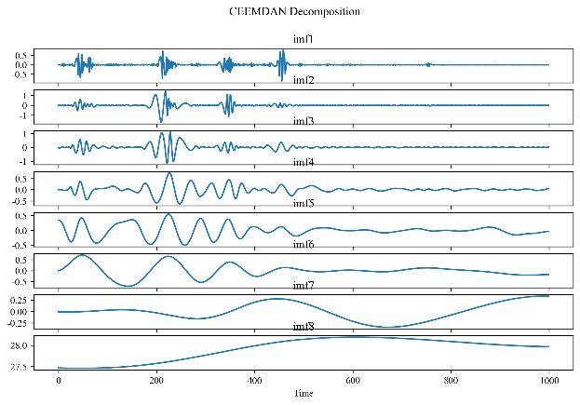
Figure 5: Complementary Ensemble Empirical Mode Decomposition diagram of noise signal (sensor3).
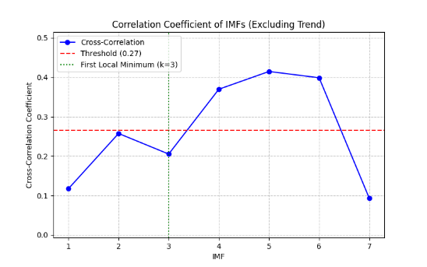
Figure 6: Correlation coefficient change curve(sensor3).

The selected IMFs are classified into strong-correlation and weak-correlation groups via mean-threshold partitioning. IMF 4–6 exhibited significant noise and were denoised via WTD before recombination. Noise reduction effect of noisy signal is shown in Fig. 7.
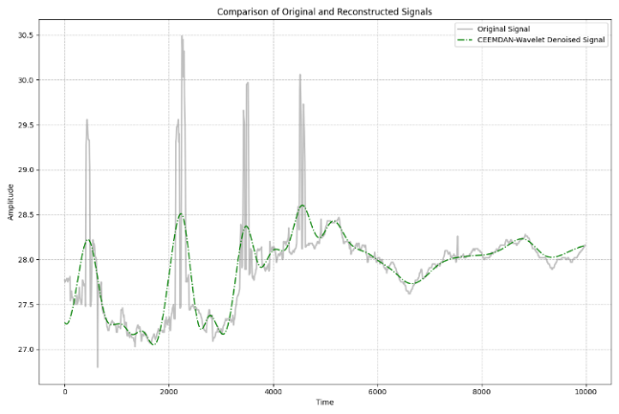
Figure 7: Noise reduction effect of noisy signal (sensor3).

5.2 Comparison Between the Proposed IMF Processing Approach and the Modal Coefficient Method Alone
The CEEMDAN algorithm inherently adds adaptive white noise during signal decomposition. While modal correlation criteria are used to select valid information components, the resulting IMFs may still contain residual white noise. Therefore, we further apply wavelet threshold denoising to these IMF components.
To validate the noise reduction effectiveness of our proposed IMF selection and processing strategy, we conducted verification and analysis using data from 4 VWSGs. Results are as follows:

Table 3: Comparison of denoising results between the proposed strategy and modal correlation criterion.

Sensor | method | dnSNR | kurtosis |  | Denoised kurtosis
Sensor1 | proposed | $$0.1*{10}^{-3}$$ |  | 0.47 | 0.35
Sensor1 | modal | $$0.3*{10}^{-3}$$ |  | 0.47 | 0.46
Sensor2 | proposed | $$0.2*{10}^{-3}$$ |  | 1.16 | 0.64
Sensor2 | modal | $$-1.2*{10}^{-3}$$ |  | 1.16 | 1.12
Sensor3 | proposed | $$-1.3*{10}^{-3}$$ |  | 4.41 | 0.36
Sensor3 | modal | $$-1.9*{10}^{-3}$$ |  | 4.41 | 0.48
Sensor4 | proposed | $$-1.4*{10}^{-3}$$ |  | 7.78 | 0.41
Sensor4 | modal | $$3.4*{10}^{-3}$$ |  | 7.78 | 3.24

Using the data of Sensor 3 as an example. When employing the modal correlation coefficient method (k=3), IMFs 4-7 were selected as higher-order IMFs for direct reconstruction. However, this approach fails to effectively eliminate residual noise within these IMFs. Given the strong noise energy in the original signal, threshold screening revealed high correlation coefficients in noise-dominant IMFs 4-6.
To address this, the proposed method performs wavelet threshold denoising (WTD) on IMFs 4-6 prior to reconstruction. This integrated processing approach combines the advantages of both techniques, ensuring denoising accuracy while significantly reducing electromagnetic noise interference. The Noise reduction effect of two different approach is shown in Fig. 8.

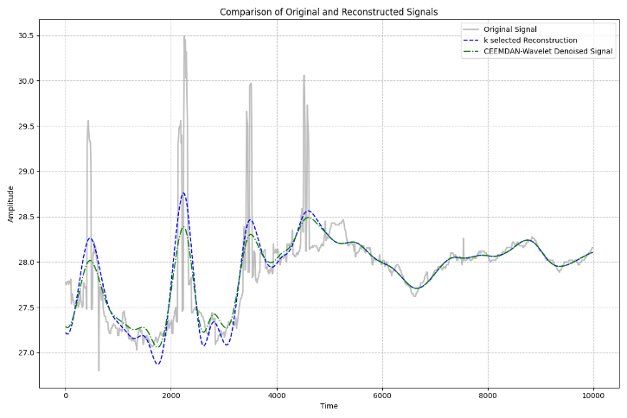
Figure 8: Noise reduction effect of proposed IMF processing approach and the modal coefficient method (sensor3).

For signals with significant variations affected by electromagnetic noise, the denoising performance was evaluated by the kurtosis and the dnSNR.
Firstly, the kurtosis of the denoised signal reflects its stationarity—a lower kurtosis value indicates better noise suppression.
Secondly, the dnSNR measures the denoising effectiveness: when dnSNR approaches zero, the denoised signal retains both its power and essential features well. A negative dnSNR (dnSNR < 0) suggests a reduction in overall signal power due to the removal of high-frequency electromagnetic noise, confirming successful noise attenuation.
The proposed method achieves a kurtosis of 0.36 compared to 0.48 from the modal coefficient method, demonstrating superior noise suppression performance. In terms of dnSNR evaluation, the proposed method yields -1.3×10⁻³ while the modal coefficient method produces -1.9×10⁻³. These results indicate that the proposed method's dnSNR being closer to zero confirms better preservation of original signal characteristics while maintaining stronger noise attenuation capability.

5.3 Comparison between CEEMDAN-WTD and Traditional denoising Methods
To evaluate the proposed CEEMDAN-WTD algorithm in all respects, we conducted comparative experiments between the proposed method and wavelet threshold denoising using selected data from 4 VWSGs. Results are as follows:

Table 4: Comparison of denoising results between the proposed method and wavelet threshold denoising.

Sensor | method | dnSNR | kurtosis |  | Denoised kurtosis
Sensor1 | proposed | $$0.1*{10}^{-3}$$ |  | 0.47 | 0.35
Sensor1 | Wavelet | $$1.4*{10}^{-3}$$ |  | 0.47 | 0.42
Sensor2 | proposed | $$0.2*{10}^{-3}$$ |  | 1.16 | 0.64
Sensor2 | Wavelet | $$0.1*{10}^{-3}$$ |  | 1.16 | 1.16
Sensor3 | proposed | $$-1.3*{10}^{-3}$$ |  | 4.41 | 0.36
Sensor3 | Wavelet | $$2.9*{10}^{-3}$$ |  | 4.41 | 4.17
Sensor4 | proposed | $$-1.4*{10}^{-3}$$ |  | 7.78 | 0.41
Sensor4 | Wavelet | $$1.0*{10}^{-3}$$ |  | 7.78 | 7.68

According to the data in Table 4, traditional denoising methods represented by wavelet threshold denoising demonstrate relatively poorer performance compared to the proposed method. This may be attributed to the selection of wavelet basis functions, indicating the inferior adaptability of improved wavelet threshold denoising. The proposed hybrid denoising method outperforms wavelet threshold denoising, as it effectively eliminates noise-dominant IMF components while denoising signal-dominant IMF components. This approach fully leverages the strong adaptability of CEEMDAN and the excellent noise-removal capability of wavelet thresholding for micro-noise.
Using the data of Sensor 3 as an example, Fig. 9 below shows the comparison of the denoising effect of the proposed method and traditional denoising methods.

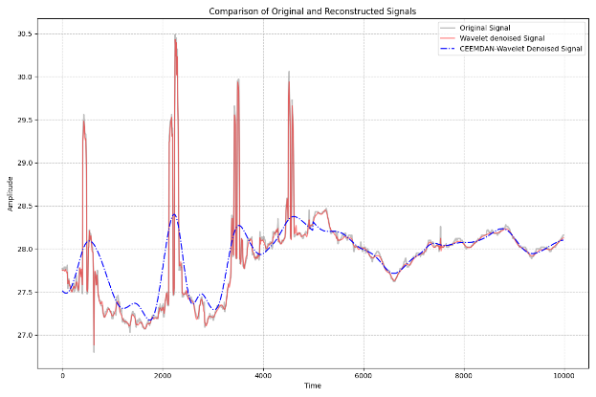
Figure 9: Noise reduction effect of CEEMDAN-WTD and traditional denoising methods(sensor3).

The result indicates Wavelet threshold denoising failed to identify EMI. The method proposed, despite minor performance dips in low-frequency segments, achieved superior overall results.

6. Discussion
6.1 Contributions
Due to the lack of research in the field of de-noising of stress sensors of bridge erecting machines, and the difficulty in removing electromagnetic noise from low-frequency signals collected by field projects, a joint de-noising method based on CEEMDAN-WTD is proposed in this paper.
While modal correlation criteria are used to select valid information components, the resulting IMFs may still contain residual white noise. Therefore, we proposed this method which combines modal correlation and threshold judgment before signal reconstruction.
Using field data from the Zhangjinggao Yangtze River Bridge mid-approach project, we evaluated the proposed method’s performance by comparing with Modal Coefficient Method and Traditional denoising Methods, the results of two experiments indicated that the proposed de-noising method preserves key features of signals while ensuring good de-noising effect.

6.2 Limitations
Despite the contributions of our work, limitations also exist. Firstly, performance of WTD used for IMFs depends on the choice of threshold, threshold function and wavelet base. appropriate parameter selection is required to maximize WTD performance. Secondly, since electromagnetic noise in multi-sensor data exhibits simultaneous occurrence characteristics, future research could enhance the identification of electromagnetic interference noise at construction sites through multi-sensor data fusion.

7. Conclusion
Our research addresses the challenge of electromagnetic interference (EMI) and complex noise in stress monitoring signals from bridge erection machines (BEMs) by proposing a hybrid CEEMDAN-WTD denoising framework, validated via field experiments on the Zhangjinggao Yangtze River Bridge mid-approach project. This method greatly reduces the signal kurtosis, effectively suppressing transient noise while preserving most signal features. Despite all of this, limitations in parameter sensitivity and multi-sensor data fusion necessitate further research.

ACKNOWLEDGEMENTS
The authors would like to acknowledge the financial support provided by the National Key R&D Program of China (No. 2023YFC3806803), and the National Natural Science Foundation of China (Grant No. 72301114).

REFERENCES
Wang, X., Ma, H. & Gao, C., (2000). Analysis of causes and preventive measures for BEM overturning. China Railway, 8: p. 18-19.
Baidu Baike, (2019). July 18 Hanzhong Bridge Erection Machines Beam Collapse Accident. [Online], Available: https://baike.baidu.com/item/7·18汉中架桥机航梁倒塌事故/23625786 [5 May 2025].
Li, Y., Chen, X., (2018). A new underwater acoustic signal denoising technique based on CEEMDAN, mutual information, permutation entropy, and wavelet threshold denoising. Entropy, 20(8): p. 563.
Niu, H., Zhang, Z. & Ning, Z., (2020). Threshold self-adaptive optimizing denoising method based on wavelet transform. Transducer and Microsystem Technologies, 39(2): p. 33-36.
Liu, H., Wang, W. & Xiang, C., (2018). A de-noising method using the improved wavelet threshold function based on noise variance estimation. Mechanical Systems and Signal Processing, 99: p. 30-46.
Zhang, L., Zhang, Z. & Zhang, H., (2018). Application of wavelet transform in denoising pressure sensor output signals. Instrument Technique and Sensor, 4: p. 10-13.
Abdelkader, R., Kaddour, A. & Derouiche, Z., (2018). Enhancement of rolling bearing fault diagnosis based on improvement of empirical mode decomposition denoising method. The International Journal of Advanced Manufacturing Technology, 97(5): p. 3099-3117.
Salman, A.H., Ahmadi, N. & Mengko, R., (2016). Empirical mode decomposition (EMD) based denoising method for heart sound signal and its performance analysis. International Journal of Electrical and Computer Engineering, 6(5): p. 1-8.
Ye, L., Iqbal, S. & Lu, Q., (2023). Feature extraction and classification of ECG signals based on EEMD and multifractal. Journal of Signal Processing, 39(1): p. 143-153.
Cheng, X., Mao, J.D. & Li, J., (2020). An EEMD-SVD-LWT algorithm for denoising a lidar signal. Measurement, 168: p. 108405.
Guo, X.F., Qiu, T.G. & Ma, W.G., (2022). A new random attenuation method of seismic signal based on CEEMDAN and wavelet transform. Journal of Geodesy and Geodynamics, 42(11): p. 1202-1210.
Hu, Y.J., Ouyang, Y. & Wang, Z.L., (2022). Vibration signal denoising method based on CEEMDAN and its application in brake disc unbalance detection. Mechanical Systems and Signal Processing, 187: p. 109972.
Wang, X., Wang, H. & Wang, C., (2021). Denoising of vibration signal of chaff cutters based on EMD adaptive threshold. Journal of China Agricultural University, 26(1): p. 99-106.
Lin, L. & Yu, L., (2008). Improvement on empirical mode decomposition based on correlation coefficient. Computer and Digital Engineering, 36(12): p. 28-36.

