Toward RDF-Based Representations of IFC 5
A First Conversion Algorithm and Prototype
Fynn Korsen^{1, *}, Niels Bartels ¹

¹ TH Köln (University of Applied Sciences), Cologne, Germany, Faculty of Civil Engineering and Environmental Technology
*Corresponding email: fynn.korsen@th-koeln.de

ABSTRACT
The forthcoming Industry Foundation Classes version 5 (IFC 5) marks a technological turning point for open Building Information Modeling (BIM). As a new major release, IFC 5 introduces structural and conceptual changes that make existing approaches for transforming IFC into Semantic Web technologies only partially applicable. Because of this, converting IFC 5 into the Resource Description Framework (RDF) requires the development of a new, formally grounded transformation algorithm. This paper presents the algorithm both conceptually and practically through a prototype implementation.
The work focuses on JSON-based IFC models. RDF-based representations are enabling machine-readable semantics, querying, ontology-based knowledge representation, and AI-driven analytics.
The proposed algorithm systematically maps IFC 5 to RDF classes, properties, and relationships. It explicitly addresses new IFC 5 concepts such as revised typing mechanisms, modularization strategies, updated serialization paradigms, and the composition of multiple IFC files into a unified model. This composition is implemented using reification, allowing provenance-aware integration of distributed model fragments within a single knowledge graph. A prototype implementation demonstrates feasibility using selected model instances. A key application area is the Operation and Maintenance (O&M) phase of buildings, where Facility Management requires integrating heterogeneous information domains such as building structure, automation, sensors, and services. RDF-based knowledge graphs enable semantic linking of static building models with dynamic operational data, supporting cross-domain queries, analytics, and optimization. The results demonstrate that a technologically adapted IFC5-to-RDF conversion is feasible and represents an important step toward semantically interoperable BIM ecosystems.

- INTRODUCTION
The Industry Foundation Classes (IFC) constitute an open standard for the exchange of digital building data throughout all phases of the building lifecycle. (Bartels et al., 2023, Borrmann et al., 2018, DIN EN ISO 16739-1:2024-09) With IFC 5, this standard undergoes a fundamental conceptual and technical reorientation: the previously monolithic, STEP-based (Standard for the exchange of product model data) serialization is replaced by a JSON-based, layer-oriented data model (.ifcx) that emphasizes composability, modular authoring, and the incremental superimposition of model contributions. (buildingSMART, buildingSMART International, 2026, van Berlo et al., 2021) While this shift substantially improves the flexibility of modelling, it also widens the gap between the file-centric representation of building data and the graph-oriented paradigms increasingly adopted for data integration, querying, and reasoning.
Semantic Web technologies, in particular the Resource Description Framework (RDF) (Beckett, 2004, World Wide Web Consortium) and the Web Ontology Language (OWL) (McGuinness and van Harmelen, 2004), offer a well-established foundation for representing building data as linked, machine-interpretable knowledge graphs. The IfcOWL ontology has demonstrated the value of expressing IFC semantics in RDF, enabling federated queries, logical inference, and the linkage of building models to external domain vocabularies. (Beetz et al., 2009) However, IfcOWL was conceived for earlier, STEP-derived IFC versions and does not address the distinctive structural concepts introduced by IFC 5, such as content-addressed layers, explicit composition, and the JSON-native encoding of attributes, schemas, and geometry.
This paper addresses the resulting need for a systematic translation of IFC 5 data into an RDF representation suitable for storage and analysis in graph databases and AI applications. A conceptual mapping framework is proposed and realized in a prototype converter that transforms .ifcx documents into Terse RDF Triple Language (.ttl) while preserving the layered semantics of IFC 5 and recording the provenance of every asserted statement. The contribution thereby bridges the emerging IFC 5 ecosystem and established Semantic Web infrastructure and provides a basis for the validation and discussion presented in the subsequent sections.

- BACKGROUND AND RELATED WORK
This section reviews the foundations on which the proposed mapping framework builds: the transition towards the layered, JSON-based IFC5 standard, the Semantic Web technologies and the IfcOWL ontology underlying a graph-based representation of building data, and the existing conversion approaches that together delineate the research gap addressed in this work.

2.1 The IFC Standard and the Transition to IFC 5
While IFC has so far been expressed through STEP and EXPRESS schema language (ISO, 2004, Terkaj and Pauwels, 2015), IFC 5 introduces a conceptual break with this lineage: the monolithic, STEP-based serialization is replaced by a JSON-based format (.ifcx) built around a prim-centric data model. Building elements are described as prims whose attributes, hierarchical children, and inheritance relationships may be authored incrementally and distributed across multiple files. Schema and data are separated, and model contributions are organized as composable layers. This reorientation is motivated by the goals of modularity, incremental authoring, and an alignment with scene-description and geometry conventions familiar from Universal Scene Description (USD).

2.2 Semantic Web Foundations: RDF, OWL, and Graph Databases
The RDF represents knowledge as triples of subject, predicate, and object, which can be aggregated into graphs and stored in triple stores or graph databases for querying (e.g. via SPARQL). The OWL adds formal semantics that enable logical inference, while Turtle provides a compact, human-readable serialization. A recurring challenge is the expression of statements about statements. This is required, for instance, to record the origin of an assertion. Established mechanisms include standard reification, named graphs, and the more recent RDF-star extension (Arndt et al., 2023). These constructs form the technical basis for the provenance modeling discussed below, and graph databases constitute the target infrastructure for federation, linkage, and reasoning over building data (Fahad et al., 2018). (Bauer and Kaltenböck, Semantic Web: Concepts, Technologies and Applications, 2007, Berners-Lee, 2005, Corry et al., 2014, McGuinness and van Harmelen, 2004, Tang et al., 2019)

2.3 Ontology-Based Representation of Building Data (IfcOWL)
The IfcOWL ontology translates IFC semantics into RDF and OWL, enabling building models to participate in the Linked Building Data ecosystem and to be linked with external vocabularies, as well as supporting federated queries and logical reasoning. However, IfcOWL was designed for STEP-based IFC versions and reflects their structural assumptions. It does not capture key aspects of IFC 5, such as content-addressed layers, explicit multi-contribution composition, and its JSON-native representation of attributes, schemas, and geometry. (buildingSMART International, Ltd., Pauwels, 2022) Conversion tools have already been developed for earlier IFC versions. The ‘IFCtoRDF’ tool can convert IFC files from versions IFC2X3_TC1 to IFC4x3_RC1 into Turtle. (Pauwels, Pauwels and Terkaj, 2019) The ‘IfcSTEP-to-IfcOWL-converters’ project enables bidirectional conversion across the same range of versions. (Chi Zhang) Both tools break down geometries and lists into completely atomic elements. There are other works that use IFC in the context of RDF. (Aydin, 2026, Pauwels et al., 2017, Schevers et al., 2007, Vanlande and Nicolle, 2008)

2.4 Provenance and Layered or Composed Models
Where building data are assembled from several sources, the traceability of each assertion becomes essential. Semantic Web provenance approaches such as PROV-O, named graphs, and reification provide means to capture data origin at the statement level. Complementary to these, content addressing, the derivation of an identifier from a cryptographic hash of the underlying content, supports reproducibility and integrity, since identical inputs yield identical identifiers and any modification is detectable. These notions are particularly relevant for layered and composed models, where later layers may refine or override earlier ones and the resolution of such conflicts must remain transparent and reconstructable.

3. METHODOLOGY & CONCEPTUAL MAPPING FRAMEWORK
Considering the technical characteristics of the IFC 5 standard and the limitations of existing converters for previous IFC versions, a new methodology for transforming IFC 5 into RDF is proposed. In addition, established software engineering principles are applied to define design requirements for the resulting tool. An analysis of existing conversion approaches shows that current solutions are unable to adequately capture the specific characteristics of the IFC 5 standard. Hence, this research addresses the following question:
How can an IFC 5 to RDF conversion tool be designed and implemented in a way that preserves the essential characteristics of the IFC 5 standard?
To address this question, a conceptual mapping framework is introduced and subsequently implemented as a prototype, which is evaluated through tests.

3.1 Design Requirements
Five requirements guide the framework (see Figure 1).
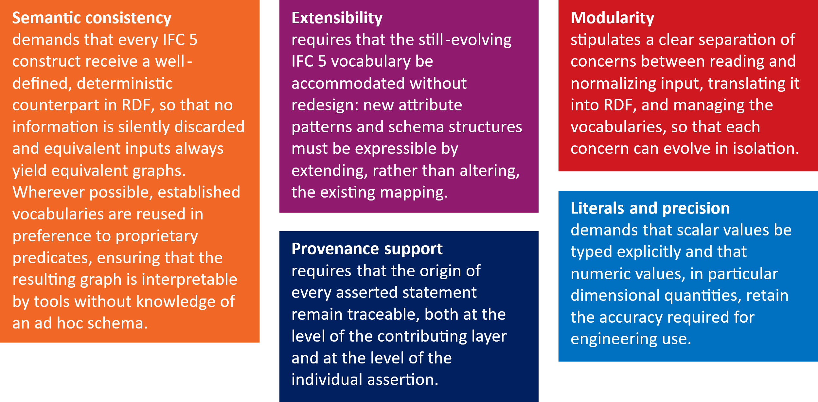
Figure 1 Five design requirements of framework

3.2 Mapping Principles
The IFC 5 metamodel is conceptually divided into a descriptive head and a data-bearing body, and the framework maps each according to its semantic role. The head carries metadata about a model contribution. Each contribution is treated as a layer that is simultaneously regarded as an ontology, allowing it to be both an addressable unit of composition and a self-contained semantic module. Header metadata are mapped onto standard vocabularies such as Dublin Core and OWL, and declared schemas are carried along in encapsulated form so that they are preserved even where no native RDF translation yet exists. The body consists of prims, the central model units of IFC 5. Each prim becomes a named individual identified by a stable IRI derived from its path. Domain attributes are translated by a rule-based, key-driven scheme: recognized patterns (class membership, classification, material, and spatial relationships) are mapped onto dedicated predicates and, where they reference other prims, onto links between individuals, while unrecognized keys are mapped deterministically into a generic namespace so that no attribute is lost. Hierarchical and inheritance relationships are modeled as reified structures rather than single predicates, preserving the named edges that IFC 5 attaches to such relationships.
Composition is treated as a first-class concept. The order of contributions defines the composition order, and the assembly of the overall model is made explicit through a composition node that references all participating layers. The substantive merging of distributed prim descriptions follows an overwrite semantics in which later contributions refine or correct earlier ones.
Provenance is anchored at two levels. Each layer is identified by a content-addressed IRI derived from a cryptographic hash of its content, yielding reproducible and integrity-preserving identity. Each meaning-bearing assertion is annotated, via reification, with the layer and composition position from which it originates, while purely technical auxiliary statements are deliberately left unannotated to avoid inflating the graph.
For values, scalar attributes are assigned explicit XSD datatypes, with dimensional numbers represented in a decimal rather than a binary floating-point form to preserve precision. Geometry, by contrast, is treated as voluminous and structurally heterogeneous and is therefore preserved as an encapsulated literal attached to its carrier prim, rather than being atomized into individual triples.

4. PROTOTYPE IMPLEMENTATION
The prototype presented below can be accessed at https://github.com/fkorsen/Ifc5-to-RDF. This paper outlines only the most salient points.
4.1 Processing Architecture and Two-Phase Pipeline
The converter developed and implemented in this work transforms model data of the JSON based IFC 5 standard (file extension .ifcx) into an RDF representation, stored as a Turtle serialization (.ttl) that can be loaded directly into a graph database. Processing is deliberately divided into two clearly separated phases, enforcing the distinction between syntactic data preparation and semantic translation.
In the first phase, the loader, input files are read and their contents aggregated into a normalized intermediate representation. The function load_ifcx deserializes the JSON document, while build_document derives from it a canonical document structure comprising four constituents: header, imports, schemas, and prims. Consolidation of model objects is performed by aggregate_prims, which merges the partial descriptions of an object distributed across the IFC 5 data stream by means of their path. In the second phase, the RDF conversion, the intermediate representation is transferred into an RDF graph. This task is carried out by the function to_rdf, which constructs a Store of the pyoxigraph library and inserts all statements as Quad objects into the default graph. The choice of pyoxigraph is motivated by its native support for the RDF data model, its efficient in memory processing, and its direct Turtle serialization via the function serialize (oxigraph). The uniform quad model thereby forms the technical foundation for the provenance annotation described later, since every statement is treated as an independent, addressable triple.
The entry point in the __main__ block joins both phases into a continuous processing chain: for each supplied input file, the raw document is loaded, the canonical document structure is created, and a SHA256 hash of the file content is computed. From these constituents a tuple of document, index, content hash, and source name is formed for each file, capturing the layered character of the input. All layers are passed to to_rdf, and the result is serialized as a Turtle file whose filename is derived from the first input file. This architecture reflects the design goal of modularity. Each function fulfils a narrowly defined task (reading, aggregating, layer annotation, attribute mapping, literal conversion), and the central vocabularies are factored out into a separate module, Namespaces, from which all namespaces (EX, IFCX, BSI_PROP, BSI_PRES, USD, and the standard vocabularies RDF, RDFS, OWL, DCTERMS, XSD) are imported. This separation keeps the translation rules independent of the concrete IRI assignment, allowing them to be developed further in isolation.

4.2 Handling of the Metamodel Structure (Head and Body)
The converter separates the descriptive head and the data carrying body because they serve different semantic roles. The head contains metadata about the layer, while the body represents the actual model objects. The head is processed in _add_layer, where metadata is mapped to standardized vocabularies using an explicit header mapping. The reuse of Dublin Core terms supports semantic consistency and interoperability, enabling external tools to interpret provenance and version information without relying on a proprietary schema. Document imports are represented via owl imports and linked to named nodes, thereby integrating external ontologies and IFC 5 references into the OWL model. Schema declarations in the head are attached to the layer via ifcx declaresSchema using blank nodes. The schema name is stored as a literal and the full definition is preserved as a JSON encoded literal with datatype rdf JSON. This design supports extensibility by allowing evolving IFC 5 schema structures to be retained even without a complete native RDF translation.
The body is represented by aggregated prims, which constitute the core modeling units of IFC 5 and combine attributes, hierarchical structure, and inheritance relationships. Each prim is typed as owl NamedIndividual and identified by a stable IRI derived from its path. Hierarchical and inheritance relations are encoded using reified structures rather than simple predicates. Child and inheritance links are represented through blank nodes that explicitly store both relation names and targets, thereby preserving the named edge semantics of IFC 5 that would otherwise be lost in a direct triple mapping.

4.3 IFC 5 Concepts and Composition of Multiple Files
A central concept of the IFC 5 standard is layered model construction, where a complete model is not necessarily defined by a single file but can be composed from multiple superimposed layers. The converter directly supports this semantics by accepting an arbitrary number of input files and interpreting their order as the composition sequence. Each input file is represented as an individual layer, which is typed in _add_layer both as ifcx Layer and owl Ontology. This dual typing links IFC 5 specific layer semantics with established ontology modeling in OWL and allows each layer to be interpreted as an independent knowledge model. The position of a layer within the composition is stored via ifcx layerIndex as an integer literal, while its origin is recorded using dcterms source, referencing the corresponding filename.
The composition of layers is explicitly represented in the graph. A dedicated composition node is introduced and typed as ifcx Composition. It is connected to all participating layers via ifcx hasLayer (see Figure 1). This explicit representation makes the model assembly process transparent and queryable, allowing downstream applications to reconstruct both the set of contributing layers and their ordering for correct semantic interpretation. The integration of layer content is performed during the loading phase. Since a single prim may be distributed across multiple files, aggregate_prims merges all partial definitions sharing the same path. The helper function _merge_section applies an overwrite based strategy, where values from later layers replace earlier ones in case of conflicts, while all changes are logged for traceability. This behavior reflects the intended semantics of layered modeling, where subsequent layers refine or correct previous information. Despite this merging process, provenance is preserved at the triple level. Each contribution remains traceable to its originating layer, ensuring that the origin of every statement can be reconstructed even after aggregation.
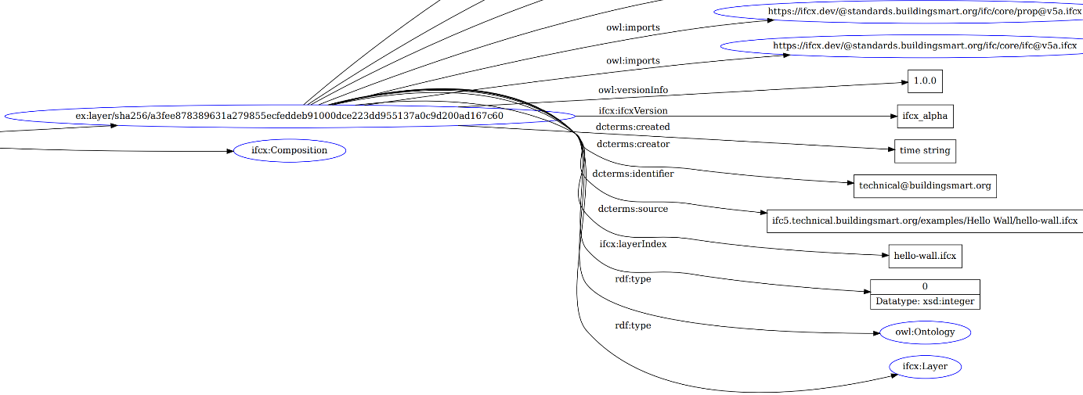
Figure 2 Visualization of the generated RDF using the Hello Wall example from (buildingSMART International, 2026)

4.4 Provenance Support
Traceability of data origin is a core design goal of the converter and is implemented at both layer and triple level. At the layer level, provenance is based on content addressing using a SHA 256 hash of the input file, producing a reproducible and integrity preserving layer IRI that uniquely identifies the file content. At the triple level, provenance is represented through standard reification, where each statement is reconstructed using rdf type rdf Statement and the rdf subject, rdf predicate, and rdf object properties, with additional metadata capturing the source layer and its position (see Figure 3). Provenance annotations are applied only to semantically relevant statements, while auxiliary structural triples are excluded to avoid graph inflation and maintain focus on meaningful origin information.
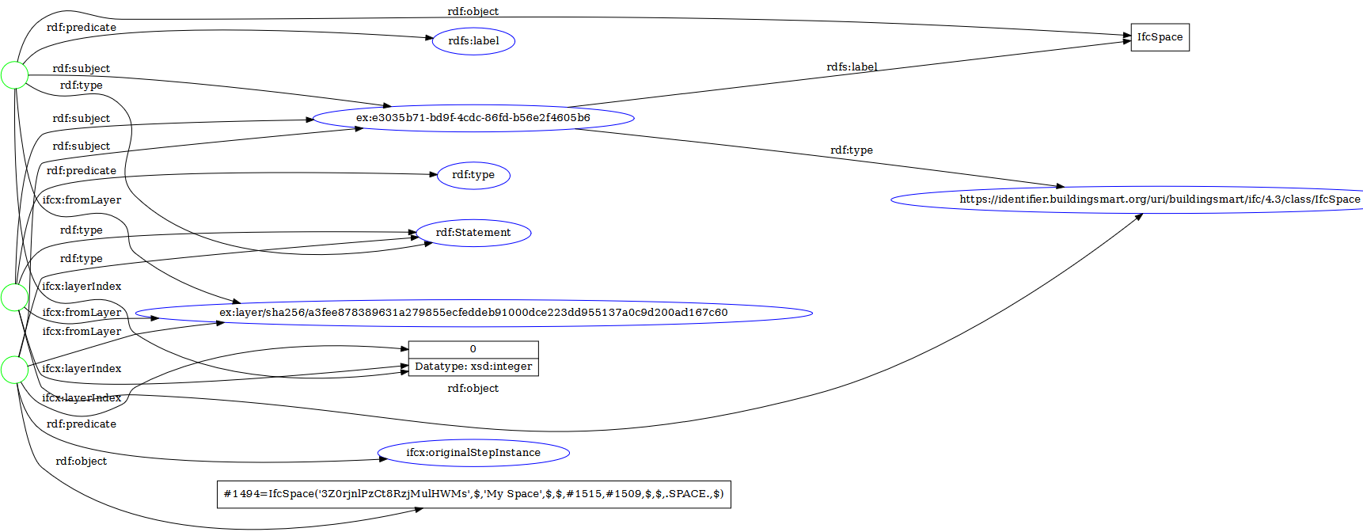
Figure 3 Isolated visualization of the IfcSpace object from the Hello Wall example (buildingSMART International, 2026) in RDF

4.5 Mapping Strategies
The translation of domain attributes in a prim constitutes the semantic core of the converter and is implemented in the function _attribute_triples as a rule based key driven mapping. The predicate is selected based on the attribute key structure and value type, and values are converted into appropriate RDF objects. This design supports extensibility, as new IFC 5 patterns can be integrated by adding additional rules without affecting existing mappings.
Specific rules handle well defined domain patterns. The classification bsi::ifc::class is mapped to rdf:type with a corresponding URI and complemented by an rdfs:label. The classification nlsfb::class is represented via ifcx::classification, while material assignments use ifcx::hasMaterial. Space boundaries are decomposed and mapped through ifcx::relatingSpace and ifcx::relatedElement. Properties with the prefixes bsi::ifc::prop:: and bsi::ifc::presentation:: are assigned to the BSI_PROP and BSI_PRES namespaces, with local names derived from the final key segment. Attributes without dedicated rules are mapped to the IFCX namespace by replacing separators with underscores, ensuring that all data is preserved through a deterministic fallback strategy.
The function _to_literal converts scalar values into RDF literals by assigning XSD datatypes according to the Python type, mapping booleans to xsd:boolean, integers to xsd:integer, floats to xsd:decimal, and strings to plain literals. Non scalar values such as nested objects or lists are encoded as JSON literals with datatype rdf:JSON. This explicit typing preserves semantic interpretability and enables numeric values to be processed as numbers in graph queries. Floating point values are mapped to xsd:decimal to maintain higher precision for building data, reflecting domain specific accuracy requirements rather than generic type conversion.
IFC 5 geometry and presentation data are represented using keys in the usd namespace and preserved as encapsulated RDF JSON literals rather than being transformed into a native RDF geometry model. This approach reflects the volume and structural heterogeneity of geometric data. Full decomposition into triples would significantly increase graph size and disrupt the integrity of the geometry representation. Encapsulation therefore ensures lossless and coherent storage while maintaining referenceability through the associated prim.

6. DISCUSSION
The results indicate that the layered, JSON-based structure of IFC 5 can be expressed in RDF without loss of its distinctive semantics. By treating each contribution as a content-addressed layer and recording the origin of every meaning-bearing assertion through reification, the framework preserves both the composition order and the traceability of individual statements. This addresses a limitation of earlier IfcOWL-based conversions, which were conceived for STEP-derived versions and do not accommodate composition or statement-level provenance. (Chi Zhang, Pauwels) The rule-based attribute mapping, combined with a deterministic fallback, ensures that no attribute is silently discarded, while the encapsulation of geometry as a coherent literal keeps the graph compact and avoids the structural inflation that full atomization would entail.
A particularly promising field of application lies in the operation and maintenance phase of the building lifecycle. Because the resulting graph is queryable in a standard graph database and links elements, classifications, materials, and spatial relationships, it can serve as a semantic backbone for facility: maintenance schedules, sensor and monitoring data, and inspection records can be attached to the corresponding prims and retrieved through federated queries. The statement-level provenance is valuable in this context, as it allows FM to determine from which contribution a given property originated and to evaluate competing assertions when models are updated over the operational lifetime. Further applications include compliance and consistency checking through reasoning, the linkage of building data to external domain vocabularies, and the incremental integration of contributions from multiple disciplines.
Several limitations qualify these findings. The mapping presently covers the most common IFC 5 attribute patterns, while less frequent or custom data are handled generically and may warrant dedicated rules. The encapsulation of geometry preserves information but does not yet expose it to geometric reasoning within the graph. Moreover, the representation of provenance through standard reification, although broadly interoperable, increases the size of the graph and could in future be complemented by more concise mechanisms such as RDF-star.

7. CONCLUSION AND FUTURE WORK
This paper has presented a conceptual mapping framework and a prototype converter that translate the layered, JSON-based IFC 5 standard into an RDF representation suitable for storage and analysis in graph databases. Guided by the requirements of semantic consistency, extensibility, modularity, provenance support, and precision, the framework expresses the IFC 5 metamodel in RDF while preserving the standard's distinctive concepts. Each model contribution is treated as a content-addressed layer, the composition of multiple files is made explicit, and the origin of every meaning-bearing assertion is recorded through reification. The prototype demonstrates that these principles can be realized in practice, producing Turtle output that is queryable with standard Semantic Web tooling and that bridges the emerging IFC5 ecosystem with established graph-based infrastructure.
Several directions remain for future work. Attribute mapping can be extended with specific rules for less common and custom data patterns to improve semantic fidelity. Encapsulated geometry could be selectively exposed in native form to support spatial reasoning within graphs. The provenance model, currently based on standard reification for interoperability, may be complemented by more compact approaches such as named graphs or RDF star to reduce graph size. Further work should also include large scale validation on multi contributor models, alignment of the generated vocabulary with the evolving IFC 5 specification and existing ontologies such as IfcOWL, and the development of application-level services, particularly for operation and maintenance where linking building data with monitoring information offers significant practical value.

REFERENCES
Arndt D., Broekstra J., DuCharme B., Lassila O., Patel-Schneider P.F., Prud'hommeaux E., Thibodeau T. and Thompson B. (2023). RDF-star and SPARQL-star. Available from: https://w3c.github.io/rdf-star/cg-spec/editors_draft.html.
Aydin M. (2026). Automated IFC-to-RDF Conversion for Semantic BIM Using IfcWall Entities, Booklet. IEEE. DOI: 10.1109/ACDSA67686.2026.11468047. https://ieeexplore.ieee.org/document/11468047?
Bartels N., Höper J., Theißen S. and Wimmer R. (2023). Application of the BIM Method in Sustainable Construction: Status Quo of Potential Applications in Practice, Springer International Publishing; Imprint Springer, Cham.
Bauer F. and Kaltenböck M. Linked Open Data: The Essentials: A Quick Start Guide for Decision Makers.
Beckett D. (2004). RDF/XML Syntax Specification (Revised). Available from: https://www.w3.org/TR/REC-rdf-syntax/.
Beetz J., van Leeuwen J. and Vries B. de (2009). IfcOWL: A case of transforming EXPRESS schemas into ontologies, Artificial Intelligence for Engineering Design, Analysis and Manufacturing, Vol. 23, No. 1, 89–101. DOI: 10.1017/S0890060409000122.
Berners-Lee T. (2005). Berners-Lee - WWW2005 Keynote. Available from: https://www.w3.org/2005/Talks/0511-keynote-tbl/.
Borrmann A., König M., Koch C. and Beetz J. (2018). Building Information Modeling, Springer International Publishing, Cham.
buildingSMART. IFC 5 Core Consultation. Available from: https://www.buildingsmart.org/ifc-5-core-consultation/.
buildingSMART International (2026). IFC5-development. Available from: https://github.com/buildingSMART/IFC5-development.
buildingSMART International, Ltd. ifcOWL. Available from: https://technical.buildingsmart.org/standards/ifc/ifc-formats/ifcowl/.
Chi Zhang. IfcSTEP-to-IfcOWL-converters. Available from: https://github.com/BenzclyZhang/IfcSTEP-to-IfcOWL-converters.
Corry E., O’Donnell J., Curry E., Coakley D., Pauwels P. and Keane M. (2014). Using semantic web technologies to access soft AEC data, Advanced Engineering Informatics, Vol. 28, No. 4, 370–380. DOI: 10.1016/j.aei.2014.05.002.
DIN EN ISO 16739-1:2024-09: Industry Foundation Classes (IFC) for data sharing in the construction and facility management industries - Part 1: Data schema (ISO 16739-1:2024); English version EN ISO 16739-1:2024 (ISO 16739-1:2024), DIN Media GmbH, Berlin. DOI: 10.31030/3538555. Available from: https://www.dinmedia.de/de/norm/din-en-iso-16739-1/379635818.
Fahad M., Bus N. and Fies B. (2018). Semantic BIM reasoner for the verification of IFC Models, eWork and eBusiness in Architecture, Engineering and Construction (Karlshøj J. and Scherer R., editors), CRC Press, 361–368.
ISO (2004). Industrial automation systems and integration — Product data representation and exchange: Part 11: Description methods: The EXPRESS language reference manual, ISO, Switzerland, Vol. 25.040.40, ISO 10303-11:2004(E). Available from: https://www.iso.org/standard/38047.html.
McGuinness D.L. and van Harmelen F. (2004). OWL Web Ontology Language Overview: W3C Recommendation 10 February 2004. Available from: https://www.w3.org/TR/2004/REC-owl-features-20040210/#s1.
Pauwels P. IFCtoRDF. Available from: https://github.com/pipauwel/IFCtoRDF.
Pauwels P. (2022). Buildings and Semantics: Data Models and Web Technologies for the Built Environment, Taylor & Francis Group, Milton.
Pauwels P. and Terkaj W. (2019). ifcOWL ontology (IFC4_ADD2_TC1). Available from: https://standards.buildingsmart.org/IFC/DEV/IFC4/ADD2_TC1/OWL/index.html.
Pauwels P., Zhang S. and Lee Y.-C. (2017). Semantic web technologies in AEC industry: A literature overview, Automation in Construction, Vol. 73, 145–165. DOI: 10.1016/j.autcon.2016.10.003.
Schevers H.A., Mitchell J., Akhurst P., Marchant D.M., Bull S., McDonald K., Drogemuller R.M. and Linning C. (2007). Towards digital facility modelling for Sydney Opera House using IFC and semantic web technology. Available from: http://www.itcon.org/cgi-bin/works/Show?2007_24.
Semantic Web: Concepts, Technologies and Applications (2007), Springer London, London.
Tang S., Shelden D.R., Eastman C.M., Pishdad-Bozorgi P. and Gao X. (2019). A review of building information modeling (BIM) and the internet of things (IoT) devices integration: Present status and future trends, Automation in Construction, Vol. 101, 127–139. DOI: 10.1016/j.autcon.2019.01.020.
Terkaj W. and Pauwels P. (2015). EXPRESS ontology.
van Berlo L., Krijnen T.F., Tauscher H., Liebich T., van Kranenburg A. and Paasiala P. (2021). Future of the Industry Foundation Classes: towards IFC 5. Available from: http://resolver.tudelft.nl/uuid:bd3b0a6b-e956-4474-bddd-94b77aa7c6e0.
Vanlande R. and Nicolle C. (2008). Context DataModel Framework: semantic facilities management, International Journal of Product Lifecycle Management, Vol. 3, 2/3, 165. DOI: 10.1504/IJPLM.2008.021440.
World Wide Web Consortium. Resource Description Framework (RDF). Available from: https://www.w3.org/RDF/.

JavaScript Object Notation, available at https://www.json.org
Available at https://standards.buildingsmart.org/IFC/DEV/IFC4/ADD2_TC1/OWL/index.html (Version IFC4_ADD2_TC1)
Available at https://www.w3.org/TR/turtle/
Available at https://www.expresslang.org/languages/express
Available at Available at https://openusd.org/release/index.html
Available at https://w3c-cg.github.io/rdf-star/cg-spec/editors_draft.html

