A Web-Based Open-Source Platform Integrating Bridge Information Modeling with Vibration-Based Structural Health Monitoring
Adil Poshad Khan^{1,2 *}, Robert Klinc², Andrej Anzlin¹, Igor Osmokrović³, Stanislav Lenart¹

¹ Slovenian National Building and Civil Engineering Institute, Ljubljana, Slovenia
² Faculty of Civil Engineering and Geodesy, University of Ljubljana, Ljubljana, Slovenia
³BEXEL Consulting, Beograd 1000, Serbia
*Corresponding email: adil.khan@zag.si

ABSTRACT
The integration of bridge information modelling (BrIM) with structural health monitoring (SHM) remains a key challenge due to the lack of interoperable platforms linking geometric-semantic digital models with sensor data and signal processing. This paper presents BrIM-SHM, an open-source, web-based platform that integrates industry foundation class (IFC) bridge model with vibration-based SHM. The framework combines three components: (1) an interactive 3D IFC viewer; (2) a multi-sensor data management system supporting accelerometer, strain gauge, and temperature type of data with automated sampling frequency detection and sensor to IFC entity linking via custom Property Sets; and (3) a Python module for operational modal analysis (OMA). The platform provides interactive power spectral density analysis and modal parameters linked with IFC geometry. The client-server architecture uses a Vite-bundled JavaScript frontend communicating with a REST API, that communicates asynchronously with the analytical back end. The framework enables a comprehensive method from IFC model loading through modal identification to writing results back as IFC Property Sets without proprietary software dependencies. This advancing sensor-enriched digital platform for bridge condition assessment and maintenance planning.

1. INTRODUCTION
Bridges play a crucial role in transportation networks, which need continuous structural health monitoring (SHM) to ensure safety and optimize maintenance planning (Brownjohn, 2006). Conventional SHM systems generate extensive amounts of health monitoring data, however this information typically remains isolated from the geometric and semantic models used during design and asset management phases of the bridge (Sun et al., 2020; Sadhu et al., 2023). Building Information Modeling (BIM) has emerged as the industry standard for capturing and managing infrastructure data throughout the lifecycle (Jeong et al., 2017). However, the current BIM concept lacks native capabilities for integrating useful SHM data and its structural parameters for bridge maintenance planning and decision support (Li, Dong and Xiang, 2024; Huang et al., 2026). This fragmentation between SHM and BIM models causes considerable inadequacies in bridge asset management.
Although IFC has become the international standard for open BIM, adoption within bridge infrastructure is still developing. Most bridge projects continue using proprietary BIM platforms, limiting interoperability between SHM systems and bridge asset management (Chen et al., 2026). Therefore, IFC 4.3 provides an opportunity to create vendor-neutral SHM workflows. To quantify the extent of this gap, it is noted that IFC 4.3 was approved as ISO 16739-1:2024 and introduced the dedicated IfcBridge extension; nevertheless, open-BIM uptake for bridges remains at an early-stage relative to buildings, as native IFC-Bridge support in mainstream authoring and asset-management tools is still maturing and comparatively few bridge owners currently mandate IFC deliverables (“Industry Foundation Classes (IFC) - buildingSMART International,” 2024).
Furthermore, various studies have demonstrated the integration of SHM and BIM. For example, sensor data were visualized in Revit using IFC4. However, sensors weren’t directly supported, they used proxy elements and custom property sets to simulate interoperability (Davila Delgado et al., 2017, 2018). A bridge SHM system were developed which combine BIM with Wigner-Ville Distribution (WVD) for damage identification (Li et al., 2022). Similarly, another study develop a system identification-enhanced visualization tool integrating modal identification with BIM for infrastructure monitoring (Singh and Sadhu, 2020). Additionally, IFC Monitor schema extension was developed to describe monitoring hardware and sensor networks within IFC models. However, these efforts primarily focused on documenting physical monitoring systems rather than integrating processed monitoring data and derived KPIs (Theiler and Smarsly, 2018).
Though, few efforts have been put forth in both academia and industry that leverage BIM to assist practitioners during the operational phase of bridge. These studies mainly focused on visualization and data integration, while limited attention has been given to use openBIM concept such as IFC standard in web-based platform with structural indicator representing the condition of the bridge. Furthermore, the Industry Foundation Class (IFC) schema provides extensible properties approaches to integrate the SHM data for bridge asset management and decision support. However, most of these studies in literature have been implemented using the desktop BIM authoring tools and proprietary data exchanges. Besides this, the main limitation is to handle a variety of monitoring data in a unified digital framework, that can assist the bridge manager and owner during the operational stage of the bridge infrastructure. Consequently, managing heterogeneous monitoring datasets and dynamically derived structural parameters within a unified and interoperable digital framework remains a significant challenge for bridge owners and asset managers (Marcellino, Toldo and Zanchetta, 2025).
Hence, this paper proposes a method for creating a unified digital framework based on IFC 4.3 schema with OMA based SHM analysis for bridge and automatically writing back the output results into the IFC with extend entities, for keeping the persistent health record of the bridge. In addition, the framework promotes interoperability by embedding monitoring-related information directly within the IFC data structure, reducing dependence on proprietary data formats and external data exchanges.

2. METHODOLOGY
This section presents the proposed BrIM–SHM methodology and its implementation in a web-based platform. First, the overall data and analysis workflow is described. The following subsections then explain the overall approaches adopted, front-end modules, the Python-based OMA back end, and the case-study evaluation approach.

2.1 Proposed BrIM–SHM methodology
This study proposes a web-based methodology for integrating bridge information modelling (BrIM) with vibration-based structural health monitoring (SHM) using an IFC 4.3 model as the central information container. The methodology connects bridge geometry and semantic information, sensor measurements, OMA, and derived modal parameters within a unified workflow. Its purpose is to demonstrate the feasibility of creating an open and persistent SHM information record associated with an IFC-based bridge model.
As illustrated in Fig. 1, the workflow begins with importing an IFC 4.3 bridge model into the web platform. The model provides the geometric and semantic representation of bridge components and the monitoring system. SHM sensor datasets are then imported in CSV or TXT format. For each dataset, the platform extracts relevant metadata, including sensor type, measurement direction, time-series length, and sampling frequency.
In the next step, each monitoring channel is associated with an IfcSensor entity and, where applicable, with the monitored bridge component. This association establishes the connection between the physical monitoring system, the recorded data, and the bridge model. The imported acceleration records are initially screened using time-domain visualization and power spectral density analysis. The selected multi-channel data are subsequently transmitted to the Python-based OMA service (Pasca and Margoni, 2025), where OMA approaches are used to identify modal parameters, including natural frequencies, damping ratios, and mode-shape vectors and exposes it via REST API.
Finally, the sensor metadata and modal-identification results are written back to the IFC model using the custom property sets Pset_SHM_SensorConfig and Pset_SHM_ModalID. The enriched IFC model can be exported and re-opened to retain the associations between bridge components, monitoring configuration, and derived modal information. The methodology is evaluated through a case study using SHM measurements from a steel railway bridge. Therefore, the presented work demonstrates an interactive web-based data-integration and analysis workflow, rather than a live-streaming monitoring deployment.

2.2 Front-end implementation
The front end consists of five modules:
- IFC Engine Layer: This layer controls IFC loading via the Fragments format, element selection/highlighting, data exchange and viewers control panels. This engine converts the IFC file to Fragments, a ThatOpen compressed geometry format, which helps in fast loading of large Ifc file and consumes lower memory (@thatopen/fragments, 2026).
- BIM Editor Layer: This layer uses web-ifc/ifcAPI instance to open the same IFC file as a STEP model. This layer provides attribute editing, Property Set (PSet), read/write capabilities, and modified IFC export independently of the Fragments rendering pipeline.
- Sensor Management Layer: The sensor layers handle dynamic sensory data which is mapped to IFC entity and CSV data file links. The sensor locations are stored accurately and automatically in IFC model coordinates utilizing the web-ifc GetCoordinationMatrix transformation.
- Vibration Analysis Layer: Applies client-side Fast Fourier Transform (FFT) and Power Spectral Density (PSD) analysis for initial data screening and manages the REST API calls to the Python backend.
- Visualization Layer: Utilizes Chart.js for time-domain, PSD, and mode shape charts, and Three.js for 3D mode shape heatmaps and animated structural deformation.
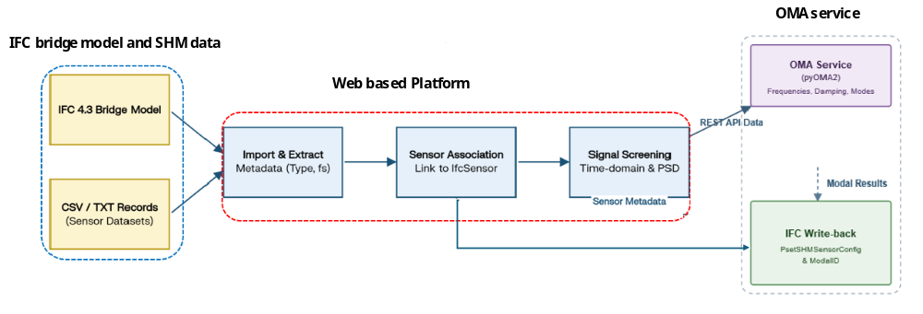
Fig 1. Proposed framework for the unified digital BrIM-SHM platform

2.3 Back-end OMA processing
To overcome the limitations of browser-based processing for complex mathematical operations, the monitoring data is transmitted via a REST API payload to a Python back end. This microservice controls the pyOMA library to execute three progressive OMA algorithms: Frequency Domain Decomposition (FDD), Enhanced FDD (EFDD), and Covariance-driven Stochastic Subspace Identification (SSI-cov). The back-end extracts key modal parameters such as natural frequencies (F_{n}), damping ratios (ξ), and mode shape vectors (Φ) and returns them to the client.
The proposed web based digital framework is illustrated in Fig 1. This methodology introduces several key features to the asset management of bridges such as backend executes FDD, enhanced FDD (EFDD), and SSI-cov to identify natural frequencies and mode shapes. Furthermore, the identified modal parameters are automatically saved back to the IFC model as standardized property sets (Pset_SHM_SensorConfig and Pset_SHM_ModalID), creating a continuing health record. This framework helps to mitigate interoperability problems by embedding sensory data useful output into the static IFC.

3. Case study: Steel railway bridge
In this study, a railway steel bridge serves as a key case study to demonstrate the feasibility of the proposed unified digital platform with integrated monitoring-related information, as shown in Fig. 2. The bridge SHM system in this case study was conducted as part of the Assets4Rail project, as detailed in the project’s official deliverables (Vezonik et al., 2019; Lenart et al., 2021; Berto et al., 2022). The case study bridge is a simply supported steel plate girder railway bridge spanning approximately 11 meters. The bridge carries a railway track and consists of two main plate girders connected by transverse bracing.
3.1 Data collection and BIM model
The monitoring systems consist of four types of sensors installed on the bridge to collect and measure sensory data during train passages, as shown in Fig. 2. A 12-3 axial MEMS accelerometer, four inductive strain transducers, and 12 foil strain gauges with a temperature sensor were installed at various positions on the bridge to measure its structural response under different conditions. In total, 23 train passages were recorded between June 8, 2021, at 12:00 and June 9, 2021, at 02:00 (Berto et al., 2022). Seven recorded passages were passenger trains, and eight were long freight trains. The remaining passages could not be classified. Sensor data is transmitted and written in tabular formats such as TXT or CSV at regular intervals and stored on the server. The vibration data were used exclusively for OMA. The acceleration signals were divided into three parts; in the first part the train is approaching the bridge, in the second part the train is on the bridge and in the third part last axle of the train has left the bridge and bridge vibrated freely. The latter signals were used to identify the natural frequencies and mode shapes. Furthermore, OMA is an output-only technique that, in this study, is applied to the free-vibration response recorded after the train has completely left the bridge. Under these conditions, the identified modal parameters depend on the bridge's dynamic characteristics rather than on the excitation details. Consequently, complete information on train type, speed, or axle configuration is not required for modal identification, and the partially unavailable train classification does not affect the validity of the identified modal parameters (Bono et al., 2025).
Although the monitoring dataset was acquired during the Assets4Rail project, it remains one of the available railway bridge datasets containing synchronized SHM measurements suitable for validating interoperable BrIM-SHM workflows. The use of archived data enables sensor-to-IFC mapping, OMA execution, visualization, and IFC export; however, it does not evaluate online acquisition, stream latency, communication failures, or continuous real-time modal tracking.
Additionally, the BIM model of the bridge was created using the BIM authoring tool Revit, and the sensory model was created using separate families in Revit. These comprehensive BIM models with sensor families were then exported into the IFC 4.3 model using the Revit mapping table at the element and category levels.

3.2 Unified digital platform
The unified digital platform was developed based on the proposed methodology, using IFC.js, Chart.js, and Three.js, with separate modules for each step as shown in Fig 3. IFC.js is an open-source JavaScript library that enables the creation of BIM on the web for loading, visualizing, and analyzing BIM models in the IFC format (That Open, 2023). Chart.js is a free JavaScript library for creating online charts (Chart.js, 2013). The platform's overall layout consists of different modules; each designed for specific tasks as shown in Fig 3. Each module assists the asset manager with maintenance planning and provides tools for condition assessment of the bridge with advanced visualization. Additionally, the backend microservice executes the pyOMA module using monitoring data available through the REST API to extract modal parameters of the bridge, which are then linked with the IFC classes to serve as thresholds or baselines for future analysis. Any drift in modal parameters can provide early indications of damage detection.

4. RESULTS
The web-based digital platform developed in this study is divided into five main components. The first section is the IFC viewer and editor, where asset managers and engineers can interact with the IFC model in a 3D view. It also includes viewer controls and data exchange features. Users can filter the monitoring system or display only the pier or girder in the IFC viewer. Additionally, it displays the hierarchy of IFC classes and attributes and allows editing of Pset attributes for each bridge component as needed during the bridge monitoring phase as shown in Fig 2 and 3.
This module, called “Sensor,” handles importing, managing, and linking structural health monitoring data to IFC-based BIM entities, as shown in Fig 4. In this layer the users can import accelerometers, strain gauge, and temperature datasets through CSV files, meanwhile upon loading the layer automatically generates summary of statistics. Furthermore, it maintains a sensor registry with sensor metadata and measurement descriptions. This layer also helps the users to semantically link the sensors and IFC entities through manual and automated approaches as shown in Fig 4. The following module, called “Vibration Analysis,” handles preliminary analysis of the acceleration data imported in the sensor module.
Furthermore, the “Modal ID” module plays a key role in OMA applications integrated with the IFC model as shown in Fig 5. The OMA pipeline proceeds as follows: (1) the user loads a multi-channel acceleration CSV file and assigns each column to a sensor; (2) a client-side Welch method identifies approximate natural frequencies for pre-selection; (3) the full time-series data is sent to the Python backend with selected frequency targets; (4) the backend executes FDD, EFDD, or SSI-cov and returns modal parameters; (5) results are stored in methodModes (per-method mode arrays); (6) modal parameters are written to the IFC via IfcAPI as Pset_SHM_ModalID entries, as shown in Fig. 6.
A primary contribution is the definition of two standardized IFC property sets for SHM data.
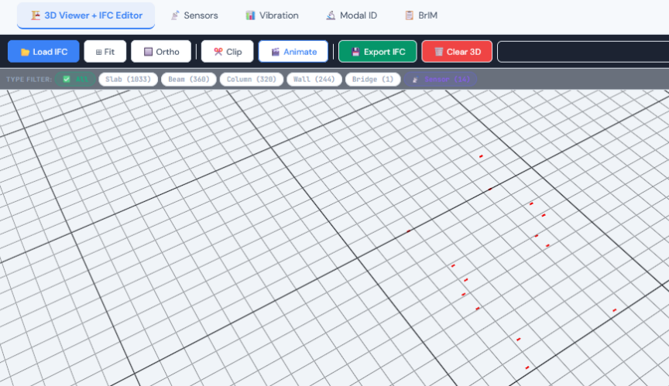
Pset_SHM_SensorConfig allows properties to be assigned to each IfcSensor entity at placement, including: SensorType (Accelerometer, Strain Gauge, etc.), Measurement Axis (X/Y/Z), Sampling Rate (Hz), Calibration Factor, Install Date, Position_X/Y/Z (m) (IFC coordinates), DataFile (URI to CSV), SamplesPerFile, RMS_g, Peak_g, and Notes. Pset_SHM_ModalID is populated after each OMA run and includes OMA Method (FDD/EFDD/SSI), Timestamp, natural frequencies (Hz), modes, and damping ratios (%) as shown in Fig 6. In this case six natural frequencies, ranging from 7.6 Hz to 28 Hz, were identified. Two of them were global modal frequencies i.e. 11.43 Hz and 16.13 Hz represent the first bending and the first torsional mode shape of the entire structure, respectively.
Sensor layout in the view

Fig 2. Sensor layout view in the unified digital platform

To validate the platform's analytical output, the identified natural frequencies were compared against the modal parameters documented for the same bridge in the Assets4Rail deliverables (Berto et al., 2022). The first global bending and torsional modes identified by the platform (11.96 Hz and 16.36 Hz) agree with the documented reference values (11.43 Hz and 16.13 Hz) within ~5%. Furthermore, to verify the interoperability of the proposed IFC enrichment, the enriched IFC model was opened in an IFC viewer, where the embedded SHM property sets were successfully preserved and displayed, as shown in Figure 6.
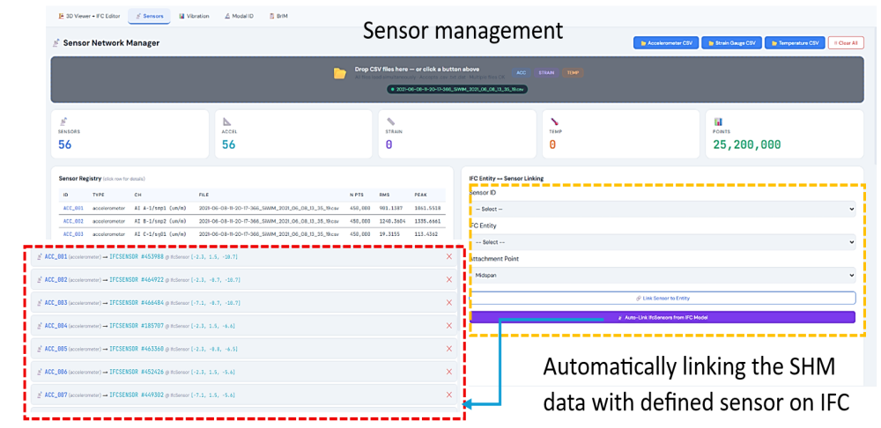
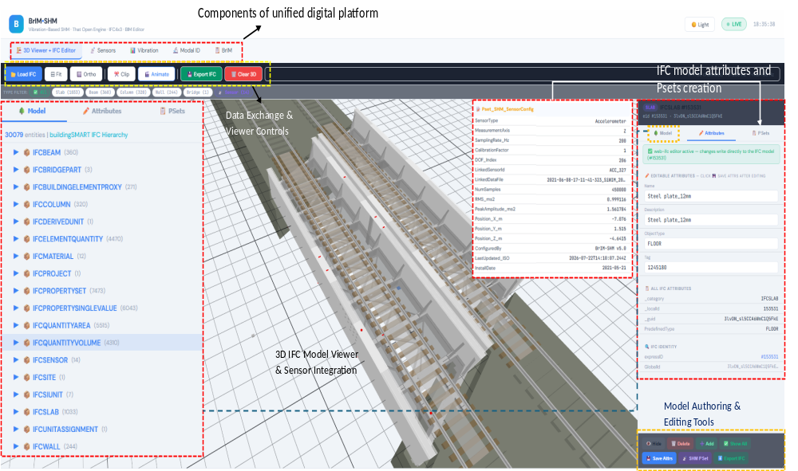
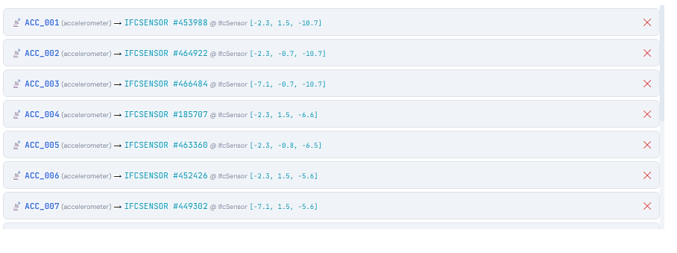
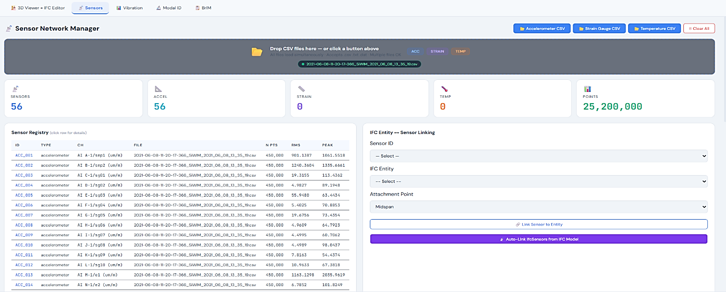
Fig 3. User interface of the unified digital platform showing IFC model visualization, sensor integration, property management, and editing tools
Automatically linking the SHM data with defined sensor on IFC
Sensor management

Fig 4. Sensor module of the unified digital platform
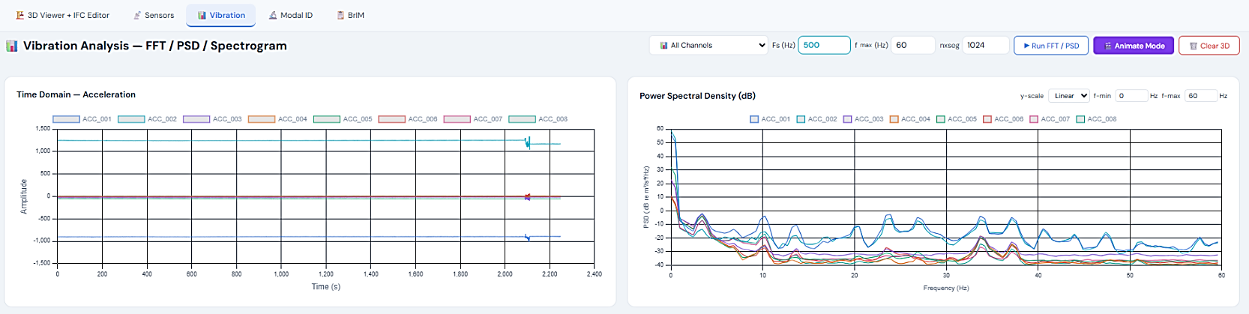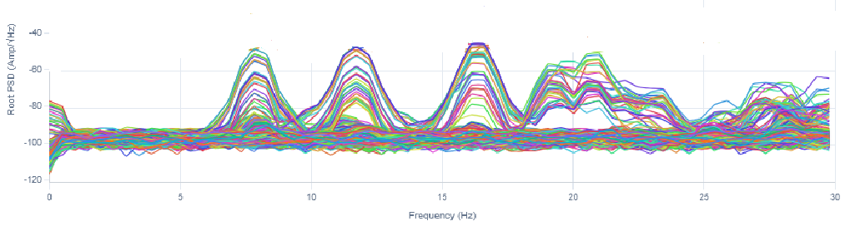
Fig 5. Vibration and Modal ID module of the unified digital platform

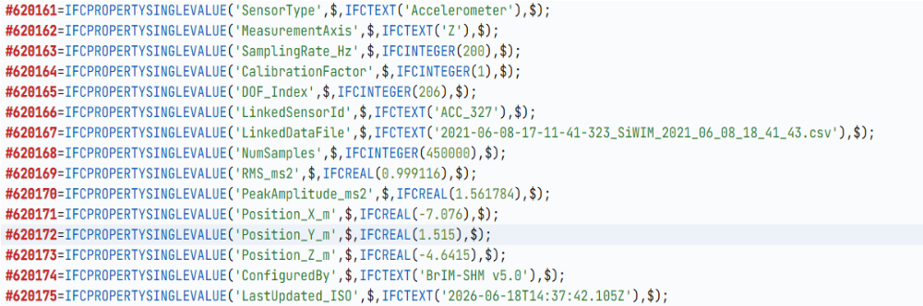
Fig 6. Semantically enriched IFC with OMA information in IFC viewer

5. DISSCUSSION AND FUTURE RECOMMENDATION
The proposed unified digital platform demonstrates a key aspect of BrIM with vibration-based SHM for asset management of bridge infrastructure. The framework was effectively demonstrated using a steel railway bridge as a case study.
The web-based platform integrates IFC 4.3 with extended properties for OMA-based SHM analysis. It also incorporates modal signatures in an IFC schema-compliant format, creating a structural state history that can be used for condition assessment of the bridge when new SHM data becomes available. A unique feature of the platform is its automatic addition of property sets, with the option to set them as a baseline for future analysis. Additionally, the platform exports the enriched IFC schema with new properties, enabling interoperability verification. A dual IFC context fragment and web-ifc – has been implemented in the platform. This approach combines fragment-based visualizations with direct IFC manipulation through ifcAPI and web-ifc, allowing the web-based BrIM platform to achieve high-performance visualization and standard-compliant editing of the IFC model within the web environment.
Despite the potential of this study, several limitations and challenges remain. First, the use of dual IFC contexts, such as fragments and web-ifc, increases preprocessing and memory requirements for large IFC models. Second, importing extensive SHM data into the platform creates storage issues. In the future, such data should be stored externally, for example, in typical databases or cloud SHM databases, to improve data management and enhance the platform's computational capabilities. Furthermore, the platform introduces a new method for creating a baseline based on OMA, so future studies could include early damage detection methods with advanced 3D visualization within the platform. Additionally, the platform can be linked with dashboards such as Power BI or Grafana to assist asset managers and bridge owners with maintenance planning and decision support.

6. CONCLUSION
This study introduces a framework applying web-based IFC/BrIM model techniques with bridge SHM, supporting the integration of SHM data into a digital bridge management system while facilitating their advanced 3D visualizations. To achieve this, the BrIM and SHM data analysis were connected in the same integrated digital platform with semantic enrichment of the IFC model with the output results from the OMA analysis. This will enable the asset manager for early identification of potential anomalies in the bridge. Furthermore, it addresses collectively the fragmentations between BrIM and SHM data environment that limits current bridge asset management practices.
The proposed workflow was applied to a steel railway bridge case study. This demonstrates a successful identification of the modal signatures with semantic enrichment of IFC model. The BrIM model was actively involved in the OMA analysis by linking geometric information with the evaluation process of modal parameters. Furthermore, the dual context of IFC enabled efficient browser-based rendering while preserving direct access to IFC entities and property data.
Consequently, while the custom Pset_SHM_SensorConfig property sets successfully documents sensor metadata such as sampling rates, the use of historical data limits the ability to demonstrate the platform's capacity to handle live data streams, dynamic sampling rate adjustments, and continuous online monitoring. Future work will focus on integrating live sensor streams to fully evaluate the platform’s real-time capabilities and end-to-end network latency.

ACKNOWLEDGEMENTS
This project has received funding from the European Union’s Horizon 2022 research and innovation programme under grant agreement No. 101119554 “BRIDGITISE” (call HORIZONMSCA-2022-DN-01). The authors also gratefully acknowledge Doron Hekič (ZAG) for providing the structural health monitoring (SHM) data.

REFERENCES

Berto, A. et al. (2022) Bridge validation report. Assets4Rail.
Bono, F.M. et al. (2025) “Automated Operational Modal Analysis of a steel truss railway bridge employing free decay response,” Journal of Infrastructure Intelligence and Resilience, 4(1), p. 100145. Available at: https://doi.org/10.1016/j.iintel.2025.100145.
Brownjohn, J.M.W. (2006) “Structural health monitoring of civil infrastructure,” Philosophical Transactions of the Royal Society A: Mathematical, Physical and Engineering Sciences, 365(1851), pp. 589–622. Available at: https://doi.org/10.1098/rsta.2006.1925.
Chart.js (2013). Available at: https://www.chartjs.org/ (Accessed: March 25, 2026).
Chen, Y. et al. (2026) “Automated generation of IFC-compliant bridge information models from structured design data,” Journal of Information Technology in Construction, p. 420. Available at: https://doi.org/10.36680/j.itcon.2026.019.
Davila Delgado, J.M. et al. (2017) “Management of structural monitoring data of bridges using BIM,” Proceedings of the Institution of Civil Engineers - Bridge Engineering, 170(3), pp. 204–218. Available at: https://doi.org/10.1680/jbren.16.00013.
Davila Delgado, J.M. et al. (2018) “Structural Performance Monitoring Using a Dynamic Data-Driven BIM Environment,” Journal of Computing in Civil Engineering, 32(3), p. 04018009. Available at: https://doi.org/10.1061/(ASCE)CP.1943-5487.0000749.
Huang, D. et al. (2026) “Building information modeling supported bridge structural health diagnosis and prognosis,” Structural Health Monitoring, 25(2), pp. 684–701. Available at: https://doi.org/10.1177/14759217241293460.
“Industry Foundation Classes (IFC) - buildingSMART International” (2024), 13 November. Available at: https://www.buildingsmart.org/standards/bsi-standards/industry-foundation-classes/ (Accessed: March 25, 2026).
Jeong, S. et al. (2017) “An information modeling framework for bridge monitoring,” Advances in Engineering Software, 114, pp. 11–31. Available at: https://doi.org/10.1016/j.advengsoft.2017.05.009.
Lenart, S. et al. (2021) Report on pre-validation activities in simulated environment. Assets4Rail.
Li, X. et al. (2022) “A BIM Based Approach for Structural Health Monitoring of Bridges,” KSCE Journal of Civil Engineering, 26(1), pp. 155–165. Available at: https://doi.org/10.1007/s12205-021-2040-3.
Li, X., Dong, Y.-X. and Xiang, W. (2024) “Developing a BIM based digital twin system for structural health monitoring of civil infrastructure,” Measurement Science and Technology, 35(11), p. 115117. Available at: https://doi.org/10.1088/1361-6501/ad730f.
Marcellino, G., Toldo, B.M. and Zanchetta, C. (2025) “Relational databases in digital platforms for monitoring: verona arena case study.”
Pasca, D.P. and Margoni, D.F. (2025) “pyOMA2: A Python module for conducting operational modal analysis,” Journal of Open Source Software, 10(115), p. 7656. Available at: https://doi.org/10.21105/joss.07656.
Sadhu, A. et al. (2023) “A Review of Data Management and Visualization Techniques for Structural Health Monitoring Using BIM and Virtual or Augmented Reality,” Journal of Structural Engineering, 149(1), p. 03122006. Available at: https://doi.org/10.1061/(ASCE)ST.1943-541X.0003498.
Singh, P. and Sadhu, A. (2020) “System Identification-Enhanced Visualization Tool for Infrastructure Monitoring and Maintenance,” Frontiers in Built Environment, 6, p. 76. Available at: https://doi.org/10.3389/fbuil.2020.00076.
Sun, L. et al. (2020) “Review of Bridge Structural Health Monitoring Aided by Big Data and Artificial Intelligence: From Condition Assessment to Damage Detection,” Journal of Structural Engineering, 146(5), p. 04020073. Available at: https://doi.org/10.1061/(ASCE)ST.1943-541X.0002535.
That Open (2023) GitHub. Available at: https://github.com/ThatOpen (Accessed: March 25, 2026).
@thatopen/fragments (2026) npm. Available at: https://www.npmjs.com/package/@thatopen/fragments (Accessed: June 19, 2026).
Theiler, M. and Smarsly, K. (2018) “IFC Monitor – An IFC schema extension for modeling structural health monitoring systems,” Advanced Engineering Informatics, 37, pp. 54–65. Available at: https://doi.org/10.1016/j.aei.2018.04.011.
Vezonik, R. et al. (2019) Report on the development of real-time monitoring, analyses of sensory data and integrating into the BIM platform. Assets4Rail.

