43rd CIB W78 Conference on IT in Construction, 6-8 October 2026, IIT Delhi, New Delhi, India
A Lean-BIM Parametric Workflow for User-Centric Affordable Housing in Developing and Lower-Income Country Contexts: From Requirements to Dashboard-Driven Design Evaluation

Aman Kumar Sharma¹, Col. (Dr). Pawan Pandey²
Department of Civil & Environmental Engineering, IIT Delhi
¹cet242263@iitd.ac.in , ² pvn@civil.iitd.ac.in

ABSTRACT
Affordable housing programmes in developing and lower-income country contexts have expanded formal delivery, yet many low-income dwellings remain weakly aligned with household size, livelihood practices, tenure conditions, climate exposure, future expansion and life-cycle affordability. Existing Building Information Modelling (BIM) applications in this sector usually support downstream tasks such as quantity take-off, clash checking, cost estimation or energy assessment after layouts have already been fixed. This paper develops and demonstrates a 12-phase Lean-BIM-Power BI workflow that connects household requirement capture, requirement classification, parametric design translation, lean design intervention, BIM schedule extraction and dashboard-driven scenario comparison. The empirical demonstration uses a structured survey of 133 households from one developing-country case context and evaluates the workflow as a proof of concept through two BIM and dashboard-integrated prototypes, a vertically expandable rural core house and a compact urban cluster unit with internal adaptability. Autodesk Revit models generate auditable schedules for walls, structural elements, openings and finishes, while Power BI dashboards compare material alternatives across cost and embodied-carbon indicators. The evaluation demonstrates traceable requirement-to-design decisions, measurable lean indicators, a 60 sq.m rural core unit, a 16-unit-per-floor urban cluster, an urban net-to-gross ratio of 68.9 per cent and a repeatable data pipeline for masonry and concrete scenarios. The contribution is a transferable requirement-to-parameter method, an integrated Lean-BIM workflow and a dashboard-supported construction informatics architecture for user-centric mass housing programmes.
Keywords: Building Information Modelling; Lean-BIM; parametric design workflow; affordable housing; developing countries; requirement engineering; Power BI; construction informatics

1. INTRODUCTION
The affordable housing challenge in developing and lower-income country contexts is not only a shortage problem but also a design-process problem because many delivered units do not adequately reflect household composition, income uncertainty, livelihood practices, tenure insecurity, climate exposure and future change. In many low-income settlements, households require flexible rooms, storage, semi-open work areas, privacy-sensitive sanitation, safe expansion and low-maintenance material choices. When these needs are not anticipated, residents often modify dwellings informally, reducing ventilation, fire safety, structural reliability and environmental performance (Agarwal et al., 2022; Garg et al., 2025; Tipple et al., 2000).
Building Information Modelling (BIM) has been widely applied in affordable and social housing for embodied-energy assessment, quantity extraction, lifecycle assessment, clash detection and construction coordination (Abanda and Tah, 2014; Ansah et al., 2021; Wong and Zhou, 2015). However, these applications generally occur after major design decisions have been made, rather than functioning as a design intelligence system that begins with household requirements and supports traceable decision-making throughout the design process.
Lean construction provides a complementary perspective because design decisions strongly influence material waste, rework, over-processing and construction complexity (Koskela, 1992). In low-income housing, interventions such as modular dimensional planning, shared walls, service clustering, reduced partitions and repetitive structural grids can reduce waste before construction begins. The unresolved issue is how such lean interventions can be encoded as BIM parameters, evaluated through schedules and communicated through dashboard analytics while preserving user needs and adaptability.
This paper addresses this gap by proposing a Lean-BIM-enabled parametric workflow for user-centric and cost-effective housing in developing and lower-income country contexts. The workflow captures household requirements, translates them into measurable design parameters, develops context-responsive layouts, evaluates them through BIM schedules and visualises trade-offs through dashboard analytics. The research aim is to demonstrate how household-level requirements can become traceable BIM-ready parameters and how lean design choices can be evaluated through a dashboard-supported decision architecture. Three research questions guide the study. RQ1 asks how user-requirement engineering can be systematically integrated into a BIM-enabled workflow for low-income housing. RQ2 asks how lean design interventions can be represented as measurable BIM schedule indicators for material efficiency, adaptability and constructability. RQ3 asks how rural and urban prototypes can demonstrate the transferability of the workflow beyond a single technology or project-specific housing demonstration.
The paper makes four contributions to the CIB W78 construction informatics discourse: (1) a 12-phase Lean-BIM-Power BI workflow from requirement capture to knowledge reuse; (2) a literature-grounded survey instrument linking household responses to design parameters; (3) operationalisation of lean interventions as BIM-evaluable indicators; and (4) dashboard analytics as a decision-support layer for comparing cost, material, carbon and adaptability trade-offs. The study is framed as a design-science research contribution. The artefact is not a single housing layout, but a reusable workflow and data architecture (Hevner et al., 2004; Peffers et al., 2007).

2. LITERATURE REVIEW
2.1 Affordable Housing Needs, Adaptability and Requirement Engineering
Affordable housing in developing and lower-income country contexts is shaped by a wider set of constraints than unit cost alone. Global housing studies emphasise tenure security, infrastructure access, sanitation, crowding, livelihood dependency, hazard exposure and social acceptability as critical determinants of housing adequacy (UN-Habitat, 2003; WHO, 2018). Housing also functions as a socio-economic asset that supports safety, income generation, social networks and resilience under poverty conditions (Moser, 1998). These perspectives challenge the assumption that low-income housing can be optimised solely through standard plans and low-cost materials. Household choices are influenced by affordability, location, services, employment access, household growth and cultural use of space (Agarwal et al., 2022; Gan et al., 2017; Huang and Du, 2015; Kallergis et al., 2018). Low-income dwellings are also frequently exposed to flooding, heat, poor ventilation, dampness and infrastructure fragility, further highlighting the need for context-responsive housing solutions (Dodman et al., 2013; Moser and Satterthwaite, 2008; Satterthwaite et al., 2020).
Adaptability is particularly important in developing-country housing because households often expand, subdivide, rent rooms or convert spaces for livelihood activities over time. Housing extension and adjustment research shows that incremental transformation is a common response to income constraints, changing aspirations and household growth (Sinai, 2001; Tipple et al., 2000). Recent studies similarly argue that housing quality depends on the capacity of dwellings to accommodate changing occupants and life-cycle requirements (Pelsmakers et al., 2022). These findings suggest that affordable housing should be viewed as an evolving system rather than a fixed product.

2.2 BIM, Lean Construction and Decision Support
Building Information Modelling (BIM) research in affordable and social housing has largely progressed through specialised applications. Studies have demonstrated BIM-based embodied-energy assessment, automated quantity extraction, lifecycle assessment and environmental performance evaluation, highlighting the potential of information-rich models to support cost and sustainability analysis (Abanda and Tah, 2014; Ansah et al., 2021; Wong and Zhou, 2015). These studies establish BIM as a credible platform for generating and managing design, quantity and performance information throughout the building lifecycle.
However, affordable housing requires more than downstream assessment. Existing BIM applications generally perform quantity take-off, energy evaluation or construction coordination after major design decisions have already been made. Reviews of BIM implementation similarly indicate that data-rich models often remain disconnected from broader design and delivery decision processes (Volk et al., 2014; Mandala and Nayaka, 2025). Consequently, limited attention has been given to how household requirements can be translated into design parameters and evaluated through BIM-supported workflows before layouts are finalised.
Lean construction provides a complementary perspective by focusing on the elimination of activities and design decisions that do not add value to users or the production system (Koskela, 1992). In housing projects, design-stage decisions can significantly influence material waste, rework and construction complexity. Arbitrary room dimensions may increase tile cutting and finishing waste, dispersed wet areas can increase pipe runs, non-repetitive structural grids reduce formwork reuse, and excessive partitions increase masonry and finishing quantities. BIM can support lean implementation by quantifying the consequences of such decisions.
Dashboard analytics further extend the value of BIM-generated information by transforming model outputs into decision-support environments. Power BI and similar platforms enable BIM schedules to be linked with cost, material and embodied-carbon databases, allowing decision makers to compare alternative design and construction scenarios. Post-occupancy and housing performance studies also highlight the importance of feedback and continuous learning in improving housing quality over time (Maslova and Burgess, 2023; Sharmin and Khalid, 2022). Collectively, BIM, Lean Construction and dashboard analytics provide complementary capabilities for affordable housing development. BIM enables data-rich modelling and quantity extraction, lean principles support design-stage waste reduction, and dashboards facilitate transparent evaluation of alternatives.

2.3 Synthesis and Research Gap
The literature shows strong progress in BIM-based assessment, Lean-BIM integration, parametric modelling, housing adaptability, post-occupancy evaluation and dashboard analytics as individual streams. The gap lies in their integration for affordable housing in developing and lower-income contexts. Existing work does not adequately demonstrate how user requirements are processed before BIM modelling, how survey categories are justified by housing literature, how lean design interventions are encoded into measurable schedule indicators and how dashboard analytics support transparent comparison of alternatives. The next section presents the 12-phase workflow as a design-science artefact that responds to this integrated gap through a literature-grounded survey instrument, BIM-based prototype development and dashboard-enabled evaluation

3. METHODOLOGY
3.1 Research Design and Workflow Architecture
The study adopts a design-science and proof-of-concept approach because it develops and evaluates a reusable Lean-BIM-Power BI workflow for affordable housing (Hevner et al., 2004; Peffers et al., 2007). The artefact developed here is a 12-phase Lean-BIM-Power BI workflow for user-centric, cost-effective housing.
The empirical demonstration uses rural and urban Indian settlements as one case context, but the workflow is deliberately structured to remain transferable across countries and programmes. As shown in Figure 1 and Table 1, the workflow is organised into the three process blocks of demand-side requirement intelligence, parametric planning and lean optimisation, and BIM analytics with learning. The sequence of phases remains stable across contexts, while local inputs such as household size, income regularity, plot condition, climate, material availability, regulation and construction technology are context specific.
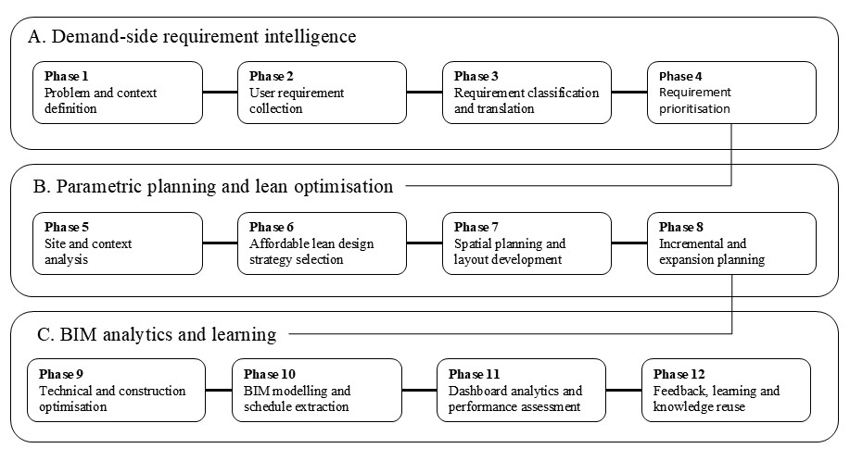
Figure 1. 12-phase Lean-BIM-Power BI workflow showing the transition from requirement intelligence to parametric design, BIM analytics and knowledge reuse.
Table 1. Formalised 12-phase workflow with phase inputs, transformations and outputs.
Phase | Key inputs | Main output or artefact
1 | Housing shortage, settlement type, affordability constraints, hazard exposure, policy or programme context. | Problem statement and boundary conditions.
2 | Household size, income regularity, tenure, spatial practices, sanitation, storage, expansion, services, hazards and comfort needs. | Household requirement database.
3 | Survey responses, field observations and literature-grounded categories. | Requirement-to-parameter matrix.
4 | Critical needs, high-priority aspirations and optional features. | Prioritised design brief and trade-off rules.
5 | Orientation, access, wind, flood risk, services, land condition and local regulations. | Site-specific parametric constraints.
6 | Prioritised brief and site constraints. | Lean design strategy set.
7 | Modular dimensions, privacy needs, service rules and structural logic. | Prototype spatial layout.
8 | Family growth, rental aspiration, livelihood use and structural feasibility. | Vertical expansion or internal adaptability plan.
9 | Layout, structural grid, material options and labour practices. | Optimised construction-ready configuration.
10 | Optimised layout and component parameters. | Revit model and element schedules.
11 | Exported schedules, rates, carbon factors and scenario filters. | Power BI decision-support dashboards.
12 | Dashboard outputs, user feedback and implementation data. | Reusable design knowledge base.

The proof-of-concept workflow was evaluated using four criteria. Design traceability assesses whether household requirements can be tracked through the requirement matrix, layout decisions, BIM elements and dashboard outputs. Construction-efficiency measurement evaluates whether lean interventions can be represented through schedule-based indicators such as wall volume, plaster area, pipe length, unique component count and formwork repetition. Adaptability assesses the ability of prototypes to accommodate planned future change without unsafe informal alteration, while informatics quality evaluates the coherence of the data pipeline linking survey inputs, BIM schedules, material libraries and dashboard filters. These criteria enable evaluation without overstating savings that require a separately modelled baseline.
Phase 2 Survey Instrument and Empirical Setup - Phase 2 serves as the requirement-engineering stage of the workflow, capturing household needs related to affordability, tenure, spatial use, services, environmental conditions, construction capability and future expansion. The survey responses were subsequently translated into design parameters for prototype development, as summarised in Table 2. The empirical demonstration used a structured survey of 133 households, comprising 68 rural households from Supaul district, Bihar, and 65 urban households from Patna and Delhi. The rural sample represented land-linked households with greater emphasis on expansion, storage, utility spaces and phased construction, whereas the urban sample reflected denser living conditions where compactness, privacy, service efficiency and internal adaptability were more critical. The survey data provided the basis for developing the requirement matrix and subsequent prototype designs.
Table 2. Phase 2 survey instrument for converting household requirements into prototype parameters.
Information category | Core survey questions | Prototype parameters derived from responses
Household, affordability and tenure | Household size, age, dependency, disability, migration absence, expected growth, income range, income regularity, repayment capacity, land ownership, rental or informal tenure. | Occupancy load; room count; accessibility; cost ceiling; unit area band; finish level; phased core-house option; expansion allowance; tenure-sensitive investment.
Settlement, existing dwelling and spatial use | Settlement type, plot size, present materials, defects, overcrowding, informal extensions, essential spaces, kitchen preference, storage, home-based work, guest stay and privacy needs. | Prototype typology; footprint; density; material palette; deficiency matrix; replacement priority; functional zoning; room adjacency; kitchen type; live-work interface; partition priority.
Services, environmental comfort and resilience | Toilet-bath preference, water source, electricity reliability, cooking fuel, storage, seasonal discomfort, daylight, air movement, smoke, dampness, mould, hazard exposure and past dwelling damage. | Wet-core layout; pipe routing; water storage; electrical points; solar-readiness; orientation; window-to-wall ratio (WWR); cross-ventilation; shading; exhaust; damp-proofing; plinth height; structural and foundation choice.
Construction capability, adaptability and prioritisation | Local material availability, labour skills, site access, preferred phasing, likely expansion mode, flexible spaces, shareable facilities, location access, priority improvements and feedback willingness. | BIM material scenarios; buildability; component size; logistics; construction sequence; structural grid; staircase position; roof capacity; non-load-bearing partitions; shared services; priority weights; Phase 12 input.

3.2 Requirement Classification, Translation and Prioritisation
Survey responses were classified into spatial, environmental, economic, social and technical requirement groups. These requirements were subsequently translated into design strategies and interventions, as summarised in Table 3.
Table 3. Phase 3 translation of survey categories into prototype design aspects and exact interventions.
Requirement Category | Design Strategy | Key Interventions
Household and affordability | Match dwelling size and cost to household needs | Flexible layout, accessible circulation, phased core-house, standardised components
Settlement and dwelling conditions | Respond to site and housing constraints | Expandable rural houses, compact urban clusters, durable materials, damp-proofing
Spatial and livelihood needs | Support daily activities and privacy | Functional zoning, multipurpose spaces, storage integration, live-work interface
Services and utilities | Improve service efficiency and maintenance | Wet-core planning, aligned service routes, water storage
Comfort and health | Enhance indoor environmental quality | Cross ventilation, climate-responsive openings, shading, damp-proofing
Resilience and safety | Reduce environmental and structural risks | Raised plinth, hazard-responsive detailing, structural continuity
Adaptability and constructability | Enable future change and buildability | Local materials, modular dimensions, planned expansion, adaptable partitions
Community priorities | Reflect user and community preferences | Shared circulation, service alignment, safe common spaces
Requirements were prioritised according to safety, sanitation, environmental performance, adaptability and affordability considerations. Critical requirements were retained during design trade-offs, while lower-priority features were introduced only when budget constraints permitted.
3.3 Construction Informatics Architecture and BIM-to-Dashboard Data Pipeline
The workflow is also a construction informatics architecture rather than a conventional BIM project sequence. A typical BIM workflow starts from a selected design and produces coordination or quantity outputs. The proposed architecture starts from a requirement database and progressively creates a requirement-to-parameter matrix, prototype geometry, BIM element schedules, schedule fact tables, material and carbon dimension tables, dashboard measures and a feedback knowledge base. This architecture is modular because agencies can initially implement Phases 2-4, 7 and 10-11, and add full analytics, energy simulation or digital-twin feedback as capacity grows. Phase 10 implements the design in Autodesk Revit using integrated architectural, structural and mechanical, electrical and plumbing (MEP) components. Revit schedules are generated for walls, floors, openings, beams, columns, concrete volumes and relevant finish areas. The schedules are exported to Excel or comma-separated values files and joined with material libraries containing unit cost, unit carbon factor, local availability and construction feasibility attributes.

4. RESULTS AND DEMONSTRATION
Rural Prototype -The rural prototype was generated by applying the full workflow to the Supaul district context. Phase 1 and Phase 2 inputs indicated larger family sizes, generally four to six members, seasonal income variation, higher storage requirements, preference for semi-open utility areas and strong aspiration for future vertical expansion. Phase 3 and Phase 4 translated these needs into a multipurpose central living space, a relatively larger storage-oriented kitchen, separate toilet and bath spaces, a semi-open front utility zone and pre-planned vertical expansion.
The resulting prototype provides approximately 60 sq.m carpet area and 70 sq.m built-up area. It uses a load-bearing masonry system, cross-ventilation logic, a semi-open buffer and a window-to-wall ratio of approximately 10 per cent. The core idea is safe incrementalism. Stage 1 delivers a complete functional ground-floor dwelling at lower initial cost, while Stage 2 enables vertical expansion through pre-planned structural continuity. This reduces the likelihood of unsafe informal modifications because the expansion path is considered during the original design. Figure 2 shows the rural prototype output.

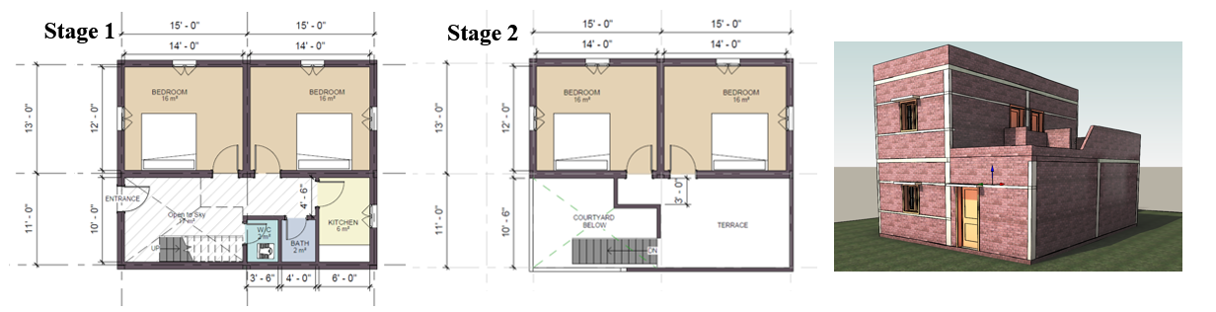
Figure 2. Rural prototype showing the ground-floor core plan, planned vertical expansion and 3D massing that together support staged affordability.
Urban Prototype - The urban prototype was generated for the Patna and Delhi contexts. Survey inputs indicated smaller households, generally three to five members, higher sensitivity to employment access, stronger need for privacy in dense settings, preference for internal flexibility rather than outward expansion and a preference for separate sanitation. These needs were translated into one enclosed bedroom, a flexible multipurpose hall, an open kitchen connected to the hall, separate toilet and bath areas organised within a compact service core and a balcony or semi-open edge for ventilation and utility activities.
The cluster arranges 16 units per floor in a repetitive linear pattern connected by a central four-foot circulation corridor. Service areas are aligned horizontally and vertically for plumbing efficiency. The modelled floor contains 576 sq.m of carpet area and 836 sq.m of built-up area, giving an approximate net-to-gross ratio of 68.9 per cent. Across the five-floor block represented by the BIM model, total built-up area is 4,180 sq.m. The structural system is a repetitive reinforced concrete frame, and the window-to-wall ratio is approximately 20 per cent. The prototype demonstrates how compactness, service efficiency and internal adaptability can be achieved without treating all units as rigid fixed layouts. Figure 3 shows the urban output.

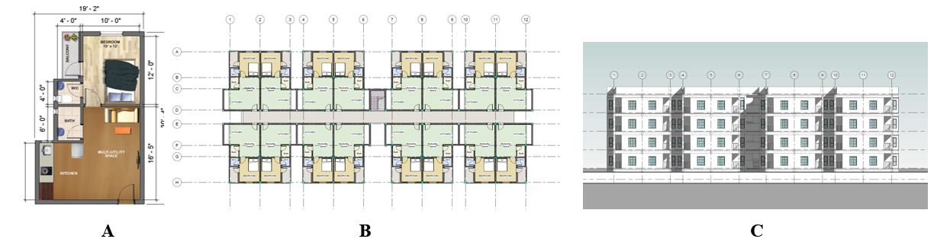

Figure 3. Urban prototype showing unit layout(A), typical cluster plan(B), elevation(C)

4.1 Lean Design Intervention Metrics and Baseline Protocol
The proof-of-concept models demonstrate how lean design interventions can be evaluated through BIM schedules. The current data support direct reporting of prototype dimensions, area ratios, window-to-wall ratios, unit counts and schedule-linked material quantities. Exact percentage savings for each intervention require a fully modelled baseline layout with comparable area, occupancy and performance assumptions which is outside the scope of this paper but is planned for future work. Therefore, Table 6 reports each intervention as a measurable BIM indicator, identifies the current evidence status and gives the baseline comparison logic for subsequent evaluation.
Table 6. Lean interventions, BIM-evaluable indicators and baseline comparison protocol.
Lean intervention | Conventional inefficiency addressed | BIM-evaluable indicator
Modular planning | Arbitrary room dimensions causing tile cutting and rework. | Tile cut-waste ratio; flooring area in full modules.
Partition reduction | Multiple fixed walls increasing masonry, plaster and finishes. | Internal wall length; wall volume; plaster area per unit.
Shared walls | Duplicated walls between adjacent units. | Wall volume per unit; external surface area per unit; plaster area.
Service clustering | Dispersed wet areas with long pipe runs. | Pipe length per fixture; bends; shaft count; wet-core adjacency.
Structural repetition | Variable spans and formwork changes. | Unique beam or column types; formwork repetition ratio; span variation.
Component standardisation | Custom door and window sizes. | Number of unique opening sizes; repeated component count.
Passive design integration | Poor orientation and uncontrolled openings. | Window-to-wall ratio; opening orientation; cross-ventilation path count.

4.2 BIM Schedule Extraction and Dashboard Analytics
The Revit models generated element-level quantity schedules for the rural and urban prototypes. Wall schedules contain wall type, length, area and volume. Structural schedules contain beam and column quantities and concrete volumes. Opening schedules document door and window sizes with level-wise distribution. These schedules are not merely documentation outputs; they become the data foundation for dashboard-based scenario testing.
The wall dashboard supports selection among different brick types. Each material alternative is linked to unit-rate in the dashboard model. In the proof-of-concept dashboard, wall schedule cards display total wall area, wall volume, labour cost, finish cost and mortar cost, while the internal and external wall categories remain filterable. The structural dashboard similarly displays beam and column quantities, concrete volumes and associated cost cards as shown in figure 4.

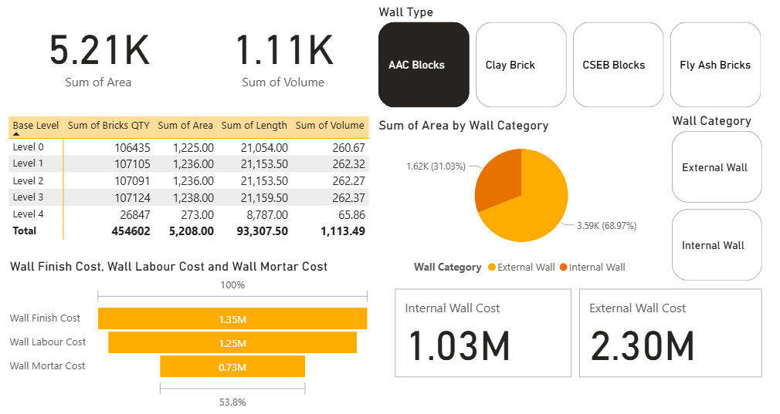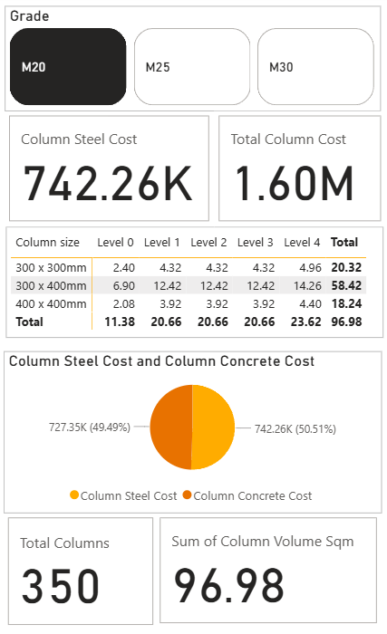
Figure 4. Wall material and column dashboard that converts BIM-extracted schedules into interactive cost

4.3 Benchmarking Against Light House Projects
The prototypes were benchmarked against six Light House Projects under Pradhan Mantri Awas Yojana Urban on IT-relevant and design-process parameters because these projects provide a useful technology demonstration reference within the empirical country context. The purpose is not to claim that the prototype replaces those technologies. Light House Projects are technology-specific demonstrations focused on rapid delivery, construction innovation and project-level performance. The proposed framework is workflow-driven and technology-agnostic. It can therefore incorporate different construction technologies while retaining the same requirement-to-parameter and dashboard decision logic. Compared with Light House Projects, the proposed workflow differs in four respects: planned adaptability, service clustering as a reusable design rule, BIM-linked dashboard analytics and a technology-agnostic process architecture that can be adapted to different contexts.

5. DISCUSSION
5.1 Requirement-Driven Workflow, Lean-BIM Evaluation and Decision Support
The study demonstrates how household requirements can be systematically translated into BIM-ready design parameters through a structured workflow. Unlike conventional BIM applications that often begin after major design decisions have already been made, the proposed approach establishes a traceable chain from user requirements to design parameters, spatial layouts, BIM schedules and dashboard outputs. This directly addresses RQ1 by showing how requirement engineering can be integrated into a BIM-enabled affordable housing process. The workflow extends beyond geometry-centred modelling by incorporating affordability, adaptability, environmental conditions and construction feasibility as explicit design inputs. In low-income housing contexts, decisions related to storage, sanitation, privacy, expansion and livelihood activities can significantly influence long-term housing performance. By formalising these requirements before design development, the workflow improves transparency and provides a clearer basis for design decision-making.
The findings further demonstrate how lean design interventions can be represented through measurable BIM indicators, thereby addressing RQ2. Strategies such as modular planning, shared walls, service clustering, partition reduction and repetitive structural grids were incorporated during prototype development and linked to quantifiable BIM outputs including wall volumes, floor areas, structural quantities and opening schedules. Dashboard analytics extend this capability by transforming BIM schedules into a decision-support environment where material, cost and embodied-carbon alternatives can be compared transparently. The resulting workflow therefore combines user requirements, lean design principles, BIM-generated information and scenario-based evaluation within a single framework.

5.2 Transferability, Limitations and Future Work
The rural and urban prototypes demonstrate the transferability of the workflow beyond a single project type or construction technology, thereby addressing RQ3. While the empirical demonstration was undertaken within the Indian affordable housing context, the workflow itself is technology-agnostic and can be adapted by modifying local inputs such as household requirements, regulations, climate conditions, material availability and construction practices. The sequence of requirement capture, design translation, BIM evaluation and dashboard-based assessment remains applicable across a wide range of affordable housing programmes.
The current study should be interpreted as a proof-of-concept demonstration rather than a full performance validation. Although the prototypes and dashboards demonstrate workflow functionality and measurable indicators, exact percentage improvements for individual lean interventions require comparison against fully modelled baseline alternatives. Similarly, post-occupancy evaluation and implementation-based validation remain outside the scope of the present study. Future work should therefore include baseline benchmarking, energy and carbon performance assessment, post-occupancy feedback integration and application of the workflow in real housing projects to further evaluate scalability and long-term effectiveness.

6. CONCLUSION
This paper developed and demonstrated a 12-phase Lean-BIM-Power BI workflow for user-centric and cost-effective housing in developing and lower-income country contexts. The workflow begins with user-requirement capture, translates household needs into measurable design parameters, incorporates lean design interventions, evaluates alternatives through BIM schedules and supports scenario comparison through Power BI dashboards. The study addresses a gap between household requirements, BIM-enabled design development and dashboard-supported decision making. The proof-of-concept demonstration used survey inputs from 133 households in rural Bihar and urban Patna and Delhi. The rural prototype provides a 60 sq.m carpet-area core unit with planned vertical expansion, while the urban prototype organises 16 units per floor within a compact cluster achieving a net-to-gross ratio of 68.9 per cent. BIM models generated auditable schedules for walls, structural elements, openings and finishes, while dashboard interfaces enabled comparison of masonry and concrete alternatives across cost and embodied-carbon indicators. The current study is a proof-of-concept demonstration and does not include fully modelled baseline comparisons or post-occupancy validation. Future work should focus on baseline benchmarking, energy and carbon assessment, post-occupancy feedback integration and implementation in real housing projects.

ACKNOWLEDGEMENTS
The author acknowledges Prof. Dr. Col. Pawan Pandey for academic guidance and constructive feedback during the development of this research. The author also acknowledges the survey participants in rural Bihar, Patna and Delhi for sharing their housing conditions, preferences and aspirations. Any remaining limitations in interpretation or analysis are the author's responsibility.

REFERENCES
Abanda, F.H. and Tah, J.H.M. (2014). Towards developing a building information modelling-based tool for embodied energy assessment of buildings. Energy and Buildings, 79, 15-26.
Agarwal, S., Singh, T.P., Bajaj, D. and Pant, V. (2022). Affordable housing in urban India: a review of critical success factors (CSFs) addressing housing adequacy with affordability for the urban poor.
Ansah, M.K., Chen, X., Yang, H., Lu, L. and Lam, P.T.I. (2021). Developing an automated BIM-based life cycle assessment approach for modularly designed high-rise buildings.
Dodman, D., Hardoy, J. and Satterthwaite, D. (2013). Understanding the nature and scale of urban risk in low-income and middle-income nations and its implications for humanitarian preparedness, planning and response. Environment and Urbanization, 25(2), 381-396.
Gan, X., Zuo, J., Wen, T. and She, Y. (2017). How affordable housing becomes more sustainable? A stakeholder study. Journal of Cleaner Production, 162, 427-437.
Garg, R., Mishra, S. and Gupta, R. (2025). Post-occupancy evaluation of affordable housing: A systematic review. Building and Environment, 250, 111167.
Hevner, A.R., March, S.T., Park, J. and Ram, S. (2004). Design science in information systems research. MIS Quarterly, 28(1), 75-105.
Huang, Z. and Du, X. (2015). Assessment and determinants of residential satisfaction with public housing in Hangzhou, China. Habitat International, 47, 218-230.
Kallergis, A., Angel, S., Liu, Y., Blei, A.M. and Sanchez, N.G. (2018). Housing affordability in a global perspective. Lincoln Institute of Land Policy Working Paper.
Koskela, L. (1992). Application of the new production philosophy to construction. Technical Report No. 72, Center for Integrated Facility Engineering, Stanford University.
Mandala, V.R. and Nayaka, R.R. (2025). Sustainable and cost-effective housing technologies for India: A comparative review. Journal of Building Engineering, 82, 108345.
Maslova, S. and Burgess, G. (2023). Delivering human-centred housing: understanding the role of post-occupancy evaluation and customer feedback in traditional and innovative social housebuilding in England. Construction Management and Economics, 41(4), 277-292.
Moser, C. and Satterthwaite, D. (2008). Towards pro-poor adaptation to climate change in the urban centres of low- and middle-income countries. Human Settlements Discussion Paper Series. IIED.
Peffers, K., Tuunanen, T., Rothenberger, M.A. and Chatterjee, S. (2007). A design science research methodology for information systems research. Journal of Management Information Systems, 24(3), 45-77.
Pelsmakers, S., Donovan, E., Hoggard, A. and Kozminska, U. (2022). Housing adaptability: New research, emerging practices and challenges. Buildings and Cities, 3(1), 704-718.
Sacks, R., Eastman, C., Lee, G. and Teicholz, P. (2018). BIM Handbook: A Guide to Building Information Modeling for Owners, Designers, Engineers, Contractors, and Facility Managers (3rd ed.). Wiley.
Satterthwaite, D., Archer, D., Colenbrander, S., Dodman, D., Hardoy, J., Mitlin, D. and Patel, S. (2020). Building resilience to climate change in informal settlements. One Earth, 2(2), 143-156.
Sharmin, T. and Khalid, R. (2022). Post-occupancy and participatory design evaluation of a marginalized low-income settlement in Ahmedabad, India. Building Research and Information, 50(6), 629-646.
Tipple, A.G., Masters, G.A. and Garrod, G.D. (2000). An assessment of the decision to extend government-built houses in developing countries. Urban Studies, 37(9), 1605-1617.
UN-Habitat. (2003). The Challenge of Slums: Global Report on Human Settlements 2003. Earthscan.
Volk, R., Stengel, J. and Schultmann, F. (2014). Building Information Modeling (BIM) for existing buildings: Literature review and future needs. Automation in Construction, 38, 109-127.
WHO. (2018). WHO Housing and Health Guidelines. World Health Organization.
Wong, J.K.W. and Zhou, J. (2015). Enhancing environmental sustainability over building life cycles through green BIM: A review. Automation in Construction, 57, 156-165.

