Exploring the Ambiguity Associated with the Actual Magnitude of the Energy Performance Gap in Buildings

Khaleel Odeh¹, Md Parvaz², Jitendra Jakkula², Pieter de Wilde², Lori McElroy¹

¹University of Strathclyde, Glasgow, United Kingdom
² Lund University, Lund, Sweden

ABSTRACT:

This paper investigates the extent of the energy performance gap in buildings, defined as the disparity between measured and simulated energy use. It underscores the persistent uncertainty regarding the true magnitude of this gap, particularly in light of the diverse benchmarks employed to evaluate the extent of the gap. A detailed case study is presented, entailing the development of four thermal energy models using four dynamic simulation tools to further examine discrepancies among simulation tools. Various simulation scenarios are conducted to evaluate the impact of differing input assumptions on the magnitude of the performance gap. The findings indicate substantial discrepancies in simulated outcomes across the tools, particularly in relation to heating and overall electricity consumption, alongside marked deviations from empirically measured energy use.

KEYWORDS:

Energy Performance Gap, Building Energy Analysis, Magnitude, Energy Policy, Standardization.

1. INTRODUCTION
The term gap is generally understood to denote a discrepancy or difference. Within the context of the energy performance gap (EPG) in buildings, commonly defined as the divergence between anticipated (i.e., simulated, designed, predicted, or calculated) and actual (i.e., measured, achieved, or realized) energy performance, the interpretation of the term gap is both broad and multifaceted. This complexity stems from the heterogeneity of building regulations, as well as the diverse methodologies employed for energy prediction and performance measurement (de Wilde, 2014; Shi et al., 2019).
The methodological approach employed to quantify the magnitude of the EPG in a given study often reflects the specific interpretation or operational definition of the EPG adopted within that context. However, this variability gives rise to significant challenges when attempting to synthesize or compare quantitative findings across multiple studies. For example, a building’s measured energy performance may be assessed against simulated, calculated, or target energy benchmarks. When aggregating data from diverse sources, discrepancies in the reference baseline—whether simulated or target performance—are often overlooked. In one study, the EPG may be defined as the deviation between measured and simulated performance, while in another, it may refer to the difference between measured and target performance. Such inconsistencies complicate efforts to draw robust conclusions regarding the severity and implications of the EPG, particularly from the perspectives of researchers, stakeholders within the architecture, engineering, and construction (AEC) industry, governmental agencies, and professional institutions.
It may be reasonably argued that variations in the magnitude of the EPG are to be expected, given the differences in quantification methodologies and simulation scenarios employed, even when measured performance remains constant across cases. Nevertheless, to effectively address the numerous well-documented challenges associated with the EPG, it is imperative to standardize the methodology used for quantifying its magnitude, anchored to a consistent and reliable energy benchmark. Such standardization is essential for accurately assessing the scale and implications of the EPG at local, municipal, national, and international levels. These implications include, but are not limited to, the management of energy supply and demand in the built environment and the widely recognized difficulty of meeting carbon reduction targets—objectives that are unlikely to be achieved without a fundamental transformation in building design, construction practices, and operational strategies (Zou et al., 2018; Brady and Hanmer-Dwight, 2016).
Furthermore, when the EPG is quantified by comparing measured and simulated energy performance, several factors such as the quality of a simulation model, the precision of input parameters, and the expertise of energy analysts introduce additional layers of complexity in accurately determining the true magnitude of the gap. For example, the exclusion or misrepresentation of critical parameters in either the simulation or measurement process can result in inconsistent comparisons, thereby complicating efforts to establish reliable cross-study correlations. Furthermore, discrepancies in EPG values may persist even when identical energy models, assumptions, and input data are employed particularly in cases where different simulation tools are used or when simulations are conducted by multiple analysts, each potentially applying unique modelling practices or interpretations.
The compliance gap between simulated and measured energy performance should not be regarded as an accurate representation of a building’s actual performance. When this discrepancy is examined, simulation assumptions are typically revised to better reflect real-world operating conditions. The actual EPG is often defined through a process known as calibration, wherein the simulation model is adjusted to account for observed operational conditions, actual weather data, occupant behaviour, and the performance characteristics of various energy systems. This calibration process enhances the accuracy of simulation models and supports the assessment of the effectiveness of energy saving measures in mitigating the EPG ultimately contributing to improved overall building performance.
From the authors’ perspective, while it is essential to investigate EPGs arising from discrepancies between measured and simulated energy performance, it is even more critical to adopt a more holistic and stakeholder-informed approach to understanding and addressing the EPG. Such an approach should account for the diverse interests and priorities of stakeholders. Simulation tools play a pivotal role in achieving energy performance targets set by building regulations and sustainability certification schemes, such as Passivhaus (PH), nearly Zero Energy Building (nZEB) standards, and performance-based rating systems like the National Australian Built Environment Rating System (NABERS), which derives its ratings from actual measured energy use.
In contrast to compliance modelling which is frequently regarded as a box-ticking exercise that inadequately represents the actual performance of buildings, the EPG between measured and target energy consumption offers a more meaningful metric. This is because it provides a basis for identifying performance deviations and implementing targeted mitigation strategies and energy-saving interventions. Within this context, dynamic simulation tools should not be viewed solely as instruments for regulatory compliance; rather, they serve as valuable tools for risk analysis, enabling the exploration of alternative design strategies and operational scenarios to achieve defined energy performance objectives.
In a policy-oriented context, where building typology and geographical location are recognized as influential factors in understanding the energy performance gap (EPG), professional bodies such as the Chartered Institution of Building Services Engineers (CIBSE) in the UK have introduced energy benchmarks categorized as ‘typical’ and ‘good practice’ to facilitate a more informed assessment of building performance. These benchmarks serve as reference points to contextualize the EPG and highlight the extent of performance deviations. However, significant variability can arise when the EPG for a single building is assessed against both benchmark types. For instance, the measured energy use may fall below the typical benchmark, suggesting a favorable outcome, while exceeding the good practice benchmark, indicating underperformance. Such inconsistencies obscure the true magnitude of the EPG and complicate its interpretation.
From an investor’s standpoint, the EPG is not solely an energy-related discrepancy, but also a financial concern manifesting as a variance between projected and actual operational expenditures. From an environmental perspective, the EPG poses a substantial barrier to achieving carbon reduction targets in a timely manner. Accordingly, there is an urgent need to investigate the impact of the EPG on climate objectives and to identify the energy efficiency measures required across different building types to meet decarbonization goals.
This study aims to explore the actual magnitude of the EPG from the perspective of various stakeholders. Specifically, it investigates how the EPG can be meaningfully interpreted by researchers, energy analysts, policymakers, and professional institutions involved in the development of energy benchmarks and building standards, such as the Passivhaus (PH) standard. To achieve this aim, the study is guided by the following objectives:

To investigate the ambiguity surrounding the actual magnitude of the EPG.

To quantify the discrepancies arising from the use of different simulation tools and scenarios.

To examine the gap between measured energy performance and various recommended or target benchmarks across multiple case studies.

To provide evidence-based recommendations derived from the study’s findings.

2. METHODOLOGY
To achieve the overarching aim and objectives of this study, two primary methodological approaches are employed: a brief state-of-the-art literature review and a comprehensive case study. Section 2.1 presents a detailed overview of the literature review, highlighting the rationale for investigating specific aspects prior to undertaking the case study. This section also identifies the research objectives addressed through the literature. Section 2.2 describes the case study building in details, while Section 2.3 outlines the simulation tools utilized and the various simulation scenarios explored.
2.1 State of the Art
The literature review examines the ambiguity surrounding the actual magnitude of the EPG, particularly in the context of varying simulation scenarios and the use of different simulation tools. It further investigates the range of reference baselines against which the EPG can be assessed, including those established by standards such as Passivhaus (PH), nearly Zero Energy Building (nZEB), and retrofit performance targets. Additionally, given that the case study is situated in Sweden, the review briefly addresses national recommendations regarding energy use intensity and indoor heating temperature setpoints relevant to the Swedish context.
2.2 Case Study Description
The case study examined in this paper is the Energy Laboratory at Lund University, Sweden. The facility was designed with the objective of identifying cost-effective strategies to reduce electricity consumption in both residential and office buildings. It comprises thermal and daylighting test cells (Bülow-Hübe et al., 2005). For the purpose of this paper, it is schematized from a building control point of view. It is viewed as consisting of three parts: the full building with a relatively limited level of control, semi-control of the test cells within the lab, and full control of the air handling units within the test cells, as illustrated in Fig. 1.
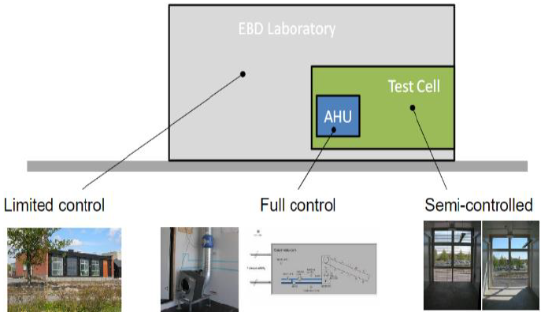
Figure 1: The LTH laboratory
2.3 Simulation Tools and Scenarios
Four energy simulation models have been created using IDA-ICE, DesignBuilder, Climate Studio, and the Integrated Environmental Solutions Virtual Environment (IESVE). The four simulation models are identical, with the same assumptions applied across the different simulation scenarios tested. Three simulation scenarios were conducted by setting indoor heating temperature setpoints at 18°C, 21°C, and 24°C to understand the influence of changing heating temperature setpoints on the magnitude of the EPG. The net floor area of the laboratory is 271.3 m², divided into 230.53 m² of conditioned and 40.77 m² of unconditioned areas, as depicted in Table 1 below.
Table 1: Conditioned and unconditioned areas in the laboratory
Spaces (conditioned) | Floor Area (m²)
Entrance | 7.74
Measurement Room | 23.25
Toilet | 4.84
Store | 3.5
Daylight test cell one | 10.8
Daylight test cell two | 10.8
Thermal cell one | 10.8
Thermal cell two | 10.8
Solar central &HVAC | 36.5
Climatic Chamber (Measurement Boxes + Corridor) | 111.5
Spaces (unconditioned)
Stair Room | 8.83
External Store | 17.36
Crawlspace | 40.77

3. A BRIEF STATE OF THE ART
Quantifying the magnitude of the Energy Performance Gap (EPG) is widely recognized as a critical research challenge, particularly given that the phenomenon has yet to be precisely defined, regulated, or standardized. Existing methods for EPG quantification have been criticized for their inadequacy in delivering comprehensive and nuanced analyses. These methods often neglect dynamic and latent components of the EPG, relying instead on simplistic comparisons between computed and measured energy performance on a monthly or annual basis, thereby disregarding short-term (daily and weekly) variations. Moreover, the calculated magnitude of the EPG is highly sensitive to the assumptions employed by energy analysts. Therefore, an accurate assessment necessitates both high-resolution, reliable data and a robust methodological framework. Such advancements are essential for informing the development of more realistic and effective energy policies (BaiYu and Pan, 2023; Palladino, 2023; FreiSagerschnig and Gyalistras, 2017; Zou et al., 2018).
An analysis of indoor temperatures in over 1,035 dwellings in Sweden reveals that 80% of the standardized indoor heating temperatures exceed 21 °C, with approximately 30% of the sample exceeding 23 °C. In contrast, the indoor temperature range recommended by the Swedish Public Health Agency lies between 20 °C and 23 °C. For the purposes of energy modeling and performance assessment, a standardized heating setpoint of 21 °C is typically assumed in both Sweden and the United Kingdom. Indoor temperature setpoints significantly influence annual energy consumption for both heating and cooling. For new constructions and retrofitted buildings, the recommended thermal comfort ranges are 20–24 °C for heating and 23–26 °C for cooling. Notably, the first certified Passive House in Sweden incorporates a flexible setpoint system, allowing occupants to adjust indoor temperatures within the range of 18–26 °C. (Wang et al., 2017; Teli et al., 2021; Henderson and Hart, 2013; Council, 2017).
According to preliminary Minimum Energy Performance Standards (MEPS) published by the Swedish National Board of Housing, Building and Planning (Boverket), the MEPS targets for 2030 specify maximum energy use of 214 kWh/m² for office buildings, 238 kWh/m² for educational facilities, and 243 kWh/m² for other building types. The subsequent MEPS targets for 2033 further reduce these thresholds to 174 kWh/m², 188 kWh/m², and 190 kWh/m², respectively. In contrast, an exemplary building in Sweden has been reported to consume only 51 kWh/m² annually—approximately 50% lower than the MEPS2030 values stipulated by Boverket. Post-occupancy evaluations of Passive House (PH) apartments in Sweden indicate a measured total electricity use of 92 kWh/m². According to Swedish energy performance criteria, the recommended maximum total energy use for buildings located in the southern region is 45 kWh/m², with an allowance of up to 55 kWh/m² when an additional 10 kWh/m² is justified (Khatibi, 2019; Murphy, 2008; Regeringskansliet, 2025; UN, 2021).

4. RESULTS & ANALYSIS
The total measured electricity consumption in the laboratory for the year 2023 amounted to 11,235 kWh. The heating temperature setpoint was maintained at 21 °C throughout the year. Monthly electricity consumption data for 2023 are illustrated in Fig.2. The lowest recorded consumption occurred in June, amounting to 291 kWh, whereas the highest was observed in January, reaching 1,608 kWh.
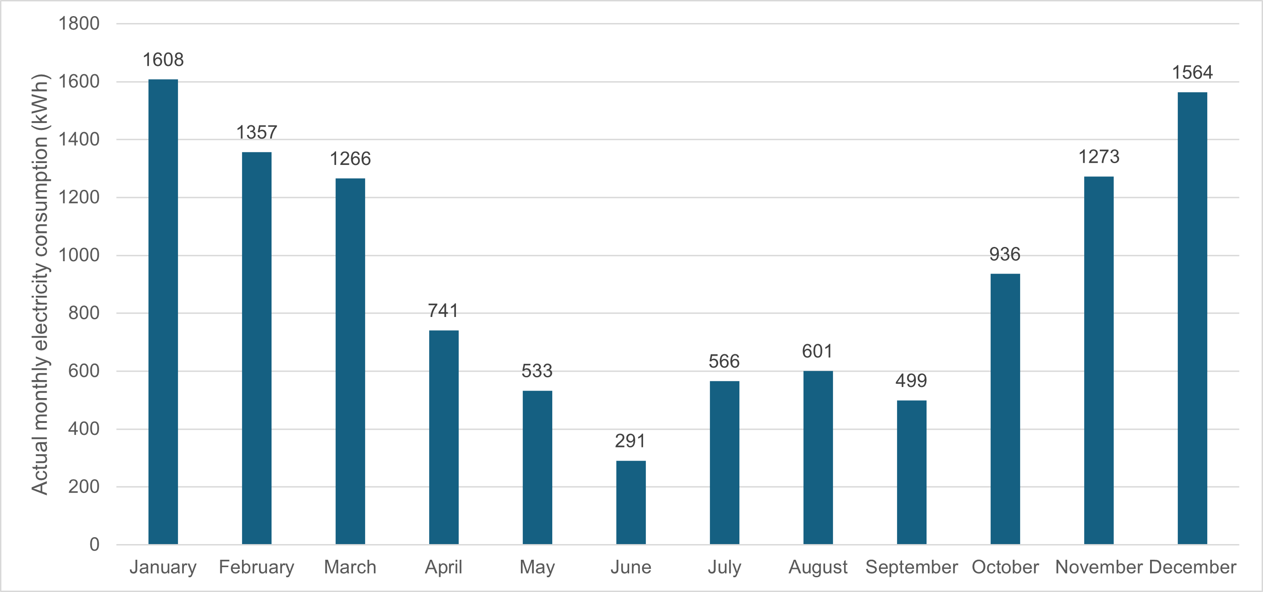
Figure 2: Monthly measured electricity consumption in 2023
The annual simulated electricity consumption, as presented in Table 2, is derived from three simulation scenarios conducted across four energy simulation tools, resulting in a total of twelve simulated values. As indicated in the table, a significant discrepancy is observed among the simulation outcomes, particularly between IES and the other three tools. Across all three temperature setpoints, IES consistently produces the highest simulated electricity consumption values, while ClimateStudio yields the lowest. This divergence highlights notable variations in simulation outputs depending on the tool employed.
Table 2: Annual simulated energy performance on the four simulation tools in kWh.
 | 24°C | 21°C | 18°C
IDA-ICE | 10660 | 8739 | 7379
DesignBuilder | 9555 | 8135 | 7064
ClimateStudio | 9157 | 7853 | 6905
IES-VE | 15859 | 11452 | 8786

The simulated electricity consumption represents total energy use, encompassing lighting, heating, cooling, equipment, and domestic hot water. Fig.3 presents the monthly simulated electricity consumption generated by the four simulation tools under a heating setpoint of 21 °C. As illustrated, IES-VE consistently produces higher monthly electricity consumption values compared to the other tools. In contrast, the simulation results from IDA-ICE, DesignBuilder, and ClimateStudio exhibit minimal variation between November and March, with more pronounced discrepancies observed from April to October.
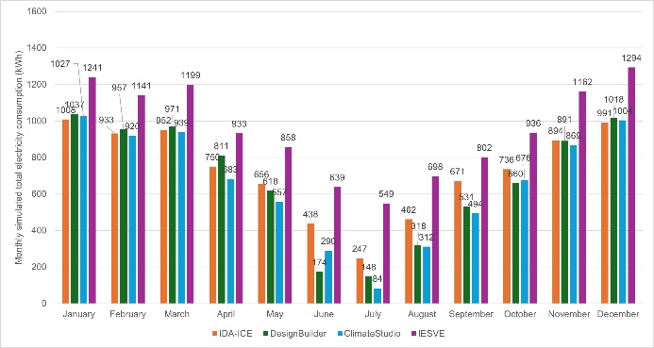
Figure 3: Monthly simulated total electricity consumption.
4.1 Gap Between Simulation Results
As previously noted, a significant discrepancy exists among the results produced by the different simulation tools. At a finer temporal resolution, Figure 4 illustrates the monthly variations in simulated heating electricity consumption. The outputs from IDA-ICE, DesignBuilder, and ClimateStudio are relatively consistent, with annual simulated heating electricity consumption values of 3,699 kWh, 3,369 kWh, and 3,123 kWh, respectively. The heating demand predicted by IDA-ICE is approximately 18% higher than that predicted by ClimateStudio. However, a substantial divergence is evident when these results are compared to those generated by IES-VE, which estimates an annual heating electricity consumption of 7,142 kWh. When comparing the IES-VE result with the average of the other three tools, IES-VE predicts approximately 110% higher heating electricity demand than the mean simulated value of the three tools.
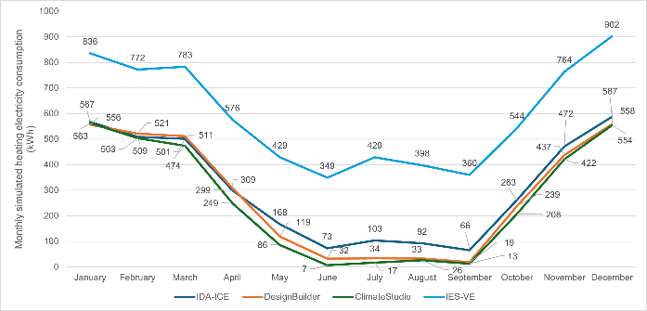
Figure 4: Monthly simulated heating electricity consumption.
In all simulation scenarios, the cooling setpoint was uniformly set at 26 °C. Nevertheless, substantial variations in simulated cooling electricity consumption are observed across the four simulation tools, as illustrated in Figure 5. The results indicate that cooling energy demand is influenced not only by the temperature setpoints but also significantly by the choice of simulation tool. Across all scenarios, IDA-ICE consistently predicts the highest cooling electricity consumption. At a heating setpoint of 21 °C, IDA-ICE estimates cooling electricity use to be 59%, 83%, and 453% higher than the values predicted by IES-VE, DesignBuilder, and ClimateStudio, respectively.
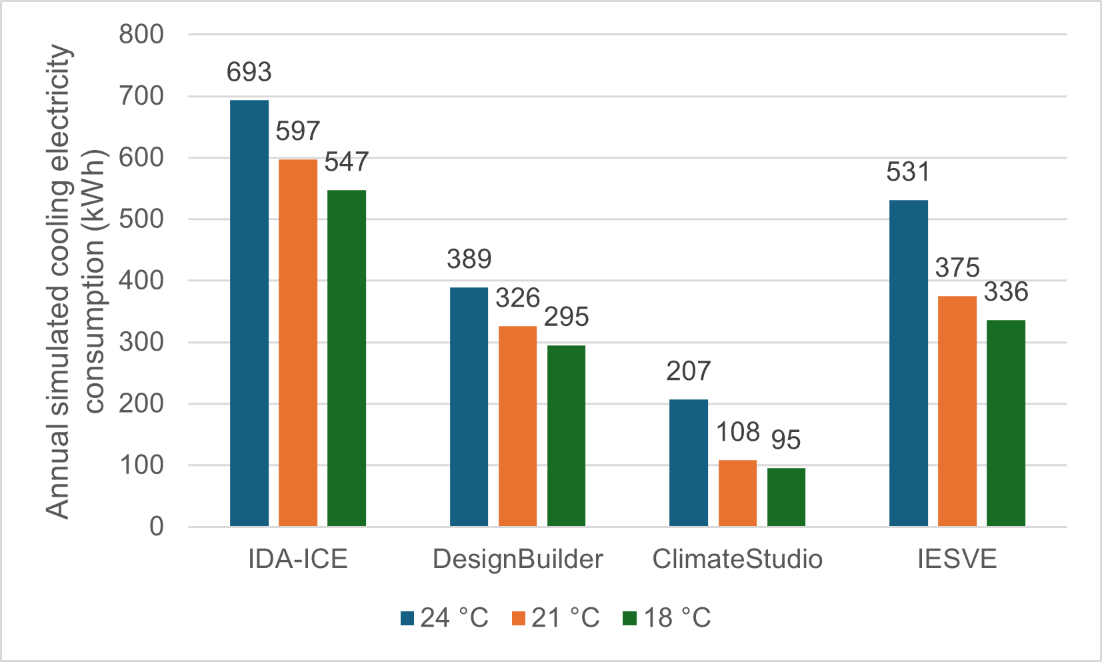
Figure 5: Annual cooling simulated electricity consumption.
Monthly simulated cooling electricity consumption, based on heating and cooling setpoints of 21 °C and 26 °C respectively, reveals considerable variation among the simulation tools during the period from April to September, as illustrated in Fig.6. Notably, from October to April, ClimateStudio reports zero cooling electricity consumption, while IES-VE estimates a minimal consumption of 14 kWh. In contrast, DesignBuilder and IDA-ICE predict 90 kWh and 60 kWh, respectively, for the same period. During this interval, DesignBuilder forecasts 543% and 50% higher cooling electricity consumption compared to IES-VE and IDA-ICE, respectively.
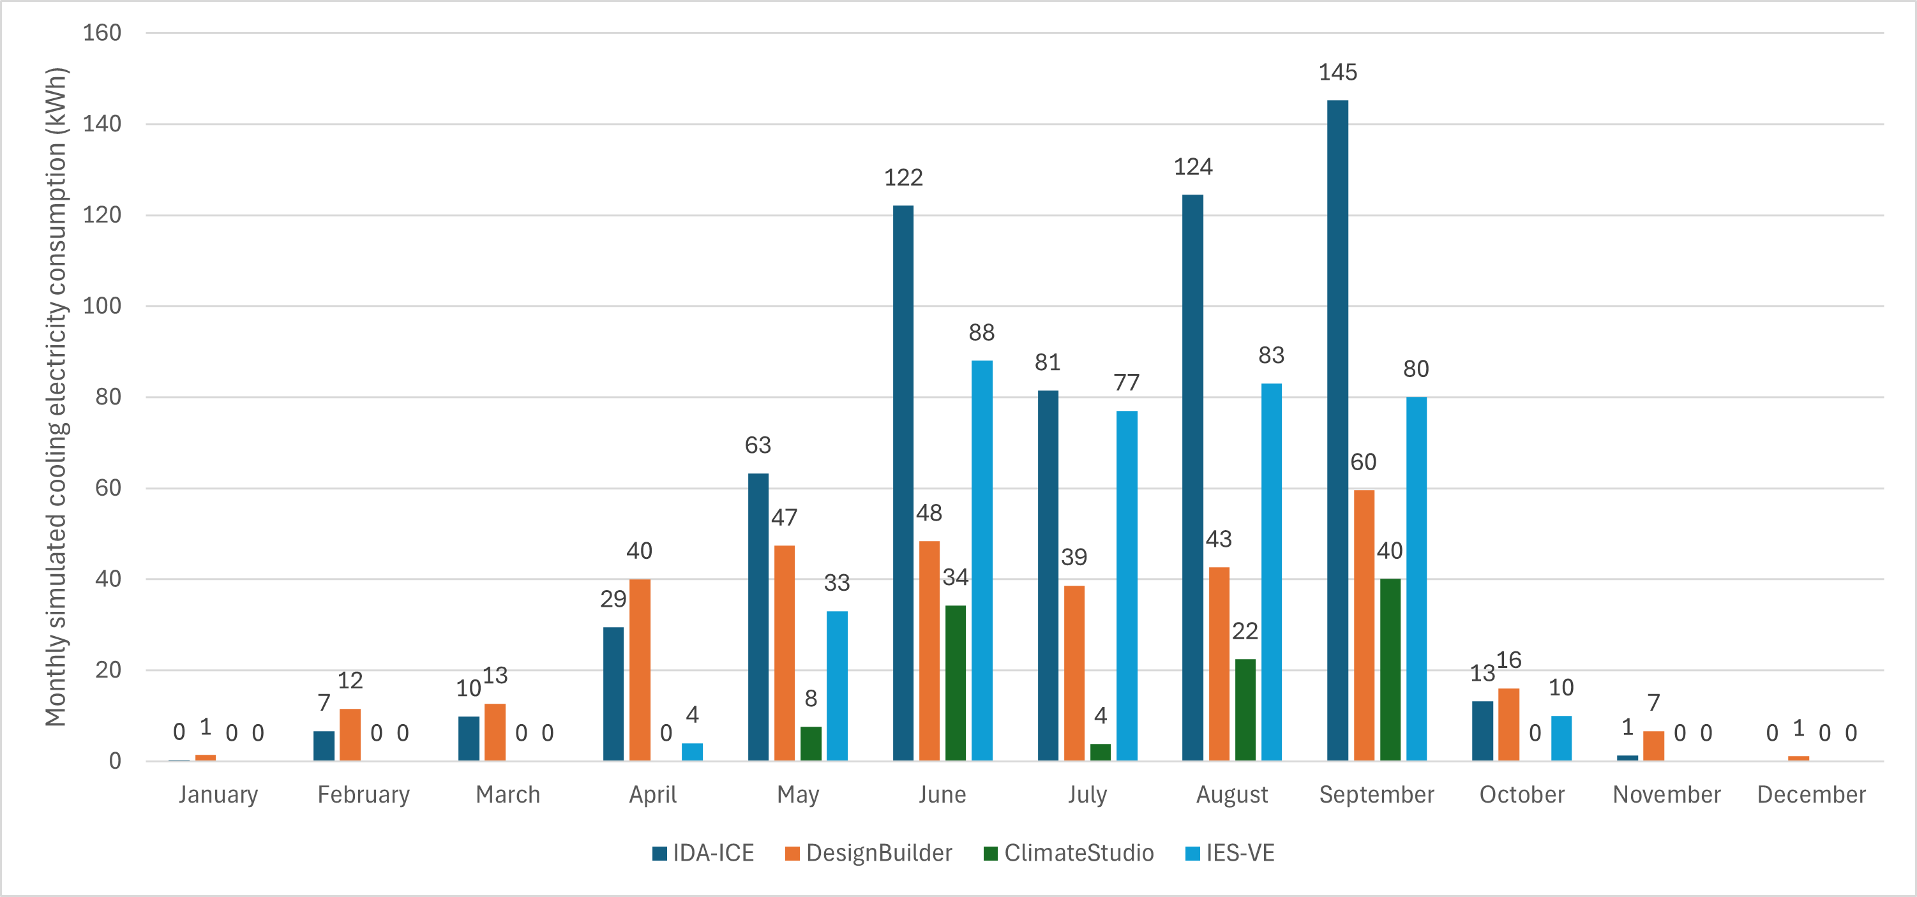
Figure 6: Monthly simulated cooling electricity consumption.
No significant discrepancies were observed in the simulated fan electricity consumption among IDA-ICE, DesignBuilder, and ClimateStudio, with the exception of December, during which ClimateStudio predicted fan electricity consumption to be 3 kWh higher than the values produced by the other two tools. However, as illustrated in Figure 7, the fan electricity consumption simulated by IES-VE is consistently and significantly lower than that predicted by the other three tools. On an annual basis, the fan electricity consumption estimated by IDA-ICE, DesignBuilder, and ClimateStudio is approximately 80.5% higher than that predicted by IES-VE. Monthly comparisons reveal the smallest discrepancies in July and December, where the other three tools predicted fan electricity use to be 46.5% and 37.5% higher than IES-VE, respectively. The largest divergence was observed in September, with the three tools estimating fan electricity consumption to be 161% higher than the IES-VE prediction.
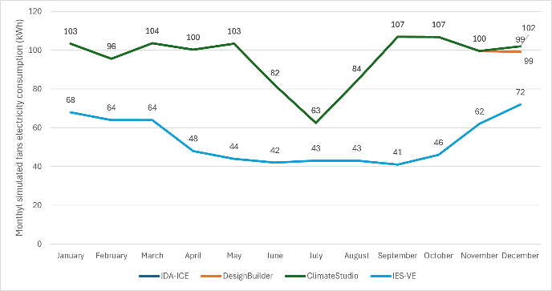
Figure 7: Monthly simulated fans electricity consumption.
The annual simulated electricity consumption for hot water, lighting, and equipment shows minimal variation across the simulation tools and is nearly identical in certain cases, as illustrated in Fig.8. For lighting, ClimateStudio predicts an annual electricity consumption that is 6.5% (124 kWh) higher than that estimated by DesignBuilder. In terms of equipment, ClimateStudio also reports a higher annual electricity consumption—approximately 6.8% (83 kWh) more—compared to IDA-ICE. For DHW, DesignBuilder estimates energy use to be 7 kWh (5.2%) greater than the value predicted by ClimateStudio.
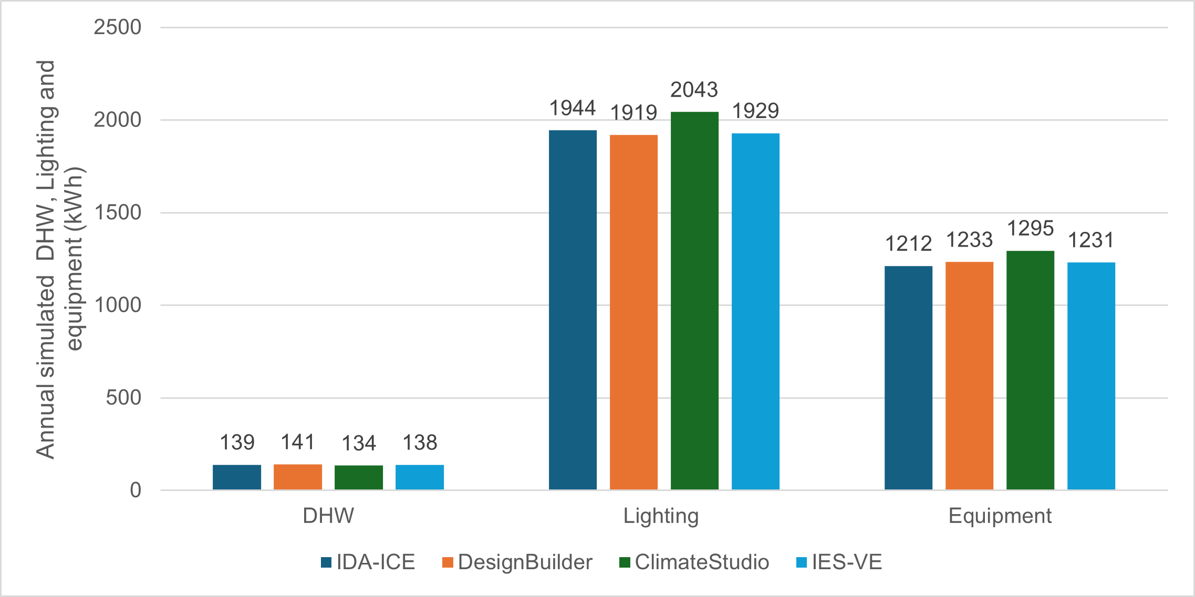
Figure 8: Annual simulated DHW, lighting and equipment electricity consumption.
4.2 Measured Versus Simulated
As previously noted, the total measured electricity consumption in the laboratory for 2023 was 11,235 kWh. Table 3 presents the comparison factors between measured and simulated electricity consumption across different scenarios. Two simulation scenarios are close to the the actual measured consumption. The first scenario, conducted using IDA-ICE with a heating setpoint temperature of 24 °C, produced a simulated electricity consumption 575 kWh lower than the measured value, corresponding to a factor of 1.05. This indicates that the laboratory consumed approximately 5% more electricity than predicted by the simulation. In the second scenario, using IES-VE with a heating setpoint of 21 °C, the laboratory was found to consume 98% of the simulated energy, with measured consumption being 217 kWh lower than the simulated value indicating a favorable EPG. Conversely, a factor of 0.71, derived from IES-VE at a 24 °C heating setpoint, indicates that the laboratory consumed only 71% of the simulated energy. Under the same heating setpoint, simulation with ClimateStudio showed that the laboratory consumed 23% more electricity than predicted.
It is also noteworthy that the range of deviation between measured and simulated results decreases as the heating setpoint temperature decreases. As shown in Table 3, the range of the gaps between the highest and lowest factors are 73% at a 24 °C setpoint, 46% at 21 °C, and 27% at 18 °C.
Table 3: Factors between measured and simulated values on different heating temperature setpoints.
 | 24 °C | 21 °C | 18 °C
IDA-ICE | 1.05 | 1.29 | 1.52
DesignBuilder | 1.18 | 1.38 | 1.59
ClimateStudio | 1.23 | 1.43 | 1.62
IES-VE | 0.71 | 0.98 | 1.28
The monthly Energy Performance Gap (EPG) was examined by comparing the measured electricity consumption for 2023 with simulated values generated using IES-VE at a heating setpoint temperature of 21 °C. As illustrated in Figure 9, the measured and simulated electricity consumption values were identical in October. In March, measured consumption exceeded the simulated value. From April to September—excluding July—the simulated electricity consumption consistently exceeded the measured values. In July, only a minimal deviation was observed, with the measured electricity consumption exceeding the simulated value by approximately 1.3%.
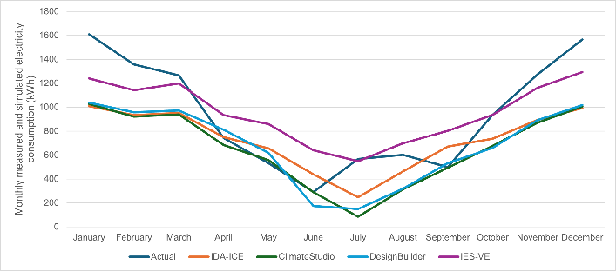
Figure 9: Measured vs simulated monthly electricity consumption.

As shown in Table 4, the range of monthly discrepancies between measured and simulated energy performance is considerable. When comparing measured consumption with IES-VE simulations, the monthly EPG varies from 3% in July to 120% in June. For DesignBuilder, the gap ranges from –14% in May indicating a favourable EPG where measured consumption is 14% lower than simulated to 282% in July. In the case of ClimateStudio, the EPG ranges from –4% in May to a peak of 574% in July. Lastly, for IDA-ICE, the monthly gap spans from –36% in June to 129% in July.
Table 4: Factors between monthly measured electricity consumption in 2023 and simulated values.
Month | IES-VE | DB | CS | IDA-ICE
January | 1.30 | 1.55 | 1.57 | 1.60
February | 1.19 | 1.42 | 1.48 | 1.45
March | 1.06 | 1.30 | 1.35 | 1.33
April | 1.26 | 0.91 | 1.08 | 0.99
May | 1.61 | 0.86 | 0.96 | 0.81
June | 2.20 | 1.67 | 1.003 | 0.66
July | 1.03 | 3.82 | 6.74 | 2.29
August | 1.16 | 1.89 | 1.93 | 1.30
September | 1.61 | 0.94 | 1.01 | 0.74
October | 1.00 | 1.42 | 1.38 | 1.27
November | 1.10 | 1.43 | 1.46 | 1.42
December | 1.21 | 1.54 | 1.56 | 1.58

Measured in 2024 Versus Simulated
The measured electricity consumption in 2024 was 18,344 kWh, representing a 63% increase (7,109 kWh) compared to the 2023 consumption. As illustrated in Figure 10, discrepancies between measured and simulated electricity consumption are more pronounced in 2024 than in 2023. In contrast to the previous year's results—where simulations conducted using IES-VE with a heating setpoint of 21 °C showed a favorable Energy Performance Gap (EPG), with measured consumption 2% lower than simulated—the 2024 data reveal a reversal. Under the same simulation scenario, the measured electricity consumption in 2024 exceeded the simulated value by 60%, as shown in the accompanying table.
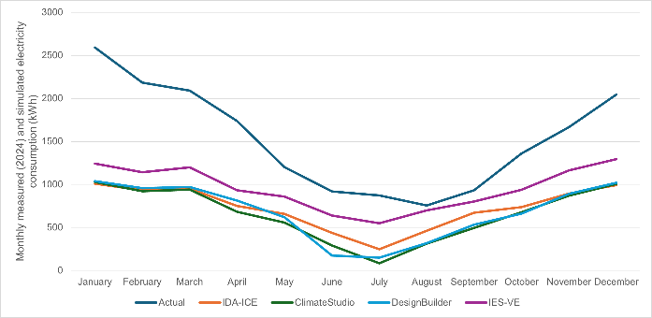
Figure 10: Measured in 2024 vs simulated.
As shown in Table 5, the range of discrepancies in 2024 also decreases with lower heating setpoint temperatures. Specifically, the gap range reduces from 72% at a setpoint of 24 °C to 47% at 21 °C, and further to 32% at 18 °C.
Table 5: Factors between annual measured (2024) and simulated values on different heating temperature setpoints.
 | 24 °C | 21 °C | 18 °C
IDA-ICE | 1.72 | 2.01 | 2.48
DesignBuilder | 1.92 | 2.25 | 2.60
ClimateStudio | 2 | 2.35 | 2.66
IES-VE | 1.16 | 1.60 | 2.01
The monthly factors comparing measured and simulated electricity consumption are presented in Table 6. The discrepancies between measured values and IES-VE simulations range from 8% in August to 109% in January. For DesignBuilder, the monthly gap spans from 75% in September to 490% in July. ClimateStudio exhibits the widest variation, with discrepancies ranging from 88% in September to 937% in July. Similarly, IDA-ICE shows gaps ranging from 39% in September to 252% in July.
Table 6: Factors between monthly measured electricity consumption in 2024 and simulated values.
Month | IES-VE | DB | CS | IDA-ICE
January | 2.09 | 2.05 | 2.52 | 2.57
February | 1.91 | 2.28 | 2.37 | 2.34
March | 1.74 | 2.15 | 2.23 | 2.16
April | 1.86 | 2.14 | 2.54 | 2.32
May | 1.40 | 1.94 | 2.16 | 1.83
June | 1.44 | 5.28 | 3.17 | 2.10
July | 1.60 | 5.90 | 10.37 | 3.52
August | 1.08 | 2.37 | 2.42 | 1.63
September | 1.16 | 1.75 | 1.88 | 1.39
October | 1.45 | 2.10 | 2.01 | 1.85
November | 1.43 | 1.87 | 1.92 | 1.86
December | 1.58 | 2.00 | 2.04 | 2.06
The magnitude of the EPG in 2023 was significantly narrower compared to that in 2024, with increases observed across all simulation scenarios. For instance, based on simulations conducted using IDA-ICE, the gap increased from 2023 to 2024 by 67%, 72%, and 96% at heating setpoints of 24 °C, 21 °C, and 18 °C, respectively. Notably, the favorable EPG observed in 2023 with a factor of 0.98 (indicating only a 2% deviation) at a 21 °C setpoint rose to 1.60 in 2024, as shown in Table 7.
Table 7: increase in the gap from 2023 to 2024
 | 24 °C | 21 °C | 18 °C
IDA-ICE | 67% | 72% | 96%
DesignBuilder | 74% | 87% | 101%
ClimateStudio | 77% | 92% | 104%
IES-VE | 45% | 62% | 73%

4.4 Measured Against Various Energy Targets
This section compares the measured electricity consumption in 2023 and 2024 against various energy performance benchmarks, including regulatory standards, national building requirements, exemplar energy-efficient buildings in Sweden, and values reported in the literature. The Energy Use Intensity (EUI) of the laboratory was calculated to be 41.41 kWh/m² in 2023 and 67.61 kWh/m² in 2024. When compared to the Minimum Energy Performance Standards (MEPS) established by the Swedish National Board of Housing, Building and Planning (Boverket), the laboratory significantly outperformed the minimum requirements for office and other building types. Specifically, in 2023, the laboratory consumed only 19% and 17% of the MEPS 2030 values for offices and other building types, respectively, indicating highly favorable Energy Performance Gaps (EPGs). Relative to the MEPS 2033 standards, the laboratory's consumption accounted for only 24% and 22% of the minimum values for offices and other building types, respectively.
In 2024, although energy use increased, the laboratory still performed efficiently, consuming approximately 32% and 28% of the MEPS 2030 thresholds, and 24% and 36% of the MEPS 2033 values for offices and other buildings, respectively.
When compared with an exemplar energy efficient building in Sweden with an EUI of 51 kWh/m², the laboratory in 2023 used approximately 81% of that value. However, in 2024, the laboratory's EUI exceeded it by approximately 33%. In comparison with PHs in Sweden where post-occupancy evaluations report a total electricity EUI of 92 kWh/m², the laboratory consumed only 45% of that amount in 2023 and 73% in 2024. Additionally, when assessed against the Swedish recommended maximum total energy use for buildings in the southern region (45 kWh/m²), the laboratory performed 25% below the benchmark in 2023, though it exceeded it by 23% in 2024.

5. DISCUSSION AND CONCLUSION
This study investigated the ambiguity surrounding the actual magnitude of the EPG in buildings by conducting a detailed comparison between measured and simulated electricity consumption using four dynamic simulation tools. Annual and monthly EPGs were assessed, highlighting substantial discrepancies depending on the simulation platform and year of observation.
While no significant deviations were observed in simulated electricity consumption for lighting, domestic hot water, and equipment between IDA-ICE, DesignBuilder, and ClimateStudio, notable differences emerged in cooling loads particularly despite the use of the same simulation engine for DesignBuilder and ClimateStudio. These discrepancies warrant further investigation, especially when significant monthly and annual gaps in simulation results are observed for cooling.
The laboratory was found to consume substantially less energy than several national and international performance targets, including PH standard and MEPS set by Boverket. However, the precise magnitude of the EPG remains uncertain due to various factors. First, electricity consumption in 2024 significantly deviated from both the 2023 measured data and simulated values across all tools. Second, the irregular occupancy patterns of the laboratory may have introduced notable inconsistencies between measured and simulated consumption, as traditional simulation assumptions often presume regular occupancy and usage patterns.
The absence of detailed electricity consumption for heating, cooling and other loads limited this paper to comparisons of overall energy use. Nevertheless, a favorable EPG of 2% was observed in 2023 when comparing measured electricity consumption to IES-VE simulations at a heating setpoint of 21 °C. However, under the same simulation scenario, the measured energy use in 2024 exceeded simulated performance by 60%, indicating a substantial increase in the EPG and highlighting the limitations of static assumptions in simulation models. Furthermore, when compared to IDA-ICE, DesignBuilder, and ClimateStudio under identical input conditions, measured energy use in 2024 exceeded simulated values by 29%, 38%, and 43%, respectively, reaffirming tool-dependent variability in simulation outputs.
While the 2023 measured performance generally fell within the range reported in the literature and aligned closely with some simulation scenarios, the sharp rise in consumption in 2024 (by 7109 kWh) resulted in large discrepancies between simulated and measured data.
Despite the challenges, comparing measured laboratory performance to literature benchmarks confirmed favorable EPGs in most cases. These insights can assist building owners and facility managers in identifying energy savings opportunities and guiding retrofitting decisions aligned with national regulations and energy performance targets. However, the variation in EPG magnitude between 2023 and 2024 also emphasizes that proximity between simulated and measured values in one year does not necessarily confirm the validity of a simulation model.
For example, simulations conducted using IES-VE at a 21°C setpoint oversitemated measured energy use by only 2% in 2023 but underestimated by 60% in 2024. In contrast, simulations using the same tool at a 24 °C setpoint overestimated energy use by 29% in 2023 yet underestimated it by 16% in 2024. This variation indicates that simulation models may not robustly capture changes year over year.
Future research will focus on calibrating simulation models with granular, measured data from submeters and occupancy sensors. This will enable more accurate assessments of the EPG and facilitate the exploration of occupant behavior impacts on energy consumption. Additionally, integrating actual system performance into the models will help clarify discrepancies between predicted and measured energy use, and support the development of targeted energy conservation strategies to ensure compliance with national energy goals and various building standards.

REFERENCES
Brady and Hanmer-Dwight, R. (2016). The Management and Control of Energy at the Design Stage of Buildings. Construction Management, [online] 2, pp.1171–1180.
Bülow-Hübe, H., Håkansson , H., & Perers, B. (2005). NEW FULL-SCALE SOLAR AND BUILDING ENERGY LABORATORY AT LUND UNIVERSITY. 1–7.
BAI, Y., YU, C. & PAN, W. Quantifying Building Energy Performance Gap Using a Multi-indicator Framework. Environmental Science and Engineering, 2023. 2483-2492.
COUNCIL, S. G. B. 2017. Miljöbyggnad 3.0 Bedömningskriterier för nyproducerade byggnader. SGBC.
de Wilde, P. (2014). The gap between predicted and measured energy performance of buildings: A framework for investigation. Automation in Construction, 41, pp.40–49.
FREI, B., SAGERSCHNIG, C. & GYALISTRAS, D. 2017. Performance gaps in Swiss buildings: an analysis of conflicting objectives and mitigation strategies. Energy Procedia, 122, 421-6.
Henderson, J. and Hart, J. (2013). BREDEM 2012 -A technical description of the BRE Domestic Energy Model. [online] Available at: https://files.bregroup.com/bre-co-uk-file-library-copy/filelibrary/bredem/BREDEM-2012-specification.pdf.
Khatibi, M. (2019). Passive house-concept apartments: sustainability evaluation in a case study of Stockholm, Sweden. IOP Conference Series: Earth and Environmental Science, 323, p.012032.
Murphy, M. (2008). Ön Development Project: Integrating Low-Energy and Passive House Technology together with District Heating.
PALLADINO, D. 2023. Energy performance gap of the Italian residential building stock: Parametric energy simulations for theoretical deviation assessment from standard conditions. Applied Energy, 345.
Regeringskansliet, R. och (2025). Boverket – the Swedish National Board of Housing, Building and Planning. [online] Regeringskansliet. Available at: https://www.government.se/government-agencies/boverket--the-swedish-national-board-of-housing-building-and-planning/ .
Shi, X., Si, B., Zhao, J., Tian, Z., Wang, C., Jin, X. and Zhou, X. (2019). Magnitude, Causes, and Solutions of the Performance Gap of Buildings: A Review. Sustainability, 11(3), p.937.
Teli, D., Psomas, T., Langer, S., Trüschel, A. and Dalenbäck, J.-O. (2021). Drivers of winter indoor temperatures in Swedish dwellings: Investigating the tails of the distribution. Building and Environment, [online] 202, p.108018.
UN (2021). Energy-Efficient Buildings Standing Out in Stockholm | Climate Technology Centre & Network | Wed, 04/14/2021. [online] Ctc-n.org. Available at: https://www.ctc-n.org/products/energy-efficient-buildings-standing-out-stockholm [Accessed 8 Apr. 2025].
Wang, Y., Kuckelkorn, J., Zhao, F.-Y., Spliethoff, H. and Lang, W. (2017). A state of art of review on interactions between energy performance and indoor environment quality in Passive House buildings. Renewable and Sustainable Energy Reviews, 72, pp.1303–1319.
Zou, P.X.W., Xu, X., Sanjayan, J. and Wang, J. (2018). Review of 10 years research on building energy performance gap: Life-cycle and stakeholder perspectives. Energy and Buildings, 178, pp.165–181.

