DIGITALISATION PLATFORM FOR MODELLING TBM TUNNEL CONSTRUCTION
Enhancing Interoperability and Collaboration
MENGQI HUANG^{,1} JELENA NINIC^{,2} QIANBING ZHANG^{,3}

¹Swinburne University of Technology, Melbourne, Australia
²University of Birmingham, Birmingham, UK
³ Monash University, Melbourne, Australia

ABSTRACT:

There is a historic investment across transport, utilities, and social infrastructure in fast-growing cities worldwide, accompanied with a substantial increase in tunnelling projects. Many critical project risks, such as ground conditions, are least well understood in early planning and development, the stage when risks are most effectively mitigated. With industry 4.0 revolutionising the AEC industries, systems and workflows are renewed to mitigate tunnelling and ground movement risks.

A framework is proposed based on the Digital Twin paradigm, centred around data, models and exchange to address the challenges surrounding tunnel boring machine (TBM) tunnelling. Workflows for uses cases during the design, construction and operation phases are also proposed supported by improved interoperability through the use of building information modelling (BIM), 3D numerical modelling, and data analytics. The resulting products demonstrate the significant potential of developing Digital Twins early stage in the project lifecycle for more effective management of tunnelling projects.

KEYWORDS:

Digital twin, early planning, tunnelling, risk identification, interoperability

1. INTRODUCTION
Tunnelling plays a unique role in serving a diverse range of economic sectors, contributing to society development. The International Tunnelling and Underground Space Association (ITA) reported that, in 2019, global investments in tunnelling projects had reached €125 billion (ITA, 2019). Considered as heavy civil (horizontal) construction, tunnelling projects need to deal with several facets of complexity throughout its design, construction, operation and maintenance. The most dominant factor is its spatial context, i.e., necessity of managing existing conditions. This is particularly true for tunnelling and underground infrastructure construction. This paper focuses on integrating 3D geological modelling, tunnelling simulations and monitoring and recording during engineering and construction stages (E&C) (e.g. geophysical sensing, geodetic and machine data) via a workflow underpinned by BIM and Digital Twin.
Tunnel construction traversing complex subterranean spaces, characterised by temporal and spatial variations can result in major delay and deviations leading to scope creep. As the digital transformation agenda extends into underground construction, digital engineering (DE), enabled by building information modelling (BIM), geographic information systems (GIS), 3D geological modelling and 3D numerical modelling, has become indispensable in design and construction processes of delivering major projects. DE practices facilitate decision-making by setting up the shared digital representation early in the lifecycle stage. As shown in Figure 1, as project progresses, real-life monitoring data is integrated to allow data-driven analysis including prediction of future events. The early engagement of DE tools enables changes to be made at lower costs. This approach counteracts the traditional linear process where changes later in the life cycle become more expensive and disruptive.

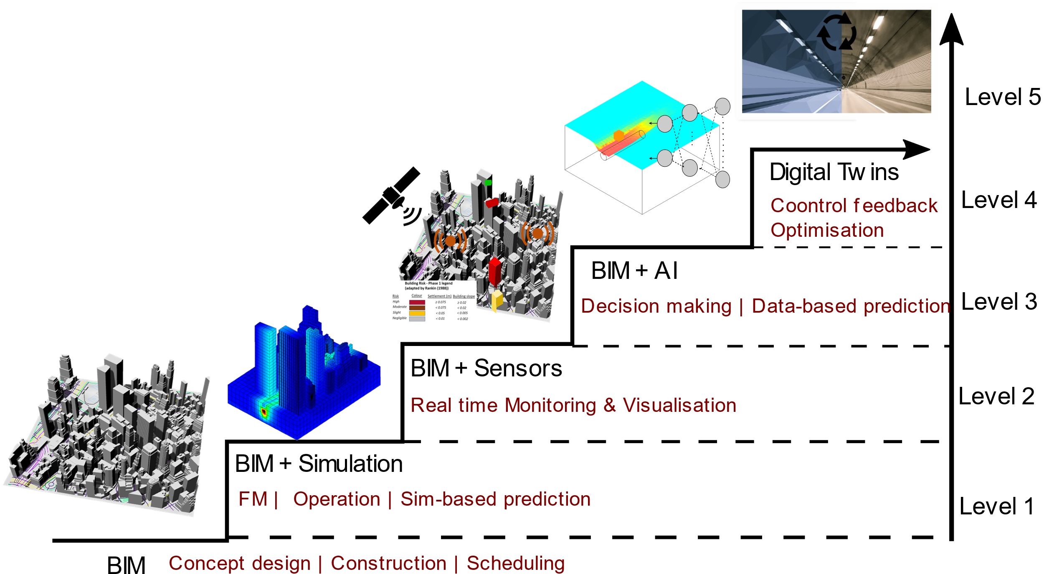
Figure 1: Transitioning from BIM to DT serving varying purposes of shared digital representations

The study presents a workflow underpinned by BIM. BIM-supported object models represent physical entities in real-life can be used for a variety of analysis applications. When coupled with sensing and data analytics, the static models become dynamic contributing to the formation of a Digital Twin. In this study, a BIM model, i.e. virtual twin, could be used in numerical simulation; the simulated settlement due to underground excavation are compared against monitored settlement. This backanalysis helps improve the accuracy of the simulation models, thus better predict future outcomes. This workflow would essentially convert the static BIM model to a Digital Twin. Once the construction is completed, the Digital Twin serves as a dynamic platform for ongoing monitoring and maintenance, continuously updated with real-time data from sensors and operational activities.

2. BIM FOR UNDERGROUND CONSTRUCTION
For design authoring of the structures, object modelling is a core technical feature. BIM-oriented digitalisation is underpinned by parametric modelling, meaning that objects are not directly represented by fixed geometry and properties, rather they are represented by parameters and rules that automatically determine the geometry. Objects are modelled at varied levels of geometric and information details, i.e., level of details (LoD). This is addressing the level of information need specified in ISO 19650, i.e. “the level of information need of each information deliverable should be determined according to its purpose” (ISO, 2018). Information encompasses geometrical and alphanumerical content defined in terms of quality, quantity and granularity. In (Rives et al., 2020), purposes or use cases of information models for tunnelling (3D ground modelling, design verification, monitoring, etc) have been proposed, leading to formulation of model view definitions (MVDs), facilitating the production of information by separate task teams. Depending on use case, level of information varies in both geometrical and alphanumerical content.

2.1 Geometrical model
In recent years, BIM technology or “Digital Engineering” has been implemented in almost all large-scale infrastructure projects. Industry efforts towards BIM in Tunnelling include guidelines published by ITA Working Group 22 “Information Modelling in Tunnelling” which provides recommendations adapted to best practice experience from BIM within tunnelling projects. Another reputable source of supporting BIM in tunnelling is “Digital Design, Construction and Operation of Underground Structures - BIM in Underground Construction” published by the German Tunnelling Committee (DAUB). The information modelling discussed within this paper are in line with these published standards for consistency in implementation.
As shown in Figure 2, multi-LoD object models with property sets can be established. The geometrical representation of the modelled objects include: LoD100 – conceptual with a symbolic and generic representation, i.e. alignment and tunnel intrados, with minimal information; LoD200 – generic representation, i.e. inclusion of grout, with approximate quantities, size, shape and location information; LoD300 – specific representation, i.e. ring model, with information such as concrete grade/mix, rebar grade, fibre reinforcement content, etc.; LoD400 – fabrication representation, i.e. segment model, connectors/bolts, etc, with specific information; LoD500 – as-built representation with accuracy in terms of size, shape, location and quantity including fitouts.
Similarly, the LoD definitions have been extended to the other underground excavations – mined cavern and prefabricated structure. With the mined cavern, the geometric form of support (rock bolts, canopy tubes) has been spatially considered in LoD100-300, with the specific systems being modelled graphically in LoD400 for fabrication purpose. Prefabricated station largely assembled a shield tunnel in terms of production process, i.e. installation of prefabricated components (as opposed to prefabricated segments in shield tunnelling), thus following a similar definition at different LoDs. Appendix B of (ITA, 2022) provides a level of LOD proposal organised along typical project stages for bored tunnels, readers are encouraged to refer to that list for more information.

Figure 2: Parametric modelling of underground infrastructure by type.

2.2 Multi-disciplinary model
Investigation and verification into tunnel design commences with selection of site and surveying of the existing conditions. Subsurface characterisation for geotechnical analysis of tunnelling is firstly performed. An algorithm is developed in the Revit plug-in, visual programming tool Dynamo to automatically retrieve and combine the geological data given in form of the borehole data to model and characterise the subsurface conditions. This process first retrieves borehole data stored in Excel format, and constructed borehole models as illustrated in Figure 3 (a). This is followed by instantiating topographies and simple stratified geological models as illustrated in Figure 3 (b). Finally, the model is scaled down to the domain of study, by defining a boundary box that creates a section of suitable size. Within the project domain, the instantiation of tunnel models is performed as shown in Figure 3 (c). The parametric modelling procedures to generate tunnel models at varied LoD has been discussed in papers (Ninić et al., 2020a; Ninić et al., 2020b), leveraging BIM tools that facilitate parametric solid modelling and parametric assembly modelling in a BIM-design authoring process (Sacks et al., 2018; Huang et al., 2021). Interested readers are recommended to refer to these literatures for more information.

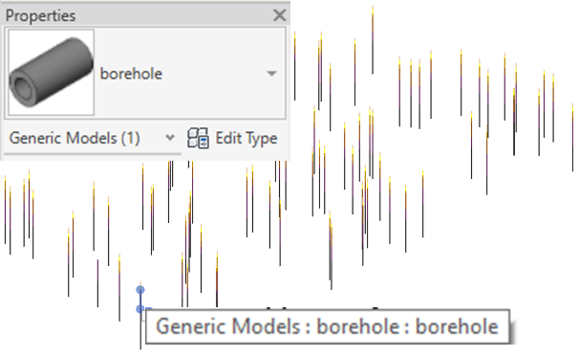
(a)
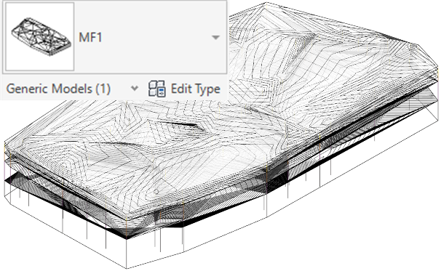
(b)
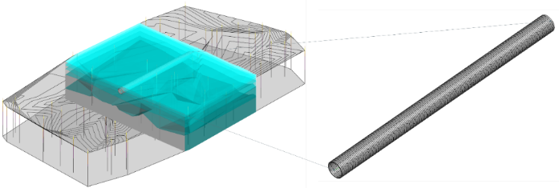
(c)
Figure 3: modelling of surrounding environment via the steps of (a) instantiations of virtual borehole models by georeferencing a spreadsheet containing the coordinates and strata information of borehole logs; (b) topographies and geological strata models; (c) project domain scoped section with tunnel model instantiation (LoD300-400, i.e. with lining segments of different types).

Furthermore, to assess the impact of tunnelling on the existing environment, the above-ground buildings have been modelled. A site near the proposed Monash station of Suburban Rail Loop (SRL) East Package is selected for demonstrating the feasibility of the framework. Figure 4 (a) illustrates the site localisation process; geographical information data of the selected site is obtained from the open-source mapping service “OpenStreetMap” in the format of “.OSM”. With several custom Dynamo packages being used to read the metadata associated with the OSM file, including categories of the as-built environments, e.g. aerial way, building, highway, land use, etc. With the “building” category being selected, the polygons that define the building boundaries are created. Then the specific metadata of building level will be extracted to allow generic models being created by vertically extruding the polygonal profiles. The extrusion is governed by the number of level times 3 meters per level, forming instances of generic objects representing buildings, as shown in Figure 4 (b). A similar result could be achieved without the use of the custom package but by exporting CAD models of buildings from online portal such as cadmapper.com. This alternative solution would be more robust as it is independent of custom packages or versions of Dynamo, however, less automated compared to the current workflow. The results of the integrated project existing conditions (geological, buildings and tunnels) are shown in Figure 4 (c).
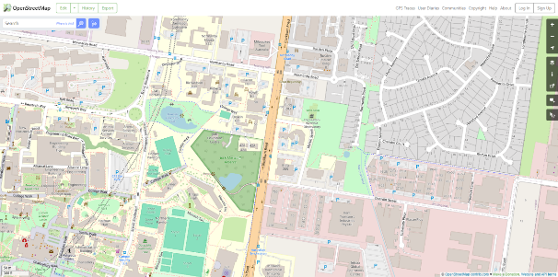
(a)
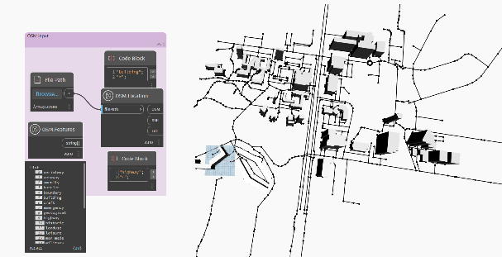
(b)
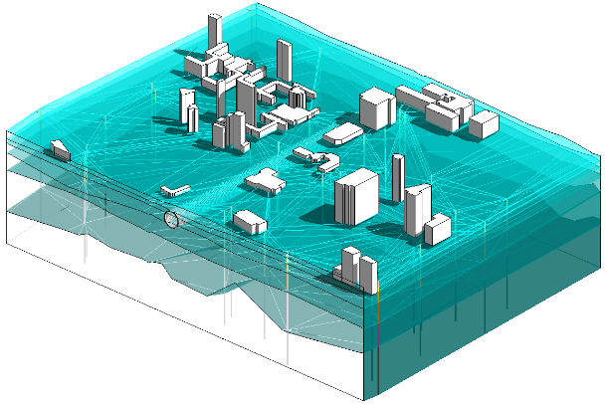
(c)
Figure 4. as-built models of buildings (a) retrieve GIS data from OpenStreetMap; (b) generate generic building models in Revit; (c) integrate with the underground model and tunnel model.

2.3 Semantic model
All models created are generic models with rather limited set of properties, to substantiate the models, metadata related to materials, mechanical and geotechnical properties could be directly added to the native BIM platform, in this case Revit. For ground models, alternatively, mechanism could be developed to retrieve these data from programs such as gINT or Leapfrog where geological models and data are commonly stored (ITA, 2022). Examples of attributes to be assigned to a segment instance and borehole instance are provided in Table 1.
Furthermore, metrics related to environmental impact may be required granularity for use case of ecological footprint assessment. These attribute values could be further extended according to project specifications and transferred across different projects (if standardised) and use cases, thus reinforcing the reusability of the database and enriching the semantics that complements the information model.

Table 1. Examples of attributes to be assigned to a segment instance and borehole instance

Selected elements | Member Type (examples) | Attribute (examples)
Segmental lining | Steel fibre-reinforced, Synthetic fibre-reinforced, Steel-reinforcing bar, base concrete | Type, thickness, steel fibre ratio, strength, equivalent strength, coarse aggregate diameter, slump, mixture
Borehole | CPT, SPT | RQD, material, level of certainty, model development stage

3. BIM TO NUMERICAL MODELLING
To evaluate tunnelling impact on the surrounding environments, BIM-to-FEM/FDM workflow proposed in (Huang et al., 2022) is adopted as shown in Figure 5. The left panel consists of model creation in Revit using Dynamo. With the models and associated attributes being retrieved by the exchange enabler. The extracted model and data are then used in numerical simulation. The interested results are extracted and fed back to BIM platform for visualisation and decision-making. This procedure is largely automated via an exchange enabler that is able to retrieve both graphical and non-graphical information from the BIM platform. Meanwhile, the exchange enabler also facilitates to create the numerical simulation models and generate corresponding commands. The enabler is realised by a set of Python scripts that are supported by the combination of BIM authoring and visual programming. The created meshed models are then run in selected numerical analysis program, in this paper, FLAC3D is engaged.
The numerical simulation of shield tunnelling process at a depth of 15m is performed considering the machine-ground-structure interaction during excavation and installation. The typical Mohr-Coulomb parameters of the rock and lining used in the simulation are reported in Table 2. The zone displacements at varied advance stage are shown in Figure 6 (only settlements, i.e. negative displacements are shown).

Figure 5. Close-loop workflow and involved processes.

The impact of settlement predicted via numerical modelling could on surrounding buildings could be visualised. (Susceptible indices with recommendations include magenta – significantly susceptible requesting immediate remediation, red – highly susceptible requesting close monitoring, orange – moderately susceptible, blue/green – insignificant or negligible). Reproduced from (Huang, 2025).
Alternatively, analytical and empirical methods for volume loss and confinement loss can be embedded directly into the BIM model for computed solutions to be visualised directly.

Table 2: Physical and mechanical properties for modelling

Property | Unit | MF4 | MF3 | MF2 | MF1 | Lining
Depth | m | 0-5 | 5-15 | 15-30 | 30-70 | -
Unit weight | γ (kN/m³) | 22.5 | 23 | 24 | 25.5 | 25
Rock mass modulus | E_{rm} (MPa) | 100 | 200 | 800 | 2500 | 35000
Poisson’s ratio | v | 0.3 | 0.25 | 0.2 | 0.2 | 0.167
Friction angle | ϕ (°) | 30 | 34 | 43 | 54 | 37
Cohesion | c (kPa) | 37 | 60 | 115 | 270 | 4000

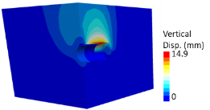 | 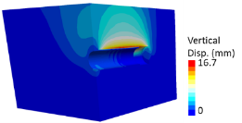 | 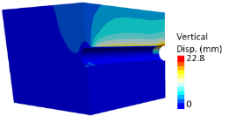
(a) | (b) | (c)
Figure 6. vertical displacements caused by tunnelling at varied advance intervals.

The significance of this DE-driven approach is for early-life stage decision support. It is worth noting that interoperability, meaning the ability to share and exchange information between different applications has been an important factor required by collaborative design process. Within the domain of BIM, interoperability is largely supported by the use of the standard data schema to represent the information models, namely Industry Foundation Classes (IFC). There have been ongoing efforts to extend IFC data schema for infrastructure uses, including tunnels (e.g. buildingSmart Infrastructure Room). However, due to the complexity of information associated with tunnelling, especially geological and geotechnical information and representations, there is yet IFC-tunnel standard being published or implemented in standard design authoring tools (e.g., Autodesk Revit, Plaxis, SketchUp, 12D, Bentley Designers, etc.). Tunnel designs and design verification via numerical modelling at the moment are still largely relied on paper-based drawings.

4. DIGITAL TWIN
As defined by NIBS “A Digital Twin of an asset is a fit-for-purpose and intelligent virtual representation of it synchronised at specific frequencies, with an existing or planned connection between the virtual and physical twin that may include analysis and the ability to actuate physical changes from the virtual twin”. The Digital Twin concept is centred around analysing the operational status of the physical artefacts to interrogate and predict future states.

Figure 7. Underground DT from circular view with key technologies identified (modified from (Zhu et al., 2025)).

The Digital Twin prototype presents in Figure 7 is consisted of a physical product, a digital counterpart, and a two-way data. For it to realise the intended functions, a series of technologies and processes are required forming a circular workflow, including inspection and sensing (i.e., data acquisition), transmission and communication, data fusion, data interpretation (including modelling and simulation), visualisation and communication, reasoning and knowledge derivation, decision-making, and action. Differs from BIM model that represents the physical product by answering “what is it?”, the Digital Twin advances from only providing description but introduces observations from the real-world to validate the model. Further analyses, including the increased use of machine learning techniques, leveraging the data can be conducted for prediction and optimisation to improve accuracy of the model. Finally, real-time intervention may be undertaken to allow for rapid adaptation to changing environment. Such progression is referred to maturity of Digital Twin (Babanagar et al., 2025).
Digital Twin is a further step of DE transformation for infrastructure. It not only facilitates visualisation of construction activities and interfaces but highlights a data-driven approach. With more available computational force, machine learning and broad artificial intelligence techniques are allowed for informed decision-making to further drive down uncertainty costs associated with tunnelling projects.
Moreover, the Digital Twin paradigm can extend beyond the E&C stages into operation and maintenance stage, which contributes significantly to resilience and sustainability of the as-built. Metadata generated during E&C are inherited and continue to build over the long service life (i.e. 100 years) of tunnels and associated underground infrastructures. Insights from these data facilitate most efficient and economical actions.

5. CONCLUSION
The DE paradigm, including the use of BIM processes, facilitates the collection, exchange, and linking of information, improving transparency and data efficiency. Since there is no standardised BIM model view for geotechnical analysis, heuristic-driven workflows are essential to improve interoperability between interdisciplinary applications and enable analysis of interactions across multiple environments.
This paper presents a workflow contributes to early-stage decision aid of tunnel design and construction leveraging BIM parametric modelling and numerically. This includes the model and data federation of ground, as-built environment and tunnel structure using object-oriented modelling. Programming interfaces have been adopted to automate the modelling and semantic enrichment processes. Moreover, it explores the requirements on developing a functional Digital Twin based on the federated BIM and analyses how the Digital Twin technology can enable smarter and more efficient planning, design, construction, and operation of tunnel projects.

ACKNOWLEDGE
The case study has only been proposed to illustrate the workflow without any reference to the actual site investigation, design or construction procedures.

REFERENCES
Agenda, I. Shaping the future of construction a breakthrough in mindset and technology. World Economic Forum, 2016. 11-16.
Babanagar N, Sheil B, Ninić J, Zhang Q, Hardy S. Digital twins for urban underground space. Tunnelling and Underground Space Technology. 2025 Jan 1;155:106140.
DAUB, 2019. Digital Design, Building and Operation of Underground Structures. BIM in Tunnelling Model Requirements - Part 3: Ground Model, Supplement to DAUB recommendation BIM in Tunnelling (2019). German Tunnelling Committee (ITA-AITES), Deutscher Ausschuss für unterirdisches Bauen e. V. (DAUB).
Huang, M.Q., Ninić, J., Zhang, Q.B., 2021. BIM, machine learning and computer vision techniques in underground construction: Current status and future perspectives. Tunnelling and Underground Space Technology 108.
ISO, 2018. BS EN ISO 19650–1:2018 Organization and digitization of information about buildings and civil engineering works, including building information modelling (BIM) - information management using building information modelling
ITA, 2019. Tunnel Market Survey 2019. International Tunneling and Underground Space Association (ITA).
URL
http://www.societaitalianagallerie.it/notizia/1618/global-market-survey-ita/download/5820/
ITA, W., 2022. BIM in Tunnelling - Guideline for Bored Tunnels, Interational Tunnelling and Underground Space Association.
Ninić, J., Bui, H.G., Meschke, G., 2020a. BIM-to-IGA: A fully automatic design-through-analysis workflow for segmented tunnel linings. Advanced Engineering Informatics 46.
Ninić, J., Koch, C., Vonthron, A., Tizani, W., König, M., 2020b. Integrated parametric multi-level information and numerical modelling of mechanised tunnelling projects. Advanced Engineering Informatics 43, 101011.
Rives, M., Borrmann, A., Alsahly, A., Atzbacher, H., Brino, G., Bucci, A., cEsnik, J., Danise, F., Dias, N., Dunn, J., Hoel, J.E., Kudoh-Wada, R., Luibello, G., Nishiyama, S., Osgoui, R.R., Robert, F., Sandrone, F., Sheil, A., Shima, H., Stefanizzi, S., Stelzer, M., Syversen, F., Thoren, J., Vendramini, M., Villa, S., Vollmann, G., Venthron, A., Weil, J., Zammit, H., Zhu, N., 2020. IFC-Tunnel Project_Report WP2: Requirements analysis report (RAR). buildingSMART International. https://app.box.com/s/3p28520cgser0sa1bvunhc99bt4qhuza/file/711362091723
Sacks, R., Eastman, C., Lee, G. and Teicholz, P., 2018. BIM handbook: A guide to building information modeling for owners, designers, engineers, contractors, and facility managers. John Wiley & Sons.
Zhu, H., Huang, M., Ji, P., Xiao, F. & Zhang, Q.-B. 2025. Transforming the maintenance of underground infrastructure through Digital Twins: State of the art and outlook. Tunnelling and Underground Space Technology, 161, 106508.

