Graph Neural Networks for Building Evacuation Prediction
Integrating Real-Time Pedestrian Flow Simulation into BIM Workflows
Double-blind review process

Do not include authors in the body text at this time

ABSTRACT:

Effective evacuation planning requires accurate pedestrian simulations, yet integrating such models into early-stage architectural design remains challenging due to manual data conversions and long simulation runtimes. Meanwhile, Building Information Modelling (BIM) is widely used for digital building representation but lacks native pedestrian simulation support. To address this gap, we propose a novel approach that combines graph-based building representations with a Graph Neural Network to predict pedestrian flow in real-time. Our method transforms parametric BIM layouts into graph representations, enabling fine-grained temporal resolution of crowd dynamics. Unlike previous surrogate models with static or coarse outputs, our approach captures density rates dynamically, facilitating rapid safety assessments during design iterations. This integration streamlines pedestrian simulation within BIM workflows, allowing for layout optimization layouts to ensure safe and efficient evacuation design.

KEYWORDS:

Graph neural network, deep learning, building evacuation, Building Information Modelling, pedestrian simulation.

1. INTRODUCTION
Dangerous situations, such as overcrowding or mass panic, can arise when numerous occupants attempt to access building exits simultaneously, particularly during evacuation scenarios. Tragic crowd disasters – including the Love Parade in 2010, the Hajj stampede in 2015, and the Seoul Halloween crowd crush in 2022 – highlight the severe consequences of unmanaged crowd dynamics. To analyse and understand these situations, and consequently implement preventive measures, the simulation of such scenarios using pedestrian simulators is crucial (Haghani & Sarvi, 2018; Helbing, et al., 2005). In the built environment, a key factor influencing these dynamics is the building's architectural layout (Natapov, et al., 2022), which is typically determined during the early stages of design. However, integrating pedestrian simulators into these early phases involves significant challenges. The process often requires manual export and conversion of stand-alone file formats, coupled with lengthy simulation runtimes ranging from minutes to hours, depending on the building's complexity (Berggold, et al., 2023). This makes the use of such simulators impractical during the initial design stages, where the architectural layout undergoes frequent changes and involves multiple stakeholders, including architects, civil engineers, planners, and other professionals. The cumbersome nature of this integration hinders the effective utilization of pedestrian simulators in the critical phases of building design, potentially compromising safety considerations in the final structure.

Another crucial methodology in the design process is Building Information Modelling (BIM), which has become an integral part of modern architectural and engineering practices (Borrmann, et al., 2018). BIM employs 3D modelling and data-rich environments to represent buildings digitally and thus facilitates the creation and management of physical and functional characteristics throughout the building lifecycle. However, despite its widespread adoption, BIM platforms often lack native support for pedestrian simulations, creating a disconnect between the design process and critical safety analyses (Siddiqui, et al., 2024).
In this study, we present a novel approach to bridge this gap by combining a graph-based representation of building layouts, derived from a parametric BIM model, with a Graph Neural Network (GNN) to generate pedestrian simulation results in real-time. Hence, our proposed method is designed to support the decision-making processes during building design by providing fast, approximative predictions of crowd and evacuation dynamics. While previous surrogate models rely on rasterization (Sohn, et al., 2020) and are limited to static estimates or coarse temporal resolution (Clever, et al., 2021; Berggold, et al., 2023), our approach provides fine-grained temporal predictions while preserving spatial flexibility. By operating directly on the floorplan topology, the model can adapt to diverse architectural layouts, enabling detailed, dynamic analyses of pedestrian flow and the impact of spatial features of bottlenecks on evacuation performance.
This paper is structured as follows: the subsequent section discusses related work in pedestrian simulations and machine learning-based surrogate models. Section 3 describes the graph-based methodology of our approach. Section 4 elaborates training details and experimental results. At last, Section 5 concludes this article.

2. RELATED WORK
Integrating pedestrian simulation into building design remains a challenge due to the limitations of existing models and tools. This section reviews conventional simulation approaches and state-of-the-art deep learning surrogate models for pedestrian and crowd dynamics.
2.1 Pedestrian Simulation in Building Design
The simulation of evacuation scenarios and mass events is essential for evaluating the architectural design solutions, and assessing potential hazards and ensuring pedestrian safety (Helbing, et al., 2005).
Various simulation models exist, typically categorized as microscopic or macroscopic (or a combination of both), each offering different levels of detail and predictive capabilities. Macroscopic models describe pedestrian movement using aggregate flow variables, such as density and velocity. These models are computationally efficient but lack detailed individual behaviour representation. In contrast, microscopic models simulate pedestrians as discrete entities. A subset of microscopic models, agent-based approaches, explicitly model interactions between individuals and their environment (Duives, et al., 2013).
Nowadays, many conventional simulators are based on microscopic, agent-based models to analyse pedestrian and crowd dynamics. The Social Force Model (Helbing & Molnar, 1995) (SFM) is the most popular representative of this category, describing the continuous movements of agents as a sum of attractive and repulsive forces acting upon agents, influenced by destinations, obstacles, and other pedestrians. Another well-known model family is the Cellular Automata-based models, which, in contrast, discretize space into grid cells, where pedestrian movement follows predefined rules and transition probabilities. Furthermore, the Optimal Steps Model (Seitz & Köster, 2012) (OSM) integrates stepwise movements of agents into the continuity of space. Similar to the SFM, agents navigate towards their destinations by optimising a utility function that encompasses various attractive and repulsive potentials.
While numerous simulation frameworks exist, their integration into BIM workflows – which has become the standard for digital building representation – remains limited. Common limitations are the lack of specific data exchange for pedestrian modelling tools, or insufficient support to capture modelling-based results (Siddiqui, et al., 2024). In addition, commercial simulators typically operate as standalone applications, requiring manual export, format conversion, and re-importing of data to generate results. This process is time-intensive, error-prone, and disrupts iterative design workflows, further complicating the use of pedestrian simulations during early-stage building design (Clever, et al., 2021).

2.2 Deep Learning Models
Deep learning (DL) has significantly influenced various disciplines, including pedestrian dynamics, forming the foundation of modern data-driven surrogate models. These models can be broadly classified into trajectory and collective prediction approaches.
Trajectory prediction focuses on forecasting individual pedestrian positions or velocities over multiple timesteps. Notable models include Social LSTM (Alahi, et al., 2016), which captures spatial-temporal dependencies using recurrent neural networks, STAR (Yu, et al., 2020), which employs self-attention mechanisms for trajectory refinement, and PECNet (Mangalam, et al., 2020), which leverages variational autoencoders to perform an intermediate destination prediction. Human trajectory prediction models are typically trained and benchmarked on publicly available datasets, mainly ETH (Pellegrini, et al., 2009) and UCY (Lerner, et al., 2007), which consist of few low-density, real-world pedestrian scenes in open environments. Consequently, the limited scope of these datasets hinders the generalization of learned models to high-density evacuation scenarios across countless building geometry possibilities. Furthermore, human trajectory prediction is constrained to short time horizons (a few seconds), making the models unsuitable for modelling prolonged evacuation processes, and thus reliable safety assessments.
Furthermore, DL models that predict emergent, collective quantities of interest in evacuation scenarios – such as evacuation time, density heatmaps, or bottleneck flows – have also been proposed. For instance, recent studies estimate evacuation time using environmental parameters (Testa, et al., 2019) or floorplan images (Berggold, et al., 2024), employing Multi-Layer Perceptron (MLP) or Convolutional Neural Network (CNN) trained on synthetic datasets, respectively. However, evacuation time, as one-dimensional metric, fails to fully capture evacuation complexity and safety. Other DL models focus on more informative quantities, such as density or flow. (Karbovskii, et al., 2021) perform short-term crowd flow prediction by estimating the number of people per timestep using ensemble learning with neural networks. However, their approach is limited to narrow spaces like corridors. (Clever, et al., 2021) predict mean density heatmaps from train station floorplan images using a CNN, but without modelling temporal dynamics. (Sohn, et al., 2020) and (Berggold, et al., 2023) address long-term crowd evolution, predicting long-term aggregation of crowd flow or cell-wise densities over coarse time intervals, respectively. These methods rely on rasterizing the environment into grids to apply pixel-based image processing techniques with the use of CNN or Transformer architectures. However, this limits flexibility compared to our proposed method that operates directly on the floorplan topology, offering fine-grained, adjustable spatial and temporal resolution. This enables detailed predictions across diverse architectural layouts, where rasterization may be impractical (e.g. L- or T-shapes, multi-story buildings or curved layouts). Moreover, unlike many existing methods, our model explicitly captures temporal dynamics, providing high-resolution forecasts.
Lastly, GNN approaches remain relatively underexplored for predicting evacuation dynamics from floorplan data. A notable exception is the work of (Li, et al., 2024), which employs a graph convolutional framework to model passenger movement and density variations in large-area complexes. Their approach leverages Wi-Fi access point coverage and other monitoring systems to infer crowd dynamics.

3. METHODOLOGY
We propose a GNN-based architecture for predicting pedestrian densities across all walkable regions of a floorplan throughout an evacuation process. This requires transforming the floorplan into a graph, where nodes represent distinct areas within the layout. To train our model, we generate a synthetic dataset based on a parametric BIM model, and run thousands of simulations using a conventional pedestrian simulator. Specifically, our dataset includes a wide range of combinations of geometry and simulation input parameters, as detailed below. The prediction task is formulated as a classification problem, encoding different levels of overcrowding risk.

3.1 Dataset Parameters
Our synthetic dataset is generated from a parametric BIM model, which resembles a single-floor office building prototype featuring multiple rooms and a central corridor (see Figure 1). Our goal is to investigate particularly dangerous, high-density situations that arise when all occupants attempt to escape the building simultaneously. Hence, we simulate evacuation scenarios, in which the rooms serve as origin areas, representing the initial locations of the occupants, while the two endpoints of the corridor serve as evacuation destinations.

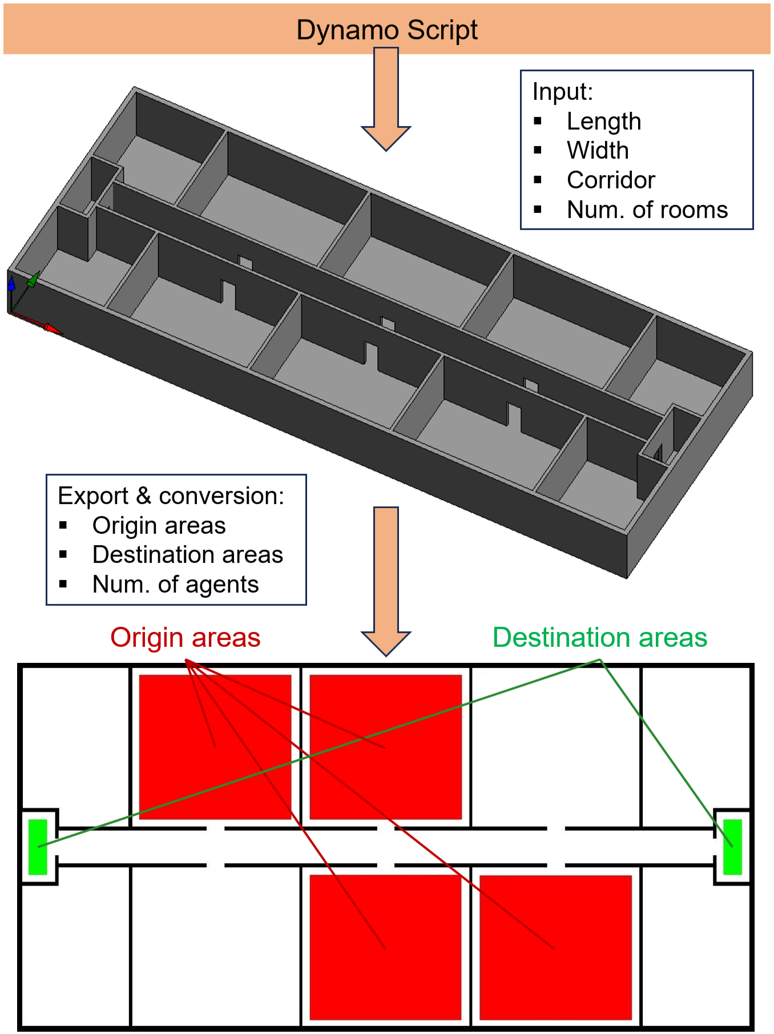
Figure 1: The office building prototype (top), based on a parametric BIM model (screenshot from Revit). To run pedestrian simulations, the floorplan must be exported and converted into simulator format, which is depicted at the bottom.

To generate training data, we conduct extensive evacuation simulations using the crowd:it simulator (accu:rate, 2025), which employs the OSM to compute agents’ locations across all timestamps.
We systematically vary four geometric input parameters: a) floorplan length, b) floorplan width, c) corridor width, and d) number of rooms per side. The simulator requires additional input parameters for dataset generation, including (a) the number and locations of origin areas, (b) the number and locations of destination areas, and (c) the initial agent count per origin. In total, the dataset encompasses 3,429 simulation results, with the corresponding parameter ranges summarized in Table 1.

Table 1: Overview of parameter ranges used to generate the dataset.
Type | Parameter | Range
Geometric | Length | [40, 45, 55] m
Geometric | Width | [20, 25, 30] m
Geometric | Corridor | [2, 3, 4] m
Geometric | Num. of rooms per side | [3, 4]
Simulation | Origins | [1 - 8]
Simulation | Destinations | [1, 2]
Simulation | Num. of agents per origin | [10, 20, 30]

For each simulation, polygon-shaped origin and destination areas are first defined. A fixed number of agents is then assigned to each origin. Prior to the first timestep, agents are initialized within their respective origin areas. The simulation proceeds sequentially, with agents moving toward their assigned destinations. When multiple destinations are available, each agent selects the nearest one. Notably, evacuation scenarios with only one active destination are also covered, representing blocked or inaccessible evacuation paths.

3.2 Floorplan Conversion into Graph
Before running the simulations, we define rules for converting floorplans into graph representations. The floorplan is first partitioned into cells, ensuring adaptability to various building layouts. Areas separated by doors are initially converted into subgraphs, which are later merged to form the final graph representation of the entire floorplan. Since rooms are typically rectangular, each subgraph is generated by dividing the room into a grid of rectangular cells based on a spatial granularity parameter SG. The number of cells along each axis is determined by dividing the room’s length by SG and rounding up, ensuring uniform cell sizes per room. Figure 2 illustrates a rectangular room with three different SG values and the resulting cell structures.

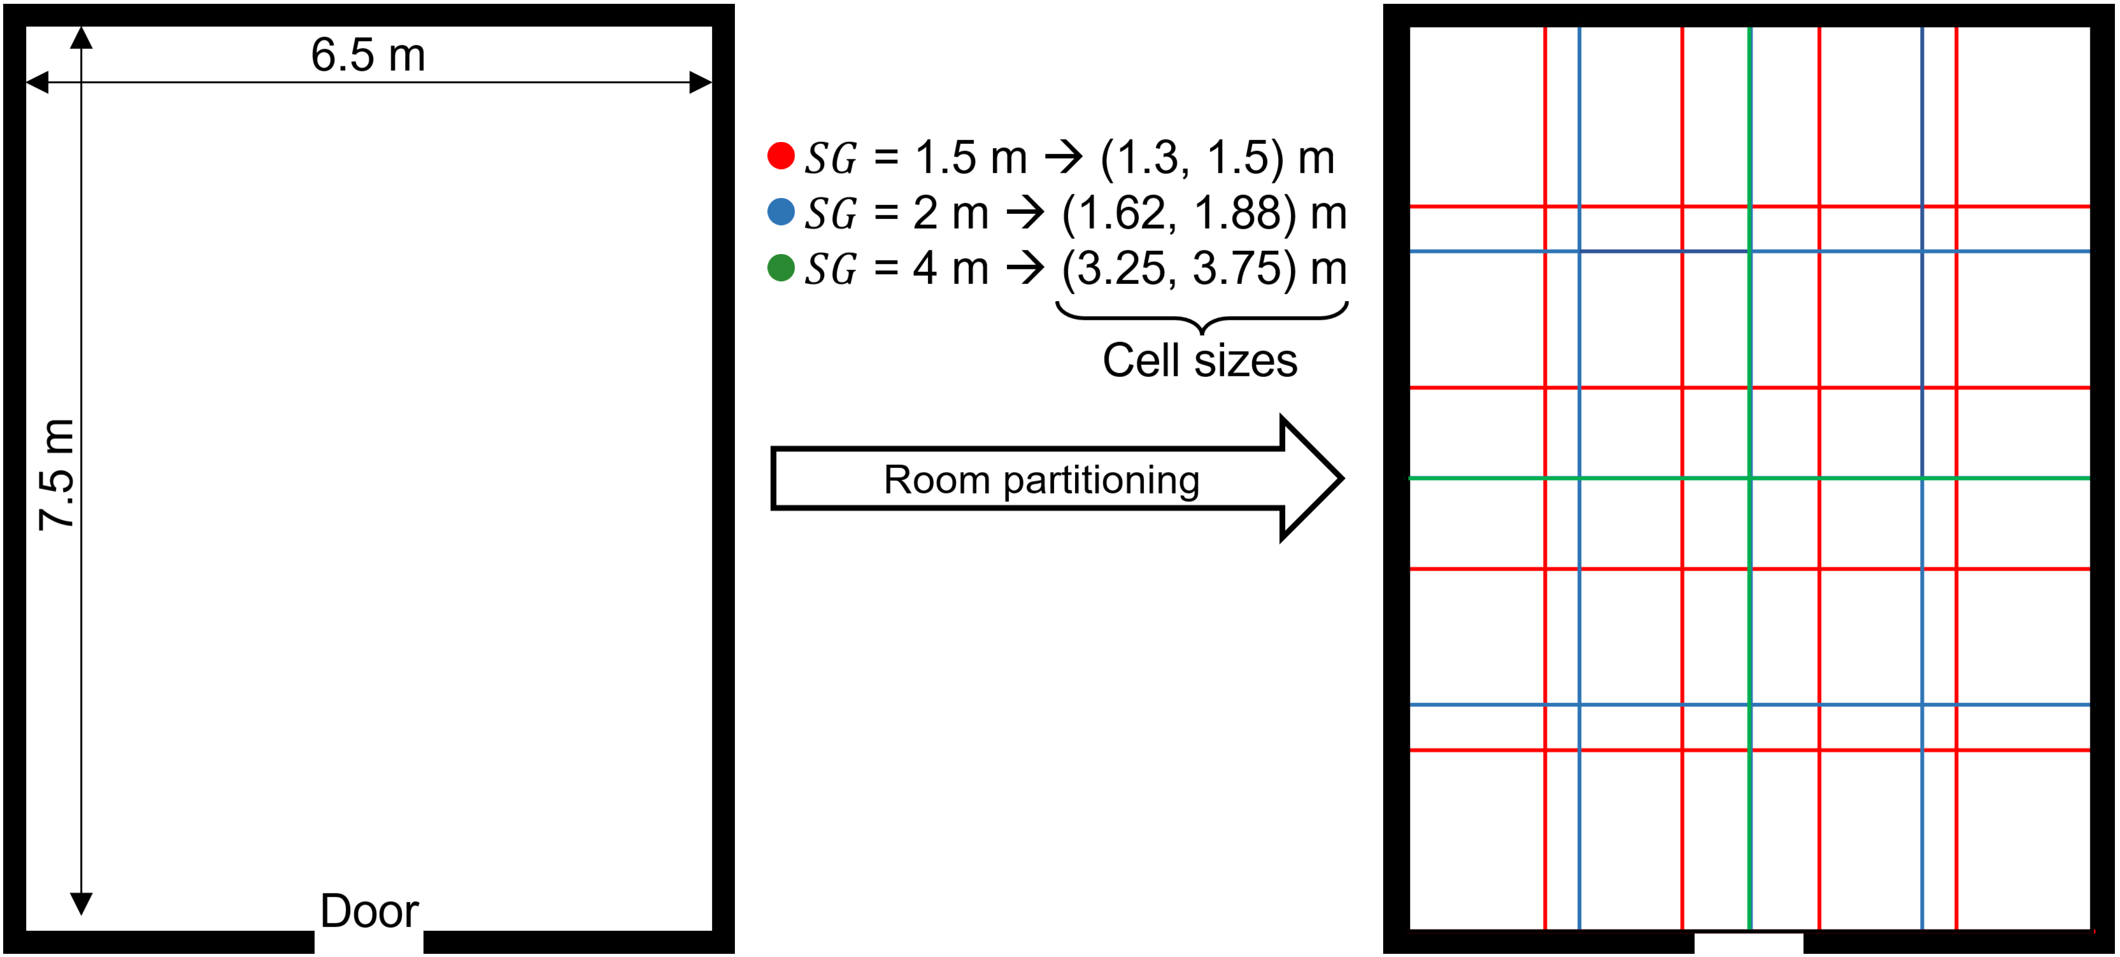
Figure 2: Room partitioning example for three different values of SG, including 1.5, 2 and 4 meters, which determines the number of cells per axis and the uniform cell sizes per room. Accordingly, lower values for SG lead to more cells, smaller cell sizes, and thus finer spatial granularity.

Each subgraph is constructed by placing a node at the centre of a cell. Nodes are connected if their corresponding cells are adjacent along the x- or y-axis, enabling the integration of subgraphs into a unified graph when rooms are linked by doorways. Once the spatial partitioning is applied, the graph structure is finalized. Figure 3 presents the floorplan from Figure 1, converted into a graph representation with SG set to 2 meters.
Each node is assigned features, including its position, type (i.e., "normal" or "destination" node), timestamp, and density value. Density is computed as the number of occupants per corresponding cell area over all timesteps. Furthermore, instead of using continuous density values, densities are discretized into four predefined classes according to Table 2. This classification aligns with the purpose of our GNN-based approach as an approximative tool, designed to highlight when and where critical overcrowding occurs rather than providing exact density measurements. By offering a rapid, interpretable assessment of evacuation safety, it supports building design decisions.
Moreover, edges are also assigned features that include the distance from the current node to the nearest destination node, edge length, overlap along the x- and y-axes between connected cells, and the positions of the connected nodes. As a result, node and edge features have dimensions of five and eight, respectively.

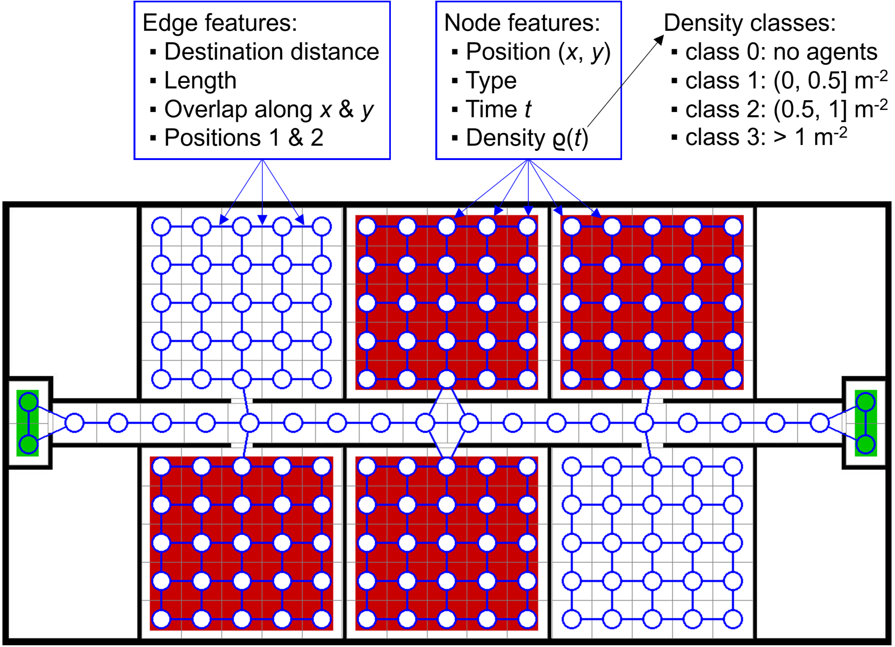
Figure 3: Floorplan conversion to a graph representation with SG set to 2 meters across all rooms (including the corridor). Notably, two subgraphs are connected when cells from different rooms overlap along x- or y-direction. In addition, node and edge features are listed, as well as the density thresholds that separate the four classes.

Table 2: Density class thresholds in terms of occupants per square meter (m⁻²).
Class | Description | Density values
0 | No occupants | 0 m⁻²
1 | Low density | ( 0, 0.5 ] m⁻²
2 | Medium density | ( 0.5, 1.0 ] m⁻²
3 | High density | > 1.0 m⁻²

Finally, to generate the dataset, simulations are conducted across numerous combinations of geometric and simulation parameters. During each simulation, agents within a cell’s boundaries are assigned to the corresponding node at each timestep, determining the node's density. Figure 4 illustrates the creation of the spatiotemporal evacuation graph, which serves as the ground truth for training the GNN.

3.3 Graph Neural Network
The spatiotemporal graph prediction is performed using a GNN. Training follows the practical use case in which the simulator receives an initial configuration – comprising the floorplan and simulation parameters – and generates the full simulation run. The same inputs are provided to the GNN in the form of the graph at first timestep, and the target timestamp additionally, to predict the corresponding node-wise density classes.
The proposed spatiotemporal GNN architecture, visualized in Figure 5, processes node and edge features through MLPs to encode feature information into higher-dimensional space (256). It then applies four consecutive layers, each comprising an Edge-featured Graph Attention (EGAT) module (Wang, et al., 2021) with four heads, GraphNorm and LeakyReLU (negative slope: 0.1). We employ EGAT specifically because it incorporates edge features in addition to node features and connectivity, unlike conventional graph convolution and graph attention. All network layers operate with a hidden dimension of 512. Finally, a prediction head performs per-node density classification.

4. EXPERIMENTAL EVALUATION
We evaluate the prediction of density classes in our spatiotemporal graph based on the results of neural network training and common classification metrics.

4.1 Neural Network Training
Our training process is based on splitting the dataset into 75% training set, 15% validation set and 10% test set. The corresponding parameters for our GNN are as follows: an initial learning rate of 6e-4, the Adam optimizer, and a learning rate scheduler that reduces the learning rate by a factor 0.75 on a validation loss plateau after 5 epochs.
To accomplish temporal predictions based on the initial crowd configuration, the GNN is provided with the target prediction timestamp, as well as the initial node density classes, and the remaining node and edge features (see Figure 5). The output is the predicted node-wise density scores corresponding to the specified timestamp.

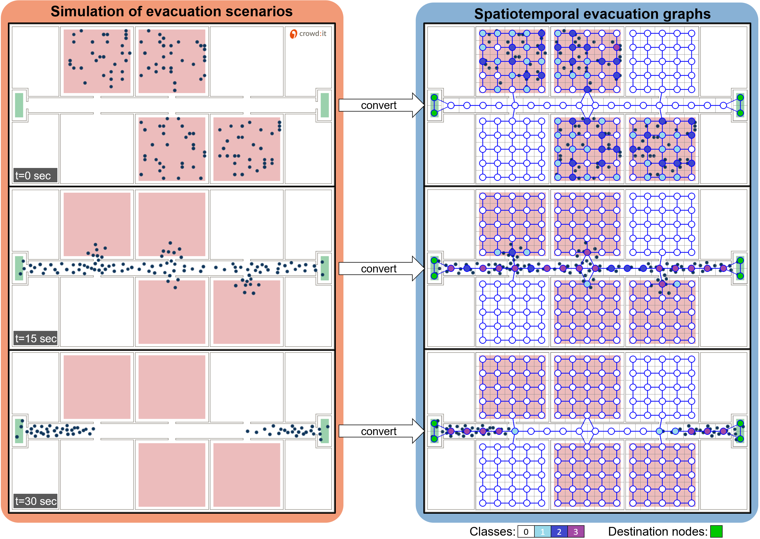
Figure 4: Conversion of the simulation result into a spatiotemporal graph, depicted at distinct timestamps. In each simulation step, an agent is assigned to a node if it is located within the node’s cell. The resulting cell’s density is converted into a class according to the aforementioned thresholds. The temporal propagation of densities within the graph throughout the simulation represents ground truth for training the GNN.
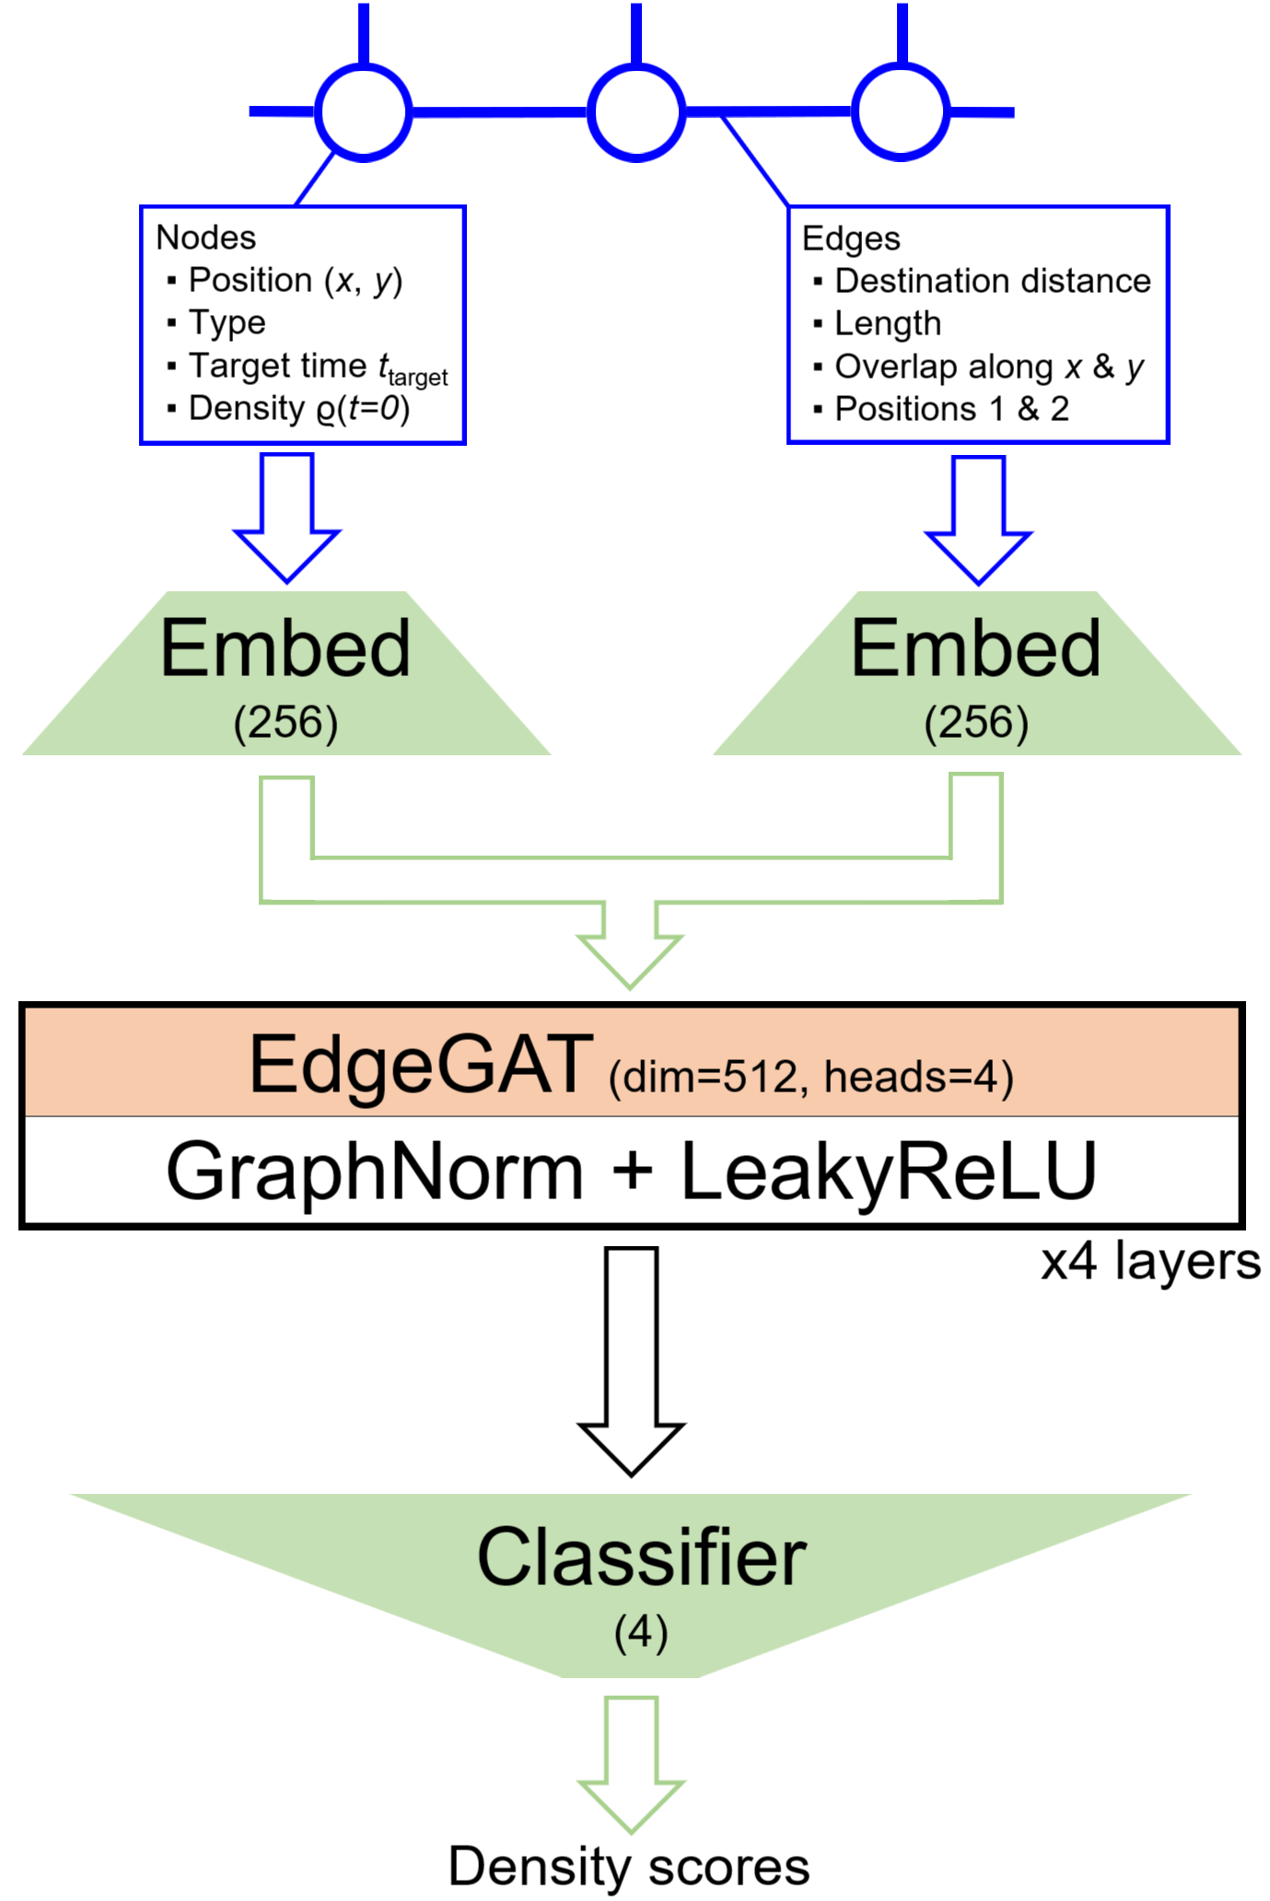
Figure 5: The architecture of the GNN, predicting the density classes across all nodes from node and edge features. After feature embeddings, we use two similar layers, each including EGAT and GraphTransformer modules, before the classification head predicts node-wise class scores.
We implement early stopping after 10 epochs if there is no improvement in validation loss. To address the significant class imbalance in our dataset, with class 0 dominating the others by a factor of approximately 10, we train our network using the Tversky Loss (Salehi, Erdogmus, & Gholipour, 2017) (TL):
TL = 1- TP / (TP + α∙FP + β∙FN) (1)
where the parameters α and β (both ≥ 0) control the trade-off between a false positive (FP) and a false negative (FN) detection. In our experiments, we systematically varied the parameters α and β within the TL function to explore the delicate trade-off between the prevalence of predictions for the dominant class and the accurate identification of minority classes. Adjusting these two parameters allowed us to fine-tune the model's sensitivity to FPs and FNs. Our optimal results were achieved by setting α=0.2 and β=0.8 to prioritize the detection of minority classes, penalizing FNs four times more.
Conversely, a traditional weighted cross-entropy loss function is also effective, allowing for the tuning of weights based on class prevalence. However, this approach has the drawback that all weights must be recalibrated whenever the dataset is expanded or when class thresholds are modified, resulting in the introduction of new classes or changes in class prevalence. In contrast, the TL function requires the adjustment of only two parameters, which represents a significant advantage in terms of flexibility and ease of adaptation to evolving datasets.
The results of the training process are plotted in Figure 6, with training and validation loss plotted over 46 epochs. Overfitting begins at epoch 35, where the validation loss starts to increase, and training is ultimately stopped after 10 epochs due to early stopping criterion.

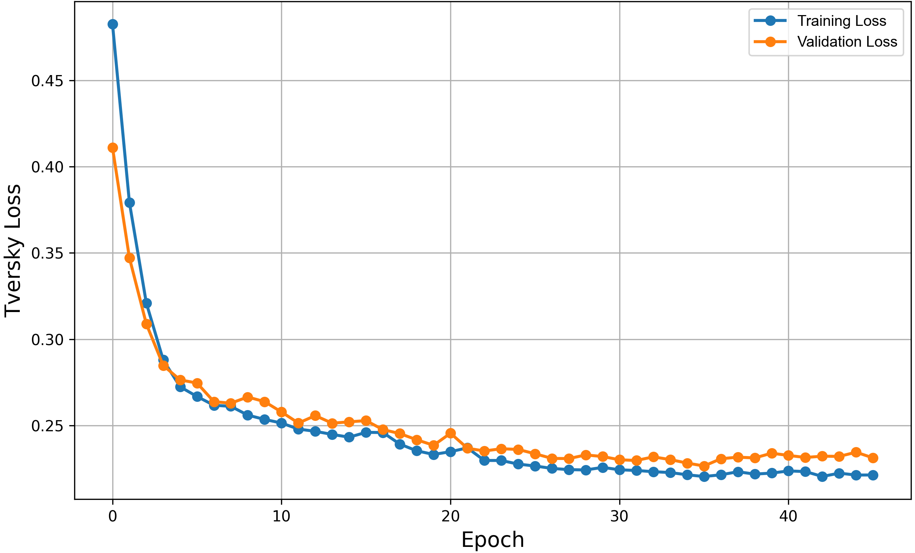
Figure 6: Training and validation curves of the Tversky loss for node-wise density classification across different timesteps.

4.2 Results
The results of the training process will be analysed by evaluating the best-performing model checkpoint, selected via the lowest validation loss, on the test set using classification metrics rather than the loss function. Accordingly, we present Recall, Precision, F1 score and the normalised confusion matrix in Figure 7 to assess performance.
Recall measures the proportion of actual positives correctly identified by the model and is calculated as True Positives (TPs) divided by the sum of TPs and FNs. Precision measures the proportion of predicted positives that are actual positives and is calculated as TPs divided by the sum of TPs and FPs. The F1 score balances precision and recall as their harmonic mean, calculated as 2 multiplied by the product of precision and recall divided by the sum of precision and recall. This metric is particularly useful for imbalanced datasets, where it provides a single score to evaluate trade-offs between FPs and FNs. Finally, the confusion matrix visualizes the distribution of class-wise predictions against true labels.
On the test set, we achieve the following class-wise performances, listed for classes 0 to 3 consecutively in Table 3. The confusion matrix is displayed in Figure 7, normalised row-wise by the true class.
Table 3: Results of highest performing GNN on the test set in terms of common classification metrics across all classes.
Class | Recall | Precision | F1 score
0 | 0.996 | 0.985 | 0.990
1 | 0.638 | 0.641 | 0.639
2 | 0.642 | 0.710 | 0.674
3 | 0.731 | 0.921 | 0.815

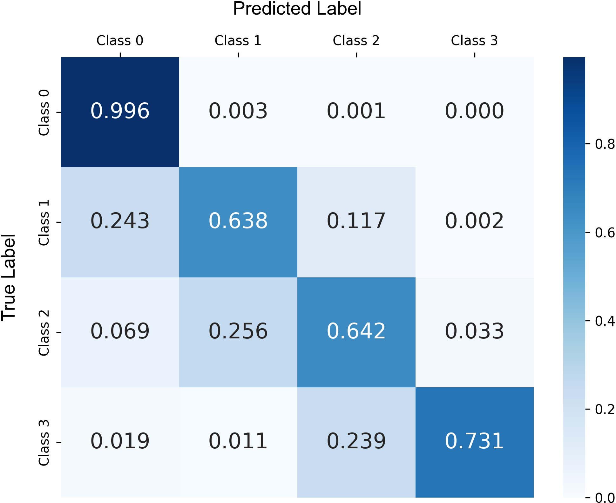
Figure 7: Results of highest performing GNN on the test set in terms of the confusion matrix, normalised row-wise by the true class.

Altogether, the results reveal a trade-off between precision and recall across classes. Class 0, which dominates the dataset, shows excellent performance with near-perfect recall (0.996) and strong precision (0.985), yielding a high F1 score (0.990). This indicates the model is highly effective at correctly identifying the majority class without excessively misclassifying other classes as class 0. Conversely, classes 1 – 3 results are promising, with both recall and precision generally in the 60–70% range. Specifically, class 1 achieves balanced recall and precision around 0.64, while class 2 shows slightly better precision (0.710) than recall (0.642), indicating the model is somewhat more conservative in assigning this label but relatively accurate when it does. Class 3 performs notably better, with a strong precision of 0.921 and recall of 0.731, resulting in the highest F1 score among the minority classes (0.815).
Critically, correctly identifying high-density cases (class 3) is the most important capability for assessing a building’s evacuation performance. In such cases, recall is more important than precision, as failing to detect a true class 3 instance, i.e. a high-density cell, is more costly than incorrectly predicting class 3. The model achieves a recall of 0.731, indicating it still misses around 26.9% of actual class 3 instances. Here, we found that fine-tuning the loss function with even higher FN penalties, by increasing β in the TL function, mainly leads to performance deterioration across all classes, suggesting that the model overcompensates and becomes less discriminative overall.
While these results are effective approximations of simulation results, future work may explore more targeted solutions, such as recall-oriented post-processing, or advanced neural network architectures and training algorithms, to improve sensitivity for minority classes without harming the overall balance.

5. CONCLUSION
This article presents a novel graph-based approach using GNNs to predict pedestrian movement in building evacuation scenarios. The research highlights the limitations of existing methods, such as agent-based modelling and physics-based simulations, which struggle with real-time adaptability. By leveraging a graph representation of spatial environments, the proposed GNN framework captures both local and global movement patterns on a macroscopic scale, offering a data-driven alternative that enhances practical applicability while approximating simulation results with sufficient accuracy. The model is trained on a spatiotemporal graph-based dataset derived from synthetic evacuation scenarios and a parametric BIM model, demonstrating its applicability to real-world use cases.
However, certain limitations persist. Firstly, the evaluation of our model happens solely on a single parametric design – namely the office building prototype. Since we employ deep learning, our model likely demonstrates a strong bias towards the training and validation data. Although synthetic data augmentation mitigates this issue to some extent, generalizing to real-world scenarios still necessitates further fine-tuning. Secondly, this study does not comprehensively assess the influence of heterogeneous pedestrian behaviours, such as panic-driven movement or individualized decision-making processes. Data-driven methods are currently constrained by the scarcity of real-world data needed to accurately model such behaviours, while synthetic data fails to capture the extensive complexity of human nature by utilizing handcrafted decision rules or potential functions that could realistically simulate them.
To address these limitations, we propose methodological enhancements, including dataset expansion and architectural improvements to the GNN to deal with much larger data volumes – potentially through more sophisticated architectures and upscaling learnable parameters. Future research should focus on integrating larger, more diverse datasets to enhance model robustness.
In conclusion, this study highlights the potential of GNNs for real-time pedestrian flow prediction in evacuation scenarios, overcoming key limitations of conventional methods. While challenges remain, the proposed methodology represents a significant advancement toward integrating data-driven techniques into safety analysis and building design.

ACKNOWLEDGEMENTS
This work has been funded by TUM Georg Nemetschek Institute – Artificial Intelligence for the Built World.

REFERENCES
accu:rate, 2025. crowd:it – the software for state-of-the-art planners. [Online] Available at: https://www.accu-rate.de/en/software/crowdit/ [Access on 01/04/2025].
Alahi, A. et al., 2016. Social LSTM: Human trajectory prediction in crowded spaces. Proceedings of the IEEE conference on computer vision and pattern recognition.
Berggold, P., Dugstad, A. & Hassaan, M., 2024. A Comparative Study of Deep Learning and Evac4BIM in Building Evacuation Design. Proceedings of 35. Forum Bauinformatik.
Berggold, P., Nousias, S., Dubey, R. K. & Borrmann, A., 2023. Towards predicting Pedestrian Evacuation Time and Density from Floorplans using a Vision Transformer. 30th Int. Conference on Intelligent Computing in Engineering.
Borrmann, A., König, M., Koch, C. & Beetz, J., 2018. Building Information Modeling: Why? What? How?: Technology Foundations and Industry Practice. Springer.
Clever, J., Abualdenien, J. & Borrmann, A., 2021. Deep learning approach for predicting pedestrian dynamics for transportation hubs in early design phases. EG-ICE Workshop on Intelligent Computing in Engineering.
Duives, D. C., Daamen, W. & Hoogendoorn, S. P., 2013. State-of-the-art crowd motion simulation models. Transportation research part C: emerging technologies.
Haghani, M. & Sarvi, M., 2018. Crowd behaviour and motion: Empirical methods. Transportation research part B: methodological, pp. 253-294.
Helbing, D., Buzna, L., Johansson, A. & Werner, T., 2005. Self-organized pedestrian crowd dynamics: Experiments, simulations, and design solutions. Transportation science.
Helbing, D. & Molnar, P., 1995. Social force model for pedestrian dynamics. Physical review E, 51(5), 4282..
Karbovskii, V. et al., 2021. Ensemble learning for large-scale crowd flow prediction. Engineering Applications of Artificial Intelligence.
Lerner, A., Chrysanthou, Y. & Lischinski, D., 2007. Crowds by example. In: Computer Graphics Forum, pp. 655-664.
Li, Z., Zhang, J. & Guan, H., 2024. Passenger spatiotemporal distribution prediction in airport terminals based on physics-guided spatio-temporal graph convolutional network and its effect on indoor environment prediction. Sustainable Cities and Society.
Mangalam, K. et al., 2020. It is not the journey but the destination: Endpoint conditioned trajectory prediction. Computer vision-ECCV 2020: 16th European conference.
Natapov, A., Parush, A., Laufer, L. & Fisher-Gewirtzman, D., 2022. Architectural features and indoor evacuation wayfinding: The starting point matters. Safety Science.
Pellegrini, S., Ess, A., Schindler, K. & van Gool, L., 2009. You'll never walk alone: Modeling social behavior for multi-target tracking. In: 2009 IEEE 12th International Conference on Computer Vision, pp. 261-268.
Salehi, S. S. M., Erdogmus, D. & Gholipour, A., 2017. Tversky loss function for image segmentation using 3D fully convolutional deep networks. Machine Learning in Medical Imaging: 8th International Workshop.
Seitz, M. J. & Köster, G., 2012. Natural discretization of pedestrian movement in continuous space. Physical Review E, 86(4):046108.
Shreya & Rajan, K., 2023. Modelling Evacuation Strategies Under Dynamic Conditions due to Obstacle Locations Based on a Semantic 3d Building Models. International Archives of the Photogrammetry, Remote Sensing and Spatial Information Sciences.
Siddiqui, A. et al., 2024. The birth of a new BIM Standard: from PED 2018 to 2023, new parameters and workflows" Going Live" for everyone. Collective Dynamics.
Sohn, S. S. et al., 2020. Laying the foundations of deep long-term crowd flow prediction. European Conference Computer Vision.
Testa, E., Barros, R. C. & Musse, S. R., 2019. Crowdest: a method for estimating (and not simulating) crowd evacuation parameters in generic environments. The Visual Computer.
Wang, Z., Chen, J. & Chen, H., 2021. EGAT: Edge-featured graph attention network. Artificial Neural Networks and Machine Learning-ICANN 2021: 30th International Conference on Artificial Neural Networks.
Yu, C. et al., 2020. Spatio-temporal graph transformer networks for pedestrian trajectory prediction. Computer Vision-ECCV 2020: 16th European Conference.

