Performance-Driven Development of Smart Building Envelopes for Retrofits
A method to assess the energy performance of smart building envelopes through simulation Drishya Jayakrishnan^{1*}, Saithaini Ithayaraaj^{1*}, Sujesh Sujan^{1,2,3}

¹ University of Liverpool, Liverpool, United Kingdom
² Norwegian University of Science and Technology, Trondheim, Norway
³ Mott MacDonald, London, United Kingdom
*Corresponding email: drishyajayakrishnan.7@gmail.com; saithaini@gmail.com

ABSTRACT
The built environment contributes to approximately 40% of carbon emissions, with existing building stock accounting for a significant portion of this total due to inefficient strategies for energy efficiency. This study investigates how a smart building envelope can be designed to improve energy performance in retrofit buildings. The study develops a reliable BIM-enabled workflow that integrates Building Information Modelling (BIM), Dynamo-based envelope controls, EPW weather data, and building energy simulation to evaluate adaptive envelope strategies for retrofit projects.
A research-by-design approach was combined with a systematic literature review to establish a knowledge base and inform the development of a prototypical retrofit testbed that incorporated simulation and scenario-based evaluation to assess alternative strategy performance, which translates findings into a workflow. The study followed key assumptions that include standard occupancy patterns and typical properties.
The study found that automation alone has a limited impact on energy performance, whereas the addition of a second-skin envelope can significantly improve thermal performance. The study demonstrates the potential of BIM-enabled adaptive envelope strategies to support effective retrofit decision-making.
A key gap identified is the absence of a standards-based BIM framework for evaluating and coordinating adaptive envelope strategies to improve the thermal performance of buildings. The findings highlight BIM’s potential in bridging the design and operation stages to achieve performance goals. However, the study has limitations, which include the use of a simplified prototypical unit, a lack of real-world application, and the absence of empirical validation. Future research should build on this work by testing the framework across various building types and integrating IoT monitoring to strengthen its practical relevance.
Overall, the research contributes to the industry by providing a scalable workflow and validated retrofit strategies.

- INTRODUCTION
Building stock accounts for approximately 40% of all carbon emissions and consumes 50% of the world’s raw materials (WorldGBC, 2024). A significant portion of this is impacted by the energy systems, which place considerable strain on the built sector and its energy infrastructure (Seghier et al., 2022). Retrofitting is therefore a crucial strategy to reduce environmental impacts while extending the operational lifespans of built assets, preventing demolition and reconstruction (He et al., 2021; Peiris et al., 2023).
The building envelope is central to the energy performance of the building by influencing the heating, cooling, and ventilation demands, while maintaining indoor environment quality and occupant comfort. Traditional retrofit approaches relied on passive strategies such as insulation, glazing, and materials to improve the envelope’s performance (G. Wang et al., 2024). Even minor envelope intervention in retrofit buildings can achieve 4% to 7% annual energy savings (Shari et al., 2023). However, integrating smart envelopes into retrofit workflows remains limited due to the lack of standardised BIM-based performance workflows and interoperable toolchains (D’Angelo et al., 2022). Although smart envelopes have been shown to improve a building’s energy performance, inconsistencies in modelling and simulation approaches hinder reliable performance assessment. Building Energy Modelling (BEM) addresses this by simulating energy demands and comfort behaviour using geometry, materials, and environmental data. In this study, Building Information Modelling (BIM) is used as a central information environment to coordinate the building geometry, performance data, and simulation workflows. Coupled with BEM, it enables an end-to-end framework where the envelope design, performance simulation, and control logic can be developed and evaluated within a common data structure.
The main aim of the research is to investigate how a smart building envelope can improve the energy performance of existing buildings. The research addresses two key questions: RQ1: How can a BIM-enabled workflow simulate and evaluate automated envelope and a second skin retrofit strategy? RQ2: What is the impact of an automated control system and a second skin on the thermal performance of existing buildings?

- LITERATURE REVIEW
2.1 Smart Building Envelopes and Retrofit Strategies
Smart building envelopes have evolved from traditional passive strategies to systems that are adaptive and responsive to the external environment. These include mechanical, material-based, and hybrid systems (Mohtashami et al., 2022; G. Wang et al., 2024). Smart Building Envelope integrates control systems, sensors, and automated decision-making to optimise the building’s energy performance (G. Wang et al., 2024).
In retrofitting, second-skin envelopes offer significant benefits over single-skin systems for achieving better performance based on the envelope’s configuration and climatic conditions. The air cavity in between acts as an insulating buffer where the heat is trapped during winter and enables controlled ventilation in summer, reducing both heating and cooling loads (Ahriz et al., 2022; Hou et al., 2021). Italos et al. (2022) further demonstrated a BIM-based retrofit project in Cyprus that combined a double-skin facade with building-integrated photovoltaics (BIPV) and achieved an 83.5% reduction in energy consumption. However, integrating retrofit strategies faces constraints such as structural limitations, cost sensitivity, and user disruption. The strategy of smart retrofitting requires balancing passive enhancements, active system upgrades, and practical implementation challenges (Peiris et al., 2023).

2.2 BIM Integrated Energy Modelling and Optimisation
A building envelope directly influences heating and cooling demands, thermal comfort, lighting, and ventilation (J. Wang et al., 2024). BIM enhances the performance potential by linking with Building Energy Modelling (BEM) to incorporate complex analytical capabilities within a shared data environment (Ciccozzi et al., 2023).
Despite BIM emerging as a transformative process, its adoption in retrofit remains less explored compared to new construction (Volk et al., 2014). Integration of BIM with BEM streamlines workflows for data collection, modelling, and analysis (D’Angelo et al., 2022). Yet, interoperability issues between formats like IFC and gbXML introduce risk of data loss and modelling errors (Alhammad et al., 2024). Previous studies demonstrate that BIM-enabled systems can result in comprehensive performance improvement in existing buildings. Yet, most BIM retrofitting focuses on static systems rather than adaptive and dynamic systems, which indicates an opportunity to integrate BIM with adaptive retrofit buildings.
2.3 Challenges and Research Gap
Implementation barriers remain in addressing institutional and regulatory constraints, building codes, standards, and procurement practices in alignment with the adoption of smart envelopes (Affonso et al., 2024). Lack of retrofit-specific level of information, details, performance benchmarks, and standards also create uncertainty in adoption (Kaashi and Vilventhan, 2023). While advancements in individual aspects such as BIM, retrofit, and smart envelope are rapidly advancing, a consistent workflow for evaluating the thermal performance of automated envelope and second-skin retrofit strategies is still lacking. This study addresses this gap through an integrated BIM-BEM workflow.

- METHODOLOGY
3.1 Research Framework
The study combines a methodological approach that integrates a targeted Systematic Literature Review (SLR) with keywords, “retrofit”, "smart building envelope”, "BIM”, "skin”, "envelope", "façade”, “prototype”, "energy efficiency", "indoor environmental quality" and "multi-objective optimisation”, with a Research-by-Design (RbD) methodology. The methodology follows an interconnected process where the SLR insights directly inform the prototype development, creating a dynamic research cycle that balances theoretical foundation and a practical, innovative approach. It links evidence-based investigation with performance-driven experimentation to evaluate how smart building envelopes can be integrated into a retrofit workflow through a BIM-enabled process. This enabled the study to have iterative experimentation through the development, simulation, and evaluation in consideration of multiple retrofit scenarios, while maintaining model assumptions and boundary conditions across the experiment.
  - Research by Design and Shoebox Modelling
A simplified shoebox office model was developed as a prototypical test model to isolate the influence of envelope variables of different retrofit envelope strategies while maintaining consistent boundary conditions. This approach also helps to maintain a consistent data schema by using shared parameters for thermal properties, control triggers, and material specifications (Dogan and Reinhart, 2013), while it holds advantages across parametric flexibility for aspects like geometry, glazing ratios, and envelope configurations.
Table 1: Scenario Overview
Scenario | Curtain Wall Window | Second Skin
1. Control model | Manual operation | None
2. Automated envelope | Automated operation | None
3. Automated second skin | Manual operation | Automated operation
4. Fully automated second skin | Automated operation | Automated operation
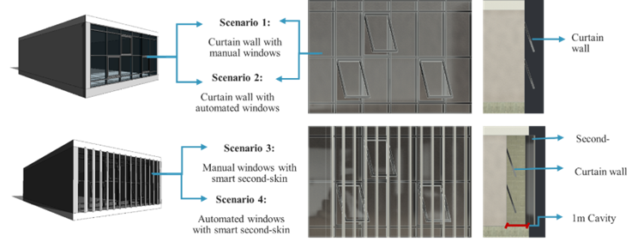
Figure 1: Shoebox model with scenario markings (Author)

The prototype represented a retrofit-compatible office unit and was developed in Autodesk Revit. To address the identified research gap in comparative evaluation, four scenarios (Figure 1) were developed as shown in Table 1. The control strategies focused on adaptive responses to the environmental conditions through rule-based operational schedules. The automated behaviours included operable window controls and second skin ventilation responses that were informed by the environmental conditions and occupancy assumptions.
3.2.1 Control Strategies for Automated Scenarios
In scenarios 2, 3, and 4, the envelope’s operation was controlled by a rule-based control strategy, modelled using Dynamo, within the BIM environment (Figure 2). This enabled the creation of parametric rules that could link the indoor and outdoor climatic conditions to the smart envelope, thereby embedding the control strategy directly into the digital building model.
For scenarios 2 and 4, the operable window was programmed to respond to thermal thresholds. Openings were activated when the indoor temperature exceeded a limit of 22°C and the outdoor temperature was within a comfort band of between 15°C and 25°C, which favours natural ventilation (Figure 2). Dynamo was selected for its direct integration with the Revit BIM environment and ability to adjust the parameters and implement rule-based relationships to operationalise the control logic with BIM models. OpenStudio and EnergyPlus were retained as the BEM environment to provide physics-based simulation of the resulting envelope configurations and operational schedules.
This implementation therefore demonstrates the integration and translation of adaptive control logic within a BIM-BEM workflow. Direct integration with optimisation frameworks or BIM-compatible environmental analysis tools could be explored in future work to increase automation and enable multi-objective optimisation. In scenarios 3 and 4, the same logic was applied to the additional external shading device, the second skin. This second skin was deployed when the outdoor air temperature was at least 2°C cooler than cavity air in summer. During winter, based on the temperature, the second skin remained shut, which allowed the trapped solar heat in the cavity to act as a buffer zone, reducing conductive heat loss from the interior.
As the energy simulation engine, EnergyPlus, cannot directly accommodate real-time, fully dynamic adaptive behaviour, a translation step was required. Within the BIM environment, Dynamo scripts were used to calculate the window and second skin opening degrees as a function of the indoor- outdoor temperature relationships; these values were exported into Excel, where they were processed into normalised opening ratios suitable for simulation input (Figure 2).
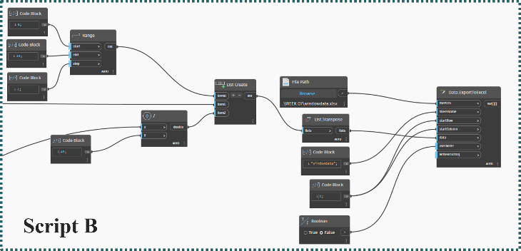
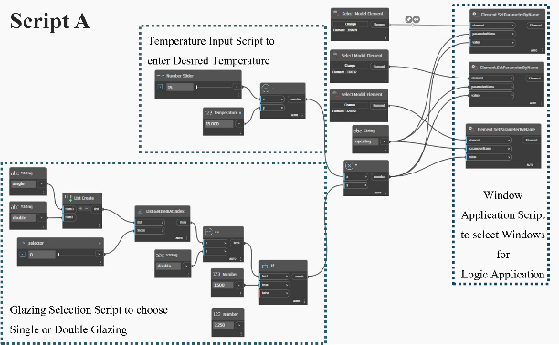
To ensure applicability to the macro-micro experiment’s climatic context, these ratios were cross-referenced with the EPW weather file to generate a typical average daily profile for winter and summer (Figure 3). From this, an opening schedule was generated for scenarios 2, 3 and 4 and then subsequently embedded into the BEM.
Figure 2: Script A- Responsive control for window from Dynamo and Script B - Calculating adaptive window and second skin opening ratios (Author)
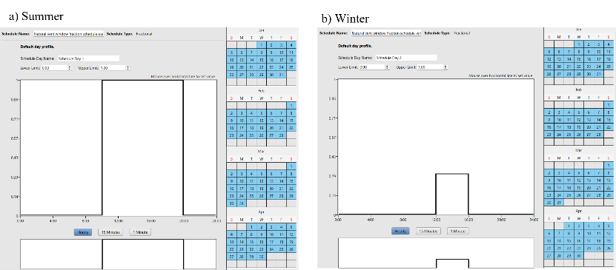
This process helps to highlight a key contribution of BIM in smart envelope research, as it enables the configuration of the environment-based control strategy directly within the digital model, provides a structured pathway for translating design rules into BEM-compatible inputs, and automates a process that would otherwise be manual and error-prone. As such, BIM serves not only as a geometric data environment but also as an intelligent intermediary that links smart envelope design intentions to simulation-based performance evaluation.
Figure 3: Average daily opening profile for windows a) summer b) winter
    - Macro and Micro Perspectives (Annual and Weekly)
The design approach was structured across macro and micro perspectives to evaluate both long term performance behaviour and short-term climatic responsiveness. At the macro perspective, this study is contextualised for the London climatic conditions to evaluate the long-term operational behaviour across all four scenarios over a full annual cycle. The micro perspective evaluated a short-term weekly performance across the contrasting climatic conditions in London, Stockholm and Abu Dhabi. Representative summer and winter weeks were simulated to evaluate the adaptability and responsiveness of the envelope control strategies under varying climatic conditions. This enabled the assessment of transferability and operational stability across the different environmental contexts.
3.2.3 Simulation Configuration and Envelope Parameters
Simulations for this research were carried out using Autodesk Revit 2025, Dynamo 3.x, OpenStudio 1.8, and EnergyPlus 24.1. The integration of the embedded BIM parameters, automated control schedules, and gbXML-based transfers ensures traceability between the design intent and simulation output. The thermal and optical properties of the envelope elements were stored within the BIM environment to ensure automatic transfer during the model export.
A constant window-to-wall ratio (WWR) of 85% was applied on the south façade of the unit for all scenarios. The thermal and optical properties of the envelope elements were stored within the BIM environment to ensure automatic transfer during the model export. The values used in the simulation are listed below in Table 2. The envelope properties were maintained consistently to isolate the effect of the smart adaptive envelope strategies. The second skin in scenarios 3 and 4 was modelled with a 1 m naturally ventilated cavity and external operable shading that is automated in response to real-time climatic conditions.
Operational schedules and internal gain assumptions were implemented for the project in accordance with the CIBSE Guide A for an office environment (CIBSE, 2015). Occupancy density was modelled at 1 person per 10m2, with operational hours assigned as 08:00 to 20:00 on weekdays. Equipment loads and lighting were assigned to a small office unit category within EnergyPlus. An ideal load system was used for the simulation to isolate the impact of the envelope system from the HVAC system performance.
ELEMENT | U-VALUE | NOTES
Glazing | 1.99 W/m²·K | Double-glazed curtain wall
Wall | 3.49 W/m²·K | Poor insulation, common in retrofit scenarios
Roof | 0.22 W/m²·K | -
Floor slab | 0.12 W/m²·K | -
Second skin (sc. 3 & 4) | - | Ventilated cavity with operable panels
Table 2: Thermal performance summary of the model (Author)
3.2.4 Performance Indicators
The performance indicators were selected to assess both the energy performance and thermal conditions of the retrofit scenarios. The primary indicators comprised annual and monthly heating energy demand (kWh), annual and monthly cooling energy demand (kWh), Indoor operative temperature (°C), and Air changes per hour (ACH).

4 RESULTS AND DISCUSSION
The reviewed studies highlighted a gap in developing integrated BIM-BEM workflows capable of linking the model, control logic, simulation, and operational performance value. The developed prototype and the integrated toolchain addressed this gap through a coordinated workflow that enabled a simulation-driven evaluation of the adaptive retrofit envelope strategies.
4.1 Macro Perspective Results: Annual and Monthly Analysis
The macro analysis evaluated the annual and monthly operational behaviour of all four scenarios under London climatic conditions. The control model exhibited high demand during the winter months and peak cooling during the summer periods. Scenario 2, which introduced an automated window operation, showed only a marginal difference from the control case, indicating that automation alone has limited influence on the overall energy performance. In contrast to this, scenarios 3 and 4, which incorporated the second skin envelope, demonstrated a substantial reduction in heating and cooling demands, achieving approximately 26-28% annual reduction when compared to the control model. Peak summer cooling demands were also reduced by approximately 6.5%, although a slight increase in the value occurred during the transitional months. Overall, the annual cooling energy demand for scenarios 3 and 4 was 13% higher than the control, which illustrates a complex interaction between thermal insulation, shading and heat accumulation (Figure 4).
The operative temperature analysis further showed that scenarios 3 and 4 have maintained a more stable indoor thermal condition throughout the year. Similarly, air change rates have increased significantly in the second skin scenarios, which demonstrates an enhanced ventilation potential while maintaining thermal comfort. Importantly, these results were derived from a BIM-based control strategy in Dynamo and translated into EnergyPlus-compatible operational profiles, ensuring interoperability and repeatability between BIM and BEM.
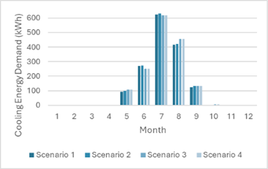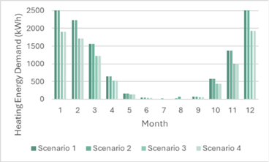
Figure 4: Monthly Cooling Energy Demand and Monthly Heating Energy Demand Comparison (kWh)
4.2 Micro Perspective Results: Weekly Analysis Across Climates
To conduct the micro analysis, a representative week in winter and summer was simulated for three cities, London, Abu Dhabi, and Stockholm. During the winter week, cooling demand was negligible in London and Stockholm, while Abu Dhabi exhibited moderate demand due to its milder conditions. The heating demand was high in London and Stockholm for the control, and negligible in Abu Dhabi. Scenario 2 demonstrated minor changes, while scenarios 3 and 4 reduced winter heating energy demand by 25% in London and Stockholm and cooling demand in Abu Dhabi by 26%, confirming the insulating effect of the smart second skin envelope as observed during the macro analysis. These scenarios also significantly increased the air change rate across all the cities with slightly lower operative temperatures in the cold climates, enhancing the indoor comfort.
During the summer week, cooling demand peaked in London, was high in Abu Dhabi and moderate in Stockholm. Again, scenario 2 showed negligible improvements in comparison to the control, while scenarios 3 and 4 reduced cooling demand by 6-14%, which maintained stable indoor temperatures. Air change rates in second skin scenarios remained substantially higher than the control, which indicated the enhanced ventilation potential across cross climates (Figure 5).
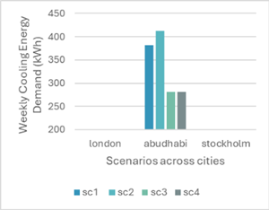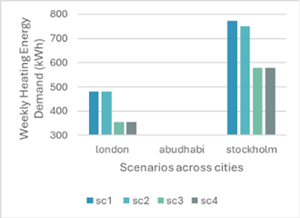
Figure 5: Winter Weekly Cooling Energy Demand (kWh) and Winter Weekly Heating Energy Demand (kWh)
4.3 BIM-BEM Workflow Implications
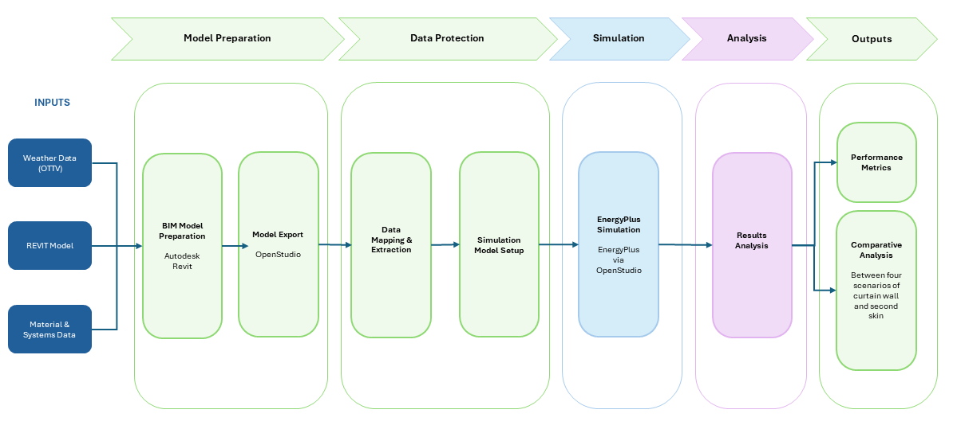
The developed workflow (Figure 6) was implemented during the study to integrate data collection and simulation within the BIM environment. Revit functioned as the central information environment for geometry, envelope properties, operational schedules, and the shared parameters, while Dynamo embedded the adaptive control logic directly within the BIM model. The developed workflow (Figure 6) was implemented during the study to integrate data collection and simulation within the BIM environment.
Figure 6: BIM Integrated Workflow (Author)
The workflow followed a structured sequence beginning with the retrofit data collection and the BIM model preparation within Revit, which is then stored in a cloud-based central repository to ensure accessibility and consistency. The model was then prepared for simulation through gbXML export into OpenStudio and EnergyPlus, enabling the transfer of properties and schedules into the BEM environment. Adaptive control strategies were parallelly translated into simulation-ready schedules using Dynamo-generated opening ratios and EPW climatic data. This allowed the environmental response to be incorporated into the annual, monthly, and weekly simulations. The simulation stage evaluated the performance indicators across all scenarios and climates.
Finally, the simulation outputs are to be fed back into the BIM environment for comparative evaluation and monitoring, which creates a coordinated feedback loop between the design parameters and the performance outcomes. This process improves the interoperability between the BIM and BEM platforms while reducing the repetitive manual data handling. The workflow demonstrates how BIM can extend beyond static modelling to support coordinated simulation, environmental monitoring and operational decision-making. It establishes a repeatable framework for evaluating retrofit envelope strategies, while from a monitoring perspective, it provides a structured pathway for integrating adaptive control logic and environmental performance data within a unified lifecycle-oriented information model.

- CONCLUSION
This research demonstrates how Building Information Modelling (BIM) can extend beyond static modelling to serve as an integrated platform for adaptive building envelope simulation and control strategies in retrofit contexts. By combining SLR with scenario-based prototype testing, the study developed a BIM-based workflow that links modelling, simulation and control logic into a reproducible and interoperable framework. The results demonstrated that automation alone offers only a limited performance improvement, whereas a second skin envelope can significantly reduce heating demand, moderate the cooling loads and improve the ventilation performance, and stabilise the indoor operative temperatures.
The research also demonstrates the role of BIM as more than a geometric modelling platform. BIM was demonstrated as a central information environment for coordinating energy modelling, simulation workflows, and thermal performance evaluation within a retrofit context. The workflow overall contributes as a reproducible and interoperable framework for evaluating adaptive envelope strategies during early-stage retrofit decision-making.
5.1 Future Recommendations and Study Limitations
The study was limited to a simplified shoebox office model and a simulation-based validation rather than empirical validation. The control thresholds were also established as rule-based prototype parameters informed by thermal comfort and natural ventilation considerations, without a formal sensitivity analysis of alternative threshold values. Future research should extend the study to a real-world case study and incorporate IoT-enabled monitoring systems for practical validation of the operational performance. The study should be undertaken across multiple building typologies to evaluate the transferability of the workflow under varying occupancy patterns, operational schedules and climatic conditions. It should also investigate integrating live sensor data for real-time adaptive control and Building Management systems to compare simulated and operational performance.

REFERENCES
Ahriz, A., Mesloub, A., Djeffal, L., Alsolami, B.M., Ghosh, A., Abdelhafez, M.H.H., 2022. The Use of Double-Skin Façades to Improve the Energy Consumption of High-Rise Office Buildings in a Mediterranean Climate (Csa). Sustainability 14, 6004. https://doi.org/10.3390/su14106004
Alhammad, M., Eames, M., Vinai, R., 2024. Enhancing Building Energy Efficiency through Building Information Modeling (BIM) and Building Energy Modeling (BEM) Integration: A Systematic Review. Buildings 14, 581. https://doi.org/10.3390/buildings14030581
CIBSE, 2015. Environmental design, [New ed.]. ed. CIBSE, London.
Ciccozzi, A., De Rubeis, T., Paoletti, D., Ambrosini, D., 2023. BIM to BEM for Building Energy Analysis: A Review of Interoperability Strategies. Energies 16, 7845. https://doi.org/10.3390/en16237845
D’Angelo, L., Hajdukiewicz, M., Seri, F., Keane, M.M., 2022. A novel BIM-based process workflow for building retrofit. Journal of Building Engineering 50, 104163. https://doi.org/10.1016/j.jobe.2022.104163
Dogan, T., Reinhart, C., 2013. Automated Conversion Of Architectural Massing Models Into Thermal ‘shoebox’ Models. Presented at the 2017 Building Simulation Conference. https://doi.org/10.26868/25222708.2013.1123
He, Q., Hossain, Md.U., Ng, S.T., Augenbroe, G., 2021. Identifying practical sustainable retrofit measures for existing high-rise residential buildings in various climate zones through an integrated energy-cost model. Renewable and Sustainable Energy Reviews 151, 111578. https://doi.org/10.1016/j.rser.2021.111578
Hou, K., Li, S., Wang, H., 2021. Simulation and experimental verification of energy saving effect of passive preheating natural ventilation double skin façade. Energy Exploration & Exploitation 39, 464–487. https://doi.org/10.1177/0144598720956288
Italos, C., Patsias, M., Yiangou, A., Stavrinou, S., Vassiliades, C., 2022. Use of double skin façade with building integrated solar systems for an energy renovation of an existing building in Limassol, Cyprus: Energy performance analysis. Energy Reports 8, 15144–15161. https://doi.org/10.1016/j.egyr.2022.11.088
Kaashi, S., Vilventhan, A., 2023. Development of a building information modelling based decision-making framework for green retrofitting of existing buildings. Journal of Building Engineering 80, 108128. https://doi.org/10.1016/j.jobe.2023.108128
Mohtashami, N., Fuchs, N., Fotopoulou, M., Drosatos, P., Streblow, R., Osterhage, T., Müller, D., 2022. State of the Art of Technologies in Adaptive Dynamic Building Envelopes (ADBEs). Energies 15, 829. https://doi.org/10.3390/en15030829
Peiris, S., Lai, J.H.K., Kumaraswamy, M.M., Hou, H. (Cynthia), 2023. Smart retrofitting for existing buildings: State of the art and future research directions. Journal of Building Engineering 76, 107354. https://doi.org/10.1016/j.jobe.2023.107354
Seghier, T.E., Lim, Y.-W., Harun, M.F., Ahmad, M.H., Samah, A.A., Majid, H.A., 2022. BIM-based retrofit method (RBIM) for building envelope thermal performance optimization. Energy and Buildings 256, 111693. https://doi.org/10.1016/j.enbuild.2021.111693
Shari, Z., Mohamad, N.L., Dahlan, N.D., 2023. BUILDING ENVELOPE RETROFIT FOR ENERGY SAVINGS IN MALAYSIAN GOVERNMENT HIGH-RISE OFFICES: A CALIBRATED ENERGY SIMULATION. Jurnal Teknologi 85, 1–15. https://doi.org/10.11113/jurnalteknologi.v85.15124
Volk, R., Stengel, J., Schultmann, F., 2014. Building Information Modeling (BIM) for existing buildings — Literature review and future needs. Automation in Construction 38, 109–127. https://doi.org/10.1016/j.autcon.2013.10.023
Wang, G., Fang, J., Yan, C., Huang, D., Hu, K., Zhou, K., 2024. Advancements in smart building envelopes: A comprehensive review. Energy and Buildings 312, 114190. https://doi.org/10.1016/j.enbuild.2024.114190
Wang, J., Li, G., Zhao, D., 2024. Multi-objective optimization of an anti-reflection AlN/VO2/AlN thermochromic window for building energy saving. Energy 288, 129798. https://doi.org/10.1016/j.energy.2023.129798

