semio: Large-Language-Model-based Building-Information-Model Alignment for Automatic-Compliance-Checking
Towards Closing the Gap between Model Authoring and Model Checking for Kit-of-Parts Architecture
UELI SALUZ¹ ILDAR BAIMURATOV¹ PHILIPP GEYER¹

¹ Leibniz University Hannover, Hannover, Germany

ABSTRACT:

Designing regulation compliant buildings is challenging. An iterative design process involving architects and experts is vital. On the design side, many authoring frameworks have been developed to enable a flexible design process. On the constraint side, many rule-based frameworks have been developed for Automated-Compliance-Checking (ACC). A general explicit algorithmic translation from authoring to constraint formats is rarely possible. An additional framework expert is needed, which limits ACC. Closing the gap between model authoring and model checking with automated model alignment is crucial. While black-box Large-Language-Models (LLMs) struggle with knowledge-intensive tasks, they are powerful in loosely instructed conversion tasks. The opposite holds for white-box symbolic reasoning frameworks such as Web-Ontology-Language (OWL). We propose to use a Chain-of-Thought (CoT) based model alignment from authoring to constraint formats. Minimizing the Framework-Expert-In-The-Loop. A Kits-of-Parts (KoP) test-case with fire safety constraints demonstrates that LLMs are capable of reasoning to align designs with regulations, enabling ACC.

KEYWORDS:

information alignment, reasoning, artificial intelligence, modular architecture, semantic web

1. INTRODUCTION
The process of verifying whether a building meets regulations is known as compliance checking. Since more than half a century researcher have tried to solve the problem of Automated-Compliance-Checking (ACC). ACC consists of three parts:
- Compliance Framework. A general framework that is expressive enough to formalize constraints (numeric, quantitative and relational) to model the compliance code.
- Formalized codes. A formal translation of the compliance codes according to the underlying compliance framework.
- Aligned Input. An aligned structured input with the necessary information which is either directly the model or derived from the model for the compliance framework to check.
In research, there is an ACC experiment for nearly every domain-specific and general-purpose framework such as shown in Table 1. Especially frameworks out of the semantic web technology stack on Resource Description Framework (RDF) are exhaustively tested. Industry Foundation Classes (IFC) which is the industry standard for exchanging Building Information Modeling (BIM) models dominates as input format. One of the goals of the Information Delivery Specification (IDS) is ACC.

Table 1. Frameworks used for ACC
Name | Input
Web Ontology Language (OWL) | RDF
Shapes Constraint Language (SHACL) | RDF
SPARQL Protocol and RDF Query Language (SPARQL) | RDF
Semantic Web Rule Language (SWRL) | RDF
Notation 3 Logic (N3Logic | RDF
Legal Knowledge Interchange Format (LKIF) | RDF
Legal Document Markup Language (LegalDocML) | RDF
Akomo Ntso | RDF
Rule Markup Language (RuleML) | RDF
Legal Rule Markup Language (LegalRuleML) | RDF
Requirement Applicability Selection Exceptions (RASE) | RDF
Solibri | IFC
BIMTester | IFC
IfcOpenShell | IFC
xbim toolkit | IFC
Web IFC | IFC
Open Building Information Modeling Rule Language (OpenBimRL) | IFC
Visual Code Checking Language (VCCL) | IFC
Gherkin | Custom
Decision Model and Notation (DMN) | Custom
Building Information Modeling Rule Language (BIMRL) | Custom
Building Information Modeling Query Language (BIMQL) | Custom
Query Language for Building Information Modeling (Q4BIM) | Custom
Building Environment Rule and Analysis Language (BERA) | Custom
Prolog | Custom
Datalog | Custom
SQL | Custom
Python | Custom
… | …

In practice, designs are modeled in platforms such as ArchiCAD, Rhino with Grasshopper, Revit with Dynamo, AutoCAD, Vectorworks, SketchUp, BricsCAD, Blender with Bonsai and Sverchok, FreeCAD, 3ds Max, CityEngine, Hypar, Spline, semio or other specific tools. Some have IFC export capabilities, but the quality differs greatly. The Model View Definitions (MVDs) are not consistent and out-of-the-box ACC is not possible. Hence, ACC in the early design phase is very rare, despite being the phase with the largest impact.
Out of all the frameworks, the proprietary model checker Solibri has been dominating the market. Both as standalone and integrated as Design Checker in ArchiCAD. Most local competitors such as Fornax (Singapore), DesignCheck (Australia), SMARTCodes (United States) have stopped business.
Besides the issue of formalizability of the compliance codes, the main practical problem for the designers is how to align the authoring format with the constraint format. There are two approaches:
- Single Model. A single format (open or closed) is used as a single-source-of-truth. This model can be federated (e.g according to domains) if it can be merged.
- Model Islands. Multiple formats (e.g. one per software) which are usually semi-automatically converted and enriched with the necessary information.
Regardless, if the Single Model approach is chosen e.g. with IFC along with features such as MVD to enable structurally differentiated views and representations of the same design, or if the Model Islands approach is chosen, information alignment is necessary.
Aligning information, such as merging multiple rooms into one usage unit and summing up the floor areas, is usually not intrinsically complicated but requires both design-specific and code-specific reasoning. Despite the low complexity, the process often requires both designers and experts in the loop because classical algorithms don’t have general reasoning capabilities.
The more intricated part on the other hand is compliance checking, which goes logically much deeper; but unlike the alignment process, it is not design-specific. Hence can be solved and validated algorithmically.
The objective of the research presented in this paper is to develop a method to perform this alignment automatically based on LLMs. The core is the transformation of a representation of a design used in model authoring to a representation for model checking enriched with all the information required for checking. On this basis, we will demonstrate how a design test case defined by a custom representation can be checked against standard building code translated to a formal representation on which we perform ACC. The alignment not only allows ACC of arbitrary design representation but enables future design assistance to use the violation report obtained from ACC as an input for automated LLM-based Design Space Exploration towards a code-compliant generated solution.

2. RELATED WORK

2.1 Model checking
A good overview on ACC is provided by (Amor, R., & Dimyadi, J., 2021). The following experiments show different capabilities of individual frameworks. A German research project MBO2BIM compared existing approaches such as IDS and concluded that no current framework is sufficient for complete ACC of the German Model Building Code (Musterbauordnung). The authors of this project develop OpenBimRL (Becker, F. M., & Napps, D., 2024). (Hjelseth, E., & Nisbet, N., 2011) use RASE to annotate US Court design guidance documents and perform user-driven model checking. (Schwabe, K., et al. 2019) write Drools rules supported by domain experts to check the geometry compliance. (Zadeh, P. A., et al., 2019) use Datalog as a schema-mapping language to represent conjunctive queries. (Li, Y., et al., 2023) apply Prolog for non-monotonic reasoning about real-world buildings. (Solihin, W., & Eastman, C., 2016) compare a SQL-based and graph-based representation for BIMRL. (Dimyadi, J., Governatori, G., & Amor, R., 2017) apply LKIF rules to Akoma Ntoso focusing on regulations semantics and logical content.
Several ontologies exist to validate building compliance. The Building Assessment Ontology (BAO) provides a semantic description of building codes, standards, certification schemes, and regulations for performance assessment. The Compliance-Management-Ontology (CoMOn) (Abdullah, N. S., Indulska, M., & Sadiq, S., 2016) shares the conceptualization for research and practice in compliance management. (Pauwels, P., et al., 2011) tackle the 3D information conversion problem with N3Logic. (Stolk, S., & McGlinn, K., 2020) use SHACL to validate doors in ifcOWL models. (Senthilvel, M., Beetz, J., 2020) use SPARQL Inferencing Notation (SPIN) and SHACL to validate a wall in FreeCAD. (Beach, T. H., et al., 2015) apply SWRL rules to construction. The Construction Quality Inspection and Evaluation Ontology (CQIE) models regulations in SWRL rules for construction quality inspection and evaluation. (Fuchs, S., et al., 2024) examine the automatic translation of regulations into the LegalRuleML language with transformer models. More ontologies can be found in Automated Compliance Checks for Construction Renovation or Demolition Works (ACCORD). Our presented approach is directly applicable to any OWL-based ontology for ACC.

2.2. Model Alignment
Most research regarding BIM alignment has been pursued for IFC models. The buildingSMART Data Dictionary (bSDD) serves to facilitate the matching of regulatory concepts to their corresponding IFC concepts. But this approach requires intensive manual effort and is difficult to generalize. Alternatively, (Zhang & El-Gohary, 2017) developed a rule-based transformation algorithm to align BIM data with regulations represented in Prolog. However, rule-based algorithms have limited scalability. There are works that facilitate the alignment process with ML techniques. For example, (Zhou & El-Gohary, 2021) and (Zheng et al. 2022) implemented information alignment utilizing similarity search. Later, (Zhang & El-Gohary, 2023) proposed a transformer-based method to align natural-language regulations with the IFC concepts. (Patlakas et al., 2024) implemented ACC with SHACL and used open-source solvers to enrich the IFC model. The closest to our study is the work by (Chen et al., 2024), where the authors utilized a combination of an LLM and Deep Learning to extract information from regulations and a rule-based algorithm to construct SPARQL queries, however IFC data were transformed into RDF format using a predefined mapping. Thus, existing works do not focus on ACC with OWL reasoning and data alignment with LLMs, relying instead on less expressive representations and manual mappings, custom software or deep learning models for information alignment.

3. METHODOLOGY
We propose a system consisting of three parts:
- Semantic Representation. The authoring format needs to be sufficiently semantically represented for the pre-trained LLM to be able to understand, reason and align the formats.
- Iterative Alignment. To enhance the aligning capabilities of the LLM and not just perform the default simple model mapping strategies between structured formats, the LLM needs to be invoked iteratively until a reasonable mapping strategy is found.
- Code Representation. The output of the alignment is a representation that utilizes classes and properties from the regulations, which are directly fed into the ACC framework to test the compliance.
As authoring tool, we chose semio which directly represents the design semantically. As constraint framework we chose OWL due to its inferencing capability and explainability. To achieve the alignment with reasoning we chose Chain-of-Thought (CoT) and One-Shot-Prompting.
We follow the methodology described in (Baimuratov, I. & Turygin, D., 2025) and formalize regulations with OWL DL. The regulations are split into two parts that can be referred to as a subject and a requirement. They are modeled as OWL classes with class restrictions that can be processed by OWL reasoning engines to automatically classify instances derived from the design model. The subject describes a set of objects that must comply with the regulation. The requirement is connected to the subject with owl:subClassOf relation and represents constraints imposed on the subject. This ensures that if a reasoner classifies a building object as a subject of the regulation, it must also belong to the class representing the requirement. If the object does not comply with the requirement, a contradiction arises. Thus, there are three possible outcomes of OWL-based ACC: 1) An instance does not belong to the class representing the subject of the regulation, and thus it is not checked against the requirement. 2) An instance is classified as the subject of the regulation and complies with the constraints inherited from the requirement. In this case, an explanation of the classification can be provided. 3) An instance is classified as the subject but does not comply with the restriction, in this case, the reasoning engine detects an inconsistency and provides its explanation that traces back to the source axioms responsible for the contradiction. Making the ACC process transparent and trustworthy.
The LLM converts the semio design from JSON format into the RDF format while enriching the data with the necessary properties for regulatory compliance checking. In our research, we evaluated several LLMs: Claude 3.7 Sonnet (thinking), DeepSeek v3 Base, Gemini 2.5 Pro Experimental (thinking) and Mistral Large. As shown in Table 2, we compared various LLMs based on key features, including their ability to generate valid OWL code, create owl:NamedIndividuals (rather than just RDF nodes), and utilize predefined classes, relations, and properties from the OWL representation of the regulation. Gemini 2.5 Pro Experimental delivered the best results, so we focused on this model in further experiments.

Table 2. Preliminary comparison of LLMs.
 | Claude | DeepSeek | Gemini | Mistral
Valid OWL code | + | + | + | -
Generated OWL individuals | - | + | + | +
Utilized the ontology | - | - | + | -

Specifically, we employ a One-Shot Learning strategy, providing the LLM with three input files along with a prompt containing example OWL individuals, as outlined in Listing 1.

Listing 1. Prompt to align the design generated by semio with the regulation represented in OWL.

Task: Instantiate the OWL ontology from [onto] by creating OWL NamedIndividuals based on the data from [design data], following the structure defined in [design schema]
Examples: When instantiating the ontology, use the following OWL NamedIndividuals as examples:
[example OWL individuals]
Input Files:
- [onto] – Defines the ontology with predefined classes, relationships, and properties.
- [design schema] – Contains the dataset to be instantiated.
- [design data] – Specifies the structure and constraints of the dataset.
Requirements:
- The output must be a valid OWL ontology in Turtle (.ttl) format.
- Preserve the original ontology and incorporate the newly created individuals.
- Use only classes, relationships, and properties defined in [onto].
- Include all relevant data from [design data].
Deliverable:
- A .ttl file containing the transformed data merged with the given ontology.

Since Gemini 2.5 Pro Experimental incorporates an embedded CoT strategy, it generates logs of its thinking process during response generation, making the alignment process more transparent.

4. TEST CASE
In this section, we demonstrate the application of our methodology with a metabolistic architectural design and a regulation from the Berlin Building Code (BauO Bln).

4.1 Formalized code
As an example of the regulations, we utilize the paragraph §35. The original regulation goes as follows:
§ 35 Notwendige Treppenräume, Ausgänge
(1) Jede notwendige Treppe muss zur Sicherstellung der Rettungswege aus den Geschossen ins Freie in einem eigenen, durchgehenden Treppenraum liegen (notwendiger Treppenraum). Notwendige Treppenräume müssen so angeordnet und ausgebildet sein, dass die Nutzung der notwendigen Treppen im Brandfall ausreichend lange möglich ist. Notwendige Treppen sind ohne eigenen Treppenraum zulässig
- in Gebäuden der Gebäudeklassen 1 und 2,
- für die Verbindung von höchstens zwei Geschossen innerhalb derselben Nutzungseinheit von insgesamt nicht mehr als 200 m² Brutto-Grundfläche, wenn in jedem Geschoss ein anderer Rettungsweg erreicht werden kann,
- als Außentreppe, wenn ihre Nutzung ausreichend sicher ist und im Brandfall nicht gefährdet werden kann.
We provide a translation of the regulation into English:
§ 35 Necessary stairwells, exits
(1) Each necessary staircase must be located in a separate, continuous stairwell to ensure escape routes from the storeys to the outside (necessary stairwell). Necessary stairwells must be arranged and designed in such a way that the use of the necessary stairs is possible for a sufficiently long time in the event of fire. Necessary staircases are permitted without a separate stairwell
- in buildings of building classes 1 and 2,
- for connecting a maximum of two storeys within the same usage unit with a total gross floor area of no more than 200 m², if a different escape route can be reached on each storey,
- as an external staircase if its use is sufficiently safe and cannot be endangered in the event of fire.
We then manually formalize this regulation in the OWL DL language. Specifically, we define 10 OWL classes, as shown in Figure 1, along with the ObjectProperties connects, in, isConnectedTo and the DataProperty totalGrossFloorArea.

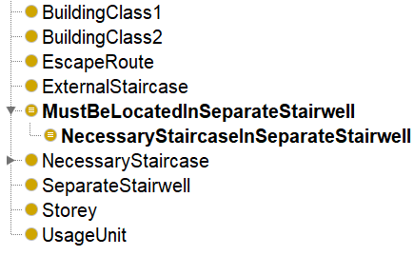
Figure 1: OWL classes of the formalized regulations.

There are two different types of classes. The first type consists of elementary classes, such as Storey and EscapeRoute, which describes building objects. The second type includes classes with complex restrictions formulated using elementary classes and encapsulating semantics of the regulation. Specifically, the class NecessaryStaircaseInSeparateStairwell defines the set of building objects being evaluated, and the class MustBeLocatedInSeparateStairwell represents the requirement against which these objects are assessed. The class restriction defining the subject of the regulation are shown in Figure 2.
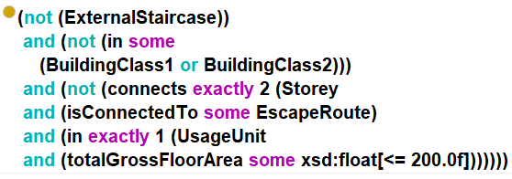
Figure 2: Restrictions of the regulation subjects.
The requirement of this regulation is straightforward and is formalized as in some SeparateStairwell.
To validate our formalization, we manually model several individuals representing building objects and “close” them, see Listing 2. For instance, for a necessary staircase that falls under none of the exceptions, we do not specify its location (even though it must be located in a separate stairwell). In this case, we automatically add with the Owlready2 library (Lamy, J. B., 2017) an axiom stating that the individual belongs to the type in only owl:Nothing (Listing 2(c)).
Without this axiom, OWL reasoning would not detect the contradiction due to the open-world assumption. Thus, when running the Pellet reasoner (Sirin, E., et al., 2007), it correctly identifies the inconsistency and provides an explanation shown in Figure 3.

Listing 2: Modeled “closed” OWL individuals that represent building objects.

(a) Usage unit
Individual: usage_unit1
Types:
UsageUnit,
connects only owl:Nothing,
in only owl:Nothing,
isConnectedTo only owl:Nothing
Facts:
totalGrossFloorArea 250.0
(b) Storey
Individual: storey1
Types:
Storey,
connects only owl:Nothing,
in only ({usage_unit1}),
isConnectedTo only owl:Nothing
Facts:
in usage_unit1
(c) Necessary staircase that does not comply with the regulation
Individual: necessary_staircase1
Types:
NecessaryStaircase,
not (ExternalStaircase),
connects only ({storey1 , storey2}),
in only owl:Nothing,
isConnectedTo only owl:Nothing
Facts:
connects storey1,
connects storey2

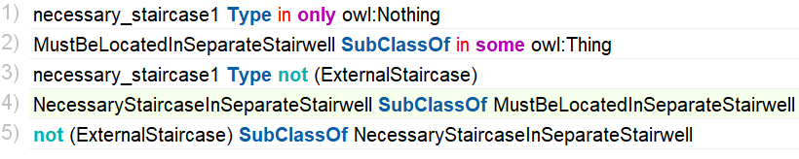
Figure 3: Explanation of the inconsistency provided by OWL reasoning.

4.2 Design
The design of the test case consists of custom elements with custom concepts defined as part of the design context to prove the general alignment capabilities of the LLM. Most concepts are different between the semio schema, the semio instance, the ontology and the ontology instance. Some concepts like connection are shared but have a different meaning: in the semio schema, it refers to ports being connected; in the regulation it refers to storeys being connected. Figure 4 shows concepts used in the semio instance. Figure 5 shows the underlying semantic connectivity graph which semio uses to synthesize the design.
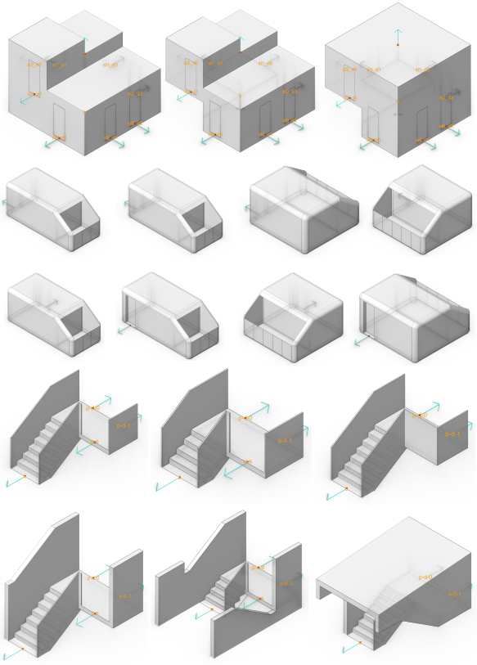Figure 4: Kit of Parts (semio types and variants with ports. Top to bottom, left to right: Tambour: First Storey, Default, Last Storey; Capsule with Balcony: \,/,q,p,J,L,s,z; External Stairwell: Default, First Storey, Last Storey; External Staircase: Default, First Storey, Last Storey)

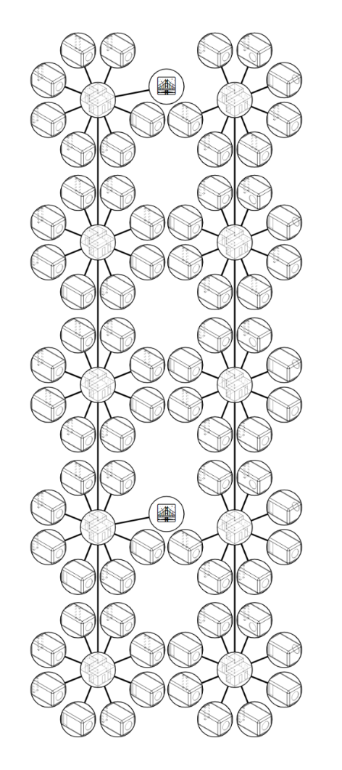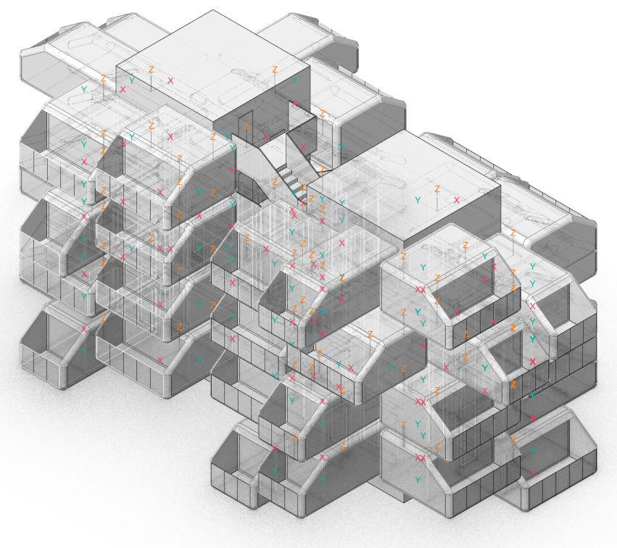
Figure 5: Semantic Design Representation (dynamic port-based connectivity graph that generates the design in semio)
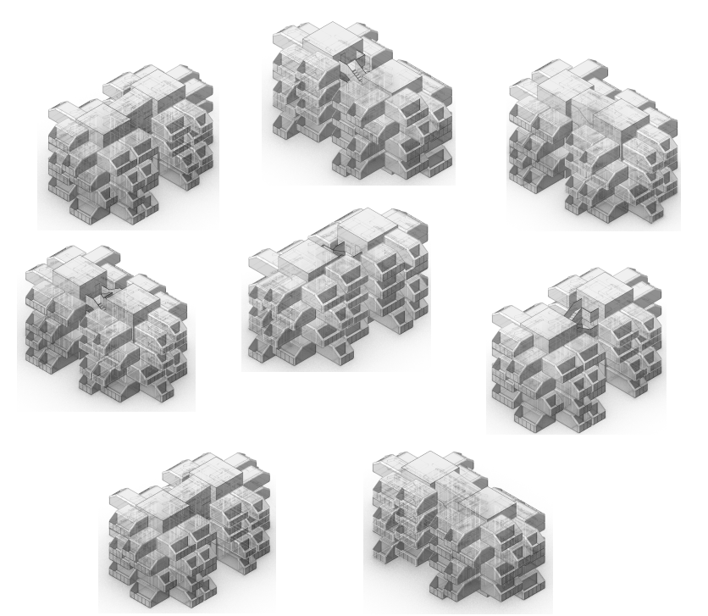
Figure 6: Design consisting of eight residential blocks with two building types: one with an external stairwell and one with a separate staircase)

4.3. Alignment
To align the design with the regulation, we provide Gemini 2.5 Pro Experimental with a prompt that includes three files (onto.txt, test-case.json, and schema.json) along with example individuals from Listing 2. Although the LLM cannot process files with the .ttl extension directly, renaming the file to .txt allows the LLM to process it.
The model breaks down the generation process into the following steps: 1. Understand the goal, 2. Analyze the Input Files. 3. Identify Mapping Opportunities. 4. Plan the OWL Individuals and Relationships. 5. Refine Connections based on Ontology. 6. Construct the TTL Output. 7. Final Review.
The most challenging part of this task is at Step 3 to determine what pieces such as Capsule and Tambour in the authoring format align with the Storeys and UsageUnits mentioned in the regulation. We provide a fragment of the LLM’s thinking log related to this challenge in Listing 3. Notably, the LLM was able to correctly utilize the classes and properties from the ontology and calculate the total floor area of the usage units. However, this was only achieved after we incorporated examples into the prompt and provided a comprehensive description of the generated design in the metadata.

Listing 3. Logs of the LLM’s thinking during the mapping between the generated design and the regulation.
* The concept of a "Storey" needs to be inferred. A set of pieces at the same vertical level (implied by connections like `t-0-0` to `t-0-1`) could constitute a `Storey`. A `Storey` likely contains `UsageUnit`s (Capsules) and is connected by `NecessaryStaircase`s (Tambours) or `ExternalStaircase`s.
* The concept of a "Usage Unit" might be more complex than just a single capsule. Perhaps a block (`t-0-*` plus its connected `c-0-*`) represents a `UsageUnit`? The description mentions "A block is a usage unit". Let's refine: The group of pieces `t-0-0` to `t-0-3` and `c-0-*-*` could form one `UsageUnit`, and `t-1-0` to `t-1-3` and `c-1-*-*` could form another.
* The concept of a `Storey` could be represented by the pieces at a certain level, e.g., `t-0-0`, `t-1-0`, `b-1` (connected to `t-1-0`), `c-0-0-*`, `c-1-0-*` could conceptually form `storey0`.
...
* `totalGrossFloorArea`: This needs to be calculated for `UsageUnit` individuals. The JSON provides "effective floor area" for `Capsule` types. We need to sum these up for all capsules within a conceptual `UsageUnit`. For "block 0", we have 4 storeys * 6 capsules/storey = 24 capsules. Each capsule has 8.74 m². Total area = 24 * 8.74 = 209.76 m². For "block 1", it's the same: 209.76 m².

As a result, the LLM generates a valid .ttl file containing OWL individuals, as shown in Figure 7. Remarkably, the LLM also generated closures for the individuals' properties, as illustrated in Listing 4.
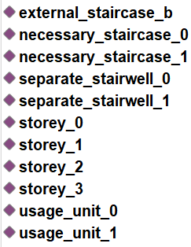

Figure 7: OWL individuals generated by LLM based on the semio design.

Listing 4: properties of the generated OWL individuals
(a) Usage unit
Individual: usage_unit_0
Types:
UsageUnit,
connects only owl:Nothing,
in only owl:Nothing,
isConnectedTo only ({storey_0 , storey_1 , storey_2 , storey_3})
Facts:
totalGrossFloorArea 209.76

(b) Storey
Individual: storey_0
Types:
Storey,
connects only owl:Nothing,
in only ({usage_unit_0 , usage_unit_1}),
isConnectedTo only ({external_staircase_b , necessary_staircase_0 , necessary_staircase_1})
Facts:
in usage_unit_0,
in usage_unit_1,
isConnectedTo external_staircase_b,
isConnectedTo necessary_staircase_0,
isConnectedTo necessary_staircase_1

(c) External staircase
Individual: external_staircase_b
Types:
EscapeRoute,
ExternalStaircase,
connects only ({storey_0 , storey_1 , storey_2 , storey_3}),
in only owl:Nothing,
isConnectedTo only owl:Nothing
Facts:
connects storey_0,
connects storey_1,
connects storey_2,
connects storey_3

(d) Internal staircase
Individual: necessary_staircase_0
Types:
NecessaryStaircase,
not (ExternalStaircase),
connects only ({storey_0 , storey_1 , storey_2 , storey_3}),
in only ({separate_stairwell_0}),
isConnectedTo only owl:Nothing
Facts:
connects storey_0,
connects storey_1,
connects storey_2,
connects storey_3,
in separate_stairwell_0

The Pellet reasoner correctly classifies the OWL individual representing the internal staircase as a subject of the regulation, as it does not fall to any of the exceptions (Figure 8). The explanation for this classification, provided by Pellet, is shown in Figure 9.

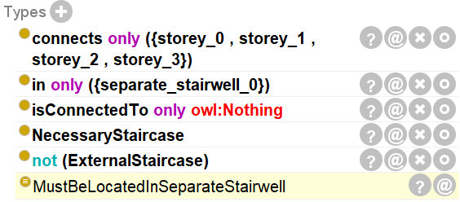
Figure 8: Classifying the internal staircase as a subject of the regulation
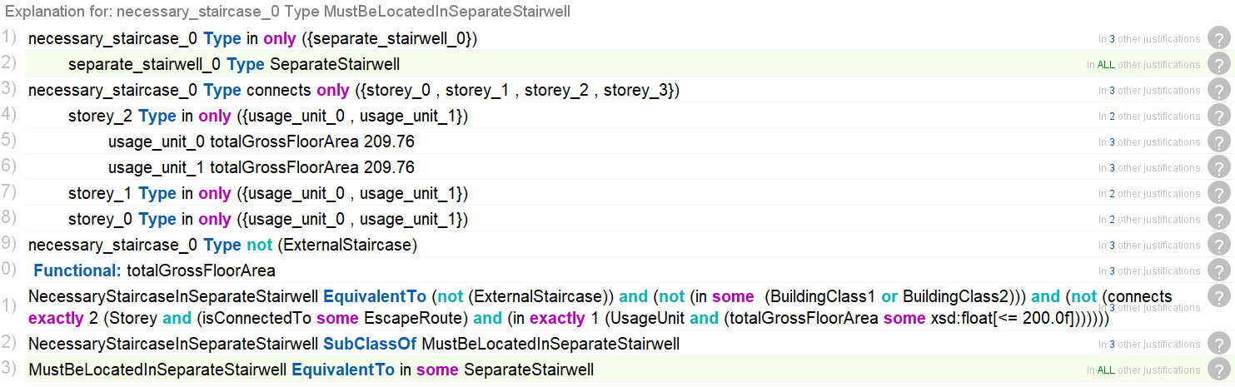
Figure 9: Reported explanation by the Pellet reasoner
Since each internal staircase is located in a separate stairwell, no violations occur. If a violation occurs, it can be used to drive the next iteration in LLM-based authoring tool such as semio or an agentic interface to existing tools such as shown in (Du et al., 2024).

5. CONCLUSION
The results show that an LLM-based BIM alignment between authoring formats such as semio and constraint formats such as OWL for designs such as KoP architecture has been demonstrated. With the CoT prompting strategy the LLM was able to perform the required reasoning resulting in the correct constraint output which was validated by the OWL engine.
An advantage of our approach is that we utilize only general-purpose reasoning with pre-trained LLMs. Thus, our approach is available for reuse in any other formalizable code. Explainability is given by the CoT log and the white-box validation reports of the OWL reasoner.
In future work, we intend to evaluate the LLMs capability for different authoring and constraint frameworks for test cases where more complex reasoning is required during the alignment. More sophisticated pipelines such as Model Context Protocol (MCP) might be necessary.
Moreover, the ultimate objective is the unification of our approach with design generation to establish code-compliant design assistance.

ACKNOWLEDGEMENTS
This research is part of the DFG Research Unit FOR 2363 EarlyBIM: Evaluation of building design variants in early phases on the basis of adaptive detailing strategies and the DFG Heisenberg Grant - Artificial Intelligence as Engineering Assistance for Sustainable Building Design.

REFERENCES
Amor, R., & Dimyadi, J., (2021). The promise of automated compliance checking. Developments in the built environment, 5, 100039.
Lee, J. K., Eastman, C. M., & Lee, Y. C., (2015). Implementation of a BIM domain-specific language for the building environment rule and analysis. Journal of Intelligent & Robotic Systems, 79, 507-522.
Becker, F. M., & Napps, D., (2024). Adding an extensive feedback loop for the creation and validation of functional requirements of BIM models. Technische Universität Hamburg. Universitätsbibliothek.
Hjelseth, E., & Nisbet, N., (2011). Capturing normative constraints by use of the semantic mark-up RASE methodology. In Proceedings of CIB W78-W102 Conference (pp. 1-10).
Schwabe, K., Teizer, J., & König, M., (2019). Applying rule-based model-checking to construction site layout planning tasks. Automation in construction, 97, 205-219.
Zadeh, P. A., Wei, L., Dee, A., Pottinger, R., & Staub-French, S., (2019). BIM-CITYGML data integration for modern urban challenges. Journal of Information Technology in Construction, 24.
Li, Y., Yang, M., Zhao, Q., Li, Z., Ma, Z., Liu, Y., & Hei, X., (2023). A Semantic Representation Method of Building Codes Applied to Compliance Checking. Mathematics, 11(11), 2552.
Solihin, W., & Eastman, C., (2016). A simplified bim model server on a big data platform. In Proceedings of the 33rd CIB W78 Conference.
Dimyadi, J., Governatori, G., & Amor, R. (2017). Evaluating legaldocml and legalruleml as a standard for sharing normative information in the aec/fm domain. In Proceedings of the Joint Conference on Computing in Construction (JC3) (Vol. 1, pp. 637-644). Heraklion, Greece: Heriot-Watt University, Edinburgh, UK.
Abdullah, N. S., Indulska, M., & Sadiq, S. (2016). Compliance management ontology–a shared conceptualization for research and practice in compliance management. Information Systems Frontiers, 18(5), 995-1020.
Pauwels, P., Van Deursen, D., De Roo, J., Van Ackere, T., De Meyer, R., Van de Walle, R., & Van Campenhout, J. (2011). Three-dimensional information exchange over the semantic web for the domain of architecture, engineering, and construction. Ai Edam, 25(4), 317-332.
Stolk, S., & McGlinn, K. (2020, June). Validation of IfcOWL datasets using SHACL. In LDAC (pp. 91-104).
Senthilvel, M., & Beetz, J., (2020). A visual programming approach for validating linked building data. Aachen, Germany: Universitätsbibliothek der RWTH Aachen.
Beach, T. H., Rezgui, Y., Li, H., & Kasim, T. (2015). A rule-based semantic approach for automated regulatory compliance in the construction sector. Expert Systems with Applications, 42(12), 5219-5231.
Fuchs, S., Dimyadi, J., Witbrock, M., & Amor, R., (2024). Transformer-based Semantic Parsing of Building Regulations: Towards Supporting Regulators in Drafting Machine-Readable Rules. In Digit. Build. Permit Conf (Vol. 2024, pp. 176-180).
Zhang, J., & El-Gohary, N. M. (2017). Integrating semantic NLP and logic reasoning into a unified system for fully-automated code checking. Automation in construction, 73, 45-57.
Zhou, P., & El-Gohary, N., (2017). Ontology-based automated information extraction from building energy conservation codes. Automation in Construction, 74, 103-117.
Zheng, Z., Zhou, Y. C., Lu, X. Z., & Lin, J. R. (2022). Knowledge-informed semantic alignment and rule interpretation for automated compliance checking. Automation in Construction, 142, 104524.
Zhang, R., & El-Gohary, N. (2023). Transformer-based approach for automated context-aware IFC-regulation semantic information alignment. Automation in Construction, 145, 104540.
Patlakas, P., Christovasilis, I., Riparbelli, L., Chen, N., Lin, X., Jiang, H., & An, Y. (2024). Automated building information modeling compliance check through a large language model combined with deep learning and ontology. Buildings, 14(7), 1983.
Baimuratov, I. & Turygin, D., (2025) TITLE PLACEHOLDER. arXiv preprint arXiv:NUMBER.
Lamy, J. B. (2017). Owlready: Ontology-oriented programming in Python with automatic classification and high level constructs for biomedical ontologies. Artificial intelligence in medicine, 80, 11-28.
Du, C., Nousias, S., & Borrmann, A., (2024). Towards a copilot in BIM authoring tool using a large language model-based agent for intelligent human-machine interaction. arXiv preprint arXiv:2406.16903.
(2024) Industry Foundation Classes (IFC) [Online], Available: https://www.buildingsmart.org/standards/bsi-standards/industry-foundation-classes [April 2025]
(2024) Information Delivery Specification (IDS) [Online], Available: https://www.buildingsmart.org/standards/bsi-standards/information-delivery-specification-ids [2025]
(2014) Resource Description Framework (RDF) [Online], Available: https://www.w3.org/RDF [2025]
(2012) Web Ontology Language (OWL) [Online], Available: https://www.w3.org/OWL [April 2025]
(2017) Shapes Constraint Language (SHACL) [Online], Available: https://www.w3.org/TR/shacl [April 2025]
(2013) SPARQL Protocol and RDF Query Language (SPARQL), Available: https://www.w3.org/TR/sparql11-query [April 2025]
(2004) Semantic Web Rule Language (SWRL) [Online], Available: https://www.w3.org/submissions/SWRL
(2004) Notation 3 Logic (N3Logic) [Online], Available: https://www.w3.org/DesignIssues/N3Logic [April 2025]
(2008) Legal Knowledge Interchange Format (LKIF) [Online], Available: https://github.com/RinkeHoekstra/lkif-core [April 2025]
(2007) Rule Markup Language (RuleML) [Online], Available: https://www.ruleml.org
(2021) Legal Rule Markup Language (LegalRuleML) [Online], Available: https://www.oasis-open.org/standard/legalruleml-core-specification-version-1-0-oasis-standard [April 2025]
(2013) Legal Document Markup Language (LegalDocML) [April 2025]
https://groups.oasis-open.org/communities/tc-community-home2?CommunityKey=3425f20f-b704-4076-9fab-018dc7d3efbe [April 2025]
(2018) Akoma Ntoso [Online], Available: https://www.oasis-open.org/standard/akn-v1-0 [2025]
(2018) Requirement Applicability Selection Exceptions (RASE) [Online], Available: http://www.aec3.eu/require1/Help_en-GB/Help_en-GB_220.html [April 2025]
(2025) Solibri, Available: https://www.solibri.com
(2025) BIMTester [Online], Available: https://wiki.osarch.org/index.php?title=BIMTester [2025]
(2025) IfcOpenShell, Available: https://ifcopenshell.org
(2025) xbim toolkit, Available: https://docs.xbim.net
(2025) Web IFC, Available: https://github.com/ThatOpen/engine_web-ifc [2025]
(2025) Open Building Information Modeling Rule Language (OpenBimRL) [Online], Available: https://github.com/OpenBimRL [April 2025]
(2017) Visual Code Checking Language (VCCL) [Online], Available: https://www.cee.ed.tum.de/ccbe/research/research-fields/building-information-modelling-processing/visual-code-compliance-checking [April 2025]
(2025) Cucumber [Online], Available: https://github.com/cucumber [April 2025]
(2025) Gherkin Language (Gherkin) [Online], Available: https://github.com/https://cucumber.io/docs/gherkin
(2024) Decision Model and Notation (DMN) [Online], Available: https://www.omg.org/dmn [April 2025]
(2024) Drools [Online], Available: https://www.drools.org
(2023) Structured Query Language (SQL) [Online], Available: https://www.iso.org/standard/76583.html
(2023) Digitalisierung der Musterbauordnung (MBO2BIM) [Online], Available: https://mbo2bim.de/ergebnisse [April 2025]
(2023) Programmation en Logique (Prolog) [Online], Available: https://www.iso.org/standard/21413.html
(1995) Programmation en Logique (Prolog) [Online], Available: https://www.iso.org/standard/21413.html
(2018) Datalog [Online], Available: https://sourceforge.net/projects/datalog [April 2025]
(2021) Building Assessment Ontology (BAO), Available: https://alexdonkers.github.io/bao [2025]
(2014) Building Information Modeling Query Language (BIMQL), Available: https://github.com/opensourceBIM/bimql [2025]
(2016) Query Language for Building Information Modeling (Q4BIM), Available: https://github.com/SimonDaum/QL4BIM [April 2025]
(2025) Design Checker, Available: https://graphisoft.com/de/design-checker [2025]
(2024) Model View Definition (MVD), Available: https://technical.buildingsmart.org/standards/ifc/mvd [April 2025]
(2025) ArchiCAD, Available: https://graphisoft.com/archicad [April 2025]
(2025) Rhino, Available: https://www.rhino3d.com
(2025) Grasshopper, Available: https://www.grasshopper3d.com [April 2025]
(2025) Revit, Available: https://www.autodesk.com/products/revit [2025]
(2025) Dynamo, Available: https://dynamobim.org
(2025) AutoCAD, Available: https://www.autodesk.com/products/autocad [2025]
(2025) Vectorworks, Available: https://www.vectorworks.net [April 2025]
(2025) SketchUp, Available: https://www.sketchup.com [April 2025]
(2025) BricsCAD,Available:https://www.bricsys.com
(2025) Blender, Available:https://www.blender.org
(2025) Bonsai, Available: https://bonsaibim.org
(2025) Sverchok, Available: https://github.com/nortikin/sverchok [April 2025]
(2025) FreeCAD, Available:https://www.freecad.org
(2025) 3ds Max, Available: https://www.autodesk.com/products/3ds-max[2025]
(2025) CityEngine, Available:
https://www.esri.com/en-us/arcgis/products/arcgis-cityengine/overview [April 2025]
(2025) Hypar, Available: https://hypar.io/ [April 2025]
(2025) Spline, Available: https://spline.design [2025]
(2025) semio, Available: https://github.com/usalu/semio [April 2025]
(2025) Automated-Compliance-Checks-for-Construction-Renovation-or-Demolition-Works (ACCORD), Available: https://accordproject.eu/accord-deliverables [2025]
(2025) buildingSMART Data Dictionary (bSDD), Available:https://www.buildingsmart.org/users/services/buildingsmart-data-dictionary[April 2025]
(2025) Claude 3.7 Sonnet, Available: https://www.anthropic.com/news/claude-3-7-sonnet [April 2025]
(2025) DeepSeek V3 Base, Available: https://huggingface.co/deepseek-ai/DeepSeek-V3-Base [April 2025]
(2025) Gemini 2.5 Thinking, Available: https://blog.google/technology/google-deepmind/gemini-model-thinking-updates-march-2025/#gemini-2-5-thinking [April 2025]
(2025) Mistral Large, Available:
https://mistral.ai/news/mistral-large [April 2025]
(2025) Berliner Bauordnung (BauO Bln), Available:
https://gesetze.berlin.de/perma?d=jlr-BauOBE2005V7P36 [April 2025]
(2024) FOR 2363, Available: https://gepris.dfg.de/gepris/projekt/271444440[2025]
(2025) Künstliche Intelligenz als ingenieurstechnische Assistenz für einen nachhaltigen Gebäudeentwurf, Available: https://gepris.dfg.de/gepris/projekt/449664610[2025]

