Data-Driven Parameter Calibration in
Additive Manufacturing for Construction
An Introduction to Learning by Printing
Luca Bettermann^{1,2}, Martin Slepicka^{1,2}, Sebastian Esser^{1,2}, André Borrmann^{1,2}

¹Technical University of Munich, Chair of Computing in Civil and Building Engineering, Munich, Germany
²Technical University of Munich, TUM Georg Nemetschek Institute – AI for the Built World, Munich, Germany

ABSTRACT

This paper introduces the Learning by Printing framework, designed to enhance performance and robustness in extrusion-based Additive Manufacturing in Construction. Leveraging Fabrication Information Modeling (FIM) as a digital backbone, the framework integrates evaluation, prediction, and calibration stages into a closed fabrication-learning loop. An experimental study on a clay extrusion setup demonstrates the framework’s ability to optimize structural performance through data-driven parameter calibration. The Gaussian Process prediction model achieves over 95% accuracy, while calibration shows to improve system performance. Future work will scale the framework to larger systems and integrate online learning for real-time control, advancing Learning by Printing toward a predictive and adaptive approach to digital fabrication.

KEYWORDS

Additive Manufacturing, Machine Learning, 3D Clay Printing, Learning by Printing, Fabrication Information Modeling

1. INTRODUCTION
Additive Manufacturing systems in construction involve complex interactions between material, design, and control parameters, often relying on human involvement for calibration and monitoring. Not only are these trial and error-based efforts resource-consuming, but they rarely lead to optimal configurations (Senthilnathan and Raphael, 2022). Extrusion-based AM methods, such as 3D Concrete Printing (3DCP), are especially sensitive to in-situ variables like material mix variations and environmental conditions (Liu et al., 2023).
These complexities have led researchers to investigate Machine Learning (ML) applications in Additive Manufacturing, such as parameter optimization techniques (Rahmani Dabbagh et al., 2022) or real-time defect detection in extrusion-based 3D printing (Farhan Khan et al., 2021). The need for real-time feedback control in AM has become increasingly evident, enabling not only the optimization of the initial settings but also the ability to respond to in-process deviations in a controlled and adaptive manner (Wang et al., 2022). These examples highlight the emergence of a rapidly expanding research field. To unify these efforts and tackle the diverse challenges in Additive Manufacturing, a standardized framework based on data-driven methods is needed (Geng et al., 2023).

1.1 Contributions and Outline
This paper expands on the Fabrication Information Modeling (FIM) framework presented by Slepicka and Borrmann (2024) by introducing Learning by Printing (LbP), a data-driven approach to address the complexity and sensitivity of AM systems. LbP aims to create a generalizable framework that unifies diverse ML applications in Additive Manufacturing, enhancing standardization and transferability of insights. Applications of the framework include the optimization of print paths, detection and refinement of under- and over-extruded sections, or the adaptation to fluctuating environmental conditions. An initial validation of Learning by Printing is demonstrated in Sections 4 and 5, by optimizing the structural stability of a linear wall in 3D Clay Printing.
As the foundation of LbP, the Fabrication Information Modeling (FIM) approach aims to enable closed-loop control systems in Additive Manufacturing. Serving as an intermediate layer between digital design and automated fabrication, FIM is well-positioned to act as a foundational platform to address today’s challenges in Additive Manufacturing for the built environment. It bridges the gap between paradigms and techniques originating from Building Information Modeling and the actions a 3D printer must perform to fabricate components of a building.

2. STATE OF THE ART
Additive Manufacturing is a transformative method where objects are produced layer by layer, in contrast to traditional subtractive or formative processes such as milling or molding. AM offers substantial advantages such as increased design freedom, automation potential, reduced manual intervention, and capability to fabricate geometrically complex and structurally optimized parts (Gosselin et al., 2016). Common AM methods include Material Extrusion, Powder Bed Fusion, Directed Energy Deposition, Binder Jetting, and Vat Photopolymerization (Paolini et al., 2019). Each technique varies significantly in materials handled, achievable precision, scale, and complexity.
2.1 3D Concrete Printing
In construction, extrusion-based methods are particularly relevant due to their scalability and flexibility in handling concrete. AM methods, such as extrusion-based 3D Concrete Printing, demand specialized infrastructure, including robotic or gantry systems for precise material deposition, pumps, or feeding systems to control material flow. The interdependency between material composition, process parameters, design strategies, and resulting structural integrity complicate the printing process. As emphasized by Bos et al. (2016), parametric modeling is essential to quantify these dependencies, enabling adaptive process control and consistent quality despite varying environmental conditions. Critical factors such as open-time, extrudability, and layer cycle-time directly influence buildability and structural stability. Insufficient control of open-time, for instance, can lead to cold joints, compromising the printed objects structural integrity. Optimization of these parameters necessitates balancing multiple competing objectives, often requiring sophisticated multi-parameter and multi-objective optimization frameworks.
The prevalent method of extruding concrete, the layer-pressing deposition, further illustrates the complexity and parametrical trade-offs that are inherent to Additive Manufacturing. The layer-pressing method provides enhanced control over layer geometry but can introduce sub-layer deformation due to pressure exerted by the nozzle (Carneau et al., 2022). Addressing these deformations necessitates a comprehensive understanding of flow mechanics and precise calibration of printing velocity, nozzle height, and material flow rate. This intricate interplay of parameters significantly impacts the local stability and accuracy of printed elements.
In addition to the parametric dependencies spanning multiple scales and disciplines, external factors and in-situ deviations further influence the printing outcome. The extrusion of cementitious materials is particularly sensitive to environmental fluctuations (Liu et al., 2023). Even minor variations in temperature or material composition can substantially affect extrusion quality, interlayer bonding, and overall structural integrity. Prefabrication presents a strategic approach to mitigate some challenges posed by exposed construction sites by offering controlled environments that ensure material consistency and reduce geometric inaccuracies (Anton et al., 2021).
2.2 Machine Learning in AM
The dynamic nature of the outlined challenges in extrusion-based Additive Manufacturing call for sophisticated systems that can balance the competing objectives effectively. Machine Learning serves as a foundational element for modern optimization and control systems by providing accurate and efficient models of complex relationships. These data-driven models approximate intricate system behaviours that are impractical to model analytically or simply unknown. Machine Learning has become a transformative tool in several manufacturing industries (Kumar et al., 2023). Considering the outlined challenges, ML-based methods are becoming increasingly prevalent in Additive Manufacturing, enhancing process automation, defect detection, and performance prediction. Moreover, ML-driven predictive modeling bridges gaps between material science, structural optimization, and process control, offering frameworks to optimize fabrication parameters across multiple scales (Babu et al., 2023).
However, the effectiveness of any data-driven model is directly dependent on the quality of the data to be modelled. Versteege et al. (2025) emphasize the need for knowledge-driven feature extraction in AM, reducing high-dimensional sensory data into actionable insights, such as layer geometry progressive layer deformation. Features of structural properties derived from domain knowledge serve as a robust and reliable foundation for predictive modeling. Sentilnathan and Raphael (2025) demonstrate a reliable prediction of the printed concretes buildability, i.e. the number of layer that can be printed before collapse, using knowledge-driven features derived from the object’s surface texture. This non-invasive feature extraction method is applied during printing, showcasing its potential for early collapse prediction and real-time control integration.
Despite significant advancements, challenges in integrating and scaling ML models across diverse AM systems persist. The absence of standardization frameworks results in fragmented research efforts, underscoring the need for unified ML architectures that seamlessly adapt to various Additive Manufacturing environments (Geng et al., 2023).
2.3 Digital Infrastructures
Tao et al. (2019) explore the relationship between Cyber-Physical Systems and Digital Twins in the context of smart manufacturing and Industry 4.0. They highlight that while both concepts facilitate cyber-physical integration, CPS focus on real-time sensing, feedback, and control, whereas DTs serve as high-fidelity digital representations of physical systems, enabling predictive modeling and lifecycle management. The study underscores the importance of bi-directional data flow between the digital and physical domains, emphasizing that CPS enhance real-time adaptability, while DTs provide a comprehensive digital footprint for long-term optimization.
In construction, Building Information Modeling (BIM) is utilized to enable the use of digital design across the life span of a building, from construction to demolition (Borrmann et al. 2021). And, to extend BIM with the ability to manage the complexity inherent in digital fabrication processes, the Fabrication Information Modeling (FIM) methodology was developed. Initially conceptualized by Duro-Royo and Oxman (2015) and later adapted by Slepicka et al. (2022), FIM is designed to bridge the gap between digital design, digital fabrication, and material computation, leveraging multi-scale and transdisciplinary data to enhance the precision and flexibility of design-to-fabrication workflows.
FIM facilitates the management of complex, multi-parameter workflows, linking digital models directly with robotic control systems. Essential aspects such as material properties, machine constraints, and fabrication process parameters are systematically integrated, significantly reducing the expertise required for managing sophisticated manufacturing tasks. The intermediate operational steps like object slicing, path planning and task scheduling are computed directly within the FIM framework.
Slepicka and Borrmann (2024) further explored the transition from FIM to fully integrated Cyber-Physical Systems. Their study highlights how FIM can facilitate closed-loop control mechanisms, ensuring that deviations between as-designed and as-built models are continuously corrected during printing. By integrating sensor data and closed-loop control, their framework moves AM closer to autonomous and self-correcting production.
By structuring and centralizing digital workflows, integrating sensor-based real-time feedback, and enabling automated data-driven corrections, FIM forms a foundational digital backbone for adaptive and intelligent fabrication processes. It lays the essential groundwork for the Learning by Printing framework, offering a holistic information and computation system encompassing all processes from digital design to fabricated object.
Common frameworks for robotic control and sensor communication in Cyber-Physical Systems include standards such as ROS2, which is widely adopted in research and industry applications.
2.4 Research Gap
The interplay between material properties, design parameters, and process variables in extrusion-based Additive Manufacturing creates a highly complex problem domain. Adjustments in one area often lead to unforeseen issues in another, complicating efforts to find stable and optimal printing configurations. Traditional approaches rely on manual calibration, that do not provide optimized solutions. Given these complexities, a structured, data-driven approach is necessary to systematically navigate the vast parameter space and identify high-performing configurations efficiently.

3. METHODOLOGY

3.1 FIM as the Foundation
Fabrication Information Modeling, as presented by Slepicka and Borrmann, integrates the necessary steps for transitioning from digital design to physical fabrication in Additive Manufacturing and serve as a foundation for the Learning by Printing framework. These steps include slicing, toolpath definition, robot kinematics, and sensor feedback into a centralized digital architecture. By unifying these elements into a single framework, FIM serves as the digital backbone of a Cyber-Physical System (CPS) for AM, enabling streamlined process management and feedback integration (Figure 1).

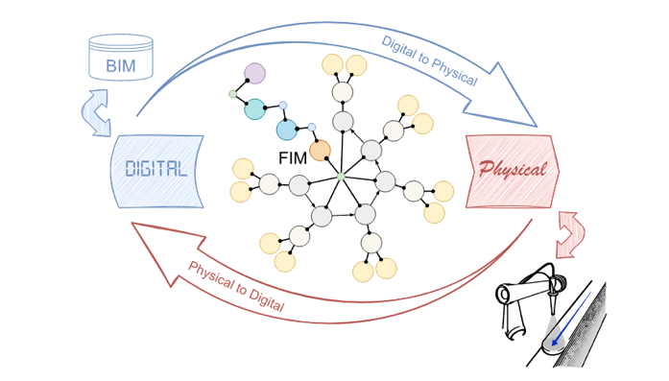Figure 1: FIM-based Cyber-Physical System in AM, as illustrated in (Slepicka and Borrmann, 2024).

In extrusion-based Additive Manufacturing, robotic systems guide a nozzle along predefined toolpaths to deposit material. The FIM framework controls this process by converting digital trajectories into sequences of robot poses, accounting for kinematic and dynamic constraints. Extrusion occurs through a robot-mounted nozzle, typically fed by a pump system. Basic configurations connect pump and nozzle directly, while advanced setups integrate components like auger screws for finer control of material flow. Key process parameters include flow rate, robot speed, nozzle height, and, depending on the system, nozzle rotation or fiber insertion.
By integrating the complete fabrication process into a single digital framework, FIM ensures that each stage, from toolpath generation to material extrusion, is explicitly defined, measurable, and parameterizable, thus making the entire process space subject to optimization through Learning by Printing.
3.2 Learning by Printing
This research introduces Learning by Printing (LbP), a data-driven approach to address the inherent complexity and sensitivity of Additive Manufacturing systems. LbP establishes a generalizable and scalable framework aimed at predicting AM outcomes in terms of geometry and physical properties. By emphasizing continuous learning, the framework progressively refines the relationships governing fabrication processes. These predictive capabilities guide iterative improvements, informing future process configurations.
Beyond predictive capabilities, the framework adopts a modular, application-agnostic architecture. By integrating domain-informed features, LbP enables accurate prediction of performance metrics and facilitates multi-objective optimization. This structured approach can be adapted to varying levels of complexity, making it transferable across diverse AM research scenarios.
3.3 Offline Fabrication-Learning Loop
LbP extends the FIM-based CPS into a continuous fabrication-learning loop, operating in two complementary modes: offline and online learning. Offline learning uses experimental data to train generalized prediction models, whereas online learning adapts these models on the fly during printing to the specificity of the current experiment using real-time data. This paper focuses on offline learning, which forms the conceptual foundation of Learning by Printing. The authors plan to provide more details on online learning in future publications.

Figure 2: Schematic description of the fabrication-learning loop of offline Learning by Printing.

The offline fabrication-learning loop requires three key capabilities: evaluation, prediction, and calibration (Figure 2). The loop begins with automated collection of sensor data from AM experiments, stored via the FIM infrastructure. The evaluation stage reduces high-dimensional data of the printed result (e.g., images or profile scans) to domain-relevant features, which are transformed into quantitative performance metrics. For most real-world applications, evaluating individual performance attributes will not be sufficient. Instead, a comprehensive set of diverse performances are to be evaluated, ranging from material sustainability to product quality to process efficiency metrics.

These isolated evaluations are unified under the term system performance (P_{sys}) and defined in Equation (1):

P_{sys} = ∑ (w_{x} * p_{x}) / ∑ w_{x} (1)
where:
w_{x} weight of attribute x;
p_{x} performance of attribute x.

The labeled dataset is used to train a prediction model that maps input parameters to expected outcomes. The prediction model captures system behavior as-predicted, while the evaluation provides the as-fabricated result. The difference serves as a learning signal, allowing the model to refine its internal representation during training.
In the calibration stage, the prediction model is subsequently used to identify parameter settings that maximize predicted system performance. This is formulated as a global optimization problem in which the prediction model serves as the objective function. Given the typically nonlinear and nonconvex nature of this space, gradient-free optimization methods are employed to avoid local optima. Once a convergence criterion is met, the resulting parameter set is used to calibrate FIM for the next experiment, closing the loop.
The accuracy of the prediction and the effectiveness of the calibration is fundamentally dependent on the quality of the preceding evaluation. Thus, a precise and well-structured evaluation model is integral to the success of Learning by Printing. Employing robust feature extraction techniques ensure that the prediction model is trained on reliable, domain-informed data, ultimately enhancing its predictive reliability.

4. IMPLEMENTATION
To validate the proposed offline fabrication-learning loop, an experimental study is conducted that evaluates the ability of the Learning by Printing framework to enhance performance and robustness of an extrusion-based AM system. The results will give a first indication on the potential of the Learning by Printing framework for addressing real-world challenges in Additive Manufacturing.
4.1 Study Design
The objective of this study is to enhance the structural stability of printed objects by optimizing the quality of point connections between the filament contour and its infill pattern (Figure 4). These connections, referred to as nodes, are especially sensitive when printing with viscous materials such as clay or concrete (Liu et al., 2023). Node strength is used as the primary performance indicator for structural integrity in this study. It is quantified as the measured filament overlap at the node relative to a target value that is defined in relation to the filament width. This results in a scale-independent metric that can be consistently applied across different studies.
In addition to structural integrity, two further and partially competing objectives are considered: the deviation between the as-designed and as-fabricated filament width, as well as the total process duration. While shorter process times are desirable for efficiency, lower printing speeds tend to yield more consistent filament widths due to the rheological behavior of the material and synchronization limitations between the robotic system and the extruder. System performance is therefore modeled as a weighted combination of three performance attributes: node overlap, filament width and process duration.
The printing process is controlled by three tunable input parameters: layer time, layer height, and path offset. All other parameters are held constant. The layer time defines the time allocated to print each layer and thereby determines the printing speed. The layer height sets the vertical resolution and influences the extrusion rate. The path offset was introduced to mitigate a previously observed drag effect at the internal nodes, where deposited material is pulled inward. This parameter extends the internal pattern slightly beyond its original path to improve connectivity at the nodes under varying process conditions. Since the layer height is one of the input variables, the number of layers per print is not fixed. Instead, a minimum object height of 10 mm is defined, and the number of layers is dynamically computed to meet this requirement.
A structured dataset is generated and evaluated to initiate the fabrication-learning loop illustrated in Figure 2. The effectiveness of the fabrication-learning loop is assessed by tracking system performance across successive iterations, as detailed in the following subsections.
4.2 Experimental Setup
The experimental study is conducted on a small-scale Additive Manufacturing setup, consisting of a UR10e robotic arm equipped with a clay extrusion system. A ZED Mini stereo camera is mounted directly on the print head (Figure 3), enabling in-situ image acquisition during the fabrication process.
This setup serves as a simplified and flexible substitute for larger-scale 3DCP systems. Since the Learning by Printing framework is agnostic to the fabrication system and its application, this small-scale implementation is suitable for an initial validation of the offline fabrication-learning loop. Further studies will be required to confirm its applicability to larger and more complex scenarios.
The object to be printed consists of a short linear wall with an outer contour and a fixed internal pattern, which produces three free-standing nodes after slicing (Figure 3). The object design and toolpaths remain constant across experiments, except for the layer height and number of layers, which are dynamically adjusted based on the selected input parameters. Throughout all experiments, the clay mixture is kept constant, with a water-to-clay ratio of 1:2.5 by weight. This ensures that material properties remain stable across all tests and isolates the effects of the process parameters.
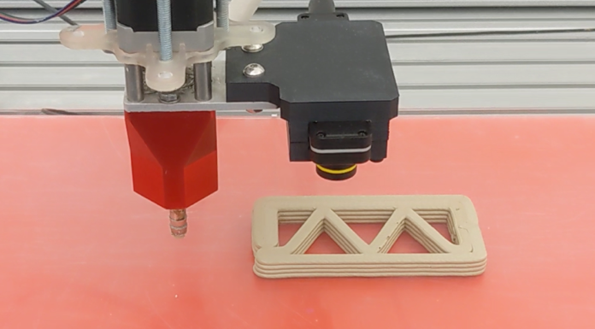
Figure 3: Print head with mounted Stereo camera taking images of the nodes of the fabricated object.

4.3 Feature Extraction and Evaluation
The feature extraction and evaluation process is fully automated and integrated into the fabrication workflow. After each printed layer, the robot executes a sensing task in which the mounted ZED Mini stereo camera captures images of the printed nodes using the ZED API. These images are stored locally on a server, with no manual intervention required. Upon completing the sensing task, the robot continues printing seamlessly. Once fabrication is complete, the evaluation model is executed via a Python script. The evaluation consists of two main stages: feature extraction and performance computation.
In the feature extraction stage, the evaluation script retrieves the node images from the server and applies a sequence of image processing steps. First, the images are undistorted to correct for lens-related effects. This is followed by a thresholding and contour fitting procedure, which isolates the top filament layer and identifies relevant features within the region of interest. Based on the detected contours, the algorithm then computes the node overlap by identifying corner points and measuring the distance between them. This distance, initially measured in pixels, is converted into millimeters using a predefined pixel-to-mm mapping. To ensure accurate measurement, the algorithm specifically targets the top layer of the filament, as including underlying layers would cause the region of interest to grow with the number of printed layers, leading to unreliable results.

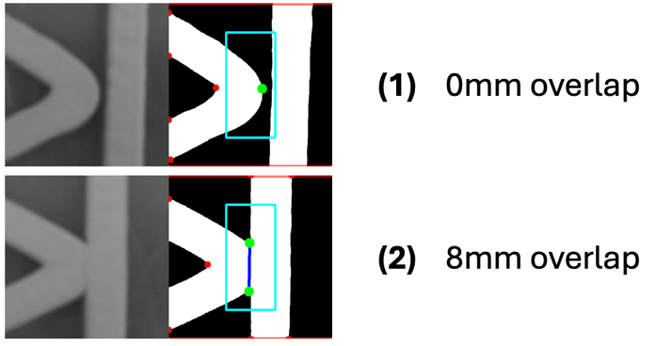
Figure 4: Visualisation of feature extraction algorithm for two distinct node scenarios.

Figure 4 illustrates two cases: (1) where only a single corner is detected within the region of interest, indicating no overlap, and (2) where two distinct corners are present, resulting in an 8 mm overlap. This targeted approach allows the algorithm to compress high-dimensional visual data into a single scalar value that reliably reflects the structural quality of the node. The same thresholded image is also used to measure the filament width. This is accomplished by summing the number of pixels across a linear region containing a single filament. The measurement is performed along the top and bottom rows of the image and averaged to increase robustness. The final value is converted from pixels to millimeters using the same pixel-to-mm mapping. The third feature, process duration, is computed from the input parameters. Since the number of layers depends on the selected layer height, the total process time t_{process} can be directly calculated from the number of layers and the layer time parameter. To derive actionable, unitless performance metrics from these features, each measurement is compared to a target or reference value. The normalized performance scores are computed in Equations (2):

p_{node} = 1 - abs(d_{n, diff} / d_{n, target}) (2.1)
p_{filament} = 1 - abs(d_{n, diff} / d_{f, target}) (2.2)
p_{process} = 1 - (t_{process} / t_{max}) (2.3)
where:
d_{x, target} target value of attribute x;
d_{x, diff} deviation from target of attr. x;
t_{process} process duration [s] ;
t_{max} max attainable duration [s].

Each performance is therefore normalized to the interval [0, 1], where 1 indicates maximal performance. While maximal performance is not always attainable, this formulation allows for a consistent and comparable evaluation across varying objectives.
4.4 Dataset and Prediction
To initialize the offline fabrication-learning loop, a structured dataset is generated using a full-factorial grid strategy. The three input parameters - layer time, layer height, and path offset - are each varied across three discrete values, resulting in a total of 27 experiments. The selected parameter combinations are defined in Table 1.

Table 1: Parameter grid that defines the dataset for the structural stability study.

parameter | value 1 |  | value 2 | value 3
layer time |  | 25 s | 50 s | 75 s
layer height |  | 1.5 mm | 2 mm | 2.5 mm
path offset |  | 0 mm | 1 mm | 2 mm

For each experiment, the normalized performance metrics p_{node}, p_{filament} and p_{process} are evaluated using the method described in the previous section. These metrics form the labels of the dataset and are the foundation for the prediction model. To model the relationship between input parameters and performance outcomes, a Gaussian Process regression model is employed (Williams and Rasmussen, 1995). GP regression is particularly suitable for low-data settings, as it produces continuous predictions with associated uncertainty estimates. In this study, the model is used to predict two performance metrics, p_{node} and p_{filament}, based on the three input parameters. The process duration metric, p_{process}, is excluded from the prediction model, as it can be computed analytically using Equation (2).
At each iteration of the fabrication-learning loop, the GP is re-trained with the expanded dataset. This allows the model to refine its representation of the parameter-performance mapping over time. The GP is configured with a radial basis function (RBF) kernel, using automatic relevance determination to adapt to the influence of each input variable. Kernel hyperparameters are optimized by maximizing the marginal likelihood. The resulting model enables informed decision-making in the calibration step by providing an increasingly accurate approximation of the system behaviour.
4.5 Calibration
In the calibration step of the fabrication-learning loop, the trained prediction model is used to identify input parameter settings that are expected to maximize system performance. This step is formulated as a global optimization problem, where the prediction model serves as the objective function and the system performance P_{sys} is computed as a weighted sum of the three individual performance metrics, as defined in Equation (1). The weights for each metric are empirically determined and listed in Table 2.

Table 2: Weights used to compute P_{sys}.
 | node | filament | process
weight | 3.0 | 2.0 | 1.25

The optimization algorithm is chosen as Differential Evolution (Das et al., 2016), for its robustness in global optimization over bounded parameter spaces, making it well-suited for surrogate-based calibration with limited data. The bounds for the input parameters are defined in Table 3. These limits ensure that the optimization remains within physically feasible and safe operational ranges.

Table 3: Input parameter search space bounds.
bounds | layer time | layer height | path offset
lower | 15 s | 1.0 mm | 0.0 mm
upper | 100 s | 3.0 mm | 3.0 mm

The calibration process concludes when a convergence criterion is met. At that point, the identified parameter set is passed to the FIM system to initialize the next experiment. This completes one iteration of the fabrication-learning loop. Over successive iterations, this procedure enables continuous performance improvement by systematically updating the prediction model and refining parameter selection.

5. RESULTS

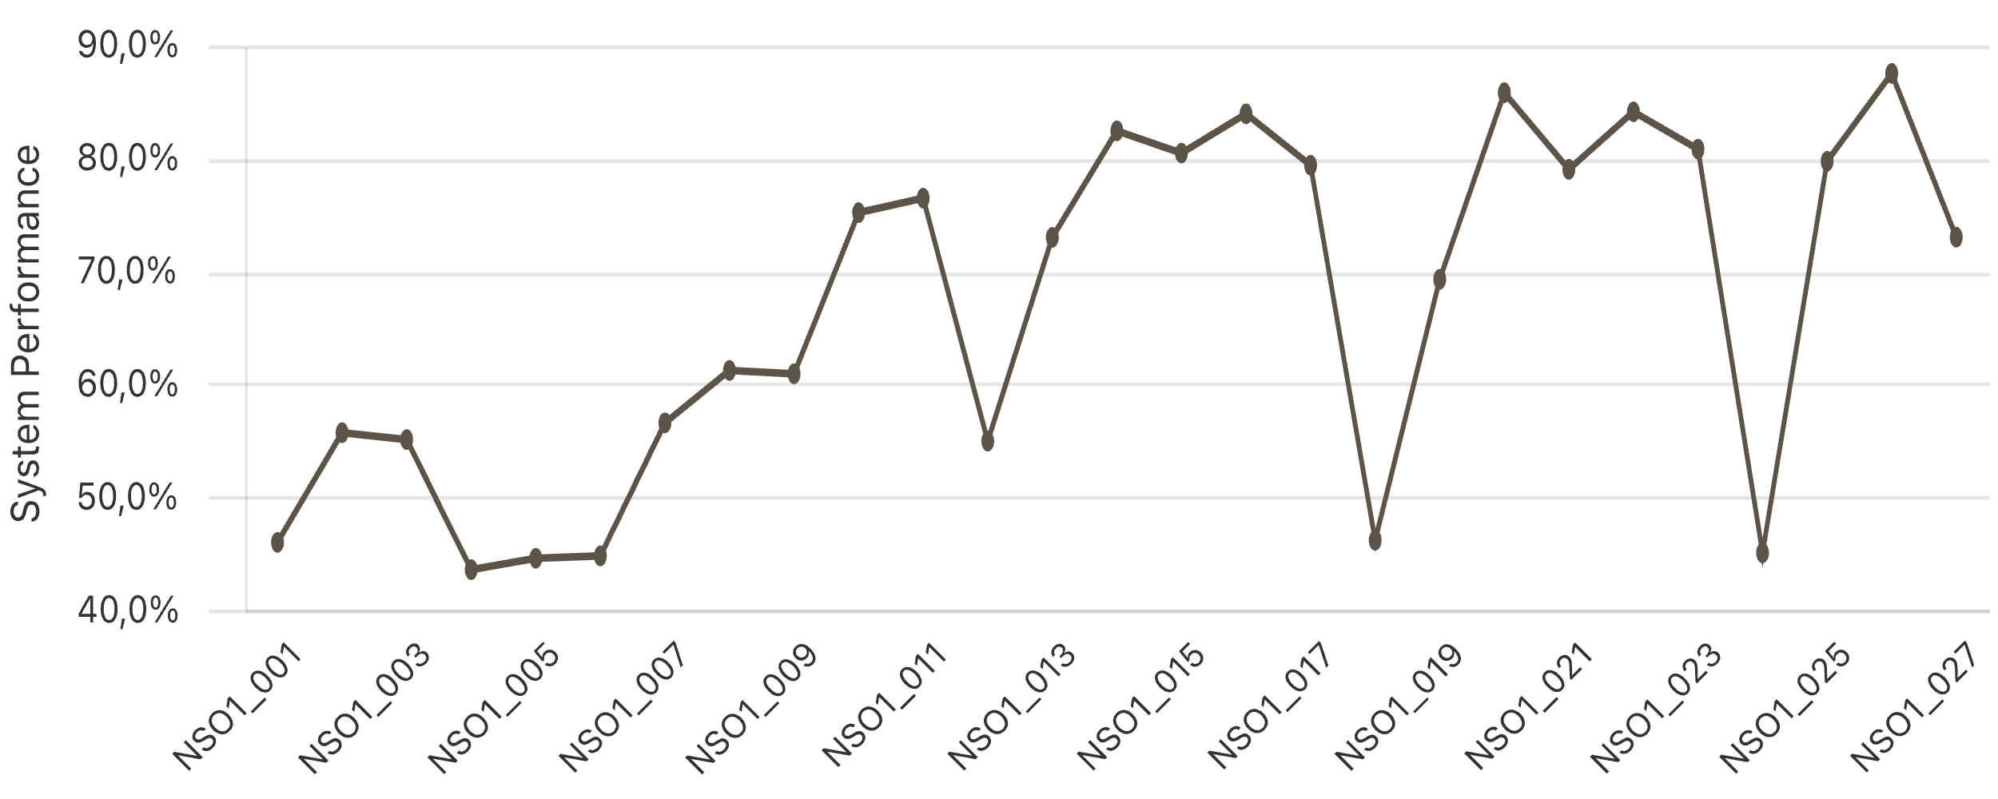
Figure 5: System performance of the 27 dataset experiments (name of every second experiment is shown).

A total of 41 experiments were conducted in this study: 27 baseline experiments used to generate the initial dataset and 14 additional experiments carried out through the offline fabrication-learning loop. The dataset displays a wide range of outcomes in terms of system performance. As shown in Figure 5, several experiments achieve high performance, while others clearly underperform. Due to the high weighting of node overlap in P_{sys}, the lowest-performing configurations are strongly correlated with missing or insufficient filament overlap between the internal pattern and the outer contour. The best system performance recorded within the dataset is 87.5%, achieved in experiment NSO1_026, while the average across all experiments is 66.8%.

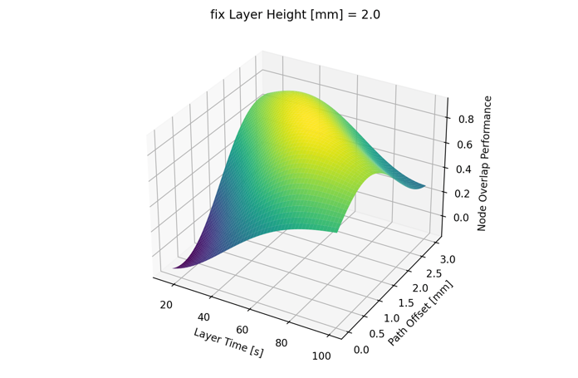Figure 6: GP model prediction surface for node overlap performance at fixed layer height (2.0 mm).

Based on this dataset, the prediction model is trained. While the full behaviour of the Gaussian Process model cannot be visualized due to its three-dimensional input space, Figure 6 shows a representative cross-section at a fixed layer height. This plot illustrates the relationship between layer time, path offset, and the predicted node overlap performance.
The model captures an inverse relationship between layer time and path offset, with high node overlap performance emerging along a diagonal in the parameter space.

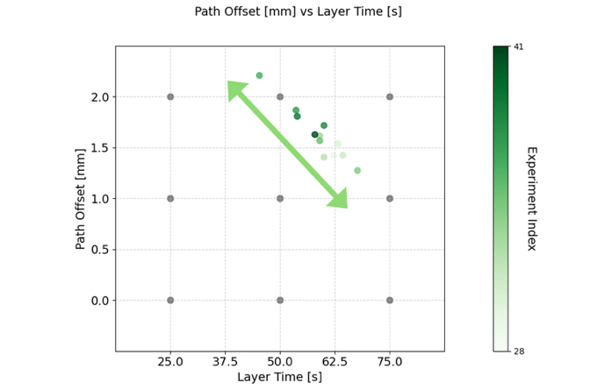Figure 7: Calibrated parameter sets for layer time and path offset. Color gradient indicates experiment sequence; grey dots represent dataset experiments.

As the fabrication-learning loop progresses, new parameter sets are iteratively selected based on the retrained prediction model. These parameter choices are visualized in Figure 7, which again shows layer time versus path offset, with experiment sequence encoded by color. The plot shows a clear progression along the diagonal axis of layer time and path offset, mirroring the pattern observed in the prediction model representation.
The resulting system performance of the 14 calibrated experiments is summarized in Figure 9. Overall, performance levels are consistently high, with early iterations plateauing before later configurations push the system to a new optimum. The highest recorded performance during calibration is 88.1% (NSO1_037), and the average across all calibration experiments is 84.6%.

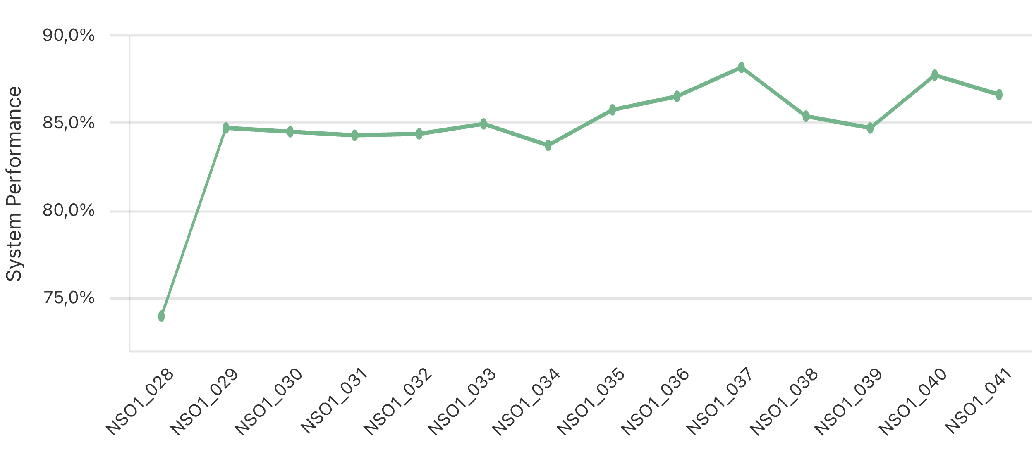
Figure 8: System performance of the 14 calibrated experiments.

Table 4 compares the initial dataset and the calibrated experiments. The calibrated experiments show a higher average system performance, with a slightly improved maximum performance.

Table 4: Comparison of dataset (1) and calibrated experiments (2), where config is defined as [layer height, layer time, offset path].

 | # Exp | Avg | Max | config of Max
(1) | 27 | 66.8% | 87.5% | [25mm, 50s, 2mm]
(2) | 14 | 84.6% | 88.1% | [25mm, 54s, 1.9mm]

To evaluate how well the prediction model adapts over time, the prediction accuracy for the two predicted performances p_{node} and p_{filament} is shown in Figure 7 across the 14 calibrated experiments. While the filament width prediction stabilizes early in the sequence, node overlap accuracy continues to improve gradually, eventually converging toward similar levels.
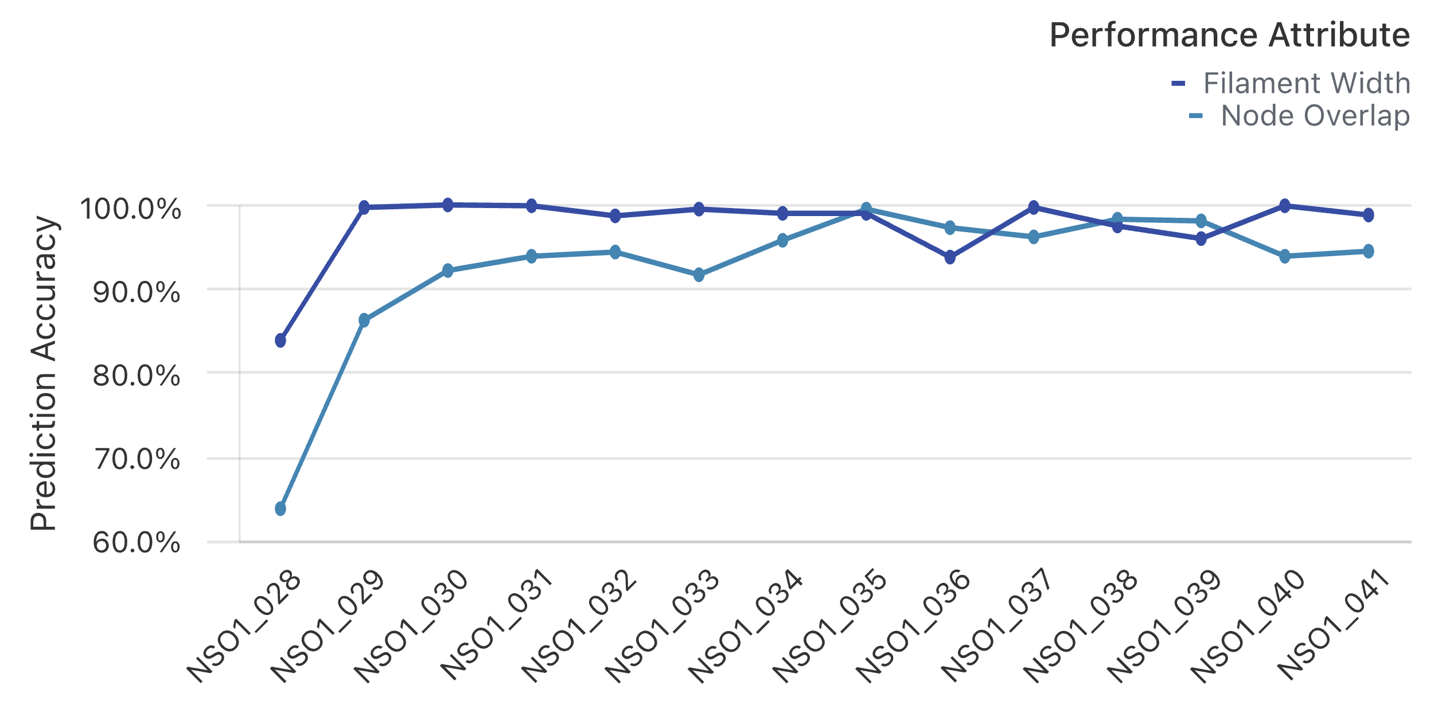Figure 9: Prediction accuracy for node overlap and filament width across the 14 calibrated experiments.

6. DISCUSSION
The results of the study reveal a meaningful interaction between the stages of the fabrication-learning loop, with clear evidence of information propagation from prediction to calibration. The Gaussian Process model identified a diagonal region in the input parameter space, where low layer times are effectively compensated by larger path offsets and vice versa. This relationship, initially captured in the model surface, was subsequently reflected in the calibrated parameter sets. As shown in Figure 8, the calibration consistently selected parameter combinations along this diagonal, indicating successful exploitation of the learned structure in the performance landscape.
Despite this early alignment between model and calibration, system performance initially plateaued. This suggests that while the model was able to direct the search toward a high-performing region, the first few parameter sets may not have fully captured the local optimum. Continued iterations of the loop allowed the model to refine its predictions, ultimately yielding configurations that pushed system performance to a higher level. The limited variability in parameter values across the final experiments shown in Figure 7 indicates that the fabrication-learning loop has converged toward an optimal region of the parameter space.
One factor that may have contributed to this slow start is the limitation of the sensing system. The ZED Mini stereo camera used for in-situ image acquisition is not designed for close-range imaging, and its API lacks manual focus control. As a result, image sharpness was inconsistent, which reduced the robustness of the feature extraction process. Since both p_{node} and p_{filament} are derived from image data, and together account for 80% of the system performance metric, even minor inaccuracies in feature extraction could have impacted learning quality and performance estimation.
In spite of the sensing limitations, the prediction model adapted well over time, with accuracy consistently surpassing 95% for both performance metrics. This enabled the calibration step to identify effective parameter configurations, leading to a new peak in system performance and reinforcing the viability of the loop even under imperfect conditions.

7. CONCLUSION AND FUTURE WORK
This study presented and validated an offline implementation of the Learning by Printing framework using an extrusion-based additive manufacturing setup. By integrating fabrication, sensing, and modeling into a closed offline loop, the system was able to iteratively improve its performance through data-driven prediction and calibration. Across successive iterations, the prediction model achieved high accuracy, and the calibration step reliably selected high-performing parameter configurations. Despite suboptimal sensing conditions and process variability, the fabrication-learning loop led to an increase in system performance, demonstrating the overall potential of the approach. These results validate the core principles of Learning by Printing for controlled offline optimization in Additive Manufacturing.
Future work will focus on two key extensions of this framework. First, a scaled-up study will be conducted using a more advanced sensing setup with improved resolution and robustness. This will allow for more precise evaluation and better support for high-performance learning. Second, the integration of online learning will be explored to enable dynamic, real-time adaptation of process parameters during fabrication, illustrated in Figure 10. The integration of closed-loop control within the fabrication-learning loop opens the door to responsive, resilient Additive Manufacturing systems capable of adjusting to disturbances or changing conditions in real time. Together, these steps will support the evolution of Learning by Printing toward a predictive, adaptive Cyber-Physical System for advanced digital fabrication.
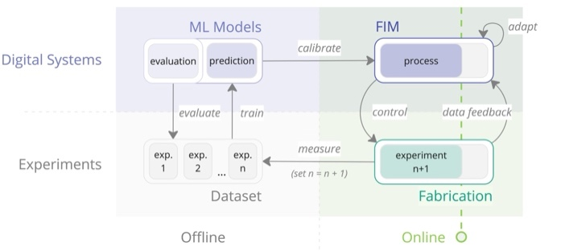

Figure 10: Integration of online data feedback and process adaptation into the fabrication-learning loop.

Acknowledgements
The authors gratefully acknowledge the funding received from EU Pathfinder Project AM2PM (Grant Agreement No. 101162318) as well as from German Research Foundation (DFG) in the frame of Transregio 277/2 project (project number 414265976).

REFERENCES
Borrmann, A., König, M., Koch, C., Beetz, J. (2021). Building Information Modeling. Springer Fachmedien Wiesbaden. https://doi.org/10.1007/978-3-658-33361-4

Duro-Royo, J., Oxman, N. (2015). Towards Fabrication Information Modeling (FIM): Four case models to derive designs informed by multi-scale trans-disciplinary data. MRS Online Proceedings Library (OPL), 1800. https://doi.org/10.1557/opl.2015.647
Senthilnathan, S., Raphael, B., 2022. Using Computer Vision for Monitoring the Quality of 3D-Printed Concrete Structures. Sustainability 14, 15682. https://doi.org/10.3390/su142315682

Liu, D., Zhang, Z., Zhang, X., Chen, Z., 2023. 3D printing concrete structures: State of the art, challenges, and opportunities. Construction and Building Materials 405, 133364. https://doi.org/10.1016/j.conbuildmat.2023.133364

Rahmani Dabbagh, S., Ozcan, O., Tasoglu, S., 2022. Machine learning-enabled optimization of extrusion-based 3D printing. Methods 206, 27–40. https://doi.org/10.1016/j.ymeth.2022.08.002

Farhan Khan, M., Alam, A., Ateeb Siddiqui, M., Saad Alam, M., Rafat, Y., Salik, N., Al-Saidan, I., 2021. Real-time defect detection in 3D printing using machine learning. Materials Today: Proceedings 42, 521–528. https://doi.org/10.1016/j.matpr.2020.10.482

Wang, P., Yang, Y., Moghaddam, N.S., 2022. Process modeling in laser powder bed fusion towards defect detection and quality control via machine learning: The state-of-the-art and research challenges. Journal of Manufacturing Processes 73, 961–984. https://doi.org/10.1016/j.jmapro.2021.11.037

Geng, S., Luo, Q., Liu, K., Li, Y., Hou, Y., Long, W., 2023. Research status and prospect of machine learning in construction 3D printing. Case Studies in Construction Materials 18, e01952. https://doi.org/10.1016/j.cscm.2023.e01952

Slepicka, M., Borrmann, A., 2024. Fabrication Information Modeling for Closed-Loop Design and Quality Improvement in Additive Manufacturing for Construction. Automation in Construction 168, 10579. https://doi.org/10.1016/j.autcon.2024.105792

Slepicka, M., Vilgertshofer, S., & Borrmann, A. (2022). Fabrication information modeling: Interfacing building information modeling with digital fabrication. Construction Robotics, 6(2), 87-99. https://doi.org/10.1007/s41693-022-00075-2

Gosselin, C., Duballet, R., Roux, Ph., Gaudillière, N., Dirrenberger, J., Morel, Ph., 2016. Large-scale 3D printing of ultra-high performance concrete – a new processing route for architects and builders. Materials & Design 100, 102–109. https://doi.org/10.1016/j.matdes.2016.03.097

Paolini, A., Kollmannsberger, S., Rank, E., 2019. Additive manufacturing in construction: A review on processes, applications, and digital planning methods. Additive Manufacturing 30, 100894. https://doi.org/10.1016/j.addma.2019.100894

Bos, F., Wolfs, R., Ahmed, Z., Salet, T., 2016. Additive manufacturing of concrete in construction: potentials and challenges of 3D concrete printing. Virtual and Physical Prototyping 11, 209–225. https://doi.org/10.1080/17452759.2016.1209867

Carneau, P., Mesnil, R., Baverel, O., Roussel, N., 2022. Layer pressing in concrete extrusion-based 3D-printing: Experiments and analysis. Cement and Concrete Research 155, 106741. https://doi.org/10.1016/j.cemconres.2022.106741

Anton, A., Reiter, L., Wangler, T., Frangez, V., Flatt, R.J., Dillenburger, B., 2021. A 3D concrete printing prefabrication platform for bespoke columns. Automation in Construction 122, 103467. https://doi.org/10.1016/j.autcon.2020.103467

Kumar, S., Gopi, T., Harikeerthana, N., Gupta, M.K., Gaur, V., Krolczyk, G.M., Wu, C., 2023. Machine learning techniques in additive manufacturing: a state of the art review on design, processes and production control. J Intell Manuf 34, 21–55. https://doi.org/10.1007/s10845-022-02029-5

Babu, S.S., Mourad, A.-H.I., Harib, K.H., Vijayavenkataraman, S., 2023. Recent developments in the application of machine-learning towards accelerated predictive multiscale design and additive manufacturing. Virtual and Physical Prototyping 18, e2141653. https://doi.org/10.1080/17452759.2022.2141653

Versteege, J., Wolfs, R.J.M., Salet, T.A.M., 2025. Data-driven additive manufacturing with concrete: Enhancing in-line sensory data with domain knowledge, Part I: Geometry. Automation in Construction 172, 106020. https://doi.org/10.1016/j.autcon.2025.106020

Senthilnathan, S., Raphael, B., 2025. Predicting Buildability Using the Surface Texture of 3D Printed Concrete Elements. J. Archit. Eng. 31, 04025010. https://doi.org/10.1061/JAEIED.AEENG-1936

Tao, F., Qi, Q., Wang, L., Nee, A.Y.C., 2019. Digital Twins and Cyber–Physical Systems toward Smart Manufacturing and Industry 4.0: Correlation and Comparison. Engineering 5, 653–661. https://doi.org/10.1016/j.eng.2019.01.014

Das, S., Mullick, S.S., Suganthan, P.N., 2016. Recent advances in differential evolution – An updated survey. Swarm and Evolutionary Computation 27, 1–30. https://doi.org/10.1016/j.swevo.2016.01.004

Williams, C., Rasmussen, C., 1995. Gaussian Processes for Regression, in: Advances in Neural Information Processing Systems. MIT Press.

