Explainable HVAC Component-Level Fault Localization Leveraging Brick and SHAP
Sadia Zahin Prodhan¹, Eleni Stroulia ^{1,*}

¹ University of Alberta, Edmonton, Canada
*Corresponding email: stroulia@ualberta.ca

ABSTRACT
HVAC systems account for a substantial share of building energy usage, and their faulty operation can increase energy and maintenance costs and occupant discomfort. Although data-driven Automated Fault Detection and Diagnostics (AFDD) models can detect anomalies from Building Management System data streams, their deployment is often limited by weak diagnostic context, because feature-level predictions do not directly indicate which physical component should be inspected. This paper presents an explainable AFDD methodology that connects data-driven fault predictions to HVAC components. The proposed approach integrates (i) multiclass machine learning classification of sensor data into normal and fault classes, (ii) SHAP-based explanation to identify the data features most predictive of each fault class, and (iii) Brick-based semantic mapping of these data features to the HVAC components emitting the underlying sensor and actuator signals. We evaluated our methodology on the public SDAHU (Single-duct Air Handling Unit) dataset, under both stratified and time-series splits. The results show that component-level localization is most reliable for actuator faults with direct physical signatures, such as damper stuck faults and cooling-coil leakage. In contrast, sensor bias faults produce distributed attributions across multiple measurements, reflecting closed-loop control effects. Overall, the proposed Brick-grounded SHAP framework improves AFDD interpretability by generating component-level diagnostic hypotheses that can support targeted maintenance inspection.

INTRODUCTION
Heating, Ventilation, and Air Conditioning (HVAC) systems are among the most energy-intensive systems in commercial buildings, and operational faults and inefficiencies can substantially increase energy consumption and maintenance costs. Prior work estimates that faults caused by sensor bias, equipment degradation, or improper operation may account for 15-30% of total building energy waste (Katipamula & Brambley, 2005). These challenges have motivated research on Automated Fault Detection and Diagnosis (AFDD), recognizing its importance for improving building reliability and efficiency (Capehart & Brambley, 2021). Data-driven AFDD methods have gained attention because Building Automation Systems (BAS) continuously generate large volumes of sensor and actuator data. By learning from labelled normal and faulty operating data, machine learning (ML) models can capture complex HVAC relationships and detect non-normative operating patterns. Compared with rule-based approaches, data-driven ML methods can offer higher diagnostic sensitivity, scale better to high-dimensional data, and adapt more easily without requiring manual effort to redefine expert rules or physical equations (Yang & Rizzoni, 2016). However, data-driven AFDD approaches remain limited in their interpretability: although they may accurately predict faults, they often provide little insight into which physical subsystem or component is responsible. This limits their practical value for facility managers, who need actionable diagnostic guidance in addition to fault classification. Thus, bridging predictive performance with physically meaningful interpretation remains an important challenge in AFDD.
Recent work has explored semantic modelling as a means of incorporating building context into fault analysis. Project Haystack provides a flexible tagging scheme for describing building assets and points (Project Haystack, n.d.) but its implementation-dependent representation can reduce semantic consistency and interoperability (Quinn & McArthur, 2022). Brick is a formal RDF/OWL-based ontology with standardized classes and relationships for HVAC equipment, sensors, and building systems, conceived to address this interoperability limitation (Balaji et al., 2016). The potential of semantic integration for HVAC diagnostics has been explored in recent literature. Xie et al. (2023) proposed a digital-twin-enabled FDD framework that uses Brick-based semantic metadata and symbolic representations of HVAC time-series data to identify and filter fault-relevant sensors. Similarly, Gourabpasi & Nik-Bakht (2024) developed a BIM- and BMS-based AFDD framework using AFDDOnto, integrating concepts from IFC (IFC, n.d.), BOT (BOT, n.d.), Brick, and IfcOWL (IfcOWL, n.d.) to provide contextual information, enrich features, and support diagnostic knowledge management. Together, these studies highlight the value of semantic context in AFDD. However, existing approaches primarily use semantic models for symbolic transformations, fault-oriented sensor filtering, feature enrichment, or rule-based knowledge representation. To the best of our knowledge, there is very limited research exploring how semantic building models can be combined directly with model-based explanations derived from data-driven classifiers. This paper addresses this gap by proposing a semantically grounded and explainable AFDD framework for component-level fault localization. The proposed methodology integrates data-driven ML for multiclass classification of HVAC sensor data into normal and fault classes, SHAP-based explanation to identify the data features most influential for each predicted fault class, and Brick-based mapping of those influential features to the HVAC components associated with emitting this data. In doing so, the framework moves beyond fault classification alone and enables more interpretable diagnosis by linking model predictions to the physical structure of the HVAC system.
To operationalize this methodology, we develop a modular pipeline using the Luigi software-pipeline framework (Erdmann et al., 2017) to implement an end-to-end process of data engineering, model training and prediction. The dataset is first enhanced through a sequence of data preprocessing and feature engineering techniques. Next, we constructed ML models using two strong classifiers, Random Forest (Movahed et al., 2023) and Fully Connected Neural Network models (Fan et al., 2023). Using these two algorithms, we trained parallel models (under stratified and time-series fold splits) on the publicly available SDAHU (Single-duct Air Handling Unit) dataset (Granderson, J., et al., 2023). We then apply SHAP (Lundberg& Lee, 2017) to identify fault-specific influential features and derive signal-to-component mappings from the Brick model of the HVAC system simulated to produce our dataset. This process produces rankings of influential sensors and their associated components, yielding interpretable diagnostic targets that can better guide maintenance actions. In summary, this work examines how a semantic building model represented in Brick can be combined with data-driven classification and model-based explanation to improve interpretability and support component-level fault localization.

THE DATASET
A Single-Duct Air Handling Unit (SDAHU) (Granderson et al., 2023) is a common HVAC configuration that conditions and distributes air through a single supply duct serving multiple zones. The SDAHU dataset used in this paper is based on simulations developed by Lawrence Berkeley National Laboratory (LBNL) and Pacific Northwest National Laboratory (PNNL) to support standardized, open-source building FDD research. The simulated system is a single-duct variable air volume (VAV) system serving the middle floor of the U.S. DOE commercial reference office building, with one interior zone and four perimeter zones.
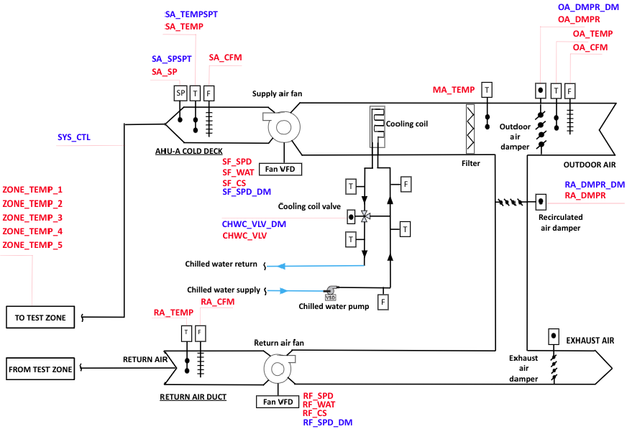
Figure 1: Schematic diagram of the SDAHU system showing all BAS variables (Granderson et al., 2023)

Table 1: Six fault and normal condition timespan on the SDAHU yearly dataset.
Fault Type | Period
Outdoor Air Temperature Sensor Bias (+4) | 2/6/18--2/12/18, 5/9/18--5/14/18, 8/7/18--8/13/18, 11/6/18--11/12/18
Supply Air Temperature Sensor Bias (+4) | 2/13/18--2/19/18, 5/16/18-- 5/21/18, 8/14/18--8/20/18, 11/13/18--11/19/18
Outdoor Air Temperature Sensor Bias (-4) | 2/20/18--2/26/18, 5/23/1--5/28/18, 8/21/18--8/27/18, 11/20/18--11/26/18
Supply Air Temperature Sensor Bias (-4) | 2/27/18--3/5/18, 5/30/18--6/4/18, 8/28/18--9/3/18, 11/27/18--12/3/18
Out Air Damper Stuck (75%) | 3/6/18--3/12/18, 6/6/18--6/11/18, 9/4/18--9/10/18, 12/4/18--12/10/18
Cooling Coil Valve Leakage (50%) | 3/13/18--3/19/18, 6/13/18--6/18/18, 9/11/18--9/17/18, 12/11/18--12/17/18
Normal | 1/30/18--2/5/18, 5/2/18--5/7/18, 7/31/18-- 8/6/18,10/30/18--11/5/18

The dataset records 30 BAS variables (most of them shown in the diagrammatic model of Figure 1) at one-minute intervals. The SDAHU simulation provides year-long logs for 21 cases: one fault-free baseline case and 20 faulted scenarios. Each case was simulated over a full year using Chicago TMY3 weather data, with the first hour of data removed from each file to eliminate simulation start-up transients. The only exception is the outdoor-air damper stuck at 100% fault case, which contains data from April 1 to November 1. For our study, we selected six representative faults corresponding to the most severe fault conditions across different component categories. For each selected fault scenario, faulted periods and corresponding normal periods were defined. Table 1 presents the detailed timelines for the selected fault and normal scenarios used in this study.

METHODOLOGY
Figure 2 diagrammatically depicts the Luigi-based AFDD workflow that implements the proposed methodology, organized into data preparation, multiclass classification, and Brick schema integration for component-level fault localization. The first step of the data preparation pipeline is to divide the SDAHU dataset into five folds, under both stratified and time-series split settings.

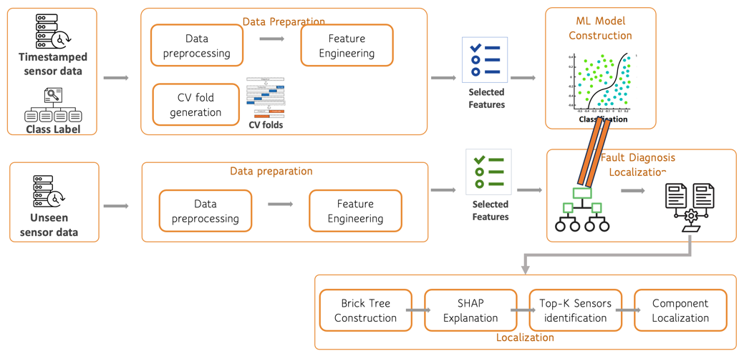
Figure 2: Overview of the proposed Luigi-based AFDD workflow, including data preparation, classifications, and Brick schema integration for SHAP-based component-level fault localization

The input to the data-preprocessing phase is a timestamped record of 30 AHU variables and its class label. During data preprocessing, this raw sensor data record is cleaned and transformed into a consistent format suitable for analysis. This step includes (i) handling missing values using median imputation, and (ii) standardizing numerical features. Next, during the feature engineering stage, additional informative variables are created from the preprocessed sensor data, with one-hot encoding used to capture temporal and operational patterns in HVAC behavior. All data points in all folds are pre-processed in the same way.
The processed datasets are then passed to the multiclass classification pipeline. For each model type, five models are constructed under the five-fold cross-validation setting, where each run uses four folds for training and the remaining fold for testing. This process is repeated so that each fold is used once as the held-out test set. The Random Forest and Fully Connected Neural Network architectures and main hyperparameters are adopted from the literature (Prodhan, 2026). The best-performing models are used for SHAP-based interpretation and Brick-grounded component-level localization.
The last step in this process is at the centre of the contribution of this study, namely linking the predicted fault to potentially faulty HVAC components. As shown in Figure 2 (bottom right), this pipeline consists of four sequential tasks: Brick Tree Construction, SHAP Explanations, Top K Sensors Identification, and Component Localization. Together, these tasks link predicted fault classes from the trained models to potential diagnostics targets in the SDAHU system.
The first task, Brick Tree Construction, parses the SDAHU Brick model. This task extracts AHU equipment, components, points, and semantic relationships among them, including component-part containment relations and component-point associations. From this graph, a signal-to-component mapping is created, linking each BAS signal used in the dataset to its corresponding point and the point’s associated HVAC component. This mapping provides the semantic foundation for translating model explanations from sensor-level evidence into component-level diagnostic targets.
The second task, SHAP Explanation, computes post hoc explanations for the trained Random Forest and FCNN models.
- For each fold, the trained model is applied to its corresponding held-out test set. Normal predictions are excluded because the focus is on fault diagnosis, and the remaining test instances are grouped according to their predicted fault class to form “fault-class dataset”.
- A subset of 200 instances is used as the reference distribution for the SHAP explainer. This background sample is selected from the same fold’s test set using stratified sampling, so that it preserves the class distribution of that fold’s test set rather than being drawn from only one class.
- The automatic explainer configuration applies a model-specific explainer where possible and falls back to a model-agnostic explainer when required. For each fault class and fold, up to 1000 high-confidence (probability > 0.85) test instances are selected from those predicted as that fault class.
The third task, Top K Sensors Identification, aggregates SHAP attributions back to their corresponding base sensor or actuator signals when the model input includes transformed or engineered features. For each fault class, the mean absolute SHAP value is calculated for every base signal to measure its average influence on the model’s prediction. The signals are then ranked, and the top five most influential signals are selected. Their relative percentage contributions are also computed to show how the explanatory importance is distributed among the dominant signals.
The fourth task, Component Localization, maps the top SHAP-ranked signals to HVAC components using the Brick-derived signal-to-component mapping. When multiple influential signals belong to the same component, their importance scores are aggregated and normalized to produce ranked component-level fault-localization outputs. All source code used to implement the proposed workflow along with the results is made available in a GitHub repository (Prodhan & Stroulia, 2026) to support transparency, reproducibility, and future extension of the framework.

FINDINGS AND DISCUSSION
This section presents the evaluation of the proposed Brick-grounded SHAP framework in two stages. First, the multiclass classification results are examined to compare model performance under stratified and time-series split settings. Second, the SHAP-based sensor explanations and Brick-based component localization results are discussed to assess whether the models provide physically meaningful diagnostic evidence for each fault class.

4.1 Multiclass Classification Evaluation
Figure 3 shows that both models achieve substantially stronger classification performance under the stratified split than under the time-series split. In the stratified setting, the confusion matrices are highly diagonal for both Random Forest and FCNN, indicating that most fault classes are correctly classified with very few misclassifications. In contrast, the time-series split produces more off-diagonal errors, especially among temperature sensor bias faults and cooling-coil leakage, suggesting that temporal generalization is more challenging when the model is tested on future operating periods.
The next stage of evaluation is primarily interpretability and localization-oriented. Rather than treating SHAP attributions as causal proof, the analysis uses them to identify which signals the models rely on for each fault class and to translate those signal-level explanations into component-level diagnostic targets within the AHU graph. Based on the classification results, the stratified-split configuration is selected for both models because it provides the strongest and most stable predictive performance. The time-series results demonstrate that temporal generalization is substantially more challenging and are therefore retained as an important assessment of model robustness under future operating conditions. However, the primary objective of the subsequent analysis is not to claim deployment-level temporal generalization, but to evaluate whether, when a fault is classified with sufficiently high confidence, its learned feature evidence can be translated into physically meaningful component-level diagnostic targets. The stratified models are therefore used for the primary localization analysis because their higher and more stable classification performance provides a larger and more reliable set of correctly represented fault patterns for examining the SHAP-to-Brick localization mechanism. Using models with substantially poorer temporal classification performance would make it difficult to distinguish errors caused by the classifier from errors introduced by the localization framework itself. The poorer time-series performance remains an important limitation and indicates that temporal robustness must be improved before the framework can be considered for operational deployment. The models were trained with one-hot encoded timestamp features, these OHE time features were excluded from component-level localization because they do not correspond to physical HVAC sensors, actuators, or equipment in the Brick model. Therefore, localization was performed using only physical BAS signals after SHAP attributions were aggregated back to their corresponding base signals.

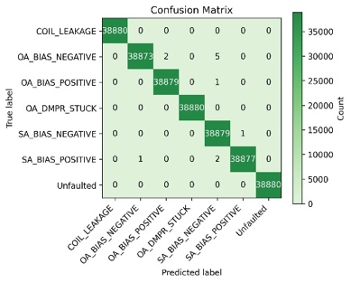 | 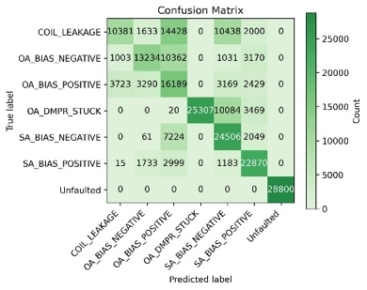 | 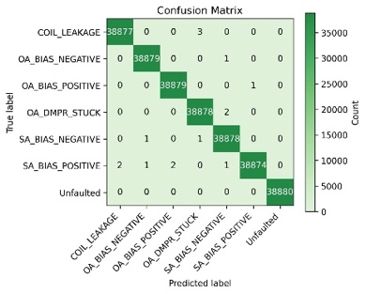 | 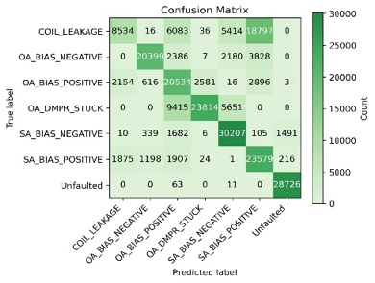
a) Stratified (RF) | b) Timeseries (RF) | c) Stratified (FCNN) | d) Timeseries (FCNN)
Figure 3: Confusion matrices for multiclass fault classification using Random Forest and Fully Connected Neural Network models under stratified and time-series split strategies: (a) Random Forest with stratified split, (b) Random Forest with time-series split, (c) FCNN with stratified split, and (d) FCNN with time-series split.

4.1 Which Sensor Data Explain Each Fault?
Table 2 presents the top-5 SHAP-ranked physical sensors for each fault class using the Random Forest (RF) and Fully Connected Neural Network (FCNN) models under stratified split settings. The top-5 sensors are reported to provide a compact but sufficiently informative view of the model’s fault-specific reasoning. This ensures that important secondary signals are not missed, particularly because HVAC faults can propagate through control-loop interactions and affect downstream variables. Conversely, reporting too many sensors may reduce interpretability by introducing lower-ranked signals that contribute less consistently to the model’s decision. Therefore, selecting the top-5 sensors provides a balance between interpretability and diagnostic coverage, capturing both direct fault-related signals and important indirect system responses. The bold sensors indicate signals that are directly associated with, or physically relevant to, the expected physical component of the corresponding fault. They are not always ranked first because SHAP ranks features according to the model’s learned predictive importance, not according to prior physical expectations. Therefore, a non-bold sensor may appear above a bold sensor when the model relies more strongly on a downstream response or correlated control signal than on the directly fault-related signal itself. Let us now review the top-5 sensors for each of the fault classes.
Cooling Coil Leakage: A consistent pattern emerges across both models: cooling-coil valve-related signals are among the most influential features. For the Random Forest model, CHWC_VLV dominates. Similarly, for the FCNN model, both CHWC_VLV and CHWC_VLV_DM are highly influential. This strengthens the interpretation that the models rely primarily on coil-side evidence when identifying cooling-coil leakage, rather than on unrelated system attributes.

Table 2: Top five SHAP-ranked sensors for each fault class using Random Forest and Fully Connected Neural Network (FCNN) models under stratified split settings. Bold features indicate sensors or control signals that are directly associated with, or physically relevant to, the expected source of the corresponding fault. CHWC_VLV=Cooling Coil Valve Position, CHWC_VLV_DM=Cooling Coil Valve Control signal, MA_TEMP=Mixed Air Temperature, SA_TEMP=Supply Air Temperature, SA_SP=Supply Air Static Pressure, SA_SPSPT=Supply Air Static Pressure Setpoint, OA_TEMP=Outdoor Air Temperature, OA_DMPR=Outdoor Air Damper Position.
Fault | RF Stratified | FCNN Stratified
Cooling Coil Valve Leakage | CHWC_VLV, RA_DMPR, MA_TEMP, SA_SP, OA_DMPR | CHWC_VLV, CHWC_VLV_DM, OA_DMPR, RA_DMPR, SA_SPSPT
Outdoor Air Temperature Sensor Bias (+4) | CHWC_VLV, MA_TEMP, SA_TEMP, SA_SP, RA_DMPR | CHWC_VLV, SA_SPSPT, SA_TEMP,, OA_DMPR, SYS_CTL
Outdoor Air Temperature Sensor Bias (-4) | CHWC_VLV, MA_TEMP, SA_SP, SA_TEMP, SA_SPSPT | OA_TEMP, SA_SP, SA_SPSPT, RA_DMPR, OA_DMPR
Out Air Damper Stuck | OA_DMPR, RA_DMPR, SA_SP, CHWC_VLV, SA_SPSPT | OA_DMPR, RA_DMPR, CHWC_VLV_DM, OA_TEMP, RF_WAT
Supply Air Temperature Sensor Bias (-4) | MA_TEMP, SA_SP, CHWC_VLV  CHWC_VLV_DM, RA_DMPR | MA_TEMP, ZONE_TEMP_3, SA_SP, SA_SPSPT, SA_TEMP
Supply Air Temperature Sensor Bias (+4) | CHWC_VLV, CHWC_VLV_DM, SA_TEMP, MA_TEMP, SA_SP | CHWC_VLV_DM, CHWC_VLV, SA_TEMP, MA_TEMP, SA_SPSPT

Outdoor Air Temperature Sensor Bias +4 and -4: For both positive and negative outdoor-air temperature sensor bias faults, the SHAP attributions in Random Forest show a distributed pattern across temperature, damper and coil-valve rather than focusing only on OA_TEMP, the Outdoor Air Temperature. For FCNN, only in negative bias OA_TEMP is the most influential sensor. Across both models, CHWC_VLV, OA_DMPR, RA_DMPR, SA_TEMP, MA_TEMP, SA_SP/SA_SPSP are identified repeatedly as influential signals. This suggests that the models identify outdoor-air temperature bias through both the outdoor-air temperature measurement and downstream HVAC responses, involving air mixing, cooling-coil operation, supply-air regulation, and zone-level effects.
An interesting finding in the FCNN results is the asymmetry between positive and negative outdoor-air temperature bias. The top-ranked sensors differ across OA Bias +4 and OA Bias -4, indicating that the model does not treat them as mirror-image faults. The positive bias is associated more with damper and cooling-valve signals, while the negative bias emphasizes OA_TEMP, SA_SP and damper-related signals. This suggests that positive and negative OA temperature biases propagate differently through the HVAC control loop, causing the model to rely on different downstream sensor and actuator responses.
Out Air Damper Stuck: The SHAP attributions show a consistent and physically meaningful pattern for the outdoor-air damper stuck fault. Across both Random Forest and FCNN models, OA_DMPR appears as the dominant signal. This indicates that the models rely strongly on damper-position evidence when identifying this fault.
Supply Air Temperature Sensor Bias +4 and -4: For both positive and negative supply-air temperature sensor bias faults, the SHAP attributions show that the models rely on a combination of temperature, cooling-coil, and zone-response signals. Across Random Forest and FCNN influential signals repeatedly include the MA_TEMP, SA_TEMP, CHWC_VLV, CHWC_VLV_DM, SA_SP, and ZONE_TEMP variables. This indicates that the models do not identify supply-air temperature bias solely from the biased SA_TEMP signal. Instead, they detect the fault through its effect on mixed-air conditions, cooling-coil valve behaviour, supply-air regulation, and downstream zone temperatures.

4.2 Which Component Is Responsible for Each Fault?
The component-level localization results are presented in Tables 3(i)-(vi), where each part of the table corresponds to one selected fault class. For each fault, the results are reported for both models. Each entry includes the ranked HVAC component identified through Brick, its normalized percentage contribution, and the BAS signals contributing to that component-level score. The rank indicates the relative order of components based on their normalized contribution, with Rank 1 representing the most influential component for that fault class. Only the top two components are mentioned in these Tables.
As shown in Tables 3(i)-(vi), component-level localization is most reliable for actuator faults, where the fault has a clear physical signature. For Out Air Damper Stuck, SHAP attributions concentrate on the damper position signal, OA_DMPR, and Brick aggregation ranks the Out Air Damper as the dominant component. Similarly, Cooling Coil Leakage produces consistent evidence from chilled-water valve signals, especially CHWC_VLV and CHWC_VLV_DM, leading to the identification of the Cooling Coil as the top-ranked component. These results suggest that Brick-grounded SHAP provides stable and physically intuitive localization when faults are expressed through actuator behaviour.
In contrast, temperature sensor bias faults show more distributed attribution patterns. Rather than isolating the biased sensor, the evidence often spreads across AHU measurements, actuator responses, and downstream control variables. For outdoor-air temperature bias, OA_TEMP appears only in negative-bias settings for FCNN but not for RF, indicating that the learned signature differs by bias direction. For supply-air temperature bias, SA_TEMP appears in several settings, but the top-ranked component shifts: the AHU dominates for negative bias, while the Cooling Coil dominates for positive bias. This reflects closed-loop control effects, where biased readings can trigger compensatory actuation and lead the model to detect downstream operational responses rather than the biased sensor alone.
Therefore, the Brick-grounded explanations should be interpreted as fault-discrimination evidence translated into probable diagnostic targets, not as proof that a particular sensor is physically faulty. Even under this constraint, the approach remains valuable for maintenance because it narrows attention to the most affected subsystems and provides sensor-supported component hypotheses that can guide targeted inspection.

Conclusion
This study presented a Brick-grounded SHAP framework for improving the interpretability of data-driven AFDD models. By combining multiclass fault classification, SHAP-based signal attribution, and Brick-based signal-to-component mapping, the proposed approach translates ML model predictions into component-level fault localization. The results show that localization is most reliable for actuator faults, such as outdoor-air damper stuck faults and cooling-coil leakage, where the fault produces clear physical signatures. In contrast, sensor bias faults produce more distributed explanations because closed-loop control responses can shift the model’s attention toward downstream measurements and actuators rather than the biased sensor alone. A key limitation is that SHAP attributions indicate model reliance, not causal fault responsibility. Therefore, the ranked components should be interpreted as inspection targets rather than confirmed faulty components. The analysis is also limited by possible inaccuracies of the Brick model. If metadata are missing or incorrectly mapped, component-level localization may be affected. Future work will extend the framework to additional HVAC systems, richer Brick models, and real building operational data. Further work could also integrate operator feedback to improve confidence in component-level diagnosis and support more reliable maintenance decision-making.

Tables 3 (i)-(vi): Brick-grounded component-level localization results for each fault class, showing the ranked HVAC components and their percentage contribution based on SHAP-identified top sensors for Random Forest and FCNN models.
- Cooling Coil Leakage
Rank | RF (Component) | RF (Sensors) | FCNN (Component) | FCNN (Sensors)
1 | Cooling Coil (55.87%) | CHWC_VLV (55.87%) | Cooling Coil (62.48%) | CHWC_VLV (39.25%);  CHWC_VLV_DM (23.22%)
2 | AHU (21.96%) | MA_TEMP (11.51%); SA_SP (10.45%) | Outdoor Air Damper– 14.66%) | OA_DMPR (14.66%)

- Out Air Temperature Sensor Bias +4
Rank | RF (Component) | RF (Sensors) | FCNN (Component) | FCNN (Sensors)
1 | AHU (61.36%) | MA_TEMP (23.24%);  SA_TEMP (21.12%); SA_SP (17.00%) | AHU (58.29%) | SA_SPSPT (20.93%);  SA_TEMP (20.77%); SYS_CTL (16.59%)
2 | Cooling Coil (24.87%) | CHWC_VLV (24.87%) | Cooling Coil (22.24%) | CHWC_VLV (22.24%)

- Outdoor Air Temperature Sensor Bias -4
Rank | RF (Component) | RF (Sensors) | FCNN (Component) | FCNN (Sensors)
1 | AHU (75.61%) | MA_TEMP (22.97%); SA_SP (21.31%); SA_TEMP(18.33%); SA_SPSPT (13.00%) | AHU (66.11%) | OA_TEMP(23.84%); SA_SP(23.68%); SA_SPSPT (18.60%)
2 | Cooling Coil (24.39%) | CHWC_VLV (24.39%) | Return Air Damper (17.45%) | RA_DMPR (17.45%)

- Out Air Damper Stuck
Rank | RF (Component) | RF (Sensors) | FCNN (Component) | FCNN (Sensors)
1 | Outdoor Air Damper (47.26%) | OA_DMPR (47.26%) | Outdoor Air Damper (42.70%) | OA_DMPR (42.70%)
2 | Return Air Damper (43.65%) | RA_DMPR (43.65%) | Return Air Damper– 37.18%) | RA_DMPR (37.18%)

- Supply Air Temperature Sensor Bias -4
Rank | RF (Component) | RF (Sensors) | FCNN (Component) | FCNN (Sensors)
1 | AHU (57.38%) | MA_TEMP (40.38%);  SA_SP (17.00%) | AHU (72.35%) | MA_TEMP (33.17%); SA_SP (14.23%);  SA_SPSPT (13.01%); SA_TEMP (11.95%)
2 | Cooling Coil (30.78%) | CHWC_VLV (16.39%); CHWC_VLV_DM (14.39%) | Zone 3 VAV (27.64%) | ZONE_TEMP_3 (27.64%)

- Supply Air Temperature Sensor Bias +4
Rank | RF (Component) | RF (Sensors) | FCNN (Component) | FCNN (Sensors)
1 | Cooling Coil (69.61%) | CHWC_VLV (36.46%);  CHWC_VLV_DM (33.15%) | Cooling Coil (69.29%) | CHWC_VLV_DM (40.40%);  CHWC_VLV (28.89%)
2 | AHU (30.39%) | SA_TEMP (10.62%);  MA_TEMP (10.35%); SA_SP (9.41%) | AHU (30.71%) | SA_TEMP (13.32%); MA_TEMP (10.93%); SA_SPSPT (6.46%)

REFERENCES
Katipamula, S. and Brambley, M.R., 2005. Methods for fault detection, diagnostics, and prognostics for
building systems—a review, part I. Hvac&R Research, 11(1), pp.3-25.
Capehart, B.L. and Brambley, M.R. eds., 2021. Automated diagnostics and analytics for buildings. CRC
Press.
Yang, R. and Rizzoni, G., 2016, October. Comparison of model-based vs. data-driven methods for fault
detection and isolation in engine idle speed control system. In Annual Conference of the PHM Society (Vol. 8, No. 1).
Project Haystack (n.d.). Project Haystack, [Online], Available: https://www.project-haystack.org/
(Accessed: 28 April 2026).
Quinn, C. and McArthur, J.J., 2022. Comparison of brick and project haystack to support smart building
applications. arXiv preprint arXiv:2205.05521.
Balaji, B., Bhattacharya, A., Fierro, G., Gao, J., Gluck, J., Hong, D., Johansen, A., Koh, J., Ploennigs, J.,
Agarwal, Y. and Berges, M., 2016, November. Brick: Towards a unified metadata schema for buildings. In Proceedings of the 3rd ACM International Conference on Systems for Energy-Efficient Built Environments (pp. 41-50).
Xie, X., Merino, J., Moretti, N., Pauwels, P., Chang, J.Y. and Parlikad, A., 2023. Digital twin enabled fault
detection and diagnosis process for building HVAC systems. Automation in Construction, 146, p.104695.
Gourabpasi, A.H. and Nik-Bakht, M., 2024. BIM-based automated fault detection and diagnostics of HVAC
systems in commercial buildings. Journal of Building Engineering, 87, p.109022.
IFC (n.d.) Industry Foundation Classes (IFC). Available at:
https://www.buildingsmart.org/standards/bsi-standards/industry-foundation-classes/(Accessed: 13 August 2026).
BOT (n.d.). Building Topology Ontology (BOT). Available at: https://w3c-lbd-cg.github.io/bot/ (Accessed:
13 August 2026).IfcOWL (n.d.). Industry Foundation Classes (IFC) schema IfcOWL. Available at:
https://technical.buildingsmart.org/standards/ifc/ifc-formats/ifcowl/ (Accessed: 13 August 2026).
Erdmann, M., Fischer, B., Fischer, R. and Rieger, M., 2017, October. Design and Execution of make-like,
distributed Analyses based on Spotify’s Pipelining Package Luigi. In Journal of Physics: Conference Series (Vol. 898, No. 7, p. 072047). IOP Publishing.
Movahed, P., Taheri, S. and Razban, A., 2023. A bi-level data-driven framework for fault-detection and
diagnosis of HVAC systems. Applied Energy, 339, p.120948.
Fan, C., Lei, Y., Sun, Y. and Mo, L., 2023. Novel transformer-based self-supervised learning methods for \
improved HVAC fault diagnosis performance with limited labeled data. Energy, 278, p.127972.
Granderson, J., Lin, G., Chen, Y., Casillas, A., Wen, J., Chen, Z., Im, P., Huang, S. and Ling, J., 2023. A
labeled dataset for building HVAC systems operating in faulted and fault-free states. Scientific data, 10(1), p.342.
Lundberg, S.M. and Lee, S.I., 2017. A unified approach to interpreting model predictions. Advances in
neural information processing systems, 30.
Prodhan, S.Z. & Stroulia, E. (2026). Detecting, Diagnosing and Explaining HVAC Faults: A Series of Case
Studies, GitHub. [online] Available at: https://github.com/sadiaprodhan/luigi_FDD/blob/master/brick_pipeline.py (Accessed: 17 May 2026).
Prodhan, S.Z. (2026). Detecting, Diagnosing and Explaining HVAC Faults: A Series of Case Studies. To
appear, Master’s thesis. University of Alberta. DOI: https://doi.org/10.7939/84411.

