Main Title: Enhancing Data-driven Design for Offshore Jacket Substructures through Synthetic Data
Subtitle
HAN QIAN¹, SHIYUE CHEN², STEFFEN MARX¹

¹ TU Dresden, Institute of concrete structures, Dresden, Germany
² TU Dresden, Faculty of electrical and computer engineering, Dresden, Germany

ABSTRACT:

Offshore jacket substructures are essential for supporting wind turbines in deep water due to their high stability and load-bearing capacity. However, as turbine sizes grow, the conceptual design of these complex structures becomes increasingly challenging. While Machine Learning has shown promise in predicting key design parameters, existing models are limited by the scarcity and low variability of real-world data. This study addresses this limitation by augmenting an existing dataset of 100 jacket samples with synthetic data generated using promising generative model for tabular data. The augmented dataset is used to train and evaluate supervised learning models, aiming to improve their predictive accuracy and robustness. Preliminary results demonstrate that synthetic augmentation can reduce overfitting, enhance model robustness, and reveal complex input-output relationships. This work highlights the potential of synthetic data as a valuable resource in data-driven conceptual design workflows for offshore jacket substructures.

KEYWORDS:

Offshore jacket substructures, data-driven conceptual design, Machine Learning, synthetic data augmentation, predictive modelling.

1. INTRODUCTION
Offshore jacket substructures, with their wide base, multiple legs, and lattice-like bracing systems, are widely used for supporting wind turbines in deep water environments due to their superior stability and load-bearing capacity (Chen, I., et al., 2016; DNV GL, 2014). As renewable energy demand grows and wind turbines increase in size, designing these complex structures has become more challenging, necessitating innovative methods to improve efficiency and reduce costs (Marjan, A. & Huang, L., 2023). Among the three design phases, conceptual, iterative, and detailed design phases, the conceptual phase is especially critical (Seidel, M., 2010). It establishes the initial topology and configuration, significantly influencing computational efforts, simulation iterations, and overall project feasibility. A well-optimized conceptual design minimizes material usage, ensures stability, and reduces costs, forming a solid foundation for subsequent refinements.
Traditionally, engineers rely on personal experience and past projects, which can lead to biases, difficulty handling complex interactions, and outdated information. This manual approach is also time-consuming and lacks standardized integration of varied environmental and operational factors. Machine Learning (ML) provides a promising alternative by uncovering complex data patterns, reducing reliance on subjective expertise, and enhancing design quality (Alpaydin, E., 2020). Earlier researches have shown ML’s promise in predicting key jacket parameters (e.g., height, weight, bracing) given specific design boundary conditions. These studies involved creating a real-world dataset from raw data on completed and under-construction offshore jackets, followed by extensive pre-processing, including data cleaning, imputation and standardization, to ensure consistency and compatibility for ML (Qian, H., et al., 2024a). Feature selection was enhanced through a multi-criterion fusion (MCF) strategy, which combined diverse criteria to identify the most relevant predictors (input variables, i.e., design boundary conditions), improving model performance by reducing redundancy (Qian, H., et al., 2024b). However, the reliance on the limited real-world dataset in these studies restricts the generalizability and robustness of ML models.
One major limitation is the scarcity of the available real design data for jackets. Specifically, real-world jacket designs are influenced by diverse factors (Bellmer, H., et al., 2007; Li, Z., et al., 2021), yet the dataset typically lacks sufficient variability to capture the full spectrum of design scenarios. This limitation hinders the ability of ML models to generalize and predict jacket structural variables accurately. Recognizing this issue, this study investigates the augmentation of the real-world dataset using synthetic data that can densify the feature space and enhance diversity, enabling ML models to better capture complex design relationships.
Preliminary findings from this study suggest that expanding the dataset with certain amounts of synthetic samples generated through the appropriate generative model can significantly enhance the predictive performance of ML models. Synthetic data improves the models' ability to generalize across diverse design scenarios, reduces the risk of overfitting, and enhances their capacity to identify implicit patterns in the relationships between input and target variables. These benefits highlight the potential of synthetic data augmentation as a useful tool in the conceptual design of offshore jacket substructures.

2. METHODOLOGY
The overall workflow for investigating the data-driven conceptual design of offshore jacket substructures can be divided into three major parts, as illustrated in Fig. 1. First, the original real-world dataset was collected and thoroughly pre-processed, involving definition of features and targets, data cleaning, imputation of missing values, and standardization of relevant features. During this stage, feature selection was applied to refine the set of input variables used in subsequent supervised learning (SL) modelling. Second, potential generative models for tabular data were investigated and compared. The model demonstrating the best performance was selected and used to generate synthetic data to augment the limited real-world dataset. By estimating the conditional distributions of existing features, this approach densifies the feature space and diversifies the dataset. Finally, the augmented dataset, comprising both real and synthetic samples, was used to train and test multiple SL models. Their predictive accuracy was evaluated by comparing performance across different sample sizes, thereby assessing the impact of data augmentation on predictive performance and guiding improved conceptual design decisions.
This integrated workflow ensures a systematic approach, from data preparation and augmentation to final ML model development and validation, specifically tailored for offshore jacket conceptual design. The initial data preparation was implemented in previous studies. Building on this foundation, this work concentrates on the second stage of data augmentation and examines its influence on the accuracy and reliability of data-driven conceptual design decisions.

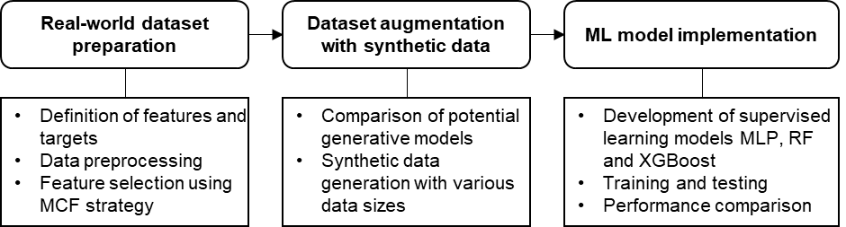
Figure 1: Workflow for investigating data-driven jacket conceptual design

2.1 Real-world dataset preparation
The raw data for real-world jackets from global offshore projects already completed or under construction were preliminarily collected and investigated in Qian, et al. (2023), and the comprehensive preparation of the real-world dataset was performed in Qian, et al. (2024a). The dataset comprises two main components: one part addresses jacket structural variables, while the other focuses on external variables. At the Level of Detail (LOD) 100 for preliminary conceptual design (Akadiri, et al., 2012), six jacket-related parameters were chosen: two discrete (leg number and brace layer number) and four continuous (weight, height, top radius and bottom radius). These variables define the overall topology of jackets and provide insights into their physical properties and load-bearing capacities in real load cases. The external variables capture design boundary conditions such as rotor nacelle assembly (RNA) data, tower characteristics, site conditions and key external loads at the transition piece (TP). In total, the dataset contains 100 instances and 24 features. Table 1 summarizes the definition of variables including wind farm information, structural variables and external variables influencing jacket design.
After collecting the original dataset, a comprehensive preprocessing procedure was conducted. Missing values were addressed using the Multiple Imputation by Chained Equations (MICE) method (Azur, M.J., et al., 2011), ensuring statistically sound and consistent imputations. Following this, the complete dataset was standardized using the min-max scaling method to normalize feature ranges and improve model compatibility. The mean and standard deviation of standardized continuous structural and external variables as well as the distribution of discrete structural variables are presented in Fig. 2. Once preprocessing was completed, feature selection was performed using the Multi-Criterion Fusion (MCF) strategy, which integrates multiple evaluation criteria to identify the most relevant predictors while reducing redundancy (Qian, H., et al., 2024b). The resulting refined dataset served as the foundation for the subsequent data augmentation process.

Table 1: Definition of the variables in the real-world dataset
Variable name | Abbreviation | Variable Type | Unit |  | Annotation
Structural variables of jackets
Leg number | LN | discrete | - |  | Number of jacket legs
Layer number | BN | discrete | - |  | Number of brace layers (or bays)
Jacket weight | JW | continuous | [t] |  | Crucial variable in the initial cost model in conceptual design without considering the weight of the foundation below the seabed
Jacket height | JH | continuous | [m] |  | Vertical height of the jacket between the TP layer and seabed
Top radius | TR | continuous | [m] |  | Radius of the circumcircle formed by the locations of jacket legs at the TP layer
Bottom radius | BR | continuous | [m] |  | Radius of the circumcircle formed by the locations of jacket legs at the ground layer of the jacket
External variables
Rated power | RP | continuous | [MW] |  | -
Rotor diameter | RD | continuous | [m] |  | Diameter of the circular area covered by the rotating blades
Rotor weight | RW | continuous | [t] |  | Total weight of the blades and hub
Nacelle weight | NW | continuous | [t] |  | -
Wind turbine weight | WW | continuous | [t] |  | Total weight of the rotor and nacelle
Tower height | TH | continuous | [m] |  | -
Tower weight | TW | continuous | [t] |  | -
Water depth | WD | continuous | [m] |  | Mean water depth in the offshore wind farm
Wind speeds | WS | continuous | [m/s] |  | Mean wind speed at 10/50/100/150/200 m above the mean sea level (MSL) in the offshore wind farm
Wave height | WH | continuous | [m] |  | Extreme wave height with a return period of 50 years in the wind farm
Wave period | WP | continuous | [s] |  | Wave period associated with the extreme wave height
Force_x | F_x | continuous | [kN] |  | Maximum aerodynamic thrust applied on the rotor and transmitted to TP
Force_z | F_z | continuous | [kN] |  | Compression force due to the superstructures (RNA and tower)
Moment_y | M_y | continuous | [kNm] |  | Maximum bending moment due to the thrust at TP
(a) Mean and standard deviation of standardized continuous jacket structural variables |  |  |  | (b) Percentage distribution of discrete jacket structural variables
(c) Mean and standard deviation of standardized continuous external variables
Figure 2: Distribution of variables in the real-world dataset.

2.2 Data augmentation
As previously mentioned, generative models were employed in this study to generate synthetic tabular data that closely resembled the real-world dataset. Four potential generative models were selected for comparative analysis: Arfpy, REaLTabFormer, Tabular Variational Autoencoder (TVAE) and Synthpop.
Specifically, Arfpy, known for its adaptability and fidelity across various data distributions, utilizes adversarial random forests. It combines random forest-based density estimation with adversarial training, enabling it to effectively learn complex distributions and generate synthetic data with high fidelity and diversity (Blesch, K., & Wright, M. N., 2023). Alternatively, REaLTabFormer leverages Large Language Models (LLMs) through transformer-based architectures. By exploiting self-attention mechanisms and extensive pre-training, it robustly synthesizes realistic tabular data while preserving intricate feature relationships (Solatorio, A. V. & Dupriez, O., 2023). In contrast, TVAE applies variational autoencoder architecture optimized specifically for tabular datasets. It encodes complex, non-linear inter-variable correlations into latent representations and then decodes these representations into synthetic data. This approach effectively preserves intricate feature interactions and distributions within generated datasets (Ishfaq, H., Hoogi, A., & Rubin, D., 2018). Lastly, Synthpop, built upon tree-based statistical algorithms, generates synthetic data by estimating the conditional distributions of each variable given the others. Its sequential imputation approach efficiently preserves key statistical properties and relationships of the original data, making it particularly suitable for generating realistic synthetic tabular datasets for engineering applications (Nowok, B., Raab, G. M., & Dibben, C., 2016).
To assess the feasibility of these four generative models, the stability of synthetic data quality across different sample sizes and their similarity to real data were evaluated. Specifically, the ability of each model to maintain original feature correlations and feature distribution characteristics was investigated. Ten evaluation metrics from the Python-based SDMetrics library (DataCebo, 2016) were employed, including CategoryCoverage, RangeCoverage, CorrelationSimilarity, ContingencySimilarity, NewRowSynthesis, TVComplement, KSComplement, Mean, Median, and Standard Deviation (Std). For example, CategoryCoverage, ranging from 0 to 1, measures the extent to which synthetic categorical variables replicate all category values found in the original dataset. Another metric, CorrelationSimilarity, evaluates the degree of correlation preservation between pairs of continuous variables by comparing synthetic data to the original data.
The general introduction of these metrics is presented in Table 2. Due to space constraints, a detailed discussion of all metrics is omitted here. Ultimately, to facilitate a comprehensive feasibility analysis, these ten metrics were aggregated into a combined metric score ranging from 0 to 10, reflecting overall synthetic data quality and similarity to the original dataset.

2.3 Supervised learning models
This study employed three SL algorithms, i.e., Multi-Layer Perceptron (MLP), Random Forest (RF) and eXtreme Gradient Boosting (XGBoost), to predict jacket structural variables. Specifically, according to the results of feature selection and structural design requirements, appropriate feature subsets were selected as inputs for these SL models that aim to estimate various structural variables as targets in the data-driven design process. These models are trained on the augmented dataset and eventually learn the relationships between input and target variables and handle both regression and classification tasks.
MLP is a feedforward artificial neural network (ANN) composed of interconnected neurons structured in multiple layers (input, hidden, and output) (Taud, H. & Mas, J. F., 2017). It captures complex, nonlinear relationships by adjusting internal weights through iterative backpropagation, making it suitable for complex prediction tasks in structural engineering contexts.
RF is a tree-based ensemble learning method characterized by constructing multiple independent decision trees in parallel during the training stage (Parmar, A., Katariya, R., & Patel, V., 2019). Each decision tree is built using a random subset of data samples and features, introducing variability. The final prediction is made through aggregating these individual outcomes, majority voting in classification problems and averaging in regression. RF models are advantageous due to their robust handling of nonlinear relationships, and inherent capability to reduce overfitting.
XGBoost is an optimized implementation of gradient boosting techniques specifically tailored for structured tabular data (Tang, Y., et al., 2015). Unlike RF, XGBoost sequentially constructs decision trees, where each new tree explicitly aims to minimize the residual errors from previously built models. It incorporates advanced features such as regularization terms (e.g., L1 and L2 penalties) within its objective function to control complexity and avoid overfitting. Moreover, XGBoost employs gradient-based optimization, efficiently parallelizing tree construction and providing fast computation even with large datasets, which significantly enhances its predictive performance and computational efficiency.
In this work, the MLP models and RF models were implemented using Python’s “MLPRegressor”, “MLPClassifier” from the “sklearn.neural_network” package as well as “RandomForestRegressor” and “RandomForestClassifier” from the “sklearn.ensemble” package. The XGBoost models was implemented using the “xgboost” package.

Table 2: General introduction of 10 evaluation metrics capturing statistical similarity between real data and synthetic data.
Metric | Data Compatibility | Description | Ideal score
CategoryCoverage | Discrete | Evaluate whether synthetic categorical data includes all categories present in real data. | Close to 1
RangeCoverage | Continuous | Check if the full numerical range of continuous variables is represented in synthetic data. | Close to 1
CorrelationSimilarity | Continuous | Assess how well pairwise correlations of continuous variables match between synthetic and real data. | Close to 1
ContingencySimilarity | Discrete | Measure similarity of interactions between categorical feature pairs using contingency tables. | Close to 1
NewRowSynthesis | Mixed | Evaluate the generation of novel synthetic data points that differ yet realistically reflect original data. | Close to 1
TVComplement | Discrete | Complement of total variation distance, assessing similarity of categorical distributions. | Close to 1
KSComplement | Continuous | Complement of Kolmogorov-Smirnov distance, comparing distributions of continuous variables. | Close to 1
Mean | Continuous | Compares the means of continuous features between synthetic and real datasets. | Close to 1
Median | Continuous | Compares the medians of continuous features, indicating robustness and central tendency preservation. | Close to 1
Std (Standard Deviation) | Continuous | Compares dispersion or variability of continuous features between synthetic and original datasets. | Close to 1

3. RESULTS
In this section, a comparative evaluation of the four generative models (Arfpy, REaLTabFormer, TVAE and Synthpop) is conducted by examining scores of their combined metrics across synthetic sample sizes ranging from 100 to 2000. The results of this evaluation are summarized in Section 3.1. Based on these results, the optimal generative model is selected to generate synthetic datasets of varying sizes, which are then integrated with the original dataset through data augmentation. These augmented datasets are applied to train and evaluate three SL models (MLP, RF and XGBoost). A comprehensive analysis comparing the predictive performances of these models under different levels of data augmentation is provided in Section 3.2.

3.1 Comparison of performances of generative models for generating synthetic data
To evaluate and compare the performance of the four generative models, each model was implemented using Python libraries (arfpy, realtabformer, SDV, and python-synthpop, respectively). Synthetic datasets of varying sample sizes (100 to 2000) were generated with each model. Subsequently, ten evaluation metrics, described previously in Section 2.2, were computed for each synthetic dataset to quantify both the stability of synthetic data quality and their similarity to the original real-world data. These individual metrics were then aggregated into a combined metrics, ranging from 0 to 10, to facilitate comprehensive comparisons. The comparative results based on the combined metrics across different sample sizes and generative models are visualized in Fig. 3.

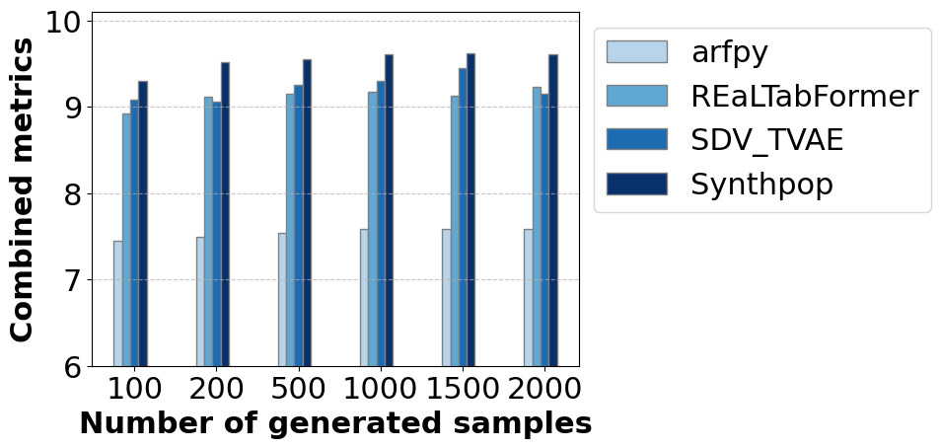
Figure 3: Combined metrics for four generative models when generating synthetic data with the sample sizes from 100 to 2000 based on 100 real samples.

As illustrated in Fig. 3, the comparative analysis of combined metrics reveals clear performance differences among the four generative models across different synthetic sample sizes. Synthpop consistently achieves the highest scores of the combined metrics, demonstrating its superior capability in generating synthetic data closely resembling the real dataset across all evaluated sample sizes. In contrast, Arfpy exhibits noticeably lower scores, indicating a comparatively weaker ability to preserve the original data characteristics. TVAE and REaLTabFormer display intermediate and relatively stable performances, with TVAE slightly outperforming REaLTabFormer in most cases. Furthermore, the combined metrics generally increase or remains stable as the number of generated samples increases, confirming that larger synthetic datasets tend to enhance data quality and similarity to real-world data. Based on these observations, Synthpop emerges as the most effective generative model for data augmentation within this study context.
To visually evaluate the balance between fidelity and diversity in synthetic data generation, four representative parameters were analysed, including two jacket structural variables (jacket height and bottom radius) and two external variables (rotor weight and water depth). Comparative histograms between the original dataset and the Synthpop-generated synthetic data (2000 samples) are illustrated in Fig. 4. As shown, the synthetic distributions closely preserve key statistical properties of the original dataset, accurately replicating primary concentration ranges and overall distribution shapes, while relative differences can be seen in the degree of variation across parameter categories. Jacket height (Fig. 4(a)) and bottom radius (Fig. 4(b)) exhibit tight alignment with original geometric distribution patterns, reflecting minor deviations. Comparatively, external variables rotor weight (Fig. 4(c)) and water depth (Fig. 4(d)) demonstrate slightly more noticeable variations, where localized differences emerge particularly around the upper-middle intervals. These controlled stochastic modifications enhance parametric diversity without compromising domain-specific validity, effectively balancing replication of critical design patterns with mitigation of overfitting risks in downstream machine learning applications.
In summary, the evaluation identifies Synthpop as the optimal generative model for generating synthetic data that harmonizes statistical fidelity with controlled diversity. Leveraging its capability to preserve critical design patterns while enhancing dataset variability, Synthpop-generated synthetic data was selected for the augmentation of the original dataset. These augmented datasets were then applied to train and evaluate supervised learning models, as detailed in Section 3.2, to evaluate their performances for predicting jacket structural design parameters under varying data sizes.

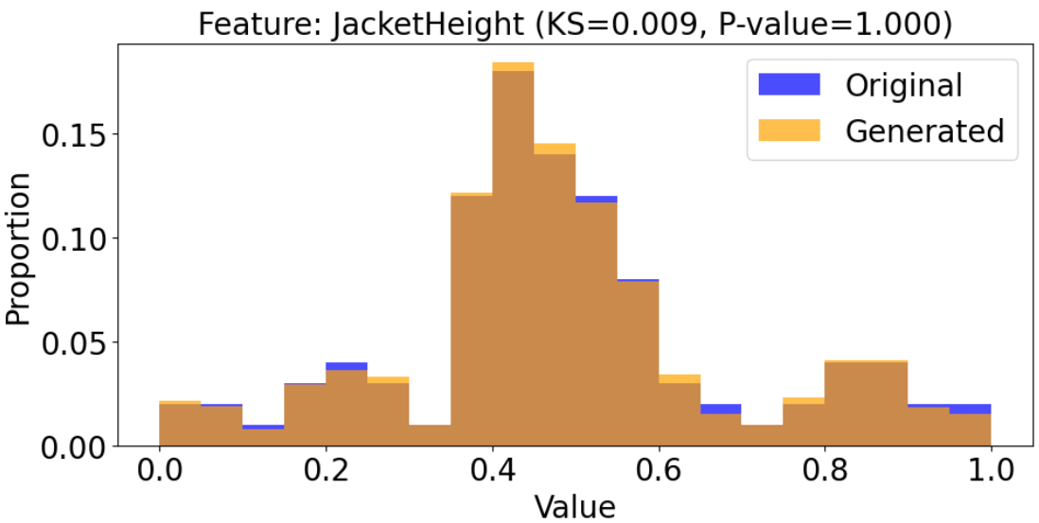 | 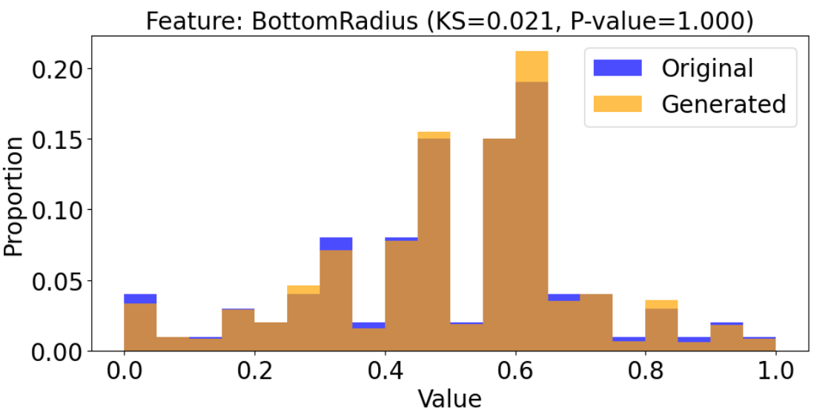
- Jacket structural variable: jacket height | - Jacket structural variable: bottom radius
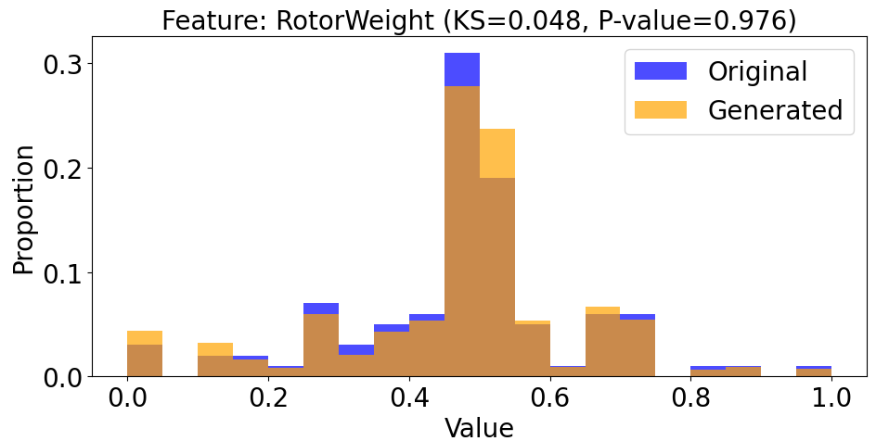 | 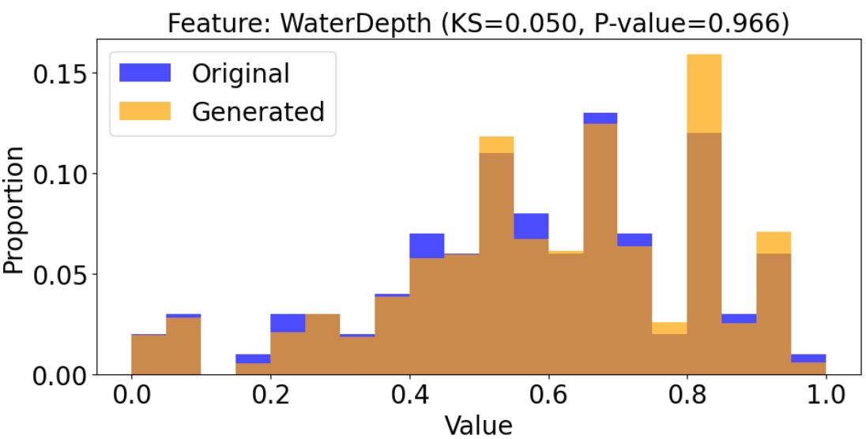
- External variable: rotor weight | - External variable: water depth
Figure 4: Histograms of distributions of standardized jacket structural variables (a) jacket height and (b) bottom radius as well as standardized external variables (c) rotor weight and (d) water depth.

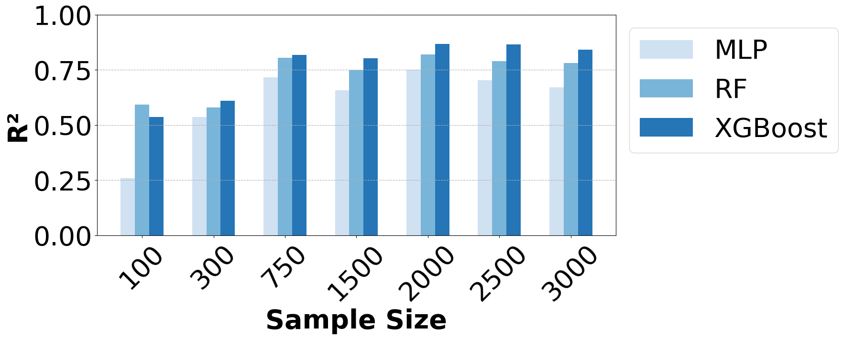 | 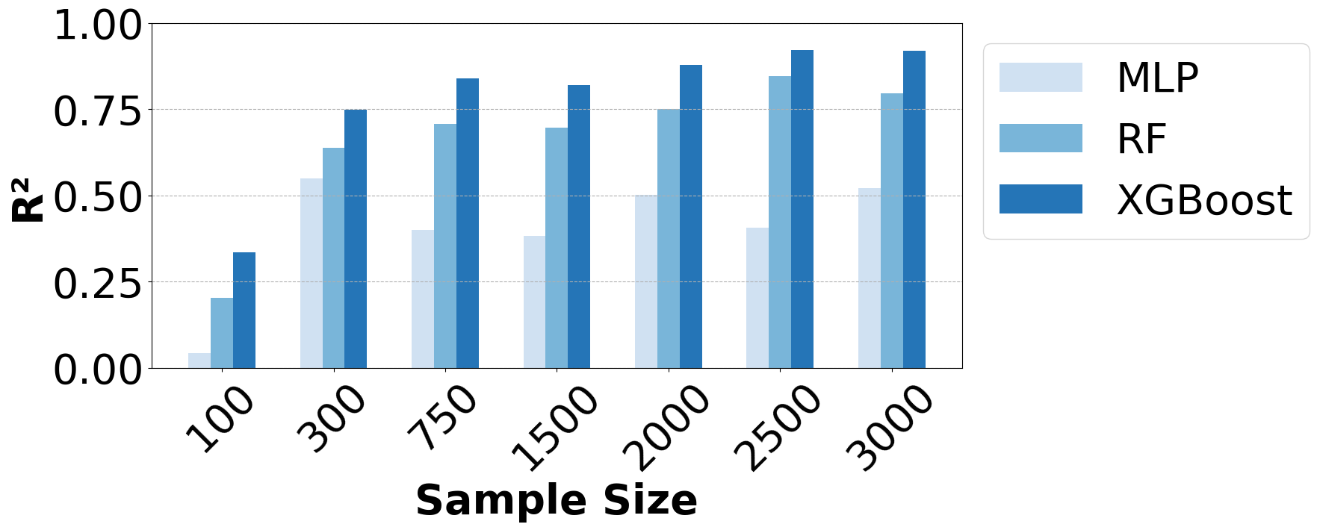
- Jacket height | - Jacket weight
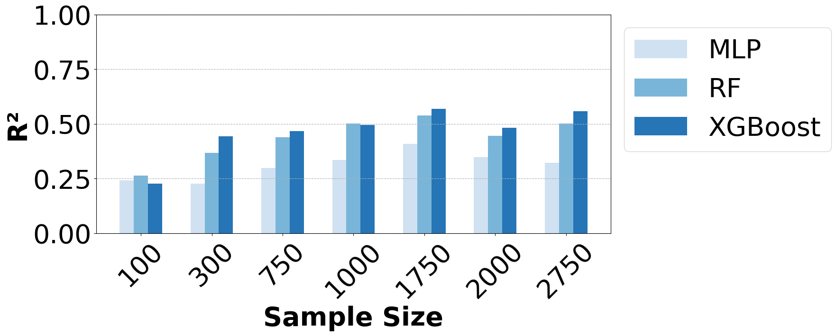 | 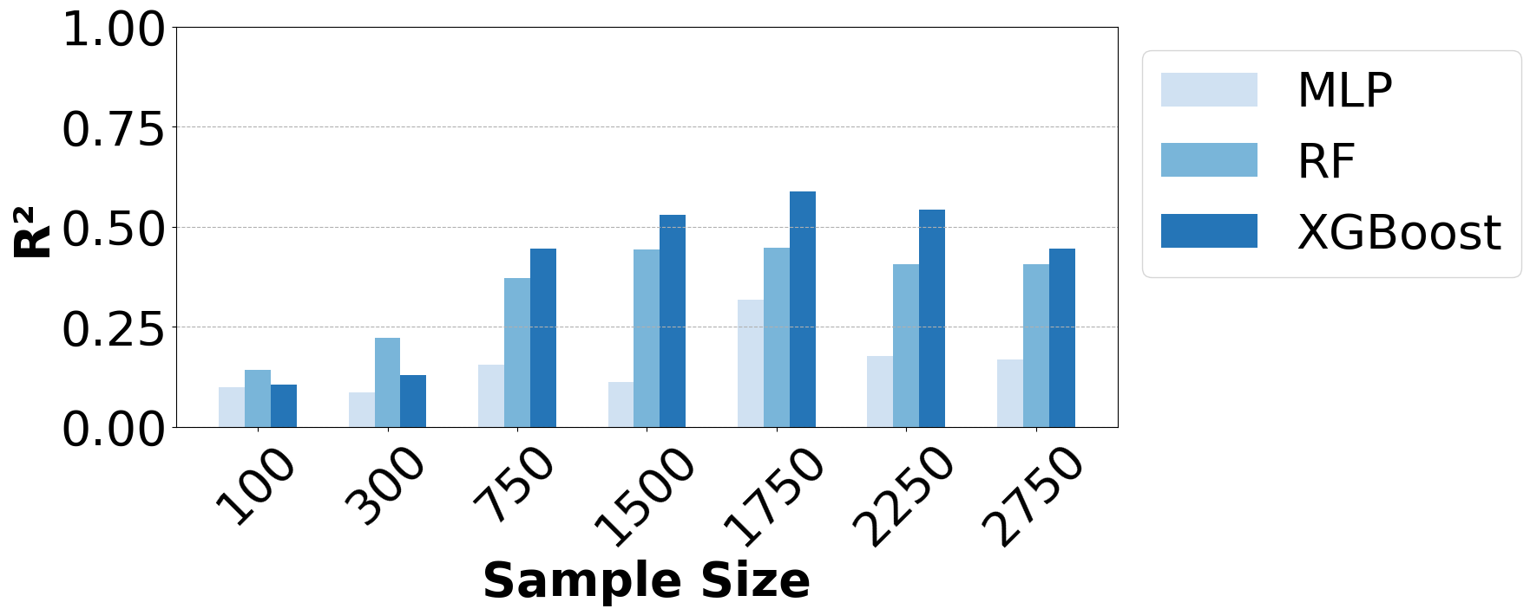
- Top radius | - Bottom radius
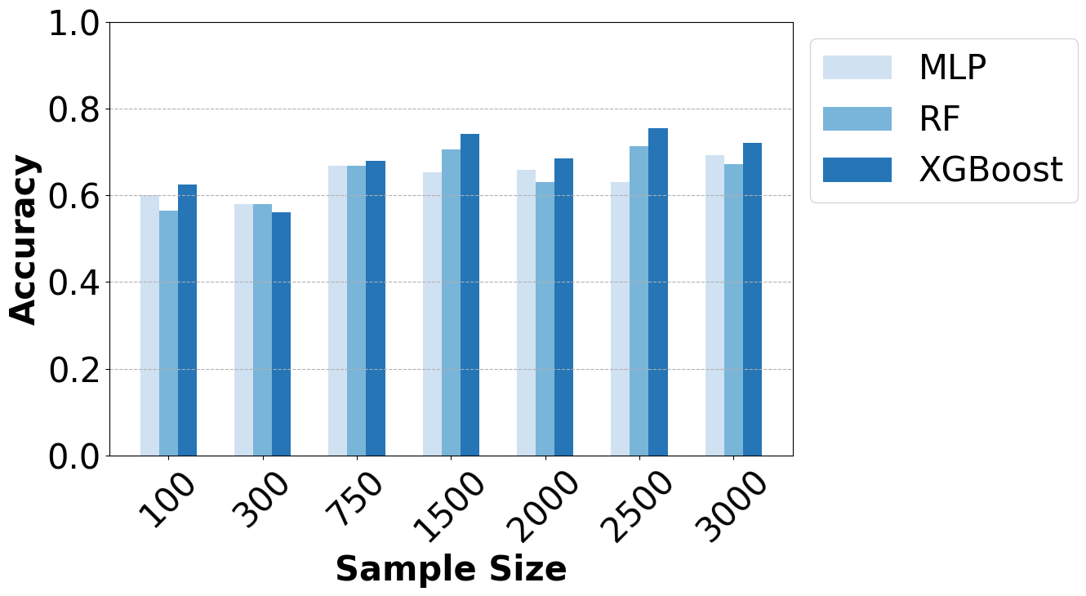 | 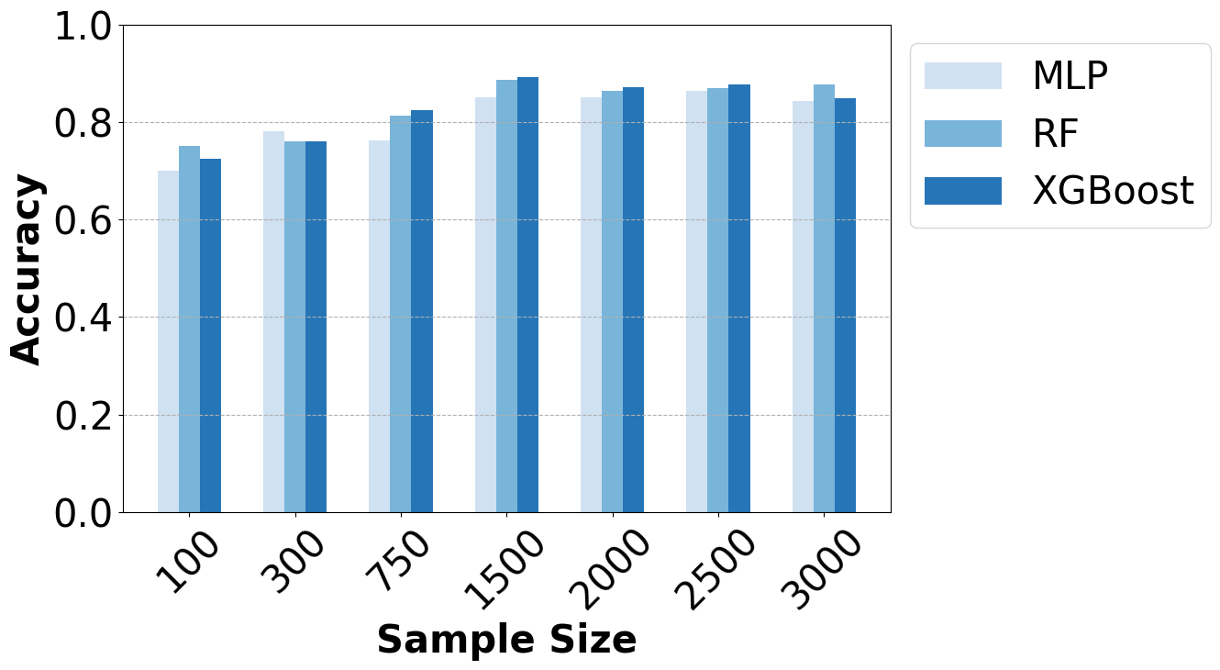
- Layer number | - Leg number
Figure 5: Predictive performances of three SL models trained on datasets with various samples sizes for predicting six jacket structural variables.

3.2 Comparison of predictive performance of supervised learning models
To assess the effectiveness of synthetic data augmentation in enhancing predictive modelling, three SL models, MLP, RF and XGBoost, were applied to datasets of varying sizes that combine original and synthetic data. For each dataset size, a standardized modelling pipeline was implemented. The dataset was divided into a training set and a testing set, with 80 % of the data used for training and the remaining 20 % reserved for testing. Prior to model evaluation, hyperparameter tuning was conducted using cross-validation within the training set to ensure robust model selection. The final models were then trained on the full training data using the optimal hyperparameters and evaluated on the independent testing set. The comparative analysis includes both regression and classification tasks. The coefficient of determination, denoted as R², was employed to evaluate model performance for predicting continuous target variables, while classification metrics of Accuracy was used for discrete targets. The results, presented in Fig 5, illustrate the predictive performances of three SL models for different targets across different sample sizes.
Generally, for four continuous targets, each model’s R² values rise with an increasing number of training samples, highlighting the positive impact of data augmentation. The synthetic samples enlarge and diversify the dataset, allowing the models to learn broader feature distributions and reduce the risk of overfitting. As a result, each model can better capture the complex relationships among design parameters, which leads to higher stability and accuracy in their final predictions. Comparing the performances of three models, XGBoost demonstrates superior scalability, consistently achieving the highest predictive accuracy. Its gradient-boosting architecture appears particularly well-suited for capturing the complex and often nonlinear relationships in structural design parameters. RF follows a similar upward trend and demonstrates competitive performance, whereas MLP demonstrates a more pronounced fluctuation and lower predictive accuracy. This variability can be attributed to the neural network’s reliance on extensive training data and sensitive hyperparameter configurations, whereas tree-based methods, such as RF and XGBoost, incorporate mechanisms (e.g., bagging, boosting) that tend to maintain more robust performance under limited or imperfect data conditions. Additionally, all three models achieve noticeably higher R² values for jacket height and jacket weight (Fig. 5(a) and 5(b)) than for top and bottom radius (Fig. 5(c) and 5(d)). The reason can be that jacket height and weight serve as broader indicators of overall structural mass and dimensions, and thus exhibit stronger correlations with other input variables. In contrast, top and bottom radius are more localized, with inherently flexible design criteria that introduce greater variability and weaker direct relationships with the available features. This difference remains evident across different sample sizes, indicating that predictions of localized geometric design parameter tend to be more challenging under the current data conditions.
Compared to predicting continuous targets, all three models attain higher predictive accuracy for discrete targets (layer and leg number), as shown in Fig. 5(e) and Fig. 5(f). A plausible explanation is that classification tasks involving fewer, well-defined categories generally exhibit lower sensitivity to small errors in predictions, which enables the models to reach more stable and accurate results. Moreover, accuracy consistently increases with larger sample sizes, as the expanded data volume helps each model refine its decision boundaries among discrete classes. In contrast to continuous targets, three SL models yield comparable performance levels in predicting layer and leg numbers, suggesting that all models capture the more distinct relationships underlying discrete variables.
Overall, these results underscore the importance of data augmentation and model selection in improving predictive accuracy for both continuous and discrete targets. Larger augmented datasets with synthetic data yield more robust performance gains, particularly for variables that are closely tied to fundamental structural properties. Although XGBoost and RF exhibit greater robustness than MLP in capturing complex relationships under limited data, all three models demonstrate increased convergence as the sample size grows.

4. CONCLUSION AND DISCUSSION
This study focused on improving the data-driven conceptual design of offshore jacket substructures through synthetic data augmentation and supervised learning. By systematically comparing four generative models (Arfpy, REaLTabFormer, TVAE and Synthpop), Synthpop was identified as the most suitable for generating high-quality synthetic tabular data, effectively balancing statistical fidelity and parametric diversity. The augmented datasets were then used to train and evaluate three SL models (MLP, RF and XGBoost) for predicting key jacket structural parameters. Results demonstrate that synthetic data significantly improves model generalizability and predictive accuracy, especially for continuous variables such as jacket height and weight. XGBoost and RF consistently outperform MLP in regression problems, particularly in settings with limited data, due to their robustness and adaptability. For predicting discrete variables, three models exhibit more stable and comparably good performances due to clearer correlations between discrete targets and the selected input variables. Overall, the findings confirm the potential of synthetic data augmentation as a valuable strategy for addressing data scarcity in early-stage engineering design and the significance of model selection in achieving accurate predictions. Future work will explore extending the framework to more complex structural configurations and investigate advanced generative models such as diffusion models. Additionally, physics-informed optimization strategies will be investigated to better support the design of localized geometric parameters that typically require more domain-specific engineering knowledge, like top and bottom radius. This knowledge-based approach will be expected to complement data-driven methods and further improve their practical applicability.

ACKNOWLEDGEMENTS
The authors want to acknowledge the support of the German Research Foundation (DFG) as part of the Collaborative Research Center 1463 (CRC 1463) "Integrated Design and Operation Methodology for Offshore Megastructures" (project number 434502799). This research was also supported by the HyBridGen project (project number 19FS2067A) funded by the Federal Ministry for Digital and Transport (BMDV).

REFERENCES
Akadiri, P.O., Chinyio, E.A. & Olomolaiye, P.O., (2012). Design of A Sustainable Building: A Conceptual Framework for Implementing Sustainability in the Building Sector. Buildings 2 (2), pp. 126–152. DOI: 10.3390/buildings2020126.
Alpaydin, E., (2020). Introduction to machine learning. Fourth ed.: The MIT Press.
Azur, M.J., Stuart, E.A., Frangakis, C., Leaf, P.J., 2011. Multiple imputation by chained equations: what is it and how does it work? International journal of methods in psychiatric research 20 (1), pp. 40–49. DOI: 10.1002/mpr.329.
Bellmer, H., et al., (2007). Standard Konstruktive Ausführung von Offshore-Windenergieanlagen. Bundesamt für Seeschifffahrt und Hydrographie (BSH).
Blesch, K. & Wright, M. N., (2023). arfpy: A python package for density estimation and generative modeling with adversarial random forests. arXiv preprint. arXiv:2311.07366.
Chen, I, Wong, B., Lin, Y., Chau, S., Huang, H., (2016). Design and Analysis of Jacket Substructures for Offshore Wind Turbines. Energies, 9 (4), p. 264. DOI: 10.3390/en9040264.
Chen, T., He, T., Benesty, M., Khotilovich, V., Tang, Y., Cho, H., ... & Zhou, T., (2015). Xgboost: extreme gradient boosting. R package version 0.4-2, 1(4), 1-4.
DataCebo, 2016. Synthetic Data Metrics (SDMetrics). [Online], Available: https://docs.sdv.dev/sdmetrics.
DNV GL, (2014). DNV-OS-J101–Design of offshore wind turbine structures. DNV GL: Oslo, Norway.
Ishfaq, H., Hoogi, A., & Rubin, D. (2018). TVAE: Deep metric learning approach for variational autoencoder. In Proc. ICLR Workshop. Vancouver, BC, Canada.
Li, Z., Wang, A., Wang, J., Dasilva, O., (2021). Offshore Platform Topsides Struc-tural Design: Using Topology Optimization to Generate Novel Design Concept. In Off-shore Technology Conference (p. D031S032R007). OTC.
Marjan, A. & Huang, L., (2023). Topology optimisation of offshore wind turbine jacket foundation for fatigue life and mass reduction. Ocean Engineering 289, p. 116228. DOI: 10.1016/j.oceaneng.2023.116228.
Nowok, B., Raab, G. M., & Dibben, C., (2016). synthpop: Bespoke creation of synthetic data in R. Journal of statistical software, 74, 1-26.
Parmar, A., Katariya, R., & Patel, V., (2019). A review on random forest: An ensemble classifier. In International conference on intelligent data communication technologies and internet of things (ICICI) 2018 (pp. 758-763). Springer International Publishing.
Qian, H., Panagiotou, E., Marx, S., Ntoutsi, E., 2023. Data-based Conceptual Design of Offshore Jackets Using a Self-developed Database. ISOPE International Ocean and Polar Engineering Conference, S. ISOPE-I-23-154.
Qian, H., Panagiotou, E., Peng, M., Ntoutsi, E., Kang, C., & Marx, S. (2024a). A novel dataset and feature selection for data-driven conceptual design of offshore jacket substructures. Ocean Engineering, 303, 117679.
Qian, H., Bartels, J. H., & Marx, S. (2024b). Conceptual Design of Offshore Jacket Substructures Using Machine Learning. In Journal of Physics: Conference Series, Vol. 2767, No. 8, p. 082010. IOP Publishing.
Seidel, M., (2010). Design of support structures for offshore wind turbines - Interfaces between project owner, turbine manufacturer, authorities and designer. Stahlbau, 79 (9), pp. 631–636. DOI: 10.1002/stab.201001362.
Solatorio, A. V. & Dupriez, O., (2023). REaLTabFormer: Generating realistic relational and tabular data using transformers. arXiv preprint. arXiv:2302.02041.
Taud, H. & Mas, J. F., (2017). Multilayer perceptron (MLP). In Geomatic approaches for modeling land change scenarios (pp. 451-455). Cham: Springer International Publishing.

