Enhancing Early-Stage BIM–LCA Integration:
bLCA as a Further Development of the eLCA Platform
Cemre Karaoglan^{1, *}, Elias Kufeld¹, Malte Junge¹, Hossamelden Elmalah¹, Linda Hildebrand², Jakob Beetz¹
¹ RWTH Aachen University, Aachen, Germany
² c u b e - Circularity in the built environment, Berlin, Germany
*Corresponding email: karaoglan@dc.rwth-aachen.de

ABSTRACT
Life Cycle Assessment (LCA) is increasingly integrated into Building Information Modelling (BIM) workflows to support environmentally aware design processes. Despite significant progress, conducting meaningful LCA in the early design phases remains challenging. Early-stage models are typically characterised by low Levels of Development (LOD), incomplete material specifications, and high uncertainty; conditions under which many existing open-source BIM–LCA workflows struggle to deliver robust results and user-friendly interfaces. To address this gap, this study presents bLCA, a further development of the web-based eLCA tool that enhances its IFC-based BIM workflow. The proposed workflow consists of three main steps: (1) model classification according to DIN 276 cost groups, (2) semi-automated product/material assignment for environmental data mapping, and (3) intuitive visualisation of LCA results tailored to the needs of architects and planners. Although still in development, the prototype shows potential to meet the initial requirements set through practitioner workshops. The overarching aim is to facilitate informed decision-making in early planning stages by lowering methodological barriers, increasing transparency, and embedding LCA more seamlessly into BIM-based design processes.

INTRODUCTION
The construction industry and the built environment have a critical environmental impact, accounting for 36% of global final energy use, 39% of energy-related CO₂ emissions (GlobalABC, 2019), and nearly half of all global resource extraction (Calle Müller et al., 2024). However, digitalisation strategies and informed decision-making embedded from the start can mitigate this impact. In response, integrating Life Cycle Assessment (LCA) and Building Information Modelling (BIM) offers an opportunity to quantify the environmental impacts of design decisions within digital construction workflows. Despite significant progress, conducting BIM-based LCA in the early design phases remains challenging. Early-stage models are typically characterised by low Levels of Development (LOD), creating a mismatch between the model data and environmental databases. Incomplete layer and material information in early-phase models, frequent design changes, iterative project updates, high onboarding costs for existing tools, limited time and LCA expertise, and black-box calculations all contribute to these challenges. At the same time, only a limited number of open-source solutions are available, most of which lack user-friendly, intuitive interfaces, robust, transparent calculations, or both (Kufeld et al., 2025). As a result, LCA is mostly conducted at the end of the project as documentation and certification rather than as part of the design decision process.
To address this gap, this study presents the bLCA tool as a further BIM-based development of the web-based eLCA tool (BBSR, n.d.). It is currently possible to work with Industry Foundation Classes (IFC) models within the eLCA interface, yet there are many areas for improvement in interpreting model data and in visual interactions. To address this, bLCA introduces a new 3D viewer interface (Alan, 2026) and a new workflow that connects the different steps of the process. The proposed workflow consists of three main steps: (1) model classification to label BIM elements according to DIN 276 (Deutsches Institut für Normung e. V., 2018), (2) (semi-)automated product and material assignment for environmental data mapping, and (3) intuitive visualisation of assessment results tailored to the needs of architects and planners with limited LCA expertise. This paper therefore focuses on designing and implementing an open-source prototype that operationalises practitioner-derived requirements for early-stage BIM-LCA workflows. With bLCA, we contribute: (1) an ML-based DIN 276 classifier for early-phase models, (2) a three-tier LOD-aware material assignment workflow, and (3) an integrated 3D visual feedback and transparency dashboard. These contributions correspond to the following research questions:
• RQ1: How can cost-group classification be automated under low-LOD, heterogeneous IFC conditions?
• RQ2: How can material/product assignment be aligned with LOD and uncertainty?
• RQ3: How can results be visualised to support non-expert design decisions?
The remainder of the paper situates these questions within existing BIM-LCA research, presents the bLCA prototype, and discusses its current limitations.

STATE OF THE ART
The integration of BIM and LCA has been widely investigated in recent years, with research spanning critical reviews of methodological approaches (Bolognesi et al., 2025; Bueno et al., 2018; Soust-Verdaguer et al., 2017), comparative assessments of existing software tools (Dharmarathna et al., 2024; Karunaratne and Dharmarathna, 2022; Schultz et al., 2016) and the development of new tool prototypes and plug-ins (Kanafani et al., 2021; Rezaei et al., 2019; Tam et al., 2023). A recurring finding across these studies is that early-phase BIM-LCA integration requires more than data exchange. It demands continuous feedback loops between design decisions and environmental outcomes (Cavalliere et al., 2019; Kamari and Schultz, 2024; Prideaux et al., 2024). Several authors have converged on a set of key requirements for such tools: hot-spot analysis of environmental impacts mapped onto the building model, an interactive 3D viewer for intuitive interpretation, benchmarking against reference values, and transparent calculation methods (Dalla Mora et al., 2020; Forth, 2024; Hollberg et al., 2021; Sartori et al., 2021). Building on these findings and informed by structured practitioner workshops with BIM Allianz (BIM-Allianz e.V., n.d.), we have developed a set of design guidelines for the bLCA tool to address the most persistent gaps identified in both the literature and current practice (Karaoglan et al., 2025).
The first step in developing the bLCA tool is to understand the current BIM integration in the eLCA tool (BBSR, n.d.), which forms the basis of this study. Users can import IFC models via eLCA’s free-to-use web interface and obtain results by entering the necessary data on a single page for the listed building elements. The workflow similarly follows three steps: building element classification, environmental data mapping with the pre-curated building element templates in the eLCA library, and display of LCA results. The building element classification algorithm performs well on complete IFC models, and the building element template logic helps assign objects using the German ÖKOBAUDAT environmental database. However, several shortcomings remain in the current IFC import workflow. Accordingly, the current prototype addresses these limitations through three central improvements: an alternative classification method, LOD-aware material assignment, and enhanced visual feedback of LCA results.

PROTOTYPE DESIGN AND IMPLEMENTATION
As a further development of the eLCA tool, bLCA aims to offer a more visual alternative for working with IFC models. The geometric data here serves as a helper for a more intuitive experience, whereas the semantic data from the IFC sets the basis for the assessment. Although continuous and at times iterative, the workflow is divided into three main steps: Model classification, material/product selection, and visualisation of results (Figure 1). From project creation through the results section, each step includes a 3D viewer to display the IFC geometry.
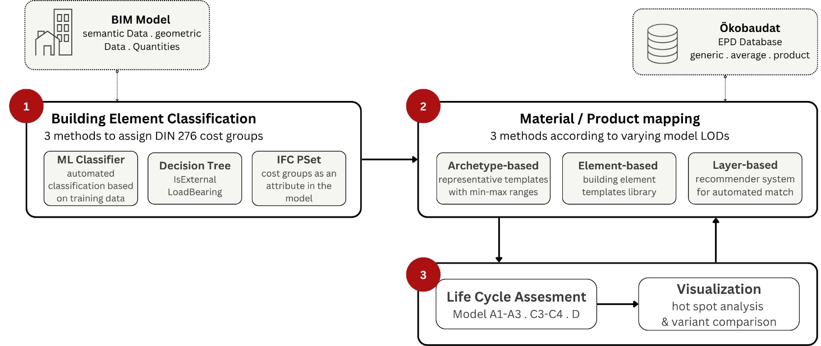
Figure 1: bLCA Tool Workflow.
The methodological approach starts by identifying workflow bottlenecks and the requirements for a BIM-LCA tool. These are derived from the literature and practitioner workshops (Karaoglan et al., 2025). These requirements and potential solutions are translated into design strategies, which are then implemented in a prototype. The following subsections therefore describe how each strategy is operationalised in this prototype.

Building Element Classification
Classification of all building construction elements according to DIN 276 (Deutsches Institut für Normung e. V., 2018) is a mandatory preliminary step in the current eLCA workflow. DIN 276 is the German technical standard that classifies building elements into hierarchically structured classes, so-called cost groups (Kostengruppen). In eLCA, these cost groups serve as the structural backbone of the life cycle assessment and as the filter for the building element template library in the next step.
eLCA already provides a classifier that attempts to determine a DIN 276 cost group for each IfcProduct by passing it through a decision tree based on its IFC class and a few native properties, such as the Boolean flags or LoadBearing. This works only where those properties are present and correct. Early-phase IFC models are often sparsely attributed, and a fixed decision tree cannot reliably resolve a large, hierarchically structured and at times ambiguous category system from a handful of general properties. As a result, cost group assignments usually must be corrected or completed element by element by hand.
bLCA addresses this with a machine learning (ML) classifier trained on element names, paired with a confidence estimate that either commits to a precise prediction, falls back to a coarser grouping, or flags uncertain cases for user review. Experimental classifier models were trained and evaluated on six datasets extracted from human-named, cost-group-classified building models. To account for real-world heterogeneity, the corpus includes data from several sources of varied quality and design development phases. In preliminary offline experiments on a large set of structured Revit-type names (roughly 14,000 elements from 49 commercial projects), the classifier achieved about 94% accuracy across 43 cost groups when evaluated on held-out data. A much smaller dataset of 736 samples from a corpus of models by architecture students only reached about 49%. Evaluation of a combined model that unifies all datasets with tuned weights for optimal generalisation is still pending, as practitioner testing of the bLCA tool is about to begin.
To let users validate and adjust the automated cost group classification, the user interface tools are combined with a 3D viewer (Figure 2). Model elements are overlaid with different colours based on their cost group classification, enabling initial visual validation. Highlighting selected list elements in the 3D viewer, along with show/hide/isolate options, further supports this. The tool offers three ways to obtain the codes and lets the user switch between them to compare the results: the new ML classifier, the previous decision-tree-based classifier, or, where cost groups have already been modelled manually, a direct read-out from the corresponding IfcProperty. The option to change the classification is always provided: users can select multiple elements and drag-and-drop them onto an existing cost group or create a new one from the drop-down list. This way, even if missing or faulty IFC model data leads to incorrect classifications, it is possible to correct them without reimporting the model.
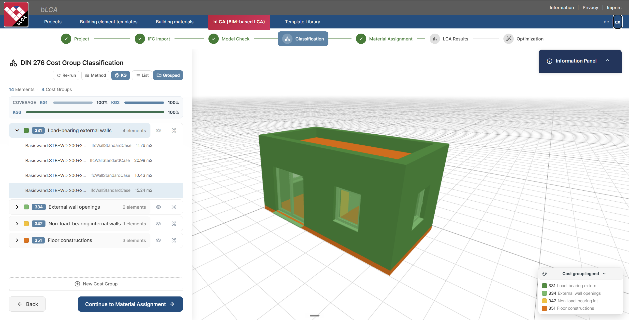
Figure 2: bLCA material classification according to DIN 276 - user interface.

Material / Product Selection
Assigning a material (generic, average LCA data) or a product (specific LCA data, EPDs) from the environmental database, in this case Ökobaudat to each layer in each building element within the project is one of the most time-consuming steps in the classical IFC-imported eLCA workflow. As a solution, three assignment systems are presented where the user can approach this step according to their need and the LOD of the building model (Figure 3):
- Archetype-based system (low-LOD): A library composed of the most commonly used building elements is presented to the user. An example here would be a load-bearing exterior wall, insulated from the inside and the outside, as two different archetypes. Each layer in each archetype represents multiple possible matches from the database, so the LCA data is a min-max range rather than a single value. With each decision, the pool of possible candidates shrinks, narrowing the possible min-max LCA result ranges for the project.
- Building element-based system (mid-LOD): The same library system in the classical eLCA (BBSR, 2022) is adapted, where users can create a library of custom building-element templates and assign them to selected model objects. A template consists of different layer compositions, each layer mapped to an Ökobaudat entry. The user can search the database by inputting keywords and assign a selected match to the new layer they would create. The same ‘recommender’ service described below also powers this keyword search. This template mechanism could, in principle, ingest the BKI Konstruktionsatlas (BKI, 2023) to use cost as an additional parameter; however, this is not part of the current implementation due to the catalogue's licensing restrictions.
- Layer-based system (high-LOD): In this option, users can list the layers in the building model and use the ‘recommender’ service to match each layer to an Ökobaudat material or product (Elmalah, 2026). The recommender operates on a pre-built index of the Ökobaudat catalogue, combining field-weighted lexical statistics with BGE-M3 embeddings. For each layer, a search query is generated from the material name, and a multilingual dense ranker (BGE-M3) retrieves candidate matches. A cross-encoder then re-ranks the top 20 candidates by jointly comparing the query with the corresponding catalogue entries. The resulting suggestions are expressed as calibrated confidence scores rather than raw similarity scores. If dense retrieval does not yield usable candidates, a field-weighted BM25F ranking based on the material name is used as a fallback. Following re-ranking, suggestions with a confidence score above 50% are automatically assigned and presented with a confirm/reject control, while lower-confidence matches are displayed as a ranked shortlist. A separate keyword-based search remains available to allow users to override the ranked recommendations. Evaluation on two public Revit sample models, each containing 54 materials, resulted in a usable Ökobaudat match at k@1 of 44% and k@20 of 85% for the English model, compared with 35% and 74%, respectively, for the German model. Although these results are insufficient to support fully unsupervised material assignment, they demonstrate the potential of the approach for a semi-automated workflow in which users oversee and validate the recommendations. IFC type and cost group were initially incorporated as additional matching cues; however, their inclusion reduced retrieval quality, and therefore only the material name was retained for re-ranking. Air and void layers are excluded because they do not contain material information. Framing layers, such as studs or joists, are instead recognised and assigned a default, editable area fraction of 20%.
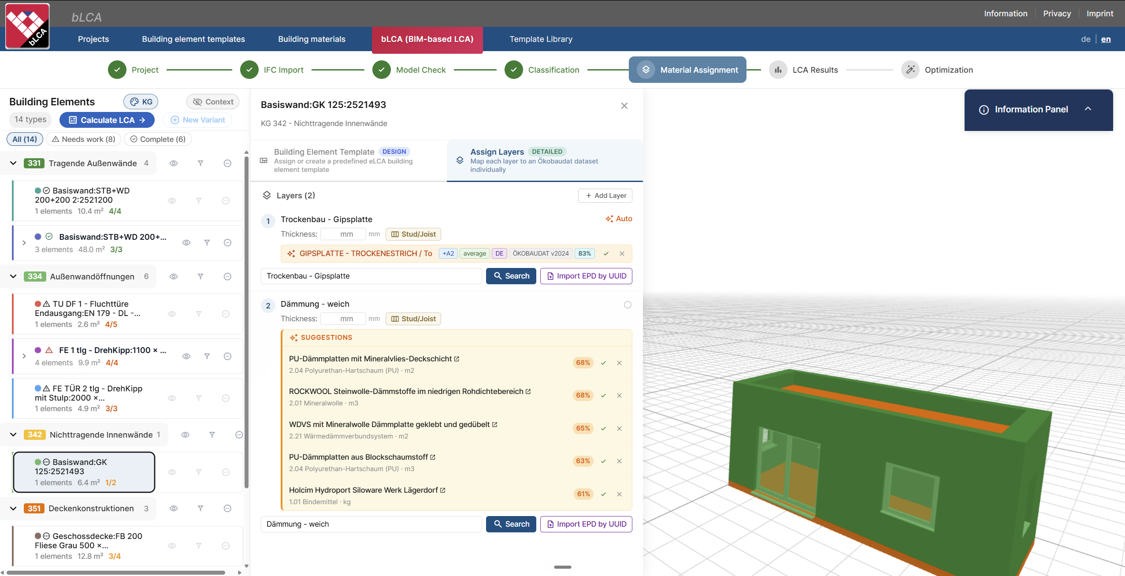
Figure 3: Material/Product selection - user interface.
Considering that an average IFC model has hundreds of building elements, it is necessary to group objects with the same layer compositions and treat them as the same ‘type’ of building element to enable parametric assignment. This way, one can change the whole group by editing only one member. Individual elements can also be broken out of their group, allowing modelling mistakes to be corrected or design changes to be applied after the fact.

Visualisation of the Results
Once the LCA is computed, the result is projected back onto the IFC model in the 3D viewer. Each building element is coloured on a green-to-red scale, normalised in one of two ways: the relative mode compares each element to the largest single contributor in the current variant and shows where the impact is concentrated, while the BNB mode compares each element's per-m²·a impact to the Global Warming Potential (GWP) reference value of the project's BNB/DGNB benchmark version and shows how much of the available budget is being consumed. A hotspot filter keeps only elements above a chosen threshold or the top-N contributors for any indicator, whereas the rest are ghosted at low opacity so the building context stays readable (Figure 4).
For design decision support and iterative testing, users can create variants by selecting alternative materials/products from the database. Users can open up to four independent computations on the same IFC model side by side in a synchronised layout. The colour scale is also shared across loaded variants, so higher-impact variants appear redder instead of each viewport self-normalising to look the same.
Calculation transparency was one of the biggest concerns raised in the workshop. For this reason, any element in the list can be expanded to reveal the underlying eLCA formula and the values fed into it (layer thickness, quantity, service life, Ökobaudat entry), broken down per EN 15978 life-cycle module. A separate calculation basis dialogue lets the user choose which modules feed into the results and into the BNB score, and recomputes both consistently. The resulting dashboard state can be exported as a printable, eLCA-styled report.
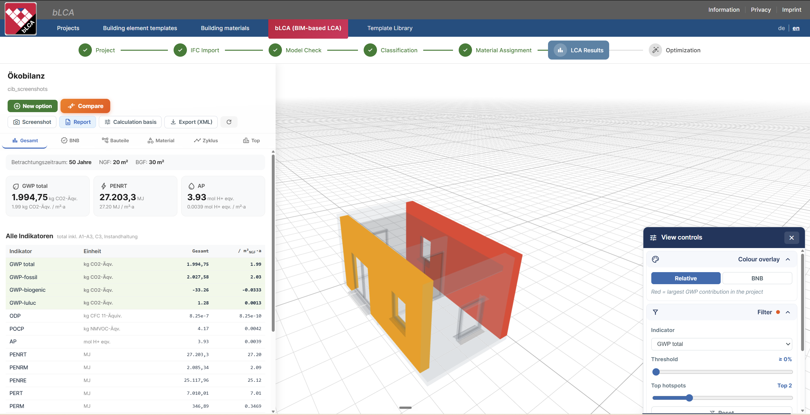
Figure 4: Visualisation of the results - user interface.

DISCUSSION
During the practitioner workshop, several requirements for a BIM-based LCA tool emerged, and shaped many of the design decisions in bLCA. The discussion below revisits these requirements and reflects on how far the current prototype addresses them.
The cost group classifier shows both the potential and the current limits of automating model classification. Even for very large models, it can be a viable solution when the naming closely matches its training corpus. Its reliability drops, however, on models it is less prepared for. Suitable training data is scarce because well-labelled industry models are difficult to share due to copyright and confidentiality, so cost groups underrepresented in training or elements with unconventional naming are classified less accurately. Closing this gap requires training data spanning a wider range of authoring styles. Expanding and balancing the training corpus is the priority for making automated classification dependable across a wider variety of real-world models. For material and product assignment, the three systems reflect the system's adaptability to LOD. Users can run a rough screening with automated matches or go into layer-level detail. The option to save custom templates has clear potential for offices that want to build an internal library over time. Grouping elements with the same layer composition and treating them as one parametric “type” is a substantial improvement over assigning hundreds of elements individually, and is essential for scaling the workflow to real-world building models.
On the results side, the dashboard provides visual feedback, calculation transparency, and variant comparison. A further workshop requirement, integration with BIM-authoring tools for iterative testing, is still in progress, with a Bonsai add-on for Blender as the first target. The interactive 3D viewer is present throughout the workflow, from project creation to results. Its bidirectional link with the element list makes the interaction more intuitive, because users no longer have to work with two disconnected representations of the same model. Closely related is the requirement to edit or fix faulty IFC models without leaving the tool. This is supported in both the cost-group classification and the layer assignment, where users can override automated results, create missing groups, or fall back to manual search. In practice, this means that models with incorrect or missing data can still be made usable without a full round-trip back to the BIM authoring tool.
These features are especially relevant because few free, open-source solutions exist for early-phase BIM-based LCA (Kufeld et al., 2025), yet the current implementation has several limitations. The archetype system remains an early prototype with a limited number of examples. For routine use, it would require a more comprehensive library, complemented by decision trees that guide planners through early design choices. Although the min–max ranges defined within the archetypes provide a useful way to represent uncertainty, they are not yet integrated into the results page. The recommender system likewise requires further testing. Its performance still depends to some extent on IFC quality, particularly consistent material naming, although manual overrides and keyword-based search provide alternative paths when automated matching is unsuccessful. The current auto-assignment threshold of 50% is a fixed heuristic rather than a learned or empirically calibrated value. Furthermore, the embedding and cross-encoder models have not yet been fine-tuned on domain-specific IFC material–Ökobaudat pairs. The assignment interface (Figure 3) is also currently information-dense and may overwhelm first-time users. A more streamlined and polished layout is therefore planned to improve usability.
The present paper should consequently be understood as a prototype implementation study rather than a completed validation. A systematic evaluation of bLCA is planned in collaboration with BIM Allianz, including a comparison with existing early-phase BIM-LCA tools using the benchmarks introduced in a companion publication (Kufeld et al., 2025). The results of this evaluation will be reported separately.

CONCLUSION
This paper presented bLCA as a prototype extension of the open-source eLCA platform for early-stage BIM-LCA workflows. The implementation addresses three recurring barriers identified in the literature and practitioner workshops: limited interaction with IFC geometry, insufficient support for low-LOD material assignment, and a lack of transparent visual feedback on LCA results. By linking a 3D viewer to classification, material assignment, and result interpretation, bLCA lowers the practical threshold for using LCA during design rather than only for later documentation.
Several directions remain open for future work. The environmental database entries can be enriched with information from external data dictionaries and similar online sources to improve the quality of automated matches and the recommender's coverage. The archetype library, currently a small prototype, should be expanded into a more comprehensive collection with decision trees that guide planners through early design choices. Individual workflow steps can also be exposed as modular components or plug-ins, allowing integration into other BIM-authoring environments.
A qualitative and quantitative evaluation of bLCA with practitioners is planned for fall 2026 in collaboration with BIM Allianz, and its results will be reported in a follow-up publication. With those findings, the tool can be iteratively refined towards the ambition stated at the outset: making environmental considerations part of early design decision-making rather than a mere certification procedure.

ACKNOWLEDGEMENTS
This work is part of the project BIM-based Life Cycle Assessment: Enhancement of the eLCA Tool with OpenBIM Standards, funded by the ZukunftBau innovation program. We thank our project partners for their continued support. We also acknowledge BIM Allianz e.V. for their valuable input.

REFERENCES
BBSR, 2022. eLCA Bauteilkatalog.
BBSR, n.d. Ökobilanzierungstool eLCA [WWW Document]. eLCA. URL https://bauteileditor.de/ (accessed 6.28.26).
BIM-Allianz e.V., n.d. BIM Allianz [WWW Document]. URL https://www.bim-allianz.de/ (accessed 2.25.25).
BMWSB, n.d. ÖKOBAUDAT (the German federal LCA database for building products) [WWW Document]. Ökobaudat. URL https://www.oekobaudat.de/ (accessed 11.5.24).
Bolognesi, C., Bassorizzi, D., Balin, S., Manfredi, V., 2025. An Overview on LCA Integration in BIM: Tools, Applications, and Future Trends. Digital 5, 31. https://doi.org/10.3390/digital5030031
Bueno, C., Pereira, L.M., Fabricio, M.M., 2018. Life cycle assessment and environmental-based choices at the early design stages: an application using building information modelling. Archit. Eng. Des. Manag. https://doi.org/10.1080/17452007.2018.1458593
Calle Müller, C., Pradhananga, P., ElZomor, M., 2024. Pathways to decarbonization, circular construction, and sustainability in the built environment. Int. J. Sustain. High. Educ. 25, 1315–1332. https://doi.org/10.1108/IJSHE-09-2023-0400
Cavalliere, C., Habert, G., Dell’Osso, G.R., Hollberg, A., 2019. Continuous BIM-based assessment of embodied environmental impacts throughout the design process. J. Clean. Prod. 211, 941–952. https://doi.org/10.1016/j.jclepro.2018.11.247
Dalla Mora, T., Bolzonello, E., Cavalliere, C., Peron, F., 2020. Key Parameters Featuring BIM-LCA Integration in Buildings: A Practical Review of the Current Trends. Sustainability 12, 7182. https://doi.org/10.3390/su12177182
Deutsches Institut für Normung e. V., 2018. DIN 276:2018-12, Kosten im Bauwesen. https://doi.org/10.31030/2873248
Dharmarathna, D., Bunster, V., Graham, P., 2024. A review of building life cycle assessment software tools: Challenges and future directions. IOP Conf. Ser. Earth Environ. Sci. 1363, 012063. https://doi.org/10.1088/1755-1315/1363/1/012063
Elmalah, H., 2026. AI-Powered Semantic Engine for Contextual BIM-Based LCA (Master’s Thesis). RWTH Aachen University, Aachen.
Forth, K., 2024. BIM-based semantic enrichment for environmental analyses using Large Language Models (Doctoral Thesis). Technische Universität München.
GlobalABC, 2019. 2019 global status report for buildings and construction. International Energy Agency: Global Alliance for Buildings and Construction, Paris.
Hollberg, A., Kiss, B., Röck, M., Soust-Verdaguer, B., Wiberg, A.H., Lasvaux, S., Galimshina, A., Habert, G., 2021. Review of visualising LCA results in the design process of buildings. Build. Environ. 190, 107530. https://doi.org/10.1016/j.buildenv.2020.107530
Kamari, A., Schultz, C., 2024. Streamlining BIM-integrated LCA for rapid-iterative-informed-early stage upfront carbon assessment by architects and engineers. Archit. Struct. Constr. 5, 5. https://doi.org/10.1007/s44150-024-00122-2
Kanafani, K., Kjær Zimmermann, R., Nygaard Rasmussen, F., Birgisdóttir, H., 2021. Learnings from Developing a Context-Specific LCA Tool for Buildings—The Case of LCAbyg 4. Sustainability 13, 1508. https://doi.org/10.3390/su13031508
Karaoglan, C., Kufeld, E., Hildebrand, L., Beetz, J., 2025. Early-Phase BIM-LCA Integration: Practice-Based Challenges and Research-Informed Solutions, in: Proceedings of the 2025 European Conference on Computing in Construction. Presented at the European Conference on Computing in Construction, Porto. https://doi.org/10.35490/EC3.2025.509
Karunaratne, S., Dharmarathna, D., 2022. A review of comprehensiveness, user-friendliness, and contribution for sustainable design of whole building environmental life cycle assessment software tools. Build. Environ. 212, 108784. https://doi.org/10.1016/j.buildenv.2022.108784
Kufeld, E., Karaoglan, C., Hildebrand, L., Beetz, J., 2025. Early-Phase BIM-LCA Tools: Performance Gaps and Insights from Literature and Practice, in: Sustainable Built Environment Conference 2025 Zurich - Extended Abstracts, SBE Conference Series. Presented at the Sustainable Built Environment Conference (SBE25), ETH Zurich, Zurich. https://doi.org/10.3929/ethz-c-000785700
Prideaux, F., Allacker, K., Crawford, R., Stephan, A., 2024. Integrating life cycle assessment into the building design process—a review. Environ. Res. Infrastruct. Sustain. 4, 022001. https://doi.org/10.1088/2634-4505/ad3577
Rezaei, F., Bulle, C., Lesage, P., 2019. Integrating building information modeling and life cycle assessment in the early and detailed building design stages. Build. Environ. 153, 158–167. https://doi.org/10.1016/j.buildenv.2019.01.034
Sartori, T., Drogemuller, R., Omrani, S., Lamari, F., 2021. A schematic framework for Life Cycle Assessment (LCA) and Green Building Rating System (GBRS). J. Build. Eng. 38, 102180. https://doi.org/10.1016/j.jobe.2021.102180
Schultz, J., Ku, K., Gindlesparger, M., Doerfler, J., 2016. A benchmark study of BIM-based whole-building life-cycle assessment tools and processes. Int. J. Sustain. Build. Technol. Urban Dev. 7, 219–229. https://doi.org/10.1080/2093761X.2017.1302839
Soust-Verdaguer, B., Llatas, C., García-Martínez, A., 2017. Critical review of bim-based LCA method to buildings. Energy Build. 136, 110–120. https://doi.org/10.1016/j.enbuild.2016.12.009
Tam, V.W., Zhou, Y., Shen, L., Le, K.N., 2023. Optimal BIM and LCA integration approach for embodied environmental impact assessment. J. Clean. Prod. 385, 135605. https://doi.org/10.1016/j.jclepro.2022.135605

The decision tree for the cost group classification in the eLCA IFC parser (KG.py): https://bitbucket.org/beibob/elca/src/master/lib/ifcparser/KG.py (accessed 7th September 2026).
BMWSB / BBSR (n.d.) ÖKOBAUDAT Database Platform: https://www.oekobaudat.de/ (accessed 9th September 2026).

