Immersive Virtual Reality for Pre-Construction Design Review
A Pre–Post Study of Constructability, Maintainability and Safety Review beyond Automated Clash Detection
Vignesh Vijayalakshmi Palanisamy¹, Senthilkumar Venkatachalam^{1, *}

¹ Dept. of Civil Engineering, Indian Institute of Technology Palakkad, Kerala, India
*Corresponding email: senthil@iitpkd.ac.in

ABSTRACT
Building Information Modelling (BIM) and automated clash detection are essential in public-sector project delivery, yet they address primarily geometric interferences and leave a class of experiential, human-scale issues (constructability, maintainability and safety) difficult to anticipate before construction. This paper reports an exploratory pre-post study of a short immersive virtual reality (VR) walkthrough added to a BIM training programme for government engineers. Twenty practising engineers reviewed a federated model of a three-storey administrative building with a glazed façade and open, un-partitioned floor plates, first through desktop BIM and Navisworks / Autodesk Construction Cloud (ACC) clash detection, then through a five-minute guided VR walkthrough. Confidence across six design-review dimensions was measured before and after VR on a five-point scale, complemented by a constructability, maintainability and safety issue checklist and technology-acceptance items. All six confidence dimensions increased significantly after VR (Wilcoxon signed-rank, p < .01; large effects, r = 0.62 to 0.85); internal consistency was high (Cronbach's α = 0.84 to 0.86); and engineers identified non-clash issues, including a seeded missing stair handrail (75%) and inadequate glazing-maintenance access (60%), that were absent from the clash report. Acceptance was near-unanimous (95 to 100% agreement across items). The findings position immersive VR as a complement to, not a replacement for, automated clash detection in pre-construction review, and provide early practitioner evidence from a public-sector context.

- INTRODUCTION
Building Information Modelling (BIM) and Common Data Environments (CDEs) are increasingly mandated in public infrastructure delivery, and model-based coordination has become a standard part of the pre-construction workflow (Piroozfar et al., 2019). Within this workflow, automated clash detection in tools such as Autodesk Navisworks and Autodesk Construction Cloud (ACC) is now routine: federated discipline models are tested for geometric interference, and the resulting clash reports drive coordination meetings before work begins.
Automated clash detection is powerful, but its scope is bounded. It answers a geometric question (do two objects occupy the same space) and does so far more reliably than any human review. It does not, however, evaluate whether a space will work for the people who build, operate and use it. A substantial share of pre-construction rework originates not in hard clashes but in experiential, human-scale conditions: insufficient headroom that no element actually intersects, service components that cannot be physically reached for maintenance, façade elements that cannot be safely accessed for installation or cleaning, missing edge protection, or large volumes whose suitability for a future fit-out is hard to judge from plan. These conditions are typically invisible to a clash report.
Immersive virtual reality (VR) offers a complementary mode of review. By placing the reviewer inside the federated model at 1:1 human scale, with an egocentric viewpoint, stereoscopic depth and a sense of presence, VR conveys spatial scale, clearance and accessibility in a way that desktop navigation and clash lists cannot. Prior research consistently reports that immersive VR improves spatial comprehension relative to non-immersive media (Calderon-Hernandez et al., 2019; Kraus et al., 2022; Safikhani et al., 2022). However, most of this evidence compares VR against 2D drawings and is drawn from students or workers rather than practising reviewing engineers; real-world studies in a construction-oriented context remain scarce (Johansson & Roupé, 2024), and evidence from public-sector engineers in a developing-country setting remains particularly limited.
This paper addresses that gap through an exploratory pre–post study conducted within a BIM training programme for government engineers. Its contributions are: (i) real-world practitioner evidence of how a short immersive VR walkthrough affects design-review confidence; (ii) a framing of VR as a complement to modern desktop BIM and automated clash detection, rather than a substitute for 2D drawings; (iii) evidence that VR surfaces non-clash constructability, maintainability and safety issues, tested with two deliberately seeded, clash-invisible defects; and (iv) technology-acceptance evidence from a public-sector context relevant to BIM-adoption policy.

- RELATED WORKS
2.1 Immersive VR and design comprehension
Across the VR-BIM literature, immersive VR conveys spatial scale, depth and volume more effectively than non-immersive media, while BIM-enabled VR improves communication and collaborative decision-making in the architecture, engineering and construction (AEC) sector (Safikhani et al., 2022). Immersive architectural visualisation has also been reported to place lower cognitive demand on the viewer than the same model viewed on a desktop monitor (Safikhani et al., 2022). A comparison of VR and CAD-based design review found that reviewers using VR identified slightly more faults than those using CAD on a screen, while VR also lowered the barrier to participation for reviewers without a CAD background (Wolfartsberger, 2019). These strengths of scale, depth and presence are particularly relevant to evaluating clearance, headroom and accessibility.
2.2 Immersive VR versus desktop and 2D review
Because desktop BIM already offers 3D navigation, the pertinent question is what immersion adds over a monitor rather than over 2D drawings. Han and Leite (2021) addressed this directly, comparing a head-mounted display (HMD) with desktop-monitor VR of the same model across 48 novices and experts: HMD users detected 48 to 59% more design errors and committed 18 to 33% fewer sequencing errors. Earlier work comparing VR with 2D drawings likewise favoured immersive viewing (Calderon-Hernandez et al., 2019), and reviews of VR in construction education note both its spatial benefits and HMD drawbacks such as discomfort and depth-perception limits (Wang et al., 2018).
2.3 Clash detection and non-geometric issues
Immersive VR has been compared with BIM (Autodesk Navisworks) for remote 3D coordination and clash resolution, with findings indicating that the immersive environment with markup communicated system conflicts more effectively than BIM markup on a 2D screenshot (Astaneh Asl & Dossick, 2022). Design errors that produce no physical clash, such as missing or redundant supports or items excluded from clash tests, can elude geometry-based clash detection entirely, and immersive review has been shown to help identify these issues (Han & Leite, 2021). In a real-world deployment, multi-user VR review helped expose design and constructability errors before physical work began, although the authors noted a shortage of real-world studies (Johansson & Roupé, 2024). Immersive VR thus complements rather than contradicts clash detection: the latter excels at identifying geometric interference, whereas the former is better suited to revealing non-geometric conditions that clash detection cannot encode.
2.4 Operability, maintainability and experiential review
Analysis of 13 real design-review meetings identified six strengths of VR over drawings, including conveying size and volume, supporting first-person sightline checks, and allowing reviewers to simulate occupying and operating a facility (Liu et al., 2020). Reviewers in these cases identified operability issues that would not have appeared in a clash report, including an exhaust fan that could not be safely accessed for maintenance and a duct that left insufficient clearance above a ladder (Liu et al., 2020). The study also found that VR alone was not superior to drawings; rather, the best outcomes were achieved when VR was used alongside other review media, reinforcing its role as a complementary tool rather than a replacement (Liu et al., 2020). Systematic review evidence similarly highlights the value of VR for verifying maintainability and MEP accessibility before construction (Safikhani et al., 2022).
2.5 Adoption and research gap
Although the technical benefits of VR are well established, evidence on its adoption indicates that practical barriers remain. The persistent gap between VR research and practice highlights the need for direct, quantitative evidence to justify investment, while cost and the availability of simpler, faster alternatives lead many professionals to prefer non-immersive solutions (Han & Leite, 2021; Safikhani et al., 2022). More evaluations in real-world settings rather than laboratory environments have also been recommended to strengthen the evidence base (Wolfartsberger, 2019). Reported outcomes must also be interpreted in light of a possible novelty effect, as first-time VR users tend to rate the technology more favourably (Liu et al., 2020; Wang et al., 2018).
In summary, despite the demonstrated benefits of immersive VR for design review, four key gaps in the literature motivate this study: the scarcity of real-world evidence from practising engineers rather than students or workers; the near-absence of public-sector, developing-country evidence; the tendency to benchmark VR against 2D drawings rather than against desktop BIM combined with automated clash detection; and the limited separation of constructability, maintainability and safety as distinct pre-construction review lenses. This study addresses all four.

- METHOD
3.1 Participants
Participants were 20 practising engineers attending a government BIM training programme. Reported professional experience ranged from 2 to 17 years (median 10.5). Prior BIM exposure was recorded as none, basic or regular, and was predominantly basic; prior VR use was recorded as yes or no, with 4 of 20 (20%) having used a VR headset previously. Participation was voluntary and anonymous, and responses were paired across the pre and post questionnaires using a self-generated code that collected no identifying information.
3.2 Federated model, seeded defects and representative clashes
The review object was a federated BIM model of a three-storey administrative building characterised by a full-height glazed façade and large, un-partitioned open floor plates intended for later fit-out. The model contained two categories of issue.
First, two clash-invisible defects were deliberately seeded to test whether VR surfaces non-geometric conditions: (a) a missing parapet/handrail in a stair area (a safety condition that produces no geometric clash), and (b) glazing panels without realistic cleaning/replacement access (a combined constructability and maintainability condition). Neither appears in an automated clash report because neither involves interpenetrating geometry.
Second, the model retained representative geometric clashes that automated clash detection does encode, for example a light fixture passing through a duct, missing wall sections, and constrained clearances around an air-handling unit (AHU). These were included so that the walkthrough could probe whether immersive review makes such conditions legible to reviewing engineers who do not themselves operate clash-detection software.
3.3 Procedure
The VR walkthrough was layered onto the participants' existing training in Autodesk Revit, Navisworks and ACC. Engineers first reviewed the model on desktop and through Navisworks/ACC clash detection, establishing their normal coordination workflow as the baseline. Each participant then undertook a five-minute guided immersive VR walkthrough following an identical scripted path through six stations: (1) entrance/atrium volume; (2) upper-floor glazed façade; (3) an empty open floor area; (4) the services zone and future ceiling height; (5) the staircase; and (6) an accessibility route. The path and narration were held constant across participants to ensure comparability; the seeded defects were not pointed out.
3.4 Instrument
The questionnaire comprised three parts. Six confidence items (P1 to P6), covering spatial-scale comprehension, clearance judgement, constructability anticipation, maintainability anticipation, safety identification, and understanding of why pre-construction coordination matters beyond clash detection, were administered identically before and after the VR walkthrough on a five-point Likert scale (1 = strongly disagree to 5 = strongly agree). Five VR and acceptance items (V1 to V5) captured perceived usefulness, comparative value over desktop tools, complementarity with clash detection, and intention to adopt. A structured checklist recorded, for each station, whether the participant flagged a constructability, maintainability or safety concern, and two open-ended prompts captured the most salient issue and any adoption concerns.
3.5 Analysis
Because the confidence items are ordinal and paired, each item and the six-item sum were analysed with the Wilcoxon signed-rank test, with effect sizes reported as r = Z/√N (about 0.1 small, 0.3 medium, 0.5 large). Internal consistency was assessed with Cronbach's α. Acceptance items are summarised as means and percentage agreement, and checklist responses as detection rates. Given the modest sample and single-group design, results are treated as exploratory; a prior-exposure moderator analysis was not pursued because reported BIM exposure was predominantly basic and too homogeneous to support a subgroup comparison.

- RESULTS
4.1 Reliability
Internal consistency was high for the confidence scale both before (Cronbach's α = 0.86) and after (α = 0.84) the walkthrough, and acceptable for the acceptance items (α = 0.80), supporting analysis of the summed confidence score.
4.2 Confidence: pre versus post
All six confidence dimensions increased significantly after the VR walkthrough, each with a medium-to-large effect size, and the summed confidence score rose from a mean of 20.6 to 27.1 (Wilcoxon Z = 3.63, p < .001, r = 0.85). Table 1 reports the item-level results and Figure 1 illustrates the shift. No participant decreased on the summed score; 19 of 20 improved and one was unchanged.

Table 1: Confidence items before and after VR (n = 20). Wilcoxon signed-rank; r = Z/√N
Item (abbreviated) | Pre Mean (SD) | Post Mean (SD) | Pre Median | Post Median | p | r
P1 Spatial scale/volume | 3.85 (0.88) | 4.60 (0.50) | 4 | 5 | .005 | 0.62
P2 Clearance judgement | 3.50 (0.76) | 4.65 (0.49) | 4 | 5 | <.001 | 0.83
P3 Constructability anticipation | 3.30 (0.73) | 4.30 (0.80) | 3 | 4 | .001 | 0.71
P4 Maintainability anticipation | 3.10 (0.72) | 4.15 (0.75) | 3 | 4 | .002 | 0.71
P5 Safety identification | 3.25 (0.97) | 4.60 (0.75) | 3 | 5 | <.001 | 0.80
P6 Value of coordination | 3.65 (0.93) | 4.75 (0.55) | 4 | 5 | <.001 | 0.75
Sum (6 items) | 20.6 (3.9) | 27.1 (2.9) | 20 | 28 | <.001 | 0.85

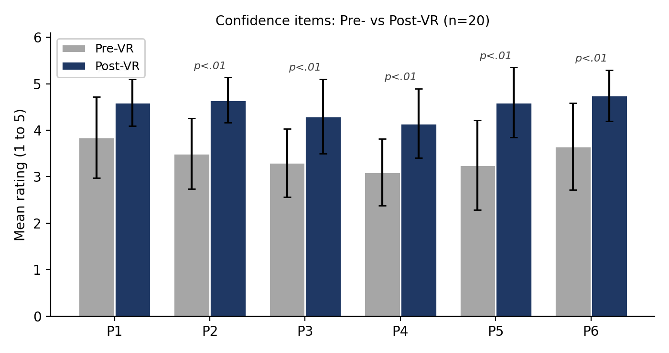
Figure 1: Mean confidence ratings before and after the VR walkthrough (n = 20; error bars = SD). All items differed significantly at p < .01 (Wilcoxon signed-rank), as labelled

4.3 Issue identification during the walkthrough
During the five-minute walkthrough, engineers identified issues of two kinds. They flagged a broad range of experiential concerns that automated clash detection does not encode (Figure 2): at least one safety concern was flagged by 18 of 20 participants (90%) and at least one maintainability concern by 17 of 20 (85%), while 13 of 20 (65%) flagged at least one constructability concern. The two seeded, clash-invisible defects were caught by most participants without prompting: the missing stair handrail as a safety concern by 15 of 20 (75%), and inadequate glazing cleaning or replacement access by 12 of 20 (60%), alongside fall or edge protection at the glazed façade (11 of 20, 55%). Specific conditions engineers reported included missing handrails, missing or unconnected wall sections, constrained clearances around an AHU, and insufficient headroom beneath services.
Engineers also readily recognised genuine geometric clashes present in the model, such as a light fixture passing through a duct, during the immersive review. Because these are true interferences, automated clash detection would also register them; their value here is that the walkthrough rendered them immediately intelligible in spatial context to reviewers who do not personally operate clash-detection software, rather than as entries in a numeric clash list. In combination, the walkthrough thus supported both comprehension of geometric clashes and identification of the non-geometric conditions that clash detection cannot capture.
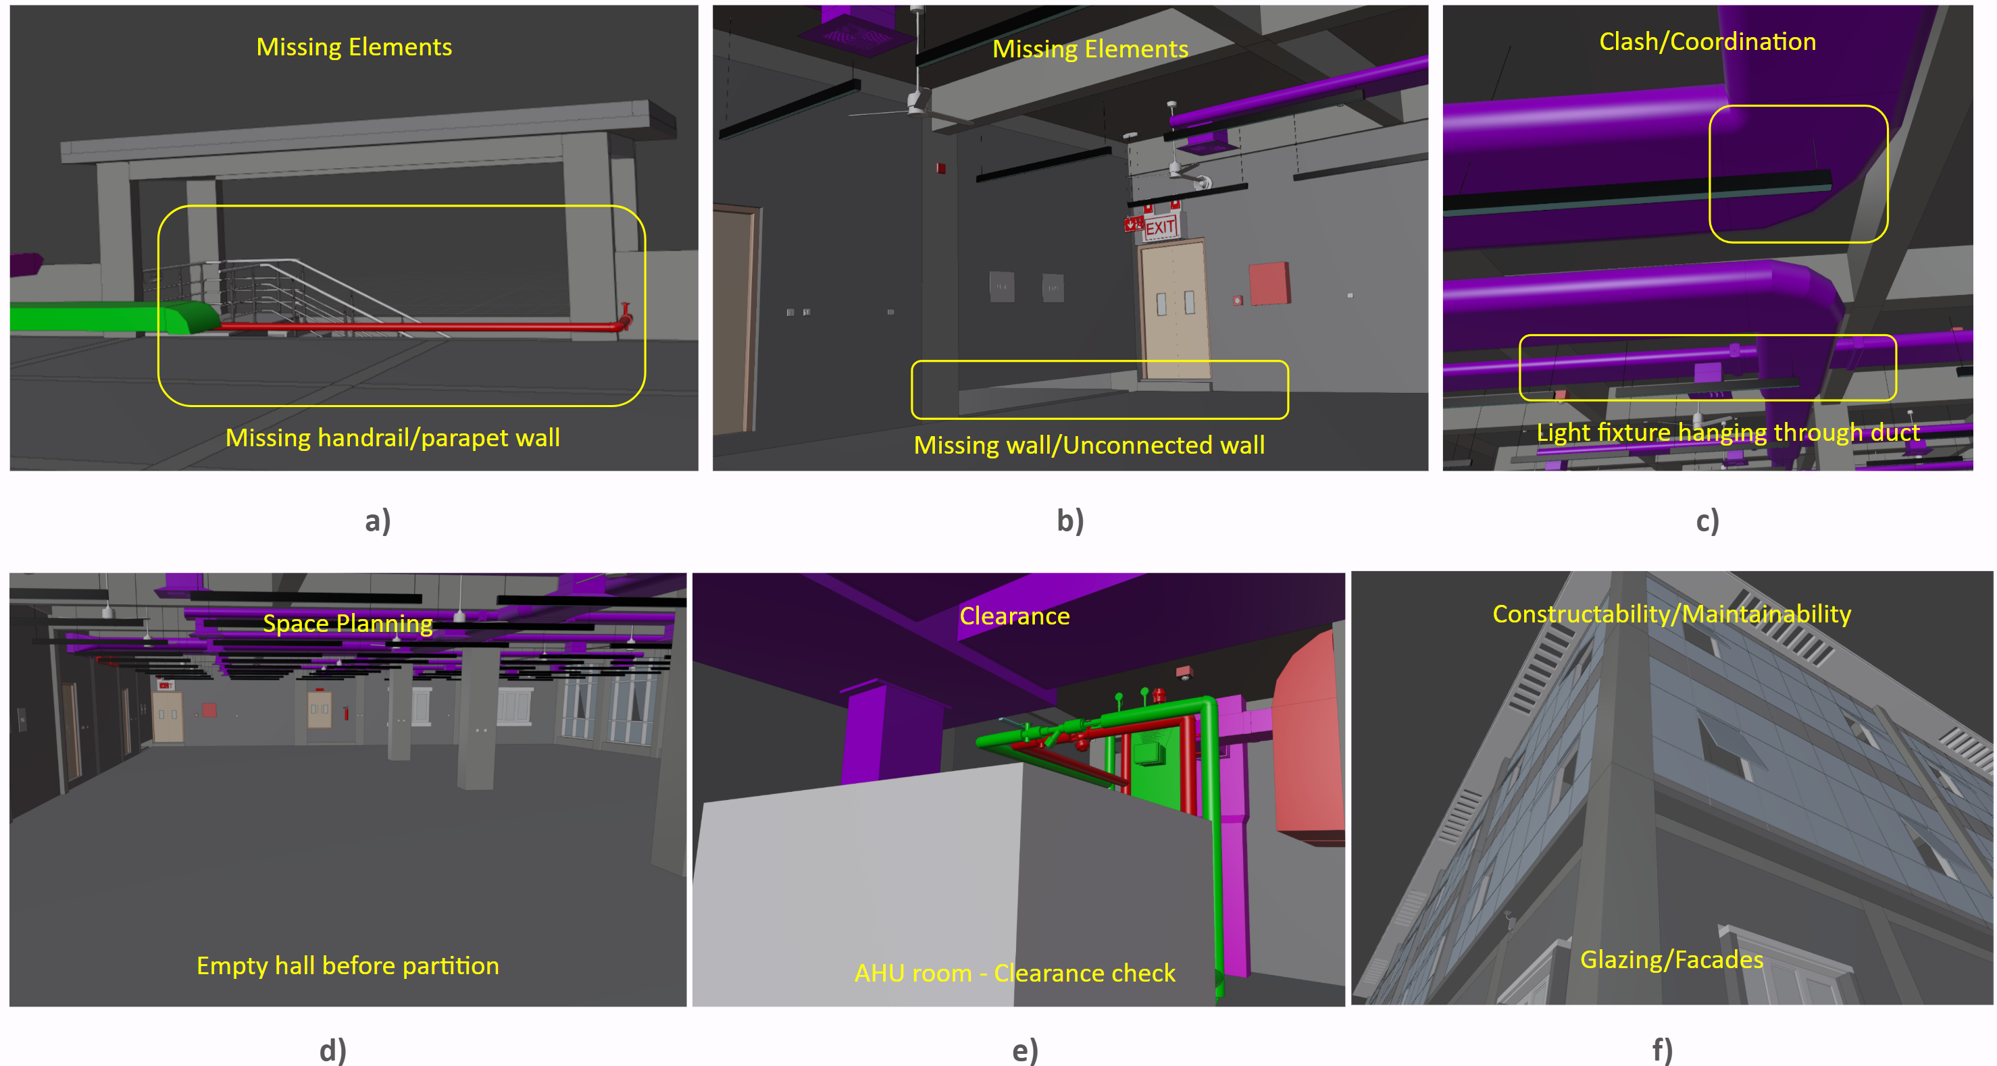
Figure 2: Representative issues as seen by engineers during the immersive VR walkthrough
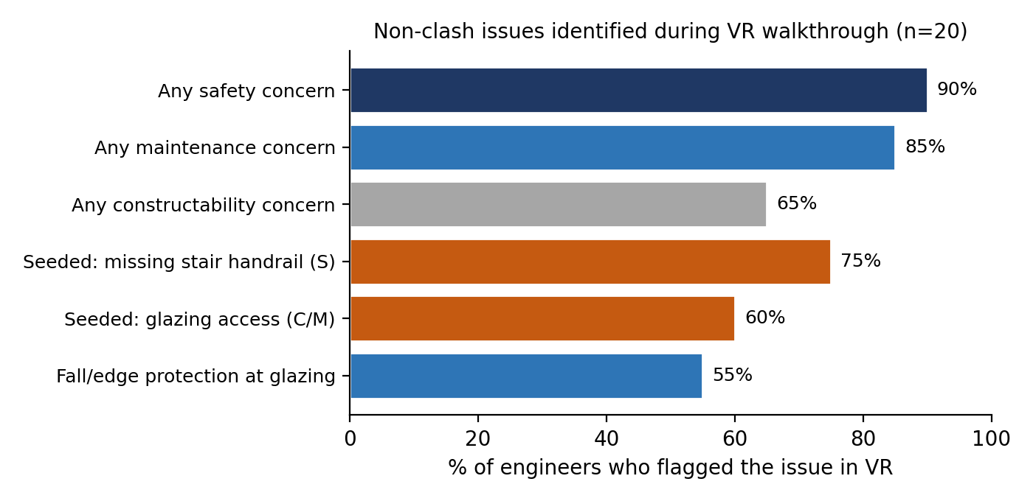
Figure 3: Non-clash issues identified during the VR walkthrough (n = 20). Orange bars are the two deliberately seeded, clash-invisible defects.

4.4 Technology acceptance
Acceptance was near-unanimous, with item means from 4.50 to 4.70 on the five-point scale. Agreement (rating of 4 or 5) ranged from 95 to 100% across the five items, and strong agreement (rating 5) from 55 to 70%. Engineers agreed that VR improved understanding of the building's scale and spaces beyond the desktop model (V1, mean 4.65), that it revealed issues absent from the clash results (V2, mean 4.55), that it conveyed real-world scale and accessibility better than desktop tools (V3, mean 4.60), that it complements rather than replaces clash detection (V4, mean 4.50), and that they intend to use or advocate for VR-BIM in future public projects (V5, mean 4.70).
4.5 Qualitative responses
Free-text responses reinforced the quantitative pattern. When asked for the most important issue VR revealed, participants cited clearance and coordination conditions, for example "AHU clearance from wall and return air duct height", "the missing blockwork in the walls, clearance issues", "safety issues and space constraints", and "integration of different elements of MEP and structure". Adoption comments were positive and forward-looking: one noted that a walkthrough before commencement helps the client and contractor identify changes and features early, another that it "will really help to understand about the clashes before execution", and several recommended the approach for future public projects, calling it "very useful at [the] initial stage".

- DISCUSSION
5.1 VR raises design-review confidence
The consistent increases across all confidence dimensions indicate that a brief immersive walkthrough meaningfully improved engineers’ confidence in reviewing the design. This extends prior evidence that immersive VR enhances spatial comprehension and lowers the barrier for non-specialist reviewers (Calderon-Hernandez et al., 2019; Wolfartsberger, 2019; Liu et al., 2020; Safikhani et al., 2022) to practising public-sector reviewing engineers. Importantly, these gains were observed after, rather than instead of, conventional desktop and clash-detection review, isolating the additional contribution of immersion. The finding that this improvement reflects more than a display effect is also consistent with Han and Leite (2021), who found that immersive HMD-based review outperformed desktop-monitor VR using the same model.
5.2 VR surfaces non-clash issues: a complement to clash detection
The issue-identification results are the study’s central practical finding and define VR’s role as twofold. First, automated clash detection cannot identify non-geometric issues such as missing handrails or inaccessible glazing because these do not involve geometric interference. However, most engineers identified both seeded defects during a five-minute walkthrough, along with additional unscripted maintainability and safety concerns. This capability aligns with Han and Leite’s (2021) observation that non-clash design errors can evade geometry-based detection and with Liu et al.’s (2020) cases where operability and clearance issues emerged only when reviewers experienced the space. Second, for genuine geometric clashes, such as a light fixture intersecting a duct, VR did not improve detection but enhanced comprehension by making the interference immediately understandable in context, particularly for reviewers who do not routinely use clash-detection software. This is consistent with Astaneh Asl and Dossick’s (2022) finding that immersive review communicated system conflicts more effectively than BIM markup.
Taken together, these findings position immersive VR as a complement to automated clash detection rather than a substitute. Desktop and clash-detection tools remain stronger for geometric identification, measurement and data management, while VR communicates these findings to non-modelling reviewers and reveals experiential constructability, maintainability and safety issues that automated tools cannot encode (Johansson & Roupé, 2024; Liu et al., 2020). The near-unanimous agreement on the complementarity item (V4) further indicates that participants viewed VR as an enhancement to existing review processes rather than a replacement.
5.3 Acceptance and public-sector adoption
Acceptance was consistently high, aligning with the generally positive reception of immersive VR reported in construction studies. However, adoption research indicates that favourable user responses alone are insufficient to bridge the persistent gap between VR research and practice. Practical barriers, including cost and the availability of simpler, faster alternatives, continue to influence professionals’ preference for non-immersive tools, while organisations require direct, quantitative evidence to justify investment (Han & Leite, 2021; Safikhani et al., 2022). For public-sector organisations, this suggests that engineer enthusiasm, although important, must be supported by institutional mechanisms to integrate VR review into established workflows. The strong intention-to-advocate response (V5) is nevertheless promising, as these engineers may serve as internal champions who support future adoption.
5.5 Limitations
Several limitations bound these claims. The outcomes reflect self-reported confidence and perceptions rather than objective task performance or measured rework. The small sample, drawn from a single programme and building without a separate control group, also means that a novelty effect cannot be excluded, a concern frequently noted for first-time VR users (Liu et al., 2020; Wang et al., 2018). A prior-exposure moderator was not examined because reported BIM exposure was highly homogeneous, while the high acceptance ratings suggest a possible ceiling effect. The findings should therefore be interpreted as exploratory practitioner evidence rather than confirmatory evidence. VR’s role is limited to identifying and communicating issues; quantitative daylight, thermal, or formal risk assessment remains the domain of dedicated analysis tools.

4. CONCLUSION
This exploratory pre–post study provides early real-world evidence that a five-minute immersive VR walkthrough, added to a conventional desktop-BIM and clash-detection workflow, significantly increases practising government engineers' confidence in pre-construction design review (all items p < .01, r = 0.62 to 0.85) and enables them to identify constructability, maintainability and safety issues, including clash-invisible defects, that automated clash detection cannot surface. Acceptance was near-unanimous, and engineers themselves characterised VR as complementary to clash detection. The findings support a modest, additive VR review step in public-sector pre-construction quality assurance, while underscoring that organisational facilitation, objective performance measures and larger controlled samples are needed to confirm and generalise the effect.

REFERENCES
Astaneh Asl, B., & Dossick, C. S. (2022). Immersive VR versus BIM for AEC team collaboration in remote 3D coordination processes. Buildings, 12(10), 1548. https://doi.org/10.3390/buildings12101548
Calderon-Hernandez, C., Paes, D., Irizarry, J., & Brioso, X. (2019). Comparing virtual reality and 2-dimensional drawings for the visualization of a construction project. In Computing in Civil Engineering 2019 (pp. 17–24). ASCE.
Han, B., & Leite, F. (2021). Measuring the impact of immersive virtual reality on construction design review applications: head-mounted display versus desktop monitor. Journal of Construction Engineering and Management, 147(6). https://doi.org/10.1061/(ASCE)CO.1943-7862.0002056
Johansson, M., & Roupé, M. (2024). Real-world applications of BIM and immersive VR in construction. Automation in Construction, 158, 105233. https://doi.org/10.1016/j.autcon.2023.105233
Kraus, M., Rust, R., Rietschel, M., & Hall, D. (2022). Improved perception of AEC construction details via immersive teaching in virtual reality. arXiv preprint arXiv:2209.10617
Liu, Y., Castronovo, F., Messner, J., & Leicht, R. (2020). Evaluating the impact of virtual reality on design review meetings. Journal of Computing in Civil Engineering, 34(1). https://doi.org/10.1061/(ASCE)CP.1943-5487.0000856
Safikhani, S., Keller, S., Schweiger, G., & Pirker, J. (2022). Immersive virtual reality for extending the potential of building information modeling in the architecture, engineering, and construction sector: systematic review. International Journal of Digital Earth, 15(1), 503–526. https://doi.org/10.1080/17538947.2022.2038291
Piroozfar, P., Farr, E. R., Zadeh, A. H., Inacio, S. T., Kilgallon, S., & Jin, R. (2019). Facilitating building information modelling (BIM) using integrated project delivery (IPD): A UK perspective. Journal of Building Engineering, 26, 100907.
Wang, P., Wu, P., Wang, J., Chi, H.-L., & Wang, X. (2018). A critical review of the use of virtual reality in construction engineering education and training. International Journal of Environmental Research and Public Health, 15(6), 1204. https://doi.org/10.3390/ijerph15061204
Wolfartsberger, J. (2019). Analyzing the potential of virtual reality for engineering design review. Automation in Construction, 104, 27–37. https://doi.org/10.1016/j.autcon.2019.03.018

