BIM-based Cemetery Management System with 3D Data Updatable via Smartphone LiDAR
Jo Suzuki¹, Yasuhiro Ueki², Satoshi Kubota³, Yoshihiro Yasumuro^{3,*}

¹ Graduate School of Science and Engineering, Kansai University, Suita, Japan
² New Type Systems, Corp., Takarazuka, Japan
³ Faculty of Environmental and Urban Engineering, Kansai University, Suita, Japan
*Corresponding email: yasumuro@kansai-u.ac.jp

ABSTRACT
This study aims to develop and evaluate an incrementally updatable cemetery BIM system to integrate local 3D data and biographical information into an existing cemetery model. In Japanese temple cemeteries, family graves are the norm; however, information on tombstone locations, plot assignments, maintenance history, and the deceased is managed separately across paper ledgers, historical records, and the memories of temple administrators. Since the condition of a cemetery changes over time due to aging, cleaning, repairs, and tomb removal, locally acquired 3D data must be integrated into existing cemetery models.
In this study, we use an SfM model of the entire cemetery as a reference coordinate system and automatically register locally acquired 3D Gaussian Splatting (3DGS) data to the corresponding tombstones. We treated the Gaussian center coordinates of the local 3DGS data as a point cloud and performed a two-stage registration process targeting the upright stones, combining principal component analysis, ICP for multiple initial pose candidates, and Point-to-Plane ICP based on planar features. The registration was validated using 10 tombstones at a cemetery; among the 6 tombstones with minimal missing data and no scale inconsistencies, the registration residuals ranged from 6.0 to 9.8 mm.
Furthermore, using a detailed local 3DGS of the reihyo-ban (commemorative stones inscribed with the names of deceased ancestors across generations), we implemented a function to semi-automatically extract biographical information—including Buddhist posthumous names—from reihyo-ban. By applying trapezoidal correction and multiple binarization processes to multi-view rendering images and then performing NDLOCR, we identified portions of vertically written text as candidates. Nine manually selected OCR candidates were evaluated using OCR confidence, character error rate, and fuzzy matching against the temple death-register database. The correct record ranked first in 8/9 cases, demonstrating a semi-automated workflow requiring administrator verification.

- INTRODUCTION
In Japan, cemeteries have evolved not merely as spaces for burial, but as religious and cultural spaces rooted in Buddhist thought. During the Edo period in the 17th century, under the “tera-uke” system, temples began overseeing the funerals and memorial services of individuals and families, strengthening the bond between the common people and temples. As a result, the custom of establishing family tombs within temple grounds or their vicinity spread, giving rise to a form of cemetery designed for cremation. In the Buddhist worldview, tombs serve as signposts for the souls of the deceased; they have functioned not only as places where bereaved families maintain a spiritual connection with the deceased but also as venues for reaffirming the bonds among relatives.
Against this cultural backdrop, Japanese temple cemeteries often feature reihyo-ban—in addition to the tombstones themselves—inscribed deceased's Buddhist posthumous names, secular names, dates of death, and ages at death, spanning generations.
These reihyo-ban serve as a medium for recording information about the local interred individuals and are important documents that correspond to the temple death registers (kako-cho) maintained by the temples. Past registers are ledgers that record religious and historical information regarding temple parishioner households (danka) and the deceased, and they play a crucial role in memorial services, commemorative rites, and cemetery management. In this study, the term “Danka” refers to families or related individuals who belong to a specific temple and own or manage a tomb in that temple’s cemetery.
In Japan, the aging population and the increase in elderly single-person households are evident, and the social conditions surrounding cemetery management and succession are changing. In recent years, there has been a growing need for long-term management of information regarding tombstone locations, plots, the interred, memorial services, and repairs. However, this information is often scattered across the head priest’s memory, paper ledgers, hand-drawn plot maps, and past records, making it difficult to continuously verify the correspondence between on-site tombstones and reihyo-ban and the temple’s internal records.
In this study, we propose a “Cemetery BIM” system that sequentially updates the 3D information of existing cemeteries by using a 3D model of the entire cemetery as a spatial foundation and automatically aligning locally acquired 3DGS data with the corresponding tombstones. Since local 3DGS data is generated in different coordinate systems for each acquisition, an alignment process is necessary to register the updated data to the appropriate tombstone objects. In this study, focusing on the upright stone—the central component of a tombstone—we implement an automatic registration method that combines principal component analysis, ICP for multiple rotation candidates, and Point-to-Plane ICP based on planar features.
Furthermore, a sustainable cemetery BIM requires not only spatial information but also the ability to store the deceased's biographical information, including Buddhist posthumous names, secular names, and dates of death, as engraved on reihyo-ban. To reduce the burden of manually transcribing and verifying a large number of reihyo-ban, we implement a user-assisted, semi-automatic input workflow that generates multi-view images from a localized 3DGS with aligned positions and presents candidate text strings through trapezoidal correction, image preprocessing, and OCR.

- RELATED WORK AND TECHNICAL BACKGROUND
BIM is a concept that integrates 3D geometric and attribute information for buildings and civil engineering structures, facilitating information sharing across the design, construction, and maintenance phases. In BIM applications for existing buildings, emphasis is placed on managing information about geometry, location, history, inspections, and repairs alongside 3D models.
In Heritage Building Information Modelling (HBIM), which focuses on cultural properties and historic buildings, efforts are underway to link historical information and restoration histories to 3D data acquired through photogrammetry and laser scanning. Temple cemeteries are also existing outdoor spaces composed of tombstones, reihyo-ban, perimeter fences, pathways, and vegetation, with each tomb site associated with diverse information such as plot number, owner, interred individual, and maintenance history. Therefore, cemetery BIM requires not only a 3D representation of the entire cemetery but also a mechanism to integrate locally acquired current status data—reflecting tombstone repairs, cleaning, floral offerings, and age-related changes—into the existing model. However, since local data is generated in different coordinate systems with each acquisition, aligning its position and orientation with the corresponding tombstone poses a challenge.
3D Gaussian Splatting (3DGS) is a method that uses numerous 3D Gaussians estimated from images taken at multiple viewpoints to rapidly generate images from new viewpoints (Kerbl et al., 2023). Since 3DGS can preserve not only shape but also the color, texture, and shading of the stone surface, it is well-suited for recording the current condition of individual tombstones and sharing that information visually. In this study, we register local 3DGS data with the corresponding tombstones within the overall cemetery model and register the alignment as updated information on shape and condition.
On the other hand, in cemetery management, not only shape information but also biographical family information—such as the deceased's Buddhist posthumous names, secular names, dates of death—engraved on reihyo-ban is important. To correlate this information with the temple death register, the characters on the reihyo-ban must be verified and entered as records. For Japanese character recognition, we use NDLOCR, which is publicly available from the National Diet Library (National Diet Library, 2022). Although NDLOCR is designed for Japanese documents, including those with vertical writing and complex page layouts, the granular texture of stone surfaces, dirt, weathering, damage, and surface shadows hinders recognition. Therefore, in this study, the OCR output is treated not as definitive information, but as candidate character strings to be used for cross-referencing with the temple death register and for verification by the administrator.

3. PROPOSED METHOD
3.1 Cemetery BIM Information Model and Incremental Updates
In this study, the entire cemetery is digitized in 3D, and the resulting spatial data serves as the foundation for a cemetery BIM. A plot management function is developed that allows temple administrators to select individual tomb plots on orthophotos generated from the overall cemetery model. Each plot is assigned a plot ID, and its location, user or family lineage, usage history, and associated tombstone objects are linked and managed accordingly.
Temple cemeteries often contain a mix of plots with different construction dates and managing entities, and management frequently relies on paper ledgers, hand-drawn maps, and the administrator’s memory. Consequently, it is not easy to spatially determine which family is using which plot or which tombstone belongs to which plot. Therefore, this study uses orthophotos to visualize the plots, enabling administrators to select specific plots directly from a map.
The plot management function enables spatial searches across the entire cemetery and allows administrators to view attribute information for individual plots. This enables administrators not only to identify specific tombsites by their location within the cemetery but also to cross-reference plot and tombstone information, and, in the future, information from the cemetery registry. Fig. 1 shows the overall architecture that integrates the cemetery-wide model, local 3DGS, reihyo-ban images, OCR candidates, and cemetery registry information.

3.2 Tombstone Information Management and Sequential Updates Using Local 3DGS
A tomb site consists of multiple components, including the headstone, base stone, incense burner, water basin, flower vase, reihyo-ban, lantern, and outer fence. Additionally, information that changes over time—such as floral offerings, ritual offerings, sutra poles, weeds, and the state of cleanliness—is also important for assessing the condition of the tomb site. In this study, each tombstone is managed as a tombstone object with a tombstone ID and plot ID, and linked to its 3D

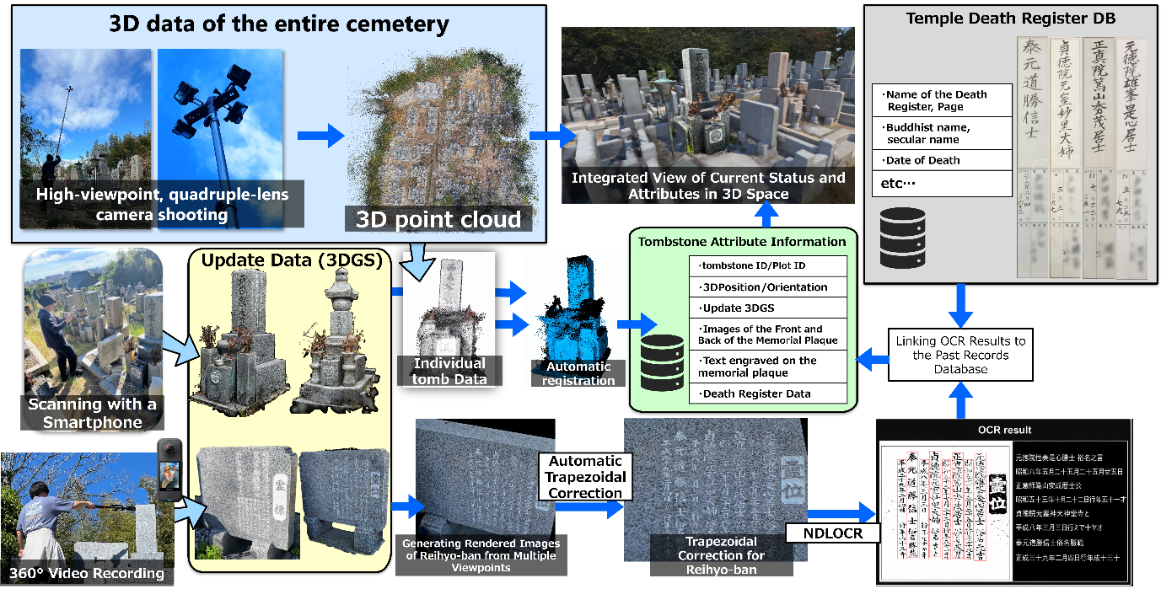
Figure 1: Proposed framework integrating the global cemetery model, local 3DGS, reihyo-ban images, OCR candidates, and cemetery registry information.

position, orientation, local 3DGS, acquisition date and time, update history, and related reihyo-ban information.
The cemetery's condition changes continuously due to tombstone repairs, cleaning, the placement and removal of floral offerings, and the decommissioning of tombs. Since it is not practical to re-survey the entire cemetery each time, this study involves taking localized photographs only of the areas surrounding tombstones that require updates and recording them as 3D Gaussian Splatting (3DGS). Local 3DGS is well-suited for sharing the current status of tombstones because it can record not only the shape of the tombstone surface but also visual information, such as floral offerings, the stone's texture, and the surrounding environment.
Since local 3DGS data is generated in a different coordinate system for each acquisition, position and orientation alignment is required to register it to the corresponding tombstone within the overall cemetery model. Therefore, this study performs a two-stage automatic registration process using the central component of the Tombstone—the upright stone—as a reference, combining principal component analysis, ICP for multiple rotation candidates, and Point-to-Plane ICP based on planar features. After alignment, the local 3DGS is registered to the corresponding tombstone ID and plot ID and treated as updated data for the overall cemetery model.
In this way, the plot management function manages the locations of tombsites throughout the cemetery, while the tombstone information management function manages the detailed status and update history of each tomb site. Automatic alignment serves as the foundational process for integrating locally acquired 3DGS data into existing tombstone objects.

3.3 User-in-the-loop Semi-automated Entry of reihyo-ban Information
Linking these inscriptions to tombstone objects and temple death-register records enables spatial and biographical information to be accessed together.
To reduce manual transcription, the system applies RANSAC plane estimation to the point cloud surrounding a reihyo-ban, selects the largest inlier cluster, and generates a rectangular planar mesh from its convex hull and minimum-area bounding rectangle. The mesh is used for multi-view rendering and perspective rectification based on the projected coordinates of its four corners. NDLOCR then extracts candidate text strings from the rectified images.
For database matching, the extracted Buddhist posthumous-name candidate is compared with the posthumous-name field of every temple death-register record. Before matching, both strings are normalized by unifying character variants, removing spaces and punctuation, excluding text following the secular-name field, and correcting common OCR variants in honorary titles. A weighted similarity score combines whole-string similarity using Python’s difflib.SequenceMatcher (0.55), partial-string similarity (0.20), character-bigram Dice similarity (0.15), and honorary-title agreement (0.10). All records are ranked by this score, and the highest-ranked candidates are presented with the corresponding reihyo-ban image for administrator confirmation.
Plane estimation, multi-view rendering, trapezoidal correction, image preprocessing, and OCR candidate generation are performed automatically. Meanwhile, the temple administrator selects the viewing angle of the reihyo-ban, makes final adjustments to the reference camera orientation, verifies the candidate images, and finalizes the records in the temple register. This user-assisted method aims to register historical information for reihyo-ban - which are subject to weathering, dirt, shadows, and missing characters - with less effort than fully manual data entry.

4. IMPLEMENTATION
4.1 Automatic Registration of Local 3DGS Data with the Overall Cemetery Model
The subject of this study is the cemetery on the grounds of Dairin-ji Temple in Akashi City, Hyogo, Japan. To capture the entire cemetery, we used a camera rig consisting of four GoPro HERO12 Black cameras mounted on a single tripod approximately 6–8 m tall, filming while walking, and constructed a 3D point cloud and 3D model using SfM. This model was used as a reference coordinate system for managing tombstone locations and plot information.
To extract the tombstone areas from the entire cemetery's point cloud, we applied point cloud semantic segmentation with PointNet++. Of the 146 tombstones in the target cemetery, 59 were used as training data, and the remaining 87 were used as untrained evaluation data. The training and evaluation data were segmented on a per-tombstone basis to ensure that no single tombstone’s point cloud was included in both sets. By cross-referencing extraction results with plot management information, we selected the tombstone areas to be updated locally.
Fig. 2 illustrates a representative target tombstone within the overall cemetery model. The red bounding box in Fig. 2(a) indicates the tombstone selected for local 3DGS registration, and Fig. 2(b) provides an enlarged view of the same tombstone. This association enables locally acquired 3DGS data to be registered to a specific tombstone object in the global cemetery model rather than being stored as an independent scan.
Of the 87 evaluation tombstones, 83 (95.4%) had an Intersection over Union (IoU) of 0.25 or higher, and 77 (88.5%) had an IoU of 0.50 or higher.
The local 3DGS for updating was acquired using Scaniverse on a LiDAR-equipped smartphone. The set of Gaussian center coordinates obtained from the PLY data was treated as a point cloud, and after removing statistical outliers, the slender upper structure corresponding to the headstone was extracted. Furthermore, the largest cluster was selected via density-based clustering to obtain the upright-stone point cloud for registration.
For registration, principal component analysis (PCA) was applied to the headstone point clouds from both the overall cemetery model and the local 3DGS, and the general orientation was aligned using the principal axes as a reference. To address the rotational ambiguity of the rectangular-cross-section upright stone, 16 candidate initial orientations were generated by combining rotations around the second and third principal axes, and ICP was applied to each candidate. After selecting the best-fitting candidate, Point-to-Plane ICP was applied to the planar features extracted using RANSAC to refine the position and orientation.
The registration was evaluated using point cloud residuals, the intrinsic variance of the point clouds based on plane approximation, and visual inspection of the registration results. Verification results for 10 tombstones showed that for the six tombstones (A–F) that had a sufficient observation range and no scale inconsistencies with the reference model, the residuals after registration ranged from 6.0 to 9.8 mm. The intrinsic variation of these point clouds was 2.0–6.0 mm, and the registration residuals were of the same order of magnitude as the variation inherent in the input point clouds.
On the other hand, tombstones G and H had large gaps on their sides or backs, and cases were observed where the orientation was inappropriate, even when the residuals were small. Furthermore, for tombstones I and J, alignment became unstable due to scale inconsistencies between the reference model and the local 3DGS, resulting in a maximum residual of 46.2 mm. Therefore, in practical applications, registration should not be determined solely by residuals; it is necessary to verify the results by considering the point cloud's observation range, scale consistency, and superimposition results in combination. Fig. 3 shows the extraction of the tombstone regions, 16 candidate initial poses, and representative registration results. Table 1 summarizes the quantitative results regarding tombstone region extraction and local 3DGS registration.

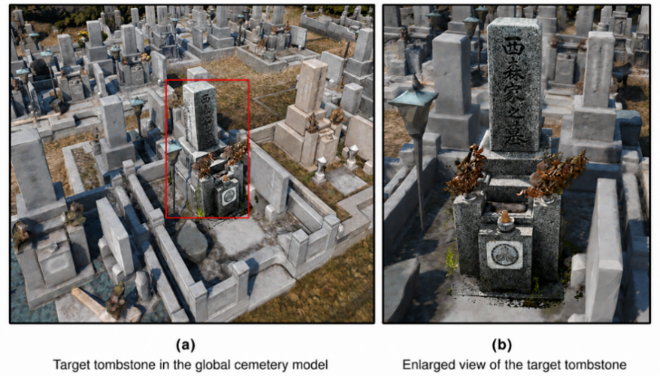
Figure 2: Representative target tombstone in the global cemetery model: (a) tombstone selected for local update; (b) enlarged view of the same tombstone.

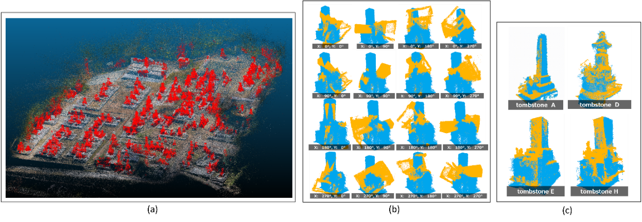
Figure 3: Automatic registration of local 3DGS data into the global cemetery model: (a) tombstone regions extracted from the global SfM point cloud; (b) sixteen PCA-based initial orientation hypotheses for a representative tombstone; and (c) final registration results for a stable case and a case affected by incomplete surface coverage.
Table 1: Quantitative summary of the automatic cemetery update pipeline.
Evaluation item | Result
Tombstone extraction, IoU ≥ 0.25 | 83/87 (95.4%)
Tombstone extraction, IoU ≥ 0.50 | 77/87 (88.5%)
Stable registration cases | 6/10
Registration residual for stable cases | 6.0–9.8 mm
Intrinsic point-cloud variation for stable cases | 2.0–6.0 mm
Maximum registration residual | 46.2 mm

4.2 Character Recognition Using Multi-View Rendering of Reihyo-ban
For character recognition on the reihyo-ban, we used a detailed 3DGS focused on character legibility, separate from the 3DGS for tombstone updates, created using smartphone LiDAR as described in Section 4.1. We extracted orthographic projection images from 360-degree videos captured with an Insta360 X4, aligned them in Metashape, exported the data in COLMAP format, and generated the 3DGS using IGS++.
We imported the PLY point cloud of the area surrounding the reihyo-ban into Unity and extracted candidate reihyo-ban surfaces using RANSAC plane estimation. We applied the convex hull and the minimum-area bounding rectangle to the largest inlier cluster to generate a rectangular plane mesh that serves as the reference for trapezoidal correction. To determine the observation side and the reference camera pose of the plane, we generated candidate virtual cameras on both sides of the plane's normal. After the user selected the side to be observed as the surface of the reihyo-ban, we fine-tuned the camera position and pose as necessary and registered that pose as the reference pose for multi-view rendering.
Centered on the registered reference camera pose, we set the yaw angle to 9 levels in 5-degree increments from −20 to 20 degrees, and the pitch angle to 5 levels at −40, −20, 0, 20, and 40 degrees, generating rendered images from a total of 45 viewpoints. For each viewpoint, a trapezoidal correction was applied to the reihyo-ban area to transform it into a rectangular image close to a front view, using a projection transformation based on the projection coordinates of the four corners of the mesh.
For each corrected image, 14 conditions were generated: grayscale, CLAHE, Gaussian blur + Otsu, CLAHE + Otsu, Bilateral filter + Otsu, the Triangle method, the Yen method, and their respective inverted images. For each case, up to 630 images—obtained from combinations of the 45 viewpoints and 14 conditions—were input into NDLOCR. At this stage, OCR candidates were compared with the reihyo-ban images, and the most appropriate candidate was selected manually.
The evaluation unit was a posthumous-name text line, not a complete OCR JSON file. Nine posthumous-name text lines from three NDLOCR JSON files were evaluated. For each manually selected OCR candidate, rank all temple death-register records using the database-matching procedure described in Section 3.3. Use the textline_id–record_id mapping only to identify the ground-truth record for evaluation, not for candidate ranking.
Table 2 shows the manually selected OCR Buddhist posthumous name candidates, OCR confidence, CER, character accuracy rate, and the rank of the correct temple death-register record for the nine cases. The combined CER for all nine cases was 43.06%, the character accuracy rate was 56.94%, and the average OCR confidence was 0.829. Furthermore, when cross-checking the manually selected candidates against the temple death-register database, the correct record was the top result in 8 out of 9 cases. These results should not be regarded as the accuracy of fully automated transcription, but rather as preliminary results from a semi-automated input method that generates candidates from multi-view images and multiple preprocessing conditions, followed by verification by an administrator. Fig. 4 shows the estimated reihyo-ban surface and virtual camera placement, while Fig. 5 shows an example of recognition results using NDLOCR.

Table 2: OCR and database-matching results for manually selected candidates from multi-view images and 14 preprocessing conditions.
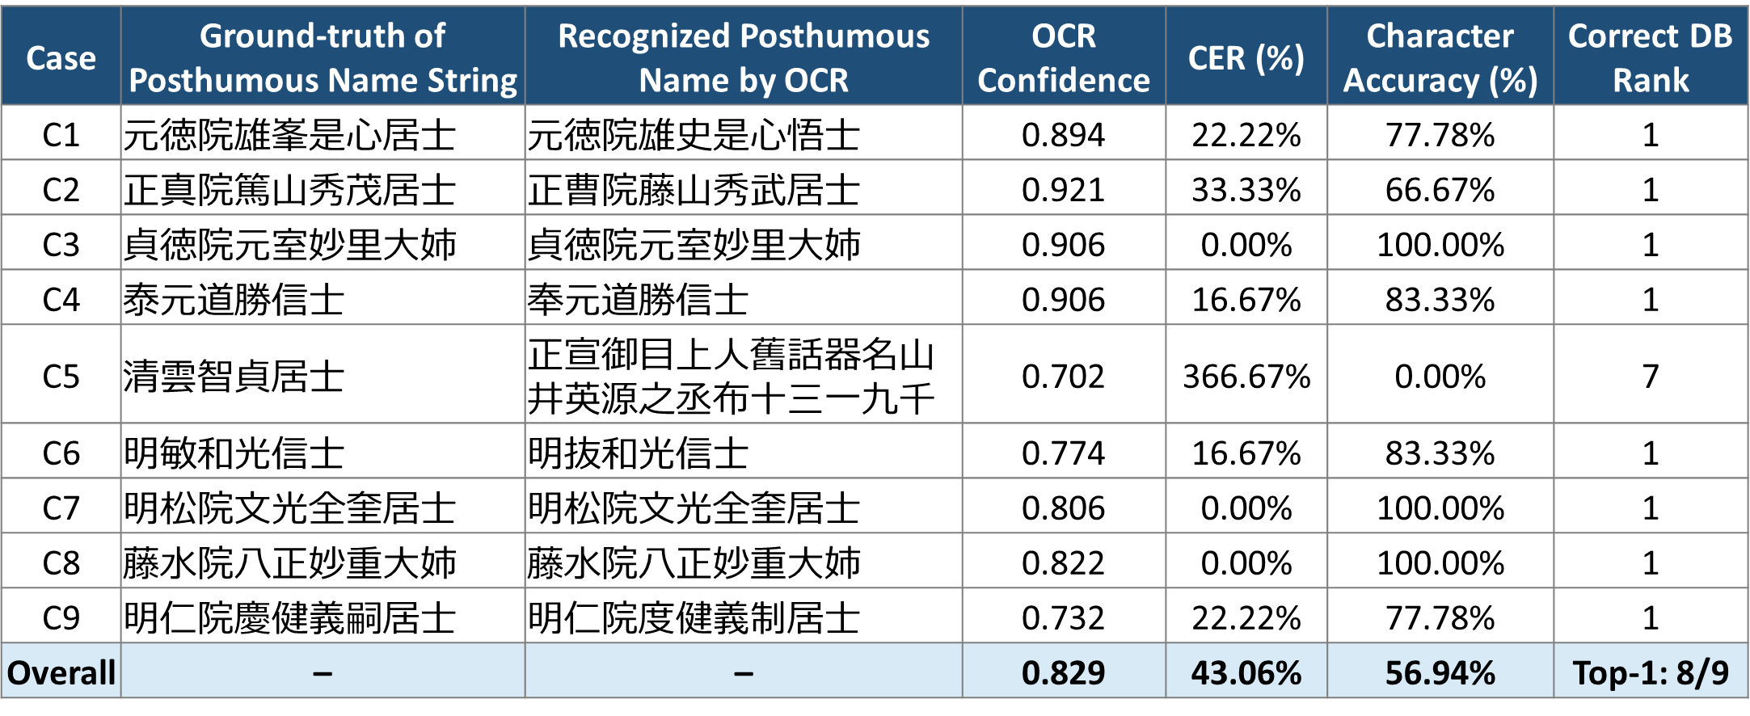

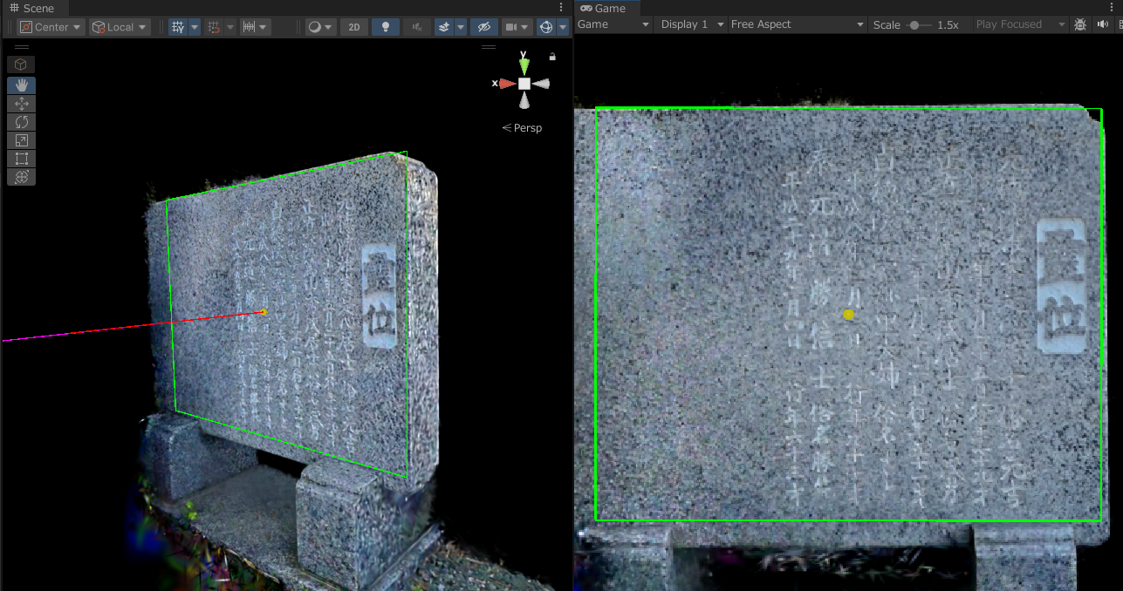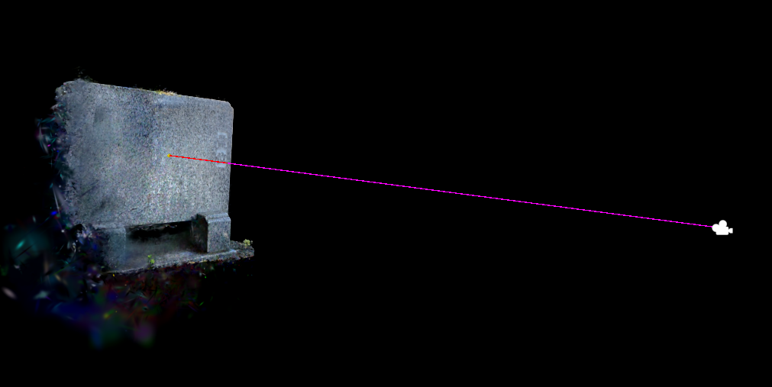
Figure 4: RANSAC-based estimation of the reihyo-ban plane and semi-automatic placement of a virtual camera.

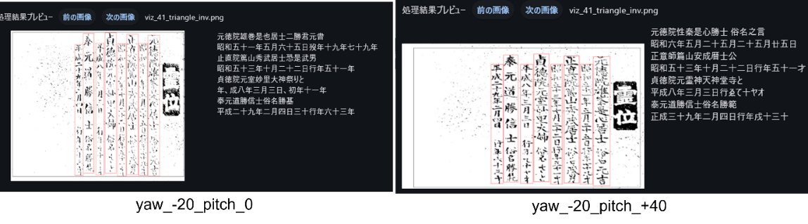
Figure 5: Two examples of OCR results obtained from perspective-rectified and binarised reihyo-ban images.

5. DISCUSSION
By automatically registering local 3DGS data with specific tombstones within the overall cemetery model, condition records acquired at different times can be integrated into a common reference coordinate system. The key here is not only to use the local 3DGS as a high-precision measurement model, but also to store information on the condition of the tombstones, floral offerings, the state before and after cleaning, and reihyo-ban details in a way that clearly identifies which tombstone each piece of data corresponds to. Automatic alignment serves as the foundation for continuous recording and updating in cemetery BIM.
On the other hand, for local data with large gaps along the sides or back, as well as scale inconsistencies, it was sometimes impossible to determine the correct orientation solely from the residuals. Therefore, in actual operation, it is necessary to combine residuals, the observation range, scale consistency, and overlay display to determine whether the data can be registered. Additionally, a shooting support function is required to detect insufficient observations or excessive camera shake during local 3DGS acquisition and prompt reshooting.
For OCR of reihyo-ban, rather than directly detecting the outline in the image, a planar mesh generated from the 3DGS point cloud was used as the reference for trapezoidal correction. Consequently, even when outline detection in the image is unstable due to patterns, dirt, or shadows on the stone surface, correction can be performed based on the region estimated in 3D space. On the other hand, since the planar mesh is an area approximation derived from the distribution of inlier points, the degree of alignment with the reihyo-ban actual surface affects the quality of the correction.
Although the OCR could not reliably recognize all characters, it was possible to identify parts of vertically written character strings as candidates, depending on the viewpoint and binarization conditions. In particular, we found that from oblique viewpoints, shadows on the engraved characters remained, making it easier to identify the outlines of character strings than from viewpoints closer to the front. Therefore, in the future, it will be necessary to automatically select candidate images using image contrast, the clarity of the character regions, and OCR confidence scores, and to further automate the process of matching OCR character string candidates with the temple death-register database.

6. CONCLUSIONS
In this study, focusing on temple cemeteries, we proposed a sequentially updatable cemetery BIM that integrates a cemetery-wide model with a local 3DGS. Based on plot and tombstone IDs, we constructed an information model that links the local 3DGS, update history, reihyo-ban images, and information from the cemetery register.
Through a two-stage automatic registration process—combining principal component analysis (PCA) of headstones, ICP for multiple rotation candidates, and Point-to-Plane ICP based on RANSAC plane features—we were able to integrate the local 3DGS into the reference model with residuals of 6.0 to 9.8 mm for targets with sufficient observation coverage and scale consistency.
Furthermore, we estimated the tombstone surface from the aligned local 3DGS and performed NDLOCR by applying trapezoidal correction and multiple binarization processes to multi-view rendering images. Although complete character recognition was not achieved, we demonstrated the potential to present candidates for administrator verification by cross-referencing OCR candidates with the tomb register database.
Moving forward, we will expand efforts to support the acquisition of local 3DGS data, automate the selection of OCR candidate images, and increase the number of cases involving comparison with the tomb register database. Through these efforts, we aim to realize a practical, operational cemetery BIM system that gradually accumulates spatial information on tombstones and biographical information on the interred.

ACKNOWLEDGEMENTS
Part of this research was supported by Kansai University Organization for Promotion of Advanced Science and Technology, Dairin-ji Temple, Akashi City, and Sekisai Kobo Makoto Stonemason Corp.

REFERENCES
Azhar, S. (2011). Building information modeling (BIM): Trends, benefits, risks, and challenges for the AEC industry. Leadership and Management in Engineering, 11(3), pp. 241–252. doi: 10.1061/(ASCE)LM.1943-5630.0000127.
Besl, P. J. and McKay, N. D. (1992). A method for registration of 3-D shapes. IEEE Transactions on Pattern Analysis and Machine Intelligence, 14(2), pp. 239–256. doi: 10.1109/34.121791.
Cabinet Office, Government of Japan. (2025). Annual Report on the Ageing Society [Summary] FY2025. Tokyo: Government of Japan.
Ester, M., Kriegel, H.-P., Sander, J. and Xu, X. (1996). A density-based algorithm for discovering clusters in large spatial databases with noise. Proceedings of the Second International Conference on Knowledge Discovery and Data Mining, pp. 226–231.
Fischler, M. A. and Bolles, R. C. (1981). Random sample consensus: A paradigm for model fitting with applications to image analysis and automated cartography. Communications of the ACM, 24(6), pp. 381–395. doi: 10.1145/358669.358692.
Kerbl, B., Kopanas, G., Leimkühler, T. and Drettakis, G. (2023). 3D Gaussian Splatting for Real-Time Radiance Field Rendering. ACM Transactions on Graphics, 42(4), Article 139. doi: 10.1145/3592433.
National Diet Library. (2022). Development of Japanese OCR software in FY2021. NDL Lab.
Penjor, T., Banihashemi, S., Hajirasouli, A. and Golzad, H. (2024). Heritage Building Information Modelling (HBIM) for heritage conservation: Framework of challenges, gaps, and existing limitations of HBIM. Digital Applications in Archaeology and Cultural Heritage, 35, e00366. doi: 10.1016/j.daach.2024.e00366.
Qi, C. R., Yi, L., Su, H. and Guibas, L. J. (2017). PointNet++: Deep hierarchical feature learning on point sets in a metric space. Advances in Neural Information Processing Systems, 30.
Tamamuro, F. (2009). The development of the temple-parishioner system. Japanese Journal of Religious Studies, 36(1), pp. 11–26.
Volk, R., Stengel, J. and Schultmann, F. (2014). Building Information Modeling (BIM) for existing buildings—Literature review and future needs. Automation in Construction, 38, pp. 109–127. doi: 10.1016/j.autcon.2013.10.023.

