Staircase Geometry Extraction from Indoor Point Clouds Using Semantic Segmentation and Geometric Parameter Estimation
Rithishram N^{1,*}, Varun Kumar Reja²
¹ School of Engineering, NICMAR University, Pune 411045, India
² Department of Civil Engineering, Indian Institute of Technology Bombay, Mumbai 400076, India
*Corresponding email: rithishram.one@gmail.com
ABSTRACT
Staircases are among the more difficult building elements to reconstruct from point clouds, because they combine several interacting surfaces, occur in different structural configurations, and are often captured with noise and occlusion. This study contributes an evaluated integration of semantic stair isolation and downstream staircase geometry extraction, with emphasis on tread-level extraction, PCA-based parameter estimation, and practical failure modes across straight, curved, spiral, and occluded staircases. A PointNet++ network first isolates the staircase from the complete scan. A geometry extraction pipeline then segments the staircase point cloud into boundary-preserving supervoxels, extracts the horizontal tread surfaces, groups them according to elevation, identifies individual treads, and estimates staircase geometric parameters using principal component analysis (PCA). A per-tread principal component analysis finally estimates the riser height, tread depth, stair width, and step count. On the Matterport3D dataset, PointNet++ isolates the staircase with 76.8% overall accuracy and 52.5% intersection over union on the staircase class. On synthetic staircases with known ground truth, the pipeline recovers straight configurations cleanly at every stage, while curved and spiral geometries show progressively more fragmented supervoxels and treads because the rectangular tread parameterisation is not designed for radially arranged treads. On two further Matterport3D staircases with complete tread visibility, the same pipeline recovers full metric geometry, including a check against Indian National Building Code (NBC) stair-dimension requirements. The study evaluates an integrated segmentation and geometry workflow and identifies the remaining challenges to be addressed in future work.
Keywords: Indoor Point Clouds, Staircase Geometry Extraction, Semantic Segmentation, Pointnet++, Supervoxel Segmentation, Scan-to-BIM
1. INTRODUCTION
As built Modelling increasingly relies on automated reconstruction of as-built geometry from indoor point clouds, a process known as Scan-to-BIM (Chen & Luo, 2026; Abreu et al., 2023). Laser scanning and RGB-D sensing now capture dense indoor point clouds routinely, and a large body of work converts these measurements into structured building models for construction monitoring, facility management and digital-twin applications (Nikoohemat et al., 2020; Tang et al., 2022). For dominant elements such as walls, floors, slabs, columns and beams, the workflow is comparatively mature, because these elements are well approximated by planar or prismatic primitives that plane-fitting methods recover from moderately noisy scans (Han et al., 2021).
Raw scans mix many object classes, vary in density and suffer from noise and occlusion, so most reconstruction pipelines first attach a semantic label to every point (Rauch & Braml, 2023; Han et al., 2021), separating structural surfaces from clutter for the downstream geometric modelling this requires (Yin et al., 2021; Yue et al., 2026). Public datasets such as Matterport3D (Chang et al., 2017) have made this practical for realistic building interiors. Learning-based segmentation has advanced rapidly since PointNet (Qi et al., 2017a) and its hierarchical successor PointNet++ (Qi et al., 2017b), which remains a practical, widely used backbone for per-point labelling at the front of a larger pipeline and has since been adapted to construction scenes with transformer- and graph-based variants (Yin et al., 2021; Rauch & Braml, 2023).
Staircases have not kept pace with this progress. A staircase is not a single primitive but an assembly of interacting components, including horizontal treads, near-vertical risers, stringers, landings and railings, arranged into distinct layouts such as straight-flight, switchback, spiral and open-riser configurations. Early studies mainly detect stairs for robotic mobility and assistive navigation (Sinha et al., 2014; Wang et al., 2022), while more recent methods estimate stair geometry from images or point clouds (Wang et al., 2024; Wei et al., 2025; Mehranfar et al., 2025), but geometric heterogeneity, tread-riser boundary noise and frequent partial observation make reconstruction harder than for planar elements. This matters because staircases govern accessibility compliance, evacuation planning and building-code verification; a recurring obstacle is that indoor scans are rarely complete, since occlusion and limited sensor coverage reduce the visibility of stair components (Zhang et al., 2024; Cai & Sur, 2022).
This paper presents and evaluates an integrated workflow that recovers staircase geometry directly from a building point cloud. A PointNet++ network first isolates the staircase through semantic segmentation. The geometry extraction pipeline then partitions the stair surface, retains the tread surfaces, groups them by elevation, extracts individual treads, and measures their dimensions using principal component analysis (PCA).
The remainder of this paper is organised as follows. Section 2 reviews the related literature and identifies the research gap. Section 3 presents the proposed methodology, followed by the experimental setup in Section 4. Section 5 presents and discusses the experimental results. Finally, Section 6 outlines the study limitations, and Section 7 concludes the paper and suggests directions for future work.
2. LITERATURE REVIEW
2.1 Indoor Point Cloud Processing and Scan-to-BIM
Reconstructing building interiors from point clouds has a substantial literature. Vectorised surface-reconstruction methods recover walls, floors and ceilings by combining plane detection with two-dimensional optimisation (Han et al., 2021), and indoor models have been built for navigation and emergency-management applications from cluttered multi-room scans (Nikoohemat et al., 2020). Semantic segmentation is increasingly combined with reconstruction for construction monitoring and as-built modelling, coupling deep learning with morphological reasoning to generate BIM elements directly from point clouds (Tang et al., 2022; Yue et al., 2026), and recent reviews chart the shift from purely geometric fitting towards procedural and learning-based Scan-to-BIM workflows (Abreu et al., 2023; Chen & Luo, 2026). These pipelines handle planar and prismatic elements well, but relative to them, staircases remain under-represented, and pipelines that carry a staircase from a full building scan through to measured geometry are scarce.
2.2 Staircase Detection
Early work on staircases focused on detection, establishing the presence, location and coarse orientation of a stairway, primarily for robotic mobility and assistive navigation (Sinha et al., 2014). Point-cloud and RGB-D approaches estimate step parameters such as riser height and tread depth to support safe traversal (Joo & Ryu, 2025), image-based deep networks detect stairs in real time (Wang et al., 2022), and connectivity- and plane-based reasoning recovers stair structure from indoor scans (Yang et al., 2019). These methods target perception and traversal rather than a code-compliant digital model, and typically assume the stair already dominates the sensor field of view.
2.3 Point Cloud Semantic Segmentation
Deep learning on raw point sets, introduced by PointNet (Qi et al., 2017a) and extended hierarchically by PointNet++ (Qi et al., 2017b), underpins most modern indoor semantic segmentation, supported by large annotated datasets such as Matterport3D (Chang et al., 2017). Residual and multi-scale variants improve segmentation of structural elements in construction scenes (Yin et al., 2021), recent surveys document its wide industry adoption (Rauch & Braml, 2023), and purpose-built datasets continue to improve segmentation of structural and temporary site elements (Yue et al., 2026). Staircases are rarely treated as a first-class semantic category in this literature and are usually absorbed into generic clutter or structural classes, limiting their usefulness as input to a dedicated geometry stage.
2.4 Staircase Geometry Extraction
A smaller body of work addresses staircase geometry directly. GSMRec (Wei et al., 2025) segments a staircase point cloud into supervoxels, retains horizontal tread surfaces and applies a local-global optimisation to reconstruct a consistent wireframe, while parametric approaches fit prototype staircase models to dense scans through model fitting (Mehranfar et al., 2025). Depth-aware learning has also been used to reconstruct stair models from single views (Wang et al., 2024). Such methods rely on high-quality supervoxel or surface partitions; the boundary-preserving supervoxel formulation of Lin et al. (2018), building on voxel-based connectivity segmentation (Papon et al., 2013), is relevant because it preserves the tread-riser boundary. These geometry methods generally assume that the staircase has already been isolated from the surrounding scene.
2.5 Research Gap
Existing methods demonstrate successful staircase detection and reconstruction, but they still encounter practical challenges when dealing with incomplete indoor scans, particularly where occlusions reduce the visibility of staircase components (Zhang et al., 2024; Cai & Sur, 2022). Segmentation and geometry extraction are also generally studied in isolation: segmentation methods label points without recovering element geometry, whereas geometry-extraction methods assume an already isolated staircase. This study evaluates a practical workflow that combines semantic segmentation and geometry extraction on Matterport3D and synthetic datasets, and identifies the remaining challenges to be addressed in future work.
3. METHODOLOGY
3.1 Overall Workflow
The proposed workflow recovers staircase geometry from a complete building point cloud through two decoupled parts. A PointNet++ network (Qi et al., 2017b) first assigns a semantic label to every point, and the points predicted as staircase structure are isolated to form a stair-only cloud. This cloud is then processed by a geometry extraction pipeline that partitions the stair surface into boundary-preserving supervoxels, retains the horizontal (tread) surfaces, groups them into discrete elevation levels, and extracts each tread individually; a per-tread principal component analysis (PCA) finally yields the staircase parameters (riser height, tread depth, stair width and step count). Semantic segmentation is used only to isolate the staircase and is not a contribution of this work; the geometry extraction and parameter-estimation stages are the focus of the paper.
3.2 Point Cloud Pre-processing and Semantic Segmentation
Raw scans are first conditioned for both segmentation and the normal-dependent geometry pipeline. Statistical outlier removal (Rusu & Cousins, 2011) is applied only when it would discard more than 1% of the points (k = 20 neighbours, standard-ratio 2.0), so that valid tread-edge points are preserved; dense real-world (RGB-D) scans are additionally voxel-downsampled. Where per-point normals are absent, they are estimated by local-neighbourhood PCA (k = 15) and oriented consistently using the Open3D implementation (Zhou et al., 2018).
Segmentation uses PointNet++ in its single-scale-grouping configuration (Qi et al., 2017b), implemented using the public reference implementation of Yan (2019) and trained on the staircase-oriented Matterport3D dataset. The network predicts one of ten building-element classes under the staircase-oriented Matterport3D taxonomy (Chang et al., 2017). Retaining the points labelled as staircase structure yields the stair-only cloud that is the input to the geometry stage.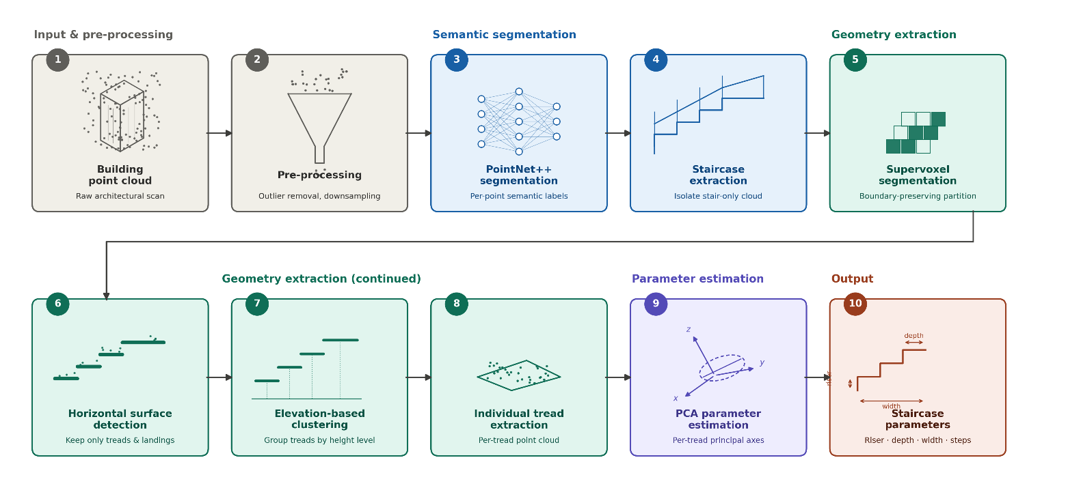
Figure 1: Overall workflow of the proposed staircase geometry extraction pipeline

3.3 Staircase Geometry Extraction
The proposed geometry pipeline integrates boundary-preserving supervoxel segmentation (Lin et al., 2018) with the staircase geometry extraction strategy presented in GSMRec (Wei et al., 2025) to provide a unified workflow for staircase geometry extraction and geometric parameter estimation. Starting from the stair-only cloud with validated normals, a k-nearest-neighbour graph (k = 15) is built, and each edge (p, q) is weighted by the Lin dissimilarity
D(p,q) = 1 − |n_{p} · n_{q}| + 0.4 × ‖p − q‖ / R, R = 0.30 m (1)
where n_{p} and n_{q} are unit normals and R is the target supervoxel resolution (Lin et al., 2018; Wei et al., 2025). The first term is small on a coplanar surface and large across a tread-riser junction, so that supervoxel boundaries coincide with physical edges. Rather than the exact energy-minimisation fusion of Lin et al. (2018), supervoxels are grown from regularly spaced seeds across only those graph edges with D < 0.15, assigning any residual points by nearest-neighbour majority vote; this seeded region-growing variant retains the published dissimilarity metric while being simpler to implement. Each supervoxel is summarised by its centroid, mean normal and point count, and those with a near-vertical mean normal are retained as horizontal-surface candidates following GSMRec (Wei et al., 2025).
The horizontal supervoxels are grouped into discrete step levels by agglomerative clustering of their centroid heights (single linkage, 0.08 m threshold), which does not require the number of steps to be known in advance. When floor planes are present in the segmented input, they are identified as the densest clusters at the extreme elevation levels and removed. Remaining clusters are accepted as treads subject to a minimum point-count check that removes noise fragments, and each validated cluster, ordered by increasing height, is exported as an individual tread point cloud. The pipeline terminates at individual tread extraction.
3.4 PCA-based Geometric Parameter Estimation
Because staircases are rarely aligned with the global axes, each extracted tread is measured in its own principal frame (Jolliffe, 2002). For a tread with centroid mean x, the eigenvectors of the point covariance matrix define the local axes: the two largest-variance eigenvectors span the tread plane and the third is its normal. Projecting the points onto the in-plane axes gives the stair width and tread depth; to suppress boundary points displaced across the tread-riser junction in RGB-D data, these extents are taken from a percentile-trimmed range rather than the raw minimum and maximum. With treads ordered by elevation, the riser height follows the standard convention of consecutive tread-height differences and the reported staircase riser, depth and width are the means over all treads, the step count being the number of validated treads. Table 1 lists the principal parameters of the pipeline, held fixed across all evaluated staircase types.
Table 1: Principal parameters of the implemented pipeline.
Stage | Parameter | Value
Outlier removal | neighbours / std-ratio | 20 / 2.0
Normal estimation | neighbourhood k | 15
k-NN graph | neighbours k | 15
Supervoxel dissimilarity | resolution R (Eq. 1) | 0.30 m
Supervoxel growing | seed spacing / threshold | 150 / 0.15
Horizontal extraction | normal threshold | 0.30
Height clustering | linkage / threshold | single / 0.08 m
Tread geometry | method | per-tread PCA

4. EXPERIMENTAL SETUP
4.1 Datasets
Two complementary datasets were used, summarised in Table 2. The semantic segmentation stage was developed on staircase regions extracted from the Matterport3D dataset (Chang et al., 2017): of 90 audited building-scale houses, 72 contained staircases, which were re-labelled under a ten-class, staircase-oriented taxonomy. The data were partitioned house-wise into 69 training houses (1,677 regions, 93,119 blocks) and 11 test houses (260 regions, 14,473 blocks), with each block containing 4,096 points. Geometry extraction was evaluated on four procedurally generated synthetic staircases with exact machine-readable ground truth (straight, switchback, spiral and open-riser), each generated as a multi-view depth-camera fusion so that tread-riser boundary noise resembles real sensor capture, together with additional real Matterport3D staircases used for qualitative and metric case studies.
Table 2: Summary of the datasets used in this study.
Property | Matterport3D | Synthetic
Role | Segmentation + case studies | Geometry evaluation
Scenes / cases | 90 houses (72 stairs) | 4 stair types
Split | 69 train / 11 test | n/a
Blocks | 93,119 / 14,473 | n/a
Ground truth | 10-class labels (+ measured geometry for case studies) | metric parameters

4.2 Software and Implementation
The pipeline was implemented in Python. Semantic segmentation used PointNet++ (Qi et al., 2017b) through the public PyTorch reference implementation of Yan (2019), and the geometry extraction stage used Open3D (Zhou et al., 2018) for point-cloud handling, normal estimation and clustering. PointNet++ was trained with a class-weighted cross-entropy loss (Adam optimiser, 20 epochs) on a single NVIDIA RTX 4060 GPU.
4.3 Evaluation Strategy
Semantic segmentation was evaluated on the Matterport3D test split using overall accuracy, mean intersection-over-union (mIoU) and per-class IoU. Geometry extraction was assessed qualitatively on the synthetic staircases by comparing the recovered supervoxels and treads against the known ground-truth configuration, and quantitatively on real Matterport3D staircases by reporting the recovered metric geometry directly, including a check against Indian NBC stair-dimension requirements where full tread visibility allowed complete measurement.
5. RESULTS AND DISCUSSION
5.1 Semantic Segmentation
Table 3: Semantic segmentation performance of the PointNet++ Network on the Matterport3D staircase test split (11 houses, 14,473 blocks).
Metric | Value
Overall point accuracy | 76.79%
Mean IoU (mIoU) | 41.89%
IoU, stair structure | 52.48%
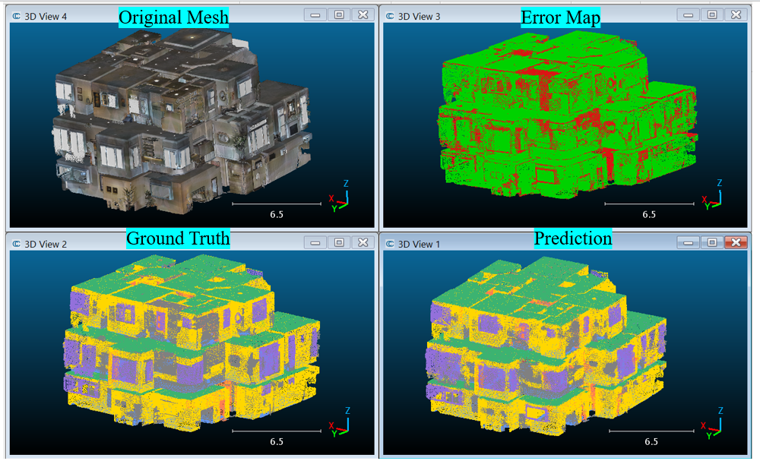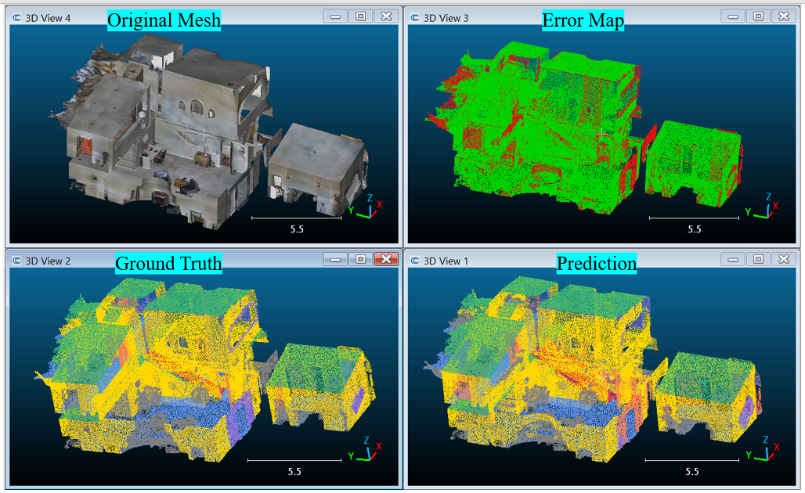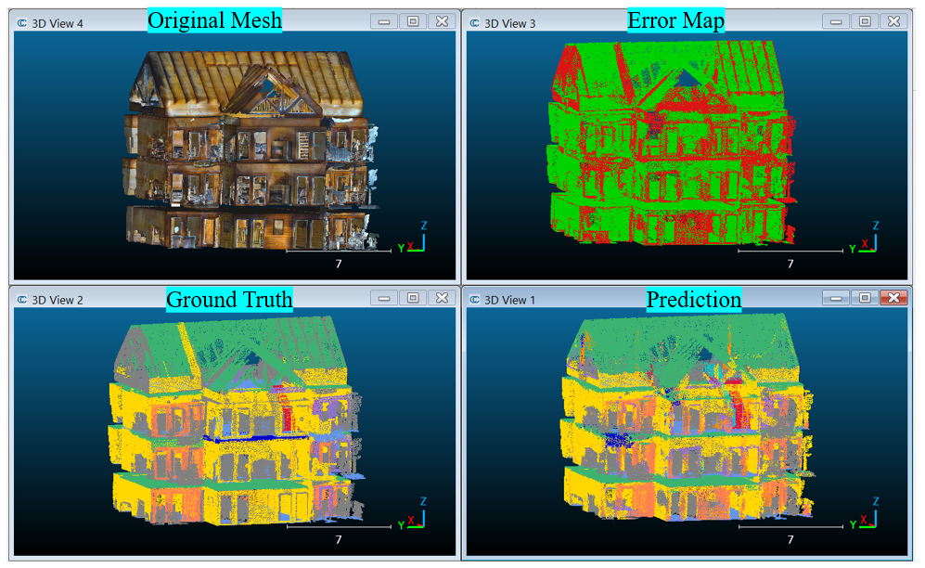
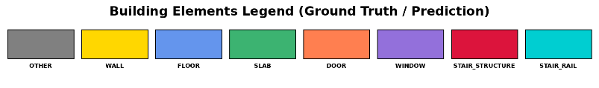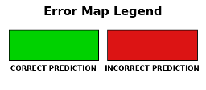
Figure 2: Whole-building predictions on three Matterport3D test houses. (a) Favourable house. (b) Favourable house. (c) Cluttered, heavily occluded house.
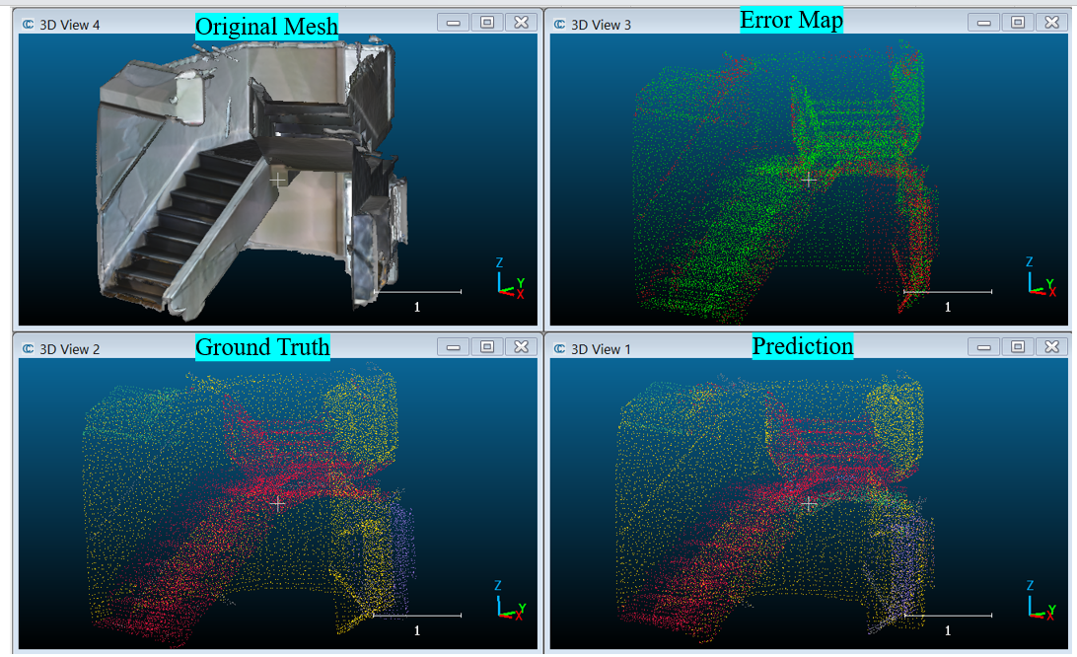 | 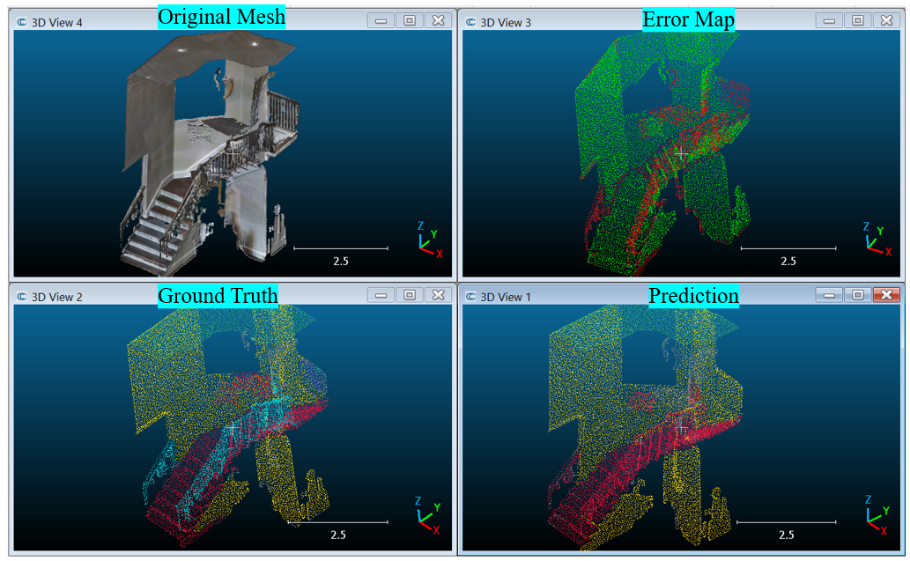 | 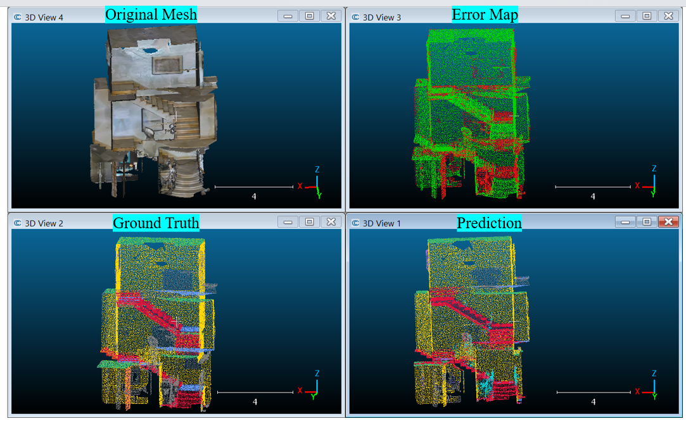
Figure 3: Semantic segmentation of isolated staircase regions. (a) Straight flight. (b) Flight with railing. (c) Multi-storey stairwell.
PointNet++ isolates the staircase from the Matterport3D scans with the overall accuracy and IoU reported in Table 3. Figures 2 and 3 show that the staircase body is recovered as a coherent region in most cases, with residual errors concentrated at the stair-to-floor boundary and, in cluttered or heavily occluded houses, across fragmented surfaces.

5.2 Geometry Extraction Results
The geometry pipeline is evaluated on Matterport3D staircase cases and on synthetic staircases with known ground truth.
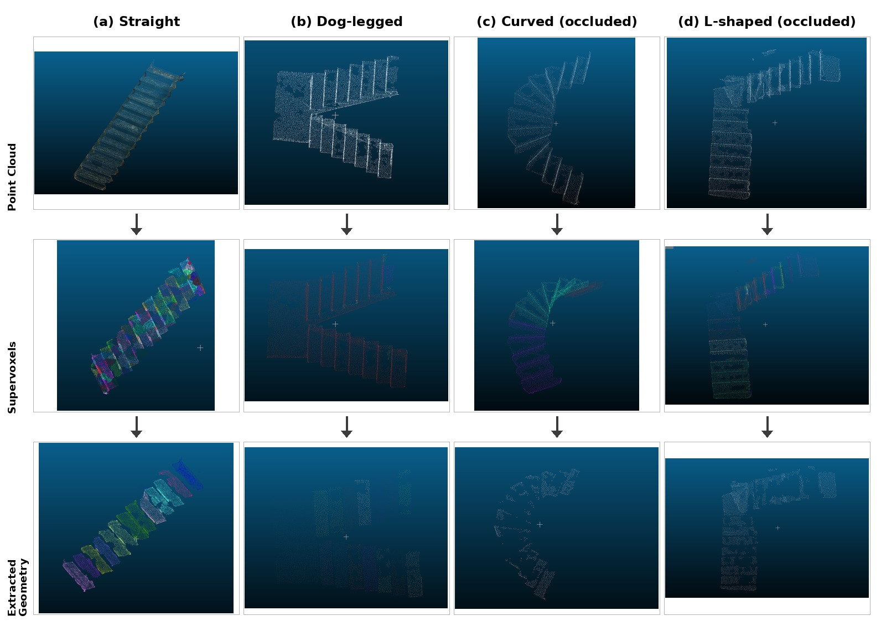
Figure 4: Geometry extraction pipeline on four Matterport3D staircase cases. (a) Straight flight. (b) Dog-legged flight. (c) Curved stairwell (occluded). (d) L-shaped stairwell (occluded).
The straight and dog-legged cases (Figure 4a,b) have near-complete tread visibility and are recovered as clean, contiguous treads. The curved and L-shaped cases (Figure 4c,d) show occlusion-induced incompleteness typical of real building scans: furniture, walls and scan gaps leave only part of each tread visible, so the supervoxel and tread-extraction stages recover partial treads. These two cases are retained as challenging real-world examples motivating the occlusion-aware reconstruction work identified as future work.
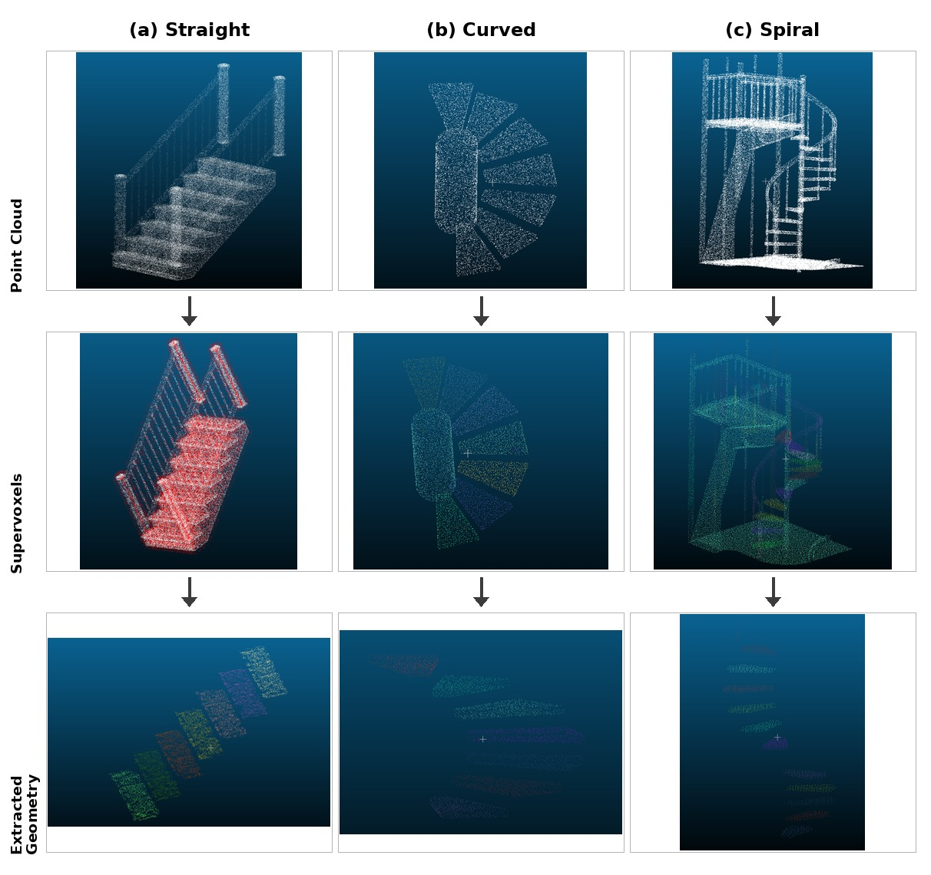
Figure 5: Geometry extraction pipeline on three synthetic staircase types with known ground truth. (a) Straight. (b) Curved. (c) Spiral.
The straight case (Figure 5a) is recovered cleanly at every stage. The curved and spiral cases (Figure 5b,c) show progressively more fragmented supervoxels and treads, because the rectangular tread parameterisation used in this study is not designed for radially arranged treads; this is visible in the extracted-tread panels and is discussed further as a limitation.
Table 4: Geometry extraction measurements for two representative case studies (straight and curved), in the pipeline's native output units.
Parameter | Straight case | Curved case
Number of treads | 7 | 7
Average width | 52.14 | 1.008
Average depth | 12.13 | 0.638
Average riser height | 7.24 | 0.179
Total run | 84.93 | 4.469
Total rise | 43.41 | 1.076
Stair angle (deg) | 27.07 | 13.53
Table 4 reports the full set of geometric parameters recovered for one straight and one curved staircase, each processed end-to-end by the pipeline. Width, depth and riser values are given in the pipeline's native output units, which are not calibrated to a common physical scale across the two source point clouds and are therefore not directly comparable to each other in absolute terms; they are included to show that the same pipeline recovers a complete, internally consistent set of parameters (tread count, width, depth, riser height, total rise and run, and stair angle) for both a straight and a curved configuration.
Table 5: Geometry extraction and Comparison with NBC 2016 Residential Stair Dimensions (Group A Buildings) for two further Matterport3D staircases with complete tread visibility.
Parameter | Case 1 (10 treads) | Case 2 (15 treads)
Average width (m) | 0.306 (FAIL) | 0.535 (FAIL)
Average depth (m) | 0.155 (FAIL) | 0.222 (FAIL)
Average riser height (m) | 0.198 (PASS) | 0.189 (PASS)
Total rise (m) | 1.779 | 2.648
Total run (m) | 1.554 | 3.335
Pitch angle (deg) | 48.86 | 38.46
NBC India compliance | Non-compliant | Non-compliant
On two further Matterport3D staircases with complete tread visibility, the pipeline recovers full metric geometry directly in metres (Table 5), which allows a direct check against Indian National Building Code stair-dimension requirements. Both staircases pass on riser height but fail the minimum width and tread-depth requirements; this reflects the dimensions of the as-built staircases themselves rather than a limitation of the extraction pipeline, and illustrates a direct code-compliance use case for the recovered geometry. The NBC comparison is presented as a demonstration of how recovered parameters could support code-checking workflows, rather than as a formal compliance audit of the source buildings.
5.3 PCA-based Parameter Estimation
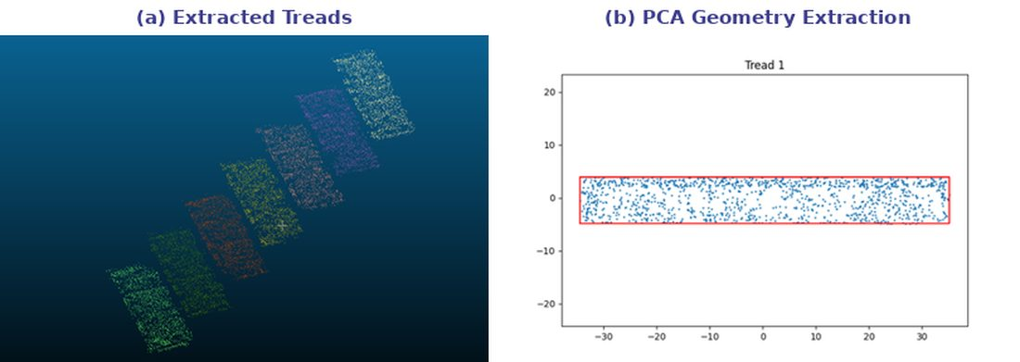
Figure 6: Per-tread PCA parameter estimation. (a) Extracted treads from a straight staircase. (b) A single tread in its principal frame with the fitted bounding rectangle.
The per-tread PCA measures each tread in its own principal frame, which removes the dependence on the global scan orientation, and estimates width, depth and riser height directly from the tread point geometry rather than reconstructing a full parametric stair mesh. An earlier validation of the straight-staircase geometry against a manually reconstructed reference model gave errors of 1.35% for stair width, 3.4% for tread depth and 4.6% for riser height, indicating that the measurement stage is accurate when the input treads are clean and rectangular; the larger depth errors observed on the depth-fused synthetic clouds therefore originate mainly from boundary noise in the segmented surface rather than from the measurement stage itself.
6. LIMITATIONS
The present implementation has a limited scope in several respects. The rectangular PCA parameterisation does not handle radially symmetric treads, so curved and spiral staircases are measured less accurately than straight and switchback configurations. Occlusion and limited sensor coverage in real-world scans can leave large sections of a tread unobserved, which limits complete geometric recovery for the affected staircases. The stair-rail class could not be evaluated quantitatively because of the available dataset split, and the geometry pipeline has not yet been run end-to-end with the segmentation stage on the same real-world scan.
7. CONCLUSION
This paper presented an integrated workflow that couples a PointNet++ semantic segmentation front-end with a geometry extraction pipeline adapted from boundary-preserving supervoxel segmentation and the GSMRec supervoxel-clustering strategy, evaluated on Matterport3D and synthetic staircase data. PointNet++ isolates the staircase reliably (76.79% overall accuracy and 52.48% IoU on the staircase class), and the geometry pipeline recovers clean, contiguous tread geometry for straight configurations, with progressively greater fragmentation for curved and spiral geometries where the rectangular tread parameterisation is not well suited to radially arranged treads. On two further real Matterport3D staircases with complete tread visibility, the pipeline additionally recovers full metric geometry directly in metres, including a National Building Code compliance check, while a further Matterport3D staircase with substantially occluded treads illustrates the practical limits of the approach. Future work will investigate occlusion-aware reconstruction and completion methods for occluded staircase cases, a curvature-aware tread parameterisation for curved and spiral flights, evaluation on a larger and more diverse set of real-world staircases, and generation of IFC/BIM-compatible geometric models from the estimated stair parameters, working towards a single pipeline that links segmentation, geometry extraction and as-built model generation.
ACKNOWLEDGEMENTS
This work was supported by the Industrial Research & Consultancy Centre (IRCC), IIT Bombay, under Grant No. 10019641 for the project “Extended Reality Based Monitoring of Construction Progress,” and by the Anusandhan National Research Foundation (ANRF), India, under Grant No. 10020253 for the project “Multi-Modal Data Fusion with Quadruped Robots for Construction Site Monitoring.”
REFERENCES
Abreu, N., Pinto, A., Matos, A. & Pires, M., (2023). Procedural point cloud modelling in scan-to-BIM and scan-vs-BIM applications: a review. International Journal of Geo-Information, 12(7): p. 260.
Cai, P. & Sur, S., (2022). DeepPCD: enabling autocompletion of indoor point clouds with deep learning. Proceedings of the ACM on Interactive, Mobile, Wearable and Ubiquitous Technologies, 6(2): p. 1-29.
Chang, A., Dai, A., Funkhouser, T., Halber, M., Nießner, M., Savva, M., Song, S., Zeng, A. & Zhang, Y., (2017). Matterport3D: Learning from RGB-D data in indoor environments. In Proceedings of the International Conference on 3D Vision (3DV), pp. 667-676.
Chen, Y. & Luo, X., (2026). Indoor scan-to-BIM workflows: progress, challenges, and future directions (2014-2024). Automation in Construction, 181: p. 106578.
Han, J., Rong, M., Jiang, H., Liu, H. & Shen, S., (2021). Vectorized indoor surface reconstruction from 3D point cloud with multistep 2D optimization. ISPRS Journal of Photogrammetry and Remote Sensing, 177: p. 57-74.
Jolliffe, I.T., (2002). Principal Component Analysis. 2nd ed. New York: Springer.
Joo, S. & Ryu, D., (2025). Robust and accurate stair geometry extraction using point cloud data. In Transactions of the Korean Nuclear Society Autumn Meeting. Changwon, Korea.
Lin, Y., Wang, C., Zhai, D., Li, W. & Li, J., (2018). Toward better boundary preserved supervoxel segmentation for 3D point clouds. ISPRS Journal of Photogrammetry and Remote Sensing, 143: p. 39-47.
Mehranfar, M., Braun, A., Borrmann, A. & Turkan, Y., (2025). Automated bottom-up, top-down method for creating digital staircase models from dense point clouds using parametric prototype models and model fitting. Journal of Information Technology in Construction (ITcon), 30: p. 920-943.
Nikoohemat, S., Diakité, A.A., Zlatanova, S. & Vosselman, G., (2020). Indoor 3D reconstruction from point clouds for optimal routing in complex buildings to support disaster management. Automation in Construction, 113: p. 103109.
Papon, J., Abramov, A., Schoeler, M. & Wörgötter, F., (2013). Voxel cloud connectivity segmentation: supervoxels for point clouds. In Proceedings of the IEEE Conference on Computer Vision and Pattern Recognition (CVPR), pp. 2027-2034.
Qi, C.R., Su, H., Mo, K. & Guibas, L.J., (2017a). PointNet: Deep learning on point sets for 3D classification and segmentation. In Proceedings of the IEEE Conference on Computer Vision and Pattern Recognition (CVPR), pp. 652-660.
Qi, C.R., Yi, L., Su, H. & Guibas, L.J., (2017b). PointNet++: Deep hierarchical feature learning on point sets in a metric space. In Advances in Neural Information Processing Systems (NeurIPS), 30: p. 5099-5108.
Rauch, L. & Braml, T., (2023). Semantic point cloud segmentation with deep-learning-based approaches for the construction industry: a survey. Applied Sciences, 13(16): p. 9146.
Rusu, R.B. & Cousins, S., (2011). 3D is here: Point Cloud Library (PCL). In Proceedings of the IEEE International Conference on Robotics and Automation (ICRA), pp. 1-4.
Sinha, A., Papadakis, P. & Elara, M.R., (2014). A staircase detection method for 3D point clouds. In 13th International Conference on Control Automation Robotics and Vision (ICARCV). Singapore: IEEE.
Tang, S., Li, X., Zheng, X., Wu, B., Wang, W. & Zhang, Y., (2022). BIM generation from 3D point clouds by combining 3D deep learning and improved morphological approach. Automation in Construction, 141: p. 104422.
Wang, C., Pei, Z., Qiu, S. & Tang, Z., (2022). Deep learning-based ultra-fast stair detection. Scientific Reports, 12: p. 16124.
Wang, C., Pei, Z., Qiu, S., Wang, Y. & Tang, Z., (2024). StairNetV3: depth-aware stair modeling using deep learning. The Visual Computer, 40(12): p. 8729-8745.
Wei, J., Wu, H., Han, J., Li, J. & Liu, C., (2025). GSMRec: a general staircase model reconstruction method based on point cloud data. International Journal of Digital Earth, 18(2): p. 2598917.
Yan, X., (2019). Pointnet_Pointnet2_pytorch: PyTorch implementation of PointNet and PointNet++ [Online]. Available: https://github.com/yanx27/Pointnet_Pointnet2_pytorch.
Yang, F., Liang, Y., Li, D., Su, F., Zhu, H., Zuo, X. & Li, L., (2019). Detection of space connectivity from point cloud for stair reconstruction. EasyChair Preprint No. 1001.
Yin, C., Wang, B., Gan, V.J.L., Wang, M. & Cheng, J.C.P., (2021). Automated semantic segmentation of industrial point clouds using ResPointNet++. Automation in Construction, 130: p. 103874.
Yue, H., Wang, Q., Gao, M.Y., Yang, T., Li, L., Chen, K. & Wang, M., (2026). A point cloud dataset and deep learning framework for semantic segmentation of construction site point clouds. Computer-Aided Civil and Infrastructure Engineering, 45: p. 100050.
Zhang, K., Zhang, A., Wang, X. & Li, W., (2024). Deep-learning-based point cloud completion methods: a review. Graphical Models, 136: p. 101233.
Zhou, Q.Y., Park, J. & Koltun, V., (2018). Open3D: A modern library for 3D data processing. arXiv preprint arXiv:1801.09847.

