Component-Based Machine Learning for Multi-Element Aggregation and Interaction: Indoor Climate Prediction

Shaofan Wang¹, Philipp Geyer¹

¹Leibniz Universität Hannover, Hannover, Germany

ABSTRACT:

Accurately and efficiently predicting airflow, mass transport, and temperature distribution in indoor environments is essential for the design phase, supporting exploration and decision-making with respect to indoor comfort and energy efficiency. However, the high computational cost of computational fluid dynamics (CFD) simulations remains a significant challenge and barrier for application of such methods. The data-driven models render a high-potential fast alternative to replace the CFD simulation to predict the indoor environment. However, generalization and reusability are still limited. Therefore, we propose component-based machine learning (CBML) for spatial flow prediction with better generalization ability than the current machine learning methods. In this paper, we tackle the aggregation of two data-driven prediction components; the success of this aggregation forms a fundamental method of CBML for CFD. The CBML surrogate model for this purpose includes three sub-models, a convolutional autoencoder with residual network (CAER), a multilayer perceptron (MLP), and a convolutional neural network (CNN). Testcase data represent a 2D rectangular room equipped with two inlets on the left and right wall; prediction of the aggregation of two separate predictions of flow caused of left inlet and right inlet forms training and test object in this paper. The CAER serves an order reducer for reducing the dimensionality of spatial data and extracting the features of components. The MLP works as a predictor to map the boundary conditions with component features. Last but not least, the CNN is regarded as an aggregator to discover how two components affect others. Comparison of predictions with CFD simulation results shows a maximum absolute error of less than 0.09 m/s for 95% of the flow field in real-time prediction. Besides, the compressed features of single-inlet and multi-inlet are mapped into latent space by t-SNE, illustrating the correlations between features of different components. These outputs demonstrate that the CBML approach is able to predict the two aggregated flow fields, thus, effectively captures complex feature interactions among multiple components, and the latent features contain useful fluid information.

KEYWORDS:

Component-based machine learning (CBML), Aggregation and interaction, Reduced order model (ROM), CFD simulation, Indoor environment prediction

1. INTRODUCTION
The attention on indoor hygiene and comfort has explosively increased since the COVID-19 pandemic resulting in an urgent demand for the rapid prediction of indoor environment (Lin et al., 2024). Besides, the design of the green building and passive house also requires indoor velocity and temperature distribution for energy-efficient ventilation (Cao et al., 2014). In order to achieve these design objectives, integrating indoor environment fast prediction into the design processes of buildings and their systems is important (Zhou et al., 2020). CFD is able to predict these spatial and temporal parameters, such as velocity and temperature distribution (Cetin, Avci and Aydin, 2020) but requires significant modelling and computational effort making them unsuitable for integration into the building design phase with its iterative decision-making. Furthermore, the CFD model is based on Navier-Stokes’s equations and numerical scheme, which is not friendly to architecture designers and building engineers, as they do not have professional knowledge of fluid mechanics and can easily lead to wrong model Settings. For this aim, some simplified CFD models are investigated, such as coarse-grid (Wang and Zhai, 2012) and fast fluid dynamics (Han et al., 2021). Besides, Recent studies have demonstrated the effectiveness of GPU-accelerated lattice Boltzmann methods (LBM) for indoor airflow and temperature distributions, showing good agreement with traditional Large Eddy Simulation approaches while reducing computational time (Khan et al., 2015). However, the computational efforts are unable to reach an acceptable extent with a certain reduction in accuracy. Therefore, a design-integrated, low-effort, intuitive, minimal specialized knowledge and rapid prediction surrogate model is necessary.
With respect to this goal, machine learning and reduced order modelling methods are introduced into this field to form a surrogate for CFD simulation and achieve fast prediction of the indoor environment (Caron, Lauret and Bastide, 2025). Some linear projection methods, such as proper orthogonal decomposition (POD) and dynamic mode decomposition (DMD) are developed to reduce the calculation effort (Long, Guo and Xiao, 2024). (Lu et al., 2023) applied the POD method to predict ventilation performance in the high-speed train compartment. However, the inherent linear nature of these low-rank approximations limits their ability to accurately reconstruct airflow distributions with high levels of nonlinearity (Wang, Chen and Geyer, 2023). Afterward, various non-linear methods are also employed, such as deep neural network (NN) to predict and reconstruct the flow fields. (Zhou and Ooka, 2021) developed a neural network for reproducing CFD simulations of non-isothermal indoor airflow fields with different pre-processing methods learning rules between different inlet velocities and airflow patterns. We applied autoencoder and residual network to reduce the dimensionality and reconstruct the indoor air velocity field with different heights of inlet positions (Wang and Geyer, 2024). The results show the potential of this method for real-time prediction with acceptable accuracy.
However, resulting data-driven models created through such methods are valid only for the flow settings and the spatial configuration defined by the training data; parameters can be varied but not topological settings such as number of inlets, outlets, windows and etc. In practical architecture design phase, designers and engineers always add or remove different components to the building and room to develop the design, then evaluate the indoor environment performance. In the process, this type of model, which we call monolithic, is unable to give a real-time prediction as feedbacks for designers, as its prediction just bases on fixed component type and number. This means that the monolithic surrogate model has limited reusability, flexibility, and generalization. Due to this reason, we are developing the approach of component-based machine learning (CBML) for indoor environment prediction. The concept of CBML is already employed in building energy prediction (Geyer and Singaravel, 2018), but there are no precedents of applying CBML to spatial indoor velocity and temperature prediction to increase the flexibility and generalization ability of the surrogate model.
In this paper, a CBML method for spatial flow and temperature field prediction based on CFD simulations is proposed. Key for this development is the aggregation of two interacting flow streams predicted as components by data-driven methods; whereas data-driven prediction has been successfully performed (Wang and Geyer, 2024), the aggregation is an important breakthrough for CBML in fluid dynamics, as it allows for combining predicted flow fields. The benchmark employed in this paper is a 2D rectangular room, where the variable is inlet number and velocity. There are three conditions, only left inlet, only right inlet and both left and right inlet. Two inlets are regarded as two components, which are predicted by data-driven methods separately. Respectively, then two of separate predictions are combined by the aggregator to achieve the prediction a room with two components. The output of this three-component surrogate model is the indoor velocity field.
The rest of this paper is organized as follows. First, we introduce the engineering constraints and research context, emphasizing the challenges in indoor airflow prediction and the need for surrogate modelling. Next, we describe the methodologies, including the CFD simulation setup and surrogate modelling framework, followed by a detailed discussion of CAER, MLP, and CNN in capturing spatial patterns of velocity and temperature distributions. Then, we present the results and discussion, evaluating model accuracy, computational efficiency, and generalization under different airflow conditions. Finally, we summarize the key findings and outline future research directions, including potential improvements in efficient aggregation algorithms.

2. METHODOLOGY
In this study, a CBML approach is developed to enable real-time indoor environment prediction using a multi-component aggregation surrogate model. The pipeline of the CBML method is shown in Fig. 1, which is composed of three neural networks: a CAER serving as an order reducer, an MLP acting as a predictor, and a CNN as aggregator that captures the interaction between two components. And, traditional CFD simulation is employed to generate the dataset for training the surrogate model. The latent features of the left inlet (green), right inlet (purple), and dual inlets (yellow) will be clustered using the t-SNE method to reveal the underlying patterns.
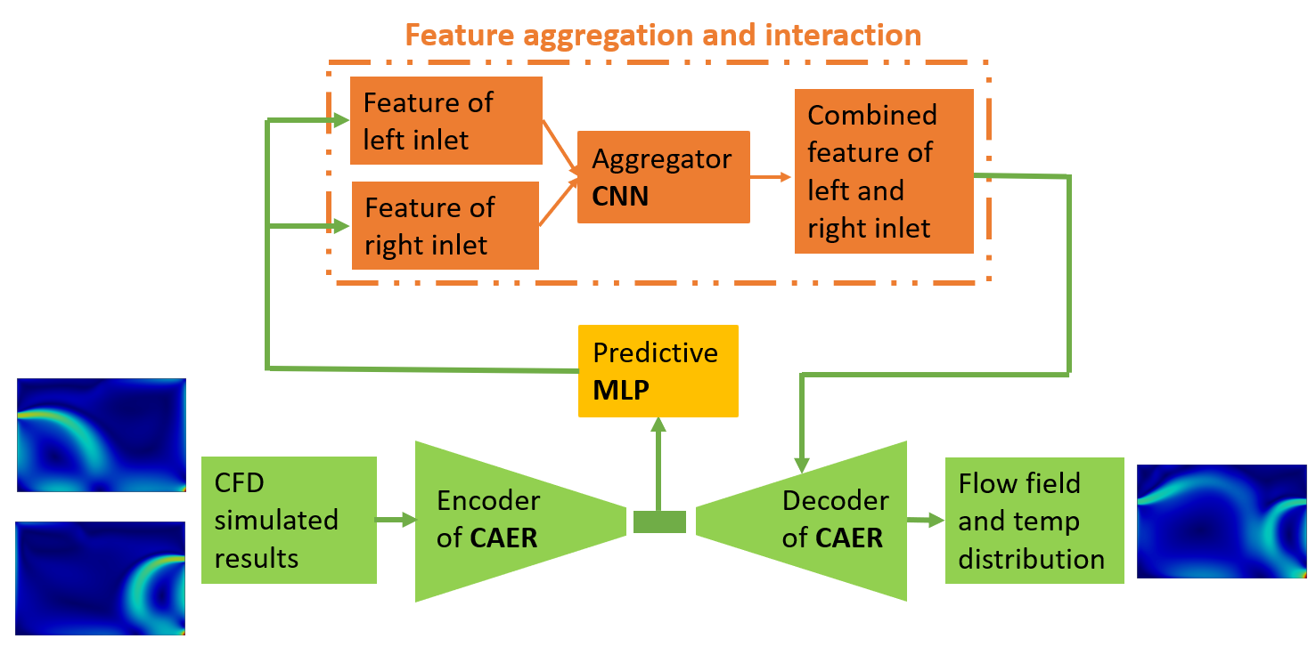
Fig. 1 Architecture of CBML
2.1 Dataset generation
In order to generate the dataset for training and testing the surrogate model, CFD simulation is utilized to predict the indoor velocity and temperature distributions. In this regard, a 2D rectangular room served as a benchmark shown in Fig. 2 has dimensions of 1.5 meters in the x direction and 1 meter in the y direction. Within this room, two windows are present, each measuring 0.9 meters, located on the left and right walls at 35 °C. The thermal boundary conditions of the ceiling and floor are set as heat flux at -200 $W$ meaning heat flow out of room. The temperature of inlet air is 10 °C. The setting of temperature and heat flux aims to simulate the cooling work condition with cooled air, floor and ceiling under summer condition. Considering the component and aggregation, three-room cases are adopted, with only left inlet, with only right inlet and with both left and right inlets. The first two cases are used to extract the feature of left inlet and right inlet, then the last case is used to recognize the interactive effects between left inlet and right inlet.
The simulations are based on the Reynolds-Averaged Navier-Stokes (RANS) equations coupled with the k-ε turbulence model, striking a balance between computational efficiency and accuracy. OpenFOAM is employed for the simulations on a virtual Linux system, utilizing AMD Ryzen Threadripper PRO 3975WX 32-Core processors. The computational domain is discretized using the Finite Volume Method (FVM). The Boussinesq approximation is applied to model the buoyancy term in the momentum equation. To enhance accuracy near boundaries, wall functions are implemented for all walls and windows. These functions effectively handle the boundary conditions for turbulent kinetic energy and Reynolds stress in turbulence models, facilitating a more precise calculation of turbulence parameters in near-wall flow regions and ultimately improving simulation accuracy.
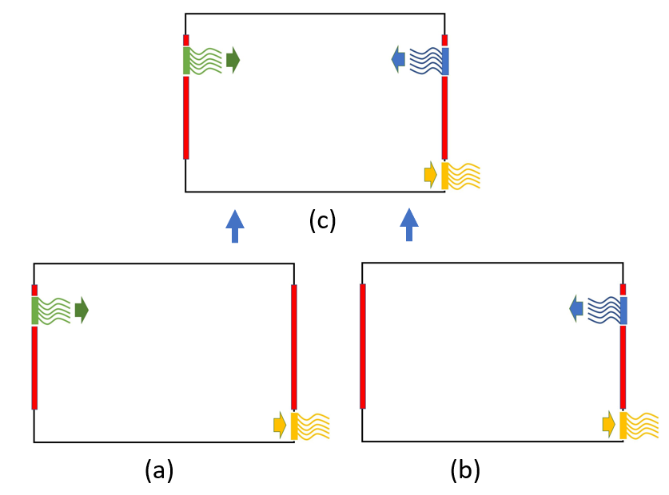
Fig. 2. Benchmark case (a: left inlet only, b: right inlet only, c: dual inlet)
The training data is designed for predicting indoor airflow fields under dual air supply conditions by aggregating airflow fields from single left and single right air supply scenarios. The dataset consists of five different air supply velocities for the left inlet and five different velocities for the right inlet. By performing a full factorial combination of these velocity levels, a total of 25 cases are generated for dual air supply conditions. These datasets focus on the indoor velocity distribution as the dependent variable. The dataset selection, as outlined in Table 1 and Table 2, is conducted manually. While a larger dataset typically enhances model performance, it also increases training time and data requirements. To balance computational efficiency and adaptability to sparse data, only 25 sets of training data were chosen for this study.
Table 1. Training dataset (Unit: m/s)
Only left inlet
0.05 | 0.25 | 0.50 | 0.70 | 1.00
Only right inlet
0.05 | 0.25 | 0.50 | 0.70 | 1.00
Dual inlet (L: left, R: right)
L: 0.05  R: 0.05 | L: 0.05  R: 0.25 | L: 0.05  R: 0.50 | L: 0.05  R: 0.70 | L: 0.05  R: 1.00
L: 0.25  R: 0.05 | L: 0.25  R: 0.25 | L: 0.25  R: 0.50 | L: 0.25  R: 0.70 | L: 0.25  R: 1.00
L: 0.50  R: 0.05 | L: 0.50  R: 0.25 | L: 0.50  R: 0.50 | L: 0.50  R: 0.70 | L: 0.50  R: 1.00
L: 0.70  R: 0.05 | L: 0.70  R: 0.25 | L: 0.70  R: 0.50 | L: 0.70  R: 0.70 | L: 0.70  R: 1.00
L: 1.00  R: 0.05 | L: 1.00  R: 0.25 | L: 1.00  R: 0.50 | L: 1.00  R: 0.70 | L: 1.00  R: 1.00
Table 2. Testing dataset (Unit: m/s)
Dual inlet (L: left, R: right)
L: 0.1  R: 0.9 | L: 0.2  R: 0.8 | L: 0.4  R: 0.6 | L: 0.6  R: 0.4 | L: 0.8  R: 0.2 | L: 0.9  R: 0.1
2.2 Surrogate model
This chapter describes the details of surrogate model structure, training process, and testing process. There are three scenarios of cases, the first one is single left inlet, the second one is single right inlet, and last one is dual inlet. Firstly, traditional CFD simulation generates the dataset of three scenarios, which then serve to train a CAER, from which the compressed features are extracted. Then a predictive MLP is applied to map the inlet velocity with compressed features of a single component. The next step occurred in the aggregator consists of combining the features of the left inlet and the right inlet to produce the combined features for the aggregation scenarios, which serves to predict the interaction effect of the two inlets. Subsequently, the combined features are fed into the decoder part of the CAER to reconstruct the flow field and temperature distribution of the room with dual inlets. The overall structure of CBML for flow field prediction is shown in Fig. 1.
The CAER, used for order reduction, is a combination of a convolutional autoencoder and a residual network. There is a shared encoder for both velocity and temperature, and two separate decoders for the reconstruction of the velocity field and the temperature field, respectively, shown in Fig. 3. The shared encoder and separate decoder architecture offer several advantages in predicting indoor airflow fields. First, it extracts common features from both velocity and temperature fields, enhancing feature efficiency. Second, it reduces model complexity and prevents overfitting by lowering the number of parameters. Third, it captures the inherent coupling between velocity and temperature, improving physical consistency. Last but not least, independent decoders allow detailed reconstruction, optimizing specific characteristics of each field. The CAER reduces the data dimensionality from 2 × 100 × 150 to 64 × 4 × 5, making the extracted feature 23.4 times smaller than the original data size. The final configuration employs mean squared error (MSE) as the loss function, a learning rate of 10⁻⁴, and the Adam optimizer with a decay rate of 10⁻⁷, a widely used variant of stochastic gradient descent. Additionally, the sigmoid function is applied as the activation function before the output.
The structure of the aggregator is a CNN which has 4 layers. The input of the aggregator, with dimensions 128 × 4 × 5, is a fusion of the left inlet feature and right inlet feature. The output of the aggregator, with dimensions 64 × 4 × 5, will be fed into the decoder of CAER to reconstruct flow and temperature fields.
The MLP predictor is a fully connected neural network, which is already employed and shows excellent performance in previous research (Wang and Geyer, 2024). It serves as the predictive model mapping the inlet velocity and compressed features of a single inlet.
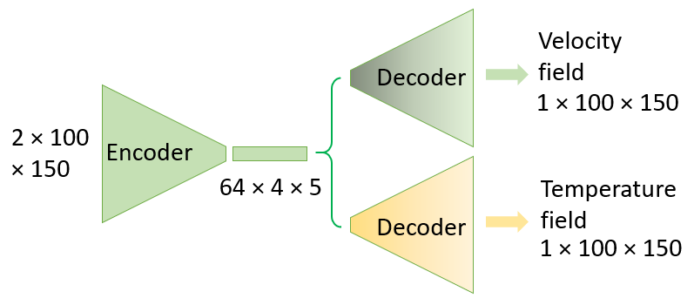
Fig. 3. CAER structure

3. RESULTS AND DISCUSSION
In this section, the velocity distribution of the surrogate model and CFD simulation are presented, compared and analysed. Fig. 6 and Fig. 7 each consist of three columns. The first column represents the ground truth from CFD simulations, the second column shows the predictions from the surrogate model, and the third column illustrates the absolute error between the first two figures. Fig. 6 presents the results on the training dataset, while Fig. 7 displays the results on the testing dataset.
3.1 Training dataset
Fig. 6 presents a comparison of CFD results (left column), surrogate model predictions (middle column), and absolute error maps (right column) for different inlet velocity combinations in the training dataset. The surrogate model effectively captures the global flow structures, including the primary velocity distributions, recirculation zones, and jet interactions. The predicted velocity fields closely resemble the CFD simulations, demonstrating that the model has successfully learned the dominant flow patterns from the training data. However, deviations between the predicted and CFD results are evident in certain regions, particularly in areas with strong velocity gradients and shear layers.
The observed velocity distributions indicate that increasing the left inlet velocity from 0.05 m/s to 1.0 m/s while right inlet velocity is fixed at 0.70 m/s increases the interaction between the two inlet streams leading to more pronounced velocity gradients and vortex formations. For cases with small left inlet velocities (e.g., L = 0.05, R = 0.70 and L = 0.25, R = 0.70), the surrogate model exhibits noticeable deviations near the jet boundary and recirculation zones. The absolute error maps indicate that the largest discrepancies occur in regions where velocity transitions sharply, suggesting that the model may struggle to capture fine-scale turbulent structures. These errors could be attributed to the inherent complexity of turbulent flows, as well as possible limitations in the model’s ability to learn highly nonlinear interactions present in the flow field. In contrast, the surrogate model performs significantly better for balanced inlet conditions (e.g., L = 0.70, R = 0.70 and L = 1.00, R = 0.70), where the velocity distributions in both CFD and predicted results show strong alignment. The error maps reveal that discrepancies in these cases are more evenly distributed and generally lower in magnitude, indicating that the model generalizes well on scenarios where momentum contributions from both inlets are relatively equal. This suggests that the model has successfully captured the underlying physical trends of the flow when both inlets contribute comparably to the overall velocity distribution.
3.2 Testing dataset
On the test dataset, the surrogate model demonstrates strong predictive capability in capturing the overall flow structures observed in the CFD simulations, as shown in Fig. 7. The predicted velocity fields closely resemble the CFD results, particularly in regions with moderate velocity gradients and stable jet interactions. The model successfully replicates the primary flow features, including the jet trajectories, recirculation zones, and velocity distributions. However, differences arise in areas with high velocity variations, such as shear layers and recirculation zones, where turbulent mixing and strong velocity gradients dominate. The absolute error maps indicate that the largest deviations occur in cases with significant inlet velocity asymmetry (e.g., L = 0.1, R = 0.9 and L = 0.9, R = 0.1), where the model struggles to fully capture the sharp momentum differences between the two inlet streams. Fig. 4 (division: max, 95%, 75%, 50%, 25%, min) clearly indicates this trend: the errors decrease when the left and right inlet velocities become more similar. Similarly, when the velocity difference between the left and right inlets is large, the prediction error of the indoor airflow field also increases. These errors suggest that the model has difficulty generalizing to conditions where one inlet has a dominant effect on the overall flow, leading to localized inaccuracies in high-shear regions. Additionally, Fig. 4 demonstrates that 95% of the flow field exhibits errors below 0.1 m/s, highlighting the overall reliability of the model’s predictions on the test dataset.
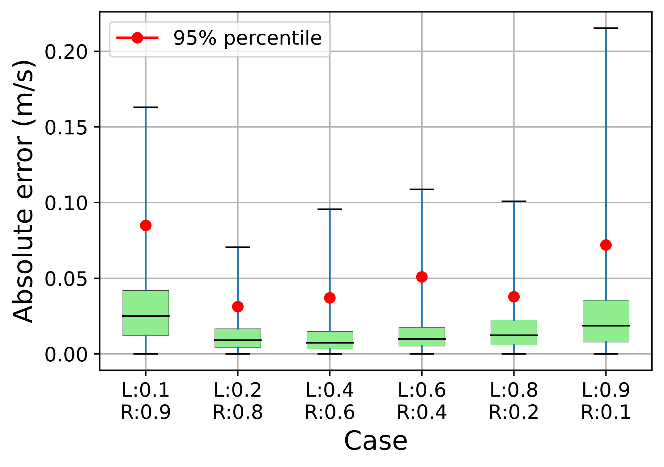
Fig. 4 Absolute error on the testing dataset
Despite these localized errors, the model performs well in cases where the inlet velocities are more balanced (e.g., L = 0.4, R = 0.6 and L = 0.6, R = 0.4), suggesting that it generalizes effectively under moderate flow conditions. The error remains relatively low in these cases, indicating that the model has learned the fundamental flow dynamics from the training dataset. However, in high-gradient regions, such as jet impingement zones and shear layers, the model tends to over-smooth velocity variations, resulting in underprediction of localized velocity peaks.
3.3 t-SNE Clustering Analysis
The 3D clustering visualization shown in Fig. 5 illustrates how the model differentiates flow conditions based on latent features. The data points are categorized into three groups: only left inlet (green), only right inlet (purple), and both left and right inlets (yellow). From the distribution, the identified split in left-inlet and right-inlet cases as distinct clusters is evident indicating that the model effectively learns and separates their unique flow characteristics. The cluster of dual inlets is also visible as cluster and positioned between the left and right inlet. This shows that the latent space is able to capture the main flow patterns under different air supply conditions and represent their differences in a low-dimensional way. This phenomenon provides strong theoretical support for the CBML method, demonstrating that the latent space follows physical principles. It also indicates that the low-dimensional features of the dual-inlet case can be interpolated and composed from the single-inlet cases.
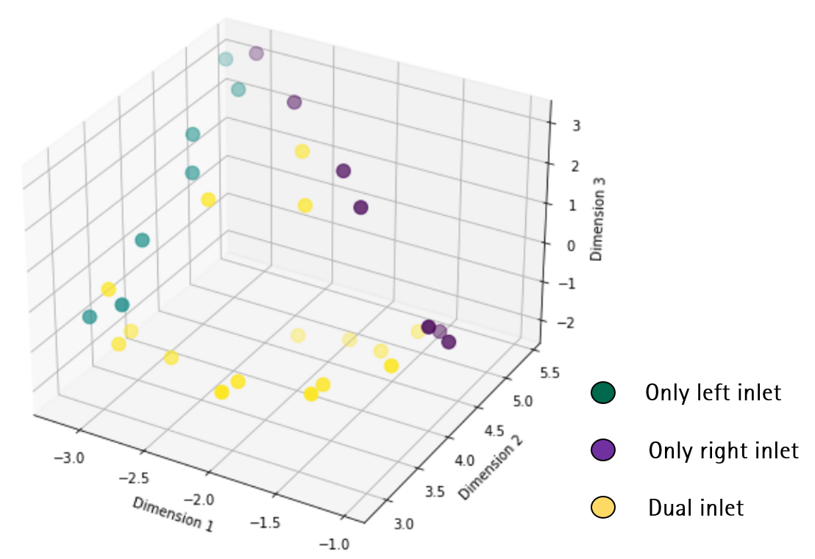
Fig. 5. t-SNE Clustering

4. CONCLUSION
This study demonstrated that the CBML method is applicable for CFD simulation surrogate modelling to predict indoor flow fields. The surrogate model is composed of three neural networks, CAER as reductor, MLP as predictor and CNN as aggregator. The 2D room with one or two inlets with different velocity works as a benchmark case, which is simulated by an CFD model to generate the training and testing data. It has been shown that it is possible to utilize and aggregate the compressed features of a single left and right inlet from CAER to generate the integrated low-rank features for dual inlet conditions, which are then reconstructed in the decoder of CAER.
Overall, the experiment results demonstrate the strong performance of the CBML model on both training and testing data, indicating that the neural network has effectively learned the fundamental patterns and mechanism of indoor velocity distribution. The mean absolute error of the training dataset is around 5 times smaller than the testing dataset which is still in an acceptable range, which means that the CBML surrogate model is reliable on environment prediction for 2D room. Furthermore, an interesting finding is that the model performs better when the inlet velocities at left and right are relatively balanced. For cases with significant asymmetry (e.g., L = 0.05, R = 0.70), the error is more pronounced indicating that the model has difficulty capturing strong momentum differences between the two inlet streams. Last but not least, clustering visualization by t-SNE demonstrates that the latent space effectively captures and differentiates flow patterns under different air supply conditions, supporting the CBML method by showing that dual-inlet features can be aggregated from single-inlet cases while preserving physical consistency.
In summary, this suggests that the CBML method holds promise for understanding and capturing the interaction between multiple flow components based on latent space aggregation, which benefits the real-time flow prediction and finally design and optimization of building and air conditioning systems. This approach has therefore the potential to overcome the current barrier of design-integrated CFD prediction that physical simulation and monolithic data-driven models have. Moreover, this approach modularizes feature extraction and relationship learning between different components, enabling independent debugging and improvement. A modular structure enhances model transparency by clearly illustrating the impact of each component, making it easier to explain model logic and physics law compared to a monolithic model.
Further research will explore potential improvements, such as incorporating gradient consistency constraints to enforce better velocity transitions or expanding the training dataset to include more cases with extreme velocity differences. Additionally, implementing physics-informed loss functions, such as vorticity-based constraints, could help the model better capture turbulent structures. Future work will focus on refining the surrogate model’s ability to resolve sharp velocity transitions and improving its robustness across a broader range of flow conditions, ensuring its applicability to complex indoor airflow predictions.

CFD CBML model Error

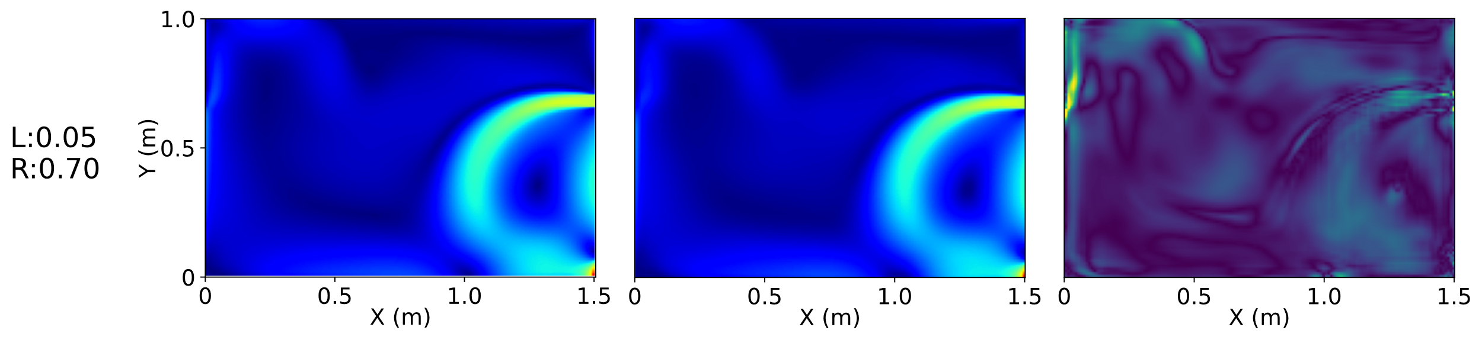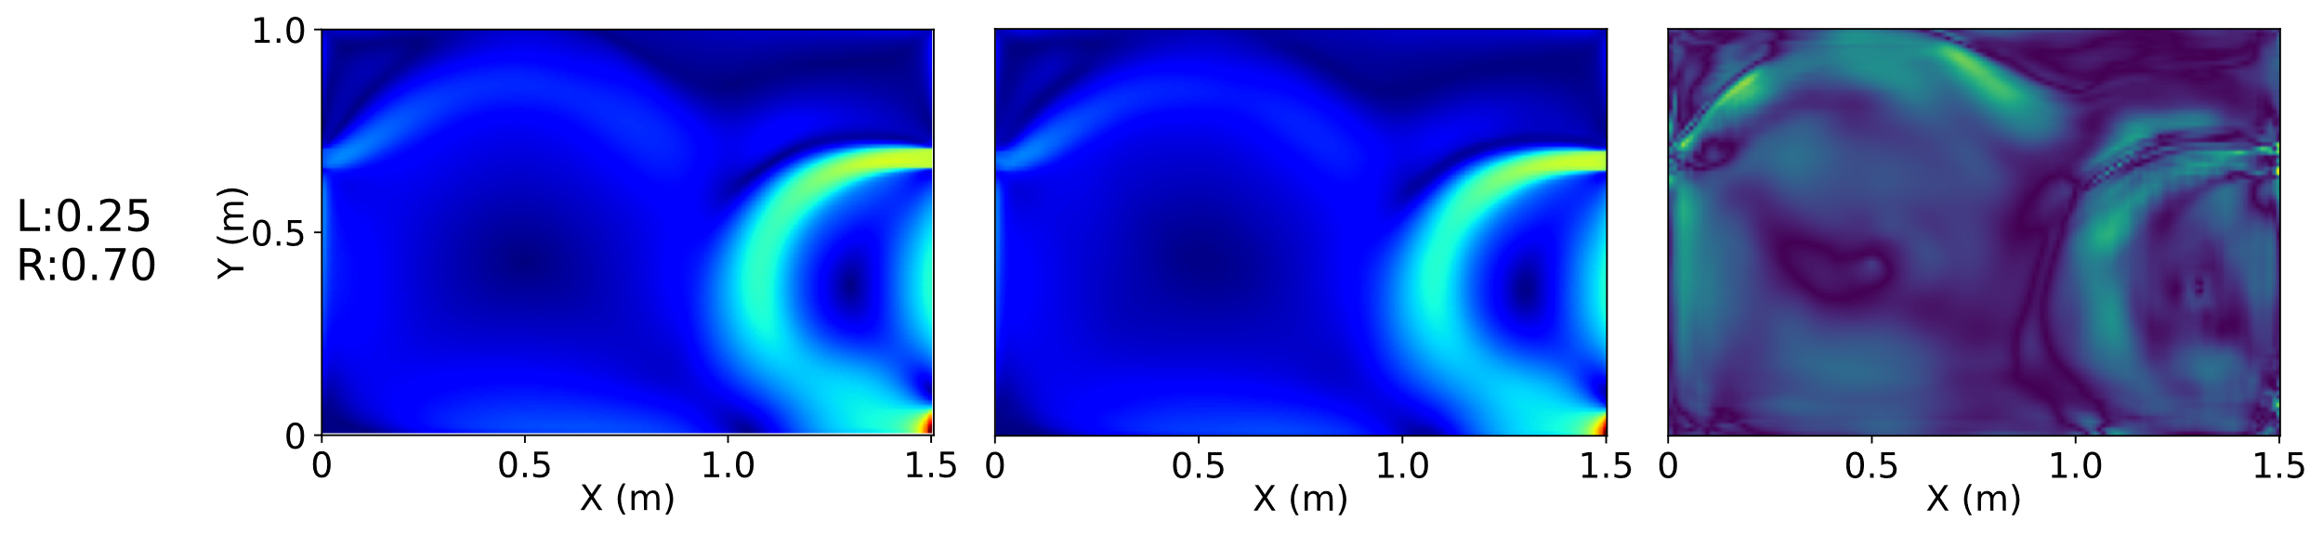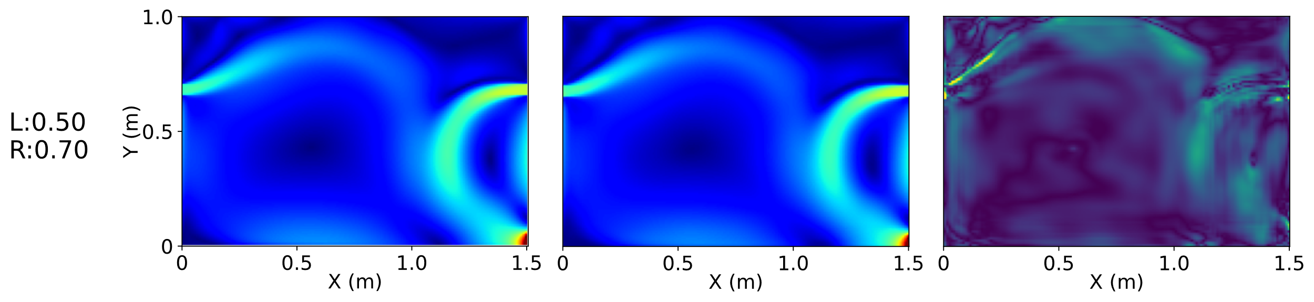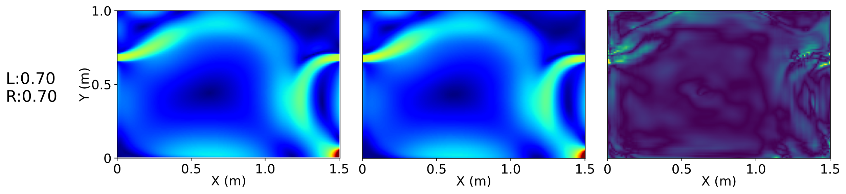
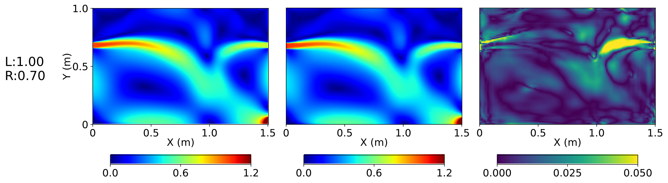
Fig. 6. Training dataset (L: left inlet velocity; R: right inlet velocity; Unit: m/s)

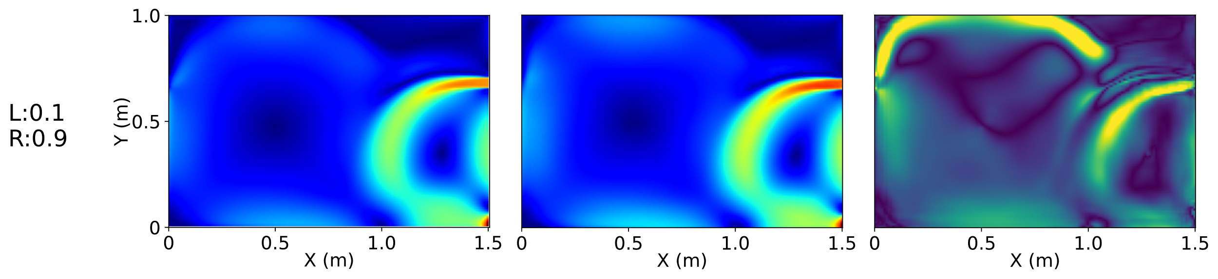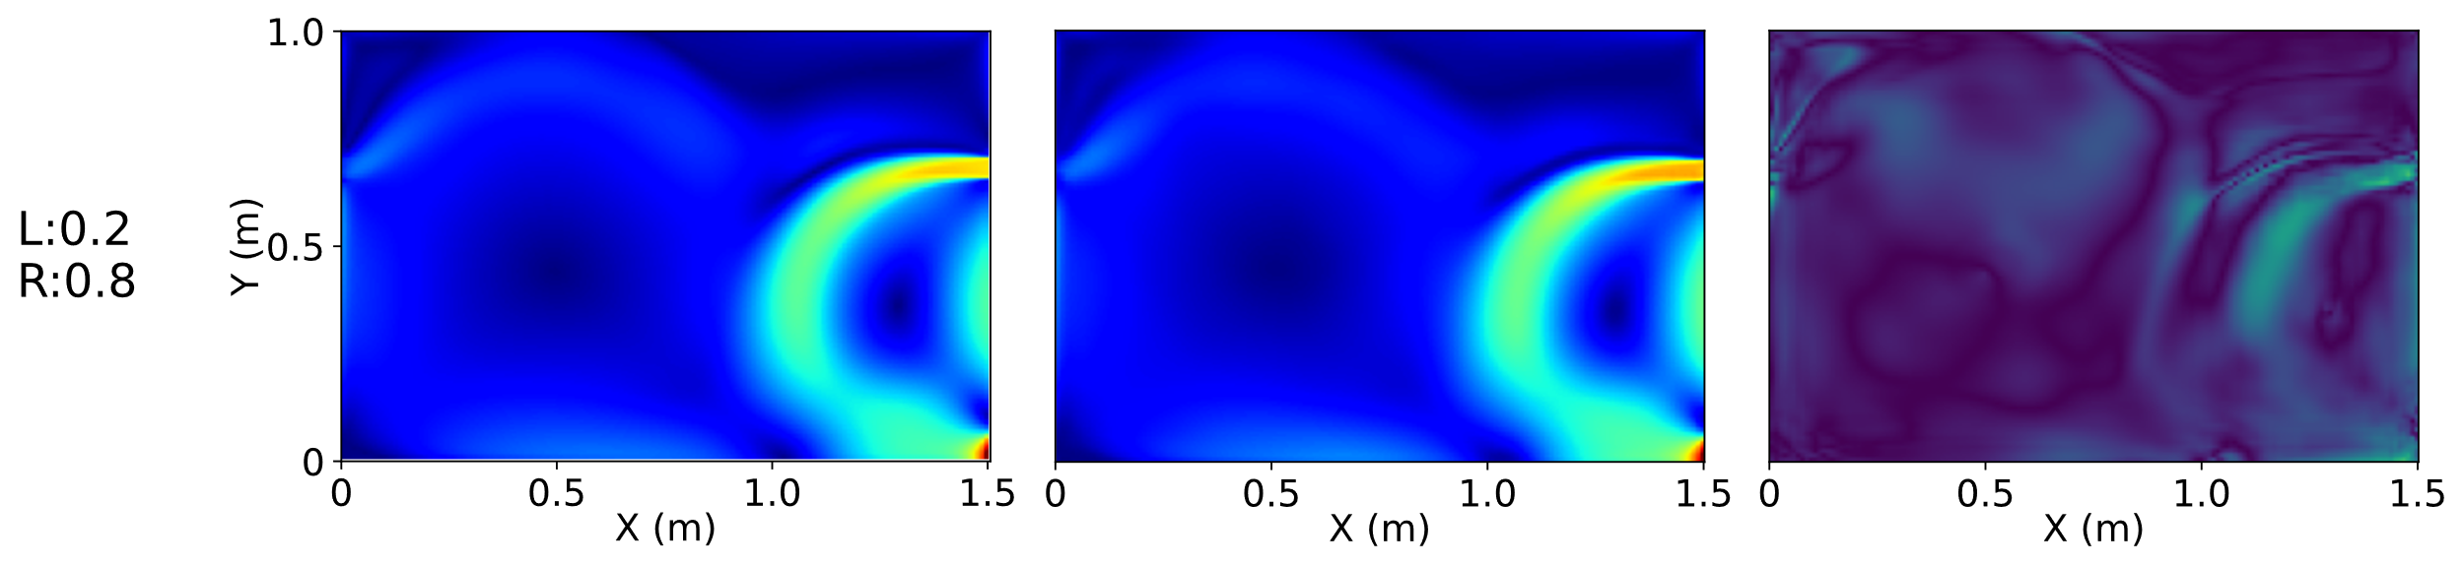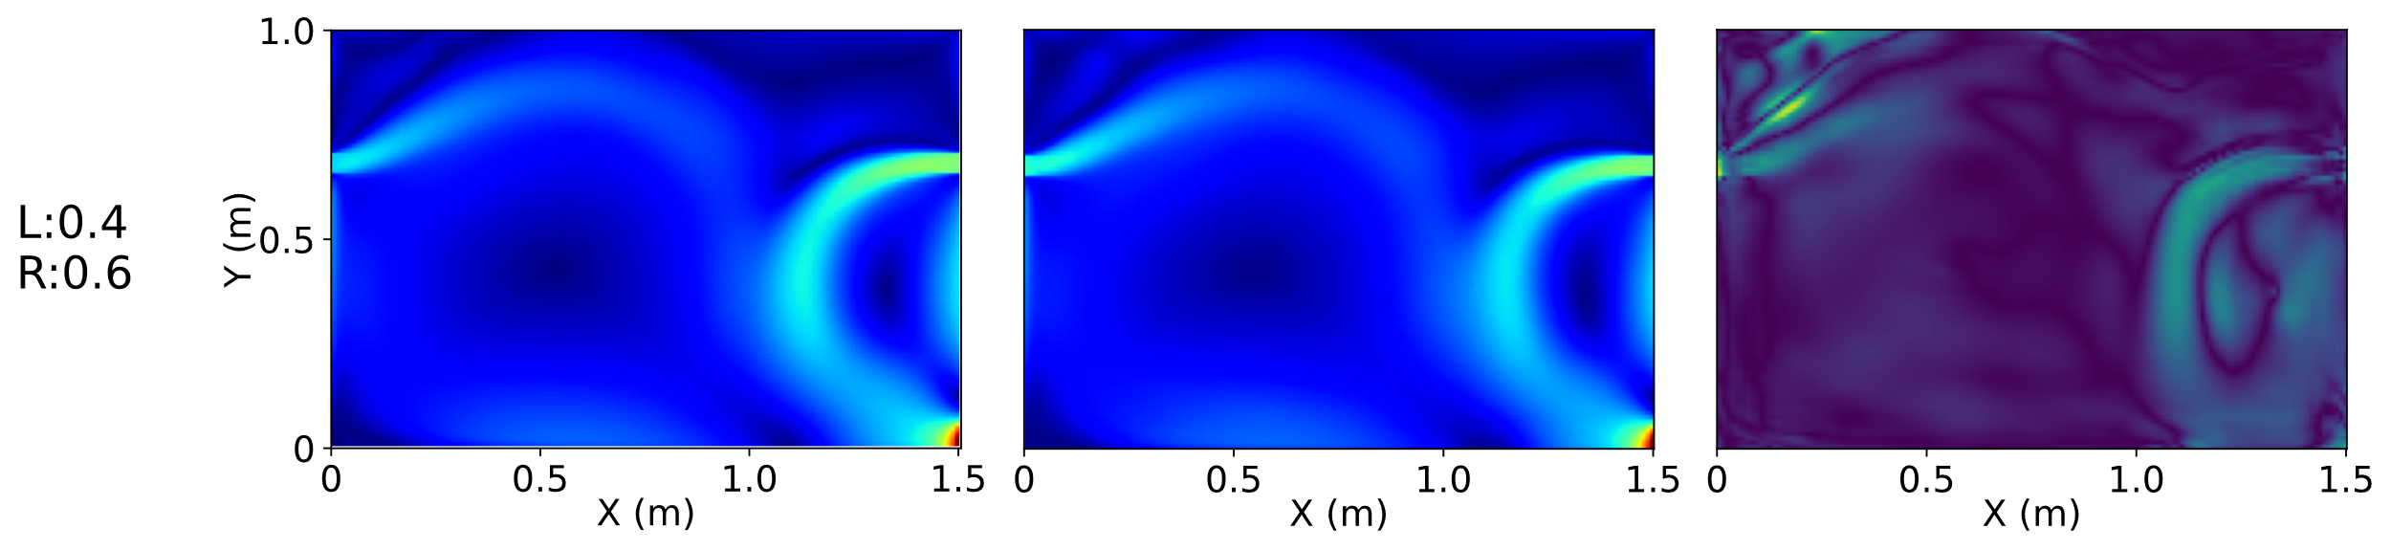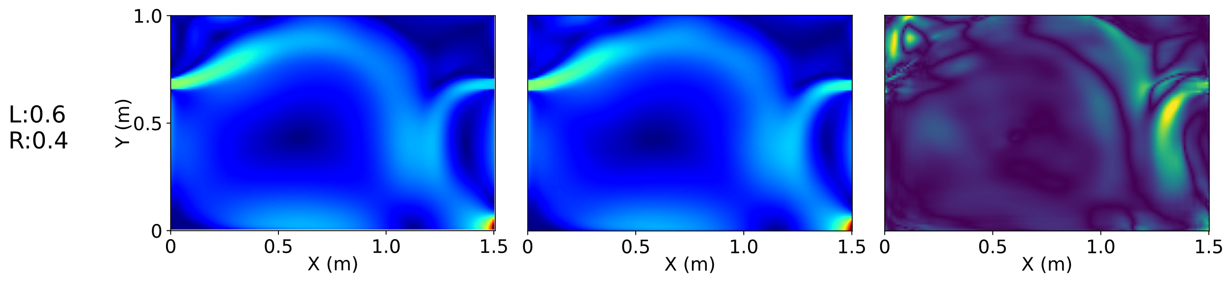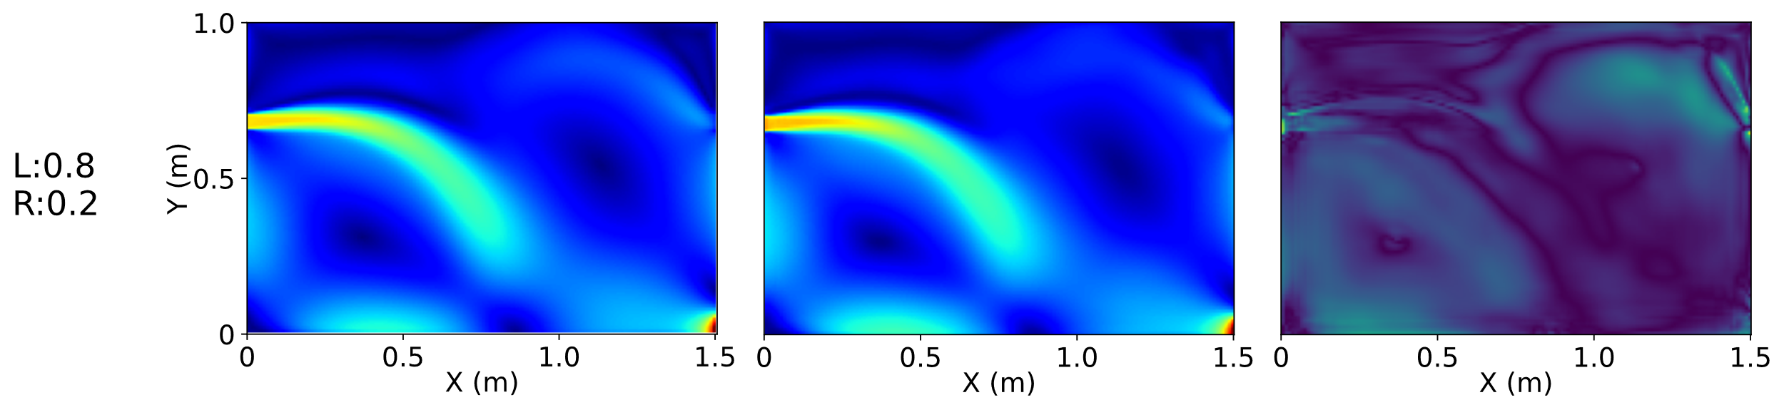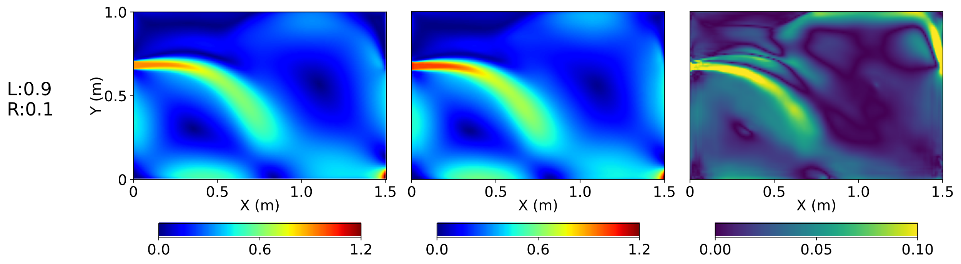
Fig. 7. Testing dataset (L: left inlet velocity; R: right inlet velocity; Unit: m/s)

ACKNOWLEGEMENTS
The author gratefully acknowledges support from the Europa-Programm (Grant No. 2014/C 198/01) and the DFG Heisenberg Programme (Grant No. GE 1652/4-1).

REFERENCES
Cao, G. et al. (2014) ‘A review of the performance of different ventilation and airflow distribution systems in buildings’, Building and Environment, pp. 171–186. Available at: https://doi.org/10.1016/j.buildenv.2013.12.009.
Caron, C., Lauret, P. and Bastide, A. (2025) ‘Machine Learning to speed up Computational Fluid Dynamics engineering simulations for built environments: A review’, Building and Environment. Elsevier Ltd. Available at: https://doi.org/10.1016/j.buildenv.2024.112229.
Cetin, Y.E., Avci, M. and Aydin, O. (2020) ‘Influence of ventilation strategies on dispersion and removal of fine particles: An experimental and simulation study’, Science and Technology for the Built Environment, 26(3), pp. 349–365. Available at: https://doi.org/10.1080/23744731.2019.1701332.
Geyer, P. and Singaravel, S. (2018) ‘Component-based machine learning for performance prediction in building design’, Applied Energy, 228, pp. 1439–1453. Available at: https://doi.org/10.1016/j.apenergy.2018.07.011.
Han, X. et al. (2021) ‘An open source fast fluid dynamics model for data center thermal management’, Energy and Buildings, 230. Available at: https://doi.org/10.1016/j.enbuild.2020.110599.
Khan, M.A.I. et al. (2015) ‘Real-time flow simulation of indoor environments using lattice Boltzmann method’, Building Simulation, 8(4), pp. 405–414. Available at: https://doi.org/10.1007/s12273-015-0232-9.
Lin, Y. et al. (2024) ‘A systematic review on COVID-19 related research in HVAC system and indoor environment’, Energy and Built Environment. KeAi Communications Co., pp. 970–983. Available at: https://doi.org/10.1016/j.enbenv.2023.07.009.
Long, Y., Guo, X. and Xiao, T. (2024) ‘Research, Application and Future Prospect of Mode Decomposition in Fluid Mechanics’, Symmetry. Multidisciplinary Digital Publishing Institute (MDPI). Available at: https://doi.org/10.3390/sym16020155.
Lu, Y. et al. (2023) ‘An efficient design method of indoor ventilation parameters for high-speed trains using improved proper orthogonal decomposition reconstruction’, Journal of Building Engineering, 71, p. 106600. Available at: https://doi.org/https://doi.org/10.1016/j.jobe.2023.106600.
Wang, H. and Zhai, Z.J. (2012) ‘Analyzing grid independency and numerical viscosity of computational fluid dynamics for indoor environment applications’, Building and Environment, 52, pp. 107–118. Available at: https://doi.org/10.1016/j.buildenv.2011.12.019.
Wang, S., Chen, X. and Geyer, P. (2023) ‘Feasibility Analysis of POD and Deep-Autoencoder for Reduced Order Modelling: Indoor Environment CFD Prediction’, in Building Simulation Conference Proceedings. International Building Performance Simulation Association, pp. 647–654. Available at: https://doi.org/10.26868/25222708.2023.1227.
Wang, S. and Geyer, P. (2024) ‘Flow Field Prediction with Various Air Inlet Positions Based on Convolutional Neural Network’, in Proceedings of the 31st International Workshop on Intelligent Computing in Engineering, EG-ICE 2024, pp. 146–155. Available at: https://www.scopus.com/inward/record.uri?eid=2-s2.0-85207181622&partnerID=40&md5=5c82e0fa52520ca2fa8a658533a55caa.
Zhou, Q. and Ooka, R. (2021) ‘Influence of data preprocessing on neural network performance for reproducing CFD simulations of non-isothermal indoor airflow distribution’, Energy and Buildings, 230, p. 110525. Available at: https://doi.org/https://doi.org/10.1016/j.enbuild.2020.110525.
Zhou, Y. et al. (2020) ‘Passive and active phase change materials integrated building energy systems with advanced machine-learning based climate-adaptive designs, intelligent operations, uncertainty-based analysis and optimisations: A state-of-the-art review’, Renewable and Sustainable Energy Reviews, 130, p. 109889. Available at: https://doi.org/https://doi.org/10.1016/j.rser.2020.109889.

