Ride to the Future:
Development of a VR Bicycle Simulation to Evaluate Real-world Infrastructure and Traffic
LISA BAULE¹ MICHAEL DISSER¹ STEFAN GÖBEL¹

¹Technical University of Darmstadt, Darmstadt, Germany

ABSTRACT:

The use of bicycles as an alternative mode of transportation is gaining importance as an increasing number of cities aspire to reduce the amount of car traffic, especially in their city centres. This results in decreased traffic jams, reduced emissions, and increased well-being, but also introduces new challenges for infrastructure planning and updating traffic regulations.

To evaluate different traffic situations that occur in urban areas or newly planned infrastructure before construction from a cyclist's perspective, this paper presents a first-person VR bike simulator implemented in the Unity game engine. The user cycles through the virtual world by using a bike mounted on a home trainer while wearing a VR headset. The pedalling and steering of the bike are transferred as input to the simulation via a microcontroller. The environment was enlivened by different road users, including bicycles, cars, and motorbikes, controlled by a 2D traffic simulation.

The simulator was tested in a study with 21 contestants. Their behaviour during the tests and the post-test questionnaire indicates that this kind of immersive simulation is a suitable tool for evaluating existing and newly planned infrastructure in urban areas.

KEYWORDS:

Virtual Reality, Digital Twin, Simulation, Traffic.

1. INTRODUCTION
The rising amount and importance of bicycle traffic, especially in cities, is a welcomed change in traffic from an environmental and health perspective. More bikes and fewer cars automatically lead to less environmental pollution and increased well-being since additional factors such as traffic noise and exhaust fumes are also reduced. Another positive effect of this change in transportation is the reduction of traffic jams and the general traffic load in city centers. (Bundesamt für Digitales und Verkehr, 2022)
In Germany, the Federal Highway Research Institute (BASt) is in charge of setting and updating regulations for bicycle infrastructure. These regulations define, for example, the recommended minimum width of bicycle lanes and paths and the minimum distance from moving traffic, depending on the speed limit, to ensure all road users’ safety. In practice, these regulations cannot always be assured. Many German cities lack continuous and safe bicycle infrastructure (ADAC e.V., 2020). This is affirmed by a study conducted by the German Cyclists Association (ADFC), which shows that most cyclists do not consider the regulations given to ensure their safety to be sufficient (ADFC, 2019).
Since cyclists are usually less protected than most other road users, people’s objective level of safety in traffic and the given infrastructure, as well as their subjective perception of it, is an important aspect of their decision to use a particular type of mobility. Although there are many reasons for (not) using a bike, safety is proven to be an aspect that actively keeps people from using their bikes (Heinen et al., 2010).
This contrasts with the aim of many cities to see an increase in bicycle traffic for its positive effects on the environment and well-being of the citizens. It can be promoted and supported by ensuring that the infrastructure follows the given regulations, but the subjective feeling of safety cannot be modelled by formalities.
This is not only a problem in Germany but in many countries of the world, e.g. Canada (Winters et al., 2011), the UK (Department for Transport, 2017), and more (von Stülpnagel & Binnig, 2022).
Therefore, a way is needed to evaluate existing and new infrastructure that goes beyond simply complying with given regulations. The results can be used to improve the existing infrastructure or plan new infrastructure in a sustainable way to make cycling more attractive again.
To address this, our paper presents an immersive virtual reality (VR) bicycle simulator to experience and evaluate potentially endangering traffic situations from a cyclist’s point of view. Therefore, users can experience realistic traffic from a first-person view within a real-world 3D city environment, which serves as a digital twin of an actual urban space.
The system can assist urban planning in two ways and thereby help to increase the amount of safe bike infrastructure. Firstly, it can be used to evaluate the given infrastructure and identify dangerous areas without endangering people in the real world. Thereby, different traffic situations and distributions in a real-world area can be tested in a short amount of time to evaluate the infrastructure under different circumstances.
Secondly, the system can be used to test new infrastructure before the actual construction. This enables a new way of evaluation in an early stage of urban planning, which has the major advantage that it is still possible to react adequately to discovered weaknesses.

2. RELATED WORK
An easy way to give feedback on traffic infrastructure is by using images. This was done, for example, by FixMyCity (2020), where citizens were provided with 3D images of different traffic infrastructure variants and had to decide whether they’d feel safe in the particular situation or not. Images from different perspectives were provided, i.e. the view from a pedestrian, a cyclist, and the driver of a car in the same setting. They gathered lots of data on the perceived safety of people, but using images limits the point of view and lacks any interaction.
To overcome these limitations, VR bicycle simulators have been used before.
Moreover, O’Hern et al. (2017) conducted a study to evaluate users' behaviour on a bicycle simulator compared to the real world. They demonstrated that a cyclist’s behaviour in the virtual world can be transferred to the real world in most aspects. Their findings validate the use of a VR bicycle simulator in our use case.
The work that comes closest to ours is that of Ullmann et al. (2020). They developed a VR bicycle simulator to support territorial and urban planning. The 3D model used was partly based on a real city. The simulator was constructed with a bike on a home trainer, equipped with a VR tracker for steering and a hall sensor for the user’s pedaling speed. As traffic simulation, PTV Vissim was used. They demonstrate that the VR approach enhances immersion and presence and show that VR is a suitable medium for acquiring subjective feedback.
Compared to their and other previous works, this paper’s novelty lies in two aspects. First, it presents a modular, low-budget approach to creating a VR bicycle simulator so that it can be used by a wider target group and be adapted and customized as easily as possible. Second, it incorporates common traffic violations into the traffic simulation to increase the level of realism of the simulated environment, which we could not find in any related work.

3. OBJECTIVES
The goal of this work is to enrich public participation feedback on bicycle infrastructure for city planners by including subjective perceptions of safety of the target group.
This shall, on the one hand, benefit the current goal of many cities to move further towards climate-neutral traffic by providing an inviting infrastructure for cyclists. It thereby promotes this mode of transportation to a wider target group. We aim for a better understanding of the cyclist’s needs for the city planners. This can improve not only the subjective assessment of safety but also the actual safety of existing and new bicycle infrastructure.
On the other hand, we want to motivate a wider target group to take part in public participation. Specific hardware and a more immersive way of getting to know and experience the current state of planning in a particular area can improve the understanding and acceptance of the process and build up more tolerance for inconveniences such as construction sites (Halvorsen, 2003).
Therefore, we break our goals down into the following aspects: First, we aim to build up a hardware setup that is low-budget and easy to use. We want the user to focus on the assessment rather than the technology used to do it, to gain valuable feedback on the environment for the urban planners, addressing our first goal. Therefore, the simulator hardware must be intuitive to use in every aspect, which, in our case, means as close as possible to the use of a common bike in the real world. This new way of experiencing urban planning stages in an immersive way shall also mobilize people who would usually not take part in public participation. The low-budget approach makes the simulator more accessible, especially for communities with a lower budget for public participation events.
Secondly, the environment we provide for the simulation must be recognizable. This does not necessarily mean that it must be photorealistic, but it is important that users recognize their everyday environment and can relate the simulation to the real world. We further want to get closer to reality by not only providing a recognizable environment but by representing a city as it is: lively. This is important for a meaningful evaluation of infrastructure, to get feedback that is valuable and usable for urban planners.
Finally, we want to provide a modular system that can easily be customized and adapted. This is important, for example, to be able to transfer the system to a different area to do the same evaluations but also to make it applicable to different use cases. Ideally, we want our system to be customizable to every geo-based scenario that requires a subjective assessment from a 1st person point of view.
We believe that such a system can be a valuable addition to public participation processes and that the feedback generated can enrich the urban planning process.

4. METHODOLOGY
For our methodology, we first provide an overview of the overall system and the design choices that were made throughout the development. Details follow in Sections 3.1 to 3.3, where Section 3.1 describes the simulator setup in-depth, while Section 3.2 focuses on the decisions made regarding the traffic simulation. Section 3.3 addresses the traffic adjustments we made to ensure that not only the ideal world is shown but rather one that is closer to reality.

To reach our overall goal, multiple components need to work together (Fig. 1).

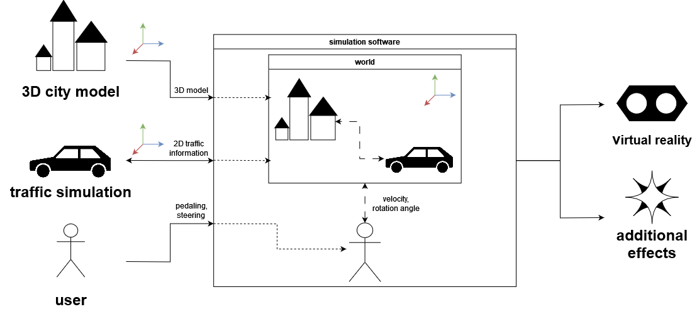
Figure 1: The basic structure of the system.

The simulation software is the core of the system. It was implemented using the Unity game engine and takes in multiple inputs. It contains the 3D city model as the basic environment through which the user moves. The software receives movement information generated by the user using the simulator hardware, i.e. the bike mounted to the home trainer. It generates pedalling and steering data, which is then pre-processed and forwarded to the simulation software by a microcontroller, as further described in section 3.1.
Additionally, it is given position and rotation data from other road users in 2D from the traffic simulation. It uses the given 2D information to enliven the 3D environment by mapping the 2D information onto 3D objects in the scene, creating a realistic setting for the user to move through.
The output is a virtual reality application with additional effects, like simulated wind from a fan and surround sound. We decided to use a VR setup to realistically put the user in the cyclist's perspective and increase immersion. VR provides a 360-degree view, which is particularly important for cyclists to check their surroundings, as a bike does not normally have mirrors like a car or motorcycle. As a VR output device, the Vive Pro HMD was used.
The 3D environment can be provided in the form of any 3D model format the Unity game engine can handle, which are various standard formats as well as proprietary formats from software like Blender or Maya. Therefore, there are many ways to conduct a city model for our application, for example, through CityGML, Revit, Autodesk Infraworks, or by creating custom models.
The city model of choice was provided by the Serious Games research group from the Technical University of Darmstadt (Serious Games Research Group, 2021). It contains a detailed and textured model of the university’s city centre campus (Fig. 2). It was chosen due to its high level of detail.
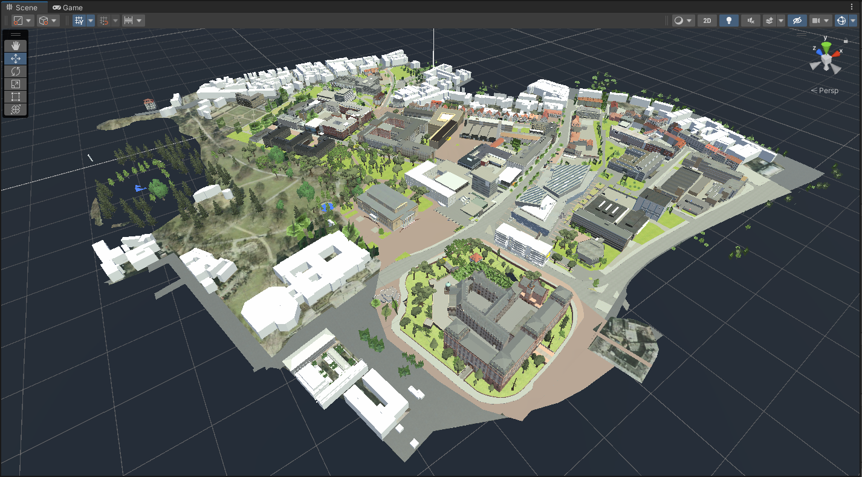
Figure 2: The 3D city centre campus model of TU Darmstadt.

To simulate traffic, the Simulation of Urban Mobility (SUMO) (Lopez et al., 2018) was used. It was chosen due to its flexibility, customization possibilities, and real-world base.
SUMO is an open source 2D traffic simulation developed by the German Aerospace Centre (DLR), which is based on Open Street Map (OSM). In SUMO, the types and amount of traffic participants can be specified when generating the simulation, which gives us a high level of flexibility. It can generate traffic based on real-world map data but provides a tool to alter the traffic network, which is ideal for our use case of testing different variants of infrastructure, as further described in section 3.2. It also provides a bidirectional Traffic Control Interface (TraCI), which we need for our traffic adjustments, as further described in 3.3.
Together, all these components create a realistic 3D environment where the user can move through using the bike setup (Fig. 3). It provides a high level of realism so that the focus of the user can be on the evaluation of the infrastructure and traffic situations rather than on the technology displaying it.

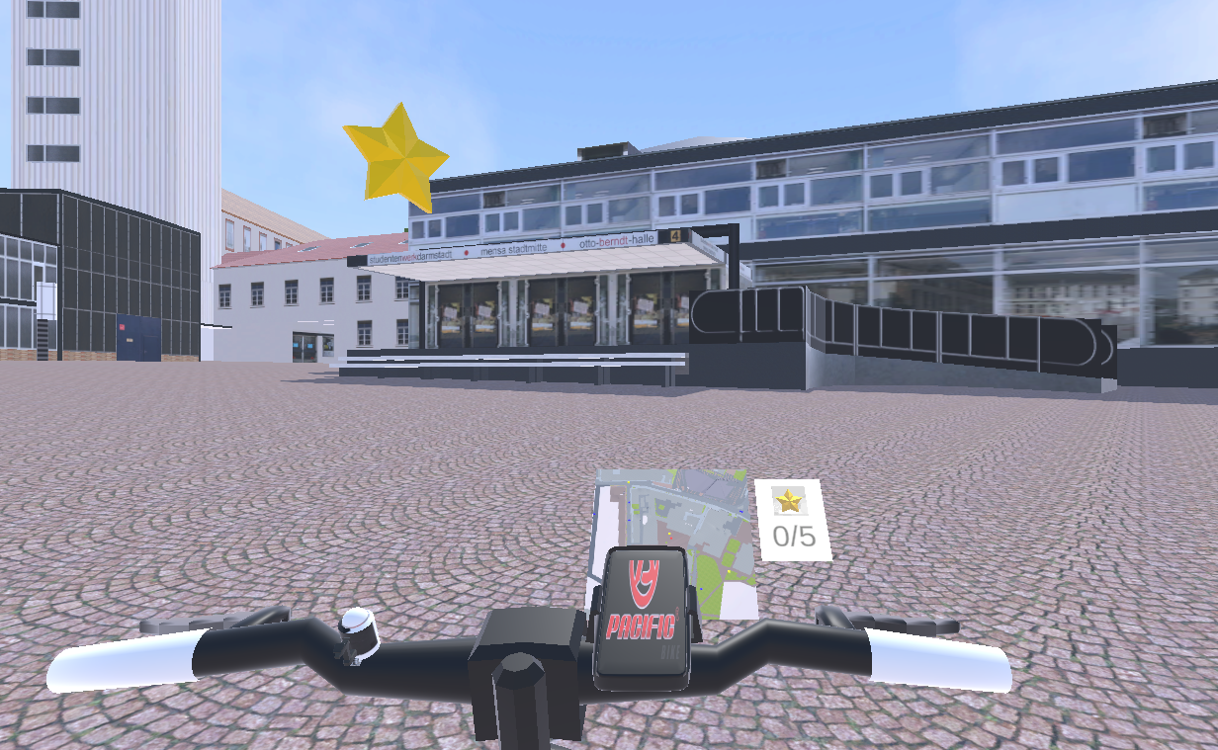
Figure 3: The 1st person in-game perspective.

4.1 Simulator Hardware Setup
The first step towards our simulator was the construction of the hardware. The basis is a standard mountain bike placed on an indoor bike trainer (Fig. 4), with different sensors mounted onto the bike and connected to an ESP-32 microcontroller to collect and transmit the user input. A Hall sensor is attached to the bicycle frame close to the rear wheel, and two magnets are positioned in the wheel’s spokes opposite each other. The Hall sensor detects the passing of the magnets as the user pedals, thereby enabling the calculation of the user’s speed. To ascertain the steering angle, a potentiometer is connected to the handlebar via two gears.
To simulate the wind during cycling, a fan was positioned in front of the bike. This configuration has been shown to enhance immersion and mitigate symptoms of motion sickness, a common occurrence in VR applications (Matviienko et al., 2022). The fan is controlled by a remote, which can be operated by a small servo motor. This motor is triggered by speed changes of the users pedaling, allowing for an automated adjustment of the wind’s intensity according to the user’s speed.

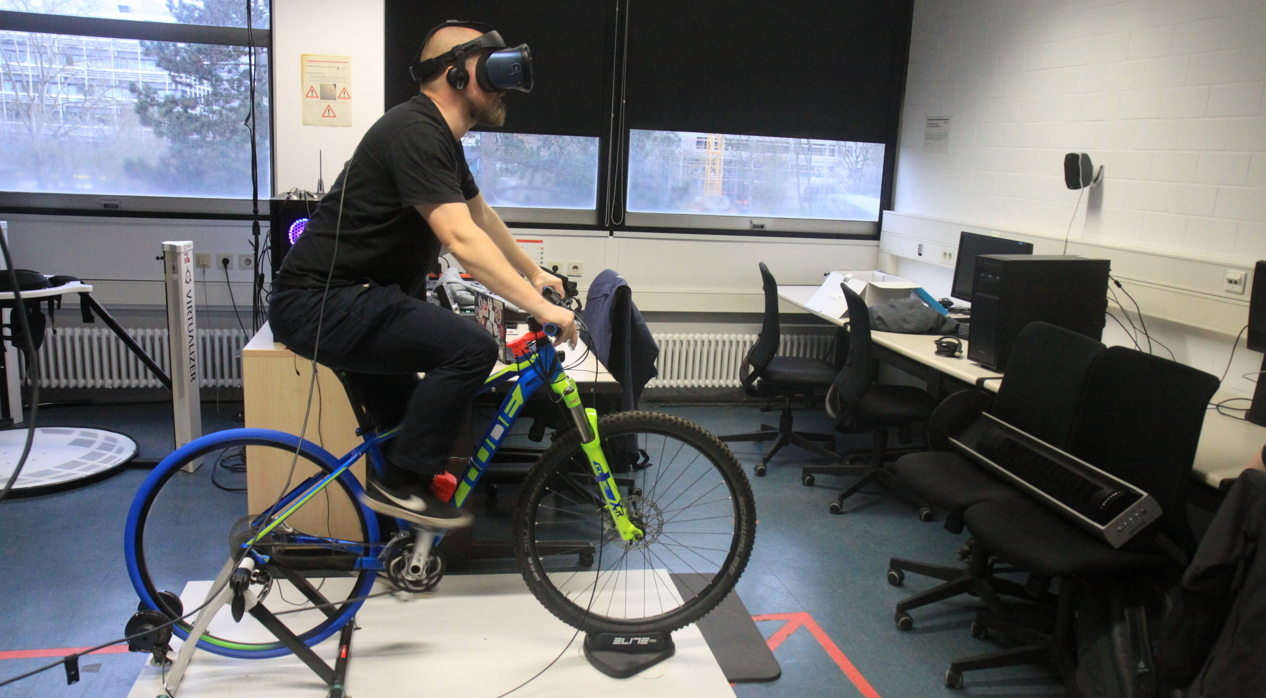
Figure 4: The hardware setup of the simulator.

All components are connected to a ESP-32 microcontroller (Fig. 5). It receives all collected data, performs the necessary pre-processing steps to make the data easier to interpret for the simulation software, and forwards the data to the same. The modular nature of the system allows for easy and fast customization and enhancement. Replacing and adding of components is made as easy as possible to allow customizations for different use cases.

To apply the data received from the microcontroller to the users’ digital movement in a realistic manner, the Kinematic Bicycle Model (Rajamani, 2011) was used. It provides the necessary mathematical basis to calculate a bike model's movement and rotation from the given input. It is defined by two wheels on one axis, where the front wheel is steering. The changes in position and rotation are calculated using the velocity of the user pedaling, the steering angle δ, and the length of the bicycle.
Once calculated, the translation and rotation are applied to the player, who then sees a direct translation from the given input to the visual movement in VR.

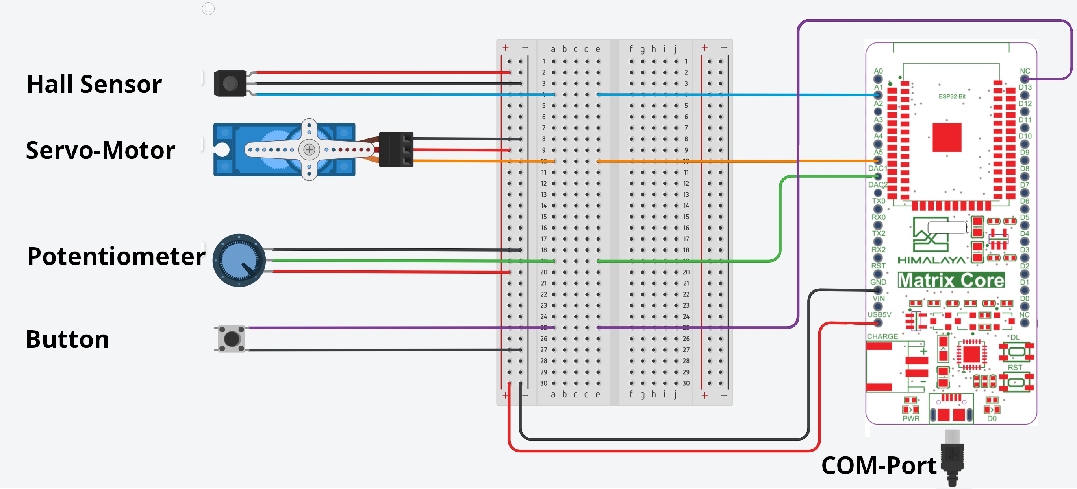
Figure 5: The microcontroller setup.

4.2 Traffic Simulation
The included traffic simulation provided by SUMO is generated in advance using SUMO's WebWizard. This python application is provided with SUMO and creates a traffic network and a simulation based on OSM data. Using the WebWizard has the big advantage that all areas covered by OSM can be used as a basis for the traffic generation. The WebWizard allows the selection of a geographical area and creates a network including all known metadata about the area. This includes, for example, a lane model of roads, cycle and pedestrian lanes, speed limits, or public transport routes and stops.
SUMO also supports the conversion of other digital road networks from sources like Asam OpenDrive, PTV Vissim, Matsim, or others to a road network that can be used by SUMO itself and all additional tools provided. This gives the freedom to use different sources of input data, depending on what's available in each use case, and makes the system highly adaptive to the available data and transferable to other areas.
Additionally, the generated network can be customized with NetEdit, a tool also provided directly with SUMO. This allows further usage and adjustment for planning variations within a reasonable amount of effort. The simulation is launched concurrently with the simulator software.

It would have been possible to introduce the user to the simulation and inform SUMO about the users’ motion since the traffic simulation provides a bidirectional interface to communicate changes. We decided against this option because it would have resulted in a simulated world, where every traffic participant would not be disrupted by the user but adapt its actions to whatever the user does. This mitigates the awareness of the user for the surrounding traffic participants and thereby limits the realistic experience. We, therefore, decided to implement a custom alternative.
The goal of the traffic simulation is to enliven the environment and make the experience for the user more realistic. We do not want to scare users by getting them run over or simulating how dangerous traffic can be for cyclists. That’s why we decided against a mechanism where the user could be involved in an actual accident.
To still combine the independent user and an outside traffic simulation in a meaningful way, to be able to move in the same environment, multiple approaches were considered, and the following was selected:
Simulated vehicles are displayed in 3D in our application. They are not aware of the user most of the time and follow their route. When the user enters a designated area surrounding a simulated vehicle, either by driving by or when the vehicle is passing the user, this vehicle will be made aware of the nearby user and react.
The vehicle's first attempt is, as in real life, to overtake the user on the bike if possible. If that’s not possible, for example, because another vehicle is coming up on the oncoming lane, it will come to a halt instead. To make the user aware of the unplanned halt of a vehicle and to increase the realism, this vehicle will honk.
If a vehicle needs to stop because of the user, this information will be transferred back to the simulation so that the corresponding vehicle in 2D can stop as well. This ensures that other approaching vehicles are aware of the stopping vehicle and can react to the changed situation.

4.3 Traffic Adjustments
One of our two main contributions is the inclusion of traffic violations into the simulation to create a more realistic environment for the infrastructure evaluation and thereby get more meaningful and relevant feedback for the urban planning process.
To decide which kind of violations should be included, current statistics from the Federal Statistical Office of Germany were consulted (Statistisches Bundesamt, 2021). General causes of traffic accidents and accidents specifically involving cyclists were considered. We decided on three main traffic violations that are common in urban traffic and are known to cause accidents with cyclists: speeding, failure to maintain proper distance when overtaking, and sudden door openings of parking cars.
To provide different gradations of traffic misbehaviour, a difficulty level was introduced. The three levels, ‘easy’, ‘medium’, and ‘hard’, determine how likely it is that a simulated vehicle will not obey the traffic rules regarding the three named aspects.
While ‘easy’ does not include any violations, ‘medium’ sets on average 20% of the vehicles up for violations, and ‘hard’ even does that for 50% on average. Whether a particular car is violating the traffic rules or not is decided at instantiation.
In addition to the higher likeliness for violations, the speed increases and the takeover distance decreases with a higher difficulty level as well. Medium difficulty introduces the possibility of a parking car opening the driver’s door when the user is approaching. At ‘high’, it is randomly decided if none, one, or both front doors of a parking car are opened when the user is passing it.
SUMO's bidirectional interface supports these adjustments, since not only can speed changes be set from outside, but SUMO also adjusts the behaviour of the surrounding vehicles accordingly. Thanks to this, we only needed to handle the behaviour of the first car approaching the user, and all following are handled by the simulation itself.

5. EVALUATION
A user test (n=21, age: 20-45 years old) was conducted to evaluate the simulator regarding the users’ perception of the environment and assess the suitability of the simulator in the context of public participation. Each participant was asked to navigate through the 3D world and collect five floating stars. On average, the participants spent 19 minutes in the simulation.
The goal of the evaluation was to obtain the target group’s opinion on the usability and suitability of the developed system for carrying out an informed assessment of existing or new infrastructure, including traffic.
The evaluation was done via a think-along protocol, observations during the test, and a post-test questionnaire. The questionnaire included demographic questions, impressions regarding the 3D city model, the handling of the hardware, and the perception of the traffic. Additionally, questions regarding simulation sickness, based on the Simulator Sickness Questionnaire (SSQ) developed by Kennedy et al. (1993), were included. The results can be found in Section 6.1.

6. RESULTS
This paper shows a low-budget VR bicycle simulator developed to support public participation by providing a method for the subjective evaluation of traffic infrastructure from a cyclist's point of view. It is designed for use during public participation events. The low-budget approach allows not only big cities to utilize the tool but also smaller communities with a lower public participation budget.
The simulator was developed to evaluate existing infrastructure and find dangerous areas without endangering people in the process. With only small adaptions, it allows the testing of different environmental and traffic situations, providing valuable insights in a short amount of time.
Also, the system provides a way to test new infrastructure that is still in the planning phase. Here, the system provides a more understandable and accessible way to current planning for the public. Different planning alternatives can be compared directly with each other and the existing one from a 1st person view, helping citizens to give more informed feedback on matters discussed in the context of public participation. With the help of our tool, this feedback can be gained in an earlier planning stage, which has the advantage that it is still possible to react to given feedback and discovered weaknesses accordingly.
We developed a modular and, therefore, customizable approach to a system that can be adapted to different real-world areas and traffic situations. Many different 3D models and traffic data types can be utilized for the system to allow the usage of data already available for the respective area. This makes it highly transferrable to different geographic locations.

6.1 Evaluation Results
Our study participants provided us with valuable feedback and ideas for further iterations of the project. The findings of the study are summarized in the following.
First, in every section of the post-game questionnaire, a Likert scale was used to gain an overall impression of the application and its main components. Users rated the 3D city model, the simulator hardware, and the traffic simulation on a scale from 1 (very unrealistic) to 5 (very realistic) (Fig. 6).

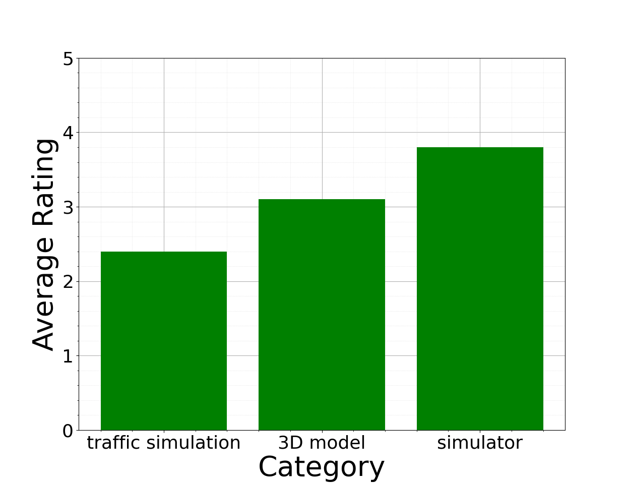
Figure 6: The fist user assessments of the main components of 'Ride to the Future'.

The lowest score was received for the traffic simulation with 2.4/5 measurement units. For most users, a main reason for a low rating was the amount of road users. They are used to full-scale city traffic, and the number of cars, busses, and bikes seemed unrealistically low in their opinion. This is an issue easily solvable by adjusting the parameters of our traffic simulation. A limiting factor is only the performance in VR. It must be avoided that the traffic simulation has an impact on the general performance of the application since a low FPS rate in VR can lead to simulator sickness, which would make the application no longer sensibly usable.
Additionally, some users were irritated by the behaviour of the cars near themselves. The mechanism we used to avoid accidents did not always feel natural in their opinion. Alternatives could be studied in a further iteration of the project.
Since traffic is one of our main novelties, the concerns of the users must be taken into account and will be improved for future developments.

The 3D model received an average overall score of 3.1/5 measurement units. The main point of criticism was the models’ level of detail. Users missed smaller infrastructural elements, such as pedestrian crossings, signs, and environmental decorations. Since the model was only utilized for our purposes, but not altered, we consider the remarks made by users for the future selection of models for this application.

The main area of our development was the simulator itself. With 3.8/5 measurement units, it received the highest rating of the three categories. The observations showed that everybody was able to handle the hardware intuitively. Still, the controls can be further improved in the future. In particular, the braking functionality was mentioned by multiple users. They were missing the ability to brake hard and therefore to stop abruptly instead of continuously decreasing their speed by rolling out.
Also, an occasional jerk when riding for a longer time was criticised. This was due to performance issues and needs to be addressed in further iterations since it influenced the user's control over the bike.
Due to remarks in the literature and prior experience, we included questions about simulator sickness in our questionnaire. We asked generally about the three main areas covered by the SSQ, which are nausea, oculomotor disturbance, and disorientation (Fig. 7).

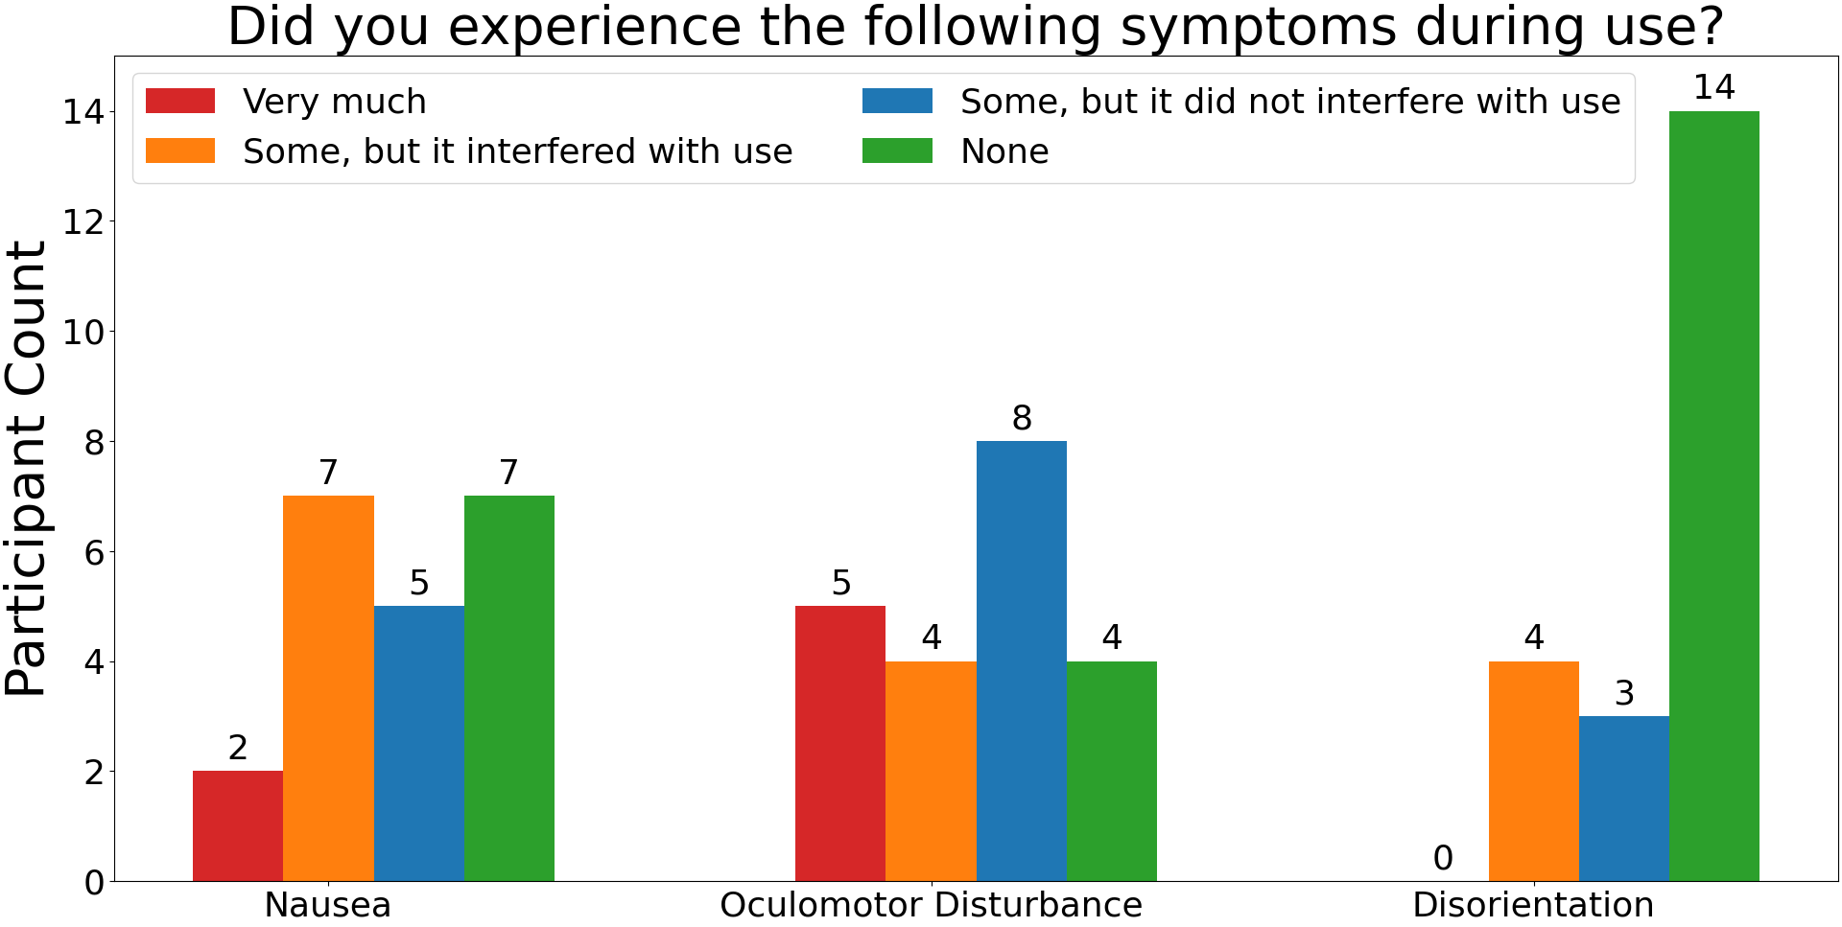
Figure 7: The Simulator Sickness Question Results.

On average, about 60% felt some kind of influence of the VR experience, but only 34,92% stated a distracting influence on the experience from which 11,11% felt strong discomfort. These numbers need to be evaluated further, but we consider the performance caused jerking and disturbances occurring after a longer time in VR a main cause for these ratings. Also, 19 minutes of play time is relatively long, especially for people who have never or only slightly used VR before.
However, more countermeasures based on existing literature, such as the fan for wind simulation we implemented, can be included in the future to mitigate the negative effects of VR on users, like a dynamic field of view or vibrations, as shown, for example, in (Matviienko et al., 2023).
Still, the system overall reached a rating of 3.9/5 measurement units, showing that users see the value and potential of the system.
The use case specific questions at the end of the questionnaire confirm the first assessment. With a rating of 4.2/5 measurement units, users see the biggest potential of the system in evaluating new infrastructure. But also for a reassessment of existing infrastructure, the rating of 3.9/5 measurement units shows a clear plus for the system.

6.2 Limitations
Currently, our system is limited by the performance of the PC it is running on and the software itself. In VR, it is especially important to ensure a stable and concurrent FPS rate so that no jerking or jitters occur since this can easily lead to VR sickness. We want to avoid any distractions for the user from experiencing the environment. The traffic simulation is also a factor influencing the performance since the number of messages and the amount of information to process in the software can become a bottleneck. This is especially challenging since we are dealing with urban areas where the amount of traffic is usually steadily high. Therefore, we need to make sure that the utilization is distributed efficiently throughout the given resources.

A city might have or currently does work on a digital twin for multiple purposes, as many do, which ensures the possibility of testing existing infrastructure. But for the testing of different variants, new 3D models need to be created based on existing plans by the cities, and the traffic network must be adjusted accordingly. This could exceed the capacity of a smaller city or municipality.

7. OUTLOOK
Besides these limitations, there are many opportunities to extend the current state of the system.
First, the system could be upgraded in a hardware manner. There are bike trainers that provide a bluetooth interface to transfer the speed or steering information to any device asking for it. This could be used if the low-budget aspect is not as important as the easier construction in a given context.
For the evaluation of the user’s behaviour, in the future, more quantitative measurements can be introduced. Our study mainly focuses on the qualitative and subjective feedback from users, as we consider this an important and new angle, but there are many possibilities to, additionally, conduct more quantitative measurements. Inspired by previous work in the field, information like the average speed of the user, the number of lane changes or abrupt brakes could be considered as an additional factor for the evaluation of a certain area and its traffic infrastructure.
To enhance realism, the traffic simulation could also be enriched with more data. Real life traffic counts can be included, not only to provide a realistic feeling for the traffic in a specific area, but also to simulate different scenarios, e.g. rush hour in the morning or afternoon, weekends with potentially more traffic out of the city or at certain hot spots, but less in industrial areas, and more. This could be used to efficiently test infrastructure under different conditions.
Also, traffic-independent changes could be modeled. Different weather and lighting conditions can be included in the software to show an area, e.g. by day and by night, under the influence of rain or snow, or with a limited view because of fog. All these aspects influence an area and could easily be considered using our system.
A change of the mode of transportation only makes sense in the bigger range of bicycles because of the proposed hardware setup. Still, more types of bicycles can be introduced to also evaluate an area with a cargo bike or a bicycle trailer since these have different requirements than a standard bicycle.
All these considerations could be valuable extensions for the proposed system and should be considered in further work.

8. CONCLUSION
This paper presents a modular system for a VR bicycle simulator as a new approach to represent and evaluate existing or new urban infrastructure. The environment is composed of a 3D city model and a traffic simulation included for more realism.
The user controls the virtual bike using a real bike mounted on a home trainer and supplied with multiple sensors to get the users’ pedalling and steering data. Additional effects like surround sound and simulated wind through a fan were also implemented to increase realism. The visualisation is done in VR for a higher level of immersion.
The novelties of our approach are, on the one hand, the low-budget, modular approach to creating a VR bicycle simulator, making it more accessible for smaller communities with a lower budget for public participation and highly customizable through its modular design. On the other hand, we introduce the inclusion of common traffic violations in the used traffic simulation. This increases the realism of our system compared to previously developed ones and adds an important aspect to the evaluation, where not only the ideal world is presented, but a rather realistic one.
An evaluation with 21 participants was conducted. Its results were mainly positive and show that the system can provide a subjective evaluation of infrastructure from a cyclist’s perspective and could also be extended to get objective data as well. Especially the value for the evaluation of newly planned infrastructure was emphasised here.

Overall, the concept shows great potential for a modular system that allows the objective and subjective evaluation of infrastructure from a cyclist’s perspective. Through its immersive nature, the system includes the subjective sense of safety in the results. This helps to improve infrastructure not only based on formal regulations but also on subjective safety measures from the target group.
That’s why it can, for example, be used as a tool for public participation, either for the evaluation of existing infrastructure or the testing of new ideas and infrastructure variants. It can provide valuable data for city planners directly from the target group. Due to its modular structure, the system can easily be customized and applied to other cities. The traffic simulation is applicable to any area covered by OSM, and all additionally needed to transfer the system is a 3D model of the new area. As the creation of digital twins of cities is promoted in many areas of the world, their availability is likely to increase accordingly. This is supporting systems like ours since it will be applicable to more and more areas in a meaningful way.

ACKNOWLEDGEMENTS
The project on which this report is based on was funded by the Federal Ministry of Education and Research under grant number 16SV9196. The responsibility for the content of this publication lies with the authors.

REFERENCES
ADAC e.V. (2020). ADAC Test: Jeder dritte Radweg zu schmal. https://presse.adac.de/meldungen/adac-ev/tests/adac-test-jeder-dritte-radweg-zu-schmal.html
ADFC. (2019). So geht Verkehrswende.
Bundesamt für Digitales und Verkehr. (2022). National Cycling Plan 3.0.
Department for Transport. (2017). British Social Attitudes Survey 2017: Public attitudes towards transport.
FixMyCity. (2020). Vergleiche 1.779 Radinfrastrukturen. Mach den Radwege-Check. https://radwege-check.de/
Halvorsen, K. E. (2003). Assessing the Effects of Public Participation. Public Administration Review, 63(5), 535–543. https://doi.org/10.1111/1540-6210.00317
Heinen, E., van Wee, B., & Maat, K. (2010). Commuting by Bicycle: An Overview of the Literature. Transport Reviews, 30(1), 59–96. https://doi.org/10.1080/01441640903187001
Kennedy, R. S., Lane ,Norman E., Berbaum ,Kevin S., & and Lilienthal, M. G. (1993). Simulator Sickness Questionnaire: An Enhanced Method for Quantifying Simulator Sickness. The International Journal of Aviation Psychology, 3(3), 203–220. https://doi.org/10.1207/s15327108ijap0303_3
Lopez, P. A., Behrisch, M., Bieker-Walz, L., Erdmann, J., Flötteröd, Y.-P., Hilbrich, R., Lücken, L., Rummel, J., Wagner, P., & Wiessner, E. (2018). Microscopic Traffic Simulation using SUMO. 2018 21st International Conference on Intelligent Transportation Systems (ITSC), 2575–2582. https://doi.org/10.1109/ITSC.2018.8569938
Matviienko, A., Hoxha, H., & Mühlhäuser, M. (2023). What does it mean to cycle in Virtual Reality? Exploring Cycling Fidelity and Control of VR Bicycle Simulators. Proceedings of the 2023 CHI Conference on Human Factors in Computing Systems, 1–15. https://doi.org/10.1145/3544548.3581050
Matviienko, A., Müller, F., Zickler, M., Gasche, L., Abels, J., Steinert, T., & Mühlhäuser, M. (2022, April 30). Reducing Virtual Reality Sickness for Cyclists in VR Bicycle Simulators. https://doi.org/10.1145/3491102.3501959
O’Hern, S., Oxley, J., & Stevenson, M. (2017). Validation of a bicycle simulator for road safety research. Accident; Analysis and Prevention, 100, 53–58. https://doi.org/10.1016/j.aap.2017.01.002
Serious Games Research Group. (2021). 3D Campus. https://www.etit.tu-darmstadt.de/serious-games/forschung_und_projekte_sg/3d_campus_sg/index.en.jsp
Ullmann, D., Kreimeier, J., Götzelmann, T., & Kipke, H. (2020). BikeVR: A virtual reality bicycle simulator towards sustainable urban space and traffic planning. Proceedings of Mensch und Computer 2020, 511–514. https://doi.org/10.1145/3404983.3410417
von Stülpnagel, R., & Binnig, N. (2022). How safe do you feel? – A large-scale survey concerning the subjective safety associated with different kinds of cycling lanes. Accident Analysis & Prevention, 167, 106577. https://doi.org/10.1016/j.aap.2022.106577
Winters, M., Davidson, G., Kao, D., & Teschke, K. (2011). Motivators and deterrents of bicycling: Comparing influences on decisions to ride. Transportation, 38(1), 153–168. https://doi.org/10.1007/s11116-010-9284-y

https://www.ptvgroup.com/en/products/ptv-vissim
https://www.vive.com/de/setup/vive-pro-hmd/
https://www.openstreetmap.org

