Cognitive Building Avatars:
An LLM-Based Data Framework for Intelligent Building Management

Habeb Astour^{1,*}, Christian Bürgy^{1,2}, Bastian Wibranek¹, Hamed Shariat-Yazdi¹

¹ Darmstadt University of Applied Sciences, Darmstadt, Germany and European University of Technology, European Union
² Carnegie Mellon University, Pittsburgh, PA, USA
*Corresponding email: habeb.astour@h-da.de

ABSTRACT
The construction industry and building operations are undergoing rapid digitization, resulting in extensive digital records of buildings, their systems, and their use. However, building-related information is often segmented across disciplines and scattered across heterogeneous data sources and formats from BIM models and sensor streams to PDF plans, emails, and maintenance logs making it difficult to access, integrate, and interpret coherently. This paper proposes a framework for the creation of Cognitive Building Avatars, AI-driven conversational representations of buildings based on Large Language Models (LLMs), semantic knowledge structures, and multimodal building data. The framework integrates information from Building Information Modeling (BIM), IoT sensors, building automation systems, and facility management platforms, transforming heterogeneous data into a unified and human-accessible knowledge representation. By combining data fusion, knowledge graphs, and LLM-based reasoning, the proposed approach enables buildings to answer questions, explain operational states, and provide context-sensitive support for both technical and non-technical users. A proof-of-concept evaluation explores the feasibility of using knowledge-graph-based representations for building-related question answering and identifies limitations related to semantic coverage, model consistency, data volume, and the processing of complex IFC models. The work contributes an initial architecture and empirical exploration of how existing semantic building standards and LLM-based agents can be combined to support explainable and user-centered interaction with heterogeneous building information.
- INTRODUCTION
Dealing with digital building models of existing structures mostly come with the challenge of having incomplete data; sometimes, specialized data types are missing, sometimes the model even lacks the basic geometric model. This data might be available as paper documents or in poor quality digitized formats, but needs to be analyzed, interpreted and augmented for use in design, construction and operation. We focus on existing buildings, i.e. construction in built environments and the operation phase of the building life cycle.

1.1 Fragmentation in Building and Facility Management
Building operations, maintenance, and facility management (FM) are characterized by fragmentary and heterogeneous data environments. Information is distributed across BIM models, IoT infrastructures, building automation systems, legacy documentation, and maintenance databases. This fragmentation frequently leads to information loss, inefficiencies, and inconsistent communication between stakeholders. A cognitive building avatar provides a unifying interface capable of merging multiple data sources and communicating them through natural language. Recent research shows that LLM-based systems can act as intermediaries between complex technical data and human stakeholders (Ly, R. and Shojaei, A., 2024).

1.2 Building in Existing Structures
More than 80% of construction activity occurs within existing buildings. These buildings often lack consistent or complete digital records. Missing documentation, inconsistent standards, and historical alterations complicate renovation or FM processes. Digital twins have shown promise in retrofitting and existing-building management (Dai, C. et al., 2024); however, they often remain too technical for everyday users. A cognitive building avatar can fill this gap by interpreting incomplete data, harmonizing diverse sources, and explaining building behavior in human-readable form.

1.3 User-Centered Access to Building Knowledge
Most building information systems (including BIM software) are optimized for expert audiences. This limits accessibility for non-technical users such as occupants, visitors, or non-specialized facility staff. Cognitive avatars based on LLMs support intuitive building communication, transforming complex models into interactive knowledge systems (Luo, P. et al., 2025). Rather than introducing another building representation, this work investigates how these existing technologies can be orchestrated through specialized agents to support interaction with heterogeneous and incomplete building information.

- State of Research
As large language models (LLMs) advance quickly, the use on specialized problems with specific data needs is still not commonly implemented. The challenges come from a very diverse data set of building models, ranging from static geometric and topographic data to dynamic sensor information about the state or resources of the building.

2.1 Artificial Intelligence and Large Language Models
Recent advances in Large Language Models (LLMs) demonstrate capabilities in semantic reasoning, multimodal interpretation, and knowledge generation. Their potential to connect heterogeneous datasets and articulate complex relationships makes them suitable for conversational digital twins (Ly, R. and Shojaei, A., 2024; Akhavian, R. et al., 2025). In building applications, their relevance lies less in replacing established building information representations than in providing a flexible interface for interpreting queries, retrieving relevant information, and generating user-adapted explanations. This differs from conventional BIM interfaces, which generally require users to navigate predefined data structures and domain-specific software.
At the same time, LLMs remain dependent on the quality, structure, and context of the information provided to them. They can generate plausible but unsupported information and their behavior may vary between models and iterations. For building applications, these limitations make structured representations, retrieval mechanisms, and traceable source information particularly important. The proposed Cognitive Building Avatar therefore positions the LLM as an interaction and orchestration component rather than as the authoritative source of building knowledge.

2.2 Digitization in the Construction Industry – Research Status on BIM
Building Information Modeling (BIM) has evolved from a geometry-centered 3D modeling tool and a construction management process into a comprehensive digital representation of buildings and the interaction with this over their entire lifecycle. Contemporary research focuses on extending BIM through semantic enrichment to overcome interoperability limitations and enhance machine readability.
Semantic BIM approaches using ontologies such as ifcOWL, the Building Topology Ontology (BOT), and the Brick Schema have been shown to improve interoperability and support machine reasoning ((Bartlett, S. et al., 2024); (Stolk, S. and McGlinn, K., 2020); (Roxin, A. et al., 2021)). These ontologies enable the transformation of BIM data into linked-data structures and knowledge graphs, which form the foundation for intelligent building applications.
The integration of BIM with IoT systems and operational data has contributed to the emergence of digital twins capable of representing real-time building states. Research demonstrates that IFC-based digital twin methodologies, combined with behavioral models and resource tracking, significantly improve construction monitoring and building operations (Dai, C. et al., 2024).
However, key challenges persist:
• limited interoperability between BIM authoring tools,
• insufficient semantic richness in many practical BIM models,
• incomplete or inconsistent data in existing buildings,
• complexity rendering BIM inaccessible to non-experts.

Recent bibliometric studies confirm the rising importance of semantic web technologies for facility management and digital twins (Costa, A. and Madrazo, L., 2023). As BIM evolves toward semantic and dynamic information representations, an open research question is how these representations can be combined with recent LLM capabilities without sacrificing domain semantics, traceability, and data quality. LLM-driven cognitive building avatars are investigated in this work as one possible interaction and orchestration approach for this integration.

- A framework for Building AVATARS
The conceptual framework for the Cognitive Building Avatar organizes existing building information technologies into a multi-stage architecture. Heterogeneous building data is integrated and semantically enriched before being processed by specialized AI components and exposed through a natural-language interface. The architecture therefore focuses on the orchestration of established representations and services rather than on replacing existing BIM, ontology, knowledge graph, or digital twin technologies. Figure 1 illustrates this process across three functional layers: Available Data, the AI Engine, and the resulting Building Avatar.

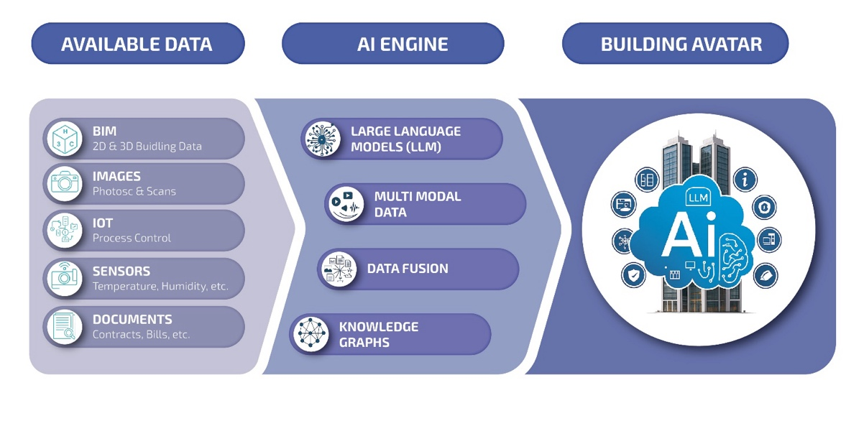
Figure 1: three-layer process to create and update the Building Avatar.

3.1 Available Data Layer
The Available Data Layer consolidates heterogeneous building-related datasets across the building lifecycle and makes their provenance, semantics, and spatiotemporal referencing explicit. In practice, buildings produce (i) structured engineering data (e.g., BIM/IFC, asset registers), (ii) operational time series (BAS/BMS and IoT streams), (iii) unstructured and semi-structured documents (PDFs, emails, work orders), and (iv) external context (weather, grid signals). A core requirement for a cognitive building avatar is to treat these sources not merely as files, but as evidence objects with metadata describing ownership/stewardship, schema/format, update latency, access path (API/database/files), and data quality indicators (Castello, C.C. et al., 2014).
Structured design and asset information: BIM models (e.g., IFC) provide geometry and rich object-based descriptions but vary strongly in completeness and FM readiness. Open standards such as IFC and COBie have been studied as carriers for asset register creation and life-cycle information transfer, highlighting gaps between design intent and operational needs (Patacas, J. et al., 2015). For semantic interoperability and machine reasoning, BIM data can be transformed into linked data representations (e.g., ifcOWL) and validated against constraints ((Pauwels, P. and Terkaj, W., 2016); (Stolk, S. and McGlinn, K., 2020)). Building topology can be expressed explicitly (buildings–storeys–spaces–elements) using lightweight vocabularies such as the Building Topology Ontology (BOT) (Rasmussen, M.H. et al., 2021).
Operational telemetry (BAS/BMS, IoT, meters): Operational data ranges from typical BMS polling intervals (e.g., minutes) to high-frequency measurements for specific modalities (e.g., vibration). Because analytics portability depends on consistent semantics, sensor and equipment points should be described using established tagging/ontology approaches such as Brick or Project Haystack, which model equipment, points, and relationships and support scalable building analytics ((Balaji, B. et al., 2016); (Balaji, B. et al., 2018); (CABA, 2016)).
Documents and visual data: As-built plans, inspection photos, scan campaigns, reports, and contracts remain central for existing buildings and FM decision-making. For a cognitive avatar, these sources should be captured with document metadata (time, author, scope, affected asset/space) and—where possible—linked to the same semantic identifiers used for BIM and telemetry ((Ramonell, C. et al., 2023); (Biagini, C. et al., 2024)).
The Available Data Layer should therefore expose each dataset with a minimal “data passport” (format, temporal coverage, spatial linkage, stewardship, and known limitations) and support both batch access (BIM/documents) and stream access (telemetry), while maintaining lineage and traceability. The Building Avatar therefore depends on mobilizing heterogeneous building data into a consistent and auditable representation while preserving source provenance and known limitations. Three recurring issues dominate practice: (i) velocity/volume heterogeneity, (ii) granularity alignment & contextualization, and (iii) data quality & feature engineering.
i. Velocity and Volume Heterogeneity: Building-data includes low-velocity, high-volume artifacts (e.g., BIM files, scan data, document archives) and higher-velocity telemetry (BAS/BMS point streams, meters). A pragmatic consequence is a hybrid ingestion strategy: batch pipelines for heavy static artifacts, and streaming (or micro-batch) pipelines for operational time series. A well-established reference pattern is the lambda architecture family, which separates historical recomputation from low-latency updates and a serving layer for queries (Balaji, B., et al. 2016). For the proposed Building Avatar, the goal is not real-time everywhere, but fit-for-purpose latency: e.g., comfort/controls may need near-real-time states, while compliance reporting and cost analytics can remain batch-oriented.
ii. Granularity Alignment and Contextualization: Mobilization must align heterogeneous sources across time, space, and asset context so that downstream models and the LLM-based assistant operate on comparable, interpretable units. Different building tasks require different temporal resolutions (e.g., operational diagnostics vs. energy reporting), and model performance can be sensitive to sampling rate, aggregation windows, and lag structures. Therefore, resampling and aggregation should be explicit and documented (including time zone handling, missingness policies, and aggregation operators), rather than being implicit transformations embedded in analysis scripts ((Deb, C. et al., 2017); (Jain, R.K. et al., 2014)). Building portfolios store information at different spatial levels (e.g., room lists, drawings, BMS point trees, maintenance records) and in different representations (e.g., room lists, drawings, BMS point trees, maintenance records). Contextualization requires establishing cross-source identifiers and mappings so that a measurement, a document, and a maintenance event can be traced to the same real-world entity (room, asset, or system). Knowledge-graph-based integration approaches are one established way to achieve such cross-source linking and maintain consistency at portfolio scale (Ramonell, C. et al., 2023). Many signals are only interpretable when complemented by context variables such as schedules, weather, occupancy proxies, setpoints, and operational modes. Reviews of data-driven building energy prediction consistently highlight the importance of weather and calendar-related features (and, where available, usage-related proxies) for predictive performance and interpretation ((Amasyali, K. and El-Gohary, N.M., 2018); (Deb, C. et al., 2017)).
iii. Data Quality, Reliability, and Feature Engineering: Operational building data is frequently affected by missingness, drift, and outliers. Consequently, mobilization should include explicit validation/correction and provenance tracking (lineage: how raw data was collected and transformed) as first-class outputs, not as ad-hoc preprocessing (Castello, C.C. et al., 2014). For missing data in building sensor streams, comparative studies show that imputation strategy matters and should be chosen based on missingness patterns and downstream (Castello, C.C. et al., 2014). Sensor error and calibration drift can require systematic correction strategies rather than one-off commissioning (Kim, H.-J. et al., 2022). Finally, “feature engineering” should be treated as a reproducible, documented transformation layer (e.g., lag/rolling statistics, aggregations, weather- and schedule-conditioned indicators), because model validity and interpretability depend on how raw measurements are transformed into stable indicators (Deb, C. et al., 2017).

3.2 AI Engine Layer
At the center of the framework lies the AI Engine, which acts as the cognitive core of the system. It consists of four interconnected components:
• Large Language Models (LLMs): Advanced generative AI systems capable of understanding, reasoning, and generating human-like text based on complex building data.
• Multimodal Data Processing: The architecture is intended to support different building data modalities, including text, images, BIM structures, and operational data. These modalities may require dedicated preprocessing and task-specific agents before relevant information is made available to the LLM.
• Data Fusion: All input sources are merged into an integrated knowledge representation. This step includes cleaning, normalization, semantic enrichment, and linking previously isolated datasets.
• Knowledge Graphs: The fused data is stored in graph-based structures that encode building relationships, dependencies, and operational logic. Knowledge graphs provide explicit representations of entities and relationships that can support structured retrieval, reasoning, and traceability. They can improve the grounding of LLM-based responses but do not by themselves guarantee correct reasoning or eliminate hallucinations.

Together, these components transform raw building data into interpretable, queryable knowledge.

3.3 Building Avatar Layer
The final output of the system is the Building Avatar, a cognitive interface through which humans can interact naturally with the digital representation of a building. The intended Building Avatar should support:
• Answering questions about building conditions, energy performance, or system behavior
• Explaining states, anomalies, and maintenance needs in clear natural language
• Providing context-sensitive guidance to facility managers, planners, and occupants
• Acting as a conversational digital twin that enhances accessibility to complex data

Through the integration of multimodal data, semantic knowledge structures, and LLM capabilities, the building is transformed into an intelligent, interactive entity capable of meaningful dialogue.

- Use Case: Retrieving Answers under Data Scarcity and Heterogeneity
The use case described in this section represents the intended application scenario of the framework. The proof-of-concept in Section 5 focuses more narrowly on topology- and geometry-related information retrieval from IFC models and therefore does not yet validate the complete energy-management scenario.
Building models or representations used today, mostly base on graphical data (2D, 3D) and add semantic information. While these are readily available for new buildings, built environments lack certain data types, most problematic for standard BIM applications: Only paper-based 2D drawings exist, sometimes in out-dated versions. The proposed Building Avatar will provide some of AI’s core value: “AI comprises any technique that enables computers to mimic human behavior and reproduce or excel over human decision-making to solve complex tasks independently or with minimal human intervention” (Russell, S.J. and Norvig, P., 2021) and hence, will provide the best answers to requests of its human communication partner (user).
The Building Avatar also aims to provide the best Human-Building Interaction (HBI) experience, where HBI would focus on “enabling built environments that can learn, adapt, and evolve at different scales (individual building, community level, city level) to improve the quality of life of its users while optimizing resource usage and service availability” (Becerik-Gerber, B. et al., 2022).
The following use case for retrieving information on energy consumption shall demonstrate this approach, it is one of the use cases, currently worked on in this research.

4.1 Context: Available Data
While seeking information for energy consumption in a built environment, we might see only global data, such as the consumption of the complete building or even only the energy bill from accounting; there might not be any information about the building’s geometry, level and room layouts or about the usage scenario and number of inhabitants or working staff in the building. Hence, due to the scarcity or complete absence of this data, with standard tools it might not be possible to relate the consumption to kWh, liters or cubic meters of the energy source to square meters, rooms or persons. With the LLM-based Building Avatar, the available information could be interpreted and contextualized across different sources. However, information that is absent from the source data cannot reliably be reconstructed by an LLM alone. The system should therefore distinguish between directly observed information, derived information, estimates, and unavailable information.

4.2 Transformation: AI Engine
To transform the available data into informative answers, the Building Avatar’s AI Engine makes use of specialized LLMs, data fusion techniques, and knowledge graphs to process the existing multimodal data. For the energy consumption use case, this means that the Building Avatar has access not only to the available data, but also to historic data from other, similar buildings, to standards, regulations and calculation algorithms, as well as to pre-defined knowledge graphs. The latter can support grounded Retrieval-Augmented Generation (RAG) by providing relevant information from structured and documented sources. The objective is not to eliminate hallucinations, but to reduce unsupported responses and improve traceability.

4.3 Presentation: Resulting Output
In a final step, the Building Avatar will present the retrieved data in an easy-to-consume way, or it will offer several options for the user to choose from. For the energy consumption use case, the Avatar might offer different data types or the ratio between different variables and can offer numbers, text, graphics or even short videos showing the consumption over time or in a geometric representation of the building.
As stated at the beginning of this chapter, this part will become essential for the acceptance of the proposed Avatar; but development in HBI and especially in HCAI (Human-centered Artificial Intelligence) is advancing fast, so it can be assumed that this use case and many others will be realistic in the near future.

- Agentic AI architecture for Building Avatars
To build the described framework and to realize the use cases, we designed an Agentic AI architecture to support the necessary functionality. The architecture consists of six main blocks, the Input and Output Layers, the Agent Layer as the main interaction components, and for the management tasks, we added Data, Orchestration and Service Layers (compare figure 2).

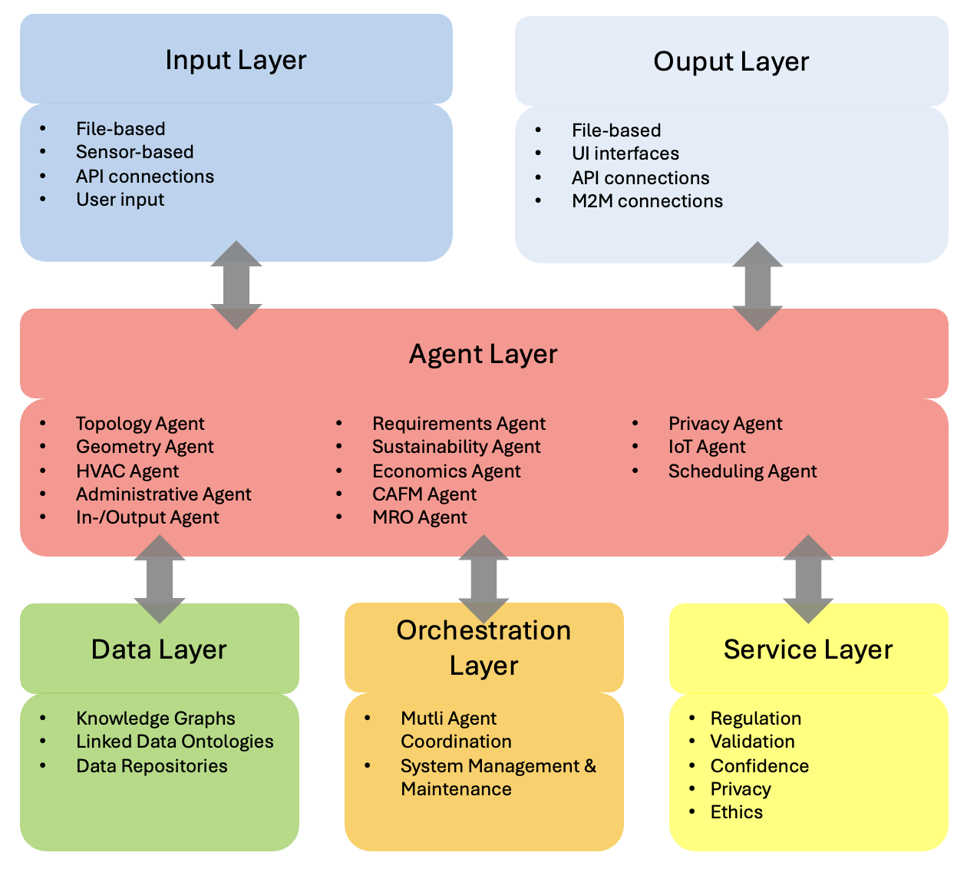
Figure 2: Agentic AI architecture for Building Avatars

5.1 Proof-of-Concept
To address the high number of defined “special agents” in the Agent Layer, we started with a proof-of-concept (PoC) of the first two, topology and geometry, as well as the Input and Output Layers. For that PoC, we used a testbed described by (Hellin, S. 2025) and four available commercial-off-the-shelf LLMs, Claude, ChatGPT, Gemini and Perplexity to walk through the complete process. With each LLM, we generated two prompts, one to set up a generic knowledge graph, based on the common notations IFC, BRICK, and schema.org and one for filling this knowledge graph with data from uploaded building files in IFC format.
We executed this process for all four LLMs and then used the 105 questions defined by (Hellin, S. 2025) together with the provided ground truth to see, what the performance of the defined process was for each LLM. In a second iteration, we used the standard LLM chat functionality to ask each LLM to provide ideas for improvement of the process, providing them with their own results in comparison to the ground truth. We followed the suggestions and ran the set of questions again to see the difference in performance.

5.2 PoC results with four LLMs
The PoC showed us, that the concept of a generic knowledge graph is feasible and gave us some direction to where we need to be careful about and what needs to be implemented for the agents to be of real value to the Building Avatar framework.
Table 2 shows a summary of the results. As these give not, yet, a detailed picture, we learned how different the LLMs perform. Perplexity for example is missing in this overview, because we could not generate any meaningful knowledge graph using the process described above. Hence, we could not address the questions of the testbed using Perplexity.
The next significant finding is that the performance of ChatGPT decreased in the second iteration. we assume that the knowledge graph, created in the second round, was too complex to fill it with the building data. Gemini performed less compared to the other two LLMs, here the generic knowledge graph was very short and hence, could not include enough building data. Claude performed best in both iterations. The improvement from the first to the second round mainly came from its suggestion to include ifcOpenShell in the generic graph. Hence, it could answer more questions on geometric attributes correctly.
The testbed had two building models as IFC and IFC-MEP files. While the first one (Duplex) is rather small, the second one, a dental clinic model had an IFC length of 2 million lines. The limitation for the LLMs in this respect is the token windows, which did not fit the complete model at once.

Table 1: Comparison of performance on (Hellin, S. 2025) questions
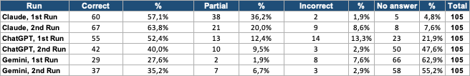

Overall, our main takeaways are that we need to include all relevant notations and formats for the corresponding agent, being very specific for the underlying use case; if there are no appropriate notations, we or the community must define and agree on new standards, e.g. for upcoming environmental regulations. Further, we need to process the data in a way, so the LLMs can handle the amount of data provided, essentially adding a sequential data processing or a separation between generative tasks and search/mapping tasks. Finally, we will need to further test the architecture against existing testbeds in the specific fields of the different agents, or, if not applicable, define such testbeds ourselves.

- Work in Progress and Future Work
Current research focuses on extending the proof-of-concept architecture toward a fully functional Cognitive Building Avatar. Ongoing work includes the development of additional specialized agents, the collection and integration of heterogeneous building datasets, and the refinement of knowledge graph structures based on BIM, Brick, BOT, and related standards. Particular attention is given to existing buildings, where incomplete and fragmented data remains a major challenge.
Future work will address scalable processing of large building models through agent-based workflows and retrieval-augmented generation (RAG), while further improving multimodal data integration and Human-Building Interaction (HBI). The framework will be validated through real-world pilot applications and connected to external facility management and building automation systems. Standardized BIM–IoT–AI interfaces and benchmarking approaches will be essential for broader adoption.

- Conclusion
This work demonstrates how BIM, digital twin technologies, knowledge graphs, and LLM-based AI can converge into cognitive and interactive building representations. By translating heterogeneous and often fragmented building data into natural-language explanations, Cognitive Building Avatars increase accessibility, transparency, and operational intelligence. They represent a promising step toward user-centered, intelligent, and participatory building ecosystems, particularly in the context of existing buildings with incomplete and heterogeneous information.

REFERENCES
Akhavian, R., Amani, M., Mootz, J., Ashe, R., & Beheshti, B. (2025). Building Information Models to Robot-Ready Site Digital Twins (BIM2RDT): An Agentic AI Safety-First Framework. arXiv.D.
Amasyali, K., & El-Gohary, N. M. (2018). A review of data-driven building energy consumption prediction studies. Renewable and Sustainable Energy Reviews, 81, 1192–1205. doi:10.1016/j.rser.2017.04.095
Balaji, B., Bhattacharya, A., Fierro, G., Gao, J., Gluck, J., Hong, D., Johansen, A., Koh, J., Ploennigs, J., Agarwal, Y., & Culler, D. (2016). Brick: Towards a Unified Metadata Schema for Buildings. Proceedings of the 3rd ACM International Conference on Systems for Energy-Efficient Built Environments (BuildSys). doi:10.1145/2993422.2993577
Balaji, B., et al. (2018). Brick: Metadata schema for portable smart building applications. Applied Energy, 226, 1273–1292.
Bartlett, S., et al. (2024). Integration of Industry Foundation Classes and Ontology: Data, Applications, Modes, Challenges, and Opportunities. Buildings, 14(4), 911.
Becerik-Gerber, B., Lucas, G., Aryal, A., Awada, M., Bergés, M., Billington, S., ... & Zhu, R. (2022). The field of human building interaction for convergent research and innovation for intelligent built environments. Scientific Reports, 12(1), 22092.
Biagini, C., Capone, P., Donato, V., & Facchini, N. (2024). Digital twins and facility management: Integrating documents, BIM, and IoT data. Automation in Construction, 154, 105012.
CABA. (2016). CABA white paper on Project Haystack. Continental Automated Buildings Association. Available at: https://project-haystack.org/file/22/CABA-White-Paper-on-Project-Haystack.pdf (12/12/2025)
Castello, C. C., Fan, L., & Davidson, I. (2014). Data Quality Challenges in Smart Building Sensor Data. Proceedings of the 2014 IEEE International Conference on Big Data. doi:10.1109/BigData.2014.7004280
Costa, A., & Madrazo, L. (2023). Semantic Web Technologies in Construction Facility Management: A Bibliometric Analysis and Future Directions. Buildings, 15(21), 3845.
Dai, C., Cheng, K., Liang, B., Zhang, X., & Liu, Q. (2024). Digital twin modeling method based on IFC standards for building construction processes. Frontiers in Energy Research.
Deb, C., Zhang, F., Yang, J., Lee, S. E., & Shah, K. W. (2017). A review on time series forecasting techniques for building energy consumption. Renewable and Sustainable Energy Reviews, 74, 902–924. doi:10.1016/j.rser.2017.02.085
Jain, R. K., Smith, K. M., Culligan, P. J., & Taylor, J. E. (2014). Forecasting energy consumption of multi-family residential buildings using support vector regression: Investigating the impact of temporal and spatial monitoring granularity on performance accuracy. Applied Energy, 123, 168–178. doi:10.1016/j.apenergy.2014.02.057
Kim, H.-J., Cho, S., & Lee, J. (2022). Sensor Fault Detection and Calibration Drift Diagnosis in Building Energy Systems. Energy and Buildings, 258, 111847. doi:10.1016/j.enbuild.2022.111847
Luo, P., Prieto, S. A., Parn, E., de Soto, B. G., & Brilakis, I. (2025). LLM-Driven Human-Robot Interaction with Digital Twins for Facility Management. Proceedings of the IAARC.
Ly, R., & Shojaei, A. (2024). Autonomous Building Cyber-Physical Systems Using Decentralized Autonomous Organizations, Digital Twins, and Large Language Models. arXiv.
Patacas, J., Dawood, N., Vukovic, V., & Kassem, M. (2015). BIM for facilities management: Evaluating BIM standards in asset register creation and service life planning. ITcon, 20, 313–331.
Pauwels, P., & Terkaj, W. (2016). IfcOWL: A Case of Transforming EXPRESS Schemas into Ontologies. Artificial Intelligence for Engineering Design, Analysis and Manufacturing, 30(1), 89–101. doi:10.1017/S0890060415000341
Ramonell, C., Chacón, R., & Posada, H. (2023). Knowledge graph-based data integration system for digital twins of built assets. Automation in Construction, 156, 105109. doi:10.1016/j.autcon.2023.105109
Rasmussen, M. H., Lefrançois, M., Bonduel, M., Hviid, C. A., & Karlshøj, J. (2021). BOT: The Building Topology Ontology of the W3C Linked Building Data Group. Semantic Web, 12(1), 143–161.
Roxin, A., et al. (2021). Interoperable Digital Building Twins Through Communicating Materials and Semantic BIM. SN Computer Science.
Russell, S. J., & Norvig, P. (2021). Artificial Intelligence: A Modern Approach, Global Edition 4e.
Stolk, S., & McGlinn, K. (2020). Validation of IfcOWL datasets using SHACL. LDAC2020.
Sylvain Hellin, Stavros Nousias, André Borrmann, Natural Language Information Retrieval from BIM Models: An LLM-Based Agentic Workflow Approach; 2025, European Conference on Computing in Construction CIB W78 Conference on IT in Construction, Porto, Portugal.

