Toward LLM-Executable Commissioning of Construction Robots: Issue-Based Diagnosis of a Simulator-to-Real Excavator Posture Discrepancy
Ryoko Arashida^{1,*}, Masahide Horita ¹

¹ the University of Tokyo, Tokyo, Japan
*Corresponding email: arashida@i-con.t.u-tokyo.ac.jp

ABSTRACT
Autonomous construction requires a commissioning process that adapts generic simulated motions to site- and machine-specific execution behavior before real deployment. This paper proposes an issue-based, LLM-executable commissioning framework for diagnosing physical simulator-to-real discrepancies in construction robot motions. The framework represents an observed discrepancy as a structured issue and decomposes it into execution stages, branch hypotheses, targeted evidence collection, diagnostic treatment, and reusable corrective actions. OpenAI Codex was used as the LLM-based diagnostic and coding agent, while real-machine execution and physical measurements were supervised by the researcher for safety and practical access to the testbed. The framework was demonstrated in a single commissioning case using a ROS 2 Foxy-based scale-model excavator robot converted from a commercially available radio-controlled excavator. The case study analyzed a simulator-to-real excavator posture discrepancy in which floor contact was observed although the initial simulator predicted sufficient clearance. The diagnosis led to command-to-posture calibration, bucket geometry updates, lowest-point evaluation, and residual uncertainty registration, reducing the minimum-height error from 3.891 cm to 0.185 cm. The case demonstrates the feasibility of using LLM-executable issue diagnosis to convert a physical sim-to-real discrepancy into reusable simulator and evaluation updates for subsequent motion optimization.

INTRODUCTION
Autonomous construction is increasingly expected to integrate construction planning, motion optimization, digital simulation, and real-machine execution. Robotic excavator systems and autonomous earthwork machinery have demonstrated progress in excavation, truck loading, planning, control, and digital-twin integration (Johns, R. L. et al., 2023; Jud, D. et al., 2021; Liu, Z. & Kim, J. I., 2025; Stentz, A. et al., 1999; Terenzi, L. & Hutter, M., 2024). However, practical deployment requires more than generating motion plans in simulation. A selected motion must also be commissioned against the site- and machine-specific execution behavior of the actual construction robot.
This commissioning step is difficult because the machine available at a site may differ from the assumed simulator in attachment geometry, calibration state, command interpretation, control response, and setup condition. A motion that appears feasible in a generic simulator may therefore fail or diverge when replayed on the real machine. In conventional operation, human operators and engineers can observe the behavior, adjust commands, and avoid problematic motions through experience. In unmanned or minimally supervised construction, this human-centered troubleshooting process cannot be assumed. Moreover, real-machine trials are constrained by safety, equipment load, setup time, and measurement cost. Commissioning therefore requires targeted diagnostic experimentation rather than random or exhaustive parameter tuning.
For autonomous construction, the commissioning process itself must eventually be executable without relying on an on-site human operator to formulate hypotheses, decide the next test, and translate observations into model updates. This paper therefore proposes an issue-based LLM-executable commissioning framework for construction robots. The framework treats each simulator-to-real discrepancy as a structured issue and decomposes it into execution stages, cause categories, branch hypotheses, targeted evidence collection, diagnostic treatment, and corrective actions. The objective is not merely to find a command that works on the real machine, but to diagnose why a simulator-selected motion fails or diverges and to convert the finding into reusable planning information, such as simulator updates, evaluation updates, machine-specific constraints, or residual uncertainty items.
In the proposed framework, the LLM-based agent manages the diagnostic reasoning loop. Its role is to organize hypotheses, request measurements or tests, generate replay and analysis code, inspect logs and simulator outputs, interpret returned evidence, and propose corrective actions. In the present implementation, the physical action layer was human-supervised: the researcher launched real-machine trials and performed physical measurements for safety, equipment protection, and practical access to the testbed. However, the diagnostic workflow was structured so that these physical actions could be replaced by automated sensing, standardized logging, and safety-aware execution modules in future deployments.
The framework is demonstrated through excavator motion commissioning using a ROS 2 Foxy-based scale-model excavator robot testbed. The case study analyzes a simulator-to-real excavator posture discrepancy in which the simulator predicted sufficient bucket-floor clearance but floor contact was observed during real-machine replay. The main contribution of this paper is an issue-based, LLM-executable commissioning framework that enables an LLM-based agent to improve a construction robot simulator through a closed diagnostic loop: decomposing an observed discrepancy into execution stages and testable branch hypotheses, assigning targeted evidence collection, interpreting returned measurements and logs, and converting the diagnosis into simulator updates, candidate-evaluation updates, and residual uncertainty items.

RELATED WORK
Autonomous construction robots have been studied for excavation, earthmoving, material handling, assembly, and inspection. In excavation and earthmoving, prior studies have demonstrated autonomous truck loading, full-scale hydraulic excavator operation, excavation planning, and robotic construction using on-site materials (Johns, R. L. et al., 2023; Jud, D. et al., 2021; Stentz, A. et al., 1999; Terenzi, L. & Hutter, M., 2024). Recent reviews further indicate that autonomous earthwork machinery is moving toward integrated control, safety assurance, digital-twin integration, and multi-machine coordination (Liu, Z. & Kim, J. I., 2025). Construction digital twins have also been studied as cyber–physical representations that connect design information, sensing, feedback, and model updating (Deng, M., Menassa, C. C., & Kamat, V. R., 2021; Karanfil, D. et al., 2026; Wang, X. et al., 2024). These studies show the importance of linking robot execution with digital models, but they often assume that the relevant model parameter or update target is already identifiable.
The mismatch between simulated and real robotic behavior is widely discussed as the reality gap or sim-to-real discrepancy. Existing approaches include system identification, real-to-sim transfer, residual learning, controller calibration, software-stack alignment, and domain randomization (Aljalbout, E. et al., 2026; Salvato, E. et al., 2021). Robotic fault detection and diagnosis also provides relevant concepts for identifying abnormal robot behavior, including model-based, data-driven, and knowledge-based diagnosis (Khalastchi, E. & Kalech, M., 2019). However, construction robot commissioning requires a prior diagnostic step: identifying which part of the cyber–physical workflow caused the discrepancy and how the correction should be reused in later planning. Commissioning discrepancies are not always component faults; they may reflect incomplete simulator representations, undocumented command semantics, missing collision geometry, insufficient evaluation logic, or residual uncertainty.
Large language models have recently been used as agents for scientific experimentation, tool use, debugging, and root cause analysis. In chemical experimentation, systems such as Coscientist and ChemCrow show that LLMs can support experimental planning and domain-specific reasoning when grounded through documentation retrieval, code execution, external tools, and laboratory automation (Boiko, D. A. et al., 2023; M. Bran, A. et al., 2024). In software diagnosis, systems such as OpenRCA and ChatDBG show that LLMs can use logs, metrics, traces, system information, and runtime states to support root-cause analysis and debugging (Levin, K. H. et al., 2025; Xu, J. et al., 2025). These studies suggest that LLM agents can support problem solving when grounded in tools, logs, traces, and domain-specific information. However, existing approaches address different parts of the commissioning problem. Sim-to-real and system-identification methods mainly improve transfer performance or estimate predefined parameters; robotic fault diagnosis focuses on component or system faults; and LLM-based debugging primarily operates on software artifacts.
Construction robot commissioning may instead begin before the correction target is known, with discrepancies arising from command interpretation, machine response, geometry, replay implementation, evaluation logic, or residual uncertainty. This study therefore addresses the cross-layer diagnosis of simulator-to-real discrepancies and converts the diagnostic findings into reusable simulator, calibration, evaluation, constraint, or uncertainty updates. Its contribution is not a new calibration algorithm or fault classifier, but an issue-based structure that makes this diagnostic process executable by an LLM-based agent.

ISSUE-BASED LLM-EXECUTABLE COMMISSIONING METHOD

Framework overview
The proposed method is designed to make construction robot commissioning executable by an LLM-based diagnostic agent. The starting point is a generic digital simulator rather than a machine-specific calibrated model. The initial simulator generates candidate motions under idealized assumptions and does not fully represent machine-specific effects such as command-to-posture deviation, stopping error, speed-dependent actuation limits, bucket-speed variability, or communication delay.
Commissioning begins when a simulator-selected motion is replayed on the real machine and produces a discrepancy from the simulated behavior. The purpose is not merely to find an alternative command that works, but to diagnose why the motion failed or diverged and to convert the finding into reusable planning information.
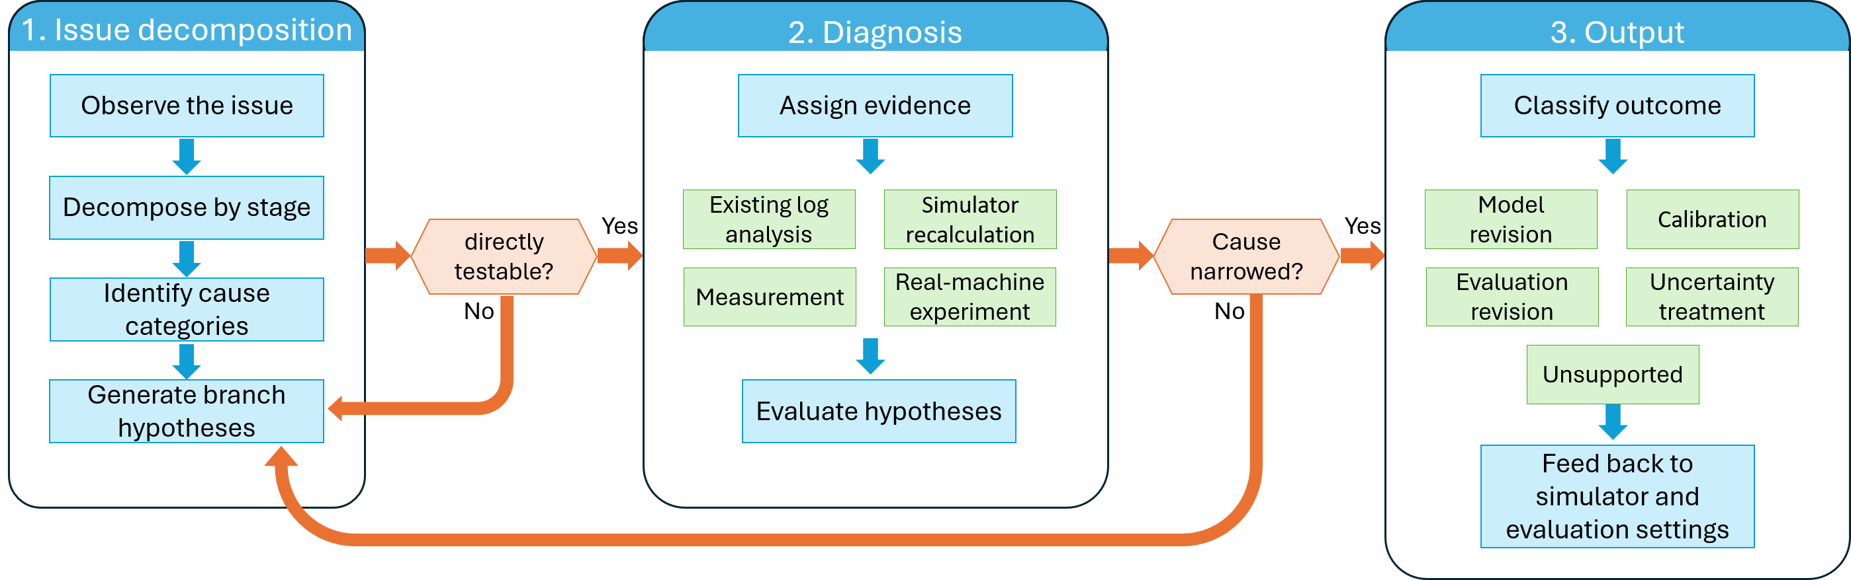
Figure 1: Issue-based diagnostic workflow for LLM-executable commissioning.
Fig. 1 summarizes the proposed issue-based diagnostic workflow. The workflow starts from an observed simulator-to-real discrepancy and decomposes it into execution stages, cause categories, and testable branch hypotheses. Each hypothesis is assigned targeted evidence, such as existing-log analysis, simulator checks, physical measurements, image checks, or real-machine trials. The diagnostic result is then classified as a simulator update, calibration update, evaluation-logic update, operational constraint, residual uncertainty item, or rejected explanation, and is fed back to subsequent motion optimization or experiment planning.

LLM-managed diagnostic loop and physical action layer
OpenAI Codex was used as the LLM-based diagnostic and coding agent. It generated and revised hypotheses, experiment plans, replay and analysis code, diagnosis reports, and simulator-update proposals, while requesting and interpreting logs, measurements, and simulator results. Physical measurements and real-machine trials were performed by the researcher for safety, equipment protection, and practical access to the testbed. The objective was not to compare Codex with human experts, but to formalize commissioning activities that currently depend on human observation and engineering judgment for eventual use in unmanned or minimally supervised construction.
Each branch hypothesis had to define an observable test. Broad explanations such as “the simulator is inaccurate” were therefore replaced by specific statements of what should be measured, inspected, or replayed and what evidence would support or reject them.

Corrective actions and evaluation concept
The output of issue diagnosis is classified into reusable forms: simulator or evaluation updates, operational constraints, residual uncertainty items, or rejected explanations. In the case study, the main corrective actions were simulator updates, candidate-evaluation updates, and residual uncertainty registration.
For posture or geometric discrepancies, the outcome can be evaluated by comparing a simulator-predicted quantity with the corresponding measured real-machine quantity. In the following case study, the primary metric is the minimum-height error between the simulator-predicted bucket lowest point and the measured real-machine bucket lowest point.

Testbed and Initial Simulator

Excavator testbed and command interface
The case study used a ROS 2 Foxy-based scale-model excavator robot testbed. The testbed was based on a model construction robot system previously developed for construction automation research and education (Yajima, R. et al., 2023). The excavator was represented as a serial mechanism with three main working joints: boom, arm, and bucket. The testbed also included a rotator for upper-structure rotation, but the commissioning issue analyzed in this paper concerned the side-view posture of the boom, arm, and bucket.
The digital model used nominal link dimensions and bucket reference points to compute the side-view posture of the excavator and the height of the bucket tip or lower point. In this paper, (H) denotes the bucket hinge point, and (T) denotes the bucket tip point. These points were used to define bucket posture and to compare simulator-predicted and measured real-machine bucket positions. Fig. 2 shows the scale-model excavator, joint definitions, motion ranges, and measured dimensions used in the initial simulator.
The command interface allowed target joint angles and speed ratios to be published to the excavator through ROS topics. The main command topics were the boom, arm, bucket, and rotator angle topics, each of which accepted a target angle and a speed ratio. The joint-state topic provided subscribed joint angles used for posture comparison. In this paper, speed ratio refers to the relative speed command specified with the target joint angle. Because it is defined relative to the internal maximum speed used by the controller, it does not directly correspond to a fixed physical angular velocity under all postures or operating conditions.
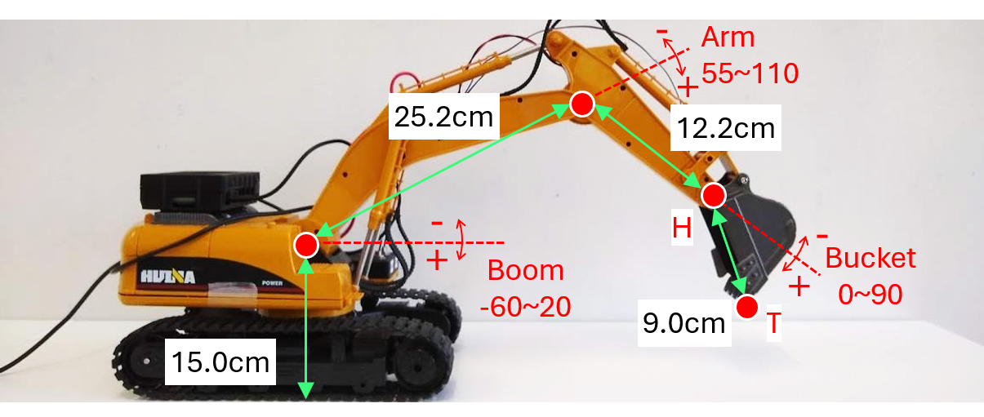
Figure 2: Scale-model excavator robot, joint definitions, motion ranges, and measured dimensions used in the initial simulator.

Initial simulator and replay procedure
The case study focused on the excavator motion component of an ideal-condition simulator. The initial simulator was constructed to generate and evaluate candidate digging postures before increasing the number of real-machine trials. It accepted candidate boom, arm, and bucket angles and computed the corresponding side-view excavator posture using nominal link dimensions, documented joint-angle definitions, bucket reference points, and simple clearance checks.
Candidate postures were evaluated based on geometric feasibility, bucket height, and task-level suitability for excavation. The initial model did not include machine-specific execution effects such as command-to-posture deviation, joint stopping error, speed-dependent actuation limits, bucket-speed variability, material-flow uncertainty, or communication delay. Therefore, a posture that appeared feasible in the initial simulator still required real-machine replay and commissioning diagnosis before it could be treated as a reliable motion candidate.
After candidate generation, selected excavator motions were replayed on the real machine. The replay procedure published target boom, arm, and bucket angles together with speed ratios, and recorded command logs, joint-state logs, measurements, and observations of the resulting machine behavior. When the real-machine behavior diverged from the simulated behavior, the discrepancy was registered as an issue and analyzed using the issue-based diagnostic method described in Section 3.

CASE STUDY: SIMULATOR-TO-REAL EXCAVATOR POSTURE DISCREPANCY

Observed issue and execution-stage decomposition
The commissioning issue was observed during replay of an excavator motion selected from the initial simulator. The simulator predicted that the selected excavator posture would maintain sufficient clearance above the floor. However, during real-machine replay, floor contact was observed around the bucket. The initial minimum-height error between the simulator-predicted bucket lowest point and the measured real-machine bucket lowest point was 3.891 cm, indicating that the discrepancy was not only a qualitative floor-contact observation but also a measurable clearance-prediction error.
The observed floor contact was treated as a symptom of a simulator-to-real excavator posture discrepancy, rather than as an isolated contact issue. To diagnose this discrepancy, the issue was decomposed into the execution stages shown in Table 1.
Table 1: Execution stages and diagnostic questions for the simulator-to-real excavator posture discrepancy.
Stage | Execution layer | Diagnostic question
S01 | Point/reference consistency | Were H, T, and floor references consistent across simulation, measurement, and posture reconstruction?
S02 | Geometry model | Did the simulator omit clearance-critical geometry, such as the bucket lower point or H-to-T geometry?
S03 | Command-to-posture mapping | Did the documented angle definitions fail to reproduce the real side-view posture?
S04 | Candidate evaluation | Did endpoint-only evaluation miss intermediate postures, lowest-point changes, or tolerance effects?
S05 | Replay consistency | Did the replayed command sequence differ from the simulator candidate?
S06 | Execution response | Did speed ratio, delay, incomplete arrival, or phase-transition residuals cause posture deviation?

Branch-explanation diagnosis and updates
Because the issue was a compound discrepancy, the diagnosis did not reduce the symptom to a single root cause. Instead, the diagnosis separated rejected explanations, simulator updates, candidate-evaluation updates, and residual uncertainty items. Table 2 summarizes the branch explanations tested for each execution stage.
The diagnosis converted the floor-contact symptom into simulator and candidate-evaluation updates. The updated simulator incorporated bucket lower-body geometry, H-to-T relative bucket representation, and local command-to-posture calibration. The candidate-evaluation procedure was revised to evaluate intermediate postures and the lowest bucket point rather than only endpoint postures. Remaining effects, including bucket-response variability and residual arrival error, were retained as uncertainty items instead of being forced into a deterministic model.
Table 2: Branch explanations and diagnostic outcomes for the simulator-to-real excavator posture discrepancy. Highlighted rows, marked with *, indicate diagnostic updates assessed in the ablation analysis.
Stage | Tested explanation | Evidence from check or test | Diagnostic outcome
S01 | Inconsistent reference frames or point definitions caused the discrepancy. | Reference and point-definition checks confirmed that neither a simple reference mix-up nor H/T point confusion sufficiently explained the discrepancy. | Unsupported
S02 | The simulator evaluated only the bucket tip and omitted the bucket lower point. | Measurements of H-T distance, M/L point, and bucket side geometry showed that tip-only evaluation was insufficient for robust floor-clearance assessment. | Model revision*
S02 | The bucket should be represented by H-to-T relative angle and length rather than by absolute bucket position. | Reorganizing bucket measurements using H-to-T length and arm-relative H-to-T angle improved bucket posture reconstruction. | Calibration*
S03 | The documented joint-angle definitions did not reproduce the real side-view boom/arm posture. | Comparison of commanded joint angles, subscribed ROS angles, measured H/J/T positions, and reconstructed side-view posture showed that the ideal-angle model was insufficient. | Calibration*
S04 | Endpoint-only clearance evaluation missed lower intermediate postures. | Evaluation of phase-intermediate postures and bucket lowest point showed that endpoint-only evaluation was unsafe for clearance checking. | Evaluation revision*
S04 | Arrival tolerance at phase boundaries shifted the possible lowest point downward. | The tolerance envelope for boom, arm, and bucket arrival residuals showed that residual arrival error could affect worst-case clearance. | Uncertainty treatment
S05 | The replay code sent a different angle sequence from the selected simulator candidate. | Comparison of candidate values, replay code, and command logs found no major transcription mismatch for the target replay. | Unsupported
S05 | Re-publishing or publish order caused a general decrease in minimum height. | One-shot and repeated publishing tests under controlled initial posture showed that re-publishing or publish order was not a general primary cause. | Unsupported
S06 | Speed-ratio transitions, joint delay, or nonlinear joint response caused the discrepancy. | Real joint-trajectory analysis under different speed-ratio settings showed that boom/arm response was partially characterizable, but did not sufficiently explain the representative discrepancy; bucket response remained variable. | Uncertainty treatment

Quantitative evaluation and corrective action
The effect of the simulator updates was evaluated using the minimum-height error between the simulator-predicted bucket lowest point and the measured real-machine bucket lowest point, defined as $e_{z}= \left|z_{sim, min}-z_{real, min}\right|$, where $z_{sim, min}$ is the simulator-predicted lowest-point height and $z_{real, min}$ is the measured real-machine lowest-point height. In the Issue02 diagnostic example, the initial evaluation produced a minimum-height error of 3.891 cm. After updating the command-to-posture mapping, relative bucket geometry, and lowest-point evaluation procedure, the final evaluation reduced the minimum-height error to 0.185 cm. This reduction reflects changes in the posture-prediction and clearance-evaluation procedure, rather than a simple height correction applied to an identical simulated posture.
Fig. 3 provides a visual reference by overlaying the initial simulator result, measured real-machine posture, and updated simulator result for the same commanded joint angles. The measured real-machine posture was obtained from physical measurements and registered to the photograph using corresponding points.
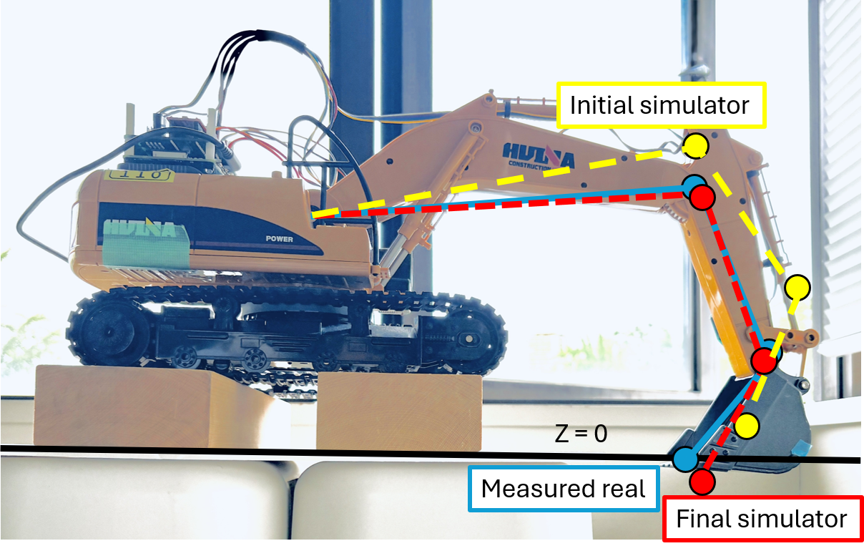
Figure 3: Visual comparison of the initial simulator, measured real-machine posture, and updated simulator under the same commanded joint angles. The measured posture was registered to the photograph using corresponding points.
Table 3 summarizes the ablation analysis of the diagnostic updates incorporated into the final simulator and evaluation procedure. The purpose is not to assign independent contribution rates to individual updates, but to show that the final improvement depended on multiple interacting corrections. Each row reports ${∆e}_{z}$, the increase in minimum-height error when the corresponding update is excluded from the final model. Because the values are not additive, they should be interpreted as evidence that the discrepancy was compound rather than caused by a single isolated factor. This result supports the diagnostic treatment in Table 2: the discrepancy was not attributable to a single isolated factor, but required a combination of calibration, geometry representation, evaluation revision, and uncertainty treatment.
Table 3: Ablation effects of diagnostic updates for the simulator-to-real excavator posture discrepancy.
Diagnostic update | ${∆e}_{z}$ when excluded | Interpretation
Model revision: bucket lower-point geometry | 0.000 cm | Retained because the bucket body can become lower than the cutting edge tip in other postures.
Calibration: command-to-posture mapping | 3.839 cm | Had the largest effect; the documented ideal-angle model did not reproduce the real boom/arm posture.
Calibration: H-to-T relative bucket representation | 0.175 cm | Improved consistency by representing the bucket using H-to-T relative angle and length.
Evaluation revision: intermediate-pose and lowest-point evaluation | 0.310 cm | Reduced clearance underestimation caused by endpoint-only evaluation.

CONCLUSION
This paper proposed an issue-based LLM-executable commissioning framework for adapting generic construction robot simulations to machine-specific execution behavior. The framework is designed to make the commissioning process itself executable by an LLM-based diagnostic agent. Starting from an observed simulator-to-real discrepancy, the agent decomposes the issue into execution stages and testable branch hypotheses, requests targeted evidence, interprets returned measurements and logs, and converts the diagnosis into reusable simulator updates, evaluation updates, constraints, or uncertainty items.
The framework was demonstrated using a ROS 2 Foxy-based scale-model excavator testbed. The case study focused on a simulator-to-real excavator posture discrepancy in which the initial simulator predicted sufficient bucket-floor clearance, whereas floor contact was observed during real-machine replay. The diagnosis identified multiple relevant layers, including bucket geometry representation, command-to-posture calibration, candidate-evaluation logic, replay consistency, and residual execution uncertainty. By incorporating the correctable factors into the simulator and evaluation procedure, the minimum-height error was reduced from 3.891 cm to 0.185 cm.
In the present implementation, real-machine trials and physical measurements were supervised by the researcher for safety, equipment protection, and practical access to the testbed. Within this human-supervised physical action layer, the LLM-based agent managed the diagnostic reasoning loop by generating hypotheses, requesting evidence, interpreting returned measurements and logs, and proposing simulator-update actions. The present study is limited to a single posture-related commissioning issue on one scale-model excavator platform and therefore does not establish generalizability across discrepancy types, construction tasks, or robot platforms. Computational performance was not formally benchmarked. Future scalability assessments should consider the number of branch hypotheses, the volume of logs and sensor data, simulator complexity, and the number of commissioning issues processed concurrently.
Future work should first examine the framework across multiple commissioning issues, including discrepancies associated with control response, perception, communication, geometry, and task performance, and across different construction robot platforms. The method should also be integrated into broader construction planning, where diagnosed simulator updates, evaluation updates, constraints, and uncertainty items are fed back not only to individual motion candidates but also to task sequencing, machine allocation, and multi-machine coordination. Such extensions are necessary to evaluate both the generalizability and scalability of LLM-executable commissioning at the planning-system level.

ACKNOWLEDGEMENTS
This work was supported by JSPS KAKENHI Grant Number JP25K01302 and the i-Construction System Studies Endowed Chair, Faculty of Engineering, The University of Tokyo.

REFERENCES
Aljalbout, E., Xing, J., Romero, A., Akinola, I., Garrett, C. R., Heiden, E., Gupta, A., Hermans, T., Narang, Y., Fox, D., Scaramuzza, D., & Ramos, F., (2026). The Reality Gap in Robotics: Challenges, Solutions, and Best Practices. Annual Review of Control, Robotics, and Autonomous Systems, 9(1): p. 403–432. DOI: 10.1146/annurev-control-031924-100130.
Boiko, D. A., MacKnight, R., Kline, B., & Gomes, G., (2023). Autonomous chemical research with large language models. Nature, 624(7992): p. 570–578. DOI: 10.1038/s41586-023-06792-0.
Deng, M., Menassa, C. C., & Kamat, V. R., (2021). From BIM to digital twins: A systematic review of the evolution of intelligent building representations in the AEC-FM industry. Journal of Information Technology in Construction, 26: p. 58–83. DOI: 10.36680/j.itcon.2021.005.
Johns, R. L., Wermelinger, M., Mascaro, R., Jud, D., Hurkxkens, I., Vasey, L., Chli, M., Gramazio, F., Kohler, M., & Hutter, M., (2023). A framework for robotic excavation and dry stone construction using on-site materials. Science Robotics, 8(84): p. eabp9758. DOI: 10.1126/scirobotics.abp9758.
Jud, D., Kerscher, S., Wermelinger, M., Jelavic, E., Egli, P., Leemann, P., Hottiger, G., & Hutter, M., (2021). HEAP - The autonomous walking excavator. Automation in Construction, 129: p. 103783. DOI: 10.1016/j.autcon.2021.103783.
Karanfil, D., Lindmark, D., Servin, M., Torick, D., & Ravani, B., (2026). Developing a calibrated physics-based digital twin for construction vehicles. Digital Twin, 3(2): p. 2592382. DOI: 10.1080/27525783.2025.2592382.
Khalastchi, E. & Kalech, M., (2019). On Fault Detection and Diagnosis in Robotic Systems. ACM Computing Surveys (CSUR), 51(1): p. 1–24. DOI: 10.1145/3146389.
Levin, K. H., van Kempen, N., Berger, E. D., & Freund, S. N., (2025). ChatDBG: Augmenting Debugging with Large Language Models. Proceedings of the ACM on Software Engineering, 2(FSE): p. FSE085:1892-FSE085:1913. DOI: 10.1145/3729355.
Liu, Z. & Kim, J. I., (2025). Autonomous Earthwork Machinery for Urban Construction: A Review of Integrated Control, Fleet Coordination, and Safety Assurance. Buildings, 15(14): p. 2570. DOI: 10.3390/buildings15142570.
M. Bran, A., Cox, S., Schilter, O., Baldassari, C., White, A. D., & Schwaller, P., (2024). Augmenting large language models with chemistry tools. Nature Machine Intelligence, 6(5): p. 525–535. DOI: 10.1038/s42256-024-00832-8.
Salvato, E., Fenu, G., Medvet, E., & Pellegrino, F. A., (2021). Crossing the Reality Gap: A Survey on Sim-to-Real Transferability of Robot Controllers in Reinforcement Learning. IEEE Access, 9: p. 153171–153187. DOI: 10.1109/ACCESS.2021.3126658.
Stentz, A., Bares, J., Singh, S., & Rowe, P., (1999). A Robotic Excavator for Autonomous Truck Loading. Autonomous Robots, 7(2): p. 175–186. DOI: 10.1023/A:1008914201877.
Terenzi, L. & Hutter, M., (2024). Toward Autonomous Excavation Planning. IEEE Transactions on Field Robotics, 1: p. 292–317. DOI: 10.1109/TFR.2024.3485037.
Wang, X., Yu, H., McGee, W., Menassa, C. C., & Kamat, V. R., (2024). Enabling Building Information Model-driven human-robot collaborative construction workflows with closed-loop digital twins. Computers in Industry, 161: p. 104112. DOI: 10.1016/j.compind.2024.104112.
Xu, J., Zhang, Q., Zhong, Z., He, S., Zhang, C., Lin, Q., Pei, D., He, P., Zhang, D., & Zhang, Q., (2025). OpenRCA: Can Large Language Models Locate the Root Cause of Software Failures? In ICLR 2025.
Yajima, R., Muramoto, I., Matsushita, F., Nagatani, K., & Ozawa, K., (2023). Development of a Model Construction Robot System Using ROS [in Japanese]. In Proceedings of the 5th Symposium on the Promotion of i-Construction, Japan Society of Civil Engineers, 2025. DOI: 10.11532/kensetsumanagement.2023.0_33.

