Workflow Automation using Digital Twins and Smart Contracts
— A Decentralised Framework for Precast Concrete Production
Xuling Ye, Simon Kosse, Philipp Hagedorn, Markus König

Computing in Engineering, Department of Civil and Environmental Engineering, Ruhr University Bochum, Bochum, Germany

ABSTRACT:
In the precast concrete domain, automating production workflows is essential for improving efficiency and reducing reliance on manual labour. This paper presents a framework for automating workflow execution using IOTA-enabled smart contracts and Digital Twins (DT). The approach integrates real-time sensor data, managed via the Asset Administration Shell (AAS), to trigger predefined process tasks by smart contracts. These smart contracts automate tasks such as monitoring and controlling process parameters based on predefined conditions, reducing the need for manual intervention. The implementation of this framework is demonstrated through a use case in precast concrete production, where smart contracts automate the curing process by adjusting a series of actions based on both temperature data and curing time. A proof of concept is provided to show the feasibility of automating workflow tasks in construction, illustrating the potential for increased efficiency and data-driven decision-making in production environments.

KEYWORDS:
Workflow Automation, Smart Contract, IOTA, Construction Digital Twins, Asset Administration Shell

1. INTRODUCTION
Nowadays, the level of automation in precast concrete plants varies widely, depending on factors such as plant size, production volume, and available technology. In most plants, only a limited number of sub-processes are automated, with many operations still relying heavily on manual labour (Friedrich, T., 2019). However, advances in Industry 4.0 (I4.0) technologies such as the Internet of Things (IoT), Digital Twin (DT), Artificial Intelligence (AI), and robotics are expected to significantly increase the level of automation, thereby improving efficiency, accuracy, and flexibility of production processes. The increasing alignment of precast concrete production with I4.0 principles allows for more efficient and data-driven manufacturing processes. I4.0 introduces automation, IoT-enabled devices, and advanced analytics into production, enabling real-time monitoring and optimisation of critical operations such as concrete mixing, curing, and reinforcement placement (Kagermann, H., Wahlster, W. & Helbig, J., 2013).
A challenge in automating production systems for producing precast concrete elements is to achieve seamless orchestration of tasks and processes, which requires effective coordination of predefined rules, real-time data inputs, and integrated digital systems (Neubauer, R., 2017). Automated workflow execution in precast production refers to automatically initiating, monitoring, and completing tasks based on predefined rules. It can be achieved by the seamless and autonomous management of production processes using digital tools and technologies, such as IoT devices, smart contracts, and integrated data systems. Smart contracts—self-executing agreements operating on decentralised platforms like blockchain—operate based on predefined rules embedded in their code and automatically trigger actions when certain conditions are met (Ye, X. et al., 2024). For example, curing cycles can be automatically adjusted based on temperature sensor readings, or quality inspections can be triggered when certain thresholds are met.
This research proposes an approach for automated workflow execution based on IOTA-enabled smart contracts in construction DTs. The Asset Administration Shell (AAS), the established implementation of the DT in I4.0, has already been applied in previous research to the production of precast concrete elements and is also used for implementing the DT in this work (Kosse, S. et al., 2022). Smart contracts enable the automated execution of predefined workflows, with the resultant transactional data being immutably recorded within the IOTA distributed ledger framework, providing a decentralised and scalable solution explicitly designed for IoT and data-driven environments. IOTA’s smart contract protocol enables the execution of complex logic across distributed systems, facilitating automated and tamper-proof workflow execution. The proposed approach is demonstrated through a use case of automated curing in precast concrete production, where IoT sensors enable real-time monitoring of temperature and humidity. This data is continuously updated in the DT via the AAS, enabling dynamic control of the curing process via smart contracts.

2. Literature Review
2.1 Distributed Ledger Technologies in Construction
Distributed Ledger Technologies (DLTs) are systems that allow the recording of transactions and data across multiple nodes in a network in a secure, transparent, and immutable manner (El Ioini, N. & Pahl, C., 2018). These systems ensure that data is tamper-proof and verifiable, providing robust solutions for various industries, including construction. The most well-known form of DLT is blockchain, which records transactional data in a series of interconnected blocks that are cryptographically linked, ensuring data cannot be altered once recorded (Li, J. & Kassem, M., 2021). Another innovative type of DLT is IOTA, which employs a Directed Acyclic Graph (DAG) structure called the Tangle (Denis, N., Chabridon, S. & Laurent, M., 2024). IOTA’s standout features include feeless transactions and high scalability, making it ideal for the IoT, where microtransactions are common. IOTA’s unique features and benefits present a promising opportunity for the construction industry. Its scalability, feeless transactions, and enhanced security capabilities make IOTA a compelling candidate for driving efficiency and innovation in construction projects. Additionally, integrating smart contracts within these DLTs can further automate and streamline processes (Ye, X., Zeng, N. & König, M., 2022). Smart contracts ensure that agreements are executed automatically when predefined conditions are met, enhancing trust, transparency, and efficiency in construction transactions.
Numerous studies have demonstrated the transformative potential of DLT in the construction industry, with a primary focus on blockchain and smart contract applications. Several review papers have highlighted the advancements specific to this field. For instance, Li, J. & Kassem, M. (2021) comprehensively analyse blockchain applications, including improving information management, enhancing transparency, and integrating with technologies like Building Information Modeling (BIM) and the IoT. Similarly, Ye, X., Zeng, N. & König, M. (2022) explore blockchain-based smart contract applications for automating payment systems and contract execution, identifying strategies to overcome adoption barriers and enhance efficiency in construction projects. Sun, W., et al. (2023) emphasise the increasing maturity of blockchain applications, with a noticeable shift from conceptual discussions to practical case studies and technical implementations over the past five years. Recent research, such as Celik, B., Abraham, Y. & Attaran, M. (2024), reviews the use of blockchain for purposes like automating contract management, streamlining payments, and enhancing supply chain transparency.
However, IOTA has yet to be adapted to the construction industry. Its unique features and benefits present a promising opportunity. The industry could potentially leverage IOTA to achieve efficient, cost-effective microtransactions and secure data management.

2.2 Integrating DTs and DLT in Construction
According to Boje, C., et al. (2020), a DT in construction is a real-time, dynamic digital representation of a physical asset, system, or process that integrates sensor data, simulations, and historical information. Unlike traditional BIM, it continuously updates and synchronises with the physical environment, enabling monitoring, analysis, and optimisation throughout the construction lifecycle. Although the number of DTs in construction is steadily increasing (Opoku, D.-G.J. et al., 2021), significant challenges remain to their widespread adoption. One of the biggest challenges in implementing DTs in the construction industry is reliable data management and visibility (Yang et al., 2024). As large amounts of real-time data from multiple sources are brought together, it is important to ensure data integrity and traceability to avoid manipulation and errors. Security and distributed collaboration are closely related, as many parties—contractors, architects, and government—need to access the same data. This requires robust access controls and protection mechanisms against cyber-attacks (Teisserenc, B. & Sepasgozar, S., 2021; Reim, W., Andersson, E. & Eckerwall, K., 2023). Legal and regulatory frameworks also play an important role, particularly concerning data protection, liability, and standardisation of data formats and interfaces. Without clear guidelines and secure infrastructures, the widespread use of DTs in the construction industry remains challenging (Opoku, D.-G.J. et al., 2021). DLTs (especially blockchain) present innovative solutions to overcome key challenges in implementing DTs in construction. Cao, X., et al. (2022) demonstrate how integrating blockchain with DTs enhances data management and transparency, leveraging blockchain’s decentralisation, immutability, and security features to establish a highly trusted platform for data sharing. Similarly, (Putz, B. et al., 2021) introduce a component-based data model and an access control framework tailored for lifecycle participants. Their EtherTwin prototype ensures confidentiality through encryption and decentralised data sharing, eliminating the need for central authority. Teisserenc, B. & Sepasgozar, S. (2021) address critical security and data protection challenges in the construction industry, emphasising the necessity of robust access control mechanisms and effective cybersecurity measures to mitigate risks associated with distributed collaboration. Given the inherently decentralised nature of data exchange in construction projects, the authors highlight blockchain technology as a fundamental solution for enhancing information security within common data environments. Lee, D., et al. (2021) developed an integrated framework that combines DT technology with blockchain to enhance information sharing in construction projects to address challenges related to data authenticity, traceability, and security.
The precast concrete industry is at the early stages of automation, with low productivity and limited technological adoption compared to other industries. While some processes, such as concrete mixing and component handling, have seen moderate automation, others, like formwork preparation and reinforcement placement, remain primarily manual (Reichenbach, S. & Kromoser, B., 2021). Recently, driven by the goal of integrating the I4.0 paradigm into the construction sector, significant advancements have been made in applying DT technology to produce precast concrete elements. In their research, Kosse, S., et al. (2022; 2024) employ the AAS to integrate DT technology into precast concrete production, enabling standardised data exchange and process automation. The AAS serves as a digital representation of physical assets, consolidating design, material, and real-time production data to enhance monitoring, quality control, and efficiency in line with I4.0 principles. However, while research has advanced DT technology and data integration in precast concrete production, process automation remains unexplored. Studies focus on monitoring and quality control, but the automation of workflows and decision-making still lacks academic attention, requiring further investigation for full I4.0 adoption. Smart contracts offer a promising solution for process automation in precast concrete production by enabling secure, autonomous execution of predefined tasks without intermediaries (Ye, X., Liu, L. & König, M., 2024). By leveraging blockchain technology, they ensure transparency, traceability, and real-time validation of production workflows (Wang, Z. et al., 2020). IOTA, a distributed ledger-based framework, has already been successfully integrated with the AAS to enable secure and scalable data exchange in industrial applications (Dogan, A. et al., 2020).

3. Concept
The reviewed literature has shown that integrating IOTA into the DT can offer advantages for automatically controlling production in a precast concrete plant. However, the application of IOTA in the construction domain is little researched, and thus, following our previous research (Ye, X., Liu, L. & König, M., 2024), this paper aims to present a prototype implementation for an IOTA-based DT of a production system that can monitor and control processes using the workflows defined in smart contracts. With this prototype, we do not aim to present a productive solution yet, but to lay the groundwork for exploring and demonstrating the capabilities of a system built upon the AAS and IOTA.
Figure 1 shows the concept developed in this research for automating process tasks using IOTA smart contracts. The core of this approach is using sensor data as a trigger mechanism, where, for example, exceeding a predefined critical sensor value activates the smart contract. The sensor data is collected via an InfluxDB time-series database, while referencing the data series takes place in the AAS of the respective asset. A monitoring service accesses the required endpoint information from the AAS to ensure access to the relevant sensor data. When a defined condition is met, such as exceeding a threshold, the service initiates the appropriate process task. The automatic execution of process tasks is achieved through rule-based smart contracts, enabling efficient and scalable process automation.
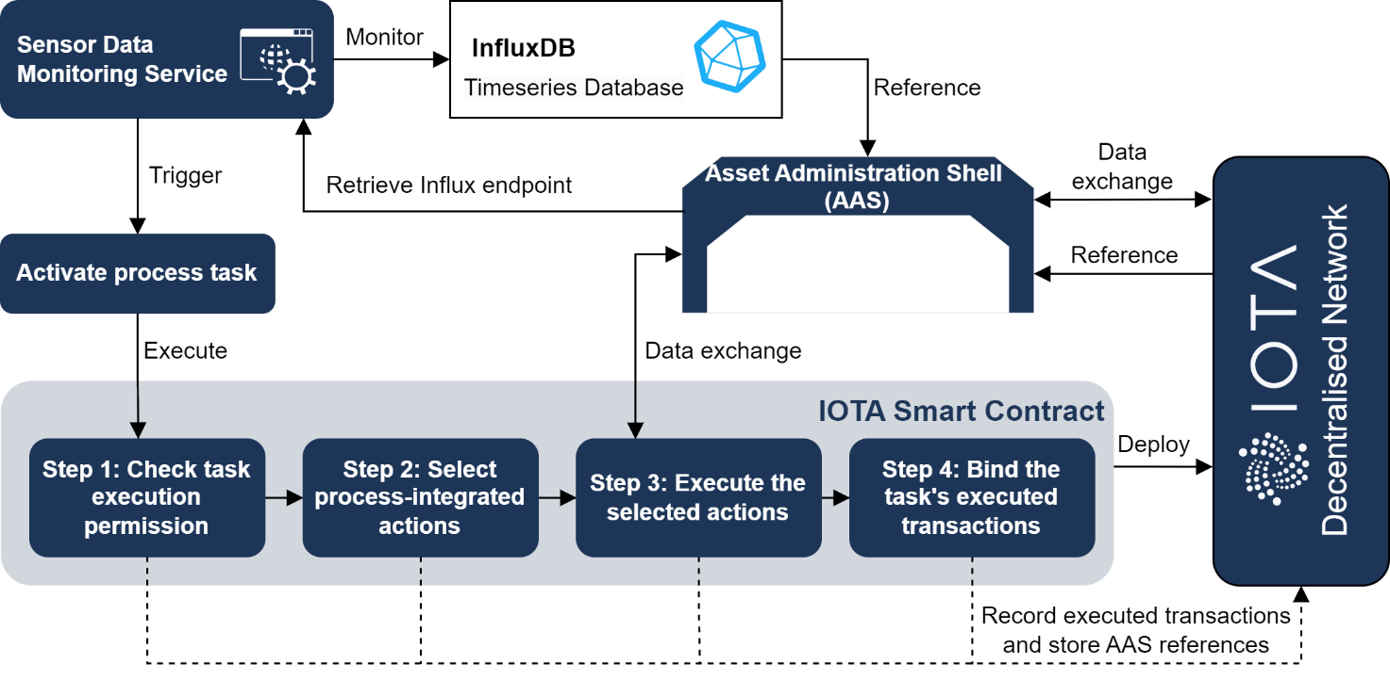
Activating a process task triggers its associated smart contract, which executes the predefined functions. These smart contracts are deployed on the IOTA network, where all associated AASs undergo verification to ensure proper authorisation for task execution. In the next step, process-integrated actions are selected to achieve specific objectives, such as executing commands via IoT devices or controlling robotics. Each action is clustered as a bundle of predefined functions within dedicated action-specific smart contracts. In the third step, which activates systems or linked physical devices to execute the selected actions. During execution, each action’s associated AAS reference is stored in the corresponding transaction to establish a clear link to the relevant AAS. Each executed smart contract function generates a transaction, which will be further stored in the IOTA network. Once all functions of the selected actions have been completed, the executed transactions of this process task are grouped into a process-integrated data structure with the task identifier, corresponding actions’ information, and the referenced AAS, which stores the task’s historical data. Consequently, all AAS-related transactions and their respective references are maintained in the IOTA ledger and can be linked back to their corresponding AASs. Historical information on any AAS can be queried within the IOTA network.
This research contributes to the digital transformation of the precast concrete industry by integrating smart contracts and DTs to enable automated workflow execution. This approach supports data-driven decision-making by providing accurate, real-time insights into production processes. The automated activation of smart contracts facilitates the seamless progression of production steps, reducing the need for manual intervention and minimising delays. Additionally, it enhances quality control by ensuring that subsequent tasks are initiated only when predefined conditions, such as material readiness, are satisfied.

4. Implementation
The proposed framework is theoretically applicable to various industrial automation cases. However, since the specific implementation of AAS and smart contract actions varies from case to case, this paper focuses on a specific use case to demonstrate the implementation details. This section introduces the selected use case, presents a sequence diagram of the interactions between components in the system, explains the implementation steps, and provides a general structure for the smart contract logic.
Figure 1: Overall proposed framework.

4.1 Use Case
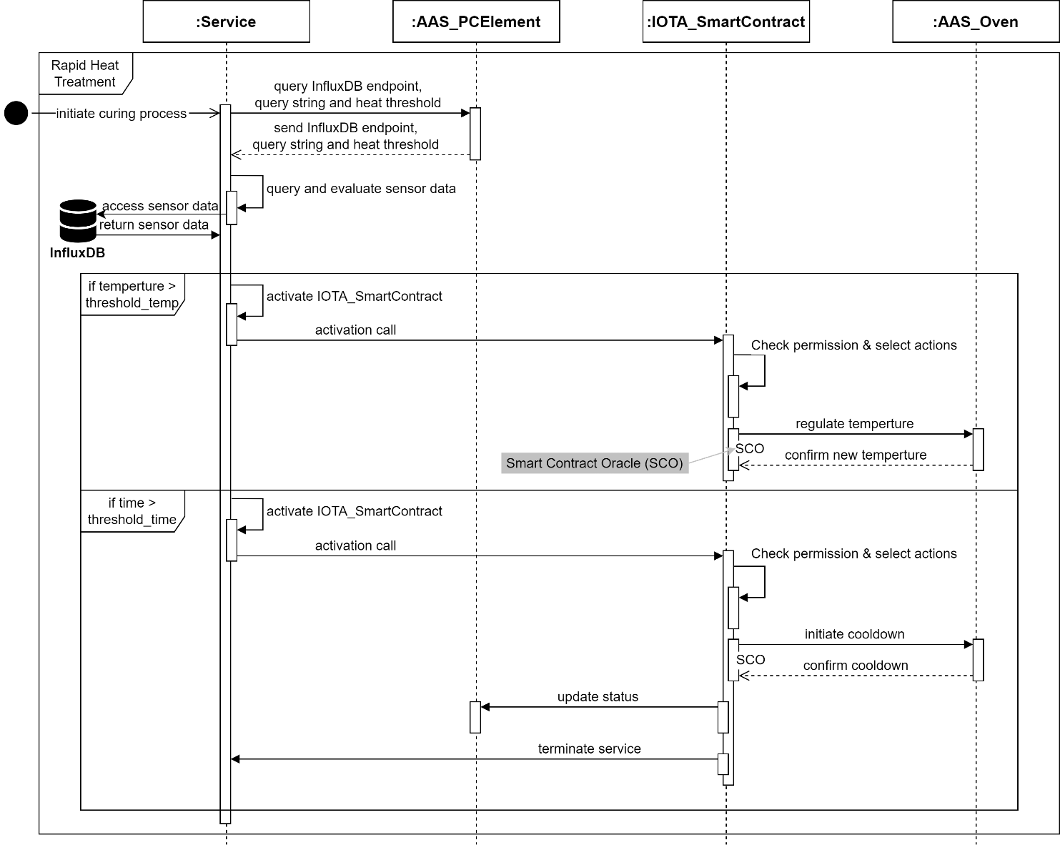
Curing precast concrete products by rapid heat treatment is a promising method for significantly reducing production times and increasing the efficiency of industrial manufacturing processes. Targeted heating in the oven accelerates the hydration of the cement so that the otherwise lengthy concrete curing can be achieved within a few hours. However, precise temperature control is critical to the success of this method, as excessive temperature gradients can lead to stresses in the material and, hence, structural damage. This research presents a control system that uses a smart contract to make automated process adjustments to address these challenges. The system monitors the temperature development and regulates the heating process to ensure uniform heating. At the same time, once the heat treatment is completed, the system automatically initiates subsequent production steps, such as demoulding or quality control.
Figure 2: Sequence diagram of the proposed framework in the precast concrete products’ curing process.
As shown in Figure 2, the process involves five key components that work together to control and automate the rapid heat treatment of precast concrete products. First, an InfluxDB instance continuously records temperature and strain data from sensors embedded in the precast concrete part, making it available for process monitoring and optimisation. Second, a higher-level service provides process control and smart contract activation. Third, the DT of the precast concrete element (i.e., “:AAS_PCElement”) provides key parameters such as target temperature and process duration to enable precise control of the heat treatment. Fourth, the DT of the oven acts as an interface to the oven control system and ensures that the specified temperature profiles are implemented according to the rules. Fifth, an IOTA-based smart contract (i.e., “:IOTA_SmartContract”) is used to ensure the automation of the entire process and to enable transparent and tamper-proof execution through its decentralised structure.
The curing process starts with the rapid heat treatment initialisation, which activates the central control service. In the first phase of the process, the service retrieves the relevant query parameters, including the InfluxDB endpoint and the specific query string, from the DT of the precast concrete element. It also queries the process parameters defined for the heat treatment, such as the target temperature and duration. The service then establishes a continuous connection to InfluxDB to collect temperature and strain sensor data from the sensors embedded in the precast concrete element. This data is continuously compared with the predefined heat treatment parameters to ensure accurate monitoring of the curing process. Based on the temperature curve and elapsed process time, the service decides on further process control measures.
An IOTA-based smart contract is activated to adjust the oven temperature or terminate the heat treatment process. The smart contract plays a central role in process automation by first checking the permissions of the control service and then selecting appropriate actions based on this. As shown in the presented sequence diagram, either the oven temperature is adjusted or the heat treatment process is stopped. In the case of a temperature adjustment, the control of the DT of the oven is modified accordingly. Through the existing bidirectional coupling between the DT and the physical oven, the change in the digital representation is directly transferred to the physical system, ensuring that the temperature in the physical twin is adjusted. When the process is completed, the smart contract automatically initiates the cooling process of the oven and updates the status of the precast concrete element via its Smart Contract Oracle (SCO), which is a trusted service to bridge on-chain smart contracts and off-chain data or systems. The smart contract and AAS-based DTs communicate via AAS Representational State Transfer (REST) Application Programming Interfaces (APIs). Finally, the smart contract schedules the control service for the rapid heat treatment, efficiently completing the entire process and freeing up resources for subsequent production cycles.

4.2 Implementation
This section presents the implementation details of the proposed automation framework, focusing on the interaction between the IOTA smart contract and the SCO to manage the curing process in the precast concrete industry. Since smart contracts cannot directly access external data or trigger actions in external systems for security reasons, a SCO is developed to address this limitation by securely fetching real-world data or interacting with off-chain services and delivering that information to smart contracts. The implementation includes a smart contract (coded in Solidity) deployed on the IOTA EVM Testnet and a SCO (coded in Node.js) that enables the smart contract to communicate with the AASs through REST API calls.
The IOTA smart contract, implemented for the use case called CuringProcessAutomation, is designed to automate value updates in the AAS service by emitting events that the SCO monitors. It is deployed with published code on the IOTA EVM Testnet via Remix IDE (Figure 3). The automation is triggered by sensor data, such as temperature readings exceeding a predefined threshold, which activates a series of smart contract functions. Specifically, when the temperature or the processing time reaches the set threshold, the smart contract functions “updateOvenTemperature”, “updateOvenStatus”, and “updateElementStatus” are called, corresponding to the actions required for the curing process. Each smart contract function directly interacts with the AAS of the respective assets, namely the oven and the precast element, through the SCO (via event “requestAASUpdate”) that facilitates REST API calls to update their statuses, such as changing the oven’s temperature, cooling down the oven, and completing the curing process.

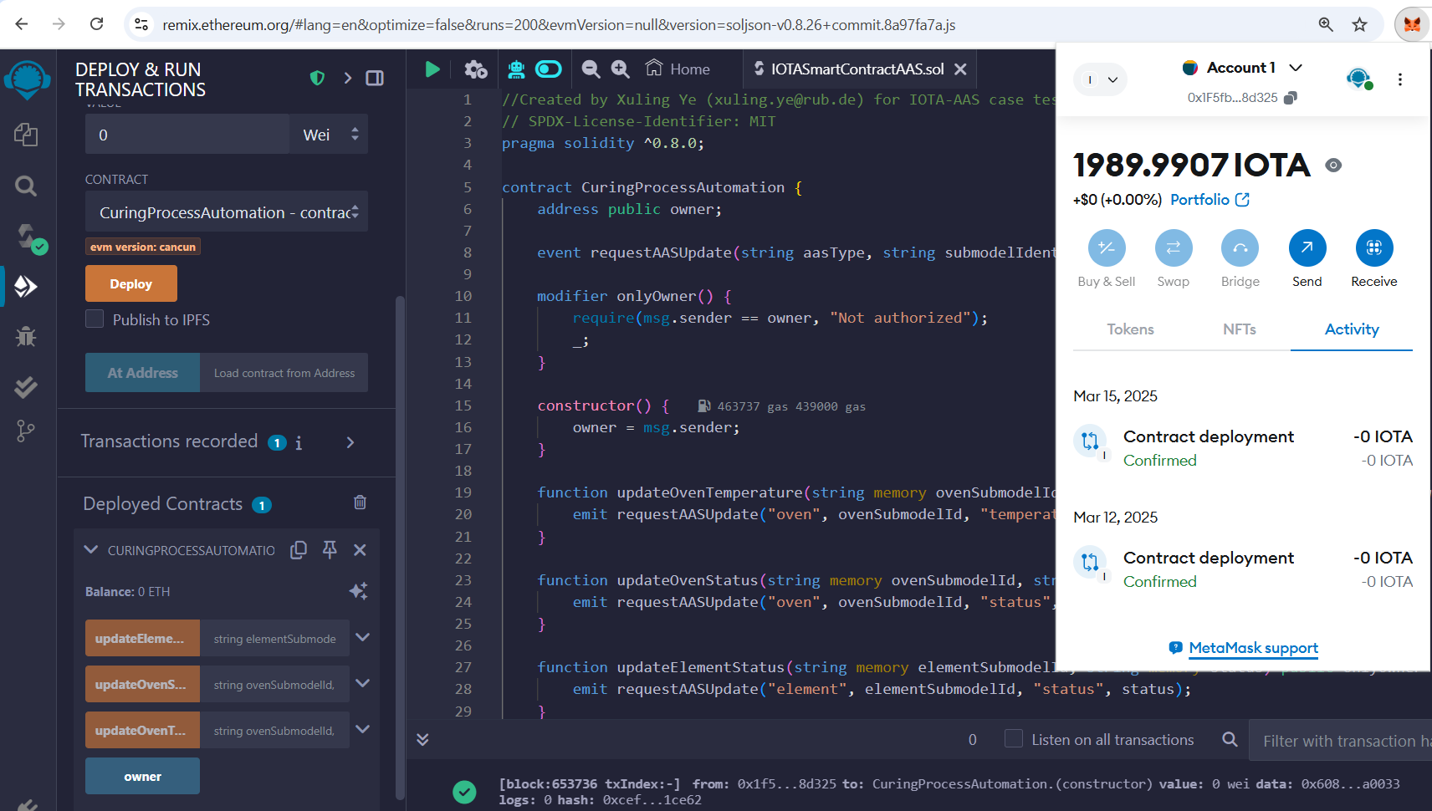
The SCO (shown as Node.js code in Figure 4) is used to listen for events emitted by the smart contract (via “requestAASUpdate” event, Lines 25 of Figure 4) and makes the appropriate REST API calls to the AASs, ensuring that the system operates autonomously. Both the oven AAS (Line 14 of Figure 4) and precast concrete element AAS (Line 15 of Figure 4) are deployed locally for testing based on the AAS API provided by Plattform_i40.
Figure 3: The IOTA smart contract results shown in Remix IDE.
Upon receiving an update request from the smart contract, the SCO determines the appropriate AAS API URL based on the AAS type (i.e., oven or precast concrete element). It then sends a POST request to the corresponding API, updating the AAS's data (such as temperature or status) by modifying the relevant key-value pair in the AAS. This process ensures seamless communication between the IOTA smart contract and the AAS, enabling real-time control and monitoring of physical assets in an automated and decentralised manner.
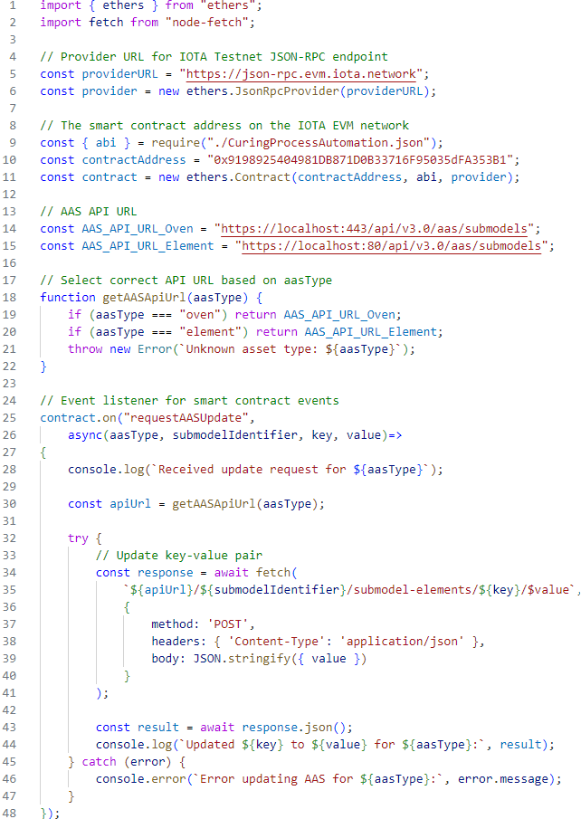
Figure 4: SCO implementation via Node.js

5. Proof of Concept
As part of the proof of concept, the accelerated curing of a precast concrete element is investigated to demonstrate the presented approach. The Y-module presented in (Kosse, S. et al., 2023) is used, which has been specifically designed to optimise manufacturability and assembly efficiency. Its suitability for rapid heat treatment makes it particularly suitable for serial production. The element has integrated temperature sensors that record readings every ten minutes to continuously capture the temperature curve (Figure 5). The proof of concept considers the scenario in which the core temperature of the element exceeds a temperature threshold at 80°C, resulting in a correction of the oven temperature to ensure optimal curing conditions.
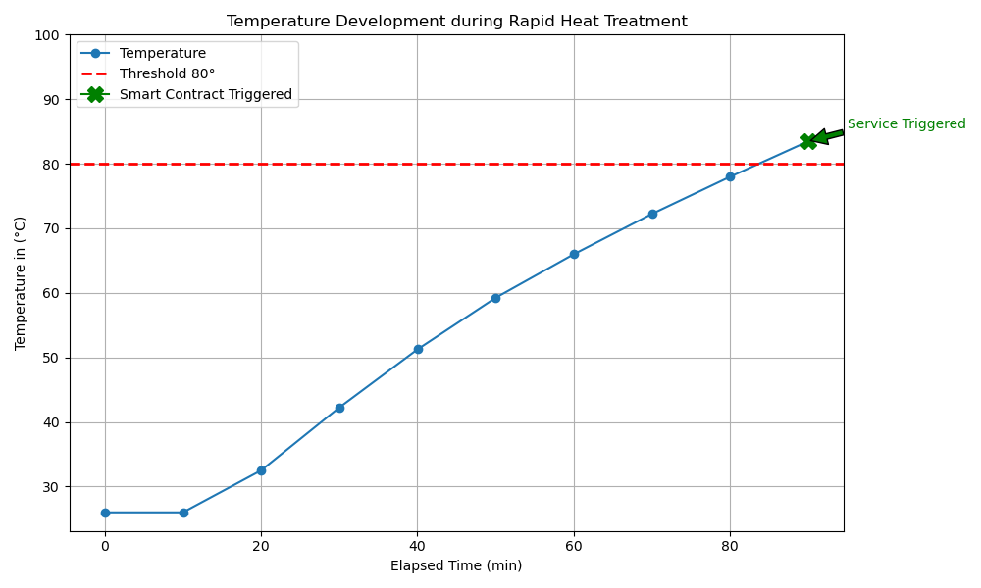
Once the element reaches 80°C, the oven temperature should be corrected to 80°C for optimal curing conditions. In this case, the service triggers the “updateOvenTemperature” smart contract function to update the oven temperature to 80°C. After curing the precast concrete element, the oven is cooled down, and the element curing process is completed. In this case, both the “updateOvenStatus” and “updateElementStatus” smart contract functions are triggered, resulting in the oven status changing to “cooldown” and the element status changing to “cured”. This demonstrates a fully automated process for managing the curing phase in precast concrete production. The transaction results of the smart contract execution can be viewed in the IOTA EVM Testnet explorer (Figure 6).
Figure 5: Temperature graph of the precast concrete element reaching 80°C.

6. CONCLUSION
This paper presents a decentralised framework for automating construction industrial workflows using IOTA smart contracts and DTs. The proposed concept uses sensor data as a trigger mechanism, where predefined thresholds automatically activate IOTA smart contracts to execute process tasks. These smart contracts are designed to interact with AASs, enabling the system to update asset status based on sensor inputs. A use case in the precast concrete industry and its corresponding concept implementation are presented to demonstrate the feasibility of our proposed concept. The implemented IOTA smart contract successfully interacted with the AAS service via the implemented Oracle and automated key steps, including stopping the oven, updating the curing status, and initiating the transportation of curing elements. Results show that the concept can support automated process control, improving efficiency, and traceability, reducing the need for human intervention throughout the production process.
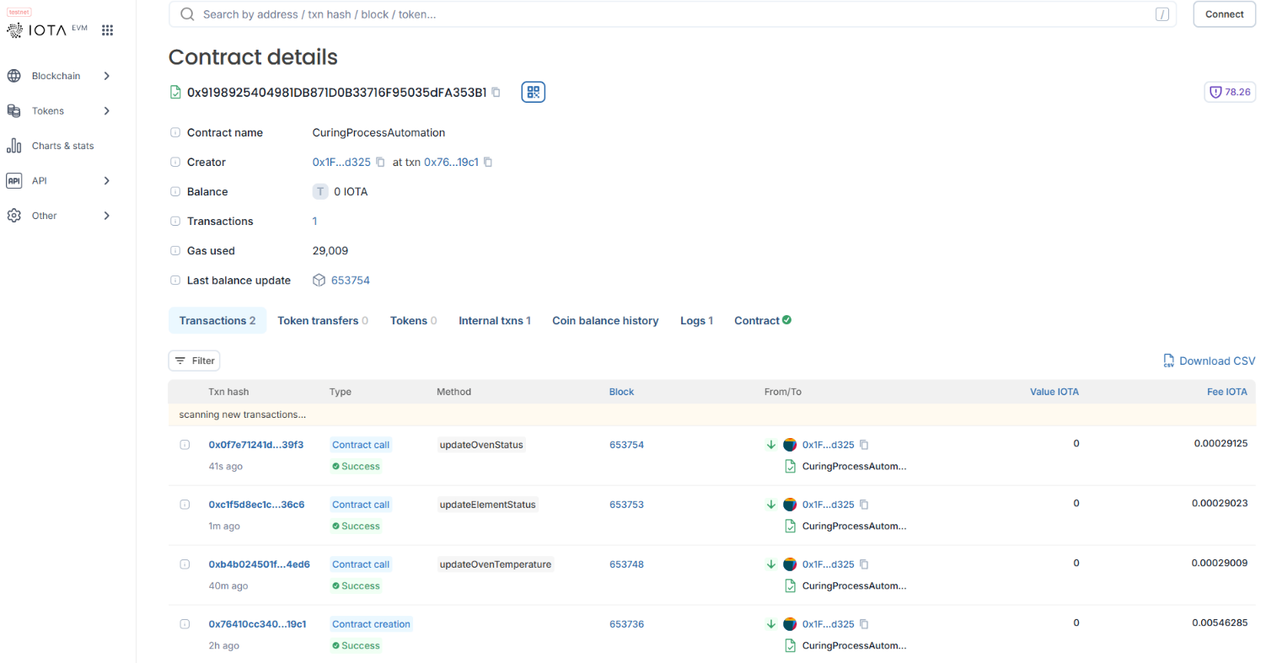
While the framework successfully automates critical process tasks, there are opportunities for further improvement. Expanding the framework's adaptability to larger and more complex construction environments could enhance its scalability. Additionally, optimising data flow among framework components may improve performance in scenarios with high data volume. Future work could also explore more flexible condition-triggering mechanisms to extend the framework’s ability to handle dynamic production environments. These enhancements would further strengthen the framework’s ability to support efficient and data-driven decision-making in construction industrial automation.
Figure 6: The smart contract transaction records of the precast concrete element curing process.

ACKNOWLEDGEMENTS
This research is funded under Grant No. 423963709 by the German Research Foundation as part of the priority program “SPP2187 – Adaptive modularized constructions made in flux”.

References
Boje, C., Guerriero, A., Kubicki, S. & Rezgui, Y. (2020) Towards a semantic Construction Digital Twin: Directions for future research. Automation in Construction, 114, 103179. Available from: https://doi.org/10.1016/j.autcon.2020.103179.
Cao, X., Li, X., Xiao, Y., Yao, Y., Tan, S. & Wang, P. (2022) BDTwins: Blockchain-based Digital Twins Lifecycle Management. In: 2022 IEEE SmartWorld, ubiquitous intelligence & computing, autonomous & trusted vehicles, scalable computing & communications, digital twin, privacy computing, metaverse (SmartWorld/UIC/ATC/ScalCom/DigitalTwin/PriComp/Metaverse): Haikou, China, 15-18 December 2022 : proceedings, The 8th IEEE Smart World Congress (SmartWorld 2022), Haikou, China, Dec. 15 - 18. IEEE: Piscataway, NJ, pp. 2003–2010.
Celik, B.G., Abraham, Y.S. & Attaran, M. (2024) Unlocking Blockchain in Construction: A Systematic Review of Applications and Barriers. Buildings, 14(6), 1600. Available from: https://doi.org/10.3390/buildings14061600.
Denis, N., Chabridon, S. & Laurent, M. (2024) Bringing privacy, security and performance to the Internet of Things using IOTA and usage control. Annals of Telecommunications, 79(7-8), 585–601. Available from: https://doi.org/10.1007/s12243-023-01005-1.
Dogan, A., Belyaev, A., Nagel, J., Rijo, G., Bondza, A. & Block, C. et al. (2020) Distrubuted Ledger-based Infrastructure for Industrial Digital twins: 5 use cases enabled by Blockchain, IOTA Tangle and ECLASS.
El Ioini, N. & Pahl, C. (2018) A Review of Distributed Ledger Technologies. In: Panetto, H., Debruyne, C., Proper, H.A., Ardagna, C.A., Roman, D. & Meersman, R. (Eds.) On the Move to Meaningful Internet Systems. OTM 2018 Conferences. Springer International Publishing: Cham, pp. 277–288.
Friedrich, T. (2019) Computergesteuerte Fertigung im Betonfertigteilwerk. BetonWerk International (BWI), (5), 142–149.
Kagermann, H., Wahlster, W. & Helbig, J. (2013) Recommendations for Implementing the Strategic Initiative INDUSTRIE 4.0 ‐ Securing the Future of German Manufacturing Industry. Final Report of the Industrie 4.0 Working Group, München. Available from: http://​forschungsunion.de​/​pdf/​industrie_​4_​0_​final_​report.pdf.
Kosse, S., Betker, V., Hagedorn, P., König, M. & Schmidt, T. (2024) A Semantic Digital Twin for the Dynamic Scheduling of Industry 4.0-based Production of Precast Concrete Elements. Advanced Engineering Informatics, 62, 102677. Available from: https://doi.org/10.1016/j.aei.2024.102677.
Kosse, S., Forman, P., Stindt, J., Hoppe, J., König, M. & Mark, P. (2023) Industry 4.0 Enabled Modular Precast Concrete Components: A Case Study. In:, International RILEM Conference on Synergising expertise towards sustainability and robustness of CBMs and concrete structures. Springer, Cham, pp. 229–240.
Kosse, S., Vogt, O., Wolf, M., König, M. & Gerhard, D. (2022) Digital Twin Framework for Enabling Serial Construction. Frontiers in Built Environment, 8. Available from: https://doi.org/10.3389/fbuil.2022.864722.
Lee, D., Lee, S.H., Masoud, N., Krishnan, M.S. & Li, V.C. (2021) Integrated digital twin and blockchain framework to support accountable information sharing in construction projects. Automation in Construction, 127, 103688. Available from: https://doi.org/10.1016/j.autcon.2021.103688.
Li, J. & Kassem, M. (2021) Applications of distributed ledger technology (DLT) and Blockchain-enabled smart contracts in construction. Automation in Construction, 132, 103955. Available from: https://doi.org/10.1016/j.autcon.2021.103955.
Neubauer, R. (2017) Mechanisation and Automation in Concrete Production. In: Elliott, K.S. & Hamid, Z.A. (Eds.) Modernisation, Mechanisation and Industrialisation of Concrete Structures. Wiley, pp. 210–300.
Opoku, D.-G.J., Perera, S., Osei-Kyei, R. & Rashidi, M. (2021) Digital twin application in the construction industry: A literature review. Journal of Building Engineering, 40, 102726. Available from: https://doi.org/10.1016/j.jobe.2021.102726.
Putz, B., Dietz, M., Empl, P. & Pernul, G. (2021) EtherTwin: Blockchain-based Secure Digital Twin Information Management. Information Processing & Management, 58(1), 102425. Available from: https://doi.org/10.1016/j.ipm.2020.102425.
Reichenbach, S. & Kromoser, B. (2021) State of practice of automation in precast concrete production. Journal of Building Engineering, 43, 102527. Available from: https://doi.org/10.1016/j.jobe.2021.102527.
Reim, W., Andersson, E. & Eckerwall, K. (2023) Enabling collaboration on digital platforms: a study of digital twins. International Journal of Production Research, 61(12), 3926–3942. Available from: https://doi.org/10.1080/00207543.2022.2116499.
Sun, W., Antwi-Afari, M.F., Mehmood, I., Anwer, S. & Umer, W. (2023) Critical success factors for implementing blockchain technology in construction. Automation in Construction, 156, 105135. Available from: https://doi.org/10.1016/j.autcon.2023.105135.
Teisserenc, B. & Sepasgozar, S. (2021) Adoption of Blockchain Technology through Digital Twins in the Construction Industry 4.0: A PESTELS Approach. Buildings, 11(12), 670. Available from: https://doi.org/10.3390/buildings11120670.
Wang, Z., Wang, T., Hu, H., Gong, J., Ren, X. & Xiao, Q. (2020) Blockchain-based framework for improving supply chain traceability and information sharing in precast construction. Automation in Construction, 111, 103063. Available from: https://doi.org/10.1016/j.autcon.2019.103063.
Ye, X., Liu, L. & König, M. (2024) Improving Data and Process Management for Digital Twins: A Smart Contract-Driven Solution Integrating CDE and Blockchain for the Construction Industry. In: Computing in Civil Engineering 2024, ASCE International Conference on Computing in Civil Engineering, Pittsburgh, USA, July 28-31.
Ye, X., Zeng, N. & König, M. (2022) Systematic literature review on smart contracts in the construction industry: Potentials, benefits, and challenges. Frontiers of Engineering Management, 9(2), 196–213. Available from: https://doi.org/10.1007/s42524-022-0188-2.
Ye, X., Zeng, N., Tao, X., Han, D. & König, M. (2024) Smart Contract Generation and Visualization for Construction Business Process Collaboration and Automation: Upgraded Workflow Engine. Journal of Computing in Civil Engineering, 38(6), 4024030. Available from: https://doi.org/10.1061/JCCEE5.CPENG-5938.

https://www.iota.org/, last accessed: 26.03.2025
https://soliditylang.org/, last accessed: 23.03.2025
https://explorer.evm.testnet.iotaledger.net/address/0x9198925404981DB871D0B33716F95035dFA353B1?tab=contract, last accessed: 23.03.2025
https://app.swaggerhub.com/apis/Plattform_i40/AssetAdministrationShellServiceSpecification, last accessed: 23.03.2025
https://explorer.evm.testnet.iotaledger.net/address/0x9198925404981DB871D0B33716F95035dFA353B1?tab=txs, last accessed: 25.03.2025

