Main Title: Reframing Digital Twins as Boundary Objects: Exploring Stakeholder Interactions in Urban and Infrastructure Management
Subtitle Bridging Technology and Collaboration for Sustainable Urban Development
DELVAL THIBAUT¹ BRUNO BARROCA² JEROME AUBRET³

¹Centre Scientifique et Technique du Bâtiment, Champs sur Marne, France
² Université Gustave Eiffel, Paris, France
³ Région Pays de la Loire, Nantes, France

ABSTRACT

Digital twins are widely studied for their technical aspects, yet their role in urban planning and management remains underexplored. This research, conducted with CSTB and the Pays de la Loire Region, conceptualizes digital twins as boundary objects fostering stakeholder interactions. Four demonstrators support this study: air quality monitoring in high schools, water level sensors for coastal flood management, energy monitoring for public building, and a public lighting digital twin. The findings challenge the purely technical view of digital twins, positioning them as strategic enablers of collaboration, bridging stakeholder interests for sustainable urban and infrastructure development.

KEYWORDS

Digital Twin, Stakeholder Interaction, Urban Management, Environmental Monitoring

1. REDEFINING DIGITAL TWINS: CONTEXT AND RESEARCH FRAMEWORK
1.1 Research framework
Digital twins have been widely explored in research, primarily focusing on their technical attributes and applications across various industries However, their role in urban planning and infrastructure management remains less examined. (Shuaiming; 2022).
This study aims to redefine digital twins beyond their conventional technical framing, considering them as boundary objects that facilitate interactions among stakeholders. In this context, the digital twin can be understood as a new intermediary object, in line with Sana Boudhraâ's definition (Sana Boudhraâ's, 2016), which raises questions about the future transformations in stakeholder interactions. It functions as a new informational or cognitive artifact (Donald Arthur, 1991) altering how information is managed and communicated within the ecosystem. By acting as a shared point of reference, the digital twin enables different actors—such as engineers, policymakers, and urban planners—to collaborate more effectively, translating complex data into actionable insights and fostering mutual understanding across disciplines. This transformation not only enhances decision-making processes but also catalyzes changes in how stakeholders engage with and respond to urban and infrastructure challenges.

Conducted in collaboration with CSTB and the Pays de la Loire Region, this research explores the concept of digital twins by first examining their definition in the literature and then analyzing how it materializes in four demonstrators: air quality monitoring in high schools, water level sensors for coastal flood risk management, energy monitoring at the Grand Port of Nantes, and a digital twin for public lighting. These case studies provide real-world insights into how digital twins function as boundary objects, facilitating stakeholder engagement, fostering collaboration, and contributing to shared decision-making processes.

By challenging the traditional perception of digital twins as mere technical tools, this research proposes a strategic reconceptualization, positioning them at the intersection of technology and human interactions. This perspective highlights their potential as enablers of cooperation, bridging diverse stakeholder interests to support sustainable urban and infrastructural development.

1.2 Digital Twin definition
The concept of the digital twin emerged in the early 2000s within the industry as a Product Lifecycle Management (PLM) tool, later adopted in the aerospace sector for high-fidelity simulations (Michael Grieves, 2016). Over time, it expanded into manufacturing and construction, particularly in connection with Building Information Modeling (BIM) and infrastructure management. (Heng Sun, 2022).
A digital twin is a precise virtual replica of a physical object, system, or process, maintaining a dynamic link between the real and digital worlds. It enables real-time monitoring and scenario forecasting. Its functionality integrates interactions from the physical world to the digital (Digital Shadow) via sensors and IoT, as well as transformative feedback from the digital to the physical world (Digital Twin). (Jakob Trauer, 2020).
From research conducted on the concept of the digital twin, an initial definition emerges, considering it as a new object of study characterized by a real-time representation of the physical world. Fueled by sensor data, the digital twin analyzes this information to generate actionable intelligence, thereby facilitating the transformation of the physical environment and creating value. (Fig. 1)

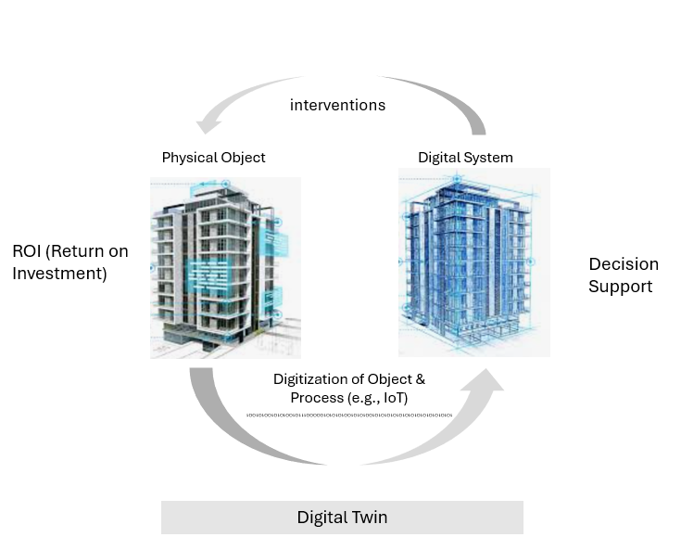

Figure 1: Digital Twin definition

1.3 Observational Approach to Understanding Stakeholder Engagement with Digital Twins
The approach integrates into the process of conceptualizing stakeholders' interest in digital twins, drawing on insights from over thirty meetings with various actors and a detailed analysis of meeting reports. (Fig. 2) Workshops with stakeholders serve as an observational framework to understand how they would perceive, interact and engage with digital twin within their professional contexts. This participatory observation method fosters discussions and experience-sharing, enabling real-time analysis of relational and strategic dynamics.

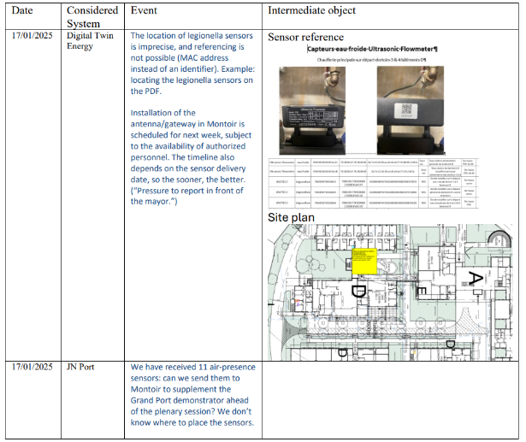
Figure 2: Extract from Workshop Minutes with Analysis of Boundary Objects

The observation focuses on several key aspects: understanding current professional practices, identifying stakeholders' expectations of digital twins, and analyzing barriers or drivers influencing adoption. A comprehensive analytical table has been developed to synthesize these insights, ensuring a structured evaluation of stakeholder perspectives. The results presented here focus on the challenges encountered in defining the digital twin concept, developed between September 2024 and April 2025. This process led to the creation of initial digital twin prototypes, designed to serve as a foundation for discussions with the industry and research partners. Further observation will continue during the deployment phase scheduled for 2025-2026, allowing for an in-depth analysis of the technical, organizational, and human constraints associated with large-scale implementation.

2. INCORPORATING EXPERIMENTS INTO THE DEFINITION OF THE DIGITAL TWIN

2.1 Digital twin for public lighting
Public lighting is a key focus for digital twins in urban and regional planning, especially in areas committed to developing real-time management solutions for public infrastructure (Luca Piovano, 2022). Optimization strategies for public lighting are indeed central to public debates. Various automation experiments have already been conducted in cities such as Dijon, Chartres, and Angers. In projects like "On Dijon," (Louis Jolivalt, (2024) the goal is to integrate the control information of streetlights into a hypervisor. The digital twin facilitates the real-time retrieval of data from electrical cabinets, which is then simulated and analyzed in terms of lighting performance. Based on this analysis, the system generates scenarios to improve the quality of lighting. (Pohlmann, 2024). Other studies on digital twins in public lighting aim to adjust switching times, both for turning lights on and off. The primary objective of such a digital twin is to reduce energy consumption associated with public lighting, thus achieving tangible impacts on real-world conditions. The lighting levels, as a strategic issue, focus on enhancing the efficiency of public lighting by selecting optimal lamp posts. Certain studies suggest that energy consumption for public outdoor lighting could be reduced by 30% to 50% by adjusting energy use to actual needs, resulting in significant energy savings. (Grega Bizjak, 2022) However, the challenge also lies in providing the right lighting quality for user comfort and safety.

A definition derived from the concept elaborated in part 1 for the digital twin of public lighting would be that it collects real-time data on lighting fixture from the cabinets, enables lighting simulations to propose improvement scenarios, and ultimately transforms the physical environment by reducing energy consumption or enhancing comfort. (Fig. 3)

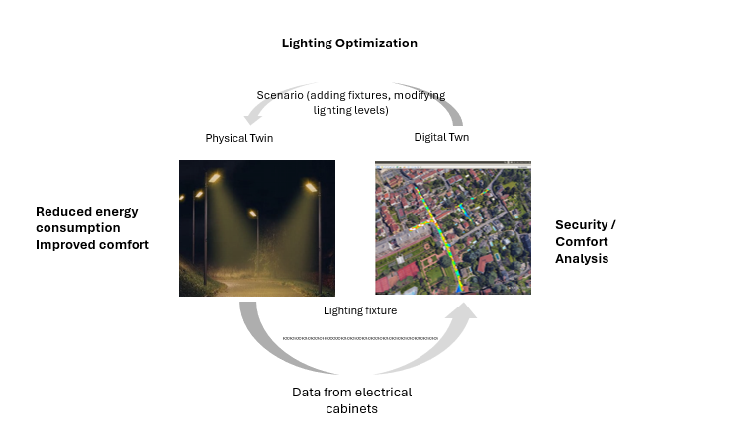
Figure 3: Concept of digital twin for public lightning

The digital twin for public lighting, developed in collaboration with the Pays de la Loire region, was used to simulate and analyze the impact of different lighting configurations on urban spaces. Two experiments were conducted with the digital twin: the first at the neighborhood scale, where a streetlight's placement and type were modified to assess their effects on road and sidewalk illumination, ensuring safety and comfort. The second, at the street scale, focused on evaluating light pollution by modeling detailed architectural elements like windows and roof overhangs. The digital twin enabled visualization of illumination levels, allowing stakeholders to test different scenarios and optimize lighting strategies dynamically.

2.2 Digital Twins for Energy Consumption Management

The concept of a digital twin for energy management is becoming increasingly strategic for asset holders (Gerrit Rolofs, 2024), particularly in large infrastructures like ports. Efficient energy management is crucial to ensuring regulatory compliance, such as with France's Building Automation & Control Systems (BACS) regulation, introduced in July 2020 to reduce energy consumption in tertiary buildings (Yoann Queyroi, 2024).
The digital twin facilitates real-time monitoring of energy consumption across different systems (e.g., heating, lighting), based on daily or monthly reference data. (Yasmin Fathy, 2021). Moreover, it helps to analyze past consumption to adjust reference levels to meet the requirements of energy regulations.
In practice, the digital twin allows for the collection of real-world data through various sensors installed across buildings and systems. These sensors capture data on energy consumption (e.g., electricity, heating, lighting) and occupancy levels, providing a real-time view of energy use and system performance. (Cui Li, 2023)

This data is then integrated into the digital twin, creating an accurate representation of the physical environment. In the experiment conducted with the Pays de la Loire region, a key challenge was distinguishing between tertiary and industrial buildings, where energy consumption is typically higher due to outdated installations. Many electrical schematics require updates, and agents must assess the infrastructure—a process that can be costly, particularly when it comes to deploying sensors for energy monitoring.

The digital twin enables modifications in the real world by allowing operators to remotely adjust energy usage, such as controlling heating or lighting based on real-time occupancy data. It also supports predictive maintenance (Mia Luna; 2025). by analyzing energy consumption trends and identifying areas for improvement. With a digital twin, stakeholders can efficiently track energy consumption, detect deviations, and ensure compliance with energy regulations, ultimately contributing to better energy management and cost reduction.

A key application of the digital twin for energy management, as outlined in Part 1, is its ability to monitor energy consumption by equipment type, such as heating systems. By leveraging historical data and cross-comparing different spaces, it enables intelligent analysis to detect anomalies and generate alerts when irregularities arise. Ultimately, it acts as a strategic tool to support regulatory compliance, such as with the tertiary energy decree, while driving energy efficiency and consumption reduction. (Fig. 4)
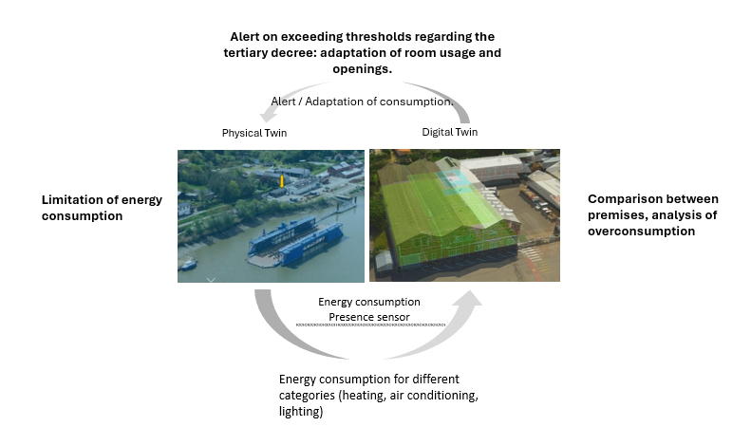
Figure 4: Concept of digital twin for energy Management

The digital twin for energy consumption, developed in collaboration with the Pays de la Loire region, was implemented at the Grand Port of Saint-Nazaire to monitor and optimize electricity usage in compliance with the BACS. IoT sensors were deployed in selected buildings to provide detailed energy consumption data. Sub-metering devices were installed on electrical panels, ensuring precise tracking of energy usage by associating equipment and spaces with specific circuit departures. The system also accounted for amperage requirements, ensuring compatibility with the monitoring infrastructure. This digital twin enables real-time energy management, supporting data-driven decision-making for improved efficiency.

2.3 Digital Twin for Managing Coastal Flooding
The concept of Digital Twin (DT) in flood management is gaining traction as it offers a transformative approach to understanding and mitigating the impacts of flooding in coastal and riverine areas, yet it still lacks a comprehensive framework to fully integrate and optimize its potential.(Chenyu Ge, 2025)
A Digital Twin for flood management creates a real-time, virtual replica of physical environments, integrating a wide range of data sources including topographical data, weather forecasts, and hydrological models. (Hans Jørgen, 2023)
This allows for the simulation of flood events, providing accurate predictions of water levels, storm surges, and the behavior of water bodies under various conditions. The ability to visualize flood risks and their effects on urban areas, infrastructure, and the environment enables better preparedness, response strategies, and decision-making. (Ary Setijadi, 2025)

By incorporating a variety of sensors, including those placed along flood-prone areas or near critical infrastructure, a Digital Twin can help monitor current conditions and trigger early warning systems. It provides actionable insights to authorities and stakeholders, allowing for proactive flood management, such as the deployment of resources, protective measures, and communication with affected populations. Furthermore, the integration of predictive analytics can optimize flood risk assessments and improve the planning of flood defenses, ensuring that both short-term and long-term flood management strategies are effective. Digital Twins for flood management are thus seen as vital tools in the fight against climate change and extreme weather events. (Hans Jørgen, 2023)

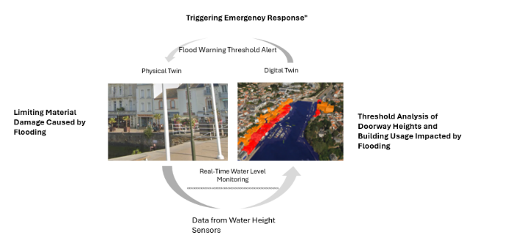
Figure 5: Concept of digital twin for flood Management

Another key application emerging from the concept developed in Part 1 for the digital twin of flood management lies in its capacity to collect real-time water level data. By analyzing this data, the digital twin identifies the most probable flood scenarios, visualizes risks to infrastructure and populations, and triggers alerts when predefined thresholds are exceeded. This proactive approach contributes to risk mitigation and damage reduction (Fig. 5)

2.4 Digital Twin for Air Quality Management in High Schools

Air quality management has become a strategic issue, particularly following the COVID-19 crisis, which highlighted the importance of ventilation system management. (Delval, 2021)
In response to these challenges, the digital twin offers a transformative approach to monitoring and controlling indoor environments. By integrating real-time data from a network of sensors deployed throughout a building, the digital twin ensures continuous observation of key environmental factors such as CO2 levels, temperature, humidity, and occupancy. (Chiu Kit Lo, 2025). The use of digital twins for air quality monitoring has already been explored in contexts such as subway stations (Sangsu Choi, 2022), where real-time monitoring of air quality plays a critical role. However, its implementation in building environments, particularly in educational institutions, remains limited. In schools, where ensuring a healthy and comfortable environment for students and staff is crucial, research on digital twins has attracted significant interest from various stakeholders, including school maintenance teams.

In the context of the Pays de la Loire Region, an experimentation was conducted in a high school to explore the effectiveness of the digital twin in managing indoor air quality. Around 54 sensors were installed across various areas of the school, with 36 of these sensors dedicated to air quality monitoring (CO2, temperature, humidity) and occupancy tracking. These sensors were strategically placed to cover different types of classrooms, such as practical labs and lecture rooms, as well as varied spaces like gyms and dormitories. The collected data is centralized in a data lake and visualized through a simplified BIM model, providing building managers with a comprehensive overview of environmental conditions. This digital twin system enables automatic actions, like opening windows to improve ventilation when CO2 levels exceed thresholds, and employs predictive analytics to facilitate long-term management of air quality. This hands-on experimentation in the Pays de la Loire Region demonstrates the practical application of the digital twin in improving air quality management and occupant comfort, establishing a model for future implementations in schools and other public buildings.

The digital twin developed in collaboration with the Region Pays de la Loire generates a vast amount of data that must be centralized in a data lake and visualized through a simplified BIM model, offering managers a comprehensive and intuitive overview of environmental conditions. Based on the data collected by the sensors, automatic actions can be triggered, such as opening windows to improve ventilation when CO2 levels exceed thresholds. The system can also offer predictive analytics for medium- and long-term management, facilitating proactive control of air quality and occupant comfort.

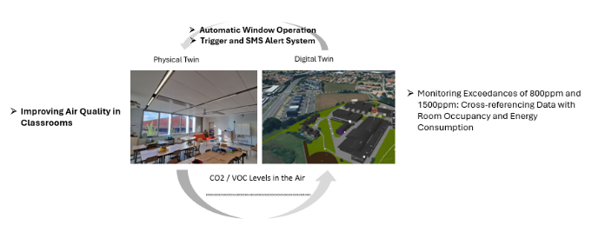
Figure 6: Concept of digital twin for Air Quality Management

In the context of this research on the concept of the digital twin, initially described in Part 1, a new form of application emerges, focusing on air quality management in high schools. The digital twin collects real-time data on classroom air quality, continuously monitoring key parameters such as CO2 levels, temperature, and humidity. When air quality thresholds are exceeded, the system detects these anomalies and can trigger corrective actions, such as adjusting ventilation settings or opening windows. (Fig. 6)

3. CHALLENGES OF INTERACTION WITH DIGITAL TWINS
3.1 Stakeholder Perspectives on the Public Lighting Digital Twin

In the context of digital twins for public lighting, several boundary objects emerge as a result of stakeholder interactions. One crucial boundary object is the simulation data. This data serves as an intermediary tool for various stakeholders, such as "Territoire Energie" organizations, regional authorities, municipalities, and urban planners. It enables these groups to access and manipulate the digital twin’s outputs, thus facilitating communication and decision-making across different levels of governance. The ability to modify simulation parameters is essential for municipal technical services, as it allows them to adjust lighting conditions dynamically based on real-world variables like weather or seasonal changes. This flexibility has been a crucial challenge in defining the user interface. (Fig. 7), ensuring a clear understanding of interactions between different stakeholders engaging with the digital twin.

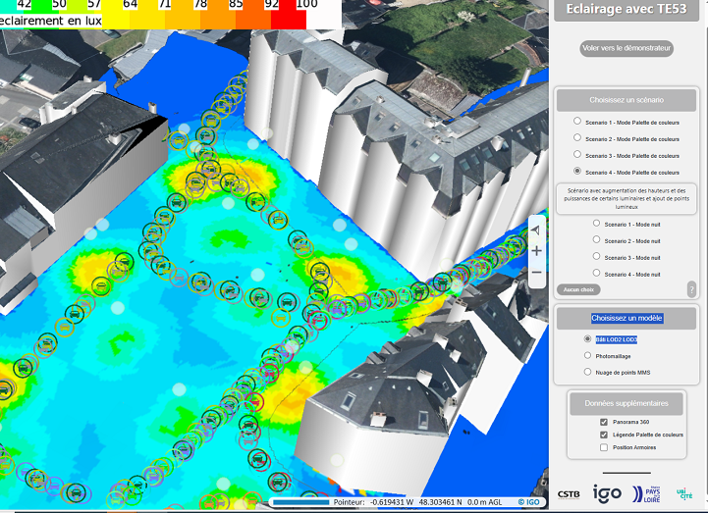
Figure 7: User Interface of the Digital Twin for Public Lighting in the Pays de la Loire Region.

An important boundary object is the data export functionality. This allows stakeholders to integrate the results from the digital twin into their existing workflows, making it actionable and ensuring continuity with traditional planning and management processes. By enabling these external actors to incorporate simulation results into familiar formats, the export functionality acts as a bridge between the digital twin and the operational systems in place.

In the context of the digital twin system, information-sharing processes serve as boundary objects that facilitate the exchange of information among different stakeholders. For example, the SDIS (French Emergency Services) has shown interest in leveraging the data from the digital twin to improve their operational efficiency, such as using electrical cabinet information to illuminate entire neighborhoods during interventions. This demonstrates the potential for information sharing across various actors in a regional digital twin setup.

Table 1: Actor Mapping and Boundary Objects in the Digital Twin for Public Lightning.
Boundary Object | Actors Involved | Role in Interaction
Simulation Data | "Territoire Énergie" Organizations, Regional Authorities, Municipalities, Urban Planners | Facilitates communication and decision-making by providing modifiable lighting simulations
User Interface | Municipal Technical Services, Urban Planners | Ensures stakeholders can dynamically adjust lighting conditions based on real-world variables
Data Export Functionality | Municipalities, Regional Authorities, Urban Planners | Enables integration of digital twin results into existing planning and management workflows

3.2 Stakeholder Perspectives on Digital Twins for Energy Consumption Management
In the case of digital twins for energy management, there are several key boundary objects that facilitate interaction among stakeholders. The IoT sensor data itself serves as an intermediary between the technical experts managing the energy system, such as engineers and the facilities management team at the Grand Port of Saint-Nazaire, and the broader organizational stakeholders, such as energy regulators and municipal authorities. This data allows these stakeholders to collectively monitor energy consumption, track performance, and ensure compliance with energy-saving decrees (BACS), making it essential for shared decision-making.
Another boundary object is the mapping between sensors and physical spaces within the digital twin. This mapping acts as a common reference point for various stakeholders, particularly when understanding complex electrical systems. It serves to bridge the gap between traditional electrical schematics and real-time sensor data, ensuring that energy usage data is accurately linked to the physical locations where energy is consumed. This is essential in overcoming challenges related to outdated or incomplete data and ensuring effective monitoring and analysis.
Interoperability standards for data exchange also function as a boundary object. The need for consistent and secure data exchange between different systems, such as energy management systems, sensor networks, and building management platforms, becomes a crucial point of interaction. These standards are negotiated between the technical teams and software developers to ensure smooth integration and data flow across platforms, allowing stakeholders to make informed decisions based on accurate, up-to-date information.

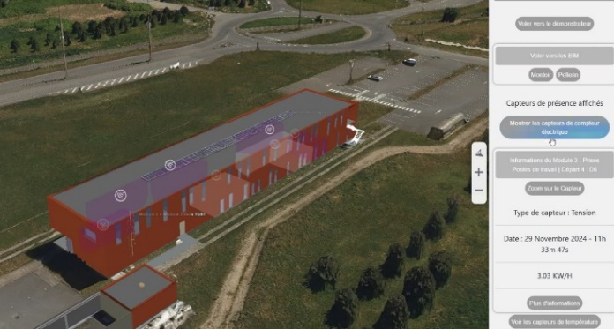Figure 8: User Interface of the Digital Twin for Energy Management in the Pays de la Loire Region.

User behavior and occupancy data serve as boundary objects, linking the digital twin to its real-world context through the user interface designed for the Pays de la Loire Digital Twin (Fig. 8). These data sets offer insights into how changes in occupancy patterns or equipment usage can influence overall energy consumption, enabling facility managers and energy planners to make informed adjustments. By incorporating user behavior and operational context into the digital twin, it evolves from a passive monitoring tool into an active management platform that can enhance energy efficiency. However, the issue of data protection regulations has been raised several times, with strong opposition to placing sensors in individual offices, which has caused significant frustration within the digital twin design team.

Table 2: Actor Mapping and Boundary Objects in the Digital Twin for Energy Management.

Boundary Object | Actors Involved | Role in Interaction
IoT Sensor Data | Engineers, Facilities Management Team, Energy Regulators, Municipal Authorities | Enables real-time monitoring of energy consumption and regulatory compliance-making
Mapping Between Sensors and Physical Spaces | Engineers, Facility Managers, Technicians | Links energy usage data to specific locations, improving monitoring and analysis
Interoperability Standards and security | Engineers, Technical Teams, Software Developers, Energy Managers, Technicians | Ensures seamless data exchange between energy management, sensor networks, and building systems sensitive data.
User Behavior and Occupancy Data | Facility Managers, Energy Planners, Municipal Authorities | Provides insights into how occupancy patterns impact energy consumption, enabling adaptive management

3.3 Challenges of Interaction with Digital Twins for flood Management

In the context of flood management, data integration serves as a key boundary object in the interactions among stakeholders. The diverse range of data sources—such as hydrological models, weather data, water level sensors, and geographical information—must be integrated seamlessly within the digital twin to generate accurate predictions and effective responses. This integration facilitates collaboration between hydrologists, emergency response teams, and local authorities, as they all rely on the same real-time, synchronized data to make decisions. The accuracy and timeliness of the data are crucial, with outdated or incomplete information potentially undermining the system's effectiveness, thus requiring careful attention to data collection and management practices as a shared reference for all stakeholders involved.

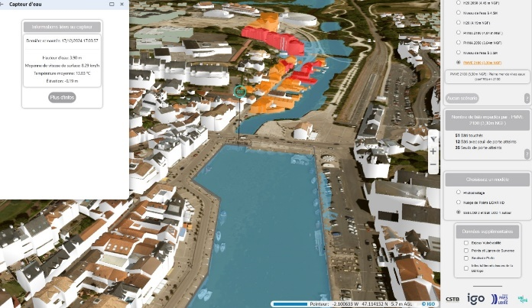Figure 9: User Interface of the Digital Twin for Flood Management in the Pays de la Loire Region.

Another boundary object is the user interface of the digital twin system (Fig. 9). It acts as an intermediary between technical experts and a wide range of end users, including local government officials, emergency responders, and citizens. The interface needs to be designed in a way that makes the detailed, complex flood data understandable and actionable for various stakeholders with differing levels of technical expertise. This necessitates user-centric design, training, and clear communication, ensuring that all participants can interact with the system effectively to make timely and informed decisions.

Finally, data security and privacy are boundary objects that mediate concerns between stakeholders, particularly when personal or sensitive information may be included in the flood management data. Ensuring that the system strikes the right balance between accessibility for emergency responders and local authorities, and maintaining the security of personal data, is crucial for fostering trust and participation in the system. These concerns highlight the need for collaborative efforts in setting up the appropriate security protocols, ensuring that the flood management digital twin remains both accessible and secure for all involved parties.

Table 3: Actor Mapping and Boundary Objects in the Digital Twin for Flood Management.
Boundary Object | Actors Involved | Role in Interaction
Data Integration | Hydrologists, Emergency Response Teams, Local Authorities | Ensures all stakeholders rely on accurate, real-time, and synchronized data for decision-making
User Interface | Technical Experts, Local Government Officials, Emergency Responders, Citizens | Makes complex flood data understandable and actionable for users with varying levels of technical expertise.
Data Security & Privacy | Emergency Responders, Local Authorities, Data Protection Officers | Balances accessibility for key actors while ensuring the protection of personal and sensitive data.

3.4 Challenges of Interaction with Digital Twins for Air Quality Management
In the context of air quality management, several boundary objects emerge to facilitate interaction between different stakeholders, such as building managers, maintenance teams, and data scientists. One of the most critical boundary objects is the integration of real-time data with other building management systems, including occupancy tracking and energy consumption. These data streams, when combined within the digital twin, allow for a more comprehensive understanding of air quality dynamics. However, the integration process presents challenges as stakeholders must align their systems to work seamlessly together, creating a shared framework for monitoring and responding to air quality changes.

Another key boundary object in this scenario is the human supervision of automated actions. While certain actions, like adjusting ventilation or air filtration, can be automated based on real-time air quality data, human intervention remains crucial. Supervisors need to manage alerts, make adjustments, and interpret the broader context that automated systems may miss. This human interaction with the system highlights the importance of user-friendly interfaces that allow building managers and maintenance teams to make informed decisions quickly (Fig. 9). However, balancing the automation of actions with the need for human judgment creates a dynamic where different stakeholders must coordinate their efforts, with the digital twin acting as the common reference point.

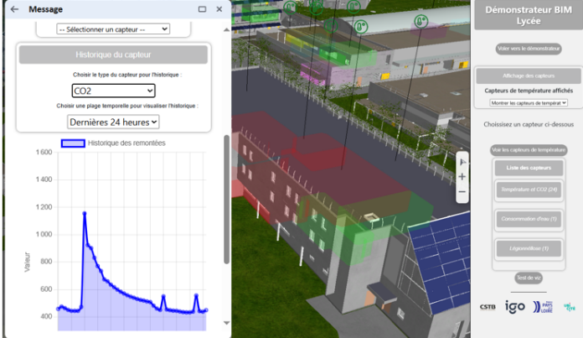

Figure 9: User Interface of the Digital Twin for Air Quality Management in the Pays de la Loire Region.

Data privacy concerns are another significant challenge, particularly regarding sensitive air quality data collected in public or semi-public spaces such as schools. These concerns often arise when stakeholders, such as students, teachers, maintenance staff, and school administrators, worry about how their personal data—such as their occupancy patterns or movements within the school—could be utilized. Ensuring that the system respects privacy regulations while still providing valuable insights for air quality management is essential to foster trust and ensure the participation of all involved parties. Data security protocols, including anonymization and encryption, become boundary objects that help mediate these concerns between technical teams, privacy advocates, and users.
Finally, the interoperability of various tools used by maintenance and building management teams adds another layer of complexity. For example, building management systems, computer - aided maintenance management systems, and centralized technical management systems all need to work together seamlessly within the digital twin framework to ensure effective air quality management and operational efficiency. These systems often come from different vendors, each with its own specifications and data formats. Ensuring that all these tools can work together seamlessly within the digital twin framework requires collaboration and standardization, making interoperability a central boundary object in this scenario. When systems fail to communicate effectively, it not only impedes the digital twin’s potential but also complicates the work of those managing air quality, as they are left navigating incompatible systems without a clear shared interface.

Table 4: Actor Mapping and Boundary Objects in the Digital Twin for Air Quality
Boundary Object | Actors Involved | Role in Interaction
Integration of real-time data with building management systems | Building Managers, Maintenance Teams, Data Scientists | Enables a shared framework for monitoring air quality, occupancy, and energy use
Human supervision of automated actions | Building Managers, Maintenance Teams | Balances automated ventilation adjustments with human decision-making
Data privacy concerns | Technical Teams, Privacy Advocates, Occupants | Addresses risks related to air quality data collection in public spaces
Interoperability of various tools | Maintenance Teams, Building Managers, Vendors | ensures compatibility between different systems used for air quality management

4. CONCLUSION

This study demonstrates the pioneering use of digital twins as boundary objects in urban and infrastructure management, highlighting their potential to facilitate collaboration among diverse stakeholders. As one of the first territorial digital twins created by the region, these projects showcase how digital twins can bridge gaps between sectors and improve decision-making processes.

The four demonstrators—air quality monitoring, coastal flood risk management, energy optimization, and public lighting—illustrate how digital twins foster cross-disciplinary collaboration by acting as boundary objects that mediate between different stakeholders, enabling them to align their actions towards common goals.

Moving forward, addressing technical challenges such as data integration and system interoperability, as well as managing human factors like stakeholder expectations, will be crucial. Further exploration into deployment logistics and maintaining these systems will refine the approach and ensure scalability.

REFERENCES
Ary Setijadi, (2025). Title. The Digital Twin City in Enhancing Flood Evacuation Systems: Future Opportunities and Challenges. DOI: 10.1109/ACCESS.2025.3539346

Chenyu Ge, (2025). Title. Urban flooding digital twin system framework, Science & Control Engineering: An Open Access Journal 13(1), DOI: 10.1080/ 21642583.2025.2460432

Cui Li, 2023, (2023). Title. Intelligent Monitoring Platform and Application for Building Energy Using Information Based on Digital Twin, DOI: 10.3390/en16196839

Chiu Kit Lo, (2025). Title. The Application of Digital Twin for Indoor Air Quality Management: A Case Study in Hong Kong. DOI: 10.70731/8sk2aa87

Delval Thibaut, (2025). Title. A BIM-Based Approach to Assess COVID-19 Risk Management Regarding Indoor Air Ventilation and Pedestrian Dynamics. International Journal of Civil and Environmental Engineering

Donald Arthur, (1991). Title. Cognitive Artifacts Boundary Object In book: Designing Interaction:
Psychology at the Human-Computer InterfacePublisher: Cambridge University PressEditors

Gerrit Rolofs, (2024). Title. Integrating Digital Twins and Cyber-Physical Systems for Flexible Energy Management in Manufacturing Facilities: A Conceptual Framework, DOI: 10.3390/electronics13244964

Grega Bizjak, (2022) Title. Energy Consumption Indicators for Public Lighting, DOI: 10.33383/2021-053

Hans Jørgen, (2023). Title. A New Digital Twin for Climate Change Adaptation, Water Management, and Disaster Risk Reduction (HIP Digital Twin). DOI: 10.3390/w15010025

Huaiming; (2022). Title. Digital twin and its applications in the construction industry: A state-of-art systematic review DOI: 10.12688/digitaltwin.17664.1

Heng Sun, (2022). Title. , Research on Intelligent Dispatching System Management Platform for Construction Projects Based on Digital Twin and BIM Technology, Advances in Civil Engineering Volume 2022, Article ID 8273451

Jakob Trauer, (2020). Title. , what is a digital twin? – definitions and insights from an industrial case study in technical product development, DOI: 10.1017/dsd.2020.15

Luca Piovano, (2022). Title. Towards a Digital Twin for Smart Street Lighting systems Using a Virtual Reality interface. Conference: 17th International Symposium on the Science and Technology of Lighting (LS:17)

Louis Jolivalt, (2024). Title. The project OnDijon: sociotechnical mechanisms of the smart city and metropolitain governance. p. 91-108 https://doi.org/10.4000/norois.14235
Mia Luna; (2025). Title. Digital Twin Technology for BCA Bridging the Gap Between Physical and Digital Audits

Michael Grieves, (2016). Title. Origins of the Digital Twin Concept, DOI: 10.13140/RG.2.2.26367.61609

Pathomthat Chiradeja, (2023). Title. Development of public lighting system with smart lighting control systems and internet of thing (IoT) technologies for smart city

PohlmannGonzaga Filipe, (2024). Title. Innovative Lighting Systems: Opportunities for Energy Savings, DOI: 10.5539/jms.v12n1p122

Sana Boudhraâ, (2016). Title. Boundary Object Concepts and Standardization, through the study of the article by Star and Griesemer, confronted with the concepts of Latour and Pickering, DOI: 10.13140/R.G.2.1.1061.8001

Sangsu Choi, (2022). Title. Digital Twins-based Monitoring and Analysis System of Air Quality in Subway Metro. Transactions of the Korean Society of Mechanical Engineers A 46(1):107-114 DOI: 10.3795/KSME-A.2022.46.1.107

Shuaiming; (2022). Title. Digital twin and its applications in the construction industry: A state-of-art systematic review DOI: 10.12688/digitaltwin.17664.1

Yasmin Fathy, (2021). Title. Digital Twin-Driven Decision Making and Planning for Energy Consumption. Journal of Sensor and Actuator Networks (JSAN) 10(2):37. DOI: 10.3390/jsan10020037

Yoann Queyroi; (2024). Title. Alain Resplandy-Bernard. Patrimoine immobilier public : quels enjeux notamment dans le contexte de la transition écologique ? Regards croisés entre recherche et pratique; Action publique. Recherche et pratiques, 2024, n°20, pp. 10-21. ffhal-04536396f

