Tackling Process Amnesia in Construction Workflows:
A Framework for Workflow Reconstruction from Institutional Records
A.Effat Mosa^{1,*}, Tamer El-Diraby¹

¹ Department of Civil and Mineral Engineering, University of Toronto, Toronto, Canada
*Corresponding email: ae.mosa@mail.utoronto.ca
Abstract
Construction is a process-intensive industry, yet knowledge of how work is carried out is often fragmented across institutional records not created for process analysis. Process mining can reveal actual process behaviour when suitable event logs exist, but construction records often lack explicit case boundaries, activities, timing and process relations. This paper frames this condition as Process Amnesia, where records survive but workflow knowledge is not represented in a connected and reusable form. The paper proposes a hybrid framework for recovering and qualifying workflow knowledge from such records, using institutional work orders and retrofit as the initial empirical setting. A controlled construction lexicon, Technical Language Processing and cross-checks with structured fields extract candidate process elements into an Evidence Log that retains source, time basis and confidence. For selected typical recurring workflows, normative reference models are manually developed, reviewed with subject matter experts, and frozen before recovered process instances are reconstructed and aligned against them. The contribution is an upstream method for transforming fragmented institutional records into traceable process evidence that supports workflow reconstruction, practitioner validation and future process knowledge graph-based reuse across projects. This paper specifies the framework; systematic validation remains future work.
Keywords: construction workflow, process amnesia, technical language processing, evidence log

1. Introduction

1.1 The problem of process knowledge loss
Construction is a process-intensive industry, yet much of its process knowledge is not systematically captured, particularly knowledge of how work is actually carried out (Debs and Hubbard, 2023). During project execution, teams coordinate tasks, trades, constraints and decisions in response to changing local conditions. The resulting workflow knowledge is often distributed across change orders, emails, work orders, meeting records and the memory of individual practitioners. Projects are delivered, but the reusable understanding of how work was sequenced, coordinated and changed may remain fragmented or be lost. This problem sits within a broader industry context in which construction productivity has remained low relative to sectors such as manufacturing (McKinsey Global Institute, 2017).
Business Process Management is a mature discipline (Weske, 2012; Dumas et al., 2018), yet formal process modelling and management remain limited in construction. Where processes are modelled, approaches are often manual, time consuming and dependent on expert interpretation (Costa et al., 2019; Marengo, Nutt and Perktold, 2022). One contributing factor is the project oriented nature of the industry: individual projects are treated as distinct delivery efforts, even though many contain recurring processes and subprocesses that could be compared and reused across projects (Martinez and Nik-Bakht, 2024).

1.2 Process Amnesia
This paper uses the term Process Amnesia to describe a failure to retain and connect workflow knowledge in a reusable form, even when institutional records remain available. This knowledge includes the sequence of activities, coordination between actors, changes made during execution, and the reasoning behind those changes. Figure 1 distinguishes record retention and access problems from workflow representation problems. These conditions can coexist: preserving records alone does not ensure that workflow knowledge can be recovered and reused.
The underlying problem is not new. Related literature has examined knowledge loss in organisations and the failure to capture and reuse lessons from project delivery (Levallet and Chan, 2019; Debs and Hubbard, 2023). The term focuses attention on the workflow level, where surviving records do not readily preserve or expose the process knowledge required for future reuse.
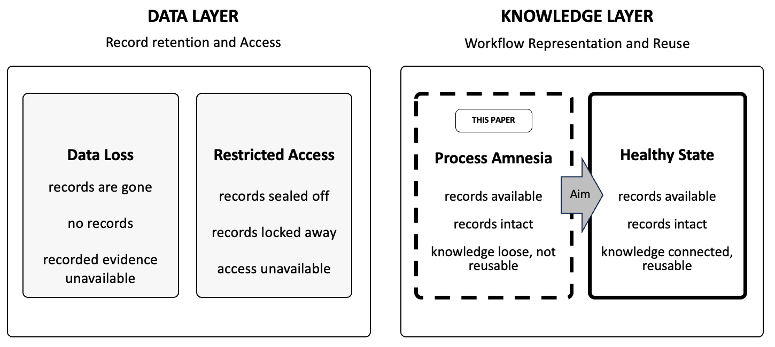
Figure 1. Process Amnesia sits on the knowledge layer.

1.3 Aim and contribution
The aim of this paper is to propose a hybrid framework for recovering construction workflow knowledge from institutional records that were not created for process analysis. It asks how incomplete records can be converted into auditable process evidence for workflow reconstruction while preserving uncertainty. Retrofit work orders provide the initial application setting.
The main contribution is an upstream framework for recovering and qualifying evidence. It combines a controlled construction lexicon, Technical Language Processing, cross checks with structured fields and an Evidence Log that retains the source, time basis and confidence of recovered elements. Reconstructed traces are compared with independently developed and frozen reference models for practitioner review. Process Amnesia provides the problem framing; graph integration is a proposed route for later reuse.

2. Background: Process Knowledge, Knowledge Loss and Workflow Capture

2.1 Process knowledge and its value
A process can be understood as a set of related activities together with the roles that perform them, the objects being acted upon, and the resources used (El-Gohary and El-Diraby, 2010) . A business process coordinates such activities to deliver a product or service (Weske, 2012). Business Process Model and Notation (BPMN) provides a graphical notation for representing these processes (Object Management Group, 2011).
The business process management literature has established the value of making processes explicit so that they can be analysed, compared and improved. Process models can support greater visibility of how work is performed and provide a basis for identifying deviations, inefficiencies and opportunities for improvement (Reinkemeyer, 2020). In construction, this value depends on whether process knowledge can first be captured from the fragmented records and practices through which work is actually executed (Martinez and Nik-Bakht, 2024).

2.2 Process knowledge loss in construction
Construction workflow knowledge is lost for both structural and informational reasons.
Structurally, the industry is organised around projects. Each project is treated as a distinct delivery effort, which encourages teams to prioritise immediate execution over documenting recurring process patterns for future reuse. Although local conditions vary, many projects share recurring subprocesses such as investigation, shutdown planning, hazardous material handling, trade sequencing, inspection and handover (D’Angelo et al., 2022; Debs and Hubbard, 2023). A related difficulty is the use of static planning tools in dynamic project environments. Schedules and formal documents capture intended processes, while site conditions and coordination decisions continue to change during execution (D’Angelo et al., 2022).
Informationally, process evidence is distributed across multiple systems and document types. Work orders, drawings, building information models (BIM), requests for information (RFIs), meeting minutes, schedules, cost records and change orders each preserve only part of the workflow, so surviving records may still fail to become explicit and reusable process knowledge (Levallet and Chan, 2019; Pauwels, Costin and Rasmussen, 2022). Much of this information is also stored in non-process-aware systems whose schemas were designed for administration or data management rather than process reconstruction (Pérez-Castillo et al., 2011; Martinez and Nik-Bakht, 2024). Tacit knowledge further compounds this fragmentation because coordination practices and decision reasoning often remain with individual practitioners rather than being systematically captured and transferred.
The result is a recurring pattern in which the planned process is relatively explicit at the outset, while the knowledge of how work was actually sequenced, coordinated and changed becomes fragmented during execution. This condition motivates the Process Amnesia framing used in this paper.

2.3 Approaches to process capture
Process capture combines expert modelling with methods that analyse recorded activity. Traditional process modelling relies on workshops, interviews and expert knowledge to describe how work is expected to occur. These methods produce understandable models but can be time-consuming and may reflect prescribed rather than actual practice(Van Der Aalst, 2018). Process mining introduced a complementary bottom-up approach by discovering process behaviour from event logs generated during execution.
Process mining depends on the availability and quality of those event logs (Chen et al., 2019). Conventional approaches require identifiable process instances, activities and timing information, while construction records are often distributed across non-process-aware systems and lack explicit process semantics (Chen et al., 2019; Martinez and Nik-Bakht, 2024). Generating suitable event logs can therefore require substantial data integration and transformation before process discovery can begin.
Machine learning can support predictive monitoring (Harl et al., 2020), while language models can assist process modelling from textual descriptions (Kourani et al., 2024). Their use for workflow recovery requires a clear link between each output and the records that support it. The proposed framework combines automated extraction with explicit evidence, formal constraints and practitioner review.

2.4 Text mining and workflow extraction in construction
Text mining converts unstructured text into structured information through techniques such as preprocessing, entity extraction, classification and clustering. In technical domains, these methods must account for abbreviations, local terminology and incomplete language. Technical Language Processing adapts general language processing methods to these characteristics(Brundage et al., 2021; Sundaram and Zeid, 2024).
Text mining is already established in construction for extracting entities and classifying records across design, procurement, contracts, safety and maintenance (Baek, Jung and Han, 2021; Sobhkhiz and El-Diraby, 2025). This work demonstrates that individual construction records can be interpreted computationally. However, identifying what a record concerns does not by itself establish which records belong to the same process instance, what sequence occurred, or how activities depended on one another. This distinction is central to workflow recovery.
Related process mining research shows how structured records support workflow analysis. Martinez and Nik-Bakht (2024) transform relational change management records into structured event logs, while Pan and Zhang (2021) discover processes from BIM event logs. Kang and Haas (2018) examine automated conformance checking, and Khodabakhshian and Re Cecconi (2022) use risk registers and change logs for risk analysis. Formal modelling also has precedents: CoPModL supports construction process modelling and satisfiability checking(Marengo, Nutt and Perktold, 2022). Martinez Lagunas and Nik-Bakht (2024) nevertheless identify event log generation and process semantics as continuing barriers to wider process mining adoption in construction.
Closer to the problem addressed here, Sanchez Ferriz, Exposito and La Borderie (2025) derive event logs from unstructured construction site reports using NLP, text embeddings and clustering. König et al. (2025), reviewing process mining with unstructured data across sectors, likewise find that relatively few studies connect unstructured records directly to process analysis. These studies indicate that text can contribute to process reconstruction, while leaving open the upstream problem of recovering and qualifying process evidence when case boundaries, execution times and process relations are incomplete or uncertain.
Knowledge graph research provides methods for combining heterogeneous construction information. Zhang and Jiang (2025) identify process modelling and optimisation among the remaining challenges, while Kong and Ahn (2024) review knowledge extraction and ontology development for construction safety. These approaches inform future reuse; the evidence for activity occurrence and order still needs to be established.

2.5 Gap addressed by this paper
The gap addressed here concerns the joint recovery and qualification of case membership, activities, timing and relations from incomplete institutional records. Text classification identifies record content, while event log generation and process modelling provide important precedents for reconstruction. Uncertain execution evidence still needs explicit treatment. The proposed framework combines extraction from records with formal reference models, retaining the basis and uncertainty of each interpretation. Table 1 summarises the requirements drawn from the preceding review and the corresponding framework responses.
Table 1. Requirements from the literature and proposed framework responses
Requirement | Problem in current records | Proposed framework response
Recover recurring workflows (Martinez Lagunas and Nik-Bakht, 2024) | Project records preserve individual tasks but may leave recurring patterns unclear. | Assemble related records into candidate cases and compare recurring subprocesses.
Make extraction auditable (van der Aalst, 2018; Harl et al., 2020) | An output is difficult to assess when its supporting records and assumptions are unclear. | Retain source links, time basis, confidence and extraction decisions in the Evidence Log.
Handle noisy language (Brundage et al., 2021; Sundaram and Zeid, 2025) | Work order text contains abbreviations, missing verbs and local shorthand. | Use lexicon normalisation and cross checks with structured fields.
Recover workflow evidence (Levallet and Chan, 2019) | Records may exist without becoming reusable process knowledge. | Retain supported activities and relations; compare them with a frozen reference and record gaps.
Support reuse (Debs and Hubbard, 2023; Pauwels, Costin and Rasmussen, 2022) | Past workflows rarely become templates or playbooks. | Use practitioner review, versioned templates and a process knowledge graph to support reuse.

3. Proposed Framework

3.1 Overview
The framework comprises five steps (Figure 2). Steps 1 and 2 work bottom up from institutional records: process elements are extracted using a controlled lexicon and organised in an Evidence Log that retains their supporting evidence and uncertainty. Step 3 provides the top down component, in which selected recurring workflows are manually formalised with subject matter experts and frozen as normative reference models. In Step 4, recovered process instances are reconstructed and aligned with these references, and deviations are reviewed by practitioners. Step 5 outlines how reviewed workflow knowledge could be represented in a process knowledge graph for comparison and reuse across projects.
The work order dataset is a practical starting point defined by data access. Other documents may preserve coordination decisions and execution details that work orders omit.
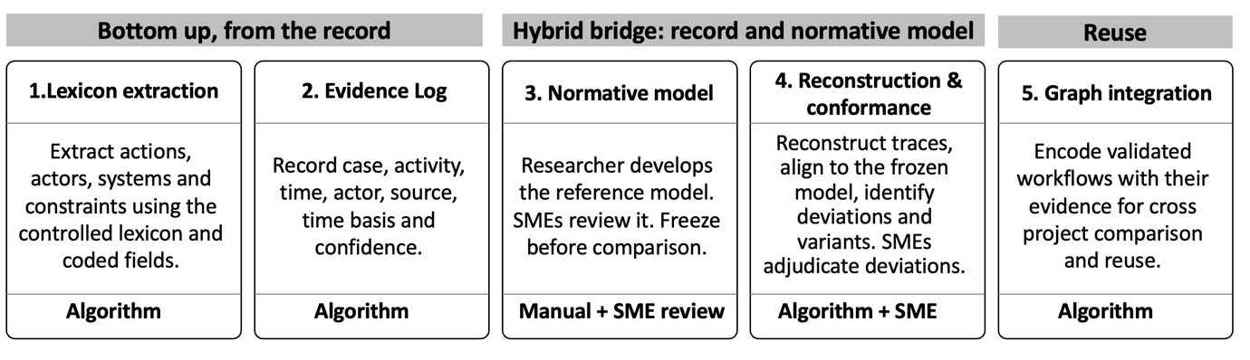
Figure 2. The five steps and the roles of algorithms and subject matter experts (SMEs).

3.2 Data source, scope and Evidence Log
The data available for the proposed application are drawn from the University of Toronto Facilities and Services work order system. The records include free text descriptions, work centre codes, dates, status, priority, space and asset references, and other structured fields.
Retrofit is used as the initial application subdomain. For this study, it refers to work that upgrades or modifies an existing asset to improve performance, extend service life through renewal, or change its function. Routine repairs and preventive servicing are treated as maintenance. Because both types of work are recorded within the same institutional system, candidate retrofit cases must be screened using descriptions and related fields, with unclear cases retained for review.
The records were not created for process reconstruction. Instead, different fields provide partial workflow evidence. Parent child relationships help identify candidate case boundaries, work centre codes indicate assigned trades, and free text descriptions contain activities, systems and constraints. Dates provide partial timing evidence and may describe ticket administration rather than field execution. No individual field provides a complete process instance.
The framework therefore treats each work order as a source of partial process evidence. Related records are linked to form candidate process instances using parent child relationships, assets, locations and compatible work descriptions. A shared location alone does not establish a case. The reason for each link is retained, together with uncertainty about activity, timing, sequence and case membership.
The Evidence Log is a table of candidate process elements grouped by a provisional case identifier. It records case, activity, time, actor, time basis, source and confidence, with constraints and relations linked to the relevant entries. Time basis states whether a date is reported in text, inferred or taken from an administrative field. Unknown times remain unknown, and ranges retain their stated precision. Source identifies the record and supporting text or field so that the interpretation can be checked.
Table 2. Work-order components and their workflow relevance
Work-order component | Potential workflow evidence | Limitation
Parent-child hierarchy | Candidate case boundary and subprocess grouping. | Links may reflect administration; shared scope needs to be checked.
Short text / activity text | Task action, system reference, issue or constraint cue. | Noisy, abbreviated and locally specific.
Work-centre code | Assigned work centre or trade. | Requires an institutional lookup; assignment may differ from who performed the work.
Dates and status fields | Partial sequence and timing evidence. | Ticket dates and status changes may differ from field execution times.
Asset, space and system fields | Affected building element or location. | May be incomplete, inconsistent or absent.
Hazard or asbestos marker | Constraint cue relevant to retrofit sequencing. | Indicates a possible constraint; it does not confirm that a survey or abatement occurred.

3.3 Controlled lexicon
The framework uses a controlled lexicon to map technical language in institutional records to process-relevant concepts such as actions, actors, systems, issues, constraints and resources. It provides a consistent vocabulary for extraction, makes term matching traceable, and constrains interpretation to documented concepts.
The lexicon is organised in three layers. The foundation layer (A) combines IC-PRO-Onto, which provides higher-order process concepts and relations (El-Gohary and El-Diraby, 2010), with the work order taxonomy developed by Sobhkhiz and El-Diraby (2025), which provides observed terms across Actions, Systems and Issues. A second layer (B) adds retrofit-specific terminology, including activities, systems and constraints relevant to building upgrades. A third layer (C) captures institution-specific shorthand, including abbreviations, work centre labels and recurring operational terms.
Before evaluation, subject matter experts review the lexicon, its definitions and the rules for mapping local terms. The reviewed version is then frozen. Unmatched terms are logged for later revision.

3.4 The Technical Language Processing (TLP) pipeline
Technical Language Processing uses the lexicon to interpret work order text and extract candidate process elements, including actions, actors, systems and constraints. The pipeline addresses noise, ambiguity and variability separately. Noise is treated through de identification and normalisation while preserving negation, timing expressions and whether work is requested or reported as completed. Original text and record identifiers remain available for audit. Ambiguity is addressed by comparing text derived candidates with structured fields such as work centre, asset, date and parent child hierarchy. Variability is handled by mapping abbreviations and alternative expressions to the corresponding controlled lexicon concept.
The TLP output is treated as candidate process evidence. A lexicon match supports an interpretation of the text; evidence that an activity occurred must be assessed separately. Agreement with relevant structured fields provides additional support, although fields copied from the same source are not independent confirmation. Where evidence is contradictory or insufficient, the interpretation remains unresolved.
Evidence basis and confidence are recorded separately. Evidence basis identifies whether an interpretation is stated or inferred. High confidence requires clear, corroborated support; medium confidence indicates a plausible interpretation with limited support. Each rating includes its reason, and the rating rules are fixed before evaluation. Conflicting or insufficient evidence remains unresolved. These qualitative categories describe evidential support rather than calibrated probabilities.
Where ambiguity remains after lexicon matching and cross checks with structured fields, a large language model (LLM) assisted second opinion may be used to suggest alternative interpretations. Its output is logged and cannot write directly to the Evidence Log or override contradictory source evidence. A suggestion can be accepted only after source checks and practitioner review, with the decision and its reason retained.
Figure 3 illustrates the pipeline through a worked example, showing how raw technical text is normalised, mapped to the controlled lexicon and checked against structured fields. The phrase “ASB CHK PRIOR” expresses a requested condition; it does not confirm that an asbestos check occurred. The table describes support for interpreting terms. Execution status and timing still require separate evidence before reconstruction.
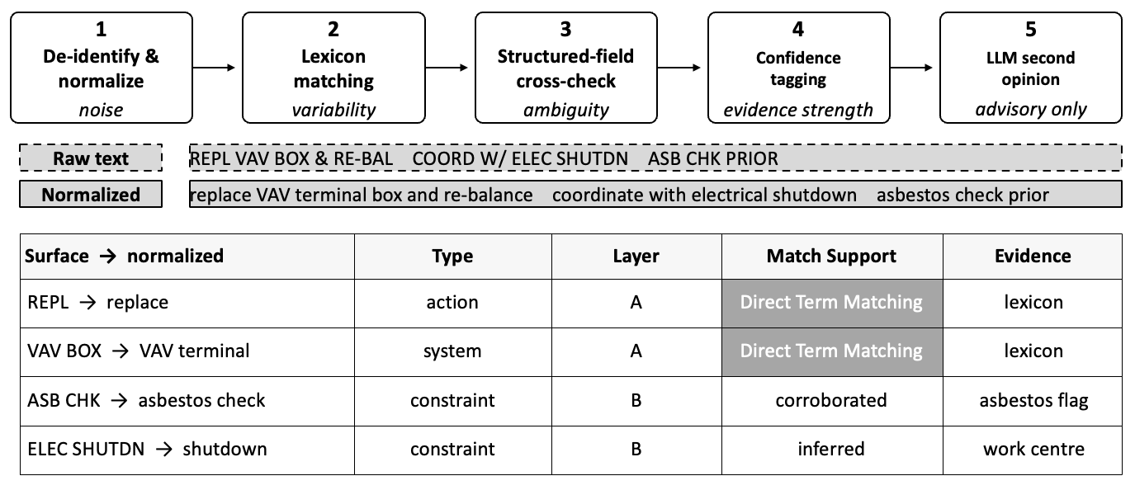
Figure 3. TLP stages and an illustrative term extraction example. Match support is distinct from evidence of execution.

3.5 Formalisation and the normative model
For each selected recurring workflow, the researcher manually develops a normative reference model with subject matter experts, independently of the traces used for evaluation. The model states expected activities, dependencies and the conditions under which they apply. It is reviewed, versioned and frozen before reconstruction begins. BPMN provides a readable representation for practitioner review. Later revisions are recorded as new versions.
The lexicon supplies the vocabulary, while a focused set of first order logic constraints specifies activity identity, precedence and the basis of temporal claims. This design draws on the explicit process semantics of the Process Specification Language (Grüninger and Menzel, 2003). The proposed constraints distinguish statements about ticket dates from statements about execution. Internal consistency and agreement with expected practice are checked separately: a well formed trace may still reveal a genuine departure from the reference. For example, where the reference requires hazard clearance before removal, missing clearance evidence is recorded as unobserved. The rule supplies an expectation; it does not supply evidence that clearance occurred.

3.6 Workflow reconstruction and conformance
For each candidate process instance, the relevant entries in the Evidence Log are computationally assembled into a workflow trace. Only entries with supporting execution evidence enter the recovered trace; requests remain contextual evidence. Activities are mapped to BPMN steps, actors or trades to lanes, and supported sequence and handoff relations to flows. Each element retains its source and evidence status. Where order is uncertain, the output remains a set of annotated fragments; missing dates or links are not replaced by an assumed sequence. Expected activities without supporting evidence remain outside the reconstructed trace.
Each trace is compared with the frozen normative model. Three states describe elements in that comparison: observed means an expected element has supporting record evidence; unobserved but expected means an applicable expected element has no supporting evidence; observed but not anticipated means a supported element is absent from the reference. A single comparison can include all three states. Here, observed refers to evidence in records; its reliability remains qualified by source and confidence. Sequence deviations are recorded separately. Comparison across instances identifies candidate variants for practitioner review.

3.7 Validation and Practitioner review
Practitioner review is embedded at two points in the framework. First, subject matter experts review the controlled lexicon and normative model before these are frozen for evaluation. Second, practitioners examine recovered traces and their supporting records, including uncertain and rejected interpretations. They assess whether deviations reflect recovery errors or genuine differences in field practice. Where the records and practitioner accounts cannot resolve a discrepancy, it remains inconclusive. Agreement with the normative model alone does not establish that the reconstruction is correct.
The proposed reconstruction success criterion is traceability and explainable deviation: each represented element has a source, and practitioners can attribute each reviewed deviation to a recovery error or a supported difference in practice. Recovery errors must be corrected before a trace is approved for reuse. Unresolved deviations are reported separately. Evaluation will distinguish coverage of applicable expected activities, conformance of recovered traces and the proportion of deviations that can be explained. Proposed reference model changes become new versions; the version used for evaluation remains unchanged. This paper specifies the procedure; implementation and systematic validation are reserved for subsequent work.

4. Conclusions and Further Work

Process Amnesia refers to the failure to transform surviving records and project experiences into reusable workflow knowledge. Construction records often retain individual activities but lack clarity on sequence, coordination, and rationale. Recovering this knowledge requires explicit analysis of what records support and what remains uncertain.

The proposed framework involves five steps: lexicon-based extraction, Evidence Log creation, formalization of a normative model, reconstruction and conformance, and graph integration. The lexicon guides interpretation, and the Evidence Log documents each claim with its source, time, and confidence. Reconstructed traces are compared to references, and deviations are assessed. Activities without evidence remain unobserved, forming a basis for identifying recurring workflow patterns and their reusability.

Conceptually outlined here, the next step is applying the framework to institutional work order data. This will test case assembly, activity interpretation, and sequence recovery, while examining limitations posed by incomplete or missing records. Repeated applications will help analyze variants. Distinguishing missing evidence from activities that didn’t occur remains a challenge.

Future work includes encoding workflows in a process knowledge graph linked to source records and evidence status. Recurring patterns could become templates indicating applicable asset types, constraints, and supporting cases. After practitioner approval, these could be exported as BPMN models for project management or asset systems. New records and revisions would support updates, with earlier versions retained for audit. This outlines a path to living templates; further testing is needed for implementation across record types and domains.

References
Baek, S., Jung, W. and Han, S.H. (2021) "A critical review of text-based research in construction: Data source, analysis method, and implications," Automation in Construction, 132, p. 103915.
Brundage, M.P. et al. (2021) "Technical language processing: Unlocking maintenance knowledge," Manufacturing Letters, 27, pp. 42–46.
Chen, L. et al. (2019) "Improving the quality of event logs in the construction industry for process mining," in Proceedings of the 36th International Symposium on Automation and Robotics in Construction (ISARC 2019), pp. 804–811.
Costa, L. et al. (2019) "Challenges of process modeling in architecture and engineering to execute projects and public works," Journal of Construction Engineering and Management, 145(1).
D’Angelo, L. et al. (2022) "A novel BIM-based process workflow for building retrofit," Journal of Building Engineering, 50, p. 104163.
Debs, L. and Hubbard, B. (2023) "Gathering and disseminating lessons learned in construction companies to support knowledge management," Construction Economics and Building, 23(1/2).
Dumas, M. et al. (2018) Fundamentals of Business Process Management. Berlin, Heidelberg: Springer.
El-Gohary, N.M. and El-Diraby, T.E. (2010) "Domain Ontology for Processes in Infrastructure and Construction," Journal of Construction Engineering and Management, 136(7), pp. 730–744.
Grüninger, M. and Menzel, C. (2003) "The Process Specification Language (PSL) theory and applications," AI Magazine, 24(3), pp. 63–74.
Harl, M. et al. (2020) "Explainable predictive business process monitoring using gated graph neural networks," Journal of Decision Systems, 29(sup1), pp. 312–327.
Kang, S. and Haas, C.T. (2018) "Evaluating artificial intelligence tools for automated practice conformance checking," in Proceedings of the 35th International Symposium on Automation and Robotics in Construction (ISARC 2018).
Khodabakhshian, A. and Re Cecconi, F. (2022) "Data-Driven Process Mining Framework for Risk Management in Construction Projects," IOP Conference Series: Earth and Environmental Science, 1101, p. 032023. https://doi.org/10.1088/1755-1315/1101/3/032023
Kong, F. and Ahn, S. (2024) "Use of Knowledge Graphs for Construction Safety Management: A Systematic Literature Review," Information, 15(7), p. 390. https://doi.org/10.3390/info15070390
König, F. et al. (2025) "Unstructured Data in Process Mining: A Systematic Literature Review," ACM Transactions on Management Information Systems, 16(3), pp. 1–34.
Kourani, H. et al. (2024) "Process Modeling With Large Language Models," in Enterprise, Business-Process and Information Systems Modeling (BPMDS/EMMSAD 2024), Lecture Notes in Business Information Processing, vol. 511. Cham: Springer, pp. 229–244.
Levallet, N. and Chan, Y.E. (2019) "Organizational knowledge retention and knowledge loss," Journal of Knowledge Management, 23(1), pp. 176–199.
Marengo, E., Nutt, W. and Perktold, M. (2022) "CoPModL: Construction process modeling language and satisfiability checking," Information Systems, p. 101457.
Martinez Lagunas, A.J. and Nik-Bakht, M. (2023) "Enabling process mining in the construction industry: An event log schema for change management process," in Proc. CSCE Annual Conference. Cham: Springer Nature Switzerland, pp. 103–117.
Martinez Lagunas, A.J. and Nik-Bakht, M. (2024) "Process Mining, Modeling, and Management in Construction: A Critical Review of Three Decades of Research Coupled with a Current Industry Perspective," Journal of Construction Engineering and Management, 150(11).
McKinsey Global Institute (2017) Reinventing Construction: A Route to Higher Productivity. McKinsey & Company.
Object Management Group (2011) Business Process Model and Notation (BPMN), Version 2.0.
Pan, Y. and Zhang, L. (2021) "Automated process discovery from event logs in BIM construction projects," Automation in Construction, 127, p. 103713.
Pauwels, P., Costin, A. and Rasmussen, M.H. (2022) "Knowledge Graphs and Linked Data for the Built Environment," in Industry 4.0 for the Built Environment. Cham: Springer, pp. 157–183.
Pérez-Castillo, R. et al. (2011) "Generating event logs from non-process-aware systems enabling business process mining," Enterprise Information Systems, 5(3), pp. 301–335.
Reinkemeyer, L. (ed.) (2020) Process Mining in Action: Principles, Use Cases and Outlook. Cham: Springer.
Sanchez-Ferriz, D., Exposito, E. and La Borderie, C. (2025) "Event log extraction using Natural Language Processing and text embeddings," in 2025 IEEE 33rd Int. Conf. Enabling Technologies (WETICE), pp. 1–6.
Sobhkhiz, S. and El-Diraby, T. (2025) "A semi-supervised framework for generating multi-dimensional taxonomies from asset maintenance documents," Engineering Applications of Artificial Intelligence, 161, p. 112010.
Sundaram, S. and Zeid, A. (2025) "Technical language processing for Prognostics and Health Management: applying text similarity and topic modeling to maintenance work orders," Journal of Intelligent Manufacturing, 36(3), pp. 1637–1657.
van der Aalst, W.M.P. (2018) "Process discovery from event data: Relating models and logs through abstractions," WIREs Data Mining and Knowledge Discovery, 8(3), p. e1244.
Weske, M. (2012) Business Process Management. Berlin, Heidelberg: Springer.
Zhang, J. and Jiang, S. (2025) "Systematic Literature Review on Knowledge Graphs in Construction Management from a Multi-Modal Perspective," International Journal of Human–Computer Interaction, 41(5), pp. 2788–2807.

