Generation and Evaluation of Synthetic Point Cloud Data for Training of Machine Learning Models
Hanxin Ma¹, Jan Martens¹, Jörg Blankenbach¹

¹Chair of Computing in Civil Engineering and Geoinformation Systems and Geodetic Institute, RWTH Aachen University, Aachen, Germany

ABSTRACT:

Machine learning is increasingly applied for automating the creation of Building Information Models (BIM) of infrastructure objects and for point cloud semantic segmentation. However, machine learning is often costly and time-consuming due to the substantial volume of point cloud training data required which in turn must be captured and processed. This paper proposes the use of virtual laser scanning software to generate synthetic point clouds as a cost-effective alternative to manual capturing. It evaluates the impact of training machine learning models for infrastructure semantic segmentation using a hybrid dataset of real-world and synthetic point clouds. The findings indicate that models trained on hybrid datasets markedly outperform those trained solely on real-world data. This improvement illustrates the potential of augmenting datasets with synthetic data to not only improve model accuracy but also reduce the resources needed for manual data collection and labelling.

KEYWORDS:

Infrastructure, Synthetic point clouds, Scan-to-BIM, Machine Learning, Semantic Segmentation

1. INTRODUCTION
Infrastructure objects such as bridges and roads are critically prone to deterioration over time, resulting in safety concerns that necessitate regular maintenance or reconstruction. In response, the architecture, engineering, and construction (AEC) industry increasingly relies on Building Information Modelling (BIM) to enhance the resilience of infrastructure objects (Eastman et al., 2011).
In the realm of infrastructure management, the precise digital representation of infrastructure objects is fundamental to the creation of “as-is" BIM models. Advancing beyond these static models, the concept of digital twins marks a great evolution by providing a dynamic, real-time representation of these assets (Borrmann et al., 2022), (Crampen and Blankenbach, 2023).
Scan-to-BIM technology is widely used to create accurate “as-is" BIM models of infrastructure objects, which are also essential for developing digital twins (Deng et al., 2021). This process integrates scanning technologies into the BIM framework, enabling the precise conversion of real-world data into digital BIM-enabled models (Son et al., 2015).
Following the Scan-to-BIM paradigm, point clouds represents the first step in reconstruction. Point clouds are primarily obtained through two methods: 3D reconstruction from image data, utilizing techniques such as dense image matching (DIM) (Remondino et al., 2013) and structure from motion (SfM) (Schonberger and Frahm, 2016), and 3D laser scanning, which includes terrestrial (TLS) and mobile laser scanning (MLS) (Wang and Kim, 2019). Although effective, these methods are often costly and time-intensive, particularly for extensive infrastructure data collection (Laefer, 2013), (Williams et al., 2013), (Lu and Brilakis, 2017). Additionally, the point clouds generated require substantial pre-processing, including registration (Yan et al., 2017) and denoising (Zhou et al., 2022), to be usable for BIM models creation. The next step is semantic segmentation, where objects are segmented and classified based on geometric attributes. Manual segmentation is not only time-consuming but also susceptible to errors. To overcome these limitations, current technology employs supervised machine learning techniques to automate this step (Perez-Perez et al., 2021). Machine learning models, trained on accurately labelled data, automate the conversion of 3D scan data into BIM elements, enhancing both the speed and accuracy of the process through continuous learning and algorithm optimization. These models depend on extensive training datasets to establish correct mapping relationships between the scanned data and BIM elements, enabling precise identification and conversion of structural features into the BIM framework (Kotsiantis et al., 2007).
Accelerating the process of Scan-to-BIM while maintaining data accuracy remains a critical research challenge in the field. In this paper, we introduce a novel approach for training semantic segmentation machine learning models: utilizing synthetic point clouds of infrastructure objects as a data source. Compared to traditional techniques like 3D reconstruction from image data or 3D laser scanning, this method allows for faster and broader access to data. Additionally, synthetic point clouds can be directly employed in machine learning models, thereby eliminating labour-intensive pre-processing steps such as manual segmentation and labelling. We conducted experiments on datasets that combine real-world and synthetic point clouds to validate the quality and usefulness of synthetic data for data set augmentation. Specifically, by training our machine learning models on these hybrid datasets for semantic segmentation, we observed noticeable improvements in the performance of existing architectures on real data.
The main contributions of this paper are as follows:
1) Generation of synthetic point clouds: We employ virtual laser scanner software to generate synthetic point clouds of infrastructure objects.
2) Creation of real-world and hybrid point cloud datasets: We develop real-world point cloud datasets of infrastructure objects and combine them with synthetic point clouds to form multiple hybrid datasets. These hybrid datasets contain various combinations of real-world and synthetic point clouds proportions.
3) Performance evaluation of semantic segmentation models: We train machine learning models on these real-world and hybrid point cloud datasets, followed by detailed evaluations to compare their performance in semantic segmentation tasks.

2. RELATED WORK
This section provides an overview of existing datasets and machine learning algorithms related to semantic segmentation of point clouds.
An extensive collection of open-source datasets is now available for semantic segmentation tasks in machine learning. These datasets are primarily categorized by scene scale into indoor and outdoor scenes. Indoor datasets, such as S3DIS (Armeni et al., 2017), ScanNet (Dai et al., 2017) and Habitat-MP3D-Semantic (Yadav et al., 2023), typically include semantic labels for various indoor elements like floors, walls, and furniture. On the other hand, outdoor datasets, which focus on urban scenes such as Semantic3D (Hackel et al., 2017), Paris-Lille-3D (Roynard et al., 2018), SemanticKITTI (Behley et al., 2019), Toronto-3D (Tan et al., 2020), DublinCity (Zolanvari et al., 2019) and SensatUrban (Hu et al., 2022), contain labels for features such as ground, buildings, and vegetation. In addition to general datasets, there are also specialized ones for specific scenarios. For instance, OpenTrench3D (Hansen et al., 2024) is designed for underground utility surveying and mapping, containing annotations for main utilities (newly installed utilities), other utilities (uncovered existing utilities), and more. These datasets are generated primarily by collecting point clouds from actual scenes using technologies such as RGB-D sensors, 3D laser scanners (TLS, MLS, ALS), and UAV photogrammetry. The point clouds are then annotated, either manually or semi-manually, a process that is both time-consuming and costly, particularly for complex, large-scale scenes including numerous categories. Additionally, most of the datasets mentioned are geared towards automated driving research, which often suffers from a limited number of labels related to infrastructure objects.
Some researchers have adopted innovative methods to efficiently generate synthetic point clouds and create large-scale datasets. For instance, the Paris-CARLA-3D (Deschaud et al., 2021) and STPLS3D (Chen et al., 2022) datasets cleverly combine real-world point clouds with synthetic ones, enhancing the diversity and robustness of the training data. Additionally, datasets like SynLiDAR (Xiao et al., 2022) and SynthCity (Griffiths and Boehm, 2019) are entirely formed from synthetic point clouds, providing controlled environments for detailed evaluation. These synthetic point clouds are generated using various methods: the CARLA simulator (Dosovitskiy et al., 2017) for dynamic urban scenarios, the AirSim simulator (Shah et al., 2018) in Unreal Engine 4 (UE4) for transforming 2D images into three-dimensional data, and BlenSor (Gschwandtner et al., 2011) for virtual laser scanning. Although numerous open-source datasets are available for semantic segmentation in large-scale scenes, they are often inadequate for infrastructure-specific research, as complex structures like bridges and roads require targeted data collection. In this paper, we supported supplementing real-world data with synthetic point clouds as a viable data source. Utilizing synthesis methods from existing datasets, we employed the virtual laser scanning software Helios++ (Winiwarter et al., 2022) to generate the specific synthetic point clouds needed for this study.
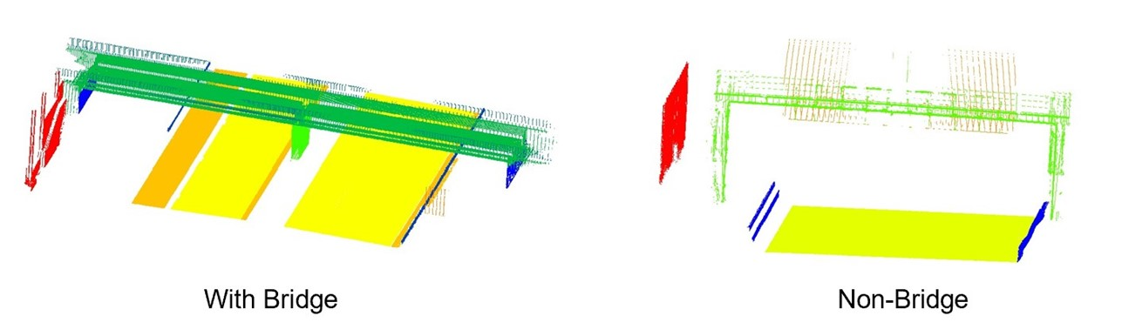Machine learning algorithms currently used for semantic segmentation of point clouds primarily utilize neural network-based frameworks (Landrieu and Simonovsky, 2018). Initially, the researcher inputs the point cloud into the neural network in a voxelized format (Tchapmi et al., 2017), (Riegler et al., 2017), (Wang et al., 2017), (Graham and Van der Maaten, 2017), which leverages the uniform grid structure of voxelization to enhance data anageability and computation efficiency. Subsequently, building on the precedent set by PointNet (Qi et al., 2017), the raw point cloud is used directly as input, markedly enhancing data processing efficiency and eliminating the need for preprocessing while preserving the data’s integrity. Building further on PointNet, subsequent developments in neural network architectures, such as PointNet++ (Qi et al., 2018), PointCNN (Li et al., 2018), and KPConv (Thomas et al., 2019), also directly take point clouds as input. Notably, PointCNN and KPConv introduce adaptations of convolutional operators commonly used in image classification networks, allowing for effective feature extraction directly from point clouds. In this paper, we explored these neural network architectures that directly utilize raw point clouds as inputs for training and evaluating semantic segmentation on our datasets.

3. METHODS
3.1 Synthetic point cloud generation
To enhance the realism of synthetic point clouds for infrastructure objects, we first created corresponding 3D mesh models from existing real-world point clouds. These 3D mesh models were then converted into synthetic point clouds using the virtual laser scanner software, Helios++. Initially, we utilized TLS to collect real-world point clouds of bridges and MLS for roads. Following data collection, we employed Autodesk Revit to construct 3D mesh models based on these point clouds. Given the intricate structures of bridges and roads, it was challenging to replicate every geometric detail in our models. Therefore, the models achieved only a rough approximation of the original point clouds. These approximated models served as the input for Helios++, which then generated synthetic point clouds from the given 3D mesh.
In accordance with the official Helios++ guidelines, our process begins with the creation of a scene XML file. This file specifies the path to the OBJ file of the 3D mesh models and includes the necessary transformations, such as translations, scaling, and rotations, required to align the models accurately within the simulation environment. We ensured that no additional transformations were applied beyond these essentials, maintaining the integrity of the original model specifications.
Subsequently, we prepared a Survey XML file that detailed the scene's XML file path, the type of scanner employed, and the designated scanning positions. To accurately replicate real-world conditions, we configured all settings in the Survey XML file to match the specifications and parameters of the laser scanner used for capturing the original point clouds (in this case a Riegl VZ-400).
To automate the remaining process, we executed Helios++ within a Python environment, using the Survey XML file as a parameter to initiate the process. Helios++ processed the entire scene file, which included all 3D mesh models, to generate separate synthetic point clouds for each specified scan position. We successfully generated a total of 13 synthetic point clouds using this methodology.
Real-world point clouds typically contain spatial coordinates (x, y, z) and intensity information, with RGB data being available depending on the capturing method. Furthermore, they require further processing for successful segmentation and manual labelling. Conversely, synthetic point clouds usually include labels and intensities alongside their spatial coordinates, while generally lacking normal vectors. The inclusion of RGB data in synthetic point clouds is contingent upon the RGB characteristics of the 3D model used in Helios++. In our case, since the input 3D model lacked RGB texture information, the resulting synthetic point clouds similarly lacked this feature.
Figure 1: Two scenarios in the dataset: with bridge (left) and non-bridge (right).

3.2 Machine learning model training
The next phase is dedicated to training machine learning models for semantic segmentation of infrastructure objects. In total, we have 39 real-world point clouds and 13 synthetic point clouds. These point clouds cover two different road scenarios, as depicted in Figure 1 (roads with and without bridges). Following pre-processing, our point clouds retain only the XYZ coordinates and the label for each point.
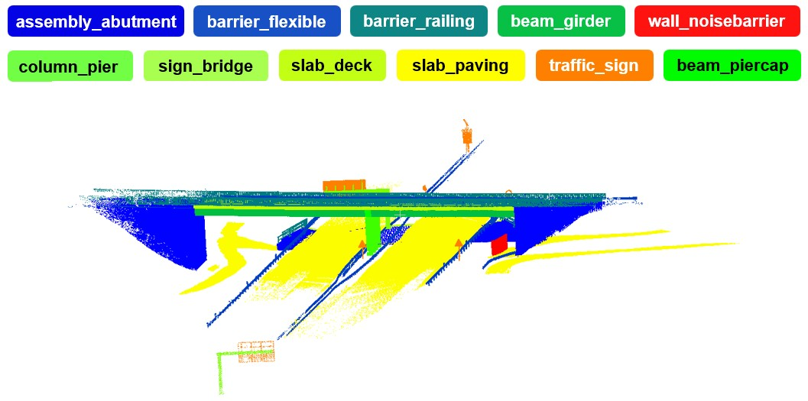In both scenarios, our dataset focuses exclusively on the essential components of the infrastructure objects, omitting extraneous elements such as vegetation and ground surfaces. The object categories in the infrastructure object dataset are based on the IFC standard and are as follows: assembly_abutment, barrier_flexible, barrier_railing, beam_girder, wall_noisebarrier, column_pier, sign_bridge, slab_deck, slab_paving, traffic_sign, beam_piercap (see also Figure 2).
Figure 2: Real-world reference point cloud for the Kohlscheid bridge, detailing the included classes.
We prepared five datasets which include: the ‘real’ dataset, which consists only of real-world point clouds; the ‘hybrid’ datasets, which combine real-world point clouds with synthetic point clouds at varying ratios of 25% (hybrid_25%), 50% (hybrid_50%), and 75% (hybrid_75%), and the ‘synthetic’ dataset, made up entirely of synthetic point clouds. This configuration serves a dual purpose: first, to assess whether integrating synthetic point clouds with real-world data can effectively enhance semantic segmentation; second, to determine the optimal ratio of synthetic to real-world point clouds needed to achieve the best results in semantic segmentation for real-world scenarios.
In this paper, we focused on neural network-based algorithms due to their exceptional ability to manage complex, high-dimensional data, such as large-scale point clouds of infrastructure objects. We selected KPConv specifically for its adaptability to the irregular structures and varying densities typical of such data sets. KPConv is particularly adept at capturing both local and global features of point clouds, which is crucial for detailed and accurate semantic segmentation. It supports end-to-end learning, facilitating seamless model training and enhancing generalization across diverse scenarios. We trained five datasets for semantic segmentation employing transfer learning techniques with pre-trained KPConv models. Initially, the S3DIS dataset, which is tailored for indoor scenes, was utilized for the pre-training phase. During this stage, we set the initial parameter values to be relatively small to match the typical scale of indoor environments: in_radius, which determines the radius of the KPConv convolution kernel applied to each point, and first_subsampling_dl, the level of subsampling applied to the point cloud data prior to input into the neural network. To adapt the models for outdoor scenes, which typically involve larger and more varied spatial extents, we adjusted these in_radius to 4m and first_subsampling_dl to 6cm to better reflect the differing conditions.
Table 1: Evaluation of semantic segmentation performance on the datasets real, hybrid 25%, hybrid 50%, hybrid 75% and synthetic.
Datasets | Total | Assembly_  abutment | Barrier_  flexible | Barrier_  railing | Beam_  girder | Beam_  piercap | Column_  pier | Sign_  bridge | Slab_  deck | Slab_  paving | Slab_  sidewalk | Traffic_  sign | Wall_  noisebarrier
Real | 29.66 | 76.96 | 0.01 | 0.01 | 79.22 | 4.81 | 55.93 | 0.20 | 53.13 | 85.59 | 0.0 | 0.00 | 0.0
Hybrid_25% | 71.61 | 89.53 | 99.40 | 89.89 | 83.14 | 15.93 | 97.91 | 94.76 | 92.91 | 97.73 | 0.0 | 96.13 | 1.95
Hybrid_50% | 70.73 | 89.81 | 99.73 | 94.51 | 81.16 | 15.05 | 88.33 | 93.89 | 92.78 | 97.56 | 0.0 | 95.86 | 0.03
Hybrid_75% | 70.89 | 90.17 | 99.50 | 95.18 | 76.27 | 13.37 | 95.95 | 93.90 | 92.42 | 97.90 | 0.0 | 95.96 | 0.00
Synthetic | 71.04 | 89.68 | 99.63 | 96.31 | 77.03 | 12.16 | 92.67 | 95.81 | 94.18 | 98.32 | 0.0 | 96.71 | 0.01

We selected the real-world point cloud of the Kohlscheid bridge as a test set to demonstrate the results of semantic segmentation. This scene was captured using TLS, ensuring the point cloud is characterized by high accuracy and resolution. This high level of detail is crucial for assessing how well our models can interpret and segment complex infrastructure objects, thus validating the potential of our methods in real-world applications. Figure 2 illustrates the real-world point cloud “Kohlscheid bridge” and the assciated 11 labels (excluding class slab_sidewalk).

4. RESULTS
We employed the metric mean Intersection over Union (mIoU) to evaluate the semantic segmentation results across five datasets: real, hybrid_25%, hybrid_50%, hybrid_75% and synthetic. Figure 3 presents the visualization of the results from semantic segmentation after training on each dataset.
Table 1 displays the mIoU and IoU scores for each class across the five datasets, outlining both overall and individual class performance in semantic segmentation:
1) The mIoU scores for the dataset consisting solely of real-world point clouds is 29.66%, indicating poor overall results in semantic segmentation for models trained on this dataset. Classes with distinct shape irregularities, such as barrier_flexible, barrier_railing, sign_bridge, and very small objects like traffic_sign, are hardly recognizable. The reason for this result is that real-world datasets typically contain fewer instances of classes with irregularly shaped or small objects, leading to insufficient feature extraction. Additionally, classes with irregularly shapes are challenging to label manually, often resulting in inaccurate labels that negatively impact semantic segmentation results. Consequently, in this dataset, only regular objects with more distinctive features, such as assembly_abutment, beam_girder, and slab_paving, are identified more effectively.
2) Both the hybrid dataset, which included synthetic point clouds, and the dataset consisting entirely of synthetic point clouds achieved markedly higher mIoU scores compared to the dataset containing only real-world point clouds. Specifically, the mIoU scores improved by 41.95% for hybrid_25%, 41.07% for hybrid_50%, 41.23% for hybrid_75%, and 41.38% for the synthetic dataset. The improvement in mIoU scores was considerable, suggesting a positive effect on semantic segmentation from the use of synthetic point clouds.
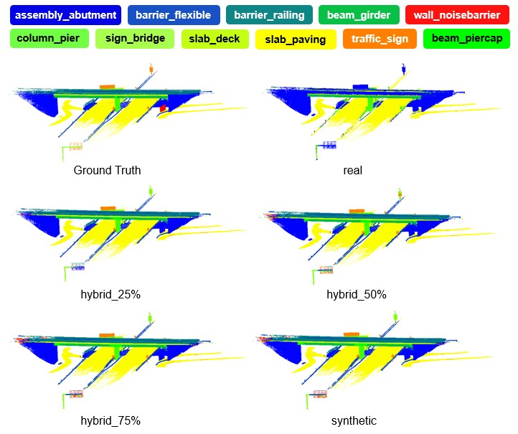3) In the hybrid dataset with varying ratios of synthetic point clouds, the ones containing 25% synthetic data achieved the highest mIoU scores. This indicates that incorporating 25% synthetic point clouds into the dataset yields the best semantic segmentation results across these five experiments. The findings suggest that employing synthetic data as a method of data augmentation is indeed feasible and effective. There appears to be an optimal balance between synthetic and real-world data that maximizes the validity and performance of the model. Integrating too much synthetic data might overlook specific real-world nuances, while an overreliance on real-world data could introduce noise and inconsistencies. Either scenario can compromise the model's accuracy and generalizability.
Figure 3: Visualization of semantic segmentation results after training on each dataset.
4) The IoU scores for all classes trained on both the hybrid dataset and the synthetic point cloud-only dataset were higher than those obtained from training on the dataset with only real-world point clouds. Classes such as barrier_flexible, barrier_railing, sign_bridge, and traffic_sign, which were difficult to recognize when trained only with real-world point cloud dataset, became easily identifiable and were effectively segmented with the addition of synthetic point clouds. This suggests that the addition of synthetic data, providing a more uniform and comprehensive representation of these objects, enhances feature learning. It was particularly interesting to note that among the five datasets, the hybrid_25% dataset excelled in recognizing specific bridge components such as beam_girder, beam_piercap, and column_pier. In contrast, the dataset made up entirely of synthetic point clouds achieved the best results for roadway components, including sign_bridge, slab_paving, and traffic_sign. This suggests that synthetic data, while generally effective, is slightly less representative of bridges compared to roads. The key reason for this discrepancy lies in the inability of synthetic data to accurately or fully capture the complex structures of bridges. In contrast, roads, which typically feature regular and simpler geometric forms, may not require as detailed a local representation in the point cloud, leading to higher segmentation accuracy with synthetic data.

5. DISCUSSION
We found that the accuracy of semantic segmentation dramatically improved with the use of synthetic point clouds, which offer several benefits. First, they allow for the automatic acquisition of accurate annotations without human error, leading to more precise labelling and improved model learning. Second, synthetic point clouds enhance the diversity of class instances, particularly beneficial for underrepresented classes with few real-world examples, thus boosting model performance on these classes. The results show that the hybrid dataset with 25% synthetic point clouds achieved the highest mIoU score among the five datasets studied. This finding indicates that although synthetic data offers additional training scenarios and accurate labels, it is derived from 3D mesh models that do not replicate the irregularities and complexity of real-world infrastructure objects, resulting in a lack of geometric detail. Conversely, real data provides essential real-world detail that synthetic point clouds cannot perfectly capture. The synergy of synthetic and real data broadens the training set's diversity, fostering more generalized feature learning, reducing overfitting, and enhancing model robustness across various unseen scenarios. We also found that adjusting the ratio of synthetic point clouds in the dataset enables more targeted scene-specific studies, particularly for bridge or road scenes. For instance, roadway component identification yielded the best results with a dataset entirely made up of synthetic point clouds. This indicates that synthetic data can create a more consistent and controlled learning environment, particularly for simpler environments that are easily simulated with high accuracy. This finding suggests that for certain tasks, fully synthetic datasets could be sufficient to provide the necessary information for effective training.
Therefore, combining synthetic with real-world point clouds as a dataset remains a preferred methodology, offering time and cost savings over traditional real-world data collection methods. Although the synthetic point clouds in this study were based on real-world data, this approach can be expanded in future work to minimize the need for extensive real-world data collection. Once accurate 3D mesh models for each class are established, they can be utilized to generate unlimited data without further real-world collection, substantially reducing long-term data collection costs and labour requirements. In addition to its core capabilities, Helios++ offers a variety of adjustable parameters that can be finely tuned to match specific requirements of the 3D model. This flexibility not only enhances the accuracy of the simulations but also enables the generation of multiple synthetic point clouds from the same model. Consequently, our method of enhancing machine learning models for semantic segmentation by generating synthetic point clouds from 3D models using Helios++ is entirely feasible and merits further development.

6. CONCLUSION
This paper investigated the enhancement of machine learning semantic segmentation performance with synthetic point clouds. Our results showed that integrating synthetic point clouds substantially boosts dataset performance in semantic segmentation tasks. Furthermore, our analysis of models trained with varying ratios of synthetic and real-world data, including 25%, 50%, and 75%, revealed that a 25% inclusion of synthetic data optimizes segmentation accuracy. This ratio substantially enhances the model's ability to accurately segment complex infrastructure features. Moving forward, this research establishes a solid foundation for further investigation into the optimal mixture of synthetic and real data for
infrastructure projects. This knowledge could greatly enhance the accuracy and cost-effectiveness of infrastructure design and maintenance.

REFERENCES
C. Eastman, P. Teicholz, R. Sacks, K. Liston, B. Handbook (2011), A guide to building information modeling for owners, managers, designers, engineers and contractors, BIM handbook 2, 147–150.
A. Borrmann, J. Blankenbach, J. Beetz, M. König, R. Becker, A. Göbels, M. Mafipour, J. Martens, M. Scheffer, S. Vilgertshofer, et al. (2022), Technologien zur Generierung digitaler Zwillinge als Grundlage für Betrieb und Instandhaltung baulicher Infrastruktur.
D. Crampen, J. Blankenbach (2023), Loadt: towards a concept of level of as-is detail for digital twins of roads, in: Proceedings of the 30th international workshop on intelligent computing in engineering (EG-ICE).
M. Deng, C. C. Menassa, V. R. Kamat (2021), From bim to digital twins: A systematic review of the evolution of intelligent building representations in the aec-fm industry., Journal of Information Technology in Construction 26.
H. Son, C. Kim, Y. Turkan (2015), Scan-to-bim-an overview of the current state of the art and a look ahead, in: ISARC. Proceedings of the International Symposium on Automation and Robotics in Construction, volume 32,
Citeseer.
F. Remondino, M. G. Spera, E. Nocerino, F. Menna, F. Nex, S. Gonizzi Barsanti (2013), Dense image matching: Comparisons and analyses, in: 2013 Digital Heritage International Congress (DigitalHeritage), volume 1, IEEE, pp. 47–54.
J. L. Schonberger, J.-M. Frahm, Structure-from-motion revisited (2016), in: Proceedings of the IEEE conference on computer vision and pattern recognition, pp. 4104–4113.
Q. Wang, M.-K. Kim (2019), Applications of 3d point cloud data in the construction industry: A fifteen-year review from 2004 to 2018, Advanced engineering informatics 39 306–319.
D. F. Laefer (2013), Planning infrastructure documentation with aerial laser scanning.
K. Williams, M. J. Olsen, G. V. Roe, C. Glennie (2013), Synthesis of transportation applications of mobile lidar, Remote Sensing 5 4652–4692.
R. Lu, I. Brilakis (2017), Recursive segmentation for as-is bridge information modelling.
L. Yan, J. Tan, H. Liu, H. Xie, C. Chen (2017), Automatic registration of tls-tls and tls-mls point clouds using a genetic algorithm, Sensors 17.
L. Zhou, G. Sun, Y. Li, W. Li, Z. Su (2022), Point cloud denoising review: from classical to deep learning-based approaches, Graphical Models 121, 101140.
Y. Perez-Perez, M. Golparvar-Fard, K. El-Rayes (2021), Scan2bim-net: Deep learning method for segmentation of point clouds for scan-to-bim, Journal of Construction Engineering and Management.
S. B. Kotsiantis, I. Zaharakis, P. Pintelas, et al. (2007), Supervised machine learning: A review of classification techniques, Emerging artificial intelligence applications in computer engineering.
I. Armeni, S. Sax, A. R. Zamir, S. Savarese (2017), Joint 2d-3d-semantic data for indoor scene understanding, arXiv preprint arXiv:1702.01105.
A. Dai, A. X. Chang, M. Savva, M. Halber, T. Funkhouser, M. Nießner (2017), Scannet: Richly-annotated 3d reconstructions of indoor scenes, in: Proceedings of the IEEE conference on computer vision and pattern recognition, pp. 5828–5839.
K. Yadav, R. Ramrakhya, S. K. Ramakrishnan, T. Gervet, J. Turner, A. Gokaslan, N. Maestre, A. X. Chang, D. Batra, M. Savva, et al. (2023), Habitat-matterport 3d semantics dataset, in: Proceedings of the 16 IEEE/CVF Conference on Computer Vision and Pattern Recognition, pp. 4927–4936.
T. Hackel, N. Savinov, L. Ladicky, J. D. Wegner, K. Schindler, M. Pollefeys (2017), Semantic3d. net: A new large-scale point cloud classification benchmark, arXiv preprint arXiv:1704.03847.
X. Roynard, J.-E. Deschaud, F. Goulette (2018), Paris-lille-3d: A large and high-quality ground-truth urban point cloud dataset for automatic segmentation and classification, The International Journal of Robotics Research 37, pp. 545–557.
J. Behley, M. Garbade, A. Milioto, J. Quenzel, S. Behnke, C. Stachniss, J. Gall (2019), SemanticKITTI: A dataset for semantic scene understanding of lidar sequences, in: Proceedings of the IEEE/CVF international conference on computer vision, pp. 9297–9307.
W. Tan, N. Qin, L. Ma, Y. Li, J. Du, G. Cai, K. Yang, J. Li (2020), Toronto-3d: A large-scale mobile lidar dataset for semantic segmentation of urban roadways, in: Proceedings of the IEEE/CVF conference on computer
vision and pattern recognition workshops, pp. 202–203.
S. Zolanvari, S. Ruano, A. Rana, A. Cummins, R. E. Da Silva, M. Rahbar, A. Smolic (2019), Dublincity: Annotated lidar point cloud and its applications, arXiv preprint arXiv:1909.03613.
Q. Hu, B. Yang, S. Khalid, W. Xiao, N. Trigoni, A. Markham (2022), Sensaturban: Learning semantics from urban-scale photogrammetric point clouds, International Journal of Computer Vision 130, pp. 316–343.
L. H. Hansen, S. B. Jensen, M. P. Philipsen, A. Møgelmose, L. Bodum, T. B. Moeslund (2024), Opentrench3d: A photogrammetric 3d point cloud dataset for semantic segmentation of underground utilities, in: Proceedings of the IEEE/CVF Conference on Computer Vision and Pattern Recognition, pp. 7646–7655.
J.-E. Deschaud, D. Duque, J. P. Richa, S. Velasco-Forero, B. Marcotegui, F. Goulette (2021), Paris-carla-3d: A real and synthetic outdoor point cloud dataset for challenging tasks in 3d mapping, Remote Sensing 13.
M. Chen, Q. Hu, Z. Yu, H. Thomas, A. Feng, Y. Hou, K. McCullough, F. Ren, L. Soibelman (2022), Stpls3d: A large-scale synthetic and real aerial photogrammetry 3d point cloud dataset, arXiv preprint arXiv:2203.09065.
A. Xiao, J. Huang, D. Guan, F. Zhan, S. Lu (2022), Transfer learning from synthetic to real lidar point cloud for semantic segmentation, in: Proceedings of the AAAI conference on artificial intelligence, volume 36, pp. 2795–2803.
D. Griffiths, J. Boehm (2019), Synthcity: A large scale synthetic point cloud, arXiv preprint arXiv:1907.04758.
A. Dosovitskiy, G. Ros, F. Codevilla, A. Lopez, V. Koltun (2017), Carla: An open urban driving simulator, in: Conference on robot learning, PMLR.
S. Shah, D. Dey, C. Lovett, A. Kapoor (2018), Airsim: High-fidelity visual and physical simulation for autonomous vehicles, in: Field and Service Robotics: Results of the 11th International Conference, Springer, pp. 621–635.
M. Gschwandtner, R. Kwitt, A. Uhl, W. Pree (2011), Blensor: Blender sensor simulation toolbox, in: Advances in Visual Computing: 7th International Symposium, ISVC 2011, Las Vegas, NV, USA, September 26-28, 2011. Proceedings, Part II 7, Springer, pp. 199–208.
L. Winiwarter, A. M. E. Pena, H. Weiser, K. Anders, J. M. Sánchez, M. Searle, B. Höfle (2022), Virtual laser scanning with helios++: A novel take on ray tracing-based simulation of topographic full-waveform 3d laser
scanning, Remote Sensing of Environment.
L. Landrieu, M. Simonovsky (2018), Large-scale point cloud semantic segmentation with superpoint graphs, in: Proceedings of the IEEE conference on computer vision and pattern recognition, pp. 4558–4567.
L. Tchapmi, C. Choy, I. Armeni, J. Gwak, S. Savarese (2017), Segcloud: Semantic segmentation of 3d point clouds, in: 2017 international conference on 3D vision (3DV), IEEE, pp. 537–547.
G. Riegler, A. Osman Ulusoy, A. Geiger (2017), Octnet: Learning deep 3d representations at high resolutions, in: Proceedings of the IEEE conference on computer vision and pattern recognition, pp. 3577–3586.
P.-S. Wang, Y. Liu, Y.-X. Guo, C.-Y. Sun, X. Tong (2017), O-cnn: Octree-based convolutional neural networks for 3d shape analysis, ACM Transactions On Graphics (TOG).
B. Graham, L. Van der Maaten (2017), Submanifold sparse convolutional networks, arXiv preprint arXiv:1706.01307.
C. R. Qi, H. Su, K. Mo, L. J. Guibas (2017), Pointnet: Deep learning on point sets for 3d classification and segmentation, in: Proceedings of the IEEE conference on computer vision and pattern recognition.
C. R. Qi, L. Yi, H. Su, L. J. Guibas (2017), Pointnet++: Deep hierarchical feature learning on point sets in a metric space, Advances in neural information processing systems 30.
Y. Li, R. Bu, M. Sun, W. Wu, X. Di, B. Chen (2018), Pointcnn: Convolution on x-transformed points, Advances in neural information processing systems.
H. Thomas, C. R. Qi, J.-E. Deschaud, B. Marcotegui, F. Goulette, L. J. Guibas (2019), Kpconv: Flexible and deformable convolution for point clouds, in: Proceedings of the IEEE/CVF international conference on computer vision, pp. 6411–6420.

