Computer Vision for Reuse-Oriented Building Surveys: A Comparative Analysis
Rolf Starke^{1,*}, Lukas Fritzsche¹, Benjamin Felbrich², Ilija Vukorep¹

¹ Brandenburg University of Technology, Cottbus, Germany
² University of Stuttgart, Stuttgart, Germany
*Corresponding email: starke@b-tu.de

ABSTRACT
Pre-demolition audits (PDA) are central instruments for circular construction, but the manual identification, counting and assessment of reusable building components remains labour-intensive and difficult to scale. This paper evaluates whether image-based computer vision can support reuse-oriented building surveys under realistic audit conditions. Three strategies were compared on photographs from two industry-led case studies: closed-set YOLO instance segmentation models, SAM 3 with text prompts, and SAM 3 with visual exemplar prompts. Eighteen object classes were derived directly from the audit reports and manually annotated in 91 site photographs, resulting in 1,797 ground-truth instances. Evaluation used mask mAP50–95, complemented by precision, recall, F1 scores and qualitative visual inspection. None of the tested approaches reached a reliability level sufficient for fully automated auditing. The closed-set model achieved a low overall F1 score of 0.15 on the independent PDA test data, while SAM 3 with text prompts obtained high recall but many false positives. SAM 3 with visual exemplar prompts achieved the best overall balance, with 0.30 precision, 0.60 recall and 0.40 F1. The results show that real reuse-oriented building survey imagery exposes challenges that are hidden by standard computer-vision benchmarks, including fine-grained object type distinctions, reflections in glass and mirrors, ambiguous component terminology, disassembled elements and domain-specific long-tail classes. Across approaches, a human-in-the-loop workflow built on visual prompting emerged as the most promising route toward practical audit automation.

1. INTRODUCTION
The construction sector is one of the largest sources of material use and construction and demolition waste. Circular-economy strategies therefore increasingly depend on reliable information about what is already present in the existing building stock and which components can be retained, reused, prepared for reuse, recycled or recovered. The updated EU Construction and Demolition Waste Management Protocol explicitly links pre-demolition and pre-renovation audits to the identification of reuse potential and waste streams (European Commission, 2024). The DIN SPEC 91484 formalises a procedure for recording construction products prior to demolition or renovation as a basis for assessing their high-quality reutilisation potential (DIN, 2023).
Reuse-oriented building surveying, here referred to as pre-demolition auditing (PDA), is therefore a key process for turning buildings into actionable material inventories. For reuse decisions, coarse estimates of material streams are not sufficient. Designers and reuse actors require object-level information on component type, quantity, location, size, condition and removability. Without this information, reusable components remain difficult to integrate into planning processes and often fall back into lower-value recovery pathways (Çetin, 2023; Nauyryzbay et al., 2025).
Existing surveying, scan-to-BIM and digital twin workflows predominantly rely on LiDAR-based point clouds, which are notoriously difficult to interpret due to their geometric complexity and the limited availability of point cloud classification models caused by the lack of sufficiently large, annotated 3D datasets. Image datasets on Hugging Face outnumber point cloud datasets by roughly two orders of magnitude. Specifically, image-based computer vision and vision-language foundation models appear promising because they can exploit a much larger visual-data ecosystem and because text or exemplar prompts may reduce the need for class-specific retraining. Recent work has explored multimodal models for construction inspection reporting, construction safety monitoring and post-disaster damage evaluation (Pu et al., 2024; Chan et al., 2025; Zhao et al., 2025). However, their applicability to reuse-oriented building surveys has not yet been systematically tested.
This paper therefore asks whether closed-set instance segmentation, text-prompted foundation-model segmentation or visual-exemplar prompting is better suited for detecting reusable building components in real PDA images. The contribution is not a new detection model, but a comparative analysis of three practical strategies under audit-like conditions. The central argument is that real reuse-oriented building survey imagery exposes failure modes that are hidden by standard computer-vision benchmarks, and that these failure modes determine whether a system can support reliable reuse inventories.

2. METHODOLOGY
Conventional pre-demolition and pre-renovation audits typically combine a desk study with an early site visit to identify relevant material streams and components, while more detailed follow-up measurements are required where reuse is plausible and object-level information is needed.
The study is part of a larger project on real-time building component inventory using a portable NVIDIA Jetson-based system and a ZED X stereo camera. The overall project aims to detect, localise, count, measure and assess building parts for reuse. This study focuses on the first and most critical step in that pipeline: detecting reusable components in RGB site photographs.
2.1 Case studies and ground truth
Two existing audits conducted by industry specialists were used as benchmarks: an office building in London, United Kingdom, and a residential unit in Cottbus, Germany. The term PDA is used in this paper although the two case studies were conducted before renovation rather than demolition, because the underlying audit logic and the emerging regulatory terminology are closely aligned. The audits were not produced for this study, which makes the photographs and object selections representative of practical reuse-oriented survey work rather than laboratory data collection. From the audit reports, 18 reusable component classes were derived: boiler, carpet, ceiling light, conference chair, desk, desk chair, door, elevator, emergency exit sign, faucet, filing cabinet, external glass, internal glass, mirror, radiator, sink, toilet and vent.
The ground-truth dataset consists of 91 photographs taken during the original audit visits and 1,797 annotated object instances. Bounding boxes were manually annotated in CVAT. SAM 3 (Carion et al., 2025) was then used as an interactive segmentation tool to convert these boxes into instance masks. This use of SAM 3 is separate from the later open-set detection experiments. At the ground-truth stage, SAM 3 served only to accelerate mask outlining, and all masks were manually reviewed and corrected by the researchers.
Instance segmentation was selected instead of bounding-box object detection because the downstream inventory task requires counting and future measurement of reusable components. Mask-based evaluation is stricter than box-based evaluation and better reflects later requirements for surface, length and object-boundary estimation. Model outputs were evaluated against the ground truth using mask mAP50–95, precision, recall and F1 score, and were inspected in FiftyOne, chosen for its image dataset handling and inspection capabilities.
Three approaches were used to generate predictions for comparison with the PDA ground truth: closed-set instance segmentation with YOLO (Jocher et al., 2026), text prompts and visual exemplar prompts with SAM 3 (Carion et al., 2025). YOLO and SAM 3 are high-performing and widely adopted model families in their respective domains.

2.2 Closed-set instance segmentation
The first strategy represents a conventional closed-set training approach. YOLO26x-seg (Jocher et al., 2026) instance segmentation models were trained for the PDA-derived classes. A key methodological decision was to exclude the PDA benchmark images entirely from training and validation. This avoids a common problem in AEC computer-vision studies: even where the exact same images are not used, near-identical rooms or viewpoints in both training and testing may make a model appear accurate while it fails to generalise once applied in a different building. This is due to high intra-class variance for objects in the architectural and construction domain.
Training data was aggregated for each class from Google Open Images V7 (Kuznetsova et al., 2020), LVIS (Gupta et al., 2019), specialised datasets on GitHub and Roboflow Universe subsets. Complete class coverage was not achieved. Available datasets did not represent audit-specific distinctions such as internal glass versus external glass. The datasets varied widely in size, with the radiator dataset containing 207 samples and the glass dataset containing 3,328 samples. Generally, data quality was prioritised over dataset size. An 85/15 training/validation split was used for the source datasets.
To improve generalisation to unseen PDA imagery, two additional measures were introduced during training. First, class-specific negative samples were added to reduce false-positive detections. These negative samples accounted for approximately 20% of the corresponding training set and were selected from categories that were visually or semantically close to the target class. For example, picture frames were added as negative samples for the mirror class. Second, hyperparameter optimisation was conducted with Ray Tune (Liaw et al., 2018) and logged with Weights & Biases to support systematic comparison of training runs. Selected augmentation parameters, including mosaic augmentation and input image size, were subsequently adjusted manually because hyperparameter optimisation on the training and validation data does not ensure generalisation capability.
During inference, Slicing Aided Hyper Inference (SAHI) (Akyon et al., 2022) was tested with a 10% slice overlap. This was necessary because the PDA photographs had substantially higher resolutions than most available training images. Upsampling the training data would have introduced interpolation artefacts, while downsampling the PDA images would have removed image detail and reduced the visibility of small or distant objects. SAHI addresses this issue by dividing high-resolution images into overlapping tiles, running inference on each tile, and merging the resulting detections. However, sliced inference also introduced additional errors in some classes. For example, partially sliced doors were sometimes misclassified as elevators. At the same time, it substantially improved the detection of small objects such as vents and ceiling lights. SAHI was therefore applied only to classes for which it produced a higher mask mAP50–95.
An attempt to merge all datasets through a bidirectional auto-labelling workflow was abandoned because of error accumulation.

Table 1: Main configuration of the closed-set training workflow.
Parameter | Value
Tuning epochs | 120
Tuning iterations | 80
Tuning algorithm | ASHA (Ray Tune)
Tuning objective | Val/mAP50-95(M)
Training model | YOLO26x-seg
Training patience | 200
Training hardware | 4 x A4000, 16 GB each

The sources of the training datasets, the full tuning and training pipeline, and the training configurations are published at: https://gitlab.com/Digitales_Entwerfen/cvmgrhttps://gitlab.com/Digitales_Entwerfen/cvmgr

2.3 Text prompting
The second strategy used SAM 3 as an open-set promptable concept segmentation model with text prompts (Carion et al., 2025). The text prompts were taken directly from the PDA terminology. No alternative prompt formulations, synonyms or class descriptions were tested. This decision was made to evaluate the most direct workflow that an auditor or designer might use when translating an existing audit class list into a model query.

2.4 Visual exemplar prompting
The third strategy used SAM 3 with visual exemplar prompts. For each class, a single exemplar was manually drawn as a bounding box in one image and used to query the same concept across the test set. This should not be confused with annotation or fine-tuning: the exemplar is converted into a model embedding and used as a prompt, while the model weights remain unchanged. Visual exemplar prompting is particularly relevant for building inventories because many reusable components have high intra-class variance and can be difficult to describe unambiguously with short text prompts. A single visual example may communicate object form and subtype more effectively than a class name alone.
3. RESULTS
Table 2: Overall performance on PDA test images.
Prediction approach | mask mAP50–95 | F1 | True positives | False positives
YOLO26x-seg | 0.14 | 0.15 | 272 | 1,541
SAM 3 visual | 0.38 | 0.40 | 1,089 | 2,541
SAM 3 text | 0.42 | 0.21 | 1,234 | 9,049

Overall performance on the PDA test images was insufficient for fully automated reuse-oriented auditing. The results nevertheless show important differences between the three strategies. SAM 3 visual exemplar prompting achieved the strongest overall balance, with an F1 score of 0.40. SAM 3 text prompting achieved the highest recall, but at the cost of many false positives. The closed-set models converged during training with an average mask mAP50–95 of 0.51, but dropped to 0.27 on the held-out PDA test set. This gap shows that performance on curated validation data or standard benchmarks does not transfer directly to reuse-oriented building survey imagery. The following analysis therefore examines the error patterns behind this drop and compares how the three segmentation approaches behave under real audit conditions. These patterns were identified through visual inspection in FiftyOne and are discussed below.

Figure 1: Per-class precision on the PDA test set. Visual exemplar prompting produced higher precision for many classes, while text prompting frequently over-detected broad concepts.

Figure 2: Per-class recall on the PDA test set. Text prompting and closed-set training often detected many true objects, but high recall did not translate into reliable inventories because of false positives.

3.1 Error patterns

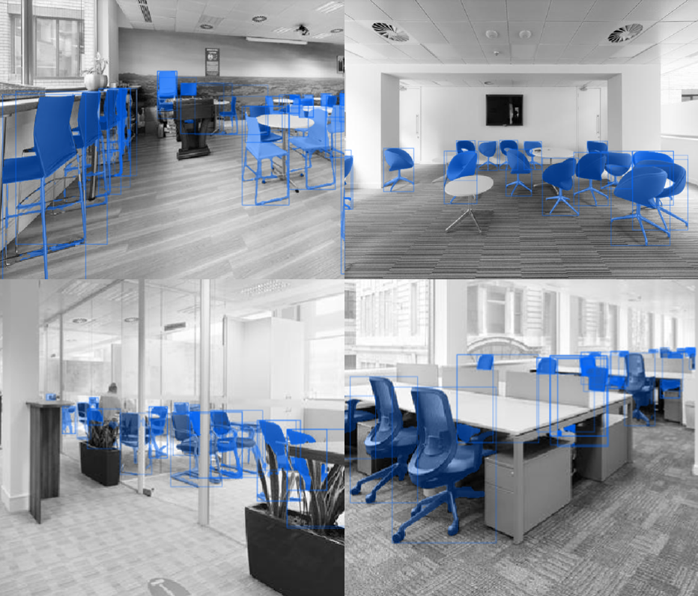
Figure 3: Examples of chair-class ambiguity: false-positive detections on bar chairs (top left) and lounge chairs (top right), compared with true-positive detections of conference chairs (bottom left) and desk chairs (bottom right).

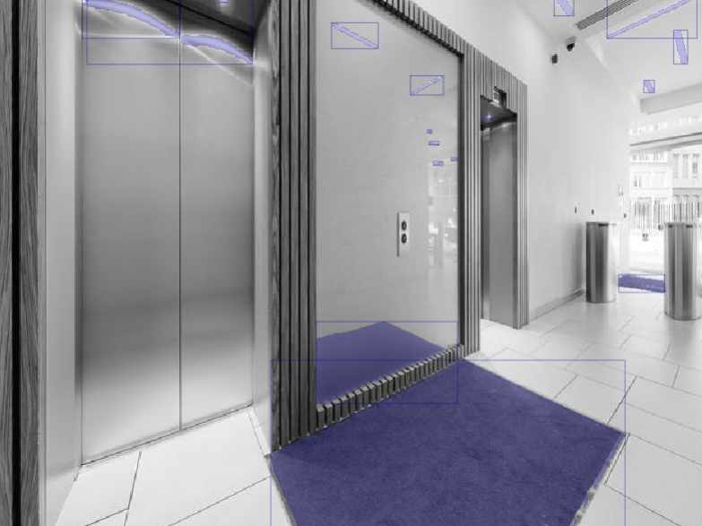
Figure 4: Example of reflections: false-positive detections of carpet and ceiling lights.

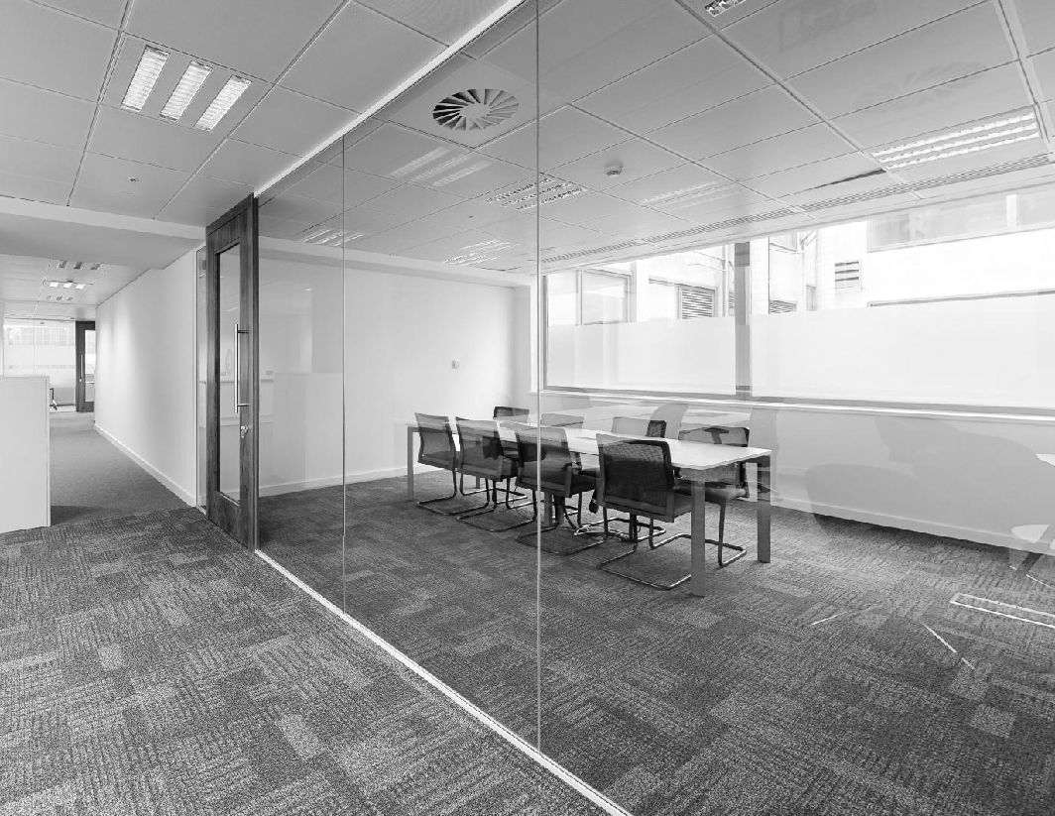
Figure 5: Internal and external glazing as a context-dependent classification problem that the tested models did not reliably resolve.

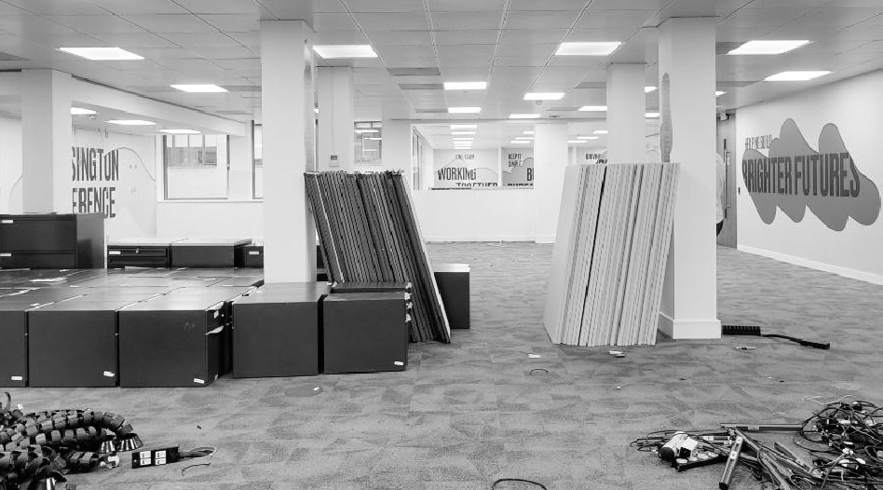
Figure 6: Flipped filing cabinets and disassembled desks as examples of atypical component states that reduced detection reliability.

The quantitative results became interpretable only through visual inspection of the predictions. Six recurring error patterns were identified. First, the models struggled with fine-grained type distinctions that are common in reuse audits. In the PDAs, conference chairs and desk chairs were listed separately because of their quantities and reuse value, while other chair types were not listed. General training datasets and concept text prompts could not reliably distinguish between closely related furniture categories (Figure 3).
Second, reflective and transparent surfaces created systematic false positives. Objects reflected in mirrors or glass were frequently detected as if they were physically present in the room. A logical post-processing rule may remove detections inside mirror regions, but the same rule is not generally valid for glass, because an object may be either a reflection or a real object behind the glass plane (Figures 4 and 5).
Third, functional class names were interpreted too broadly. The clearest example is the class “door”. The text-prompted model detected building doors but also cupboard doors, drawers and dishwasher fronts. The closed-set model avoided some of these semantic false positives but struggled with open doors, where the visible silhouette differs substantially from a closed door.
Fourth, disassembled or flipped components were not reliably detected. Desks with separated tops and frames, or filing cabinets placed on their side, no longer matched the common visual appearance of the object class. This is a specifically relevant PDA problem because reusable components are often moved, stacked or partly dismantled during renovation and strip-out phases (Figure 6).
Fifth, the hypothesis that foundation models would necessarily underperform on building-specific long-tail classes was not supported by the results. For classes such as emergency exit signs and vents, the SAM 3 variants outperformed the closed-set model even where specialised training data had been assembled.
Sixth, glass illustrates a boundary between material recognition and component inventory. All three approaches detected glass only to a limited extent, and none reliably distinguished internal from external glazing as required by the audit reports. The fact that glass was the only class where a closed set model managed to outperform the open vocabulary detection (Figure 2) can be attributed to the high quality of Apple’s Dense Material Segmentation dataset (Upchurch and Niu, 2022).
4. LIMITATIONS
The study is limited by the size and composition of the benchmark. Two case studies, 91 images and 18 classes are sufficient for a contrastive assessment of the three strategies, but not for statistically robust claims about all building component classes. The class distribution is uneven; for example, rare classes such as boilers occur only a small number of times. Class-level scores should therefore be interpreted as indicators of behaviour rather than definitive performance estimates.
The prompt-based approaches were intentionally tested with minimal prompt engineering. Text prompts used the audit terminology directly, and visual exemplar prompting used only one exemplar per class. Future work should test semantically similar terms, richer descriptions, multiple visual exemplars and embedding-based prompt selection. The closed-set approach is also constrained by the availability of external datasets. Some audit-relevant distinctions, such as internal versus external glazing, were not represented by suitable training data.
Finally, this paper evaluates detection only. The broader reuse-oriented workflow also requires instance persistence across viewpoints, spatial localisation, duplicate removal, dimension estimation and condition assessment

5. CONCLUSION
This paper compared closed-set YOLO instance segmentation, SAM 3 text prompting and SAM 3 visual exemplar prompting for detecting reusable building components in real PDA imagery. None of the tested approaches achieved the reliability required for fully automated pre-demolition or pre-renovation auditing. The strongest overall result was obtained by visual exemplar prompting, which achieved an F1 score of 0.40 and provided the best compromise between recall and precision.
The results show that the main obstacle is not simply the absence of a stronger detector. PDA detection requires models to reproduce expert inventory decisions, including fine-grained component distinctions, context-dependent material categories, and atypical object states such as reflected, transparent, disassembled or repositioned components. These error patterns are not well represented in standard computer-vision benchmarks and make reuse-oriented building survey a distinct computer-vision problem rather than a straightforward application of generic object detection.
The three approaches showed complementary strengths and limitations. SAM 3 text prompting is attractive because it detects many objects without training data, but its false-positive rate makes it unsuitable as a direct inventory generator without class-specific confidence calibration. The closed-set YOLO approach is more controllable but depends strongly on the availability and relevance of class-specific training data. Visual exemplar prompting occupies a useful middle ground: it retains the flexibility of a foundation model while allowing the auditor to specify the intended visual subtype with minimal input.
The results therefore support a practical shift from fully automated detection toward assisted, human-in-the-loop inventory generation. In such a workflow, an auditor would define or confirm visual exemplars for relevant building components during a site visit, while the model proposes candidate detections for review.

ACKNOWLEDGEMENTS
This study is part of the research funded by the Zukunft Bau research initiative of the Federal Institute for Research on Building, Urban Affairs and Spatial Development on behalf of the German Federal Ministry for Housing, Urban Development and Building. The authors acknowledge the use of GPT-5.5 for spellchecking and grammar improvements.
REFERENCES
Akyon, F. C., Altinuc, S. O. & Temizel, A., (2022). Slicing Aided Hyper Inference and Fine-Tuning for Small Object Detection. In: 2022 IEEE International Conference on Image Processing (ICIP), Bordeaux, France. https://doi.org/10.1109/ICIP46576.2022.9897990
Carion, N., Gustafson, L., Hu, Y.-T., Debnath, S., Hu, R., Suris, D., Ryali, C., Alwala, K. V., Khedr, H., Huang, A., Lei, J., Ma, T., Guo, B., Kalla, A., Marks, M., Greer, J., Wang, M., Sun, P., Rädle, R., et al., (2025). SAM 3: Segment Anything with Concepts. arXiv:2511.16719. https://doi.org/10.48550/arXiv.2511.16719
Chan, C.-F., Wong, P. K.-Y., Guo, X., Cheng, J. C. P., Chan, J. P.-C., Leung, P.-H. & Tao, X., (2025). Context-aware vision-language model agent enriched with domain-specific ontology for construction site safety monitoring. Automation in Construction, 177, 106305. https://doi.org/10.1016/j.autcon.2025.106305
Çetin, S., (2023). Towards a circular building industry through digitalisation: Exploring how digital technologies can help narrow, slow, close, and regenerate the loops in social housing practice. A+BE | Architecture and the Built Environment, 13(22), 1–236. https://doi.org/10.7480/abe.2023.22.7284
DIN, (2023). DIN SPEC 91484:2023-09. Procedure to record building materials as a base to evaluate the potential for a high-quality reutilization prior to demolition and renovation work (pre-demolition audit). DIN Media. https://www.dinmedia.de/en/technical-rule/din-spec-91484/371235753
European Commission, (2024). EU construction & demolition waste management protocol including guidelines for pre-demolition and pre-renovation audits of construction works. Publications Office of the European Union. https://op.europa.eu/en/publication-detail/-/publication/d63d5a8f-64e8-11ef-a8ba-01aa75ed71a1/language-en
Gupta, A., Dollár, P. & Girshick, R., (2019). LVIS: A Dataset for Large Vocabulary Instance Segmentation. In: Proceedings of the IEEE/CVF Conference on Computer Vision and Pattern Recognition (CVPR). https://doi.org/10.1109/CVPR.2019.00550
Kuznetsova, A., Rom, H., Alldrin, N., Uijlings, J., Krasin, I., Pont-Tuset, J., Kamali, S., Popov, S., Malloci, M., Kolesnikov, A., Duerig, T. & Ferrari, V., (2020). The Open Images Dataset V4: Unified image classification, object detection, and visual relationship detection at scale. International Journal of Computer Vision, 128, 1956–1981. https://doi.org/10.1007/s11263-020-01316-z
Liaw, R., Liang, E., Nishihara, R., Moritz, P., Gonzalez, J. E. & Stoica, I., (2018). Tune: A Research Platform for Distributed Model Selection and Training. arXiv:1807.05118. https://doi.org/10.48550/arXiv.1807.05118
Nauyryzbay, A., Kumisbek, A., Amangeldiyeva, A., Kim, J. R. & Guney, M., (2025). Estimating Demolition Waste Recoverable Fractions in Rapidly Transforming Urban Zones. Sustainability, 17(21), 9686. https://doi.org/10.3390/su17219686
Pu, H., Yang, X., Shi, Z. & Jin, N., (2024). Automated Inspection Report Generation Using Multimodal Large Language Models and Set-of-Mark Prompting. In: 41st International Symposium on Automation and Robotics in Construction, Lille, France. https://doi.org/10.22260/ISARC2024/0130
Qi, C. R., Su, H., Mo, K. & Guibas, L. J., (2017). PointNet: Deep Learning on Point Sets for 3D Classification and Segmentation. In: Proceedings of the IEEE Conference on Computer Vision and Pattern Recognition (CVPR). https://doi.org/10.1109/CVPR.2017.16
Rashdi, R., Martínez-Sánchez, J., Arias, P. & Qiu, Z., (2022). Scanning Technologies to Building Information Modelling: A Review. Infrastructures, 7(4), 49. https://doi.org/10.3390/infrastructures7040049
Son, H., Kim, C., Turkan, Y., Bosché, F. & Haas, C. T., (2015). Scan-to-BIM: An Overview of the Current State of the Art and a Look Ahead. In: Proceedings of the 32nd International Symposium on Automation and Robotics in Construction, Oulu, Finland. https://doi.org/10.22260/ISARC2015/0032
Jocher, G., Qiu, J., Liu, M., Lyu, S., Akyon, F. C. & Kalfaoglu, M. E., (2026). Ultralytics YOLO26: Unified Real-Time End-to-End Vision Models. arXiv:2606.03748. https://doi.org/10.48550/arXiv.2606.03748
Upchurch, P. & Niu, R., (2022). A Dense Material Segmentation Dataset for Indoor and Outdoor Scene Parsing. In: Proceedings of the European Conference on Computer Vision (ECCV). https://arxiv.org/abs/2207.10614
Zhao, F., Zhang, C., Zhang, R. & Wang, T., (2025). Visual Prompt Learning of Foundation Models for Post-Disaster Damage Evaluation. Remote Sensing, 17(10), 1664. https://doi.org/10.3390/rs17101664

