A Comprehensive Literature Review of Personalised Indoor Comfort: Artificial Intelligence Approaches and Applications
SHIYI SUN^{1,} HAIJIANG LI^{1*}, ALI KHUDHAIR¹

¹ BlM for Smart Engineering Centre, School of Engineering, Cardiff University,Cardiff, UK,

ABSTRACT:
With the rising demand for human-centric and energy-efficient indoor environments, Artificial Intelligence (AI) has emerged as a transformative tool for enhancing personalised comfort in buildings. This review synthesises findings from 90 peer-reviewed studies published between 2008 and 2024, focusing on AI applications across four primary comfort dimensions: Thermal Comfort (TC), Indoor Air Quality (IAQ), Acoustic Environment (AE), and Visual Comfort (VC). Results reveal a significant research disparity, with 97.75% of studies focusing solely on TC, leaving IAQ, AE, and VC untapped. While AI techniques, such as Artificial Neural Networks (ANNs), Support Vector Machines (SVMs), and Random Forests (RF), demonstrate high predictive accuracy for TC, integrated, multidimensional comfort models remain scarce. Key gaps include cross-domain modelling, context-specific adaptation, integration of physiological and psychological indicators, and privacy-aware AI deployment. This study proposes a multidimensional framework that fuses environmental and personal factors to support holistic comfort modelling. It presents strategic insights for developing inclusive, adaptive, and privacy-conscious AI-driven comfort systems, guiding future research and practical implementation in the built environment.
KEYWORDS:
personalised comfort, thermal comfort, artificial intelligence, machine learning, indoor environmental quality

1. INTRODUCTION
People spend approximately 87% of their time indoors (Klepeis et al., 2001), making indoor environmental quality a critical factor for health, well-being, productivity, and overall satisfaction (Vimalanathan & Babu, 2020; Abbasi et al., 2021; Lan et al., 2021; Wu et al., 2021a; Wu et al., 2021b). Despite building design standards aimed at ensuring thermal comfort for at least 80% of occupants, real-world satisfaction levels are significantly lower. A study in North America, for instance, found that only 38% of surveyed occupants were satisfied with indoor temperatures (Karmann et al., 2021), revealing a persistent disconnect between design expectations and actual user experiences.
Thermal comfort is primarily assessed using the Predicted Mean Vote (PMV) and Predicted Percentage of Dissatisfied (PPD) models. However, these models often fail to capture actual occupant experiences. Cheung et al. (2021), using the ASHRAE Global Thermal Comfort Database II, found that PMV accurately predicted thermal sensations in only 34% of cases. Similarly, Lan et al. (2021) and others have criticised these models for neglecting individual differences such as age, gender, metabolic rate, clothing insulation, and physical activity. For example, metabolic heat increases with movement (Liu et al., 2021), while light activity in cooler environments can reduce thermal discomfort (Vasilikou & Nikolopoulou, 2019). These findings highlight the need for personalised comfort models that account for physiological and behavioural diversity.
At the same time, buildings are responsible for around 40% of global energy consumption and nearly one-third of greenhouse gas emissions (Cao et al., 2021; Yang et al., 2021). Over 50% of building energy performance (BEP) outcomes are influenced by human behaviour, operation strategies, and indoor environmental quality (Yoshino et al., 2021). Therefore, aligning comfort optimisation with energy efficiency is essential for sustainable building operation.
In recent years, AI has emerged as a powerful tool in this context, offering data-driven models that can predict and adapt to occupant comfort needs. Machine learning techniques such as Artificial Neural Networks (ANNs), Support Vector Machines (SVMs), and Bayesian algorithms have achieved predictive accuracies exceeding 80% (Wahid et al., 2019; Shan et al., 2021; Jiang & Yao, 2021; Tekler et al., 2021). These models can incorporate both environmental data and occupant feedback, enabling more adaptive and personalised comfort control. However, current research is disproportionately focused on TC, while other crucial comfort dimensions such as IAQ, AE, and VC remain underexplored (Fantozzi & Rocca, 2021; Pigliautile et al., 2021). Comfort is inherently multisensory and multidimensional, with complex interactions between its various factors. For example, Li et al. (2021) demonstrated that temperature and humidity levels directly influence perceived air quality, with higher temperatures and humidity reducing IAQ satisfaction. Despite such interactions, most AI-driven studies analyse each factor in isolation, limiting their effectiveness in real-world scenarios.
Moreover, personalised comfort is shaped not only by environmental variables but also by physiological and psychological attributes (Li et al., 2021; Kosonen & Tan, 2021). Factors such as stress, cognitive load, and emotional state can substantially affect comfort levels. Achieving truly personalised comfort requires integrating these human-centric indicators into AI models.
Additionally, many AI systems rely on sensitive data from personal sensors or cameras to assess individual parameters, such as clothing insulation or activity levels. While effective, these methods raise significant concerns about privacy (Khalil et al., 2021). Without secure data handling and privacy-preserving mechanisms, such technologies risk eroding user trust and may hinder large-scale implementation.
This paper presents a comprehensive literature review of AI applications in personalised indoor comfort. Specifically, the study analyses how AI has been applied to model personalised comfort, compares the accuracy and interpretability of different machine learning techniques, and proposes a multidimensional comfort framework that incorporates both environmental and personal factors. The paper also highlights key research gaps and offers recommendations for future development of intelligent, inclusive, and secure comfort systems. The paper is structured as follows: Section 2 outlines the research methodology, including the literature review strategy and data analysis techniques used to synthesise relevant studies. Section 3 introduces a multidimensional theoretical framework for personalised indoor comfort, derived from the literature, and provides a detailed analysis of both environmental and personal comfort indicators. Section 4 reviews the current state of AI applications in personalised indoor comfort, with a focus on three key domains: thermal comfort prediction, smart environmental control optimisation, and strategies for improving data efficiency and privacy protection. Section 5 presents a critical discussion of existing research gaps and future directions, highlighting the need for integrated, multidimensional models, cognition-aware personalisation, contextual adaptability across building types, and robust, privacy-preserving AI frameworks. Finally, the conclusion is given in Section 6.

METHODOLOGY
This study adopts the Comprehensive Literature Review (CLR) method to systematically evaluate and synthesise existing research in the field of personalised indoor comfort. The CLR approach integrates both quantitative and qualitative studies, covering theoretical frameworks, experimental research, modelling techniques, and AI applications. This methodology offers a comprehensive understanding of current trends, research gaps, and future directions in this interdisciplinary field.
To ensure the authority and comprehensiveness of the sources, literature retrieval was primarily conducted using Scopus and Web of Science databases. Search queries included keywords such as ‘Building Comfort’, ‘Personalised Comfort Models’, ‘Artificial Intelligence’, and ‘Machine Learning’, combined with Boolean operators to optimise relevance. The inclusion criteria were as follows:
(1) Timeframe: Publications from 2008 to 2024 were selected to ensure the inclusion of both foundational and recent studies.
(2) Document type: Only peer-reviewed journal articles, review papers, and conference proceedings were considered. Grey literature (e.g., blogs, white papers, news reports) was excluded.
A total of 1,705 documents were initially retrieved. A two-stage screening process was applied to ensure the selection of high-quality and relevant studies. In the first stage, title, abstract, and keyword screening, 382 duplicate records were removed. After excluding irrelevant studies, 229 papers remained. In the second stage, full-text screening was conducted to eliminate papers with unclear methodologies, insufficient data, or conclusions misaligned with the review objectives. Redundant papers with overlapping methods or datasets were also removed. Priority was given to recent and highly cited studies to enhance academic impact and timeliness. Ultimately, 78 core publications were selected for in-depth review. The screening process is illustrated in Figure 1.
To ensure completeness, this study also incorporated relevant international standards and industry guidelines, including ASHRAE 55, ISO 7730, EN 16798-1, ISO 16000, and the ISO 3382 series, which are commonly used benchmarks for evaluating indoor comfort. Additionally, a backward citation analysis of the 78 core publications was conducted, resulting in the inclusion of 12 additional relevant studies.In total, 90 core papers were analysed. These papers were selected based on the following criteria:
- direct relevance to indoor environmental comfort (thermal, acoustic, visual, or air quality).
- contribution to methodological development or application in comfort assessment.
To identify research hotspots and thematic trends, VOSviewer software was employed for co-word analysis. Keywords and phrases appearing at least five times across the 90 core articles were extracted and visualised to highlight dominant themes and topic evolution (see Figure 2). As shown in Figure 2, “thermal comfort” emerged as the most frequently occurring and most centrally connected term, indicating its dominant position in the field of comfort-related research. While this focus has driven advancements in thermal comfort modeling and personalization, it also reflects a narrow application scope of AI, with limited exploration of how such techniques could enhance understanding and management of acoustic, lighting, or air quality comfort.

MULTIDIMENSIONAL FRAMEWORK FOR PERSONALISED INDOOR COMFORT
To advance the development of intelligent, adaptive, and human-centric indoor environments, this study proposes a Multidimensional Framework for Personalised Comfort (Figure 3). Derived from the analysis of 90 peer-reviewed studies and established international standards (e.g., ASHRAE 55; ISO 7730), this framework conceptualises personalised comfort as a dynamic outcome of bidirectional interactions between environmental conditions and individual characteristics. The framework serves two core purposes: (1) to structure and synthesise the fragmented literature across the four principal comfort dimensions: TC, IAQ, AE, and VC; (2) to guide the development of AI-driven comfort models that integrate environmental and personal indicators for holistic, adaptive control.
As illustrated in Figure 3, the framework is composed of two primary domains: (1) Environmental Comfort Indicators, influenced by the local climate and indoor environment; (2) Personal Comfort Indicators, encompassing physical, physiological, psychological, and behavioural traits. These domains are interconnected through contextual interplay, forming the foundation for AI systems that generate adaptive, real-time responses to occupant needs.

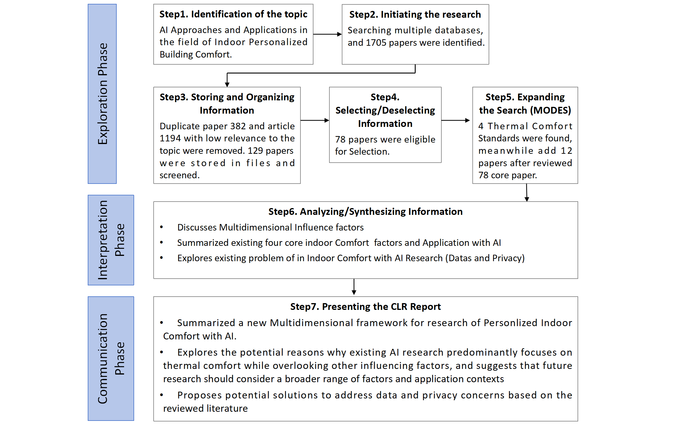
Figure 1: Flowchart of the publication selection process according to CLR.
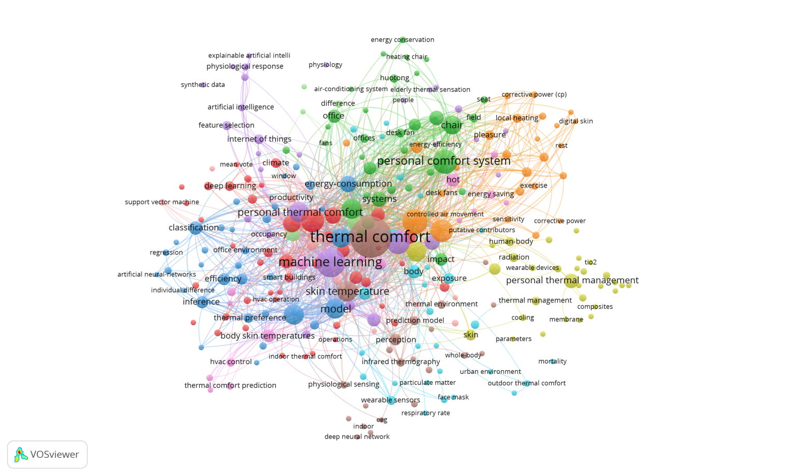
Figure 2: VOSviewer Keywords.

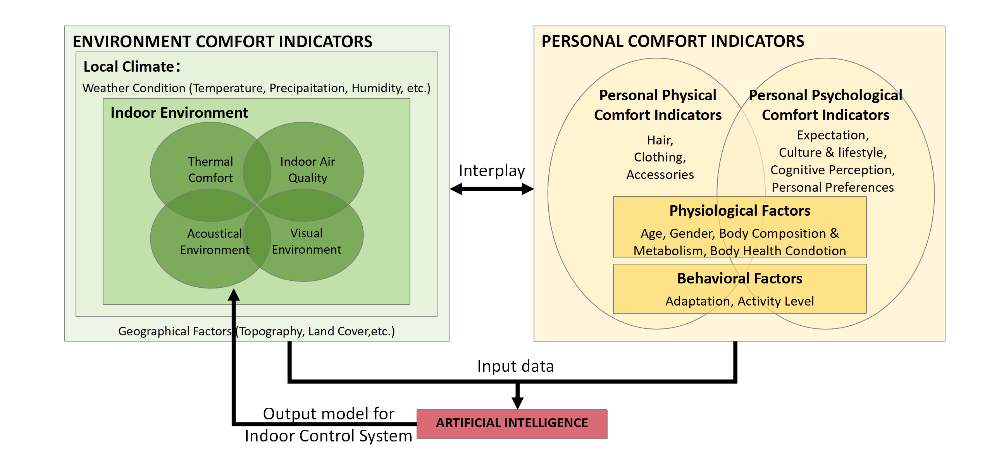

Figure 3: Multidimensional Framework for Personalized Comfort.

3.2. Environmental Comfort Indicators
Environmental comfort indicators are categorised into two interrelated layers: the Local Environment and the Indoor Environment. Together, these layers determine the physical conditions occupants experience and form the foundational layer of the proposed Multidimensional Framework for Personalised Comfort (see Figure 3).
The Local Environment refers to the broader geographical, climatic, and cultural context in which a building is situated. As an external factor, it significantly influences architectural design choices and indoor environmental conditions. In contrast, the Indoor Environment comprises the controllable physical parameters within a building that directly shape occupants’ sensory experiences, health, and comfort (Fantozzi & Rocca, 2021; Pigliautile et al., 2021).

3.2.1 Local Environment Factors
The local environment includes both climate conditions—such as temperature, solar radiation, precipitation, humidity, wind speed, and snowfall—and geographical and cultural variables, including topography, land use, and occupant behaviour norms. These factors influence building performance, thermal loads, ventilation strategies, and passive design decisions (González, 2021; Xiong et al., 2021; Huang et al., 2021). For example, coastal regions benefit from oceanic moderation, resulting in smaller temperature fluctuations but higher humidity levels. This often necessitates the use of energy-intensive dehumidification systems (Philokyprou et al., 2021). Conversely, inland arid zones require humidifiers to maintain indoor relative humidity within a comfort range (Lei & Liu, 2013).
Geographical characteristics, such as elevation and urban morphology, also affect comfort. In mountainous areas, lower temperatures and thinner air require well-insulated, airtight construction to minimise heat loss. In urban centres, the urban heat island effect elevates ambient temperatures, demanding adaptive shading and ventilation strategies to mitigate overheating (Shen et al., 2021).
Cultural factors also play a significant role. Variations in lifestyle, space usage, and daily routines can impact comfort perception and indoor conditions. For instance, BK et al. (2023) found that Asian households spend five times more time cooking daily than British households, leading to significantly higher indoor pollutant levels under otherwise similar spatial conditions. To ensure effective comfort system design, it is essential to integrate climatic, geographical, and cultural variables into both building-level strategies and AI-driven comfort models.

3.2.2 Indoor Environment and Current AI Research Trends
The Indoor Environment comprises four core comfort dimensions that directly affect occupant health, satisfaction, and productivity (Fantozzi & Rocca, 2021; Pigliautile et al., 2021). While each of these domains has been the subject of international technical standards (e.g., ASHRAE, ISO), their integration into AI-based personalised comfort systems remains uneven.
TC refers to an individual’s perception of being thermally “neutral”—neither too hot nor too cold—under specific thermal conditions (ASHRAE 55, 2020; ISO 7730, 2005). It has the most developed research base and is strongly correlated with energy consumption and the performance of HVAC systems. Recent AI and ML studies have successfully enhanced TC prediction accuracy and enabled dynamic HVAC control (Kim et al., 2021).
IAQ refers to the cleanliness and health of indoor air, influenced by pollutants such as CO₂, PM2.5, VOCs, and by factors including ventilation type, relative humidity, and oxygen levels (ASHRAE 62.1, 2019; ISO 16000, 2004). Poor IAQ can lead to respiratory illness, fatigue, and cognitive decline (Li et al., 2021). Despite its significance, IAQ remains underrepresented in AI studies, often treated as a secondary element to TC. Fanger (1987) introduced DECIPOL as a subjective measure of perceived air pollution; however, AI models rarely incorporate IAQ as a primary target (Kim et al., 2021).
AE involves the quality and level of sound within a space, including noise, reverberation, and sound clarity. Poor acoustics can lead to increased stress, reduced concentration, and fatigue (Berglund et al., 1999; ISO 3382-1, 2009; ISO 22955, 2021). AE is influenced by both external sources (e.g., traffic, construction) and internal sources (e.g., HVAC systems, appliances). Room geometry and material choices also play critical roles. AI research in AE is still limited and often explored alongside TC and IAQ, particularly in efforts to reduce HVAC noise (Muthuraj et al., 2023).
VC refers to the adequacy of lighting in terms of intensity, colour temperature, glare, and spatial layout. Lighting impacts circadian rhythms, visual health, and emotional well-being (Giarma et al., 2021; ISO 8995, 2002; LEED, 2021). AI applications in VC are emerging, focusing on co-optimising lighting and thermal conditions. However, VC remains the least explored dimension in AI comfort research (Khosravi et al., 2023).
This study systematically analysed 90 core AI-related papers focusing on the Indoor Environment and found that TC dominates, accounting for 97.75% of the studies. In comparison, IAQ accounted for 3.37%, AE for 1.12%, and VE for 2.25%. Moreover, IAQ, AE, and VE are rarely studied as independent topics but are often integrated with TC, forming a cross-disciplinary research pattern.
As shown in Figure 4, most studies on IAQ, AE, and VC are not standalone investigations, but are embedded within broader TC-focused research. The figure employs an overlapping visualisation rather than a traditional pie chart to reflect the interconnected nature of these comfort domains.

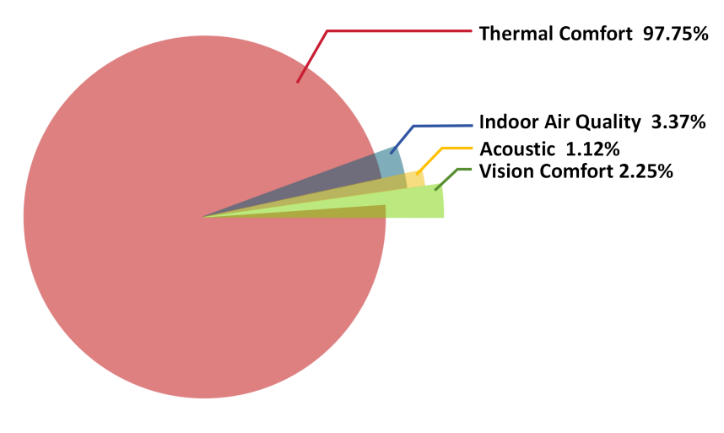
Figure 4: Current Research on Indoor Comfort Indicators with AI: TC overwhelmingly dominates the AI literature, while IAQ, AE, and VE remain underrepresented and often integrated into TC studies.

The dominance of TC in AI research is primarily due to its direct link to energy efficiency, as TC significantly influences the performance and energy consumption of HVAC systems (Li et al., 2023). Occupants often manually adjust temperature settings in response to discomfort, leading to added energy consumption. Optimising TC can therefore improve both comfort and sustainability, aligning with low-carbon building objectives. However, comfort dimensions are inherently interconnected (Tang et al., 2021). For instance, high temperature and humidity levels increase indoor pollutant emissions, affecting IAQ (Huang et al., 2023). Sound pressure levels can negatively impact thermal perception (Tang et al., 2021). Lighting colour temperature can influence thermal sensation. These interactions necessitate the need for multi-factor AI models that move beyond single-variable predictions to address the complexity of real-world comfort scenarios.

3.3. Personal Comfort Indicators
In the proposed Multidimensional Framework for Personalised Comfort (Figure 3), personal comfort indicators are positioned as a critical complement to environmental factors. While traditional models often treat personal variables as secondary—typically adjusting only TC estimates—this study recognises them as cross-cutting determinants that influence all four comfort domains: TC, IAQ, AE, and VC. Drawing upon interdisciplinary research in physiology, psychology, and behavioural science, personal comfort indicators are categorised into three interconnected domains: Physiological Factors, Psychological Factors and Behavioural Factors. Together, these factors determine how individuals interpret, adapt to, and interact with their indoor environments.

3.3.1. Physiological Factors
Physiological characteristics shape how the body responds to environmental stimuli and influence baseline comfort thresholds. Older adults often exhibit reduced thermoregulatory capacity and narrower TC ranges. As a result, they are more vulnerable to environmental fluctuations and may require more stable indoor conditions to maintain comfort and health. Moreover, Gender-based differences in thermal perception have been widely studied, though results remain inconclusive. Wang et al. (2021) identified three general findings across the literature: statistically significant differences, (2) weak or non-significant trends, and (3) no observable differences. While several studies suggest women report lower satisfaction with thermal environments than men, this trend is not universal. For example, Indraganti and Rao (2010) found higher thermal satisfaction among women in India, highlighting the role of cultural and climatic contexts.
Other physiological variables such as body fat percentage, muscle mass, and metabolic rate influence both heat production and dissipation. Individuals with higher metabolic rates or distinct body compositions may experience discomfort in the same environmental conditions that others find acceptable. Similarly, individuals with chronic illnesses or cardiovascular, respiratory, or neurological conditions may have altered responses to temperature, air quality, or noise, necessitating more tailored comfort strategies.

3.3.2. Psychological Factors
Psychological variables significantly mediate the perception and evaluation of environmental conditions. For instance, People’s thermal expectations are shaped by their regional climate, social norms, and past exposure. For example, individuals from colder regions may be more tolerant of lower temperatures than those from warmer climates. Moreover, Sedentary individuals may prefer warmer conditions, while those with active routines may find cooler environments more comfortable. Personality traits such as openness or neuroticism may also affect comfort sensitivity.
Emotional and cognitive contexts influence perceptions of comfort. A noisy environment may feel more disruptive during focused work than during leisure activities, while lighting conditions can impact mood and alter the perception of temperature and noise.

The cultural context is another important psychological factor. Cultural expectations about noise levels, lighting preferences, spatial openness, and cooking behaviours can influence the way comfort is experienced.

3.3.3. Behavioural Factors
Behavioural factors reflect how individuals actively manage their environment to restore or maintain comfort. One of the most immediate behavioural responses to discomfort, clothing affects thermal perception and energy balance. While standards like ASHRAE 55 incorporate clothing insulation into thermal models, real-world clothing choices are influenced by factors such as fashion, culture, gender norms, and dress codes, making them complex to predict.
Activity level also plays a role, as Physical exertion increases metabolic heat production and alters thermal sensation. Occupant activity varies by context, such as workplaces, classrooms, and gyms, and demands situationally adaptive comfort strategies. Moreover, sitting, standing, or transitioning between physical states impacts perceived comfort and heat exchange with the environment. Actions such as adjusting windows, using fans or heaters, changing rooms, or modifying lighting are common responses to discomfort. These behaviours introduce variability into comfort modelling but also provide valuable data about user preferences.
Many comfort experiments have attempted to standardise behavioural variables (e.g., requiring participants to wear similar clothing or remain seated) to isolate environmental effects (Wyon et al., 1971; Beshir & Ramsey, 1981; Grivel & Candas, 1991). While effective for controlled research, such approaches do not reflect the adaptive richness of real-world environments. AI-based comfort models must therefore be designed to accommodate behavioural variability, not suppress it.
Despite growing recognition of the importance of personal comfort indicators, most AI models continue to prioritise environmental data alone, treating personal variables as static (e.g., age, gender) or excluding them entirely due to data collection challenges. However, advancements in wearable technology, smart furniture, and affective computing are making physiological and behavioural data increasingly accessible. These technologies provide a pathway to: (1) Real-time monitoring of personal comfort states; (2) Dynamic model adaptation based on user feedback and biometric inputs; (3) Context-aware system responses that personalise comfort delivery.
To unlock the full potential of personalised comfort, future research must prioritise the integration of physiological, psychological, and behavioural indicators—not only in TC modelling but across IAQ, AE, and VC domains as well. Doing so will require truly interdisciplinary collaboration, combining insights from environmental engineering, data science, psychology, and human-computer interaction. Such integration is crucial for creating inclusive, adaptive, and intelligent indoor environments that respond to both environmental and human complexities.
Taken together, environmental and personal comfort indicators form a tightly interconnected system, where physical conditions and individual responses co-evolve in real time. Recognising this interplay is essential for designing intelligent indoor environments that adapt not only to external variables, but also to the nuanced needs of diverse occupants. The next section examines how AI is currently utilised to model, predict, and optimise comfort across these dimensions—highlighting current trends, limitations, and future opportunities.

AI APPLICATION IN PERSONALISED INDOOR COMFORT
AI technologies are being gradually applied to indoor comfort research, particularly in the domain of TC. Among the 90 core studies reviewed in this work, TC accounted for over 97% of AI-related comfort modelling. In contrast, research on IAQ, AE, and VE remains underdeveloped and typically integrated with thermal modelling rather than treated independently (Figure 4). This section synthesises current AI applications in personalised indoor comfort, focusing on three principal areas: (1) thermal comfort prediction, (2) smart environmental control optimisation, and (3) data efficiency and privacy strategies.

4.1. Thermal Comfort Prediction
TC prediction is the most extensively explored application of AI in indoor environmental research. AI models aim to estimate occupants’ thermal states—typically expressed through thermal sensation votes (TSV), thermal preference, or comfort/discomfort classifications—based on environmental and personal input features.
A range of machine learning algorithms have been applied to this task, including ensemble and optimisation techniques such as Random Forest (RF), Support Vector Machine (SVM), Gradient Boosting Machines (GBM), and Extreme Gradient Boosting (XGBoost). These models have consistently outperformed traditional statistical approaches and the widely used PMV model, which often fails to capture the complexity of real-world occupant responses.
Recent studies demonstrate that hybrid AI structures can improve prediction accuracy by 10%–40% (Feng et al., 2023; Liu et al., 2025; Haghirad et al., 2023). Notable approaches include: (1) Combining mathematical models with machine learning; (2) Integrating physiological signal data (e.g., skin temperature, heart rate); (3) Applying reinforcement learning for dynamic control and adaptation. These techniques have been shown to improve both comfort prediction and energy efficiency, with some studies reporting up to 22% energy savings without compromising user satisfaction.
Another emerging trend is contextualising TC models based on building type. Generic models often fail to perform well across different environments, such as schools, offices, or homes, due to variations in activity patterns and occupant expectations. For example, Bai et al. (2025) found that Gradient Boosting Machines (GBM) performed best in classrooms, achieving an accuracy of 94.49%. In contrast, Random Forest (RF) was more effective in offices and residential buildings, achieving accuracies of 81.62%–84.97%. This study underscores the importance of contextualising model development to the functional and operational characteristics of different indoor environments. Table 1 presents a selection of AI-based TC prediction studies, highlighting their algorithms, settings, and performance outcomes.

Table 1: Thermal Comfort Prediction Article Summary
Author | AI Algorithm | Application Scenarios | Key Findings
Aryal & Becerik-Gerber, 2019 | RF,SVM,KNN,subspace KNN | General Building | Introducing Thermal Sensation and Thermal Satisfaction for TC prediction, achieving the highest accuracy by combining Air Temperature, Wrist Temperature, and Thermal Camera data.
Zhao et al., 2014 | Recursive Least Squares, RLS | Office | The PDTC model achieves higher accuracy in describing personal TC, with significantly lower prediction and regression errors (MSE and Bias) than the traditional PMV model.
Qi et al. (2023). | SVR | General Building | The personalised regression model has an RMSE of 0.6692, with the lowest MAE at 23°C and 26°C, measuring 0.657 and 0.541, respectively.
Haghirad, Heidari and Hosseini (2024) | RF | General Building | The accuracy reaches 34% when using the PMV model and 72.4% when incorporating 12 related parameters.
Ghahramani et al. (2015) | Online Learning + Bayesian Network | General Building | The prediction accuracy is 70.14% ± 8.20%.
Wu et al. (2023). | RF, SVM, Logistic Regression (LR) | General Building | SVM achieves the highest accuracy at approximately 78%.
Wu et al., 2023 | RF, LR, SVM | General Building | RF achieves the highest accuracy at approximately 69%
Wang et al., 2020 | SVM， LR | General Building | SVM achieves the highest accuracy at 63.9%.
Kliangkhlao et al., 2024 | SVM， KNN, ANN | General Building | With physiological parameters included, SVM achieves the highest accuracy at approximately 95%.
Feng, Wang, Wang and Chen (2023) | RF, XGboost | Dwelling | With the inclusion of physiological parameters, XGboost achieves a prediction accuracy of 98.95%.
Bai et al. (2025). | Gradient Boosting Machine(GBM), Extreme Gradient Boosting(XGB),RF | Classroom, Office, Dwelling | GBM is suitable for classrooms (94.49%), while RF is suitable for offices and multi-unit residential buildings (81.62% and 84.97%, respectively).

4.2. Smart Environmental System Control Optimisation
Beyond prediction, AI is being actively used to power intelligent environmental control systems, particularly within HVAC (Heating, Ventilation, and Air Conditioning) operations. These systems aim to maintain personalised comfort while optimising energy use. Unlike static or purely predictive models, smart control systems operate in real-time closed-loop configurations, where environmental parameters are continuously adjusted in response to new data and occupant feedback. Key AI techniques in this domain include Model Predictive Control (MPC), Deep Reinforcement Learning (DRL), and various forms of intelligent logic embedded in HVAC and Personal Comfort Systems (PCS).
Chaudhuri et al. (2019) proposed a collaborative control strategy that integrates central HVAC systems with localised PCS devices. This hybrid approach enables individual occupants to fine-tune their immediate environment, reducing the load on central systems and significantly improving both comfort and energy efficiency. Similarly, Muthuraj et al. (2024) developed a noise-aware ventilation control system for classroom environments. Their model classified air conditioning unit (ACU) noise levels and used this information to dynamically adjust ventilation settings, thereby balancing thermal and acoustic comfort. These studies demonstrate how AI can facilitate multidimensional comfort control, extending beyond temperature to encompass noise, air quality, and user preferences.
The integration of AI into environmental control systems allows for a range of advanced functionalities. These include dynamic adjustment of temperature and airflow setpoints, coordination between central HVAC and PCS units, and continuous learning from real-time feedback to improve user satisfaction. The ability to personalise comfort delivery at the individual level, while also reducing energy consumption, represents a significant advancement toward adaptive, occupant-centric smart buildings.

4.3. Data-Driven Efficiency and Privacy Challenges
While the potential of AI for personalised comfort is clear, these systems are highly dependent on large volumes of high-quality data. The availability, granularity, and reliability of input data directly influence the precision of model outputs. At the same time, collecting such data presents significant challenges in terms of efficiency, scalability, and privacy. As AI comfort systems evolve toward real-time and individualised operation, researchers are increasingly focused on strategies to reduce data dependency and enhance user privacy without compromising model performance.
One approach to reducing data requirements involves clustering users based on similar thermal preferences. This enables the development of generalised comfort models that do not require individual-level training for every occupant. For example, Lee et al. (2017) combined clustering techniques with Bayesian Optimisation and XGBoost to build efficient TC models in office settings. Their method reduced data collection costs and computational complexity while maintaining strong predictive accuracy.
Another promising strategy is Federated Learning (FL), which allows AI models to be trained across decentralised edge devices without transmitting raw data to a central server. Instead, only encrypted model parameters are shared, preserving user privacy. Khalil et al. (2022) applied Federated Neural Networks (Fed-NN) in both factory and office environments, achieving 80.39% prediction accuracy while reducing communication costs and safeguarding personal data, making this approach particularly suitable for privacy-sensitive contexts such as smart homes and healthcare facilities.
To address data scarcity in under-instrumented buildings, researchers have turned to deep learning and transfer learning techniques. Somu et al. (2021) proposed a hybrid CNN-LSTM model capable of processing spatiotemporal sensor data and demonstrated that transfer learning could effectively reduce the amount of labelled training data required. Tekler et al. (2024) further tested a TL-CNNLSTM-FT model and reported minimal loss in accuracy even when training data was reduced to just 10% of the full dataset. Yang et al. (2025) compared several hybrid AI models, including Hybrid Decision Trees, SVM, KNN, RF, and Neural Networks, and found that the Hybrid-NN variant achieved the highest overall prediction accuracy at 97.78%.
Together, these advancements in data efficiency and privacy protection are critical for scaling AI-based comfort systems. They open the door to broader deployment in diverse building types and user groups, without imposing excessive data burdens or violating user privacy. Table 2 summarises representative recent studies in the areas of data optimisation, privacy protection, and AI algorithm enhancement.

Table 2: Representative Studies on Data Efficiency and Privacy in AI-Based Thermal Comfort Research

Author | AI Algorithm | Application Scenarios | Main Finding
Lee et al., 2017 | Bayesian Optimization + XGBoost | Office | A generalised model is built using clustering methods, reducing the need for individual modelling.
Khalil et al., 2022 | Fed-NN | Factory and Office | The prediction accuracy is 80.39%, while protecting privacy and reducing costs.
Somu et al. (2021) | Hybrid Deep Transfer Learning, TL CNN-LSTM（Transfer Learning Convolutional Neural Networks-Long Short-Term Memory） | General Building | By combining CNN and LSTM to process spatiotemporal data, transfer learning reduces the data requirements for training.
Tekler et al., 2024 | TL-CNNLSTM-FT（Thermal Preference and Air Movement Preference） | General Building | The accuracy is 69.3% with 100% of the data and 66.8% with 10% of the data.
Yang et al. (2025). | Hybrid-DT, Hybrid-SVM, Hybrid-KNN, Hybrid-RF, Hybrid-NN | General Building | Hybrid-NN achieves the highest prediction accuracy at 97.78%.

DISCUSSION AND FUTURE DIRECTIONS
This study has synthesised recent advancements in the integration of AI with personalised indoor environmental comfort. While considerable progress has been made, particularly in the domain of TC, research into other critical dimensions such as IAQ, AE, and VC remains underdeveloped. These dimensions are often addressed in isolation, lacking the coherent, multidimensional frameworks necessary for holistic comfort modelling. As the field transitions from single-variable optimisation to occupant-centric systems, future research must address five interrelated challenges: theoretical integration, deep personalisation, contextual adaptability, privacy protection, and collaborative infrastructure.
First, current models are predominantly focused on TC, with limited cross-dimensional integration. However, indoor comfort is inherently multidimensional, shaped by complex interactions among environmental variables. For example, temperature and humidity jointly affect the emission and perception of volatile organic compounds (VOCs), influencing IAQ. Acoustic conditions can modulate thermal perception and cognitive performance, while lighting brightness and colour temperature influence circadian rhythms and may even affect thermal sensitivity. Future AI models should capture these nonlinear interdependencies using advanced architectures such as Bayesian networks, graph-based reasoning, or multimodal deep learning, which can fuse heterogeneous data streams into unified comfort prediction and control systems.
Second, current personalisation efforts are often limited to basic demographic or physiological variables such as age, gender, and body mass. While informative, these features fall short of capturing the cognitive, emotional, and cultural dimensions of comfort perception. Emerging technologies in affective computing and wearable sensing offer promising pathways for deeper personalisation. Physiological signals such as electroencephalography (EEG), electrodermal activity (EDA), heart rate variability (HRV), and facial expression analysis can provide rich, real-time proxies for cognitive and emotional states. By integrating these signals with psychological profiling, AI systems can evolve from reactive comfort control to cognition-aware, emotion-sensitive models, enhancing inclusivity and responsiveness.
Third, comfort needs and behavioural patterns vary significantly across building types—such as homes, offices, classrooms, and healthcare settings—yet most AI models are developed and validated in homogeneous environments. This limits their generalisability and practical deployment. Future research should prioritise the creation of scenario-specific comfort ontologies and adaptive models capable of transferring knowledge across spatial, functional, and cultural contexts. Techniques such as transfer learning, domain adaptation, and reinforcement learning can support rapid calibration to new environments. Additionally, embedding contextual metadata—including room function, occupancy patterns, and local climate—into AI pipelines can improve both predictive accuracy and control robustness.
Fourth, as AI systems increasingly rely on personal and physiological data, privacy protection emerges as a critical barrier to widespread adoption. Although methods such as federated learning and data anonymisation offer promising solutions, several challenges remain. These include high algorithmic and communication overhead, slow convergence rates in decentralised models, and vulnerabilities to model inversion and side-channel attacks. To mitigate these risks, future research should explore hybrid privacy-preserving frameworks—such as federated learning combined with differential privacy to bound data leakage risks, blockchain-based multiparty computation for decentralised trust management, and edge computing to enable localised inference and reduce data transmission.
Finally, to accelerate progress and promote reproducibility, the field would benefit from the creation of an open, multidimensional indoor comfort data-sharing platform. This platform should include standardised comfort metrics across TC, IAQ, AE, and VC; annotated physiological, behavioural, and affective indicators; and privacy-safe, user-consented data collection protocols. Equally important is the cultivation of cross-disciplinary collaboration among environmental engineers, architectural scientists, cognitive psychologists, data scientists, and ethicists. Such collaboration is essential to design comfort systems that are not only intelligent and adaptive but also equitable, inclusive, and ethically grounded.

CONCLUSION
This study has reviewed and synthesised recent advancements in the application of AI to personalised indoor comfort modelling. It focused on three core domains: thermal comfort prediction, smart environmental control optimisation, and strategies for improving data efficiency and privacy protection. The findings reveal a significant imbalance in the literature, with thermal comfort dominating current research while other key comfort domains—such as IAQ, AE, and VC—remain substantially underrepresented.
Although AI models have made notable progress in capturing individual preferences, several critical challenges persist. These include the lack of integrated, cross-dimensional models; limited adaptability across various building types and user groups; insufficient incorporation of psychological and affective indicators; and growing concerns over data privacy, transparency, and ethical use.
To address these gaps, this study proposes a multidimensional framework that integrates both environmental and personal comfort indicators. Based on the findings, four priority areas are recommended for future research and development: (1) the creation of unified, multi-factor comfort models that account for the interplay between TC, IAQ, AE, and VC; (2) the integration of cognitive, emotional, and physiological factors to enable deeper personalisation; (3) the development of adaptive, generalisable models suitable for diverse real-world settings; and (4) the implementation of privacy-aware AI approaches that balance performance with ethical data stewardship.
With continued interdisciplinary collaboration and technological innovation, AI has the potential to move beyond simple comfort prediction and become the foundational engine of intelligent, inclusive, and privacy-conscious indoor environments, enabling a new generation of human-centric smart buildings.

REFERENCES
Abbasi, A.M., Motamedzadeh, M., Aliabadi, M., Golmohammadi, R., Tapak, L. (2021) ‘The impact of indoor air temperature on the executive functions of human brain and the physiological responses of body’, Journal of Environmental Psychology, 45(2), pp. 110-120. https://doi.org/10.15171/hpp.2019.07

Berglund, B., Lindvall, T., Schwela, D.H. and World Health Organization, Occupational and Environmental Health Team (1999) Guidelines for community noise. Geneva: World Health Organization. Available at: https://iris.who.int/handle/10665/66217 (Accessed: 15 March 2025).

Beshir, M.Y. and Ramsey, J.D. (1981) ‘Comparison between male and female subjective estimates of thermal effects and sensations’, Applied Ergonomics, 12(1), pp. 29-33. https://doi.org/10.1016/0003-6870(81)90091-0

BK, S., Gall, A. and Shahzad, S. (2023) ‘Impact of cultural behaviour on indoor comfort: Examining the air quality in homes and exploring observational and experimental methods of representation through filmmaking’, E3S Web of Conferences, 396, Article Number 02035, pp. 1-6. https://doi.org/10.1051/e3sconf/202339602035

Cao, X., Dai, X. and Liu, J. (2021) ‘Building energy-consumption status worldwide and the state-of-the-art technologies for zero-energy buildings during the past decade’, Energy and Buildings, 212, pp. 50-60. https://doi.org/10.1016/j.enbuild.2016.06.089

Cheung, T., Schiavon, S., Parkinson, T., Li, P. and Brager, G. (2021) ‘Analysis of the accuracy on PMV – PPD model using the ASHRAE Global Thermal Comfort Database II’, Building and Environment, 205, pp. 140-150. https://doi.org/10.1016/j.buildenv.2019.01.055

Fanger, P.O. (1970) Thermal comfort: Analysis and applications in environmental engineering. Copenhagen : Danish Technical Press.

Fanger, P.O. (1973) ‘Assessment of man's thermal comfort in practice’, British Journal of Industrial Medicine, 30(4), pp. 313–324. https://doi.org/10.1136/oem.30.4.313

Fanger, P.O. (1987) ‘Introduction of the olf and the decipol units to quantify air pollution perceived by humans indoors and outdoors’, Energy and Buildings, 12(1), pp. 1-6. https://doi.org/10.1016/0378-7788(88)90051-5

Fantozzi, F. and Rocca, M. (2021) ‘An extensive collection of evaluation indicators to assess occupants’ health and comfort in indoor environment’, Atmosphere, 12(1), pp. 40-55. https://doi.org/10.3390/atmos11010090

Feng, Y., Wang, J., Wang, N. and Chen, C. (2023) ‘Alert-based wearable sensing system for individualized thermal preference prediction’, Building and Environment, 232, 110047. https://doi.org/10.1016/j.buildenv.2023.110047

Giarma, C., Tsikaloudaki, K. and Aravantinos, D. (2021) ‘Daylighting and visual comfort in buildings’ environmental performance assessment tools: A critical review’, Energy and Buildings, 250, pp. 80-95. https://doi.org/10.1016/j.proenv.2017.03.116

Grivel, F. and Candas, V. (1991) ‘Ambient temperatures preferred by young European males and females at rest’, Ergonomics, 34(3), pp. 365-378. https://doi.org/10.1080/00140139108967320

González, E.P. (2021) ‘Architecture and environment: a critical bibliography’, Cuaderno de Notas, (22), pp. 150-167. https://doi.org/10.20868/cn.2021.4754

Haghirad, M., Heidari, S. and Hosseini, H. (2023) ‘Advancing personal thermal comfort prediction: A data-driven framework integrating environmental and occupant dynamics using machine learning’, Building and Environment, 230, 110215.
https://doi.org/10.1016/j.buildenv.2024.111799

Huang, B., Zhang, Z. and Chen, W. (2021) ‘Framework restoration on Tang Dynasty garden as a multiple-histories environment: Regions, ecology, architecture, and human behavior’, Journal of Architectural Heritage, 35(2), pp. 70-85. https://doi.org/10.1016/j.heliyon.2024.e35190

Huang, S., Xiong, J. and Zhang, Y. (2023) ‘The impact of relative humidity on the emission behaviour of formaldehyde in building materials’, Building and Environment, 220, pp. 85-100. https://doi.org/10.1016/j.proeng.2015.08.1019

Indraganti, M. and Rao, K.D. (2010) ‘Effect of age, gender, economic group and tenure on thermal comfort: A field study in residential buildings in hot and dry climate with seasonal variations’, Energy and Buildings, 42(3), pp. 273-281. https://doi.org/10.1016/j.enbuild.2009.09.003

Jiang, L. and Yao, R. (2021) ‘Modelling personal thermal sensations using C-Support Vector Classification (C-SVC) algorithm’, Building and Environment, 210, pp. 145-155. https://doi.org/10.1016/j.buildenv.2016.01.022

Karmann, C., Schiavon, S. and Arens, E. (2021) ‘Percentage of commercial buildings showing at least 80% occupant satisfaction with their thermal comfort’, Building and Environment, 195, pp. 70-78. Available at: https://escholarship.org/content/qt89m0z34x/qt89m0z34x.pdf?t=p9m07w (Accessed: 5 March 2025).

Khalil, M., Esseghir, M. and Merghem-Boulahia, L. (2021) ‘A federated learning approach for thermal comfort management’, Advanced Engineering Informatics, 52, pp. 85-100. https://doi.org/10.1016/j.aei.2022.101526

Khosravi, M., Huber, B., Decoussemaeker, A., Heer, P. and Smith, R.S. (2023) ‘Model predictive control in buildings with thermal and visual comfort constraints’, Building and Environment, 220, pp. 100-115. https://doi.org/10.1016/j.enbuild.2023.113831

Klepeis, N.E., Nelson, W.C., Ott, W.R., Robinson, J.P., Tsang, A.M., Switzer, P., Behar, J.V., Hern, S.C. and Engelmann, W.H. (2001) ‘The National Human Activity Pattern Survey (NHAPS): A resource for assessing exposure to environmental pollutants’, Journal of Exposure Analysis and Environmental Epidemiology, 11(3), pp. 231-252.
https://www.nature.com/articles/7500165 (Accessed: 2 March 2025)

Kosonen, R. and Tan, F. (2021) ‘The effect of perceived indoor air quality on productivity loss’, Building and Environment, 216, pp. 100-110. https://doi.org/10.1016/j.enbuild.2004.06.005

Lan, L., Qian, X.L., Lian, Z.W. and Lin, Y.B. (2021) ‘Local body cooling to improve sleep quality and thermal comfort in a hot environment’, Building and Environment, 184, pp. 123-130. https://doi.org/10.1111/ina.12428

Lan, H., Hou, H. and Gou, Z. (2021) ‘A machine learning led investigation to understand individual difference and the human-environment interactive effect on classroom thermal comfort’, Building and Environment, 207, pp. 100-115. https://doi.org/10.1016/j.buildenv.2023.110259

Lei, Y.L. and Liu, Y. (2013) ‘Modern architecture in Shanbei influenced by regional environment’, in Huang, Y., Bao, T. and Wang, H. (eds.) Construction and Urban Planning, PTS 1-4. Advanced Materials Research, 671-674, pp. 2219-2222.
http://doi.org/10.4028/www.scientific.net/AMR.671-674.2219

Li, S., Zhang, X., Li, Y., Gao, W., Xiao, F. and Xu, Y. (2021) ‘A comprehensive review of impact assessment of indoor thermal environment on work and cognitive performance - Combined physiological measurements and machine learning’, Building and Environment, 220, pp. 85-100. https://doi.org/10.1016/j.jobe.2023.106417

Liu, K., Nie, T., Liu, W., Liu, Y. and Lai, D. (2021) ‘A machine learning approach to predict outdoor thermal comfort using local skin temperatures’, Building and Environment, 215, pp. 110-125. https://doi.org/10.1016/j.scs.2020.102216

Muthuraj, K., Othmani, C., Krause, R., Oppelt, T., Merchel, S. and Altinsoy, M.E. (2023) ‘A convolutional neural network to control sound level for air conditioning units in four different classroom conditions’, Building and Environment, 220, pp. 70-85. https://doi.org/10.1016/j.enbuild.2024.114913

Philokyprou, M., Michael, A., Malaktou, E. and Savvides, A. (2021) ‘Environmentally responsive design in Eastern Mediterranean: The case of vernacular architecture in the coastal, lowland and mountainous regions of Cyprus’, Building and Environment, 220, pp. 95-110. https://doi.org/10.1016/j.buildenv.2016.10.010

Pigliautile, I., Casaccia, S., Morresi, N., Arnesano, M., Pisello, A.L. and Revel, G.M. (2021) ‘Assessing occupants’ personal attributes in relation to human perception of environmental comfort: Measurement procedure and data analysis’, Building and Environment, 198, pp. 100-110. https://doi.org/10.1016/j.buildenv.2020.106901

Shan, C., Hu, J., Wu, J., Zhang, A., Ding, G. and Xu, L.X. (2021) ‘Towards non-intrusive and high accuracy prediction of personal thermal comfort using a few sensitive physiological parameters’, Building and Environment, 215, pp. 85-95. https://doi.org/10.1016/j.enbuild.2019.109594

Shen, P., Ji, Y., Li, Y., Wang, M., Cui, X. and Tong, H. (2021) ‘Combined impact of climate change and urban heat island on building energy use in three megacities in China’, Building and Environment, 220, pp. 140-155. https://doi.org/10.1016/j.enbuild.2025.115386

Tang, H., Ding, Y. and Singer, B. (2021) ‘Interactions and comprehensive effect of indoor environmental quality factors on occupant satisfaction’, Building and Environment, 220, pp. 80-95. https://doi.org/10.1016/j.buildenv.2019.106462

Tekler, Z.D., Lei, Y., Peng, Y., Miller, C. and Chong, A. (2021) ‘A hybrid active learning framework for personal thermal comfort models’, Building and Environment, 215, pp. 110-120. https://doi.org/10.1016/j.buildenv.2023.110148

Vasilikou, C. and Nikolopoulou, M. (2019) ‘Outdoor thermal comfort for pedestrians in movement: thermal walks in complex urban morphology’, International Journal of Biometeorology, 64, pp. 277-291. Available to：https://link.springer.com/article/10.1007/s00484-019-01782-2?utm_source=getftr&utm_medium=getftr&utm_campaign=getftr_pilot&getft_integrator=sciencedirect_contenthosting (Accessed: 3 March 2025)

Vimalanathan, K. and Babu, T.R. (2021) ‘The effect of indoor office environment on the work performance, health and well-being of office workers’, Journal of Environmental and Occupational Health, 22(4), pp. 145-160. Available at:
https://link.springer.com/article/10.1186/s40201-014-0113-7 (Accessed: 2 March 2025).

Wahid, F., Ismail, L.H., Ghazali, R. and Aamir, M. (2019) ‘An efficient artificial intelligence hybrid approach for energy management in intelligent buildings’, KSII Transactions on Internet and Information Systems, 13(12), pp. 5722-5740. https://doi.org/10.3837/tiis.2019.12.007

Wang, Z., de Dear, R., Luo, M., Lin, B., He, Y., Ghahramani, A. and Zhu, Y. (2021) ‘Individual difference in thermal comfort: A literature review’, Building and Environment, 220, pp. 100-115. https://doi.org/10.1016/j.buildenv.2018.04.040

Wu, J., Hou, Z., Shen, J. and Lian, Z. (2021) ‘Quantitative effect on work performance considering interactions among multiple indoor environmental factors’, Journal of Building Performance, 12(4), pp. 230-240. https://doi.org/10.1016/j.buildenv.2020.107286

Wu, Y., Chen, X., Li, H., Zhang, X., Yan, X., Dong, X. and Li, X. (2021) ‘Influence of thermal and lighting factors on human perception and work performance in simulated underground environment’, Environmental Science and Ecology, 28(3), pp. 310-320. https://doi.org/10.1016/j.scitotenv.2022.154455

Wyon, D.P., Andersen, I. and Lundqvist, G.R. (1972) ‘Spontaneous magnitude estimation of thermal discomfort during changes in the ambient temperature’, Journal of Hygiene (London), 70(2), pp. http://doi.org/203-221.10.1017/s0022172400022269

Xiong, J., Li, B., Short, C.A., Kumar, P. and Pain, C. (2021) ‘Comprehensive evaluation of natural ventilation potential of buildings in urban areas under the influence of multiple environment-related factors’, Building and Environment, 220, pp. 80-95. https://doi.org/10.1016/j.jobe.2023.106417

Yang, L., Yan, H. and Lam, J.C. (2021) ‘Thermal comfort and building energy consumption implications – A review’, Renewable and Sustainable Energy Reviews, 128, pp. 200-210. https://doi.org/10.1016/j.apenergy.2013.10.062

Yang, C., Zhang, R., Kanayama, H., Sato, D., Taniguchi, K., Matsui, N. and Akashi, Y. (2023) ‘Hybrid personalized thermal comfort model based on wrist skin temperature’, Building and Environment, 230, 110205. https://doi.org/10.1016/j.buildenv.2024.112321

Yoshino, H., Hong, T. and Nord, N. (2021) ‘IEA EBC annex 53: Total energy use in buildings—Analysis and evaluation methods’, Energy and Buildings, 233, pp. 120-130. https://doi.org/10.1016/j.enbuild.2017.07.038

