Quantifying Higher-order Modal Interactions in Urban Transportation: A Visibility Graph Approach to Extreme Weather Adaptation
XUHUI LIN^{,1} QIUCHEN LU^{,1} LONG CHEN^{,2} TAO CHENG^{,3} TIM BROYD^{,1} XIANGHUI ZHANG^{,3}

¹ The Bartlett School of Sustainable Construction, University College London, UK
² 2Department of Architecture and Civil Engineering, City University of Hong Kong, Hongkong, CN
³ SpaceTime Lab, Department of Civil, Environmental and Geomatic Engineering, University College London, UK

ABSTRACT:

Climate change and extreme weather events increasingly challenge urban transportation systems' ability to maintain essential mobility services. While existing research has examined individual transportation modes or simplified interactions, the complex dynamics emerging from multi-modal interactions under stress remain poorly understood. This study introduces the Multi-modal Visibility Graph Irreversibility (MmVGI) framework to analyse transportation system behaviour during extreme weather events. By integrating concepts from non-equilibrium dynamics with visibility graph analysis, our approach quantifies complex interactions between different transportation modes and reveals the underlying mechanisms driving system non-equilibrium characteristics. Through a case study in the City of London during an extreme rainfall event, we demonstrate that transportation system adaptation exhibits clear hierarchical patterns across different road types, with cycling emerging as a crucial component in system adaptation. These findings offer valuable guidance for urban planners and transportation engineers in developing targeted resilience strategies during increasingly frequent extreme weather events.

KEYWORDS:
Multi-modal Transportation Systems, Non-equilibrium System, Extreme Weather Resilience, Higher-order Modal Interactions, Visibility Graph

1. INTRODUCTION
Climate change has emerged as one of the most pressing challenges facing modern cities, with extreme weather events becoming increasingly frequent and intense (Aerts et al. 2018). Among various urban infrastructure systems, surface transportation networks are particularly vulnerable to climate-related disruptions, yet they are critical for maintaining urban mobility and economic activities (Lin et al. 2024). Understanding how multi-modal surface transportation systems - including buses, private cars, bicycles, and pedestrians - respond to and recover from extreme weather events has become crucial for urban resilience. The complexity of multi-modal surface transportation systems under extreme conditions stems from their intricate patterns of interaction and interdependence (Sun, Chow, and Madanat 2020). During severe weather events, these interactions become more pronounced as travellers adapt their mode choices and routes in response to disruptions. For instance, when heavy rainfall affects road conditions, the interactions between different modes intensify as they compete for limited usable road space, potentially leading to system-wide instability (Yang et al. 2025). Traditional approaches to analysing transportation systems behaviours have primarily focused on normal operating conditions, employing static network properties or simplified flow models. However, these methods prove inadequate when studying system behaviour under extreme weather conditions, where non-linear interactions and complex adaptation patterns dominate (Barahimi, Eydi, and Aghaie 2021). These complex adaptation patterns can be understood through the lens of non-equilibrium dynamics (Nartallo-Kaluarachchi et al. 2024). During extreme events, transportation systems operate far from equilibrium states, exhibiting directional flows and asymmetric evolution patterns that cannot be adequately described by traditional equilibrium-based models. The system's deviation from equilibrium manifests as irreversibility in traffic patterns (Nartallo-Kaluarachchi et al. 2024), where the forward and backward trajectories of system states follow fundamentally different probability distributions. This irreversibility represents a critical characteristic of transportation networks under stress and provides a quantitative basis for measuring system adaptation capacity. Current approaches to analysing system behaviour during extreme weather events primarily focus on individual modes or simplified interactions (L. Wang et al. 2024), failing to capture the complex, non-linear dynamics that emerge when multiple modes interact under stress. Furthermore, while existing research has examined transportation systems under extreme conditions, these studies have not fully revealed the fundamental non-equilibrium characteristics that drive system behaviour during such events. Understanding these non-equilibrium properties is crucial because they represent the underlying mechanisms through which transportation systems adapt to and recover from extreme disruptions. Current approaches typically focus on describing observed phenomena rather than uncovering the physical principles that govern system evolution during stress (Abdulla, Mostafavi, and Birgisson 2019). Thus, a fundamental gap exists in understanding how irreversibility manifests across different organisational levels in transportation systems, particularly during extreme weather events. To address these gaps, this study develops a comprehensive framework based on non-equilibrium dynamics for analysing multi-modal transportation systems under extreme weather conditions. We introduce the Multi-modal Visibility Graph Irreversibility (MmVGI) framework, which enables the quantification of complex interactions between different transportation modes during extreme events. By mapping multi-modal traffic patterns to visibility graphs, this approach captures both the temporal evolution of traffic states and the spatial organisation of modal interactions. Additionally, we develop methods for measuring unique contributions to system irreversibility, enabling the identification of genuine higher-order interactions that cannot be reduced to simpler modal combinations.
The remainder of this paper is organised as follows. Section 2 reviews relevant literature on transportation system analysis, non-equilibrium dynamics, and their applications. Section 3 presents the theoretical foundation and methodology for quantifying multimodal irreversibility. Section 4 demonstrates the application of the approach through real-world case studies. Section 5 discusses the implications of the findings and their practical significance. Finally, Section 6 concludes the paper with a summary of key contributions and future research directions.

2. LITERATURE REVIEW
Transportation system analysis has evolved significantly over recent decades. Early traffic flow theories established by Lighthill and Whitham and Richards provided the foundation for understanding vehicular movement through hydrodynamic principles (Gazis 2002). Daganzo (Daganzo 1994) extended these concepts with his cell transmission model, enabling more sophisticated network-level analysis. As urban transportation became increasingly complex, researchers began examining multi-modal interactions. Ben-Akiva and Lerman (Koppelman and Ben-Akiva 1977) developed frameworks for analysing travel behaviour across different modes under normal condition, while Gallotti and Barthelemy (Gallotti and Barthelemy 2015) introduced multilayer network approaches specifically for transportation systems. Recent research has increasingly focused on transportation resilience during disruptions. Studies by Wang et al. (B. Wang et al. 2024) have demonstrated how localised flooding can trigger large-scale network failures through cascading effects. Borowska-Stefańska et al. (Borowska-Stefańska et al. 2025) examined how urban floods disrupt transportation equilibrium. Despite these advances, existing approaches primarily focus on individual modes or simplified interactions, failing to capture the complex dynamics that emerge when multiple modes interact under stress. As noted by Lynn et al. (Lynn et al. 2022), traditional methods struggle to account for the non-linear nature of these interactions during extreme events. Non-equilibrium dynamics offers valuable frameworks for analysing systems operating far from equilibrium, as transportation networks do during extreme events. The concept of entropy production rate (ERP), developed through works by Seifert (Seifert 2012) and others, provides a natural measure for quantifying the degree of non-equilibrium in a system. Crooks (Crooks 1999) established fundamental relationships between entropy production and the irreversibility of system trajectories, offering theoretical tools for analysing directional patterns in complex systems. Nartallo-Kaluarachchi et al. (Nartallo-Kaluarachchi et al. 2024) demonstrated how irreversibility analysis can reveal higher-order organisation in complex networks, showing particular promise for understanding multi-level interactions. Transportation researchers like Zhou et al. (Zhou, Bouyekhf, and El Moudni 2013) have begun applying entropy-based approaches to urban networks, though their application to multi-modal systems under extreme conditions remains limited. Despite these methodological advances, most existing studies examine either spatial or temporal aspects in isolation, failing to capture the spatiotemporal interactions characteristic of transportation systems during extreme events.
This review identifies two critical research gaps in the current understanding of transportation systems under extreme conditions. First, current research has not fundamentally revealed what causes the non-equilibrium characteristics in transportation systems during extreme events. Without understanding these underlying mechanisms, we cannot quantitatively measure how different components contribute to overall system behaviour or identify critical vulnerabilities. Second, existing analytical frameworks fail to capture the full complexity of multi-modal interactions, particularly the higher-order interactions that emerge during extreme conditions. Most studies analyse individual modes or simple pairwise relationships, overlooking the synchronised changes across multiple modes that characterize system adaptation.

3. METHODOLOGY
The complex interactions within multi-modal transportation systems during extreme weather events require a comprehensive analytical framework that can capture both their non-equilibrium characteristics and multi-level modal interactions. In this section, we present the methodological approach that progresses from theoretical foundations to practical measurements. As illustrated in Fig.1, the MmVGI framework transforms multivariate traffic data into network representations to analyse system behaviour. The framework consists of three key components: (a) visibility graph construction, where temporal patterns are mapped to network structures; (b) degree distribution analysis, which reveals asymmetric evolution patterns through in-degree and out-degree distributions; and (c) irreversibility quantification, which measures system non-equilibrium characteristics at multiple organisational levels. This approach enables us to distinguish between combined effects and unique contributions of different modal interactions, revealing the complex adaptation patterns that emerge during extreme weather events. Building on this framework, we first establish the theoretical foundations for analysing transportation systems as non-equilibrium systems, then detail the methods for quantifying multimodal irreversibility and identifying genuine higher-order interactions.
3.1 Theoretical Foundations
Multi-modal transportation systems in urban environments share road space and resources, thereby creating complex interactions between different modes. During extreme weather events, these interactions intensify as travellers adapt their mode choices and routes in response to adverse conditions. Traditional transportation analysis methods prove inadequate for understanding these complex dynamics, as they typically focus on individual modes or simplified interactions. To comprehend these phenomena, we turn to non-equilibrium dynamics theory. According to the second law of thermodynamics, in the absence of entropy sinks (Cooper 1967), the average entropy of a system increases over time. In transportation systems, this manifests through preferential directions in the evolution of traffic states that cannot be reversed without additional energy input. The EPR serves as a natural measure of the degree of non-equilibrium in the system and can be derived from the irreversibility of observed trajectories:
where represents the system trajectory and its time reversal, with measuring the Kullback-Leibler divergence between forward and time-reversed trajectories. In the context of real-world transportation data, the irreversibility of traffic flow patterns serves as a natural measure of how far the transportation system deviates from equilibrium.

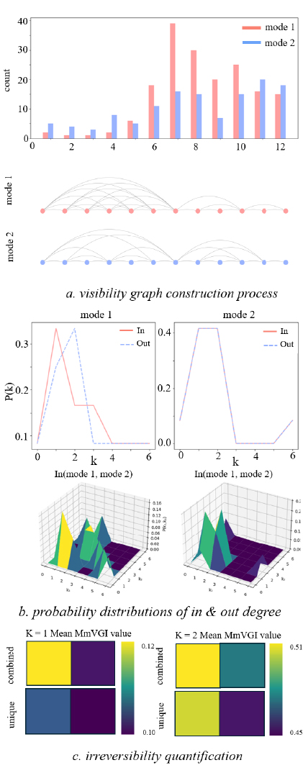
Figure 1: Illustration of the Multi-modal Visibility Graph Irreversibility (MmVGI) Framework. a) visibility graph construction process b) probability distributions of in/out degree. c) irreversibility quantification

3.2 Multi-modal Visibility Graph Irreversibility Framework
We introduce the MmVGI framework to analyse transportation systems with N different modes. This framework, illustrated in Fig.2, comprises three key components: visibility graph construction (Fig. 2(a), (b)), degree distribution analysis (Fig.2(c)), and joint probability distributions quantification (Fig.2(d)).
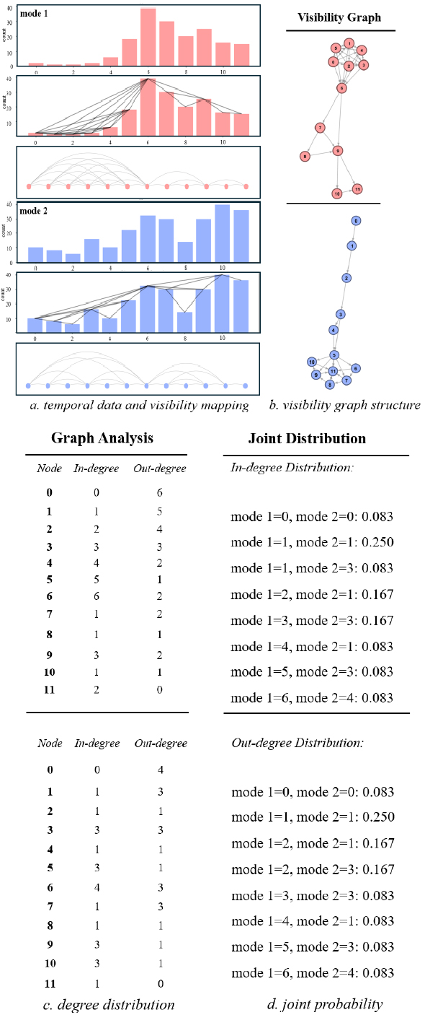
Figure 2: Construction and Analysis Process of Multi-modal Visibility Graphs. a) temporal data and visibility mapping. b) visibility graph structure. c) degree distribution analysis. d) joint probability distributions

3.2.1 Visibility Graph Construction
The framework transforms multivariate time series into visibility graphs through a systematic process. For any two data points and in the time series, a connection exists if and only if any intermediate point (where ) satisfies the following geometric visibility condition:
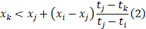
This mapping preserves key dynamical features of the original signal, including periodicity, fractality, and causality. To capture the temporal direction of evolution, we construct directed edges pointing from earlier to later times, represented by the adjacency matrix:
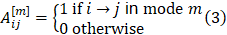

3.2.2 Degree Distribution Analysis
For each node, we calculate its in-degree and out-degree in each mode:
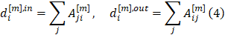
These distributions capture the fundamental asymmetry in system evolution. For a

subsystem, we compute the joint degree distributions:
These distributions contain complete information about system state transitions and form the basis for the irreversibility analysis.

3.2.3 Irreversibility Quantification
To quantify the irreversibility, we employ the Jensen-Shannon divergence:
where:
Through this method, we can systematically analyse temporal irreversibility at different levels: corresponds to the characteristics of individual modes, reflects interactions between mode pairs, and higher order reveals complex collective behavioural patterns.

4. CASE STUDY
4.1 Data Description
This case study focuses on the City of London, covering an area of 12.727 km² with approximately 5,200 road segments analysed (Fig.3(a)-(e)). We utilised comprehensive traffic data from University College London's Department of Civil, Environmental and Geomatic Engineering, encompassing hourly flow measurements across four primary transportation modes: buses, cars, cycles, and walks (Fig.3(f)). We selected October 3, 2020, as the primary study period, which represents a significant extreme weather event with the highest daily rainfall (31.7mm area-average) in the UK since records began in 1891. This extreme event provides an ideal case for examining how multi-modal transportation systems respond to and recover from severe weather disruptions.
4.2 Multi-modal Irreversibility Analysis
Using the MmVGI framework, we transformed multi-modal traffic flow data into visibility graphs and calculated irreversibility measures based on Jensen-Shannon divergence between in-degree and out-degree distributions (Fig.3(g)). This approach allowed us to quantify temporal asymmetry in traffic patterns at multiple organisational levels. The statistical analysis of modal interactions revealed systematic patterns 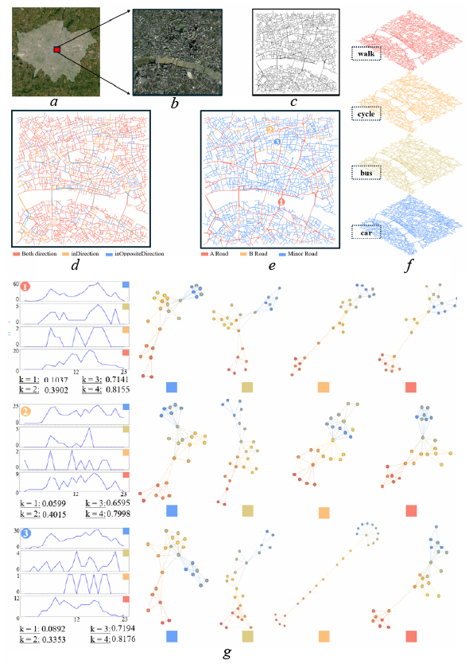
Figure 3: Multi-modal Visibility Graph Analysis of Urban Transportation Network during Extreme Weather Event. a) study area location, b) satellite view, c) road network, d) network by direction, e) network by hierarchy, f) modal temporal patterns, g) modal interaction networks

across different orders, as shown in Fig.4. Using a colour gradient scheme where lighter shades indicate stronger irreversibility, we examined interactions across the four primary modes: cars, buses, cycles, and walks. Single-mode analysis (k=1) showed distinctive behavioural patterns, with motorised modes demonstrating moderate irreversibility values (cars: 0.0872, buses: 0.0791) reflecting their operational stability. Bus services exhibited pronounced stability due to scheduled operations, while walk flows displayed the highest irreversibility (0.1026), suggesting remarkable adaptability to changing conditions. Cycling patterns showed the lowest irreversibility (0.0645), indicating well-distributed flows that maintain balance across the network. Pairwise interactions (k=2) revealed strong coupling between motorised transportation modes, with car-bus combinations showing particularly high irreversibility values (0.2891) along major corridors. Vehicular-walk interactions also demonstrated significant irreversibility (car-walk: 0.2754, bus-walk: 0.2649), suggesting adaptive complementarity during adverse weather. In contrast, cycling-related pairs maintained lower irreversibility values (car-cycle: 0.2376, bus-cycle: 0.2215), indicating more independent behavioural patterns. Third-order analysis (k=3) uncovered sophisticated multi-modal interactions, notably in the car-bus-walk combination (0.4328). This finding suggests complex adaptation mechanisms during extreme events, where these three modes demonstrate coordinated adjustments that cannot be captured through simpler analyses. Other triple-mode combinations showed relatively lower values (car-bus-cycle: 0.3876, car-cycle-walk: 0.3923), further highlighting the unique importance of the car-bus-walk interaction.
The spatial analysis revealed distinct irreversibility patterns across different modal combinations throughout the transportation network (Fig.5). Single-mode analysis of vehicular traffic showed pronounced irreversibility along A Roads (MmVGi values reaching 0.8347), highlighting the fundamental structure of urban mobility where primary roads exhibit high dynamic complexity due to concentrated vehicular flow. Dual-mode interactions demonstrated differential effects across the road hierarchy. The car-bus combination showed high irreversibility values (0.8907) along A Roads, indicating strong coupled dynamics between these motorised modes. The car-cycle combination (0.9009) revealed distinct patterns on B Roads and Minor Roads, with extensive yellow-green regions emerging in previously low-irreversibility areas. This suggests cycling significantly influences network dynamics at these scales, serving as a redistributive force where motorised traffic is less dominant. The car-walk combination (0.9149) produced more subtle effects, primarily affecting localised sections of Minor Roads rather than causing network-wide impacts. Higher-order analysis revealed that the transition from car-bus-cycle to car-bus-cycle-walk configurations showed minimal additional changes in irreversibility patterns, suggesting pedestrian flows integrate into existing modal patterns without introducing substantial new dynamic structures. In contrast, the comparison between car-bus and car-bus-cycle patterns demonstrated significant reorganisation of network dynamics across B Roads and Minor Roads. These findings indicate that transportation system adaptation during extreme weather events operates differently across road hierarchies. While motorised modes dominate A Road dynamic, cycling emerges as a significant influence on secondary networks, introducing dynamic variability and reshaping local irreversibility patterns. This hierarchical understanding is crucial for developing targeted resilience strategies that account for both primary corridor performance and local network dynamics.

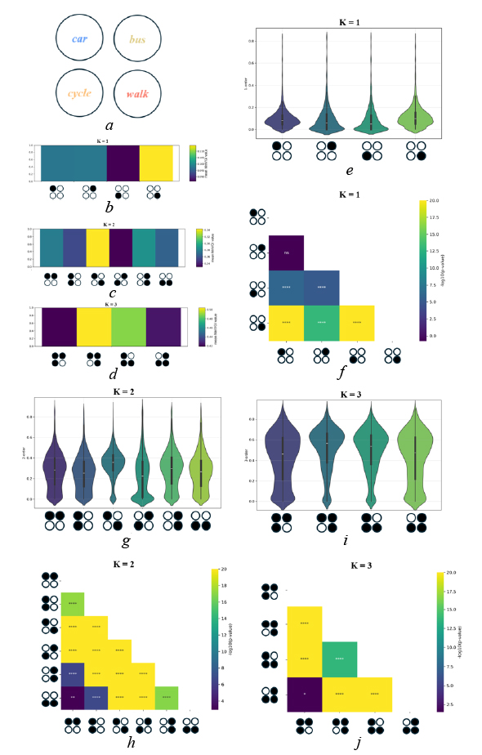
Figure 4: Multi-order Analysis of Modal Interactions through Irreversibility Measurements and Statistical Testing. a) transportation modes, b-d) irreversibility heatmaps, e-g) distribution analysis, h-j) statistical significance maps

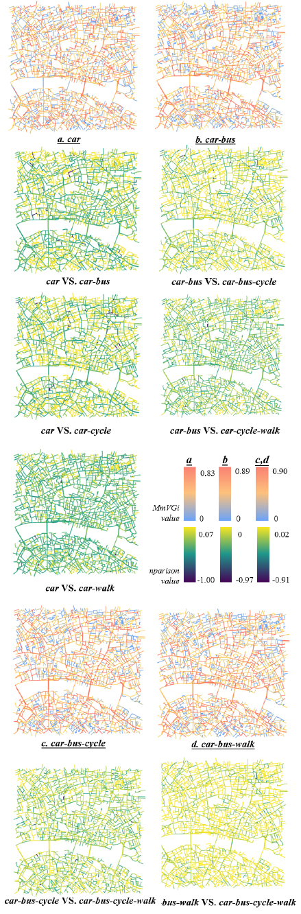
Figure 5: Spatial Distribution and Comparison of Multi-modal Irreversibility Patterns in Urban Transportation Networks. a) single-mode irreversibility (car), b) dual-mode irreversibility (car-bus), c) triple-mode irreversibility (car-bus-cycle), d) triple-mode irreversibility (car-bus-walk)

5. DISCUSSION
The analysis of multi-modal transportation networks during extreme weather events reveals several significant findings with important theoretical and practical implications. The spatial distribution of irreversibility across different road hierarchies demonstrates that A Roads maintain relatively stable dynamics dominated by motorised transport (irreversibility values of 0.8907 for car-bus combinations), while B Roads and Minor Roads show greater adaptive capacity through modal diversification, particularly through cycling integration (irreversibility value of 0.9009 for car-cycle combinations). This hierarchical pattern challenges traditional infrastructure planning approaches that often prioritize motorised transport and suggests resilience strategies should adopt a more balanced approach across the entire network hierarchy. The third-order analysis, which revealed the importance of the car-bus-walk combination (0.4328), demonstrates that multi-modal transportation systems exhibit complex adaptation mechanisms during extreme events that cannot be captured through analyses of individual modes. The MmVGI framework introduced in this study offers methodological advances by integrating visibility graph analysis with non-equilibrium dynamics concepts, capturing both spatial network patterns and temporal evolution characteristics that conventional methods overlook. From a practical perspective, these findings suggest the need for integrated, multi-modal management strategies during extreme weather events, including differentiated response strategies based on road hierarchy, enhanced support for cycling in secondary networks, and consideration of higher-order modal interactions in transportation planning. Future transportation resilience planning should move beyond the traditional focus on individual infrastructure components to embrace a systems perspective that accounts for the complex, non-linear interactions revealed in this study, helping cities develop more effective adaptation strategies for increasingly frequent extreme weather events.

6. Conclusion
Climate change and extreme weather events increasingly threaten urban transportation systems, challenging their ability to maintain essential mobility services. Traditional approaches to analysing system behaviour have proven inadequate for understanding the complex dynamics that emerge when multiple transportation modes interact under stress. This study introduced the MmVGI framework to address these limitations, integrating concepts from non-equilibrium dynamics to quantify complex interactions between different transportation modes. Through the analysis of London's transportation network during an extreme rainfall event, we demonstrated that adaptation exhibits clear hierarchical patterns across different road types. While primary roads maintain stable dynamics dominated by motorised transport, secondary networks show complex patterns of modal interaction, with cycling emerging as a crucial component in system adaptation. These findings advance theoretical understanding of urban system dynamics and practical approaches to transportation management, offering valuable insights for developing more resilient transportation systems for future climate challenges.

REFERENCES
Abdulla, B, A Mostafavi, and B Birgisson. 2019. ‘Characterization of the Vulnerability of Road Networks to Fluvial Flooding Using Network Percolation Approach’. In , edited by YK Cho, F Leite, A Behzadan, and C Wang, 428–35.
Aerts, J. C. J. H., W. J. Botzen, K. C. Clarke, S. L. Cutter, J. W. Hall, B. Merz, E. Michel-Kerjan, J. Mysiak, S. Surminski, and H. Kunreuther. 2018. ‘Integrating Human Behaviour Dynamics into Flood Disaster Risk Assessment’. Nature Climate Change 8 (3): 193–99. https://doi.org/10.1038/s41558-018-0085-1.
Barahimi, Amir Hossein, Alireza Eydi, and Abdolah Aghaie. 2021. ‘Multi-Modal Urban Transit Network Design Considering Reliability: Multi-Objective Bi-Level Optimization’. Reliability Engineering & System Safety 216 (December):107922. https://doi.org/10.1016/j.ress.2021.107922.
Borowska-Stefańska, Marta, Adam Bartnik, Maxim A. Dulebenets, Michał Kowalski, Alireza Sahebgharani, Przemysław Tomalski, and Szymon Wiśniewski. 2025. ‘Changes in the Equilibrium of the Urban Transport System of a Large City Following an Urban Flood’. Reliability Engineering & System Safety 253 (January):110473. https://doi.org/10.1016/j.ress.2024.110473.
Cooper, J.L.B. 1967. ‘The Foundations of Thermodynamics’. Journal of Mathematical Analysis and Applications 17 (1): 172–93. https://doi.org/10.1016/0022-247X(67)90174-6.
Crooks, Gavin E. 1999. ‘Entropy Production Fluctuation Theorem and the Nonequilibrium Work Relation for Free Energy Differences’. Physical Review E 60 (3): 2721–26. https://doi.org/10.1103/PhysRevE.60.2721.
Daganzo, Carlos F. 1994. ‘The Cell Transmission Model: A Dynamic Representation of Highway Traffic Consistent with the Hydrodynamic Theory’. Transportation Research Part B: Methodological 28 (4): 269–87. https://doi.org/10.1016/0191-2615(94)90002-7.
Gallotti, Riccardo, and Marc Barthelemy. 2015. ‘The Multilayer Temporal Network of Public Transport in Great Britain’. Scientific Data 2 (1): 140056. https://doi.org/10.1038/sdata.2014.56.
Gazis, Denos C. 2002. ‘The Origins of Traffic Theory’. Operations Research 50 (1): 69–77. https://doi.org/10.1287/opre.50.1.69.17776.
Koppelman, Frank S., and Moshe E. Ben-Akiva. 1977. ‘Aggregate Forecasting with Dissaggregate Travel Demand Models Using Normally Available Data’. In Transport Decisions in an Age of Uncertainty: Proceedings of the Third World Conference on Transport Research Rotterdam, 26 – 28 April, 1977, edited by Evert J. Visser, 159–66. Dordrecht: Springer Netherlands. https://doi.org/10.1007/978-94-009-9707-3_26.
Lin, Xuhui, Qiuchen Lu, Long Chen, and Ioannis Brilakis. 2024. ‘Assessing Dynamic Congestion Risks of Flood-Disrupted Transportation Network Systems through Time-Variant Topological Analysis and Traffic Demand Dynamics’. Advanced Engineering Informatics 62 (October):102672. https://doi.org/10.1016/j.aei.2024.102672.
Lynn, Christopher W., Caroline M. Holmes, William Bialek, and David J. Schwab. 2022. ‘Emergence of Local Irreversibility in Complex Interacting Systems’. Physical Review E 106 (3): 034102. https://doi.org/10.1103/PhysRevE.106.034102.
Nartallo-Kaluarachchi, Ramón, Leonardo Bonetti, Gemma Fernández-Rubio, Peter Vuust, Gustavo Deco, Morten L. Kringelbach, Renaud Lambiotte, and Alain Goriely. 2024. ‘Multilevel Irreversibility Reveals Higher-Order Organisation of Non-Equilibrium Interactions in Human Brain Dynamics’. 0 📊. https://doi.org/10.1101/2024.05.02.592195.
Seifert, Udo. 2012. ‘Stochastic Thermodynamics, Fluctuation Theorems and Molecular Machines’. Reports on Progress in Physics 75 (12): 126001. https://doi.org/10.1088/0034-4885/75/12/126001.
Sun, Jiayun, Aaron C. H. Chow, and Samer Michel Madanat. 2020. ‘Multimodal Transportation System Protection against Sea Level Rise’. Transportation Research Part D: Transport and Environment 88 (November):102568. https://doi.org/10.1016/j.trd.2020.102568.
Wang, Binwu, Yan Leng, Guang Wang, and Yang Wang. 2024. ‘FusionTransNet for Smart Urban Mobility: Spatiotemporal Traffic Forecasting Through Multimodal Network Integration’. arXiv. 0 📊. https://doi.org/10.48550/arXiv.2405.05786.
Wang, Longjian, Shuichao Zhang, Gábor Szűcs, and Yonggang Wang. 2024. ‘Identifying the Critical Nodes in Multi-Modal Transportation Network with a Traffic Demand-Based Computational Method’. Reliability Engineering & System Safety 244 (April):109956. https://doi.org/10.1016/j.ress.2024.109956.
Yang, Zhicheng, Xiaobing Liu, Jiangfeng Wang, Xuedong Yan, Rui Shen, and Zhengqi Huo. 2025. ‘Assessment on Resilience of Urban Agglomeration Transportation System Considering Passenger Choice and Load-Capacity Factor’. Reliability Engineering & System Safety 253 (January):110527. https://doi.org/10.1016/j.ress.2024.110527.
Zhou, Huide, Rachid Bouyekhf, and Adbellah El Moudni. 2013. ‘Modeling and Entropy Based Control of Urban Transportation Network’. Control Engineering Practice 21 (10): 1369–76. https://doi.org/10.1016/j.conengprac.2013.06.007.

