Dealing with Semantically Diverse Dictionaries for the Construction Sector
A Study on Making bSDD RDF-compatible
Pieter Pauwels^{1,*}, Lukas Kirner¹, Dani Metilli², Kathrin Füllenbach²

¹ Eindhoven University of Technology, Eindhoven, The Netherlands
² TDCC-NES, Delft University of Technology, Delft, The Netherlands
*Corresponding email: {p.pauwels,l.kirner}@tue.nl, {d.metilli,k.fuellenbach}@tudelft.nl

ABSTRACT
The Architecture, Engineering, and Construction (AEC) sector is digitizing fast, nevertheless it struggles considerably with all forms of semantics amongst its stakeholders. The AEC sector is notoriously dispersed and consisting of many small and medium enterprises, leading to a significant diversity in local, national, and international ‘dialects’ of construction vocabulary. This diversity has been captured in multiple ways in the past, most notably the buildingSMART Data Dictionary (bSDD) and a number of web-based vocabularies in the Semantic web, also known as ontologies. In this paper, those two are brought closer together, by investigating how the multitude of vocabularies in the bSDD can be made available as first-class citizens of the Semantic web and linked data domains. Multiple alternative representations in the Resource Description Framework (RDF) are explored, leading to an analytical comparison and finally a recommendation on how to represent construction-oriented vocabularies for use in the AEC sector.

- INTRODUCTION
The construction sector (or AEC sector) is very well known for a number of features, one being that it consists of many disparate stakeholders of various sizes. The AEC sector consists of many small and medium enterprises in all disciplines, including architectural design offices, engineering offices, and construction companies; on the other hand, the sector also includes several large companies, including nation-wide infrastructure organizations that work closely with the local governments. In such an environment, communication is key, which is where matters often go wrong in the case of engineering and construction. Different organizations use different vocabularies and naming conventions. In large companies, those vocabularies or naming conventions tend to be hard-wrought and the result of months or years of discussions and evolutions. What comes out is a convention that is standard within the company, after which this vocabulary can be communicated to peers such that those peers also understand the same language and can achieve mutual communication and perhaps even understanding.
This situation is much more challenging (or not) in a small company of only a few employees. Since such a small company consists of way fewer employees, communication and understanding is typically much easier to achieve, and a lot less effort is needed to come to a mutual agreement on vocabulary. Terms are fewer, less intricate, and thus easier to agree upon. Communication and interoperability becomes a lot more flexible in these organisations, and the goal is often rather to be flexible and efficient in responding to market requirements. For example, when collaborating with large companies or governmental organizations, small companies can arguably more easily adapt to the data needs and naming conventions of the larger organisation. Of course, this situation becomes even more convoluted and interesting when considering an international situation, when multiple languages need to be combined on top of a multitude of terms and vocabularies.
In this situation of multitudes of vocabularies, data dictionaries play an important role since many years. In ISO 23386 (ISO, 2020), the term “data dictionary” is defined as a “centralized repository of information about data such as meaning, relationships to other data, origin, usage and format”. A central solution proposed and pursued several years ago is the International Framework for Dictionaries (IFD), which is an ISO standard that was proposed by buildingSMART International and standardised under ISO 12006-3 (ISO, 2022). It provides a framework to relate construction terms to each other, across domains and languages (Fig. 1). This standard allows to define multiple classes and types, including their properties, and map these classes and properties to each other.
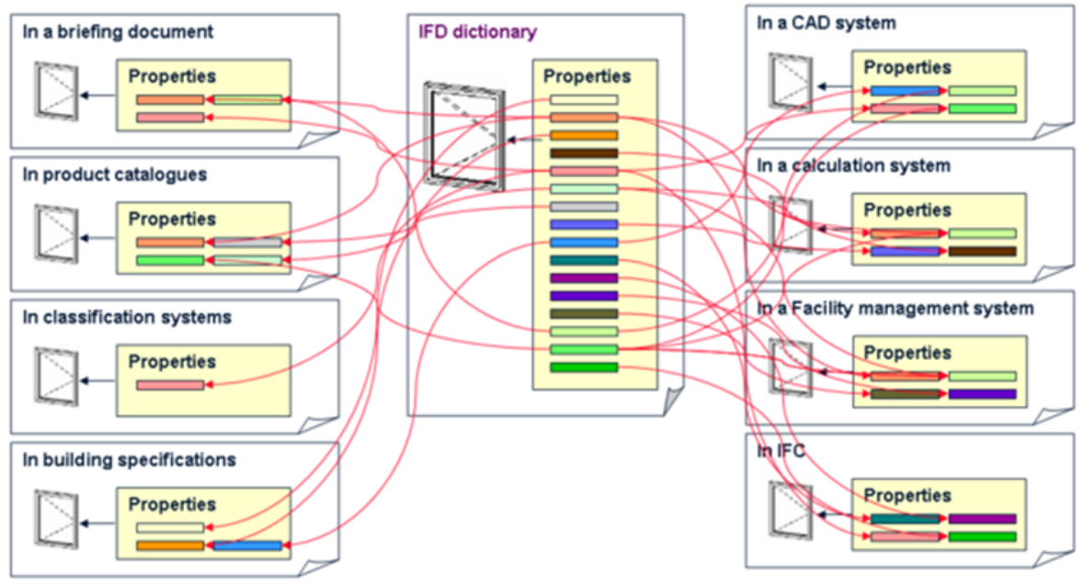
Figure 1 - Overview of the main purpose of the IFD standard (Figure from ISO (2022)).
Further to definitions, IFD provides unique identifiers for construction concepts, properties, and relationships, ensuring that the same concept can be understood consistently across languages, software platforms, and national classification systems. Rather than storing geometric or project-specific data, IFD defines the meaning of terms and their relationships, complementing the Industry Foundation Classes (IFC) standard (ISO, 2024), which describes the structure and exchange of building information. By now, the IFD concept has evolved into the buildingSMART Data Dictionary (bSDD), which serves as the practical implementation of this semantic framework and supports interoperability throughout the building lifecycle using an API-centric software implementation approach.
Besides the API-first approach of the bSDD towards dictionaries, a number of other approaches exist towards representing dictionaries. This includes the use of Semantic web technologies and their Web Ontology Language (OWL)-based ontologies (Berners-Lee, 2001; Pauwels et al., 2017; Akbarieh et al., 2025), the use of JSON-based dictionaries, and also Object Type Libraries (OTLs) (Costin et al., 2022). OTLs originate from the object-oriented approach for documenting object types (e.g. libraries of families and objects in the Autodesk Revit platform) and can be available in JSON and OWL as well. Overall, the OWL-based approach tends to provide a much more formal and well-structured basis for defining ontologies, and would thus be more fit for larger organizations that have structure well-defined, while the JSON-based approach tends to be more flexible and more fitting to smaller organisations and their often web-based data exchanges.
While the bSDD provides a number of ontologies (or vocabularies), it is currently not OWL-compatible. In this paper, we therefore aim to investigate how data dictionaries can be offered in the construction industry, through the bSDD, relying on the guidelines provided by standards and guidelines from the World Wide Web Consortium (W3C) (Garijo and Poveda-Villalòn, 2020). The paper first provides an overview of related works (Section 2), with dictionary-oriented ontologies in OWL, particularly BEO, IFC, and OPM. Section 2 also provides a review of how vocabularies are currently offered in the bSDD. Section 3 makes a proposal of how vocabularies can effectively be documented in the bSDD, covering key topics such as the overall approach taken (Section 3.1), dealing with properties (Section 3.2), and versioning. Section 4 documents a number of example cases that show the expected results, ending with a conclusion in Section 5.

- RELATED WORKS
This Section first gives an overview of how the BuildingSMART bSDD currently organizes and provides its data dictionaries, particularly focusing on the overall approach and the output RDF graph representations (Section 2.1). Second, the Section documents the way in which types and properties are commonly represented using Semantic web technologies, particularly considering the Ontology for Property Management (OPM) (Rasmussen et al., 2018), the IFC ontology (ifcOWL) (Pauwels and Terkaj, 2016), and the Built Element Ontology (BEO).

2.1 BuildingSMART Data Dictionaries
The buildingSMART Data Dictionary (bSDD) is a cloud-based platform that is developed and maintained by buildingSMART International. In principle, it does not function as a single data dictionary, yet rather provides the infrastructure to host multiple dictionaries, such as IFC, ETIM, and UniClass, focusing explicitly on the AEC industry. It hereby relies on the ISO12006-3 standard for data dictionaries, which includes a meta-language that can be used to structure the dictionary. For example, when retrieving the class IfcWall from the bSDD, it can be exported in RDF graph format (TTL syntax), as displayed in Listing 1 (unused prefixes removed).
Listing 1 – RDF graph output for the IfcWall class in the bSDD, in TTL syntax.
@base <https://identifier.buildingsmart.org/uri/buildingsmart/ifc/4.3/class/IfcWall>.
@prefix rdf: <http://www.w3.org/1999/02/22-rdf-syntax-ns#>.
@prefix dictionary: <https://standards.buildingsmart.org/DataDictionary#>.
@prefix ifc4_3: <https://identifier.buildingsmart.org/uri/buildingsmart/ifc/4.3>.

<https://identifier.buildingsmart.org/uri/buildingsmart/ifc/4.3/class/IfcWall>
rdf:type dictionary:Class;
dictionary:ActivationDateUtc "2024-01-12";
dictionary:ClassType "Class";
dictionary:Code "IfcWall";
dictionary:Definition "The wall represents a vertical construction that may bound or subdivide spaces. Wall are usually vertical, or nearly vertical, planar elements, often designed to bear structural loads. A wall is however not required to be load bearing."@en-us;
dictionary:Domain ifc4_3:;
dictionary:Name "Wall"@en-us;
dictionary:ReferenceCode "IfcWall";
dictionary:Status "Active";
dictionary:Uid "6cb09e6f-b387-44bc-afcc-563e5b5b5ead";
dictionary:VersionDateUtc "2024-01-12".
In this example, mostly metadata is provided for the class that is presented, including names, descriptions, codes, dates, identifiers, and similar. Furthermore, one can see that the snippet uses just one namespace called dictionary, corresponding to the bSDD Data Dictionary schema. That implies that the data presented constitutes an instance graph (RDF graph) and not an OWL ontology, as one would expect for a collection of ontologies.
  - Dictionaries in the Semantic web
In the Semantic web, the first-class citizen to define terms including classes, properties and relationships is an OWL ontology. An OWL ontology is formal, explicit specification of a shared conceptualization, which commonly includes not just terms and definitions, yet a complete graph-oriented representation of a schema. A prime example of such a vocabulary is the IFC ontology (also ifcOWL). While this ontology contains terms and definitions, the structure of this ontology is majorly different from the structure of a dictionary as it is targeted and supported by the bSDD, namely a list of classes, and their associated properties, including definitions for both (Figure 1).
The IFC ontology has lied at the basis of the set of ontologies made available through the set of Linked Building Data (LBD) ontologies. The ontologies that are overlapping with IFC are the Building Topology Ontology (BOT), the Built Element Ontology (BEO), the MEP ontology, and ontologies for representing geometry, such as OMG (Ontology for Managing Geometry) and FOG (File Ontology for Geometry formats). Of these ontologies, the last two are out of scope for the current paper, as they are focused on geometry. Furthermore, also the BOT ontology is not a good candidate for representing dictionaries as specified by the ISO12006-3 standard. The BEO and MEP ontologies (Listing 2), however, are plain taxonomies, directly derived from IFC and representing classes, their definitions, and hierarchical relationships. This is much closer to the goal of ISO 12006-3.
Listing 2 – snippet from the BEO ontology.
@base <https://w3id.org/beo#> .
@prefix : <https://w3id.org/beo#> .
@prefix owl: <http://www.w3.org/2002/07/owl#> .

### https://w3id.org/beo#AbutmentAssembly
:AbutmentAssembly rdf:type owl:Class ;
rdfs:subClassOf :ElementAssembly ;
rdfs:comment "A bridge abutment built up of walls, beams, slabs etc."@en , "Estribo de un puente formado por muros, vigas, losas, etc."@es ;
rdfs:label "Abutment Assembly"@en ,
"Estribo"@es .
A few differences and similarities can be noticed between Listing 1 and 2. Namespaces in the BEO ontology follow W3C guidelines (single dereferenceable URI). Furthermore, a hierarchical tree structure is provided, which is not the case in the bSDD. Also, a description is provided for each class, but further metadata is lacking in Listing 2. A key difference between these two approaches is furthermore that Listing 2 represents an OWL ontology, and not instances (RDF graph). This ontology is described using proper owl:Class concepts, instead of the custom dictionary:Class concepts used in Listing 1. Also, the metadata are represented using standard and recommended RDFS attributes, which could be easily complemented with Dublin Core attributes.
3. METHOD
The Related Works section clearly shows two different approaches to represent data dictionaries in the AEC sector. It is argued in this paper that these two approaches can be brought together, such that the dictionaries as provided by the bSDD become compatible with the Semantic web domain. This would allow the terms and definitions of the construction sector to be more openly available for use by any linked data or Semantic Web developer. In the below sections, we explain how the bSDD can be restructured and re-organised, particularly its RDF graph output, to achieve that goal.
3.1 Overall Setup and Approach
First and foremost, the overall setup regarding the publication of these dictionaries is important. A starting point in this regard is the already existing bSDD, which indicates what content is preferably available and how. First, one should be able to create a number of custom vocabularies, as is currently possible using an upload functionality (Req. 1). Second, the content of vocabularies is expected to contain primarily classification labels (Req. 2), not necessarily in a hierarchy, including metadata, IDs, and descriptions (Req. 3). Also, properties need to be available in a similar way (Req. 4). The bSDD contains ‘materials’ and ‘groups of properties’, which appear less critical. It is finally assumed that vocabularies need to be fairly flexible (Req. 5), and have versioning enabled (Req. 6).
Based on this list of requirements, a key first decision needs to be made, which relates to the distinction of class-level statements (ontology, TBox) and instance-level statements (instances, ABox). In a strong ontology engineering approach, the dictionaries in the bSDD would clearly be modelled as first class citizen OWL ontologies. That is indeed fitting for the larger and more established ontologies that one can find in larger organizations. However, many of the schemas and organizations in the construction sector expect a higher level of flexibility, with the possibility of adding terms as required. In that case, a more RDF-centric or even labelled property graph (LPG)-based approach is fitting, in which the ontology layer is limited. That last approach is the one currently used in the bSDD (Listing 1). Transforming the current approach to a more OWL-centric approach leads to the example in Listing 3.
Listing 3 – OWL ontology snippet for the IfcWall class, in TTL syntax, using an ontology formatting as recommended by common W3C standard guidelines.
ifc:IfcWall a owl:Class;
rdfs:comment "The wall represents a vertical construction that may bound or subdivide spaces. Wall are usually vertical, or nearly vertical, planar elements, often designed to bear structural loads. A wall is however not required to be load bearing."@en-us ;
rdfs:isDefinedBy ifc4_3: ;
rdfs:label "Wall"@en-us ;
dct:alternative "IfcWall" ;
dct:identifier "IfcWall" ;
dct:created "2024-01-12T10:00:00"^^xsd:dateTime ;
dct:identifier "6cb09e6f-b387-44bc-afcc-563e5b5b5ead" .
The example shows a namespace for the snippet in question, namely ifc:, which can point to a dedicated namespace for this resource. It is problematic that the ontologies of distinct organisations would be hosted by the bSDD instead of in their own servers, yet this may be resolved by using the bSDD as a permanent identifier system, such as PURL or W3ID, that allows rerouting to the relevant server (IRI). Furthermore, the example snippet relies on common owl:, rdfs:, and dct: prefixes (namespaces) to annotate the class description with metadata, according to common guidelines. Using this approach, anyone in the AEC industry can instantiate an instance of type ifc:IfcWall, following standard Semantic Web best practices. Hence, this seems the most fitting approach. However, when the ontology needs to be updated, extended or refined, a whole new version would be needed, which assumingly requires a long administrative process, as is commonly the case in standardising data models. For dictionaries in the construction sector, this is not a viable prospect or option, and more flexibility is desired (Req. 5). Note that the ifc:IfcWall in Listing 3 is also available already in the IFC ontology itself; it only serves here as an example case. When using the approach in Listing 3 to a regular dictionary like Uniclass or ETIM for example, the same overall evaluation holds about it being difficult to update, extend or refine. The approach in Listing 3 is thus more fitting for larger organizations that are quite well able to host their dictionaries on their own servers as well, including a regular versioning approach of their choice. Examples are the BHoM ontology and the Waternet OTL, yet several further examples exist.
For smaller or more agile organisations, a need exists for more flexible data and vocabulary usage. In this case, the approach shown in Listing 4 is usable. In this case, terms are not defined as a whole new ontology that is to be instantiated. Instead, a small pre-existing ontology can be used, in this case dictionary:, for example; and terms can be individuals. This is the approach currently followed by bSDD as well. In this case, an instance can be declared in the bSDD, such as bsdd:IfcWall, as shown in Listing 4, as an instance of dictionary:Class. The same metadata can be associated to this instance. This clearly constitutes a less disruptive approach compared to the current bSDD approach, and it is expected to be more attractive to small organisations, with changing dictionaries.
Listing 4 – RDF graph with instance data, enriched with more recommended RDFS and Dublin Core attributes.
bsdd:ifcWall
rdf:type dictionary:Class ;
rdfs:comment "The wall represents a vertical construction that may bound or subdivide spaces. Wall are usually vertical, or nearly vertical, planar elements, often designed to bear structural loads. A wall is however not required to be load bearing."@en-us ;
rdfs:isDefinedBy ifc4_3: ;
rdfs:label "Wall"@en-us ;
dct:alternative "IfcWall" ;
dct:identifier "IfcWall" ;
dct:created "2024-01-12T10:00:00"^^xsd:dateTime ;
dct:identifier "6cb09e6f-b387-44bc-afcc-563e5b5b5ead" .
There are precedents to this approach. In a way, the way in which enumerations are encoded in an ontology is very similar, since those are encoded as owl:Individual, such that one can directly relate to these from within an instance ABox RDF graph. A clear example of both the approaches in Listing 3 and 4 is present in the OPM ontology, as explained in Bonduel et al. (2022). So-called Level 1 properties are represented as direct data properties that are part of an OWL ontology and can be used as such. The BEO, MEP and PROPS ontologies follow that approach and consist of plain classes, object properties and datatype properties. Level 3 properties, also the most complex case of OPM ontology encoding, relies on a property <prop> as an instance (ABox instance graph), which allows the addition of metadata, as complex as full state representations even (see Fig. 3).

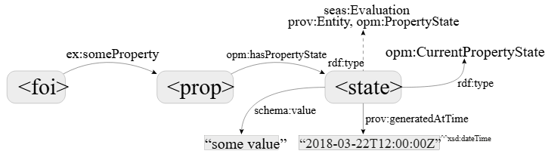
Figure 3 - Property modelling approach promoted by L3 property modelling in the OPM ontology (image from OPM).
In practice, if this approach is followed by the bSDD (Listing 4), then any individual can specify elements (instances) from their instance graph, assumingly a Building Information Model (BIM) or Linked Building Data (LBD) graph, as shown in Listing 5. In that case, a simple inst:wall_3mDrG instance can be classified according to as many ontologies and classes as needed, such as bot:Element and beo:Wall, and it can also have a relation dictionary:hasBsddClass with bsdd:ifcWall. In this scenario, the dictionary: ontology consists of one class and one object property in total, showing how little disruptive this is. Furthermore, this is as flexible as the AEC domain would like it to be, since anyone can create a set of classes as desired and needed. A disadvantage is the lesser stability, and also the impossibility of representing parent-child relationships (subsumption).
Listing 5 – RDF graph with an example wall (inst:wall_3mDrG), classified as a bot:Element, a beo:Wall, and with a reference to the bSDD class bsdd:IfcWall.
inst:wall_3mDrG
a bot:Element, beo:Wall ;
dictionary:hasBsddClass bsdd:ifcWall ;

3.2 Properties
Assuming the above, what is the effect on properties? In principle, the same approach (Listing 4) can be followed for these. This is in fact already illustrated in Fig. 3, where one can see how a property can be defined at instance level (property modelling level 3 according to Bonduel et al. 2022). Such property can similarly be used by an instance building model graph.
Listing 6 – RDF graph with an example property defined in the bSDD (metadata left out for brevity’s sake), and its value and unit filled in through the instance RDF graph (building model).
inst:wall_3mDrG
a bot:Element, beo:Door ;
dictionary:hasBsddClass bsdd:IfcWall ;
opm:hasProperty inst:concreteCover_1oBrU .

inst:concreteCover_1oBrU
ex:hasValue “20” ;
ex:hasUnit “mm” ;
dictionary:hasBsddProperty bsdd:concreteCover

bsdd:concreteCover
rdf:type dictionary:Property;
rdfs:comment "The protective concrete cover at reinforcing bars according to local building regulations."@en-us;
The representation of domains and ranges using rdfs:domain and rdfs:range is not formally possible in this case, since the property is encoded as an instance and not a first-class citizen data or data/object property. As domains and properties currently are not encoded in the bSDD, it does not appear to be a priority. Also outside the bSDD, several ontologies exist that prefer to not encode domains and ranges, leaving this flexibility to the user, e.g. the BRICK ontology. In case one would want to encode properties as part of a regular OWL ontology, one could use the standard approach, that is shown in Listing 6. Beware that in such regular case, it is still a challenge to also encode units of measure using a relatively simple approach, as explained in Bonduel et al. (2022).
Listing 6 – RDF graph with an example property defined in the bSDD (metadata left out for brevity’s sake), and its value and unit filled in through the instance RDF graph (building model).
ex:concreteCover
rdf:type owl:DataTypeProperty ;
rdfs:domain ifc:IfcWall ;
rdfs:range xsd:double ;
rdfs:subPropertyOf bsdd:concreteProperty .

inst:wall_3mDrG
a bot:Element, beo:Door ;
dictionary:hasBsddClass bsdd:IfcWall ;
ex:concreteCover 20 .
Special attention needs to be given to ‘materials’, which are not an unimportant part of the bSDD. Nevertheless, for materials, we assume in this case that this can be encoded using a regular ontology modelling approach, similar to using the IFC ontology. The IFC ontology allows linking elements to its constituent materials. Using the same techniques as listed above, it is assumed here that these materials can further be linked to property sets or classification mechanisms in the bSDD. Finally, ‘groups of properties’ are used in some bSDD dictionaries to collect properties into sets based on their function. These groups appear to be somewhat redundant with RDFS subproperty hierarchies, which are currently not implemented by bSDD. To ensure compliance with Semantic web standards, it would be preferable to replace groups of properties with regular rdfs:subPropertyOf relations.

3.3 Versioning
For versioning of ontologies, three (3) main options are available from the literature, namely (1) default setup, (2) explicit IRI versioning as done before in the AEC industry (ifcOWL), (3) default setup with additional explicit IRI versioning. In this paper, we consider the third option as the most promising for the case of vocabularies in the bSDD.
Option 1: Default Setup Ontologies are usually identified via ontology IRIs and version IRIs, as shown in Listing 7. Each version is accessible via its version IRI, and the ontology IRI points to the latest version (Motik et al., 2012). Usually, the terms defined in the versions use the ontology IRI as base IRI, so that a term is referred to as for example <http://www.example.com/my/term>.
Listing 7 – Versioning for an example graph.
<http://www.example.com/my> a owl:Ontology ;
owl:versionIRI <http://www.example.com/my/2.0> .
This default setup has the implication that even though versions can be specified with dct:conformsTo or owl:imports, it is not immediately obvious in the ABox which version has been used. In case terms are dereferenceable, clicking on the term will lead users to the latest version of it. This default setup is good for interoperability, reusability and maintainability of the data, yet less preferable for industries that maintain older versions and keep using them, which is the case here.
Option 2: Explicit IRI versioning in the AEC sector In the AEC sector, precision is crucial. Users need to have full control over which version they use, and therefore, for example ifcOWL uses an explicit way of versioning IRIs, where each version is its own ontology with corresponding version and base IRIs. This gives users full control and naturally enables dereferenceable versioned term IRIs such as e.g. <http://www.example.com/my/2.0/term> for users to look up the definitions of the terms they use. This setup has the drawbacks that there is no link between different ontology versions, and that no stable IRIs for terms are available. For example, <http://www.example.com/my/1.0/term> and <http://www.example.com/my/2.0/term> coexist and refer to versions of the same term, but there is no unversioned <http://www.example.com/my/term>. Additionally, for every new version, all terms receive new IRIs, regardless of whether they changed or not, and there is no direct relation between terms in different versions by default. The introduction of new terms therefore causes significant extra work for management, upgrading and cross-version usage.
Option 3: Default setup with additional explicit versioning We recommend the middle ground between these two solutions, by implementing the default setup with an additional resolution service to dereference versioned term IRIs. This gives the user the choice of using stable or versioned term IRIs and thereby offers the best of both worlds. The drawback is that the implementation is not straightforward and expensive, as most current tools for ontology deployment do not support it out-of-the-box, and additional effort is required for managing it. Therefore, at present this solution is not widely applied in practice. An example of an ontology that implements this option is FIBO, the Financial Industry Business Ontology.

4. RESULTS
While the previous section explains the proposed reasoning behind choosing one option of the other in representing dictionaries for the AEC sector (focused on bSDD as a solution), the current section aims to give an example case that shows what the result would be like for an end user. For this purpose, a sample LBD graph is assumed for a plain building, aiming to link that to an example reference implementation of a bSDD with instance-level content as shown in Listing 4, 5, and 6. Following the method as explained, a graph is obtained as displayed in Fig. 4. This graph represents a (part of a) simple house, with all elements referencing a term from the bSDD dictionary according to the IFC terms, as well as a link between all properties and their corresponding (assumed) bSDD properties. In this example, only 4 OWL classes are present: bot:Element, beo:Wall, dictionary:Class, and dictionary:Property.
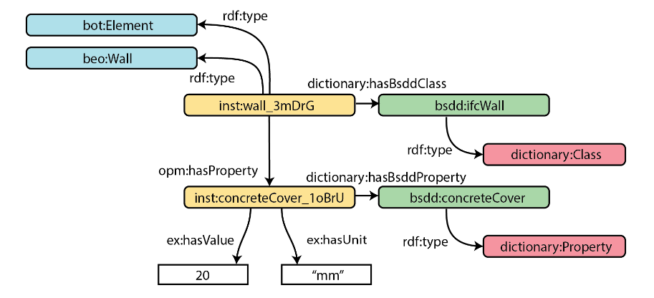
Figure 4 - Sample RDF graph connecting BIM model with bSDD terms and concepts.
5. CONCLUSION
In this paper, we presented an open investigation of dictionaries as used in the construction sector (AEC industry). This industry is notoriously diverse and disparate, with many dictionaries of various sizes and complexities. It was argued in this paper that some dictionaries are more of use to larger organisations, predominantly the more well-structured and formalized dictionaries; while others are more of use to smaller or more agile organisations, namely the more light-weight and instance-oriented dictionaries. The related works section pointed primarily at the bSDD platform for managing dictionaries, as well as a number of ontologies provided in the AEC Linked Building Data community. Based on that earlier work, it is proposed in this paper to focus on an instance-oriented representation of dictionaries, which is to a degree already the approach taken in the bSDD. A better formalization has been proposed, and shown to be usable with a simple house use case. The resulting approach is considered to be easily implementable in the existing bSDD platform, scalable, supportive of the smaller organisations that are present in the AEC sector, as well as correct according to semantic web guidelines. Of course, there are limitations to this approach. Especially, the proposed approach does not opt for an OWL-ontology-oriented approach, in which each dictionary is specified using a more rigorous OWL ontology. This may be preferred, especially by larger organisations. They may nevertheless specify their own full-scale ontologies on their own servers, following regular linked data guidelines. Even with this scope limitations, we believe that the current work can represent a viable way forward for representing dictionaries of different scales and sizes using proper semantic technologies. Further testing is expected in collaboration with standardisation bodies and companies, especially buildingSMART International and the W3C.

ACKNOWLEDGEMENTS
This work would not have been possible without the valuable support of RVO – TKI Bouw & Techiek for the SuGeST project, taking place in the Netherlands at TU Eindhoven and TU Delft. Furthermore, the support of the researchers’ host institutions as well as the valuable collaboration with Artur Tomczak of the bSDD and the efforts of buildingSMART International has been obviously instrumental in writing this paper. Dani Metilli and Kathrin Füllenbach are supported through the Strengthening Local and Thematic DCCs programme, funded by Open Science NL.
REFERENCES
Akbarieh, A., Osadcha, I., Farghaly, K., Bosché, F., & Puust, R. (2025). Development of a Built Environment Ontology Lookup Service (BE-OLS) with a New Ontology Evaluation. In Proceedings of the 2025 European Conference on Computing in Construction & 42nd International CIB W78 Conference on Information Technology in Construction European Council on Computing in Construction (EC3). https://doi.org/10.35490/EC3.2025.353
Berners-Lee, T., Hendler, J. and Lassila, O. (2001). The Semantic Web. Scientific American 284 (5) pp. 34-43.
Bonduel, M., Pauwels, P., and Klein, R. (2022) Property modelling in the AECO industry. In: Buildings and Semantics: Data Models and Web Technologies for the Built Environment. CRC Press, London, UK.
Costin, A., Ouellette, J.W., and Beetz J. (2022) Building product models, terminologies, and object type libraries. In: Buildings and Semantics: Data Models and Web Technologies for the Built Environment. CRC Press, London, UK.
Garijo, D. and Poveda-Villalòn, M. (2020) Best Practices for Implementing FAIR Vocabularies and Ontologies on the Web. In: Applications and Practices in Ontology Design, Extraction, and Reasoning. IOS Press, Netherlands.
International Organisation for Standardisation, (2020) ISO 23386:2020: Building information modelling and other digital processes used in construction - Methodology to describe, author and maintain properties in interconnected data dictionaries. ISO Standard, [Online], Available: https://www.iso.org/standard/75401.html [30 June 2026].
International Organisation for Standardisation, (2022) ISO 12006-3:2022: Building construction - Organization of information about construction works. Part 3: Framework for object-oriented information. ISO Standard, [Online], Available: https://www.iso.org/standard/74932.html [30 June 2026].
International Organisation for Standardisation, (2022) ISO 16739:2024: Industry Foundation Classes (IFC) for data sharing in the construction and facility management industries. ISO Standard, [Online], Available: https://www.iso.org/standard/84123.html [30 June 2026].
Motik, B., Patel-Schneider, P.F., and Parsia, B. (2012) OWL 2 Web Ontology Language Structural Specification and Functional-Style Syntax [Online], Available: http://www.w3.org/TR/owl-syntax [30 June 2026].
Pauwels, P., & Terkaj, W. (2016). EXPRESS to OWL for construction industry: towards a recommendable and usable ifcOWL ontology. Automation in Construction, 63, 100-133. https://doi.org/10.1016/j.autcon.2015.12.003
Pauwels, P., Zhang, S., & Lee, Y.-C. (2017). Semantic web technologies in AEC industry: a literature review. Automation in Construction, 73(C), 145-165. https://doi.org/10.1016/j.autcon.2016.10.003
Rasmussen, M. H., Lefrancois, M., Bonduel, M., Hviid, C. A., & Karlshøj, J. (2018). OPM: An ontology for describing properties that evolve over time. In Proceedings of the 6th Linked Data in Architecture and Construction Workshop. pp. 24-33. https://ceur-ws.org/Vol-2159/03paper.pdf
Rasmussen, M. H., Lefrançois, M., Schneider, G. F., & Pauwels, P. (2021). BOT: The building topology ontology of the W3C linked building data group. Semantic Web, 12(1), 143-161. https://doi.org/10.3233/SW-200385

https://www.buildingsmart.org/users/services/buildingsmart-data-dictionary/
https://search.bsdd.buildingsmart.org/
https://w3id.org/beo#
https://w3id.org/bot#
https://pi.pauwel.be/voc/distributionelement#
http://w3id.org/omg#
https://w3id.org/fog#
https://w3c-lbd-cg.github.io/opm/
https://edmcouncil.org/frameworks/industry-models/fibo/

