Participatory Infrastructure Planning through
Data-Driven Multimodal Visualisations
MARKUS BERGER¹, ALEXANDER POGMORE², URS RIEDLINGER³, SEBASTIAN SCHILLING⁴, ALBRECHT VAATZ⁵ ⁶, MARTIN WOGAN⁵ ⁷

¹University of Rostock, Rostock, Germany
²University of Birmingham, Birmingham, England
³Fraunhofer FIT, Sankt Augustin, Germany
⁴HTW Dresden, Dresden, Germany
⁵TU Dresden, Dresden, Germany
⁶DB Bahnbau Gruppe GmbH, Berlin, Germany
⁷B/M Consult GmbH, Braunschweig, Germany

ABSTRACT:
In infrastructure planning processes, most participants only get to see a limited, pre-filtered view of the project, dictated by their specific role in the workflow and the software they use. Changes or suggestions they make based on their understanding or from their point of view will almost inevitably contradict decisions made in another part of the project. Ideally, when this happens, their tools should immediately warn them about the consequences and conflicts introduced by their decision, in the moment that a change is made. In this paper, we thus present a system design for how to create highly responsive, data-driven multimodal visualization tools that focus on one specific part of the planning process, but keep the participant informed on the requirements of the entire project. We show a prototype based on this design and discuss challenges and necessary developments to implement such systems in practical contexts.

KEYWORDS:
Public participation, human-computer interaction, ontologies, multimodal visualisation, infrastructure planning

1. INTRODUCTION
Infrastructure planning often consists of closed processes which lack continuous communication with the broader public or even all involved project stakeholders. Once communication occurs, it is usually too late, too limited, and too static (BMDV, 2024). Important decisions are already made, and only a minimal array of possible solutions is presented, usually as static documents or models. This makes it difficult for stakeholders to see the planning process as a whole and experiment with different scenarios. Even if more advanced visualization methods like Virtual Reality (VR) are used, the environments shown remain mostly static.
These are, in part, management problems. However, technological limitations like the lack of data sharing automation and the fact that visualisation and reporting tools only show a fraction of the necessary context exacerbate the problem. Planning efficiency and options for interaction are limited, as no stakeholder can escape their limited project view and use a common interactive interface to engage with the greater project context.
To address these challenges, we present a system design that evolves beyond the sharing of planning data and moves towards a large collection of integrated, multimodal, and interactive planning applications. Such applications would connect to a larger digital knowledge infrastructure, display a specific aspect of the project, and allow for a set of highly responsive interactions appropriate for that aspect. Some existing, popular examples from the infrastructure domain are tools like Streetmix (2025) or 3DStreet (2025). They use visualization and interactivity, paired with encoded rules, to allow the playful exploration of the design space available within a certain step of the planning process. However, these tools do not yet automatically interact with the larger project context.
In our design, once a user finishes an interaction in such an interactive tool, the application would provide real-time, data-driven feedback on the immediate, as well as the project-wide consequences, of that change. These changes can be captured and preserved to inform subsequent planning processes and support comprehensive decision-tracking. Additionally, these systems would selectively deliver only the information that is relevant and permitted for individual users (e.g. information that is relevant for an expert vs. a member of the public). These applications would be deployable across various interfaces, ranging from personal devices like smartphones and mixed reality head-mounted displays (HMDs) to collaborative multi-user environments such as display tables or Cave Automatic Virtual Environments (CAVEs).
For this, we first discuss the state of the art in infrastructure-related visualization interfaces. We then introduce certain relevant concepts from the ontology, HCI and visualization disciplines. Based on these concepts, we then describe a generic overview of our system design. Finally, we demonstrate the design on a use-case specific prototype and discuss the results.

2. STATE OF THE ART
2.1 Data-Driven Visualizations for Infrastructure Planning
Different visualization modalities have been a popular topic for the Architecture, Engineering, Construction and Operation (AECO) domain for a long time. But while public participation is a common theme in such systems, especially for Extended Reality (XR) applications (DIPAS, 2025; Sinning et al., 2023a; Sinning et al., 2023b; Saßmannshausen et al., 2021), none have integrated ontologies nor comprehensively addressed all relevant stakeholders, such as urban planners. Boos et al. (2023) show that, even without semantic knowledge representation, interfaces to other data sources, like geographic information systems (GIS), need careful consideration to be efficient, in this case for dimension estimation performance.
Paraschivoui et al. (2025) emphasise collaborative aspects of urban design utilizing Augmented Reality (AR) systems, primarily focusing on in-situ interactions, where AR offers significant benefits.
Beyond HMD-based systems, Pogmore et al. (2024) conduct a systematic review for CAVEs in the AEC domain, featuring research that focusses on how the technology can be used for collaborative design review (Hall et al., 2022; Nikolić et al. 2019; Maftei et al., 2018) or optimization processes (Fandáková et al. 2020).
Another common theme in participatory interfaces is the use of tangible or haptic interfaces, realized for example by using models of buildings or streets that participants can move over a display table (Maquil, 2016). Such interfaces are rarely digitally integrated into planning processes, however the higher availability of specialized haptic hardware, for example through off-the-shelf VR controllers, is driving some research in the domain (Berger et al., 2024).
There is potential in using guidelines and findings from the Scandinavian tradition of participatory design, for example from Ehn (1998), for digital system development. Despite some challenges identified when deploying digital tools (Bjögvinsson 2012), most of the ideas remain valid and important to shape the way implementations and problems should be approached.

2.2 Ontologies and Knowledge Representation for Infrastructure Planning
Ontologies are formal, shared conceptualisation of a domain that provide a structured, machine-readable vocabulary. They offer some significant advantages over traditional data models such as relational databases and simple lists. They provide richer semantic expressiveness, enabling a deeper understanding of data. Ontologies also promote reusability and standardisation, often incorporating concepts from parent ontologies. They facilitate automated reasoning and inference, allowing the extraction of implicit relationships. This makes them great candidates for encoding rules and guidelines that must remain consistent across the project, allowing them to be checked whenever a significant change is made within a planning application. At the same time, this also keeps them flexible: the common semantic framework of an ontology allows data and its relationships to evolve over time, while well-written queries will still function and integrate all the new information, without changing the machine-readable format of the answer.
Several ontologies are relevant to the AECO domain. These include the Building Information Modelling, the Architecture, Engineering and Construction Compliance Checking and Permitting Ontology (Dridi et al., 2024), for representing and reasoning about regulatory documents, the Building Topology Ontology (Rasmussen et al., 2020) and other ontologies for digital twins in AECO. Porwol et al. (2016) describe an ontology for participatory infrastructure planning with the public on different political levels, but their focus is not on the construction domain. More advanced ontologies specific to the infrastructure sector are currently being developed (Vaatz et.al., 2023).
However, there are also some issues with integrating ontologies into interactive planning tools. Complex ontologies, especially when using many of them at once, can be too slow to respond to interactions in real-time. Queries to the full set of ontologies need to be executed selectively.
The main challenge in real-world use cases however is, that a set of complex, nesting, and often under-specified rules and regulations must first be translated into a working ontology, which has proven difficult, for example in the context of road regulation (Wogan et al. 2024).

3. METHODOLOGY
As discussed in the introduction, the goal is to create strong, data-driven analytical tools that integrate into complex planning processes and are usable for both expert as well as non-expert stakeholders.
Such tools are complex and thus are always tailor-made for specific purposes. This puts them into contrast with general-purpose tools like Computer Aided Design (CAD) software, which can cover many use cases but often has lacking interactivity and responsivity.
Web-tools like Streetmix are useful for ideation and public communication, while a collaborative design review by experts might benefit from a high-fidelity 3D application running on VR-HMDs or in a CAVE. No such application will be able to contain the entire complexity of a planning process. They will only model small parts of the world.
If we take tool specialization as a given, then the only way to achieve a more integrated planning process is to generalize the knowledge-representation. We thus need a generalized knowledge base that stays consistent across the planning process but can be filtered for sub-knowledge about specific steps as needed. This sub-knowledge should offer decision-support and context within the specialized applications, while not getting in the way of any other discipline knowledge that is implicit in how these applications are built.
This digital knowledge infrastructure would contain the current version of the planning process in the form of models or documents, as well as semantic knowledge like ontologies and simulation models. From these, each program can take what it needs. Every time a user opens a program, a copy of the current project state is generated, and any interaction with this program potentially alters this copy. Depending on the program, different parts of the knowledge base are deployed, aiding the user in their interactions through live model checking or decision support.
Depending on the performance of the system or the specific program, the current state could also be validated against the full collection of ontologies and simulation models either periodically or on explicit request.
Once the user is satisfied and ends their interaction with the specific program, their copy of the project state is saved as a new branch. Ideally, this would happen in a version-controlled way, with the possibility of diverging branches that can later be merged. Comments could be left in this project state, which would be useful for collecting public feedback or for explaining the context of expert decision-making.
In this section, we will thus first discuss both ontologies and interactive visualizations in the context of these goals and then create a system design that combines them. Afterwards, this system design will be used as a basis for a simple prototype.

3.1 Ontology Aspects
For this paper, we will assume that an ontology already exists for each given use-case. The main problem to solve then is that unlike a database, an ontology is not a system that simultaneously creates a consistent data model and also stores all relevant data. It can contain rules, regulations, and guidelines, but will not contain every planning decision or model. This means that the project will still be made up of disparate containers of data, from ontologies, over databases, to CAD models. Any application working within the project needs to account for this and dynamically integrate project knowledge and the ontology.
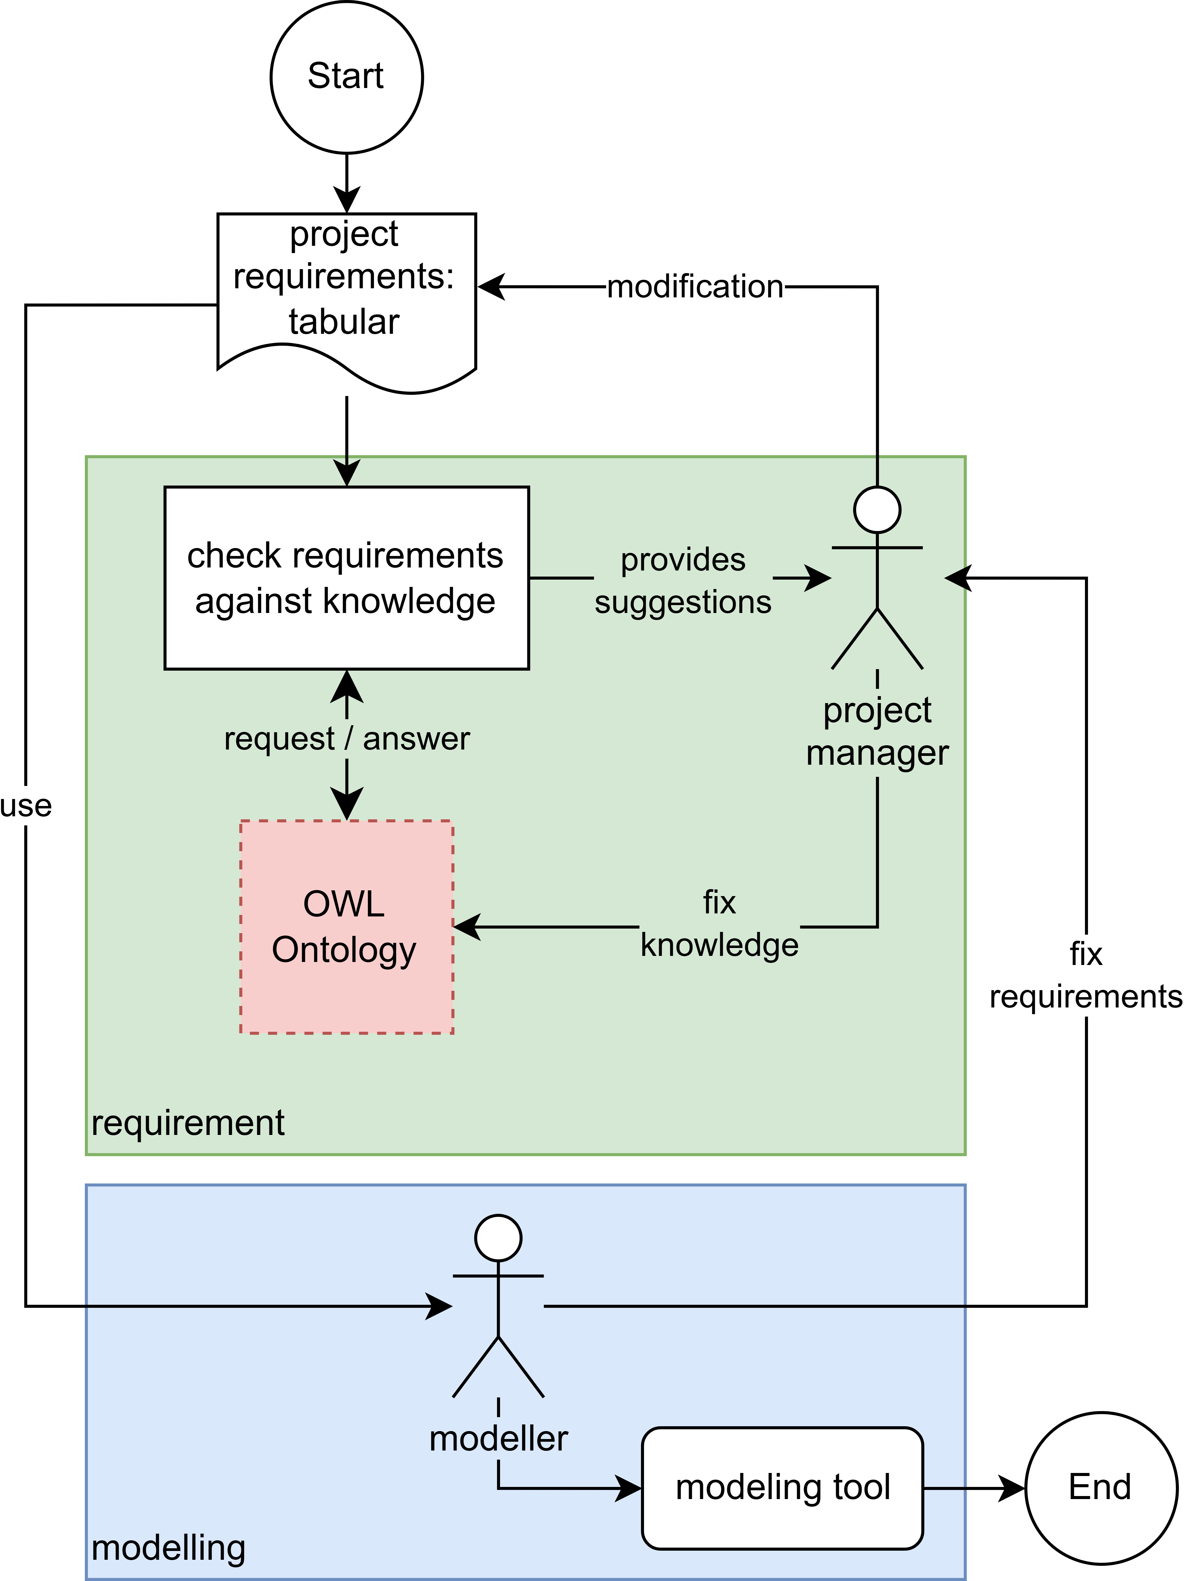
We will approach this issue by examining how an actual planning process, which moves from a requirements phase to a modelling phase and back, would function with ontology checking. First, we assume that the project requirements exist as a kind of dictionary, in which different named factors are given numerical, truth or text values, or are left empty. These values are then used to construct a logical query to an ontology, which responds by informing us about possible rule violations in the given values and lists possible choices or alternatives. This answer would be checked by a project manager, who then starts to communicate with the modeller about realising the requirements into a CAD model. The whole process is shown in Figure 1. A discussion of how to build such project-integrated ontologies can be found in (Wogan, 2025). In this paper, we instead deal with the question of how to create data-driven visualizations that connect into such a knowledge-driven planning processes. If we had an ontology that could accurately represent most of the project requirements and knowledge – how would our planning tools need to change to make use of them?
The first step is to make the request-and-answer process with the ontology machine-readable and formally specified, to allow for repeatable visualizations and interactions. For this, we need to classify the types of answers that an ontology can give.
First, it can warn if a value set in the requirements breaks the encoded rules or not. Whether this is the case or not, it can then offer the allowed bounds of a numerical value, or what the different valid options are for a value that specifies a class or category. It can also highlight dependencies that are implied by the current state (for example that a certain system needs to be added to a building once it reaches a specified size), or even alternative configurations. How these values can work in the context of a visualization application is discussed in the following section.

3.2 Visualization and Interaction Aspects
While most actions in a planning process can be successfully handled with generalized CAD and calculation software, many tasks benefit from special software tools that offer focussed analysis or modelling capabilities. Such products are trending more and more towards offering these workflows in a very responsive, highly interactive, and visual way. However, there is often a lack of integration of semantic knowledge, that allows the software to respond to interactions in an informed way. We expect controlled assistance and resistance from other interfaces we use in our daily lives, like lane assist systems in modern cars, but they are still rare in specialist software. A responsive expert tool could immediately resist interactions that would make a bike lane narrower than allowed, or even be supportive in completing interactions that would make a project more environmentally friendly. To achieve something like this, the knowledge must be immediately available, putting every interaction into a constant dialogue with ontologies and other knowledge models.
Figure 1: A simplified view of how an ontology would currently be used within a project context.
Because these applications work in environments including VR, CAVEs or even projection desks with 3D models (Dembski et al., 2020), this can be paired with meaningful feedback that goes past just the visual domain. This could be simple haptic feedback like vibrations on a touchpad, or even special hardware like a force-feedback knob that can offer resistance as certain values are scaled up or down. Auditory feedback, usually relegated to warning sounds when certain software interactions are not permitted, could instead be informing us about whether we are moving in a positive or negative direction for a certain value. This can potentially create interfaces that are playful in a way that invites public participation. For professional applications, each interaction could be enriched with subtle feedback, covering multiple domains of expert knowledge, making them useful for any kind of participation in a design process.
To implement such highly interactive, multi-modal tools, we first need a broad classification of interactions, as well as a specification for communication points with the decision-support infrastructure.
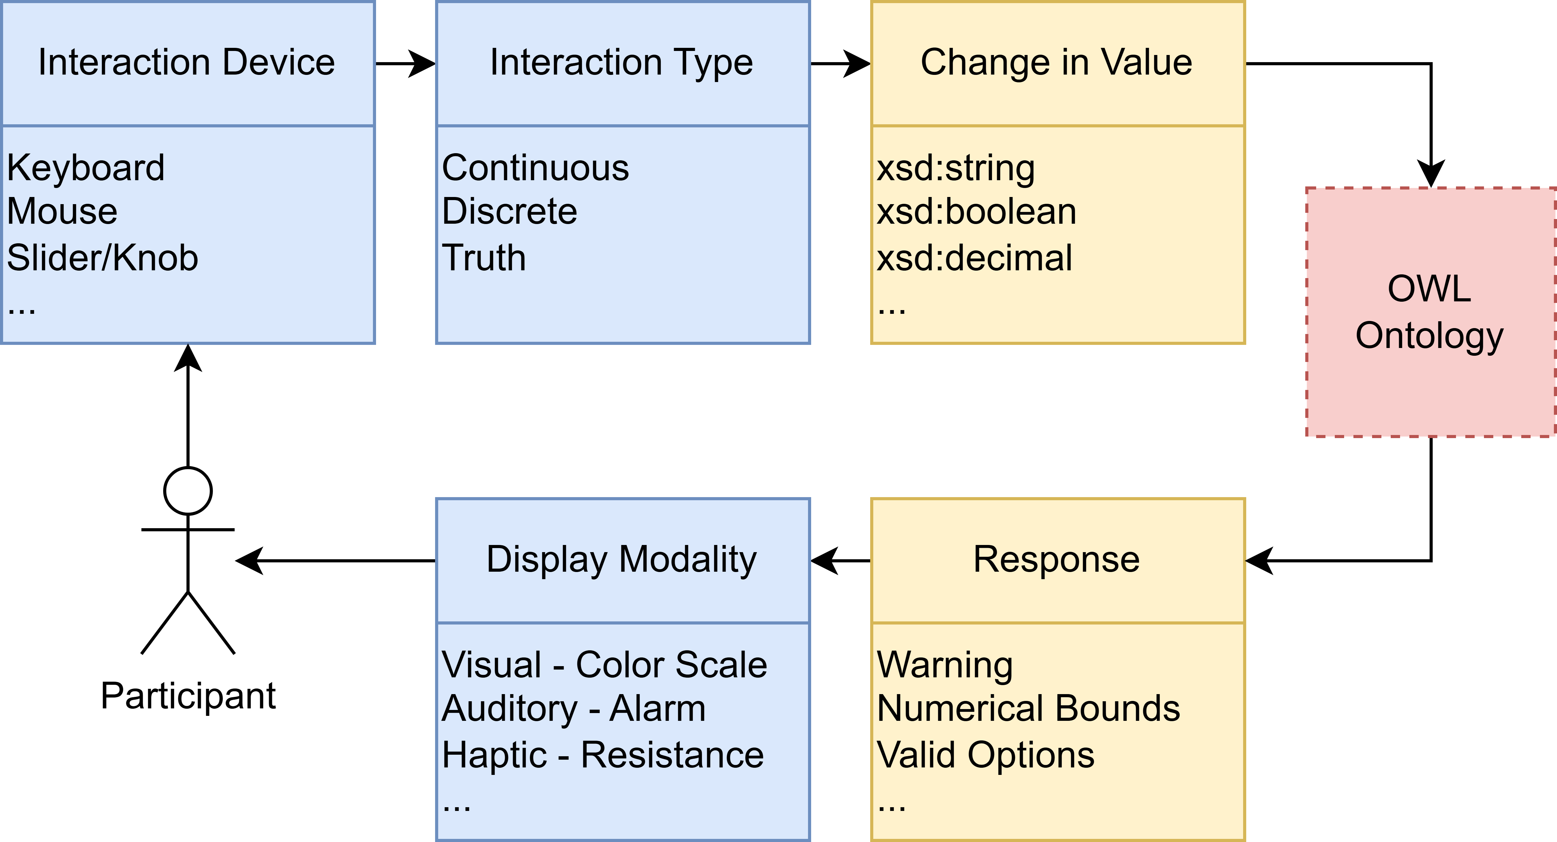
Within this infrastructure planning context, any interaction can either be a continuous change along an axis (usually numerical values, like the height of a building), a discrete change in classification (like changing the type of material used in a wall), a change in a truth value (like whether a road allows certain vehicles or not) or a geometric change (like completely changing the shape of a building). Geometric changes are difficult to validate in the context of project requirements and ontologies, and any validation would be difficult to visualize in the general case. Thus, any change in the geometry will ideally have to be translated into one of the other possible changes.
Any change made by an interaction then either triggers a check against the ontology or not. Whether this is necessary can be decided either by the application or by the user. This can have performance implications, so whenever possible, knowledge already present in the application should be used. Reducing the interactions to three types of possible changes has the advantage that the visual, auditory or haptic feedback can be designed by simply considering the type of interaction in combination with the data type that is being changed. Possible data types are given by the framework of the ontology. A common format is the Web Ontology Language (OWL), which uses the data types of the Resource Description Framework (RDF) it is based on.
The available interaction devices are then put into a direct feedback loop with the available display devices. The feedback itself depends on the modality of the display. A certain number of warnings, numerical bounds and valid options can be integrated directly into the visualization feedback loop, while higher-order responses like dependencies and alternatives would in most cases have to be communicated through an additional text-based interface. Capitalizing on recent developments in Large-Language Models (LLMs), this could even be conceptualized as a chatbot that runs in conjunction with the visualization.
Figure 2 shows the flow of this knowledge-integrated multimodal feedback loop.
Figure 2: A visualization-interaction loop that integrates ontology knowledge.

3.3 System Design
The previously described visualization application now needs to integrate into the wider project context. The flow of operations starts at a web-based or native application running in a given display environment. A common interface to the knowledge infrastructure loads a copy of all necessary geometric and tabular project information, such as plan geometries or price lists, as well as a subset of the required knowledge base.
This subset could consist of individual numerical bounds or valid options from the full ontology (if certain choices were already made beforehand) or they could be complete ontologies. The application will also already encode some knowledge not found in the digital infrastructure, either implicitly by how its interaction flows are designed, or explicitly through internal validation procedures. A CAD application focused on road construction would for example not even allow editing of anything but a road (implicit) but would also contain lists of available materials (explicit).
Then, interactions with the software which change the project plan will cause requests to the copied knowledge base, as shown in Figure 2. This results in an updated visualisation that might highlight immediate issues with a decision that was taken. As such, the user is lead to a result that conforms to all the rules and best practices that are known based on the local copy.
Finally, the result is again checked against the entire knowledge base. For this, the specialist application does not need to be aware of all possible values across all domains - instead, it only needs to return the new state of those values that were originally loaded into it. To implement this, there needs to be a well-defined Application Programming Interface (API), that allows the visualization to check for sets of values without having to write any direct queries to the ontology. Possible issues that only arise with the full context are then reported to the user through the previously defined types of ontology response. The user can comment on these issues and leave additional feedback, pushing this configuration into the digital infrastructure as a new branch for the versioning system.
See Figure 3 for a sequence diagram describing the complete flow.
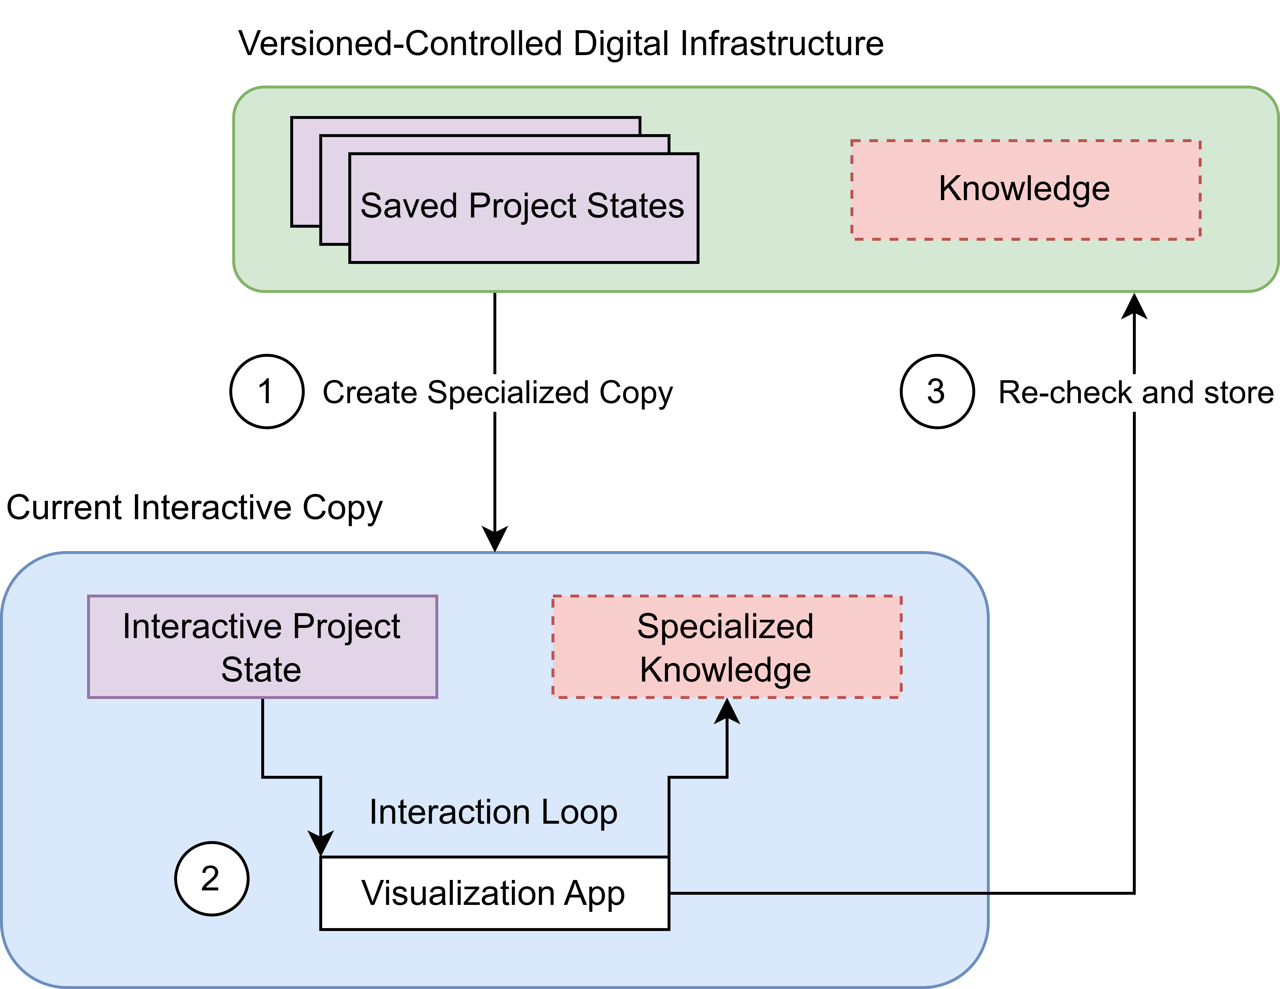
4. RESULTS
Even though the previously described system assumes a level of knowledge standardization that is not yet common in the field, there is no technological barrier that prevents us from building such systems now. In the following example we will show a limited prototype that implements our system design.

4.1 Case Study: Continuous Visualisation and Feedback for a Street Project
When planning a street rework in an urban context, several factors are set: Surrounding buildings will likely remain where they are, creating a situation in which we have limited space that we can fill with roads, bike lanes, sidewalks, grass, trees, streetlamps, and more. There is no “correct” way to arrange these elements, however there are many regulations, depending on the country and context, as well as preferences and experiences from experts and the public. For a given street, all that is necessary is to divide it into segments that run along the axis of the street and then specify the distribution of parts for each segment.
There will be two parts to this system: First, a real-time 3D application that allows us to set the position and width of street segments interactively. Second, there is a server application that waits for requests sent by the 3D application
The 3D application was developed in the Unity game engine, as it integrates with most VR, CAVE and other specialty display and interaction systems, and can thus be a base for various future developments. In the current prototype, it shows a simple scene with two sidewalks, two bike lanes and a road segment. There are visualization elements, which give information about measurements and validity of the current state, and interaction elements, which can be moved to change the width of individual segments.
The server application consists of a Python script, which manages API calls, queries to the ontology, and the project state. The project state is a simple configuration file containing key-value pairs. In the prototype, the knowledge is represented by a single RDF-specified ontology, that implements specific parts of the German guidelines for the design of urban roads (RASt E, 2012).
The two applications communicate through API calls, initiated by a KnowledgeManager script in the Unity application. Some knowledge is kept locally within the manager (for example the numerical bounds for the width of each road segment). The API calls then only happen in specific situations (for example when one lane is set to a width of 0, as this can change which regulatory category applies), or at user direction through a button press.
Figure 3: Operation of the system, showing how a specialized visualization interface manages its own interactive copy of the project state, and then feeds it back to the version controlled digital infrastructure.
Figure 4 shows a screenshot of the interface, including the street segments, visualization elements and UI. One of the measurement tools is highlighting a violation of a bounded numerical value. Figure 5 then shows a system overview of the prototype implementation.
The prototype is currently still missing an implementation of versioning. Because project state files are simple key-value configuration files, this could be realized with a Python library that enables programmatic management of a git repository on the server.

4.2 Discussion
With our prototype, we showed a basic working implementation of our system. For the RASt-based street ontology and a small project state-file, the API response time stays real-time capable, with a sub-second response time. The local knowledge is mostly encoded in how the visualization deals with the different types of values in the API response – which does not require much additional work, as categorical values and numerical bounds are already common in interactive visualizations. When developing the prototype, the integration of the Python server and the Unity application only required configuring the API calls and handling the distributed project state in the Unity KnowledgeManager.
The example we used here is simplified – both in terms of the capabilities of the Unity application and the complexity of the ontology. However, most of the difficulty in creating more complex ontologies and visualizations lies in creating the ontologies and visualizations themselves. If the visualization developer keeps the possible response values in mind, the integration of the two parts will not be the main issue.
One aspect that is missing in the current prototype is the ability to add comments and discussions to the saved state. This could be solved with a text input that appears the moment a save is made and which is then processed to appear as a commit comment in the git repository. If we want to instead allow for spatialized comments that can reference specific parts of the scene, a more customized solution would be required.
We will now discuss more generalized issues that the knowledge representation and visualizations might face. The two main technical challenges for visualizations in infrastructure planning are successful data integration and computational performance limitations. Planning data sources are heterogenous and include unstructured documents, building information models (BIM), structured tabular data from many different domains, and geospatial data. Standardized file formats and conversion pipelines alleviate these issues to a degree, but there will still be a customization of the data integration for each new application.
The same issue exists for ontologies. Currently, integration of ontologies within real-world project data is a mostly unsolved issue, as the data tends to reflect real-world complexities, which is difficult to systematically model in a well-structured way.
The issue of computational complexity also appears in both domains: the real-time performance of the multimodal visualization interface itself, and the timely querying of the ontology. The former, like data integration, requires careful work in finding the right amount of graphical and interaction fidelity for a certain display and computer system. The issue of ontology performance is, to a degree, avoided by our design, as the local knowledge management is specifically created in the context of the visualization, and the global knowledge management only gets queried asynchronously whenever necessary. However, this only holds true if the global ontology queries do not exceed a response time of several seconds or at most minutes, as users still expect a timely answer. In this case, cloud computing approaches might become necessary.
Apart from technical challenges, there are questions of usability and user adoption. While multimodal visualizations in VR, CAVEs or tangible interfaces can be more intuitive to users, they can also overwhelm. However, the main design difficulty here is the design of the specific visualization tool, not its combination with the ontology. The visualization needs to be approachable, responsive, and informative. There is much research on usability and accessibility for many of these technologies already, which can be translated to systems as presented here. The main usability question that remains is how to present dependency and alternative inputs. In our prototype, we form simple textual representations. However, this is prone to misunderstandings. Adoption of a more interactive chatbot-approach might be helpful.
How some of these challenges are tackled will also depend on the strategic place of each application in the planning process. If their main aim is public participation, the visualization design must be more accessible. Systems that allow experts to work collaboratively need to focus on offering powerful interaction and reasoning tools.
The last challenge of our system design concerns the quality of ontologies. Because we are trying to model existing laws, norms, and regulations, it is vital that the ontologies themselves are compliant and legitimate. The system should never imply that a successful pass of the ontology means that there will be no further issues in dealing with regulatory praxis. Similarly, any uncertainty that is present in an ontology should be highlighted with a visualization that is capable of communicating such uncertainties.
Furthermore, while the system is made for dealing with value and content changes in the ontology, any deeper changes to their structure and logic would require changes in each affected tool. Such changes should be rare in a well-defined ontology, but can never be fully avoided. This is most commonly handled through larger version updates – any new version of the ontology that is driving the semantic knowledge base would call for a new version of the visualization tools

5. CONCLUSION AND FUTURE WORK
In this paper, we presented a system design that enables the development of data-driven multi-modal planning tools. As a proof-of-concept, we implemented a prototype to solve a specific street-planning use case, featuring simplified versions of each sub-system. Future research should target more advanced use cases, with prototypes evaluated in real-life planning sessions or public participation processes. These lessons and prototypes could finally be turned into a collection of varied visualization interfaces, all implementing the same, well-defined data-exchange protocols with the knowledge infrastructure. Project managers could then create an integration of their project for the knowledge infrastructure and would immediately have access to several working, highly dynamic applications to support their planning process.
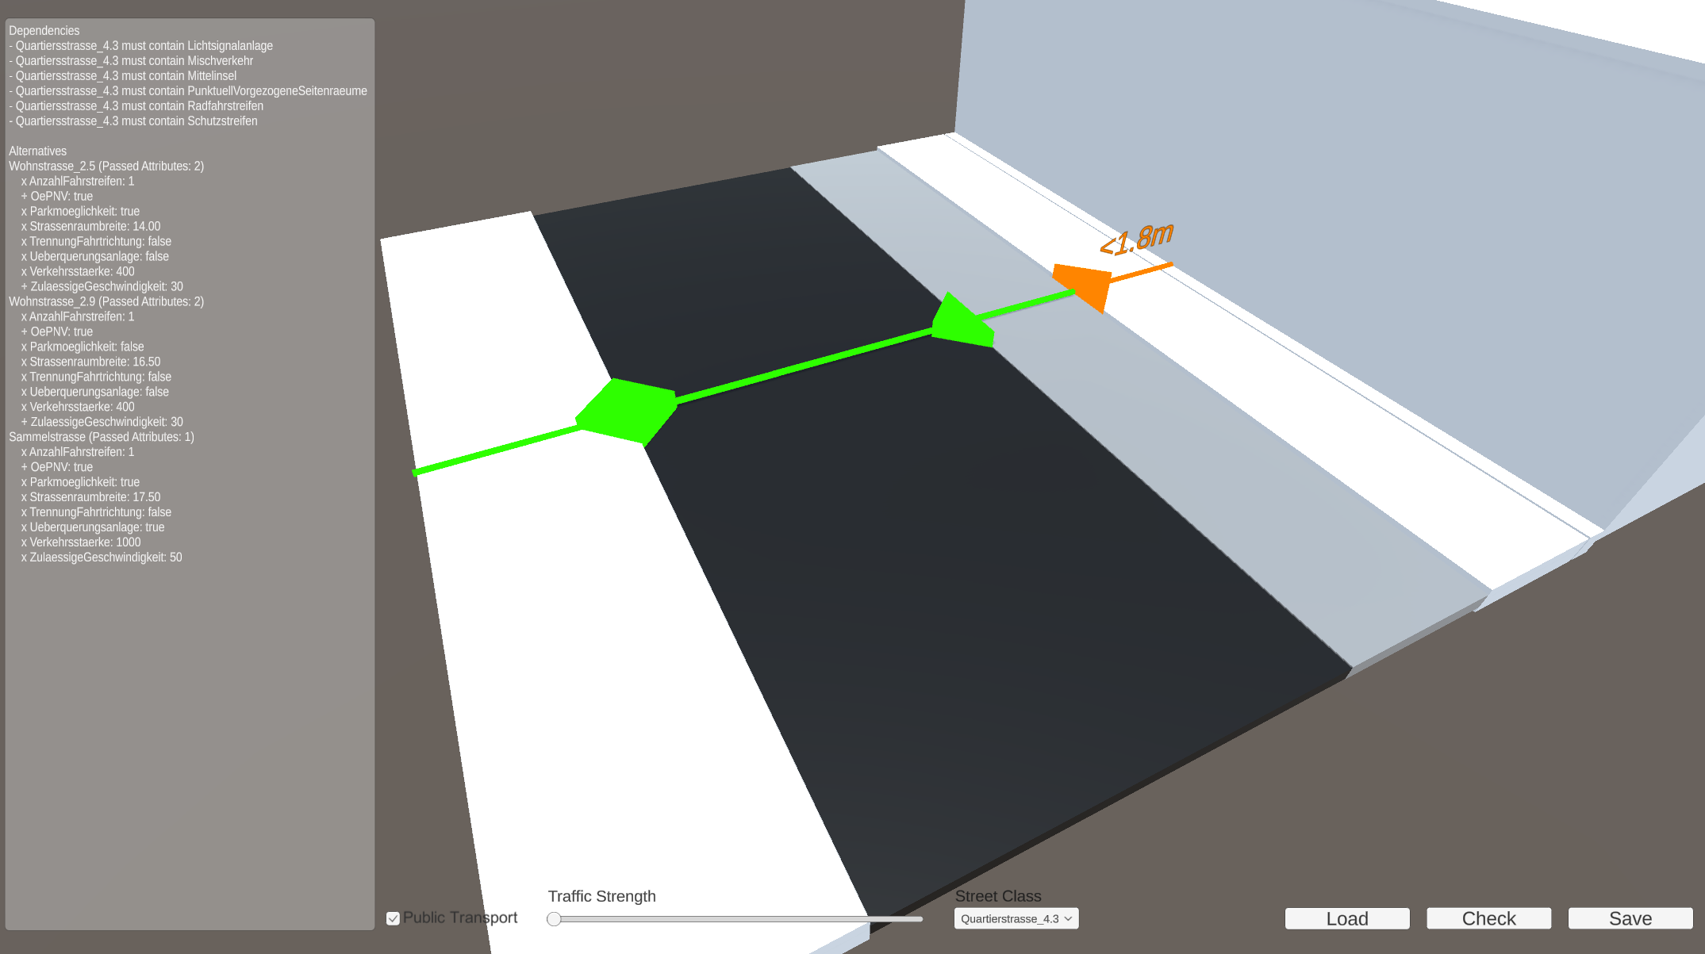
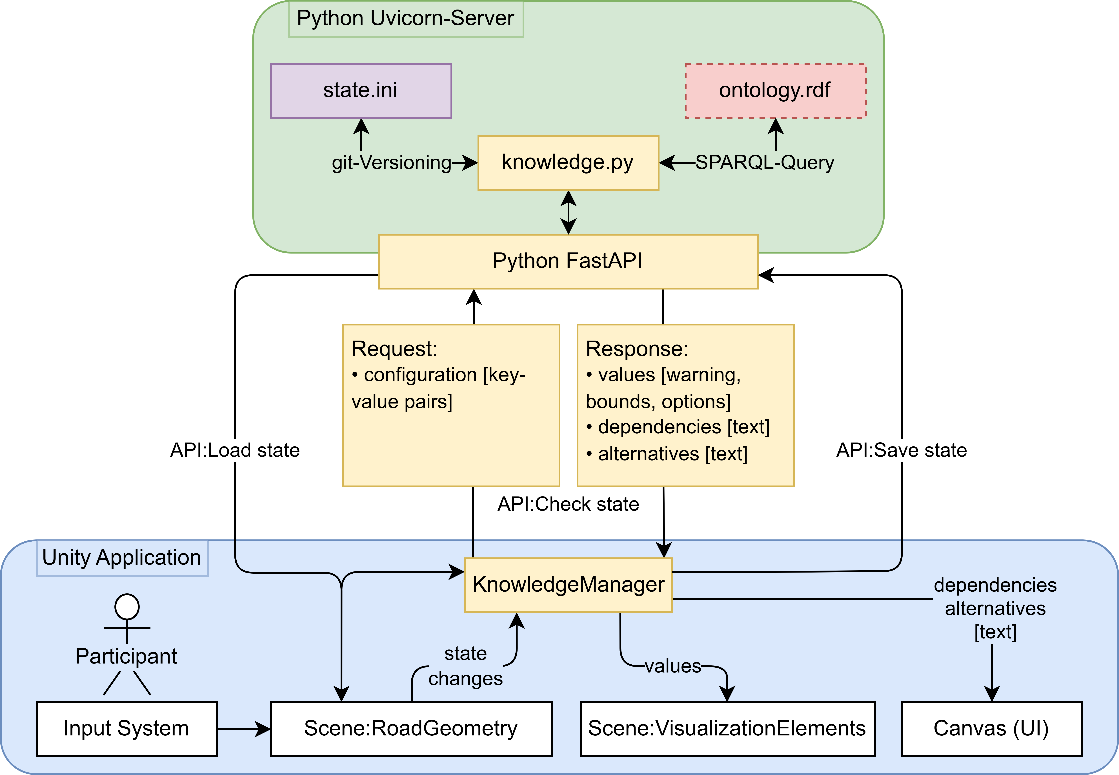
Figure 5: A full overview of the prototype design for a multimodal data-driven planning application, which allows for real-time interaction with a road segment in a Unity application (blue) and validates any changes according to the knowledge base (green). This validation is done through API-based communication (yellow).
Figure 4: A screenshot of the visualisation prototype. The coloured elements are interaction handles, which can be dragged to the left and to the right to widen or narrow individual segments of the road. The orange element warns of a value that is out of bounds according to the rules of the ontology The text box on the left displays additional dependencies and alternatives in text form. The bottom row contains additional contextual controls for the scene as well as buttons that execute the three different API calls.
To reach this level of integration, our current design and prototype need to be extended through focussed system engineering, which integrates all complexities of planning processes, ontologies and real-time applications. Advanced concepts like versioning ontologies and planning uncertainty need to be included.
The current knowledge infrastructure should also be extended with other types of systems, like simulation models and AI-based reasoning agents. Current research on integrating semantic knowledge representations into LLMs could evolve into a design for multimodal visualizations, in which the user is continually supported and guided by several specialized AI agents.

REFERENCES
BMDV (2014). Manual for Good Public Participation. Berlin: Federal Ministry of Transport and Digital Infrastructure.
StreetMix (2025). StreetMix. [Online] Available: https://streetmix.net [Accessed: 8. April 2025].​
3DStreet (2025). 3DStreet - Design the future. [Online] Available: https://www.3dstreet.org/ [Accessed: 8. April 2025].​
DIPAS (2025). DIPAS – Thinking Digital Participation Further. [Online] Available: https://www.dipas.org/en [Accessed: 8. April 2025].​
Sinning, H., Brandenburger, Y., Kruse, R. & Rogoll, S. (2023a). Partizipative Stadtentwicklung mit XR-Technologien. Forum Wohnen und Stadtentwicklung, 2, p. 88–92.
Sinning, H., Semialjac, J. & Rogoll, S. (2023b). XR-Participation-Spaces: New opportunities of citizen participation in city planning? In: Book of Abstracts: 35th AESOP Annual Congress Integrated Planning in a World of Turbulence, Łódź, Poland, pp. 147–148.
Saßmannshausen, S.M., Radtke, J., Bohn, N., Hussein, H., Randall, D. & Pipek, V. (2021). Citizen-centered design in urban planning: How augmented reality can be used in citizen participation processes. In: Proceedings of the 2021 ACM Designing Interactive Systems Conference, 28, pp. 250–265.
Boos, U.C., Reichenbacher, T., Kiefer, P. & Sailer, C. (2023). An augmented reality study for public participation in urban planning. Journal of Location Based Services, 17(1), pp. 48–77.
Paraschivoiu, I., Steiner, R., Wieser, J. & Meschtscherjakov, A. (2025). Crafting Cities Together: Co-located Collaboration with Augmented Reality for Urban Design. In: Proceedings of the 2025 ACM Conference on Computer Supported Cooperative Work, 2025.
Pogmore, A.C., Davies, R.J. & Cooke, N.J. (2024). Virtual Versus Reality: A Systematic Review of Real-World Built Environment Tasks Performed in CAVEs and a Framework for Performance and Experience Evaluation. In: Virtual Worlds, 3(4), pp. 536–571.
Hall, B., Kessler, J., Edo-Ohanba, O., Collins, J., Zhang, H., Allegreti, N., Duan, Y., Wang, S., Palaniappan, K. & Calyam, P. (2022). Networked and Multimodal 3D Modeling of Cities for Collaborative Virtual Environments. In: 2022 IEEE/ACM International Conference on Big Data Computing, Applications and Technologies (BDCAT), 2022, pp. 204-212.
Nikolić, D., Maftei, L. & Whyte, J. (2019). Becoming familiar: How infrastructure engineers begin to use collaborative virtual reality in their interdisciplinary practice. Journal of Information Technology in Construction, 24, pp. 489–508.
Maftei, L., Nikolic, D. and Whyte, J. (2019). Challenges Around Integrating Collaborative Immersive Technologies into a Large Infrastructure Engineering Project. In: Proceedings of the 35th CIB W78 2018 Conference: IT in Design, Construction, and Management, 1–3 October 2018, Chicago, USA, pp. 315–321.
Fandáková, M., Zábovská, K., Bucko, B., and Zábovský, M. (2020). Improvements of Computer Assisted Virtual Environment (CAVE). In: 43rd International Convention on Information, Communication and Electronic Technology (MIPRO 2020), Opatija, Croatia, pp. 1680–1684.
Maquil, V. (2016). Towards understanding the design space of tangible user interfaces for collaborative urban planning. Interacting with Computers, 28(3), pp. 332–351.
Berger, M., Ploennings, J., and Wogan, M. (2024). Input Strategies for Precise CAD Modelling with Modern Interaction Devices. In: 2024 European Conference on Computing in Construction (EC³ 2024), 2024, Crete, Greece.
Ehn, P. (1998). Manifesto for a digital bauhaus. Digital Creativity, 9(4), pp. 207–217.
Bjögvinsson, E., Ehn, P. and Hillgren, P.-A. (2012). Design Things and Design Thinking: Contemporary Participatory Design Challenges. Design Issues, 28(3), pp. 101–116.
Dridi, A., Patlakas, P., Lefrançois, M., Beach, T., Petr, H., and Vakaj, E. (2024). AEC3PO: A Knowledge Model for Machine Executable Construction Regulations. Preprint Available at SSRN 4784123.
Rasmussen, M.H., Lefrançois, M., Schneider, G.F., and Pauwels, P. (2020). BOT: The Building Topology Ontology of the W3C Linked Building Data Group. Semantic Web, 12(1), pp. 143–161.
Porwol, L., Ojo, A. and Breslin, J.G. (2016). An ontology for next generation e-Participation initiatives. Government Information Quarterly, 33(3), pp. 583–594.
Vaatz, A., Hamdan, A.-H., Al-Sadoon, N., Wogan, M., and Menzel, K. (2023). Integration of Semantic Temporal Information in BIM Using Ontologies. In: 2023 European Conference on Computing in Construction (EC³ 2023), 2023, Crete, Greece.
Wogan, M., Meyer, N., Mohan, N., Schilling, S., Vaatz, A., Lelke, T., Menzel, K. and Groß, R. (2024). Digital Rules in Infrastructure Planning: Presentation of an Ontology-Based Approach. In: 31st International Workshop on Intelligent Computing in Engineering (EG-ICE 2024), 2024, Vigo, Spain, pp. 31–40.
Wogan, M., Mohan, N., Schilling, S., Jaud, S., Menzel, K., Gross, R. (2025). Management of Model Requirements across Projects: An ontology and IDM / MVD based approach across lifecycles. Accepted in: 32nd International Workshop on Intelligent Computing in Engineering (EG-ICE 2025), 2025, Glasgow, Scotland.
Dembski, F., Wössner, U., Letzgus, M., Ruddat, M. and Yamu, C. (2020). Urban digital twins for smart cities and citizens: The case study of Herrenberg, Germany. Sustainability, 12(6), 2307.
Forschungsgesellschaft für Straßen- und Verkehrswesen (FGSV) (2012). Richtlinien für die Anlage von Stadtstraßen: RASt 06, Korrigierter Nachdruck Mai 2012. Cologne: FGSV-Verlag.

