Interoperability Debt in AECO Sector: Why Data Standardisation Failures Persist Across Projects
Vikram Dhotre *, Xun Xu

University of Auckland, New Zealand
*Corresponding email: vikram.arunkumar.dhotre@auckland.ac.nz

ABSTRACT
Data standardisation failures, including inconsistent classification, metadata ambiguity, fragmented validation practices, delayed information delivery, and software-dependent data exchange, persist across Architecture, Engineering, Construction, and Operations (AECO) projects despite growing digitalisation and the adoption of OpenBIM standards, data exchange schemas, and lifecycle information management frameworks. Existing interoperability research often treats these failures as isolated technical or implementation problems, giving less attention to how they accumulate across the built asset lifecycle.
This paper conceptualises interoperability debt as a lifecycle-oriented governance construct that explains how recurring implementation failures accumulate into long-term information management liabilities. Using a conceptual framework development methodology, the study synthesises literature on interoperability, OpenBIM standards, lifecycle information management, governance, and technical debt.
The resulting framework shows that recurring OpenBIM implementation failures evolve into technical, semantic, process, and governance debt. These debt types accumulate across the built asset lifecycle, producing deferred integration effort, reduced data trust, traceability gaps, and constrained lifecycle information reuse. The framework further shows that weak accountability, diffuse stewardship, and limited validation practices allow interoperability debt to persist throughout the built asset lifecycle.
The paper contributes a lifecycle-oriented explanation of persistent data standardisation failure and provides a governance-focused basis for reducing interoperability debt through early information requirements, structured validation gates, defined stewardship roles, performance monitoring, and organisational learning. The framework is illustrated using the Crossrail/Elizabeth Line case and provides a foundation for future empirical validation and measurement development.

- INTRODUCTION
The Architecture, Engineering, Construction, and Operations (AECO) sector is undergoing rapid digital transformation associated with Construction 4.0. Across the built asset lifecycle, projects increasingly rely on structured digital information, platform-based collaboration environments, OpenBIM standards, data exchange schemas, and lifecycle information management practices to support coordination, compliance, delivery, and long-term asset use (Succar, 2009; Volk et al., 2014; ISO, 2018). Despite these advances, achieving consistent information continuity and reuse across the built asset lifecycle remains a persistent challenge (Whyte & Hartmann, 2017). Fragmentation across disciplines, organisations, software platforms, and lifecycle stages continues to lead to duplicate data entry, inconsistent metadata, delayed handovers, and limited downstream information reuse (Whyte & Hartmann, 2017). Although OpenBIM standards, including Industry Foundation Classes (IFC), Construction Operations Building Information Exchange (COBie), Information Delivery Specifications (IDS), and BuildingSmart Data Dictionary (bSDD), together with information management frameworks, are intended to support consistent information exchange and lifecycle continuity (buildingSMART, 2020; ISO, 2018), standardisation failures persist across projects. As a result, apparent compliance with OpenBIM standards does not necessarily produce consistent operational practice, reliable validation, or trustworthy lifecycle information continuity (Whyte & Hartmann, 2017).
Existing literature has often treated interoperability problems as technical barriers, exchange limitations, or implementation challenges, with particular emphasis on technical and adoption-oriented perspectives rather than lifecycle-wide information continuity and governance (Ozturk, 2020; Turk, 2020; Doe et al., 2024; Succar & Kassem, 2015). While these perspectives are valuable, they give less attention to how repeated short-term deviations from standardised practice accumulate over time and create deferred integration burdens. In AECO projects, local workarounds may satisfy immediate coordination or programme pressures while embedding inconsistencies that become apparent at later lifecycle stages (Whyte & Hartmann, 2017; Zhu et al., 2021; Otranto et al., 2025; Dong & Moshood, 2026). Interoperability failure should therefore be understood not merely as a technical exchange problem, but as a lifecycle governance challenge in which decisions about information requirements, validation, stewardship, and accountability shape the long-term continuity, trustworthiness, and reuse of project information (Whyte & Hartmann, 2017; ISO, 2018).
To address this gap, this paper introduces the concept of interoperability debt as a lifecycle-oriented explanation for persistent data standardisation failures in AECO projects. Conceptually informed by technical debt, which describes future costs arising from short-term technical decisions (Cunningham, 1992), interoperability debt refers to the accumulated lifecycle burden created when data standardisation practices are delayed, inconsistently operationalised, or bypassed during project delivery, resulting in deferred integration effort, reduced data trust, and constrained lifecycle information reuse. Unlike technical debt, interoperability debt extends beyond software artefacts to encompass technical, semantic, process, and governance dimensions within AECO’s multi-organisational information environments (Whyte & Hartmann, 2017). As such, interoperability debt provides an explanatory mechanism for understanding why data standardisation failures not only occur, but also accumulate, persist, and influence lifecycle information continuity.
The objective of this paper is to develop a conceptual framework explaining how recurring OpenBIM implementation failures generate, accumulate, and perpetuate interoperability debt across the built asset lifecycle.
The paper addresses three research questions:
- Why do data standardisation failures persist despite the adoption of OpenBIM standards in AECO projects?
- How do OpenBIM implementation failures generate and accumulate interoperability debt across the built asset lifecycle?
- What governance interventions can reduce interoperability debt and strengthen lifecycle information continuity?
This study makes three principal contributions to interoperability research. First, interoperability debt is introduced as a lifecycle-oriented conceptual lens for explaining persistent interoperability failure in AECO information environments. Second, a four-dimensional framework covering technical, semantic, process, and governance debt is developed to explain how debt forms, accumulates, and affects lifecycle information continuity. Third, governance-oriented mitigation mechanisms are proposed to reduce debt accumulation and strengthen digital continuity across the built asset lifecycle.

- BACKGROUND AND RELATED WORK
  - Interoperability, standardisation, and lifecycle continuity
Interoperability in the AECO sector may be understood as the capacity of systems and project stakeholders to exchange, interpret, govern, and reuse information consistently across platforms and lifecycle stages; it therefore extends beyond data exchange (Ozturk, 2020; Turk, 2020). Data exchange may be technically successful while still producing inconsistencies in classifications, metadata, and information requirements when these are not interpreted or validated consistently across software platforms, information systems, and lifecycle uses (Turk, 2020; Lee et al., 2021).
Similarly, technically compliant workflows may fail operationally where validation procedures and responsibility structures are insufficiently defined (Whyte & Hartmann, 2017). Interoperability should therefore be regarded as a multidimensional construct encompassing technical dimensions related to formats and system compatibility, semantic dimensions related to shared meaning and classification alignment, process dimensions related to workflow coordination and validation, and governance dimensions related to stewardship, accountability, authority, and enforcement of information practices (Succar & Kassem, 2015; Gebremichael et al., 2022; Triana González & Lozano Diez, 2024; ISO, 2018).
Alignment across these dimensions depends on effective data standardisation. Nevertheless, the existence of OpenBIM standards does not in itself ensure consistent implementation (buildingSMART, 2020; ISO, 2018). In this study, interoperability debt is conceptualised across four dimensions. Technical debt refers to liabilities arising from exchange fragility, system incompatibility, and software dependencies; semantic debt arises from inconsistent terminology, classification, metadata, and information meaning; process debt results from deficiencies in information delivery, validation, and workflow coordination; and governance debt arises from weak stewardship, accountability, authority, and enforcement of information practices.
Table 1 summarises the roles of OpenBIM standards in data standardisation, typical implementation failures, and the associated interoperability debt dimensions.

Table 1. OpenBIM standards, implementation failures, and associated interoperability debt
OpenBIM standard | Role in data standardisation | Typical implementation failure | Interoperability debt generated
ISO 16739 (IFC) | Enables structured model and data exchange across software platforms | Exchange fragility, inconsistent export or import routines, version conflicts, tool-specific dependencies | Technical debt
COBie | Structures asset information for handover and facility management | Incomplete asset fields, poor-quality handover information | Process debt; semantic debt
ISO 19650 | Defines information management processes, responsibilities, Common Data Environment (CDE) workflows, and information requirements | Requirements not operationalised, unclear accountability, weak validation gates | Governance debt; process debt
IDS | Specifies information delivery requirements and validation rules | Late or inconsistent definition of information requirements; limited validation use | Process debt; governance debt
bSDD | Supports shared terminology, object definitions, and classification consistency | Inconsistent naming, classification gaps, ambiguous object meanings | Semantic debt

Previous investigations of IFC-enabled information exchange reported practical challenges related to information loss, inconsistent interpretation, and software-specific implementation differences despite the use of standardised exchange formats (Pazlar & Turk, 2008). In practice, fragmented software ecosystems, divergent interpretations of information requirements, weak validation procedures, disconnected handover processes, and diffuse responsibilities across project actors frequently undermine the operational consistency necessary for reliable lifecycle information continuity (Doe et al., 2024; Chatsuwan et al., 2025; Lee et al., 2021; Whyte & Hartmann, 2017).

  - Research gap
As shown in Table 1, OpenBIM standards establish common information exchange, management, and classification practices across the built asset lifecycle, but their effectiveness depends on consistent implementation, validation, and governance. Existing studies have identified interoperability barriers, governance weaknesses, and implementation challenges across AECO projects. Recent reviews and ecosystem-level studies highlight persistent problems associated with fragmented information environments, low data interoperability, weak cross-party coordination, and poor continuity between project delivery and operations (Ozturk, 2020; Doe et al., 2024; Li et al., 2021).
Previous research has developed conceptual structures for BIM adoption (Succar & Kassem, 2015), lifecycle information management approaches (Li et al., 2021), frameworks for information integration and interoperability (Gebremichael et al., 2022), and data connectivity models for Construction 4.0 environments (Dhotre et al., 2024). However, these studies give less attention to how unresolved implementation deficiencies accumulate across lifecycle stages and create deferred integration burdens. This paper addresses this gap through the concept of interoperability debt. Its novelty lies not in identifying another list of interoperability barriers, but in explaining how local deviations from standardised practice become accumulated liabilities that persist, intensify, and reappear across lifecycle stages.

- RESEARCH APPROACH
This study adopts Jabareen's (2009) conceptual framework development approach to explain why data standardisation failures persist in AECO projects despite the availability of OpenBIM standards and lifecycle information management practices.
Relevant literature was identified through focused searches of Scopus, Web of Science, and Google Scholar using keywords including interoperability, data standardisation, IFC-based exchange, ISO 19650 implementation, lifecycle information management, information handover, data governance, technical debt, and construction interoperability. The review covered four complementary knowledge domains: construction interoperability, lifecycle information management, governance and accountability, and technical debt theory.
Approximately 95 publications were initially identified. Following screening for relevance to recurring interoperability failures, OpenBIM implementation, lifecycle continuity, validation, governance, and multi-organisational project delivery, 16 publications were selected for conceptual synthesis, supported by relevant international standards and key reference sources.
The selected literature was analysed to identify recurring implementation failures and underlying explanatory concepts. These concepts were iteratively synthesised into four interrelated dimensions of interoperability: technical, semantic, process, and governance, which form the basis of the proposed conceptual framework.

- INTEROPERABILITY DEBT FRAMEWORK
Figure 1 presents the Interoperability Debt Framework, illustrating how recurring OpenBIM implementation failures evolve into interoperability debt across the built asset lifecycle and how governance mechanisms mitigate or reinforce its accumulation. The framework was developed through three analytical steps. First, recurring implementation failures identified in Table 1, including version conflicts and tool-specific dependencies, inconsistent naming and classification, incomplete or delayed information delivery, limited validation practices, and unclear accountability, were synthesised into representative OpenBIM implementation failures. Second, these recurring failures were interpreted through the concept of interoperability debt to explain how deviations from standardised information practices generate deferred integration effort, reduced information trust, traceability gaps, and constrained lifecycle information reuse. Third, these failures were organised into interacting debt dimensions and mapped across the built asset lifecycle to show how unresolved deficiencies accumulate from design through operations.
The framework integrates the four interoperability debt dimensions defined in Section 2.1: technical, semantic, process, and governance debt and conceptualises them as interacting rather than independent liabilities. Governance debt acts as a cross-cutting condition through which weak accountability, stewardship, and organisational oversight allow the other debt dimensions to form, interact, and persist throughout project delivery.
The framework further illustrates the mechanism through which interoperability debt accumulates over time. OpenBIM implementation failures rarely occur independently; instead, technical, semantic, and process deficiencies reinforce one another as project information moves across organisational and lifecycle boundaries. For example, inconsistent classification may increase validation effort, while inadequate validation procedures may allow semantic inconsistencies to propagate into downstream asset information. As these interrelated debt dimensions remain unresolved, they accumulate progressively across the built asset lifecycle, becoming increasingly visible through manual reconciliation, remediation effort, metadata deficiencies, traceability gaps, reduced information trust, lower asset data reuse, and diminished digital twin readiness.
Governance-based debt-repayment mechanisms constitute the final component of the framework. Early information requirements, structured validation gates, clearly defined stewardship responsibilities, and continuous monitoring through organisational learning and performance indicators provide mechanisms for reducing debt accumulation before interoperability problems become embedded within project information structures. Effective governance can therefore reduce debt accumulation, remediation effort, and information-quality deficiencies while strengthening lifecycle reuse and digital continuity.
A key contribution of the framework is its distinction between OpenBIM standards and their implementation. The framework does not suggest that standards such as IFC, COBie, ISO 19650, IDS, or bSDD are inherently inadequate. Rather, it demonstrates that interoperability debt emerges when the information requirements, validation processes, stewardship arrangements, and governance mechanisms associated with these standards are inconsistently interpreted, incompletely operationalised, or weakly enforced across organisations and lifecycle phases. In this respect, interoperability debt represents the accumulated consequence of implementation deficiencies rather than shortcomings in the standards themselves.

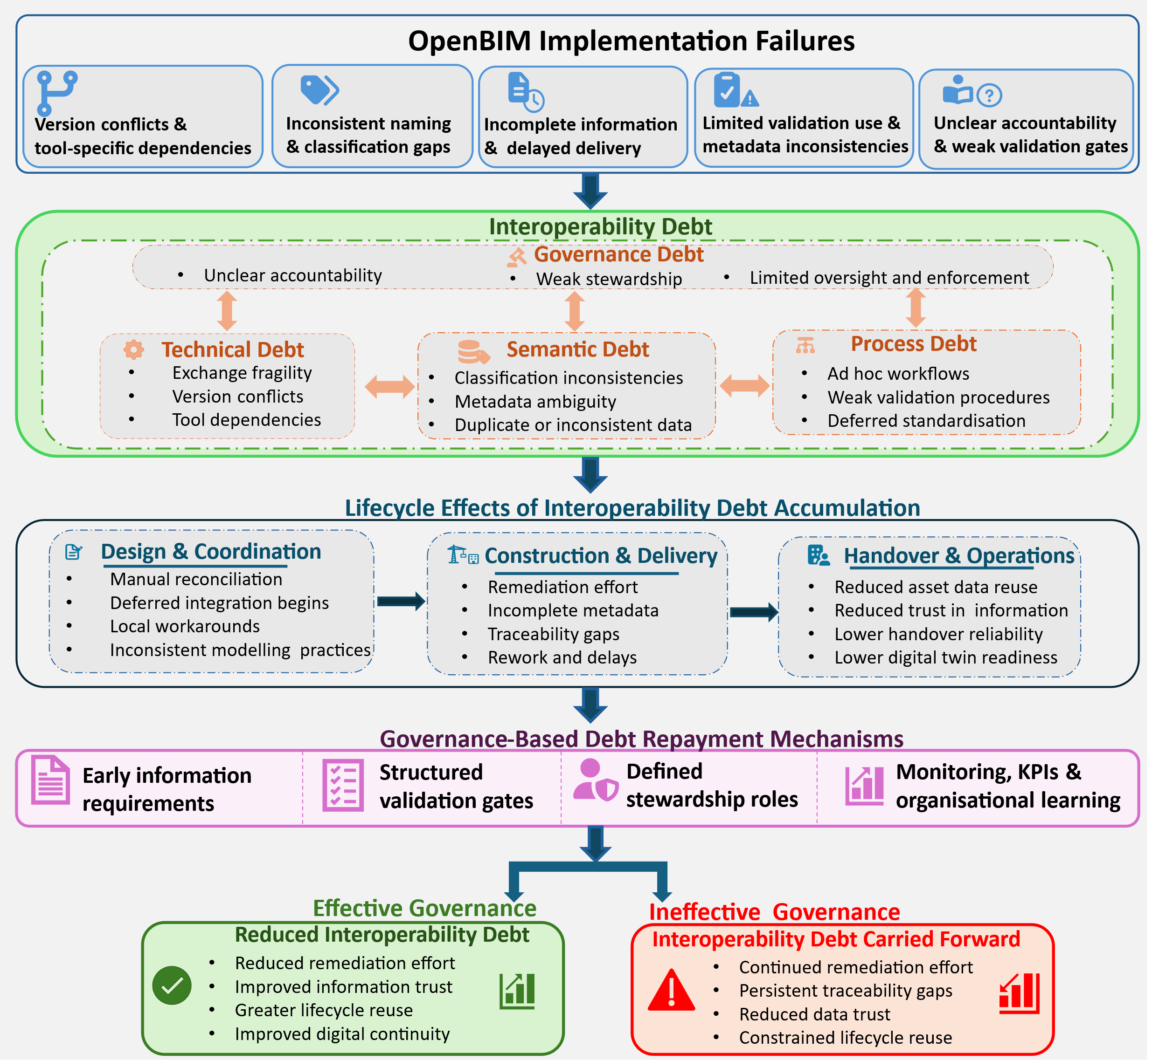
Figure 1: Interoperability Debt Framework: Evolution of OpenBIM implementation failures into debt mechanisms, lifecycle effects, and governance controls.

Accordingly, the framework should be interpreted as a lifecycle-oriented explanatory model rather than a linear process model.

- ILLUSTRATIVE APPLICATION OF THE FRAMEWORK: CROSSRAIL / ELIZABETH LINE
Crossrail/Elizabeth Line is a major railway infrastructure programme in London, UK, involving the delivery and integration of railway infrastructure, systems, and associated asset information across a complex multi-organisational environment. Its scale, multi-year delivery and handover, and extensive documentation of asset information management through the Crossrail Learning Legacy programme make it a relevant context for illustrating the framework (Taylor, 2017; MacDonald, 2016). Table 2 maps this documented evidence to the interoperability debt cycle. The case is used as an illustrative application rather than a formal empirical validation of the framework.
Table 2. Crossrail case evidence mapped to the interoperability debt cycle
Framework Element | Crossrail Case Evidence | Debt Dimension | Implication for the Framework
Debt Formation | Master Deliverables Lists, asset information requirements, asset breakdown structures, data dictionaries, and contractual deliverables requiring progressive definition and alignment. | Governance; process | Debt forms through ambiguous, delayed, or weakly operationalised requirements.
Debt Accumulation | Requirement for consistent asset identification, naming, labelling, classification, attributes, and data capture across a complex stakeholder ecosystem. | Semantic; process | Inconsistencies accumulate unless controlled through standards, procedures, and roles.
Technical Integration Challenges | Integration of CDE, BIM models, GIS, asset records, Operation & Maintenance information, and operator information systems. | Technical | Technical debt arises when information is distributed across weakly integrated systems.
Debt Interest | Additional checking, correction, validation, integration effort, and reduced confidence in lifecycle information. | All four dimensions | Debt interest appears as rework, delayed readiness, and reduced trust.
Debt Repayment | Asset identification standards, asset information procedures, asset data dictionaries, CDE integration principles, and BIM performance metrics. | Governance; semantic; process; technical controls | Debt repayment requires governance, validation, stewardship, and monitoring.

Note: Evidence is synthesised from Crossrail Learning Legacy documentation (MacDonald, 2016) and published accounts of the Elizabeth Line digital delivery programme (Taylor, 2017).
The mapping illustrates how documented project conditions can be interpreted as a lifecycle accumulation process rather than as isolated interoperability failures.

- DISCUSSION
This study reframes persistent AECO interoperability failure as a lifecycle governance phenomenon by explaining how recurring implementation deficiencies develop into accumulated information management liabilities. In doing so, it extends technical debt theory (Cunningham, 1992) to the socio-technical context of construction.
The framework further indicates that the adoption of standards alone is insufficient without clearly defined information requirements, validation, stewardship, and accountability, consistent with research identifying organisational and ecosystem-level challenges to AECO interoperability (Doe et al., 2024). This also aligns with lifecycle information management research emphasising information centralisation, interoperability, and traceability (Triana González & Lozano Diez, 2024), as well as evidence that weak alignment of information requirements and unclear acceptance criteria can undermine BIM-FM interoperability (Chatsuwan et al., 2025).
From a practical perspective, the framework provides a governance-oriented mechanism for reducing interoperability debt through structured validation, standardised information management practices, and continuous monitoring. These interventions support improved lifecycle information continuity, more reliable handover information, greater asset data reuse, and enhanced digital twin readiness (Bellon et al., 2025; Dong & Moshood, 2026).
As a conceptual framework, this study requires broader empirical validation. Although the Crossrail/Elizabeth Line case illustrates its practical relevance, future research should examine interoperability debt across different project contexts and develop methods for measuring debt formation, accumulation, and mitigation over time.

- CONCLUSION
Persistent data standardisation failures in AECO projects are better understood as accumulated interoperability debt generated when standardised information practices are delayed, inconsistently operationalised, or bypassed during project delivery, undermining information continuity, handover reliability, and downstream digital reuse.
The Interoperability Debt Framework explains how recurring implementation failures can create persistent liabilities despite the availability of OpenBIM standards and information-management frameworks. The Crossrail illustration demonstrates its application to documented project conditions, while future research should empirically test the framework and develop measures of debt formation, accumulation, and repayment. Interoperability debt, therefore, provides a basis for understanding and measuring the long-term consequences of data standardisation failure in digital construction environments.

ACKNOWLEDGEMENT
This study is part of the New Zealand Ministry of Business, Innovation and Employment (MBIE), Endeavour Research Programme titled ‘Developing a Construction 4.0 transformation of Aotearoa New Zealand’s construction sector’ (Contract number: HERX2201; Reference number: CONT-83666_ENDRP-HER).

REFERENCES
Bellon, F.G., Martins, A.C.P., de Carvalho, J.M.F., de Souza, C.A.F., Ribeiro, J.C.L., César Júnior, K.M.L. and de Oliveira, D.S. (2025) ‘IFC framework for inspection and maintenance representation in facility management’, Automation in Construction, 174, p. 106157. https://doi.org/10.1016/j.autcon.2025.106157
buildingSMART (2020) Industry Foundation Classes (IFC) – ISO 16739. buildingSMART International.
https://ifc43-docs.standards.buildingsmart.org
Chatsuwan, M., Moriwaki, A., Ichinose, M. and Alkhalaf, H. (2025) ‘BIM–FM interoperability through open standards: A critical literature review’, Architecture, 5(3), p.74. https://doi.org/10.3390/architecture5030074
Cunningham, W. (1992) ‘The WyCash portfolio management system’, in Proceedings of OOPSLA ’92. New York: ACM. https://doi.org/10.1145/157709.1577
Dhotre, V., Xu, X., Lu, Y. and Heinzel, H. (2024) ‘A conceptual data connectivity model for Construction 4.0’, in Proceedings of the 51st International Conference on Computers and Industrial Engineering (CIE51). Sydney, Australia, 8–11 December 2024.
Doe, R., Kaur, K., Selway, M. and Stumptner, M. (2024) ‘Ecosystem interoperability for the architecture, engineering, construction & operations (AECO) sector’, Journal of Information Technology in Construction (ITcon), 29, pp. 347–376. https://doi.org/10.36680/j.itcon.2024.017
Dong, K. and Moshood, T.D. (2026) ‘Digital twins across the asset lifecycle: Technical, organisational, economic, and regulatory challenges’, Buildings, 16(5), p. 1084. https://doi.org/10.3390/buildings16051084
Gebremichael, D.D., Lee, H., Lee, Y. and Jung, Y. (2022) ‘Unified breakdown structure for information integration to enhance interoperability in the built environment’, Journal of Computing in Civil Engineering, 36(6), p. 04022030. https://doi.org/10.1061/(ASCE)CP.1943-5487.0001046
ISO (2018) ISO 19650-1: Organization and digitization of information about buildings and civil engineering works, including building information modelling (BIM) — Information management using building information modelling. Geneva: International Organization for Standardization. https://www.iso.org/standard/68078.html
Jabareen, Y. (2009) ‘Building a conceptual framework: Philosophy, definitions, and procedure’, International Journal of Qualitative Methods, 8(4), pp. 49–62. https://doi.org/10.1177/160940690900800406
Lee, Y.-C., Eastman, C.M. and Solihin, W. (2021) ‘Rules and validation processes for interoperable BIM data exchange’, Journal of Computational Design and Engineering, 8(1), pp. 97–114. https://doi.org/10.1093/jcde/qwaa064
Li, L., Yuan, J., Tang, M., Xu, Z., Xu, W. and Cheng, Y. (2021) ‘Developing a BIM-enabled building lifecycle management system for owners: Architecture and case scenario’, Automation in Construction, 129, p. 103814. https://doi.org/10.1016/j.autcon.2021.103814
MacDonald, I. (2016) Information Handover Principles. Crossrail Learning Legacy. London: Crossrail Ltd. Available at: https://learninglegacy.crossrail.co.uk/documents/information-handover-principles/ (Accessed: 10 June 2026).
Otranto, R.B., Miceli Junior, G. and Pellanda, P.C. (2025) ‘BIM-FM integration through openBIM: Solutions for interoperability towards efficient operations’, Journal of Information Technology in Construction (ITcon), 30, pp. 298–318. https://doi.org/10.36680/j.itcon.2025.012
Ozturk, G.B. (2020) ‘Interoperability in building information modeling for AECO/FM industry’, Automation in Construction, 113, p. 103122. https://doi.org/10.1016/j.autcon.2020.103122
Pazlar, T. and Turk, Z. (2008) ‘Interoperability in practice: Geometric data exchange using the IFC standard’, ITcon, 13, pp. 362–380. https://www.itcon.org/2008/24
Succar, B. (2009) ‘Building information modelling framework: A research and delivery foundation for industry stakeholders’, Automation in Construction, 18(3), pp. 357–375. https://doi.org/10.1016/j.autcon.2008.10.003
Succar, B. and Kassem, M. (2015) ‘Macro-BIM adoption: Conceptual structures’, Automation in Construction, 57, pp. 64–79. http://dx.doi.org/10.1016/j.autcon.2015.04.018
Taylor, M. (2017) ‘Crossrail project: Building a virtual version of London’s Elizabeth line’, Proceedings of the Institution of Civil Engineers – Civil Engineering, 170(6), pp. 56–63. https://doi.org/10.1680/jcien.17.00022
Triana González, S.J. and Lozano Diez, R.V. (2024) ‘Systematization of BIM data management to improve centralization, interoperability and traceability of building asset information in digital environments’, International Journal of Architectural Computing. https://doi.org/10.1177/14780771241310210
Turk, Ž. (2020) ‘Interoperability in construction – Mission impossible?’, Developments in the Built Environment, 4, p. 100018. https://doi.org/10.1016/j.dibe.2020.100018
Volk, R., Stengel, J. and Schultmann, F. (2014) ‘Building information modeling (BIM) for existing buildings—Literature review and future needs’, Automation in Construction, 38, pp. 109–127. https://doi.org/10.1016/j.autcon.2013.10.023
Whyte, J. and Hartmann, T. (2017) ‘How digitizing building information transforms the built environment’, Building Research & Information, 45(6), pp. 591–595. https://doi.org/10.1080/09613218.2017.1324726
Zhu, L., Shan, M. and Xu, Z. (2021) ‘Critical review of building handover-related research in construction and facility management journals’, Engineering, Construction and Architectural Management, 28(1), pp. 154–173. https://doi.org/10.1108/ECAM-10-2018-0442

