Requests for Information in Construction Projects: Comparing Systematic Literature Evidence with Industry Survey Findings
Md. Sundid Anam¹, Anik Biswas Joy¹, Binamra Ghimire¹, Jhonattan G. T. Martinez Ribon^{1, *}, Lorenzo I. Loyola Osorio¹
¹ Department of Civil and Architectural Engineering, Aarhus University, Aarhus, Denmark
*Corresponding author: jgmartinez@cae.au.dk
ABSTRACT
Requests for Information (RFIs) are central to resolving design ambiguities and coordination gaps in construction, yet conventional practices remain associated with delays, rework, and fragmented communication. This study examines how Construction 4.0 technologies, including Building Information Modelling (BIM), Virtual Reality (VR), reality capture, and cloud collaboration, can enhance RFI workflows while investigating the gap between their potential and current industry implementation. A two-part methodology combined a PRISMA 2020 systematic review of 35 peer-reviewed studies (2010–2025), supported by bibliometric analysis, with an exploratory survey of 101 construction professionals, predominantly from Bangladesh and Nepal. The literature identifies BIM, VR, cloud platforms, Lean methods, and artificial intelligence as enablers of proactive RFI management. Survey findings confirm continued reliance on paper-based forms and two-dimensional drawings, with limited BIM and negligible VR adoption, despite generally positive practitioner perceptions of digital and remote tools. The findings reveal that this theory–practice gap is driven primarily by organizational, infrastructural, and procedural barriers, including limited device availability, insufficient training, unclear policies, and connectivity constraints. Consequently, digital RFI transformation should be approached as a socio-technical implementation challenge rather than solely a technology-development problem, requiring organizational readiness, workforce training, standardized procedures, and integration with existing construction workflows. The study provides an empirical foundation for developing and evaluating integrated BIM–VR–cloud RFI workflows aligned with Construction 4.0.
Keywords: Request for Information; Virtual Reality; Building Information Modelling; Reality Capture; Cloud collaboration; Construction 4.0; Communication efficiency.
1. INTRODUCTION
In the complex environment of modern construction projects, the Requests for Information (RFI) process serves as a primary mechanism for clarifying uncertainties, correcting errors, and obtaining additional information across the project lifecycle (Morales et al., 2022). An RFI is a formal written request initiated by a contractor or subcontractor to seek clarification on issues related to design, construction, or contractual documents, helping to ensure that all stakeholders share a unified understanding of project specifications and thereby preventing misunderstandings, disputes, and costly rework (Hanna et al., 2012).
Despite their importance, traditional RFI practices exhibit notable inefficiencies, including prolonged response times, fragmented documentation, and disorganized data flows that hinder decision-making and delay progress (Afzal et al., 2025). In some building projects, up to 77% of RFIs are triggered by inconsistencies, errors, or omissions in drawings and specifications (Black, 2017). The consequences are significant: unresolved RFIs can place activities on the critical path, reduce productivity, and escalate costs, with the average cost of reviewing and answering a single RFI estimated at roughly USD 1,080 (Hughes et al., 2013). Reported response times also vary by project type, averaging around 12.2 days for building construction and 7.7 days for highway projects, confirming that turnaround time is a meaningful performance indicator (Hughes et al., 2013); (Hanna et al., 2012).
The Architecture, Engineering, Construction, and Operations (AECO) sector has increasingly adopted digital solutions to address these issues. BIM supports design coordination and clash detection but seldom incorporates a complete RFI feedback loop, while cloud platforms improve data accessibility without inherently ensuring timely communication (Aibinu et al., 2019). Within this context, immersive technologies such as VR have begun to attract attention for enabling full-scale visualization and more intuitive coordination (Montecinos-Orellana et al., 2025). However, these solutions often operate in isolation, lacking an integrated system that connects RFI submission, visualization, review, and approval, and the practical effect of immersive technologies on RFI response times and decision accuracy remains insufficiently explored. Moreover, although numerous studies propose BIM-, VR-, and cloud-enabled RFI workflows, evidence on their actual adoption in industry and on how feasible practitioners consider them remains limited. This study addresses that gap directly.
To address these gaps, this study evaluates current RFI practices and investigates how BIM, cloud platforms, and VR can be integrated to improve communication and streamline the RFI process, drawing on a systematic literature review and an industry survey.
The RFI process begins when a project participant submits a request for clarification regarding missing, unclear, or conflicting information; the responsible party reviews the request, may seek additional information or consult other team members, and then responds; if the response does not fully resolve the issue, additional RFIs may be issued, creating an iterative communication cycle that can affect project efficiency and decision-making (Morales et al., 2022). In the South Asian markets from which most responses were drawn, chiefly Bangladesh and Nepal, this cycle is still carried out in a largely manual, document-based manner: RFIs are typically raised and tracked through paper forms, spreadsheets, or email rather than integrated platforms, with two-dimensional drawings as the main reference and only limited use of BIM or immersive tools, which leaves the iterative clarification process more exposed to delays, drawing-version confusion, and repeated requests for the same issue.
The review and survey were organized around the following research questions:
RQ1: What are the primary obstacles and challenges affecting the successful implementation of the RFI process in construction projects?
RQ2: Which Construction 4.0 technologies have been utilized to support, automate, or improve the RFI process in construction practices?
RQ3: In what ways can the incorporation of Construction 4.0 technologies into traditional RFI workflows enhance response times and improve the quality of information exchange?
The principal contribution of this paper is a direct comparison between the academic evidence base and contemporary industry practice. By aligning the findings of a systematic literature review with those of an industry survey, the study identifies where theory and practice converge and diverge, and establishes an empirical foundation for the development of next-generation, VR-powered RFI workflows.
2. RESEARCH METHODOLOGY
A two-part research design was adopted to combine theoretical synthesis with empirical evidence. The first part comprised a systematic literature review conducted in accordance with the Preferred Reporting Items for Systematic Reviews and Meta-Analyses (PRISMA 2020) framework, complemented by a bibliometric analysis. The second part consisted of a structured industry survey designed to anchor the review findings in current construction practice.
2.1 Systematic Literature Review
A Boolean search strategy combining terms related to RFI, BIM, VR, and Construction 4.0 was applied across Scopus, Web of Science, and Google Scholar. The search returned 842 records (Scopus 147, Web of Science 169, Google Scholar 526). After removing 70 duplicates, we screened 772 records by title and abstract, excluding 612 as outside the review’s scope. Because “RFI” is an ambiguous acronym, the search also returned unrelated work on requests for inspection and on radio-frequency identification (RFID), which was removed, together with studies addressing BIM or construction digitalization in general without engaging the RFI process. Because few studies combine RFI, BIM, and VR simultaneously, we searched separate keyword combinations, which inevitably retrieved many tangential records; we retained only studies linking the RFI process to a Construction 4.0 technology. Of the 160 reports then sought for retrieval, 95 could not be retrieved in full text, leaving 65 for full-text eligibility assessment. A further 30 studies were excluded for lacking methodological depth or relevance, resulting in 35 studies included in the review (Figure 1). Inclusion was restricted to peer-reviewed, English-language studies published between 2010 and 2025 within the AECO context.
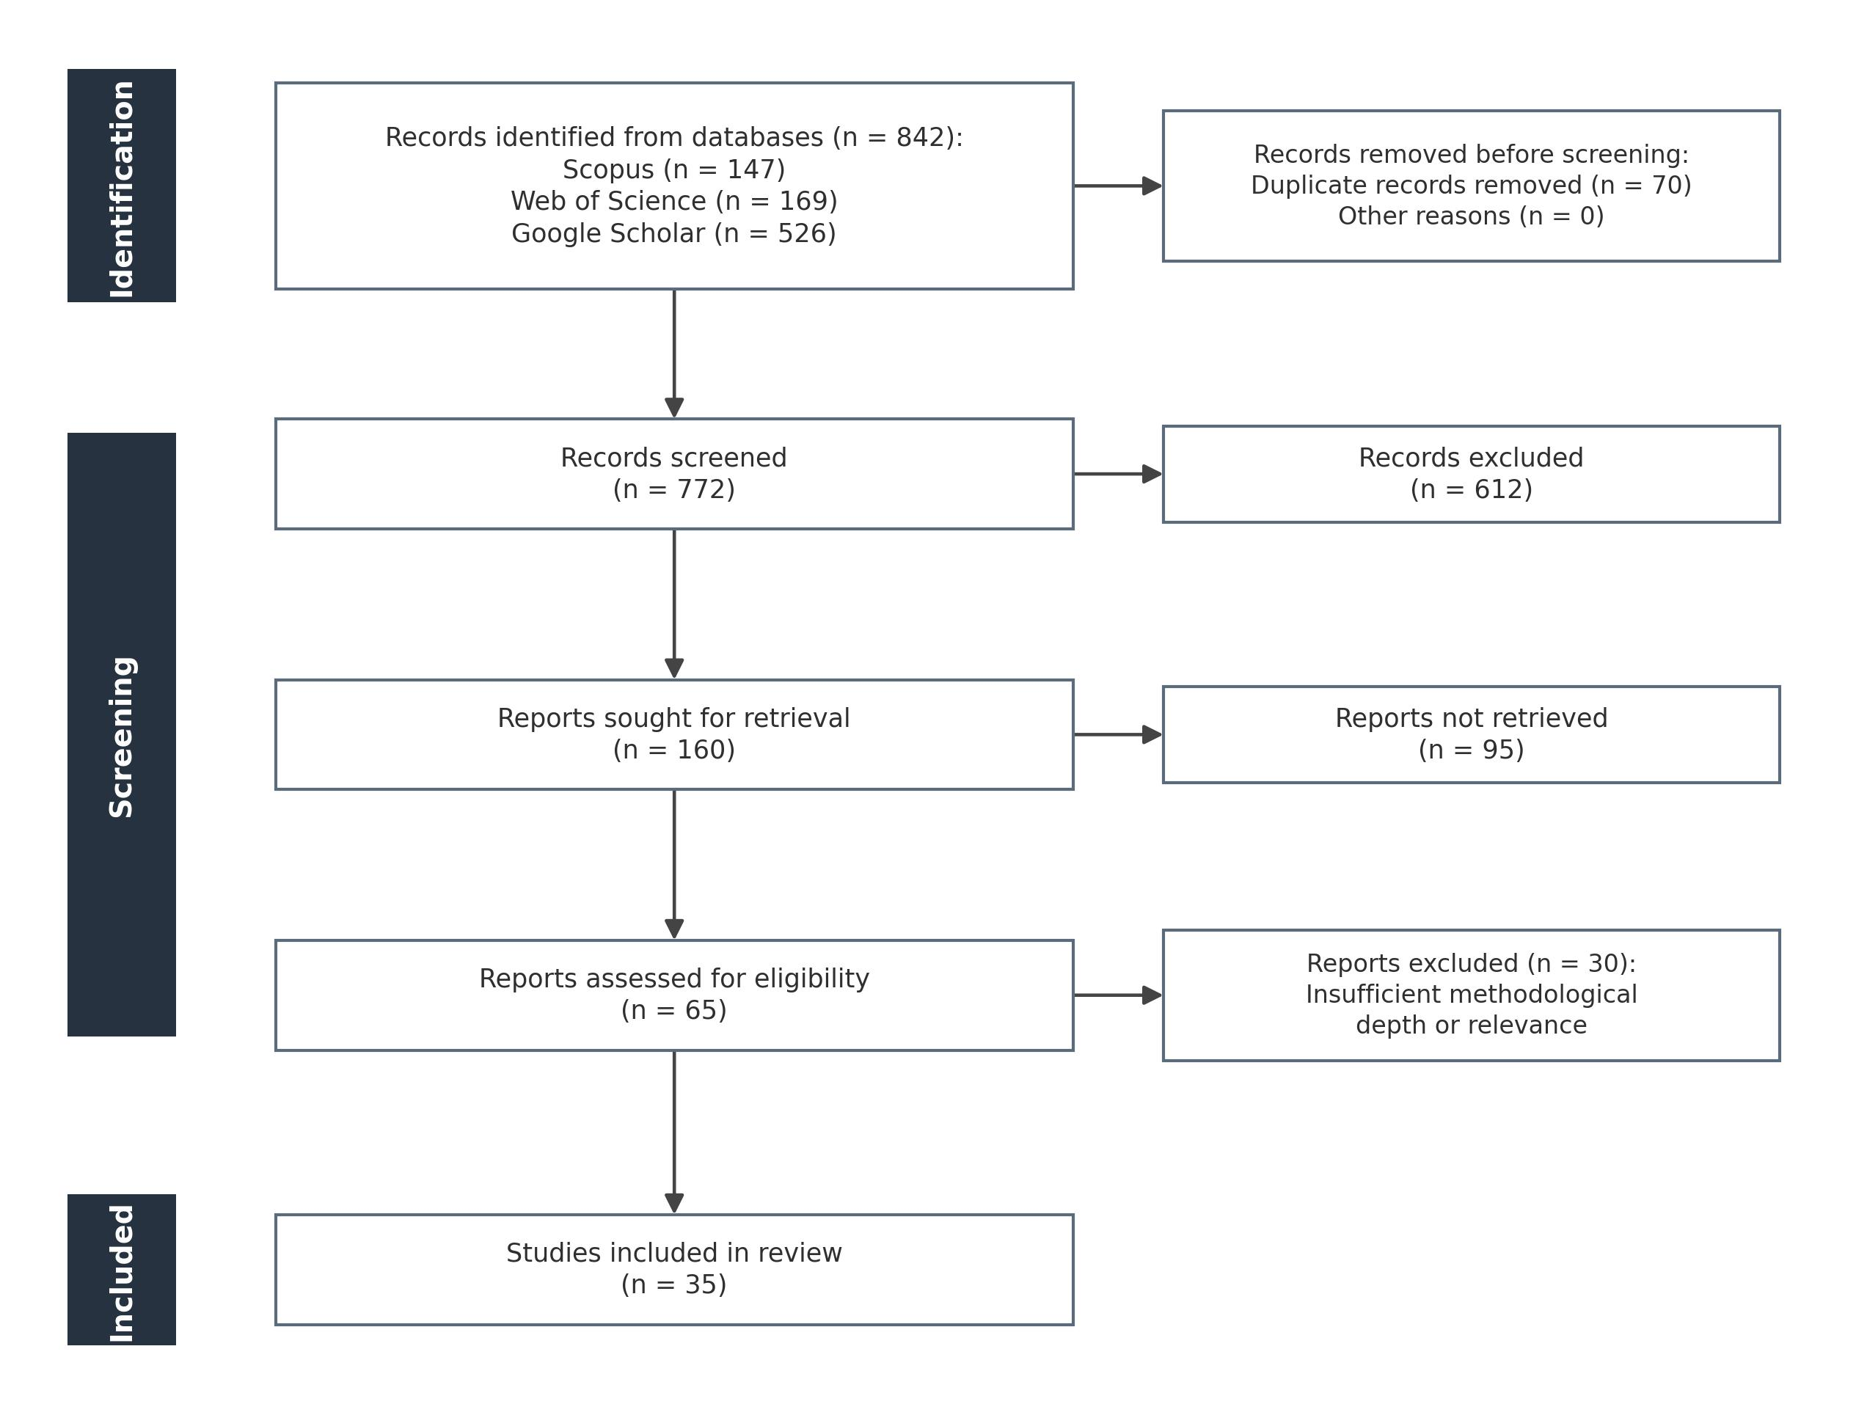
Figure 1: PRISMA 2020 flow diagram illustrating the study selection process.
To ensure the credibility of the evidence base, the selected studies were appraised using a combination of quantitative bibliometric indicators and qualitative judgement. The Field-Weighted Citation Impact was used to benchmark citation performance against disciplinary norms, the h-index was used to gauge author influence, and journal quality was assessed through the Journal Impact Factor, the SCImago Journal Rank, and indexing in Scopus and the Web of Science. These indicators were treated as supplementary rather than decisive, and were balanced against assessments of methodological rigour and direct relevance to RFI and Construction 4.0 research.
2.2 Industry Survey
A structured questionnaire of 33 items, combining multiple-choice, Likert-scale, and open-ended formats, was developed to address RQ1 to RQ3. It examined existing RFI submission, tracking, and approval workflows (RQ1), the digital tools currently in use (RQ2), and practitioners’ perceptions of digital and immersive technologies for improving response times and information quality (RQ3). The survey was distributed through Google Forms to professional civil engineers and construction experts in a range of roles and countries. Of 150 professionals invited, 101 valid responses were obtained, a response rate of approximately 67%, which is considered strong for construction-management research. Responses were concentrated in South Asia, predominantly Bangladesh (59%) and Nepal (31%), reflecting the authors’ professional networks; because these are markets where digital construction tools are still emerging, this concentration is likely to shape the findings, particularly the pronounced theory–practice gap reported below, and should be borne in mind when interpreting the results. Responses were exported in CSV format and analyzed using descriptive statistics, with Likert responses coded from 1 (strongly disagree) to 5 (strongly agree). Consistent with its exploratory aim, the study focused on general trends rather than statistical hypothesis testing.
Table 1: Structure of the survey questionnaire.
Survey section | Main focus
Respondent and project profile | Country, role, organization type, experience, project type and size
RFI experience and current practice | Procedure formality, submission methods, monthly RFI volume, response time, outcomes, approval authority
Digital tool usage | Tools in use (2D CAD/PDF, BIM, VR/AR, 360° photos, drones, CDE) and frequency of digital-model use
Perceptions and challenges (Likert) | Documentation and traceability, causes of RFIs, delay impacts on schedule and cost, potential of digital tools, willingness for remote/virtual inspection
Barriers to digital adoption | Suitable devices, training and skills, clear policy, internet connectivity, cost, resistance, data security
3. LITERATURE REVIEW FINDINGS
The synthesis of the 35 selected studies is organized around the three research questions and preceded by a brief bibliometric overview of the research landscape.
3.1 Bibliometric Overview
Annual scientific production was limited between 2010 and 2015, increased modestly during 2016 to 2018 alongside the wider adoption of BIM, and rose markedly from 2021 onward, reflecting the broader movement towards Construction 4.0. A keyword co-occurrence analysis revealed two principal clusters: a managerial cluster centered on requests for information, construction projects, and project management, and a technological cluster comprising building information modelling, virtual reality, and architectural design. The links between the clusters underscore the growing integration of digital technologies into RFI management.
A thematic map classifying themes by relevance (centrality) and development (density) is presented in Figure 2. Request for information, information process, and lead time appear as well-developed and central motor themes, while BIM, VR, design, and collaboration emerge as basic themes that are central but still developing, confirming that immersive and model-based technologies remain an active and incompletely explored frontier directly aligned with the aim of this study.
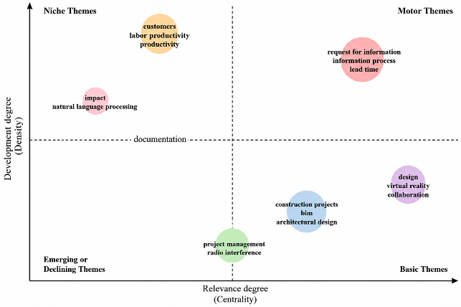
Figure 2: Thematic map of the research landscape by relevance (centrality) and development (density).
3.2 Causes and Consequences of RFI Inefficiency (RQ1)
RFIs frequently arise from shortcomings in project documentation and fragmented communication. The growing specialization of the AECO industry creates information silos and risk-transfer behaviors that further increase the need for formal clarifications (Alves et al., 2016). The consequences are extensive: unresolved RFIs shift tasks onto the critical path, reduce productivity, and increase costs, with each additional day of delay reportedly raising overall project cost by as much as 0.5% (Marsh, 2024). Delays also heighten the risk of rework, safety hazards, and contractual disputes, particularly where fragmented communication causes RFIs to be lost or misinterpreted (Afzal et al., 2025).
A closer analysis shows that RFI inefficiency is not a single problem but a cluster of interacting causes. Documentation-related causes- incomplete, ambiguous, or conflicting drawings and specifications- generate the largest share of clarification requests, while coordination and interface failures between disciplines convert minor ambiguities into formal RFIs requiring cross-disciplinary interpretation. A third, often overlooked driver is contractual: in fragmented delivery structures, parties deliberately route queries through formal RFIs to document their position and transfer risk and liability, inflating RFI volumes independently of genuine design uncertainty. These causes compound one another because information-clarification RFIs depend on interpreting contract documents across several parties, making them the slowest to resolve and the most likely to migrate onto the critical path, where delay propagates into rework, productivity loss, and cost escalation. This layered causal structure matters for technology adoption: interventions that improve only documentation quality, without also easing coordination and reducing contractual friction, are unlikely to deliver the efficiency gains reported in isolated studies.
3.3 Construction 4.0 Technologies for RFI Improvement (RQ2)
BIM is widely recognized for reducing RFI frequency through early clash detection and for improving the efficiency of RFIs that do arise by linking them to specific model elements, thereby reducing ambiguity and improving traceability (Morales et al., 2022); (Filho et al., 2016).
VR extends these capabilities by providing immersive, full-scale visualization that improves spatial cognition and supports collaborative problem-solving, particularly for complex geometries that are difficult to interpret from two-dimensional drawings (Sidani et al., 2021); (Rashidi et al., 2023). Multi-user VR environments further enable geographically dispersed teams to collaborate synchronously, reducing communication delays (Montecinos-Orellana et al., 2025).
Cloud-based platforms and Common Data Environments support the centralized submission, tracking, and retrieval of RFIs, and their effectiveness increases when integrated with BIM (Sandoval et al., 2023); (Papajohn & El Asmar, 2021). Lean methods such as the Last Planner System add structured prioritization of high-impact RFIs (Marsh, 2024), while artificial intelligence and natural-language processing techniques are increasingly used to classify RFIs and predict response times (Panahi et al., 2024); (Ozogul & Ergen, 2024). The literature consistently indicates that the greatest benefits arise when these technologies are implemented in an integrated rather than isolated manner.
Reality-capture technologies complement these tools by grounding RFI workflows in accurate as-built conditions. LiDAR scanning and photogrammetry produce point clouds that can be aligned with the design model, allowing as-designed and as-built discrepancies to be documented within an RFI and providing verifiable spatial context when combined with BIM and VR.
3.4 Barriers to Adoption (RQ3)
Despite these documented benefits, adoption is impeded by systemic barriers. These include resistance to change and limited user proficiency (Dinsmore, 2014), high software and hardware costs together with interoperability problems (Marsh, 2024), and a pervasive lack of standardization in RFI procedures, data structures, and workflows across organizations (Hanna et al., 2012). Organizational and contractual constraints, in which stakeholders deliberately rely on formal RFIs to manage risk and liability, further reduce incentives for transparent digital integration (Papajohn & El Asmar, 2021).
The literature concludes that overcoming these barriers requires coordinated efforts in training, standardization, and organizational change rather than technological advancement alone. This socio-technical character of adoption is corroborated by recent evidence from the wider construction-technology literature. In a systematic review of technology implementation, (Chen et al., 2022) conclude that realizing the benefits of digital tools depends not only on the technologies themselves but on parallel changes in organizational operating systems, education and training, and contracting and procurement, situating the barriers in technological, cultural, organizational, and institutional contexts. Extending this, (Chen et al., 2024) identify eight critical barriers to digital-technology adoption, led by entrenched industry standards, limited client interest, and the absence of a financial driver, and classify them across technical, environmental, and social dimensions, showing that organizational characteristics themselves shape which barriers dominate. Taken together, these studies reinforce that the obstacles to digital RFI workflows are as much social and organizational as technical.
4. SURVEY FINDINGS
The respondent profile is summarized in Table 2. Participants were predominantly based in South Asian countries, with the largest groups from Bangladesh and Nepal, and occupied roles spanning site engineers, consultants, project engineers, and QA/QC inspectors. Roughly half worked for consulting or supervision companies, and most had between three and ten years of experience. The distribution confirms that responses were drawn from professionals actively engaged in day-to-day RFI and inspection processes.
Table 2: Respondent profile summary (n = 101).
Category | Sub-category | n | %
Country of work | Bangladesh | 60 | 59.4
 | Nepal | 31 | 30.7
 | Other countries | 10 | 9.9
Current position | Site / junior engineer | 32 | 31.7
 | Consultant/supervision engineer | 23 | 22.8
 | Project / senior engineer | 15 | 14.9
 | QA/QC engineer/inspector | 14 | 13.9
 | Other roles | 17 | 16.8
Organization type | Consultant | 51 | 50.5
 | Main contractor | 25 | 24.8
 | Client/government | 14 | 13.9
 | Sub-contractor / other | 11 | 10.9
Experience | Less than 3 years | 17 | 16.8
 | 3 to 10 years | 57 | 56.4
 | More than 10 years | 27 | 26.7
4.1 Current RFI Practices and Tool Usage
RFI and inspection processes were largely formalized, with 74.3% of respondents reporting documented, standardized procedures, although 19.8% described their procedures as only partly formal. Signed hard-copy RFI forms remained the most common exchange channel (61.4%), followed by email (27.7%), while only 10.9% used online platforms or document-control systems. Monthly RFI volumes varied considerably, with 32% of respondents processing 11 to 50 RFIs per month and 23% handling more than 500, reflecting differences in project scale. Most respondents (53.5%) received responses within one to three days, but approximately 11% reported delays exceeding one week. In terms of outcomes, the most frequent status was approved with comments (63.4%), followed by direct approvals (27.7%), indicating that RFIs often require iterative clarification rather than immediate resolution.
Tool usage revealed a strong reliance on conventional documentation (Figure 3). Two-dimensional CAD or PDF drawings were used by 89.1% of respondents, whereas only 29.7% used BIM models, and only 7.9% employed VR or AR tools. Site-capture tools such as 360-degree photographs were used moderately (32.7%). Although the adoption of advanced tools was limited, 39.6% of respondents reported using digital drawings or models often or very often, indicating a transitional phase of increasing familiarity.
Exploratory cross-tabulation revealed several patterns that, although not tested for statistical significance, add nuance to these aggregate figures. BIM adoption varied inversely with experience: 41% of respondents with under three years’ experience reported using BIM models, compared with 30% of those with six to ten years and only 22% of those with more than fifteen, suggesting that recent entrants, likely exposed to digital methods during their education, drive much of the current uptake. Adoption also differed by organization type, being lowest among consultants (22%), who formed the largest respondent group, and higher among main contractors (36%) and client or government bodies (50%). Consultants were likewise less willing to adopt remote or virtual inspection (mean 3.37) than main contractors (3.72). Because the survey was exploratory, these relationships are presented as indicative rather than confirmatory, but they suggest that adoption barriers are unevenly distributed across roles and career stages, a consideration for any future deployment strategy.
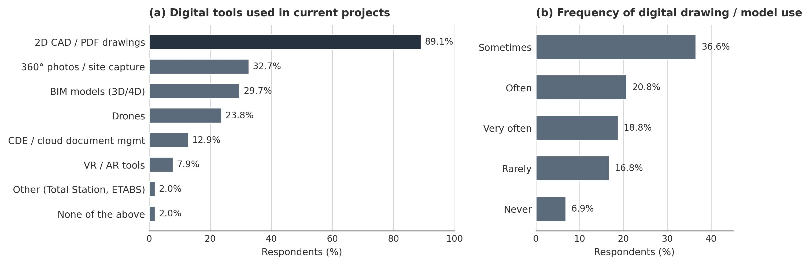
Figure 3: (a) Use of digital tools in construction projects; (b) frequency of digital drawing usage.
4.2 Barriers and Perceptions
The most significant barriers to adopting digital and remote tools were infrastructural and human rather than technological (Figure 4). The absence of suitable devices was reported by 65.3% of respondents, and insufficient training or user skills by 59.4%, followed by the lack of clear policies (37.6%) and unreliable internet connectivity (33.7%). Client or consultant resistance, hardware and software costs, and data-security concerns were comparatively less frequent.
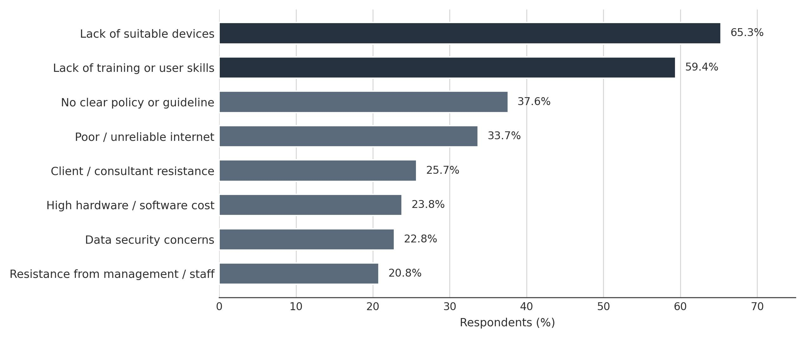
Figure 4: Key barriers to the adoption of digital and remote RFI and inspection tools.
Likert-scale perceptions (Table 3) reinforced these patterns. Respondents moderately agreed that RFI records are documented and traceable (mean = 3.45) and that RFI delays affect project schedules (mean = 3.43) and costs (mean = 3.42). The highest agreement concerned the potential of digital tools to reduce RFI and inspection processing time (mean = 3.64), together with a clear willingness to use remote and virtual inspection methods (mean = 3.44). These results indicate strong practitioner readiness for digital adoption. Interpreted through a socio-technical lens, these results locate the principal obstacles not in the technologies themselves but in the surrounding human and organizational conditions, device provision, skills, policy, and connectivity, consistent with adoption barriers reported across the construction-technology literature.
Table 3: Descriptive statistics of Likert-scale responses (n = 101).
Likert statement (1 = strongly disagree, 5 = strongly agree) | Mean | SD
RFI records are properly documented and traceable | 3.45 | 1.23
Important RFI decisions are often given verbally | 2.50 | 1.18
RFIs are raised due to unclear drawings/specifications | 2.90 | 1.14
Different drawing versions cause site confusion | 3.05 | 1.14
Coordination delays slow RFI closure | 3.09 | 1.24
Delays in responding to RFIs affect the project schedule | 3.43 | 1.19
RFI-related design issues increase project cost | 3.42 | 1.12
Digital tools can reduce RFI / inspection processing time | 3.64 | 1.11
Willingness to use remote/virtual inspection tools | 3.44 | 1.05
Remote inspection is useful when key personnel are absent | 3.46 | 1.10
5. COMPARISON AND DISCUSSION
Bringing the two strands together reveals strong agreement on the nature of the RFI problem but a marked divergence on the state of digital adoption. In relation to RQ1, the literature positions RFIs as structural indicators of information-flow deficiencies driven by design ambiguity, fragmented coordination, and documentation inconsistencies (Hanna et al., 2012); (Love et al., 2014). The survey corroborates this directly, with practitioners frequently attributing RFIs to unclear drawings, multiple document versions, and coordination delays. Both sources also converge on response time as a critical performance indicator, reinforcing its validity as a measure of RFI efficiency.
With respect to RQ2 and RQ3, the principal divergence concerns implementation. Whereas the literature extensively documents BIM, VR, LiDAR, and cloud-based workflows as means of improving visualization, traceability, and collaboration, the survey shows that practice remains dominated by two-dimensional drawings and paper-based forms, with negligible use of immersive technologies. This gap between theory and practice is the central empirical finding of the study. Importantly, practitioners expressed generally positive perceptions of digital and remote tools, which indicates that the gap is not primarily attitudinal but is instead rooted in organizational, infrastructural, and procedural constraints, an interpretation consistent with the barriers identified in both strands. This convergence extends beyond RFIs to digital adoption in construction more broadly: the organizational, financial, and standards-related barriers that dominate the survey mirror those reported in the wider literature on construction-technology adoption (Chen et al., 2022; Chen et al., 2024). The agreement between an RFI-focused South Asian sample and international, technology-general studies suggests that the barriers observed here are not merely local artifacts but reflect a structural, socio-technical adoption problem, and that interventions must therefore address organizational readiness, client engagement, and industry standards alongside the technical design of RFI tools.
These findings carry clear implications for the design of VR-enabled RFI workflows. Because a substantial proportion of RFIs originates from inadequate visualization and misinterpretation of design intent, immersive three-dimensional review offers a direct means of reducing ambiguity during RFI generation and resolution. The receptiveness of practitioners to remote inspection, particularly when key decision-makers are not on site, supports the integration of VR with BIM, LiDAR, and cloud platforms for centralized tracking and synchronous collaboration. However, the prominence of device, training, and policy barriers indicates that such systems must be embedded within existing workflows and supported by standardized procedures and user-friendly interfaces, rather than deployed as standalone visualization tools. When strategically integrated, VR-powered workflows have the potential to transform RFI management from a reactive clarification process into a proactive coordination mechanism.
Addressing RQ3 specifically, the convergence of the two strands suggests that the largest gains are likely to come not from any single technology but from an integrated configuration in which BIM provides the data backbone, VR delivers immersive visualization, and cloud platforms enable real-time, traceable exchange. Because the survey shows that delays and iterative clarification, rather than outright rejection, dominate current RFI outcomes, interventions that enrich the information content of each RFI, through model-based context and shared spatial reference, are well positioned to reduce both response time and the volume of repeat requests. The requirements implied by these findings are taken up as a direction for future work (Section 6).
6. CONCLUSION AND FUTURE WORK
This study examined the limitations of conventional RFI practices and the potential of Construction 4.0 technologies to improve RFI efficiency and information quality, combining a PRISMA-based systematic review of 35 studies with an exploratory survey of 101 construction professionals. The literature and the survey agree that RFIs are driven by documentation ambiguity, fragmented communication, and coordination challenges, and that response time is a key performance indicator. At the same time, the study identifies a clear gap between the theoretical potential of BIM, VR, Reality Capture, and cloud-based tools and their limited application in practice, a gap attributable mainly to organizational readiness and workflow integration rather than to technological resistance. Integrating VR with BIM and cloud platforms, therefore, emerges as a promising direction to address visualization limitations and enable more proactive, collaborative RFI workflows.
Several limitations should be acknowledged. The survey was exploratory and descriptive, prioritizing practitioner perceptions over causal inference, and its respondent base was geographically concentrated in South Asia, which may limit generalizability. Advanced statistical or experimental validation was beyond the present scope. Future research should develop and validate VR-enabled RFI frameworks through pilot implementations and controlled case studies, comparing conventional and VR-supported workflows to quantify improvements in response time, error reduction, and decision quality, and should further investigate user experience, cost-benefit considerations, and integration with emerging artificial-intelligence techniques. Equally important, future work should target the implementation and adoption side of this agenda rather than technology development alone. Because the barriers to digital RFI workflows are as much organizational and social as technical (Chen et al., 2022; Chen et al., 2024), research is needed on change management, training and skills development, client engagement, standardization of RFI procedures, and the adaptation of contractual practices, so that technically capable systems translate into sustained use. Framing digital RFI transformation as a socio-technical problem is likely to be decisive for its success.
Based on this empirical baseline, the most concrete direction for future work is to develop and evaluate a prototype of an integrated BIM-VR-cloud RFI workflow. In this prototype, reality capture (LiDAR or 360-degree imaging) would anchor as-built site conditions, a federated BIM model would act as the data backbone with element-level linkage, an immersive VR environment would let practitioners inspect the model at full scale and create RFIs anchored to specific model elements, and a cloud-based common data environment would support the rest of the lifecycle, visualization, routing, status tracking, and multi-stage approval, with a complete audit trail. The prototype should then be evaluated with industry professionals, including practitioners of the kind surveyed here, through structured usability testing and expert assessment, and benchmarked against conventional document-based workflows to quantify gains in response time, error reduction, and decision quality, providing the controlled evidence that the present study identifies as the principal gap between the promise and the practice of digital RFI management.
ACKNOWLEDGEMENTS
The authors gratefully acknowledge the academic supervision and guidance provided at Aarhus University and thank the construction professionals who participated in the survey.
REFERENCES
Afzal, M., Wong, J. K. W., and Ahmadian Fard Fini, A. (2025). Towards a digital approach for managing requests for information in construction projects: a literature review. Construction Innovation, 25(5), pp. 1345–1369. doi:10.1108/CI-05-2023-0113
Aibinu, A. A., Carter, S., Francis, V., and Vaz-Serra, P. (2019). Request for information on frequency and turnaround time in construction projects. Built Environment Project and Asset Management, 10(1), pp. 1–15. doi:10.1108/BEPAM-10-2018-0130
Alves, T. D. C. L., Pestana, A. C. V. M. F., Gilbert, E., and Hamzeh, F. (2016). Lean principles for the management of construction submittals and RFIs. Journal of Professional Issues in Engineering Education and Practice, 142(4), 05016004. doi:10.1061/(ASCE)EI.1943-5541.0000285
Black, J. (2017). Investigating the cause of requests for information in civil construction projects. University of Southern Queensland.
Chen, X., Chang-Richards, A. Y., Pelosi, A., Jia, Y., Shen, X., Siddiqui, M. K. and Yang, N. (2022). Implementation of technologies in the construction industry: a systematic review. Engineering, Construction and Architectural Management, 29(8), pp. 3181–3209. doi:10.1108/ECAM-02-2021-0172
Chen, X., Chang-Richards, A. Y., Yiu, T. W., Ling, F. Y. Y., Pelosi, A. and Yang, N. (2024). A multivariate regression analysis of barriers to digital technologies adoption in the construction industry. Engineering, Construction and Architectural Management, 31(11), pp. 4281–4307. doi:10.1108/ECAM-11-2022-1051
Dinsmore, R. C. (2014). Investigating the impact of the request for information process in construction. University of Southern Queensland.
Filho, J. B. P. D., Angelim, B. M., Guedes, J. P., de Castro, M. A. F. and Barros Neto, J. D. P. (2016). BIM-based requests for information facilitation and coordination. Open Engineering, 6(1). doi:10.1515/eng-2016-0076
Hanna, A. S., Tadt, E. J., and Whited, G. C. (2012). Request for information: benchmarks and metrics for major highway projects. Journal of Construction Engineering and Management, 138(12), pp. 1347–1352. doi:10.1061/(ASCE)CO.1943-7862.0000554
Hughes, N., Wells, M., Nutter, C, and Zack, J. (2013). Impact and control of RFIs on construction projects. Navigant Construction Forum.
Love, P. E. D., Zhou, J., Sing, Chun-pong, and Kim, J.T. (2014). Assessing the impact of RFIs in electrical and instrumentation engineering contracts. Journal of Engineering Design, 25(4–6), pp. 177–193. doi:10.1080/09544828.2014.935305
Marsh, P. (2024). Enhancing information flow in construction: integrating BIM and Lean tools into the RFI process. Aston University.
Montecinos-Orellana, S., Muñoz-La Rivera, F., Mora-Serrano, J., Ubach, P.A and Bopp, M. J. (2025). Multi-user virtual reality tool for remote communication in construction projects. Systems, 13(9), 789. doi:10.3390/systems13090789
Morales, F., Herrera, R. F., Muñoz-La Rivera, F., Atencio, E. and Núñez, M. (2022). Potential application of BIM in RFI processes in building projects. Buildings, 12(2), 145. doi:10.3390/buildings12020145
Ozogul, C., and Ergen, E. (2024). Metadata extraction of RFIs using natural language processing and machine learning algorithms. In Proceedings of the European Conference on Computing in Construction. doi:10.35490/EC3.2024.287
Panahi, R., Kivlin, J.-P., and Louis, J. (2024). Request for information recommender system for pre-construction design review using NLP, ChatGPT, and computer vision. In Computing in Civil Engineering, pp. 159–166. ASCE. doi:10.1061/9780784485224.020
Papajohn, D., and El Asmar, M. (2021). Impact of alternative delivery on the response time of requests for information for highway projects. Journal of Management in Engineering, 37(1), 04020098. doi:10.1061/(ASCE)ME.1943-5479.0000866
Rashidi, A., Yong, W. Y., Maxwell, D., and Fang, Y. (2023). Construction planning through 4D BIM-based virtual reality for light steel framing building projects. Smart and Sustainable Built Environment, 12(5), pp. 1153–1173. doi:10.1108/SASBE-06-2022-0127
Sandoval, I. S. M., Bernardo, J. P. A. O., Dionisio, S. R., and Aquino, A. H. (2023). Application of information and communication technologies to optimize the RFI process in construction projects. IEEE. doi:10.1109/CONIITI61170.2023.10324094
Sidani, A., Dinis, F., Sanhudo, L., Duarte, J. S, Baptista, J. P., Martins, J. P., and Soeiro, A. (2021). Recent tools and techniques of BIM-based virtual reality: a systematic review. Archives of Computational Methods in Engineering, 28(2), pp. 449–462. doi:10.1007/s11831-019-09386-0

