Automated Conceptual Bridge Topology Generation using Image-Conditioned Diffusion
Aswin Lal^{1,3}, Morris Benedikt Florek^{2,3}, Chongjie Kang^{2,3}, Jörg Blankenbach^{1,3}, Steffen Marx^{2,3}

¹ Chair of Computing in Civil Engineering and GIS and Geodetic Institute, RWTH Aachen University, Germany
² Institute of Concrete Structures, Dresden University of Technology, Germany
³ Cluster of Excellence CARE, TU Dresden and RWTH Aachen, Germany
*Corresponding email: aswin.lal@gia.rwth-aachen.de

ABSTRACT
The initial design phase of bridge construction involves the drafting of conceptual topologies that help engineers in analysing the feasibility of proposed bridge designs. The purpose of this phase is to explore and document different design solutions for a bridge, taking into account various relevant factors like the structural load requirements, topography and environmental factors, safety standards, economic viability and aesthetic appeal among others. Today, this process is done manually making the early decision-making stage time consuming and cost intensive. To address these issues, the potential of AI methods can be leveraged to develop data-driven models that assist engineers in the preliminary design phase to generate, compare and analyse multiple topologies. In light of the extensive research that has been carried out in recent years on powerful diffusion models capable of creating high-quality and diverse images using natural language, we propose a ControlNet-guided diffusion model that can generate multiple design topologies of a bridge from input topography images and design constraints given in the form text prompts. ControlNet-guided diffusion was used for this task as it enables precise conditioning on input topography images, ensuring that the generated designs follow the terrain while at the same time satisfying the design specifications. The results of our experiments demonstrate the ability of the model in generating multiple structurally plausible and context-aware bridge topologies that adhere to both terrain features and design constraints. The generated designs are promising, indicating the potential of ControlNet-guided diffusion models in the rapid and efficient generation of bridge topologies. The trained model is also evaluated using several metrics and compared the results with our previously implemented Conditional Generative Adversarial Network.

- INTRODUCTION
The conceptual design phase of bridges aims to identify and document the most appropriate design solution for a roadway or railway connecting two points across a terrain. Bridge designers use their expertise and experience in analysing and comparing several design options by considering the application, topographical and environmental factors, economic viability, individual creativity and intuition. The conceptual topologies are usually created based on the topographical cross-section of the location and relevant design constraints like the number of spans, available clearance, construction material and pier alignments. This process is performed manually, making it time-consuming and highly dependent on the designer’s individual expertise. Recognizing this challenge, we propose the use of generative Artificial Intelligence as an effective way to achieve automation in the initial design phase. We explore models, currently acting as proof-of-concept tools, intended to assist designers in the initial design process. The proposed methodology combines simplified topographical images of potential bridge sites with natural language inputs as design constraints to generate plausible bridge designs. This allows designers to guide the generative model by specifying design requirements and constraints during the generation process tailored to the bridge application and topographical situation.
Building on the capabilities of generative adversarial networks based on the pix2pix architecture (Isola, P., et al., 2017) trained on a curated dataset (see Section 4.1), as demonstrated in our previous study (Lal A., et.al., 2026), this work extends the investigation into data-driven approaches using diffusion models enhanced using ControlNet (Zhang, L., et.al., 2023) for conceptual bridge topology generation. While the previous study focused on guiding the generator of the pix2pix architecture using pretrained BERT (Devlin, J., et.al., 2018) embeddings derived from design prompts, this work proposes a shift towards diffusion-based generative modelling by training a ControlNet enabled diffusion framework trained on our curated dataset to predict bridge topologies. Since the focus of this study is only on highway bridge applications, our dataset only includes simple frame and girder bridge configurations. The predictions made by both models are evaluated and compared both qualitatively and quantitatively using relevant evaluation metrics to assess the effectiveness of the proposed methodology (see Section 5).

- RELATED WORKS
While AI-based methods have been used recently to achieve automation across various domains, their integration within the construction sector is still in its early stages. In recent years, AI-based methods have been adopted in the construction sector, for example, in structural health monitoring applications using image data (Spencer, B., et.al., 2025). Novel methods in architectural design include the study conducted by (Spiegelhalter, T., 2023) on the use of AI-assisted generative design with topological optimization to reduce weight and cost. (Liang, Z., et.al., 2025) proposed a large visual-language model-guided topology optimization method to automatically generate and edit structural designs according to conceptual requirements. (Nauata, N. & Chang, K.-H., 2020) and (Ghannad, P. & Lee, Y.-C., 2022) trained generative models to automate the generation of house-plans and modular housing designs respectively. (Horvath, A.-S. & Pouliou, P., 2024) conducted experiments on the use of text-to-text, text-to-image and image-to-image generative methods to create conceptual architecture. There has recently also been a surge in research exploring the integration of Large Language Models (LLMs) into Building Information Modelling (BIM), particularly for applications such as natural language-driven BIM generation, AI-assisted design automation and information retrieval from BIM models (Du, C., et.al., 2026; Alwashah, Z., et.al 2026; Hellin, S., et.al 2025). In the domain of bridge designing in particular, the application of data driven approaches remains comparatively limited. Our methodology, in contrast, seeks to integrate the strengths of both image-based and text-based generative models to support the generation and context-aware and structurally plausible bridge design alternatives.
In addition to factors like the structural integrity, safety and durability, the topography and surroundings are also key factors in bridge designing. Although its potential has been proven in design generation, the application generative AI in this domain is restricted to the limited availability of data and relevant parameters. (Balmer, V., et.al 2024) simulated data using different design criteria to train a Conditional Variational Autoencoder (CVAE) that acts as a forward performance predictor and inverse design generator for a multi-span prestressed concrete pedestrian bridge in Switzerland. Due to their ability to generate high quality images, diffusion models have also gained attention in generative design and image synthesis applications. (Mazé, F. & Ahmed, F., 2023), for example, showed that diffusion models achieved better performance compared to GANs in structural topology optimization. (Herron, E., et.al., 2024) used a latent diffusion model in the initial stage of bridge design for structural topology optimization. (Leng, H., et.al., 2024) and (Zhang, H. & Zhang, R., 2025) trained diffusion models for the efficient generation of architectural floor plans. (Zhou, Y., et.al., 2024) implemented a ControlNet-guided diffusion model to automate the task of shear wall layout generation for high-rise buildings. They experimentally prove the better effectiveness of this approach as compared to GAN-based methods. (He, M., et.al., 2026) implemented a ControlNet-based diffusion model for urban design generation by incorporating spatial site constraints as image inputs and planning guidance as textual conditions.
As opposed to the aforementioned studies and innovations, our work investigates the utilization of generative AI for conceptual bridge topology generation during the early design phase, using topographical images and natural language prompts as design constraints. Such a methodology for bridge topology generation has not been previously investigated to the best of our knowledge.

- Methodology
The objective of our model is to automatically generate conceptual bridge topologies conditioned by design prompts for given topography images. We strive to achieve this goal by using a multimodal generative framework that integrates image data representing the topography with natural language inputs describing the design specifications. During training, the model receives the image of the topography, where a bridge is to be designed, along with a design prompt specifying the structural constraints. Each topography is mapped to three different target topologies corresponding to three predefined design constraints:
- a single span frame bridge
- a three span beam bridge with straight piers
- a three span frame bridge with inclined piers
These three bridge configurations have been selected as they were the most frequently occurring design types within the dataset. Since the present study represents ongoing work and is primarily intended as a proof of concept, the limited set of constraints was used to systematically evaluate the model’s behaviour under controlled conditions. This allows the possibility of extending the framework to incorporate more diverse and complex design specifications for more comprehensive bridge design scenarios. During inference, the model generates multiple design variants for the same topography, corresponding to the design prompts. This aligns with the process of the initial phase of bridge design, where conceptual design exploration and the evaluation of multiple design solutions are carried out for identifying suitable structural configurations under the given site and design constraints.
To implement this task, we adopted a pretrained ControlNet-guided diffusion model, which allows the user to guide the image generation process using input conditions given in the form of design prompts. It was initialized from a model pretrained on large-scale image datasets using Stable Diffusion v1.5 as the backbone, where it was trained to condition on depth maps for image generation, enabling spatially structured control over the synthesis process. ControlNet preserves the generative capabilities of the pretrained diffusion model while enabling fine-grained control over spatial structure through the injected conditioning branches. We fine-tuned the model on our curated dataset of bridge configurations and design specifications, allowing it to learn the relationships between the site conditions, feasible structural forms and design constraints. This enables the model to iteratively refine latent representations to generate structurally plausible topology proposals during inference that satisfy the semantic constraints expressed through the prompts.
During training, the ControlNet architecture has been optimized by freezing the Stable Diffusion backbone (layers corresponding to U-Net, VAE and text encoder) and updating only the ControlNet weights. This allows the model to retain its generative prior, while learning to inject spatial conditioning from the structural input maps. We incorporated classifier-free guidance through random text dropout (a dropout rate of 10% was employed during training) to enable the model to learn both conditional and unconditional generation pathways. This improved the sensitivity of the model to the text inputs and improved its robustness during inference.

- Experimental Setup
Since no publicly available dataset exists for training and evaluating an AI model for the task of generating conceptual bridge topologies, we developed our own dataset for carrying out the experiments. The creation of the custom dataset, the training and hyperparameter settings and the evaluation metrics used to validate the predictions of the trained model are described in Section 4.1, Section 4.2 and Section 4.3, respectively.

4.1 Dataset
The quality and reliability of the dataset is crucial to training a generative model capable of predicting realistic bridge topologies. Keeping this in mind, the authors collected designs of existing bridges from literature sources such as the Bridge Handbook (Mehlhorn, G. & Curbach, M., 2014) and Bridges: Aesthetics and Design (Leonhardt, F., 1983). Given the existence of a large variety of bridge and terrain types, the dataset is restricted to small to medium-sized beam and frame bridges within their associated topographic settings. The 2D longitudinal topology of the bridges and their topographic profiles were reconstructed using a CAD authoring software. The drawings obtained from the literature were first cleaned by removing irrelevant information like numerical annotations, text labels, dimensions and other additional markings. The whole data creation process used to convert bridge and topography drawings from the literature to image pairs is visualized in Fig. 1.
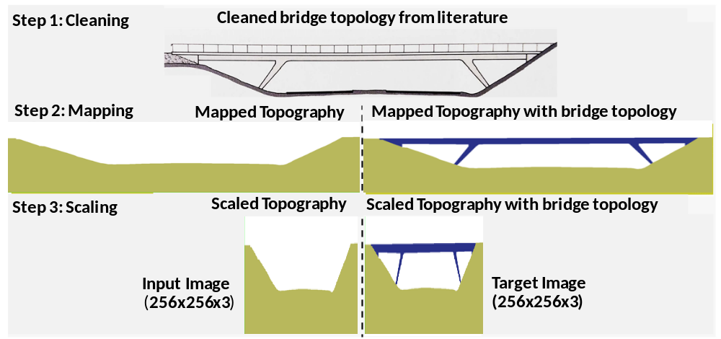
Figure 1: Overview of the data generation process used to convert bridge and topography drawings from literature into image-pairs.

The topography and the bridge topology are then mapped to RGB images, where green pixels represent the topography and blue pixels represent the bridge topology. The images are then reshaped to have a dimension of 256x256x3 to reduce computational cost and memory usage, while still maintaining sufficient structural information. The pixel values were normalized to be within the range [-1, 1] for better convergence during training. The topographies included in the dataset have been simplified for our experiments, but they retain sufficient details to represent the general valley for training the model. For each input topography-topology combination, two additional bridge variants (one each for the other two design constraints) were developed by civil engineering lecturers. This enables the ControlNet model to map each input image to three distinct topologies based on the design constraints, allowing it to learn multiple feasible design solutions for a single topographic condition. This leads to each topographic image being mapped to three different topologies, corresponding to the three distinct design constraints as shown in Fig. 2.
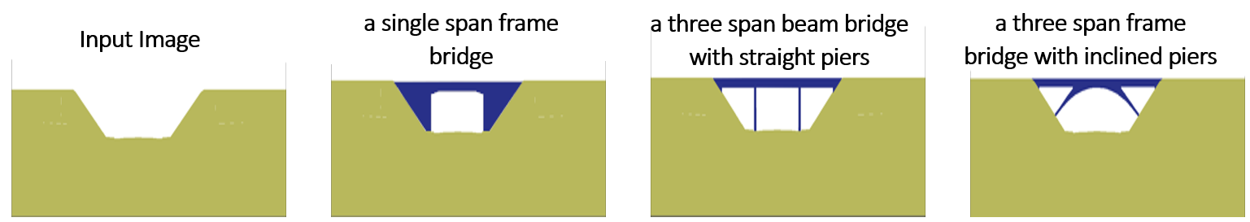
Figure 2: Example showing three possible bridge topologies corresponding to three different design constraints for the same input topography image.

An important aspect to note here is the loss of absolute real-world scale during the image preparation process. However, since our work focuses only on the early-stage conceptual designing of bridges, the relative proportions and spatial relationships are more relevant than absolute scale and precise real-world dimensions. Additionally, as the study involves conceptual bridge topologies based only on raw topography, additional parameters related to geography, environmental conditions, soil characteristics and other site-specific factors are not incorporated in the dataset. Furthermore, the dataset also does not fully represent the entire spectrum of architectural diversity found in real-world bridge engineering, as we focus only on beam and frame bridges commonly used in highway infrastructure.

4.2 Training and Hyperparameter Settings
The dataset, which consists of 195 pairs of images in total, was augmented using operations like translation and horizontal flipping to create a total of 6240 image pairs. This was then split into 5601 train and 639 validation images. The model was trained with a learning rate of 1x10⁻⁵ for 100 epochs using the AdamW optimizer (Loshchilov, I. & Hutter, F., 2019) applied to the ControlNet parameters. Training was carried out on an NVIDIA L40S GPU with 48 GB GDDR6 VRAM. During inference, a guidance scale (controls how strongly the generation follows the condition) of 1.5 and 100 inference steps (number of denoising iterations) were used. The trained model was evaluated on a test dataset consisting of 78 previously unseen images. The authors acknowledge the relatively smaller size of the independent dataset, which was constrained by the limited availability of images. Future work will focus on expanding the dataset to include a larger number of test images.

4.3 Evaluation
The trained model was quantitively evaluated using metrics like the Structural Similarity Index Measure (SSIM) (Wang, Z., et al 2004), the Fréchet Inception Distance (FID) (Heusel, M., et al 2017), Intersection over Union (IoU), CLIP Score (Hessel, J., et al 2021) and the Learned Perceptual Image Patch Similarity (LPIPS) (Zhang, R., et al 2018) score. These metrics jointly evaluate the structural similarity, diversity in predictions, perceptual quality and the semantic consistency between the generated images and the ground-truths.
For two images a and b, the SSIM determines the structural similarity by comparing aspects like the similarity in brightness, contrast and structure (edges and textures). SSIM ranges from 0 to 1, where 1 indicates perfect similarity between ground-truth and prediction. It is mathematically defined as given in Equation (1):
SSIM (a, b) = $\frac{\left(\text{2}{\text{μ}}_{\text{a}}{\text{μ}}_{\text{b}}\text{+ }{\text{C}}_{\text{1}}\right)\text{(2}{\text{σ}}_{\text{ab}}\text{+ }{\text{C}}_{\text{2}}\text{) }}{\left({\text{μ}}_{\text{a}}^{\text{2}}\text{+ }{\text{μ}}_{\text{b}}^{\text{2}}\text{+ }{\text{C}}_{\text{1}}\right)\left({\text{σ}}_{\text{a}}^{\text{2}}\text{+ }{\text{σ}}_{\text{b}}^{\text{2}}\text{+ }{\text{C}}_{\text{2}}\right)}$ (1)
where μ_{a} and μ_{b} are the mean intensities, σ_{a} and σ_{b}, the standard deviations and σ_{ab}, the covariance between a and b respectively.
FID evaluates the diversity and realism in the model’s predictions by comparing the feature distributions of the ground-truths and those of the predictions. Features of both sets are extracted using a deep Convolutional Neural Network (CNN) pretrained on the ImageNet dataset. Given the smaller test dataset size, features from the layer prior to the auxiliary classifier were used instead of the final pooling layer, which typically requires at least 2048 images. Smaller FID values (closer to 0) for the predictions indicate greater similarities with the ground-truths. The FID for a mapping between the source domain X (ground-truths) to a target domain Y (model predictions), can be calculated as given in Equation (2):
FID = ‖μ_{x}-μ_{y} ‖²+Tr (Σ_{x}+ Σ_{y}-2(Σ_{x} Σ_{y} )^{(1⁄2)}) (2)
where μ_{x} and μ_{y} are the means and Σ_{x} and Σ_{y} the covariances of the two distributions respectively and Tr is the trace of a matrix.
The IoU is determined by extracting the predicted bridge topology (${\text{Mask}}_{\text{pred}}$) and the ground truth topology (${\text{Mask}}_{\text{gt}}$) as binary masks and computing the intersection-over-union between both masks. It is defined as the ratio of intersection to the union of the two binary masks, as defined in Equation (3).
IoU = $\frac{{\text{Mask}}_{\text{pred}} \text{∩} {\text{Mask}}_{\text{gt}}}{{\text{Mask}}_{\text{pred}} \text{∪} {\text{Mask}}_{\text{gt}}}$ (3)
where ∩ and ∪ represent the intersection and union of the masks respectively. Higher values for the IoU indicates better structural alignment between the two masks.
The LPIPS measures the perceptual similarity between the generated and ground-truth images by comparing the deep features extracted using pretrained CNNs. For an input image x and ground-truth image y, the LPIPS is computed mathematically as given in Equation (4), where ф_{l} (.) represents the feature activations extracted from the l-th layer of the CNN (with l indicating the layer index), H_{l} and W_{l} are the spatial dimensions of the feature maps at layer l and w_{l} denotes the channel-wise weights. Lower LPIPS values suggest higher similarities between the extracted features and hence higher perceptual similarity between the predictions and ground-truths.
LPIPS (x, y) = $\sum_{l}{\frac{1}{{ \text{H}}_{l}{\text{ W}}_{l}}{\left\|w_{l}⊙(ϕ_{l}\left(x\right)-ϕ_{l}\left(y\right)) \right\|}_{2}^{2}}$ (4)
The semantic alignment of the generated images with their corresponding text prompts were evaluated using the CLIP score. CLIP (Radford, A., et al., 2021) is a vision-language model that learns a joint embedding space between images and texts by large-scale pretraining on image-text pairs. The CLIP score is calculated as the cosine similarity between the embeddings of the text-image pairs in their shared embedding space. Higher values for the CLIP score indicate better semantic alignment between the generated images and the text prompts. The CLIP score of an image (I) – text (T) pair with embeddings ${\text{f}}_{\text{I}}(I)$ and ${\text{f}}_{\text{T}}(T)$ from the image and text encoders of the vision-transformer respectively, is computed as shown in Equation (5):
CLIP score (I, T) = $\frac{{\text{f}}_{\text{I}}(I)\text{.}{\text{f}}_{\text{T}}\text{(T)} }{\left\|{\text{f}}_{\text{I}}(I) \right\| \left\|{\text{f}}_{\text{T}}\text{(T)} \right\|}$ (5)
Although several metrics have been defined in the literature that quantitively evaluate the image generation capabilities of generative models, qualitative evaluation of the results remains important, especially for applications like conceptual bridge topology designing, where structural plausibility, aesthetics and the harmonious integration into the landscape are not fully captured by numerical scores alone.

- Results
The predictions made by the trained model on the unseen test images are presented in this section. The predictions are compared qualitatively and quantitatively with those made by the previously developed BERT-guided pix2pix model.

5.1 Qualitative Evaluation
The qualitative evaluation of the trained model is performed out by visually comparing the input topography image, the corresponding ground-truth topology and the model’s predictions for each text constraint. The conceptual topologies predicted by the model on five unseen images from the test dataset are shown in Fig. 3.
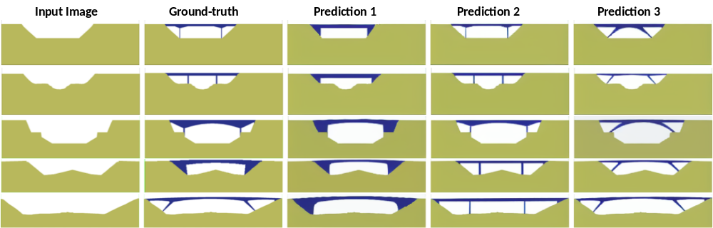Figure 3: Predictions of the trained model on unseen test images. Predictions 1, 2 and 3 correspond to images generated for each of the three design prompts respectively.
Predictions made for each input image in accordance with the design prompt are shown in the figure along with the ground-truths. Additionally, two design alternatives corresponding to the other two design prompts are also visualized. This shows the ability of the model in generating different topologies for the same topographic image based on varying design constraints specified using text prompts.
A comparison of the model’s superior performance over the BERT-guided pix2pix model on the test data is visualized in Fig. 4.
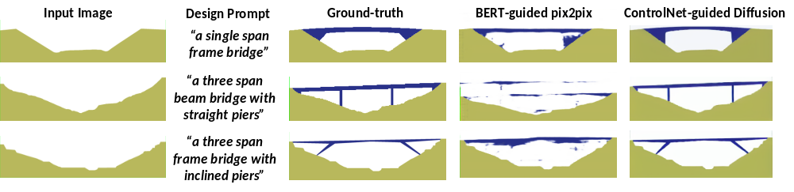Figure 4: A comparison of predictions made by the pix2pix model guided by BERT embeddings and the trained ControlNet-guided diffusion model on the same topography-design prompt combinations.
It can be seen clearly that the ControlNet-guided diffusion model outperforms the BERT-guided pix2pix model in generating complete and high-quality images that follow the ground-truths.

5.2 Quantitative Evaluation
The evaluation metrics defined in Section 4.3 have been used to validate the predictions made by the model on the test dataset. A comparison of the results of both the BERT-guided pix2pix model and the ControlNet-guided diffusion based on the evaluation metrics defined in Section 5.1 is presented in Table 1.
Table 1: The evaluation metrics calculated for both the ControlNet-guided diffusion model and the BERT-guided pix2pix model on the test dataset.
Generative Model | SSIM ↑ | FID ↓ | LPIPS ↓ | IoU ↑ | CLIP Score ↑
BERT-guided pix2pix | 0.8516 | 0.7477 | 0.2021 | 0.4449 | 0.2286
ControlNet-guided diffusion | 0.8930 | 0.4638 | 0.1545 | 0.5878 | 0.2469

It is evident from the table that the ControlNet-guided diffusion model outshines the pix2pix model guided by BERT embeddings across all evaluation metrics. This proves the effectiveness of the ControlNet-based conditioning along with text-guided diffusion for bridge topology generation. The model is able to predict images that are not only structurally similar to the ground-truth images, but also align semantically to the input text prompts. In addition to the numerical evaluation of such a model using metrics popular in Generative AI literature, perceptual validation of the generated topologies by domain experts is essential in assessing its employability in real-world scenarios.

- Conclusions and Outlook
The goal of our work was to prove the feasibility of utilising a ControlNet-based diffusion model in the early bridge design phase to assist bridge designers and engineers in automating the otherwise time-consuming and tedious task of bridge topology generation. For this purpose, a curated dataset based on existing bridges was prepared. Before augmentation, the image pairs were restricted to a narrow family of bridge types, limiting the number of design possibilities. While this is indeed a limitation of the current dataset, the objective of the study is to prove the capability of the model in generating conceptual topologies from sketches of topographies, leveraging a pretrained model fine-tuned on the curated dataset enabling faster convergence. We prove both qualitatively and quantitatively the better performance of the trained model relative to a pix2pix model conditioned on BERT embeddings, by comparing their predictions on a set of unseen test images.
Due to the limited size of the dataset, the model was not exposed to a wider variety of design solutions and more diverse collection design constraints. Having proven the potential of our proposed workflow, we plan on extending the capabilities of the model by training it on a more diverse and larger dataset with greater variety and complexity in the design prompts to enable the generation of a wider range of bridge topologies. Since bridges are 3D structures, future works will also focus on generating additional outputs like cross-sectional images and design parameters like the dimensions of the deck, piers and other structural components. Since the current work focuses only on conceptual topology generation from sketches of bridges, which lack absolute scale and do not allow for an explicit extraction of individual structural components, a more detailed engineering-level validation of the predictions is beyond the scope of this study. Future developments will include the extension of the existing dataset to also incorporate real-world scale and geometry, thereby enabling a more physics-informed training and evaluation of bridge topologies using parameters like the slenderness ratios and load-bearing analysis.

- Acknowledgement
This work was funded by the Deutsche Forschungsgemeinschaft (DFG, German Research Foundation) under the Cluster of Excellence CARE – EXC 3115 – 533767731.

REFERENCES

Alwashah, Z., Xiao, B., Liu, H., Mueller, S.T., Shao, X. (2026). Reliable LLM-driven BIM automation through capability-based multi-dimensional evaluation. Automation in Construction, 187, 106910. DOI: 10.1016/j.autcon.2026.106910
Balmer, V., Kuhn, S.V., Bischof, R., Salamanca, L., Kaufmann, W., Perez-Cruz, F. & Kraus, M., (2024). Design Space Exploration and Explanation via Conditional Variational Autoencoders in Meta-Model-Based Conceptual Design of Pedestrian Bridges. Automation in Construction, 163: p. 105411. 10.1016/j.autcon.2024.105411
Devlin, J., Chang, M.-W., Lee, K. & Toutanova, K., (2018). BERT: Pre-training of Deep Bidirectional Transformers for Language Understanding. arXiv preprint arXiv:1810.04805. DOI: 10.48550/arXiv.1810.04805
Du, C., Esser, S., Nousias, S., Borrmann, A. (2026). Text2BIM: Generating Building Models Using a Large Language Model-Based Multiagent Framework. Journal of Computing in Civil Engineering, 40(2), 04025142. DOI: 10.1061/JCCEE5.CPENG-6386
Ghannad, P. & Lee, Y.-C., (2022). Automated modular housing design using a module configuration algorithm and a coupled generative adversarial network (CoGAN). Automation in Construction, 139: p. 104234. DOI: 10.1016/j.autcon.2022.104234
He, M., Liang, Y., Wang, S., Zheng, Y., Wang, Q., Zhuang, D., Tian, Li. & Zhao, J., (2026). Human-guided urban form generation using multimodal diffusion models. Building and Environment, 287: p. 113892. DOI: 10.1016/j.buildenv.2025.113892
Hellin, S., Nousias, S. & Borrmann, A., (2025). Natural Language Information Retrieval from BIM Models: An LLM-Based Multi-Agent System Approach. Proceedings of the European Conference on Computing in Construction (EC³). DOI: 10.35490/EC3.2025.265
Herron, E., Rade, J., Jignasu, A., Ganapathysubramanian, B., Balu, A., Sarkar, S. & Krishnamurthy, Adarsh., (2024). Latent Diffusion Models for Structural Component Design. Computer-Aided Design, 171: p. 103707. DOI: 10.1016/j.cad.2024.103707
Hessel, J., Holtzman, A., Forbes, M., Le Bras, R. & Choi, Y., (2021). CLIPScore: A Reference-free Evaluation Metric for Image Captioning. arXiv preprint arXiv:2104.08718. DOI: 10.48550/arXiv.2104.08718
Heusel, M., Ramsauer, H., Unterthiner, T., Nessler, B. & Hochreiter, S., (2017). GANs Trained by a Two Time-Scale Update Rule Converge to a Local Nash Equilibrium. Advances in Neural Information Processing Systems (NeurIPS). DOI: 10.48550/arXiv.1706.08500
Horvath, A.-S. & Pouliou, P., (2024). AI for conceptual architecture: Reflections on designing with text-to-text, text-to-image, and image-to-image generators. Frontiers of Architectural Research, 13(3): p. 593–612. DOI: 10.1016/j.foar.2024.02.006
Isola, P., Zhu, J.-Y., Zhou, T. & Efros, A.A., (2017). Image-to-Image Translation with Conditional Adversarial Networks. Proceedings of the IEEE Conference on Computer Vision and Pattern Recognition (CVPR): p. 5967–5976. DOI: 10.1109/CVPR.2017.632
Lal, A., Kang, Chongjie, K., Özcan, B., Blankenbach, J., Marx, S., (2026). Journal of Computing in Civil Engineering. DOI: 10.1061/JCCEE5/CPENG7429
Liang, Z., Zhang, Y.-F., Wang, Y. & Li, W., (2025). Integrating large models with topology optimization for conceptual design realization. Advanced Engineering Informatics, 67: p. 103524. DOI: 10.1016/j.aei.2025.103524
Leng, H., Gao, Y. & Zhou, Y., (2024). ArchiDiffusion: A novel diffusion model connecting architectural layout generation from sketches to Shear Wall Design. Journal of Building Engineering, 98: p. 111373. DOI: 10.1016/j.jobe.2024.111373
Leonhardt, F., (1983). Bridges: Aesthetics and Design. Deutsche Verlags-Anstalt (DVA), Stuttgart, Germany.
Loshchilov, I. & Hutter, F., (2019). Decoupled Weight Decay Regularization. arXiv preprint arXiv:1711.05101. DOI: 10.48550/arXiv.1711.05101
Mazé, F. & Ahmed, F., (2023). Diffusion Models Beat GANs on Topology Optimization. Proceedings of the AAAI Conference on Artificial Intelligence (AAAI-23), 37: Article 1024, p. 9108–9116. DOI: 10.1609/aaai.v37i8.26093
Mehlhorn, G. & Curbach, M., (2014). Handbuch Brücken. Springer Fachmedien Wiesbaden.
Nauata, N. & Chang, K.-H., (2020). House-GAN: Relational Generative Adversarial Networks for Graph-Constrained House Layout Generation. Computer Vision – ECCV 2020, 24(1): p. 162-77. DOI: 10.48550/arXiv.2003.06988
Radford, A., Kim, J.W., Hallacy, C., Ramesh, A., Goh, G., Agarwal, S., Sastry, G., Askell, A., Mishkin, P., Clark, J., Krueger, G. & Sutskever, I., (2021). Learning Transferable Visual Models From Natural Language Supervision. International Conference on Machine Learning (ICML). DOI: api.semanticscholar.org/CorpusID:231591445
Spencer, B.F., Sim, S.-H., Kim, R.E. & Yoon, H., (2025). Advances in artificial intelligence for structural health monitoring: A comprehensive review. KSCE Journal of Civil Engineering, 29(3): p. 100203. DOI: 10.1016/j.kscej.2025.100203
Spiegelhalter, T., (2023). Performance-based, AI-ML-assisted Generative EA Design with Bio-inspired Topological Optimisations of a 50m, 3D-printed Steel Bridge. International Journal of Structural and Civil Engineering Research, p. 63–67. DOI: 10.18178/ijscer.12.3.63-67
Wang, Z., Bovik, A.C., Sheikh, H.R. & Simoncelli, E.P., (2004). Image quality assessment: from error visibility to structural similarity. IEEE Transactions on Image Processing, 13(4): p. 600–612. DOI: 10.1109/TIP.2003.819861
Zhang, L., Rao, A. & Agrawala, M., (2023). Adding Conditional Control to Text-to-Image Diffusion ModelsDOI: 10.48550/arXiv.2302.05543.
Zhang, R., Isola, P., Efros, A.A., Shechtman, E. & Wang, O., (2018). The Unreasonable Effectiveness of Deep Features as a Perceptual Metric. Proceedings of the IEEE/CVF Conference on Computer Vision and Pattern Recognition (CVPR). DOI: 10.1109/CVPR.2018.00068
Zhang, H. & Zhang, R., (2025). An Attention-Based Constrained Diffusion Model for Accessible Floor Plan Generation. Journal of Computing in Civil Engineering, 39(5). DOI: 10.1061/JCCEE5.CPENG-6
Zhou, Y., Leng, H., Meng, S., Wu, H. & Zhang, Z., (2024). StructDiffusion: End-to-end intelligent shear wall structure layout generation and analysis using diffusion model. Engineering Structures, 309: p. 118068. DOI: 10.1016/j.engstruct.2024.118068

