Participatory Digital Twins for Flood Resilience

Ranjith K. Soman^{1,*},Erica Arango¹, Özgün Balaban², Pieter Pauwels²

¹ Delft University of Technology, Delft, Netherlands
² Eindhoven University of Technology, Eindhoven, Netherlands
*Corresponding email: r.soman@tudelft.nl

ABSTRACT
Flood resilience digital twins are increasingly use to support scenario planning and emergency response; however, many remain expert-driven, technically fragmented, and weakly connected to the communities they are intended to serve. This paper presents a design framework for participatory digital twins in flood resilience, developed through engaged scholarship across two urban pilots: Rotterdam in the Netherlands and Tambaram, Chennai in India. The framework structures participatory digital twin design around three resilience phases, preparedness, absorption, and learning. It further proposes three interfaces, namely planning, user consultation, and situational awareness, supported by a modular service-oriented architecture and transparent model coupling. Implementation progress is demonstrated through a web-based prototype integrating flood simulation, building and road impact assessment, as well as, evacuation-related information into layered geospatial visualisations. The paper shows how digital twins can act as boundary objects that connect expert modelling, local knowledge, operational response, and continuous learning.

INTRODUCTION
Floods are among the most frequent and damaging natural hazards globally, with an estimated 1.81 billion people directly exposed to significant flood risk (Rentschler, Salhab & Jafino, 2022). Climate change is intensifying this exposure: the IPCC projects an increase in extreme precipitation of approximately 7% per 1°C of global warming, with urbanisation further amplifying risk by encroaching on natural drainage systems (IPCC, 2021). Building flood resilience, defined as the ability of a city to prepare for, absorb, recover from, and adapt to flood events (Meerow et al., 2016), has therefore become a central priority in urban governance.
Digital twins (DTs) have emerged as promising tools for supporting the prepare, absorb, and adapt/learn phases of flood resilience by enabling scenario planning, real-time situational awareness, damage assessment, and evidence-based adaptation planning. By integrating hydrological, hydraulic, and urban models into a bi-directional, data-driven representation of the city, DTs enable decision-makers to visualise flood scenarios and evaluate intervention strategies before and during events (Ge & Qin, 2025; Kaynak et al., 2025). However, existing DT applications for flood resilience remain predominantly expert-driven and technology-led: processes are top-down, interfaces are designed for specialists, and direct engagement with local communities and non-expert stakeholders remains limited (Nochta et al., 2021; Luo et al., 2025).
This gap is consequential. Flood resilience is not only a technical challenge but a sociotechnical one, local actors hold knowledge of vulnerabilities, behaviours, and adaptive capacities that models alone cannot capture. A participatory digital twin, one designed to engage local government, planners, and residents as active users across the prepare and absorb phases, has the potential to improve both the quality and legitimacy of flood management decisions. Yet despite growing recognition of this need, no design framework for participatory digital twins in flood resilience contexts currently exists in the literature (Luo et al., 2025). This paper addresses that gap by developing a design-oriented framework for participatory digital twins in flood resilience. Rather than proposing participation as a general principle, the framework translates it into practical design guidance through stakeholder-specific interfaces, modular architecture, transparent model coupling, and learning mechanisms for collaborative flood resilience decision making.

STATE OF THE ART

Digital Twins for Flood Resilience
Digital twins, defined as dynamic, bi-directional digital representations of physical systems that enable real-time monitoring, simulation, and decision support, have been increasingly applied to urban flood management over the past decade (Nochta et al., 2021; Ghaffarian, 2025). Early applications focused on hydrological and hydraulic modelling, coupling rainfall-runoff models with urban drainage simulations to forecast inundation extents and depths. More recent frameworks have extended this to city-scale infrastructure integration, combining flood forecasting with transportation networks and critical infrastructure to support emergency action planning (Kaynak et al., 2025). Lifecycle-oriented frameworks have further positioned the DT as a continuous management tool spanning preparedness, response, and recovery, rather than a static planning instrument (Ge & Qin, 2025). Beyond flood management specifically, urban digital twins have been framed as a sociotechnical construct requiring alignment between technical systems and governance structures (Nochta et al., 2021). Ghaffarian (2025) advances this further by proposing the concept of a 'digital risk twin' that explicitly integrates social vulnerability, equity, and institutional dimensions into disaster risk management, moving beyond purely physical system representation. These framings collectively signal a maturing of the field from infrastructure-centred to systems-centred perspectives on resilience.

Siloed Models and the Absence of Integration for Decision Making
High-resolution digital twins have increasingly been developed for individual urban subsystems, including flood-risk twins that combine hydrological/hydraulic simulation, remote sensing and sensor feeds; transport-infrastructure twins for monitoring and network performance; and city-scale urban twins based on 3D city models and urban-planning data (Batty, 2018; Dembski et al., 2020). However, the literature repeatedly identifies data integration, interoperability, lifecycle updating and socio-technical operationalisation as unresolved barriers, meaning that many urban twins still function as domain-specific applications rather than integrated decision-support infrastructures (Lei et al., 2023; Azadi et al., 2025). In flood resilience practice, this fragmentation forces decision-makers to reconcile outputs from hydrological, mobility and urban-planning tools, while technical interfaces can limit the involvement of residents, community organisations and frontline responders.
This is problematic because participatory modelling research shows that models become more legitimate and useful when stakeholders help frame the problem, test assumptions and interpret scenarios, rather than only receiving expert-produced results (Voinov & Bousquet, 2010; Whatmore & Landström, 2011). Where human behaviour is included in flood and disaster models, it is often through agent-based simulations of evacuation, warning response, shelter choice or household decisions within synthetic populations (Chen et al., 2023). Although such approaches are valuable for testing soft adaptation measures, they usually represent communities as simulated agents inside the model, not as active participants in the modelling and decision process. Citizen-facing digital twins and interactive flood visualisations show that digital environments can improve transparency, comprehension and feedback, but only when interfaces and governance processes are deliberately designed for public interaction and collaborative interpretation (Dembski et al., 2020). The gap, therefore, is not merely a lack of technical fidelity, but a lack of design knowledge on how to build flood digital twins as participatory socio-technical systems from the outset.

Towards Guidelines for Participatory Digital Twins
The preceding sections establish that digital twins for flood resilience have advanced technically but remain expert-driven, siloed, and disconnected from the communities they are meant to serve. The response in the literature has largely been to call for more participation, but calls for participation are not the same as design guidance. What is missing is not recognition that participatory digital twins are needed, but a framework for how to design one.
Existing work does not answer foundational design questions: What objectives should a participatory digital twin serve across different stakeholder groups? What interfaces are needed, for whom, and at which phases of the resilience cycle? How should heterogeneous technical models, hydrological, urban, behavioural, be coupled in ways that are meaningful to non-expert users? How should learning from community engagement feed back into the twin? These are design questions, and the literature does not address them systematically. Luo et al. (2025), reviewing 84 urban digital twin publications spanning 2014–2024, found that direct citizen engagement remains limited and identified participatory design as a key area for future research, but stop short of providing design guidance. This paper directly addresses that gap.
This research adopts an engaged scholarship approach (Van de Ven, 2007), in which the design of the participatory digital twin emerged through sustained, iterative engagement with the stakeholders who would use it rather than being specified in advance by researchers alone. The study was conducted across two contrasting urban pilots, Rotterdam in the Netherlands and Tambaram, Chennai in India. Four stakeholder workshops and five practitioner interviews were conducted between June 2024 and January 2026 with local authorities, water and infrastructure agencies, researchers, NGOs, designers, and transport actors. The engagement explored flood management roles, digital twin opportunities, deployment barriers, and intervention priorities. Findings were thematically analysed to derive the stakeholder needs, interface requirements, model-coupling choices, and learning mechanisms that underpin the proposed design framework (Section 3). This paper focuses on presenting the resulting design principles and implementation rather than the qualitative analysis itself.

Participatory Digital Twin Design

Participatory Decision Making Across the Resilience Cycle
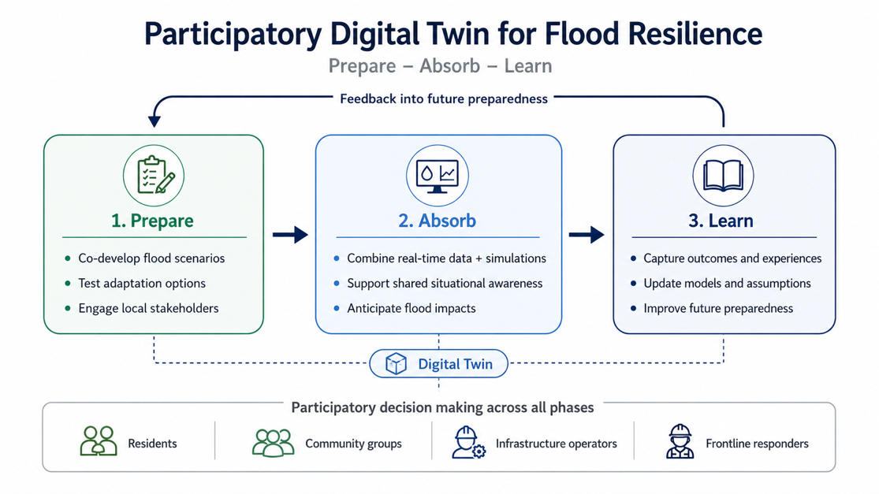
Participatory decision making using a digital twin unfolds across three phases of the flood resilience cycle: prepare, absorb, and learn (Figure 1). In the prepare phase, local authorities and technical experts use the digital twin to co-develop flood scenarios, test adaptation options, such as Blue-Green Infrastructure interventions, drainage upgrades, and land-use changes, and establish response plans, reflecting the broader resilience logic of preparing for, absorbing, and adapting to adverse events (National Research Council, 2012; O’Donnell et al., 2020). These outputs are not kept within technical teams but are made accessible to local actors, including residents, community organisations, infrastructure operators, and frontline responders, through purpose-designed visualisations. Such visual and participatory approaches allow stakeholders to stress-test planning assumptions, identify practical gaps, and contribute local knowledge that technical models alone may not capture (Maskrey et al., 2016; Whatmore & Landström, 2011; White et al., 2010). In the absorb phase, the same digital twin integrates real-time sensor data with pre-computed simulations to support shared situational awareness across departments and community actors, helping decision-makers verify whether planning assumptions hold under live conditions and anticipate the progression of flood impacts (Bakhtiari et al., 2023; Ge & Qin, 2025). Connecting both phases is a learning layer: observed outcomes, stakeholder experiences, and deviations from predicted behaviour are systematically captured after each event and engagement cycle, creating an evolving knowledge resource that feeds back into improved scenario planning, refined model parameters, and stronger governance processes for future flood resilience (Bloemen et al., 2018; Haasnoot et al., 2013). This three-phase logic, prepare, absorb, learn, is what the participatory digital twin was designed to operationalise, and it informed all subsequent design decisions regarding interfaces, architecture, and model coupling.
Figure 1: Digital Twin-Enabled Participatory Flood Resilience Process

Modular Architecture
Participatory digital twins require an architecture that can evolve with changing stakeholder needs, analytical capabilities, and data sources. Rather than being developed as monolithic applications for a single purpose, they are better realised using a service-oriented architecture (SOA) (See Figure 2), where independent analytical services can be developed, deployed, and updated without affecting the overall system (Papazoglou & van den Heuvel, 2007; Jamshidi et al., 2018). An orchestration layer forms the core of the architecture, managing data exchange, communication, and service execution while coordinating dependencies between simulations. This enables outputs from one service, such as flood inundation modelling, to trigger complementary services including traffic routing, emergency planning, or resilience assessment.
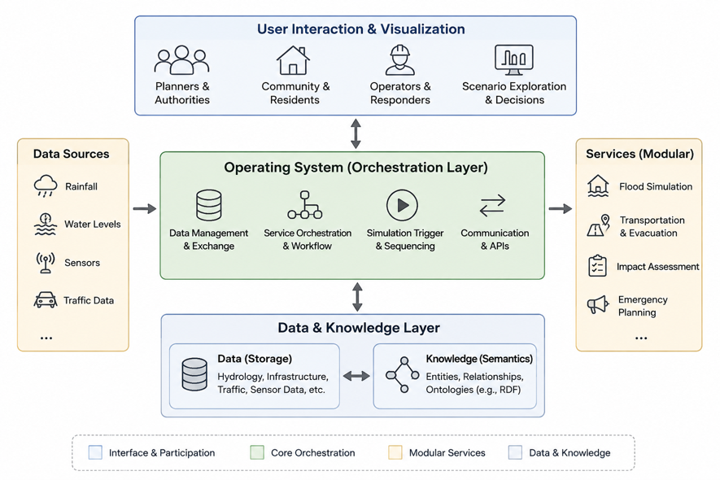
A clear separation between data and knowledge further improves extensibility. While the data layer stores static data about the city as well as observations from sensors, hydrological models, transport systems, and other sources, the knowledge layer captures the semantic relationships between infrastructure assets, hazards, and urban processes. Such separation allows new analytical services to be introduced by extending the semantic model rather than restructuring existing datasets. Knowledge graph approaches based on Resource Description Framework (RDF) and linked data principles provide a flexible mechanism for achieving semantic interoperability across heterogeneous data sources and simulation services.
Figure 2: Participatory Digital Twin Architecture
The user interaction layer is the primary interface for participation. Instead of exposing technical model outputs directly, it provides simplified, role-specific visualisations that support collaborative exploration of scenarios, adaptation options, and operational decisions. Acting as a boundary object, the interface enables stakeholders with different expertise, including planners, emergency responders, infrastructure operators, and residents, to interpret common information and contribute to decision making (Star & Griesemer, 1989; Whatmore & Landström, 2011). During preparedness, the interface supports participatory scenario development and evaluation, while during flood events it integrates real-time observations with simulations to provide shared situational awareness and decision support. This modular separation of orchestration, services, knowledge, and interaction enables the digital twin to evolve continuously as new models, data sources, and stakeholder requirements emerge.

Model Coupling for Participatory Digital Twins
A participatory digital twin cannot rely on isolated domain models if it is to support collaborative decision making across the flood resilience cycle. The challenge identified in the previous sections is therefore not only integrating heterogeneous datasets, but coupling analytical models in ways that remain transparent, extensible, and understandable to both technical and non-technical stakeholders. Several options exist: rule-based coupling, co-simulation, system dynamics, and Bayesian network mediation. Co-simulation can represent dynamic model interaction but is computationally demanding and difficult to synchronise; system dynamics captures long-term feedbacks but lacks operational spatial detail; and Bayesian networks support uncertainty reasoning but require extensive calibration (Gomes et al., 2018).
For this study, loosely coupled, service-oriented model integration is recommended, with rule-based coupling as the default operational method. Rule-based coupling is suitable because it makes model relationships explicit, explainable, and easy to revise. For example, flood-depth outputs can trigger transport-network changes such as speed reduction or road closure, enabling flood and mobility impacts to be explored together. This approach supports modular evolution, stakeholder interpretation, and practical deployment within a participatory digital twin (Papazoglou & van den Heuvel, 2007; Pregnolato et al., 2017).

Participatory Interfaces
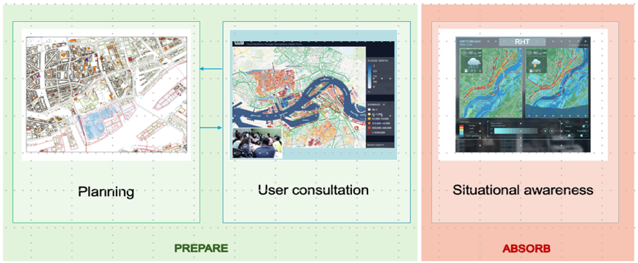
The preceding design principles naturally translate into three complementary interfaces aligned with the resilience cycle: planning, user consultation, and situational awareness (Figure 3). The planning interface supports technical users in developing and evaluating adaptation measures by integrating outputs from multiple analytical services. The user consultation interface simplifies these scenarios into accessible visualisations, enabling residents, infrastructure operators, emergency responders, and community organisations to validate assumptions, identify local constraints, and contribute experiential knowledge through participatory dialogue (Star & Griesemer, 1989; Whatmore & Landström, 2011). During flood events, the situational awareness interface combines real-time observations with coupled model outputs to provide operational decision support for authorities (Bakhtiari et al., 2023). Together, these interfaces operationalise the modular architecture and model-coupling framework by translating complex simulations into role-specific information that supports collaborative decision making throughout the prepare, absorb, and learn phases of flood resilience.
Figure 3:Participatory digital twin interfaces supporting decision making

IMPLEMENTATION
The participatory digital twin has been implemented as a web-based application that integrates geospatial visualisation, simulation outputs, and stakeholder interaction within a common interface. The platform includes multiple map layers, including base maps, building footprints, road networks, flood inundation rasters, and road congestion (Figure 4). Flood extent is represented as coloured raster pixels to make flood depth and spatial extent understandable to both technical and non-technical users. Additional layers show estimated impacts on buildings and transport infrastructure, allowing users to explore the consequences of different flood and adaptation scenarios.
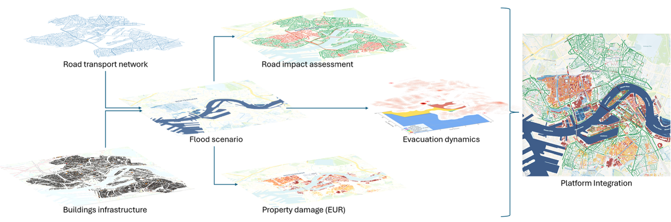
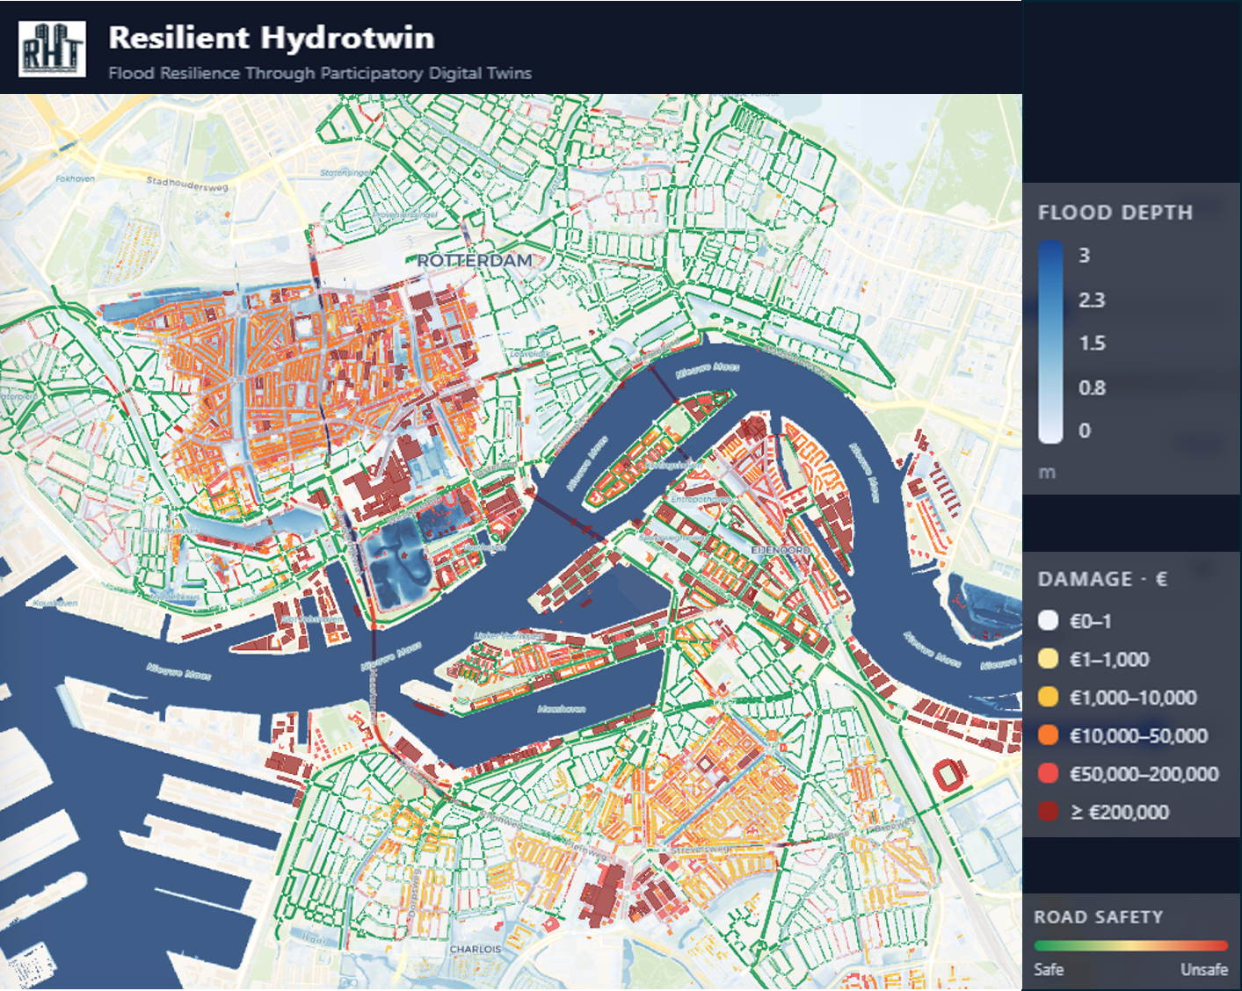
On the service side, hydrological and hydrodynamic compound flood simulation has been implemented using MIKE for the Tambaram pilot and SFINCS for the Rotterdam pilot (DHI, 2024; Leijnse et al., 2021). Flood impact on buildings is assessed using Delft-FIAT, while flood impacts on roads and evacuation behaviour are modelled through agent-based simulation services (Deltares, 2024). Model coupling follows a sequential workflow: adaptation scenarios are first created through hard and soft interventions on the map; these generate modified terrain and geospatial inputs for flood simulation; the resulting flood outputs are then passed to building, road-impact, and evacuation models. The coupled results are returned to the interface as layered maps for expert review and stakeholder consultation. The workflow is designed to support iterative preparedness planning. Expert users create intervention scenarios through the planning interface, after which model outputs are visualised as accessible layered maps. These maps act as boundary objects for consultation with local communities, helping stakeholders understand both positive and negative impacts of proposed interventions and contribute local knowledge. Feedback from consultation can then be used to revise scenarios and repeat the process.
Figure 4: Current implementation of the participatory digital twin interface, integrating multiple simulation outputs into a layered geospatial visualisation.
Implementation is still ongoing. The stakeholder-facing interface has not yet been formally tested and is planned for evaluation in the coming months. The learning component of the digital twin, which will capture consultation outcomes, observed event data, and deviations from predicted behaviour, is also under development. Real-time simulation is not currently feasible for the full model chain because hydrodynamic and agent-based simulations remain computationally intensive. Therefore, surrogate modelling is being explored to approximate simulation outputs more rapidly and enable faster scenario comparison during decision-making meetings, using multivariate analysis to support online service deployment.

Discussion
This paper addresses a gap in digital twin research by moving from the question of whether participation is needed to how participatory digital twins can be designed for flood resilience. Existing flood digital twins have advanced in hydrological, hydraulic, transport, and urban modelling capability, but they often remain expert-centred and fragmented across technical domains (Nochta et al., 2021; Ge & Qin, 2025; Luo et al., 2025). The proposed framework contributes to this knowledge gap by clarifying the objectives, interfaces, model-coupling logic, and learning mechanisms required for a participatory digital twin.
First, the objectives of a participatory digital twin differ across stakeholder groups. For local authorities and technical experts, the digital twin should support scenario development, adaptation planning, and evaluation of hard and soft interventions. For residents, community organisations, infrastructure operators, and responders, it should translate technical model outputs into understandable consequences, such as flood depth, road disruption, building damage, and evacuation implications. This extends participatory modelling arguments that models become more legitimate and useful when stakeholders help frame assumptions and interpret scenarios, rather than only receiving expert outputs (Voinov & Bousquet, 2010; Whatmore & Landström, 2011).
Second, the framework shows that participation requires different interfaces across the resilience cycle. The planning interface serves experts during the prepare phase; the user consultation interface supports local actors in validating and refining scenarios; and the situational awareness interface supports authorities and responders during the absorb phase. These interfaces are not merely visual dashboards. They function as boundary objects: shared representations that allow actors with different expertise, responsibilities, and interests to collaborate without requiring identical technical understanding (Star & Griesemer, 1989). In this sense, the digital twin becomes a social coordination device as much as a technical system.
Third, heterogeneous models should be coupled in ways that preserve both analytical value and interpretability. Hydrological, urban impact, transport, and behavioural models can be connected through loosely coupled, service-oriented workflows, where flood outputs trigger impact, accessibility, and evacuation assessments. Rule-based coupling is especially appropriate for participatory settings because it keeps model relationships explicit and explainable, for example by translating flood depth into road disruption or building damage (Papazoglou & van den Heuvel, 2007; Pregnolato et al., 2017).
Finally, learning must be treated as a core function of the digital twin. Community feedback, observed event outcomes, and deviations from simulated behaviour should feed back into scenario design, model assumptions, and governance processes. This transforms the digital twin from a one-off planning tool into an evolving knowledge infrastructure for adaptation, consistent with adaptive planning literature (Bloemen et al., 2018; Haasnoot et al., 2013). Although implementation and interface testing remain ongoing, the paper advances design knowledge by showing how participatory flood digital twins can integrate technical modelling with stakeholder interpretation, decision support, and continuous learning.

Conclusion
This paper advances flood resilience digital twin research by shifting attention from technical integration alone to the design of participatory socio-technical systems. Its main contribution is a design framework that connects stakeholder engagement, modular architecture, transparent model coupling, and learning across the prepare, absorb, and learn phases of flood resilience. The framework translates broad calls for participation into concrete design guidance through three interface types: planning, user consultation, and situational awareness. The contribution is primarily conceptual and design-oriented, supported by implementation progress in two contrasting pilots. Rather than claiming a fully validated system, the paper demonstrates how participatory digital twins can be structured to connect expert modelling, community interpretation, and operational decision support. Future work should formally evaluate the stakeholder-facing interfaces, operationalise the learning component, and test whether the framework improves inclusiveness, legitimacy, and decision quality across different flood-risk and governance contexts
For researchers, the framework opens a design-oriented research agenda on participatory interfaces, explainable model coupling, semantic knowledge layers, surrogate modelling, and methods for evaluating whether digital twins improve legitimacy, inclusiveness, and decision quality. For practitioners, it offers a practical blueprint for developing digital twin platforms that integrate expert planning, community consultation, and operational situational awareness without locking cities into monolithic systems.

ACKNOWLEDGEMENTS
This research was funded by the Dutch Research Council (NWO) and the Department of Science and Technology, Government of India (DST) through the NWO-DST Merian Fund, grant number 482.482.302.

REFERENCES
Azadi, S., Kasraian, D., Nourian, P., & van Wesemael, P. J. V., (2025). What have urban digital twins contributed to urban planning and decision making? From a systematic literature review toward a socio-technical research and development agenda. Smart Cities, 8(1): Article 32. DOI: 10.3390/smartcities8010032
Bakhtiari, V., Piadeh, F., Behzadian, K., & Kapelan, Z., (2023). A critical review for the application of cutting-edge digital visualisation technologies for effective urban flood risk management. Sustainable Cities and Society, 99: Article 104958. DOI: 10.1016/j.scs.2023.104958
Batty, M., (2018). Digital twins. Environment and Planning B: Urban Analytics and City Science, 45(5): p. 817-820. DOI: 10.1177/2399808318796416
Bloemen, P., Reeder, T., Zevenbergen, C., Rijke, J., & Kingsborough, A., (2018). Lessons learned from applying adaptation pathways in flood risk management and challenges for the further development of this approach. Mitigation and Adaptation Strategies for Global Change, 23: p. 1083-1108. DOI: 10.1007/s11027-017-9773-9
Chen, C., Koll, C., Wang, H., & Lindell, M. K., (2023). An interdisciplinary agent-based evacuation model: Integrating the natural environment, built environment, and social system for community preparedness and resilience. Natural Hazards and Earth System Sciences, 23: p. 733-749. DOI: 10.5194/nhess-23-733-2023
Deltares, (2024). Delft-FIAT: A fast and flexible flood impact assessment tool, [Online], Available: https://www.deltares.nl/en/software-and-data/products/delft-fiat-flood-impact-assessment-tool [25 June 2026].
Dembski, F., Wössner, U., Letzgus, M., Ruddat, M., & Yamu, C., (2020). Urban digital twins for smart cities and citizens: The case study of Herrenberg, Germany. Sustainability, 12(6): Article 2307. DOI: 10.3390/su12062307
DHI, (2024). MIKE+ 2D Overland: Flood Modelling Software, [Online], Available: https://www.dhigroup.com/technologies/mikepoweredbydhi/mikeplus-2d-overland [25 June 2026].
Ge, C., & Qin, S., (2025). Urban flooding digital twin system framework. Systems Science & Control Engineering, 13(1): Article 2460432. DOI: 10.1080/21642583.2025.2460432
Ghaffarian, S., (2025). Rethinking digital twin: Introducing digital risk twin for disaster risk management. npj Natural Hazards, 2: Article 79. DOI: 10.1038/s44304-025-00135-x
Gomes, C., Thule, C., Broman, D., Larsen, P. G., & Vangheluwe, H., (2018). Co-simulation: A survey. ACM Computing Surveys, 51(3): Article 49. DOI: 10.1145/3179993
Haasnoot, M., Kwakkel, J. H., Walker, W. E., & ter Maat, J., (2013). Dynamic adaptive policy pathways: A new method for crafting robust decisions for a deeply uncertain world. Global Environmental Change, 23(2): p. 485-498. DOI: 10.1016/j.gloenvcha.2012.12.006
IPCC, (2021). Climate Change 2021: The Physical Science Basis. Cambridge: Cambridge University Press. DOI: 10.1017/9781009157896
Jamshidi, P., Pahl, C., Mendonça, N. C., Lewis, J., & Tilkov, S., (2018). Microservices: The journey so far and challenges ahead. IEEE Software, 35(3): p. 24-35. DOI: 10.1109/MS.2018.2141039
Kaynak, S., Kaynak, B., Mermer, O., & Demir, I., (2025). City-scale digital twin framework for flood impact analysis: Integrating urban infrastructure and real-time data analytics. Urban Climate, 64: Article 102640. DOI: 10.1016/j.uclim.2025.102640
Lei, B., Janssen, P., Stoter, J., & Biljecki, F., (2023). Challenges of urban digital twins: A systematic review and a Delphi expert survey. Automation in Construction, 147: Article 104716. DOI: 10.1016/j.autcon.2022.104716
Leijnse, T., van Ormondt, M., Nederhoff, C. M., & van Dongeren, A., (2021). Modeling compound flooding in coastal systems using a computationally efficient reduced-physics solver: Including fluvial, pluvial, tidal, wind- and wave-driven processes. Coastal Engineering, 163: Article 103796. DOI: 10.1016/j.coastaleng.2020.103796
Luo, J., Liu, P., Kong, X., Shen, J., Wu, Q., & Xu, D., (2025). Urban digital twins for citizen-centric planning: A systematic review of built environment perception and public participation. International Journal of Applied Earth Observation and Geoinformation, 143: Article 104746. DOI: 10.1016/j.jag.2025.104746
Maskrey, S. A., Mount, N. J., Thorne, C. R., & Dryden, I. L., (2016). Participatory modelling for stakeholder involvement in the development of flood risk management intervention options. Environmental Modelling & Software, 82: p. 275-294. DOI: 10.1016/j.envsoft.2016.04.027
Meerow, S., Newell, J. P., & Stults, M., (2016). Defining urban resilience: A review. Landscape and Urban Planning, 147: p. 38-49. DOI: 10.1016/j.landurbplan.2015.11.011
National Research Council, (2012). Disaster Resilience: A National Imperative. Washington, DC: The National Academies Press. DOI: 10.17226/13457
Nochta, T., Wan, L., Schooling, J. M., & Parlikad, A. K., (2021). A socio-technical perspective on urban analytics: The case of city-scale digital twins. Journal of Urban Technology, 28(1-2): p. 263-287. DOI: 10.1080/10630732.2020.1798177
O’Donnell, E., Thorne, C., Ahilan, S., Arthur, S., Birkinshaw, S., Butler, D., Everett, G., Fenner, R., Glenis, V., Kapetas, L., Kilsby, C., Krivtsov, V., Lamond, J., Maskrey, S., O’Donnell, G., Potter, K., Vercruysse, K., Vilcan, T., Wright, N., & Dawson, D. A., (2020). The blue-green path to urban flood resilience. Blue-Green Systems, 2(1): p. 28-45. DOI: 10.2166/bgs.2019.199
Papazoglou, M. P., & van den Heuvel, W.-J., (2007). Service oriented architectures: Approaches, technologies and research issues. The VLDB Journal, 16(3): p. 389-415. DOI: 10.1007/s00778-007-0044-3
Pregnolato, M., Ford, A., Wilkinson, S. M., & Dawson, R. J., (2017). The impact of flooding on road transport: A depth-disruption function. Transportation Research Part D: Transport and Environment, 55: p. 67-81. DOI: 10.1016/j.trd.2017.06.020
Rentschler, J., Salhab, M., & Jafino, B. A., (2022). Flood exposure and poverty in 188 countries. Nature Communications, 13: Article 3527. DOI: 10.1038/s41467-022-30727-4
Star, S. L., & Griesemer, J. R., (1989). Institutional ecology, “translations” and boundary objects: Amateurs and professionals in Berkeley’s Museum of Vertebrate Zoology, 1907-1939. Social Studies of Science, 19(3): p. 387-420. DOI: 10.1177/030631289019003001
Van de Ven, A. H., (2007). Engaged Scholarship: A Guide for Organizational and Social Research. Oxford: Oxford University Press. DOI: 10.1093/acprof/9780199226290.001.0001
Voinov, A., & Bousquet, F., (2010). Modelling with stakeholders. Environmental Modelling & Software, 25(11): p. 1268-1281. DOI: 10.1016/j.envsoft.2010.03.007
Whatmore, S. J., & Landström, C., (2011). Flood apprentices: An exercise in making things public. Economy and Society, 40(4): p. 582-610. DOI: 10.1080/03085147.2011.602540
White, I., Kingston, R., & Barker, A., (2010). Participatory geographic information systems and public engagement within flood risk management. Journal of Flood Risk Management, 3(4): p. 337-346. DOI: 10.1111/j.1753-318X.2010.01083.x

