Enhancing Resilience in Urban Rail Transit Construction: Evaluation and Improvement Approaches

ABSTRACT:

This study develops a resilience evaluation method for Urban Rail Transit Projects (URTPs) to address construction disruptions including equipment failures and extreme weather. Integrating the Technical-Organizational-Social (TOS) framework with TOPSIS methodology, we establish a comprehensive factor system and employ combined weighting with extension cloud model for assessment. Empirical analysis of Project J reveals higher resilience level. The research contributes: (1) a novel TOS-based evaluation system for URTP construction-phase resilience, (2) hybrid quantitative assessment method combining subjective-objective weighting and extend cloud model, and (3) prioritized improvement strategies targeting critical resilience factors. These outputs provide both theoretical advancement in infrastructure resilience metrics and practical guidance for URTP risk management, demonstrating how systematic resilience evaluation can inform targeted interventions to enhance project robustness against complex construction challenges.

KEYWORDS:

Urban rail transit projects, Construction stage, Resilience evaluation, Combinatorial weighting, Extension cloud model

1. INTRODUCTION
Urban rail transit project (URTP) stands out as the most efficient public transportation system in terms of capacity, offering remarkable benefits like energy conservation and high performance. In recent years, the scale of URTP construction has continued to expand, and it plays important role in urban planning and development strategies. According to CHINA ASSOCIATION OF METROS, metro systems remain the predominant urban rail transit mode in China as of 2024, accounting for 76.27% of all URTPs. Notably, six mainland Chinese cities recorded over 50 km of new URT lines in 2024, with national annual additions projected to exceed 1,000 km by 2025.
However, since URTPs are commonly constructed underground, they often face harsh construction conditions, intricate construction techniques, and many management challenges (Peng et al., 2019). Unfavourable geohydrological conditions exist in the strata of the urban zone, while engineering activities can also disturb the surrounding soil, thus causing ground collapse (Perissin et al., 2012). Crane-related accidents (Qi et al., 2023), collapses, and rock burst incidents (Sousa and Einstein, 2021) during URTP construction collectively pose significant challenges to project objectives.
Scholars are increasingly striving to fortify project construction by integrating the concept of resilience, thereby enabling projects to more effectively withstand, absorb and recover from potentially disruptive events (Hosseini and Barker, 2016). Previous studies have predominantly focused on the operation phase, and there is insufficient linkage between multi-phase shock responses and practical construction management. Therefore, this research established a comprehensive resilience assessment framework through the innovative integration of TOPSIS methodology, combined weighting methods and extension cloud model. This approach enables systematic evaluation and enhancement of URTPs' preventive capabilities and disturbance resistance during critical construction activities. By shifting the analytical focus to project implementation stages, the proposed model addresses a critical gap in current resilience engineering literature while providing practical tools for optimizing construction-phase risk mitigation strategies.

2. LITERATURE REVIEW

2.1 Concept of resilience
Initially, resilience primarily reflected the capacity to resist and recover, and now scholars have further emphasized its adaptive attributes and innovative capabilities (Walker et al., 2004). Conceptualized as an exceedingly complex adaptive system, it has increasingly gained favour across various fields of study, such as sustainable development and urban governance. Urban resilience is characterized as a process that is constantly changing and adapting over time, enabling cities to function as interconnected systems that operate efficiently and recover quickly from disturbances, including the effects on residents from both primary and secondary disasters caused by natural and human-induced factors (Coaffee et al., 2018).
As a critical infrastructure, URTP is essential for sustaining urban operations. Its construction resilience refers to the ability to utilize on-site elements (5M1E et al.) to respond, restore, adapt, and optimize when confronted with sudden disruptions. This capacity enhances risk mitigation and ensures the achievement of quality-safety benchmarks during complex construction processes.

2.2 Resilience of URTP
Existing research on URTP resilience has primarily concentrated on operational-phase assessment, reflecting a marked increase in scholarly attention over the past five years. This trend parallels the expansion of URTP systems, which has correspondingly amplified their exposure to unforeseen events. (Khademi et al., 2021) employed network scanning methods to find the most vulnerable parts of the rail transportation network. (Chen et al., 2022) used simulation to assess the average loss ratios of URTP operational service metrics, which reflected the resilience of URTP to short-term operational interruptions. (Mu et al., 2025) built a comprehensive resilience evaluation model for URTPs through factor selection based on a three-phase shock response: absorption, buffering, and recovery during system disturbances.
Contrarily, research focusing on the construction phase remains notably limited. A systematic search of Scopus and Web of Science (WoS) databases reveals a scarcity of publications when combining keywords “resilience”, “urban rail transit”, and “construction”. To strengthen resilience at the organizational level during construction, (Liu and Yuan, 2024) proposed a evaluation model for Urban URTPs based on a cloud matter-element approach, in which critical resilience factors were derived from literature frequency analysis. Their work contributes to the theoretical framework of the evolutionary process of URTP construction resilience. The process comprises five stages: maintain ($t_{0}$-$t_{1}$, stable operation), absorb ($t_{1}$-$t_{2}$, performance decline under disturbance), respond ($t_{2}$-$t_{3}$, intervention implementation), restore ($t_{3}$-$t_{4}$, gradual recovery phase), optimize ($t_{4}$-$t_{5}$, different stable status). As illustrated in Fig.1, the horizontal axis represents time, while the vertical axis denotes project performance. Post-disruption outcomes depend on the system’s resilience level, which may lead to full recovery, partial restoration, or enhanced performance.

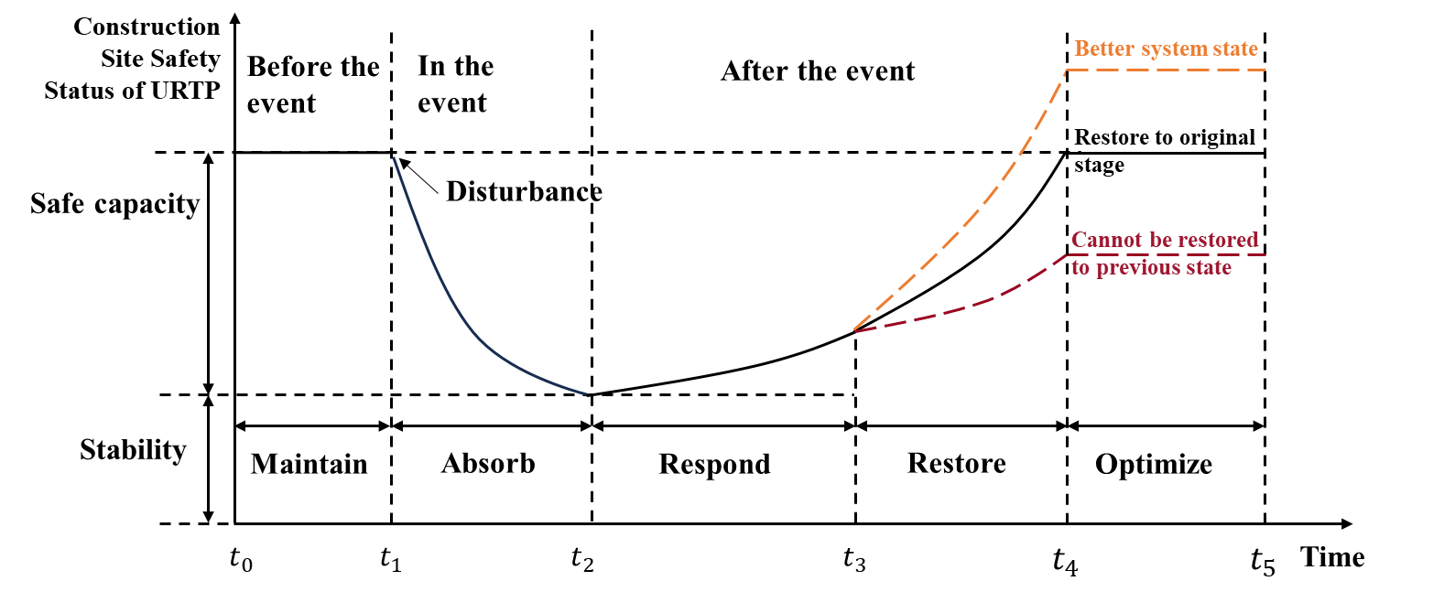
Figure 1: Evolutionary process of URTP construction resilience.

Current resilience optimization strategies primarily focus on transportation aspects, including operational efficiency optimization based on multi-source data (Zhan et al., 2023) and repair sequence of malfunctioning stations (Chen et al., 2021). A systematic resilience enhancement framework for URTP construction remains unexplored.
Resilience evaluation frameworks have emerged as critical tools for understanding infrastructure adaptability, enabling evidence-based interventions in construction projects (Peñaloza et al., 2020). While operational resilience dominates urban rail transit research through risk modelling and recovery analytics, construction-phase resilience mechanisms remain fragmented. Current analytical methods exhibit dual limitations in addressing construction-phase disturbances, lacking both assessment tools for dynamic scenarios and systematic methodologies that incorporate operational parameters and field conditions. These limitations underscore the need for resilience evaluation frameworks that enhance interoperability between resilience theories and construction management practices.

3. METHODOLOGY
This study aims to lessen the impact of interruptions and bolster the URTP’s resilience to potential risks. The approach involved a process-oriented analysis focused on disaster prevention and resistance. Thus, the study constructed a resilience evaluation method and proposed strategies for resilience enhancement, including the screening of factors, evaluation model building, and case study. The overall method process is shown in Fig. 2.

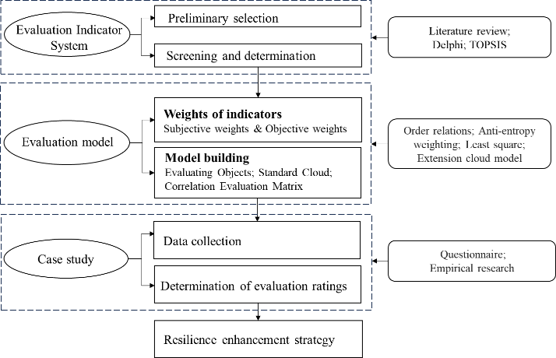
Figure 2: The structure of the research methodology.

3.1 Factor screening
The preliminary factor selection is conducted through systematic synthesis of relevant literature and URTP construction regulatory files, with subsequent refinement via the TOPSIS method. It is a multi-criteria decision-making approach that ranks alternatives by measuring their relative proximity to an optimal solution (Gkountis and Zayed, 2015).
Building upon the preliminary system, TOPSIS method was strategically chosen for factor screening. Expert input was solicited to score the various attributes, enabling the identification and elimination of superfluous factors. This meticulous process culminated in the derivation of the final, refined system. This method encompasses a process that begins with a standardized decision matrix Y, like the following Equation 1:
$Y\left(y_{ij}\right)=x_{ij}/\sqrt{\sum_{1}^{m}{x_{ij}^{2}}}$ (1)
Where $x_{ij}$ – the score of the $j_{th}$ expert on the $i_{th}$ evaluation index, $i$=1,2…n, j=1,2…k.
Then to identify the ideal and anti-ideal solutions, followed by the computation of the Euclidean distance for each factor, as shown in Equation 2:
$d_{i}^{+}=\sqrt{\sum_{j=1}^{n}{(y_{ij}-y_{j}^{+})^{2}}}; d_{i}^{-}=\sqrt{\sum_{j=1}^{n}{(y_{ij}-y_{j}^{-})^{2}}}$ (2)
Where $d_{i}^{+}$ – the distance from the ideal solution;
$d_{i}^{-}$ – the distance from the negative ideal solution.
The process concludes with the determination of the closeness $C_{i}$ of each factor to the ideal objective, while $C_{i}$ =$d_{i}^{-}$/ ($d_{i}^{+}+d_{i}^{-}$). Existing research suggests that factors with a proximity less than 0.5 have minimal impact (Chai et al., 2024). Thus, a threshold of 0.5 was established, keeping only those factors with a proximity above 0.5.

3.2 Combination weighting method
The composite weighting method combines the flexibility and universality of subjective approaches with the scientific and rational basis of objective ones. It mitigates the human bias inherent in subjective weighting and the impracticality issues of data scarcity in purely objective weighting, thus minimizing the constraints of relying on a single weighting method (Gkountis and Zayed, 2015).
In the ordinal relation (subjective weighting), ratio r between the neighbouring factors is a key measure. When $r_{i}$ =1, it means that the factors $x_{i}$ and $x_{i-1}$ are equally important. After calculating the factor’s weight at the end ranking, the evaluator determines the rational value of $r_{i}$ and then calculates the neighbouring values.
The anti-entropy weighting method is selected to do objective weighting due to its ability to address the excessive sensitivity of entropy weighting and to reduce weight volatility (Ou et al., 2023). Let $p_{ij}$ represents the normalized evaluation value (the score of $i_{th}$ expert on the $j_{th}$ evaluation index), while the anti-entropy $h_{j}$ and weight $r_{j}$ are shown in Equation 3:
$h_{j}=-k\sum_{i=1}^{n}{p_{ij}\ln\left(1-p_{ij}\right); w_{j}=h_{j}/ \sum_{j=1}^{m}{h_{j}}}$ (3)
Finally, least square (Liu et al., 2017) can make the deviation of subjective and objective weights as small as possible. The specific calculation process is shown in Equation 4, Let x, y be the multiplicative coefficients of $ω_{sbj}$ and $ω_{0bj}$, and x + y = 2:
$L=\sum_{i=1}^{n}{\sum_{j=1}^{m}{\left\{\left[c_{ij}\left(x·ω_{sbj}-ω_{j}\right)]^{2}+\right.\left[c_{ij}\left(y·ω_{obj}-ω_{j}\right)\left.]^{2}\right\}\right.\right.}}+4λ(\sum_{j=1}^{m}{ω_{j}}-1)$;
$\frac{∂L}{∂ω_{j}}=-\sum_{i=1}^{n}{2c_{ij}^{2}(x·}ω_{sbj}+$
$y·ω_{obj}-{2ω}_{j})+4λ=0$ (4)
Where L – Lagrangian polar function.
The combined weight vector of each index can be calculated by converting the partial derivative formula into matrix form.

3.3 Extension cloud evaluation model
The extended cloud model (ECM) integrates the matter-element extension theory with cloud modelling techniques by substituting the characteristic value $V$ in the matter-element framework with three-dimensional characteristic parameters ($E_{x}$, $E_{n}$, $H_{e}$). $E_{x}$ represents the expected value (distribution centre), $E_{n}$ quantifies the entropy (conceptual uncertainty), and $H_{e}$ measures the hyper-entropy (uncertainty of entropy) (Ju et al., 2022).
Step 1: Determine evaluated matter elements
The study evaluates URTP construction resilience, where the evaluation system mainly contains qualitative factors expressed in natural language. Given the fuzziness and uncertainty of these factors, the normal cloud model is employed to transfer quantitative feature of the factors. The matter-element representation $R$ is shown in Equation 5:
$R=\left[\begin{matrix}N_{1} & C_{1} & \left(E_{x1},E_{n1},H_{e1}\right) \\ ⋮ & ⋮ & ⋮ \\ N_{n} & C_{n} & \left(E_{xn},E_{nn},H_{en}\right)\end{matrix}\right]$ (5)
Where N – URTP construction phase;
C – Construction resilience evaluation index.
Step 2: Construct the standard cloud
Based on resilience mechanisms and URTP construction characteristics; while referencing construction management, risk management, and vulnerability assessment standards, URTP construction resilience level is classified into five grades, as shown in Table 1. Level V indicates superior URTP resilience with strong resistance, absorption, rapid response and recovery capacities, enabling prompt restoration of normal operations following disruptive events. Lower resilience levels represent a gradual decline across all capacity metrics.

Table 1: Construction resilience level table of URTP

Resilience Level | Rank | Score range
I | Lowest | [1,3)
II | Lower | [3,5)
III | Medium | [5,7)
IV | Higher | [7,8)
V | Highest | [8,9]

The score intervals ($a_{i}$,$b_{i}$) in Table 2 are transformed into cloud parameter space ($E_{x}$, $E_{n}$, $H_{e}$) following Equation (6).
$E_{x}$ = ($a_{i}+b_{i}$)/2; $E_{n}$ = (${b_{i}-a}_{i}$)/6; $H_{e}$= s (6)
Where s – Constant, adjusted for variable features.
Step 3: Build the correlation degree evaluation matrix
Given the assessed value $x_{i}$ for the $i_{th}$evaluation factor, the correlation degree is calculated as Equation (7):
$c_{i}=\exp\left[-\frac{{\left(x_{i}-E_{x}\right)}^{2}}{2{\left({En}_{i}^{'}\right)}^{2}}\right]$ (7)
Where $c_{i}$ – Membership degree between factors and the standard cloud;
${En}_{i}^{'}$ – Normally distributed random number.
For each cloud drop ($x_{i}$,$c_{i}$), 99.74% fall within ($E_{x}$-$3E_{n}$, $E_{x}$+$3E_{n}$). Thus, the “$3E_{n}$”-rule is applied to calculate correlation degrees, ensuring rigorous hierarchical classification. Treat the resilience factor and grade cloud as two sets, then compute their intersection $M$ and union $N$. Correlation degree $c$=$|M|/|N|$. Let $c_{ij}$ denote the correlation degree of factor $i$ ($i$=1,2...n) to resilience level $j$ ($j$=1,2...5). The correlation matrix $C$ is given by Equation (8):"
$C=\left[\begin{matrix}c_{11} & … & c_{15} \\ ⋮ & ⋮ & ⋮ \\ c_{n1} & … & c_{n5}\end{matrix}\right]$ (8)
Step 4: Determine the evaluation level
Let $W$ be the calculated weight vector, then the comprehensive evaluation vector of URTP construction resilience $CR$ = $WC$ = (${cr}_{1}$, ${cr}_{2}$, ${cr}_{3}$, ${cr}_{4}$, ${cr}_{5}$). The calculation of fuzzy grade eigenvalue $r$ is shown in Equation (9):
$r= \frac{\sum_{i=1}^{5}{{cr}_{i}s_{i}}}{\sum_{i=1}^{5}{{cr}_{i}}}$ (9)
Where $s_{i}$ – Score corresponding to the five levels of resilience, $s_{i}$ = (1, 2, 3, 4, 5).
To reduce the impact of random number ${En}_{i}^{'}$ on the evaluation results, the expected value $E_{crx}$is the average value of $r_{i}$ after repeated calculation. The number of repetitions $n$ is 2000. Repeated calculations yield correlation degrees between evaluation factors and resilience levels, ultimately determining the final resilience rating of URTP construction resilience.
Entropy $E_{rn}$ is used to evaluate the degree of dispersion of the results, as in Equation (10):
$E_{rn}=\sqrt{\frac{1}{n}\sum_{i=1}^{n}{{\left[r_{i}\left(x\right)-\right.\left.E_{crx}\right]}^{2}}}$ (10)
Reliability metric $δ$ exhibits an inverse dependence on data dispersion, and $δ$ = $E_{rn}$/$E_{crx}$, with $δ$ < 0.01 indicating statistically reliable results.

4. EVALUATION FACTOR SYSTEM
The evaluation factor system constitutes the primary and pivotal step in resilience assessment for URTP construction. This study initially adopted a systematic literature analysis methodology, identifying 15 evaluation frameworks pertinent to URTP through Scopus and Web of Science databases. These frameworks include multidimensional system, including: “absorption-buffering-recovery” in operational phase assessments (Mu et al., 2025); “personnel-material-environment-information” in URTP construction organization (Liu and Yuan, 2024) and “technical-organizational-environmental” in evaluation of safety performance (Peñaloza et al., 2020).
On this basis, the preliminary selection of 26 secondary factors was conducted through the Technical-Organizational-Social (TOS) framework, with the calibration of construction guidelines (e.g., Code for risk management of underground works in urban rail transit).
TOPSIS method was utilized to understand the impact of each factor on resilience. Expert opinions were solicited through a Likert scale questionnaire survey and subsequently subjected to quantitative analysis, offering data to guide factor selection. The questionnaire was mainly distributed to 9 experts with a foundation and experience in URTP construction, including civil and structural, signalling and emergency. The outcomes of factor screening are visually summarized in Fig. 3, while Table 2 presents the finalized evaluation framework alongside explanatory annotations.

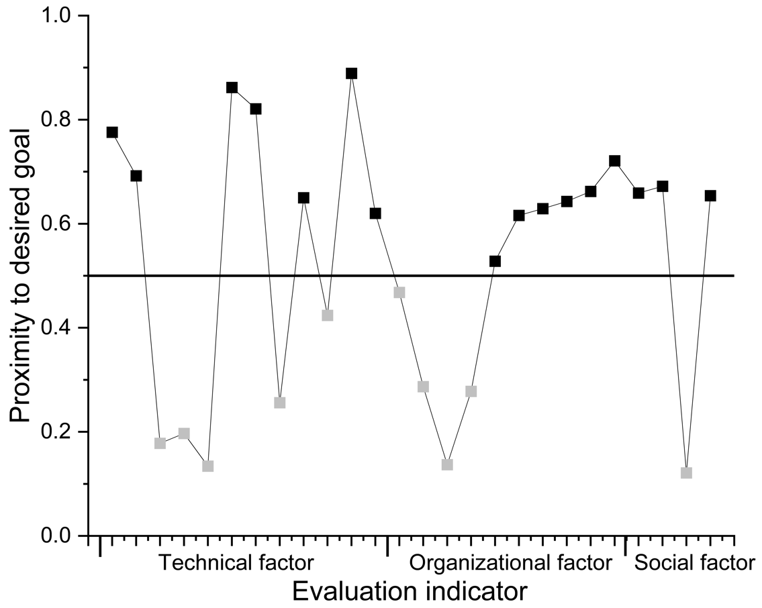
Figure 3: Proximity diagram of factors to ideal targets

Table 2: Final evaluation factor system

Evaluation Dimension | Secondary Evaluation Factors
Technical Dimension  T | Stability of energy supply T1
Technical Dimension  T | Mechanical equipment availability T2
Technical Dimension  T | Redundancy of construction monitoring systemT3
Technical Dimension  T | Communication equipment and signal transmission effectiveness T4
Technical Dimension  T | Supply and stockpiling of raw material T5
Technical Dimension  T | Safety and protective equipment T6
Technical Dimension  T | Impact of adjacent structure T7
Organizational Dimension  O | Emergency organizational movement control capacity O1
Organizational Dimension  O | Completeness of emergency preparedness O2
Organizational Dimension  O | Rehabilitation and aftercare capacity O3
Organizational Dimension  O | Daily production education and training O4
Organizational Dimension  O | Completeness of construction management system O5
Organizational Dimension  O | Safety awareness for construction workers O6
Social Dimension  S | Degree of perfection of laws, regulations, and norms S1
Social Dimension  S | Government’s command and control capacity S2
Social Dimension  S | Social rescue force S3

5. CASE STUDY
The evaluation model was utilized for Station J in a Chinese city as a case study. The project is traversed by another subway line to the north and is surrounded by residential areas. During the construction phase, the project primarily confronts disruptive events such as ground collapse. Based on the evaluation index system, we designed a questionnaire and invited 18 experts closely involved in Project J to score the impact of each factor on construction resilience. Three project managers who participated in indicator screening were interviewed to establish primary indicators' ordinal relationships. The standard cloud feature parameters for Levels I–V were computed using Equation (6) as follows: [(2, 0.33, 0.1), (4, 0.33, 0.1), (6, 0.33, 0.1), (7.5, 0.17, 0.1), (8.5, 0.17, 0.1)]. Fig. 4 presented the standard cloud diagrams of the factors generated by Python.

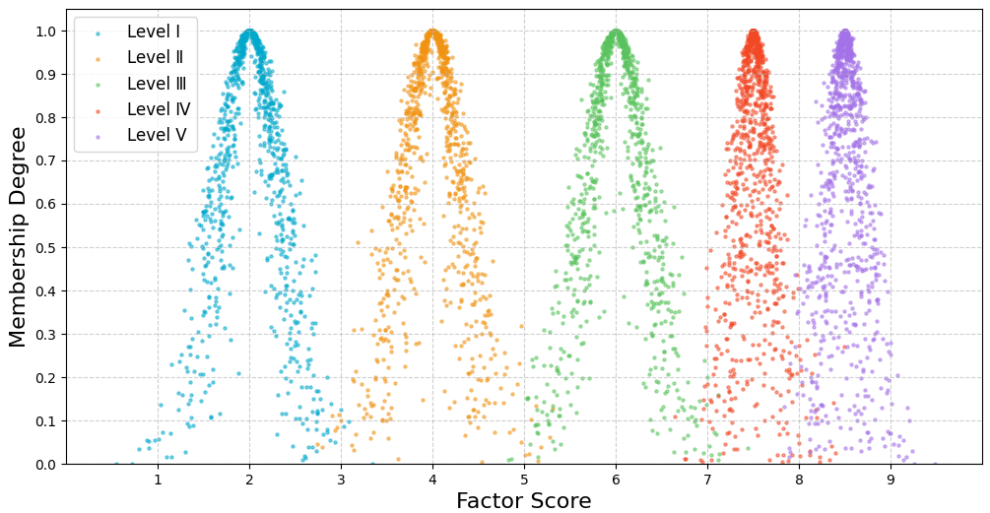
Figure 4: Standard cloud level map of factors

Experts prioritized the primary factors as: Technical > Organizational > Social. Due to $r_{1}$ = $r_{2}$=1.2, the objective weights of primary factors are 0.3956, 0.3297 and 0.2747 respectively. The calculated weights for each indicator are systematically compiled in Table 3, derived through the previously specified analytical procedure.

Table 3: Combined weights of Project J evaluation factors

Evaluation factors | Subjective weight | Objective weight | Combined weight
T1 | 0.0862 | 0.0622 | 0.0736
T2 | 0.0305 | 0.0785 | 0.0556
T3 | 0.0513 | 0.0623 | 0.0571
T4 | 0.1034 | 0.0610 | 0.0813
T5 | 0.0254 | 0.0614 | 0.0442
T6 | 0.0366 | 0.0719 | 0.0550
T7 | 0.0615 | 0.0639 | 0.0628
O1 | 0.0580 | 0.0604 | 0.0593
O2 | 0.0975 | 0.0666 | 0.0813
O3 | 0.0345 | 0.0579 | 0.0468
O4 | 0.0697 | 0.0575 | 0.0633
O5 | 0.0288 | 0.0579 | 0.0440
O6 | 0.0415 | 0.0574 | 0.0498
S1 | 0.0907 | 0.0572 | 0.0732
S2 | 0.1088 | 0.0639 | 0.0854
S3 | 0.0755 | 0.0600 | 0.0674

Using the ECM and Python, we calculated the correlation between each factor and the five resilience levels. To reduce random number effects, each dataset was processed 100 times, and the average values were taken. The result is a 16×5 correlation matrix C, as shown in Equation 11, where values below 0.0001 were set to 0.
C=$\left[\begin{matrix}0.0000 & 0.0000 & 0.0018 & 0.8885 & 0.0028 \\ 0.0000 & 0.0000 & 0.0612 & 0.0224 & 0.0000 \\ 0.0000 & 0.0000 & 0.2955 & 0.0019 & 0.0000 \\ 0.0000 & 0.0000 & 0.0037 & 0.7293 & 0.0012 \\ 0.0000 & 0.0000 & 0.7652 & 0.0003 & 0.0000 \\ 0.0000 & 0.0000 & 0.0054 & 0.7766 & 0.0024 \\ 0.0000 & 0.0000 & 0.0649 & 0.0219 & 0.0000 \\ 0.0000 & 0.0000 & 0.0013 & 0.8754 & 0.0024 \\ 0.0000 & 0.0000 & 0.0018 & 0.9271 & 0.0025 \\ 0.0000 & 0.0000 & 0.0329 & 0.0548 & 0.0000 \\ 0.0000 & 0.0000 & 0.0832 & 0.0213 & 0.0000 \\ 0.0000 & 0.0000 & 0.0031 & 0.6106 & 0.0007 \\ 0.0000 & 0.0000 & 0.1302 & 0.0053 & 0.0000 \\ 0.0000 & 0.0000 & 0.0028 & 0.6500 & 0.0010 \\ 0.0000 & 0.0001 & 0.9825 & 0.0080 & 0.0000 \\ 0.0000 & 0.0000 & 0.1589 & 0.0000 & 0.0000\end{matrix}\right]$(11)
Where the left-to-right order indicates correlations with Levels I–V.
The matrix results show most factors are closely linked to Level IV (higher resilience). The project's overall resilience vector Z = W×U = [0.0000 0.0000 0.1674 0.3766 0.0009], also indicating a higher resilience level. Reliability metric $δ$ = $E_{rn}$/$E_{crx}$ = 0.03/3.69 = 0.081 < 0.01, meeting the requirements, demonstrated low dispersion and high reliability in resilience evaluation results.

6. RESILIENCE IMPROVEMENT STRATEGY
Project J demonstrates Level IV resilience, indicating robust capabilities to withstand and absorb disruptions such as ground collapse events. The system maintains effective emergency response functions while exhibiting good recovery and adaptive capacities, enabling faster restoration to normal operations. The results correlate with our field investigation showing no major construction accidents occurred.
Based on the correlation evaluation matrix, resilience-enhancing strategies can be specifically proposed for identified low-resilience indicators, thereby improving the overall resilience level of the project. Factors demonstrating stronger correlations with highest and higher resilience levels exhibit superior resilience performance, like T1, T4, T6, O1, O2 and S1. This finding demonstrates the project perform well in technical resilience, particularly in energy supply, safety protection and communication and signal engineering. Given limited resources, these factors may maintain current resilience levels.
Substantial resilience improvement can be achieved by strategically prioritizing indicators that are strongly linked to low resilience yet possess considerable optimization headroom. Based on the evaluation results, T5, O6, and S2 exhibit the lowest resilience levels. The comprehensive framework for enhancing URTP construction resilience is presented in Fig. 5.
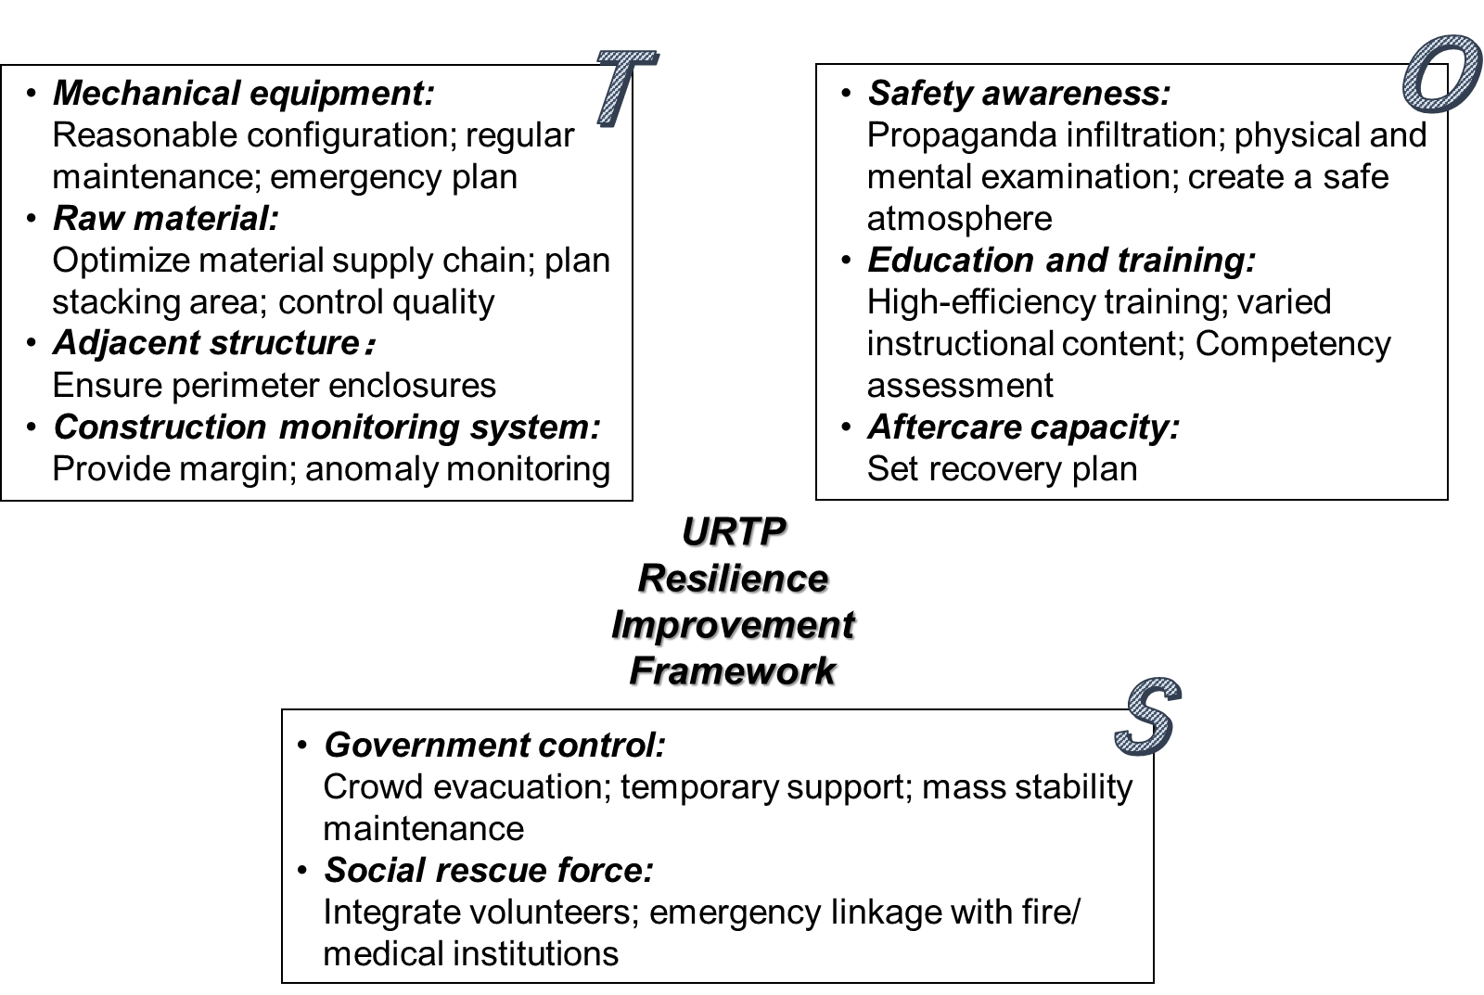
Figure 5: Improvement framework of URTP construction resilience

Within the technical dimension, priority must be given to securing robust raw material supply chains and transportation systems. This necessitates targeted optimization of critical supply chain components, including transport route selection, stringent material inspection protocols, and dynamic inventory management with controlled disbursement quotas. Meanwhile, quality compliance standards need to be strictly enforced to prevent safety hazards. The proper configuration of mechanical equipment, including tunnel boring machines, is critical to avoid operational disruptions. Regular inspections must monitor aging components and mechanical wear, with scheduled maintenance to minimize failure risks. Moreover, proactive defence strategies must be implemented to ensure equipment can effectively absorb disturbances and facilitate rapid recovery to steady-state operations during disruptive events. For construction monitoring systems, critical nodes should incorporate equipment redundancy (e.g., deploying different sensors) to minimize single-point failure risks. Additionally, a backup system with direct BIM platform connectivity can ensure rapid response during primary system failures.
Regarding organizational factors, worker-related aspects require particular attention. Continuous safety awareness among workers must be maintained, supported by prominently displayed safety signage. Enhancing team cohesion fosters a collective safety culture, with foremen playing a pivotal leadership role. Physiological monitoring is critical, especially for high-risk underground operations, to mitigate fatigue-related hazards. Education and training have always been fundamental components of effective construction management, encompassing critical knowledge areas such as construction-related regulations, fire safety principles, and first aid. To enhance learning outcomes and maintain engagement, modern pedagogical approaches should incorporate immersive technologies like VR simulations, peer-to-peer knowledge sharing, and competency verification through skills assessments. Furthermore, the implementation of positive reinforcement strategies, particularly performance-based incentive systems contribute to a more safety-conscious and skilled workforce.
URTP projects typically involve extensive coordination across multiple jurisdictions, necessitating integrated management by competent authorities such as the Ministry of Emergency Management and the Ministry of Transport to facilitate in-time decision-making, such as effective on-site evacuation procedures and public order maintenance. In the event of URTP-related incidents, which invariably cause traffic disruptions, pre-established social rescue force becomes particularly valuable. A proactively developed digital platform can efficiently consolidate resources, including volunteer networks and civilian-donated relief supplies. Furthermore, institutionalized emergency coordination mechanisms with fire departments and medical institutions enable rapid response capabilities, significantly mitigating potential casualties.

7. CONCLUSION
This study establishes a comprehensive resilience evaluation framework for URTP during the construction phase by integrating the Technical-Organizational-Social (TOS) paradigm, which was empirically validated through subway Project J. Through systematic analysis of regulations, literature, and engineering practices, we initially identified 26 candidate factors before refining them to 16 validated evaluation factors using TOPSIS methodology. The application of a combined order relation and anti-entropy weighting approach, coupled with an Extensible Cloud Model (ECM) analysed through Python computational methods, revealed Project J's good resilience performance (Level IV/V). Simultaneously, specific vulnerable factors were pinpointed through correlation matrix analysis. These dimension-specific enhancement strategies make dual contributions: theoretically advancing resilience frameworks for infrastructure systems, while practically enabling measurable resilience improvements in complex construction projects. The study demonstrates that systematic resilience evaluation can effectively guide targeted interventions, ultimately optimizing overall project resilience performance.
Current limitations in data quantification suggest future research directions, particularly through integrating emerging technologies like EEG signals to enhance indicator validation. Advanced methods and concepts like AI and digital twins have been developed rapidly and are closely related to resilience research. But application of them in URTP construction safety management has yet to be strengthened.

REFERENCES
CHAI, N. J., ZHOU, W. L., CHEN, Z. Y., LODEWIJKS, G. & ZHAO, Y. Y. 2024. Multi-attribute fire safety evaluation of subway stations based on FANP - FGRA - Cloud model. Tunnelling and Underground Space Technology, 144.
CHEN, J., LIU, J., PENG, Q. & YIN, Y. 2021. Strategies to Enhance the Resilience of an Urban Rail Transit Network. Transportation Research Record, 2676, 342-354.
CHEN, J. Q., LIU, J., DU, B., PENG, Q. Y. & YIN, Y. 2022. Resilience Assessment of an Urban Rail Transit Network Under Short-Term Operational Disturbances. IEEE TRANSACTIONS ON INTELLIGENT TRANSPORTATION SYSTEMS, 23, 24841-24853.
COAFFEE, J., THERRIEN, M.-C., CHELLERI, L., HENSTRA, D., ALDRICH, D. P., MITCHELL, C. L., TSENKOVA, S., RIGAUD, É. & PARTICIPANTS, T. 2018. Urban resilience implementation: A policy challenge and research agenda for the 21st century. Journal of Contingencies and Crisis Management, 26, 403-410.
GKOUNTIS, I. & ZAYED, T. 2015. Subway Infrastructure Condition Assessment. Journal of Construction Engineering and Management, 141, 04015042.
HOSSEINI, S. & BARKER, K. 2016. Modeling infrastructure resilience using Bayesian networks: A case study of inland waterway ports. Computers & Industrial Engineering, 93, 252-266.
JU, W., WU, J., KANG, Q., JIANG, J. & XING, Z. 2022. A method based on the theories of game and extension cloud for risk assessment of construction safety: A case study considering disaster-inducing factors in the construction process. Journal of Building Engineering, 62, 105317.
KHADEMI, N., BABABEIK, M. & FANI, A. 2021. Sparse rail network robustness analysis: Functional vulnerability levels of accidents resulting from human errors. Journal of Safety Science and Resilience, 2, 111-123.
LIU, B. S., HUO, T. F., LIAO, P. C., YUAN, J. F., SUN, J. & HU, X. 2017. A special Partial Least Squares (PLS) path decision modeling for bid evaluation of large construction projects. Ksce Journal of Civil Engineering, 21, 579-592.
LIU, W. & YUAN, X. 2024. Research on the Resilience Evaluation of Urban Rail Transit Construction Organization Based on the Cloud Matter-Element Model: A Case Study of Nanchang West Station. Buildings, 14, 616.
MU, D., ZUO, Z., MAO, C. & YANG, G. 2025. Assessment of Urban Rail Transit System Resilience Based on a Cloud Matter-Element Model. Journal of Transportation Engineering, Part A: Systems, 151, 04024110.
OU, X. D., WU, Y. F., WU, B., JIANG, J., CHEN, J. Y. & ZHANG, L. 2023. Improved unascertained measure model for risk evaluation of collapse in highway tunnels. NATURAL HAZARDS, 119, 1149-1170.
PEñALOZA, G. A., SAURIN, T. A. & FORMOSO, C. T. 2020. Monitoring complexity and resilience in construction projects: The contribution of safety performance measurement systems. Applied Ergonomics, 82, 102978.
PENG, Y.-T., LI, Z.-C. & SCHONFELD, P. 2019. Development of rail transit network over multiple time periods. Transportation Research Part A: Policy and Practice, 121, 235-250.
PERISSIN, D., WANG, Z. & LIN, H. 2012. Shanghai subway tunnels and highways monitoring through Cosmo-SkyMed Persistent Scatterers. ISPRS Journal of Photogrammetry and Remote Sensing, 73, 58-67.
QI, H., ZHOU, Z., YUAN, J., LI, N. & ZHOU, J. 2023. Accident pattern recognition in subway construction for the provision of customized safety measures. Tunnelling and Underground Space Technology, 137, 105157.
SOUSA, R. L. & EINSTEIN, H. H. 2021. Lessons from accidents during tunnel construction. Tunnelling and Underground Space Technology, 113, 103916.
WALKER, B., HOLLIN, C. S., CARPENTER, S. R. & KINZIG, A. 2004. Resilience, adaptability and transformability in social-ecological systems. ECOLOGY AND SOCIETY, 9.
ZHAN, Q., YUQIU, J., ZHENHUA, Z., QI, Z. & AND LUO, L. 2023. Associations of land use around rail transit stations with jobs–housing distribution of rail commuters from smart-card data. Geo-spatial Information Science, 26, 346-361.

