Digital Twins between Manufacturing and AECO: Current Status and Future Prospects towards Cross-Domain Coupling
Mathias Artus, Christian Koch, Christoph Legat

ABSTRACT: Digital Twins of structures and systems are important for the future of digitalization, leading to optimized efficiency, sustainability, and resilience. In this context, the domains of Architecture, Engineering, Construction, and Operations (AECO), as well as industrial manufacturing, which have heretofore been regarded as distinct, are becoming increasingly interconnected because of shared objectives, including the optimization of resources, lifecycle management, and system interoperability. Digital Twins could be one method to bridge both domains. Distinct terms, guidelines, and standards form barriers on the way of interconnecting both disciplines. This paper analyses differences in the state of practice and the state of the art in order to suggest prospective ways for future integration. A common understanding of life cycles, processes, and data exchange will help to bridge the gap between both domains.

KEYWORDS: Digital Twin, BIM, AAS, Smart Manufacturing, Sector Coupling

1. Introduction
The growing intricacy of contemporary infrastructure and manufacturing systems necessitates the development of novel methodologies to optimize efficiency, sustainability, and resilience. The domains of Architecture, Engineering, Construction, and Operations (AECO), as well as industrial manufacturing, which have heretofore been regarded as distinct, are becoming increasingly interconnected because of shared objectives, including the optimization of resources, lifecycle management, and system interoperability. Moreover, as construction and infrastructure become increasingly automated using (among other things) industrial equipment, there is a growing need for interoperability between cross-sector technologies. The utilization of information from one domain is essential for the beneficial application of that information in another domain. Accordingly, data transfer across domains is a pivotal need and opportunity. The concept of sector coupling is also regarded as a pivotal technology in the context of the energy transition and the pursuit of climate neutrality. Achieving such integration requires robust mechanisms for data and information exchange across sectoral boundaries and different phases of the lifecycle. The concept of the Digital Twin has emerged as a promising paradigm for addressing these challenges. A variety of definitions of Digital Twins exist from industry, academia, and standardization bodies. Thereby, most definitions share the common understanding that a Digital Twin is a virtual representation of a physical system. Optionally, a Digital Twin might be enriched with real-time data and/or equipped with the ability to offer additional functional aspects, such as the simulation of behaviors, processes, and interactions. Its capacity to span the physical and digital realms renders it an efficacious instrument for uniting disparate physical domains through the digital domain, exemplified by its utility in uniting the civil engineering and manufacturing sectors. Notwithstanding the potential advantages, a significant challenge persists in facilitating seamless data exchange and integration across sectors. Both domains have traditionally relied on proprietary or domain-specific standards for data representation and management. This has resulted in significant barriers when attempting to couple processes or share insights. The utilization of standardized data models and interoperability frameworks by Digital Twins provides a potential solution to these barriers. They facilitate seamless translation, enrichment, and utilization of data and processes from one domain into another, thereby fostering cross-sectoral collaboration.
In each sector, specifics of the lifecycle are addressed by sector-specific standards and solutions (Borrmann et al., 2018; DIN and DKE, 2023; Meyer, Böll and Legat, 2025) also, specific requirements for data and its value-added use are implemented in the (mostly sector-specific) applications and solutions. This is the case for both construction and manufacturing, which results in technological islands having very limited, largely proprietary possibilities for exchanging information. Leading to limited possibilities for realizing the potential of digital twins in the context of information provision across (life cycle and sectoral) boundaries, and thus for exploiting great economic potential, but also great potential regarding ecological and sustainable issues. Logically, it is necessary to minimize barriers and media discontinuities in the collaboration between Manufacturing and AECO. Future digitalization of AECO requires to improve the interoperability with manufacturing. Other literature reviews discuss what can be learned from manufacturing. In contrast to these reviews, this paper focuses on the idea of improving interoperability, by addressing the questions: Which conceptual assumptions have both industries in common or are different? Which standards do exist in these domains and how could they complement each other?
The subsequent organization of this paper is delineated by the methodology exhibited in Figure 1. Initially, terms and definitions are provided in Section 2, which serve as the foundation for subsequent analysis. Subsequent chapters are dedicated to a comparative analysis of manufacturing and AECO. Section 3 provides an examination of standards and guidelines, while Section 4 offers an analysis of the state of research. Section 5 discusses the intersection of the two sectors and briefly presents existing approaches. The insights gained from the analysis presented in the preceding chapters are discussed in chapter 6, and possible needs for research and standardization are derived. The paper is summarized in Section 7, and an outlook on further work is given.

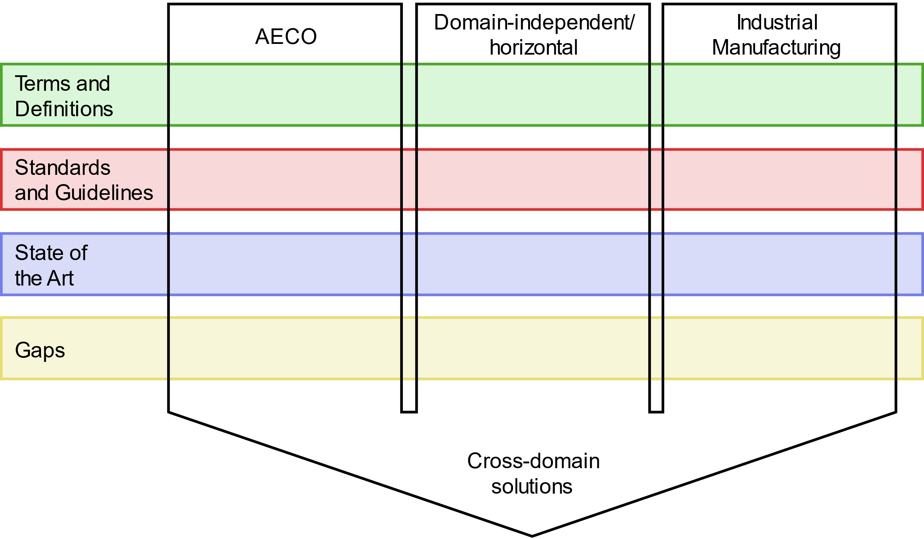
Figure 1: Methodology for intersectional analysis

2. Terms and definitions
Words, terms, and concepts are core elements in engineering domains. Specialists in collaborative environments rely on trust in each other and trust builds upon a common vocabular and understanding. Therefore, clear terms and definitions and mandatory.

2.1 Manufacturing
Industrial production is traditionally based on a stable, detailed standardization framework (DIN and DKE, 2023; Meyer, Böll and Legat, 2025); the sector is also subject to strict regulatory requirements in some cases — in addition to the Machinery Directive (Directive 2006/42/EC of the European Parliament and of the Council 2005). Industry-specific regulations also apply in Europe, such as for medical products (Regulation (EU) 2017/745 of the European Parliament and of the Council 2017). In most cases, standards that have been developed through full consensus are implemented, a phenomenon that is partly attributable to the international acceptance of these standards, but also to the specific role and possibility of self-declaration of conformity in Europe (Meyer, Böll and Legat, 2025). Standards developed by the International Electrotechnical Commission (IEC) are frequently employed in this region, particularly those established by Technical Committee No. 65 (TC65), which has undertaken the responsibility of formulating international standards for systems and components utilized in the domains of measurement, control, and automation of industrial processes. It also coordinates standardization activities that affect the integration of components and functions into such systems, including safety and security aspects. This standardization work is to be carried out in the international areas for devices and systems (IEC TC 65).
In the context of international endeavors concerning the digital transformation of the manufacturing sector, a multitude of reference models have been formulated. Illustrative examples include the Industrie 4.0 reference model depicted in Figure 2, which was developed in Germany, and the Industrial Internet Reference Architecture (Industry IoT Consortium, 2022), which originated in the United States.

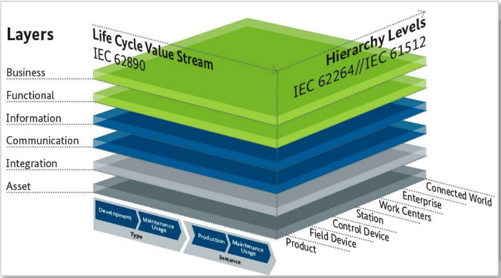Figure 2: RAMI4.0 – Reference Model Industrie 4.0 (Heidel, 2019)
Beyond full-consensus standards from ISO and IEC, standards driven by consortia are widespread in the manufacturing sector. Two notable examples are the OPC Foundation and the Industrial Digital Twin Association (IDTA), both of which are strongly connected to IEC TC65.

2.2. AECO
The AECO industry aims to streamline design, construction and operation related processes around buildings and civil engineering structures. Central point of these attempts is the concept of Building Information Modelling (BIM). BIM comprises several methodologies and standards to support processes in the entire life cycle of a building by the means of digitizing these processes. In the center, the Industry Foundation Classes (IFC) is a standardized object-oriented data format for exchanging building information between different stakeholders and software (International Organization for Standardization 16739:2018). Several product elements and storeys form a building, which is part of a site, and the site is part of a project. Furthermore, processes, actors, properties and documents can be added to each object. This data can be stored in different formats, e.g., ISO 10303, Extensible Markup Language (XML) or Resource Description Framework (RDF) (Borrmann et al., 2018). Both, BIM and IFC, form the basis for DTs in the built environment (Bundesministerium für Digitales und Verkehr, 2023).
Different use cases require different data and IFC aims to support all these use cases, which leads to a complex and highly flexible data format. To reduce the size and room of interpretation of IFC files, additional standards exist. An Information Delivery Manual (IDM) defines who sends when which information to which recipient (ISO 29481). These definitions can be stored in a machine-readable format, i.e., Information Delivery Specification (IDS). Often, AECO software vendors use proprietary data formats. Exports to the IFC standard may be filtered and controlled via Model View Definitions (MVD) that provide parameters for necessary objects, geometries, relationships etc. With respect to the circumstance that buildings are parts of cities or landscapes, CityGML is an open standard for storing and exchanging geospatial information. Unfortunately, CityGML and IFC are developed independently.
Construction projects require often additional data besides the IFC files, for example, documents, databases or geospatial information. Hence, this data must be organized and linked. Common Data Environments (CDE) offer a central point of information with processes, persons, roles, permissions and data. Such CDEs are meant to collaboratively work on projects; hence, they are often provided as online portals with included editors and viewers (Borrmann et al., 2018). If a given state of a construction project with an IFC file and its related data shall be exchanged, the Information Container for linked Document Delivery (ICDD) is suitable (ISO 21597). Both rely on the IFC file as main data source. All other data is related to this information in some way. All those concepts aim at the direction of DTs with regards to digitalization.
Digital Twin (DT) is a relatively new term in AECO, and hence there are different definitions provided in the literature (Barricelli, Casiraghi and Fogli, 2019; Naderi and Shojaei, 2023). Unlike manufacturing products, which are produced in large numbers, buildings and structures are unique and commonly built once. A DT is defined as a “realistic digital representation of physical things” in the Gemini principle (Bolton et al., 2018). This is a very basic definition and leaves out aspects of synchronization, scaling, purpose etc. Another definition is given by the Federal Ministry for Digital and transport: ‘A Digital twin is a digital counterpart of a physical system, whereby the real system and its digital counterpart are connected with an automatized real time data and information exchange over the entire life cycle.' (Bundesministerium für Digitales und Verkehr, 2023) Pärn et al. (2024) highlight that the current understanding of Digital Twins (DT) is too simplistic and limited in its scope (Pärn et al., 2024). Lei et al. (2023) include aspects, such as real-time data, geometric and semantic data, operations and functions (Lei et al., 2023). Similar definitions are provided by other researchers as well (Jiang et al., 2021). Pärn et al. (2024) considered multiple use cases for digital twins comparable to systems in reality (Pärn et al., 2024). To distinguish DT from BIM, this paper considers a DT as a combination of a physical system, virtual representation and automatic data exchange between both (buildingSMART International Ltd., 2020; Bundesministerium für Digitales und Verkehr, 2023). Furthermore, it aims at one service at least (Ketzler et al., 2020). Besides DT, digital shadows exist. Following Grieves, a digital shadow consists of a physical system, its digital counterpart and an automatic data exchange from the real system to the digital counterpart, i.e., a DT without an automatic data exchange from digital to real (Grieves and Vickers, 2017). Only some publications are aware of this distinction, like Osman et al. (2023). Cyber-physical systems (CPS) is a third term used synonymously to DT. Davila Delgado et al. (2017) highlights the trend of building a DT based on several CPS.

3. Standards and guidelines

3.1 Manufacturing
The digital transformation of manufacturing, especially through digital twins, relies on a complex ecosystem of standards to ensure interoperability, consistency and scalability across systems and industries (DIN and DKE, 2023; Meyer, Böll and Legat, 2025).
Standardized reference architectures, such as ISO 23247, are essential for ensuring the seamless creation, processing, and integration of digital twins in manufacturing (Ferko et al., 2023). Despite the existence of standards like ISO 23247, many digital twin architectures do not fully align with these guidelines, indicating a gap between theoretical frameworks and practical implementation.
Within IEC, the TC65 is developing standards for smart manufacturing. The IEC TR 63319 employs a meta-modeling methodology to analyze and identify commonalities among various smart manufacturing reference models. By situating each reference model within a unified meta-model framework, the report facilitates a comparative analysis, highlighting both shared and unique features across the models. Consequently, the report serves as a foundational analysis for stakeholders aiming to understand and integrate various smart manufacturing reference models, promoting interoperability and coherence in the development of smart manufacturing systems. IEC IEC 63339:2024 ED1 defines a Unified Reference Model for Smart Manufacturing that provides a consistent framework for modeling elements, relationships, and processes across the manufacturing lifecycle. It sets criteria for developing specialized reference models. This standard helps unify diverse manufacturing systems and their reference models, e.g. RAMI4.0 (Heidel, 2019) or IIRA (Industry IoT Consortium, 2022), under a common conceptual structure, facilitating coherent development and innovation in smart manufacturing. ​ ISO/IEC TR 63306-1 establishes a structured framework and defines the vocabulary for developing entries in the Smart Manufacturing Standards Map Catalogue. This framework facilitates systematic mapping and interconnection of standards and standardization projects pertinent to various facets of smart manufacturing, including products, production processes, supply chains, and industrial services. Based upon this, ​ ISO/IEC TR 63306-2 provides a comprehensive listing of standards pertinent to smart manufacturing, detailing their characteristics.
In the context of digital twins, the OPC UA protocol stack and the information model are both pertinent. The latter facilitates the (semantic) modeling of information on data points. Whereas the OPC Foundation is the maintainer of the standard, stable versions are standardized as IEC TR 62541-1. Companion specs in the machinery domain are developed and maintained by umati (VDW — Verein Deutscher Werkzeugmaschinenfabriken e.V., 2025). The IDTA is the user organization of the so-called Asset Administration Shell (AAS), a concept for the industrial twin originally developed in Germany. The AAS has gained international acceptance and standardization through the IEC 63278 series (IEC 63278-1). The IDTA develops application-specific models in a consortial manner, designating them as sub-models of the AAS. These sub-models are incorporated into the IEC as required, particularly for regulatory reasons in Europe.
ISO/IEC 30172 and ISO/IEC 30173 are standards developed from the perspective of the industrial Internet of Things (IoT) and cyber-physical system (CPS) theory within ISO/IEC JTC1 SC41. ISO/IEC TR 30172 provides a collection of use cases for digital twins, illustrating their application across different domains and life cycle stages. This technical report comprises detailed descriptions and diagrams for each use case, thereby serving as a practical guide for implementing digital twin solutions. Building upon these insights, ISO/IEC 30173 establishes a standardized framework for digital twin technology, defining essential concepts and terminology to ensure a common understanding across various applications and industries. Recently, the activities of the technical committee responsible for these standards are aligning its activities through liaison with activities in IEC TC65 on smart manufacturing (see above).
In ISO, TC 184 is also working intensively on digital twins – beyond others – in the manufacturing domain. ISO 23247 is a multipart standard that defines a digital twin framework specifically tailored for manufacturing systems. It outlines the architectural principles (ISO 23247-2), functional components (ISO 23247-3), and interoperability requirements necessary for creating and integrating digital twin solutions, enabling standardized data exchange and cohesive system integration across production processes (ISO 23247-4). In this context, also ISO 10303 series known as STEP (Standard for the Exchange of Product Model Data) as well as ISO 15531 series describing industrial manufacturing management data are relevant in context of digital twins in manufacturing.

3.2 AECO
One aim of DTs is to streamline and automatize data processing and decision making in the particular application area. BIM has a very similar goal. It is important to consider characteristic features of systems to be twinned, e.g., the life cycle of products. Borrmann et al. (2018) defined the life cycle of a building as shown in Figure 3. A building is designed in a conceptual way, then detailed constructed and constructed. During the operation phase, the building is used. If modifications are required, they may lead to another conceptual design phase.

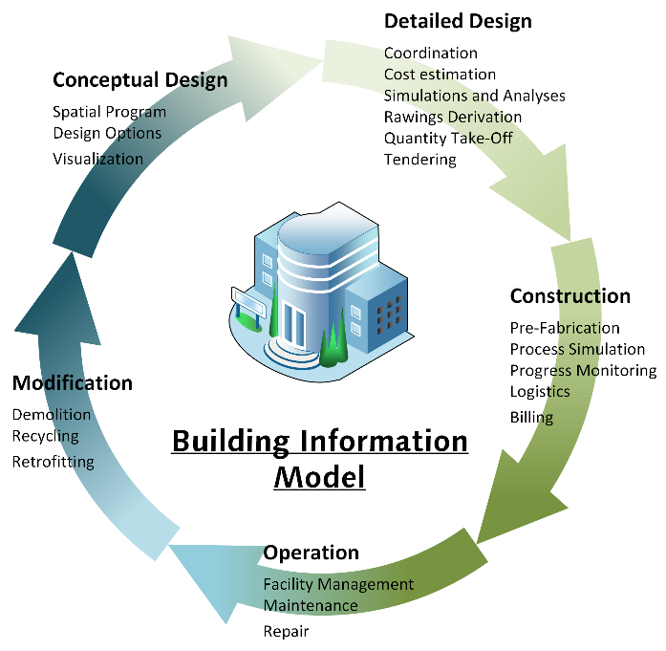
Figure 3: AECO life cycle model (Artus and Koch, 2020)
Currently, there are still problems with the definition and use of BIM-compliant standards, not to mention standards relating to digital twins, which do not exist yet (AlBalkhy et al., 2024; Zhao and Taib, 2022). Germany published a first maturity and implementation plan for BIM in 2015. It contains 3 steps for the implementation as well as a first level of data exchange and process requirements (Bundesministerium für Verkehr und digitale Infrastruktur, 2015). Further levels and requirements are explained in later versions. Since 2022 all national owned buildings must be built using the defined maturity level one of the BIM method (Bundesministerium des Inneren, für Bau und Heimat and Bundesministerium der Verteidigung, 2021). Level one covers 9 use cases during the planning phase.
With the ICDD, a standard to exchange building models at a specific point in time accompanied by external data has been developed (ISO 21597). Another requirement is versioning files and working on a project collaboratively. This is cumbersome by sending mail and handling documents manually. Addressing these needs, the ISO 19650-4 defines the CDE as central space for data management and collaboration.
The German Federal Ministry for Digital and Transport provides 5 maturity levels of DTs: (1) a virtual replica including object-related condition data. Maturity level (2) includes measurements data from sensors, (3) adds a condition prediction. Level (4) uses AI to derive action recommendations, leading to a full autonomous DT that learns and decides (Bundesministerium für Digitales und Verkehr, 2023). It is questionable whether AI has to be used to fulfill level 4 or if there are analytical methods. Furthermore, full autonomous DTs according to level 5 lead to the question of responsibility in case of wrong decisions. Talking about buildings’ DTs with respect to the fully automatized data exchange, it is not possible to have a building’s DT during the design and construction phase of the building.
Both industries developed plenty of standards. They have in common standards for data exchange and vocabulary (IFC, STEP, ​ ISO/IEC TR 63306-1). However, these standards are incompatible until now. Some standards from manufacturing, e.g., AAS, have been partly evaluated for the construction industry already Kosse et al. (2022). This shows a lead of the manufacturing industry in DT compared to AECO.

4. State of research

4.1 Manufacturing
Digital twins are emerging as a key technology in manufacturing, enabling seamless integration between physical and virtual systems (Fuller et al., 2020). Recent systematic literature reviews have analyzed the current state of research in manufacturing, highlighting its potential for monitoring, optimization, and forecasting (Atalay et al., 2022). Digital Twins leverage Industry 4.0 concepts and technologies such as artificial intelligence, Internet of Things, and cyber-physical systems to simulate real-time working conditions and facilitate intelligent decision-making (Fuller et al., 2020). While Digital Twins can offer significant benefits for engineering product lifecycle management and business innovation, challenges remain in areas such as modelling consistency, data analytics integration, and efficient cyber-physical data mapping (Feldmann et al., 2016). With the upcoming data ecosystems in manufacturing - also referred to Europe as Manufacturing-X (Bundesministerium für Wirtschaft und Klimaschutz and Bundesministerium für Bildung und Forschung, 2023) - the concept of data spaces and digital twins co-evolve and start to fuse (Redeker et al., 2021; Somma et al., 2023; Volz et al., 2023). Volz et al. (2023) investigates how digital twins and data spaces can be leveraged to realize the Industry 4.0 vision of decentralized, networked production. It outlines the necessary building blocks for establishing a data space, most notably, the integration of digital twins using the latest Industry 4.0 Asset Administration Shell specifications—to enable efficient data exchange among partners. Another research direction is on manufacturing systems as dynamic, self-organizing systems. Redeker et al. (2021) emphasizes that Digital Twins must be implemented using established standards such as the AAS and supported by dedicated platforms to effectively organize manufacturing processes and enable cross-company data sharing. In this context, agentic approaches to implement Digital Twins in industrial applications arise (Reinpold et al., 2025).

4.2 AECO
Several DT frameworks exist in literature. Mathematically, a DT can be understood as state variables that are measured via sensors including failures, included in a model with uncertainties and parameters (Chiachío et al., 2022). Other frameworks describe structural or behavioral models. New technologies are not directly and fully implemented in industry; hence maturity models are used to provide a qualitative assessment of concepts (Davila Delgado and Oyedele, 2021).
Some frameworks provide a rough overview of the system structure split up into several blocks (Broo and Schooling, 2021; Chiachío et al., 2022). With respect to processes, some frameworks describe necessary steps during DT development (Bickford et al., 2020). Diverse sectors, stakeholders and applications are another challenge in defining standards. Civil infrastructure includes mobility and public utilities with a diverse spectrum of entities, e.g., roads, bridges, harbors, airports, train stations, hospitals, landfills, water reservoirs or power plants, all of them with specific demands and standards. Hence, many DT frameworks focus on such topics (Gourisetti et al., 2023; Keskin, Salman and Koseoglu, 2022; Zhou et al., 2024). This already leads to a high complexity, not to mention the long life-cycles of buildings and civil engineering structures. With respect to the Unified Modelling Language, which includes behavioral and structural models, it would be necessary to define behavioral and structural standards for DTs in the AECO sector aiming at improving communication, supporting different applications, enhance participation and smoothen data transition between different domains.
Some available research also follows the idea of learning from manufacturing because their research focused on DTs for some years already. Davila Delgado and Oyedele (2021) focus on terminology, structural and functional definitions in literature. The idea is to transfer concepts from manufacturing to AECO, but there are constraints because of the different environments given by the disciplines. In contrast to that, Abanda et al. (2025) respects differences between both disciplines. However, some projects require a tight collaboration of manufacturing and AECO, e.g., refinery buildings, hence, shared communication is necessary. The level of digital modeling has been reached by the acceptance and implementation of the BIM methodology. The level of digital shadowing is currently the state of practice, as BIM models with integrated (shadowed) sensors currently act as "digital twins" - even if they are now yet twins. Reaching the level of real digital twinning still seems to be a future vision in the AECO industry.

5. Intersections of Manufacturing & AECO
Both sectors are considered individual engineering disciplines. However, there exist necessary interactions within the sector-specific life cycles. One of these interactions is depicted in Figure 4: Industrial manufacturing produces building elements, such as precast concrete, panels, windows, or bricks, for buildings built by the AECO industry (Liu et al., 2021). These elements are integrated into buildings, such as factory buildings, which therefore are again used for production by industrial manufacturing.

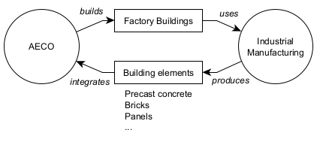
Figure 4: Example: Interaction use cases for industrial manufacturing and AECO
This elementary illustration demonstrates the necessity of a bidirectional exchange of information between the sectors of AECO and Manufacturing as depicted in Figure 5. For instance, the fabrication of building components necessitates information such as the geometry of the component and material requirements, as well as contractual information, e.g., delivery time and location. In the context of Industrie 4.0, this use case is also referred to as order-driven production (Bundesministerium für Wirtschaft und Klimaschutz and Bundesministerium für Bildung und Forschung, 2016), which results in numerous, yet unresolved challenges in modeling products (Bundesministerium für Wirtschaft und Klimaschutz and Bundesministerium für Bildung und Forschung, 2017, 2019). The complexity increases due to heterogeneous models in the cross-sector data exchange considered here. This is important for the planning of new buildings. Knowledge about available elements and related parameters may provide pivotal information for decision making. Vice versa, planning a production line requires building information to properly plan machine placement, optimize product routes in the building, etc.
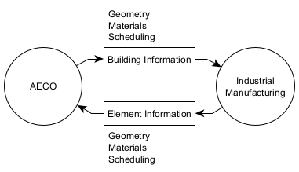
Figure 5: Example: Information exchange between industrial manufacturing and AECO
The integration of Manufacturing and AECO has gained significant attention because of its potential to enhance lifecycle management, improve automation capabilities, and address interoperability challenges between traditionally isolated sectors.
Although literature explicitly addressing integrating frameworks remains relatively limited, existing studies demonstrate varying degrees of engagement. Kosse et al. (2022), for instance, comprehensively address both criteria, advocating for the direct integration within modular construction frameworks. They emphasize standardized information management practices, such as the Asset Administration Shell and Information Container for Linked Document Delivery, to streamline lifecycle integration across domains. Similarly, Heinbach, Hülsmann and Kosse (2022) contribute by practically integrating BIM and AAS to facilitate modular construction processes and automated precast concrete production connecting real-time process data with design models, bridging AECO and Manufacturing.
In principle, two converging approaches can be observed in literature: AECO application in manufacturing and industrial digital twins application in AECO. Badenko et al. (2024), for example, focus on the application of AECO digital twin concepts, i.e. BIM, in manufacturing aimed at sustainable infrastructure. However, there is no integration of industrial digital twin concepts, limiting the practical interoperability achievable through their proposed framework. In contrast, Wimmer and Braml (2024) as well as Zribi et al. (2025) explore Digital Twins from a manufacturing perspective, engaging the AECO. They highlight critical challenges, including interoperability, data standardization, and adoption barriers. Improving the interoperability of both domains would need to (1) bridge the gaps in standards, (2) identify a cross-domain understanding of DTs and (3) develop cross-domain frameworks for DTs spanning manufacturing and AECO.

6. Discussion
It is evident from literature that the topic Digital Twinning is important. After several research about frameworks, use cases and technologies, researchers now aim to clarify terms, build vocabulary and structure this new research area. DT has its origin in aeronautics and aviation, has been adopted by manufacturing and now enters the sector of civil engineering. All three engineering domains inherit different assumptions. Manufacturing and aviation develop one model and produce it several times. Aeronautics has a model, constructs a prototype, tests, improves and again constructs a prototype. Civil engineers design and plan buildings and structures based on the (uncontrolled) environment in which they are built. Each single building and structure are unique in design and location. There can be retrofittings of structures, until it is demolished finally. Similar to the physical object, the DT is unique and has to be constructed in parallel with the building or structure. This leads also to a very specific life cycle.
Manufacturing can assume a well-defined workspace, with less dynamic and limited movement of machinery. Construction sites are much more dynamic, humans can draw decisions that are not objective, machinery is bigger, more dangerous to humans, and mostly controlled by humans.
These are some examples of why both disciplines show numerous differences. However, more and more projects require that both domains act together on an integral basis. Ironically, the construction of intelligent buildings and the associated digital twins is based on the cooperation between the manufacturing industry, which produces measuring devices, as well as architects and civil engineers, who design, plan, build and operate structures. An even tighter collaboration is necessary for refineries or similar single production line factories.
Numerous standards for DTs in the area of industry 4.0 have been defined in the manufacturing sector. AECO has only some basic guidelines for specific cases and/or data exchange. Nowadays, manufacturing puts its focus on implementing these standards into specific factories or plants. Considering the differences of both industries, the conclusion can be drawn that standards from manufacturing will not directly fit for civil engineering demands and need adjustments based on the listed differences above. IFC is the established exchange format in the construction sector and is rooted in the STEP standard of the manufacturing industry. This makes it clear that, on the one hand, concepts from manufacturing can be groundbreaking for the AECO sector, but on the other hand, those cannot be adopted without reservation.

7. Conclusion, Summary & Outlook
DT is important to further improve digitalization of the AECO sector. Future projects will require more and more collaboration between manufacturing and AECO. Without a shared understanding and common standards this won’t be possible. A review of standards, guidelines and research shows some similarities in terms and research, but also a lack of standards in the AECO industry and shared standards for communication in and between both disciplines.

REFERENCES
Abanda, F.H. et al. (2025) ‘Digital twin for product versus project lifecycles’ development in manufacturing and construction industries’, Journal of Intelligent Manufacturing, 36(2), pp. 801–831. doi: 10.1007/s10845-023-02301-2
AlBalkhy, W. et al. (2024) ‘Digital twins in the built environment: Definition, applications, and challenges’, Automation in Construction, 162, p. 105368. doi: 10.1016/j.autcon.2024.105368
Artus, M. and Koch, C. (2020) ‘State of the art in damage information modeling for RC bridges – A literature review’, Advanced Engineering Informatics, 46, p. 101171. doi: 10.1016/j.aei.2020.101171
Atalay, M. et al. (2022) ‘Digital twins in manufacturing: systematic literature review for physical–digital layer categorization and future research directions’, International Journal of Computer Integrated Manufacturing, 35(7), pp. 679–705. doi: 10.1080/0951192X.2021.2022762
Badenko, V. et al. (2024) ‘Principles for Sustainable Integration of BIM and Digital Twin Technologies in Industrial Infrastructure’, Sustainability (Switzerland), 16(22), p. 9885. doi: 10.3390/su16229885
Barricelli, B.R., Casiraghi, E. and Fogli, D. (2019) ‘A Survey on Digital Twin: Definitions, Characteristics, Applications, and Design Implications’, IEEE Access, 7, pp. 167653–167671. doi: 10.1109/ACCESS.2019.2953499
Bickford, J. et al. (2020) ‘Operationalizing digital twins through model-based systems engineering methods’, Systems Engineering, 23(6), pp. 724–750. doi: 10.1002/sys.21559
Bolton, A. et al. (2018) Gemini Principles.
Borrmann, A. et al. (2018) Building Information Modeling. Cham: Springer International Publishing.
Broo, D.G. and Schooling, J. (2021) ‘A Framework for Using Data as an Engineering Tool for Sustainable Cyber-Physical Systems’, IEEE Access, 9, pp. 22876–22882. doi: 10.1109/ACCESS.2021.3055652
buildingSMART International Ltd. (2020) Enabling an Ecosystem of Digital Twins. Available at: https://​www.buildingsmart.org​/​wp-​content/​uploads/​2020/​06/​Enabling-​Digital-​Twins-​Positioning-​Paper-​Final.pdf (Accessed: 7 April 2025).
Bundesministerium des Inneren, für Bau und Heimat and Bundesministerium der Verteidigung (2021) Masterplan BIM für Bundesbauten. Available at: https://​www.bmi.bund.de​/​SharedDocs/​downloads/​DE/​veroeffentlichungen/​2021/​10/​masterplan-​bim.pdf​?​__blob=​publicationFile (Accessed: 7 April 2025).
Bundesministerium für Digitales und Verkehr (2023) Digitaler Zwilling von Brucken: Beitrag zum Masterplan Digitaler Zwilling Bundesfernstraßen. Available at: https://​digitalerzwilling.bundesfernstrassen.de​/​download/​21959/​?​tmstv=​1693989511 (Accessed: 7 April 2025).
Bundesministerium für Verkehr und digitale Infrastruktur (2015) Stufenplan Digitales Planen und Bauen. Available at: https://​bmdv.bund.de​/​SharedDocs/​DE/​Publikationen/​DG/​stufenplan-​digitales-​bauen.pdf​?​__blob=​publicationFile (Accessed: 7 April 2025).
Bundesministerium für Wirtschaft und Klimaschutz and Bundesministerium für Bildung und Forschung (2016) Aspects of the Research Roadmap in Application Scenarios. Available at: https://​www.plattform-i40.de​/​IP/​Redaktion/​EN/​Downloads/​Publikation/​aspects-​of-​the-​research-​roadmap.html (Accessed: 8 April 2025).
Bundesministerium für Wirtschaft und Klimaschutz and Bundesministerium für Bildung und Forschung (2017) Application scenario in practice: order-controlled production of a customised bicycle handlebar. Available at: https://​www.plattform-i40.de​/​IP/​Redaktion/​EN/​Downloads/​Publikation/​application-​scenario-​in-​practice.html (Accessed: 8 April 2025).
Bundesministerium für Wirtschaft und Klimaschutz and Bundesministerium für Bildung und Forschung (2019) Secure Retrieval of CAE Data. Available at: https://​www.plattform-i40.de​/​IP/​Redaktion/​EN/​Downloads/​Publikation/​secure-​retrieval-​of-​cae-​data.html (Accessed: 8 April 2025).
Bundesministerium für Wirtschaft und Klimaschutz and Bundesministerium für Bildung und Forschung (2023) International Manufacturing-X Playbook. Available at: https://​www.plattform-i40.de​/​IP/​Redaktion/​DE/​Downloads/​Publikation/​manufacturing-​x/​International-​Manufacturing-​X-​Playbook.html (Accessed: 8 April 2025).
Chiachío, M. et al. (2022) ‘Structural digital twin framework: Formulation and technology integration’, Automation in Construction, 140. doi: 10.1016/j.autcon.2022.104333
Davila Delgado, J.M. et al. (2017) ‘Management of structural monitoring data of bridges using BIM’, Proceedings of the Institution of Civil Engineers - Bridge Engineering, 170(3), pp. 204–218. doi: 10.1680/jbren.16.00013
Davila Delgado, J.M. and Oyedele, L. (2021) ‘Digital Twins for the built environment: learning from conceptual and process models in manufacturing’, Advanced Engineering Informatics, 49. doi: 10.1016/j.aei.2021.101332
Deutsches Institut für Normung (DIN) and Deutsche Kommission Elektrotechnik Elektronik Informationstechnik (DKE) (2023) German Standardization Roadmap Industrie 4.0 Version 5.0. Available at: https://​www.dke.de​/​resource/​blob/​2244336/​dbbd9c02812f04cc1ab0063647262645/​german-​standardization-​roadmap-​industry-​4-​0-​version-​5-​data.pdf (Accessed: 7 April 2025).
Directive 2006/42/EC of the European Parliament and of the Council 2005. Available at: https://​eur-lex.europa.eu​/​legal-​content/​EN/​TXT/​PDF/​?​uri=​CELEX:02006L0042-20190726 (Accessed: 8 April 2025).
Feldmann, S. et al. (2016) ‘A comprehensive approach for managing inter-model inconsistencies in automated production systems engineering’, 2016 IEEE International Conference on Automation Science and Engineering (CASE), 2016 IEEE International Conference on Automation Science and Engineering (CASE), Fort Worth, TX, USA, 21-25 August: IEEE, pp. 1120–1127. doi: 10.1109/COASE.2016.7743530
Ferko, E. et al. (2023) ‘Standardisation in Digital Twin Architectures in Manufacturing’, Proceedings - IEEE 20th International Conference on Software Architecture, ICSA 2023 (70 – 81). doi: 10.1109/ICSA56044.2023.00015
Fuller, A. et al. (2020) ‘Digital Twin: Enabling Technologies, Challenges and Open Research’, IEEE Access, 8, pp. 108952–108971. doi: 10.1109/ACCESS.2020.2998358
Gourisetti, S.N.G. et al. (2023) ‘A Theoretical Open Architecture Framework and Technology Stack for Digital Twins in Energy Sector Applications’, Energies, 16(13). doi: 10.3390/en16134853
Grieves, M. and Vickers, J. (2017) ‘Digital Twin: Mitigating Unpredictable, Undesirable Emergent Behavior in Complex Systems’, in Kahlen, F.-J., Flumerfelt, S. and Alves, A. (eds.) Transdisciplinary Perspectives on Complex Systems. Cham: Springer International Publishing, pp. 85–113.
Heidel, R. (2019) Industrie 4.0: The Reference Architecture Model RAMI 4.0 and the Industrie 4.0 component. Available at: https://​www.dinmedia.de​/​de/​publikation/​rami-​4-​0-​and-​the-​industrie-​4-​0-​component/​296158879 (Accessed: 7 April 2025).
Heinbach, J.H., Hülsmann, B. and Kosse, S. (2022) ‘Integration of BIM and Industry 4.0 - approach for rapid deployment of digital twins for modular construction’, Poceedings of 33. Forum Bauinformatik, Forum Bauinformatik, 2022-09. Available at: https://​mediatum.ub.tum.de​/​doc/​1688387/​ero7ed6n0cfwavinmfeqbd145.Heinbach%20et%20Al.%202022.pdf (Accessed: 8 April 2025).
IEC (2020) OPC Unified Architecture - Part 1: Overview and concepts.
IEC (2023) A meta-modelling analysis approach to smart manufacturing reference models.
IEC (2023) Unified reference model for smart manufacturing.
IEC (2023) Asset Administration Shell for industrial applications - Part 1: Asset Administration Shell structure.
IEC (2025) Industrial-process measurement, control and automation.
Industry IoT Consortium (2022) The Industrial Internet Reference Architecture.
International Organization for Standardization (2013) Industry Foundation Classes (IFC) for data sharing in the construction and facility management industries.
ISO (2004) Industrial automation systems and integration — Industrial manufacturing management data.
ISO (2016) Building information models - Information delivery manual: DIN-Media.
ISO (2019) Organization and digitization of information about buildings and civil engineering works, including building information modelling (BIM).
ISO (2020) Information container for linked document delivery - Exchange specification. Berlin: DIN Media GmbH.
ISO (2021) Automation systems and integration - Digital twin framework for manufacturing.
ISO (2021) Automation systems and integration - Digital twin framework for manufacturing.
ISO (2021) Automation systems and integration - Digital twin framework for manufacturing.
ISO (2024) Industrial automation systems and integration - Product data representation and exchange.
ISO/IEC (2020) Smart manufacturing standards map (SM2).
ISO/IEC (2020) Smart manufacturing standards map (SM2).
ISO/IEC (2023) Digital twin — Concepts and terminology.
ISO/IEC (2023) Internet of things (loT) — Digital twin — Use cases.
Jiang, F. et al. (2021) ‘Digital twin and its implementations in the civil engineering sector’, Automation in Construction, 130, p. 103838. doi: 10.1016/j.autcon.2021.103838
Keskin, B., Salman, B. and Koseoglu, O. (2022) ‘Architecting a BIM-Based Digital Twin Platform for Airport Asset Management: A Model-Based System Engineering with SysML Approach’, Journal of Construction Engineering and Management, 148(5). doi: 10.1061/(ASCE)CO.1943-7862.0002271
Ketzler, B. et al. (2020) ‘Digital Twins for Cities: A State of the Art Review’, Built Environment, 46(4), pp. 547–573. doi: 10.2148/benv.46.4.547
Kosse, S. et al. (2022) ‘Digital Twin Framework for Enabling Serial Construction’, Frontiers in Built Environment, 8. doi: 10.3389/fbuil.2022.864722
Lei, B. et al. (2023) ‘Challenges of urban digital twins: A systematic review and a Delphi expert survey’, Automation in Construction, 147, p. 104716. doi: 10.1016/j.autcon.2022.104716
Liu, Y. et al. (2021) ‘BIM-BVBS integration with openBIM standards for automatic prefabrication of steel reinforcement’, Automation in Construction, 125, p. 103654. doi: 10.1016/j.autcon.2021.103654
Meyer, O., Böll, M. and Legat, C. (2025) ‘Status and Future Prospects of the Standardization Framework Industry 4.0: A European Perspective’, in Service Oriented, Holonic and Multi-Agent Manufacturing Systems for Industry of the Future: Proceedings of SOHOMA 2024: Springer Cham.
Naderi, H. and Shojaei, A. (2023) ‘Digital twinning of civil infrastructures: Current state of model architectures, interoperability solutions, and future prospects’, Automation in Construction, 149, p. 104785. doi: 10.1016/j.autcon.2023.104785
Osman, A.H. et al. (2023) ‘Assessing a thermoelectric radiative cooling partition as a personalised comfort system using empirical experiments enhanced by digital shadow visualisation’, Building and Environment, 245, p. 110833. doi: 10.1016/j.buildenv.2023.110833
Pärn, E. et al. (2024) Twin Systems: Digit Twins of the Built Environment. United Kingdom: Self-Published.
Redeker, M. et al. (2021) ‘Towards a digital twin platform for industrie 4.0’, Proceedings - 2021 4th IEEE International Conference on Industrial Cyber-Physical Systems, ICPS 2021 (39 – 46). doi: 10.1109/ICPS49255.2021.9468204
Regulation (EU) 2017/745 of the European Parliament and of the Council 2017. Available at: https://​eur-lex.europa.eu​/​legal-​content/​EN/​TXT/​HTML/​?​uri=​CELEX:32017R0745&​from=​IT (Accessed: 8 April 2025).
Reinpold, L.M. et al. (2025) ‘Systematic comparison of software agents and Digital Twins: differences, similarities, and synergies in industrial production’, Journal of Intelligent Manufacturing, 36(2), pp. 765–800. doi: 10.1007/s10845-023-02278-y
Somma, A. et al. (2023) ‘Digital Twin Space: The Integration of Digital Twins and Data Spaces’, 2023 IEEE International Conference on Big Data (BigData), 2023 IEEE International Conference on Big Data (BigData), Sorrento, Italy, 15-18 December: IEEE, pp. 4017–4025. doi: 10.1109/BigData59044.2023.10386737
VDW — Verein Deutscher Werkzeugmaschinenfabriken e.V. (2025) umati. Available at: https://​umati.org​/​ (Accessed: 7 April 2025).
Volz, F. et al. (2023) ‘On the Role of Digital Twins in Data Spaces’, Sensors, 23(17). doi: 10.3390/s23177601
Wimmer, J. and Braml, T. (2024) ‘Digital twins for engineering structures—An Industry 4.0 perspective’, Structural Concrete, 25(6), pp. 4202–4218. doi: 10.1002/suco.202400683
Zhao, Y. and Taib, N. (2022) ‘Cloud-based Building Information Modelling (Cloud-BIM): Systematic literature review and Bibliometric-qualitative Analysis’, Automation in Construction, 142, p. 104468. doi: 10.1016/j.autcon.2022.104468
Zhou, F. et al. (2024) ‘Digital Twin-Enabled Smart Maritime Logistics Management in the Context of Industry 5.0’, IEEE Access, 12, pp. 10920–10931. doi: 10.1109/ACCESS.2024.3354838
Zribi, H. et al. (2025) ‘Industry 4.0: digital twins characteristics, applications, and challenges in-built environments’, Production & Manufacturing Research, 13(1). doi: 10.1080/21693277.2025.2456277

