Assessing reuse scenarios through circularity and LCA metrics
A case study of a town hall renovation in Luxembourg
Annie Guerriero^{1,*}, Hajar El Ammari ¹, Derya Yilmaz¹, Calin Boje¹, Elma Durmisevic², Maria Candelas³

¹ Luxembourg Institute of Science and Technology, Esch-sur-Alzette, Luxembourg
² GTB Lab, Heerlen, The Netherlands
³ Municipality of Beckerich, Beckerich, Luxembourg
*Corresponding email: annie.guerriero@list.lu

ABSTRACT
Generating 38,4% of total waste in the European Union, the construction industry is transitioning toward Circular Economy (CE) practices due to its major environmental impact. Circular economy promotes multiple strategies allowing to extend the lifespan of existing building materials and reducing demolition waste, the reuse of materials is one of them. The paper presents a BIM-based methodology combining circularity indicators and Life Cycle Assessment (LCA) to evaluate renovation scenarios. This methodology is deployed on a pilot building in Beckerich (Luxembourg) that is planned to be renovated. Two scenarios have been created and compared: a Business-as-usual (BAU) approach and a Circular (CIR) scenario (i.e. reuse). Results show that the CIR scenario significantly reduces environmental impacts. The research also highlights the importance of combining circularity indicators with LCA to support informed decision-making and demonstrates the key role of BIM in enabling low-carbon and resource-efficient renovation strategies.

- INTRODUCTION
In recent years, the construction sector has started its transition to a circular economy. Generating 38,4% of total waste in the European Union (Eurostat, 2022), the construction industry has a significant potential to adopt new circular practices aiming at preserving the value of buildings, components and materials longer and contributing to the decarbonisation of the sector. According to Ellen Mac Arthur Foundation, “The circular economy is a system where materials never become waste and nature is regenerated. In a circular economy, products and materials are kept in circulation through processes like maintenance, reuse, refurbishment, remanufacture, recycling, and composting.” (Ellen MacArthur Foundation, 2026). To disrupt with the linear economy and the take-make-waste model, research works and new regulations started to appear. The materials inventories became an important step to identify the value of materials and components before the demolition of a building at its end of life, allowing to envisage a second-hand market and the reuse of materials in new building designs. Nevertheless, there are still plenty of barriers in the sector that limit the reuse practices (Belli-Riz et al., 2022, Charef and Emmitt, 2021, Cheshire, 2021, Heinrich and Lang, 2019). We can identify in the literature that one of the most important of them is the lack of information about the buildings and their composition, as well as the lack of tools supporting the decision-making process. Because effective reuse requires a specific process including careful disassembly and transport to a storage area and has to contribute to an environmental benefit, defining a reuse strategy should involve the comparison of Business-as-usual practice with Circular scenario and use circularity and LCA (Life Cycle Assessment) metrics to guide the decision-making process, helping to maximize resource efficiency and increase the quantity of materials diverted from the waste stream. Key element of the digital transition of the construction industry, the Building Information Model (BIM) has a fundamental role in the centralization of materials data throughout the building’s lifecycle until its end-of-life, supporting the generation of materials inventory and material passport (Akbarieh et al., 2020). It also helps the calculation of the environmental impacts through BIM to LCA process, as well as the analysis of the reuse potential of the building components (Durmisevic et al., 2021). In this paper, a BIM-based process supporting the analyses and comparison of reuse scenarios, including both LCA and circularity metrics is introduced and deployed in a case study: the renovation of a town hall building in Luxembourg. Two scenarios of renovation (i.e. Business-as-usual versus circular approach) are analysed and compared through LCA and circularity indicators.

- METHODOLOGY
Figure 1 illustrates the methodology developed in this paper to define a reuse strategy combining both circularity assessment and LCA indicators. After an on-site visit and data collection about the building, a materials inventory was generated to support several analyses. Based on a 3D scan, a BIM model was created and was used to support several analyses:
- the reuse potential analysis,
- the adaptability of the building to new uses.
In parallel, a manual materials inventory and a classical reuse potential analysis based on on-site visual inspection was conducted by an architecture office responsible for a preliminary design study. The recommendations for materials reuse elaborated based on this on-site assessment, coupled with the BIM-based assessment of reuse potential and adaptability, were used to define two scenarios (i.e. a Business-as-usual scenario (BAU) and a Circular scenario (CIR) incorporating a reuse strategy) for which LCA and MCI analyses were conducted in order to compare the outcomes in terms of environmental impact and circularity.

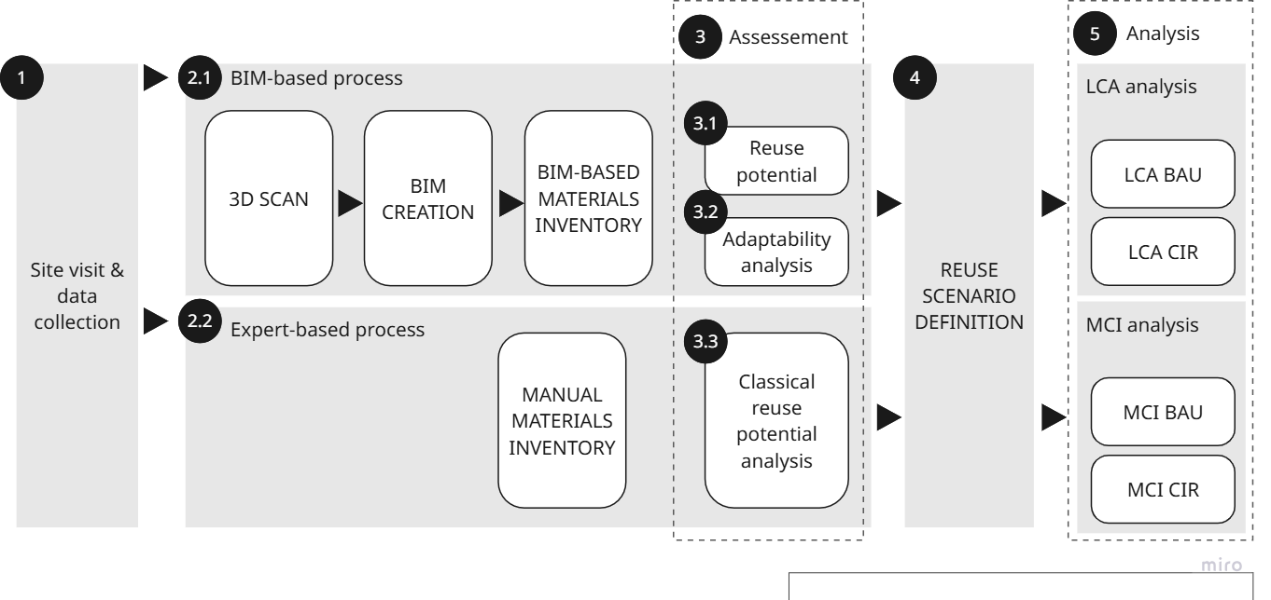
Figure 1. Methodology

- CASE STUDY
  - Description of the pilot building
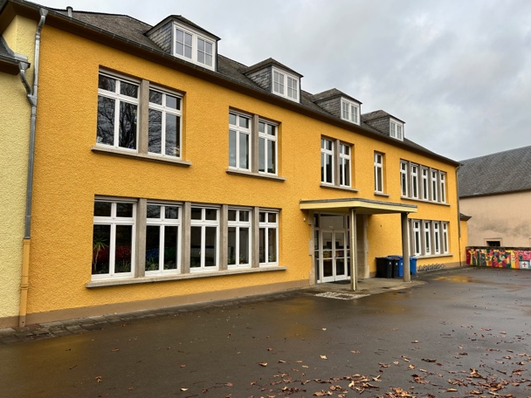
The building considered in this study (Figure 2) is a primary school constructed in mid 1900's (+/- 1940/1950) in the municipality of Beckerich in Luxembourg. Due to the construction of a new school, the building is planned to be renovated and used to extend the existing city hall which is currently located in an adjoining building. The building was constructed in stones and has been renovated several times from its initial construction. In the framework of the Horizon Europe REGEN project, the building has been used for circularity analyses in order to identify the strategies that would allow to reduce the quantity of demolition waste that will be generated during the renovation.
Figure 2. View of the pilot building
  - Reuse potential and adaptability analysis of the building
In this pilot case, two indicators aligned with specific circular design strategies were used to assess the Circularity Profile/Potential of the building (Durmisevic, 2006): 1) The design for disassembly strategy is supported by the Reuse Potential (RP) methodology, 2) the design for adaptability is supported by the Transformation Capacity (TC) analysis. Fully transformable buildings are dynamic and adaptable buildings that can evolved by shifting their function, extending, shrinking or relocating. The RP indicator assesses the ease with which materials can be recovered without damaging the materials themselves or the surrounding materials. It reflects material reuse scenarios and material savings. The method assesses the nature of the connections and determines how easily building products and materials can be recovered without damaging surrounding parts (Durmisevic et al., 2021). As shown in Figure 3, the reversible BIM highlights BIM components using a colour scale: the components with a low reuse potential appear in red, while those with high reuse potential are highlighted in green. The TC indicator assesses the ease with which a building can be transformed without demolition. It expresses the effectiveness and efficiency of altering the functional and physical characteristics of a building or its parts to meet changing needs and requirements (BAMB, 2020). The TC indicator also reflects transformation scenarios of a building, as presented in the Figure 3.
Both methodologies rely on a BIM model as initial source of information about the building. The virtual characterization and modelling of the building was achieved using 3D scanning and then BIM models. The BIM was used to create a detailed material inventory and conduct circularity assessment analyses using the above-mentioned methodologies. The RP analysis revealed that the reuse potential of materials in Beckerich is RP 0.3, which classifies the building as having a Circularity Profile 1 (up to 20% of materials can be reused). The transformation capacity study indicated that the building has the capacity to be converted into different types of apartments and offices. This is reflected by the TC score of 0.67. A building with such a TC/RP ratio is classified as Circularity Profile 3 (up to 70% of materials can be reused) (see Figure 3). The results of these first analyses confirm that the building has a good potential to be adapted to new function, and that multiple building components could be reused. The elements provided by the architectural office as well as these analyses confirm that the building has a potential for CE strategy.
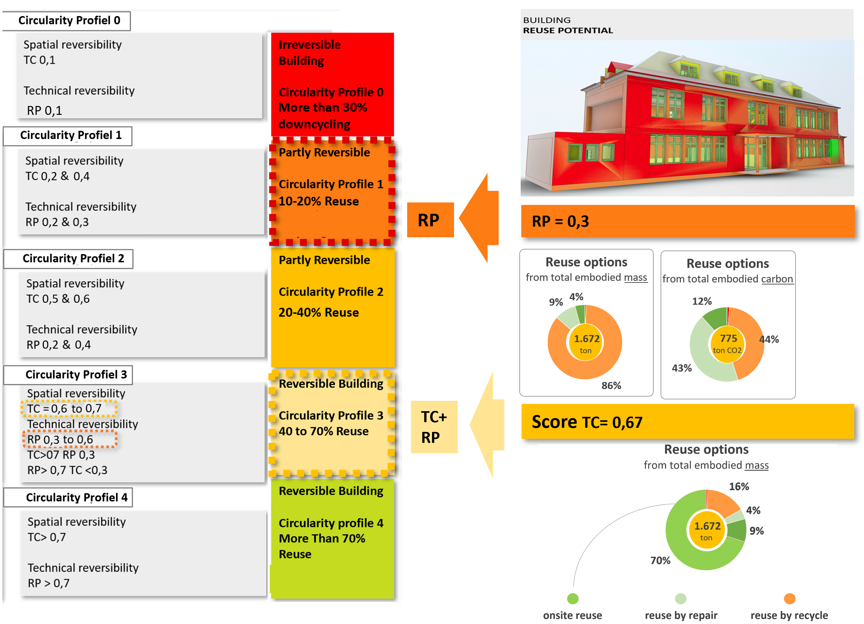
Figure 3. Circularity Profile of Beckerich as a function of TC and RP indicators (source: GTB Lab)
  - Reuse strategy and assessment based on sustainability and circularity metrics
Definition of reuse scenarios
Both BIM-based and expert assessments indicate that the building can be adapted into offices and serve as an extension of the municipality of Beckerich’s offices. The assessments also showed that while some building components are deteriorated and need to be replaced several others have a high reuse potential, such as the natural slate roofing, the wooden window frames, the wooden doors, etc. Based on these assessments two scenarios were defined for this study taking a relevant (derived from the analysis) subset of these building components: first, a Business-as-usual scenario (BAU) where during the renovation these building components are demolished, disposed of and brand-new products replace them; second, a scenario that considers the circular potential of the building components (CIR) and reuses part of them on-site during the renovation (See Table 1).

Table 1. Data about the Business-as-usual scenario (BAU) & incorporating a Circular scenario (CIR)
Existing Building components | Mass (kg) | BAU | CIR
Roof – Natural slate tiles | 12611 | New product | Reuse
Floor- Ceramic tiles | 2322 | New product | New product
Floor – Vinyl surfaces | 1316 | New product | New product
Doors – Internal, wood | 884 | New product | Reuse
Windows – Wood frame | 166 | New product | Reuse
Windows – Double/Triple glazing | 1566 | New product – Triple glazing | New product double glazing
For both scenarios, the window frames and window glazing are considered separately as the wood frame has a high potential for reuse while the glazing needs to be replaced. In the BAU, for windows both the frame and the glazing will be replaced. An increase in energy performance (U-value) through triple glazing windows was considered. In CIR, we opt for reusing the window frames and replacing the glazing. However, in this case the window frames are only adapted for double glazing.
For the LCA, the production of new materials, their end-of-life treatment, and processes associated with the refurbishment and preparation for reuse of building elements were considered.
Comparing environmental impacts of BAU and CIR
In this study, environmental impacts were assessed using the EF 3.1 method (Andreasi Bassi et al., 2023) and the life cycle inventory was based on background data from the Ecoinvent v3.11 database. Figure 4 presents a comparative contribution analysis of the BAU and CIR scenarios across 7 environmental impact categories. The BAU scenario accounts for the majority of environmental impacts in all categories, with contributions ranging from 52.7% to 92.7%, whereas the CIR scenario shows comparatively lower contributions ranging from 7.3% to 47.3%. For the climate change impact category (GWP100), the BAU scenario contributes 2.5 times higher than the CIR scenario contribution. The difference is particularly substantial for the Land use impact category, where the BAU scenario accounts for 92.7% of the total impact, approximately 12.7 times higher than the CIR scenario (7.3%).
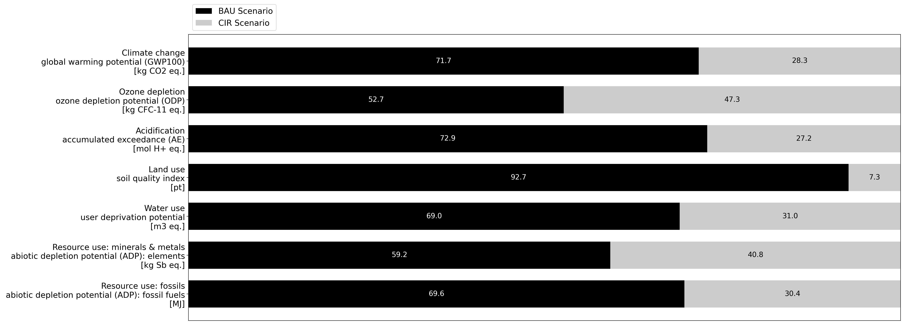
Figure 4. Contribution analysis comparison of BAU and CIR scenarios
Figure 5 presents the normalized LCIA (Life Cycle Impact Assessment) scores for the BAU and CIR scenarios, respectively. A normalized score of 0 indicates the lowest environmental impact, whereas a score of 1 represents the highest impact. The results indicate that triple glazing exhibit the highest overall impacts in the climate change category under the BAU scenario, whereas double glazing shows the highest overall impacts under the CIR scenario. For the BAU scenario in climate change impact category, the building components are ranked from the most to least environmentally impactful as follows: triple glazing > natural slate tiles > vinyl floor surfaces > wooden window frames > ceramic tiles > internal doors. As for the CIR scenario ranking: double glazing > vinyl floor surfaces > ceramic tiles > internal doors > wooden window frames, natural slate roof tiles.
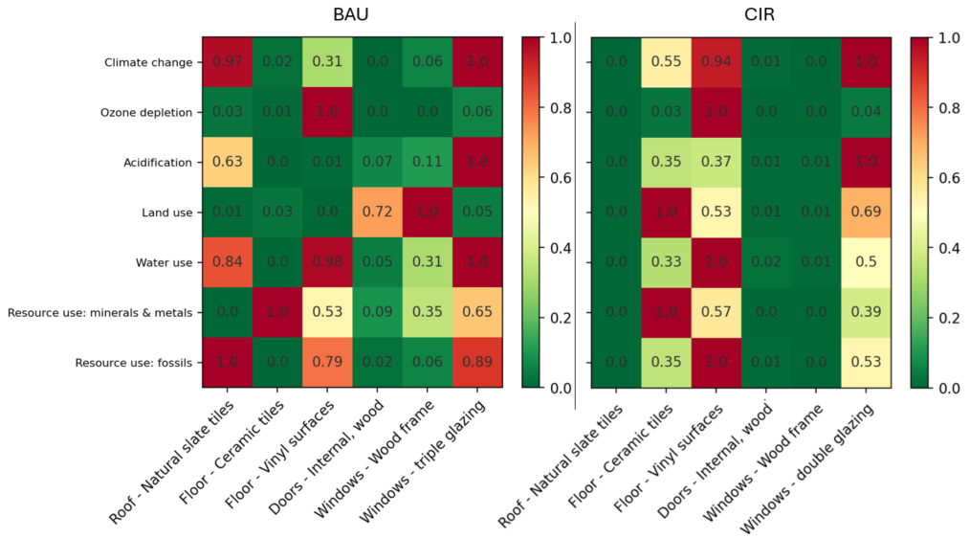
Figure 5. Normalised LCIA scores obtained for the BAU and CIR scenarios
Figure 6 presents the contribution analysis of building components in the BAU scenario across the 7 impact categories. Climate change: Triple glazing was the main contributor to climate change impact (29.8%), followed by natural slate roof tiles (29.1%) and vinyl floor surfaces (14.8%). Wooden window frames accounted for 9.5% of the impacts, whereas ceramic floor tiles and interior doors contributed 8.7% and 8.2%, respectively. Ozone depletion: Vinyl floor surfaces were responsible for the vast majority of ozone depletion (84%), while triple glazing and natural slate roof tiles contributed 6.2% and 4%, respectively. Land use: Wooden window frames were the primary contributor to land use impacts, accounting for 51% of the total, followed by interior doors with 37.2%.
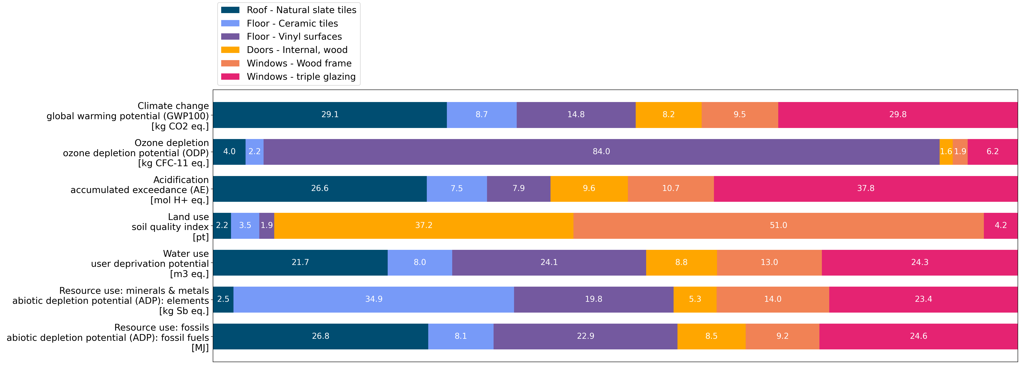
Figure 6. Contribution Analysis: BAU
Figure 7 illustrates the contribution analysis of the building components in the CIR scenario across the 7 impact categories. Climate change: Double glazing contributed the largest share of the climate change impact (39.8%), followed by vinyl floor surfaces (37.4%) and ceramic floor tiles (21.9%). Ozone depletion: Vinyl floor surfaces accounted for the highest share of ozone depletion (93.6%), while double glazing and ceramic floor tiles contributed 3.8% and 2.5%, respectively. Land use: Ceramic floor tiles accounted for the highest share of land use impacts (44.4%), followed by double glazing (30.7%) and vinyl floor surfaces (23.6%).
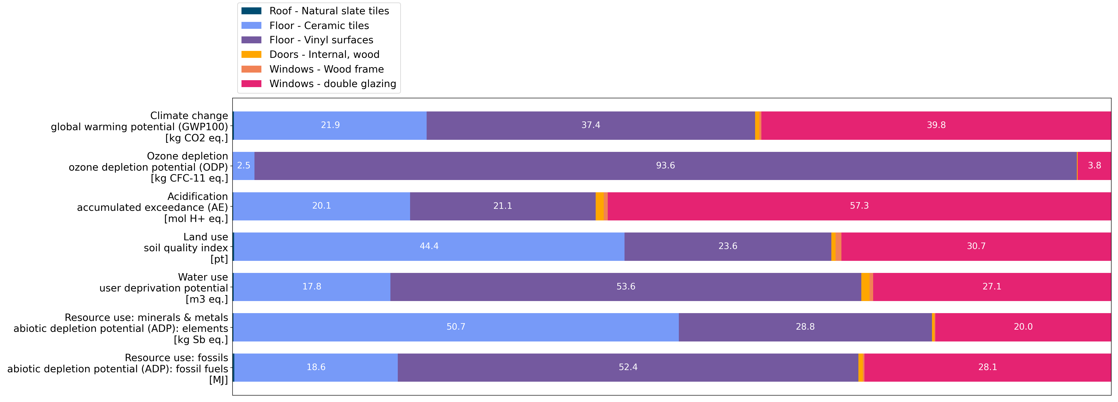
Figure 7. Contribution Analysis: CIR
Comparing Material Circularity of BAU and CIR
The Material Circularity Indicator was originally developed by the Ellen MacArthur Foundation (Ellen MacArthur Foundation, 2019) and later adapted for the construction sector by MADASTER (Madaster, 2021). It functions as a circularity reporting tool that helps stakeholders make informed decisions at various levels (e.g. Product design, building design and product selection). For this study the MCI is used as a tool to compare the BAU and CIR scenarios in terms of circularity gains.

Table 2. Madaster MCI calculation (from (Madaster, 2021))
CI global | CI=1-LFI*F(X)
 | F(X)=$\frac{0.9}{CI Use}$ with 0.9 is a Utility constant
CI production | CI _{production}=F_{R}+F_{RR}+F_{U} |  | Linear Flow Index (LFI)  LFI= $\frac{V+W}{2M+\frac{Wf-Wc}{2}}$
CI production | F_{R :} Fraction of recycled materials (as a % of the product mass)  F_{RR}: Fraction of rapidly renewable materials (as a % of the product mass)  F_{U}: Fraction of reused products and/or components (as a % of the product mass) |  | V= M(1-CI_{production});  W= M(1-C_{r}-C_{u}) +$\frac{Wf+Wc}{2}$;  W_{f}= M$\frac{(1-E_{F})F_{R}}{E_{F}}$ ;  W_{c}=M(1-E_{c})*C_{R}
CI Use | CI_{Use} =$\frac{L}{L av}$ |  | M: Product mass ; W: Mass of waste (kg) ;  Wf: Mass of waste (kg) generated by the recycling process that provides the materials used to manufacture a product  Wc: Mass of waste (kg) generated by the recycling process after the useful life of the product.  𝐶_{R}: Fraction of materials with a waste recycling scenario (as a % of the product mass);  C_{u}: Fraction of materials with a waste reuse scenario (as a % of the product mass)  E_{f}: Efficiency of the recycling process (%) supplying the materials to manufacture a product. The default value of 75% can be changed manually, since the required data is not available.  E_{C}: Efficiency of the recycling process (%) for a product with a waste recycling scenario.  The default value of 75% can be changed manually, since the required data is not available.
CI Use | L: Potential functional lifecycle of a product, in years  L_{av}: Industry-average lifecycle of a building layer, in years
CI End of Life | CI_{End of Life}=C_{R}*E_{C}+C_{U}
CI End of Life | C_{R}: Fraction of materials that can be potentially recycled at the end of its useful life (as a % of the product mass)  E_{C}: Efficiency of the recycling process in the end-of-life phase (%)  C_{U}: Fraction of components and/or products that can be potentially reused at the end of its useful life (as a % of the product mass)
Figure 8 presents the Material Circularity Indicator (MCI) per component and an aggregated total score for the BAU and CIR scenarios calculated according to the equations of Table 2. The score ranges from 0, indicating the least circular, to 1, indicating the most circular. For calculating the MCI, we extracted data from Environmental Product Declarations (EPDs) and the BIM model. Since data on the industry-average lifecycle of products was unavailable, we decided to make it equal to the potential functional lifecycle of a product in the BAU scenario, which set the CI Use at 1 for all products. This decision implied that it would have no impact on the overall circularity score in the BAU. In contrast, for the CIR scenario, the potential functional lifecycle of a product was halved compared to that of a new product, this meant that the CI Use for these products was reduced by half.
The aggregated total score demonstrated a twofold increase in circularity in the CIR scenario (0.65) compared to the BAU scenario (0.34). This improvement is primarily due to the significant increase in the MCI of natural slate tiles, which rose from 0.31 in the BAU scenario to 0.77 in the CIR scenario.
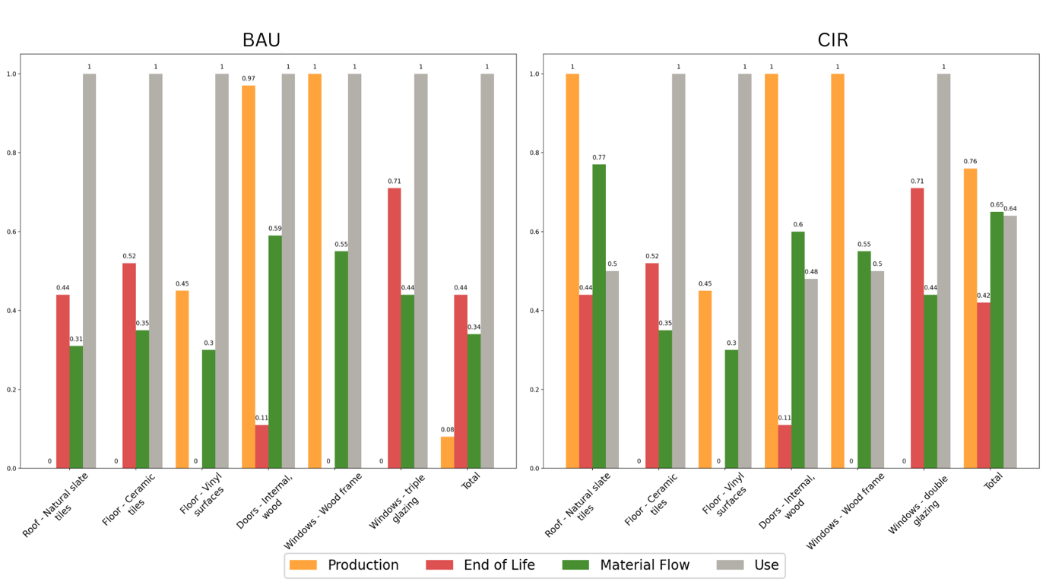
Figure 8. MCI results for BAU and CIR scenarios
Interestingly, although the internal doors and window frames were considered as reused in the CIR scenario, they did not contribute to an increase in the MCI. This can be explained by the structure of the formula, which gives equal weight to the fraction of rapidly renewable material and the fraction of reused material at production. Since these components are made almost entirely of rapidly renewable material (wood), their circularity indicator at the production stage had already reached its maximum value in the BAU scenario therefore the decision to reuse them in the CIR scenario did not reflect on the MCI score.

- DISCUSSION
The methodology defined in this paper (see section 2) allowed to articulate several indicators (i.e. reuse potential, transformation capacity, MCI, LCIA) which are complementary to evaluate both the circularity potential and the environmental performance of renovation scenarios. These indicators are mainly connected through a BIM-based workflow. The pilot case demonstrated a good adaptability potential and significant opportunities for materials reuse. This was further confirmed by analyses conducted in parallel by an architectural office responsible for preliminary studies for the Beckerich municipality. Based on the RP and TC indicators two scenarios were elaborated: a Business-as-usual (BAU) scenario and a Circular scenario (CIR) promoting the reuse of building components. Then both scenarios were compared based on an LCA analysis and an MCI calculation. The CIR scenario demonstrated lower environmental impacts by avoiding new material production. The analysis confirmed that newly manufactured components remained the principal environmental hotspots in the CIR scenario, whereas reused components exhibited comparatively low impacts due to avoided raw material extraction and manufacturing processes. The study confirms that MCI alone is not sufficient to determine the circularity of a renovation scenario. As mentioned in (Figueirinhas et al., 2026), the MCI was designed to serve as a decision-making tool for designers and businesses. It enables the comparisons between product versions and the establishment of minimum circularity thresholds. The study highlighted that the MCI score requires to be associated with LCA analysis to capture the environmental value of a renovation strategy. The study also demonstrated the important role of BIM to support the generation of detailed materials inventory and facilitate the calculation of circularity and environmental assessment metrics. Moreover, BIM-based visualisation tool, such as reversible BIM, provided representations that facilitated the interpretation of the results and supported the decision-making process.
At this stage, this research presents several limitations. In the context of this paper, the BIM-based framework was tested in a unique pilot building. The analysis considered only a subset of materials and a single CIR scenario. This limits the generalization of the results that should be tested on other scenarios across multiple building typologies to further validate the approach and strengthen the robustness of the framework. Moreover, several assumptions regarding the CIR scenario (e.g. concerning BAU end-of-life scenarios) influence the results of the LCA analysis and the environmental benefits are therefore subject to uncertainties. Sensitivity analysis on key parameters such as materials transport distance would provide additional insights reinforcing the consistency of the results. The lack of available data for assessing circularity of construction materials (e.g. for industry-average lifecycle of a building layer) also represents a limit of this research. Due to these gaps, this factor was not covered in the MCI calculation. This may influence the global results. Additionally, the study focused on the circularity and LCA assessment associated with materials while operation energy performance of the building was not fully integrated in the framework. Consequently, the investigation of the links between LCA, circularity metrics and operational energy simulations through a BIM-based process could constitute an important perspective for future research, enabling a more robust assessment of low-carbon and circular strategies.

- CONCLUSION
Moving towards resilient cities will require the development of advanced metrics to evaluate architectural and renovation projects. The research demonstrates that the combination of RP, TC, MCI and LCA provides an interesting framework to assess circular and low carbon renovation strategies and promote reuse on-site of materials when feasible. The results of this study confirm that reuse of building components could contribute to a significant reduction of the environmental impacts by extending the lifespan of existing building materials and reducing demolition waste.
This study also underlines the limitations of the MCI indicator and the need to combine it with LCA analysis to properly assess the environmental performance of renovation scenarios promoting reuse practice. Finally, the study highlights the key role of BIM in centralizing building and material information required for circularity and LCA analyses. Moreover, BIM-based visualizations and simulations can support informed decision-making and guide AEC practitioners toward better circular, low-carbon renovation strategies. Finally, the findings of this research open new perspectives for future works on the development of IT tools for renovation roadmaps, including new types of indicators, and integrated methodologies supporting the assessment of environmental, functional, and circular benefits of renovation scenarios.
- ACKNOWLEDGEMENTS
This paper is published as part of the REGEN project, which received funding from the European Union’s Horizon research and innovation program under grant agreement N° 101123325.
REFERENCES
ANDREASI BASSI, S., BIGANZOLI, F., FERRARA, N., AMADEI, A., VALENTE, A., SALA, S. & ARDENTE, F. 2023. Updated characterisation and normalisation factors for the Environmental Footprint 3.1 method. In: JRC technical Report, European Commission.
AKBARIEH, A., JAYASINGHE, L. B., WALDMANN, D. & TEFERLE, F. N. 2020. BIM-Based End-of-Lifecycle Decision Making and Digital Deconstruction: Literature Review. Sustainability, 12.
BAMB. 2020. Transformation capacity [Online]. Available: https://www.bamb2020.eu/topics/circular-built-environement/common-language/transformation-capacity/ [Accessed 26/06/2026].
BELLI-RIZ, P., BENOIT, J., FABIANI, S., GHYOOT, M., GUICHARD, C., HUYGEN, J.-M., DE GUILLEBON, M. & TOPALOV, H. 2022. Réemploi, architecture et construction. Méthodes, ressources, conception, mise en oeuvre, Editions Le Moniteur.
CHAREF, R. & EMMITT, S. 2021. Uses of building information modelling for overcoming barriers to a circular economy. Journal of Cleaner Production, 285.
CHESHIRE, D. 2021. The Handbook to Building a Circular Economy, London, RIBA publishing.
DURMISEVIC, E. 2006. Transformable Building Structure, Design for Disassembly as a key to introduce sustainable engineering to building design and construction. TU Delft.
DURMISEVIC, E., GUERRIERO, A., BOJE, C., DOMANGE, B. & BOSCH, G. 2021. Development of a conceptual digital deconstruction platform with integrated Reversible BIM to aid decision making and facilitate a circular economy. CIB W78 2021. Luxembourg.
ELLEN MACARTHUR FOUNDATION 2019. Circularity indicators, An approach to measuring circularity, Methodology.
ELLEN MACARTHUR FOUNDATION. 2026. Available:
https://www.ellenmacarthurfoundation.org/topics/circular-economy-introduction/overview
[Accessed 26/06/2026].
EUROSTAT. 2022. Waste generation, excluding major mineral waste, 2022 [Online]. Available: https://ec.europa.eu/eurostat/statistics-explained/index.php?title=Waste_statistics#Total_waste_generation[Accessed 28/06/2026].
FIGUEIRINHAS, D., VAKULENKO, Y., PåLSSON, H. & HELLSTRöM, D. 2026. Advancing circularity metrics: Revisiting the Ellen MacArthur Foundation’s Material Circularity Indicator. Resources, Conservation and Recycling, 226.
HEINRICH, M. & LANG, W. 2019. Materials passport - Best practices, Innovative Solutions for a Transition to a Circular Economy in the Built Environment.
MADASTER. 2021. Madaster Circularity Indicator explained [Online]. Available: https://docs.madaster.com/files/en/Madaster%20%20Circularity%20Indicator%20explained.pdf [Accessed 28/06/2026]

